Title: Global warming and artificial shorelines reshape seashore biogeography

Wei Wang ¹, Jie Wang ², Francis M. P. Choi ³, Ping Ding ⁴, Xiao-xu Li ¹, Guo-dong Han ¹, Meng-wen Ding ¹, Minquan Guo ⁴, Xiong-wei Huang ¹, Wei-xiang Duan ¹, Zhi-yuan Cheng ¹, Zhi-yuan Chen ¹, Stephen J. Hawkins ^{5,6}, Yuwu Jiang ¹, Brian Helmuth ^{3,7}, Yun-wei Dong ^{1,2}

1 State Key Laboratory of Marine Environmental Science, College of Ocean and Earth Sciences, Xiamen University, Xiamen 361102, People’s Republic of China
2 Key Laboratory of Mariculture, Ministry of Education, Fisheries College, Ocean University of China, Qingdao 266001, People’s Republic of China
3 Marine Science Center, Northeastern University, Nahant, MA 01908, USA
4 Marine Forecasting Center of Fujian Province, Fuzhou 350003, People’s Republic of China
5 The Marine Biological Association of the UK, The Laboratory, Citadel Hill, Plymouth PL1 2PB, UK
6 School of Ocean and Earth Science, National Oceanography Centre Southampton, University of Southampton, European Way, Southampton SO14 3ZH, UK
7 School of Public Policy and Urban Affairs, Northeastern University, Boston, MA 02115, USA
Correspondence author: Yun-wei Dong
Phone: +86-18659211278
Email: dongyw@xmu.edu.cn

ACKNOWLEDGEMENTS The authors thank Professor G. N. Somero for comments, discussion and revisions on this manuscript, Dr. S. Crickenberger for conversations that enhanced data analysis and Ms. Jia-mei Xiao and Mr. Wei-di Yang for sample collection. We would like to acknowledge the financial support provided by National Natural Science Foundation of China (41776135, 41976142, 41476115), Nature Science Fund for Distinguished Young Scholars of Fujian Province (2017J07003) and National Basic Research Program of China (2013CB956504).

AUTHOR CONTRIBUTION YD and BH designed the study; WW, WJ, XL, GH, MD, X H, ZCheng, ZChen and YD carried out field surveys and larval sampling; YJ, PD and MG performed simulation of larval dispersal; WW, XL, WJ, GH and MD carried out laboratory experiment; FMPC and BH performed Heat Budget Model temperature estimations; WW, WJ, FMPC, XL, PD, SH, YD, BH, YJ and WD analysed and interpreted the data; YD, SJH, BH and WW led the writing, but all authors contributed to the writing.

BIOSKETCH Yun-wei Dong is mostly interested in macroecology and ecological physiology. His work mainly focuses on studying the impacts of climate change and human activities on the biogeography of intertidal species.

ABSTRACT
Aim: Rapid anthropogenic warming coupled with changes in land use is altering the distributions of species, with consequences for ecosystem functioning and services. It is crucial to evaluate species range shifts based on understanding of the interaction of temperature with non-climatic factors such as habitat availability and dispersal potential. Here, we aim to investigate roles of environment temperature, habitat availability and population connectivity on the distributions of hard-shore intertidal animals. We further examine potential roles of extensive artificial seawall construction in enabling poleward expansion of species in China, thus reshaping coastal biogeography.
Location: Chinese coast.
Time period: 2013-2017.
Major taxa studied: Intertidal invertebrates.
Methods: We took an integrative approach encompassing distributional ecology, thermal physiology, molecular genetics, heat budget modeling and larval dispersal, to elucidate how interacting multiple drivers, including temperature, habitat availability and larval dispersal, determine distributions of hard-shore invertebrates, focusing on what sets their range edges at a boundary between biogeographic provinces.
Results: Our results untangle the complex interactions of global climate change with the impacts of regional scale coastal development. Temperature, larval transport and habitat availability are the major proximate factors controlling the range limits of coastal marine species. The artificial shorelines provide suitable habitats for hard-shore species on the Yangtze River Delta, and minimum temperature at winter is an important factor setting the new northern range limit of these hard-shore species along the Chinese coast.
Main conclusions: In the face of global warming and global sprawl of marine hard infrastructure, species distributions, community structures and biogeographic patterns are experiencing dramatic changes. The combined influence of multiple human stressors including climate change and artificial shoreline can be evaluated by using a multidisciplinary framework, including ecological distribution, physiological sensitivity of species to these stressors, and the role of dispersal in maintaining population connectivity.

KEYWORDS
biogeography, climate change, coastal development, habitat availability, population connectivity, species distribution, thermal physiology

1 INTRODUCTION
Anthropogenic global warming and habitat transformation have jointly led to shifts in species distributions, changes in community structure, and, potentially, rearrangement of biogeographic provinces (Nowakowski et al., 2018; Pereira et al., 2010; Vitousek, Mooney, Lubchenco, & Melillo, 1997). Untangling the interactions of these factors is challenging, yet vital in order to forecast future ecological responses. By far the most common approach used in generating predictions has been to quantify the current environmental conditions present at existing range boundaries, and then to extrapolate these presumed limiting factors to future modelled environmental conditions. Mainly statistical (Araújo & Peterson, 2012; Pagel et al., 2014; Stuart-Smith, Edgar, Barrett, Kininmonth, & Bates, 2015) but also mechanistic (Kearney & Porter, 2009; Poloczanska, Hawkins, Southward, & Burrows, 2008; Thomas & Bacher, 2018) approaches have been attempted. A key attribute of these methods has been the assumption that the physiological tolerance of a species to environmental (usually climatic) conditions ultimately sets its distribution limits (i.e. its fundamental niche space), and therefore any amelioration (e.g. at a poleward range edge) or worsening (e.g. at an equatorial range edge) will result in a range shift (Deutsch et al., 2008; Harris et al., 2018; Sunday et al., 2014). It has also been shown, however, that non-climatic factors such as ocean currents or the absence of suitable habitat for settlement can serve as barriers to dispersal and thus determine range edges (Cannizzo, Dixon, & Griffen, 2018; Dong, Huang, Wang, Li, & Wang, 2016; Gaylord & Gaines, 2000; Keith, Herbert, Norton, Hawkins, & Newton, 2011; Kimura & Weiss, 1964). Models that fail to incorporate these limiting factors can lead to either over- or under-projections of biogeographic shifts. The limitations of traditional modeling approaches take on new significance in an era when both the formation of new barriers to dispersal as well as the creation of new habitat (e.g. seawalls) is proliferating. A comprehensive mechanistic framework that causally links biogeographic distribution of species and their thermal physiology, for understanding the combined effect of global warming and habitat modification is still lacking. Perhaps nowhere is a need for such a framework as evident as in coastal marine systems.
With high connectivity in the marine ecosystem (Cowen & Sponaugle, 2009), marine organisms with pelagic larvae are often assumed to more fully occupy the extent of latitudes allowed by their thermal tolerance limits than are many terrestrial animals with more limited modes of dispersal (Kinlan & Gaines, 2003); consequently, some marine species have been observed to rapidly extend their poleward range boundaries and contract their equatorward boundaries with climate warming (Sunday, Bates, & Dulvy, 2012). The fingerprint of warming on these economically and ecologically important ecosystems is already evident (Heron, Maynard, Van Hooidonk, & Eakin, 2016; Hoegh-Guldberg & Bruno, 2010; Pecl et al., 2017), and current global marine diversity patterns are expected to continue changing rapidly in response to ocean warming (Harley et al., 2006; Molinos et al., 2016; Sunday, Bates, & Dulvy, 2012). However, most of the world’s coastline is warming at rates that can exhibit high spatial and temporal heterogeneity, and changes are occurring not just at range boundaries but also well within species ranges (Burrows et al., 2011; Helmuth et al., 2002; Lima & Wethey, 2012; Oey, Chang, Chang, Lin, & Xu, 2013; Sevellec & Drijfhout, 2018). Concurrently, with increasing coastal development (e.g., industry, transportation, aquaculture, residential use, tourism and coastal defense), more and more artificial structures are being built along coastlines world-wide (Bulleri & Chapman, 2010; Dong, Huang, Wang, Li, & Wang, 2016; Huang, Wang, & Dong, 2015). These proliferating artificial hard substrata change local and regional biodiversity primarily through the provision of new habitat (Firth et al., 2016). They also facilitate the establishment and spread of both native and exotic species, leading to changes of long-standing distributional boundaries (Bishop et al., 2017; Cannizzo, Dixon, & Griffen, 2018). With both climate change and emergence of new hard substrata bridging habitat gaps and increasing connectivity, animals inhabiting intertidal areas can rapidly occupy new hard-shore habitats at locations where conditions are within the species’ thermal tolerance range. Once established, populations on these habitat patches can serve as critical “stepping stones”, enabling further colonization at other sites beyond the limits of present-day larval dispersal (Hannah et al., 2014). Importantly, and in contrast to most heuristic models, range edges can expand rapidly via these mechanisms. These range boundary shifts and assemblage composition changes will consequently reshape coastal biogeography, potentially at the level of biogeographic province.
The unprecedented coastal development and increasing warming along the Chinese coastline provide an excellent opportunity to study how climate change and habitat modification, two of the most important contemporary anthropogenic drivers, interact to change coastal biodiversity, ecosystem functioning and biogeographic patterns. The Yangtze River Mouth is regarded as a biogeographic barrier and is the boundary of two ecological provinces, the Cold Temperate Northwest Pacific and the Warm Temperate Northwest Pacific provinces (Spalding et al., 2007). Climate, available suitable habitat and Yangtze River discharge have been deemed to be main causes of this barrier, coupled with historical events during glacial cycles (Dong et al., 2012; Ni, Kern, Dong, Li, & Park, 2017; Wang, Tsang, & Dong, 2015). Due to the shortage of appropriate substrate on Yangtze River Delta, rocky intertidal species are largely precluding from settling on the shore from the Yangtze River Mouth (~30°N) to Lianyugang, Jiangsu (~34.5°N) (Huang, 2008; Wang, Qian, Wang, & Guo, 2013; Zhang, Qi, Zhang, & Ma, 1963; Zhao, Li, Kong, & Yu, 2017). Over 60% of the Chinese shoreline has been modified due to land reclamation and other activities involving coastal construction (Hou et al., 2016; Ma et al., 2014). These hard artificial structures along the shoreline have transformed many natural muddy tidal-flats to a relatively homogeneous ‘grey’ artificial shoreline in the last few decades (Hou et al., 2016). The limited ecological and genetic data that exist reveal that these new artificial hard substrata can facilitate the poleward migration of hard-shore species (Dong, Huang, Wang, Li, & Wang, 2016). To mechanistically explore the impacts of coastal development and increasing warming on the biogeographic pattern of intertidal species, in the present study, we took an integrative approach encompassing distributional ecology, biophysics, thermal physiology, molecular genetics and larval dispersal to achieve the following purposes. First, by using distributional ecology and phylogeographic studies we wished to determine whether the construction of artificial shorelines, as suitable habitats for rocky intertidal species, can alter the species distribution and biogeographic pattern of intertidal macrobenthos along the Chinese coastline. Second, by using hydrodynamic model simulation and metabarcoding we tested whether larvae of southern intertidal species can go northwards beyond the Yangtze River Mouth, the former biogeographic barrier. Third, by using biophysics and physiological measurements, we examined whether temperature is a limiting factor for setting the northern range limit of hard-shore species that are absent in the natural muddy tidal-flats, but settle on and colonize artificial structures. Our work provides strong evidence that these artificial structures help set range limits for these species and, more broadly, alter a boundary between biogeographic provinces.

2 MATERIALS AND METHODS
2.1 Assemblage Surveys and Analyses
To investigate the spatial-temporal changes of the community structure on the artificial and natural rocky shores, nine field surveys of intertidal macrobenthos were performed at 17 locations along the Chinese coastline from 2013 to 2017 (Figure 1, and Supporting Information Table S1). Among these 17 locations, two of them are natural rocky shores, namely Lianyungang (LYG) and Shenjiawan (SJW), and the others are artificial shorelines. At each location, species searches were conducted along at least 100 m of shore at each location for 1 h during low tides, and presence/absence data were recorded. The rocky shore species compositions of invertebrates, including mobile, sessile and sedentary macrobenthic species of Gastropoda, Bivalvia, Polyplacophora and Cirripedia (body size > 0.5 cm) were recorded. Non-metric multidimensional scaling (nMDS) and cluster analysis based on Bray–Curtis similarity of presence/absence data were used to visualize the pattern of assemblages using PRIMER v7 (Clarke, Somerfield, & Gorley, 2008).

2.2 Biogeographic and phylogeographic patterns
To analyze the change in the northern distribution range limits of southern species and populations with or without coastal artificial structures, the presence of two southern species (the snail Nerita yoldii and the oyster Crassostrea sikamea) at the 17 locations along the Chinese coastline were continuously recorded during the nine field surveys from 2013 to 2017 to track their northern distribution edges (Figure 1). As two southern species, the northern distribution range limit of N. yoldii and C. sikamea occurred to the south of the Yangtze River Mouth before the construction of artificial shorelines on the Yangtze River Delta (Huang, 2008; Wang, Qian, Wang, & Guo, 2013; Zhang, Qi, Zhang, & Ma, 1963). Thus, by tracking their distribution range shift, it is possible to discover the impacts of artificial shoreline on the biogeographic patterns of southern rocky shore species.
In investigating the phylogeographic pattern of ubiquitously distributed species along the Chinese coastline, it is important to know the impacts of artificial shoreline on the genetic structures of widely distributed species. The barnacle Fistulobalanus albicostatus is a dominant species on both natural rocky shores and artificial hard shores along the whole Chinese coastline. In the present study, it’s population genetic structure was analyzed using the mitochondrial Cytochrome Oxidase I (COI) gene. Barnacles were collected from Lianyungang (LYG), Binhaigang (BHG), Shuangyanggang (SYG), Wanggangzha (WGZ), Zhonganpeng (ZAP), Dayanggang II (DYG II) and Jiantiao (JT) (Figure 1, Supporting Information Table S1). A total of 145 sequences of COI (GenBank Accession number: MH782278-MH782422) from 7 populations were amplified and sequenced using LCO1490 and HCO2198 (Folmer, Black, Hoeh, Lutz, & Vrijenhoek, 1994). PCR reactions were conducted following the protocol described in Dong, Huang, Wang, Li, & Wang (2016). Sequencing was tested in both forward and reverse directions and sequences were assembled and manually inspected for ambiguities using DNAMAN7 software (Lynnon BioSoft, Quebec, Canada). Other COI sequences of three common species on the hard shore along the Chinese coastline, Siphonaria japonica, Littorina brevicula and Littoraria sinensis, were download from GenBank (Dong, Huang, Wang, Li, & Wang, 2016, GenBank Accession number, KP195742-KP196013, KP196014-KP196241, KP196242-KP196327; Wang, Tsang, & Dong, 2015, GenBank Accession number, KF716505-KF716747).
A simulated annealing approach implemented in SAMOVA v. 2.0 (Dupanloup, Schneider, & Excoffier, 2002) was used for a varying number of groups (K) to define groups of populations that were phylogeographically homogeneous and maximally differentiated from each other. The analysis was run for 2–7 groups (5 simulations repeated for each K), with 1,000 permutations. Then the grouping associated with the highest F_{CT} (i.e., the best number of groups and the best population configuration) was selected. Based on the results of groupings defined by the SAMOVA, a hierarchical analysis of molecular variance (AMOVA) using ARLEQUIN v. 3.5 (Excoffier, Smouse, & Quattro, 1992) was conducted, to test for the phylogeographic separations of the four species, which are widely distributed along the Chinese coastline.

2.3 Simulation of larval dispersal
For simulating larval dispersal to test whether the larvae of southern species can go northwards beyond the Yangtze River Mouth and to discover the seasons at which larvae of southern species can move further northward, we used the results of an operational hydrodynamic model to predict the dispersal of pelagic larvae from different areas along the coasts of the East China Sea and the Yellow Sea. The operational hydrodynamic model is based on the Regional Ocean Modeling System (ROMS) (Haidvogel et al., 2000, Shchepetkin & McWilliams, 2005), and the modelling domain covers the Northwestern Pacific Ocean with curvilinear grids. It can simulate currents in all the water column (30 layers) with a spatial resolution ranging from approximately 45 km at the open boundary to about 3.0 km along the Chinese coast. The details of the operational model can be referred to previous studies (Chen, Jiang, Liu, & Gong, 2017; Liao, Oey, Yan, Li, & Jiang, 2018; Lin, Yan, Jiang, & Zhang, 2016). Based on the model results, a drift trajectory program was developed to simulate the trajectories of larvae as passive particles. Simulations were run starting from 57 locations (Supporting Information Table S2) at four distinct times: January 15th (winter), April 14th (spring), July 11th (summer) and November 6th (autumn) 2017. The number of simulative passive particles from each location and starting time was 200. Based on the pelagic larval durations (PLD) of common intertidal rocky shore species (Supporting Information Table S3), we chose a simulation time of 30 days with a step size of 1 hour.

2.4 Larvae Metabarcoding
For investigating whether the larvae of southern intertidal species can be found to the north of the Yangtze River Mouth, plankton samples were collected on August 2014 and June 2015 around the Yangtze River Mouth and Yellow Sea coast (Supporting Information Figure S1) using a plankton net (Mesh size 0.155 μm) and were stored at -20°C for metabarcoding analysis. DNA extraction and PCR amplification were carried out as described by Ding, Wang, & Dong (2018). A COI gene fragment from total genomic DNA was pyrosequenced on the Roche 454 GS FLX⁺ platform at Xiamen University. An improved QIIME pipeline (Caporaso et al., 2010) was used to analyze the raw data. Firstly, sequences of primers and Multiplex Identifiers (MIDs) were removed from the raw 454 reads. Then, quality control, denoising and chimera removal were run by using the QIIME pipeline. Because of the lack of reference sequences database of COI for Operational Taxonomic Units (OTU) picking and taxonomic assignment, programs CROP (Hao, Jiang, & Chen, 2011) and SAP (Munch, Boomsma, Huelsenbeck, Willerslev, & Nielsen, 2008) were used to fulfill OTU picking (at 97% similarity) and taxonomic assignment for the final species composition of zooplankton.

2.5 Body temperature estimation and cold thermal-safety margins (cTSM) measurements
For testing whether minimum temperature at winter is a limiting factor for restraining the northern range limit of rocky intertidal species, the cold thermal-safety margins (cTSM) were calculated by integrating the body temperature and thermal tolerance. The snail N. yoldii is originally a southern-occurring species, but recently has extended its range northward in a stepwise manner (Wang et al., 2018), with a current northern range limit at ~33°N.
Estimates of body temperature for N. yoldii from 1978 to 2017 were calculated using a heat budget model (Marshall, Rezende, Baharuddin, Choi, & Helmuth, 2015) modified for snails from a model originally developed for mussels (Helmuth et al., 2011). The model was tailored by changing the shape and size of the animal, and the amount of contact with the substratum to be specific for each snail species. Variables for the heat budget model, such as air temperature, wind speed and solar radiation, were extracted from NOAA’s Climate Forecast System Reanalysis (CFSR). CFSR provides global hourly environmental data with geographic area of 0.3° x 0.3° pixels (Saha et al., 2010). Body temperature estimations for each species and location were summarized as 95th and 99th percentiles of minimum body temperature (T_{b_min}) from 1979 to 2017.
Snails (N. yoldii) were collected from five locations (Xiamen, XM; Dongtou, DT; Zhoushan, ZS; Dayanggang II, DYG II; Yangguang Island; YGD) along the Chinese coastline and acclimated at 16 °C under identical conditions for ~6 months. In the laboratory, snails were washed in filtered seawater, allowed to emerge from their shells and attach to lidded Petri dishes and the substrata of the Petri dishes were then cooled down from 16 °C at a rate of 6 °C h⁻¹ using a water bath THD-3030 (Tianheng, China). A non-invasive method was used to measure individual heart rates (Chelazzi, Pirro, & Williams, 2001). FLT_{cold} (flatline temperature of cardiac performance) was the low temperature at which cessation of heartbeat was first observed (n =12 to n= 19). Low temperatures lethal for 50% of individuals (LT₅₀) of four populations (Xiamen, XM; Zhoushan, ZS; Dayanggang II, DYG II; Yangguang Island; YGD) were calculated. When temperature reached each designated temperature (-4，-6，-8，-10，-12 and -14 °C) using the method as above mentioned, 3 parallel groups (5 individuals in each group) were randomly taken out and allowed to recover at 16 °C for 7 d. The survival of each treatment group was examined, and LT₅₀ of each population was calculated using Probit analysis (n=3). One-way ANOVA was used to determine the difference in FLT_{cold} and LT₅₀ among different populations by SPSS 20.0 (IBM Corp, NY).
The cold thermal-safety margins (cTSM) for FLT_{cold} or LT₅₀ are defined as:
cTSM = FLT_{cold} – T_{b_min} (1)
or
cTSM = LT₅₀ – T_{b_min} (2)
where T_{b_min} is the minimum body temperature. When the cTSM < 0, animals can tolerate the low temperature in winter; when the cTSM > 0, animals are threatened by low temperatures under either FLT or LT₅₀.

3 RESULTS
3.1 Community structural similarity
From 2013 to 2017, 21 species of macrobenthos, including molluscs and barnacles, were recorded at 17 locations from the Yangtze River Mouth to north of the Yangtze River Delta (Figure 1a and Supporting Information Table S1). Based on Bray-Curtis similarity of presence/absence data (Supporting Information Table S4), cluster analysis (Figure 1c) and non-multidimensional scaling plots (Figure 1d), we show that all 17 locations can be generally divided into three groups with 60% similarity. Because there was not hard substrate before the construction of artificial shorelines, hard-shore assemblages on the former muddy tidal-flats, from Donghai Bridge (DB) to Binhaigang (BHG), were absent until recent times. With the construction of sea-defense on the muddy tidal-flats, three emergent assemblages on the artificial habitats in the middle of Yangtze River Delta between latitude of 33-34°N (SHYG, DFG and LSD) clustered together as group 1. Some assemblages on the artificial habitats up to latitude 33°N (WGZ) clustered together with a southern natural rocky shore (SJW) at 31°N as group 2. Three assemblages on the artificial shorelines at the northern Yangtze River Delta (SYG, ZDZ and BHG) clustered with the assemblage at the northern natural rocky shore (LYG) as group 3.
Due to a lack of appropriate habitats on the natural muddy tidal-flats in the Yangtze River Delta up until recent times, the historical northern distributional boundaries of N. yoldii and C. sikamea were around 30°N ~ 31°N (Figure 2a). On the artificial hard shores in the Yangtze River Delta, these two southern species now are dominant species and their northern distribution range limits have moved further north to 33°~34°N. During the period of our field survey, the distribution of N. yoldii showed a gradual expansion of its northward distribution. From 2014 to 2017, it expanded from 32°30.0’ to 33°10.8’, a distance of 80 km.
AMOVA results, based on the COI gene, showed that populations of F. albicostatus along the Chinese coast divide into two groups, a northern group and a southern group (Table 1). This is also true for the other three species, S. japonica, L. brevicula and L. sinensis (Table 1). With the construction of artificial habitats, the northern boundary of the southern group for all four species moved across the Yangtze River Mouth to the artificial structures around 33°N (Figure 2b).

3.2 Larvae dispersal across the Yangtze River barrier
For the intertidal species that reproduce in spring and summer to the south of the Yangtze River Mouth (area C), larvae with PLDs > 17d can go beyond the Yangtze River Mouth and reach the coast of the Yangtze River Delta (Figure 3a-d and Supporting Information Figure S2). For the intertidal species on the artificial habitat at the Yangtze River Delta (area B), their larvae can move further north to the north China rocky shore (area A) in spring and summer (Supporting Information Figure S2), and move southward to areas south of the Yangtze River Mouth (PLD >17 d) in autumn and winter (Supporting Information Figure S2).
Using a DNA barcoding technique with COI as the biomarker, N. yoldii and C. sikamea larvae were found in the Yellow Sea, 34.5°N, in August 2014 and June 2015, further confirming that larvae of southern species can reach the coastal region beyond the current northern distributional limit of adults at a latitude of ~33°N (Figure 3e). Results of taxonomic assignment are available through Dryad, and all the metabarcoding data were deposited at GenBank (SRA accession: PRJNA559658).

3.3 Body temperature estimation and cold thermal safety margin
Among different populations, N. yoldii showed no significant differences in either FLT_{cold} or LT₅₀ (FLT_{cold}, F_{(4, 70)}= 0.345, P= 0.846; LT₅₀, F_{(3, 11)}= 0.133, P= 0.938) (Figure 4). However, the cTSM results manifested the divergent dangers arising from cold stress among populations. High percentages of individuals were predicted to have survived cold stress during winter at sites from Xiamen (XM, ~24°N; 52.94%), Southern China to Zhoushan (ZS, 30°N; 42.11%), south of the Yangtze River Mouth. However, hindcasts suggested that N. yoldii on the artificial structures at Dayanggang II (DYG II) and Yangguang Island (YGD) (both ~32°N) suffered high mortality (95-100%) during winter (Figure 4a). The minimum body temperature (T_{b_min}) at most locations increased from 1979 to 2017, especially at the Yangtze River Delta (30~35°N) (Supporting Information Figure S3; Figure 4b, c). Specifically, T_{b_min} at the Yangtze River Mouth, the original northern distribution limit around 30°N, and its current distribution range limit, around 33°N, clearly increased from 2010 to 2017 (Figure 4b, c). At 30°N, the 95th of T_{b_min} of N. yoldii increased from 8.97 °C in 2010 to 10.21 °C in 2017; at 33°N, T_{b_min} increased from 4.80 °C in 2010 to 8.04 °C in 2017. The 99th percentiles of T_{b_min} also showed warming trends at both 30°N and 33°N from 2010 to 2017.

4 DISCUSSION
Habitat availability, larval transport and temperature are important factors controlling the range limits of intertidal macrobenthos along the Chinese coastline. Our results further confirm the respective roles of these three variables in establishing species distributions in the face of anthropogenic climate change and development-driven habitat modification (Bishop et al., 2017; Deutsch et al., 2008; O'Connor et al., 2007). These results are critical for predicting biogeographic ranges in a rapidly changing world, and for suggesting how human activities might need to be altered to ameliorate or adapt to these changes.
The effects of artificial shoreline in reshaping biogeographic patterns of intertidal macrobenthos, as indexed by community similarity and distribution of rocky shore species, are verified by data from the five-year field survey. Due to a lack of appropriate habitats on the natural muddy tidal-flats in the Yangtze River Delta up until recent times, the original distribution boundaries of the hard-shore species we investigated lay to the south of the Yangtze River Mouth (about 30°N ~ 31°N) (Dong et al., 2012; Dong, Huang, Wang, Li, & Wang, 2016; Wang, Tsang, & Dong, 2015). All the assemblages of hard-shore species on the coastal artificial structures at the Yangtze River Delta have appeared during the past few decades in conjunction with the construction of structures made of concrete and rocks. With the construction of artificial hard shore, rocky intertidal species appeared on these structures. For example, seawalls in Zhonganpeng (ZAP) were built in July 2013, and there were no hard-shore macrobenthic species at that time. From 2014 to 2017, L. sinensis, L. brevicula, C. sikamea, F. albicostatus became common species on the seawalls, indicating that the artificial structures were rapidly occupied by rocky intertidal species. In the present study, the community similarity index and the northward range shift of southern species (N. yoldii and C. sikamea) clearly show that the former biogeographic boundary between Cold Temperate Northwest Pacific and Warm Temperate Northwest Pacific provinces has been breached and a new boundary now exists approximately 200 km further northward along the shoreline. These results indicate that the appearance of new hard-surface habitats with the construction of coastal structures has facilitated the northward distributional shift for southern fauna.
Phylogeographic data also support the conjecture that the genetic boundary for the ubiquitously distributed species has moved further northward with the construction of artificial structures. Excluding the populations on the artificial hard shores on the Yangtze River Delta, a phylogeographic break lies at the Yangtze River Mouth for intertidal rocky shore species (e.g. Cellana toreuma, Thais clavigera and Siphonaria japonica) (Dong et al., 2012; Ni, Kern, Dong, Li, & Park, 2017; Wang, Tsang, & Dong, 2015). The construction of coastal structures also has modified the phylogeographic pattern of intertidal macrobenthos and the construction of artificial hard shores can assist southern haplotypes of widely distributed intertidal species to move across the Yangtze River Mouth. Therefore, both biogeographic and phylogeographic data support the appearance of a new boundary for hard-shore macrobenthic assemblages around 33°N.
Hydrodynamic simulation and DNA metabarcoding data showed that larvae of some southern species can go beyond the Yangtze River Mouth. In many marine invertebrates with complex life histories, their range boundaries may be delimited by effects on multiple life-stages (Crickenberger & Wethey, 2018; Pandori & Sorte 2019). The pelagic stage is the dominant stage for the exchange of individuals among such marine populations (Cowen & Sponaugle, 2009). Life-history features and larval behaviour can interact with current regimes to make organisms more or less able to breach the dispersal barrier around the Yangtze River Mouth. Reproductive season, retention features and coastal processes play important roles in larval dispersal and settlement (Day, 2000). The results from high-resolution Regional Ocean Modeling System (ROMS) hydrodynamic modelling show clearly that pelagic larvae can move further northwards across the Yangtze River Month in spring and summer. As previous studies mentioned, there are some limitations of ROMS for simulating larval dispersal (Levin, 2006), and the impacts of larval behavior were not considered in the simulations (Kim & Barth, 2011; Pfeiffer-Herbert, McManus, Raimondi, Chao, & Chai, 2007). Here, the main purpose of ROMS simulation is to test whether the larvae of southern fauna can go northwards beyond the Yangtze River Mouth and to identify the season at which larvae of southern species can move further northward. The DNA metabarcoding data confirmed that the pelagic larvae of southern species appeared in the Yellow Sea, north of the Yangtze River Mouth, with a PLD > 17 days. Thus, the oceanographic currents around the Yangtze River Mouth don’t limit the northward dispersal of the larvae with a relatively long PLD, at least when the China Coastal Current flows northwards. It thus is pertinent to investigate other potential limiting factors, notably temperature that that could be important in resetting the northern range limit.
Low temperature in winter is an important factor for setting the new northern range limit of intertidal species along the Chinese coastline. A mechanistic understanding of the drivers of range limits is necessary to evaluate how distributions of species will likely shift with climate change. The physiologically based species distribution models (SDMs) incorporate the mechanistic links between the physiological traits of organisms and their environments, and potentially make more robust and confident predictions of species ranges under the environmental changes to come (Harris et al., 2018; Kearney & Porter, 2009). Tolerance of low temperatures is a plausible causal factor that determines the northern range limits of ectothermic species. Results of cTSM for N. yoldii showed that individuals at latitude of ~33°N are currently threatened by low temperatures in winter, confirming that low temperature is a limiting factor for further northward range shift of this southern species. With further global warming, the latitude at which cTSM challenges first occur is likely to increase over time, allowing a further northward shift in distribution.
Besides habitat availability, larval transport and temperature, there are multiple biotic and abiotic factors potentially affecting species distribution and then biogeographic patterning (Araújo & Peterson, 2012; Kearney & Porter, 2009). As previous studies described, biotic interaction, including food sources (Bustamante et al., 1995; Ding, Wang, & Dong, 2018; Notman, McGill, Hawkins, & Burrows, 2016), competition (Wethey, 2002) and predation (Matassa & Trussell, 2015; Miller, Matassa, &Trussell, 2014; Rilov, 2009), can affect the distribution of intertidal species. Microhabitat heterogeneity (Denny, Dowd, Bilir, & Mach, 2011; Dong et al., 2017), biogenic habitat (Jurgens & Gaylord, 2018; Wangkulangkul, Hawkins, & Jenkins, 2016) and behavioral responses (Ng et al., 2017) are also important factors for determining species distribution shift and biogeography along the coastline. In addition, climate change is likely to have profound influences on the strength, direction, and behavior of the world’s major current systems (Bindoff et al., 2007). These changes to currents have the potential to strongly influence the distribution of marine ecosystems (Hoegh-Guldberg & Bruno, 2010).
With a higher pace of shifting climate in marine ecosystems (Burrows et al., 2011), temperature plays an increasingly important role in influencing reproductive output (Moore, Thompson, & Hawkins, 2011), rates of larval development (O'Connor et al., 2007), as well as affecting the survival and reproduction of adults (Deutsch et al., 2008). Ocean temperature can change the duration of the larval period, influence larval dispersal distance and survival, and thus have a direct and predictable influence on population connectivity, community structure and regional-to-global scale patterns of biodiversity (O'Connor et al., 2007). For sessile adults, temperature can affect survival and reproduction in their benthic habitats (Morley, Batt, & Pinsky, 2017). Minimum temperature is an essential limiting factor restricting northwards shifts in distribution for the range shifting southern hard shore species; the low temperature around 33°N sets a new ‘red line’ for their northern range limit (Figure 5), but this ‘red line’ may continue to shift to higher latitudes with on-going global change. In the face of global warming and human-caused habitat modifications, species distributions, community structures and biogeographic patterns are experiencing unprecedented change due to the responses of organisms to the interactions of these global and local drivers. These ecological and biogeographic alterations are now seen to be occurring in both marine and terrestrial environments, and they pose critical challenges to the future of the biosphere in a world increasingly impacted by anthropogenic change.

CONFLICT OF INTEREST The authors have no conflict of interests to declare

DATA ACCESSIBILITY
The taxonomic assignment results of larval metabarcoding, the data on macrobenthic species in the nine field surveys, and the results of larval dispersal simulations are available through Dryad (doi.org/10.5061/dryad.z612jm67k). All metabarcoding data have been uploaded to GenBank (SRA accession: PRJNA559658).

REFERENCES
Araújo, M. B., & Peterson, A. T. (2012). Uses and misuses of bioclimatic envelope modeling. Ecology, 93, 1527-1539.
Bishop, M. J., Mayer-Pinto, M., Airoldi, L., Firth, L. B., Morris, R. L., Loke, L. H. L., ... Dafforn, K. A. (2017). Effects of ocean sprawl on ecological connectivity: impacts and solutions. Journal of Experimental Marine Biology and Ecology, 492, 7-30.
Bindoff, N. L., Willebrand, J., Artale, V., Cazenave, A., Gregory, J. M., Gulev, S., ... Shum, C. K. (2007). Observations: Oceanic Climate Change and Sea Level. (pp. 387-432). Cambridge: Cambridge University Press.
Bulleri, F., & Chapman, M. G. (2010). The introduction of coastal infrastructure as a driver of change in marine environments. Journal of Applied Ecology, 47, 26-35.
Burrows, M. T., Schorman, D. S., Buckley, L. B., Moore, P., Poloszanska, E. S., Brander, K. M., ... Richardson, A. J. (2011). The pace of shifting climate in marine and terrestrial ecosystems. Science, 334, 652-655.
Bustamante, R. H., Branch, G. M., Eekhout, S., Robertson, B., Zoutendyk, P., Schleyer, M., … McQuaid, C. (1995). Gradients of intertidal primary productivity around the coast of South Africa and their relationships with consumer biomass. Oecologia, 102, 189-201.
Cannizzo, Z. J., Dixon, S. R., & Griffen, B. D. (2018). An anthropogenic habitat within a suboptimal colonized ecosystem provides improved conditions for a range-shifting species. Ecology and Evolution, 8, 1521-1533.
Caporaso, J. G., Kuczynski, J., Stombaugh, J., Bittinger, K., Bushman, F. D., Costello, E. K., … Knight, R. (2010). QIIME allows analysis of high-throughput community sequencing data. Nature Methods, 7, 335-336.
Chelazzi, G., Pirro, M. D., & Williams, G. (2001). Cardiac responses to abiotic factors in two tropical limpets, occurring at different levels of the shore. Marine Biology, 139, 1079-1085.
Chen, Z. Y., Jiang, Y. W., Liu, J. T., & Gong, W. P. (2017). Development of upwelling on pathway and freshwater transport of Pearl River plume in northeastern South China Sea. Journal of Geophysical Research-Oceans, 122, 6090-6109.
Clarke, K. R., Somerfield, P. J., & Gorley, R. N. (2008). Testing of null hypotheses in exploratory community analyses: similarity profiles and biota-environment linkage. Journal of Experimental Marine Biology and Ecology, 366, 56-69.
Cowen, R. K., & Sponaugle, S. (2009). Larval dispersal and marine population connectivity. Annual Review of Marine Science, 1, 443-466.
Crickenberger, S., & Wethey, D. S. (2018). Annual temperature variation as a time machine to understand the effects of long-term climate change on a poleward range shift. Globe Change Biology, 24, 3804-3819.
Day, T. (2000). Competition and the effect of spatial resource heterogeneity on evolutionary diversification. The American Naturalist, 155, 790-803.
Denny, M. W., Dowd, W. W., Bilir, L., & Mach, K. J. (2011). Spreading the risk: Small-scale body temperature variation among intertidal organisms and its implications for species persistence. Journal of Experimental Marine Biology and Ecology, 400, 175-190.
Ding M. W., Wang Z. K., & Dong Y. W. (2018) Food availability on the shore: linking epilithic and planktonic microalgae to the food ingested by two intertidal gastropods. Marine Environmental Research, 136, 71-77.
Deutsch, C. A., Tewsbury, J. J., Huey, R. B., Sheldon, K. S., Ghalambor, C. K., Haak, D. C., & Martin, P. B. (2008). Impacts of climate warming on terrestrial ectotherms across latitude. Proceedings of the National Academy of Sciences USA, 105, 6668-6672.
Dong, Y. W., Huang, X. W., Wang, W., li, Y., & Wang, J. (2016). The marine ‘great wall’ of China: local- and broad-scale ecological impacts of coastal infrastructure on intertidal macrobenthic communities. Diversity and Distributions, 22, 731-744.
Dong Y. W., Li, X. X., Choi, F. M. P., Williams, G. A., Somero, G. N., & Helmuth, B. (2017). Untangling the roles of microclimate, behaviour and physiological polymorphism in governing vulnerability of intertidal snails to heat stress. Proceedings of the Royal Society B: Biological Sciences, 284, 20162367.
Dong, Y. W., Wang, H, S., Han, G. D., Ke, C. H., Zhan, X., Nakano, T., & Williams, G. A. (2012). The impact of Yangtze River discharge, ocean currents and historical events on the biogeographic pattern of Cellana toreuma along the China coast. PLoS One, 7, e36178.
Dupanloup, I., Schneider, S., & Excoffier, L. (2002). A simulated annealing approach to define the genetic structure of populations. Molecular Ecology, 11, 2571–2581.
Excoffier, L., Smouse, P. E., & Quattro, J. M. (1992). Analysis of molecular variance inferred from metric distances among DNA haplotypes: application to human mitochondrial DNA restriction data. Genetics, 131, 479–91.
Firth, L. B., Knights, A. M., Bridger, D., Evans, A. J., Mieszkowska, N., Moore, P. J., ... Hawkins, S. J. (2016). Ocean sprawl: challenges and opportunities for biodiversity management in a changing world. In R. N. Hughes, D. J. Hughes, I. P. Smith & A. C. Dale (Eds), Oceanography and Marine Biology: An Annual Review. (pp. 193–269). New York: CRC Press-Taylor & Francis Group.
Folmer, O., Black, M., Hoeh, W., Lutz, R., & Vrijenhoek, R. (1994) DNA primers for amplification of mitochondrial cytochrome c oxidase subunit I from diverse metazoan invertebrates. Molecular Marine Biology and Biotechnology, 3, 294–299.
Gaylord, B., & Gaines, S. D. (2000). Temperature or transport? Range limits in marine species mediated solely by flow. The American Naturalist, 155, 769–789.
Haidvogel, D. B., Arango, H. G., Hedstrom, K., Beckmann, A., Malanotte-Rizzoli, P., & Shchepetkin, A. F. (2000). Model evaluation experiments in the North Atlantic Basin: simulations in nonlinear terrain-following coordinates. Dynamics of Atmospheres & Oceans, 32, 239-281.
Hannah, L., Flint, L., Syphard, A. D., Moritz, M. A., Buckley, L. B., & McCullough, I. M. (2014). Fine-grain modeling of species’ response to climate change: holdouts, stepping-stones, and microrefugia. Trends in Ecology & Evolution, 29, 390-397.
Hao, X. L., Jiang, R. J., & Chen, T. (2011). Clustering 16S rRNA for OTU prediction: a method of unsupervised Bayesian clustering. Bioinformatics, 27, 611-618.
Harley, C. D. G., Hughes, A. R., Hultgren, K. M., Miner, B. G., Sorte, C. J. B., Thornber, C. S., … Williams, S. L. (2006). The impacts of climate change in coastal marine systems. Ecology Letters, 9, 228-241.
Harris, R. M. B., Beaumont, L. J., Vance, T. R., Tozer, C. R., Remenyi, T. A., Perkins-Kirkpatrick, S. E., ... Bowman, D. M. J. S. (2018). Biological responses to the press and pulse of climate trends and extreme events. Nature Climate Change, 8, 579-587.
Helmuth, B., Harley, C. D. G., Halpin, P. M., O'Donnell, M., Hofmann, G. E., & Blanchette, C. A. (2002) Climate change and latitudinal patterns of intertidal thermal stress. Science, 298, 1015-1017.
Helmuth, B., Yamane, L., Lalwani, S., Matzelle, A., Tockstein, A., & Gao, N. (2011). Hidden signals of climate change in intertidal ecosystems: What (not) to expect when you are expecting. Journal of Experimental Marine Biology and Ecology, 400, 191-199.
Heron, S. F., Maynard, J. A., Van Hooidonk, R., & Eakin, C. M. (2016). Warming trends and bleaching stress of the world's coral reefs 1985-2012. Scientific Reports, 6, 38402.
Hoegh-Guldberg, O., & Bruno, J. F. (2010). The impact of climate change on the world’s marine ecosystems. Science, 328, 1523-1528.
Hou, X. Y., Wu, T., Hou, W., Chen, Q., Wang,Y. D., & Yu L. J. (2016). Characteristics of coastline changes in mainland China since the early 1940s. Science China Earth Sciences, 59, 1791–1802.
Huang, Z. G. (2008). Marine species and their distribution in China. Beijing: China ocean press.
Huang, X. W., Wang, W., & Dong, Y. W. (2015). Complex ecology of China's seawall. Science, 347, 1079.
Jurgens, L. J., & Gaylord, B. (2018). Physical effects of habitat‐forming species override latitudinal trends in temperature. Ecology letters, 21, 190-196.
Kearney, M., & Porter, W., 2009. Mechanistic niche modelling: combining physiological and spatial data to predict species’ ranges. Ecology letters, 12, 334-350.
Keith, S. A., Herbert, R. J. H., Norton, P. A., Hawkins, S. J., & Newton, A. C. (2011). Individualistic species limitations of climate-induced range expansions generated by meso-scale dispersal barriers. Diversity and Distributions, 17, 275-286.
Kim, S., & Barth, J. A. (2011) Connectivity and larval dispersal along the Oregon coast estimated by numerical simulations. Journal of Geophysical Research, 116(C6), C06002.
Kimura, M., & Weiss, G. H. (1964). The stepping stone model of population structure and the decrease of genetic correlation with distance. Genetics, 49, 561-576.
Kinlan, B. P., & Gaines, S. D. (2003). Propagule dispersal in marine and terrestrial environments: a community perspective. Ecology, 84, 2007-2020.
Levin, L. A. (2006) Recent progress in understanding larval dispersal: new directions and digressions. Integrative and Comparative Biology, 46, 282-297.
Liao, E. H., Oey, L. Y., Yan, X. H., Li, L., & Jiang, Y. W. (2018). The deflection of the China Coastal Current over the Taiwan Bank in Winter. Journal of Physical Oceanography, 48, 1433-1450.
Lima, F. P., & Wethey, D. S. (2012). Three decades of high-resolution coastal sea surface temperatures reveal more than warming. Nature Communication, 3, 704.
Lin, X. Y., Yan, X. H., Jiang, Y. W., & Zhang, Z. C. (2016). Performance assessment for an operational ocean model of the Taiwan Strait. Ocean Modelling, 102, 27–44.
Ma, Z., Melville, D. S., Liu, J., Chen, Y., Yang, H., Ren, W., ... Li, B. (2014). Rethinking China's new great wall. Science, 346, 912-914.
Marshall, D. J., Rezende, E. L., Baharuddin, N., Choi, F., & Helmuth, B. (2015). Thermal tolerance and climate warming sensitivity in tropical snails. Ecology & Evolution, 5, 5905-5919.
Matassa, C. M., & Trussell G. C. (2015). Effects of predation risk across a latitudinal temperature gradient. Oecologia, 177, 775-784.
Miller, L. P., Matassa, C. M., & Trussell G. C. (2014). Climate change enhances the negative effects of predation risk on an intermediate consumer. Global Change Biology, 20, 3834-3844.
Molinos, J. G., Halpern, B. S., Schoeman, D. S., Brown, C. J., Kiessling, W., Moore, P. J., ... Burrows, M. T. (2016). Climate velocity and the future global redistribution of marine biodiversity. Nature Climate Change, 6, 83-88.
Moore, P. J., Thompson, R. C., & Hawkins, S. J. (2011). Phenological changes in intertidal con-specific gastropods in response to climate warming. Global Change Biology, 17, 709-719.
Morley, J. W., Batt, R. D., & Pinsky, M. L. (2017). Marine assemblages respond rapidly to winter climate variability. Globe Change Biology, 23, 2590-2601.
Munch, K., Boomsma, W., Huelsenbeck, J. P., Willerslev, E., & Nielsen, R. (2008). Statistical assignment of DNA sequences using Bayesian phylogenetics. Systematic Biology, 57, 750-757.
Ng, T. P. T., Lau, S. L. Y., Seuront, L., Davies, M. S., Stafford, R., Marshall, D. J. & Williams, G. A. (2017). Linking behaviour and climate change in intertidal ectotherms: insights from littorinid snails. Journal of Experimental Marine Biology and Ecology, 492, 121-131.
Ni, G., Kern, E., Dong, Y. W., Li, Q., & Park, J. K. (2017). More than meets the eye: the barrier effect of the Yangtze River outflow. Molecular Ecology, 26, 4591-4602.
Notman, G. M., McGill, R. A. R., Hawkins, S. J., & Burrows, M. T. (2016). Macroalgae contribute to the diet of Patella vulgata from contrasting conditions of latitude and wave exposure in the UK. Marine Ecology Progress Series, 549, 113-123.
Nowakowski, A. J., Watling, J. I., Thompson, M. E., Brusch IV, G. A., Catenazzi, A., Whitfield, S. M., ... Todd., B. D. (2018). Thermal biology mediates responses of amphibians and reptiles to habitat modification. Ecology Letters, 21, 345-355.
O'Connor, M. I., Bruno, J. F., Gaines, S. D., Halpern, B. S., Lester, S. E., Kinlan, B. P., & Weiss, J. M. (2007). Temperature control of larval dispersal and the implications for marine ecology, evolution, and conservation. Proceedings of the National Academy of Sciences USA, 104, 1266-1271.
Oey, L. Y., Chang, M. C., Chang, Y. L., Lin, Y. C., & Xu, F. H. (2013). Decadal warming of coastal China Seas and coupling with winter monsoon and currents. Geophysical Research Letters, 40, 6288-6292.
Pagel, J., Anderson, B. J., O'Hara, R. B., Cramer, W., Fox, R., Jeltsch, F., ... Schurr, F. M. (2014). Quantifying range-wide variation in population trends from local abundance surveys and widespread opportunistic occurrence records. Methods in Ecology and Evolution, 5, 751-760.
Pandori, L. L. M., & Sorte, C. J. B. (2019). The weakest link: sensitivity to climate extremes across life stages of marine invertebrates. Oikos, 128, 621–629.
Pecl, G. T., Araujo, M. B., Bell, J. D., Blanchard, J., Bonebrake, T. C., Chen, I. C., … Williams, S. E. (2017). Biodiversity redistribution under climate change: Impacts on ecosystems and human well-being. Science, 355, eaai9214.
Pereira, H. M., Leadley, P. W., Proença, V., Alkemade, R., Scharleman, J. P. W., Fernandez-Manjarrés, J. F., ... Walpole, M. (2010). Scenarios for global biodiversity in the 21st century. Science, 330, 1496-1501.
Pfeiffer-Herbert, A. S., McManus, M. A., Raimondi, P. T., Chao, Y., & Chai, F. (2007). Dispersal of barnacle larvae along the central California coast: a modeling study. Limnology and Oceanography, 52, 1559-1569
Poloczanska, E. S., Hawkins, S. J., Southward, A. J., & Burrows M. T. (2008). Modeling the response of populations of competing species to climate change. Ecology, 89, 3138-3149.
Rilov, G. (2009). Predator-prey interactions of marine invaders. In: G. Rilov, J. A. Crooks (Eds.), Biological Invasions in Marine Ecosystems: Ecological, Management, and Geographic Perspectives. (pp. 261-285). Berlin, Heidelberg: Springer Berlin Heidelberg.
Saha, S., Moorthi, S., Pan, H., Wu, X., Wang, J., Nadiga, S., ... Goldberg, M. (2010). The NCEP climate forecast system reanalysis. Bulletin of the American Meteorological Society, 91, 1015–1057.
Sevellec, F., & Drijfhout, S. S. (2018). A novel probabilistic forecast system predicting anomalously warm 2018-2022 reinforcing the long-term global warming trend. Nature Communication, 9, 3024.
Shchepetkin, A. F., & McWilliams, J. C. (2005).The regional oceanic modeling system (ROMS): a split-explicit, free-surface, topography-following-coordinate oceanic model. Ocean Modelling, 9, 347-404.
Spalding, M. D., Fox, H. E., Allen, G. R., Davidson, N., Ferdana, Z. A., Finlayson, M., ... Robertson, J. (2007). Marine ecoregions of the world: A bioregionalization of coastal and shelf areas. Bioscience, 57, 573-583.
Stuart-Smith, R. D., Edgar, G. J., Barrett, N. S., Kininmonth, S. J., & Bates, A. E. (2015). Thermal biases and vulnerability to warming in the world's marine fauna. Nature, 528, 88-92.
Sunday, J. M., Bates, A. E., & Dulvy, N. K. (2012). Thermal tolerance and the global redistribution of animals. Nature Climate Change, 2, 686-690.
Sunday, J. M., Bates, A. E., Kearney, M. R., Colwell, R. K., Dulvy, N. K., Longino, J. T., & Huey, R. B. (2014). Thermal-safety margins and the necessity of thermoregulatory behavior across latitude and elevation. Proceedings of the National Academy of Sciences USA, 111, 5610-5615.
Thomas, Y., & Bacher, C. (2018). Assessing the sensitivity of bivalve populations to global warming using an individual-based modelling approach. Globe Change Biology, 24, 4581-4597.
Vitousek, P. M., Mooney, H. A., Lubchenco, J., & Melillo, J. M. (1997). Human domination of earth's ecosystems. Science, 277, 494-499.
Wang, H. Y., Qian, L. M., Wang, A. M., & Guo, X. M. (2013). Occurrence and distribution of Crassostrea sikamea (Amemiya 1928) in China. Journal of Shellfish Research, 32, 439-446.
Wang, J., Tsang, L. M., & Dong, Y. W. (2015). Causations of phylogeographic barrier of some rocky shore species along the Chinese coastline. BMC Evolutionary Biology, 15, 114.
Wang, J., Yan H. Y., Cheng, Z. Y., Huang, X. W., Wang, W., Ding, M. W., & Dong, Y. W. (2018). Recent northward range extension of Nerita yoldii (Gastropoda: Neritidae) on artificial rocky shores in China. Journal of Molluscan Studies, 84, 345-353..
Wangkulangkul, K., Hawkins, S. J., & Jenkins, S. R. (2016). The influence of mussel-modified habitat on Fucus serratus L. a rocky intertidal canopy-forming macroalga. Journal of Experimental Marine Biology and Ecology, 481, 63-70.
Wethey, D. S. (2002). Biogeography, competition, and microclimate: the barnacle Chthamalus fragilis in New England. Integrative and Comparative Biology, 42, 872-880.
Zhang, X., Qi, C. Y., Zhang, F. S., & Ma, S. T. (1963). A preliminary study of the demarcation of marine molluscan faunal regions of China and its adjacent waters. Oceanologia et Limnologia Sinica, 2, 124–138.
Zhao, D., Li, Q., Kong, L., & Yu, H. (2017). Cryptic diversity of marine gastropod Monodonta labio (Trochidae): did the early Pleistocene glacial isolation and sea surface temperature gradient jointly drive diversification of sister species and/or subspecies in the Northwestern Pacific?. Marine Ecology, 38, e12443.

TABLE 1 Results from analysis of molecular variance (AMOVA) in Fistulobalanus albicostatus, Siphonaria japonica, Littoraria sinensis and Littorina brevicula.
Species | Among groups |  |  |  | Among locations  within groups |  |  |  | Within locations
 | d.f. | Φ_{CT} | %Var |  | d.f. | Φ_{SC} | %Var |  | d.f. | Φ_{ST} | %Var
Fistulobalanus albicostatus | 1 | 8.03694* | 80.55 |  | 5 | -0.00537 | -0.05 |  | 138 | 1.94615 | 19.50
Siphonaria japonica | 1 | 1.09559*** | 29.75 |  | 10 | -0.02019 | -0.55 |  | 317 | 2.60697*** | 70.80
Littoraria sinensis | 1 | 0.26965* | 36.33 |  | 8 | 0.00659 | 0.89 |  | 262 | 0.46602*** | 62.78
Littorina brevicula | 2 | 0.02210** | 10.31 |  | 5 | -0.00145 | -0.68 |  | 220 | 0.19363*** | 92.42
The grouping refers to the best SAMOVA population grouping: for Fistulobalanus albicostatus, South group [ZAP, DYG II, JT], North group [LYG, BHG, SYG, WGZ]; for Siphonaria japonica, South group [YGD, SJW, ZS, XM, DS, HK, HAK], North group [WH, QD, RZ, LYG, ZDZ]; for Littoraria sinensis, South group [WGZ, ZAP, XDZ, YGD, HGZ, DYG I, DT, XM], North group [QD, LYG]; for Littorina brevicula, South group [YGD, DYG I, SJW, DT], North group [QD, LYG, ZDZ], Single group [WH]. See Table S1 for locality abbreviations. *P < 0.05; **P < 0.01; ***P < 0.001. Φ_{CT}, Φ_{SC,} Φ_{ST} mean the total molecular variance among groups, among populations within groups, and among populations whatever the groups, respectively. %Var means the proportion of this part of variance accounted for the total genetic variance.

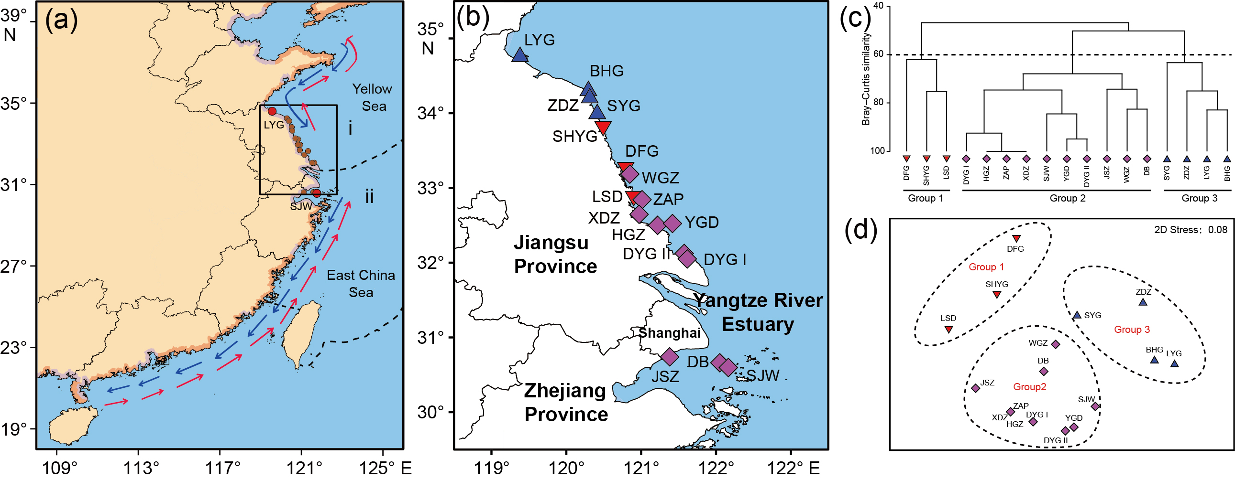

FIGURE 1 Field survey locations and assemblage structure of rocky shore species. (a) Field survey locations; The dashed lines are the boundaries of marine ecoregions: (i) the Cold Temperate Northwest Pacific and (ii) the Warm Temperate Northwest Pacific. In autumn and winter, the China Coastal Current (CCC, blue arrows) flows from north to south along the China coast, and in spring and summer, the CCC (red arrows) flows northwards into East China Sea. (b) The partial enlarged map of panel a, abbreviations: LYG, Lianyungang; BHG, Binghaigang; SYG, Shuangyanggang; SHYG, Shuangyanggang; DFG, Dafenggang; WGZ, Wanggangzha; LSD, Liangduo South Dam; ZAP, Zhonganpeng; XDZ, Xindongzhen; YGD, Yangguang Island; HGZ, Huangangzhen; DYG II, Dayanggang II; DYG I, Dayanggang I; JSZ, Jinshanzui; DB, Donghai Bridge; SJW, Shenjiawan. Cluster analysis (c) and non-metric multidimensional scaling analysis (d) for community structure of rocky shore species based on Bray–Curtis similarity of presence/absence data. Different shapes and colors of points indicate different groups in panel b, c, d.

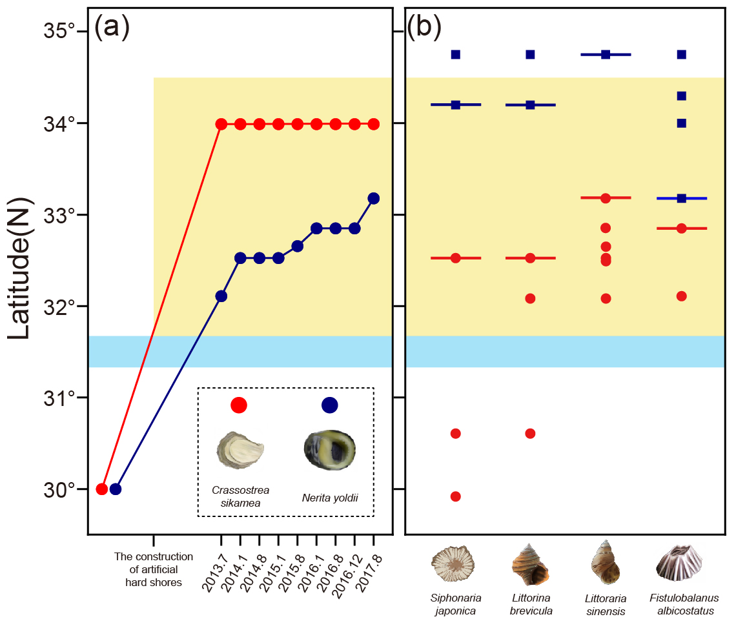
FIGURE 2 Biogeographic and phylogeographic patterns of rocky shore species influenced by artificial coastal structures. (a) The changes in the northern distribution range limits of southern species, Nerita yoldii and Crassostrea sikamea, based on data from 9 field surveys from July 2013 to August 2017. The range limits of these two species before the construction of artificial hard shores were obtained from previous studies (Huang, 2008; Wang, Qian, Wang, & Guo, 2013; Zhang, Qi, Zhang, & Ma, 1963). (b) The distribution range limits of the southern group (red lines) and the northern group (blue lines) of widespread species with coastal artificial structures; the red circles and blue squares represent the southern populations and northern populations of each species from 30 °N to 35 °N, respectively, based on the results of analysis of molecular variance (AMOVA)(Table 1). The cyan shadings indicate the Yangtze River Mouth. The yellow shadings indicate the area of coastal artificial structures.

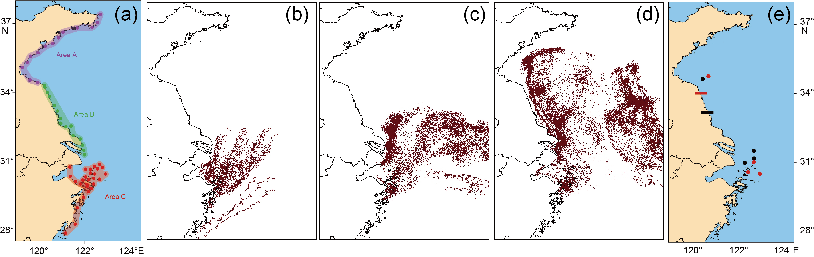
FIGURE 3 The results of larval dispersal simulations and detection of intertidal species’ larvae in aquatic communities. (a) starting locations of the larval dispersal simulations. The dispersive trajectory of larvae with different pelagic larval durations [(b)1~7d, (c)8~17 d, (d)18~30 d] from area C in summer. (e) The distribution of Nerita yoldii (black circles) and Crassostrea sikamea (red circles) larvae and the northern distribution range limits of adult Nerita yoldii (black line) and Crassostrea sikamea (red line).

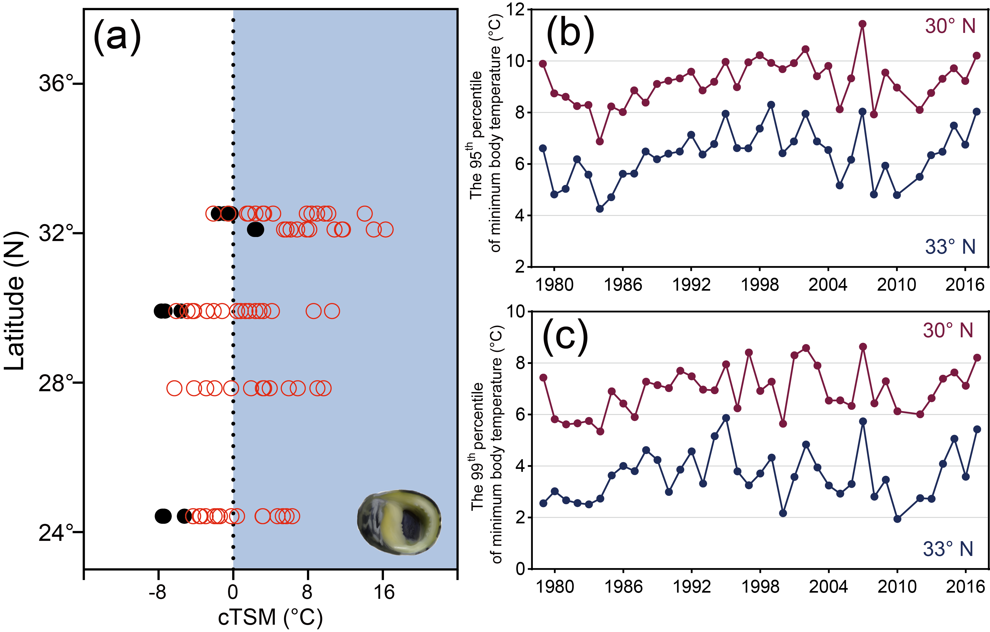FIGURE 4 The cold thermal-safety margins (cTSM), which represent the difference between cold temperature tolerance (FLT or LT₅₀) and minimum body temperature (T_{b_min}), for Nerita yoldii (a). Solid circles are cTSM for LT₅₀; hollow circles are cTSM for FLT. The shaded region shows where species are threatened by low temperatures due to either FLT or LT₅₀. The 95th (b) and 99th (c) percentiles of minimum body temperature (T_{b_min}) of Nerita yoldii at 30°N (red lines) and 33°N (blue lines).

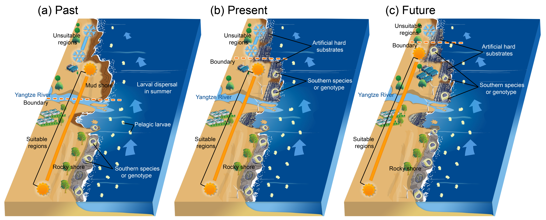

FIGURE 5 The processes whereby anthropogenic global warming and habitat transformation affect species distributions, community structure, and, potentially, shifting of biogeographic provinces. (a) Without artificial structures on the muddy shore, pelagic larvae of southern rocky intertidal species can’t settle and survive on the muddy shore north of the Yangtze River Mouth due to the lack of available substrata, even though some portions of larvae can pass through the low salinity runoff. In the absence of hard structures, then, the boundary of the two eco-provinces lies in the Yangtze River Mouth. (b) With the construction of artificial structures on the muddy shores north of the Yangtze River Mouth, larvae can now settle and develop into adults on these artificial habitats; thus, the boundary of the two eco-provinces moves further north to around 33°N. The new northern limit of species distribution is related to the minimum body temperature in winter. The artificial structures on the muddy shore, serving as stepping stones, can promote the northward dispersal of larvae, but surviving at higher latitudes may be limited by winter temperatures. (c) With the construction of the artificial infrastructures on muddy shores plus warming, it is reasonable to speculate that the boundary of the two eco-provinces will potentially move further north in future.
Supplementary Information for

Global warming and armored shorelines reshape seashore biogeography

Wei Wang, Jie Wang, Francis M. P. Choi, Ping Ding, Xiao-xu Li, Guo-dong Han, Meng-wen Ding, Min-quan Guo, Xiong-wei Huang, Wei-xiang Duan, Zhi-yuan Cheng, Zhi-yuan Chen, Stephen J. Hawkins, Yu-wu Jiang, Brian Helmuth, Yun-wei Dong

Yun-wei Dong
Email: dongyw@xmu.edu.cn

This file includes:

Figs. S1. Larval samples collection locations.
Figs. S2. Results of larval dispersal simulations
Figs. S3. Annual anomaly of Littorina brevicula at different locations from 95th percentile and 99th percentile of minimum body temperature mean during 1979-2017.
Tables S1. Survey and sample locations.
Tables S2. The information of starting locations of the larval dispersal simulations.
Tables S3. The pelagic larval duration (PLD) of common intertidal rocky shore species on artificial structures along the coast of Jiangsu province.
Tables S4. Macrobenthic species on artificial structures and nearby natural rocky shores in field surveys.

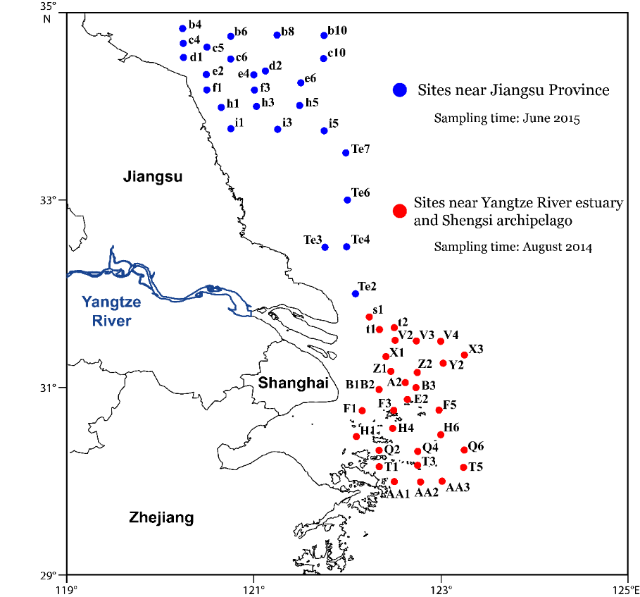
Fig. S1. Larval samples collection locations.
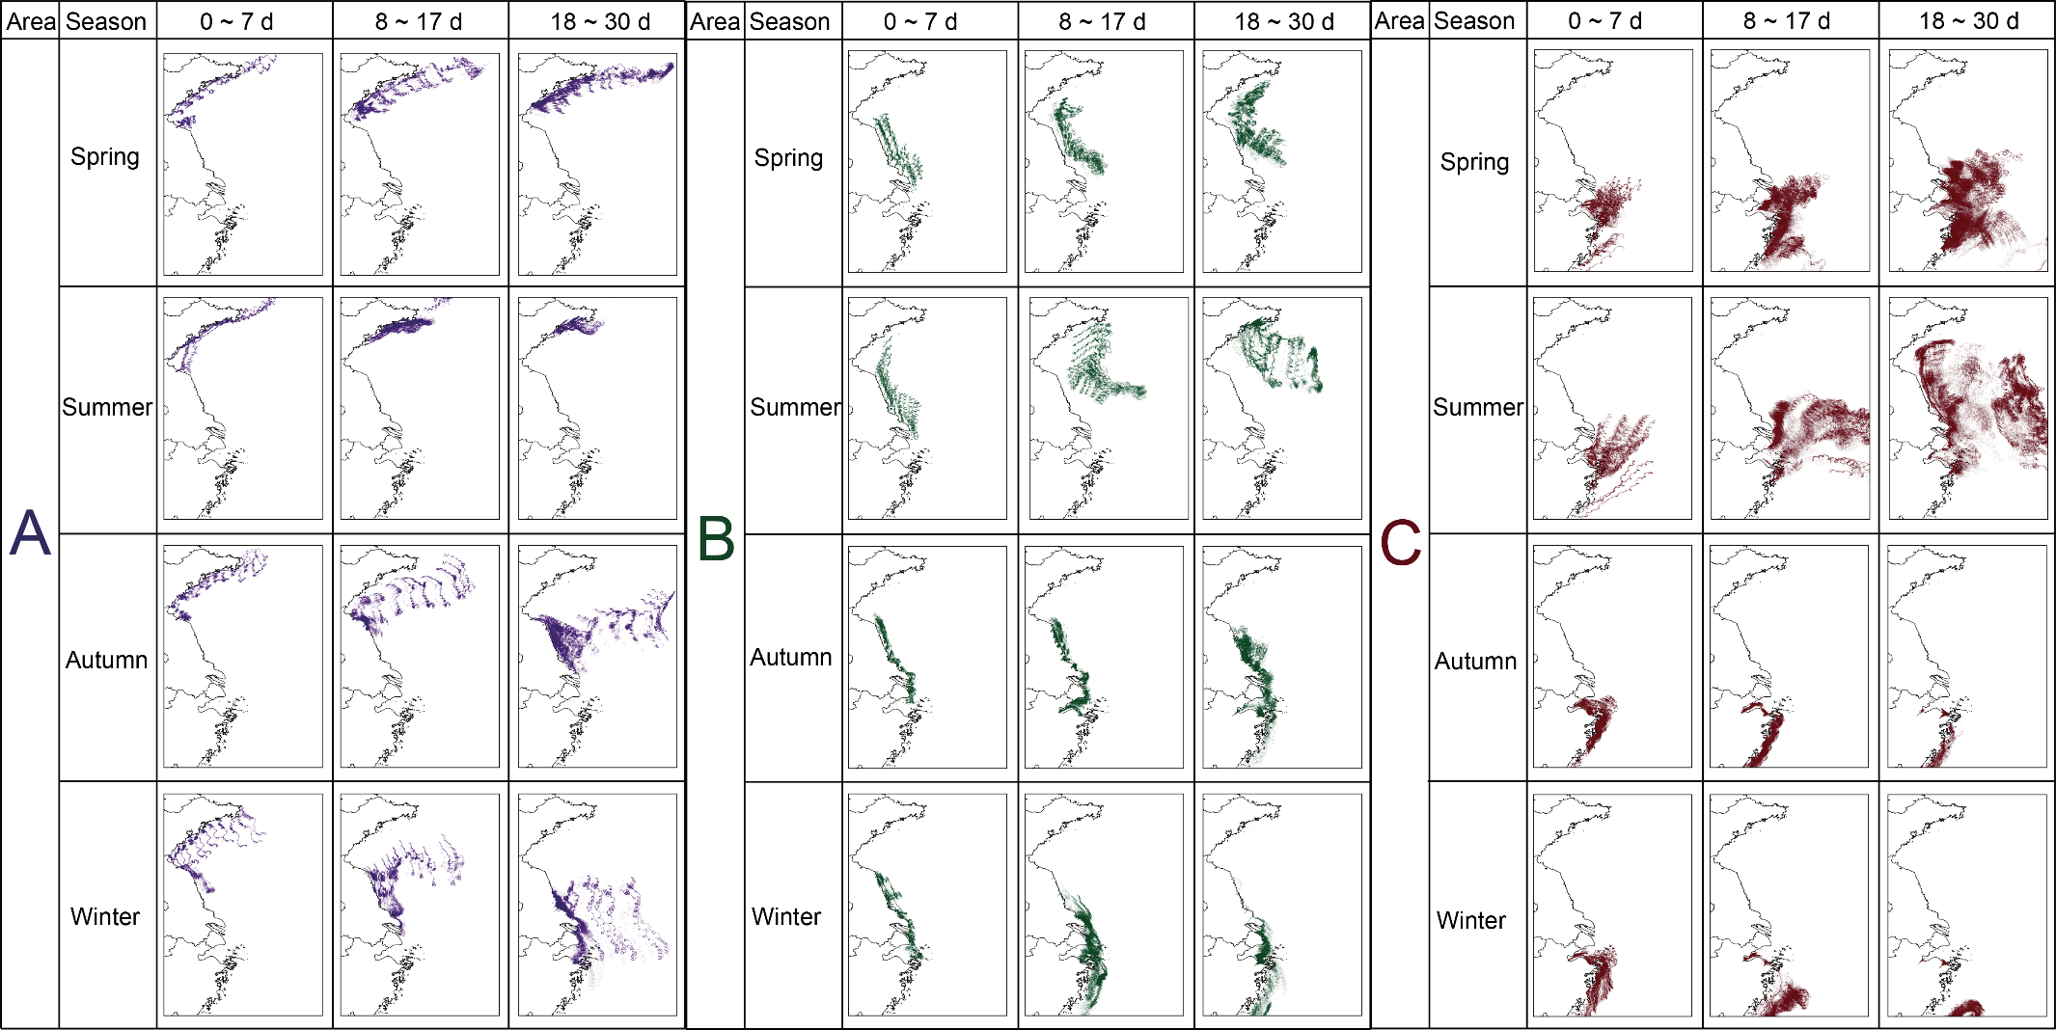
Fig. S2. Results of larval dispersal simulations

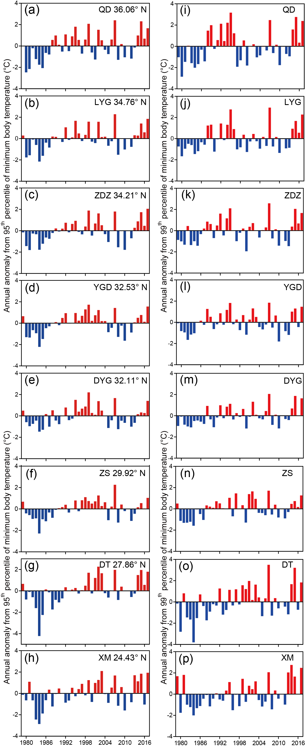
Fig. S3. Annual anomaly of Littorina brevicula at different locations from 95th percentile (a-h) and 99th percentile (i-p) of minimum body temperature mean during 1979-2017. See Table S1 for locality abbreviations.

Table S1. Survey and sample locations.
Type of substratum | Location | Abbreviation | Latitude (°N) | Longitude (°E) | Age of artificial  structure  (years by August 2017) | Individual numbers for phylogeographic analyses (n)
 |  |  |  |  |  | Fistulobalanus albicostatus | Siphonaria japonica | Littorina brevicula | Littoraria sinensis
Natural rocky shore | Weihai | WH | 37°31.567’ | 122°00.333’ | / | / | 25 | 30 | /
 | Qingdao | QD | 36°03.010’ | 120°21.205’ | / | / | 20 | 30 | 24
 | Rizhao | RZ | 35°27.731’ | 119°35.951’ | / | / | 20 | / | /
 | Lianyungang | LYG | 34°45.453’ | 119°22.373’ | / | 20 | 25 | 26 | 30
Artificial hard substratum | Binhaigang | BHG | 34°17.546’ | 120°16.929’ | 9 | 26 | / | / | /
 | Zhendongzha | ZDZ | 34°12.288’ | 120°18.115’ | 20 | / | 10 | 27 | /
 | Shuangyanggang | SYG | 33°59.359’ | 120°23.981’ | 5 | 18 | / | / | /
 | Sheyanggang | SHYG | 33°48.876’ | 120°28.895’ | 24 | / | / | / | /
 | Dafenggang | DFG | 33°15.691’ | 120°46.923’ | 6 | / | / | / | /
 | Wanggangzha | WGZ | 33°10.809’ | 120°50.336’ | 6 | 17 | / | / | 28
 | Liangduo South Dam | LSD | 32°52.322’ | 120°54.827’ | 34 | / | / | / | /
 | Zhonganpeng | ZAP | 32°51.069’ | 120°58.306’ | 4 | 22 | / | / | 25
 | Xindongzhen | XDZ | 32°39.281’ | 120°58.062’ | 5 | / | / | / | 25
 | Yangguang Island | YGD | 32°31.472’ | 121°24.169’ | 11 | / | 66 | 29 | 30
 | Huangangzhen | HGZ | 32°30.030’ | 121°12.038’ | 7 | / | / | / | 29
 | Dayanggang II | DYG II | 32°06.473’ | 121°35.111’ | 8 | 21 | / | / | /
 | Dayanggang I | DYG I | 32°04.830’ | 121°36.362’ | 7 | / | / | 29 | 30
 | Jinshanzui | JSZ | 30°43.999’ | 121°22.615’ | 6 | / | / | / | /
 | Donghai Bridge | DB | 30°38.485’ | 122°03.478’ | 11.5 | / | / | / | /
Natural rocky shore | Shenjiawan | SJW | 30°36.103’ | 122°08.110’ | / | / | 10 | 28 | /
 | Zhoushan | ZS | 29°55.052’ | 122°25.193’ | / | / | 32 | / | /
 | Jiantiao | JT | 29°04.56’ | 121°37.980’ | / | 21 | / | / | /
 | Dongtou | DT | 27°51.470’ | 121°10.953’ | / | / | / | 29 | 30
 | Xiamen | XM | 24°33.433’ | 118°09.083’ | / | / | 28 | / | 21
 | Dongshan | DS | 23°44.143’ | 117°31.794’ | / | / | 28 | / | /
 | Hongkong | HK | 22°12.444’ | 114°15.613’ | / | / | 37 | / | /
 | Haikou | HAK | 20°03.925’ | 110°11.405’ | / | / | 28 | / | /

Table S2. The information of starting locations of the larval dispersal simulations.
Area | Location | Latitude (N) | Longitude (E)
A | A1 | 37°23'47.45" | 122°42'19.53"
 | A2 | 37°02'23.51" | 122°34'30.22"
 | A3 | 36°49'41.80" | 122°20'41.26"
 | A4 | 36°48'16.34" | 121°42'17.46"
 | A5 | 36°37'09.64" | 121°05'00.65"
 | A6 | 36°22'29.17" | 120°52'57.27"
 | A7 | 36°07'07.61" | 120°38'00.10"
 | A8 | 36°00'12.28" | 120°18'37.07"
 | A9 | 35°43'18.52" | 119°59'49.38"
 | A10 | 35°34'12.22" | 119°39'34.96"
 | A11 | 35°18'12.44" | 119°31'28.88"
 | A12 | 35°04'46.02" | 119°18'13.53"
 | A13 | 34°32'19.55" | 119°38'51.37"
 | A14 | 34°25'54.76" | 119°58'55.63"
B | B1 | 34°17'33.27" | 120°16'40.00"
 | B2 | 34°12'28.22" | 120°17'53.95"
 | B3 | 33°59'24.18" | 120°23'48.96"
 | B4 | 33°49'12.07" | 120°29'07.35"
 | B5 | 33°25'02.97" | 120°42'54.44"
 | B6 | 33°10'52.58" | 120°50'22.97"
 | B7 | 32°51'05.48" | 120°58'11.19"
 | B8 | 32°39'08.72" | 120°58'51.26"
 | B9 | 32°30'07.15" | 121°12'08.28"
 | B10 | 32°31'21.31" | 121°25'54.20"
 | B11 | 32°06'53.06" | 121°31'13.79"
 | B12 | 31°57'32.07" | 121°49'43.43"
 | B13 | 31°42'01.94" | 121°55'49.57"
 | B14 | 31°28'29.08" | 121°59'06.47"
 | B15 | 31°16'50.99" | 122°00'58.60"
C | C1 | 30°51'51.44" | 122°40'24.29"
 | C2 | 30°43'43.08" | 122°47'32.00"
 | C3 | 30°39'54.24" | 122°35'04.71"
 | C4 | 30°45'32.48" | 122°27'05.53"
 | C5 | 30°38'42.59" | 122°16'25.64"
 | C6 | 30°38'45.65" | 122°03'52.40"
 | C7 | 30°28'48.03" | 122°16'31.93"
 | C8 | 30°26'27.44" | 122°27'40.93"
 | C9 | 30°26'16.15" | 122°55'51.57"
 | C10 | 30°12'43.45" | 122°40'23.31"
 | C11 | 30°18'25.00" | 122°03'51.33"
 | C12 | 30°15'13.70" | 122°24'53.75"
 | C13 | 30°11'00.16" | 122°12'13.66"
 | C14 | 30°00'14.83" | 122°24'51.43"
 | C15 | 30°10'40.31" | 121°56'44.41"
 | C16 | 29°59'24.32" | 122°06'59.77"
 | C17 | 30°00'23.09" | 121°50'30.04"
 | C18 | 29°48'22.75" | 122°18'34.01"
 | C19 | 29°40'29.99" | 122°11'40.02"
 | C20 | 30°44'19.82" | 121°22'47.56"
 | C21 | 30°20'24.91" | 121°23'42.38"
 | C22 | 30°06'51.57" | 121°37'03.86"
 | C23 | 29°53'51.94" | 122°08'02.92"
 | C24 | 29°25'49.56" | 121°58'15.57"
 | C25 | 28°57'46.83" | 121°42'30.55"
 | C26 | 28°15'13.58" | 121°36'48.45"
 | C27 | 27°51'54.00" | 121°11'25.40"
 | C28 | 27°27'24.79" | 121°06'07.20"

Table S3. The pelagic larval duration (PLD) of common intertidal rocky shore species on artificial structures along the coast of Jiangsu province.
Species | Pelagic Larval Duration | References
Gastropoda
Littoraria sinensis | 3–10 weeks | (Reid, Dyal, & Williams, 2010)
Littorina brevicula | 9 days | (Son & Hong, 1998)
Patelloida pygmaea | pelagic development | (Anderson, 1966)
Thais clavigera | >60 days | (Guo et al., 2015)
Nerita yoldii | ~1 month | (Yeung, 2006)
Siphonaria japonica | >7 days | (Hirano, 1980)
Monodonta labio | pelagic development | (Iijima & Furota, 1996)
Bivalvia
Crassostrea gigas | >17 days | (Rose, Paynter, & Hare, 2006)
Crassostrea sikamea | >17 days | (Rose, Paynter, & Hare, 2006)
Xenostrobus atratus | pelagic development | (Reid, 1998)
Cirripedia
Fistulobalanus albicostatus | 5 -7 days | (Chang et al., 2017)

Table S4. Macrobenthic species on artificial structures and nearby natural rocky shores in field surveys. See Table S1 for locality abbreviations.
Class | Species | Sampling Sites
 |  | LYG | BHG | ZDZ | SYG | SHYG | DFG | WGZ | LSD | ZAP | XDZ | YGD | HGZ | DYG II | DYG I | JSZ | DB | SJW
Gastropoda | Littoraria sinensis | ++ | ++ | ++ | ++ | ++ | ++ | ++ | ++ | ++ | ++ | ++ | ++ | ++ | ++ | ++ | ++ | ++
 | Littorina brevicula | ++ | ++ | ++ | ++ |  | + | ++ |  | ++ | + | ++ | ++ | ++ | ++ |  | ++ | ++
 | Siphonaria japonica | ++ | ++ |  |  |  |  |  |  |  |  | ++ |  |  |  |  |  | +
 | Nerita yoldii |  |  |  |  |  |  | + |  | ++ | + | ++ | ++ | ++ | ++ | ++ | ++ | ++
 | Patelloida pygmaea | ++ | ++ | ++ | ++ |  |  | + |  |  |  |  |  |  |  |  |  | ++
 | Cellana toreuma | +
 | Thais clavigera | ++ | + | ++ |  |  |  | + |  |  |  | ++ |  | ++ |  |  |  | ++
 | Monodonta labio | ++ |  |  |  |  |  |  |  |  |  | ++ |  | + |  |  |  | ++
 | Echinolittorina radiata | ++ | ++ |  |  |  |  |  |  |  |  | ++ |  | ++ | + |  | ++ | ++
 | Nipponacmea radula | ++ | + | ++
 | Nipponacmea nigrans |  |  |  |  |  |  |  |  |  |  |  |  |  |  |  |  | ++
Bivalvia | Crassostrea gigas | ++ | ++ | ++ | ++ | ++ | ++ | ++
 | Crassostrea sikamea |  |  |  | ++ | ++ | ++ | ++ | ++ | ++ | ++ | ++ | ++ | ++ | ++ | ++ | ++ | ++
 | Mytilus galloprovincialis | ++ | + |  | +
 | Musculus senhousia |  |  | + | ++
 | Xenostrobus atratus | ++ | ++ |  | ++ |  |  |  | + | ++ | ++ | ++ | ++ | ++ | ++ |  |  | ++
 | Barbatia virescens | ++ | + | +
Polyplacophora | Acanthochiton rubrolineatus | ++
Cirripedia | Fistulobalanus albicostatus | ++ | ++ | ++ | ++ | + |  | ++ | ++ | ++ | ++ | ++ | ++ | ++ | ++ |  | ++ | ++
 | Chthamalus challengenri | ++
 | Amphibalanus reticulatus | + |  |  | ++ | + |  | ++ |  |  |  |  |  |  |  |  |  | ++
The red “+” means in each cell represented the species was found in summer; the red “+” means in each cell represented the species was found in winter.

References in Supplementary Information
Anderson, D. T. (1966). The reproduction and early life histories of the gastropods Notoacmea petterdi (Ten-Woods) Chiazacmaea flammea (Quoy and Gaimard) and Patelloida alticostata (Angas) (Fam Acmaeidae). Proceedings of the Linnean Society of New South Wales, 90, 106-114.
Chang, Y. W., Chan, J. S. M., Hayashi, R., Shuto, T., Tsang, L. M., Chu, K. H., & Chan, B. K. K. (2017). Genetic differentiation of the soft shore barnacle Fistulobalanus albicostatus (Cirripedia: Thoracica: Balanomorpha) in the West Pacific. Marine Ecology, 38, e12422.
Guo, X., Zhao, D., Jung, D., Li, Q., Kong, L. F., Ni, G., ... Park, J. K. (2015). Phylogeography of the rock shell Thais clavigera (Mollusca): Evidence for long-distance dispersal in the northwestern pacific. PLoS One, 10, e0129715.
Hirano, Y. (1980). Siphonaria (pulmonate limpet) survey of Japan-II. Periodicity of spawning activity in Siphonaria japonica. Publications of the Seto Marine Biological Laboratory, 25, 335-342.
Iijima, A., & Furota, T. (1996). Variation of reproductive features among local populations of Monodonta labio: Possibility of longdistance transportation of larvae by Kurosio Current. Annual report of Marine Ecosystems Research Center, Chiba University, 16, 29-33.
Reid, R. G. B. (1998). Mollusca: the Southern Synthesis. Clayton South VIC: CSIRO Publishing.
Reid, D. G., Dyal, P., & Williams, S. T. (2010). Global diversification of mangrove fauna: a molecular phylogeny of Littoraria (Gastropoda: Littorinidae). Molecular Phylogenetics and Evolution, 55(1), 185-201.
Rose, C. G., Paynter, K. T., & Hare, M. P. (2006). Isolation by distance in the eastern oyster, Crassostrea virginica, in Chesapeake Bay. Journal of Heredity, 97, 158-170.
Son, M. H., & Hong, S. Y. (1998). Reproduction of Littorina brevicula in Korean waters. Marine Ecology Progress Series, 172, 215-223.
Yeung, C. Y. (2006). The ecology of Nerita yoldii and N. albicilla on Hong Kong rocky shores. PhD Thesis, The University of Hong Kong.

