Subject strapline:
Agricultural technology

Title:
Satellites and crop interventions

Standfirst:
Lack of good quality monitoring and evaluation data is a key barrier to large-scale uptake of agriculture interventions. Data from low-cost micro satellites has strong potential to bridge this gap and promote sustainable intensification targets.

Author name
Jadunandan Dash
Department of Geography and Environmental Sciences
University of Southampton, University Rd, Southampton SO17 1BJ, UK
J.DASH@soton.ac.uk

The United Nations Food and Agriculture Organisation estimates that global food production must be nearly doubled by 2050 to meet demand from an estimated 10 billion people [REF 1]. Two strategies to meet this growing demand are expanding the land under cultivation, known as extensification, and raising crop yields on existing farmlands through more intensive farm management, or intensification. With most cultivable land being used for agriculture and increasing pressure from urban growth and land degradation, it is difficult to increase arable land without impacting natural ecosystems. Therefore, intensification and better agricultural management are often considered preferable. However, uptake of sustainable intensification methods has been slow and minimal in part due to difficulties obtaining farm-scale and even field-scale information on crop production. Jain et al, propose using micro satellite data to overcome key observational limitations, documenting from space increases in crop yields from a fertilizer intervention. This advance could target underperforming farms or fields for suitable treatment [REF 2] and in turn promote yield gains.
Various methods have been tested to date on experimental farms at the field scale, including new cropping patterns, new ways of applying fertiliser, and new harvestings techniques to increase production from exiting land with minimal environmental impact [ REF 3, REF 4]. However, uptake of these are generally low, including given perceived technological and financial barriers due to lack of information [ REF 5] and farmer’s reticence to overturn or augment long-running practice. For smallholder farmers, demonstrating the impact of any intervention at the scale of their field is vital. Despite the growing application of high-tech approaches in industrial agriculture, large-scale evaluation and productive agriculture policy and aid are hindered by a lack of accurate data in many developing regions.
Jain et al., provides a unique example highlighting the capability of current low-cost satellite data to monitor agricultural intervention impacts, in this case a low-cost device for applying fertilizer more evenly. A series of satellite data collected during the growing season visualized the crop yield at the field level and the gains over time from this intervention. Moreover, the satellite’s ability to cover such a large spatial extent enabled the researchers to identify areas with the largest yield gaps, as a priority for possible future interventions.
Rapid development of Earth-observation technology has now enabled detailed monitoring of crop growth at unprecedented spatial and temporal scales [REF 6]. With increased availability and affordability, data from satellite sensors such as the European Space Agency’s Sentinel 2 Multi spectral Imager and the series of sensors from Planet’s Dove satellites are being explored to bring satellite monitoring to the individual field level. In theory, such information opens new opportunities. For example, farmers can receive crop growth and production information for fields on their mobile devices, thus helping them make decisions about where and when to apply fertiliser.
Nitrogen limitation is the main cause of yield gaps in India’s Eastern Indo Gangetic plain [REF -7], where authors targeted the intervention. Spreading fertiliser by hand often distributes it unevenly across a field. The new fertiliser spreader addressed that limitation, providing a 5% yield gain without any increase in input. Since the profit from this increase in grain production is higher than the cost of the new spreader, there is a strong likelihood that local farmers might adopt this. Authors used satellite-derived measures of vegetation greenness as proxies for crop production and linked these ground-measured yields at the field scale to develop an empirical model. This model was able to capture the yield from use of the new fertiliser spreader and to identify the spatial pattern of exiting yield gaps. This is a crucial information for both farmers, to adopt practices for their fields, and for policymakers, to develop policy to up upscale such interventions.
Results from Jain et al., are encouraging and demonstrate that satellite data can be used as an objective, low-cost tool for targeting sustainable-- intensification interventions. However, this proof of principle, while valuable, has limitations. For one, the crop specific nature of the relationship between satellite data and ground data limits the transferability of the same model to other part of the world with different crops. Therefore, the model is validated for wheat crop yield estimation in the Eastern Indo Gangetic plain but will benefit from repeated validation for other crops and regions. As well, building the capacity of local agricultural-extension officers to appreciate the usefulness of these dataset and apply these in practice will be a monumental task.
With nearly three quarter of farms across the world less than 1 ha in size [REF 8], any intervention and monitoring must be appropriate for small farms to contribute broadly to poverty alleviation and food security. Although improving crop yields in more and less intensified systems are both important, improving yields for smallholders in rural India, Kenya, and Brazil will contribute more to meeting sustainability targets than marginally increasing them in already productive systems and regions, such as the midwestern United States. Following from Jain et al., further research should evaluate the potential of such satellite-based solutions for other crops and strategies for disseminating the information and insights to farmers in a cost effective and timely manner. Rapid development of satellite technology coupled with the rapid rise in mobile-phone penetration in the rural area will increasingly empower individual farmers with timely and accurate information on crop conditions. This will be a major step forward to achieve our food security goals.

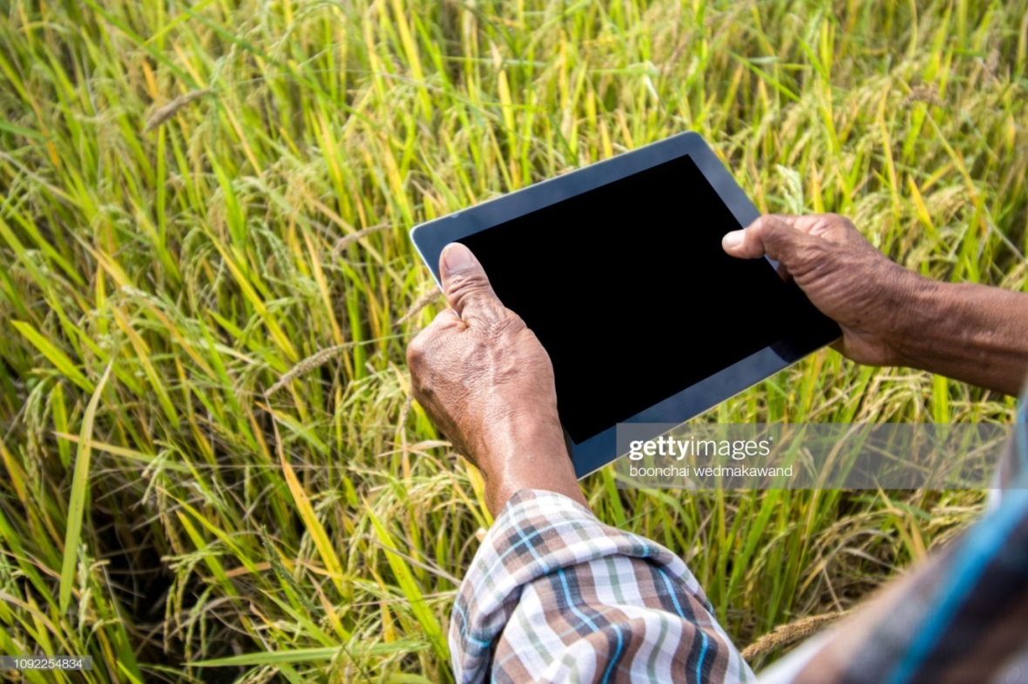
Figure caption: A key challenge to upscaling the sustainable intensification efforts is a lack of data to demonstrate benefits and identify areas to target interventions. Jain et al. showed that data from low-cost satellite sensors can help predict crop yields at the individual field scale, crucial information that can be disseminated to farmers to inform their agricultural management practices and decisions.

Getty Creative #: 1092254834

References
- United Nations, Department of Economic and Social Affairs, Population Division, 2019
World Population Prospects 2019: Highlights: https://population.un.org/wpp/Publications/Files/WPP2019_10KeyFindings.pdf

- Jain et al., Using Satellite Data to Evaluate and Target Sustainable IntensificationInterventions Can Double Their Impact, Nature Sustainability

- Royal Society, Reaping the Benefits: Science and the Sustainable Intensification of Global Agriculture (Royal Society, London, UK, 2009).

- Berkhout, E., Glover, D., & Kuyvenhoven, A. (2015). On-farm impact of the System of Rice Intensification (SRI): Evidence and knowledge gaps. Agricultural Systems, 132, 157-166.

- Jack, K. and Tobias, J. (2017). Seeding success: Increasing agricultural technology adoption through information. IGC Growth Brief Series 012. London: International Growth Centre.

- Fritz, S., See, L., Bayas, J. C. L., Waldner, F., Jacques, D., Becker-Reshef, I., ... & Rembold, F. (2019). A comparison of global agricultural monitoring systems and current gaps. Agricultural systems, 168, 258-272.

- Mueller, N. D., Gerber, J. S., Johnston, M., Ray, D. K., Ramankutty, N., & Foley, J. A. (2012). Closing yield gaps through nutrient and water management. Nature, 490(7419), 254.

- Lowder, S. K., Skoet, J., & Raney, T. (2016). The number, size, and distribution of farms, smallholder farms, and family farms worldwide. World Development, 87, 16-29.

