The role of temperature on the aerobic response of encapsulated embryos of Ocenebra erinaceus (Neogastropoda, Muricidae): A comparative study between two populations

Maria Loreto Mardones¹*, Phillip B. Fenberg¹, Sven Thatje¹, Chris Hauton¹

1. School of Ocean and Earth Science, National Oceanography Centre, University of
Southampton, Southampton SO14 3ZH, UK

Corresponding author: mlm1y14@soton.ac.uk
Address: School of Ocean and Earth Science, University of Southampton, National Oceanography Centre Southampton, European Way, Southampton SO14 3ZH, UK

Abstract
Climate warming can affect the developmental rate and embryonic survival of ectothermic species. However, it is largely unknown if the embryos of populations from different thermal regimes will respond differently to increased warming, potentially due to adaptations to natal environmental conditions. The effects of temperature on respiration rates and oxygen content of the intracapsular fluid were studied during the intracapsular development of Ocenebra erinaceus in two subtidal populations, one from the middle of their geographic distribution, the Solent, UK and another towards the southern portion: Arcachon, France. In this laboratory study, embryos were exposed to temperatures in the range of 14 - 20 °C. The encapsulation period for both populations was shorter at higher temperatures and intracapsular oxygen availability decreased as development progressed. However, the embryonic aerobic response differed between populations. Encapsulated embryos from the southern population (Arcachon) showed higher respiration rates and metabolic adjustment to elevated temperatures; however, encapsulated embryos from the Solent showed no metabolic adjustment, high capsular mortalities and limited acclimation to high temperatures. Our results suggest that aerobic response of encapsulated embryos is locally adapted to the temperature history of their natal environment and illustrates the importance of local environmental history in determining the fate of key life stages in response to a changing marine climate.

Key words: temperature, encapsulation, aerobic metabolism, local adaptation, oxygen consumption, intracapsular fluid.

1. Introduction
Temperature plays an important role regulating multiple levels of biological organization, from limiting physiological and biochemical processes, to shaping the distribution of species across latitudes (Somero, 2005; Jones et al., 2009; Weiss et al., 2009). The thermal tolerance response of ectothermic organisms is partly a function of their capacity for metabolic adjustment to cope with environmental fluctuations (Sokolova and Pörtner, 2003). One indicator of such metabolic adjustment in ectotherms can be made through measurements of aerobic metabolism, which reflects the energetic cost of adaptation to a particular environment (Clarke, 2003; Schulte, 2015). Aerobic metabolism is highly influenced by environmental temperatures; if temperature increases, aerobic metabolism increases. However, if ambient temperatures surpasses an optimal threshold, then oxygen deficiency and insufficient energy supply within cells occurs, which causes a decrease in aerobic response and a transition to an anaerobic mode producing a systemic failure (Pörtner, 2002).

In coastal marine environments, benthic invertebrates tolerate short-term fluctuations of temperature (and salinity, pH and oxygen availability) on a daily or even hourly basis (Helmuth et al., 2006; Segura et al., 2014). However, for some organisms living at the extreme of their physiological range (Somero, 2010) slight changes in temperature could affect them negatively. This is especially important during early stages of development when there is a higher sensitivity to the thermal environment (Zippay and Hofmann, 2010; Edmund et al., 2001). In many prosobranch gastropods, part of the embryonic development occurs enclosed in physically complex structures known as capsules (Pechenik, 1986). Females lay benthic egg masses (i.e. groups of capsules) on the rocky shore and then leave them for a period of time, depending on the type of development (i.e. direct or indirect) and environmental conditions. During intracapsular development, capsules confer protection to embryos against osmotic shocks, desiccation, UV effects, salinity changes and predation (Pechenik, 1982, 1983; Rawlings, 1999; Przeslawski, 2004), reducing mortality during early stages. However, under warming temperatures, encapsulation can present a challenging environment for embryos (Cancino et al., 2011).

Temperature and oxygen availability are limiting factors for encapsulated species (Strathmann and Strathmann, 1995, Fernández et al., 2006), impacting development rates, embryonic shell calcification, the number of developed embryos, abnormalities, development synchrony, and clutch size (Lardies and Fernández, 2002; Cancino et al., 2003). Whilst the oxygen demand of developing embryos within capsules increases throughout development (Cumplido et al., 2011), an increase in temperature and the low oxygen diffusion through the capsule wall reduces the oxygen availability within capsules, which can adversely impact embryonic development (Cancino et al., 2003; Fernández et al., 2006). Few studies have been aimed at understanding the effects of elevated temperatures on the aerobic response of encapsulated embryos, although Cancino et al., (2011) demonstrated high respiration rates, high mortality and increased abnormalities in encapsulated embryos of Chorus giganteus exposed to high temperatures, from 9 to 15 °C. However, it still remains unclear whether the metabolic response of encapsulated embryos is influenced by local conditions and whether embryos from different thermal regimes exhibit different aerobic adjustments to increased temperature.

Local adaptation has been shown in marine species that exhibit low dispersal potential in response to selection imposed by strong gradients (i.e. coastal systems; Sanford and Kelly, 2011). Species with direct development often exhibit low gene flow and restricted connectivity between populations, increasing the potential for local adaptation (Beherens Yamada, 1989; Parsons, 1998). Most studies however have been conducted on adult populations and little is known about early stages and whether the encapsulated stages are locally adapted to their natal environments (Sanford and Kelly, 2011). For example, Zippay and Hofmann (2010) showed a latitudinal effect on the thermal tolerance response of encapsulated veligers of Nucella ostrina. Larvae from northern latitudes were less tolerant of heat stress than those from central latitudes. Thus, larvae displayed different thermal tolerance limits as a function of latitude at which they were collected. The local temperatures experienced by encapsulated embryos may determine the embryos’ thermal tolerance. However, the degree to which local conditions could influence the thermal tolerance response of early ontogenetic stages in encapsulated species has not yet been explored.

Here, we seek to identify the role of temperature warming on embryonic aerobic response and development of the European sting winkle Ocenebra erinaceus (Linnaeus, 1758). This species is a mixed developer commonly found on the intertidal and shallow subtidal of UK and French Atlantic coasts. Females enclose their embryos in capsules and leave them on the rocky substrate for up to 2-3 months until they hatch as swimming larvae with a short planktonic phase of up to 5 days (Gibbs, 1996). After this period, and depending on ambient temperatures, larvae metamorphose into crawling juveniles. We conducted a comparative study; first, to contribute understanding of the aerobic response of encapsulated embryos of O. erinaceus at elevated temperatures. Second, to understand whether the aerobic response of encapsulated embryos is influenced by local conditions. Third, to understand the possible impact of the physical characteristics of the capsule wall on the embryos’ aerobic response. We hypothesized that there would be an effect of geographical origin in the thermal tolerance response of encapsulated embryos of O. erinaceus. Embryos from two widely geographically separated locations would exhibit differences in their ability to acclimate to temperatures outside of the natural thermal range. Considering that we are facing an increase in global temperatures, comparative studies between populations during early ontogenetic stages provide important insights about intraspecific adaptations and how populations may respond in the future.

2. Materials & Methods

2.1. Reproductive life cycle of Ocenebra erinaceus
To study intraspecific differences in O. erinaceus, females were collected from two different populations: one from the middle of their geographic distribution, the Solent, Southampton, UK (50° 51’ N, 001° 21’ W) and another towards the southern portion of their geographic distribution: Arcachon, France (44° 41’ N, 001° 11’ W). The distribution of O. erinaceus extends from the British Isles to the Mediterranean, Madeira and the Azores (Skewes, 2005). In the Solent, the reproductive season is between April and May, when sea surface temperatures (SST) fluctuate between 12 and 16 °C. Females typically enclose 48 eggs per capsule and each brood consists of 21 capsules on average, with a mean laying effort of 1012 eggs per female (Smith et al., 2015). The Solent population exhibits one reproductive laying peak per year between April and May. No information was found regarding the reproductive cycle of O. erinaceus in Arcachon, France. However, Martel et al. (2004) observed only one laying peak in May in Rivedoux, France, a site 250 km North from Arcachon. At the end of May, a unique recruitment event of juveniles of O. erinaceus was observed 3 weeks after laying (Martel et al., 2004). Martel et al. (2004) reported that Rivedoux females enclosed 74 eggs per capsule and each brood consisted on 24 capsules on average, with a mean laying effort of 1800 eggs per female.

2.2. Thermal data acquisition
Sea surface temperatures for the Solent were collected from XAUK buoy (https://stormcentral.waterlog.com/public/XAUKBuoy) and Arcachon from REPHY dataset 1987-2016 (http://doi.org/10.17882/47248) over three years: 2014 - 2016. Monthly temperatures were obtained by averaging the data per month (Fig. 1a). Seasonal temperatures for winter (December to February) and spring (March to May) were compared between populations (Fig. 1b). These seasons were chosen due to their importance in the reproductive cycle of O. erinaceus. The increase in temperature between winter and spring induces the spawning in this species and the intracapsular development occurs during the spring months (Martel et al., 2004).

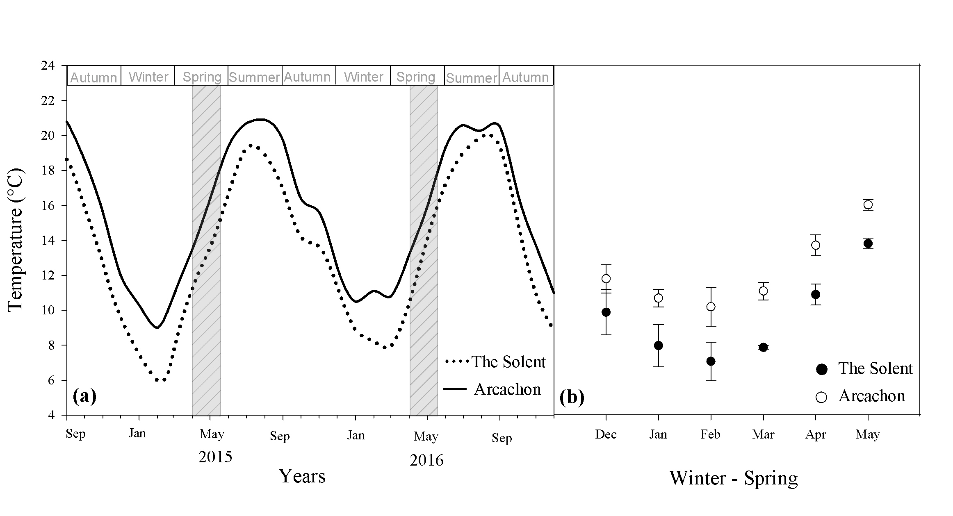
Figure 1. (a) Average monthly sea surface temperatures for the Solent, UK (50° 51’ N, 001° 21’ W) and Arcachon, France (44° 41’ N, 001° 11’ W) from September 2014 to December 2016. Grey dashed bars indicate the time that embryos spend inside capsules in the field, according to Smith et al. (2015) and Martel et al. (2004). (b) Average sea surface temperatures between 2014 and 2016 for winter (December to February) and spring (March to May) in the Solent and Arcachon. Values given are mean ± standard error for 3 consecutive years.

2.3. Female and egg mass collection and maintenance
Females of O. erinaceus were collected via trawling from the Solent between February-March 2016 and from a commercial oyster bed in Arcachon in October 2017. During sampling, sea surface temperature in the Solent ranged between 9 and 10 °C and in Arcachon, between 14 and 16 °C. After sampling, females from both populations were transferred in thermally insulated boxes to the National Oceanography Centre, Southampton (NOCS), UK to aquarium conditions of continuously re-circulated seawater that originated from Empress Dock. Both populations were maintained under different temperature regimes that matched the temperatures that adults experienced in the field in the natal locations (Fig.1a). For the Solent population, females were maintained at: March: 8 ± 1 °C, April: 11 ± 1 °C and May: 14 ± 0.3 °C. On the contrary, the 150 snails from Arcachon, France were collected during winter months and then transferred to the NOCS’s laboratory facilities. To ensure that the females experienced conditions similar to the Arcachon, they were maintained as follows: October: 17 ± 1 °C; November: 15 ± 1 °C, December: 12 ± 1 °C; January: 10 ± 1 °C, February: 10 ± 1 °C; March: 11 ± 1 °C. In both populations, salinity was maintained within the range 32.5 – 34.0 psu on average. Snails from both populations were feed ad libitum with mussel and oyster flesh three times per week.

Females from the Solent started to deposit egg masses between April and May 2016 and females from the Arcachon population started between February and March 2017. Female size and number of capsules was recorded during laying. To quantify the aerobic response to temperature, embryos were exposed to 14, 16, 18 and 20 °C during intracapsular development. This period of intracapsular development was considered sufficient to test whether embryos exhibit intraspecific differences due to geographic origin; however, potential maternal effects cannot be completely discounted. After one or two days of laying at maternal rearing temperatures, 2 – 3 egg masses (n = 20-35 capsules per egg mass) were transferred individually to one of three common temperature treatments in the Solent (14, 16 and 18 °C) and four temperature treatments in Arcachon (14, 16, 18 and 20 °C) in 1.8 L aquaria with filtered seawater (1 μm) and constant aeration. Embryos from the Solent were not exposed to 20 °C because of high mortalities observed at 18 °C. In both populations, every week, 1-2 capsules per egg mass were dissected to identify the intracapsular ontogenetic stage, survival and abnormalities according to Smith et al. (2015). Embryo survival was assessed weekly. Embryo mortality was considered when capsules developed an external purple colour or when no larval activity was found. Dead capsules were dissected and the ontogenetic stage was recorded. Developmental abnormalities were identified when some of the embryos inside the capsule showed malformations in their shell morphology (Fig. 2).

Figure 2. Ontogenetic stages of O. erinaceus during the intracapsular development used in the experiments. (a) egg capsule; (b) early veliger stage (EV); (c) pediveliger stage (PV); (d) abnormal embryo in pediveliger stage; (e) late pediveliger stage (LP); (f) Abnormal embryos in late pediveliger stage. Scale bars: (a) = 1 cm, (b-f) = 100 μm.

2.4. Oxygen concentration in the intracapsular fluid
Oxygen concentration inside capsules was determined according to Cancino et al. (2011), with minor modifications. Briefly, capsules in pediveliger (i.e. intermediate stage: 790 – 810 μm size) and late pediveliger stage (i.e. advanced stage: 880 – 890 μm size) were placed in 1.8 l aquarium filled with filtered seawater (1 μm; salinity 33) at 100% air saturation with stirring. A pre-calibrated microelectrode (Microx TX3 PreSens, calibrated with NaSO₃, according to manufacturer’s protocol) was inserted through the capsule plug using a dissecting microscope to ensure that the embryos inside were not damaged. Oxygen concentrations were measured for 30 minutes; however, the first five minutes were not considered to avoid the disturbance produced by the microelectrode. Between 9 – 10 capsules per temperature treatment were measured in both populations. The oxygen concentration of seawater in the aquarium was recorded with values ranging between 9 – 10 mg O₂ L⁻¹ in all temperature treatments, with salinities ranging between 33 and 34 psu. After the measurements, capsule size, number of eggs and stage of development were quantified using a dissecting microscope (LEICA MZ16).

Capsule size and number of embryos per capsule was different between populations (Table 1). In the Solent, capsule size was 7 ± 0.3 mm and the mean number of embryos per capsule laid was 45. For the Arcachon population, mean capsule size was 9 ± 0.4 mm and the number of embryos per capsule was 75. The oxygen volume inside capsules was estimated using the relation given by Pechenik (1983), whereby the egg mass volume (i.e. all eggs inside of one capsule) was subtracted from the capsule volume. The ratio of the oxygen volume available per egg mass inside the capsule was constant between populations with values ranging between 5.49 ± 1.5 and 5.53 ± 1.7 in Solent and Arcachon, respectively. Thus, the oxygen availability was similar and comparable between populations, despite the different capsule sizes and number of embryos per capsule.

2.5. Oxygen consumption rate (OCR) in encapsulated and excapsulated embryos
In order to understand the effect of temperature on the OCR in encapsulated and excapsulated embryos (i.e. embryos removed from the capsule chamber), capsules and embryos were kept in hermetically sealed vials filled with 2 ml of filtered seawater (0.5 μm and salinity 33 psu), saturated at 100% of oxygen and at the same temperature used during their development. In each vial, the oxygen concentration was measured at the start of the study and after three hours. As controls, oxygen concentration was determined in three vials per measurement, with the same physical conditions but without animals. After three hours, the oxygen content of vials with embryos was subtracted from the mean oxygen concentration of the control vials to determine respiration rate. For the Solent population, measurements for pediveliger and late pediveliger stage were recorded and for the Arcachon population for early veliger, pediveliger and late pediveliger stage were measured (Table 1). To estimate the OCR, after each measurement, the number of embryos, stage of development and capsular development was recorded under a microscope. OCR was expressed as mg O₂ h⁻¹embryo⁻¹ per capsule.

The Solent
Experiments | 14 °C |  |  | 16 °C | 18 °C | 20 °C
Oxygen availability
Capsule size | 7.2 ± 1.0 |  |  | 6.7 ± 0.5 | 6.7 ± 0.5 | n.d
N° of eggs | 51 ± 9 |  |  | 47 ± 5 | 46 ± 6
OCR
Capsule size | 7.0 ± 0.7 |  |  | 6.6 ± 0.6 | 7.0 ± 0.5 | n.d
N° of eggs | 41 ± 11 |  |  | 45 ± 6 | 46 ± 7
Arcachon
Oxygen availability
Capsule size | 9.2 ± 0.8 |  |  | 8.9 ± 0.6 | 9.0 ± 0.8 | 9.8 ± 0.8
N° of eggs | 72 ± 11 |  |  | 69 ± 8 | 70 ± 12 | 81 ± 11
OCR
Capsule size | 9.3 ± 0.9 |  |  | 9.1 ± 0.7 | 9.2 ± 0.8 | 9.9 ± 1.0
N° of eggs | 75 ± 17.3 |  |  | 74 ± 11.8 | 74 ± 16.6 | 82 ± 19.7

Table 1. Summary of capsule size and number of embryos per capsule exposed to temperatures (14, 16, 18 and 20 °C) used in the oxygen availability and oxygen consumption rate (OCR) experiments in the Solent and Arcachon. ‘n.d.’ represents no data collected under that treatment. Values are given as mean ± standard deviation.

2.6. Statistical analysis
Two-way ANOVA’s were used to compare the average monthly seawater temperatures between Arcachon and the Solent in winter (Dec – Feb) and spring (Mar – May) independently, for three consecutive years (2014 - 2016) to establish if pre-spawned females and intracapsular embryos experienced significantly different temperatures between populations.
Thereafter, to analyse the effects of temperature on the different variables measured in this study, the Arcachon and the Solent populations were treated independently due to different thermal regimes that females were maintained in the laboratory. Developmental rates were analysed with Kruskal-Wallis analysis of variance by ranks, followed by Tukey post hoc analysis. Capsular survival and abnormalities were analysed by one-way ANOVA followed by Tukey post hoc analysis. Prior to analysis, the percent survival and abnormal capsules was arcsine transformed. Intracapsular oxygen concentration in the intracapsular fluid was analysed by two-way ANOVA followed by Tukey post hoc, with temperature and ontogenetic stage of development as factors. Oxygen consumption rates were analysed by three-way ANOVA followed by Holm-Sidak multiple comparisons, with ontogenetic stage of development, temperature and embryo condition (i.e. excapsulated and encapsulated embryos) as factors. Normality and homogeneity of variance were confirmed before respective analysis and statistical significance was identified at p < 0.05. Statistical analysis was performed with SigmaStat Software 12.5.

3. Results
3.1. Thermal history of sampling sites
Significant differences in average monthly temperatures (SST) were observed between Arcachon and the Solent during winter months (Location: F _{(1,16)}=26.34, p < 0.001; Month: F _{(2,16)}=7.569, p < 0.05); however, the interaction between location and month was not significantly different (F _{(2,16)}=0.55, p > 0.05). The Solent experienced colder water temperatures than Arcachon during January and February, reaching values between 7 and 10 °C compared with Arcachon where SST ranged between 10 and 12 °C (Tukey post hoc analysis; p < 0.05). During spring months, a similar pattern was observed between Arcachon and the Solent (Location: F _{(1,14)}=138.02, p < 0.001; Month: F _{(2,14)}=178.98, p < 0.001), again with no significant interaction (F _{(2,14)}=0.36, p > 0.05). Tukey post hoc analysis showed colder spring SST in the Solent than in Arcachon with temperatures ranging between 10 - 14 °C and 13 - 17°C, respectively (Fig. 1b).

3.2. Intracapsular time, survival and embryo abnormalities
The intracapsular time decreased significantly with high temperatures in both populations (Table 2). In the Solent, development at 14 °C took approx. 74 days. However, in capsules exposed to 18 °C the intracapsular time decreased by 38% (p < 0.05). Similar developmental rates were observed in Arcachon with faster development at high temperatures (p < 0.05). Survival throughout the intracapsular development period showed a different pattern between populations (Table 2). Egg masses from the Solent exposed to elevated temperatures showed poor acclimation to high temperatures; only half of the capsules containing developing embryos survived in each egg mass at 18 °C (Tukey post hoc analysis, p < 0.05; table 2). On the contrary, survival was not affected by the increase of temperature for Arcachon embryos (p > 0.05). The percentage of capsules with embryos with normal development was not significantly different between temperature treatments in the Solent (Table 2; p > 0.05). On the contrary, 20% of capsules had abnormal embryos when egg masses were exposed to 20 °C for the Arcachon population (p < 0.05). From these data it is clear that whilst extreme temperature impacts embryo survival in the Solent population, extreme temperature resulted in developmental abnormality in embryos from Arcachon, showing a differential effect of temperature – depending on population origin.

Location | T (°C) | IT (days) | ES (%) | N (%)
 | 14 | 73.3 ± 2.9 | 93.0 ± 3.5 | 100 ± 0.0
Solent | 16 | 49.5 ± 2.1 | 100 ± 0.0 | 100 ± 0.0
 | 18 | 45.5 ± 0.7 | 52.2 ± 4.3 | 94.4 ± 5.6
 | H = 5.455, p < 0.05 |  | F _{(2,8)} = 33.074, p < 0.05 | F _{(2,8)} = 1.0, p > 0.05
 | 14 | 79.7 ± 2.3 | 100 ± 0.0 | 100 ± 0.0
Arcachon | 16 | 49.0 ± 2.6 | 98.9 ± 1.1 | 97.1 ± 2.5
 | 18 | 41.3 ± 4.0 | 93.9 ± 2.8 | 91.4 ± 4.7
 | 20 | 38.7 ± 1.2 | 89.9 ± 7.8 | 79.6 ± 3.3
 | H = 9.528, p < 0.05 |  | F _{(3,14)}= 1.875, p > 0.05 | F _{(3,11)} = 5.08, p < 0.05

Table. 2 Temperature effects on intracapsular time (IT), the percentage of embryo survival per egg mass (ES) and in the percentage of capsules with embryos with normal development (N) of O. erinaceus. Values given are mean ± standard deviation, n = 2-3 egg masses in the Solent and n = 3 egg masses in Arcachon per temperature treatment. Statistical analysis: Kruskal-Wallis Test for IT and one-way ANOVA for ES and N.

3.3. Oxygen concentration in the intracapsular fluid
Intracapsular fluid oxygen concentration was significantly affected by the stage of development and increases in temperature for both populations, respectively. In the Solent, there was a significant interaction between temperature and ontogenetic stage of development (F _{(2,1)}=4.754, p < 0.05; Fig. 3a). The oxygen concentration in capsules containing embryos in the late pediveliger stage decreased compared to capsules in the pediveliger stage. Temperature significantly affected the oxygen concentration in the late pediveliger stage from 6 - 7 mg O₂ L⁻¹ at 14 °C to 3 – 2 mg O₂ L⁻¹ at 16 and 18 °C, respectively. Similarly, in the Arcachon population, oxygen concentration decreased significantly with increasing temperature and ontogenetic stage of development (F _{(3,1)}= 5.937, p < 0.05, Fig. 3b). Capsules containing pediveliger stage embryos exposed to 14°C showed relatively high oxygen concentrations (5 mg O₂ L⁻¹) in comparison with the other temperature treatments, where values ranged between 3-4 mg O₂ L⁻¹. In contrast, the oxygen concentration in capsules containing late pediveliger embryos was reduced at higher temperatures, from 2.5 – 3.5 mg O₂ L⁻¹ at 14 – 16 °C to 1.3-1.9 mg O₂ L⁻¹ at 18- 20 °C.
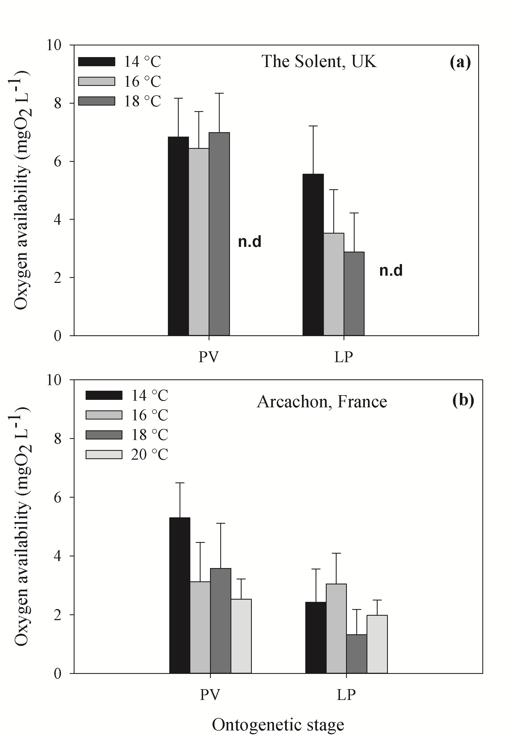
Figure 3. Temperature effects on the intracapsular oxygen availability of capsules with embryos in pediveliger (PV) and late pediveliger (LP) stages. (a) The Solent (Two-way ANOVA: T (°C) x Stage: F _{(2,1)}=4.754, p < 0.05; T (°C) = p < 0.05; Stage = p < 0.05; and (b) Arcachon (Two-way ANOVA: T (°C) x Stage: F _{(3,1)}= 5.937, p < 0.05; T (°C) = p < 0.05; Stage = p < 0.05). The ‘n.d.’ represents no data for the temperature treatment. Values given are mean ± standard deviation, n = 9 – 10 capsules were measured per temperature treatment in each population.

3.4. Oxygen consumption rate (OCR) in encapsulated and excapsulated embryos
The OCR changed as a function of increased temperature, ontogenetic stage of development, embryonic condition (i.e. encapsulated and excapsulated embryos), and population (Fig. 4; table 3). In both populations, the OCR increased as development progressed; however, excapsulated embryos consumed more oxygen than encapsulated embryos in advanced stages (Holm-Sidak; p < 0.001). Thus, the capsule wall restricted the OCR in encapsulated embryos (Fig. 4).

The OCR of encapsulated embryos in the Solent increased as the development progressed, from pediveliger to late pediveliger stage (Fig. 4 a-b; table 3). However, increased temperature did not affect the oxygen consumption in encapsulated late pediveliger embryos (p > 0.05), demonstrating low acclimation to high temperatures. Interestingly, excapsulated embryos in the same ontogenetic stage showed an increase in their OCR when exposed to 18 °C (p < 0.05). Contrasting results were observed in Arcachon, where increased temperatures produced a flexible metabolic response (Fig. 4 c-d; table 3). Embryos in advanced ontogenetic stages (encapsulated and excapsulated embryos) consumed more oxygen than early stages. Moreover, high temperatures increased the OCR in each ontogenetic stage, especially in embryos exposed to 18 and 20 °C (p < 0.05).

Factor | The Solent |  |  |  |  | Arcachon
 | df | SS | MS | F | P | df | SS | MS | F | P
C | 1 | 1.5 x 10⁻⁵ | 1.5 x 10⁻⁵ | 45.3 | ** | 1 | 3.4 x 10⁻⁴ | 3.4 x 10⁻⁴ | 445.1 | **
T° | 2 | 0.2 x 10⁻⁵ | 0.1 x 10⁻⁵ | 3.4 | 0.1 | 3 | 3.9 x 10⁻⁵ | 1.3 x 10⁻⁵ | 16.9 | **
S | 1 | 6.8 x 10⁻⁵ | 6.7 x 10⁻⁵ | 204.6 | ** | 2 | 1.9 x 10⁻⁴ | 9.7 x 10⁻⁵ | 127.7 | **
C x S | 2 | 0.7 x 10⁻⁵ | 0.3 x 10⁻⁵ | 11.06 | ** | 3 | 2.7 x 10⁻⁵ | 0.9 x 10⁻⁵ | 12.2 | **
C x T° | 1 | 1.4 x 10⁻⁵ | 1.4 x 10⁻⁵ | 42.9 | ** | 2 | 9.4 x 10⁻⁵ | 4.7 x 10⁻⁵ | 62.0 | **
T° x S | 2 | 0.3 x 10⁻⁵ | 0.1 x 10⁻⁵ | 5.7 | ** | 6 | 1.1 x 10⁻⁵ | 1.8 x 10⁻⁶ | 2.377 | *
C x T° x S | 2 | 0.5 x 10⁻⁷ | 0.2 x 10⁻⁷ | 0.1 | 0.9 | 6 | 0.9 x 10⁻⁶ | 1.7 x 10⁻⁶ | 2.165 | 0.1
Error | 107 | 3.5 x 10⁻⁵ | 0.3 x 10⁻⁶ |  |  | 196 | 1.4 x 10⁻⁴ | 0.7 x 10⁻⁶

Table 3. Results of three-way ANOVAs using OCR of encapsulated and excapsulated embryos from two populations at pediveliger and late pediveliger stage in The Solent and early veliger, pediveliger and late pediveliger stage in Arcachon. (*) Means p values < 0.05 and (**) means p value of < 0.001. Factors: condition: excapsulated and encapsulated (C); Temperature (T°); developmental stage (S).
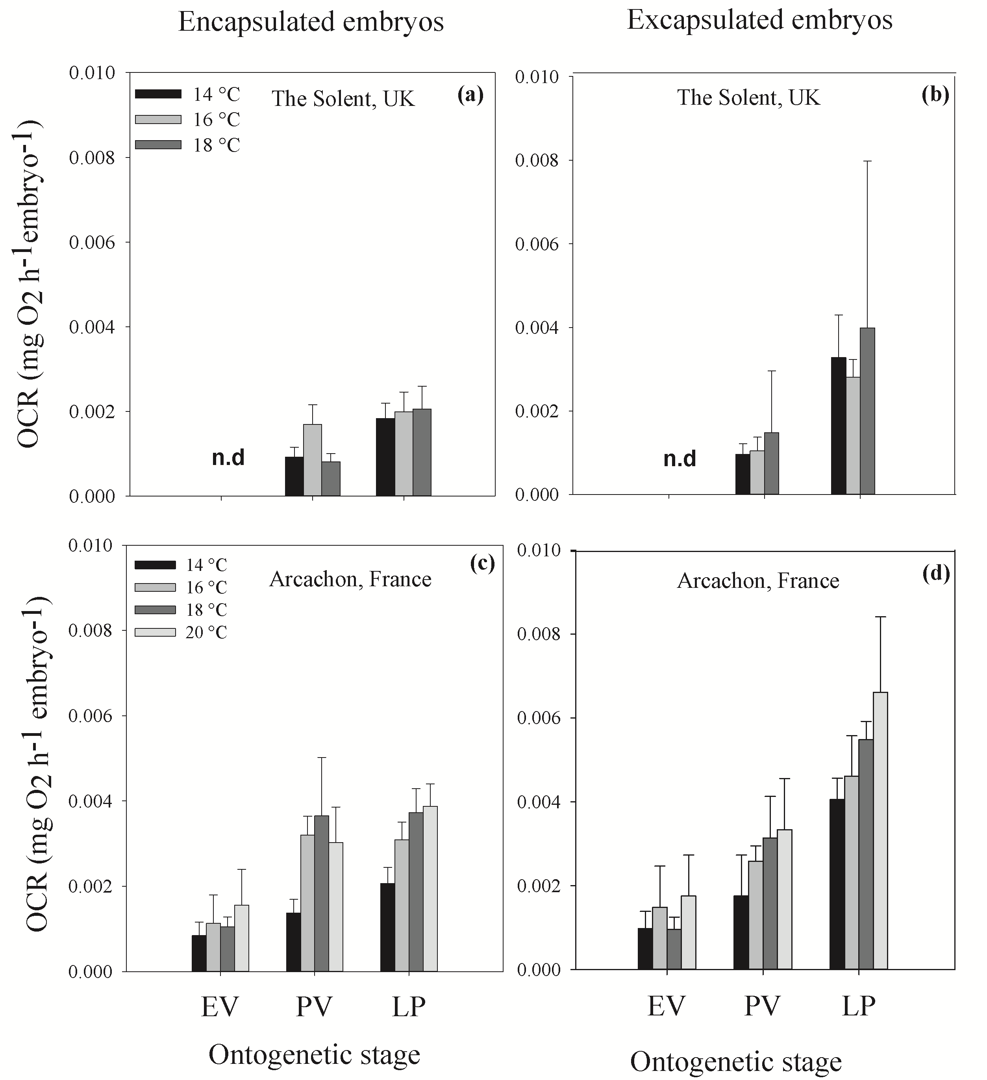

Figure 4. Temperature effects on oxygen consumption rate (OCR) on encapsulated and excapsulated embryos in early veliger (EV), pediveliger (PV) and late pediveliger stage (LP) from the Solent (a,b) and Arcachon (c,d) populations. The ‘n.d.’ represents no data for the temperature treatment. Values given are mean ± standard deviation, n = 8 – 10 eggs capsules per temperature treatment.

4. Discussion
The early life stages of marine organisms are thought to be more vulnerable to extreme temperatures, exhibiting narrow thermal tolerance windows in comparison with juvenile or adult stages (Byrne, 2012). This could be particularly pronounced for encapsulated species where temperature and oxygen availability are critical variables for tissue oxygenation and embryo survival inside of egg masses (Cancino et al., 2011). The aim of this study was to understand the effects of temperature on the development and aerobic response of embryos of different populations of Ocenebra erinaceus. The upper thermal tolerance limits of encapsulated embryos of O. erinaceus could be explained in part by the physiological effects of temperature, but also adaptation to local environmental conditions.

The duration of intracapsular development decreased with increasing temperatures in both populations. Intracapsular development took 70 days at 14 °C but only 40 days at 18 °C for both populations (Table 2). Indeed, it is well known that increased temperatures affect the development rate of encapsulated species (Spight et al., 1974; Roller and Stickle, 1989; Cancino et al., 2003; Przeslawski; 2004, Smith et al., 2013; Smith et al., 2015).

However, despite the fact that developmental rates were similar between populations, the aerobic response of encapsulated embryos varied according to the source population. Thus, we suggest that aerobic response of encapsulated embryos of O. erinaceus to increasing temperature appears to be locally adapted, as a function of temperature, oxygen availability and embryonic oxygen demands (Fig. 4; Table 3).
The respiration rate of encapsulated embryos from Arcachon increased during development (i.e. from pediveliger to late pediveliger stage) and with temperature, demonstrating a high metabolic acclimation to temperatures between 14 and 20 °C. The highest respiration rates were observed in advanced embryos exposed to elevated temperatures (18 -20 °C). High temperature has been shown to cause an increase in the metabolic rates in ectothermic species. Indeed, positive correlations have been found between oxygen consumption and increased temperature in other encapsulated species (Brante, 2006; Moran and Woods, 2007; Cancino et al., 2011).
As development progressed in the Arcachon population, embryos consumed more oxygen and the oxygen concentration inside the capsules decreased, with values ranging between 5 and 6 mg O₂ L⁻¹ in pediveliger stages to 3 and 2 mg O₂ L⁻¹ in late pediveliger stages (Fig. 2). This situation was more pronounced in advanced stages exposed to high temperatures as they consumed more oxygen, which resulted in hypoxic conditions inside the capsules (1-1.8 mg O₂ L⁻¹ at 20 °C). Similar findings have been observed in other prosobranch gastropods, where the oxygen content within capsules decreases as embryonic development progresses and temperature increases (Cancino et al., 2011; Cumplido et al., 2011, Lardies and Fernández 2002).
The thermal acclimation to higher temperatures observed in the aerobic response of the Arcachon embryos could explain the high survival rates observed in all temperature treatments, with values between 90 and 100%. Normally, subtidal Arcachon embryos are exposed to temperatures ranging between 13 and 18 °C during intracapsular development in the field (Fig. 1), thus our experimental range between 14 and 18 °C did not affect embryonic survival. Nonetheless, temperatures outside of the normal temperature range had a sub-lethal cost on embryonic fitness; twenty percent of capsules from each egg mass showed abnormal embryos at 20 °C. We conclude that in order to tolerate high temperatures, embryos incur high energetic demands, which result in development abnormalities. Previous reports have shown that high temperatures and low oxygen conditions negatively impact embryonic development, increasing the number of abnormal embryos (Fernández et al., 2006), or the number of empty shells (Smith et al., 2013).

In contrast, encapsulated embryos from the Solent population showed limited metabolic acclimation to high temperatures. For this population, oxygen consumption increased as development progressed and oxygen content within capsules decreased (Fig. 3-4a). However, for the Solent population, an increase in temperature did not affect embryonic oxygen consumption. It has been argued that the increase in metabolism with temperature represents a significant metabolic energetic challenge for organisms and some populations show temperature-insensitive metabolism as a strategy to survive in fluctuating environments (Verbeck et al., 2016). We propose that the lack of acclimation observed in Solent embryos was because they were thermally insensitive to temperatures outside of the normal range due to the high energetic demands. These high energetic demands were coincident with high embryo mortality observed at elevated temperatures. Only half of the embryos from each egg mass exposed to 18 °C reached the juvenile stage, which demonstrates that embryos were not able to tolerate temperatures above 18 °C. Usually, Solent embryos are exposed to temperatures between 12 and 16 °C in the subtidal during intracapsular development (Fig. 1) and therefore, 18 °C represents a critical point for development in this population.

As such, encapsulation seems to be a maladaptive strategy to warming temperatures. In our study, the capsule wall acted as a barrier for the oxygen diffusion and hence, impacted embryonic oxygen demands (see also: Segura et al., 2010). Embryos removed from their capsule chambers showed higher respiration rates compared to encapsulated embryos in both populations (Fig 4; Table 3, factor: embryonic condition). For example, at the same developmental stage the respiration rate of excapsulated embryos was 100% higher than encapsulated embryos. Unexpectedly, when excapsulated embryos from the Solent population were exposed to aerated filtered seawater (100% saturation), they then showed metabolic adjustment to increased temperature. Therefore, the capsule wall restricted oxygen diffusion and, combined with elevated temperatures, reduced the oxygen availability which affected the respiration rate of advanced encapsulated embryos. As Segura et al. (2010) have shown, the capsule wall may act as a barrier for the diffusion of oxygen. The oxygen diffusion coefficient of the capsule wall of Crepipatella dilatata was lower than the oxygen diffusion coefficient in pure water, which impacted the oxygen availability inside the capsules (Segura et al., 2010). To increase oxygen availability, the capsule wall of C. dilatata became thinner as the development progressed increasing its permeability. However, even though the permeability increased, it was insufficient to supply the embryonic oxygen demands at the end of the intracapsular development. Our results support the idea that the capsule wall could act as a barrier for oxygen diffusion, significantly reducing oxygen availability inside the capsule (Cancino et al., 2011) and this oxygen reduction can be intensified under warming temperatures, ultimately impacting embryonic survival.

Local adaptation is likely to be a reasonable explanation for the differences observed in the aerobic response of these two populations. Previous studies have shown that geographically separated populations (i.e. reproductively isolated) have evolved different thermal tolerances to their local environments (Kelly et al., 2012). Theoretically, populations from low latitudes will be the most thermally tolerant due to local adaptation to warmer conditions (Kelly et al., 2012); however, thermal tolerance limits can vary not only latitudinally but also among different habitats and geographic location (Kuo and Sanford 2009). For example, Kuo and Sanford (2009) found that the upper thermal tolerance limit in juveniles of the gastropod Nucella caniculata was locally adapted throughout the northeastern Pacific coast. They identified that regional differences, such as tidal regimes, can act as selective forces resulting in populations that are physiologically adapted to local environmental conditions. Thus, in our study, the local environmental conditions experienced by embryos influenced the aerobic response and limited the thermal tolerance response. However, it must be stressed that – from our work - we cannot distinguish between phenotypic plasticity and genetic differentiation (i.e. local adaptation). The potential influence of maternal effects or non-genetic developmental plasticity could not be eliminated in our results. Female thermal history before spawning can induce phenotypic carry-over effects on the offspring and, therefore, can influence the thermal tolerance response of embryos (Shama et al., 2014). In our study, the colder temperatures experienced by Solent females could have influenced the thermal tolerance of embryos, resulting in poor acclimation to temperatures outside of their normal thermal range.

In conclusion, this study is among the first to report intraspecific differences in the aerobic response of encapsulated species. We demonstrated that early stages of O. erinaceus are vulnerable to high temperatures that extend beyond their normal range of temperature. The aerobic response of embryos was constrained by local environmental conditions. Moreover, we demonstrated that encapsulation might be maladaptive for developing embryos of O. erinacea at high temperatures. With a projected increase of +2.73 °C (± 0.72) in sea surface temperature by the end of this century (Bopp et al., 2013) it is likely that the survival of O. erinaceus, especially during early stages when they are more sensitive to thermal stress, will be affected by climate warming – but this will be differentially expressed in populations from different thermal environments.

Acknowledgments
The authors wish to thanks to R. Robinson, for helping with the setup of experiments at the NOCS. The authors also acknowledge the kind assistance of Professor Xavier de Montaudouin from Marine Station D’Arcachon and Dr. Luca Peruzza for the collection of animals. The study received financial support from BECAS CHILE CONICYT and the University of Southampton.

6. References
Beherens, Y.S., 1989. Are direct developers more locally adapted than planktonic developers?. Mar. Biol. 103, 403–411.
Brante, A., 2006. An alternative mechanism to reduce intracapsular hypoxia in ovicapsules of Fusitriton oregonensis (Gastropoda). Mar. Biol. 149, 269–274.
Bopp, L., Resplandy, L., Orr, J.C., Doney, S.C., et al. 2013. Multiple stressors of ocean ecosystems in the 21st century: projections with CMIP5 models. Biogeosciences 10: 6225-6245.
Byrne, M., 2012. Global change ecotoxicology: Indentification of early history bottlenecks in marine invertebartes, variable species responses and variable experimental approaches. Mar. Environ. Res. 76, 3-15.
Cancino, J.M., Gallardo, J.A., Brante, A., 2011. The relationship between temperature, oxygen condition and embryo encapsulation in the marine gastropod Chorus giganteus. J. Mar. Biol. Assoc. UK. 91, 727–733.
Cancino, J.M., Gallardo, J.A., Torres, F.A., 2003. Combined effects of dissolved oxygen concentration and water temperature on embryonic development and larval shell secretion in the marine snail Chorus giganteus (gastropoda: Muricidae). Mar. Biol. 142, 133–139.
Clarke, A., 2003. Costs and consequences of evolutionary temperature adaptation. Trends Ecol. Evol. 18, 573–581.
Cumplido, M., Pappalardo, P., Fernández, M., Averbuj, A., Bigatti, G., 2011. Embryonic development, feeding and intracapsular oxygen availability in Trophon geversianus (Gastropoda: Muricidae). J. Molluscan. Stud. 77, 429–436.
Edmund, P.J., Gates, R.D., Gleason, D.F., 2001. The biology of larvae from the reef coral Porites astreoides, and their response to temperature disturbance. Mar. Biol. 139, 981-989.
Fernández, M., Pappalardo, P., Jeno, K., 2006. The effects of temperature and oxygen availability on intracapsular development of Acanthina monodon (Gastropoda: Muricidae). Rev. Chil. Hist. Nat. 79, 155–167.
Gibbs, P.E., 1996. Oviduct malformation as a sterilising effect of tributyltin ( TBT) - induced imposx in Ocenebra erinacea ( Gastropoda : muricidae ). J. Molluscan Stud. 662, 403–413.
Helmuth, B., Mieszkowska, N., Moore, P., Hawkins, S., 2006. Living on the Edge of Two Changing Worlds: Forecasting the Responses of Rocky Intertidal Ecosystems to Climate Change. Annu. Rev. Ecol. Evol. Syst. 37, 373–404.
Jones, S.J., Mieszkowska, N., Wethey, D.S., 2009. Linking thermal tolerances and biogeography: Mytilus edulis (L.) at its southern limit on the east coast of the United States. Biol. Bull. 217, 73–85.
Kelly, M.W., Sanford, E., Grosberg, R.K., 2012. Limited potential for adaptation to climate change in a broadly distributed marine crustacean. Proc. R. Soc. B. 279, 349-356.
Kuo, E. S. L., Sanford, E., 2009. Geographic variation in the upper thermal limits of an intertidal snail: implications for climate envelope models. Mar. Ecol. Prog. Ser. 388, 137-146.
Lardies, M.A., Fernández, M., 2002. Effect of oxygen availability in determining clutch size in Acanthina monodon. Mar. Ecol. Prog. Ser. 239, 139–146.
Martel, C., Guarini, J.M., Blanchard, G., Sauriau, P.G., Trichet, C., Robert, S., Garcia-Meunier, P., 2004. Invasion by the marine gastropod Ocinebrellus inornatus in France. III. Comparison of biological traits with the resident species Ocenebra erinacea. Mar. Biol. 146, 93-102.
Moran, A.L., Woods, H.A., 2007. Oxygen in egg masses: interactive effects of temperature, age, and egg-mass morphology on oxygen supply to embryos. J. Exp. Biol. 210, 722–731.
Parsons, K.E., 1998. The role of dispersal ability in the phenotypic differentiation and plasticity of two marine gastropods. II. Growth. J. Exp. Mar. Biol. Ecol. 221,1–25.
Pechenik, J., 1982. Ability of some gastropods egg capsule to protect against low-salinity stress. J. Exp. Mar. Biol. Ecol. 71,195–208.
Pechenik, J., 1983. Egg capsules of Nucella lapillus (L) protect against low-salinity stress. J. Exp. Mar. Biol. Ecol. 71, 165–179.
Pechenik, J., 1986. The encapsulation of eggs and embryos by molluscs: an overview. Am. Malacol. Bull. 4: 165-172.
Pörtner, H.O., 2002. Climate variations and the physiological basis of temperature dependent biogeography: Systemic to molecular hierarchy of thermal tolerance in animals. Comp. Biochem. Physiol. A Mol. Integr. Physiol. 132, 739–761.
Przeslawski, R., 2004. A review of the effects of environmental stress on embryonic development within intertidal gastropod egg masses. Molluscan Res. 24, 43–63.
Rawlings., T.A. 1999. Adaptations to physical stresses in the intertidal zone: The egg capsules of neogastropod molluscs. Am. Zool. 39, 230–243.
Roller, A., Stickle, W.B., 1989. Temperature and salinity effects on the intracapsular development, metabolic rates, and survival to hatching of Thais haemastoma canaliculata (Gray) (Prosobranchia: Muricidae) under laboratory conditions. J. Exp. Mar. Biol. Ecol. 125, 235–251.
Sanford, E., Kelly, M.W., 2011. Local Adaptation in Marine Invertebrates. Annu. Rev. Mar. Sci. 3, 509–535.
Schulte, P.M., 2015. The effects of temperature on aerobic metabolism: towards a mechanistic understanding of the responses of ectotherms to a changing environment. J. Exp. Biol. 218, 1856–1866.
Segura, C. J., Chaparro, O.R., Paschke, K.A., Pechenik, J.A., 2010. Capsule walls as barriers to oxygen availability: Implications for the development of brooded embryos by the estuarine gastropod Crepipatella dilatata (Calyptraeidae). J. Exp. Mar. Biol.Ecol. 390, 49-57.
Segura, C.J., Chaparro, O.R., Pechenik, J.A., Paschke, K.A., Osores, S.J.A., Navarro, J.M., Cubillos, V.M., 2014. Delayed effects of severe hypoxia experienced by marine gastropod embryos. Mar. Ecol. Prog. Ser. 510, 59–71.
Shama, L.N.S., Strobel, A., Mark, F.C., Wegner, K.M., 2014. Transgenerational plasticity in marine sticklebacks: maternal effects mediate impacts of a warming ocean. Funct. Ecol. 1-13.
Skewes, S.M. 2005. Ocenebra erinaceus Oyster drill. In Tyler-Walters H. and Hiscock K. (eds) Marine Life Information Network: Biology and Sensitivity Key Information Reviews, [on-line]. Plymouth: Marine Biological Association of the United Kingdom.
Smith, K.E., Reed, A.J., Thatje, S., 2015. Intracapsular development and dispersal polymorphism in the predatory gastropod Ocenebra erinaceus (Linnaeus 1758). Helgoland Mar. Res. 69, 249–258.
Smith, K.E., Thatje, S., Hauton, C., 2013. Thermal tolerance during early ontogeny in the common whelk Buccinum undatum (Linnaeus 1785): Bioenergetics, nurse egg partitioning and developmental success. J. Sea. Res. 79, 32–39.
Sokolova, I.M., Pörtner, H.O. 2003. Metabolic plasticity and critical temperatures for aerobic scope in a eurythermal marine invertebrate (Littorina saxatilis, Gastropoda: Littorinidae) from different latitudes. J. Exp. Biol. 206, 195–207.
Somero, G.N., 2005. Linking biogeography to physiology: Evolutionary and acclimatory adjustments of thermal limits. Front. Zool. 2, 1.
Somero, G.N. 2010. The physiology of climate change: how potentials for acclimatization and genetic adaptation will determine ‘winners’ and ‘losers’. J. Exp. Biol. 213, 912–920.
Spight, T.M., Birkeland, C., Lyons, A. 1974. Life histories of large and small murexes (Prosobranchia: Muricidae). Mar. Biol. 24, 229–242.
Strathmann, R.R., Strathmann, M.F. 1995. Oxygen-supply and limits on aggregation of embryos. J. Mar. Biol. Assoc. UK 75, 413–428.
Verbeck, W.C.E.P., Bartolini, F., Marshall, D.J., Pörtner, H-O., Terblanche, J.S., White, C.R., Giomi, F. 2016. Can respiratory physiology predict thermal niches. Ann. N. Y. Acad. Sci. 1365, 73-88.
Weiss, M., Heilmayer, O., Brey, T., Thatje, S. 2009. Influence of temperature on the zoeal development and elemental composition of the cancrid crab, Cancer setosus Molina, 1782 from Pacific South America. J. Exp. Mar. Biol. Ecol. 376, 48–54.
Zippay, M.L., Hofmann, G.E. 2010. Physiological tolerances across latitudes: thermal sensitivity of larval marine snails (Nucella spp.). Mar. Biol. 157, 707–714.

