Compression-compression fatigue behaviour of Gyroid-type Triply Periodic Minimal Surface porous structures fabricated by Selective laser melting

Lei Yang ^{a, b}, Chunze Yan ^{a,}, Wenchao Cao ^{b}, Zhufeng Liu ª, Bo Song ª, Shifeng Wen ª, Cong Zhang ^{d}, Yusheng Shi ª, Shoufeng Yang ^{b, c,*}
ª State Key Laboratory of Materials Processing and Die & Mould Technology, School of Materials Science and Engineering, Huazhong University of Science and Technology, China
^{b} Department of Mechanical Engineering, Member of Flanders Make, KU Leuven (Catholic University of Leuven), 3001 Leuven, Belgium
^{c} Materials Research Group, Faculty of Engineering and the Environment, University of Southampton, Southampton, UK
^{d} Reliability Engineering Institute, School of Energy and Power Engineering, Wuhan University of Technology, Wuhan 430063, China

Abstract: Triply Periodic Minimal Surface (TPMS) porous structures are recognized as the most promising bionic artificial structures for tissue engineering. The fatigue properties of additive manufactured porous structures are essential for long-term use in a dynamical bio-skeletal environment. The aim of this study is to study the compression-compression fatigue behaviour and the underlying fatigue mechanism of Gyroid cellular structures (GCS), a typical TPMS porous structure. The high-cycle fatigue results show that both cyclic ratcheting and fatigue damage phenomena contribute to the failure of GCS during fatigue testing. For most fatigue loading stress, the failure samples have nearly 45° fracture bands along the diagonal surface. The fatigue ratio of GCS reaches 0.35 for as-built samples and can be raised to 0.45 after sandblasting treatment. The fatigue ratio values are higher than most of the other bending-dominated lattice structures, suggesting superior fatigue resistance properties of GCSs due to the smooth surface connection between struts. Besides, a systematic investigation of the crack initiation and propagation was conducted by both deformation analysis and finite element method to support experimental phenomena. The results also indicate that the fatigue resistance properties of GCSs are significantly enhanced by sandblasting post-treatment, through removing the adhered powder particles, inducing compressive residual stress on the surface and generating a nanocrystalline zone.
Keywords: Additive manufacturing; Selective laser melting; Triply periodic minimal surface; Porous structure; Fatigue properties; Stainless steel

1 Introduction
Triply Periodic Minimal Surface (TPMS) porous structures have been considered as versatile sources of bionic bone tissue engineering, due to their biomorphic geometric characteristics, such as high porosity, highly interconnected network, and smooth surface [1-3]. These features are beneficial for cell penetration, vascular ingrowth, nutrient diffusion, and waste production elimination [4]. For instance, Melchels et al. assessed the cell proliferation properties of scaffolds with different pore architectures. It was found that Gyroid type TPMS scaffolds showed 10-time greater permeability than that of their counterparts and can be more easily wetted and intruded by a cell suspension [5]. Shi et al. analysed the cortical bone morphological features of a rabbit femoral bone by CT reconstruction and generated bionic porous scaffolds based on TPMS structures and a sigmoid function [6]. Sanjairaj proposed a design method for design graded scaffolds to mimic the native tissue microenvironment based on TPMS structures [7].
In addition to biomorphic geometric characteristics, implants are supposed to match mechanical properties of the surrounding bone tissue, including Young’s modulus and strength [8]. Lower modulus and strength for implant material mean unreliable repair and will result in larger deformation of the implant under load, while a higher modulus and strength result in stress shielding [9]. Thus, it is essential to experimentally study the mechanical properties of implants before the implementation of customised designing. Traditional methods are limited to the fabrication of stochastic foams or simple meshes and it is difficult to precisely control geometrical parameters and the corresponding mechanical response. Thanks to the development of AM technique and equipment, high resolution and complete control of geometric features can be addressed for metal lattice structures via powder-bed AM processes, such as selective laser melting (SLM) [10-14] and electron beam melting (EBM) [15-17]. Therefore, the mechanical property testing of highly controlled scaffold samples has become possible and drawn a lot of attention.
Yan et al. experimentally verified the high AM manufacturability of TPMS structures and found that the Ti-6Al-4V Gyroid cellular structure (GCS) had a similar mechanical response to that of trabecular and cortical bones [3, 18]. Yánez et al. fabricated a series of GCSs with different porosity via EBM and the combined results of experimental and finite element (FE) analysis implied versatile stiffness and strength of Gyroid structures. They can hence be used for the correction of bone defects [19]. Besides, highly tailored functionally graded porous structure based on TPMS structure can be achieved by structural optimization [20, 21].
To date, previous studies mostly focused on manufacturing, static mechanical response as well as topology optimization [20-25]. Only a small number of publications have been dedicated to investigating the fatigue behaviour of TPMS cellular structure [26, 27]. However, according to statistics, one of the most important inducements of bone fractures among the elderly is fatigue damage resulting from repetitive, low-intensity loading of normal daily activities [28]. Thus, the fatigue behaviour of porous structures is vital for long-term use in biomedical or engineering applications, where structures typically experience cyclic loading [29-31]. Furthermore, due to the adhered partially melted powder particles on the surface, a major drawback of powder-bed AM techniques is the rough surfaces and multiple crack initiation points, which will significantly affect their fatigue properties [32, 33].
TPMS porous structures include sheet-based TPMS foam and strut-based TPMS cellular/scaffold/lattice [34, 35]. The previous study of fatigue properties of TPMS porous structures focused on the sheet-based TPMS foam. Bobbert et al. additively manufactured porous metallic biomaterials based on TPMS and found that TPMS foam has significantly improved compressive fatigue resistance compared to strut-based lattices, due to the smooth and continuous geometries inhibiting the initiation and development of fatigue cracks [26]. Later, the stretching-dominated deformation behaviour of TPMS foam under both compressive and tensile loading was illustrated to be one of the main reasons for the superior fatigue properties [27]. Although the strut-based TPMS cellular has bending-dominated deformation behaviour, the FE analysis of TPMS structures implemented in Ref. [25] showed a more uniform stress distribution of TPMS cellular compared to strut-based lattices in Ref. [36]. It suggests that the fatigue properties of strut-based TPMS cellular deserve further investigation.
Furthermore, surface enhancement treatments have positive effects on the retardation of fatigue crack initiation and growth [37]. By inducing compressive residual stress in the subsurface of metallic components, the fatigue properties are effectively enhanced by surface treatments, such as sandblasting [37], low plasticity burnishing [38], shot peening [39], laser peening [40], and water jet peening [40]. Sandblasting is a useful post-treatment in AM field [41, 42], where the as-built samples are blasted repeatedly by high-speed sand particles, leading to not only removal of bonded metal powders but also generation of a residual compressive stress layer in the subsurface region. However, these studies mainly focus on bulk materials. Rare work has been done on the effect of sand-blasting on the fatigue behaviour of porous structures.
Therefore, the aim of this work was to investigate the fatigue properties of the Gyroid type TPMS cellular structure. Both static compressive responses and high-cycle compression-compression fatigue responses were tested. The ratcheting effect, as well as the effect of adhered powder particles on fatigue fracture, were studied in this work. Furthermore, the strut deformation and fatigue failure mechanism were thoroughly investigated via both experimental and FE methods. Moreover, a series of counterparts with sand-blasting treatment were prepared and the enhancement effect of sand-blasting on static and dynamic mechanical properties was tested.
The structure of the paper is as follows. Section 2 starts by introducing the designing method and fabrication process of 316L GCSs, and then pass to describe the details of measurements, characterization and FE method in turn. Next, section 3 presents the results in surface morphologies, quasi-static compressive and fatigue properties of SLM-made 316L GCSs. Section 4 discusses the crack initiation and propagation, the fracture mechanism in the fatigue process; and emphatically analyses the effects of unit cell type and sandblasting on the fatigue properties. The paper ends in section 5 by reviewing the main results of the present study.

2 Methodologies

2.1 Design and fabrication of 316L GCSs
GCS with a relative density of 15% was modelled via MATLAB (Mathworks Inc., USA) software. The Gyroid unit cell is governed by a mathematical equation,
(1),
where a and t control the unit cell size and the volume surrounded by the Gyroid surface. More detailed modelling method was described in our previous paper [21]. In this paper, a and t are assigned values of 4 and 1.0439, respectively. The gained Gyroid unit cell possesses a relative density of 15% and a unit cell size of 4 mm. All GCS samples in this study are based on this Gyroid unit cell. A bidirectional scanning strategy with 90° rotation angle was utilised to layer-by-layer fabricated GCS samples using Gaussian distributed 316L powder (Praxair Surface Technologies, Inc., USA). 316L GCS samples with a dimension of 20 mm × 20 mm × 20 mm were manufactured by an M-lab cusing instrument (Concept Laser GmbH, Germany) with an inert atmosphere. Printed GCS samples were cut from the base plate by wire electrical discharge machining (Wire-EDM) and then cleaned in pure alcohol with ultrasonically vibration. After the cleaning, samples were divided into as-built group and sandblasting group. The as-built group was carried out in the later experiments without any post-treatment, while the samples in the sandblasting group were surface treated in a sandblasting machine PEENMATIC 620S (iepco AG, Switzerland). The aluminium oxide sand used in the sandblasting process possesses an average grain size of 250$μm$. The outer surface of the samples was uniformly blasted to remove the adhered powder particles with a pressure of 0.44MPa at the outlet of the spray gun.

2.2 Measurements and characterization
The particle size distribution of the 316L powder was tested by Mastersizer 3000 laser diffraction particle size analyzer (Malvern Panalytical Inc., UK). Surface morphology prior to fatigue testing and fracture surfaces after the testing were observed using a Quanta 650 FEG scanning electron microscope (SEM) (FEI, America) under 10kV. Electron Backscattered Diffraction (EBSD) experiments were carried out to obtain the grain size distribution and polo figures using an orientation imaging microscopy system attached to the SEM system and the scanning step was 2μm. The quantitative analysis of the effect of sandblasting on the surface morphology was examined using X-ray computed tomography (CT) with a Nikon XT H 225 ST (Nikon Metrology NV, Belgium). Uniaxial compression tests were performed with an AG-IC100 KN Electronic Universal Testing Machine (SHIMADZU, Japan) at room temperature. A constant compressive speed was applied along the build direction (Z) to achieve 0.1% strain rate of the entire structure in accordance with ISO 13314: 2011 [43].
High-cycle compression-compression fatigue tests were conducted using a hydraulic test frame (EHF-UK100K2-040-1A, SHIMADZU, Japan). A constant loading frequency (20 Hz, sinusoidal wave shape) and a constant load ratio, R=0.1, were used. R is defined as the ratio of the minimum to maximum values of the absolute loading stress ${{\left|σ\right|}_{min}}/{{\left|σ\right|}_{max}}$. Samples were considered to have failed when the specimens lost 90% of their initial stiffness (i.e. when the displacement magnitude was 10 times higher than its initial value) [44]. Otherwise, the tests were stopped at 2 × 10⁶ cycles (run-out). The corresponding maximum stress withstanding the applied number of cycles was adopted as the fatigue strength [45].
The fatigue loading stress ${\left|σ\right|}_{max}$ was chosen according to the static compression test. First, a loading stress value of ${0.5σ}_{plateau}$ was selected to conduct the fatigue loading. Then the value was increased at an interval of ${0.05σ}_{plateau}$ until the cyclic period is less than 10⁴. Meanwhile, the loading stress value was decreased until the samples get rid of the failure status withstanding 2 × 10⁶ cycles. The final loading stress values for as-built GCSs were: 16.9MPa, 15.6MPa, 14.3MPa, 13.0MPa, 11.7MPa, 10.7MPa, and 9.1MPa. For each loading stress, two samples were tested. The group of chosen loading stress value was also applied to the fatigue tests of sand-blasted samples to compare with the as-built samples.

2.3 Finite element method
FE method was applied to analyse the stress distribution on the surface of GCS under compressive loading. ABAQUS/Standard 6.14 was utilised to perform the analysis. Considering the simulation efficiency and required accuracy, a partial model consisted of 8 unit cells was used in this work. The 3D solid element of the 4-node tetrahedral type was employed to mesh the lattice model with six degrees of freedom per node in this simulation process. An element size of 0.08mm was chosen to achieve high accuracy and total 611,099 elements and 146, 829 nodes were generated. The minimum time increment size was set to be 1×10⁻⁵ s and an isotropic plastic hardening model with an initial strength of 170 MPa was chosen [46]. In the simulation, the material was assumed to have an elastic modulus of 210GPa and a Poisson’s ratio of 0.3 [47]. The FE analysis in this paper is limited to the elastic period of GCS. Therefore, only a displacement of 0.1 mm was applied on the top surface of the mesh model and the maximum strain was 1.25%, which was within the elastic stage as shown in Fig. 3.

3 Results

3.1 Surface morphologies of the as-built and sand-blasted samples
CT-reconstructed volumes of as-built and sand-blasted GCSs were compared with the engineering design. Three-dimensional surface deviation maps of GCSs between the CT data and engineering design are presented in Fig. 1(a) and (b). The legend represents the deviation values of CT-reconstructed models compared with the design. As shown in the figures, GCS can be successfully manufactured by SLM technology without broken struts in the structures. Rough surfaces with partially melted powders are clearly shown for the as-built GCSs, while smooth surfaces are observed for the sand-blasted samples. The result suggested that sandblasting can effectively remove the bonded powders, which are commonly observed in powder-bed fused processes [48, 49]. It is worth noting that the largest deviations occur at the upper inner walls of sphere-like pores for both as-built and sand-blasted samples, coinciding with overhangs.
The embossments in the overhanging area characterised with red colour in the surface deviation maps were induced by the formation of dross defects and the collapse of molten pools at the downward-facing surfaces [50]. Since the thermal conductivity of metal powder is dramatically lower than that of solid metal [51], the accumulated heat makes a larger molten pool. Under the influence of gravity, the hot droplet in the overhanging area will drop into the previous powder layer, resulting in a rough surface and severe distortion. The sandblasting treatment can only remove the bonded powder particles on the surface but has scarcely any effect on adjusting the distortion surfaces.
Fig. 1(c) and (d) show the statistical surface deviations of as-built and sand-blasted GCSs, while Fig. 1(e) and (f) present the statistical strut diameters. The surface deviations of both GCSs are Gaussian distributed. The D-values (D10, D50 and D90), i.e., the intercepts for 10%, 50% and 90% of the cumulative percentage based on surface area of as-built GCS, are -0.024, 0.030, and 0.098, respectively. D-values of sand-blasted GCS are -0.030, 0.021, and 0.085, which are all smaller than that of as-built GCS. However, the distribution of strut diameters is not completely in conformity with Gaussian distribution law. A clear sub-peak is founded in the strut diameter curve with the diameter of 0.058mm, which is likely the noise coming from the bonded powder particles.

Fig. 1 X-ray CT data analysis for the SLM-fabricated GCSs and the 316L powder particle size distribution: (a) and (b) are three-dimensional surface deviation maps before and after sandblasting, (c) and (d) are statistical surface deviation distributions before and after sandblasting, (e) and (f) are the statistical strut diameters before and after sandblasting, (g1) and (g2) are the typical examples of struts with bonded powder particles, and (h) is the 316L powder particle size distribution.

As shown in Fig. 1(h), the 316L powder has a Gaussian particle size distribution with volume-based D-values: D10 = 18.3μm, D50 = 31.3μm and D90 = 52.0μm. The diameter of the single powder particle is lower than the noise found in Fig. 1(e), which indicates that powders may clump together or be fused to form larger particles. Two typical samples of struts with the bonded powder particles through analysing the CT-reconstructed model are shown in Fig. 1(g) and verify the inference: Fig. 1(g1) shows that the particles clumped together and Fig. 1(g2) presents that larger particles were generated on the surfaces of GCSs. The noise has been successfully removed by sandblasting process, as it cannot be found in the strut diameter curve of sand-blasted GCS.
The peak surface deviations of two GCSs are 0.028mm and 0.013mm, respectively; and the strut diameters at the peaks of percentage distribution curves are 0.791mm and 0.825 mm respectively. The difference between the two peak surface deviations is 0.015 mm, which is approximately half of the average diameter of 316L powders. The difference between the strut diameters at the peaks is 0.034, which is approximately the average powder diameter. The results show that all the surfaces of GCS are uniformly treated in the sandblasting process.
Microscopic images of the as-built and sand-blasted samples were presented in Fig. 2. Fig. 2(a)–(c) present the figures of as-built GCS in the top, lateral, and bottom views respectively, while Fig. 2(d)–(e) present the figures of sand-blasted GCS in the top, lateral, and bottom views respectively. The figures illustrated that the top surface of as-built GCS is characterised by stair-stepping effect; the lateral surfaces are characterised by tiny powder particles attached on the lateral surface; the bottom surfaces are characterised by agglomerated particles and solidified droplet, resulting in severe local variation compared with the designed CAD. This phenomenon is consistent with the observation from CT-reconstructed models, which caused by the lack of support and inefficient cooling at the overhang area [51, 52]. On the contrary, all sand-blasted samples yield smooth surfaces after removing the surface particles. There are only a few bumps left at the overhang area.

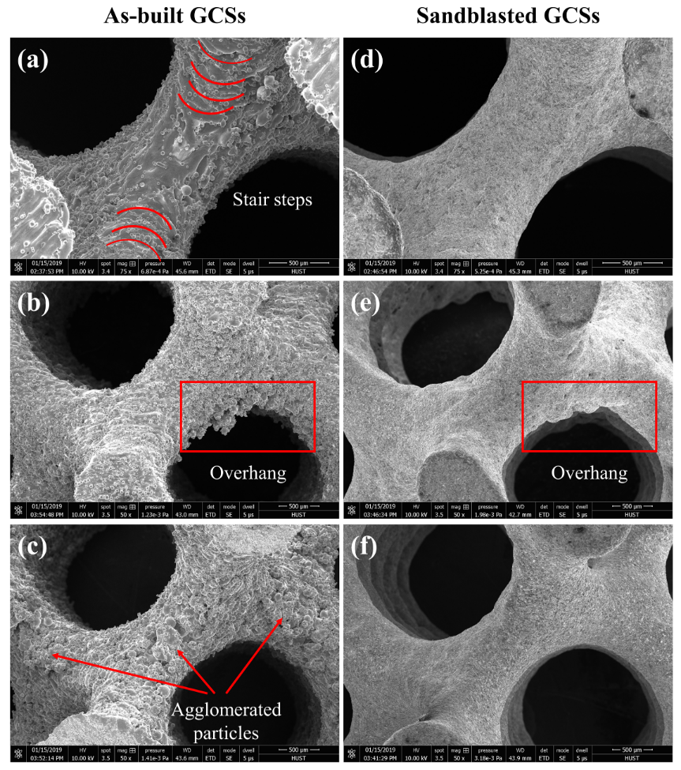Fig. 2 Surface morphologies of the as-built (a-c) and sand-blasted samples (d-f): (a) and (d) in top view, (b) and (e) in lateral view, while (c) and (f) in bottom view.

3.2 Quasi-static compressive properties
In this work, the static compression tests of three sand-blasted samples with the same relative density of 15% were conducted. The static compressive data of as-built GCS was acquired from our previous research [21]. The typical comparison between as-built and sand-blasted compressive strain-stress curves is presented in Fig. 3(a). The loading directions are both along building direction (Z-axial), as shown in Fig. 3(b). The long plateau region of the strain-stress curves indicates excellent plasticity of both groups of GCSs. Besides, the mechanical response of sand-blasted GCS was higher than that of as-built GCS. According to the theory in Ref. [21], Young’s modulus and plateau stress were gained, respectively. The compressive strength of each sample was defined as the 0.2% offset stress [22]. Although the studied sand-blasted samples have lower relative density and strut diameter, the tested mechanical responses are higher than that of as-built samples. As shown in Fig. 3(c), Young’s moduli of sand-blasted GCSs increase from 1097.87 ± 20.85 MPa to 1163.69 ± 23.33 MPa; yield strength increase from 19.15 ± 0.45 MPa to 20.95 ± 0.35 MPa; while the plateau stress increase from 26.18 ± 0.33 MPa to 27.65 ± 0.38 MPa. The improved mechanical properties can be attributed to the work-hardening induced by the local plastic deformation on the surface of GCSs [53]. Both groups of 316L GCS showed high ductility. The struts deformed and contacted with each other and finally turned to “honeycomb-like” structures, as shown in Fig. 3(a).
It is worth noting that recent papers demonstrate the anisotropy of smooth-shell metamaterials based on TPMS [54, 55]. Our recent work also presented polar diagrams to illustrate the anisotropic properties of GCS [34]. Regardless of the microstructure change in additively manufactured components, the loading direction used in this paper along Z-axial ([001]) is the softest direction of strut-based GCS.
However, a strong texture along the building direction, i.e. [001] direction, was observed in 316L additively manufactured bulk and lattices in a recent study by Kong et al. [56]. Furthermore, the compression tests were conducted by Kong et al. and the resistance to deformation of cubic lattices along the X-axis and Y-axis was confirmed to be higher than that of the Z-axis, due to the anisotropy. The Gyroid-type unit cell also has the cubic symmetry. However, as shown in Fig. 3(d) and (e), the macroscopic compressive results of GCSs show that GCS in Z-axial has a slightly higher mechanical response compared with that in X and Y axials, which is in contrast to the results in [56].
Fig. 3 Strain-stress curves the mechanical properties of as-built and sand-blasted GCS samples
To investigate the anisotropic properties of the AM-made 316L GCSs, EBSD experiments were performed to gain the grain distribution and polo figures. As illustrated in our previous paper [34], there are two types of struts in the Gyroid unit cell: horizontal strut and inclined strut. Thus, the horizontal and vertical cross-sections of horizontal struts and vertical cross-section of the inclined strut were chosen as the typical sampling locations of EBSD experiments, as shown in Fig. 4(a). The inverse pole figures (IPFs) (Fig. 4(b)) show that columnar grains are formed with grain directions perpendicular to the boundaries of molten pools [57]. Some indication of epitaxial growth between adjacent layers can be observed locally, but no prominent elongated columnar crystals along Z-axial are found. The polo figures (Fig. 4(c)) show that texture indices are all close to 1, indicating that grains have no clear preferred orientation tilted from the building direction (more than 10222 grains were statistically counted for each polo figure). The results show a quite different phenomenon within Ref. [56], but is consistent with the observation in Ref. [58-60].
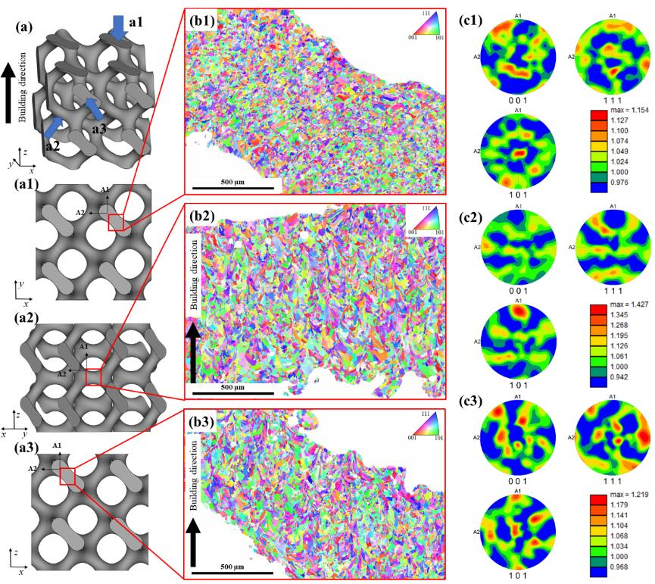
Fig. 4 The IPFs and polo figures of as-built 316L GCSs: (a) the schematic diagram of GCS, (a1)(a2)(a3) the sampling locations, (b1)(b2)(b3) the IPF results, and (c1)(c2)(c3) the polo figures.

The difference of the anisotropy of texture in SLM-made lattices is caused by the scanning strategy of the laser and geometric features of lattices. Firstly, a rotation of scanning direction is believed to be able to avoid the formation of strong texture, generating an almost isotropic polycrystalline microstructure [60]. As the bidirectional scanning strategy was used in the SLM process, the directions of thermal gradients in each layer will change layer by layer. Furthermore, unlike the cubic lattice in [56], there is no vertical strut in GCS, thus the direction of maximum thermal gradient in the GCS is not exactly along Z-axial during the layer-by-layer fabrication process. Therefore, in this paper, although the growth direction of columnar crystals has a slightly [001] orientation, the texture of 316L GCS hardly has a preferred orientation. A similar phenomenon was also observed in SLM-made diamond lattices without vertical struts in Ref. [58, 59], in which isotropic elastic properties of matrix material was chosen to conduct the FE analysis. Thus, the matrix material of GCSs was also assumed to be isotropic in the later FE analysis in this study.
The difference of the mechanical responses along different directions can be attributed to the Wire-EDM process, which results in a lower dimension along Z-axial and uncomplete unit cells as shown in Fig. 3(b) [21]. The uncomplete unit cell does not affect the resistance to deformation along Z-axial. While when the load comes from X or Y axials, the fragmentary struts have little contribution to the resistance to deformation, thus, lower the mechanical properties [25].

3.3 Fatigue properties

3.3.1 Strain accumulation
The curves of accumulated strain versus the number of cycles are shown in Fig. 5 (a) and (b) for the as-built and sand-blasted samples of GCSs, respectively. The main characteristic of 316L GCS subjects to compressive fatigue loading is the gradual accumulation of the strain, which shortens the tested specimens. There are three classical stages, namely periods of primary strain increase stage (N<100), constant plateau stage over a wide cycle range, and a rapid strain accumulation stage.
However, the three stages are not clearly observed in all specimens. For the low-stress loading, the specimen did not experience failure or fracture during the studied cycles; while for the as-built samples under large-stress loading, the constant plateau stage is not clearly shown in the figures, as the load is close to the yield stress. Between the constant plateau and rapid strain accumulation stages, an abrupt jump strain point (N_{c}) is defined as the point of demarcation. The curves show that, for both as-built and sand-blasted GCSs, the value of N_{c} increases as the loading stress decreases.
Fig. 5 Accumulated strains varying with cycle numbers and stresses of GCSs before and after sandblasting

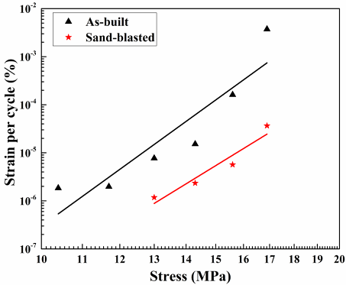
Fig. 6 Effect of stress on the accumulated strain per cycles of as-built and sand-blasted GCSs
Based on the accumulated strains in Fig. 5, the accumulated strain per cycle, $dε/dN$, before the point of demarcation N_{c} were calculated for GCSs under different loading stress, as shown in Fig. 6. It is clearly observed that, for both as-built and sand-blasted GCSs, the accumulated strain per cycle increases as the loading stress increase and the sand-blasted GCSs show higher resistance to deformation in the fatigue testing process.

3.3.2 Cyclic stress-strain
Fig. 7 shows the hysteresis loops of as-built and sand-blasted samples respectively, with a loading stress value of 13.0 MPa. For both groups of samples, hysteresis loops are characterised by increasing nonlinearity and hysteresis prior to failure. The cyclic ratcheting was involved in the fatigue process since hysteresis loops are gradually moved along the strain axis. As shown in Fig. 7 (a) and (b), the hysteresis loops for both as-built and sand-blasted samples shift along the strain axis and are parallel to each other at the beginning stage of fatigue testing. However, for as-built samples, the secant modulus gradually decreases after 10⁴ cycles, which is resulted by the formation and growth of fatigue cracks in the struts [28, 38], while for sand-blasted samples, the hysteresis loops were always parallel to each other until the failure. It is noticed that in the primary strain increase stage, the minimal strain in the hysteresis loops are larger than the specified value, while the maximum strain is smaller than the specified value. This can be explained by the unreliable contact between dies and samples caused by the unparalleled and rough upper and lower surfaces of the samples.
Cyclic ratcheting strain and fatigue damage strain of two groups of samples were calculated on the hysteresis loops according to the method described in Ref. [28]. As shown in Fig. 7(c), the fatigue ratcheting strain was defined as the translation of the minimum strain, , of each hysteresis loop from the 200th cycle, from which the loading stress became stable. While the fatigue damage strain was defined as the difference of the hysteresis loop strains between the current and the 200th cycles. Two kinds of accumulated strains illustrate the cyclic creep process and fatigue crack nucleation and growth process, respectively.

Fig. 7 Effect of stress on the cyclic ratcheting rate of GCSs and the cyclic ratcheting and fatigue damage strains of the as-built and sand-blasted GCSs

The results were plotted in Fig. 7(d) and (e). It can be clearly observed that for both groups of samples, the dominating contributor to fatigue failure was cyclic ratcheting. Furthermore, the cyclic ratcheting strain value of as-built GCS was higher than that of sand-blasted GCS, which illustrated that the fatigue property of GCSs has been enhanced by the sandblasting treatment. The fatigue damage strain did not increase prominently for the as-built GCS at the beginning of the fatigue test, but the effect of fatigue damage gradually increased after 10⁴ cycles. However, for sand-blasted GCS, the fatigue damage strain was nearly zero in the whole process of the fatigue test. Only at the last counting point before the failure of the whole structure, the value of damage strain raised to 0.03%. It demonstrated that the GCSs have higher crack resistance ability after sandblasting treatment.

3.3.3 Fatigue life and fatigue ratio
The compressive fatigue life of metal porous structures is commonly defined as the cycle number, corresponding to the abrupt jump strain point (N_{c}) [61-63]. However, for as-built GCS under cyclic stress value of 16.9MPa, the strain at the abrupt jump strain point is larger than 7%, as shown in Fig. 5(a). The overall strain value has exceeded the linear elastic region shown in Fig. 3. Therefore, in this case, the fatigue life was defined as the number of cycles when the specimens lost 90% of their initial stiffness [31, 64]. The gained fatigue life, with respect to the loading stress, were plotted in Fig. 8. The plot shows that the fatigue life of GCSs is highly related to the loading stress. Therefore, higher fatigue life can be gained by lowering the loading stress. In this work, the fatigue strength of the sand-blasted GCS was 11.7MPa at 2 ×10⁶ cycles, while the value of the as-built GCS was 9.1MPa. The results showed that the fatigue life of GCS substantially increased after the sandblasting process.
Fatigue ratio, also called fatigue endurance limit [26, 27], is defined as the ratio of the fatigue limit or fatigue strength to the tensile strength for tension-compression fatigue [65], and the ratio of fatigue strength to the plateau stress for compression-compression fatigue [66]. The fatigue ratio can be used to estimate the fatigue resistance properties of the tested structures and materials. Values of the fatigue ratio vary among different materials, loading methods, and sample structures. The fatigue ratio of commercial 316L stainless steel is 0.32-0.38 withstanding at least 2 × 10⁶ fatigue cycles [65, 67], while the fatigue ratio of 316L processed by SLM is only 0.19 in Ref. [68], which is dramatically lower than the ones fabricated by traditional methods, due to the rough surface and initiated cracks and pores [68]. As shown in Fig. 8, the fatigue ratio value of SLM-made 316L GCSs is 0.35 for as-built sample and 0.45 for sandblasted sample, which are comparable to that of commercial 316L stainless steel.

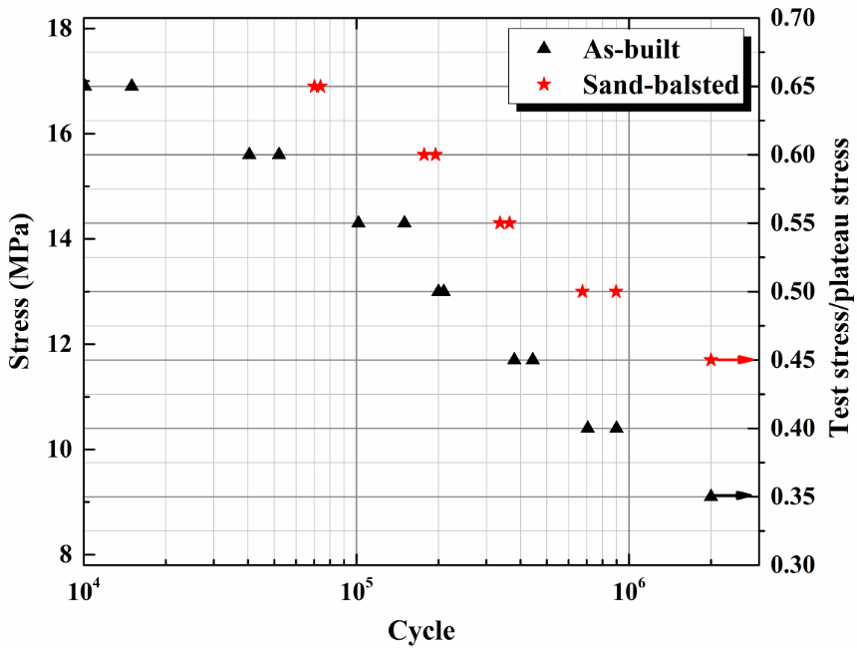
Fig. 8 S–N plots of the as-built and sand-blasted GCSs.

3.3.4 Fracture band and fracture surface morphologies
As shown in Fig. 9, the macro-features of GCSs were recorded by a digital camera after the fatigue testing. For both as-built and sand-blasted GCSs, most samples had a nearly 45° fracture bands along the diagonal surface, where the shear stress reached the maximum value. The phenomenon is different from the static compression testing of 316L GCS. Yang et al [21] observed a uniform deformation characteristic without obvious fracture for 316L GCS, due to the high plasticity of 316L material. However, it is also worth noting that the 45° fracture bands are similar to the shear failure mode for the bulk samples [69, 70] and scaffold samples [25, 70, 71] of brittle materials under static compressive loading.
Fig. 9 Macro feature and failure mode of GCSs after the fatigue testing.

Besides, as the maximum stress level in fatigue test increased, the inclined struts in the same layer of as-built GCSs preferably yielded and deformed uniformly. The fatigue testing was stopped when the samples lost most of their initial stiffness. No clear 45° fracture band was observed for these samples. The failure mode is similar to the static compressive responses of 316L GCSs investigated in [21]. Results show that the failure mode of GCSs changed in accordance with the cyclic stress. As the cyclic stress increased to a value close to the yield stress, plastic deformation accumulated in the tested sample, resulting in the disappearance of the fracture band. However, no change of failure mode was observed in the sand-blasted GCSs, when the fatigue loading stress is in this paper’s region.
As shown in Fig. 8, the fatigue strength of as-built and Sand-blasted GCS withstanding 2 × 10⁶ cycles were 9.1MPa and 11.7 MPa, respectively. Although no fatigue failure occurred, local cracks and strut failure were found in the tested samples. The phenomenon is consistent with the observation carried out by [66]. However, it differed from the observation reported in Ref. [72], in which no strut cracking was observed prior to fatigue life attainment.
Fig. 10 Crack distributions of as-built and sand-blasted GCSs.

Fig. 10 shows the crack distributions of as-built and sand-blasted GCSs. Cracks occurred at both ends of the inclined struts. One lies on the upper surface while the other lies on the downward surface. Normally the cracks appear in pairs, while in some struts there is only one crack. The paired cracks will be discussed and explained in section 4.1.
Fig. 11 shows the fracture surface morphologies and typical fracture modes. The fracture surfaces of both groups of GCSs show two typical regions [33, 67]: region Ⅰ characterised by a radial flow pattern and region Ⅱ exhibiting typical dimples of ductile fracture. The radial flow pattern shows the crack initiation and propagation, while the dimples reveal the final fracture or instant rupture. Fig. 11(b) shows that for as-built GCS, the fatigue crack mainly initiates at the root of the bonded powder particles and propagates toward the centre of the struts. The partially molten powder particles on the surface induced lots of crack initiation points [33]. For sand-blasted GCS, although the cracks initiate from the surface, no clear crack initiation point was found. In region Ⅰ of both as-built and sand-blasted samples, the striations, i.e., a pattern of ripples was clearly shown. The typical fracture surface in ductile materials represents the successive propulsion of the crack front [33, 61].
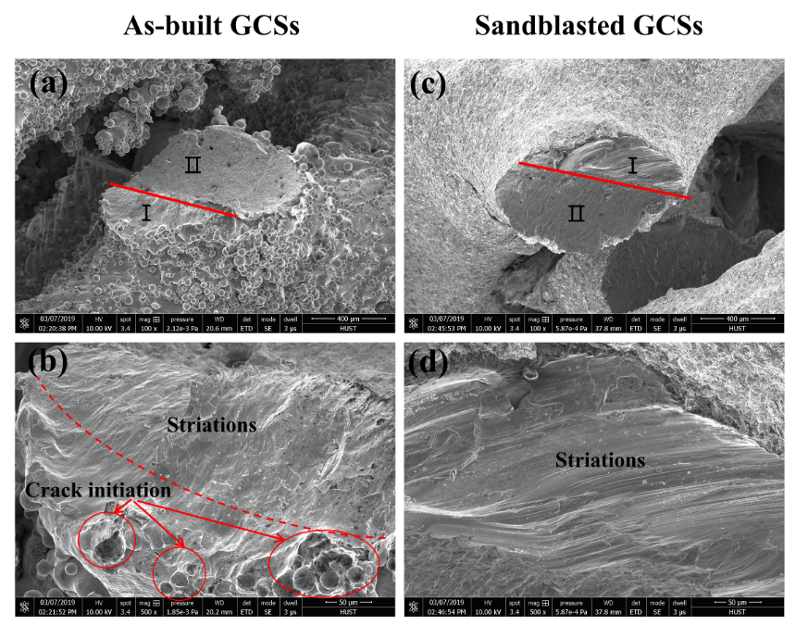
Fig. 11 Fracture surface morphology of GCSs before and after the fatigue testing: (a) and (c) show the typical fractures, (b) and (d) depict the crack initiation and propagation.

4 Discussion

4.1 Crack initiation and propagation
Ductile fracture process is the formation of cracks in metals due to the nucleation, growth and coalescence of voids [73]. The formulation of the isotropic Hosford–Coulomb model proposed by Mohr and Marcadet showed high accuracy in predicting the fracture of metals [73, 74]. The Hosford-Coulomb criterion can be described as,
(2)
(3)
is the Hosford equivalent stress [75]; , , and are three principal stresses; a, c, and denote the Hosford exponent, the friction coefficient and the cohesion, respectively. The Hosford-Coulomb model illustrated that the fracture initiation of ductile metal depends on three principal stresses.
However, It has been suggested that cracking in metalworking is associated with induced tensile stress for ductile fracture [76]. Cockroft and Latham have reported that fracture would occur when the integrated value of the described function reaches a critical value $C$. The reduced form of Cockroft-Latham function can be formulated as,
(4)
where $σ^{*}$ is the tensile stress, $ε_{f}$ is the fracture strain, and $C$ is a constant. Cockroft-Latham function demonstrates that ductile fracture is highly relevant to the maximum principal stress distributed in the porous structures.
Hosford-Coulomb models correspond to the current state of ductile fracture. However, Cockroft-Latham model could be more convenient for researchers and engineers to qualitatively analyse the possibility of cracking. Li et al. investigated the fatigue fracture of diamond-shape magnesium porous structures by experimental and FE methods and found that cracking was most likely caused by the tensile stresses that were concentrated at the strut junctions [58, 59].
In order to thoroughly analyse the deformation behaviour and stress level on the surfaces of GCS, a quarter model of one unit cell was extracted and unfolded to make all struts in a plane. The process is presented in Fig. 12. A Gyroid unit cell includes four equivalent sub-layers [21], and thus, the quarter model is enough to demonstrate the stress status of the whole model.
Fig. 12 Schematic of unfolding quarter Gyroid unit cell: a) Gyroid unit cell; b) quarter model; c) unfolded model.

Fig. 13 presents the schematic of the free body diagram of the struts and shows the deformation mode under compressive load. The longitudinal elongation and torsion of struts are neglected. Therefore, the general deformation mode of the inclined strut AB involves only lateral displacement with flexural rotation [77]. As shown in Fig. 13, the surface facing the rotate direction is pressed and forms a compressive stress region following the rotation of struts, while the surface opposite to the rotation direction is pulled and forms tensile stress region.

Fig. 13 Schematic of the free body diagram of the struts: a) the initial status; b) deformed status under the compressive loading.

FE analysis was also conducted to visually present the stress distribution. Fig. 14 and Fig. 15 present the maximum principal stress distribution on the surface of GCS under monotonic compressive loading. The FE results show that severe stress concentrates on the interior between two struts (region I) as well as centres of inclined struts (region C), whereas the lowest maximum principal stress with a negative stress value locates at the exterior between two struts (region O). The results show that under the cyclic compressive loading during the fatigue test, regions I and C experience serious tensile stress, which leads to crack nucleation and growth.
A local segmentation K in Fig. 14 was extracted and the local view is shown in Fig. 15. From the partial views along different directions, it is found that the tensile stress zone and the compressive stress zone appear in pairs. The former lies in region I and the latter in region O. Two region Is, coinciding with tensile stress, are on both upper and downward surfaces of one inclined strut, as every inclined strut connects with two horizontal struts. Fig. 15(b) shows that the compressive stress is helically distributed around the inclined struts. This interesting phenomenon is caused by the helical surface in the Gyroid structure.

Fig. 14 Maximum principal stress distribution on the surfaces of the deformed GCS.
Fig. 15 Partial views of segmentation K: a) Maximum principal stress distribution with both tensile and compressive stress, b) Maximum principal stress distribution only with compressive stress.
The FE results shown in Fig. 14 and 15 verify the analysis in Fig. 13. They demonstrate strong tensile stress concentrations on both the upper and downward surface of the inclined struts. The results indicate that cracks are easy to initiate and propagate at those two parts. This is in accordance with the experimental observation of Fig. 10.

4.2 The mechanism of fatigue
The fatigue mechanism of metallic lattice structures has been well investigated, and most of the attention has been paid on aluminium and titanium alloys. Two main mechanisms for the fatigue failure of lattice struts are proposed: cyclic ratcheting of the struts as well as the fatigue crack initiation and propagation.
Ratcheting is defined as the accumulation of plastic strain cycle-by-cycle for certain stress amplitude with non-zero mean stress [78]. McCullough et al. [72] attributed the fatigue failure of aluminium alloy foams to the progressive accumulation of strain by material ratcheting of the weakest cross-section, which was referred to as ‘cell edge’. Cracking was observed prior to the fatigue life on the cell edge. McCullough et al. [72] formulated the relationship of fatigue life upon relative density and load ratio R as,
(5)
where, is the relative density of GCS, is the monotonic yield strain of the parent material, and , p, n and are constants related to the material.
Zhou and Soboyejo [61] suggested that fatigue failure is mainly due to the formation and growth of surface cracks in connecting ligaments. However, a recent study illustrated that cyclic ratcheting and fatigue crack both play important roles in the fatigue damage of Ti-6Al-4V lattices [63, 66]. A model combing the effects of both cyclic ratcheting strain and damage strain was proposed by Li et al. [66]. The cycle damage (dD/dN) to the struts in the fatigue testing can be expressed as,
(6)
where, is the ductility of the material and , , and are constants related to the material.
However, it is worth noting that, in previous works [66, 72], the ratcheting rate model of strut edge was based on a uniaxial cyclic tension test of standard tensile bars [79]. Only the maximum loading stress during the fatigue test was considered in the derivation process, while local stress acting on the struts differed in unite cell types, due to topological effect [25] [36]. Considering different stress distributions, it would be more reasonable to use the local maximum stress (Von Mises stress or maximum tensile stress) to analyse the cycle damage as follows,
(7)
The data of the current study is insufficient to accurately predict the fatigue life or cycle damage (dD/dN). However, Eq. (5) ~ (7) describe the dependence of cyclic ratcheting and damage to the porous structures upon the stress level, relative density, and material constants. In this work, both cyclic ratcheting and the fatigue crack were observed, while the former dominated the fatigue failure of both as-built and sand-blasted GCSs. Eq. (5) ~ (7) imply that fatigue life is inversely proportional to loading stress, and the experimental results in Fig. 8 proved this.
Based on Eq. (7), it can be predicted that lowering the local stress level (for instance, topology optimization) on struts may enhance the fatigue life. TPMS structures may possess higher fatigue properties due to uniform stress distribution [25]. More comparison with other unit cell types will be carried out in section 4.2.1. Furthermore, the cyclic ratcheting and damage to the porous structure are closely related to the material-related constants. Therefore, it can be deduced that improving the mechanical properties of struts materials may accordingly improve the fatigue properties, which will be analysed in section 4.2.2.

4.2.1 The effect of unit cell type
Eqs. (5) and (6) only revealed the effects of macro factors, such as the loading stress amplitude, the loading ratio, and the macro-mechanical properties of the tested samples [63, 66, 72, 80]. However, the internal strut topology also plays an important role in the fatigue properties of porous structures through changing the stress distribution. Furthermore, Zhao et al. [63] and Li et al. [81] illustrated that the cyclic ratcheting is highly affected by the buckling/bending properties. By increasing the buckling force component, the cyclic ratcheting of inclined struts will decrease and the fatigue strength increases. As shown in Table 1, only the cubic lattice with buckling property owns a high fatigue ratio close to 0.5, while the value of other bending dominated lattices is roughly 0.1-0.36. In this paper, although the dominated deformation mode of struts is bending [18], both as-built and sand-blasted GCSs have higher fatigue ratio values of 0.35 before and 0.45 after sandblasting treatment, which can be attributed to the smooth surface connection between struts. The FE analysis of TPMS structures of Ref. [25] demonstrated that the SG cellular structure has a more uniform stress distribution under the loading and the stress values at different positions on the TPMS is small. To the contrary, the straight edges and sharp turns in strut-based cellular structures result in high-stress concentration near the joints [36]. Based on Eq. (7), the finer stress distribution on the surface of TPMS structures not only retards the cyclic ratcheting but also lowers the crack initiation and propagation, leading to higher monotonic compressive and fatigue properties.

Table 1 Comparison of the fatigue ratio of lattices consisted of different cell types
Cell type | Material | Fabrication method | Post-treatment | Ultimate cycles | Fatigue strength  (MPa) | Plateau Strength  (MPa) | Fatigue ratio | R | Reference
Cubic | Ti-6Al-4V | EBM | None | 10⁷ | 75 | 155.9 ± 10.6 | 0.48 | 0.1 | [63]
G7 | Ti-6Al-4V | EBM | None | 10⁷ | 9.8 | 59.6 ± 2.4 | 0.16 | 0.1 | [63]
Rhombic dodecahedron | Ti-6Al-4V | EBM | None | 10⁷ | 13.9 | 77.2 ± 6.5 | 0.20 | 0.1 | [63]
Rhombic dodecahedron | Ti-6Al-4V | EBM | None | 10⁷ | - | - | 0.1-0.2 | 0.1 | [66]
Diamond | Ti-6Al-4V | EBM | None | 10⁶ | - | - | 0.15-0.25 | 0.1 | [32]
Diamond | CoCr | SLM | None | 10⁶ | 20 | 55.14 ± 2.03 | 0.36 | 0.1 | [31]
Tetrahedron 500 | Pure titanium | SLM | None | 10⁶ | 70.90 | 417.70 ± 9.81 | 0.17 | 0.19 | [64]
Tetrahedron 500 | Pure titanium | SLM | None | 10⁶ | 12.50 | 100.65 ± 2.98 | 0.12 | 0.19 | [64]
Octahedron 500 | Pure titanium | SLM | None | 10⁶ | 130.6 | 453.04 ± 10.48 | 0.29 | 0.19 | [64]
Octahedron 1000 | Pure titanium | SLM | None | 10⁶ | 26.00 | 117.30 ± 5.98 | 0.22 | 0.19 | [64]
Gyroid | 316L | SLM | None | 2 × 10⁶ | 9.1* | 26.18 | 0.35 | 0.1 | This work
Gyroid | 316L | SLM | sandblasting | 2 × 10⁶ | 11.7* | 27.56 | 0.45 | 0.1 | This work

4.2.2 The effect of sandblasting
Besides the internal strut topology of porous structures, it has been documented that the fatigue properties of porous structures are also closely related to the mechanical properties and microstructure characteristics of parent materials [61, 82]. As illustrated in Eq. (7), the material constants are key factors and affect the final fatigue properties of porous structures. Gaudin and Feaugas observed that planer slip is recoverable and cross-slip attributes to ratcheting, due to the enhanced resistance of dislocation movement in cross slip [82]. Zhou and Soboyejo [61] revealed that the failure of open-cell aluminium foam occurs following the fatal transgranular fracture on coarse grains.
In sandblasting, high-speed aluminium oxide particles successively bombarded the surface of the GCSs, which not only removed the partially bonded powders but also resulted in severe local plastic deformation in the surface region. Since the partially melted particles contributed little to the mechanical properties, the removal of bonded powders only reduced the weight and surface roughness without affecting the mechanical properties [83]. However, the severe plastic deformation caused strain hardening on the surface of GCS [37]. The work hardening not only increased the stiffness and strength of GCSs, but also improved the fatigue property [37].
From the point of cyclic ratcheting, sandblasting process lowered the cyclic ratcheting strain of GCS, as shown in Fig. 7. The nano-crystalline zone together with the work hardening surface obtained from the sandblasting process improved the hardness and mechanical properties of the struts. The plastic strain was retarded by the enhanced surface and resulted in higher cyclic stability [84].
In terms of crack initiation and propagation, the sandblasting treatment also enhanced the structure and retarded crack nucleation and growth. The accumulated strain figure in Fig. 7(e) showed that nearly no fatigue damage strain was generated during the fatigue process. The fracture morphologies depicted in Fig. 11 showed that the early pore and cracks induced in the SLM process did not grow to lead fatal failure of struts after sandblasting treatment. This result may be explained by the fact that the sandblasting process removed the crack initiation points (i.e. bonded powder particles) [33]. Besides, the compressive residual stress was generated in the surface layer and contribute to fatigue life in term of lowering the tensile stress on the surface and retarding micro-crack nucleation or growth [37]. Local dislocations were pinned at the grain boundary in the deformed surface region during the sandblasting process, which causes difficulty in the micro-crack growth. Furthermore, it was experimentally observed that a nano-crystalline zone was formed on the surface layer of sandblasted samples, resulting in higher resistance to crack initiation [53, 85].
Similar results were also observed in 316L bulk samples [33, 68]. Due to the rough surface and initiated cracks and pores, the fatigue life of 316L processed by SLM [68] is lower than the ones fabricated by traditional methods [65, 67]. The fatigue ratio tested in [68] is 0.19, while the samples in [33] can only survive less than 2 × 10⁵ cyclic when the fatigue loading stress is 0.35 times of the ultimate strength. At the meantime, the fatigue resistance is drastically improved by the surface treatment for both traditional methods [65, 67] and SLM process [33, 68].

5 Conclusion and future outlook
In this paper, Gyroid type TPMS, a bionic artificial structure, was utilised to fabricate porous structures through selective laser melting. Both static compressive responses and high-cycle compression-compression fatigue responses of GCSs were investigated. The effect of adhered powder particles as well as sandblasting post-treatment on compression-compression behaviours of 316L GCSs was also illustrated. The main finding and conclusions drawn from this study are:
- The CT-reconstructed model and SEM figures illustrated that the bonded powder particles, which are commonly observed in powder-bed fused processes, have been successfully removed. The sand-blasted samples showed a smoother surface and a smaller deviation from the engineering design. The monotonic compressive mechanical properties are enhanced after the sandblasting process. In the static compression tests, both groups of 316L GCS showed high ductility and deformed to “honeycomb-like” structures.
- During the fatigue testing, three classical stages were found in the strain accumulation curves for most tested samples. The accumulated strain value per cycle decreases as the decrease of the maximum loading stress. Both cyclic ratcheting and fatigue damage phenomena were found and attributed to the failure of GCS during fatigue testing, while cyclic ratcheting still dominated the fatigue failure of both as-built and sand-blasted GCSs. The failure mode of as-built GCSs showed a switch from a nearly 45° fracture band to uniformly deformation, as the maximum loading stress has increased and was close to the yield stress of GCSs.
- A systematic investigation of the crack initiation was conducted by deformation analysis combined with the FE method. Results showed that cracks were easy to initiate and propagate on both the upper and lower surfaces of the inclined struts. The partially molten powder particles on the surface induced crack initiation points and accelerate the failure. Gyroid type TPMS cellular was found to have higher fatigue ratio values of 0.35 before and 0.45 after sandblasting treatment, which can be attributed to the smooth surface connection between struts.
- Sandblasting treatment significantly improved the fatigue resistance properties of GCSs. The nano-crystalline zone together with the work hardening surface obtained from the sandblasting process lowered the cyclic ratcheting. Crack nucleation was also greatly retarded by removing the crack initiation points and lowering the tensile stress on the surface in sandblasting.

6 Acknowledgements
The study was supported by the National Natural Science Foundation of China (Grant No. 51671091) and China Scholarship Council (No. 201706160036). The authors would like to thank anonymous reviewers and editors for their insightful comments, Dr Wei Li, Qing Teng, Jinliang Zhang, and Yuanjie Zhang for the assistance with the EBSD experiments, as well as the State Key Laboratory of Materials Processing and Die &Mould Technology for related measurements and characterization.

Reference:
[1] S.C. Kapfer, S.T. Hyde, K. Mecke, C.H. Arns, G.E. Schroder-Turk, Minimal surface scaffold designs for tissue engineering, Biomaterials 32(29) (2011) 6875-6882.
[2] S. Rajagopalan, R.A. Robb, Schwarz meets Schwann: design and fabrication of biomorphic and durataxic tissue engineering scaffolds, Med. Image Anal. 10(5) (2006) 693-712.
[3] C. Yan, L. Hao, A. Hussein, P. Young, Ti-6Al-4V triply periodic minimal surface structures for bone implants fabricated via selective laser melting, J. Mech. Behav. Biomed. Mater. 51 (2015) 61-73.
[4] A. Castro, T. Pires, J. Santos, B. Gouveia, P. Fernandes, Permeability versus Design in TPMS Scaffolds, Materials 12(8) (2019) 1313.
[5] F.P.W. Melchels, A.M.C. Barradas, C.A. van Blitterswijk, J. de Boer, J. Feijen, D.W. Grijpma, Effects of the architecture of tissue engineering scaffolds on cell seeding and culturing, Acta Biomater. 6(11) (2010) 4208-4217.
[6] J. Shi, L. Zhu, L. Li, Z. Li, J. Yang, X. Wang, A TPMS-based method for modeling porous scaffolds for bionic bone tissue engineering, Sci. Rep. 8(1) (2018) 7395.
[7] S. Vijayavenkataraman, L. Zhang, S. Zhang, J.Y. Hsi Fuh, W.F. Lu, Triply Periodic Minimal Surfaces Sheet Scaffolds for Tissue Engineering Applications: An Optimization Approach toward Biomimetic Scaffold Design, ACS Applied Bio Materials 1(2) (2018) 259-269.
[8] H.E. Burton, N.M. Eisenstein, B.M. Lawless, P. Jamshidi, M.A. Segarra, O. Addison, D.E.T. Shepherd, M.M. Attallah, L.M. Grover, S.C. Cox, The design of additively manufactured lattices to increase the functionality of medical implants, Mater. Sci. Eng., C 94 (2019) 901-908.
[9] C.A. Engh, J. Bobyn, A.H. Glassman, Porous-coated hip replacement. The factors governing bone ingrowth, stress shielding, and clinical results, The Journal of bone and joint surgery. British volume 69(1) (1987) 45-55.
[10] M.R.K. Ravari, S.N. Esfahani, M.T. Andani, M. Kadkhodaei, A. Ghaei, H. Karaca, M. Elahinia, On the effects of geometry, defects, and material asymmetry on the mechanical response of shape memory alloy cellular lattice structures, Smart Mater. Struct. 25(2) (2016) 025008.
[11] I. Maskery, A.O. Aremu, M. Simonelli, C. Tuck, R.D. Wildman, I.A. Ashcroft, R.J.M. Hague, Mechanical Properties of Ti-6Al-4V Selectively Laser Melted Parts with Body-Centred-Cubic Lattices of Varying cell size, Exp. Mech. 55(7) (2015) 1261-1272.
[12] D.S.J. Al-Saedi, S.H. Masood, M. Faizan-Ur-Rab, A. Alomarah, P. Ponnusamy, Mechanical properties and energy absorption capability of functionally graded F2BCC lattice fabricated by SLM, Mater. Des. 144 (2018) 32-44.
[13] S.M. Ahmadi, G. Campoli, S. Amin Yavari, B. Sajadi, R. Wauthle, J. Schrooten, H. Weinans, A.A. Zadpoor, Mechanical behavior of regular open-cell porous biomaterials made of diamond lattice unit cells, J. Mech. Behav. Biomed. Mater. 34 (2014) 106-15.
[14] S. Limmahakhun, A. Oloyede, K. Sitthiseripratip, Y. Xiao, C. Yan, Stiffness and strength tailoring of cobalt chromium graded cellular structures for stress-shielding reduction, Mater. Des. 114 (2017) 633-641.
[15] M. Dumas, P. Terriault, V. Brailovski, Modelling and characterization of a porosity graded lattice structure for additively manufactured biomaterials, Mater. Des. 121 (2017) 383-392.
[16] X.Y. Cheng, S.J. Li, L.E. Murr, Z.B. Zhang, Y.L. Hao, R. Yang, F. Medina, R.B. Wicker, Compression deformation behavior of Ti-6Al-4V alloy with cellular structures fabricated by electron beam melting, J. Mech. Behav. Biomed. Mater. 16 (2012) 153-62.
[17] O. Cansizoglu, O. Harrysson, D. Cormier, H. West, T. Mahale, Properties of Ti–6Al–4V non-stochastic lattice structures fabricated via electron beam melting, Mater. Sci. Eng., A 492(1-2) (2008) 468-474.
[18] C. Yan, L. Hao, A. Hussein, D. Raymont, Evaluations of cellular lattice structures manufactured using selective laser melting, Int. J. Mach. Tool. Manufact. 62 (2012) 32-38.
[19] A. Yánez, A. Cuadrado, O. Martel, H. Afonso, D. Monopoli, Gyroid porous titanium structures: A versatile solution to be used as scaffolds in bone defect reconstruction, Mater. Des. 140 (2018) 21-29.
[20] I. Maskery, A. Aremu, L. Parry, R. Wildman, C. Tuck, I. Ashcroft, Effective design and simulation of surface-based lattice structures featuring volume fraction and cell type grading, Mater. Des. (2018).
[21] L. Yang, R. Mertens, M. Ferrucci, C. Yan, Y. Shi, S. Yang, Continuous graded Gyroid cellular structures fabricated by selective laser melting: Design, manufacturing and mechanical properties, Mater. Des. 162 (2019) 394-404.
[22] A. Yanez, A. Herrera, O. Martel, D. Monopoli, H. Afonso, Compressive behaviour of gyroid lattice structures for human cancellous bone implant applications, Mater. Sci. Eng., C 68 (2016) 445-8.
[23] S. Khaderi, V. Deshpande, N. Fleck, The stiffness and strength of the gyroid lattice, Int. J. Solids Struct. 51(23-24) (2014) 3866-3877.
[24] F. Liu, Z. Mao, P. Zhang, D.Z. Zhang, J. Jiang, Z. Ma, Functionally graded porous scaffolds in multiple patterns: New design method, physical and mechanical properties, Mater. Des. 160 (2018) 849-860.
[25] L. Yang, C. Yan, C. Han, P. Chen, S. Yang, Y. Shi, Mechanical response of a triply periodic minimal surface cellular structures manufactured by selective laser melting, Int. J. Mech. Sci. 148 (2018) 149-157.
[26] F. Bobbert, K. Lietaert, A.A. Eftekhari, B. Pouran, S. Ahmadi, H. Weinans, A. Zadpoor, Additively manufactured metallic porous biomaterials based on minimal surfaces: A unique combination of topological, mechanical, and mass transport properties, Acta Biomater. 53 (2017) 572-584.
[27] C.N. Kelly, J. Francovich, S. Julmi, D. Safranski, R.E. Guldberg, H.J. Maier, K. Gall, Fatigue Behavior of As-Built Selective Laser Melted Titanium Scaffolds with Sheet-based Gyroid Microarchitecture for Bone Tissue Engineering, Acta Biomater. (2019).
[28] S. Bowman, X. Guo, D. Cheng, T. Keaveny, L. Gibson, W. Hayes, T. McMahon, Creep contributes to the fatigue behavior of bovine trabecular bone, J. Biomech. Eng. 120(5) (1998) 647-654.
[29] S.A. Khanoki, D. Pasini, Fatigue design of a mechanically biocompatible lattice for a proof-of-concept femoral stem, J. Mech. Behav. Biomed. Mater. 22 (2013) 65-83.
[30] M. Jamshidinia, L. Wang, W. Tong, R. Ajlouni, R. Kovacevic, Fatigue properties of a dental implant produced by electron beam melting® (EBM), J. Mater. Process. Technol. 226 (2015) 255-263.
[31] A. Cutolo, B. Neirinck, K. Lietaert, C. de Formanoir, B. Van Hooreweder, Influence of layer thickness and post-process treatments on the fatigue properties of CoCr scaffolds produced by laser powder bed fusion, Addit. Manuf. 23 (2018) 498-504.
[32] N.W. Hrabe, P. Heinl, B. Flinn, C. Korner, R.K. Bordia, Compression-compression fatigue of selective electron beam melted cellular titanium (Ti-6Al-4V), J. Biomed. Mater. Res. B Appl. Biomater. 99(2) (2011) 313-20.
[33] C. Elangeswaran, A. Cutolo, G.K. Muralidharan, C. de Formanoir, F. Berto, K. Vanmeensel, B. Van Hooreweder, Effect of post-treatments on the fatigue behaviour of 316L stainless steel manufactured by laser powder bed fusion, Int. J. Fatigue 123 (2019) 31-39.
[34] L. Yang, C. Yan, H. Fan, Z. Li, C. Cai, P. Chen, Y. Shi, S. Yang, Investigation on the orientation dependence of elastic response in Gyroid cellular structures, J. Mech. Behav. Biomed. Mater. 90 (2019) 73-85.
[35] I. Maskery, N.T. Aboulkhair, A.O. Aremu, C.J. Tuck, I.A. Ashcroft, Compressive failure modes and energy absorption in additively manufactured double gyroid lattices, Addit. Manuf. 16 (2017) 24-29.
[36] M. Smith, Z. Guan, W.J. Cantwell, Finite element modelling of the compressive response of lattice structures manufactured using the selective laser melting technique, Int. J. Mech. Sci. 67 (2013) 28-41.
[37] X.P. Jiang, X.Y. Wang, J.X. Li, D.Y. Li, C.S. Man, M.J. Shepard, T. Zhai, Enhancement of fatigue and corrosion properties of pure Ti by sandblasting, Mater. Sci. Eng., A 429(1-2) (2006) 30-35.
[38] P.S. Prevéy, J.T. Cammett, The influence of surface enhancement by low plasticity burnishing on the corrosion fatigue performance of AA7075-T6, Int. J. Fatigue 26(9) (2004) 975-982.
[39] G.S. Was, R.M. Pelloux, The effect of shot peening on the fatigue behavior of alloy 7075-T6, Metall. Trans. A 10(5) (1979) 656-658.
[40] H. Soyama, Comparison between the improvements made to the fatigue strength of stainless steel by cavitation peening, water jet peening, shot peening and laser peening, J. Mater. Process. Technol. 269 (2019) 65-78.
[41] D.A. Hollander, M. von Walter, T. Wirtz, R. Sellei, B. Schmidt-Rohlfing, O. Paar, H.-J. Erli, Structural, mechanical and in vitro characterization of individually structured Ti–6Al–4V produced by direct laser forming, Biomaterials 27(7) (2006) 955-963.
[42] J.-y. Xu, X.-s. Chen, C.-y. Zhang, Y. Liu, J. Wang, F.-l. Deng, Improved bioactivity of selective laser melting titanium: Surface modification with micro-/nano-textured hierarchical topography and bone regeneration performance evaluation, Mater. Sci. Eng., C 68 (2016) 229-240.
[43] I. Standard, ISO 13314: 2011 (E)(2011) Mechanical testing of metals—ductility testing—compression test for porous and cellular metals, Ref Number ISO, pp. 1-7.
[44] S.M. Ahmadi, R. Hedayati, Y. Li, K. Lietaert, N. Tümer, A. Fatemi, C.D. Rans, B. Pouran, H. Weinans, A.A. Zadpoor, Fatigue performance of additively manufactured meta-biomaterials: The effects of topology and material type, Acta Biomater. 65 (2018) 292-304.
[45] ISO 1099, Metallic Materials--Fatigue Testing--Axial Force-controlled Method, Third edition, International Organization for Standardization, 2017.
[46] G. Xu, K.Y. Luo, F.Z. Dai, J.Z. Lu, Effects of scanning path and overlapping rate on residual stress of 316L stainless steel blade subjected to massive laser shock peening treatment with square spots, Appl. Surf. Sci. 481 (2019) 1053-1063.
[47] T. Tancogne-Dejean, A.B. Spierings, D. Mohr, Additively-manufactured metallic micro-lattice materials for high specific energy absorption under static and dynamic loading, Acta Mater. 116 (2016) 14-28.
[48] B. Van Hooreweder, Y. Apers, K. Lietaert, J.P. Kruth, Improving the fatigue performance of porous metallic biomaterials produced by Selective Laser Melting, Acta Biomater. 47 (2017) 193-202.
[49] P. Heinl, L. Muller, C. Korner, R.F. Singer, F.A. Muller, Cellular Ti-6Al-4V structures with interconnected macro porosity for bone implants fabricated by selective electron beam melting, Acta Biomater. 4(5) (2008) 1536-44.
[50] Q. Han, H. Gu, S. Soe, R. Setchi, F. Lacan, J. Hill, Manufacturability of AlSi10Mg overhang structures fabricated by laser powder bed fusion, Mater. Des. 160 (2018) 1080-1095.
[51] J.-P. Kruth, P. Mercelis, J. Van Vaerenbergh, T. Craeghs, Feedback control of selective laser melting, Proceedings of the 3rd international conference on advanced research in virtual and rapid prototyping, 2007, pp. 521-527.
[52] D. Wang, Y. Yang, R. Liu, D. Xiao, J. Sun, Study on the designing rules and processability of porous structure based on selective laser melting (SLM), J. Mater. Process. Technol. 213(10) (2013) 1734-1742.
[53] X. Wang, D. Li, Mechanical, electrochemical and tribological properties of nano-crystalline surface of 304 stainless steel, Wear 255(7-12) (2003) 836-845.
[54] C. Bonatti, D. Mohr, Smooth-shell metamaterials of cubic symmetry: Anisotropic elasticity, yield strength and specific energy absorption, Acta Mater. 164 (2019) 301-321.
[55] C. Bonatti, D. Mohr, Mechanical performance of additively-manufactured anisotropic and isotropic smooth shell-lattice materials: Simulations & experiments, J. Mech. Phys. Solids 122 (2019) 1-26.
[56] D. Kong, X. Ni, C. Dong, L. Zhang, C. Man, X. Cheng, X. Li, Anisotropy in the microstructure and mechanical property for the bulk and porous 316L stainless steel fabricated via selective laser melting, Mater. Lett. 235 (2019) 1-5.
[57] S. Wen, S. Li, Q. Wei, C. Yan, Z. Sheng, Y. Shi, Effect of molten pool boundaries on the mechanical properties of selective laser melting parts, J. Mater. Process. Technol. 214(11) (2014) 2660-2667.
[58] Y. Li, K. Lietaert, W. Li, X.Y. Zhang, M.A. Leeflang, J. Zhou, A.A. Zadpoor, Corrosion fatigue behavior of additively manufactured biodegradable porous iron, Corros. Sci. 156 (2019) 106-116.
[59] Y. Li, H. Jahr, X.Y. Zhang, M.A. Leeflang, W. Li, B. Pouran, F.D. Tichelaar, H. Weinans, J. Zhou, A.A. Zadpoor, Biodegradation-affected fatigue behavior of additively manufactured porous magnesium, Addit. Manuf. 28 (2019) 299-311.
[60] R. Casati, J. Lemke, M. Vedani, Microstructure and Fracture Behavior of 316L Austenitic Stainless Steel Produced by Selective Laser Melting, J. Mater. Sci. Technol. 32(8) (2016) 738-744.
[61] J. Zhou, W.O. Soboyejo, Compression–compression fatigue of open cell aluminum foams: macro-/micro- mechanisms and the effects of heat treatment, Mater. Sci. Eng., A 369(1-2) (2004) 23-35.
[62] S. Zhao, S.J. Li, S.G. Wang, W.T. Hou, Y. Li, L.C. Zhang, Y.L. Hao, R. Yang, R.D.K. Misra, L.E. Murr, Compressive and fatigue behavior of functionally graded Ti-6Al-4V meshes fabricated by electron beam melting, Acta Mater. 150 (2018) 1-15.
[63] S. Zhao, S.J. Li, W.T. Hou, Y.L. Hao, R. Yang, R.D. Misra, The influence of cell morphology on the compressive fatigue behavior of Ti-6Al-4V meshes fabricated by electron beam melting, J. Mech. Behav. Biomed. Mater. 59 (2016) 251-64.
[64] D. Zhao, Y. Huang, Y. Ao, C. Han, Q. Wang, Y. Li, J. Liu, Q. Wei, Z. Zhang, Effect of pore geometry on the fatigue properties and cell affinity of porous titanium scaffolds fabricated by selective laser melting, J Mech Behav Biomed Mater 88 (2018) 478-487.
[65] H. Ueno, K. Kakihata, Y. Kaneko, S. Hashimoto, A. Vinogradov, Enhanced fatigue properties of nanostructured austenitic SUS 316L stainless steel, Acta Mater. 59(18) (2011) 7060-7069.
[66] S.J. Li, L.E. Murr, X.Y. Cheng, Z.B. Zhang, Y.L. Hao, R. Yang, F. Medina, R.B. Wicker, Compression fatigue behavior of Ti–6Al–4V mesh arrays fabricated by electron beam melting, Acta Mater. 60(3) (2012) 793-802.
[67] H.W. Huang, Z.B. Wang, J. Lu, K. Lu, Fatigue behaviors of AISI 316L stainless steel with a gradient nanostructured surface layer, Acta Mater. 87 (2015) 150-160.
[68] A. Riemer, S. Leuders, M. Thöne, H.A. Richard, T. Tröster, T. Niendorf, On the fatigue crack growth behavior in 316L stainless steel manufactured by selective laser melting, Eng. Fract. Mech. 120 (2014) 15-25.
[69] C. Leopold, M. Schütt, W. Liebig, T. Philipkowski, J. Kürten, K. Schulte, B. Fiedler, Compression fracture of CFRP laminates containing stress intensifications, Materials 10(9) (2017) 1039.
[70] N. Biswas, J.L. Ding, V.K. Balla, D.P. Field, A. Bandyopadhyay, Deformation and fracture behavior of laser processed dense and porous Ti6Al4V alloy under static and dynamic loadinge, Mater. Sci. Eng. A 549 (2012) 213-221.
[71] J. Kadkhodapour, H. Montazerian, A. Darabi, A.P. Anaraki, S.M. Ahmadi, A.A. Zadpoor, S. Schmauder, Failure mechanisms of additively manufactured porous biomaterials: Effects of porosity and type of unit cell, J. Mech. Behav. Biomed. Mater. 50 (2015) 180-91.
[72] K. McCullough, N. Fleck, M. Ashby, The stress-life fatigue behaviour of aluminium alloy foams, Fatigue Fract. Eng. Mater. Struct. 23(3) (2000) 199-208.
[73] D. Mohr, S.J. Marcadet, Micromechanically-motivated phenomenological Hosford–Coulomb model for predicting ductile fracture initiation at low stress triaxialities, Int. J. Solids Struct. 67-68 (2015) 40-55.
[74] G. Gu, D. Mohr, Anisotropic Hosford–Coulomb fracture initiation model: Theory and application, Eng. Fract. Mech. 147 (2015) 480-497.
[75] W. Hosford, A generalized isotropic yield criterion, J. Appl. Mech. 39(2) (1972) 607-609.
[76] M. Cockcroft, D. Latham, Ductility and the workability of metals, J Inst Metals 96(1) (1968) 33-39.
[77] R. Hedayati, M. Sadighi, M. Mohammadi-Aghdam, A.A. Zadpoor, Mechanics of additively manufactured porous biomaterials based on the rhombicuboctahedron unit cell, J. Mech. Behav. Biomed. Mater. 53 (2016) 272-94.
[78] G. Kang, Ratchetting: recent progresses in phenomenon observation, constitutive modeling and application, Int. J. Fatigue 30(8) (2008) 1448-1472.
[79] M.M. Megahed, A.R.S. Ponter, C.J. Morrison, Experimental investigations into the influence of cyclic phenomena of metals on structural ratchetting behaviour, Int. J. Mech. Sci. 26(11) (1984) 625-638.
[80] Y. Jiang, H. Sehitoglu, Modeling of cyclic ratchetting plasticity, part I: development of constitutive relations, J. Appl. Mech. 63(3) (1996) 720-725.
[81] S.J. Li, Q.S. Xu, Z. Wang, W.T. Hou, Y.L. Hao, R. Yang, L.E. Murr, Influence of cell shape on mechanical properties of Ti-6Al-4V meshes fabricated by electron beam melting method, Acta Biomater. 10(10) (2014) 4537-47.
[82] C. Gaudin, X. Feaugas, Cyclic creep process in AISI 316L stainless steel in terms of dislocation patterns and internal stresses, Acta Mater. 52(10) (2004) 3097-3110.
[83] A. Hussein, L. Hao, C. Yan, R. Everson, P. Young, Advanced lattice support structures for metal additive manufacturing, J. Mater. Process. Technol. 213(7) (2013) 1019-1026.
[84] J. Long, Q. Pan, N. Tao, M. Dao, S. Suresh, L. Lu, Improved fatigue resistance of gradient nanograined Cu, Acta Mater. 166 (2019) 56-66.
[85] T. Hanlon, Y.-N. Kwon, S. Suresh, Grain size effects on the fatigue response of nanocrystalline metals, Scripta Mater. 49(7) (2003) 675-680.

*Corresponding author Tel.: +86 027 87558155, E-mail address: c_yan@hust.edu.cn (Chunze Yan). Tel.: +32 16 324999, E-mail address: shoufeng.yang@kuleuven.be (Shoufeng Yang).

