BJS and Anaesthesia Perioperative Care: joint special issue
Framework for prehabilitation services

Leading Article (1250 words, 10 references)
Andrew Bates¹⁻³, Malcolm A. West¹⁻³, Sandy Jack¹⁻³

¹ Anaesthesia and Critical Care Research Area, NIHR Biomedical Research Centre, University Hospital Southampton NHS Foundation Trust, CE93, MP24, Tremona Road, Southampton, UK
² Integrative Physiology and Critical Illness Group, Clinical and Experimental Sciences, Faculty of Medicine, University of Southampton, CE93, MP24, Tremona Road, Southampton, UK
³ Academic Unit of Cancer Sciences, Faculty of Medicine, University of Southampton, South Academic Block, Tremona Road, Southampton, UK

Improved surgical and anaesthetic techniques, enhanced recovery pathways and peri-operative care have delivered consistent improvements in hospital stay and readmission rates following major surgery. Half of patients over the age of 60, will be living with reduced functional capacity 6-months after abdominal surgery, with a significant proportion never returning to independent living (1). If survival came at the cost of severe functional impairment, 75% of patients would decline life-saving treatment (2) so regaining independence following major surgery is clearly a high-priority, patient-centred outcome.
Shared decision-making is a key tenet of the Long Term Plan’s commitment to personalised care and is supported by the Royal Colleges. In order for patients to make truly informed decisions prior to surgery, it is reasonable that they ask two questions of clinicians;
- What risks do I face, according to my personal condition and treatment choices?
A growing body of evidence demonstrates that objectively measured physical fitness, nutritional status and psychological well-being are predictive of post-operative recovery. However, subjective clinician assessment of physical function, with highly variable nutritional, physiological and psychological assessment, remains the dominant technique. It is increasingly evident that such methods are inadequate (3). Patients are exposed to heterogenous risk stratification, with worrying implications for shared decision-making, tailored optimisation and perioperative resource allocation. A reduction in perioperative variability using objective, integrated risk stratification is urgently needed to improve and streamline care (4).
- Can anything be done to mitigate risk?
Patients arriving at the doorstep of major elective surgery rarely benefit form a tailored perioperative optimisation package, mainly due to surgical pathways designed with different aims in mind and rigid time constraints between the time surgery is first contemplated and the actual surgical date, especially for cancer patients. Improvements in post-operative outcomes, following pre-operative exercise regimens (5), nutritional supplementation (6) and psychological preparation (7) have been reported. It is increasingly evident that the 3 domains of exercise, nutrition and psychology, provide complementary benefit, encouraging a multi-modal approach to prehabilitation (8).
Aligning with the 2019 Principles and Guidance for Prehabilitation (9), and the Getting It Right First Time (https://gettingitrightfirsttime.co.uk) movement, a reduction in perioperative variability to stream line care and improve outcomes is urgently needed. We propose a step-wise framework for re-engineering local peri-operative services, aimed at transitioning between screening, assessment and intervention enabling multi-level benefits of tailored risk assessment and personalised interventions.
Screening
Undertaking screening as close as possible to patient referral, in some cases prior to diagnosis, allows sufficient time to identify and mitigate risk without threatening time to surgery. There is a wide range of candidate screening tools for all 3 domains. These tools should be validated, generalisable, simple to apply and with patient-specific cut-offs, sensitive enough to trigger specialist intervention.
Such a ‘patient staging’ vs. a ‘tumour focused staging’ approach adds value to multi-disciplinary team (MDT) presentations, thereby adding considerable value to shared-decision making in MDT/ perioperative medicine/ pre-assessment clinics. Screening tools can be applied by unregistered healthcare professionals in a highly protocolised manner.

Screening protocols should contain validated self-reporting questionnaires (Duke Activity Status Index, Clinical/ Edmonton Frailty Score and the International Physical Activity Questionnaire) as well as objective elements (timed-up and-go test and the Incremental shuttle walk test. Nutrition screening tools, accounting for personal causes of malnutrition, presenting complaint, co-morbidity and barriers to adequate dietary intake are recommended by t
he European Society for Clinical Nutrition and Metabolism (10). Psychometric screening tools (
Patient Activation Measure and Hospital Anxiety and Depression Scale) are capable to identify psychological factors that may negatively impact post-operative outcomes. These tools provide a baseline assessment with the potential of being repeated after an intervention.
Patients who are screened as ‘low-risk’ will be offered the universal interventions summarised in the intervention section below. At risk patients will be triaged towards specialist interventional services.
Assessment
Patients screened ‘at risk’, in any of the 3 domains, will receive a comprehensive assessment, from a registered healthcare specialist, encompassing identification of the specific deficit and informing a personalised prescription of targeted, specialist intervention.
Objective physical fitness assessment using the 6-minute walk-test (simple and requiring minimal equipment) or CardioPulmonary Exercise Testing (CPET (11) can be used to derive exercise prehabilitation prescriptions.
Specialist dieticians employ assessment techniques incorporating dietary habits, impact of disease, anthropometric measurements, functional assessment, measurements of body composition and biochemistry (10) to derive nutritional prehabilitation prescriptions.
Psychological assessment consisting of validated psychometric tests or face-to face interview techniques are able to direct psychological prehabilitation prescriptions (12).
Intervention
Patients may require any combination of universal, targeted or specialist for any of the 3 domains. Degree of need is dynamic and requires re-assessment (See Fig.1). We strongly recommended that interventions are monitored for effectiveness, tailored to specific treatment modalities and developed according to local need, with robust data collection systems.
Low risk patients should be guided to resources which promote healthy-eating (13), exercise (14) and behaviour change (15), with referral to local health referral schemes.
Peri-operative education programmes such as surgery school can yield positive effects on post-operative outcomes as this period offers a particular “teachable moment”. Specific perioperative quality improvement programmes may allow integration of enhanced recovery programms especially for cancer patients (16).
Physical fitness: Exercise prescription should include frequency, intensity, time and type of exercise. Current recommendations (14) for adults suggest 150 minutes per week of moderate intensity aerobic exercise; or 75 minutes at vigorous intensity; or a combination of moderate, vigorous and very vigorous. Aerobic sessions should be interspersed with two sessions of strengthening exercises per week.

Targeted interventions can safely take place within a community facility but such a lifestyle change can present significant challenges to patients. Appointment-based, local and supervised facilities are likely to increase adherence.
Specialist interventions, for those with underlying health conditions or significant deconditioning, may require some adaptation, but broadly follow the same exercise guidance. Due to elevated safety risk, these should be supervised by qualified and registered exercise professionals within a place of safety, for example the referring hospital.
Nutrition: Preoperative nutritional support should begin as soon as risk is identified. Focus on ensuring sufficient intake of protein, energy and micro-nutrients, to support anabolism, immune function and maintain body weight. It is important to consider additional nutritional requirements arising from increased exercise in a multimodal prehabilitation programme. Dietetic clinicians should refer to consensus guidance for perioperative nutritional support (10).
Prescribed, targeted treatment plans may include therapeutic diets, fortified foods, dietetic counselling and oral nutritional supplementation.
Specialist nutritional support such as enteral and or parenteral nutrition, will be delivered within a specialist treatment centre.
In order to induce a metabolically replete state at the point of surgery, patients should not be fasted overnight and should receive pre-operative carbohydrate loading. This and other strategies should form part of surgery-specific enhanced recovery programms (17).
Psychology: Preoperative psychological factors, including anxiety, depression, acute stress and low levels of self-efficacy are associated with delayed post-operative recovery (7).
Guidelines for management of anxiety and depression in cancer patients highlight the importance of stratification and guidance for implementation of a stepped care model. Targeted behavioural techniques including relaxation, counselling and emotion management interventions confer benefit (18).
Patients with pre-existing, severe psychopathology identified at assessment, should receive specialist psychological or psychiatric therapies.

Considerations for development of local prehabilitation service:
- Assess and map your surgical pathways – how might they be amended to accommodate prehabilitation? Positive change can be affected within just 2 weeks
- Gain clinical buy-in - prehabilitation crosses multiple clinical specialities and should be delivered by a specialist multidisciplinary team
- Does an existing service offer prehabilitation? There are a number of local health referral schemes to both gymnasia and well-being services. How effective are these?
- Can you align with existing rehabilitation services?
- Recommendations for specific interventions are dependent on local surgical cohort
- Assess capacity for delivery – assess local availability, within primary care, community services and in-hospital.
- Cost – this will depend on the assessment of the above considerations
- Co-design – prehabilitation services should be designed with the expert guidance of patient experience
- Quality assurance, audit and data – robust data collection focussing on patient reported outcomes is essential for service development, business case planning and quality improvement.
- For clinicians interested in prehabilitation, we recommend making contact one of the growing number of local groups offering prehabilitation services listed in the Macmillan Prehabilitation document (9).

There is a vast portfolio of evidence describing the benefits of exercise, nutrition and psychological wellbeing across the full-range of chronic health conditions. The threat posed by major surgery provides a teachable moment during which specialists can assist patients to contribute proactively to their care, in ways that are beneficial not only to their peri-operative outcomes, but also their longer-term health.

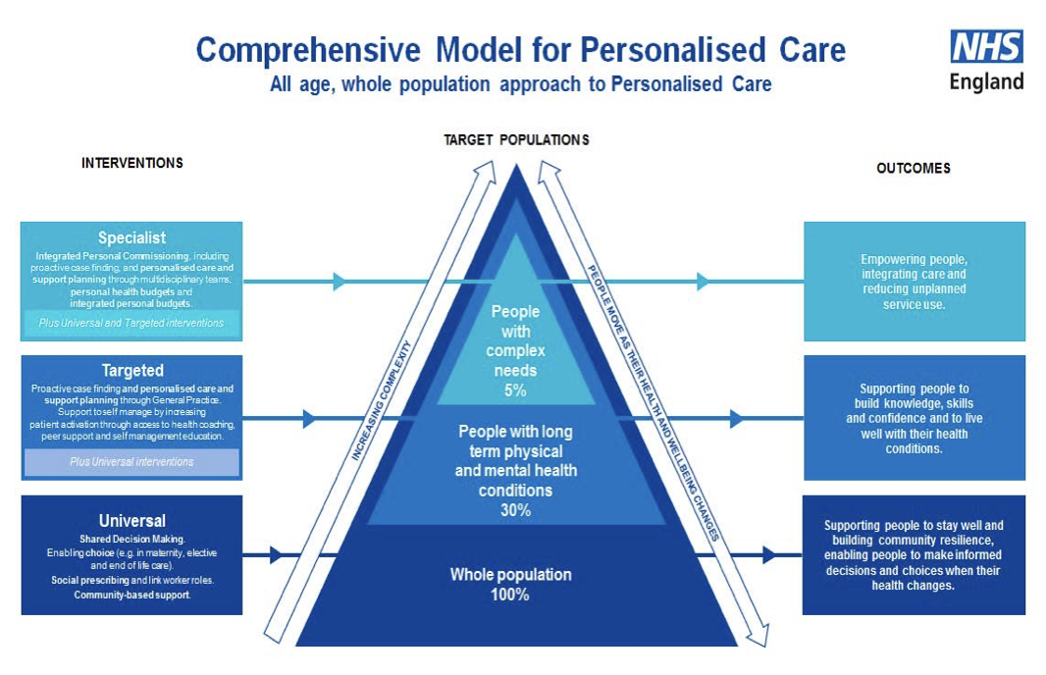
Figure 1: Patients facing elective surgical resection will have diverse needs. Screening will identify those with universal needs. Individuals who screen positive to risk will require comprehensive assessment which will inform targeted therapeutic intervention. Patients with complex health needs require specialist help, prescribed and delivered by suitably qualified and experienced healthcare professionals.
Source: NHS England. Universal Personalised Care: Implementing the Comprehensive Model. January 2019. https://www.england.nhs.uk/wp-content/uploads/2019/01/universal-personalised-care.pdf >

References:
1. Lawrence VA, Hazuda HP, Cornell JE, Pederson T, Bradshaw PT, Mulrow CD, et al. Functional independence after major abdominal surgery in the elderly. J Am Coll Surg [Internet]. 2004 Nov 1 [cited 2019 Sep 20];199(5):762–72. Available from: https://www.sciencedirect.com/science/article/abs/pii/S1072751504009226
2. Fried TR, Bradley EH, Towle VR, Allore H. Understanding the Treatment Preferences of Seriously Ill Patients. N Engl J Med [Internet]. 2002 Apr 4 [cited 2019 Sep 20];346(14):1061–6. Available from: http://www.nejm.org/doi/abs/10.1056/NEJMsa012528
3. Wijeysundera DN, Pearse RM, Shulman MA, Abbott TEF, Torres E, Ambosta A, et al. Assessment of functional capacity before major non-cardiac surgery: an international, prospective cohort study [Internet]. Vol. 391, The Lancet. 2018 [cited 2019 Sep 20]. Available from: www.thelancet.com
4. Workstreams - Getting It Right First Time - GIRFT [Internet]. [cited 2019 Sep 27]. Available from: https://gettingitrightfirsttime.co.uk/workstreams/
5. Moran J, Guinan E, McCormick P, Larkin J, Mockler D, Hussey J, et al. The ability of prehabilitation to influence postoperative outcome after intra-abdominal operation: A systematic review and meta-analysis. Surgery [Internet]. 2016 Nov 1 [cited 2019 Sep 24];160(5):1189–201. Available from: https://www.sciencedirect.com/science/article/pii/S0039606016301520
6. Burden S, Todd C, Hill J, Lal S. Pre-operative Nutrition Support in Patients Undergoing Gastrointestinal Surgery. Cochrane Database Syst Rev [Internet]. 2012 Nov 14 [cited 2019 Sep 24]; Available from: http://doi.wiley.com/10.1002/14651858.CD008879.pub2
7. Powell R, Scott NW, Manyande A, Bruce J, Vögele C, Byrne-Davis LM, et al. Psychological preparation and postoperative outcomes for adults undergoing surgery under general anaesthesia. Cochrane Database Syst Rev [Internet]. 2016 May 26 [cited 2019 Sep 24];(5). Available from: http://doi.wiley.com/10.1002/14651858.CD008646.pub2
8. Hijazi Y, Gondal U, Aziz O. A systematic review of prehabilitation programs in abdominal cancer surgery. Int J Surg [Internet]. 2017 Mar 1 [cited 2019 Sep 27];39:156–62. Available from: https://www.sciencedirect.com/science/article/pii/S1743919117301164?via%3Dihub
9. Macmillan, Royal College of Anaesthetists N. Principles and guidance for prehabilitation within the management and support of people with cancer In partnership with Acknowledgements [Internet]. 2019 [cited 2019 Sep 20]. Available from: https://www.macmillan.org.uk/_images/prehabilitation-guidance-for-people-with-cancer_tcm9-353994.pdf
10. Weimann A, Braga M, Carli F, Higashiguchi T, Hübner M, Klek S, et al. ESPEN guideline: Clinical nutrition in surgery. Clin Nutr [Internet]. 2017 Jun 1 [cited 2019 Sep 20];36(3):623–50. Available from: http://www.ncbi.nlm.nih.gov/pubmed/28385477
11. Levett DZH, Jack S, Swart M, Carlisle J, Wilson J, Snowden C, et al. Perioperative cardiopulmonary exercise testing (CPET): consensus clinical guidelines on indications, organization, conduct, and physiological interpretation. Br J Anaesth [Internet]. 2018 [cited 2019 Sep 27];120(3):484–500. Available from: www.poetts.co.uk
12. Levett DZH, Grimmett C. Psychological factors, prehabilitation and surgical outcomes: evidence and future directions. Anaesthesia [Internet]. 2019 Jan [cited 2019 May 23];74:36–42. Available from: http://doi.wiley.com/10.1111/anae.14507
13. One You [Internet]. [cited 2019 Sep 24]. Available from: https://www.nhs.uk/oneyou
14. UK Chief Medical Officers’ Physical Activity Guidelines [Internet]. 2019 [cited 2019 Sep 27]. Available from: https://assets.publishing.service.gov.uk/government/uploads/system/uploads/attachment_data/file/832868/uk-chief-medical-officers-physical-activity-guidelines.pdf
15. Overview | Behaviour change: individual approaches | Guidance | NICE. [cited 2019 Sep 27]; Available from: https://www.nice.org.uk/Guidance/PH49
16. Moore JA, Conway DH, Thomas N, Cummings D, Atkinson D. Impact of a peri-operative quality improvement programme on postoperative pulmonary complications. Anaesthesia [Internet]. 2017 Mar 1 [cited 2019 Sep 27];72(3):317–27. Available from: http://doi.wiley.com/10.1111/anae.13763
17. Gillis C, Carli F. Promoting Perioperative Metabolic and Nutritional Care. Anesthesiology [Internet]. 2015 Dec 1 [cited 2019 Sep 27];123(6):1455–72. Available from: http://insights.ovid.com/crossref?an=00000542-201512000-00038
18. Butow P, Price MA, Shaw JM, Turner J, Clayton JM, Grimison P, et al. Clinical pathway for the screening, assessment and management of anxiety and depression in adult cancer patients: Australian guidelines. 2015 [cited 2019 Sep 27]; Available from: https://onlinelibrary.wiley.com/doi/pdf/10.1002/pon.3920

