**An investigation into the geometric effect on the manufacturing accuracy of triply periodic minimal surface structures with graded density fabricated by selective laser melting**

*Lei Yang a, b, Massimiliano Ferrucci b, Raya Mertens b, Wim Dewulf b, Chunze Yan a,[1], Yusheng Shi a, Shoufeng Yang b, c,\**

*a State Key Laboratory of Materials Processing and Die & Mould Technology, School of Materials Science and Engineering, Huazhong University of Science and Technology, Wuhan 430074, China*

*b Department of Mechanical Engineering, KU Leuven (Catholic University of Leuven), 3001 Leuven, Belgium, Member of Flanders Make*

*c Materials Research Group, Faculty of Engineering and the Environment, University of Southampton, Southampton, UK, SO17 1BJ*

**Abstract:** Triply periodic minimal surfaces (TPMSs) have attracted increasing attention for their high manufacturability and biocompatibility and mechanical properties. In this work, graded Gyroid cellular structures with varying gradient directions were mathematically designed and manufactured via selective laser melting (SLM). The effect of gradient on manufacture accuracy of these structures was investigated. The results indicate that the geometry play an important role on manufacturing accuracy, due to the enlarged dimension and bonded powder particles. Decreasing density along the building direction will effectively reduce the amount of bonded powder particles. These findings illustrate the high manufacturability of graded cellular structures.

**Keywords:** Graded cellular structure; Selective Laser Melting; Triply Periodic Minimal Surface; X-ray computed tomography.

## 1 Introduction

The Gyroid surface, first discovered by Luzzati et al. in 1967 [1, 2], is one type of Triply periodic minimal surfaces (TPMSs) with mean curvature radius of zero [3]. TPMS cellular is stated as the most promising structure for biological applications, due to high manufacturability in additive manufacturing (AM) process, uniform stress distribution under loading, highly similar structure to bone tissue (such as larger surface area, high permeability, interconnected open cell structure) [4-6]. In recent years, much attention has been paid to TPMS cellular, especially Gyroid cellular structure (GCS). Hao et al. successfully fabricated GCS with the unit cell size ranging from 2 mm to 8 mm using the SLM technique, and illustrated the high manufacturability of GCS structures [7]. Hussein et al. designed more efficient support structures using GCS for SLM process to reduce material consumption and built time [8]. Yang et al. numerically studied the GCS under compressive loading and demonstrated a much more uniform stress and strain distribution compared to other lattice structures [9]. Montazerian et al. performed the compression testing of GCS and suggest a great potential for GCS to be served in design and manufacturing of graded porosity scaffolds with a comprehensive property with high permeability and mechanical properties [10]. Besides, the microstructure, surface modification and orientation dependence properties of GCS have also been systematically investigated [11-13].

However, although possessing high manufacturability, the SLM-made Gyroid cellular structures (GCS) exhibit a certain amount of error compared to the designed STL file [8, 14]. To the best of our knowledge, limited literature has been published to investigate reasons for the error. Researchers investigated the error only from the perspective of AM process. Step-stair and bonded powder particles are normally the key factors for the manufacturing accuracy of SLM-made parts, due to the nature of the powder-bed AM process. The step-stair phenomenon is caused by the limitation of slicing resolution [15], while the partially molten particles are bonded on the surface due to the heat effect around the melting pool [16]. Besides, as the laser starts from the boundary with an acceleration and the high speed moving laser needs to decelerate at the end of each scanning track, the molten pool at the boundary normally exceeds the designed boundary, resulting in enlarged dimension [17, 18].

However, the effect of the geometric feature on manufacture accuracy is also fully investigated. Therefore, in this paper, uniform GCS and continuous graded GCSs were designed and fabricated by SLM. The X-ray computed tomography (CT) was used to analyse and compare the reconstructed model with designed STL file. Mathematical equations were developed to analyse the results and are found to be reasonable and suitable to explain the observed phenomenon. These findings give a quantitative interpretation of the geometric effect on manufacture accuracy and provide a guide on the optimisation of cellular structures.

## 2 Experimental methodology

## 2.1 Design process

Gyroid surface can be generated through the mathematical equation,

 (1),

where *a* is the unit cell size, and parameter *t* controls the volume surrounded by the Gyroid surface. MATLAB (Mathworks Inc., USA) software was utilized to design the Gyroid unit cell. The parameter *a*=4 in all structures of this study, making each Gyroid unit cell 4 mm × 4 mm × 4 mm in size. The uniform Gyroid unit cell with a constant volume fraction can be obtained by using a constant *t*, as shown in Fig. 1(a), while a graded Gyroid unit cell can be gained through linear changing the value of *t* in Z direction, as shown in Fig. 1(b). Throughout this method, U-GCS and G-GCSs consisting of five unit cells were modelled in cubes of dimensions 20×20×20 mm, thus providing cellular structures containing 5 layers. The RD of U-GCS is 15%, as shown in Fig. 1(c). The continuous graded Gyroid cellular structures with a density gradient along the building direction (G1-GCS) were designed with density decreasing continuously and gradually from 20% (bottom layer) to 10% (top layer), as shown in Fig. 1(d). To investigate effect of gradient perpendicular to the building direction, the model in Fig. 1(d) was rotated by 90° with respect to *x* axial and named G2-GCS with the RD changing along Y, as shown in Fig. 1(e).

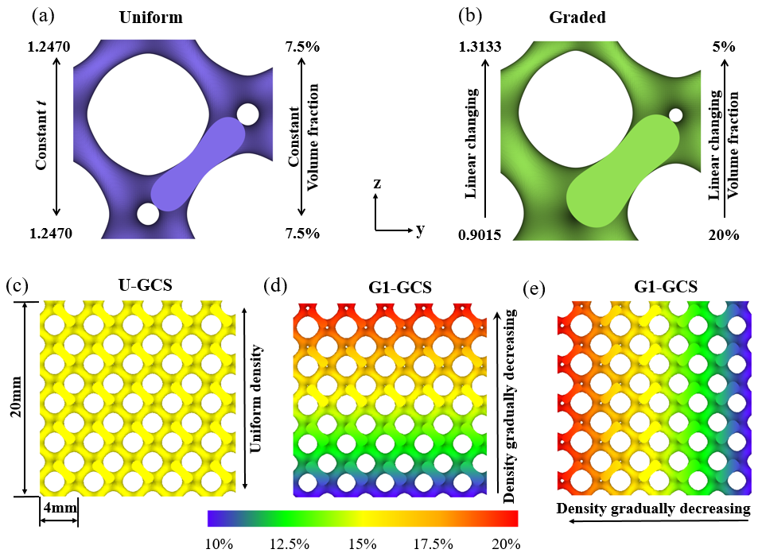

**Fig. 1.** Gyroid unit cell: (a) topology, (b) uniform unit cell, (c) continuous graded Gyroid unit cell, (d) uniform Gyroid unit cell, (e) continuous Gyroid with the gradient in the z-direction, and (f) continuous Gyroid with the gradient in the y-direction.

## 2.2 manufacturing process

The SLM process was manufactured on an M-lab cusing instrument (Concept Laser GmbH, Germany) with a 100W fibre laser. A 316 powder (Praxair Surface Technologies, Inc.) was used with Gaussian distribution and D-values: D10 = 19μm, D50 = 31μm & D90 = 49μm. Based on an initial parameter optimization, the optimized processing parameters for the 316L powder are: laser power of 90W, hatch spacing of 0.077mm, scanning speed of 600mm/s, and layer thickness of 30μm. The processing was performed at an atmosphere filled with high purity argon in the building chamber. When the manufacturing was completed, all samples were then removed from the base plate via wire Electrical Discharge Machining (Wire-EDM) and cleaned in absolute ethyl alcohol by using ultrasonic to remove the trapped loose powder.

## 2.3 Measurement and characterization

The dimensions and weight of as-built samples were measured with a vernier calliper and electronic balance, respectively. The RD of the fabricated cellular structure was determined by dividing the measured density of cellular structures by the density of the matrix material (8.00 g/cm3 for 316L stainless steel). For each type of structures, one sample was scanned by a Nikon XT H 225 ST (Nikon Metrology NV, Belgium) to determine the actual volume and VF. The volume fraction (VF), which is equivalent to RD for homogeneous material [19], was determined by dividing the measured volume by the total cubic volume of the cellular structure using X-ray computed tomography (CT). CT measurements were performed under 200 kV X-ray source acceleration voltage and 160 µA current. Detector exposure was set to 1000ms and a 0.25mm thick Sn filter was used to remove low-energy X-rays, thereby reducing the effects of beam hardening. Two-dimensional (2D) radiographic projections of the cellular structures were acquired at 3142 equally-spaced rotation positions of the sample stage, corresponding to angular increments between adjacent projections of 0.1145°. The structures were tomographically reconstructed with CT Pro 3D (Nikon Metrology NV, Belgium) from the set of acquired radiographic images. The reconstructed volumetric model consists of isotropic voxels with side lengths of 19.5 µm; each voxel is assigned a grey value corresponding to the X-ray attenuation of the material contained within the voxel. Further analysis and visualization were performed on commercially available volumetric analysis software VG Studio MAX 3.1 (Volume Graphics GmbH, Germany). The surface of the structure is determined by defining a grey value threshold. The volume of the structure can then be calculated from the resulting surface model.

## 3 Results and discussion

## 3.1 Relative density and volume fraction of as-built GCSs

Table 1 shows the measured dimensions, weight, and calculated relative densities of fabricated GCS samples. The values show that GCSs were consistently manufactured by SLM. The data in Table 1 also indicate that the measured dimensions of the manufactured GCSs deviate from their engineering designs. The measured dimensions along X and Y are consistently larger than their designed specifications, while the measured dimensions along Z are consistently smaller, due to the loss of height, when the components were cut off from the baseplate by EDM [20].

**Table 1.** Dimensions, weight and densities of fabricated GCS samples.

|  |  |  |  |  |  |  |
| --- | --- | --- | --- | --- | --- | --- |
| **Designed cellular** | **Sample number** | **Actual dimensions**  **of cellular cubic** | **Weight** | **Actual $$ρ^{*}$$** | **Average $$ρ^{*}$$** | **Deviation** |
|  |  | **(mm)** | **(g)** | **(%)** | **(%)** | **(%)** |
| **U-GCS** | **1** | 20.04 × 20.02 × 19.63 | 10.30 | 16.35 | 16.33 | 8.87 |
| **2** | 20.04 × 20.04 × 19.67 | 10.32 | 16.33 |
| **3** | 20.04 × 20.06 × 19.55 | 10.25 | 16.30 |
| **G1-GCS** | **1** | 20.04 × 20.06 × 19.61 | 10.03 | 15.91 | 15.91 | 6.60 |
| **2** | 20.02 × 20.04 × 19.54 | 9.95 | 15.89 |
| **3** | 20.04 × 20.04 × 19.59 | 10.02 | 15.93 |
| **G2-GCS** | **1** | 20.06 × 20.06 × 19.52 | 10.25 | 16.32 | 16.34 | 8.93 |
| **2** | 20.04 × 20.00 × 19.61 | 10.30 | 16.37 |
| **3** | 20.02 × 20.06 × 19.61 | 10.29 | 16.33 |

The RD values in Table 1 also indicate that measured RD over the entire sample was consistently higher than the specified value of 15% due to enlarged strut diameter and adhered powder on the surfaces [8, 9]. The enlarged strut diameter and adhered powder can be attributed to larger molten pool caused by lack of cooling [8] and more energy input on the boundary [17, 18]. As the specific surface area per unit volume (the ratio of surface area to volume) of the cellular structure is higher than the bulk material [9], the effect of enlarged strut diameter and adhered powder on the surfaces would be severe, resulting in the RD deviation.

Furthermore, the RD of the G1-GCS samples were lower than the RD of the other structures due to the decreasing density along the building direction. The actual volume and VFs in Table 2 also show consistency with the measured RD values in Table 1. The deviations in RD and VF of G2-GCS are roughly the same with that of G1-GCS, while both the deviations in RD and VF of G1-GCS samples were lower than deviations in the other two structures. The comparison illustrates that the gradient perpendicular the building direction does not affect manufacture accuracy, while the decreasing density along the building direction enhances the manufacturing accuracy

**Table 2.** Volume and VF of CT reconstructed models.

|  |  |  |  |
| --- | --- | --- | --- |
|  | **CT-Volume**  **(mm3)** | **Measured VF**  **(%)** | **Deviation**  **(%)** |
| **U-GCS** | 1311.31 | 16.7 | 11.34 |
| **G1-GCS** | 1249.55 | 16.0 | 6.67 |
| **G2-GCS** | 1308.07 | 16.7 | 11.34 |

## 3.2 Surface morphologies of the as-built GCSs

To investigate the deviation distribution of the SLM-made samples. Three-dimensional deviations between the X-ray CT reconstructed and engineering designed models are presented in Fig. 2(a). These 3D reconstructions indicate no obvious defects or broken cells within the as-built GCS. The colour contour indicates that the as-built samples agree well with the designed models, and the deviation is lower than 0.25mm. The largest deviations occur at the upper inner wall of spherical pores. These locations correspond to the presence of overhangs, as the heat conduction rate of metal powder is only 1% of the conduction rate of solid metal [16, 21]. When the laser irradiates the powder-supported zone, the absorbed energy cannot be fully conducted to the baseplate, resulting in a larger molten pool and adhering more partial melted powders below the working layer. The outline of fabricated overhangs typically exceed the designed profile in a downward direction (with respect to building direction) and generally are characterized by significantly rougher surfaces. Thus, the geometry of cellular structure effectively affect the manufacturing accuracy, especially, the overhang will result in severe bonded powder particles.

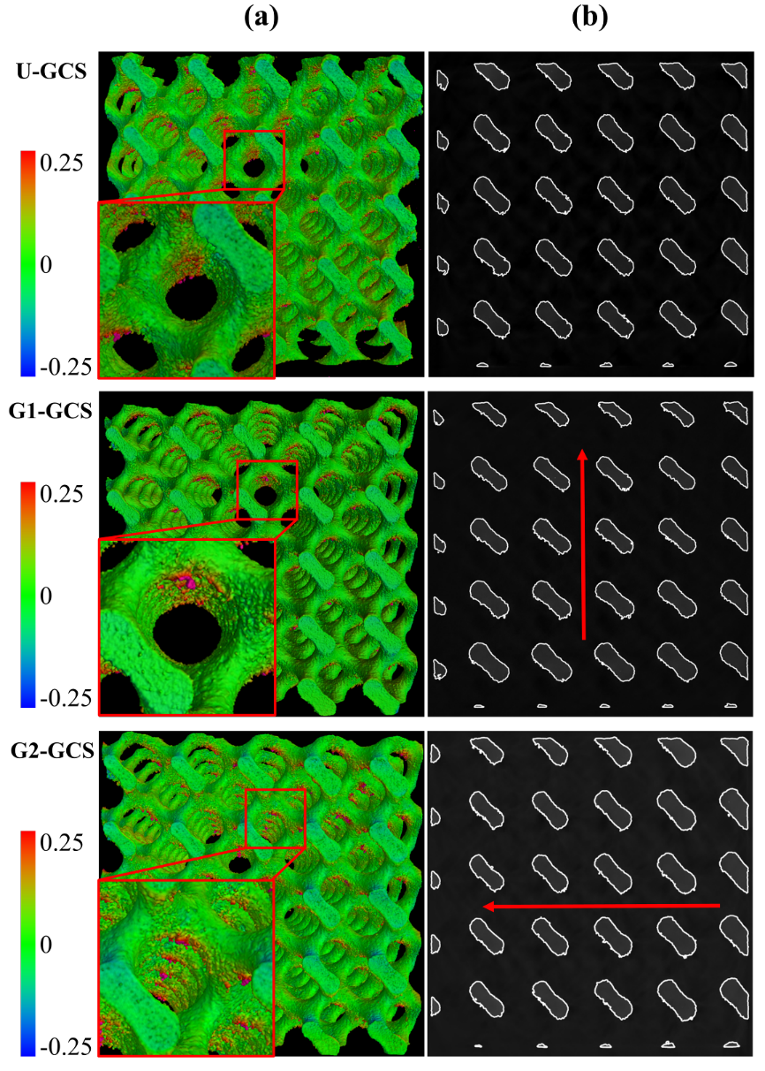

**Fig. 2.** X-ray CT reconstructed models of the SLM-fabricated GCSs: (a) 3D deviations from CAD and (b) cross-sections of the reconstructed model. The colour contour in (a) indicates the deviation between CT-reconstructed and designed models, while the arrows in (b) denote the gradient direction.

## 3.3 Effects of geometry on manufacturability

To further study the influence of geometry on manufacture accuracy, a schematic of the cross-section with several powder layers of an inclined strut is shown in Fig. 3(a), the length *l* of the overhanging area in a cross-section of an inclined strut is given by

$l=\frac{δ}{\tan{α}}$ (2)

where $δ$ is the powder layer thickness defined by the SLM process and $α$ is the inclination angle of the struts, ranging from 0 to 90 degrees.

The extent of overhanging can be described by the overhanging rate,

$η_{overhanging}=\frac{l}{D}=\frac{δ}{D⋅tanα}$ (3)

where D denotes the strut diameter.

overhanging problem

**Fig. 3.** The schematic of (a) overhang for a given inclination of the strut, (b) the geometric effect on SLM manufacturability of overhangs in cellular structures, and (c) gradient effect on SLM manufacturability of cellular structures.

Eqs. (2) and (3) indicate that, as the inclination angle decreases, the length of the overhanging area *l*,as well as the extent of overhanging $η$, increase gradually. A small value of $α$ will result in difficulty of manufacturing and even collapse of the as-built layer, due to a lack of support and the larger molten pool mentioned above [22, 23]. In this study, the upper inner wall of spherical pores is characterized by low inclination angles. Therefore, the consequences associated with overhangs (i.e. exceeded downward profile and increased surface roughness) are indeed present.

Furthermore, Eq. (3) implies that the overhanging rate also depends on the strut diameter. When 3D printing a solid part, the effect of inclined surfaces is limited to the surface roughness; the effect of inclined surfaces on the actual weight or volume of the solid part is not significant. For the cellular structures, particularly those with a low RD, strut diameter is comparable to the overhanging length; the overhanging rate and its effect on manufacturability are therefore much higher in cellular structures.

Moreover, the gradient in cellular will also affect the degree of overhanging. As shown in Fig. 3(c), for a graded strut with a diameter gradient $∆t$, it is inevitable to have a larger diameter below and smaller diameter above for achieving an equivalent RD. The calculated length of the overhanging area becomes $l-∆t/2$, which is smaller than the overhangs in the uniform case. Therefore, the higher gradient results in smaller overhangs, which will reduce the extent of bonded loose powders. In this study, for G2-GCS, the density is constant along building direction, and thus, deviations are the same level as G1-GCS, due to the equal equivalent RD. However, for G1-GCS, the gradient along building direction provides better support for the new layer and shorten the overhangs, resulting in better control of the outline and a lower deviation between the as-built and designed CAD models.

## 3.4 Further demonstration

To verify analysis gained by Eqs. (2) and (3) and further investigate the effect of geometry on manufacture accuracy, the X-ray CT reconstructed models were segmented by unit cell layer along the building and gradient direction, respectively. Layer numbering is defined along the building direction and the decreasing density direction. For U-GCS and G1-GCS, these two directions are the same, and thus one set of data is sufficient. However, two separate sets of data are required for G2-GCS, as the two directions (building and gradient) are perpendicular to each other. Fig. 4(a) shows the schematic of G2-GCS segmented into layers, and subscript *b* and *g* indicate the building and gradient directions, respectively. Thus for each layer along the building direction, the equivalent RD is the same, while the RD of each layer along gradient direction is gradually changing. For each layer, the CT measured volume is compared to the designed volume. The percentage deviation of the volume was calculated by dividing the deviation by the designed volume; percentage deviation is presented in Fig. 4(b).

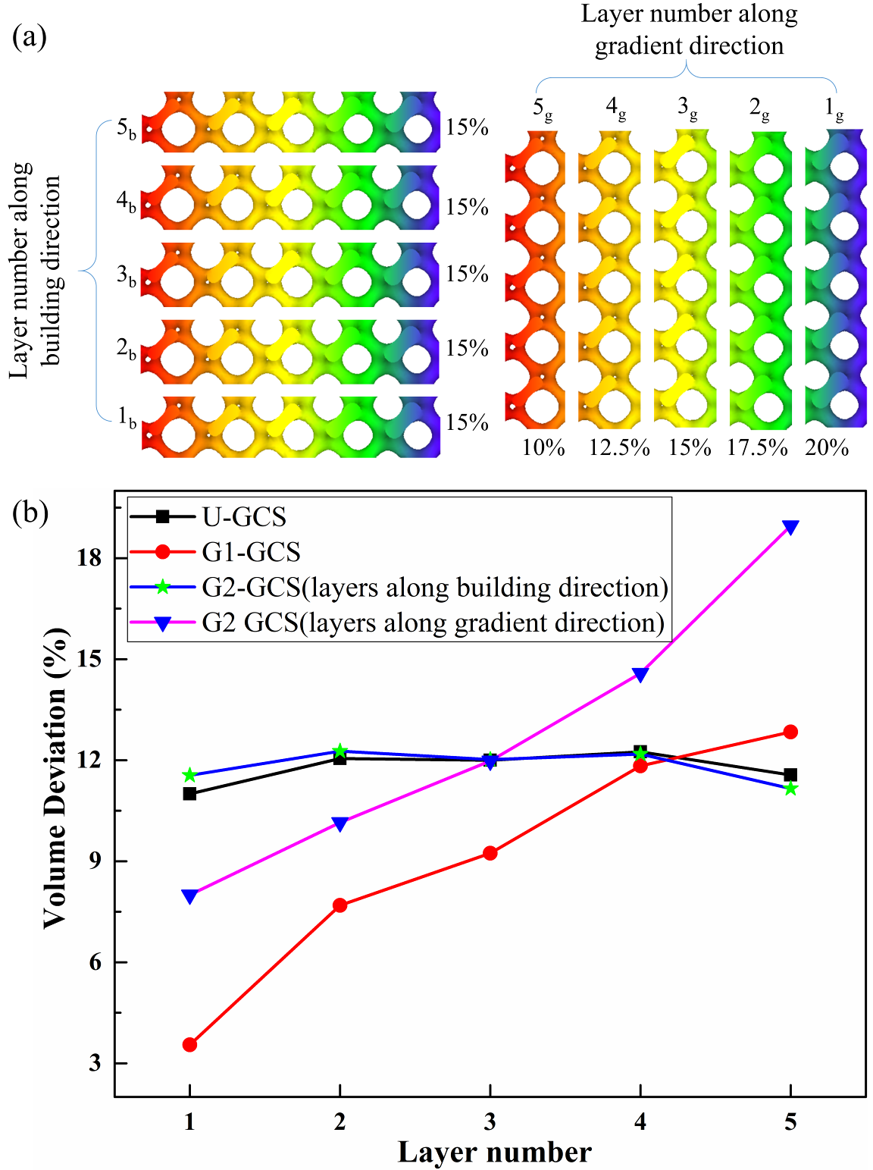

**Fig. 4.** Volume deviation between CT-reconstructed and designed CAD models: (a) schematic of G2-GCS segmented into layers and (b) percentage deviation of each layer in GCSs.

For both U-GCS and G2-GCS, the percentage deviation of VF is consistently for all layers ranging from 11.00% to 12.27%. Volume deviation of G2-GCS shows no obvious difference with U-GCS, which once again illustrate that the gradient VF perpendicular to the building direction does not affect the actual volume of as-built GCSs, due to the same designed VF for each layer.

For the layers of G1-GCS and G2-GCS (gradient direction), volume deviations significantly increase from 3.55% to 12.84% and 8.00% to 18.96% respectively as the VF of each layers decreases. This phenomenon has already explained by the analysis in section 3.3, which is focused on the strut cross-section, illustrated in Eq. (3). Furthermore, the nature of SLM technic and the surface area of cellular structures also contribute to this finding. For the layers with low RD, high laser energy is concentrated in a smaller strut, which leads to a large melt pool and increases the diameter of as-built struts and the occurrence of adhered powders [8]. Besides, the surface area per volume of cellular structure with low RD is greater than that of high RD, resulting in more bonded powders relative to its volume. It is worth noting that the volume deviation of all layers in G1-GCS is obviously lower than the corresponding g-type layers of G2-GCS with the same VF, which can be attributed to the density gradient. For the layers in G1-GCS, the decreasing density along the building direction will effectively increase the manufacturing accuracy, as discussed in section 3.3. From the analysis and discussion above, it is predictable that the increasing density along building direction will increase the overhanging area, resulting in much severer bonded power and low manufacture accuracy.

## 4 Conclusion

In summary, the manufacturing accuracy of SLM-built GCSs and G-GCSs highly depends on the geometry, including the inclination angle of struts, the relative density, and the gradient direction. Bonded powder particles were observed and the considerable deviation occurs at the upper inner wall of spherical pores with low inclination angles, due to the lack of support and insufficient cooling. The effect of bonded powder particle varies with geometry and RD and it is proved that a negative density gradient along the building direction can reduce the amount of bonded powder particles. These findings provide a reference for the design and optimization of cellular structures: for the cellular structures with certain relative density, overhangs should be avoided and a gradient with decreasing density along building direction has benefit for manufacturing.

## Acknowledgements

The study was supported by the National Natural Science Foundation of China (Grant number 51671091), the independent R&D subjects of Huazhong University of Science and Technology (Grant number 2017JYCXJJ005), and the MSCA Individual Fellowship FlexCT project (Grant number 752672).

## Reference:

[1] V. Luzzati, P. Spegt, Nature 215(5102) (1967) 701-704.

[2] V. Luzzati, A. Tardieu, T. Gulik-Krzywicki, E. Rivas, F. Reiss-Husson, Nature 220(5166) (1968) 485-488.

[3] M.R.J. Scherer, Double-Gyroid-Structured functional materials: synthesis and applications, Springer Science & Business Media2013.

[4] S. Rajagopalan, R.A. Robb, Med. Image Anal. 10(5) (2006) 693-712.

[5] S.C. Kapfer, S.T. Hyde, K. Mecke, C.H. Arns, G.E. Schroder-Turk, Biomaterials 32(29) (2011) 6875-6882.

[6] C. Yan, L. Hao, A. Hussein, S.L. Bubb, P. Young, D. Raymont, J. Mater. Process. Technol. 214(4) (2014) 856-864.

[7] L. Hao, D. Raymont, C. Yan, A. Hussein, P. Young, Design and additive manufacturing of cellular lattice structures, The International Conference on Advanced Research in Virtual and Rapid Prototyping (VRAP). Taylor & Francis Group, Leiria, 2011, pp. 249-254.

[8] A. Hussein, L. Hao, C. Yan, R. Everson, P. Young, J. Mater. Process. Technol. 213(7) (2013) 1019-1026.

[9] L. Yang, C. Yan, C. Han, P. Chen, S. Yang, Y. Shi, International Journal of Mechanical Sciences 148 (2018) 149-157.

[10] H. Montazerian, E. Davoodi, M. Asadi-Eydivand, J. Kadkhodapour, M. Solati-Hashjin, Materials & Design 126 (2017) 98-114.

[11] C. Yan, L. Hao, A. Hussein, P. Young, Journal Of the Mechanical Behavior Of Biomedical Materials 51 (2015) 61-73.

[12] C. Yan, L. Hao, A. Hussein, Q. Wei, Y. Shi, Materials Science and Engineering: C 75 (2017) 1515-1524.

[13] L. Yang, C. Yan, H. Fan, Z. Li, C. Cai, P. Chen, Y. Shi, S. Yang, To be printed.

[14] A. Yánez, A. Cuadrado, O. Martel, H. Afonso, D. Monopoli, Materials & Design 140 (2018) 21-29.

[15] G. Strano, L. Hao, R.M. Everson, K.E. Evans, J. Mater. Process. Technol. 213(4) (2013) 589-597.

[16] D. Wang, Y. Yang, R. Liu, D. Xiao, J. Sun, J. Mater. Process. Technol. 213(10) (2013) 1734-1742.

[17] K.V. Yang, P. Rometsch, T. Jarvis, J. Rao, S. Cao, C. Davies, X. Wu, Materials Science and Engineering: A 712 (2018) 166-174.

[18] A.M. Mancisidor, F. Garciandia, M.S. Sebastian, P. Álvarez, J. Díaz, I. Unanue, Physics Procedia 83 (2016) 864-873.

[19] L.J. Gibson, M.F. Ashby, Cellular solids: structure and properties, Cambridge University Press, Cambridge;New York;, 1997.

[20] P. Mercelis, J.-P. Kruth, Rapid prototyping journal 12(5) (2006) 254-265.

[21] J.-P. Kruth, P. Mercelis, J. Van Vaerenbergh, T. Craeghs, Feedback control of selective laser melting, Proceedings of the 3rd international conference on advanced research in virtual and rapid prototyping, 2007, pp. 521-527.

[22] M. Mazur, M. Leary, S. Sun, M. Vcelka, D. Shidid, M. Brandt, The International Journal of Advanced Manufacturing Technology 84(5) (2016) 1391-1411.

[23] M. Mazur, M. Leary, M. McMillan, J. Elambasseril, M. Brandt, Rapid Prototyping Journal 22(3) (2016) 504-518.

1. *Corresponding author

   Tel.: +86 027 87558155, E-mail address: [c_yang@hust.edu.cn](mailto:c_yang@hust.edu.cn) (Chunze Yan).

   Tel.: +32 16 324999, E-mail address: [shoufeng.yang@kuleuven.be](mailto:shoufeng.yang@kuleuven.be) (Shoufeng Yang).