Microstructural evolution and mechanical behavior of Cu/Nb multilayer composites processed by accumulative roll bonding

*By Chaogang Ding, Jie Xu*, Xuewen Li, Debin Shan, Bin Guo* and *Terence G. Langdon*

[*] Prof. Jie Xu, Dr. Chaogang Ding, Prof. Debin Shan, Prof. Bin Guo

*State Key Laboratory of Precision Hot Processing & School of Materials Science and*

*Engineering*

*Harbin Institute of Technology*

*Harbin 150001, China*

1. *mail:* [xjhit@hit.edu.cn](mailto:xjhit@hit.edu.cn)

Dr. Xuewen Li

*School of Materials Science and Engineering*

*Harbin University of Science and Technology*

*Harbin 150080, China*

*Prof. Terence G. Langdon*

*Materials Research Group, Department of Mechanical Engineering*

*University of Southampton*

*Southampton SO17 1BJ, UK*

Keywords: accumulative roll bonding, Cu/Nb multilayer composites, fracture, mechanical properties, microstructure

Cu/Nb multilayer composites with minimum individual layer thicknesses of ~2.8 μm were achieved by accumulative roll bonding (ARB). The microstructural evolution and mechanical properties of these composites were investigated with different layer thicknesses after ARB processing. The results show that there is no visible interfacial reaction between the Cu and Nb layers and the kernel average misorientation (KAM) distributions in electron backscattered diffraction (EBSD) maps remain in steady-state during the ARB cycles of 3 to 7. The tensile testing results demonstrate that the yield strength increases with decreasing layer thickness in Cu/Nb multilayer composites. A simultaneous increase of strength and elongation was achieved by regulating the laminated structures. Microstructure and fracture analysis indicate that the simultaneous increase of strength and elongation is attributed to the high density of bimetal interfaces which act as a barrier for dislocations mobility and crack propagation.

## 1. Introduction

Over the last two decades, the strategy of modifying the microstructures of composites through procedures such as grain refinement or introducing gradient and/or layered structures, has proven effective in improving the mechanical properties.[1-3] There are various methods for improving the mechanical properties by microstructural refinement but processing through the application of severe plastic deformation (SPD) is especially effective for producing ultrafine-grained (UFG) materials having superior mechanical properties.[4-7] To date, various SPD techniques are available such as equal channel angular pressing (ECAP),[8,9] high-pressure torsion (HPT)[10,11] and accumulative roll bonding (ARB).[12-14] Generally, ARB is especially attractive because it produces UFG metals in a continuous manner using a simple laboratory operation which is easily scaled up to provide relatively large billets for industrial applications.

The ARB process consists essentially of multiple cycles of cleaning, stacking, roll bonding and cutting[13,14] and this enables extreme strains to be imparted to a material while preserving the overall bulk dimensions. The extreme nature of this deformation can be envisioned by considering the rolling elongation where, for example, the lengths of the initial layers are elongated by hundreds of times after the seventh cycle.[14] As an available and effective technique, the ARB process is now a well-established procedure for achieving UFG or nano-grained (NG) materials. Furthermore, ARB was recently introduced to fabricate multilayer composite sheets with dissimilar starting materials such as Cu/Nb,[15,16] Cu/Al,[17,18] Cu/Ni[12] and Al/Mg[19] due to its relatively simple processing operation and consequent low cost. The effect of ARB processing on the mechanical properties and microstructural evolution was reported for various multilayer composites having different crystal structures.[16,19] In addition, multilayer composites processed by ARB may exhibit improved material properties such as tensile strength, impact behavior and corrosion resistance.[20-22] For example, it was reported that the tensile strength of an Al/Sn multilayer composite was about 2.2 times higher than for pure Al.[23] In a recent study, Cu/Nb nanostructured composites exhibited not only high conductivity[24] and high strength[15] but also they held great promise for applications requiring resistance to high energy radiation damage,[25,26] to plastic deformation[20] and to exposure at elevated temperatures. This combination of properties makes multilayer composites attractive for a range of applications.

As a structural material, multilayer composites are now attracting significant interest in both scientific research and engineering applications due to their important properties such as a high strength, excellent formability and an exceptional thermal stability.[27] Recent experimental results showed elevated strength and thermal stability of multilayer composites with continuous structure,[28,29] which is similar to the high strength of wiredrawn composites.[30,31] For example, when the continuous layer of Cu/Nb multilayer composites is refined to the nanoscale by ARB, it was shown that the composites are capable of reaching ultrahigh strength and significant ductility at 30 nm up to 1200 MPa and 8%, respectively.[20] Additionally, uniaxial tensile tests of Cu/Nb nanolaminated composites demonstrated that the yield strength generally increased with decreasing layer thickness, which is consistent with the earlier results in tensile tests of other materials processed by ARB. [32,33]According to the results of previous investigations, continuous multilayer composites with high strength and significant ductility compared with dispersion composites should have an exceptionally high potential for use in extreme conditions of temperature.[15]

In the present research, bulk Cu/Nb multilayer composites were successfully produced by ARB with individual layer thicknesses ranging from ~223.3 μm to ~2.8 μm. These materials were then used to examine the microstructural evolution as well as the strengthening mechanisms and the elongations to failure after different numbers of processing cycles.

## 2. Experimental material and procedures

2.1. Materials

The materials used in this study were commercially pure Nb (99.9 wt.%) and pure Cu (>99.9 wt.%) in the form of sheets with thicknesses of 1 mm. Sheets of Cu and Nb with dimensions of 50 mm × 60 mm were cut parallel to the original rolling direction from the cold rolled initial sheets. The Cu and Nb sheets were annealed under an argon gas atmosphere before the ARB process at 500 ℃ for 1 h and 1050 ℃ for 1.5 h, respectively.

**2.2 ARB processing**

The ARB process is, by design, both a rolling process and a bonding process. As illustrated in Figure 1, the initial cleaning step consists of wire-brushing the contact surfaces and ultrasonic cleaning in acetone. Wire-brushing is preferred over other cleaning methods, such as chemical corrosion, as it not only removes the oxide film but also enhances the surface roughness between the contact surfaces. Prior to each roll bonding step, a surface treatment of 3 min in an ultrasonic acetone bath was performed in order to enhance the bonding. In the second step, the Nb plate was sandwiched between Cu plates and then fastened together by steel wire at the four corners. Since this copper clad method is used to create Cu/Nb interfaces, a fully consistent and exceptionally clean Cu/Nb interface was achieved.[20] Subsequently, the sheets were rolled up to ~77.7% reduction in thickness without lubrication at the first rolling cycle which is necessary to improve the bonding strength of the composite interface. This initial rolling step is designated the first cycle. Through this copper clad method of equal initial sheet thickness, a high volume fraction of Cu phase multilayer composites was prepared, with 66.7% Cu volume fraction and 33.3 % Nb volume fraction. After the first rolling cycle, sandwiches were cut into three parts, degreased, wire brushed, stacked, fastened and again roll bonded. An annealing treatment was performed at 600 ℃ for 2 h under an argon gas atmosphere in order to equilibrate the differences in strength between the two phases and to minimize the occurrence of plastic instabilities and edge cracks. After the second cycle, sandwiches were annealing at 600 ℃ for 2 h under an argon gas atmosphere, then cut into two halves, annealed, degreased, wire brushed, stacked and fastened, whereupon the ARB processes continued by repeating the steps up to 7 cycles without lubrication. The rolling direction was maintained constant throughout the process. The roll bonding step was carried out in a rolling mill of 20 tons capacity with a roller diameter of 170 mm and using a rolling speed of 12 rpm.

**2.3 Experimental characterization**

The morphologies of the Cu/Nb multilayer composites were studied on the rolling direction-normal direction (RD-ND) plane using a scanning electron microscope (SEM, Quanta 200FEG). In addition, an SEM and energy dispersive spectroscopy (EDS) was employed for analysis of the interfacial zone and tensile fracture morphologies of the Cu/Nb multilayer composites. The microstructures of the resulting laminated Cu/Nb composites were characterized by electron back scatter diffraction (EBSD) using a 200FEG field emission scanning electron microscope. The EBSD specimens were first mechanically polished using SiC paper and then polished using an argon ion-beam cross-section polishing machine operating at 4.5 kV. The microstructures and kernel average misorientations (KAM) of the multilayer composites were analyzed using a TSL orientation imaging microscopy (OIM) system. The mechanical properties of the multilayer composites were examined using uniaxial tensile tests. Dog-bone shaped tensile samples were cut from the multilayer composites with nominal gauge dimensions of 5 × 2 × 0.79 mm3. All tensile specimens were mechanically polished before tensile testing and then uniaxial tensile tests were performed using the AG-XD plus-50kN testing machine under an initial strain rate of 2.0 × 10-4 s-1. To verify the accuracy of results, at least three tensile samples were tested for each specimen. In this investigation, all the microstructures and tensile properties were conducted on the as-rolled material.

## Experimental results

**3.1. Microstructural evolution during** **ARB processing**

When a strip is processed by ARB under an applied rolling reduction, the percentage rolling reduction, *η*, and the equivalent plastic strain, *ε*, are given by:[13]

 (1)



and

 (2)



where *h*0 and *h* are the initial layer thickness and the layer thickness after the ARB cycles, respectively. As the ARB proceeds, the layer thickness decreases with increasing number of cycles. Equation (2) shows that a large deformation can be realized by the ARB process. The layer thicknesses, percent rolling reductions and the equivalent strains were calculated and they are recorded in Table 1. It is readily evident that the number of layers increases exponentially with increasing numbers of ARB cycles. This change in layers will affect the microstructure and hence the mechanical properties of the multilayer composites.

SEM micrographs of the Cu/Nb multilayer composites processed by ARB are shown in Figure 2 where the bright and dark layers denote the Nb and Cu layers, respectively, and no visible interfacial reaction layer is observed. After 7 cycles of ARB, Cu/Nb multilayer composites were formed with individual layer thicknesses ranging from ~223.3 μm to ~2.8 μm. It can be seen that the samples deformed homogeneously between the Cu and the Nb layers leading to straight and continuous layers in the multilayer composites. In general, it has been reported that necking and rupture take place in the hard phase due to the difference in flow properties of the constituent phases.[12,19] For example, necking in the hard phase was reported in a tri-modal Ti/Al/Nb multilayer in which cold rolling caused necking of both the Ti and Nb layers in the Al matrix.[34] By contrast, the Cu/Nb system used in this study offers the advantages of low solubility as well as similar flow stresses for both phases, and further causes the continuous laminated structure of Cu/Nb multilayer composites.[20] Figure 2(f) shows SEM micrographs of the multilayer composites in high magnification and demonstrates that there is no necking and fracture in the Cu/Nb multilayer composites even after 7 cycles of ARB.

An SEM image together with the elemental distribution map of the composites after 2 cycles of ARB are presented in Figure 3(a). At this stage, a straight and continuous laminated structure of the two phases is observed. The formation of this microstructure is related to the similar flow properties of the Cu and Nb phases so that the layers remain intact until the last cycle. As the number of cycles increases, there are no signs of necking and fracture although wavy irregularities occur at the interfaces of the layers. Figure 3(b) shows the SEM image accompanied by the elemental distribution map of Cu/Nb multilayer composites with average layer thickness of 2.8 μm after 7 cycles of ARB. Although there is some non-homogeneous deformation, the EDS maps show clearly that the lamellar structure is maintained. In addition, several early studies show that new intermediate phases are formed after ARB processing and this was due to the use of relatively high solubility systems, such as Al/Cu/Sn[35] and Cu/Zn.[36] The present research shows that Cu and Nb elements are clearly distinguished by the interface (Figure 3), which demonstrates that after ARB processing there is no reaction between the Cu phase and the Nb phase and no intermetallic compounds are formed. This is due to the low solubility of the Cu/Nb system.[37]

Figure 4 shows the inverse pole figure (IPF) maps of the multilayer composites after ARB processing through (a, b) 3, (c, d) 5 and (e, f) 7 cycles, where the colors correspond to the different crystallographic directions parallel to the rolling direction within each grain as represented in the color-coded triangles. In the EBSD images, low-angle grain boundaries (LAGBs) where the angles of misorientation are between 2° and 15° and high-angle grain boundaries (HAGBs) with angles of misorientation above 15° are denoted by red and black lines, respectively. As the number of cycles increases, the grains size decreases and the grain numbers decrease in the layers. Comparing the Cu and the Nb layers in Figure 4, it is apparent that the shapes and sizes of the grains are different in the two layers. The grains in the Cu layer demonstrate a typical recrystallized feature with no LAGBs in the interior of the grains, whereas grains in the Nb layer exhibit extremely large aspect ratios. The IPF results indicate that no orientation was preferred in the Cu layers during ARB, whereas the Nb layer exhibits preferred orientations after ARB processing.

Figure 5 shows the higher magnification micrographs of IPF maps and KAM maps for the Cu/Nb multilayer composites after ARB processing through 3, 5 and 7 cycles. IPF maps from selected region show the microstructure of the Nb layer. Unit cell orientations of the grains are provided in Figure 5(a, c and e) inset, which indicate close crystallographic orientations of neighboring grains in the Nb layer.

Figure 5(b, d and f) show the evolution of the KAM maps in the Cu/Nb multilayer composites after ARB processing through 3, 5 and 7 cycles, respectively, where KAM is defined for a given point as the average misorientation from other points of the nearest neighbors inside the same grain. This may be selected as an index to qualitatively depict the local geometrically necessary dislocation (GND) density. After ARB processing through 3 cycles, the KAM presents a lower value in the interior grain of the Cu layer, with an average KAM value of 0.27°. However, the KAM presents a higher value in the interior grain of the Nb layer, with an average KAM value of 0.75°. The grain structure of Cu/Nb multilayer composites after ARB processing through 5 cycles is more refined than that of 3 cycles as shown in Figure 5(b and d). In addition, the average KAM values of Cu layer and Nb layer are 0.32° and 0.75°, respectively. Figure 5(f) demonstrates that the microstructures of the Cu/Nb multilayer composites were further refined with increasing numbers of ARB cycles. After ARB processing through 7 cycles, the average KAM values of the Cu layer and the Nb layer remained at 0.32° and 0.75°, which indicates the dislocation density remained in a steady-state basically during the ARB cycles of 3 to 7.

**3.2. Mechanical properties**

Figure 6 shows the engineering stress-strain curves of the Cu/Nb multilayer composites after ARB processing through different numbers of cycles: the engineering tensile stress-strain curves of annealed pure Cu and pure Nb are also included for comparison. Close inspection of the curves shows that the Cu/Nb multilayer composites exhibit typical mechanical properties including both higher strength and reduced elongation. It is also apparent that the yield stresses increase with increasing numbers of ARB cycles. After the second cycle, the yield stress reaches ~346 MPa which is nearly 3 times higher than for the annealed Cu or Nb. Furthermore, the yield stress reaches ~435 MPa when the layer thickness dropped to 2.8 μm. It should be noted that the yield strength increases monotonically with decreasing layer thickness in the Cu/Nb multilayer composites after ARB processing. These results are consistent with the earlier report in Ti/Al composite after ARB processing.[38]

To further investigate the role of ARB processing on ductility and strength in the Cu/Nb multilayer composites, the variation of the ultimate tensile stress (UTS), yield stress (YS) and elongation values with the numbers of ARB cycles, and therefore with the layer thicknesses, are presented in Figure 7. It is apparent that the UTS reaches a value of ~354 MPa after 2 cycles of ARB where this is about 1.6 times higher than for annealed pure Cu (~243 MPa) or pure Nb (~242 MPa) but the elongation values decrease. Furthermore, the flow stress of the Cu/Nb multilayer composites increases with further rolling steps with the highest UTS recorded after 7 cycles of ARB where there is a value of ~475 MPa which is ~34% higher than after only 2 cycles. Surprisingly, the elongations of the Cu/Nb multilayer composites generally increase as the ARB proceeds. The Cu/Nb multilayer composites exhibit a total elongation of ~14% after 7 cycles which is 1.3 times higher than for 2 cycles where it is ~10.5%. The Cu/Nb multilayer composites generally increase the strength and elongation with decreasing layer thickness. Although samples after 3 cycles of ARB exhibit the highest elongations, further studies are needed to fully understand such behavior. The yield strength generally increased with decreasing layer thickness of the microlaminates and this is consistent with earlier reports for Cu-Nb nanolaminates and Cu/Ta nanolamellar multilayers.[39]

**3.3. Tensile fracture morphology**

Figure 8(a-d) illustrates the fracture surfaces after tensile testing of the annealed pure Cu and pure Nb where these surfaces reveal large and deep dimples showing a ductile fracture mechanism. Figure 8(e and f) shows the backscattered electron image and secondary electron image of SEM taken from the same region of the Cu/Nb multilayer composites after processing by ARB through 3 cycles. The backscattered electron imaging technique was used to identify different layers between the Cu and Nb layers in the fracture of the composites. As shown in Figure 8(e), the Nb layers with higher atomic number (Z) are brighter than the Cu layers with lower Z atoms in the backscattered electron mode. In this case, the Cu and Nb phases are clearly identified between the layers. After 3 cycles of ARB, the fractured surfaces in the Cu layers are similar to pure Cu which indicates ductile fracture (Figure 8(f)). The Nb layers in the multilayer composite possessed some dimples which demonstrate that there was also ductile fracture. In addition, a few wedge-shaped cracks appear in the fracture surface of the specimen processed through 3 cycles, thereby suggesting that a weak bonding of the interfaces was introduced during the final rolling operation.

Figure 9 shows the fracture surfaces of the Cu/Nb multilayer composites processed by ARB through (a, b) 5, (c, d) 6 and (e, f) 7 cycles. No interfacial delamination was found in the fracture of these multilayer composites due to the strong interfaces introduced by the ARB processing. Figure 9(b) shows the fracture surfaces of Cu/Nb multilayer composites after processing by ARB through 5 cycles. The fracture surfaces of the Cu layers are covered by dimples while the Nb layers reveal many cleavage fracture characteristics, as shown in Figure 9(b). With increasing numbers of ARB cycles, more dimples covered the fracture surfaces of the Cu/Nb multilayer composites (Figure 9(d)). There are also some cleavage planes near the shallow dimples in the Nb layers. This is mainly attributed to the different deformability of the Cu layers and Nb layers. It is known that the recrystallization temperature of Nb is much higher than that of Cu.[40] While in the ARB processing routes, steps of annealing at 600 ℃ for 2 h was adopted in every cycle of the ARB procedure. Under the same heating conditions, the recrystallization will occur in the Cu layers instead of the Nb layers,[40] and the Cu layers exhibit high deformability. With the increase of tensile deformation, microcracks nucleate in the Nb layer and further propagate until the Nb layer fractured. Meanwhile, continuous deformation in the Cu layers may lead to a covering of part of the Nb layers and hence more dimples covered the fracture surfaces of the Cu/Nb multilayer composites (Figure 9(f)).

## Discussion

**4.1 Microstructural evolution during ARB processing**

It is apparent from Figure 2 that there is a straight and continuous lamellar structure in the multilayer composites which demonstrates an absence of necking and fracture in Cu/Nb multilayer composites processed by ARB for various numbers of cycles. After seven cycles, a multilayer composite with a straight and continuous laminated structure was successfully produced by ARB. As the ARB cycles increased, it was reported that the thickness of the Ni layers decreased and the layers became non-uniform in the Cu phase due to a heterogeneous distribution of strain.[12] It was also observed that a composite with a Cu matrix and homogeneously distributed Ni fragments in the matrix was achieved after 6 cycles.[12] Thus far, it appears that the necking and rupture of the harder phase in multilayered composites can be attributed to plastic instabilities which are caused by the different flow properties of the constituent phases.[41,42] Unlike some other studies,[35] the Cu and Nb phases offer an advantage of similar strengths (~243 and ~242 MPa, respectively) and relatively similar work hardening exponents (~0.335 and ~0.284, respectively) which provide excellent microstructural stability during ARB processing and allow the composite to maintain the consecutive layer distributions at the sub-micrometer scale. This is consistent with a simulation study showing that as the strength ratio of the soft phase to the hard phase increases so the multilayer composites are less likely to neck.[43]

In practice, there are numerous reports of the formation of an intermediate phase when processing by ARB and this occurs when using a relatively high solubility system such as Al/Cu/Sn[35] or Cu/Zn.[36] It was noted that a high rolling strain may accelerate diffusion between different layers of the multilayer composite and thus enhance the formation of intermetallic compounds.[44] In the present investigation, no intermetallic compounds were formed in the Cu/Nb multilayer composites because the Cu and Nb are thermodynamically immiscible at room temperature.[37] Furthermore, the corresponding results for the EDS maps suggest an absence of atomic diffusion and/or the formation of other phases between the two constituent phases (Figure 3). This is similar to an earlier report on nano-laminated Cu/Nb composites showing that sharp and ordered atomic structural layer interfaces were observed directly by high-resolution TEM.[15]

The EBSD results show that the grains in the selected Cu layer exhibit a random orientation during ARB processing. The grains in the Nb layer are obviously refined and have larger dimensions in RD because the grain length increases in RD and decreases in ND during the rolling process. These results demonstrate that the grains refine gradually with increasing numbers of ARB cycles in these Cu/Nb multilayer composites. It is apparent also that sub-grains account for much of the microstructure for the Nb layer processed by ARB through 3 cycles, while for the samples processed up to 7 ARB cycles the HAGBs effectively replace the LAGBs in the Nb layers. At the same time, a strong texture was formed during the early ARB processing. As the number of cycles increases, there is a formation of preferred orientations in the Nb layers and this may result in a good alignment of activated slip system on both sides of the grain boundaries.

The KAM analysis of the Cu/Nb multilayer composites shows that Cu layers have lower average KAM values corresponding to a lower density of dislocations, while the higher average KAM values in the Nb layers means a higher density of dislocations. The different grain morphologies and KAM values of the Cu and Nb layers may be associated with the intermediate annealing process after ARB where the annealing temperature is sufficiently high for the Cu layers to recrystallize but too low for the Nb layers to recrystallize. The low density of dislocations in the Cu layer is therefore probably caused by recrystallization processes. The average KAM values in Figure 5 suggest that the density of dislocations remains constant with increasing numbers of ARB cycles in the Cu/Nb multilayer composites. As a result, Cu grains with lower densities of dislocations and Nb grains with higher densities of dislocations are readily developed. It is concluded that the degree of work hardening remains on balance during the ARB processing through 3 to 7 cycles.

**4.2** **Improvements in the mechanical properties** **after ARB**

Recent reports on multilayer composites processed by ARB showed that the yield stress decreases with increasing numbers of cycles in ARB.[36,45] By contrast, the Cu/Nb multilayer composites used in this investigation exhibit a yield stress increase with increasing numbers of ARB cycles. For example, YS increases from ~346 MPa to ~435 MPa when the ARB processing increases from 2 to 7 cycles. In order to study this correlation, Figure 10 summarizes the data for Cu/Nb multilayer composites and presents YS values plotted against the inverse square root of the layer thickness. This plot shows that the yield strength increases monotonically with decreasing layer thickness where this is consistent with the Hall-Petch relationship[46,47], which is consistent with the earlier report on nano-scaled multilayered materials.[16]

It is widely recognized that the storage of dislocations in the interface can contribute to material strengthening[48] where this principle was discussed in the context of grain boundaries and led to the development of a Hall-Petch model based on dislocation pile-up theory. For nanolayered composites, assume that dislocation slip is the dominant plastic deformation mechanism and the layer interfaces play a similar role for dislocation pile-ups as the grain boundaries in traditional bulk materials.[49] Using this approach, a model may be developed to interpret the length-scale dependence of strengthening mechanisms in multilayer composites so that[49]

 (3)



where *σYS* is the yield strength, *h* is the layer thickness, *k* is the Hall-Petch slope and *σ0* is a measure of the lattice friction stress opposing dislocation slip. This approach leads to the conclusion that the Hall-Petch model is valid at layer thicknesses greater than ~75 nm.

As shown in Figure 10, the relationship between YS and the inverse square-root of the layer thickness is consistent with the Hall-Petch model. According to an earlier report, interfaces may act as strong barriers for dislocation motion, which has been confirmed directly by TEM in the Ag-Nb nanomultilayer system.[50] A recent study found that when neighboring grains present a very close crystallographic orientation, it may result in a good alignment of activated slip system between both sides of the grain boundaries and thereby initiate continuous slip bands across the grain boundaries.[51-53] By contrast, it is generally assumed that the phase boundaries are the strongest obstacles to dislocation motion in two-ductile-phase alloys.[49,54] For submicrometer-scale multilayer composites, dislocations are emitted from the interior of the grains and move along the slip planes towards the grain boundaries. The Nb layer has a similar lattice orientation of neighboring grains (Figure 5), which may lead to a slip transfer across grain boundaries due to the aligned slip system. This phenomenon has been discussed in many other metals[51,52] Finally, dislocations move along the same slip plane towards the layer interfaces and then they are blocked by the interfaces. The interactions of the dislocations and the interfaces form dislocation pile-ups. As this dislocation pileup forms, the force exerted on the obstacle eventually exceeds the overall strength so that the Cu/Nb multilayer composite plastically yields.[55,56] In laminated composites, this strength depends on the layer thickness because the total pile-up length is limited by the layer thickness which therefore limits the stress at the head of the pile-up [57]. As a result, the pile-up model provides a direct explanation for the linear relationship between the yield stress and the reciprocal square root of the layer thickness.

Figure 11 presents the elongation-ultimate tensile stress relationships for UFG Cu,[58,59] NG Cu,[60] gradient nano-grained (GNG) Cu foil, GNG/CG architecture Cu, coarse-grained (CG) Cu[2] and a Cu matrix X-(X=Nb,[16] Al,[17] Al/Sn,[35] Al/Mn[61]) reinforced multilayer composites fabricated by ARB. As shown in Figure 11, the Cu matrix X-reinforced multilayer composites in other investigations show either low UTS or poor elongations or both. The UFG Cu and nano-grained Cu show a high UTS with a low percentage elongation. By contrast to these various materials, the Cu/Nb multilayer composites in the present research exhibit a combination of higher elongation and high UTS. Moreover, the UTS of the Cu/Nb multilayer composites (~475 MPa) is much higher than for multilayered Al-Cu composites (~385 MPa) and the elongation increases from 3.5% in the latter to 14% in the former.[62] Therefore, it is readily concluded that the present Cu/Nb composites with multilayer structures possess excellent combinations of strength and elongation.

Figure 12(a and d) show side views of the fracture surfaces of the Cu/Nb multilayer composites after ARB processing through 4 and 7 cycles, respectively. It is readily apparent that there is no interfacial delamination between the Cu and Nb layer indicating a strong interfacial bonding in the Cu/Nb multilayer composites. The laminated composites with layer thickness of 22.2 μm display typical shear fracture characteristics with no visible microcrack in the fracture surface as is apparent in Figure 12(a). When the layer thickness drops to 2.8 μm, small numbers of microcracks nucleate in the Nb layers and propagate towards both sides until these cracks end at the interfaces between layers (Figure 12(d)). It is well established that plastic deformation is always accompanied by void or crack formation and propagation when materials exhibit a weak resistance to crack propagation, so that microcracks easily coalescence into a major crack leading to eventual fracture.[63] It was already demonstrated that a laminated structure is effective in lowering the driving force for crack propagation[64] and an investigation of the mechanical properties of multilayer steel showed that the interfaces prevent a large number of cracks propagating to the next layer.[65] It was concluded earlier that the superior mechanical properties of multilayered structures are always associated with a high resistance to either crack initiation or crack propagation or both.[3] In multilayered structures, the additional strengthening mechanisms which constrain the crack propagation behavior can contribute to the overall strength of the multilayer composites.

Figure 12 shows schematic fracture diagrams for Cu/Nb multilayer composites with 22.2 μm and 2.8 μm layer thicknesses, respectively. In the Cu/Nb multilayer composites with a layer thickness of 22.2 μm, the microcracks are initiated and nucleated in the Nb layers and microcracks develop easily into an unstable major crack with an increase in plastic deformation (Figure 12(b)). Therefore, multilayer composites with thicker layers are susceptible to premature fracture with low fracture strength and elongation as shown in Figure 12(c). These results are similar to an early report on tensile testing of Ti-(TiBw/Ti) composites processed by diffusion welding.[66]

The schematic diagrams of the fracture characteristics of the Cu/Nb multilayer composites with layer thickness of 2.8 μm in Figure 12(e and f) show that the multilayer structure can influence the fracture behavior of laminated composites. The microcracks are initiated and nucleated in the Nb layers and propagate towards both sides until the cracks end at the Cu/Nb interface where further propagation is difficult because of stabilization by the multilayer structure. As the tensile deformation continues, new microcracks form and propagate in the Nb layer so that finally the microcracks propagate into the Cu layer and this leads to the development of an unstable major crack leading to shear fracture.[67] The presence of stable cracks was directly observed by three-dimensional X-ray synchrotron tomography in TiBw/Ti-Ti(Al) laminated composites.[64] Therefore, the multilayer structure lowers the driving force during the crack propagation process so that the Cu/Nb multilayer composite with a layer thickness of 2.8 μm exhibits a combination of high elongation and high strength.

## Conclusions

1. Bulk Cu/Nb multilayer composites with different individual layer thicknesses ranging from ~223.3 to ~2.8 μm were successfully processed by ARB. The lack of any visible interfacial reaction between the Cu and Nb layers and the KAM distribution in EBSD shows that the average misorientation gradually reaches a steady-state condition after ARB through 3-7 cycles.
2. As the individual layer thicknesses decrease, the yield strength gradually increases, where this is consistent with the Hall-Petch relationship. Further analysis demonstrates that the similar lattice orientations of neighboring grains may result in alignment of activated slip system and further led to slip transfer across grain boundaries. As a result, the layer interfaces act as strong barriers for dislocation motion and the yield strength gives a thickness size effect.
3. Fracture profile analyses of the Cu/Nb multilayer composites reveal that the high density of bimetal interfaces act as a barrier for crack propagation, and this can prevent microcracks coalescence into a major crack leading to eventual fracture. Moreover, the additional strengthening mechanisms which constrain the crack propagation behavior may contribute to the overall strength and elongation of the multilayer composites.

Acknowledgements

This work was supported by the National Natural Science Foundation of China under Grant No. 51635005, the 111 Project under Grant No. B18017 and the Fundamental Research Funds for the Central Universities under Grant No. ZDXMPY20180104. The work of one of us was supported by the European Research Council under ERC Grant Agreement No. 267464-SPDMETALS (TGL).

Received: ((will be filled in by the editorial staff))  
Revised: ((will be filled in by the editorial staff))  
Published online: ((will be filled in by the editorial staff))

References

[1] R. Z. Valiev, R. K. Islamgaliev, I. V. Alexandrov, *Prog. Mater. Sci.* **2000**, *45*, 103.

[2] T. H. Fang, W. L. Li, N. R. Tao, K. Lu, *Science* **2011**, *331*, 1587.

[3] H. Wu, G. Fan, M. Huang, L. Geng, X. Cui, H. Xie, *Int*. *J*. *Plast*. **2017**, *89*, 96.

[4] Y. Estrin, A. Vinogradov, *Acta Mater*. **2013**, *61*, 782.

[5] T. G. Langdon, *Acta Mater*. **2013**, *61*, 7035.

[6] R. Z. Valiev, Y. Estrin, Z. Horita, T. G. Langdon, M. J. Zehetbauer, Y. Zhu, *JOM* **2010**, *68*, 1216.

[7] N. Tsuji, Y. Ito, Y. Saito, Y. Minamino, *Scr. Mater.* **2002**, *47*, 893.

[8] R. Z. Valiev, T. G. Langdon, *Prog. Mater. Sci.* **2006**, *51*, 881.

[9] J. Xu, J. Li, D. Shan, B. Guo, *Mater. Sci. Eng., A* **2016**, *664*, 114.

[10] A. P. Zhilyaev, T. G. Langdon, *Prog. Mater. Sci.* **2008**, *53*, 893.

[11] J. Xu, J. Li, C. T. Wang, D. Shan, B. Guo, T. G. Langdon, *J. Mater. Sci.* **2016**, *51*, 1923.

[12] M. Tayyebi, B. Eghbali, *Mater. Sci. Eng., A* **2013**, *559*, 759.

[13] Y. Saito, H. Utsunomiya, N. Tsuji, T. Sakai, *Acta Mater.* **1999**, *47*, 579.

[13] Y. Saito, N. Tsuji, H. Utsunomiya, T. Sakai, R. G. Hong, *Scr. Mater.* **1998**, *39*, 1221.

[15] S. Zheng, I. J. Beyerlein, J. S. Carpenter, K. Kang, J. Wang, W. Han, N. A. Mara, *Nat*. *Commun*. **2013**, *4*, 1696.

[16] T. Nizolek, I. J. Beyerlein, N. A. Mara, J. T. Avallone, T. M. Pollock, *Appl. Phys. Lett.* **2016**, *108*, 1.

[17] M. Eizadjou, A. K. Talachi, H. D. Manesh, H. S. Shahabi, K. Janghorban, *Compos. Sci. Technol.* **2008**, *68*, 2003.

[18] S. L. Lehoczky, *J. Appl. Phys.* **1978**, *49*, 5479.

[19] K. Wu, H. Chang, E. Maawad, W. M. Gan, H. G. Brokmeier, M. Y. Zheng, *Mater. Sci. Eng., A* **2010**, 527, 3073.

[20] T. Nizolek, N. A. Mara, I. J. Beyerlein, J. T. Avallone, J. E. Scott, T. M. Pollock, *Metallogr., Microstr., Anal.* **2014**, *3*, 470.

[21] F. Kümmel, T. Hausöl, H. W. Höppel, M. Göken, *Acta Mater.* **2016**, *120*, 150.

[22] W. Zheng, Y. X. Gao, X. P. Wang, H. Lu, L. F. Zeng, Q. F. Fang, *Mater. Sci. Eng., A* **2017**, *689*, 306.

[23] L. Ghalandari, M. M. Mahdavian, M. Reihanian, M. Mahmoudiniya, *Mater. Sci. Eng., A* **2016**, *661*, 179.

[24] T. Gu, J.R. Medy, F. Volpi, O. Castelnau, S. Forest, E. Hervé-Luanco, F. Lecouturier, H. Proudhon, P.O. Renault, L. Thilly, *Acta Mater.* **2017**, *141*, 131.

[25] A. Misra, M. J. Demkowicz, X. Zhang, R. G. Hoagland, *JOM* **2007**, *59*, 62.

[26] W. Han, M. J. Demkowicz, N. A. Mara, E. Fu, S. Sinha, A. D. Rollett, Y. Wang, J. S. Carpenter, I. J. Beyerlein, A. Misra, *Adv. Mater.* **2013**, *25*, 6975.

[27] L. Ghalandari, M.M. Moshksar, *J. Alloy. Compd*. **2010**, *506*, 172.

[28] I.J. Beyerlein, N.A. Mara, J.S. Carpenter, T. Nizolek, T.M. Pollock, *J. Mater. Res.* **2013**, *28*, 1799.

[29] V.I. Betekhtin, B.K. Kardashev, E.V. Golosov, M.V. Narykova, A.G. Kadomtsev, D.N. Klimenko, M.I. Karpov, *Tech. Phys. Lett.* **2012**, *38*, 144.

[30] L. Thilly, M. Véron, O. Ludwig, F. Lecouturier, J.P. Peyrade, S. Askénazy, *Philos. Mag. A* **2006**, *82*, 925.

[31] C.W. Sinclair, J.D. Embury, G.C. Weatherly, *Mater. Sci. Eng., A* **1999**, *272*, 90.

[32] Y. Jang, S. Kim, S. Han, C. Lim, M. Goto, Met. Mater. Int. **2008**, *14*, 171.

[33] N. Tsuji, Y. Saito, H. Utsunomiya, S. Tanigawa, *Scr. Mater.* **1999**, *40*, 795.

[34] R. Zhang, V. L. Acoff, *Mater. Sci. Eng., A* **2007**, *463*, 67.

[35] M. M. Mahdavian, H. Khatami-Hamedani, H. R. Abedi, *J. Alloy. Compd.* **2017**, *703*, 605.

[36] L. Ghalandari, M. M. Mahdavian, M. Reihanian, *Mater. Sci. Eng., A* **2014**, *593*, 145.

[37] D. J. Chakrabarti, D. E. Laughlin, *Bull. Alloy Phase Diagrams* **1982**, *2*, 455.

[38] D. Yang, P. Cizek, P. Hodgson, C.E. Wen, *Scr. Mater.* **2010**, *62*, 321.

[39] L.F. Zeng, R. Gao, Q.F. Fang, X.P. Wang, Z.M. Xie, S. Miao, T. Hao, T. Zhang, *Acta Mater.* **2016**, *110*, 341.

[40] B.L. Hansen, J.S. Carpenter, S.D. Sintay, C.A. Bronkhorst, R.J. Mccabe, J.R. Mayeur, H.M. Mourad, I.J. Beyerlein, N.A. Mara, S.R. Chen, *Int. J. Plast.* **2013**, *49*, 71.

[41] Y. M. Hwang, H. H. Hsu, H. J. Lee, *Int. J. Mach. Tool Manu.* **1996**, *36*, 47.

[42] S. L. Semiatin, H. R. Piehler, *Metall. Trans. A* **1979**, *10*, 97.

[43] M. Reihanian, M. Naseri, *Mater. Des.* **2016**, *89*, 1213.

[44] R. J. Hebert, J. H. Perepezko, *Scr. Mater.* **2004**, *50*, 807.

[45] M. M. Mahdavian, L. Ghalandari, M. Reihanian, *Mater. Sci. Eng., A* **2013**, *579*, 99.

[46] E.O. Hall, *Proc. R. Soc. London, Ser. B* **1951**, *64*, 747.

[47] N.J. Petch, *J. Iron Steel Res. Int.* **1953**, *174*, 25.

[48] X. Zhang, N. Hansen, Y. Gao, X. Huang, *Acta Mater.* **2012**, 60, 5933.

[49] A. Misra, J. P. Hirth, R. G. Hoagland, *Acta Mater*. **2005**, *53*, 4817.

[50] W. S. Lai, M. J. Yang, *Appl. Phys. Lett*. **2007**, *90*, 217.

[51] F. Bridier, P. Villechaise, J. Mendez, *Acta Mater.* **2005**, *53*, 555.

[52] L. Patriarca, W. Abuzaid, H. Sehitoglu, H.J. Maier, *Mater. Sci. Eng., A* **2013**, *588*, 308.

[53] W.Z. Abuzaid, M.D. Sangid, J.D. Carroll, H. Sehitoglu, J. Lambros, *J. Mech. Phys. Solids* **2012**, *60*, 1201.

[54] Z. Fan, P. Tsakiropoulos, P.A. Smith, A.P. Miodownik, *Philos. Mag. A* **1993**, *67*, 515.

[55] S. Subedi, I. J. Beyerlein, R. LeSar, A. D. Rollett, *Scr. Mater.* **2018**, *145*, 132.

[56] L. H. Friedman, D. C. Chrzan, *Phys. Rev. Lett.* **1998**, *81*, 2715.

[57] Y. Q. Sun, *Philos. Mag. A* **1998**, *77*, 1107.

[58] A. Fattah-Alhosseini, O. Imantalab, Y. Mazaheri, M. K. Keshavarz, *Mater. Sci. Eng., A* **2016**, *650*, 8.

[59] J. Li, J. Xu, B. Guo, D. Shan, T. G. Langdon, *Scr. Mater.* **2017**, *132*, 25.

[60] M. Shaarbaf, M. R. Toroghinejad, *Mater. Sci. Eng., A* **2008**, *473*, 28.

[61] M. Alizadeh, M. K. Dashtestaninejad, *J. Alloy. Compd.* **2018**, *732*, 674.

[62] V. Y. Mehr, M. R. Toroghinejad, A. Rezaeian, *Mater. Sci. Eng., A* **2014**, *601*, 40.

[63] H. Wu, B. C. Jin, L. Geng, G. Fan, X. Cui, M. Huang, R. M. Hicks, S. Nutt, *Metall.* *Mater. Trans. A* **2015**, *46A*, 3803.

[64] H. Wu, G. Fan, M. Huang, L. Geng, X. Cui, R. Chen, G. Peng, *Compos. Struct.* **2017**, *163*, 123.

[55] M. Seok, J. Lee, D. Lee, U. Ramamurty, S. Nambu, T. Koseki, J. Jang, *Acta Mater.* **2016**, *121*, 164.

[66] B. X. Liu, L. J. Huang, B. Kaveendran, L. Geng, X. P. Cui, S. L. Wei, F. X. Yin, *Composites, Part B* **2017**, *108*, 377.

[67] J. Inoue, S. Nambu, Y. Ishimoto, T. Koseki, *Scr. Mater.* **2008**, *59*, 1055.

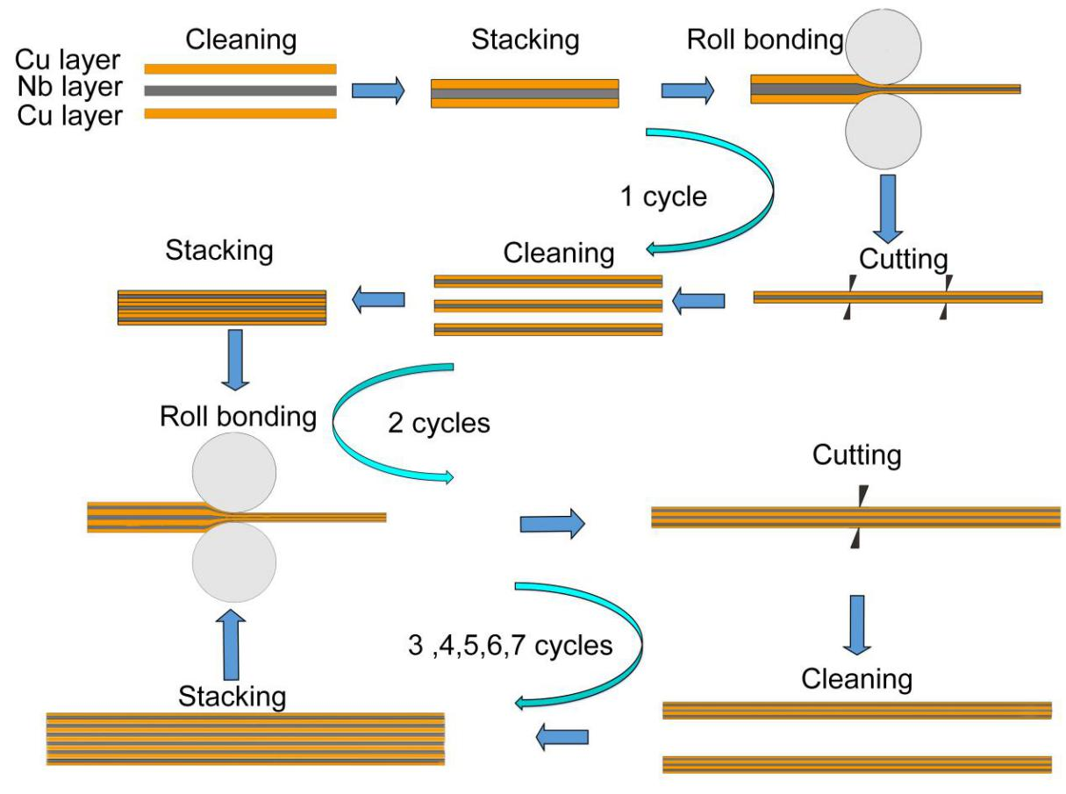

**Figure 1.** Schematic of the modified ARB process of Cu/Nb multilayer composite.

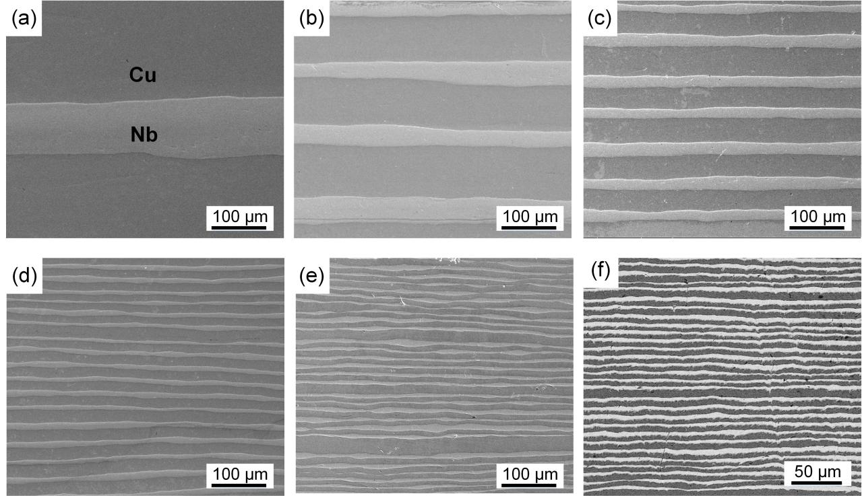

**Figure 2.** SEM micrographs of the Cu/Nb multilayer composites via ARB after: (a) 2 cycles, (b) 3 cycles, (c) 4 cycles, (d) 5 cycles (e) 6 cycles, (f) 7 cycles.

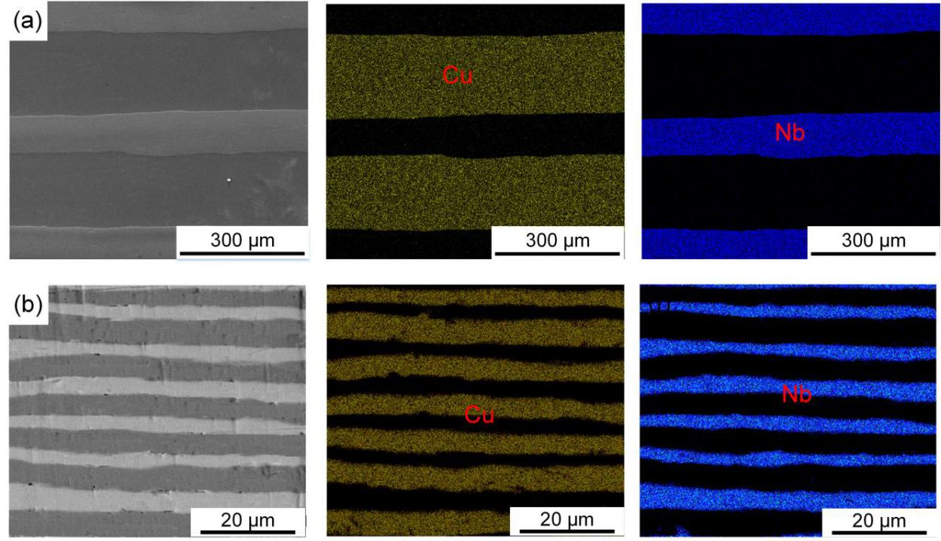

**Figure 3.** SEM images and elemental distribution map analysis of Cu/Nb multilayer composites: (a) 2 cycles, (b) 7 cycles.

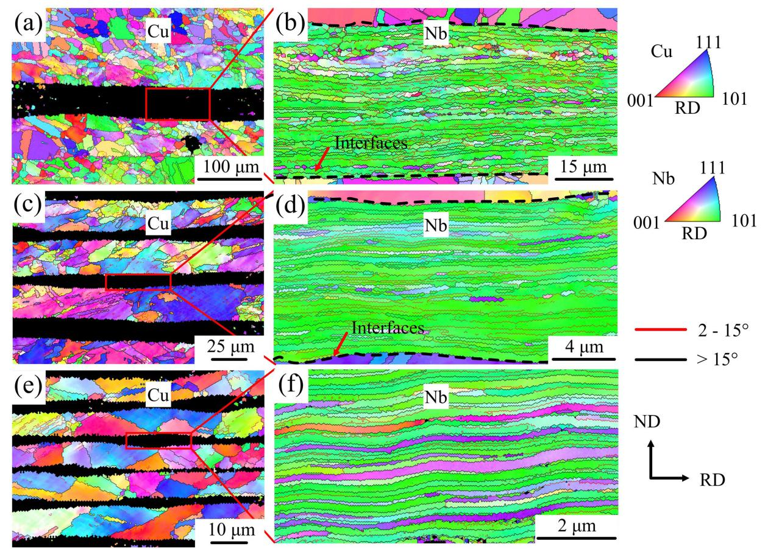

**Figure 4.** The inverse pole figure of the multilayer composites after ARB processing through: (a), (b) 3 cycles; (c), (d) 5 cycles; (e), (f) 7 cycles.

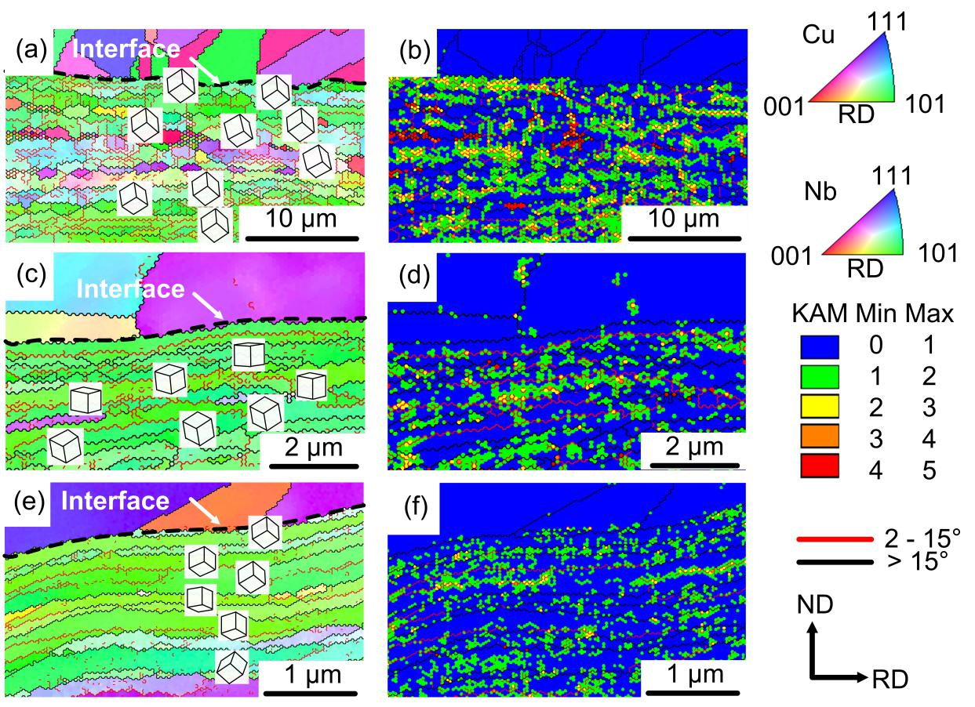

**Figure 5.** Higher magnification inverse pole figure (overlaid with unit cell orientations) and kernel average misorientation maps of the multilayer composites after ARB processing: (a), (b) 3 cycles; (c), (d) 5 cycles; (e), (f) 7 cycles.



**Figure 6.** The engineering stress-strain curves for original Cu plate, Nb plate and Cu/Nb laminate specimens after ARB processing through 2 cycles to 7 cycles.



**Figure 7.** Variations of ultimate tensile strength, yield strength and elongation of Cu/Nb multilayer composites in different cycles of ARB process.

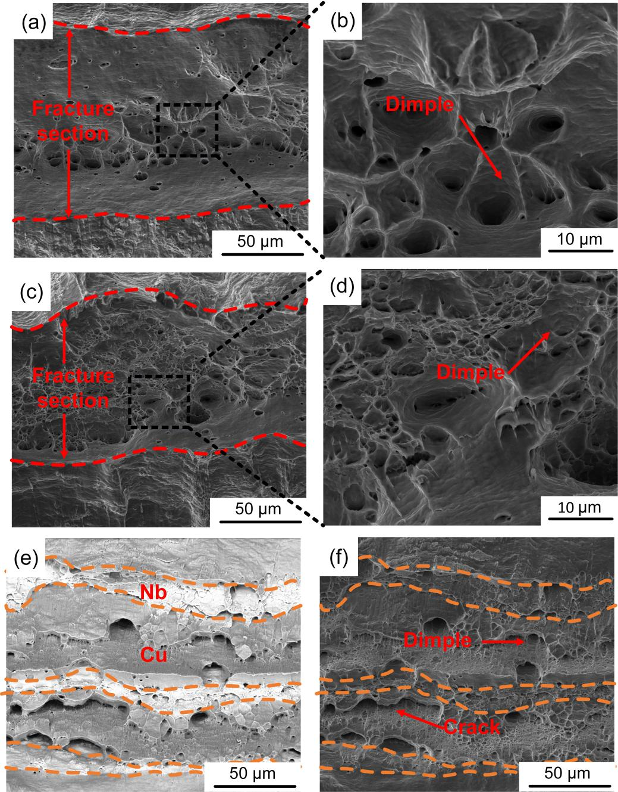

**Figure 8.** Tensile fractured surfaces of (a) pure Cu, (c) pure Nb, (b) and (d) are enlarged images corresponding to the rectangules marked in (a) and (c), respectively. Fractography of Cu/Nb multilayer composites after 3 cycles: (e) backscattered electron image and (f) secondary electron image. (The area between the two orange dotted line in e and f indicates the Nb layers.)

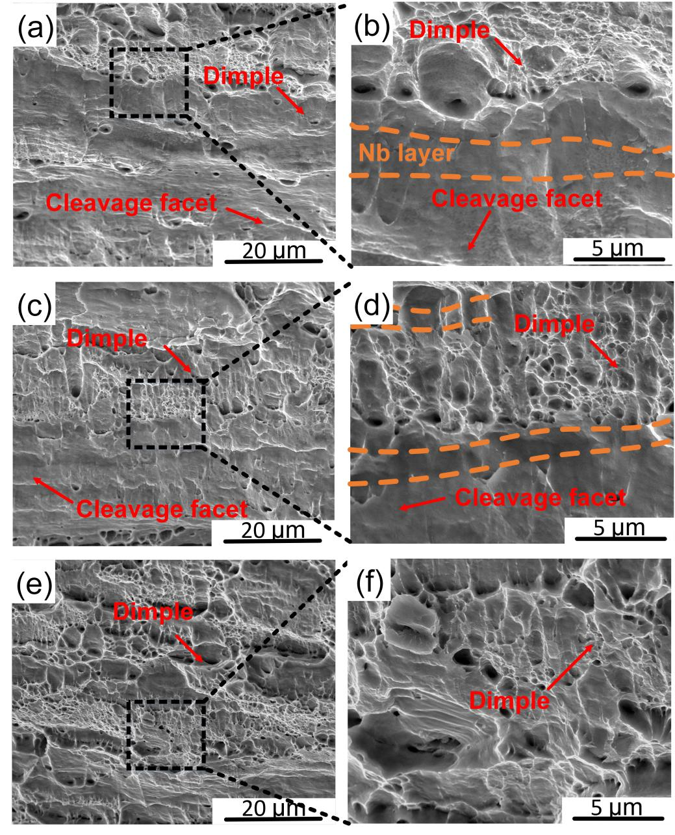

**Figure 9.** Tensilefractured surfaces of Cu/Nb multilayer composites after: (a) 5, (c) 6, (e) 7 cycles of ARB process; (b), (d) and (f) are enlarged images corresponding to the rectangules marked in (a), (c) and (e), respectively. (The area between the two orange dotted lines in b and d indicates the Nb layers)

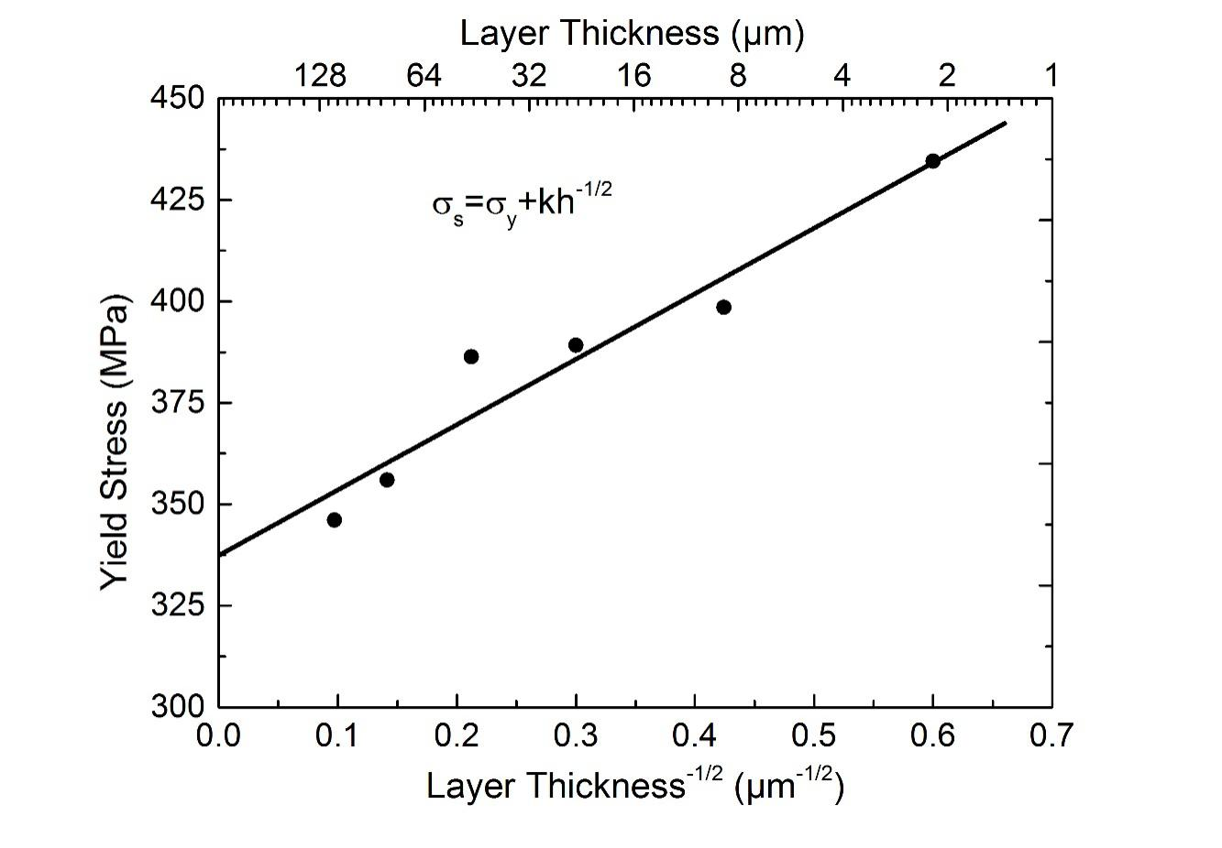

**Figure 10**. Hall-Petch relationship between layer thickness and yield stress of the Cu/Nb multilayer composites.

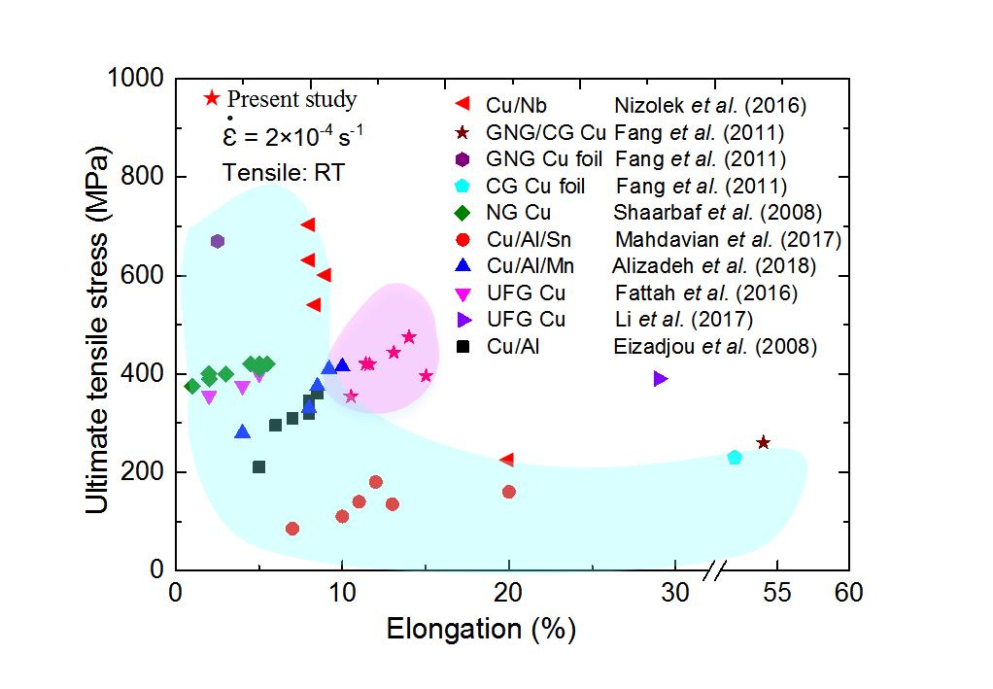

**Figure 11.** Elongation versus ultimate tensile stress of the UFG Cu,[58,59] NG Cu,[60] GNG Cu foil, GNG/CG architecture Cu, CG Cu[2] and Cu-matrix, X (X=Nb[16], Al,[17] Al/Sn,[35] Al/Mn[61]) reinforced composites.

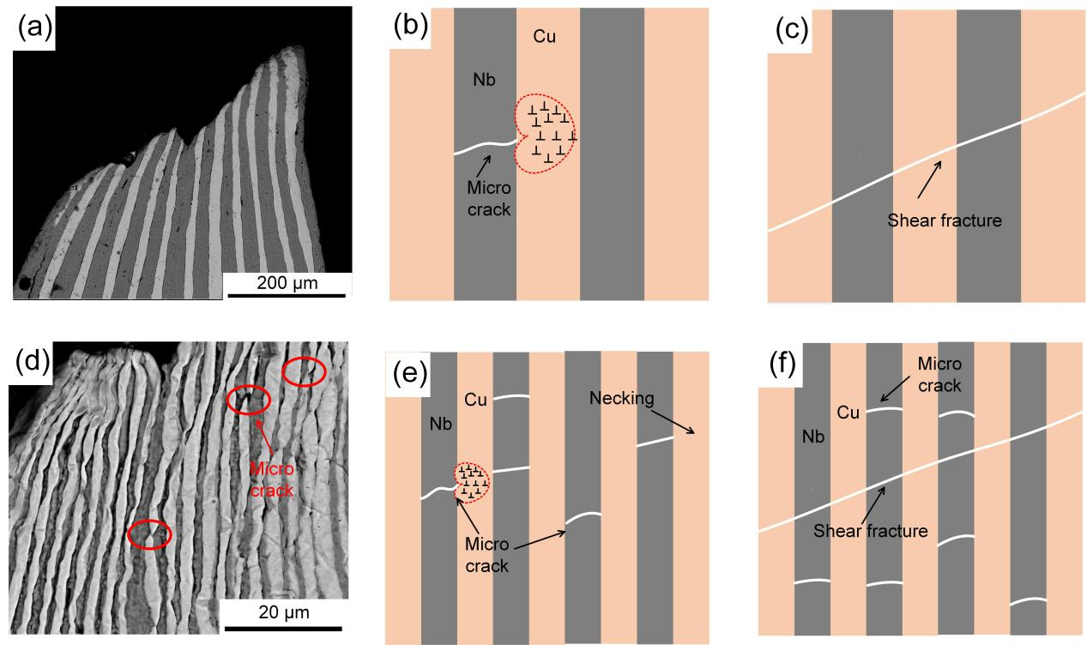

**Figure 12.** Schematic of crack propagation in Cu/Nb multilayer composites with different layer thicknesses: (a), (b), (c) 22 μm; (d), (e), (f) 2.8 μm.

**Table 1.** Measurement values of the number of layers, the layer thickness, the total strain and total rolling reduction with the number of ARB cycles

|  |  |  |  |  |
| --- | --- | --- | --- | --- |
| Number of ARB cycles | Number of layers | Layer thickness (μm) | Total strain  ε | Total rolling reduction  (%) |
| 1  2  3  4  5  6  7 | 3  9  18  36  72  144  288 | 223.3  105.6  50.0  22.2  11.1  5.6  2.8 | 1.7  2.6  3.5  4.4  5.2  6.0  6.8 | 77.7  89.4  95.0  97.8  98.9  99.4  99.7 |

Cu/Nb multilayer composites with minimum individual layer thicknesses of ~2.8 μm were achieved by accumulative roll bonding (ARB). The effect of layer thickness on the microstructure and mechanical properties was examined. The results show that there is no visible interfacial reaction between the Cu and Nb layers and a simultaneous increase of strength and elongation was achieved by regulating the laminated structures. This is attributed to the high density of bimetal interfaces which act as a barrier for dislocations mobility and crack propagation.

Chaogang Ding, Jie Xu*, Xuewen Li, Debin Shan, Bin Guo and Terence G. Langdon

Microstructural evolution and mechanical behavior of Cu/Nb multilayer composites processed by accumulative roll bonding

