Thirty years of collaboration and research from 1989 to 2019: a tribute to Ruslan Z. Valiev

T G Langdon

Materials Research Group, Department of Mechanical Engineering, University of Southampton, Southampton SO17 1BJ, U.K.

E-mail: langdon@soton.ac.uk

**Abstract**. A visit to the Institute of Problems of Superplasticity of Metals in Ufa in 1989 initiated a cooperation and collaboration with Ruslan Valiev that has continued for the last thirty years. This collaboration started with fundamental investigations of superplasticity, such as the demonstration that intragranular slip is necessary to accommodate grain boundary sliding in conventional superplastic flow, but it was then extended to cover the processing and properties of a wide range of metals produced using severe plastic deformation to achieve exceptional grain refinement. Highlights included the publication of a first comprehensive review of equal-channel angular pressing (now with more than 3600 citations on Google Scholar) and co-authoring a textbook (Bulk Nanostructured Materials: Fundamentals and Applications, published by TMS/Wiley in 2014).

1. Introduction

Creep refers to the permanent plastic flow that occurs in materials when they are subjected to a constant stress or a constant load over a long period of time and where the stress is insufficient to cause immediate fracture. In practice, creep is a diffusion-controlled process and this means it becomes important when testing at high temperatures, typically at temperatures above ~0.5*T*m where *T*m is the absolute melting temperature. Studies of creep may be traced back for more than 100 years [1] but the total strains experienced in tensile creep are generally quite small and ultimately the material breaks in catastrophic failure. Some early experiments reported quite large elongations in selected metals prior to fracture but these elongations were only of the order of a few hundreds of percent and it was only in 1934 that Pearson, working in England, reported the first demonstration of true superplasticity with a tensile elongation of ~1950% in a near-eutectic Bi-Sn alloy [2]. Unfortunately, this result received little attention in the west but it inspired extensive research in the Soviet Union and these results were later reviewed by Underwood [3] so that the process became known in other countries. It is interesting to note that the English word “superplasticity” is a direct translation from the Russian word *sverkhplastichnost*. This publicity in the west led to early experiments on vacuum forming and blow molding [4] and this progressed ultimately to the establishment of the superplastic forming industry. As of today, superplastic forming is now a major contributor in the processing of sheet metals into curved and complex shapes for use in many applications including in the aerospace, automotive and architectural sectors [5]. Early experiments showed that superplasticity required small grain sizes, typically less than ~10 μm [6], and therefore metals appropriate for superplastic forming were typically obtained by using thermo-mechanical processing to produce grain sizes in the range of ~2-5 μm.

1. Developments at the Institute of Problems of Superplasticity of Metals (IPSM) in Ufa

A critical publication appeared in the Russian literature in 1988 with the title “Low Temperature Superplasticity of Metallic Materials” [7]. This paper came from the Institute of Problems of Superplasticity of Metals (IPSM) of the Academy of Sciences of the Soviet Union in Ufa and I read the paper in translation in the library at the University of Southern California. I was amazed to discover that the authors were using an Al-4% Cu-0.5% Zr alloy with a grain size of 0.3 μm that had been produced by “shear under pressure”. At that time my students at USC were superplastically testing the British commercial Supral 100 alloy (Al-2004, Al-6% Cu-0.4% Zr) but it was impossible for us to obtain a grain size smaller than ~3-5 μm. Accordingly, I decided it was important to find out more about these experimental procedures and therefore I made arrangements with Professor Oscar Kaibyshev, Director of IPSM, to visit his institute. In May 1989 my wife, Mady, and I set off from Los Angeles with intermediate stops in Copenhagen and Moscow. In Moscow we met Mikhail Myshlyaev who was a colleague from my research on creep, Zuzana Trojanová and Pavel Lukáč from Charles University, Prague, who were also on their way to IPSM and Ruslan Valiev who arrived to accompany us on our flight. Figure 1 shows us in our hotel in Moscow before the departure for Ufa. Arriving at IPSM we were given a remarkably warm welcome and I discovered I was only their second foreign scientist. Their first foreign visitor was Herbert Gleiter of Germany and they had also started the practice of drawing and then exhibiting a caricature of each foreign visitor.



**Figure 1.** Meeting at a hotel in Moscow on the way to Ufa in May 1989: standing (from left) Mikhail Myshlyaev, Ruslan Valiev, Zuzana Trojanová, Pavel Lukáč, Mady Langdon and the author.

An important outcome of this first visit to Ufa was the recognition that it would be extremely useful to invite Ruslan Valiev to spend some time working with me at USC so that we could establish a collaborative research activity. Accordingly, I visited IPSM again in 1990 and invited Ruslan to give a presentation at a symposium on “Hot Deformation of Aluminum Alloys” which I was co-organizing at a TMS conference in Detroit, Michigan, in October 1990 and afterwards to spend some time at USC. Ruslan accepted this invitation and made his first visit to California where he undertook research measuring the intragranular strain incurred in grains of the superplastic Pb-62% Sn eutectic alloy. The results from this research showed that grain boundary sliding is the dominant flow process in superplasticity but it is continuously accommodated by intragranular dislocation movement which occurs in an oscillatory manner and makes no net contribution to the total strain. These results were published in *Acta Metallurgica Materialia* in March 1993 as our first joint publication [8]. Figure 2 shows that we also took advantage of Ruslan’s visit to spend some time exploring California.

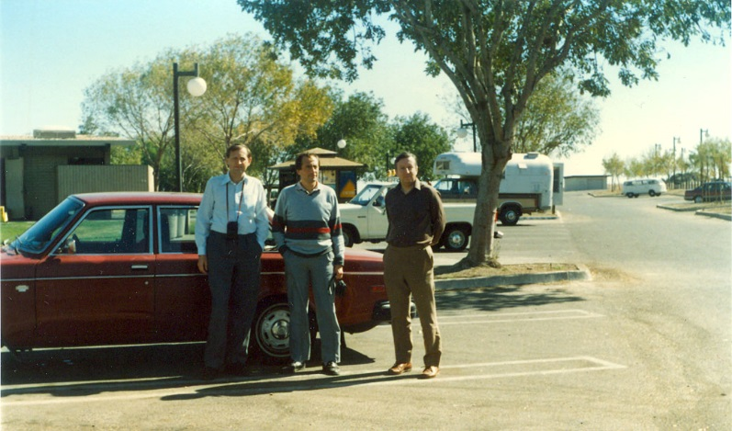

**Figure 2.** Ruslan’s first visit to California in 1990; on the road in central California with postdoc Jaroslav Fiala (left) and Ruslan (center). My red 1974 Volvo is visible at rear (I now have this car in U.K. after driving 800,000 km).

In November 1993 we published in *Journal of Materials Research* a paper on ultrafine-grained (UFG) materials processed by severe plastic deformation (SPD) and this was the first paper on these materials co-authored, at least in part, by researchers from outside of Russia [9]. This proved to be an important publication and it is now among the more than 100 papers that I have co-authored to date with Ruslan. A detailed report on my introduction to UFG materials and processing using SPD techniques was presented in a review published in 2007 [10].

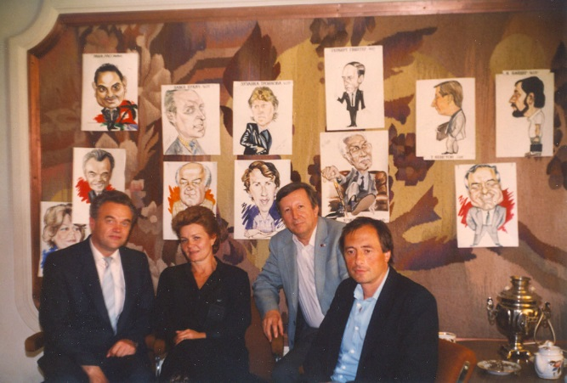

**Figure 3.** Another visit to Ufa in 1994 with (from left) Oscar Kaibyshev (Founder and Director of IPSM), Tatyana Karimova (Head of Information Services), the author and Ruslan: drawings on the wall depict foreign visitors to IPSM.

Following these initial visits to Ufa and Los Angeles, there were fairly regular meetings between Ruslan and myself, either at our home institutions or at international conferences. Figure 3 was taken on one of my later visits to IPSM in 1994 and it shows (from left) Oscar Kaibyshev, the Founder and Director of IPSM, Tatyana Karimova, the Head of the Information Services at IPSM, myself and Ruslan. The numerous drawings on the wall behind us show the caricatures of the various foreign scientists that had visited IPSM up to 1994: the drawing of the first visitor, Herbert Gleiter, is shown as third from the right at the top and my caricature is shown as second from the right at the top. Another important development in 1994 was my election as a Foreign Academician of the Academy of Sciences of the Bashkortostan Republic, the republic where Ufa is the capital city, and figure 4 shows me standing at the entrance to the impressive academy headquarters building in Ufa.

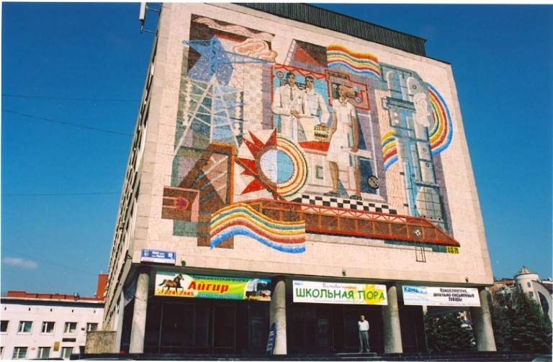

**Figure 4.** The author (at center, bottom) standing outside the headquarters building of the Academy of Sciences of the Bashkortostan Republic in Ufa.

The increasing interest in NanoSPD materials led to the organization of a NATO Advanced Research Workshop which was held in Golitsino near Moscow in August 1999. A second conference on these materials was organized in Vienna, Austria, in December 2002 and this meeting was designated NanoSPD2. Subsequently, these conferences were held every three years with NanoSPD3 at Fukuoka, Japan, in 2005, NanoSPD4 at Goslar, Germany in 2008, NanoSPD5 at Nanjing, China, in 2011, NanoSPD6 at Metz, France, in 2014 and NanoSPD7 at Sydney, Australia, in 2017. The next meeting in this series, NanoSPD8, is scheduled to be held in Bangalore, India, in September 2020.

An important development at NanoSPD2 was the formation of an International NanoSPD Steering Committee which was designed to provide a focal point for the organization of meetings and to provide assistance for all activities within the broad field of SPD. This committee was initially constituted with Ruslan as Chairman and with five additional members: Yuri Estrin (Monash University, Australia), Zenji Horita (Kyushu University, Japan), Michael Zehetbauer (University of Vienna, Austria), Yuntian Zhu (North Carolina State University, USA) and me. In 2014 the committee was expanded by adding Roberto Figueiredo (Federal University of Minas Gerais, Brazil), Hyoung Seop Kim (Pohang University of Science and Technology, Korea), Terry Lowe (Colorado School of Mines, USA), Laszlo Toth (University of Lorraine-Metz, France) and Gerhard Wilde (University of Muenster, Germany). In 2018, Megumi Kawasaki (Oregon State University, USA) was also added to the committee. A photo of a meeting of the original committee is shown in figure 5.

**Figure 5.** A meeting of the original NanoSPD International Steering Committee: (from left) Zenji Horita, Michael Zehetbauer, Ruslan Valiev, Yuri Estrin, Yuntian Zhu and the author.

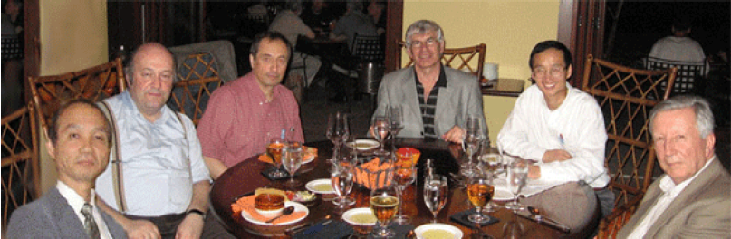

1. The development of conferences in Ufa and the production of major review publications

By the early part of the 21st century it was clear that the processing and properties of nanostructured materials, produced through the application of severe plastic deformation, had become a major research topic within the field of Materials Science. The production and testing of UFG metals had now spread to laboratories around the world and many publications on this topic were receiving large numbers of citations in the scientific literature. Two further developments contributed to the overall interest in SPD processing.

First, a series of conferences was initiated in Ufa. These meetings attracted many foreign participants but especially they provided an opportunity for local Russian researchers to present their scientific results to an appreciative audience who were able to provide valuable comments and suggestions on the nature of the work. The first of these meetings was titled “Bulk Nanostructured Materials: from Fundamentals to Innovations – BNM-2007”, it attracted participants from 23 different countries and it was followed by additional BNM conferences in later years. At the present time, the next conference will be BNM-2019 to be held in Ufa in September 2019. Figure 6 shows some of the participants at BNM-2007 when they attended a social activity at Ruslan’s summer house near Ufa. These meetings also provided an opportunity to receive additional publicity for work in the area of UFG metals. An example is shown by the main page of the Bashkortostan paper shown in figure 7 and there were also opportunities for interviews with local and national news sources.

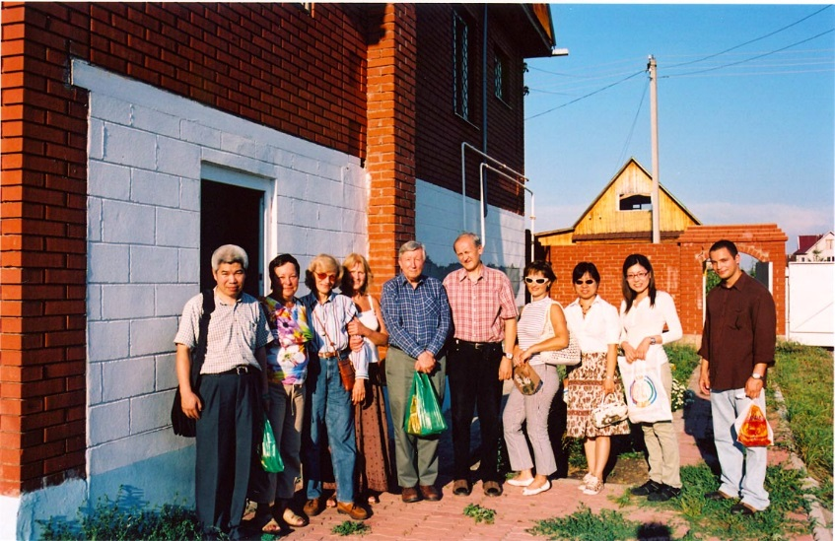

**Figure 6.** At Ruslan’s summer house near Ufa in 2007: standing (from left) Jingtao Wang (from Nanjing), a friend, Mady Langdon, Marina (Ruslan’s wife), the author, Igor Alexandrov and his wife, Cheng Xu (now at Chinese Academy of Sciences, Ningbo, China), Megumi Kawasaki (now at Oregon State University, USA) and Roberto Figueiredo (now at Federal University of Minas Gerais, Brazil).



**Figure 8.** Cover of the book “Bulk Nanostructured Materials: Fundamentals and Applications,” published by Wiley/TMS, Hoboken, NJ (2014).

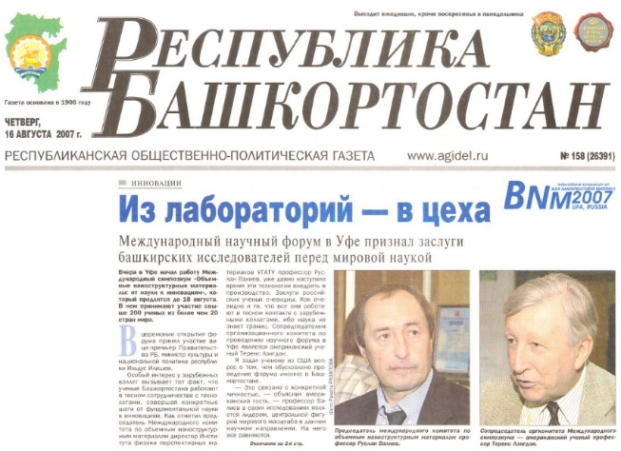

Fig. 7 Publicity in the Bashkortostan paper in 2007 for our research on UFG metals.

Second, it was important to publish major review articles documenting the principles of UFG metals and SPD processing. Accordingly, a review paper was published in 2006 in *Progress in Materials Science* describing the basic characteristics of equal-channel angular pressing (ECAP) [11]. To date, this review is listed on Web of Science as the fourth all-time most cited paper in this journal with more than 2800 citations and with more than 3600 citations on Google Scholar. It was also considered important to write an overview documenting the terminology and the procedures associated with SPD processing and UFG metals and this paper was written by the original six members of the NanoSPD International Steering Committee and published in *JOM* in 2006 [12]. This paper is now the all-time most cited paper to appear in this journal with a total of more than 1000 citations. In view of the success of this publication, the authors accepted an invitation to write a follow-up article exactly ten years later [13] and this paper, although only published in 2016, already has more than 100 citations and is the most cited *JOM* paper published in 2016. A textbook on the topic of Bulk Nanostructured Materials was co-authored with Ruslan and Alex Zhilyaev and published by Wiley/TMS in 2014 [14]. The cover of the book is shown in figure 8 and to date it has received over 270 citations.

A comprehensive review of citation statistics for papers published in the field of NanoSPD was presented in 2017 [15] and it shows that this scientific topic has many highly cited papers including the all-time most-cited papers appearing in both *Progress in Materials Science* [16] and *Scripta Materialia* [17]. These large numbers of citations confirm the world-wide interest in grain refinement through SPD processing.

1. Recognition for nanostructured materials through international awards

The outstanding research activities of Ruslan Valiev and the members of his team have been recognized by several awards. For example, he was the recipient of the Blaise Pascal Medal in Materials Science from the European Academy of Sciences at their annual meeting in Milan in 2011, he received the MSEA Journal Award from Elsevier at the TMS Annual Meeting in San Diego, California, in 2011 and he was co-recipient with Yuntian Zhu of the Sōmiya Award from the International Union of Materials Research Societies presented at Jeju Island, Korea, in 2015. Figure 9 shows Ruslan receiving the MSEA Journal Award from Enrique Lavernia, the Editor-in-Chief of *Materials Science and Engineering A*. In 2016, Ruslan, together with Rinat Islamgaliev and Igor Alexandrov of Ufa State Aviation Technical University and myself, were the recipients of the State Prize of the Republic of Bashkortostan in Science and Technology.

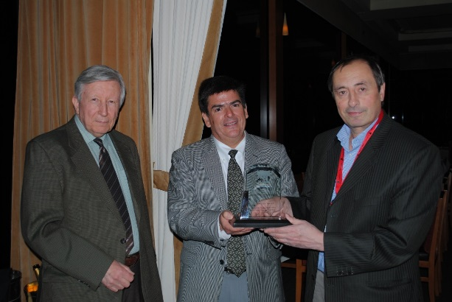

**Figure 9.** Ruslan (right) receiving the MSEA Journal Award from Enrique Lavernia (centre) at the TMS Annual Meeting in San Diego, California, in March 2011.

1. Summary and conclusions

My visit to the Institute of Problems of Superplasticity of Metals in the city of Ufa in Russia in 1989 led to a meeting with Ruslan Valiev and the initiation of a cooperation that has extended over the last thirty years and is continuing today. This cooperation has included multiple visits between our two institutes, co-authorship on more than 100 papers in the peer-reviewed scientific literature, collaborations in international conferences and the writing of extensive and widely-cited review articles and a major book.

**Acknowledgements**

This work was supported by the European Research Council under ERC Grant Agreement No. 267464-SPDMETALS. Special thanks are due to my many colleagues and friends at IPSM and at Ufa State Aviation Technical University for their unreserved support over a period that now stretches through thirty years. Their support, and the inspiration they engendered by their research activities, did much to enhance my own research and provide new stimuli for my PhD students at USC and Southampton.

**References**

[1] Andrade E N daC 1910 *Proc. Roy. Soc. London A* **81** 1

[2] Pearson C E 1934 *J. Inst. Metals* **54** 111

[3] Underwood E E 1962 *J. Metals* **14** 914

[4] Backofen W A, Turner L R and Avery D H 1964 *Trans. ASM* **57** 980

[5] Barnes A J 2007 *J. Mater. Eng. Perform.* **16** 440

[6] Langdon T G 1982 *Metall. Mater. Trans.* A**13** 689

[7] Valiev R Z, Kaibyshev O A, Kuznetsov R I, Musalimov R S and Tsenev N K 1988 *Dokl. Akad. Nauk SSSR* **301** 864

[8] Valiev R Z and Langdon T G 1993 *Acta Metall. Mater.* **41** 949

[9] Wang J, Horita Z, Furukawa M, Nemoto M, Tsenev N K, Valiev R Z, Ma Y and Langdon T G 1993 *J. Mater. Res.* **8** 2810

[10] Langdon T G 2007 *Int. J. Mater. Res.* **98** 4

[11] Valiev R Z and Langdon T G 2006 *Prog. Mater. Sci.* **51** 881

[12] Valiev R Z, Estrin Y, Horita Z, Langdon T G, Zehetbauer M J and Zhu Y T 2006 *JOM* **58** 33

[13] Valiev R Z, Estrin Y, Horita Z, Langdon T G, Zehetbauer M J and Zhu Y 2016 *JOM* **68** 1216

[14] Valiev R Z, Zhilyaev A P and Langdon T G 2014 *Bulk Nanostructured Materials: Fundamentals and Applications* (Hoboken: Wiley/TMS)

[15] Valiev R Z and Langdon T G 2017 *IOP Conf. Series: Mater. Sci. Eng.* **194** 012001

[16] Valiev R Z, Islamgaliev R K and Alexandrov I V 2000 *Prog. Mater. Sci.* **45** 103

[17] Iwahashi Y, Wang J, Horita Z, Nemoto M and Langdon T G 1996 *Scripta Mater.* **35** 143