Investigation of Dy³⁺/Tm³⁺ co-doped ZrF₄-BaF₂-YF₃-AlF₃ fluoride glass for efficient 2.9 μm mid-infrared laser applications

Haiyan Zhao, Xin Wang, Ruicong Wang, Xiaosong Lu, Masaki Tokurakawa, Shunbin Wang, Pengfei Wang

Different doping concentrations of Dy³⁺/Tm³⁺ in ZrF₄-BaF₂-YF₃-AlF₃ (ZBYA) fluoride glass samples were prepared by the melt-quenching method. Spectroscopic properties were analyzed through absorption (from 200 to 3300 nm) and emission spectra (from 1200 to 3200 nm). The spontaneous radiative transition probability, branching ratio and radiative lifetime of various energy levels transition were calculated based on the Judd-Ofelt theory. The emission cross-section value of the 1 mol% Dy³⁺/1 mol% Tm³⁺ co-doped ZBYA sample at 2.9 μm were calculated as 3.79$×$10⁻²¹ cm². Near- and mid-IR emission spectra of Dy³⁺/Tm³⁺ co-doped ZBYA-fluoride glass under the excitation of 808 nm laser diode were investigated and discussed. Analysis of the emission spectra and the energy transition process of Dy³⁺/Tm³⁺ co-doped glass indicated that the introduction of Tm³⁺ ions can effectively improve the mid-infrared fluorescence intensity of Dy³⁺ ions, thus the Dy³⁺/Tm³⁺ co-doped ZBYA-fluoride glass can be an excellent candidate material for 2.9 μm mid-infrared laser applications.

Introduction
Mid-infrared fiber lasers (in the wavelength range λ=2-5 μm) have attracted much attention for their wide range of applications in molecular spectroscopy, medical treatment, environment detection, sensors and military defense as mid-infrared lasers operate in the transparent atmospheric transmission window and cover many important molecular characteristic lines [1]. In the past decade, researchers have made great efforts to improve the output power and stability of the mid-infrared fiber lasers to meet the requirement of real applications. So far, mid-infrared fiber lasers could be achieved only in fluoride fibers such as ZBLAN [2], fluoroaluminate [3] and fluoroindate [4]. Among them, ZBLAN fibers have shown excellent lasing performance: in 2018, Yigit Ozan Aydin et al demonstrated a λ~2.82 μm fiber laser in a 7 mol% doped Er:ZBLAN fiber pumped by a high power λ~976 nm laser diode source, producing an output power up to 41.6 W [5]. Generally, the fluorozirconate glass has the advantages of wide transparency window ( λ~0.3-7 μm), low phonon energy (580 cm⁻¹) and high rare earth solubility [6]. The low phonon energy reduces the multi-phonons non-radiative relaxation probability and therefore increases the emission efficiency between rare earth ion transition levels. In the past two decades, the spectral properties of ZBLAN (53ZrF₄-20BaF₂-4LaF₃-3AlF₃-20NaF₃) glass have been extensively studied and making ZBLAN the main gain material for mid-infrared fiber lasers [7-10]. However, its poor thermal and chemical properties, including low glass transition temperature (Tg~267 ºC) and predisposition to deliquesce (for the existence of large Na content), limit its applications in high power fiber lasers. ZrF₄-BaF₂-YF₃-AlF₃ (ZBYA) glass has been proposed as a fluorozirconate glass alternative to ZBLAN, because of its better thermal and chemical stability [11, 12]. In 2016, Feifei Huang et al reported the spectroscopic and energy transfer mechanisms of Er³⁺/Pr³⁺ co-doped ZBYA glass, which confirmed that the λ~ 2.7 μm emission of Er³⁺ ions in ZBYA glass can be greatly improved by introduction of Pr³⁺ ions [13]. In order to improve the λ~ 2.7 μm emission, Huang et al also investigated the fluorescence properties and energy transfer mechanism of Ho³⁺/Er³⁺, Er³⁺/Tm³⁺ co-doped ZBYA glass [14]. These results showed the better chemical and thermal properties of ZBYA-fluoride glass and excellent emission characteristics in the λ~ 2.7 µm wavelength region.
Dy³⁺ ion is another type of rare earth ion that can be used for obtaining mid-infrared emissions at λ~ 2.9 μm due to transition ⁶H_{13/2} → ⁶H_{15/2} level [15], which is longer and wider than that obtained from Er: ⁴I_{11/2} → ⁴I_{13/2} and Ho: ⁵I₆→⁵I₇ transitions [16]. However, the mid-infrared fluorescence performance of Dy³⁺ ions is associated with a weak absorption in the near-infrared band near λ~ 808 nm, λ~ 912 nm and λ~ 1100 nm, which leads to a low absorption efficiency under the excitation of common commercial NIR LD lasers. An efficient method to improve Dy³⁺ ions mid-infrared fluorescence efficiency relies on the introduction of relevant sensitizing ions through energy transfer processes [17]. The ³H₄ level of Tm³⁺ has a strong absorption near λ~ 808 nm, while the Tm³⁺: ³F₄ level has similar spectroscopy properties to the Dy³⁺: ⁶H_{11/2} level [18, 19]. An energy transfer effect between Tm³⁺ and Dy³⁺ ions can occur in Tm³⁺/Dy³⁺ co-doped materials, which can efficiently improve the mid-infrared emissions of Dy³⁺ ions [17].
In this letter, we report the mid-infrared emission performance in different doping concentrations of Dy³⁺/Tm³⁺ co-doped ZBYA glasses.

Experiment
Dy³⁺/Tm³⁺ co-doped ZBYA glass samples were prepared by using high-purity ZrF₄, BaF₂, YF₃, AlF₃, DyF₃ and TmF₃ precursors in powder. The molar compositions of the investigated glasses were 50ZrF₄-33BaF₂-(9-x)YF₃-7AlF₃-1TmF₃-xDyF₃ (x=0.2, 0.5, 1, 2, 3); 50ZrF₄-33BaF₂-(9-x)YF₃-7AlF₃-1DyF₃-xTmF₃ (x=0.2, 0.5, 1, 2, 3). The raw material batches were weighted with a fine electronic balance and mixed in an agate mortar, and then put in a platinum crucible and melted in an electric furnace at 850 ºC in a glove box. The melts were poured onto a preheated copper plate and annealed in a furnace around the glass transition temperature for 180 min. Finally, the obtained glass samples were cut and polished for measurements. The transmission spectrum was measured with a Perkin-Elemer Lambda 900 UV spectrophotometer in the range λ~ 200 - 3300 nm and a Perkin Elmer FT-IR spectrometer in the range λ~ 3300 - 10000 nm, respectively. The Raman spectra were measured by using a Horiba LabRAM HR Evolution spectrometer. The near-infrared and mid-infrared fluorescence spectra were measured using a combination of the Zolix Omni-λ3015 infrared monochromator (InSb detector cooled with liquid nitrogen) and the SCITEC Model 420 dual-phase lock-in amplifier. The excitation source is a λ~ 808 nm diode laser with a power setting of 1.8 W. All of the measurements were carried out at room temperature.

Results and discussion
Fig.1 (a) shows the transmission spectrum of un-doped ZBYA glass in the λ~ 200-10000 nm band. The transmittance at λ~1000-6000 nm is as high as 90%, and the infrared cutoff wavelength is around λ~ 9000 nm. The figure shows that there is a small OH⁻ absorption of groups near λ~ 3 μm. The absorption coefficient α_{OH-} of OH⁻ groups can be calculated using the following equation [20]:
$$α_{{OH}^{\text{-}}}\text{=}\frac{1}{d}×ln\left(\frac{T_{b}}{T}\right)$$
where d is the glass thickness, T_{b} is the maximum transmittance of the glass, and T is the transmittance at the peak wavelength of OH⁻ absorption. The α_{OH}⁻ of the ZBYA sample is ~0.0098 cm⁻¹, which is much lower than that in gallate (~0.15 cm⁻¹) [20], tellurite (~0.6 cm⁻¹) [21], fluorotellurite (~1.09 cm⁻¹) [22], fluoroaluminate (~0.41 cm⁻¹) [23] and fluorinate (~0.06 cm⁻¹) glasses [24]. As the residual OH⁻ groups in the glass matrix can participate in the energy transfer process of rare earth ions and reduce the emission efficiency, a ZBYA glass with ultra-low OH⁻ is an attractive candidate for 3 μm laser material application [25].
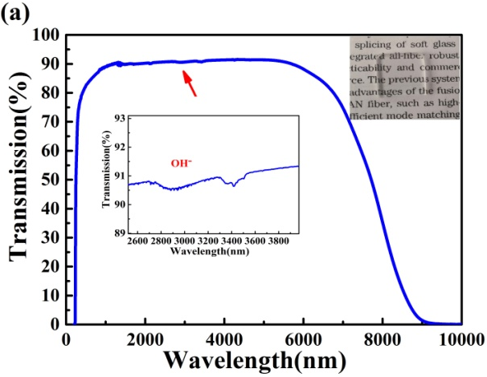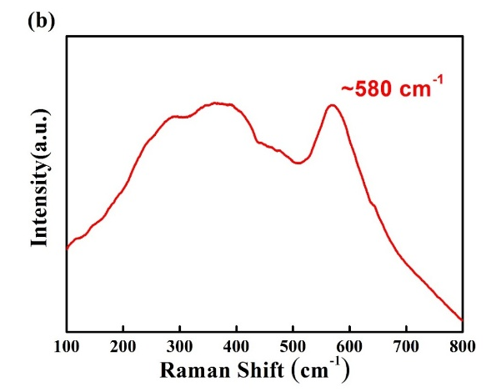
Fig.1.(a) Transmittance spectrum of the 1.5 mm thick un-doped ZBYA glass in the range λ~ 200-10000 nm. Insets: zoom of the OH⁻ absorption at λ~ 3.0 µm and image of ZBYA glass bulk (b) Raman spectrum of the ZBYA-fluoride glass sample.
Fig.1 (b) shows the Raman spectrum of the ZBYA-fluoride glass sample. An obvious Raman shift peak at 580 cm⁻¹ signs the ZBYA maximum phonon energy. It can be seen that the ZBYA phonon energy is similar to that of ZBLAN (580 cm⁻¹), and lower than fluoroaluminate glass and oxide glass matrices [26]. The lower phonon energy of ZBYA glass is an advantage for achieving lasing at λ~ 2.9 μm .

Absorption spectra and J-O analysis
Fig. 2 presents the absorption spectra of Dy³⁺ single-doped and Dy³⁺ / Tm³⁺ co-doped ZBYA glasses. It can be seen that the transitions from the ⁶H_{15/2} level to the higher levels ⁶H_{13/2,} ⁶H_{11/2}, ⁶H_{9/2}+⁶F_{11/2}, ⁶H_{7/2}+⁶F_{9/2}, ⁶F_{7/2,} ⁶F_{5/2} correspond to the absorption bands centered at λ~ 2900 nm, 1700 nm, 1300 nm, 1094 nm, 908 nm and 804 nm, respectively. Compared with the single-doped Dy³⁺ sample, the Dy³⁺/Tm³⁺ co-doped sample has a significantly higher absorption around λ~ 1700 nm and 800 nm because the Dy³⁺: ⁶H_{15/2} → ⁶H_{11/2}, ⁶H_{15/2} → ⁶F_{5/2} transition and the Tm³⁺: ³H₆ → ³F₄, ³H₆ → ³H₄ transitions are expanded at those two absorption bands respectively, and the absorption intensity is superimposed. As the concentration of Tm³⁺ ions increases, the absorption intensity increases correspondingly, which would improve the absorption efficiency at λ~800 nm.
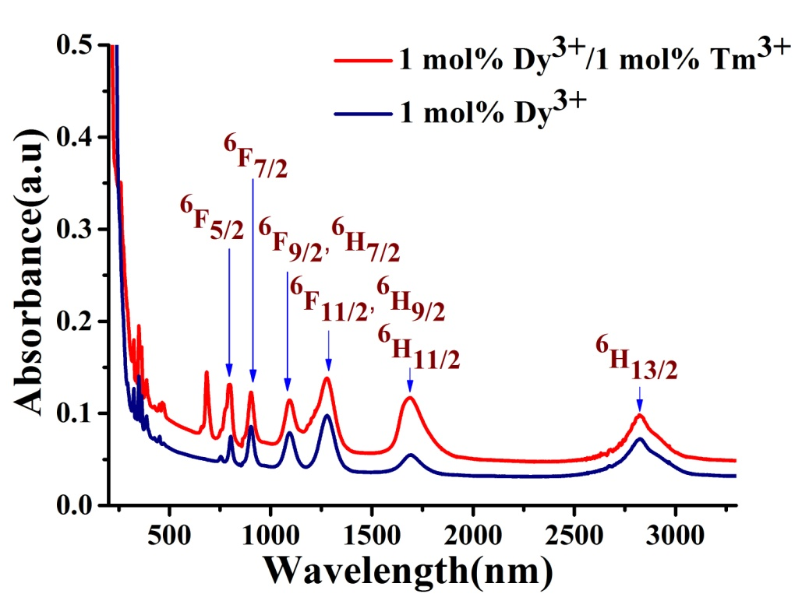
Fig.2. Absorption spectra of Dy³⁺ single-doped and Dy³⁺ / Tm³⁺ co-doped in ZBYA glasses in the range λ~ 200-3300 nm.
The relevant spectral parameters of the Dy³⁺/Tm³⁺ co-doped ZBYA glass can be calculated from the Judd-Ofelt (J-O) theory [27]. The J-O intensity parameters Ω_{t} (t=2, 4, 6) are commonly used to analyze the symmetry of the glass matrix, the covalency of the rare earth ions and the anion bonds, amongst others [28]. Generally, Ω₂ is determined by the glass matrix structure (such as symmetry around the ligand and order,) and is proportional to the covalency between the coordination anions and rare earth ions. The larger is the Ω₂ value, the lower is the symmetry around the rare earth ion and the higher is covalency. The Ω₂ value of the ZBYA sample is the smallest, similar to that of the ZBLAN and fluoroaluminate glasses but smaller than that of chalcohalide and tellurite glasses, indicating that the sample has high symmetry and strong ionicity of the coordination field in the environment. While both the parameter Ω₄ and Ω₆ are related to the local basicity of the ligands in the glass. Ω₆ is mainly affected by the overlap of the 4f and 5d orbital of rare earth ions, and its value increases with the increase of density. As Ω₆ is high, the emission bandwidth of rare earth ions and the probability of spontaneous radiation increase [29]. Table 1 shows the Judd-Ofelt intensity parameters Ω_{t} (t=2, 4, 6) in various glass hosts.
Table 1. Calculated J-O intensity parameters Ω_{t} (t=2, 4, 6) of Dy³⁺ in various glass hosts.
Ω_{t} (10⁻²⁰ cm²) | Ω₂ | Ω₄ | Ω₆
Fluoroaluminate[30] | 2.7 | 0.86 | 1.89
ZBLAN[31] | 3.29 | 1.56 | 2.48
Chalcohalide[32] | 11.82 | 3.35 | 1.56
Tellurite[33] | 6.85 | 1.75 | 1.75
ZBYA(this work) | 3.13 | 0.33 | 0.43

Table 2 lists the spontaneous radiation transitions probability (A), fluorescence branching ratio (β) and radiative lifetime (τ_{rad}) for Dy³⁺energy level transitions in the ZBYA glass sample. As expected, the spontaneous-emission probabilities for the Dy³⁺: ⁶H_{13/2} → ⁶H_{15/2} transition is 20.1 s⁻¹, which is similar to that recorded in ZBLA (19.5 s⁻¹) [34] but lower than that of ZBLAY (45.92 s⁻¹) [35]. Generally, higher spontaneous-emission probability provides a better opportunity to obtain laser actions [36]. The lifetime of the Dy³⁺: ⁶H_{13/2} energy level in ZBYA glass is calculated to be as long as 56.8 ms, favorable for achieving efficient 2.9 μm lasing.

Table 2. Radiative parameters for various selected excited levels of Dy³⁺ in ZBYA glass
Transition | Wavelength(nm) | A (s⁻¹) | β (%) | τ_{rad} (ms)
⁶H_{9/2}+⁶F_{11/2} → ⁶H_{15/2} | 1325 | 20.1 | 85.24 | 42.4
→ ⁶H_{13/2} | 2390 | 3.2 | 13.57
→ ⁶H_{11/2} | 5410 | 0.28 | 1.18
⁶H_{11/2} → ⁶H_{15/2} | 1760 | 44.3 | 94.1 | 21.2
→ ⁶H_{13/2} | 4290 | 2.8 | 5.9
⁶H_{13/2} → ⁶H_{15/2} | 2864 | 17.59 | 100 | 56.8

Assuming that the time to establish thermal equilibrium in the energy level multi-configuration is less than its radiation lifetime, according to the McCumber theory [37], the relationship between the absorption cross section σ_{abs} and the emission cross section σ_{emi} is:
$${\text{σ}}_{\text{emi}}\text{=}{\text{σ}}_{\text{abs}}\left(\text{λ}\right)\text{exp}\left[\left(\text{ε-}\text{hν}\right)\text{/KT}\right]$$
where h, ν, K, and T represent the Planck constant, photon frequency, the Boltzmann constant, and the room temperature, respectively. ε is the temperature-dependent excitation energy whose value is equal to the energy corresponding to the peak frequency of the absorption spectrum.
The absorption cross section can be calculated directly from the measured absorption spectrum:
$${\text{σ}}_{\text{abs}}\text{=}\frac{\text{ln}\left[{\text{I}}_{\text{0}}\left(\text{λ}\right)\text{/I}\left(\text{λ}\right)\right]}{\text{Nd}}\text{=}\frac{\text{2.303log}\left[{\text{I}}_{\text{0}}\left(\text{λ}\right)\text{/I}\left(\text{λ}\right)\right]}{\text{Nd}}\text{=}\frac{\text{2.303D}\left(\text{λ}\right)}{\text{Nd}}$$
where N is the concentration of rare earth ions, d is the optical path, that is, the thickness of the sample, and D(λ) is the optical density, which is derived from the absorption spectrum.
The emission cross section σ_{emi} and the absorption cross section σ_{abs} of the Dy³⁺: ⁶H_{13/2} → ⁶H_{15/2} transition of the 1 mol% Dy³⁺/1 mol% Tm³⁺ co-doped sample is presented in Fig. 3(a). The peak value of σ_{emi} at λ~2.9 μm is 3.79$×$10⁻²¹ cm², similar with that in fluoroaluminate glass (~3.96$×$10⁻²¹ cm²) [38], while lower than ZBLAY (~1.17$×$10⁻²⁰ cm²) [35] and tellurite glasses (~2.82$×$10⁻²⁰ cm²) [39] due to the different phonon energy in different glass matrices.
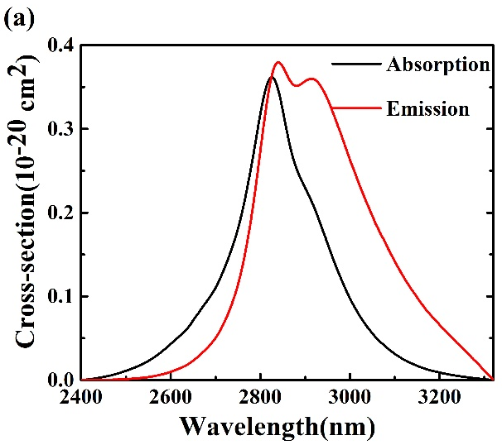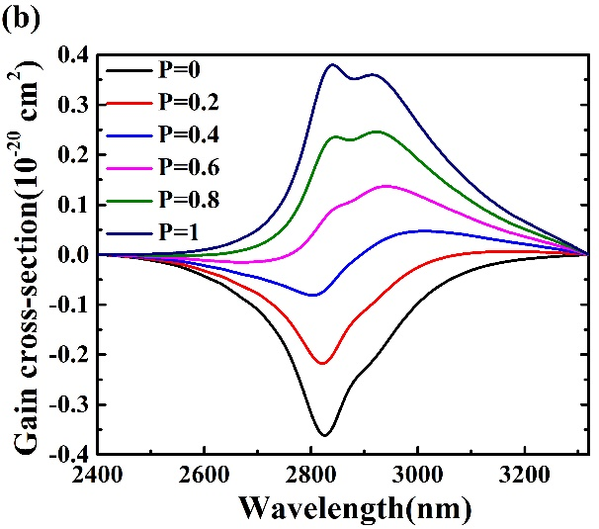
Fig.3 (a) Absorption cross-section and emission cross section of ⁶H_{13/2} → ⁶H_{15/2} transition in 1 mol% Dy³⁺/1 mol% Tm³⁺ co-doped sample; (b) Gain coefficient spectra for the ⁶H_{13/2} → ⁶H_{15/2} transition in the 1 mol% Dy³⁺/1 mol% Tm³⁺ co-doped sample.
The gain cross-section as function of the wavelength was calculated using the equation:
$$G\left(λ\right)=Pσ_{emi}-\left(1-P\right)σ_{abs}$$
where P is population inversion parameter, which is related to the concentration ratio of Dy³⁺ in the ⁶H_{11/2} and ⁶H_{13/2} level. The gain coefficients with various P ranging from 0 to 1 were presented in Fig.3 (b), and positive gain can be obtained in the range of λ~2800-3000 nm when P>4.

Fluorescence Properties and energy transfer analysis
The Near-IR fluorescence spectra of Dy³⁺/Tm³⁺ co-doped ZBYA glasses in the range λ~1150-1350 nm is given in Fig. 4. The fluorescence peak at λ~1260 nm corresponds to the transition of Tm³⁺: ³H₅ → ³H_{6.} When the Tm³⁺ concentration is fixed at 1 mol%, the fluorescence intensity at λ~1260 nm decreases as the concentration of Dy³⁺ increases, while, the fluorescence intensity at λ~1260 nm increases as the concentration of Tm³⁺ increases. This phenomenon indicates the energy transfer process between the Tm³⁺: ³H₅ and the Dy³⁺: ⁶F_{11/2,} ⁶H_{9/2} energy levels.
Fig. 5 shows the strong emissions near λ~1470 nm and λ~1800 nm, which are attributed to the radiative transitions of Tm³⁺: ³H₄ → ³F₄ and ³H₅ → ³H₆, respectively. It is found that when the Tm³⁺ doping concentration is fixed, the fluorescence intensity at λ~1470 nm and λ~1800 nm gradually decreases as the concentration of Dy³⁺ increases, which can explain the existence of energy transfer (ET) between Tm³⁺: ³H₄ → Dy³⁺: ⁶F_{5/2}, Tm³⁺: ³F₄ → Dy³⁺: ⁶H_{11/2}, due to their similar energy levels.
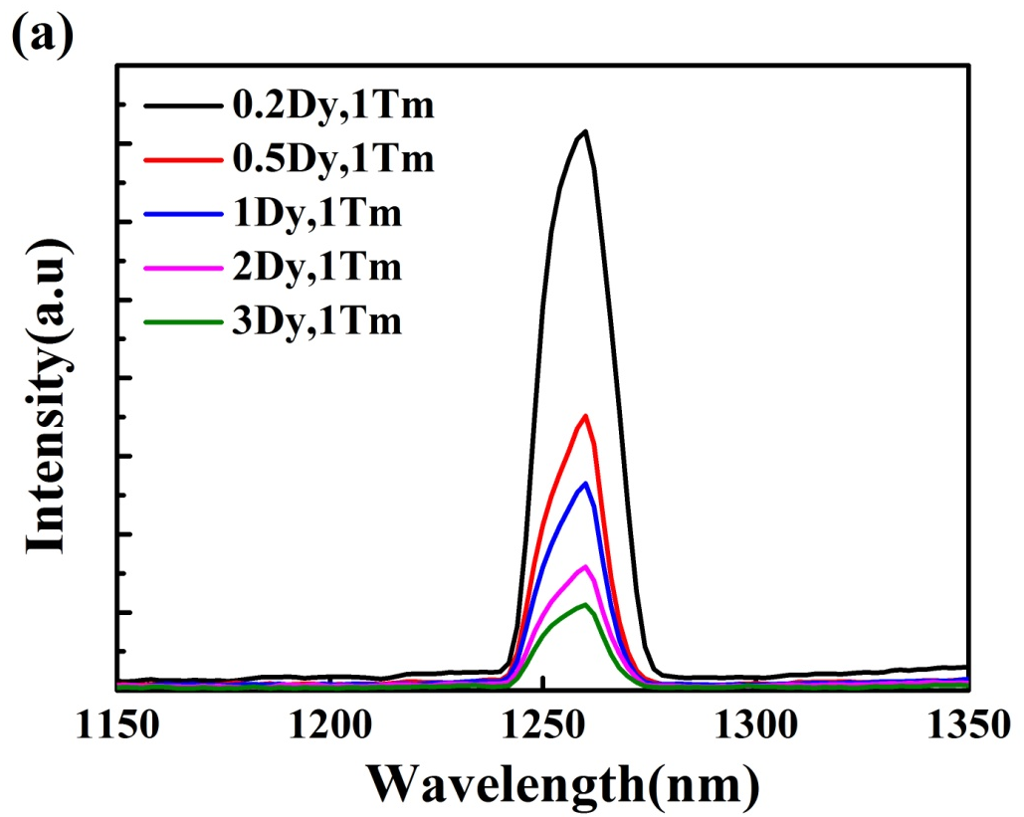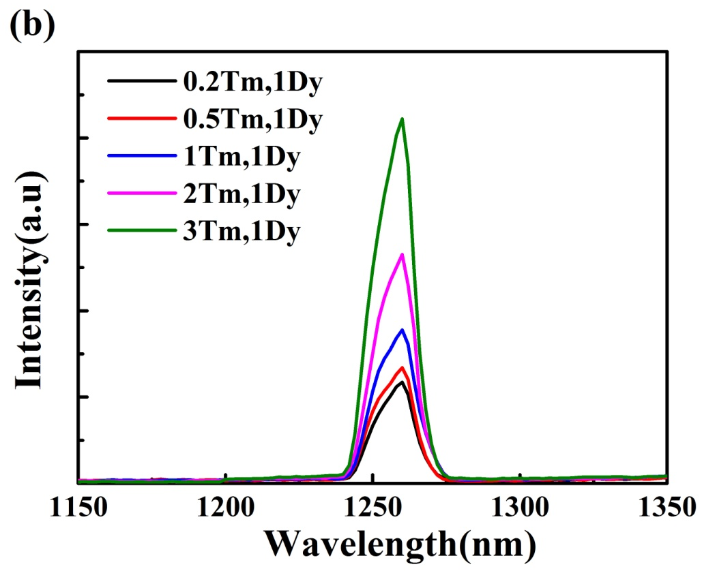
Fig. 4. Near-infrared fluorescence spectra at λ~1260 nm of Dy³⁺/Tm³⁺-doped ZBYA glasses excited at λ~808 nm.

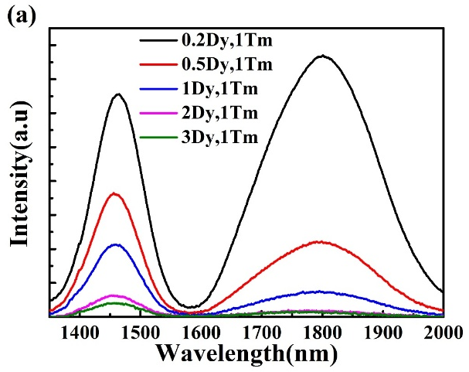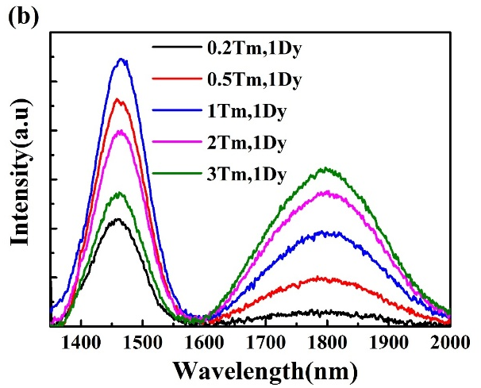
Fig. 5. Near-infrared fluorescence spectra at λ~1470 nm and λ~1800 nm of Dy³⁺/Tm³⁺ co-doped ZBYA glasses excited at λ~808 nm.

When the Dy³⁺ doping concentration is maintained at 1 mol% and the concentration of Tm³⁺ ions increases, the emission intensity at λ~1470 nm and λ~1800 nm increases, while when the concentration of Tm³⁺ adds up to 2 mol%, the emission intensity of λ~1470 nm shows a weakening trend, that is most likely due to the existence of an energy transfer process ³H₄ → ³H₆ (Tm³⁺): ⁶H_{15/2} → ⁶F_{5/2} (Dy³⁺): the number of electrons on the Tm³⁺: ³H₄ energy level is reduced, which leads to the weakening of the λ~1470 nm fluorescence.
Fig. 6 shows the 2.9 μm fluorescence spectra, which is attributed to the emission of the Dy³⁺: ⁶H_{13/2} → ⁶H_{15/2} transition. Fig. 6(a) shows that at a fixed Tm³⁺ doping concentration of 1 mol%, the 2.9 μm fluorescence intensity increases with increasing Dy³⁺doping content from 0.2 to 3 mol%, thus indicating an efficient energy transfer between Tm³⁺: ³F₄ and Dy³⁺: ⁶H_{13/2} level. When the Dy³⁺ doping concentration is fixed, the same effect occurs as the Tm³⁺ concentration increases (Fig. 6(b)). The introduction of Tm³⁺ ions increases the absorption rate of Dy³⁺ ions and also improves the pumping absorption efficiency, thereby effectively increasing the fluorescence intensity at λ~2.9 μm.

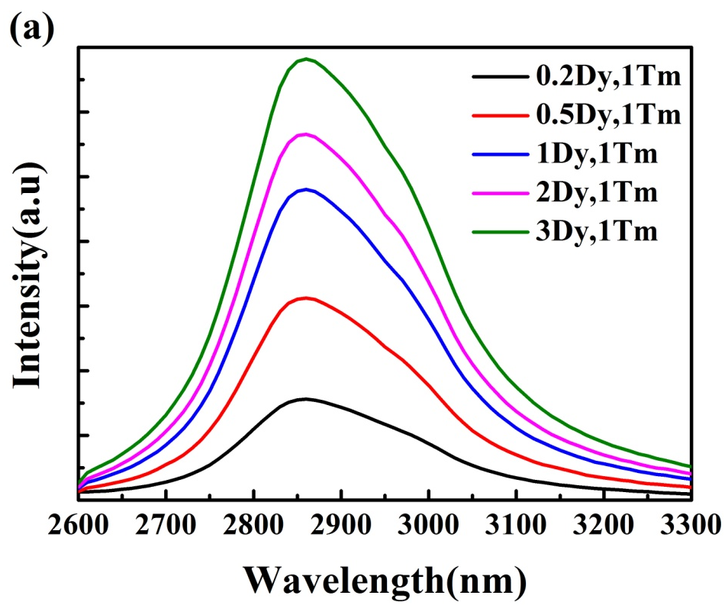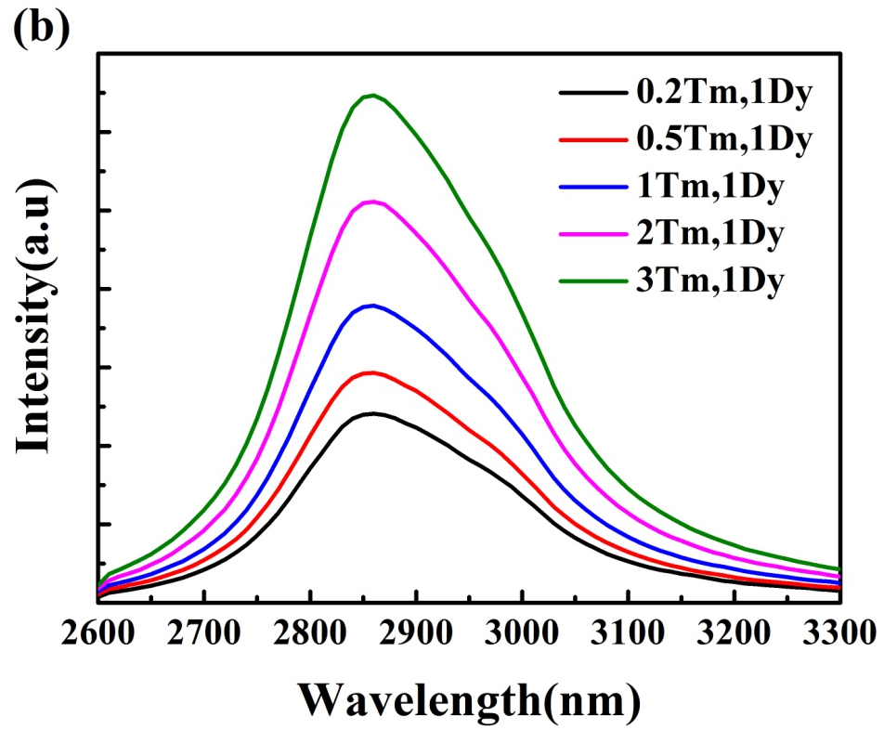
Fig. 6. Luminescence spectra of Dy³⁺ ions at the λ~2.9 μm wavelength in different doping concentrations of Dy³⁺/Tm³⁺-doped ZBYA glass excited at λ~808 nm.
Fig. 7 shows the energy transfer processes between Tm³⁺ and Dy³⁺. Under λ~808 nm laser pumping, the electrons of the Tm³⁺ ground state ³H₆ level are excited to the ³H₄ excited state level, and then transition radiatively to the ³F₄ level, resulting in a λ~1.47 μm near-infrared emission. Simultaneously, the minority of Tm³⁺ ions in the ³H₄ level will relax to the ³H₅ level through multi-phonon relaxation (MPR), and then jump to the ³H₆ level to produce λ~1.26 μm near-infrared emission. The electrons of the Dy³⁺: ⁶H_{13/2} level accumulate due to multi-phonon relaxation (MPR) of the upper level, then transition to the ground state level ⁶H_{15/2}, resulting in the 2.9 μm mid-infrared emission. The electron in the excited state ³F₄ level returns to the ground state, producing the λ~1.8 μm emission. The energy transfers (ET) Tm³⁺: ³H₄ → Dy³⁺: ⁶F_{5/2}, Tm³⁺: ³H₅ → Dy³⁺: ⁶F_{11/2} (⁶H_{9/2}), Tm³⁺: ³F₄ → Dy³⁺: ⁶H_{11/2} are signed as ET1, ET2, ET3, respectively. Besides, the Tm³⁺: ³H₄ level can be depopulated by the well-known cross relaxation (CR) ³H₆ + ³H₄ → ³F₄ + ³F₄. After the Tm³⁺: ³F₄ level is populated, electrons of the Tm³⁺: ³F₄ level can be transferred to the Dy³⁺: ⁶H_{11/2} level. In this paper, the change of infrared fluorescence spectra also confirmed the existence of these energy transfer processes.
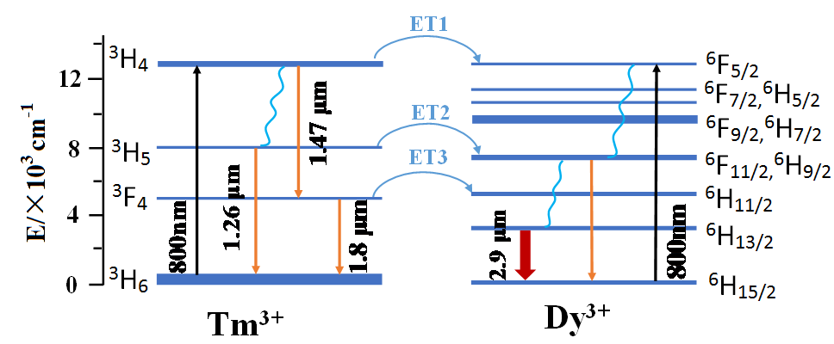
Fig. 7. Energy transfer processes between Tm³⁺ and Dy³⁺ ions in ZBYA glasses.

Conclusion
In conclusion, we investigated the λ~2.9 μm emission properties and energy transfer mechanism of Dy³⁺/Tm³⁺ co-doped ZBYA glasses. Combined with the measured near- infrared fluorescence spectra and mid-infrared fluorescence spectra, the energy transfer processes between Dy³⁺ and Tm³⁺ ions are analyzed in detail. The strong λ~2.9 μm mid-infrared emission for the Dy³⁺/Tm³⁺ co-doped ZBYA glasses was due to the occurrence of the energy transfer process of Tm³⁺: ³F₄ → Dy³⁺: ⁶H_{11/2.} Our results show that Dy³⁺/Tm³⁺ co-doped ZBYA glass is a potential gain medium for λ~2.9 μm laser application.

References
1. Seddon, A.B., et al., Progress in rare-earth-doped mid-infrared fiber lasers. Optics Express, 2010. 18(25): p. 26704.
2. Shen, Y., et al., Wavelength-tunable passively mode-locked mid-infrared Er 3+ -doped ZBLAN fiber laser. Scientific Reports, 2017. 7(1): p. 14913.
3. Jia, S.J., et al., Ho3+ doped fluoroaluminate glass fibers for 2.9 µm lasing. Laser Physics, 2017. 28(1): p. 015802.
4. Jia, S., et al., 2875 nm lasing from Ho3+-doped fluoroindate glass fibers. IEEE Photonics Technology Letters, 2017. PP(99): p. 1-1.
5. Aydin, Y.O., et al., Towards power scaling of 28 μm fiber lasers. Optics Letters.
6. Wetenkamp, L., G.F. West, and H. Többen, Optical properties of rare earth-doped ZBLAN glasses. Journal of Non Crystalline Solids, 1992. 140: p. 35-40.
7. Xia, C., et al., Mid-infrared supercontinuum generation to 4.5 microm in ZBLAN fluoride fibers by nanosecond diode pumping. Optics Letters, 2006. 31(17): p. 2553-2555.
8. Hashida, M., et al., Liquid-cooled 24 W mid-infrared Er:ZBLAN fiber laser. Optics Letters, 2009. 34(20): p. 3062-4.
9. DG, L., et al., Fifty percent internal slope efficiency femtosecond direct-written Tm³⁺:ZBLAN waveguide laser. Optics Letters, 2011. 36(9): p. 1587-9.
10. Liao, X., et al., Spectral Properties of Er(3+)/Tm(3+) Co-Doped ZBLAN Glasses and Fibers. Materials, 2017. 10(5): p. 486.
11. Rasztovits, Z.E., I. Szabó, and G.H. Frischat, DTA study of rare earth doped ZBYA-type fluoride glasses. Zeitschrift Fã¼r Elektrochemie Berichte Der Bunsengesellschaft Fã¼r Physikalische Chemie, 2010. 100(9): p. 1642-1645.
12. Ebendorff-Heidepriem, H., I. Szabó, and Z.E. Rasztovits, Crystallization behavior and spectroscopic properties of Ho3+-doped ZBYA-fluoride glass. Optical Materials, 2000. 14(2): p. 127-136.
13. Huang, F., et al., Spectroscopic and energy transfer mechanism of Er 3+ , Pr 3+ -codoped ZBYA glass. Ceramics International, 2016. 42(7): p. 7924-7928.
14. Huang, F., et al., Sensitizing effect of Ho 3+ on the Er 3+ : 2.7 μm-emission in fluoride glass. Optical Materials, 2014. 36(5): p. 921-925.
15. Deng, S.W., et al., Preparation and the mid-infrared emission properties of Dy~(3+)/Tm~(3+)-codoped GeS_2-Ga_2S_3-PbI_2 glasses. Journal of Optoelectronics Laser, 2011. 22(2): p. 223-227.
16. Jackson, S.D., Towards high-power mid-infrared emission from a fibre laser. Nature Photonics, 2012. 6(6): p. 423-431.
17. Guo, H., et al., Near- and mid-infrared emissions of Dy 3+ doped and Dy 3+ /Tm 3+ co-doped lead cesium iodide modified chalcohalide glasses. Journal of Luminescence, 2014. 148(7): p. 10-17.
18. Heo, J. and B.S. Yong, Absorption and mid-infrared emission spectroscopy of Dy 3+ in Ge-As(or Ga)-S glasses. Journal of Non-Crystalline Solids, 1996. 196(1): p. 162-167.
19. Carter, J.N., et al. High efficiency amplification and low threshold lasing at 0.8µm in a thulium-doped fluorozirconate fibre. 1992.
20. Yoshimoto, K., et al., 2.7 µm Mid-Infrared Emission in Highly Erbium-Doped Lanthanum Gallate Glasses Prepared Via an Aerodynamic Levitation Technique. Advanced Optical Materials, 2018. 6(8): p. 1701283.
21. Gomes, L., et al., Energy level decay and excited state absorption processes in erbium-doped tellurite glass. Journal of Applied Physics, 2011. 110(8): p. 646.
22. Wang, P.F., et al., Effect of dehydration techniques on the fluorescence spectral features and OH absorption of heavy metals containing fluoride tellurite glasses. Journal of Non-Crystalline Solids, 2012. 358(4): p. 788-793.
23. Huang, F., L. Hu, and D. Chen, Observation of 2.8μm emission from diode-pumped Dy3+-doped fluoroaluminate glasses modified by TeO2. Ceramics International, 2014. 40(8, Part B): p. 12869-12873.
24. Gomes, L., et al., The basic spectroscopic parameters of Ho3+-doped fluoroindate glass for emission at 3.9 μm. Optical Materials, 2016. 60: p. 618-626.
25. Clare, A.G., et al. Effect of water content on neodymium-doped fluorozirconate and fluoroaluminate glasses. in Inorganic Optical Materials II. 2000.
26. Peng, B. and T. Izumitani, Optical properties, fluorescence mechanisms and energy transfer in Tm3+, Ho3+ and Tm3+ -Ho3+ doped near-infrared laser glasses, sensitized by Yb3+. Optical Materials, 1995. 4(6): p. 797-810.
27. Goldner, P. and F. Auzel, Application of standard and modified Judd-Ofelt theories to a praseodymium-doped fluorozirconate glass. Journal of Applied Physics, 1996. 79(10): p. 7972-7977.
28. Feng, X., S. Tanabe, and T. Hanada, Spectroscopic Properties and Thermal Stability of Er3+-Doped Germanotellurite Glasses for Broadband Fiber Amplifiers. Journal of the American Ceramic Society, 2010. 84(1): p. 165-171.
29. Ofelt, G.S., Intensities of crystal spectra of rare earth ions. Journal of Chemical Physics, 1962. 37(3): p. 511-520.
30. Huang, F., et al., Spectroscopic properties and energy transfer mechanism in Dy 3+ /Tm 3+ codoped fluoroaluminate glasses modified by TeO 2. Ceramics International, 2016. 42(1): p. 132-137.
31. Zhang, J., et al., OPTICAL PROPERTIES OF Dy~(3+) IN FLUOROZIRCONATE GLASSES. Chinese Journal of Luminescence, 1999.
32. Haitao, G., et al., Host dependence of spectroscopic properties of Dy 3+ - doped and Dy 3+, Tm 3+ -codped Ge-Ga-S-CdI 2 chalcohalide glasses. Optics Express, 2009. 17(17): p. 15350-8.
33. Ma, Y., et al., 2.9μm emission properties and energy transfer mechanism in Dy3+/Tm3+-codoped tellurite glass. Materials Science and Engineering: B, 2015. 196: p. 23-27.
34. Adam, et al., Optical transitions of Dy/sup 3 +/ ions in fluorozirconate glass. Journal of Solid State Chemistry, 1988. 75(2): p. 403-412.
35. Tian, Y., et al., Broadband 2.84μm luminescence properties and Judd-Ofelt analysis in Dy3+ doped ZrF4-BaF2-LaF3-AlF3-YF3 glass. Journal of Luminescence, 2012. 132(1): p. 128-131.
36. Heo, J., Y.B. Shin, and J.N. Jang, Spectroscopic analysis of Tm(3+) in PbO-Bi(2)O(3)-Ga(2)O(3) glass. Applied Optics, 1995. 34(21): p. 4284-9.
37. Schweizer, T., et al., Spectroscopic data of the 1.8-, 2.9-, and 4.3-μm transitions in dysprosium-doped gallium lanthanum sulfide glass. Optics Letters, 1996. 21(19): p. 1594-1596.
38. Qi, F., et al., Low-hydroxy Dy3+/Nd3+ co-doped fluoride glass for broadband 2.9µm luminescence properties. Journal of Luminescence, 2017. 190: p. 392-396.
39. Wang, C., et al., Mid-infrared photo-luminescence and energy transfer around 2.8μm from Dy3+/Tm3+ co-doped tellurite glass. Infrared Physics & Technology, 2017. 85: p. 128-132.

