Temperature Gradient Effect on the Space Charge Behaviour in Multilayers of Oil and Pressboard
Xuefeng Zhao, Lu Pu, Jian Liu, Wei Duan, Zeli Ju and Haofei Sun
State Grid Shaanxi Electric Power Research Institute
Xi'an, 710100, China

Bo Huang, Miao Hao and George Chen
University of Southampton
Southampton, SO17 1BJ, UK

Nanzhan Feng
State Grid Shaanxi Electric Power Company
Xi'an, 710048, China

ABSTRACT
The presence of space charge within oil and pressboard (PB) can lead to distortion of electric field within converter transformers. Electric field distortion can cause materials to be overstressed which accelerates degradation, and can result in breakdown. Therefore, it is important to analyse the factors that affect space charge formation and dissipation such as temperature, moisture, ageing, multilayers and electric fields. This paper focuses on the temperature gradient and multilayers of oil and PB on space charge. Considering the inhomogeneous acoustic wave velocity caused by a temperature gradient and different dielectric properties of multilayers of materials, an improved space charge recovery algorithm has been developed, in which the distortion of the acoustic wave caused by the attenuation, dispersion, different dielectric properties and temperature effects have been considered. It has been found that for two layers consisting of PB and oil with the bottom electrode fixed at 20 ᵒC, the electric field in the oil increases under the temperature gradient while decreases at ambient temperature. For a three layered sample consisting of PB, oil, and PB with the bottom electrode at ambient temperature, the electric field gradient exists under the temperature gradient and the maximum electric field occurs near the cathode while occurs near the anode at ambient temperature.
Index Terms — space charge, HVDC, oil and PB, multilayers, temperature gradient

INTRODUCTION
SPACE charge formation is regarded as a major issue to be addressed for the development of HVDC equipment such as converter transformers. The existence of space charge can distort electric fields and enhance local electric fields in some regions, which subsequently accelerates the degradation process and leads to premature breakdown of insulation [1]. Therefore, it is important to investigate the factors that affect space charge formation and dissipation such as temperature, moisture, ageing, multilayers, thickness, and electric fields [2–4].
Mineral oil provides dual functions as an insulator and cooling material. The temperature of the oil at the top part is always higher than that at the bottom part of the transformer [5]. Moreover, the temperature gradient exists between different voltage ratings of windings, resulting in the temperature gradient across the intermediate insulation materials.
Manuscript received on 03 April 2019, in final form 2 June 2019, accepted accepted xx Month 20yy. Corresponding author: B. Huang.

Manuscript received on 3 April 2019, in final form 2 June 2019, accepted xx Month 20yy. Corresponding author: B, Huang.

In a high voltage insulation system, a combination of different dielectric materials is used. Consequently, interfaces are very common in high voltage electric equipment [6]. For a converter
transformer, different dielectric materials are combined, containing both oil and PB. Under a DC voltage, the interface is the preferred position for space charge accumulation. The broken bonds and additional extra chains at the interface may be regarded as deep traps for the space charge accumulation [3]. Therefore, it is extremely important to investigate the temperature gradient effect on space charge behaviour of multilayer oil and PB.
The space charge in the insulation materials has been measured by the means of the pulsed electroacoustic (PEA) technique and its working principle has been described in the paper [7]. The PEA output signal does not directly represent the space charge distribution in multilayer samples in the presence of temperature gradient [8]. There are three main reasons for this. First, a transient pulse voltage induces transient forces within the layers, which generates the acoustic wave to be detected. Considering the fact that a multilayer sample has different dielectric properties for different layer, the transient force will not only depend on the space charge, but also on the dielectric permittivities of the different materials. Second, the PEA signal depends on the propagation of acoustic waves within the material. In multilayer samples, the acoustic wave may experience different generation, transmission, reflection, attenuation and dispersion coefficients, leading to difficulties in interpreting the original acoustic wave. Thirdly, temperature affects the velocity of the acoustic wave, changing the magnitude of charge density and measured thickness of the samples. Therefore, the recovery of space charge is important to ensure that the correct pattern is acquired for electrically, acoustically, and thermally inhomogeneous multi-layered sample [9].
With the purpose to recover the space charge under the temperature gradient, several efforts have been made to recover the space charge under the temperature gradient from the acoustic perspective. Wang et al [10] proposed one layer space charge recovery under the temperature gradient. However, the recovery methodology does not consider the acoustic wave attenuation and dispersion under the temperature gradient. Zhu et al [11] and Wang et al [12] proposed the new method to recover the space charge of one layer sample under the temperature gradient. The attenuation factor $α(f,z)$ and dispersion factor $β(f,z)$ including the higher-order terms’ effect on the attenuation and dispersion have been investigated. The dispersion factor $β(f,z)$ was amended by adding quadratic-order terms to generate new transfer function to recover the space charge waveform under the temperature gradient. Generally, the existing space charge recovery methodology under the temperature gradient is only focused on one layer sample. For the purpose of the present research where multi-layered samples are encountered, the new space charge recovery algorithm under the temperature gradient must be considered.
In this paper, in order to understand the temperature gradient effect on space charge behaviour of multi-layered oil and PB, four test conditions are designed: i) no temperature gradient; ii) 20 °C temperature gradient; iii) 40 °C temperature gradient; iv) -20 °C temperature gradient. The insulation samples consist of oil and oil impregnated pressboard in several combinations.

space charge recovery algorithm
Considering different acoustic velocity, dielectric properties, attenuation and dispersion coefficients of materials in multi-layered samples and their influence by the temperature, the following issues have been addressed such as: temperature measurement, velocity measurement, temperature distribution simulation, attenuation and dispersion recovery and space charge recovery under a temperature gradient.

Temperature measurement
The temperature distribution in multi-layered samples is not uniform in the presence of a temperature gradient. Both the thermal theoretical calculations and the real temperature measurements have been conducted. Here a two-layered sample, composed of oil and oil-impregnated PB is taken as an example:
The thermal resistance R (K/W) is calculated as follows:
 | $$R=\frac{d}{λA}$$ | (1)
where $d$ (m) is the sample thickness, $λ$ (W/(mK)) is the thermal conductivity, and $A$ (m²) is the area of the upper electrode. The thickness of PB $d_{OP}$ and oil $d_{OIL}$ are both 0.5 mm. The thickness of semicon $d_{SC}$ is 0.15mm. The thermal conductivity of PB, $λ_{OP}$, oil, $λ_{OIL}$ and the semicon, $λ_{SC}$, are 0.19 W/(mK), 0.15 W/(mK) and 0.3 W/(mK) respectively. $A$ is the area of electrode and equals to $7.85×{10}^{-5}{ m}^{2}$.
The heat flow $Φ$ (W) is given by Equation (2):
 | $$Φ=\frac{T_{U}-T_{L}}{R_{SC}+R_{OP}+R_{OIL}}$$ | (2)
where $T_{U}$ and $T_{L}$ represent the temperature of the upper and bottom electrode. $R_{SC},R_{OP} and R_{OIL}$ are the thermal resistances of the semicon, the PB and the oil, respectively.
The temperature across the two layers of oil and PB $∆T$ can be expressed as:
 | $$∆T=Φ(R_{OP}+R_{OIL})$$ | (3)
When the temperature of the bottom electrode, $T_{L}$, is fixed at 20 °C. The temperature of the upper electrode $T_{U}$ is calculated from Equations (1), (2) and (3). The results of these calculations are shown in Table 1. The temperature drop across the semicon leads to the difference between the desired values and calculated results.

Table 1. Theoretical and experimental temperature of the upper electrode.
Description | Temperature
Desired$T_{U}$°C | 20 | 30 | 40 | 50 | 60
Calculated$T_{U}$°C | 20 | 31 | 41 | 52 | 63
Setting${ T}_{U}$°C | 20 | 33 | 44 | 55 | 66

Furthermore, the $T_{U}$ can be controlled by the circulation of the oil from the oil bath. The temperature of the upper and bottom electrode can be acquired using two thermocouples to measure the actual temperature gradient across the samples. The setting $T_{U}$ of oil bath values are slightly higher than the calculated values due to thermal losses shown in Table 1. For the following space charge experiments, the measured temperature values were used to guarantee the exact temperature gradient across the samples.

2.2 Acoustic velocity versus temperature
The acoustic velocity of both oil and PB at different external temperatures should be measured when performing space charge recovery under a temperature gradient. In order to achieve this, the temperatures of both electrodes were increased from 20 to 60 °C at a 10 °C interval, and the acoustic velocities of the oil and PB at each temperature were calculated based on the following equations:
 | $$u_{1}=\frac{d_{1}}{t_{1}}$$ | (3)
 | $$u_{2}=\frac{d_{2}}{t_{2}}$$ | (4)
 | $$u_{0}\left(t_{1}+t_{2}\right)= d_{1}+d_{2}$$ | (5)
where $u_{1}$(m/s) and $u_{2}$(m/s) represent the acoustic velocity of oil and PB, $d_{1}$(m) and $d_{2}$ (m) are the thickness of oil and PB, $t_{1}$ (s) and $t_{2}$ (s) indicate the time interval for both oil and PB. $u_{0}$ is the average acoustic velocity of both oil and PB. Because the acoustic wave of the oil cannot be measured from the PEA equipment directly, it was calculated based on Equations (3) to (5).
Figure 1 shows the acoustic velocity versus temperature for both the oil and oil-impregnated PB. It indicates that while the acoustic velocity of the PB increases with temperature, the acoustic velocity of the oil decreases with temperature [13]. Based on the curve-fitting function in Matlab software, the acoustic velocity versus temperature equations for oil and PB can be summarised as follows:

Oil: | $$u_{1}=-7.476T+1866$$ |  | (6)
PB: | $$u_{2}=3.5137T+2376$$ |  | (7)
where -7.476 and 3.513 are constants in unit of m/(s°C), $1866$m/s and $2376$ m/s are the acoustic velocity of $u_{1}$ and $u_{2}$ when T equals to 0 °C.
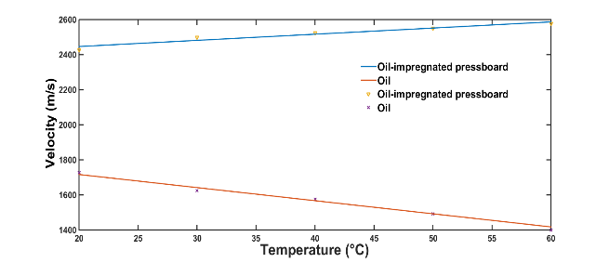
Figure 1. The acoustic velocity versus temperature for oil and PB.

2.3 Temperature gradient distribution simulation
The temperature at the interface between oil and PB is difficult to measure. To acquire this value, the temperature distribution of a three-layer PB, oil and PB was simulated using COMSOL software. The temperatures of the upper and bottom electrodes were set to 41 and 20 °C, respectively according to the calculation results shown in Table 1.
Figure 2 illustrates that the temperature distribution of a three-layer sample consisting of PB, oil and PB under a 20 °C temperature gradient. The two intermediate interface temperature are 33.8 and 26.1 °C. The majority of the temperature drop is seen across the oil due to its lower thermal conductivity. Moreover, when the temperature gradient is reversed, the two intermediate interface temperatures are 34.2 and 26.9 °C.
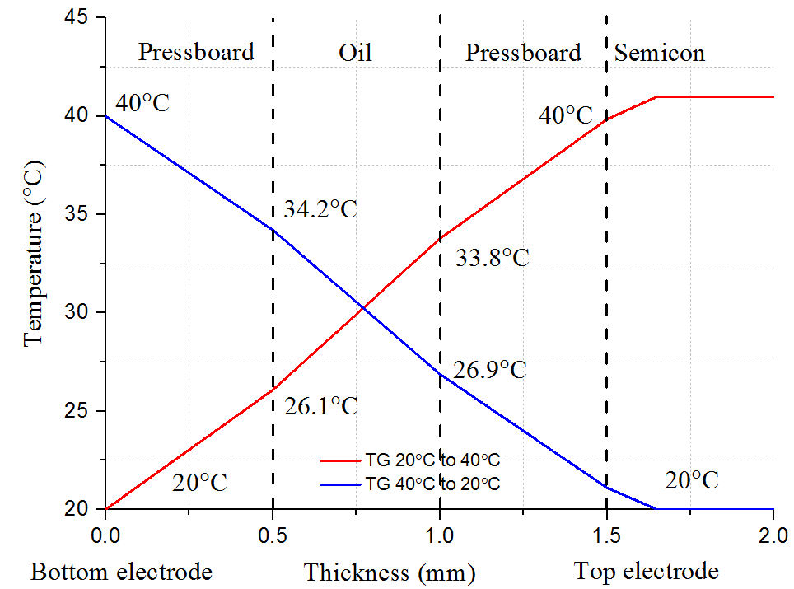
Figure 2. The temperature distribution of a three-layer sample consisting of PB, oil, and PB under a 20 °C temperature gradient.

2.4 Attenuation and dispersion
In multilayer samples, the pulse voltage distribution is not uniform across the oil and PB layers. A_{p} is the ratio between the transient pulse electric field of the oil and that of the PB, and can be expressed as follows:
$$A_{p}=\frac{E_{oil}}{E_{op}}=\frac{ε_{op}}{ε_{oil}}=1.46$$ | (8)
The transient pulse electric field of the oil is 1.46 times as high as that of the PB. Taking the acoustic wave in the oil as the point of reference, the acoustic wave in the PB should be multiplied by A_{p} to eliminate the difference caused by the different dielectric constant of materials.
For a single layer sample, the attenuation, $a\left(f\right)$, and dispersion, $β\left(f\right)$, can be calculated directly based on equations in [14]. Thus, the attenuation, $a_{PB}\left(f\right),$ and dispersion, $β_{PB}\left(f\right)$, of PB are calculated directly. However, for multilayer samples of oil and PB, the attenuation and dispersion of the individual material should be calculated separately to recover the space charge. To acquire the attenuation, $a_{oil}\left(f\right)$, and dispersion, $β_{oil}\left(f\right)$, of the oil, a transfer function $G\left(f,x\right)$can be calculated based on the definition expressed in Equations (9) and (10).
$$G\left(f,x\right)={\frac{\left|P(f,d)\right|}{\left|P(f,0)\right|}}^{\frac{x}{d}}e^{-j\frac{x}{d}\left[∅\left(f,d\right)-∅(f,0)\right]}$$ | (9)
$$G\left(f,x\right)=\frac{P\left(f,d\right)}{P\left(f,0\right)}=\frac{1}{A_{p}}TGe^{-{Nα}_{PB}\left(f\right)d_{PB}}$$
$$e^{-jNβ_{PB}\left(f\right)d_{PB}}e^{-{Mα}_{oil}\left(f\right)d_{oil}-j{Mβ}_{oil}\left(f\right)d_{oil}}$$ | (10)
where $P(f,d)$ and $P(f,0)$ are the acoustic waves in frequency domain, $T$ is the transmission coefficients, $G$ is the generation factor within the PB. N $(N≥1)$ layers of PB and M $\left(M≥1\right)$layers of oil. Here it is assumed that layers made of the same materials have similar attenuation and dispersion factors.
By combining Equations (9) and (10), the attenuation and dispersion of the oil can be deduced as shown in Equations (11) and (12). If N=2 and M=1, Equations (11) and (12) can be simplified to Equations (13) and (14), respectively.
$$α_{oil}\left(f\right)=\frac{1}{Md_{oil}}ln\frac{\left|P(f,0)\right|}{\left|P(f,d)\right|}TG\frac{1}{A_{p}}-\frac{N}{M}α_{op}(f)\frac{d_{op}}{d_{oil}}$$ | (11)
$$β_{oil}\left(f\right)=\frac{1}{Md_{oil}}\left[∅\left(f,d\right)-∅(f,0)\right]-\frac{N}{M}\frac{d_{op}}{d_{oil}}β_{op}\left(f\right)$$ | (12)
$$α_{oil}\left(f\right)=\frac{1}{d_{oil}}ln\frac{\left|P(f,0)\right|}{\left|P(f,d)\right|}TG\frac{1}{A_{p}}-2α_{op}(f)\frac{d_{op}}{d_{oil}}$$ | (13)
$$β_{oil}\left(f\right)=\frac{1}{d_{oil}}\left[∅\left(f,d\right)-∅(f,0)\right]-2\frac{d_{op}}{d_{oil}}β_{op}\left(f\right)$$ | (14)
Acoustic impedance is calculated based on equations in reference [15]. The density and acoustic velocities of different materials are shown in Table 2. Based on these values, the generation, transmission, and reflection coefficients can be calculated based on equation in [15].

Table 2. Acoustic properties of different materials.
Materials | Density ρ (kg/m³) | Velocity V (m/s) | Impedance Z  (10⁶ kg/m²s)
PB | 1200 | 2446 | 2.94
Mineral oil | 850 | 1716 | 1.46
Semicon | 1100 | 2300 | 2.5
Aluminium | 2690 | 6420 | 17.3

Figure 3 shows the acoustic wave propagation process in a three-layer sample of PB, oil, and PB. The pressure wave generated in the oil and the PB moving towards the ground electrode can be described as follows:
Figure 3. The schematic diagram of acoustic wave propagation within multilayers of oil and PB [13].
$$P_{0} \left(f\right)=\frac{1}{A_{p}}{P\left(f\right)G}_{1A}T_{1A}e^{-α_{op}\left(f\right)x-jβ_{op}\left(f\right)x}$$
$$=A_{0}(f,x)P(f) x=0$$ | (15)
$$P_{1} \left(f\right)=\frac{1}{A_{p}}{P\left(f\right)G}_{1}T_{1A}e^{-α_{op}\left(f\right)x-jβ_{op}\left(f\right)x}$$
$=A_{1}\left(f,x\right)P\left(f\right)$ $0<x<d_{oil}$ | (16)
$$P_{1i}(f)=\frac{1}{A_{p}}P(f)G_{21}T_{1A}e^{-α_{op}\left(f\right)d_{op}-jβ_{op}\left(f\right)d_{op}}$$
$$=A_{1i}(f,x)P(f) x=d_{oil}$$ | (17)
$$P_{2} \left(f\right)={P(f)G}_{2}T_{1A}T_{21}e^{-α_{oil}\left(f\right)\left(x-d_{op}\right)}$$
$${{ e}^{-jβ_{oil}\left(f\right)\left(x-d_{op}\right)}e}^{{-α}_{op}\left(f\right)d_{op}-jβ_{op}\left(f\right)d_{op}}$$
$=A_{2}(f,x)P(f)$ $d_{oil}<x<d_{oil}+d_{op}$ | (18)
$$P_{2i}(f)=P{(f)G}_{32}T_{21}T_{1A}e^{-α_{oil}\left(f\right)\left(d_{oil}+d_{op}\right)}$$
$${ e}^{-jβ_{oil}\left(d_{oil}+d_{op}\right)}$$
$$=A_{2i}(f,x)P(f)$$ | (19)
$$P_{3} (f)={\frac{1}{A_{p}}P(f)G}_{3}T_{1A}T_{21}{T_{32}e}^{-α_{op}\left(f\right)\left(x-d_{op}-d_{oil}\right)}$$
$${ e}^{-jβ_{op}\left(f\right)\left(x-d_{op}-d_{oil}\right)}e^{-α_{oil}\left(f\right)d_{oil}-jβ_{oil}\left(f\right)d_{oil}}$$
$${ e}^{{-α}_{op}\left(f\right)d_{op}-jβ_{op}\left(f\right)d_{op}}$$
=$A_{3}\left(f,x\right)P\left(f\right) { d}_{oil}+d_{op}<x<d_{oil}+{2d}_{op}$ | (20)
$$P_{3i}(f)=\frac{1}{A_{p}}P{(f)G}_{B3}T_{1A}T_{21}{T_{32}e}^{-2α_{op}\left(f\right)d_{op}}$$
$${ e}^{-2jβ_{op}\left(f\right)d_{op}}e^{-α_{oil}\left(f\right)d_{oil}-jβ_{oil}\left(f\right)d_{oil}}$$
=$A_{3i}(f,x)P(f) x=d_{oil}+{2d}_{op}$ | (21)
where $P_{0} \left(f\right)$, $P_{1}(f)$, $P_{1i}(f)$, $P_{2} (f)$, $P_{2i}(f)$,$P_{3}(f)$, $P_{3i}(f)$ are the acoustic waves generated at the Al-PB interface, in the first layer of PB, at the first PB-oil interface, in the oil layer, at the second oil-PB interface, in the second layer of PB, and at the PB-semicon interface, respectively.$G_{1A}$ $G_{1}$, $G_{21}$ $G_{2}$, $G_{32}$, $G_{3}$ and $G_{B3}$ are the relative generation factors. $T_{1A},T_{21}$ and $T_{32}$ are the transmission factors at PB-aluminium interface, the oil-PB interface, and PB-oil interface, respectively. $x$ represents the distance to the bottom electrode.
The transfer function can be simplified using Equation (22):
$$A_{s1}(f,x)=[A_{1}(f,x),A_{1i}(f,x),A_{2}(f,x),A_{2i}(f,x)$$
$${,A}_{3}(f,x),A_{3i}(f,x)]$$ | (22)
where$A_{1}(f,x),A_{1i}(f,x),A_{2}(f,x),A_{2i}(f,x),A_{3}(f,x)$ and $A_{3i}(f,x)$ are relative transfer functions. To recover the signal, the inverse of the transfer function, ${A_{s1}}^{-1}\left(f,x\right),$ can be used from Equation (23), as shown below:
$$ρ\left(f\right)={A_{s1}}^{-1}\left(f,x\right) V_{s}\left(f\right).$$ | (23)
Using an inverse fast Fourier transform (IFFT), the recovered space charge, $ρ\left(f\right)$, in the time domain can be represented using the following equation:
$$ρ\left(t\right)=IFFT[ρ\left(f\right)]$$ | (24)

2.5 Space charge recovery under temperature gradient
The acoustic wave at the anode can be expressed as:
$$P_{0}(t)=k\frac{u_{0}}{d_{0}}σ^{+}e_{p}(t)$$ | (25)
where $P_{0}\left(t\right)$ is the acoustic wave generated at ambient temperature, k is the matching coefficient, $u_{0}$ is the average velocity of sample,$d_{0}$ is the sample thickness, $σ^{+}$ is the surface charge density and $e_{p}(t)$ is the pulse electric stress [16].
The acoustic wave $P_{∆T}(t)$generated with a temperature gradient $∆T$,$P_{∆T}(t)$, can be expressed as:
$$P_{∆T}(t)=k\frac{u_{∆T}}{d_{∆T}}σ^{+}e_{p}(t)$$ | (26)
where $u_{∆T}$ is the velocity with the temperature gradient, $d_{∆T}$is the sample thickness with the temperature gradient.
By combining Equations (25) and (26), Equation (27) can be obtained to recover the charge magnitude with the temperature gradient for a three-layer sample of PB, oil, and PB:

$$P_{0}(t)=\left\{\begin{aligned}P_{∆T}(t)\frac{u_{op}}{u_{∆Top}}\frac{d_{∆Top}}{d_{op}}, &0_{}<x<d_{op} \\ P_{∆T}(t)\frac{u_{oil}}{u_{∆Toil}}\frac{d_{∆Toil}}{d_{oil}}, &d_{op}<x<d_{oil}+d_{op} \\ P_{∆T}(t)\frac{u_{op}}{u_{∆Top}}\frac{d_{∆Top}}{d_{op}}, &d_{oil}+d_{op}<x<d_{oil}+{2d}_{op}\end{aligned}\right.$$ | (27)
where $u_{op}$ and $u_{oil}$ are the acoustic velocities wave velocity of the oil and the PB at ambient temperature, respectively. $u_{∆Top}$ and $u_{∆Toil}$ are the acoustic wave velocity of oil and PB with a temperature gradient, $d_{oil}$ and${ d}_{op}$ are the thickness of the oil and the PB at ambient temperature, $d_{∆Top}$ and $d_{∆Toil}$ are the thickness of oil and the PB with the temperature gradient.
The thickness recovery of the horizontal axis for a three-layer sample of PB, oil, and PB can be expressed by the following equations:
 | $${∆x}_{0}=\left\{\begin{aligned}u_{op}/f_{s} \\ u_{oil}/f_{s} \\ u_{op}/f_{s}\end{aligned}\right.$$ | (28)
 | $${∆x}_{∆T}=\left\{\begin{aligned}u_{∆Top}/f_{s} \\ u_{∆Toil}/f_{s} \\ u_{∆Top}/f_{s}\end{aligned}\right.$$ | (29)
where ${∆x}_{0}$ and ${∆x}_{∆T}$ are the resolution of the PEA system at ambient temperature and with a temperature gradient. $f_{s}$ is the sampling frequency of the oscilloscope. Based on the combination of Equations (28) and (29), the horizontal thickness calibration can be acquired based on the real acoustic velocity of a three-layer sample of PB, oil, and PB with a temperature gradient.
Figure 4 shows the two layered consisting of 0.5 mm oil and 0.5 mm oil-impregnated PB sample space charge recovery with a temperature gradient. The applied field is 4 kV/mm with 40 °C temperature gradient. It can be noted that the change in the horizontal axis is more obvious than in the vertical axis.
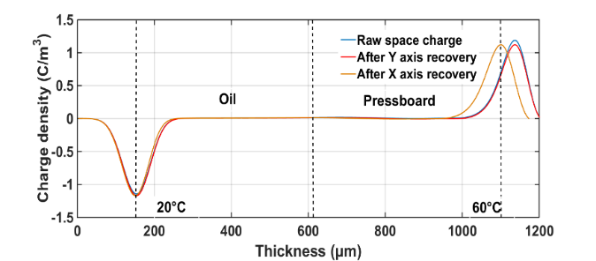
Figure 4. The space charge recovery of a two-layer sample of oil and PB with a 20 °C temperature gradient.

Figure 5 shows the recovery of the acoustic wave in a three-layer sample consisting of PB, oil, and PB with a temperature gradient of 20 °C. The three-layer sample are stressed at 15 kV. The graph shows both the vertical and horizontal recovery. The acoustic wave velocity of the oil increases and that of the PB decreases as the temperature increases, leading to a lack of obvious change of the average velocity [9]. Therefore, the anode peak shifts slightly to the left after horizontal axis recovery.
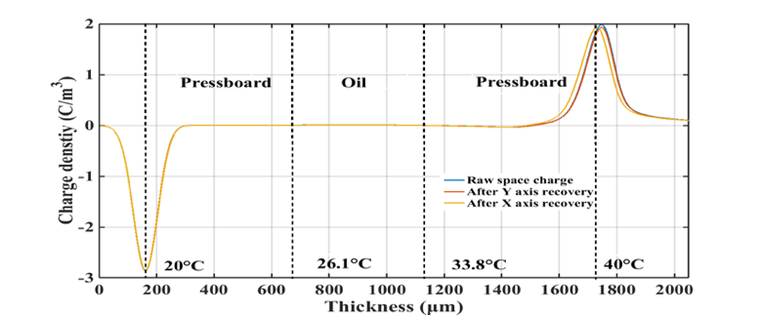
Figure 5. The recovery of the space charge in a three-layer sample of PB, oil and PB with a 20 °C temperature gradient.

Sample preparation
The PB is provided from the Taizhou Weidmann High Voltage Insulation Co. Ltd. The oil is fresh mineral oil (ZXI-S3) provided by the Shell Company. The sample preparation procedures followed previous preparation process [17] and four days standing time was required before conducting the space charge experiments. External electric field of 10 kV/mm was applied to the samples. The pulse with the waveform of 800 V, 1 kHz and 10 ns width was used in all the experiments. The DC voltage was applied for 2 hours and after that, the power was switched off and decay process was observed for further 1 hour.

Experimental results
Figure 6a shows space charge in the 0.5 mm oil-impregnated PB under 10 kV/mm at ambient temperature (AT). Homocharge injection is obvious from both electrodes. Figure 6b is space charge in the one-layer 0.5 mm oil-impregnated PB with a 40 °C temperature gradient (TG). A significant amount of positive charges are injected from the high temperature anode and move into the bulk of insulation material, leading to an electric field enhancement within the sample close to the cathode.

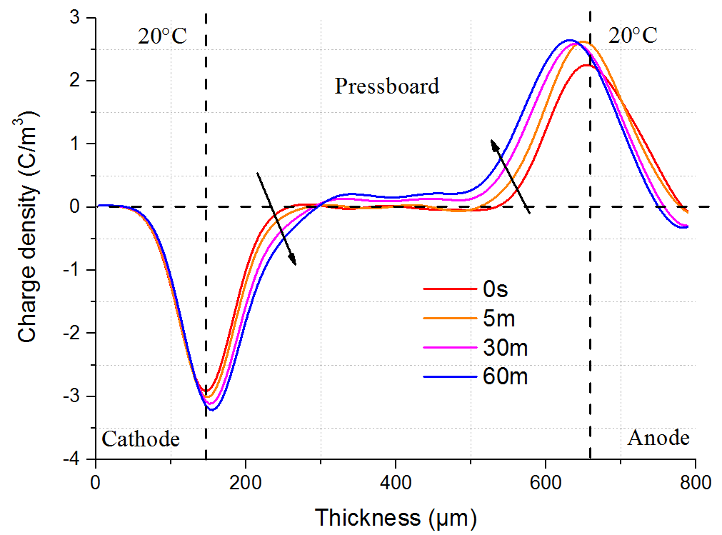 | 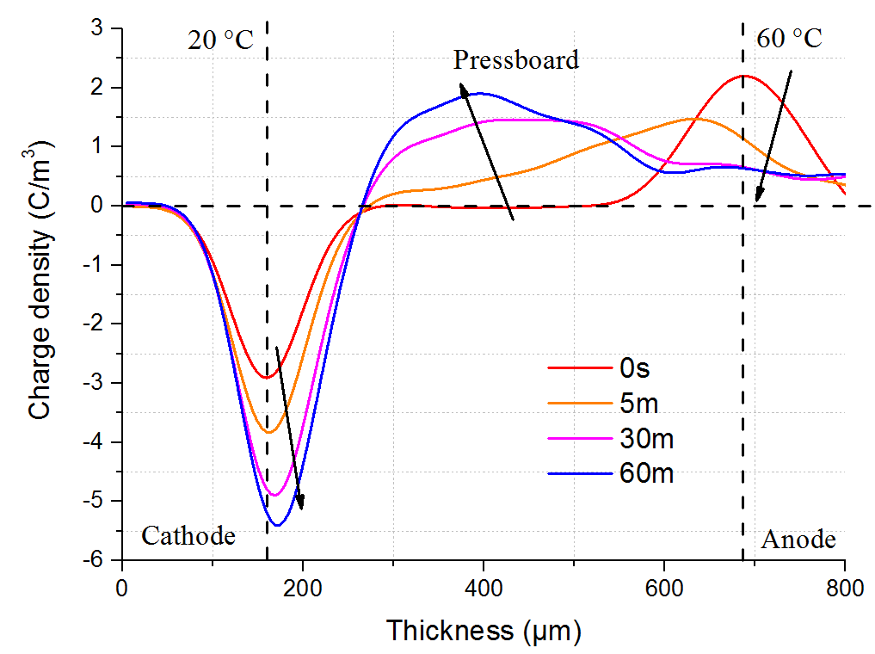
(a) AT | (b) 40 °C TG
Figure 6. Space charge for one layer of oil-impregnated PB under 10 kV/mm.

Figure 7a illustrates the space charge of two layers consisting of 0.5 mm oil and 0.5 mm oil-impregnated PB under 10 kV/mm. Homocharge injection is obvious from two electrodes. The injected positive charges accumulate adjacent to the anode. Moreover, the negative charge moves across the oil layer and accumulates at the oil and PB interface, leading to a reduction of electric field in oil, and an increase electric field in PB.
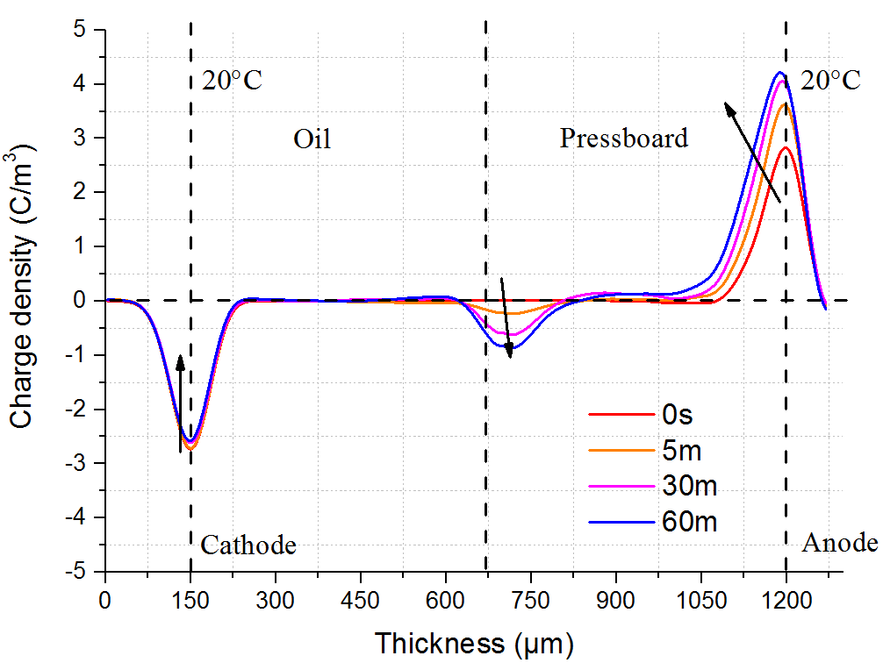 | 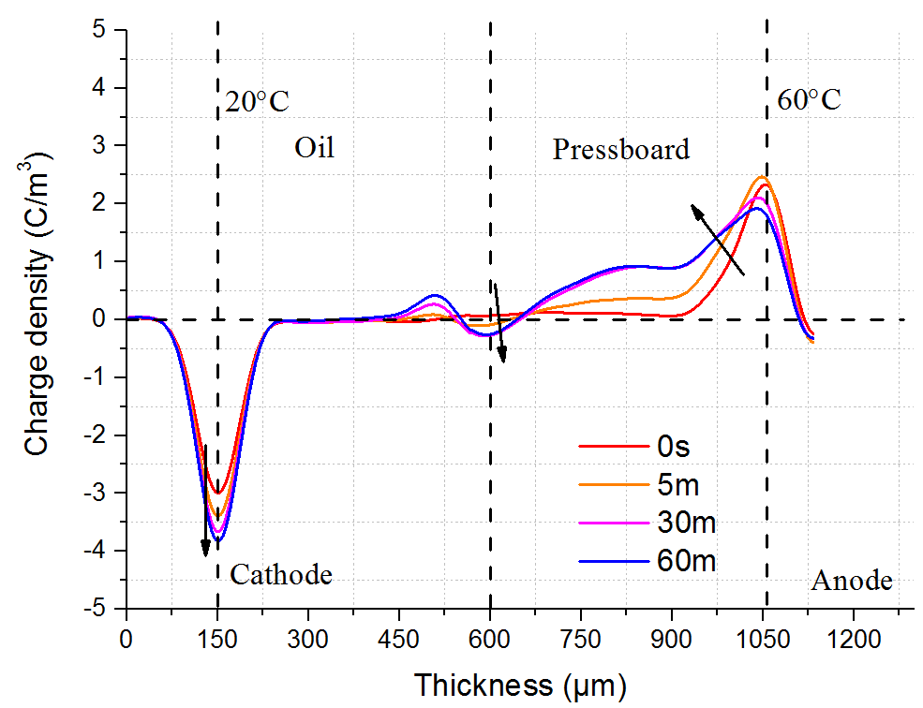
(a) AT | (b) 40 °C TG
Figure 7. Space charge of two layers of oil and PB under 10 kV/mm.
Figure 7b shows space charge with a 40 °C temperature gradient under 10 kV/mm. A significant amount of positive charges are injected from the high temperature anode. The electric field in the oil increases over time with a temperature gradient, which is the opposite to the observation shown in Figure 7a where no temperature gradient exists.
Figures 8a and 8b show space charge profiles when the high temperature electrode is the cathode and creates -20 °C temperature gradient across the sample. Figure 8a indicates that homocharge injection is obvious for one layer PB, particularly for electrons, due to the high temperature at the bottom electrode. Comparing Figure 8b and Figure 7a, it can be seen that the higher magnitude of the negative charge accumulated at the oil and PB interface, meaning the electric field in the PB is enhanced.
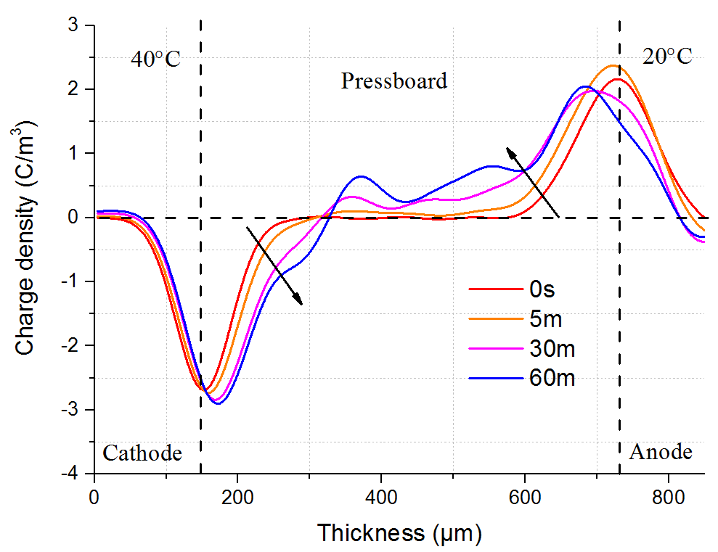 | 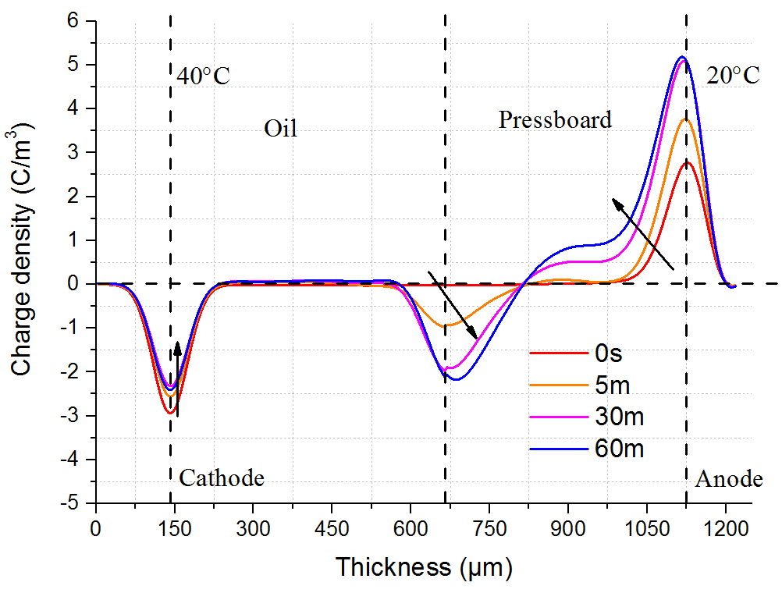
(a) one layer | (b) two layers
Figure 8. Space charge for one layer and two layers of oil and PB with
-20 °C temperature gradient under 10 kV/mm.
Figure 9a illustrates the space charge in the 0.5 mm PB, 0.5 mm oil and 0.5 mm PB under an external electric field of 10 kV/mm at ambient temperature. Homocharge injection is obvious from both electrodes, which leads to an opposite polarity of charge accumulation at the two interfaces, and their magnitude increases over time.

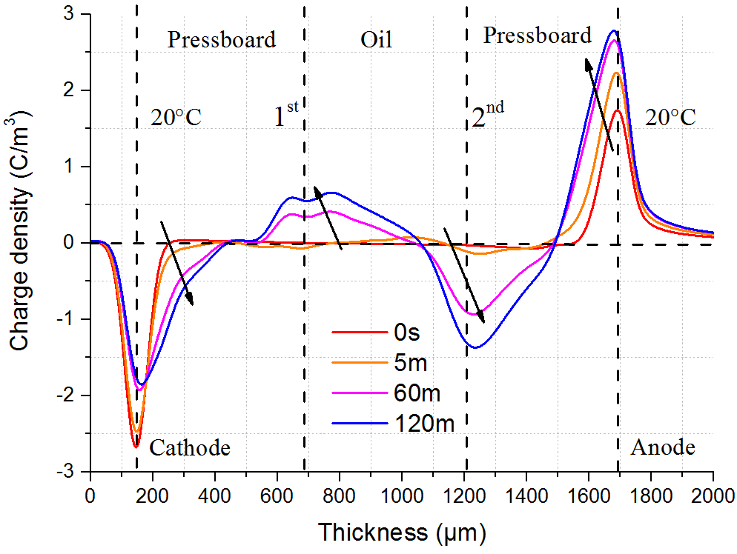 | 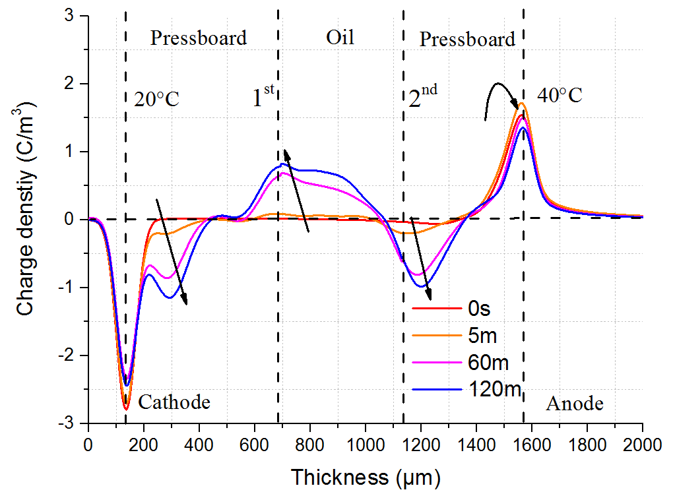
(a) AT | (b) 20 °C TG
Figure 9. Space charge of three layers of PB oil and PB under 10 kV/mm.
With a 20 °C temperature gradient as shown in Figure 9b, rather than a large decrease in the cathode peak at ambient temperature, the space charge with a temperature gradient on the cathode experiences a slight decrease from 2.7 to 2.4 C/m³, but with an obvious negative charge injection from the cathode. Moreover, there is a small decrease from 1.7 to 1.3 C/m³ in the charge near the anode over time in Figure 9b, as opposed to the significant increase from 1.7 to 2.7 C/m³ in the charge near the anode shown in Figure 9a. In addition, the larger the positive charge accumulates at the first interface, the lower the space charge accumulates at the second interface, as shown in Figure 9b, compared to Figure 9a.
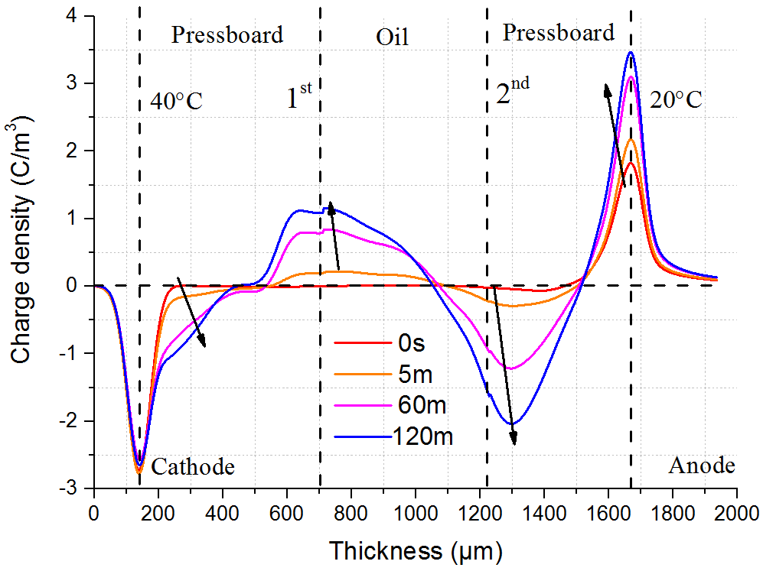
Figure 10. Space charge of three layers PB oil and PB with -20 °C temperature gradient under 10 kV/mm.

Figure 10 shows the space charge density with -20 °C temperature gradient. A large amount of negative charge is injected from the cathode due to its higher temperature. Moreover, a higher magnitude of negative charge accumulates at the second interface. When comparing Figure 10 and Figure 9a, it can be seen that more positive is injected from the anode.

Discussion

5.1 One layer
Comparing Figures 6a and 6b, it can be seen that a significant amount of positive charge has been injected from the high temperature electrode. The space charge injection is related to the threshold electric field. Below the threshold, a lower amount of charge is involved within the insulation material (Ohmic behaviour) [18]. The threshold for charge accumulation coincides with the occurrence of the transition from Ohmic behaviour to space charge limited current (SCLC) conduction [18]. The transition is highly dependent on the electrode temperature; the higher temperature reduces the threshold field and facilitates the charge injection [18,19]. Additionally, the high temperature increases the mobility of charge carriers. It has been reported that electrons have higher mobility compared to positive charge carriers at ambient temperature [20]. However, the high temperature at the anode enhances the positive charge carrier mobility, leading to a positive charge migration towards the low temperature region near to the bottom electrode. The space charge formation trapped in the material is closely related to the injected and extracted charges. Due to a large amount of positive charge injected from the high temperature anode, and a small amount of charge extracted at the low temperature cathode, a large amount of space charge can be trapped within the bulk of insulation material.

5.2 Two layers
When comparing Figures 7a and 7b, it can be seen that the lower negative charge at the oil and PB interface is a new feature with a temperature gradient. Several reasons may result in the observation. The interface between the oil and PB can be regarded as a barrier for charge movement [21]. At ambient temperature, the polarity of the interfacial charge is negative, due to the higher conductivity of the oil compared to the PB [22]. However, with a temperature gradient, the increase in temperature at the anode decreases the threshold field and increases charge carrier mobility, especially in the PB which facilitates positive charge injection from the high temperature anode. A large amount of positive charge injected from the high temperature electrode can neutralise the negative charge at the interface, leading to a decrease in the net negative charge at the interface.
When the bottom electrode becomes the high temperature electrode as shown in Figures 8a and 8b, a significant amount of the charge can be injected from the bottom electrode. Together with the increased charge carrier mobility in the oil due to high temperature, larger negative charge formation is observed at the interface, as shown in Figure 8b.

5.3 Three layers
In Figure 9a, the polarity at the two oil and PB interfaces is different. Several reasons can contribute to the observed phenomenon. Firstly, the polarity of the interfacial charge is consistent with the Maxwell-Wagner theory but the magnitude is not, which leads to an increase in the electric field within the PB, and a decrease in the electric field of the oil. Secondly, the opposite polarity of the interfacial charge is related to conductivity. The charge is able to easily migrate from the PB to the oil due to the higher conductivity of the oil. Thirdly, the opposite polarity of the interfacial charge density is correlated with the ionisation of the oil [23].
Figure 9a shows the different interfacial charge densities at ambient temperature, where the magnitude of the negative charge at the second interface is 1.5 C/m³, higher compared to the first positive interface charge density (0.5 C/m³). This occurs because of the higher mobility of electrons compared to positive charge carriers, giving rise to a higher negative charge accumulation at the second interface.
Figure 9b shows the space charge density of three layered sample consisting of PB+oil+PB with 20 °C temperature gradient. The increase in the positive charge at the first interface, the decrease in the negative charge at the second interface in Figure 9b compared to Figure 9a, and the negative charge packet near the cathode can be explained based on the same argument as described earlier. The increase in the first interfacial positive charge is related to the decreased threshold field of charge injection, as the threshold field is dependent on the temperature of the electrode [19].
The increase in the first layer positive interfacial charge density is also correlated with the injected and extracted charge [3]. With the temperature gradient, the high temperature of the anode can enhance the mobility of positive charge carriers, leading to the increase in the first layer positive interfacial charge. Moreover, considering the low extraction rate of charge carriers due to the low temperature near the cathode [24], a large amount of positive charge accumulates at the first layer interface.
The decrease in the second layer negative interface charge in Figure 9b compared to Figure 9a, is mainly the result of a large positive charge injection. The high temperature of the anode can also increase charge mobility in the layer adjacent to the electrode; thus, more positive charge can move further and neutralise the second layer negative interface charge.
Figure 10 shows the space charge profiles of three layered sample of PB+oil+PB with -20 °C temperature gradient. The increase of the magnitude of the second layer negative interface charge density is obvious. Considering the decrease in the threshold field for charge injection and the increase of negative charge carriers’ mobility, they contribute to the formation of space charge density at the second layer oil PB interface with -20 °C temperature gradient.

5.4 Electric field
When comparing Figure 6a and Figure 6b, it can be seen that the higher magnitude of the positive charge, injected from the high temperature anode, leads to a severe electric field enhancement in the one layer PB.
Comparing Figure 7a and 7b, it shows the electric field in the oil decreases at ambient temperature and it increases with a temperature gradient. Figure 7a shows with the longer voltage application time, the electric field in the oil decreases, while the electric filed in the PB increases due to the negative charge accumulation at the interface. Figure 7b shows a significant amount of positive charge is injected from the high temperature anode, leading to electric field enhancement in the oil. The lower interfacial charge results in a lower electric field enhancement in the PB.
Figure 11a shows the electric field of multilayers PB+oil+PB at ambient temperature. The maximum electric field occurs in the PB near the anode. This is due to the higher mobility of electrons compared to positive charge carriers at ambient temperature [20]. A higher magnitude of negative interfacial charge 1.36 C/m³ occurs at the second interface compared to 0.64 C/m³ at the first interface, which is shown in Figure 9a.

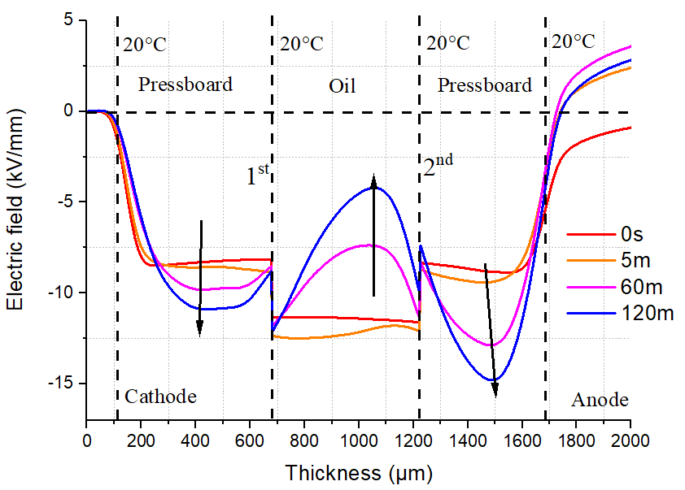 | 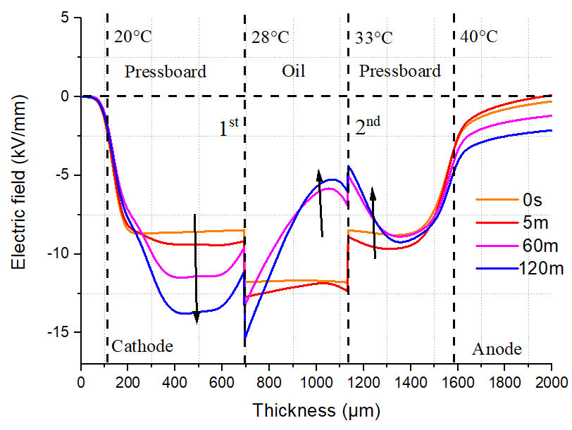
(a) | (b)
Figure 11. The electric field distribution of multilayers PB+Oil+PB; (a) ambient temperature, (b) 20 °C temperature gradient.

Figure 11b is the electric field of multilayers PB+oil+PB at a 20 °C temperature gradient. Compared to Figure 11a, the maximum electric field occurs at the first interface layer between oil and PB near the cathode. This effect can be described as field migration at the temperature gradient [25], which means the maximum electric field shifts from the PB near the anode at ambient temperature to the first interface between oil and PB near cathode under the temperature gradient.
The maximum electric field is summarized in Figure 12, including one layer (A), two layers (B) and three layers (C) conditions. A1 to A3, B1 to B3 and C1 to C3 represents the temperature gradient varies from 0 °C to 40 °C. A4, B4 and C4 represent the electric field enhancement at a -20 °C temperature gradient. From Figure 12, it reveals that higher temperature gradient leads to higher maximum electric field. For both the -20 °C and 20 °C temperature gradients, a similar maximum electric field enhancement is observed.
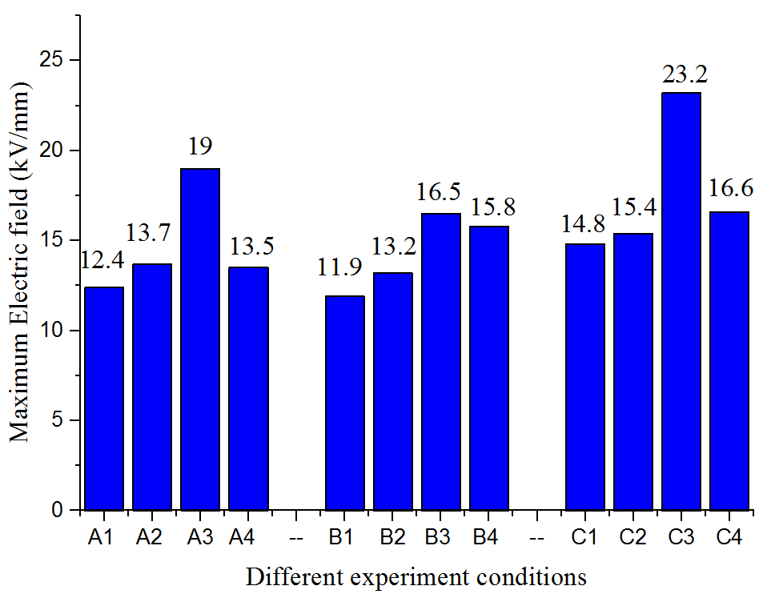
Figure 12. Maximum electric field for different conditions.

Conclusions
The experimental investigation of space charge in the multilayers of oil and PB at a specific temperature gradient are reported. The effect of temperature gradient and the multilayer on dynamics of space charge results are discussed. The following conclusions can be drawn.
- Under the temperature gradient, the charge injection is enhanced from the high temperature electrode and lead to higher maximum electric field within one layer, two layers and three layers of PB oil and PB compared to maximum electric field at ambient temperature.
- For one layer PB with 20 °C of the bottom electrode, the high temperature of anode can facilitate positive charge injection and leads to the higher maximum electric field within the sample compared to that at ambient temperature.
- For two layers oil and PB with 20 °C of the bottom electrode, the electric field in the oil decreases at ambient temperature and it increases under a temperature gradient.
- For three layer PB oil and PB, there is field migration at the temperature gradient. With 20 °C of the bottom electrode, the maximum electric field shifts from the PB near the anode at ambient temperature to the first interface between oil and PB near cathode under the temperature gradient.
- The increase temperature gradient severely affects the maximum electric field, and the increase of temperature gradient leads to an increase in the maximum electric field.

ACKNOWLEDGMENT
The authors are grateful for the financial support from the technology project of State Grid Shaanxi Electric Power Company [5226KY16001G] and 2018 Key Research and Development Program of Shaanxi [2018GY-001].

References
[1] J. S. Chahal and C. C. Reddy, “Modeling and Simulation of Pulsed Electroacoustic Measurement Method,” IEEE Syst. J., vol. 8, no. 4, pp. 1283–1292, 2014.
[2] J. Hao, G. Chen, R. Liao, L. Yang, and C. Tang, “Influence of Moisture on Space Charge Dynamics in Multilayer Oil-Paper Insulation,” IEEE Trans. Dielectr. Electr. Insul., vol. 19, no. 4, pp. 1456–1464, 2012.
[3] K. Wu and C. Cheng, “Interface Charges between Insulating Materials,” IEEE Trans. Dielectr. Electr. Insul., vol. 24, no. 4, pp. 2633–2642, 2017.
[4] C. Tang, G. Chen, M. Fu, and R. J. Liao, “Space Charge Behavior in Multi-layer Oil-paper Insulation under Different DC Voltages and Temperatures,” IEEE Trans. Dielectr. Electr. Insul., vol. 17, no. 3, pp. 775–784, 2010.
[5] A. Roberto and T. Campos, “Simulation of a Distribution Transformer,” WSEAS Trans. FLUID Mech., vol. 7, no. 3, pp. 106–115, 2012.
[6] P. H. F. Morshuis, R. Bodega, D. Fabiani, G. C. Montanari, L. A. Dissado, and J. J. Smit, “Dielectric Interfaces in DC Constructions: Space Charge and Polarization Phenomena,”IEEE Int. Conf. on Solid Dielectr.(ICSD), 2007, pp. 450–453.
[7] A. Imburgia, R. Miceli, E. R. Sanseverino, P. Romano, and F. Viola, “Review of Space Charge Measurement Systems: Acoustic, Thermal and Optical Methods,” IEEE Trans. Dielectr. Electr. Insul., vol. 23, no. 5, pp. 3126–3142, 2016.
[8] R. Bodega, P. H. T. Morshuis, and J. J. Smit, “Space Charge Measurements on Multi-dielectrics by Means of the Pulsed Electroacoustic Method,” IEEE Trans. Dielectr. Electr. Insul., vol. 13, no. 2, pp. 272–281, 2006.
[9] B. Huang et al., “Effect of Temperature Gradient on Space Charge in Multilayres Pressboard Oil and Pressboard system,” Annu. Rep. Conf. Electr. Insul. Dielect. Phenom. (CEIDP), 2017, pp. 74–77.
[10] X. Chen, X. Wang, K. Wu, Z. Peng, and Y. Cheng, “Effect of Temperature Gradient on Space Charge Waveform in Pulsed Electroacoustic Method,” ACTA Phys. Sin., vol. 59, no. 10, pp. 7327–7332, 2010.
[11] Q. Zhu, K. Wu, H. Wang, W. Xia, and S. Lv, “The Study of PEA Space Charge Waveform Recovery under Temperature Gradient,” IEEE Int. Conf. on Solid Dielectr. (ICSD), 2013, pp. 464–467.
[12] H. Wang, K. Wu, Q. Zhu, and X. Wang, “Recovery Algorithm for Space Charge Waveform under Temperature Gradient in PEA Method,” IEEE Trans. Dielectr. Electr. Insul., vol. 22, no. 2, pp. 1213–1219, 2015.
[13] M. Hao, “Oil/paper Insulation HVDC Performance”, PhD dissertation, University of Southampton, 2015.
[14] A. Vázquez, G. Chen, A. E. Davies, and R. Bosch, “Space Charge Measurement using Pulsed Electroacoustic Technique and Signal Recovery,” J. Eur. Ceram. Soc., vol. 19, no. 6–7, pp. 1219–1222, 1999.
[15] C. Tang, B. Huang, M. Hao, Z. Xu, J. Hao, and G. Chen, “Progress of Space Charge Research on Oil-Paper Insulation Using Pulsed Electroacoustic Techniques,” Energies, vol. 9, no. 1, p. 53, 2016.
[16] X. Chen, X. Wang, K. Wu, Z. R. Peng, Y. H. Cheng, and D. M. Tu, “Space Charge Measurement in LPDE Films under Temperature Gradient and DC Stress,” IEEE Trans. Dielectr. Electr. Insul., vol. 17, no. 6, pp. 1796–1805, 2010.
[17] M. Hao, Y. Zhou, G. Chen, G. Wilson, and P. Jarman, “Space Charge Behaviour in Thick Oil-Impregnated Pressboard under HVDC Stresses,” IEEE Trans. Dielectr. Electr. Insul., vol. 22, no. 1, pp. 72–80, Feb. 2015.
[18] D. Fabiani et al., “HVDC Cable Design and Space Charge Accumulation. Part 3 Effect of Temperature Gradient,” IEEE Electr. Insul. Mag., vol. 24, no. 2, pp. 5–14, 2008.
[19] D. Fabiani, G. C. Montanari, R. Bodega, P. H. F. Morshuis, C. Laurent, and L. A. Dissado, “The Effect of Temperature Gradient on Space Charge and Electric Field Distribution of HVDC Cable Models,” IEEE Int. Conf. Prop. Appl. Dielectr. Mat. (ICPADM), 2006, pp. 65–68.
[20] M. Fu, L. A. Dissado, G. Chen, and J. C. Fothergill, “Space Charge Formation and its Modified Electric Field under Applied Voltage Reversal and Temperature Gradient in XLPE Cable,” IEEE Trans. Dielectr. Electr. Insul., vol. 15, no. 3, pp. 851–860, 2008.
[21] Q. Zhu, X. Wang, K. Wu, Y. Cheng, Z. Lv, and H. Wang, “Space Charge Distribution in Oil Impregnated Papers under Temperature Gradient,” IEEE Trans. Dielectr. Electr. Insul., vol. 22, no. 1, pp. 142–151, 2015.
[22] K. Wu, Q. Zhu, H. Wang, X. Wang, and S. Li, “Space Charge Behavior in the Sample with Two Layers of Oil-Immersed-Paper and Oil,” IEEE Trans. Dielectr. Electr. Insul., vol. 21, no. 4, pp. 1857–1865, 2014.
[23] Z. Wang, “Wave Velocities in Hydrocarbons and Hydrocarbon Saturated Rocks”, PhD dissertation, Stanford University, 1988.
[24] Z. Lv, K. Wu, X. Wang, Y. Cheng, and Dissado.L.A, “Simulation of Space Charge Distribution in Polyethylene under a Temperature Gradient,” Annu. Rep. Conf. Electr. Insul. Dielect. Phenom. (CEIDP), 2014, pp. 879–882.
[25] A. Küchler, High Voltage Engineering Fundamentals Technology Applications. Springer Vieweg, 2018.

