**Incidence, patterns and outcomes with adjuvant chemotherapy for residual disease after neoadjuvant chemotherapy in muscle-invasive urinary tract cancers.**

Nieves Martinez Chanza1, Lillian Werner1, Elizabeth Plimack2, Evan Y. Yu3, Ajjai S. Alva4, Simon J. Crabb5, Thomas Powles6, Jonathan E. Rosenberg7, Jack Baniel8, Ulka N. Vaishampayan9, Dominik R. Berthold10, Sylvain Ladoire11, Syed A. Hussain12, Matthew I. Milowsky13, Neeraj Agarwal14, Andrea Necchi15, Sumanta K. Pal16, Cora N. Sternberg17, Joaquim Bellmunt1, Matthew D. Galsky18, Lauren C. Harshman1

On behalf of the RISC Investigators

1Dana-Farber Cancer Institute, Harvard Medical School, Boston, MA; 2Fox Chase Cancer Center, Philadelphia, PA; 3Fred Hutchinson Cancer Research Center, Seattle, WA; 4University of Michigan, Ann Arbor, MI; 5University of Southampton, Southampton, United Kingdom; 6Barts Cancer Institute, London, United Kingdom; 7Memorial Sloan Kettering Cancer Center, New York, NY; 8Rabin Medical Center, Petah Tivka, Israel; 9Karmanos Cancer Institute, Detroit, MI; 10Centre Hospitalier Universitaire Vaudois, Lausanne, Switzerland; 11Georges François Leclerc Cancer Center, Dijon, France; 12Clatterbridge Cancer Centre, Liverpool, United Kingdom; 13UNC Lineberger Comprehensive Cancer Center, Chapel Hill, NC; 14Huntsman Cancer Institute at the University of Utah, Salt Lake City, 15UT; Istituto Nazionale Tumori of Milan, Milano, MI, Italy; 16City of Hope, Duarte, CA; 17San Camillo-Forlanini Hospital, Rome, Italy; 18The Tisch Cancer Institute, Icahn School of Medicine at Mount Sinai, New York, NY

**Corresponding author:**

Lauren C. Harshman MD   
Dana-Farber Cancer Institute/Brigham and Women's Hospital and Harvard Medical School   
450 Brookline Ave., Boston, MA 02215 (DANA 1230)   
Phone: 617-632-2429 Fax: 617-632-2165   
E-mail: LaurenC_Harshman@dfci.harvard.edu

**Keywords:** adjuvant chemotherapy, muscle-invasive bladder cancer, muscle-invasive urinary tract cancer, neoadjuvant chemotherapy, residual disease, risk of relapse, time to recurrence.

**Word count of text:**  2539

**Word count of the abstract:** 299

**ABSTRACT**

**Background:** Patients with residual muscle-invasive urinary tract cancer after neoadjuvant chemotherapy (NAC) have high-risk of recurrence.

**Objective:** Retrospectively evaluate whether additional adjuvant chemotherapy (AC) improves outcomes compared to surveillance in patients with significant residual disease despite NAC.

**Design, setting, and participants:** We identified 474 patients who received NAC from the Retrospective International Study of Cancers of the Urothelium (RISC) database, of whom 129 had adverse residual disease (≥ypT3 and/or ypN+).

**Outcome measurements and statistical analysis:** Time to relapse (TTR) was the primary endpoint assessed starting from two months after surgery to minimize immortal time bias. Secondary endpoints included overall survival (OS), incidence of AC use, and chemotherapy patterns. Kaplan-Meier and Cox regression models estimated TTR, OS and associations with AC adjusting for the type of NAC, age and pathological stage in multivariable analyses.

**Results and limitations:** 106 patients underwent surveillance while 23 received AC. Gemcitabine-cisplatin was the most frequent regimen employed in both settings (30.4%) and the majority (82.6%) switched to a different regimen. Median follow-up was 30 months. Over 50% of patients recurred. Median TTR was 16 months (range: <1-108 months). Longer median TTR was observed with AC compared to surveillance (18 versus 10 months, *p*:0.06). Risk of relapse was significantly decreased with AC when adjusted in multivariable analyses (*p*:0.01). The subgroup analyses of ypT4b/ypN+ patients (AC: 19, surveillance: 50) who received AC had a significantly greater median TTR (20 versus 9 months; HR 0.43, 95%CI: 0.21-0.89). No difference in OS was found. Limitations include the retrospective design.

**Conclusions:** The utilization of AC after NAC in patients with high-risk residual disease is not frequent in clinical practice but might reduce the risk of recurrence. Further investigation is needed in this high-risk population to identify optimal therapy and to improve clinical outcomes such as the ongoing adjuvant immunotherapy trials.

**PATIENT SUMMARY**

We found that administering additional chemotherapy in patients who had significant residual disease despite preoperative chemotherapy is not frequent in clinical practice. While it might reduce the risk of recurrence, it did not clearly increase overall survival. We encourage participation in the ongoing immunotherapy trials to see if we can improve outcomes using a different type of therapy that stimulates the immune system.

**TEXT**

**Introduction**

Treatment of localized muscle-invasive urinary tract cancers aims to achieve cure by eliminating the primary tumor with local therapies and eradicating micro-metastases with systemic chemotherapy. Currently, the gold standard is cisplatin-based neoadjuvant chemotherapy (NAC) in eligible patients followed by radical cystectomy with bilateral pelvic lymph node dissection. Cisplatin-based NAC increases survival without affecting the feasibility and safety of the surgery [1-3]. The most commonly used cisplatin-based regimens in the perioperative setting are gemcitabine/cisplatin (GC) and dose-dense MVAC (ddMVAC: methotrexate/vinblastine/adriamycin/cisplatin) [4-9]. Pathological complete response (pCR) or downstaging to non-muscle invasive disease are indicators of biological sensitivity to cytotoxic agents and are associated with improved survival [10,11].

In the absence of upfront NAC, adjuvant chemotherapy (AC) is generally reserved for cisplatin-fit patients with high-risk pathologic features for recurrence at cystectomy such as extravesicular extension (pT3-4), lymph node positive disease, or lymphovascular invasion. Metaanalyses collating a heterogeneous mix of phase 3 studies that failed to accrue successfully suggest that cisplatin-based AC significantly decreases the risk of recurrence and prolongs survival in patients without prior NAC [12-14]. The most recent phase 3 study by the EORTC evaluated immediate adjuvant versus delayed therapy at relapse. While it closed early due to poor accrual, there was a clear benefit of improved progression free survival (PFS) with earlier AC: median PFS of 2.9 versus 0.9 years (*p*>0.0001) and a 5-year PFS of 46.8% versus 29.5% (*p*>0.0001) [15]. No OS benefit was observed. In addition, for patients with upper tract disease, recent data from the randomized POUT study demonstrated that adjuvant platinum-based chemotherapy significantly improved disease-free survival (HR 0.47, 95%CI, 0.29-0.74) [16]. Survival data is maturing but a retrospective analysis leveraging the National Cancer Database (NCDB) found a significant improvement in OS with adjuvant therapy in upper tract disease [17].

An unresolved clinical question is whether patients who do not achieve a pCR or significant down staging should receive additional AC given their high-risk of relapse. Limited evidence exists to guide the management of this subgroup of patients, and the question has never been studied prospectively. Using an international database collaboration (RISC), we evaluated the clinical outcomes of patients with residual disease after NAC who received additional AC compared to a control cohort of patients who underwent surveillance. Additionally, we strove to assess the incidence and practice patterns of AC administration after NAC.

**Materials and methods**

Regulatory approval was obtained from 23 sites participating in the Retrospective International Study of Cancers of the urothelium (RISC) database. Time of therapy administration was restricted from 1991 to 2013 to ensure modern chemotherapy practices and adequate follow-up of a minimum of two years. Patients who received NAC followed by surgical resection of the primary tumor (upper or lower urinary tract) and had adverse residual disease, defined as pathologic stage T3 or greater (ypT3 or ypT4) and/or involved pathologic lymph node (ypN+), were included. To capture a real-world experience, we included patients with radiologically evident lymph node disease (cN+), urothelial carcinoma (UC) and variant histologies, and patients who also received non-cisplatin combination therapies such as carboplatin-based regimens or cisplatin monotherapy. Patients who had less than 2 months of follow-up data or who were lost to follow-up without adequate recurrence or survival data were excluded. AC was defined as any chemotherapy administered ≤ 3 months from surgery in the absence of metastatic disease. Surveillance plans were per institutional preference or per trial requirement and generally consisted of clinical monitoring and radiologic imaging every 3-6 months during the first 2-years then every 6-12 months.

Clinicodemographic variables were collected including age, gender, race, smoking history, performance status, comorbidities, date of diagnosis, tumor primary site, clinical stage and measurable disease status as were pathologic features (histology, number of nodes removed and pathologic involvement, presence of lymphovascular invasion and margin positivity), treatment data (chemotherapy regimens administered including number of cycles, duration of treatment, and use of adjuvant radiation), response data (pathologic response and objective radiologic response in cN+) and time to event outcomes (dates of recurrence, initiation of new systemic treatment for recurrence, death and last known alive).

The primary endpoint was to assess time to relapse (TTR) in patients who received NAC and surgery followed by AC (study arm) compared to surveillance (control arm) for residual disease. TTR was defined as time from primary surgery to development of metastatic disease or censored at last known date without metastases. To minimize immortal time bias, landmark analysis of TTR was performed starting at two months post-surgery. Two months was chosen because the median time from surgery to AC initiation was 1.8 months. Secondary endpoints were OS, incidence of AC use after NAC and patterns of chemotherapy administration among the RISC centers including NAC/AC regimen type used and the number of cycles received.

We employed descriptive statistics to characterize the study cohort overall and by chemotherapy regimen in terms of baseline clinicodemographic and surgical data. Pathologic response rates were calculated with the denominator of all treated patients including those who did not complete all NAC. The association between pathological stage and use of AC was assessed using Fisher’s exact test. TTR and OS were estimated by Kaplan-Meier method. OS was defined as the time from two months post-surgery to death or censored at date last known alive. Associations between AC and TTR and OS were evaluated using a Cox regression model with univariate and multivariable analyses adjusted for pathological stage, age and type of NAC. Type of NAC was grouped according to receipt of cisplatin-based, carboplatin-based or other regimen. Pathological stage was grouped according to AJCC 7th edition into stage III (ypT3N0) and stage IV (ypN+/ypT4b) [18]. Hazard ratios (HR) for AC administration within stages was estimated by including an AC use-by-stage interaction in the model and using contrasts. A two-sided p-value ≤ 0.05 was considered statistically significant.

**Results**

Of the 474 patients who received NAC, 27.2% (*N*:129) had adverse residual disease (ypT3/T4 and/or ypN+). Clinicodemographic baseline characteristics were balanced between both groups; only age was higher in the observation group (*p:*0.03) and corrected for in the multivariate analyses (Table 1). Most patients had primary bladder tumors (96%). Upper urinary tract tumors were rare (renal pelvis 0.8%, ureter 0.8%) and unknown (2.3%). Most cancers were pure UC or mixed histologies with a UC component (87%). A minority of patients (16%) had cN+ and of those, the majority (93%) had lymphadenectomy. Median number of lymph nodes resected was 19 for AC and 14 for no AC. Of the 129 patients with adverse residual disease, 17.8% (*N*:23) received AC while 82.2% (*N*:106) started surveillance. The specific AC regimen was not included in the multivariable analysis given the small number of patients within each regimen.

The AC group had a significantly higher proportion of stage IV patients (ypN+/ypT4b) AJCC 7th edition compared to the observation group (83% versus 47%, *p*:0.002) (Table 2). There were similar rates of positive surgical margins (17% versus 16%) but a numerically higher rate of adjuvant radiation in the AC group compared to the observation cohort (17%, n=4 versus 1%, n=1). The most frequently used chemotherapy regimens in the neoadjuvant setting were GC (57.4%) and ddMVAC (21.2%). Carboplatin-based regimens (16%) and cisplatin monotherapy (2%) were administered less frequently. Of the 23 patients treated with NAC and AC, GC was the most frequent regimen employed in both settings (30.4%). ddMVAC was the second most frequently used NAC regimen (26.1%) but it was rarely employed in the adjuvant setting (4.3%). Carboplatin was generally part of a triplet with gemcitabine and taxanes with a similar rate of usage in NAC and AC settings (21.7%). Most patients switched to a different AC regimen (82.6%, Figure 1). Only four patients (17.3%) received the same agents for NAC and AC, all of whom had node positive disease at surgery. The median number of cycles administered was three for NAC and four for AC. The median time between NAC initiation and surgery was 3.4 months (Interquartile range (IQR) 2.8-4.4 months) and 1.8 months (IQR 1.6-2.5 months) between tumor resection and AC initiation. No significant differences existed in the type of chemotherapy regimens (cisplatin-based, non-cisplatin based and other) administered from 1991 to 2003 compared to 2003 to 2015.

Median follow-up in the overall cohort from two months post-surgery was 30 months (<1-108 months), at which time greater than 50% (76/129) of patients had relapsed. The median TTR was 16 months. On univariate analysis, median TTR was numerically but not statistically significantly longer with the use of AC (18 versus 10 months in the observation cohort; *p*:0.06; HR 0.54; 95% CI: 0.29-1.03)(Figure 2A). Adjusting for pathological stage, type of NAC and age, patients who received AC had a reduced risk of disease relapse (*p:*0.01; HR 0.40; 95%CI: 0.21-0.82). In the subgroup analyses of patients with ypT4b and/or ypN+ disease, a significantly greater median TTR was observed in the AC group (20 versus 9 months, HR 0.43; 95%CI: 0.21-0.89) (Figure 2B). This finding was confirmed on multivariable analysis (HR 0.30; 95%CI: 0.14-0.68) with the use of AC correlating with a 70% reduction in the risk of experiencing recurrence in this highest risk cohort. Year of surgery was not significantly associated with TTR in the univariate analysis (p=0.61). Median OS was 23 months (<1-108 months) with 67 deaths of which 75% were related to metastatic UC. No difference in OS was observed between cohorts, with both surviving a median of 23 months (HR 0.93; 95%CI: 0.52-1.70; *p:*0.82) (Figure 3). Forty-nine patients (46%) received salvage chemotherapy in the observation group. The lack of survival difference persisted on multivariable analyses (HR 0.95; 95%CI: 0.50-1.81; *p:*0.85) that incorporated NAC regimens type, pathological stage, and age. When excluding the pure variant histologies and assessing the urothelial cohort (AC: 18, observation: 83), median TTR was not reached with AC compared to 8.8 months with observation. Median OS was 24.3 months versus 27 months respectively. No differences in TTR or OS were found among the small subset of patients who received adjuvant radiotherapy (n=4) versus no adjuvant radiation (n=19), the same NAC and AC regimens (n=4) versus different regimens (n=19), or the AC regimen type classified as cisplatin-based (n=11) versus non-cisplatin-based (n=12).

**Discussion**

There is level one evidence for cisplatin-based NAC in eligible patients with localized urothelial cancers [1], and achieving a major pathologic response (<ypT2 and ypN0) to NAC portends improved survival [10,11]. Higher risk of recurrence is described among patients with residual disease despite NAC [2,3]. Little is known whether administering AC in these patients who do not achieve an ideal pathological response will improve outcomes.

We strove to retrospectively investigate the unresolved clinical question of whether administering AC in patients with adverse pathologic features despite NAC improves clinical outcomes and assessed the field’s current patterns of care. Currently there is no standard-of-care. No prospective randomized clinical trial has evaluated this question, and there have been conflicting reports from retrospective series that cumulatively encompass more than 700 patients [19-23]. Only one study showed a significant survival benefit with AC. Among 788 patients with adverse residual disease after NAC, 184 received additional AC. Median OS was significantly longer for the AC subgroup compared to the observation (29.9 versus 24.2 months, p=0.046); and OS benefit decreased significantly with age (p=0.02) [16]. However, detailed chemotherapy data on type and number of cycles was not reported in the three largest studies [21-23]. Further, as there is no evidence to support that cisplatin monotherapy or non-cisplatin regimens improve outcomes in the perioperative setting [24,25], incorporation of chemotherapy information is key when analyzing differences in TTR and OS as imbalances may sway the results. Outside of our report, the type of chemotherapy administered has only been described in two small studies. No benefit in relapse-free or cancer-specific survival was observed in a retrospective analysis comparing 29 patients who received additional AC to 51 with NAC only [20]. This study highlights the importance of understanding the potential impact of chemotherapy as 55% of the population received carboplatin-based AC, which may have influenced the results. The second study focused on the ypN+ population exclusively. Here only 11 of the 37 patients received AC after NAC, mostly with cisplatin-based treatment (73%), and a significant benefit in relapse-free survival (13 versus 4.7 months, *p*:0.001) was described [19].

In the current study, we performed a subset analysis of the highest risk patients (AJCC 7th edition) and observed an increase in median TTR with AC suggesting that additional chemotherapy may delay or reduce the risk of recurrence in patients with adverse residual disease after NAC. However, we did not detect a significant difference of OS between the surveillance and AC groups. This lack of survival difference could have been confounded by the small number of patients who received AC, the potential detrimental effects of AC, the possibility that salvage chemotherapy at time of recurrence is just as effective, the low number of OS events, adjusting for multiple variables, inclusion of non-UC variants, and incomplete data on any differences in subsequent treatments (which may have differed between these groups and was prior to routine use of checkpoint blockade).

Our work is limited by its retrospective nature. The receipt of perioperative chemotherapy was not standardized and reasons for treatment choice versus observation such as performance status, renal function, co-morbidities, or physician belief in utility were not captured. The AC patients were likelier healthier patients who could tolerate further chemotherapy (healthy user bias). Additional biases may have been inflicted by inclusion of non-standard-of-care chemotherapy regimens (cisplatin monotherapy, carboplatin), non-UC histology, and upper urinary tumors. Acknowledging that these subgroups may have a different natural history that could have influenced the observed outcomes, they represented a minority of cases and were well balanced between cohorts. The AC group was composed of a greater number of patients with ypT4b/N+ disease, which likely drove the decision to administer the adjuvant chemotherapy and radiation. However, this higher percentage of high-risk disease should have biased the AC group to worse outcomes. Finally, although we reviewed the clinical outcomes of patients spanning 22 years, there were no significant differences in outcomes in terms of chemotherapy regimen (cisplatin-based, carboplatin-based or other) administered or by year of surgery.

Acknowledging these limitations, this study represents the largest multicenter collaboration to incorporate specific information about chemotherapy regimens in terms of the type and duration of treatment. This international series underscores that the use of AC for adverse residual disease after NAC is not frequent in current clinical practice and when AC is administered, generally a different regimen was preferred. Cisplatin-based chemotherapy, specifically GC, was the most frequently used in the NAC and AC settings.

Given the proven efficacy of checkpoint immunotherapy in the metastatic setting [26-29], the question of whether to add AC may become moot. Currently, several phase 3 trials are testing adjuvant nivolumab (NCT02632409), atezolizumab (NCT02450331) and pembrolizumab (NCT03244384). These trials are specifically targeting patients at high-risk of recurrence as defined as pT3-4 and/or pN+ or adjuvant cisplatin ineligible if no prior NAC or patients with significant residual disease after prior NAC (ypT2-4 and/or ypN+).

Identification of predictive biomarkers that move beyond pathologic stage to personalize treatment is needed. Intrinsic molecular subtypes of urothelial cancer and genomic alterations have been identified as potential predictive biomarkers but require prospective validation [30]. A prospective study (SWOG 1314) is underway in the neoadjuvant setting to evaluate the ability of a gene-expression profiling algorithm (COXEN) to predict pathologic responses to GC and ddMVAC (NCT02177695).

**Conclusions**

Interrogation of an international database of non-metastatic urinary tumors treated with NAC suggests that AC administration after surgical resection might delay or reduce the risk of recurrence in patients with adverse amounts of residual disease especially ypT4 and/or ypN+ disease. Given the hypothesis generating nature of this work and lack of definite overall survival benefit, the consensus from the RISC group is to encourage participation in the ongoing adjuvant immunotherapy studies in patients with significant residual disease after platinum-based NAC and to develop other prospective studies that might definitely test this question.

**REFERENCES**

1. Flaig TW, Spiess PE, Agarwal N, et al. NCCN guidelines insights: bladder cancer version 5. 2018. J Natl Compr Canc Netw. 2018 Sep;16(9):1041-1053
2. Advanced Bladder Cancer (ABC) Meta-analysis Collaboration. Neoadjuvant chemotherapy in invasive bladder cancer: Update of a systematic review and meta-analysis of individual patient data advanced bladder cancer (ABC) meta-analysis collaboration. *Eur Urol.* 2005 Aug;48(2):202-5; discussion 205-6.
3. International Collaboration of Trialists, Medical Research Council Advanced Bladder Cancer Working Party (now the National Cancer Research Institute Bladder Cancer Clinical Studies Group), European Organization for Research and Treatment of Cancer Genito-Urinary Tract Cancer Group, et al. International phase III trial assessing neoadjuvant cisplatin, methotrexate, and vinblastine chemotherapy for muscle-invasive bladder cancer: Long-term results of the BA06 30894 trial. *J Clin Oncol.* 2011 Jun 1;29(16):2171-7
4. Choueiri TK, Jacobus S, Bellmunt J, et al. Neoadjuvant dose-dense methotrexate, vinblastine, doxorubicin, and cisplatin with pegfilgrastim support in muscle-invasive urothelial cancer: Pathologic, radiologic, and biomarker correlates. *J Clin Oncol.* 2014 Jun 20;32(18):1889-94
5. Plimack ER, Hoffman-Censits JH, Viterbo R, et al. Accelerated methotrexate, vinblastine, doxorubicin, and cisplatin is safe, effective, and efficient neoadjuvant treatment for muscle-invasive bladder cancer: Results of a multicenter phase II study with molecular correlates of response and toxicity. *J Clin Oncol.* 2014 Jun 20;32(18):1895-901
6. Galsky MD, Pal SK, Chowdhury S, et al. Comparative effectiveness of gemcitabine plus cisplatin versus methotrexate, vinblastine, doxorubicin, plus cisplatin as neoadjuvant therapy for muscle-invasive bladder cancer. *Cancer.* 2015 Aug 1;121(15):2586-93
7. Pal SK, Ruel NH, Wilson TG, Yuh BE. Retrospective analysis of clinical outcomes with neoadjuvant cisplatin-based regimens for muscle-invasive bladder cancer. *Clin Genitourin Cancer.* 2012 Dec;10(4):246-50.
8. Lee FC, Harris W, Cheng HH, et al. Pathologic Response Rates of Gemcitabine/Cisplatin versus Methotrexate/ Vinblastine/ Adriamycin/ Cisplatin Neoadjuvant Chemotherapy for Muscle Invasive Urothelial Bladder Cancer. *Adv Urol.* 2013; 2013:317190
9. Zargar H, Shah JB, Van Rhijn BW, et al. Neoadjuvant dose dense MVAC versus GC in patients with cT3-4aN0M0 bladder cancer treated with radical cystectomy. J Urol. 2018 Jan 9. DOI:<http://dx.doi.org/10.1016/j.juro.2017.12.062>
10. Zargar H, Zargar-Shoshtari K, Lotan Y, et al. Final Pathological Stage after Neoadjuvant Chemotherapy and Radical Cystectomy for Bladder Cancer-Does pT0 Predict Better Survival than pTa/Tis/T1? *J Urol*. 2016 Apr;195(4 Pt 1):886-93
11. Sonpavde G, Goldman BH, Speights VO, et al. Quality of pathologic response and surgery correlate with survival for patients with completely resected bladder cancer after neoadjuvant chemotherapy. *Cancer.* 2009 Sep 15;115(18):4104-9

Leow JJ, Martin-Doyle W, Rajagopal PS, et al. Adjuvant chemotherapy for invasive bladder cancer: a 2013 updated systematic review and meta-analysis of randomized trials. *Eur Urol*. 2014 Jul;66(1):42-54.

1. Ruggeri EM, Giannarelli D, Bria E, et al. Adjuvant chemotherapy in muscle-invasive bladder carcinoma: a pooled analysis from phase III studies. *Cancer.* 2006 Feb 15;106(4):783-8.
2. Galsky MD, Stensland KD, Moshier E, et al. Effectiveness of adjuvant chemotherapy for locally advanced bladder cancer. *J Clin Oncol*. 2016 Mar 10;34 (8):825-832
3. Sternberg CN, Skoneczna I, Kerst JM, et al. Immediate versus deferred chemotherapy after radical cystectomy in patients with pT3-pT4 or N+ M0 urothelial carcinoma of the bladder (EORTC 30994): an intergroup, open-label, randomized phase 3 trial. *Lancet Oncol*. 2015 Jan;16(1):76-86
4. Birtle AJ, Chester JD, Jones RJ, et al. Results of POUT: A phase III randomized trial of perioperative chemotherapy versus surveillance in upper tract urothelial cancer (UTUC). *Journal of Clinical Oncology* 36, no. 6_suppl (February 2018) 407-407. DOI: http://dx.doi.org/10.1200/JCO.2018.36.6_suppl.407
5. Seisen T, Krasnow RE, Bellmunt J, et al. Effectiveness of Adjuvant Chemotherapy After Radical Nephroureterectomy for Locally Advanced and/or Positive Regional Lymph Node Upper Tract Urothelial Carcinoma. J Clin Oncol. 2017 Mar 10;35(8):852-860.
6. American Joint Committee on Cancer. AJCC Cancer Staging Manual. Urinary Bladder. 7th ed. New York, NY: Springer; 2010: 497-502
7. Kassouf W, Agarwal PK, Grossman HB, et al. Outcome of patients with bladder cancer with pN+ disease after preoperative chemotherapy and radical cystectomy. *Urology*. 2009 Jan;73(1):147-52
8. Zargar-Shoshtari K, Kongnyuy M, Sharma P, et al. Clinical role of additional adjuvant chemotherapy in patients with locally advanced urothelial carcinoma following neoadjuvant chemotherapy and cystectomy. *World J Urol* 2016 Nov;34(11):1567–1573
9. Parker WP, Habermann E.B, Day CN, et al. Adverse Pathology After Neoadjuvant Chemotherapy and Radical Cystectomy: The Role of Adjuvant Chemotherapy. *Clinical Genitourinary Cancer*, 2017 Jul 22. DOI: https://doi.org/10.1016/j.clgc.2017.07.010
10. Seisen T, Jamzadeh A, Leow JJ, et al. Adjuvant Chemotherapy vs Observation for Patients with Adverse Pathologic Features at Radical Cystectomy Previously Treated with Neoadjuvant Chemotherapy. *JAMA Oncol*. 2018 Feb 1;4(2):225-229
11. Sui W, Lim EA, Joel Decastro G, Mckiernan JM, Anderson CB. Use of Adjuvant Chemotherapy in Patients with Advanced Bladder Cancer after Neoadjuvant Chemotherapy. *Bladder Cancer.* 2017 Jul 27;3(3):181-189
12. Mertens LS, Meijer RP, Kerst JM, et al. Carboplatin based induction chemotherapy for non-organ confined bladder cancer—a reasonable alternative for cisplatin unfit patients? *J Urol*. 2012 Oct;188(4):1108-13.
13. Murasawa H, Koie T, Ohyama C, et al. The utility of neoadjuvant gemcitabine plus carboplatin followed by immediate radical cystectomy in patients with muscle-invasive bladder cancer who are ineligible for cisplatin-based chemotherapy. *Int J Clin Oncol*. 2017 Feb;22(1):159-165.
14. Apolo AB, Infante JR, Balmanoukian A, et al. Avelumab, an anti- programmed death ligand 1 antibody, in patients with refractory metastatic urothelial carcinoma: results from a multicenter, phase Ib study. *J Clin Oncol*. 2017 Jul 1;35(19):2117-2124
15. Bellmunt J, de Wit R, Vaughn DJ, et al. Pembrolizumab as second- line therapy for advanced urothelial carcinoma. *N Engl J Med*. 2017 Mar 16;376(11):1015-1026.
16. Sharma P, Callahan MK, Bono P, et al. Nivolumab monotherapy in recurrent metastatic urothelial carcinoma (CheckMate032): a multi-center, open-label, two-stage, multi-arm, phase1/2 trial. *Lancet Oncol*. 2016 Nov;17(11):1590-1598.
17. Rosenberg JE, Hoffman-Censits J, Powles T, et al. Atezolizumab in patients with locally advanced and metastatic urothelial carcinoma who have progressed following treatment with platinum-based chemotherapy: a single-arm, multicenter, phase 2 trial. *Lancet* 2016 May 7;387(10031):1909–20.
18. Seiler R, Ashab HAD, Erho N, et al. Impact of Molecular Subtypes in Muscle-invasive Bladder Cancer on Predicting Response and Survival after Neoadjuvant Chemotherapy. *Eur Urol*. 2017 Oct;72(4):544-554.

**Table 1 – Clinicodemographic data**

|  |  |  |  |  |  |
| --- | --- | --- | --- | --- | --- |
| **Clinicodemographic** | **AC (*N*: 23)** | | **OBSERVATION (*N*: 106)** | | ***p* value** |
|  | ***N*** | **%, median (Q1, Q3)** | ***N*** | **%, median (Q1, Q3)** |  |
| **Age at diagnosis** | 23 | 61 (51, 68) | 105 | 66 (59, 71) | 0.03 |
| **Gender** Male / Female | 17 / 6 | 74% / 26% | 75 / 31 | 71% / 29% | 0.20 |
| **Smoking history**  Current  Former  Never  Missing | 4  9  10  0 | 17%  39%  43%  0% | 18  45  40  3 | 17%  42%  38%  3% | 0.95 |
| **Performance Statusa**  0-1  2-3  Missing | 15  0  8 | 65%  0%  35% | 89  2  15 | 84%  2%  14% | 0.84 |
| **Charlson Scorea**  0  1-2  3-4  ≥5  Missing | 9  8  1  5  0 | 39%  35%  4%  22%  0% | 51  26  12  14  3 | 48%  25%  11%  14%  3% | 0.33 |
| **cT stage**  cT1b  cT2  cT3  cT4  Missing | 0  16  3  2  2 | 0%  70%  13%  9%  9% | 4  60  33  8  1 | 4%  57%  31%  8%  1% | 0.31 |
| **cN+ stage**  cN0  cN1  cN2  cN3  cNx | 12  3  1  0  7 | 52%  13%  4%  0%  30% | 57  7  8  1  33 | 54%  7%  8%  1%  31% | 0.75 |
| **Histology**  Urothelialc  Squamous  Small-cell  Adenocarcinoma  Sarcomatoid  Others/Unknown | 18  2  0  0  0  3 | 78%  9%  0  0  0  13% | 83  5  3  2  1  12 | 78%  5%  3%  2%  1%  11% | 0.77 |

aAt the time of neoadjuvant chemotherapy initiation; bT1 disease was only included if concurrent lymph node positive disease; cUrothelial includes pure and mixed histologies with predominant urothelial component

AC = adjuvant chemotherapy; cT = clinical tumoral stage; cN+ = clinical lymph nodes stage; Q = Quartile

Percentages may not add up to 100% due to rounding

**Table 2 – Treatment characteristic and pathologic stage after neoadjuvant chemotherapy**

|  |  |  |  |  |  |
| --- | --- | --- | --- | --- | --- |
| **Treatment data** | **AC**  **(*N*: 23)** | | **OBSERVATION**  **(*N*: 106)** | | ***p* value** |
|  | ***N*** | **%, median (range)** | ***N*** | **%, median (range)** |  |
| **NAC regimen**  GC  ddMVAC  MVAC  CMV  Cisplatin  GCa  GCaP  MCaVi  Other/Unknown | 7  6  1  0  1  0  4  1  3 | 30%  26%  4%  0%  4%  0%  17%  4%  13% | 50  15  5  2  2  10  6  0  16 | 47%  14%  5%  2%  2%  9%  6%  0%  15% | 0.45 |
| **NAC number cycles** | 22 | 3 (3-4) | 102 | 3 (3-4) | 0.87 |
| **Pathological stagea**  III (ypT3a-b, ypT4a)  IV (ypT4b, ypN+) | 4  19 | 17%  83% | 56  50 | 53%  47% | 0.002 |
| **Positive surgical margin** | 4 | 17% | 17 | 16% | 0.75 |
| **Adjuvant RT** | 4 | 17% | 1 | 1% | 0.003 |
| **AC regimen**  GC  ddMVAC  MVAC  GCaP  CaP  Other/Unknown | 7  1  3  2  3  7 | 30%  4%  13%  9%  13%  30% | NA | NA | NA |
| **AC number cycles** | 20 | 4 (3-4) | NA | NA | NA |

a Pathological stage classified following the AJCC 7th edition.

AC = adjuvant chemotherapy; NAC = neoadjuvant chemotherapy; GC = Gemcitabine-Cisplatin; ddMVAC = dose dense Methotrexate-Vinblastine-Adriamycin-Cisplatin; MVAC = Methotrexate-Vinblastine-Adriamycin-Cisplatin; CMV =Cisplatin-Methrotexate-Vinblastine; GCa = Gemcitabine-Carboplatin; GCaP = Gemcitabine-Carboplatin-Paclitaxel; MCaVi = Methotrexate-Carboplatin-Vinblastine; CaP: Carboplatin-Paclitaxel; RT = radiotherapy; NA= Not applicable

Percentages may not add up to 100% due to rounding

**Figure 1 – Most frequently administered chemotherapeutic regimens in the neoadjuvant setting with the corresponding adjuvant therapy\***

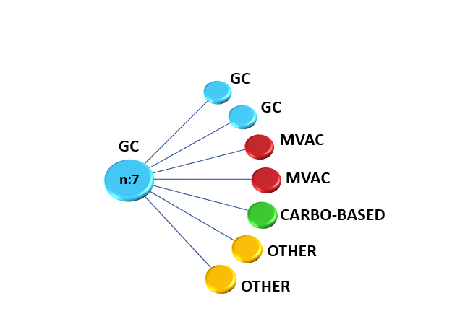

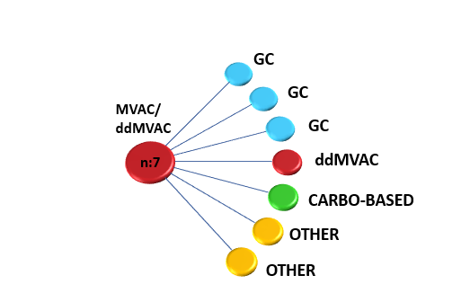

*Each line represents one patient’s pathway

GC = Gemcitabine-Cisplatin; MVAC = Methotrexate-Vinblastine-Adriamycin- Cisplatin; ddMVAC = dose dense Methotrexate-Vinblastine-Adriamycin- Cisplatin; Carbo = Carboplatin

**Figure 2: Time to relapse (TTR) in patients with adverse residual disease (ypT3-4 and/or ypN+) despite neoadjuvant chemotherapy based on adjuvant chemotherapy use.**

**Figure 2A. Patients with ypT3-4 and/or ypN+ residual disease**

Median TTR: 18 months vs. 10 months

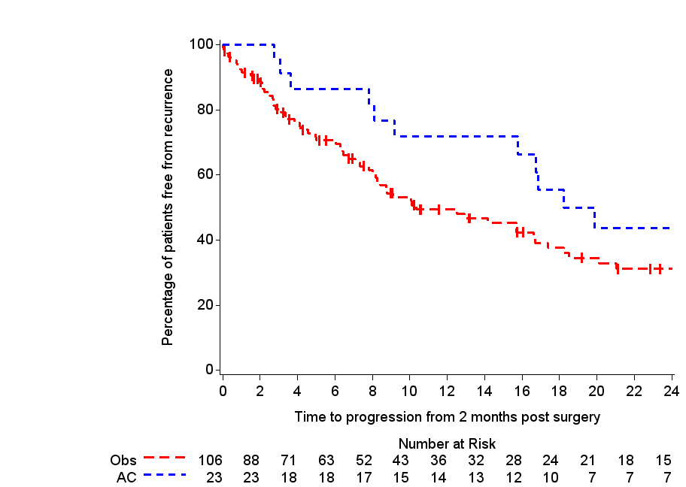

|  |  |  |  |  |  |  |  |
| --- | --- | --- | --- | --- | --- | --- | --- |
| Cohort | N | Progression | Median TTR (months) | HR univariate | p-value | HR multivariablea | p-value |
| AC | 23 | 11 | 18 | 0.54 (0.29-1.03) | 0.06 | 0.40 (0.21-0.82) | 0.01 |
| Observation | 106 | 65 | 10 | 1 (reference) | 1 (reference) |

*aMultivariable analyses were adjusted for pathological stage (stage III and stage IV disease), type of NAC (cisplatin-based and carboplatin-based and other regimens), and age*

*The Kaplan-Meier curves represent crude survival estimates.*

**Figure 2B. Patients with ypT4b and/or ypN+ residual disease**

Median TTR: 20 months vs. 9 months



|  |  |  |  |  |  |
| --- | --- | --- | --- | --- | --- |
| Cohort | N | Progression | Median TTR (months) | HR univariate | HR multivariablea |
| AC | 19 | 9 | 19.9 | 0.43 (0.21-0.89). | 0.3 (0.14- 0.68) |
| Observation | 50 | 36 | 8.9 | 1 (reference) | 1 (reference) |

*aMultivariable analyses were adjusted for pathological stage (stage III and stage IV disease), type of NAC (cisplatin-based and carboplatin-based and other regimens), and age*

*The Kaplan-Meier curves represent crude survival estimates.*

**Figure 3 – Overall survival (OS) by use of adjuvant chemotherapy**

Median OS: 23 months vs 23 months

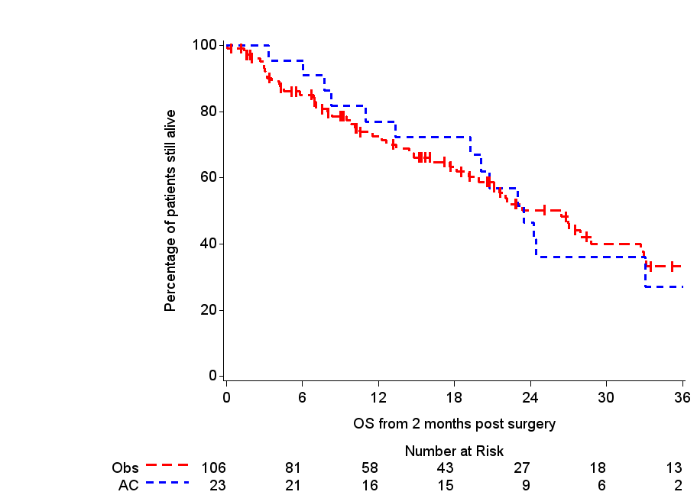

|  |  |  |  |  |  |  |  |
| --- | --- | --- | --- | --- | --- | --- | --- |
| Cohort | N | Deaths | Median OS (months) | HR univariate | p-value | HR multivariablea | p-value |
| AC | 23 | 14 | 23 | 0.93 (0.52-1.70) | 0.82 | 0.95 (0.50-1.81) | 0.85 |
| Observation | 106 | 53 | 23 | 1 (reference) | 1 (reference) |

*aMultivariable analyses were adjusted for pathological stage (stage III and stage IV disease), type of NAC (cisplatin-based and carboplatin-based and other regimens), and age*

*The Kaplan-Meier curves represent crude survival estimates.*