Supplementary Material

Table S1
Instructions for Each Experimental Condition
Condition assignment | Instruction for selecting domains | Instruction for visualization | Instruction for writing | Example
Downward social comparison | Step 1. Here are four things that are important to some students. Which one is most important to YOU? Select 1 thing that is most IMPORTANT to you. There are no right or wrong answers.  The most important thing to me is:  o how good I am at sports (e.g., football, tennis, hockey, gymnastics, or dancing)  o how good I am at making music (e.g., guitar, flute, piano, or singing)  o how good I am at doing my schoolwork (e.g., math or language)  o how good I am at making friends (e.g., how nice other people think I am or how many friends I have) | Step 2. This step is a thinking exercise. You don’t have to write anything yet. You just need to think carefully.  1. Look back at what you have chosen in Step 1 [the thing that is most important to you].  2. Think about a moment when YOU WERE BETTER THAN YOUR PEERS at this thing. How did you notice that you were better than your peers?  3. Please try to remember what happened, as much as possible. What happened exactly? What did you think? And how did you feel? | Step 3. This step is about the event you just thought about, when YOU WERE BETTER THAN YOUR PEERS at this thing.  Try to describe this event below. What happened exactly? What did you think? And how did you feel?  Write down as much as possible. It does not matter if you make spelling mistakes. | A 9-year-old girl who selected the domain music:  “I was better than my peers at singing. I can sing and others can’t. I find myself really important. I love singing, I keep doing it, and I'm simply the best.”
Upward social comparison | Step 1. Here are four things that are important to some students. Which one is most important to YOU? Select 1 thing that is most IMPORTANT to you. There are no right or wrong answers.  The most important thing to me is:  o how good I am at sports (e.g., football, tennis, hockey, gymnastics, or dancing)  o how good I am at making music (e.g., guitar, flute, piano, or singing)  o how good I am at doing my schoolwork (e.g., math or language)  o how good I am at making friends (e.g., how nice other people think I am or how many friends I have) | Step 2. This step is a thinking exercise. You don’t have to write anything yet. You just need to think carefully.  1. Look back at what you have chosen in Step 1 [the thing that is most important to you].  2. Think about a moment when YOU WERE WORSE THAN YOUR PEERS at this thing. How did you notice that you were worse than your peers?  3. Please try to remember what happened, as much as possible. What happened exactly? What did you think? And how did you feel? | Step 3. This step is about the event you just thought about, when YOU WERE WORSE THAN YOUR PEERS at this thing.  Try to describe this event below. What happened exactly? What did you think? And how did you feel?  Write down as much as possible. It does not matter if you make spelling mistakes. | A 10-year-old girl who selected the domain schoolwork:  “We had a math assignment and I didn’t get it at all. Everyone knew the answer except me. I was really embarrassed. I wanted to get out of the class, but I didn’t. The teacher explained the answer later and I understood it. Luckily, I felt better again afterwards.”
Downward temporal comparison | Step 1. Here are four things that are important to some students. Which one is most important to YOU? Select 1 thing that is most IMPORTANT to you. There are no right or wrong answers.  The most important thing to me is:  o how good I am at sports (e.g., football, tennis, hockey, gymnastics, or dancing)  o how good I am at making music (e.g., guitar, flute, piano, or singing)  o how good I am at doing my schoolwork (e.g., math or language)  o how good I am at making friends (e.g., how nice other people think I am or how many friends I have) | Step 2. This step is a thinking exercise. You don’t have to write anything yet. You just need to think carefully.  1. Look back at what you have chosen in Step 1 [the thing that is most important to you].  2. Think about a moment when YOU GOT BETTER at this thing. How did you notice that you got better?  3. Please try to remember what happened, as much as possible. What happened exactly? What did you think? And how did you feel? | Step 3. This step is about the event you just thought about, when YOU GOT BETTER at this thing.  Try to describe this event below. What happened exactly? What did you think? And how did you feel?  Write down as much as possible. It does not matter if you make spelling mistakes. | A 13-year-old girl who selected the domain friendship:  “At first, I didn’t have many friends. But at some point, I was done with it. So, I started sitting next to random people and they became my best friends. Now that I have that many friends I feel good and confident.”
Upward temporal comparison | Step 1. Here are four things that are important to some students. Which one is most important to YOU? Select 1 thing that is most IMPORTANT to you. There are no right or wrong answers.  The most important thing to me is:  o how good I am at sports (e.g., football, tennis, hockey, gymnastics, or dancing)  o how good I am at making music (e.g., guitar, flute, piano, or singing)  o how good I am at doing my schoolwork (e.g., math or language)  o how good I am at making friends (e.g., how nice other people think I am or how many friends I have) | Step 2. This step is a thinking exercise. You don’t have to write anything yet. You just need to think carefully.  1. Look back at what you have chosen in Step 1 [the thing that is most important to you].  2. Think about a moment when YOU GOT WORSE at this thing. How did you notice that you got worse?  3. Please try to remember what happened, as much as possible. What happened exactly? What did you think? And how did you feel? | Step 3. This step is about the event you just thought about, when YOU GOT WORSE at this thing.  Try to describe this event below. What happened exactly? What did you think? And how did you feel?  Write down as much as possible. It does not matter if you make spelling mistakes. | An 11-year-old girl who selected the domain schoolwork:  “The time when I deteriorated in practice exams. It made me feel dissatisfied. The teacher told me that it didn’t matter, but I thought something else. I was a little ashamed.”
Control condition | Step 1. Here are four things that are important to some students. Which one is least important to YOU? Select 1 thing that is LEAST IMPORTANT to you. There are no right or wrong answers.  The least important thing to me is:  o how good I am at sports (e.g., football, tennis, hockey, gymnastics, or dancing)  o how good I am at making music (e.g., guitar, flute, piano, or singing)  o how good I am at doing my schoolwork (e.g., math or language)  o how good I am at making friends (e.g., how nice other people think I am or how many friends I have) | Step 2. This step is a thinking exercise. You don’t have to write anything yet. You just need to think carefully.  1. Look back at what you have chosen in Step 1 [the thing that is least important to you].  2. You have chosen something that is least important to you. But this thing is important to some of your peers. Think about a moment when you noticed that it was IMPORTANT TO SOME OF YOUR PEERS. How did you notice that this thing was important to some of your peers?  3. Please try to remember what happened, as much as possible. What happened exactly? How did you notice that this thing was important to some of your peers? | Step 3. This step is about the event that you have just thought about, when you noticed that that one thing was IMPORTANT TO SOME OF YOUR PEERS.  Try to describe this event below. What happened exactly? How did you notice that this thing was important to some of your peers?  Write down as much as possible. It does not matter if you make spelling mistakes. | A 16-year-old boy who selected the domain music:  “It happened in second grade during the music class. A girl was really good at music and when she was criticized by the teacher, she was really affected by that.”

Table S2
Factor Loadings Based on a Principal Components Analysis with Oblimin Rotation for 6 Items from the Superiority and Improvement Goal Orientation Scale (N = 566)
When I think about the event, I want to… | Superiority goals | Improvement goals
- be better than my peers. | .89
- perform better than my peers. | .91
- do better than my peers. | .93
- be better than I used to be. |  | .86
- improve myself. |  | .85
- get better at things that I do. |  | .87
Note. Total N = 566. Seventeen students, who did not complete the Superiority and Improvement Goal Orientation Scale, were missing from the principle component analysis. There were two factors with Eigenvalue > 1. The two-factor solution explained 78.63% of the variance. Superiority and improvement goals were moderately correlated (r = .35, p < .001).

Coding Children’s Comparisons
Twenty percent of children’s writings were coded by two independent coders. After establishing the inter-rater reliability (Cohen’s κ > .77), one of the coders coded the remaining 80%. We defined downward social comparison as comparing oneself favorably to others; upward social comparison as comparing oneself unfavorably to others; downward temporal comparison as comparing one’s present self favorably to one’s past self; and upward temporal comparison as comparing one’s present self unfavorably to one’s past self. Each comparison type was coded as present (1) or absent (0). It was possible for a writing to contain multiple types of comparisons. To provide a stringent test of our manipulation, comparisons were coded as present only if children described them explicitly (e.g., for downward social comparison: “I am/did better than others” or “Others are/did worse than me”). They were not coded as present, if children only hinted at comparisons without describing them explicitly (e.g., “We were playing soccer with other kids, and I did very, very well”) or when comparisons were imposed on children by other people (e.g., “I do not think I got worse at math, but my teacher told me that my math scores were in decline”).
Figures S1-S4 display the percentage of children who engaged in a certain type of comparison within each experimental condition. We conducted chi-square tests to examine whether children in a certain comparison condition engaged in the type of comparison they were instructed. Children who were instructed to engage in downward social comparison engaged in downward social comparison more than those who were in other comparison conditions, χ²(1, 577) = 193.94, p < .001, Φ = .58. Children who were instructed to engage in upward social comparison engaged in upward social comparison more than those who were in other comparison conditions, χ²(1, 577) = 174.38, p < .001, Φ = .55. Children who were instructed to engage in downward temporal comparison engaged in downward temporal comparison more than those who were in other comparison conditions, χ²(1, 577) = 140.60, p < .001, Φ = .49. Finally, children who were instructed to engage in upward temporal comparison engaged in upward temporal comparison more than those who were in other comparison conditions, χ² (1, 577) = 117.27, p < .001, Φ = .45.

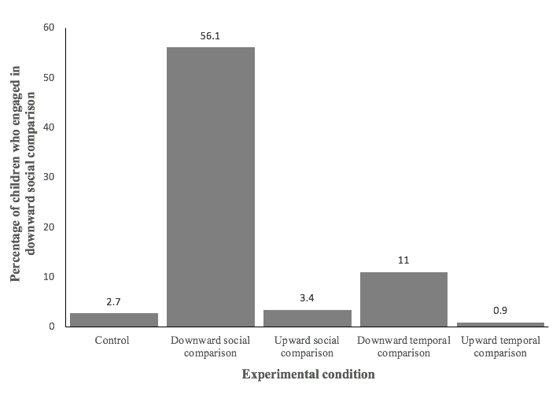
Figure S1. Percentage of children who engaged in downward social comparison within each experimental condition.
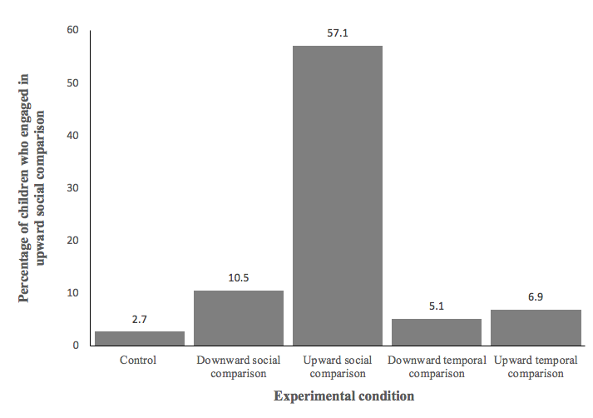
Figure S2. Percentage of children who engaged in upward social comparison within each experimental condition.
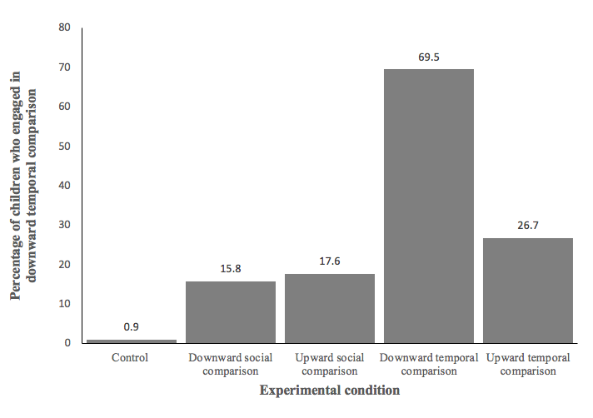
Figure S3. Percentage of children who engaged in downward temporal comparison within each experimental condition.
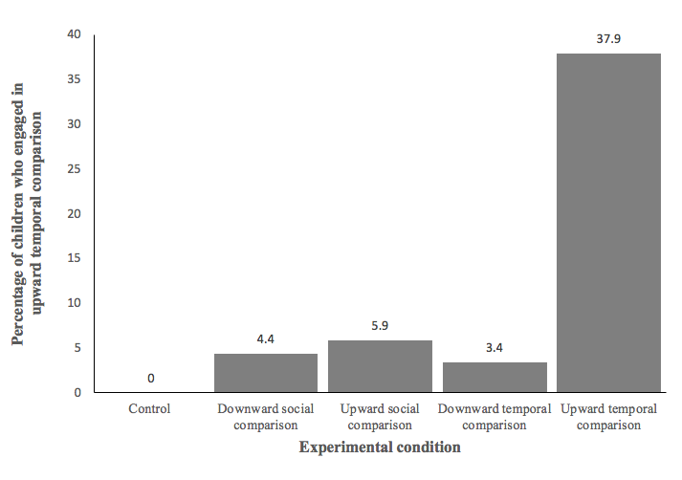
Figure S4. Percentage of children who engaged in upward temporal comparison within each experimental condition.
Exploratory Measure: Self-Esteem
We included the 6-item State Self-Esteem Scale (M = 3.07, SD = .76, Cronbach’s α = .92; Thomaes et al., 2010) as an exploratory measure, given that it captures a subjective state similar to pride and shame. There was no main effect of comparison type, F(1, 567) = 0.10, p = .750, η_{p}² < .01, but there was a main effect of comparison direction, F(1, 567) = 254.59, p < .001, η_{p}² = .31. Relative to the control condition (M = 3.21, SE = 0.06), downward comparisons (M = 3.51, SE = 0.04) raised children’s self-esteem, p < .001, 95% confidence interval (CI) for the mean difference [-0.44, -0.15], whereas upward comparisons (M = 2.57, SE = 0.04) lowered children’s self-esteem, p < .001, 95% CI for the mean difference [0.50, 0.79]. Also, self-esteem was higher after downward comparisons than after upward comparisons, p < .001, 95% CI for the mean difference [-1.05, -0.82]. Thus, results for self-esteem mirror those for pride and shame.
There was also an unexpected Comparison Type × Comparison Direction interaction, F(1, 567) = 4.27, p = .039, η_{p}² = .01, suggesting that the effect of comparison direction was more pronounced for temporal than social comparison. However, none of the planned pairwise comparisons were significant: Downward temporal comparison (M = 3.58, SE = 0.06) did not make children feel better or worse about themselves than did downward social comparison (M = 3.44, SE = 0.06), p = .093, 95% CI for the mean difference [-0.30, 0.02]; and upward temporal comparison (M = 2.52, SE = 0.06) did not make children feel better or worse about themselves than did upward social comparison (M = 2.62, SE = 0.06), p = .216, 95% CI for the mean difference [-0.06, 0.26].

Developmental Trends
We analyzed data using 3 (comparison type: social, temporal, none) × 3 (comparison direction: downward, upward, none) × 3 (age group: middle-to-late childhood, early adolescence, middle adolescence) between-subjects Analyses of Variance separately for each outcome variable. We followed up significant effects with planned pairwise comparisons. We set the alpha level at 0.05, two-tailed.
Pride. There was a main effect of comparison direction, F(1, 553) = 145.95, p < .001, η_{p}² = .21, but no main effect of comparison type, F(1, 553) = 0.85, p = .357, η_{p}² < .01, or age group, F(2, 553) = 0.19, p = .824, η_{p}² < .01. Relative to the control condition (M = 2.60, SE = 0.07), downward comparisons (M = 3.05, SE = 0.05) made children prouder, p < .001, 95% confidence interval (CI) for the mean difference [-0.60, -0.29], whereas upward comparisons (M = 2.20, SE = 0.05) made them less proud, p < .001, 95% CI for the mean difference [0.24, 0.55]. Also, downward comparisons made children prouder than did upward comparisons, p < .001, 95% CI for the mean difference [-0.97, -0.72]. The Comparison Type × Age Group interaction appeared to be significant, F(2, 553) = 3.61, p = .028, η_{p}² = .01, but it was no longer significant when followed up, F(4, 559) = 1.78, p = .131, η_{p}² < .01, which suggests a false positive finding (Venables, 2000). There was no Comparison Type × Comparison Direction interaction or a Comparison Direction × Age Group interaction, F(1, 553) = 0.25, p = .621, η_{p}² < .01, F(2, 553) = 0.21, p = .808, η_{p}² < .01, respectively. Also, there was no Comparison Type × Comparison Direction × Developmental Group interaction, F(2, 553) = 1.68, p = .187, η_{p}² = .01. Thus, the effects of social and temporal comparisons on pride did not depend on age group.
Shame. There was a main effect of comparison direction, F(1, 551) = 34.87, p < .001, η_{p}² = .06. Relative to the control condition (M = 1.56, SE = 0.06), upward comparisons (M = 1.73, SE = 0.04) made children feel more ashamed, p = .023, 95% CI for the mean difference [-0.32, -0.02], whereas downward comparisons (M = 1.33; SE = 0.04) made them feel less ashamed, p = .002, 95% CI for the mean difference [0.09, 0.38]. Also, upward comparisons made children feel more ashamed than did downward comparisons, p < .001, 95% CI for the mean difference [-0.52, -0.29].
There was also a main effect of age group, F(2, 551) = 3.09, p = .046, η_{p}² = .01. Relative to middle-to-late childhood (M = 1.61, SE = 0.05), shame was marginally lower in early adolescence (M = 1.49, SE = 0.04), p = .050, 95% CI for the mean difference [0.00, 0.25]. By contrast, shame levels did not differ between middle-to-late childhood and middle adolescence (M = 1.55; SE = 0.07), p = .461, 95% CI for the mean difference [-0.10, 0.22], or between early and middle adolescence, p = .404, 95% CI for the mean difference [-0.21, 0.09]. There was no main effect of comparison type, F(1, 551) = 0.25, p = .620, η_{p}² < .01. There was no Comparison Type × Comparison Direction interaction, Comparison Direction × Age Group interaction, or Comparison Type × Age Group interaction, F(1, 551) = 0.00, p = .991, η_{p}² < .01, F(2, 551) = 0.31, p = .732, η_{p}² < .01, F(2, 551) = 1.54, p = .215, η_{p}² < .01, respectively. Also, there was no Comparison Type × Comparison Direction × Age Group interaction, F(2, 551) = 0.12, p = .883, η_{p}² < .01. Thus, the effects of social and temporal comparisons on shame did not depend on age group.
Superiority goals. There was no main effect of comparison direction or age group, F(1, 547) = 0.00, p = .944, η_{p}² < .01, and F(2, 547) = 2.19, p = .113, η_{p}² = .01, respectively. There was a marginally significant main effect of comparison type (which became significant when all non-significant predictors were dropped from the model), F(1, 547) = 3.19, p = .075, η_{p}² = .01, and the pattern of findings mirrored those reported in the main text: Relative to the control condition (M = 1.90, SE = 0.08), social comparisons (M = 2.20, SE = 0.05) made children adopt superiority goals, p = .002, 95% CI for the mean difference [-0.49, -0.11], whereas temporal comparisons (M = 2.02, SE = 0.05) did not, p = .215, 95% CI for the mean difference [-0.31, 0.07]. Social comparisons made children adopt superiority goals more than did temporal comparisons, p = .020, 95% CI for the mean difference [-0.33, -0.03].
There was no Comparison Type × Comparison Direction interaction, Comparison Type × Age Group interaction, or Comparison Direction × Age Group interaction, F(1, 547) = 0.00, p = .999, η_{p}² < .01, F(2, 547) = 0.41, p = .664, η_{p}² < .01, F(2, 547) = 0.16, p = .853, η_{p}² < .01, respectively. Also, there was no Comparison Type × Comparison Direction × Age Group interaction, F(2, 547) = 2.38, p = .094, η_{p}² < .01. Thus, the effects of social and temporal comparisons on superiority goals did not depend on age group.
Improvement goals. There was no main effect of comparison type, comparison direction, or age group, F(1, 546) = 1.96, p = .162, η_{p}² = .01, F(1, 546) = 1.97, p = .161, η_{p}² < .01, and F(2, 546) = 1.51, p = .223, η_{p}² = .01, respectively. There was no Comparison Type × Comparison Direction interaction, Comparison Type × Age Group interaction, Comparison Direction × Age Group interaction, or Comparison Type × Comparison Direction × Age Group, F(1, 546) = 0.12, p = .731, η_{p}² < .01, F(2, 546) = 1.12, p = .328, η_{p}² < .01, F(2, 546) = 1.86, p = .156, η_{p}² = .01, respectively. Also, there was no Comparison Type × Comparison Direction × Age Group interaction, F(2, 546) = 0.49, p = .616, η_{p}² < .01. Thus, the effects of social and temporal comparisons on improvement goals did not depend on age group.
Improvement versus superiority goals ratio. There was a main effect of comparison type, F(1, 546) = 6.03, p = .014, η_{p}² = .01. Relative to the control condition (M = 1.86, SE = 0.08), temporal (M = 1.92, SE = 0.05) and social (M = 1.70, SE = 0.06) comparisons did not make children adopt improvement versus superiority goals, p = .523, 95% CI for the mean difference [-0.26, 0.13], p = .100, 95% CI for the mean difference [-0.03, 0.36], respectively. However, relative to each other, temporal comparisons made children adopt improvement versus superiority goals more than did social comparisons, p = .004, 95% CI for the mean difference [-0.38, -0.07].
There was also a main effect of age group, F(2, 546) = 4.51, p = .011, η_{p}² = .02. Relative to middle-to-late childhood (M = 1.91, SE = 0.06), improvement (vs. superiority) goals were lower in middle adolescence (M = 1.60; SE = 0.08), p = .003, 95% CI for the mean difference [0.11, 0.52], whereas it was neither high nor low in early adolescence (M = 1.84, SE = 0.05), p = .386, 95% CI for the mean difference [-0.09, 0.23]. Also, improvement (vs. superiority) goals were higher in early adolescence relative to middle adolescence, p = .012, 95% CI for the mean difference [-0.44, -.05]. There was no main effect of comparison direction, F(1, 546) = 0.56, p = .453, η_{p}² < .01. Also, there was neither Comparison Type × Comparison Direction interaction, nor Comparison Type × Age Group interaction, or Comparison Direction × Age Group interaction, F(1, 546) = 0.00, p = .952, η_{p}² < .01, F(2, 546) = 0.27, p = .760, η_{p}² < .01, F(2, 546) = 0.30, p = .744, η_{p}² < .01, respectively. Similarly, there was no Comparison Type × Comparison Direction × Age Group interaction, F(2, 546) = 2.02, p = .134, η_{p}² < .01. Thus, the effects of social and temporal comparisons on improvement goals (vs. superiority goals) did not depend on age group.
Progress. There was a main effect of comparison type, F(1, 548) = 6.11, p = .014, η_{p}² = .01. Relative to the control condition (M = 2.55, SE = 0.08), both temporal (M = 3.08, SE = 0.06) and social (M = 2.87, SE = 0.06) comparisons made children feel more progressed, p < .001, 95% CI for the mean difference [-0.74, -0.34], p = .002, 95% CI for the mean difference [-0.52, -0.12], respectively. As hypothesized, temporal comparisons made children feel more progressed than did social comparisons, p = .008, 95% CI for the mean difference [-0.38, -0.06].
There was also a main effect of comparison direction, F(1, 548) = 28.95, p < .001, η_{p}² = .05. Relative to the control condition (M = 2.55, SE = 0.08), downward comparisons (M = 3.24, SE = 0.06) made children feel more progressed, p < .001, 95% CI for the mean difference [-0.89, -0.50], whereas upward comparisons (M = 2.71, SE = 0.05) made them feel neither more nor less progressed, p = .095, 95% CI for the mean difference [-0.36, 0.03,]. Also, downward comparisons made children feel more progressed than did upward comparisons, p < .001, 95% CI for the mean difference [-0.68, -0.37]. There was no main effect of age group, F(1, 548) = 0.81, p = .447, η_{p}² < .01. Also, there was no Comparison Type × Comparison Direction interaction, Comparison Type × Age Group interaction, or Comparison Direction × Age Group interaction, F(1, 548) = 0.75, p = .388, η_{p}² < .01, F(2, 548) = 0.11, p = .900, η_{p}² < .01, F(2, 548) = 1.95, p = .144, η_{p}² < .01, respectively. Similarly, there was no Comparison Type × Comparison Direction × Age Group interaction, F(2, 548) = 1.90, p = .151, η_{p}² < .01. Thus, the effects of social and temporal comparisons on progress did not depend on age group.
Insight. There was no main effect of comparison type, comparison direction, or age group, F(1, 560) = 0.12, p = .733, η_{p}² < .01, F(1, 560) = 1.03, p = .311 η_{p}² < .01, F(2, 560) = 0.06, p = .943 η_{p}² < .01, respectively. Although the Comparison Type × Comparison Direction interaction was no longer significant, F(1, 560) = 2.21, p = .138, η_{p}² < .01, the pattern of findings mirrored those reported in the main text: Upward temporal comparison (M = 2.31, SE = 0.28) and upward social comparison (M = 2.73, SE = 0.28) writing exercises did not differ in number of insight words, p = .283, 95% CI for the mean difference [-1.20, 0.35]. However, writing exercises of downward temporal comparison (M = 2.64, SE = 0.28) contained more insight words than did those of downward social comparison (M = 1.79, SE = 0.28), p = .031, 95% CI for the mean difference [-1.64, -0.08]. There was no Comparison Type × Age Group interaction, Comparison Direction × Age Group interaction, or Comparison Type × Comparison Direction × Age Group interaction, F(2, 560) = 1.66, p = .190, η_{p}² < .01, F(2, 560) = 0.10, p = .902, η_{p}² < .01, and F(2, 548) = 1.19, p = .306, η_{p}² < .01, respectively. Thus, the effects of social and temporal comparisons on insight did not depend on age group.

References
Thomaes, S., Reijntjes, A., Orobio de Castro, B., Bushman, B. J., Poorthuis, A., & Telch, M. J. (2010). I like me if you like me: On the interpersonal modulation and regulation of preadolescents’ state self-esteem. Child Development, 81, 811–825. doi:10.1111/j.1467-8624.2010.01435.x
Venables, W. N. (2000). Exegeses on Linear Models. Paper presented to the S-PLUS User's Conference. Washington, DC, 8–9th October, 1998. Retrieved from https://www.stats.ox.ac.uk/pub/MASS3/Exegeses.pdf

