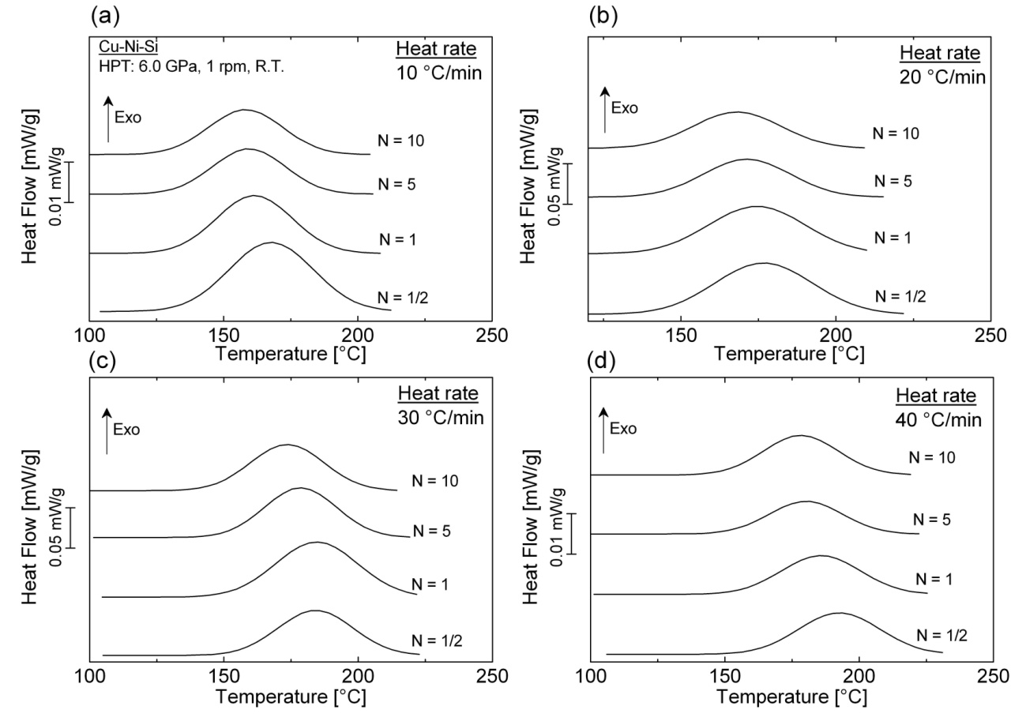
Figure 1: DSC scans at a heating rate of 10, 20, 30 and 40 °C/min corresponding to the recrystallization phenomena in Cu–Ni–Si alloy processed by HPT for N = ½, 1, 5 and 10 turns respectively.

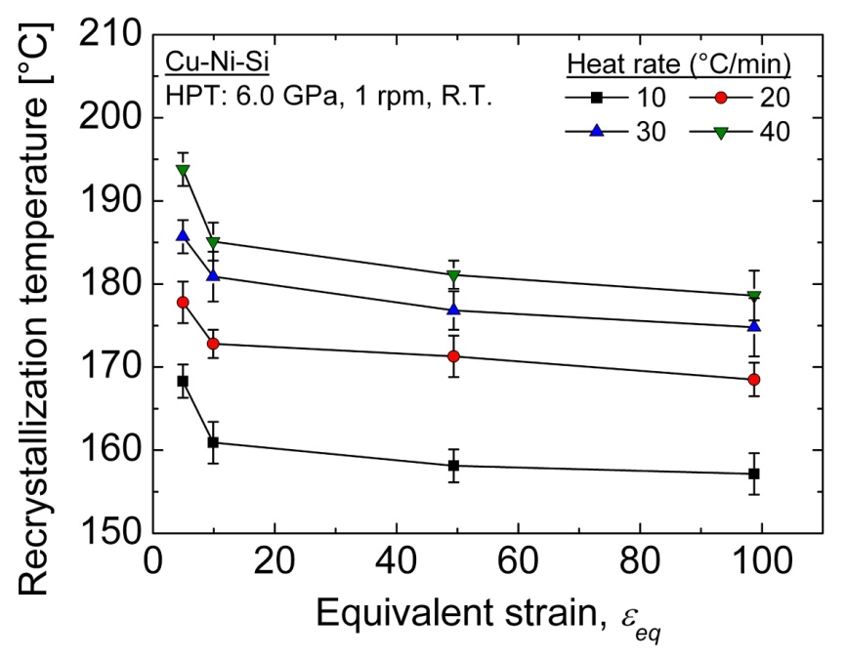
Figure 2: Evolution of the recrystallization temperature peak of Cu–Ni–Si alloy as function of equivalent strain.

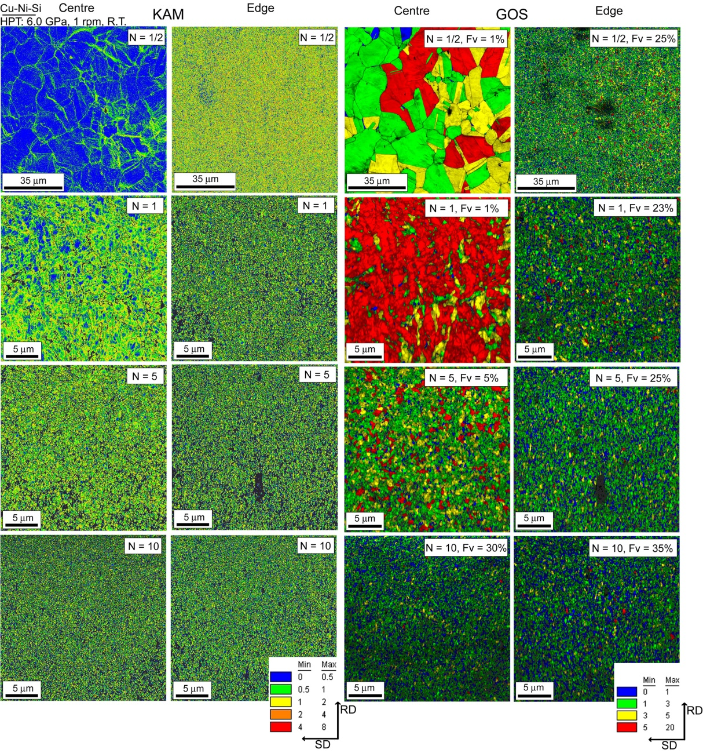
Figure 3: KAM and GOS maps near the centre (left column) and near the edge (right column) of Cu-Ni-Si discs processed by HPT for N = ½, 1, 5 and 10 turns, respectively.

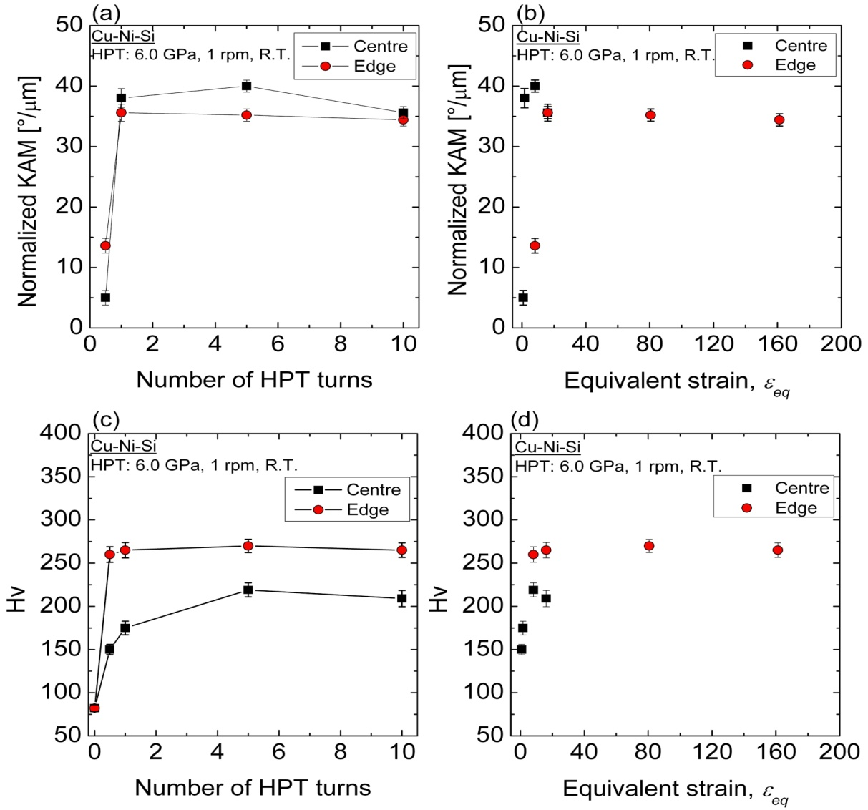
Figure 4: (a, b) Evolution of averaged KAM values as function of number of HPT turns and equivalent strain and (b, c) evolution of mean value of microhardness as function of number of HPT turns and equivalent strain for Cu-Ni-Si alloy processed by HPT for N = ½, 1, 5 and 10 turns, respectively.

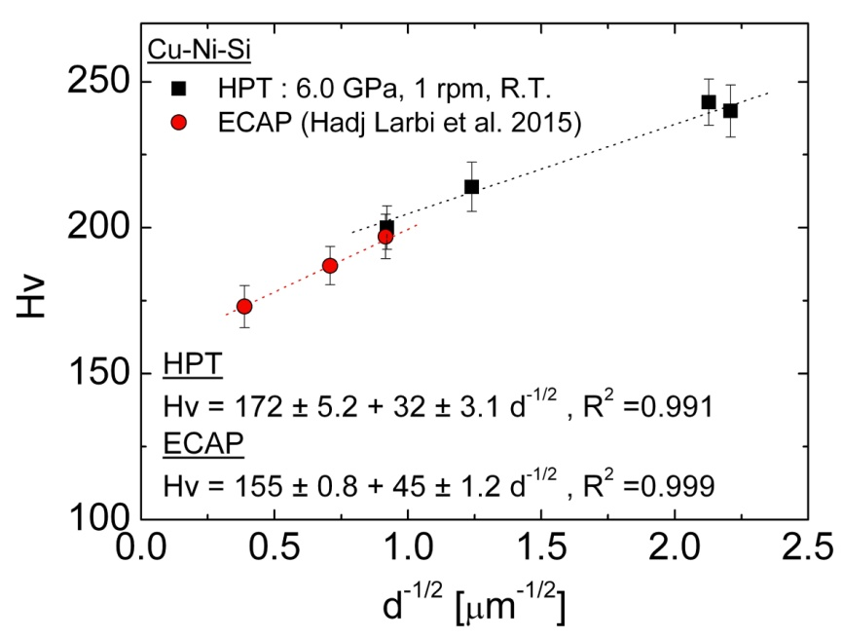
Figure 5: Evolution of microhardness for Cu-Ni-Si alloy processed by HPT for N = ½, 1, 5 and 10 turns as function of inverse of the square root of the mean grain size representing the Hall–Petch relationship. Data from the same Cu-Ni-Si alloy processed by ECAP at 150 °C through N = 2, 8 and 12 passes using route A [6] are also presented.

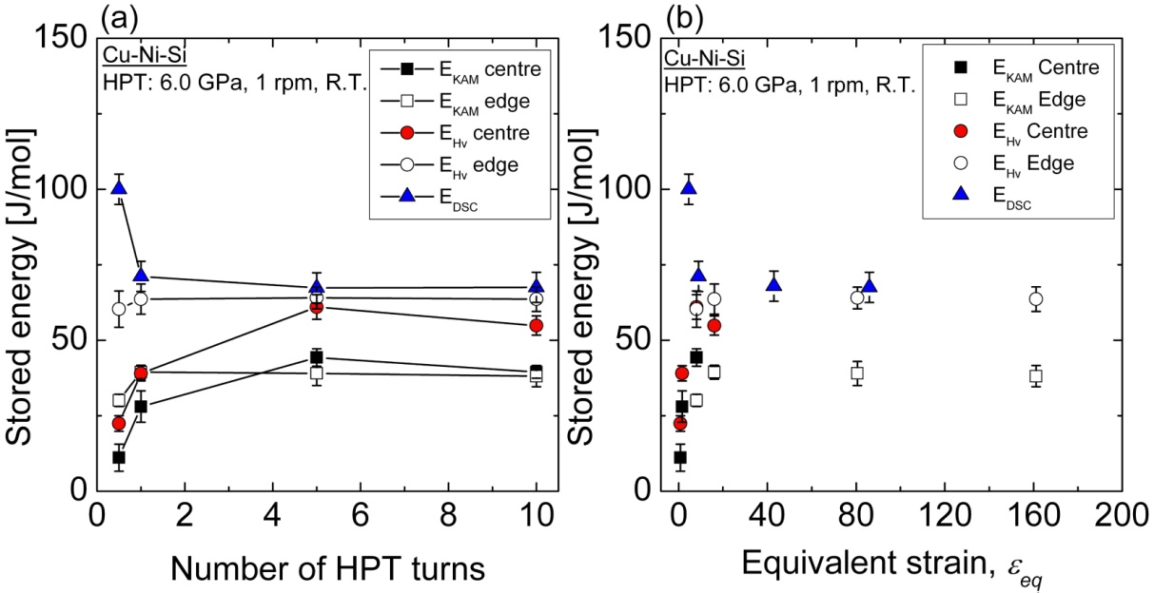
Figure 6: Evolution of stored energy estimated by KAM, Hv and DSC analysis for Cu-Ni-Si alloy processed by HPT for N = ½, 1, 5 and 10 turns as function of: a) number of HPT turns and b) equivalent strain.

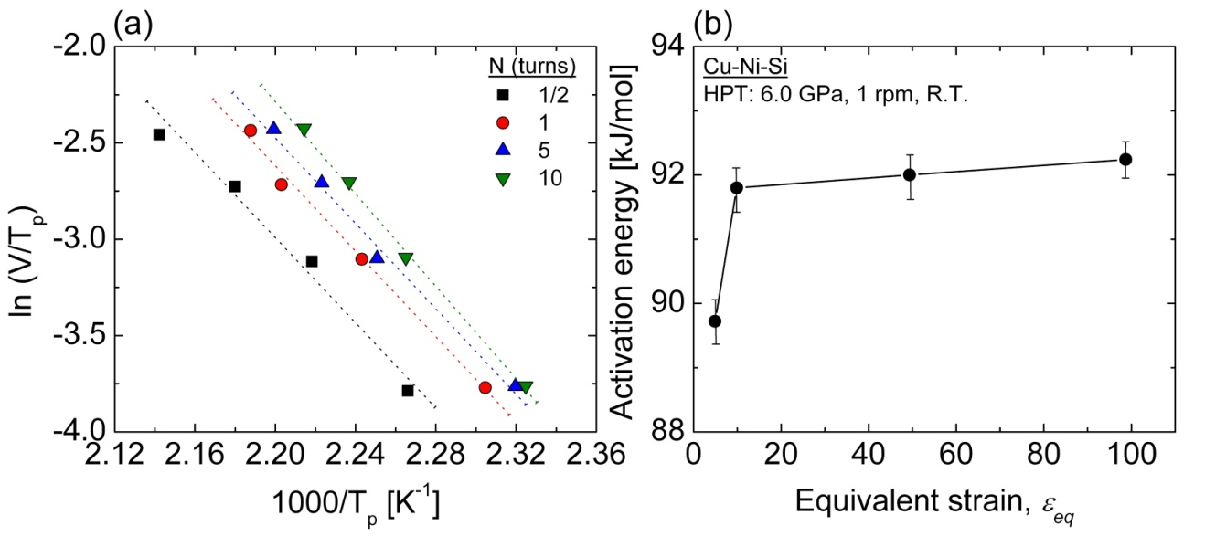
Figure 7: (a) Boswell plots for recrystallization peak in Cu–Ni–Si alloy processed by HPT for N = ½, 1, 5 and 10 turns and (b) Evolution of activation energy of recrystallization as function of equivalent strain.

