Femtosecond laser self-assembly for silver vanadium oxide (SVO) flower structures
Yi-Ke Sun,² Wei-Wei Xu,³ Toshihiro Okamoto,³ Masanobu Haraguchi,³ and Lei Wang^{1,4,*}
¹State Key Laboratory of Integrated Optoelectronics, College of Electronic Science and Engineering, Jilin University, Changchun 130012, China
²Department of Physics, University of Science and Technology of China, Hefei, Anhui 230027, China
³Department of Optical Science and Technology, Faculty of Engineering, Tokushima University, Tokushima 7708506, Japan
⁴Optoelectronic Research Centre, University of Southampton, SO17 1BJ, UK
*Corresponding author: leiwang1987@jlu.edu.cn
Received XX Month XXXX; revised XX Month, XXXX; accepted XX Month XXXX; posted XX Month XXXX (Doc. ID XXXXX); published XX Month XXXX

Flower-liked silver vanadium oxide (SVO) micropatterns were realized by femtosecond laser in-situ writing from its precursor. Self-assembled petals irradiated by femtosecond laser were observed standing on the substrate along with the scanned routine assisted by the formation of silver seeds and plasmonic-mediated effects. By controlling the concentration of ammonium monovanadate and the laser exposure time, different thickness of petals was manipulated from ~ 100 nm to microns. The SVO products were confirmed Ag₄V₂O₇, AgVO₃ and part of Ag₃VO₄ by X-ray diffraction (XRD) measurement. Photon-driven self-assembly for in-situ fabrication of microstructures presents to be an effective and facile technique for SVO and other functional compounds.
© 2019 Optical Society of America
http://dx.doi.org/10.1364/OL.99.099999
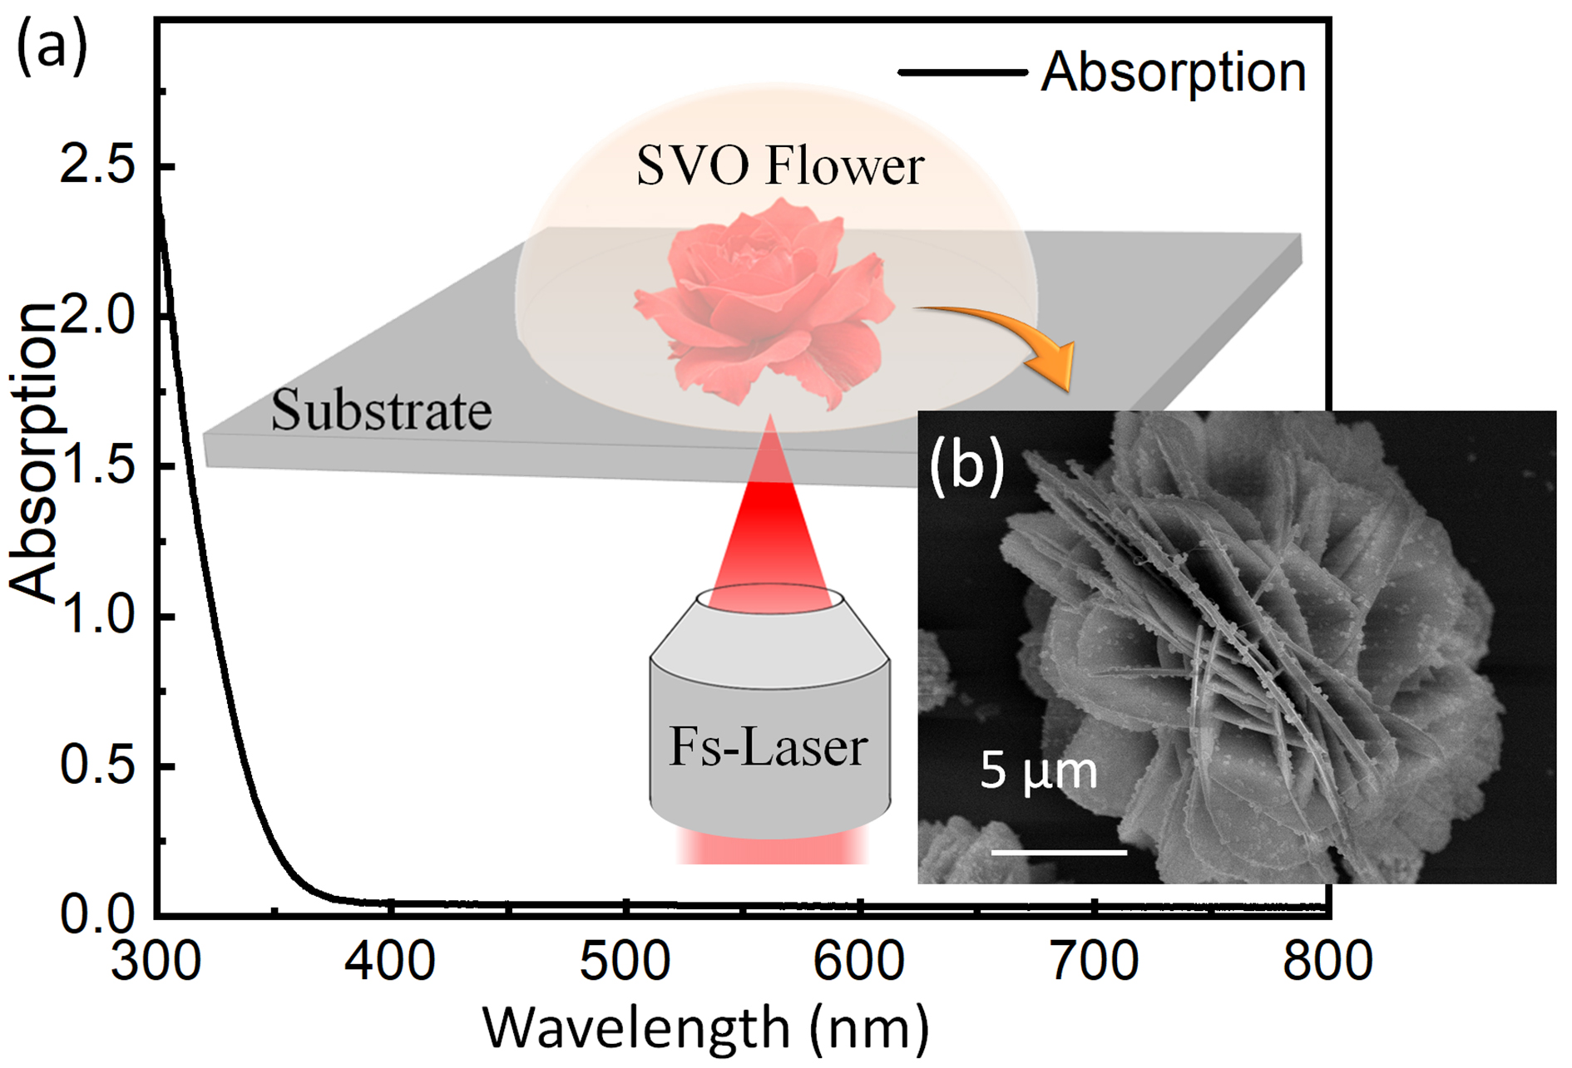
Silver vanadium oxide (SVO) has attracted many interests in the potential applications in cathodic electrodes, [1, 2] gas detection, [3, 4] and lithium batteries [5-7] owing to its unique channel structure and ionic properties[8-10]. Based on the common method of chemical synthesis by accurate temperature and pressure control, SVO with different compositions has been obtained and extensively studied, such as Ag₂V₄O₁₁, [5, 11] Ag₃VO₄, [12] and AgVO₃ [2, 3, 13-16]. Generally, the SVO by chemical synthesis is of benefit to solution-processing compatibility, which imparts tractable nature of SVO for further applications. However, the increasing demand for the micro/nanodevices of sensing and electronic usually require fine control of structures.[3, 15] Transfer method by picking out one from a mess of clusters is significantly a difficulty, which will hinder the potential applications, let alone positioning and shaping. Therefore, to develop a flexible and in-situ fabrication method becomes interesting and essential. It is worth noting that femtosecond (fs-) laser direct writing is an upward tendency due to its advantages of nanometer spatial resolution and 3D prototyping capability.[8-10, 17-23] To date, not only have flexible micro/nanostructures been realized from the photon-sensitive materials, metal nanostructures are also produced directly from its salt solutions by photon-driven reduction reactions. [24-26] Various structures have been developed from their precursors, such as silver micro-electrode,[26, 27] Ag/Au micro-heater,[28, 29] Ag surface enhanced Raman scattering (SERS) substrate[25] and Ag/Au/Pt microdevices[25, 28, 29]. Although the current research has drawn a comprehensive picture of laser in-situ self-assembly from solutions, most of the materials are noble metals. Laser direct writing of compounds from their precursors – such as SVO patterning - are not realized due to the complex photon-chemical reactions. [5, 30-33]
Herein, we produced flexible patterned SVO structures by fs-laser from its precursor based on seeding effect and plasmonic mediated thermal effect. Self-assembled flower-liked structures
Fig. 1. (a)Absorption of the precursor and the schematic of fs-laser induced flower-liked structures. (b). the SEM image of structures.
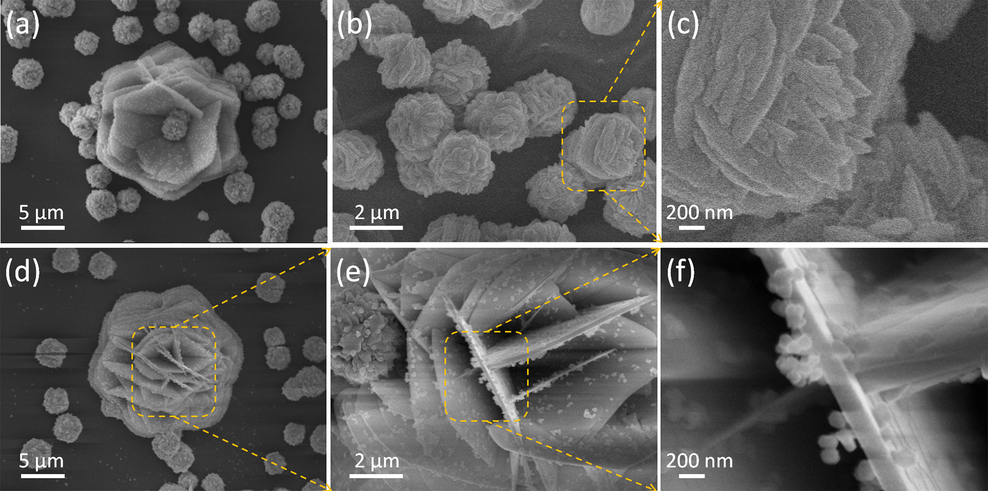
Fig. 2. The obtained flower-liked structures irradiated by fs-laser for 10 mins. (a, d) different shapes of SVO flower. (b, c) were the nucleation structures before flower-liked structures. (e) was the magnified figure of (d); (f) was the magnified figure of (e). The scale bars in (a-d), (b, e), and (c, f) denote 5 µm, 2 µm and 200 nm, respectively.
were directly produced by laser irradiation from its precursor. (Fig. 1) These structures arranged in patterns as the fs-laser scanning routines. The petal thickness from 100 nm to microns were well-controlled by the concentration of NH₄VO₃ and laser exposure time. Compounds of Ag₄V₂O₇ and AgVO₃ and part of Ag₃VO₄ were evidenced by X-ray diffraction (XRD) measurement.
A Ti:Sapphire oscillator laser system (Spectra Physics) was conducted at a central wavelength of 800 nm, pulse duration of 120 fs and repetition rate of 80 MHz. A 3D scanning system assembling a galvano mirror and a piezo-electric transducer (PZT) stage was used for laser fabrication. To make sure the obtained micropattens adhered to the substrate, the laser beam was focused right on the interface between SVO precursor and glass (typically 170 µm thick) by an objective lens (50 ×, NA 0.7). The precursor was synthesized first by mixing 17 mg silver nitrate (AgNO₃), 17 mg sodium citrate, and 200 µL ammonia into 1 ml deionized water. Then a certain mass of m = 2 - 34 mg ammonium monovanadate (NH₄VO₃, typically m = 8 mg in all Figures except for Fig. 4) was added to obtain concentrations from 17.1 – 273.5 mmol/L (mM) and kept for at least 1 hour in dark at room temperature. To measure the surface structure morphology, the sample sputtered with 5-nm platinum (Pt) film was observed under a scanning electron microscope (SEM, JEOL 6700F). For the XRD (Model Rigaku Ru-200b) characterization, a large-area square pattern (5 mm × 5 mm) fabricated by close splicing 100 µm × 100 µm micro-patterns was used to obtain the crystal phase properties.
Flower-liked structures were found leaving on the substrate after focused femtosecond laser with power 20 mw (250 pJ, ~1.4×10⁶ W/cm²) irradiating into the solution for 10 mins. The general crystal growth process was classified into several steps, monomer concentration period, nucleation period and growth period.[27] Once the silver ions were released and combined with VO₃⁻, SVO nanoclusters were immediately formed. Then following the nucleation by concentration and dislocation accumulation, these nanoparticles growing into the undeveloped flower-liked structures scattered around the flower-liked structures, as shown in Fig. 2(a-c). In the growth period, the petals of flowers were first stimulated layer by layer packing at the bottom (Fig. 2(a)) and finally closed with crossed layers upright on the top (Fig. 2(c-f)). As measured in Fig. 2(f), the nanopetals and some growing nanoclusters were around 100 - 200 nm thick. The self-assembled structures grew more and more densely in the scanned routine as
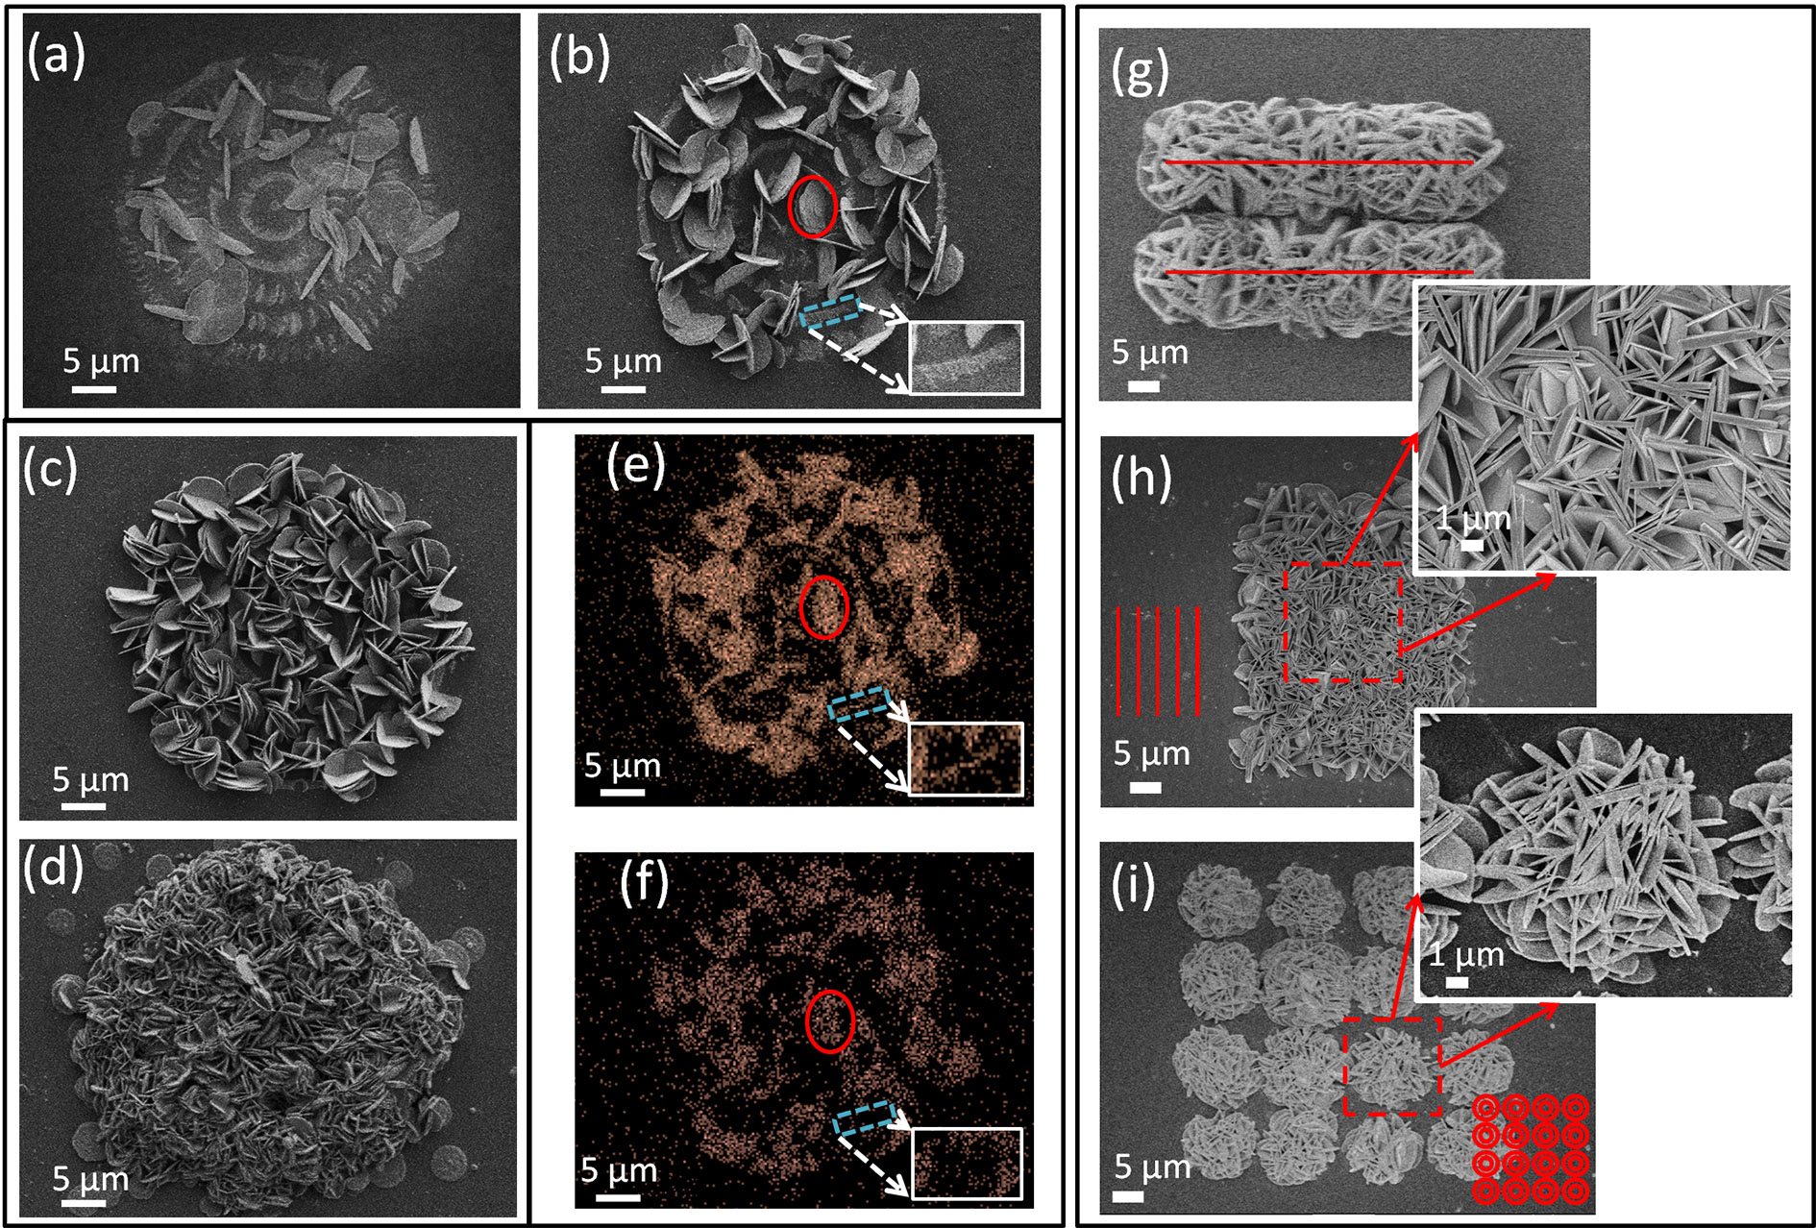
Fig. 3. Self-assembled structures formed by fs-laser scanning with different exposure time (a-d) and routines (g-i). The exposure time for (a-d) were 200 µs, 500 µs, 1 ms and 8 ms per dot, respectively. (d, f) were the Ag and V distribution in EDS mapping. (g-h) were scanned with straight line of 20 µm separation and 5 µm separation. (i) was scanning respectively. with circular lines of 2 µm separation. All the power used was 20 mw. The exposure time for (g-i) was 3 ms per dot.
the exposure time prolonged. (Fig. 3.(a-d)) When the exposure time was 200 µs per dot, a few of petals were left on the scanned position.(Fig. 3(a)) When the exposure time increased to 500 µs/dot, more petals were formed as shown in Fig. 3(b). Because of the irrelevance of alignments with the scanning direction, the denser nanopetals resulted in more intersections between them, as presented in the case of increased exposure time, 1 ms/dot and 8 ms/dot in Fig. 3(c-d). In order to find the distribution of element Ag and V, the energy dispersive spectrometer (EDS) mapping was conducted on the structures in Fig. 3(b), as shown in the red solid elliptical region in Fig. 3(e, f). There were two important phenomenon in the structure formation. One is the preformed seeding line for the formation of SVO nanopetals on the substrate, as shown in the dashed blue square region of Fig. 3(b). The line was made of silver by comparing the element distribution in Fig. 3(e) and Fig. 3(f). It played a significant role as the initial seeds for the formation of SVO and supported the standing up of petals on the substrate. As a comparison, the petals without seeding lines of Fig. 2 grew firstly layer by layer on the substrate before the appearance of upright ones. The second is the descent of the required pulse energy and acceleration of the growth process caused by plasmonic-mediated effect.[25, 34-36] Since for the weak absorption at a wavelength of 800 nm (Fig. 1), a higher pulse energy of more than 250 pJ was required for the electron excitation and the following photon-driven reactions. The pulse energy decreased to 100 pJ after 10 min scanning due to the increasing density of nanocrystal in the precursor, which were produced by laser scattering and localized electric enhancement irradiated by femtosecond laser. In this circumstance, the same of 250 pJ and 3 ms per dot resulted a denser and jagged pattern, as shown in Fig. 3(g). Further, the petals in the pattern presented thinner in the center and thicker in the boundary. Although the beam diameter was around 1.5 µm, the petal diameter of 5 - 10 μm obstructed part of laser in the incident direction and scattered more light in the fresh position when the scanning distance was less than 5 μm. More, laser accumulated heat drove part of the products to the boundary making the final scanning routine at a higher concentration. As a result, thinner and denser structures
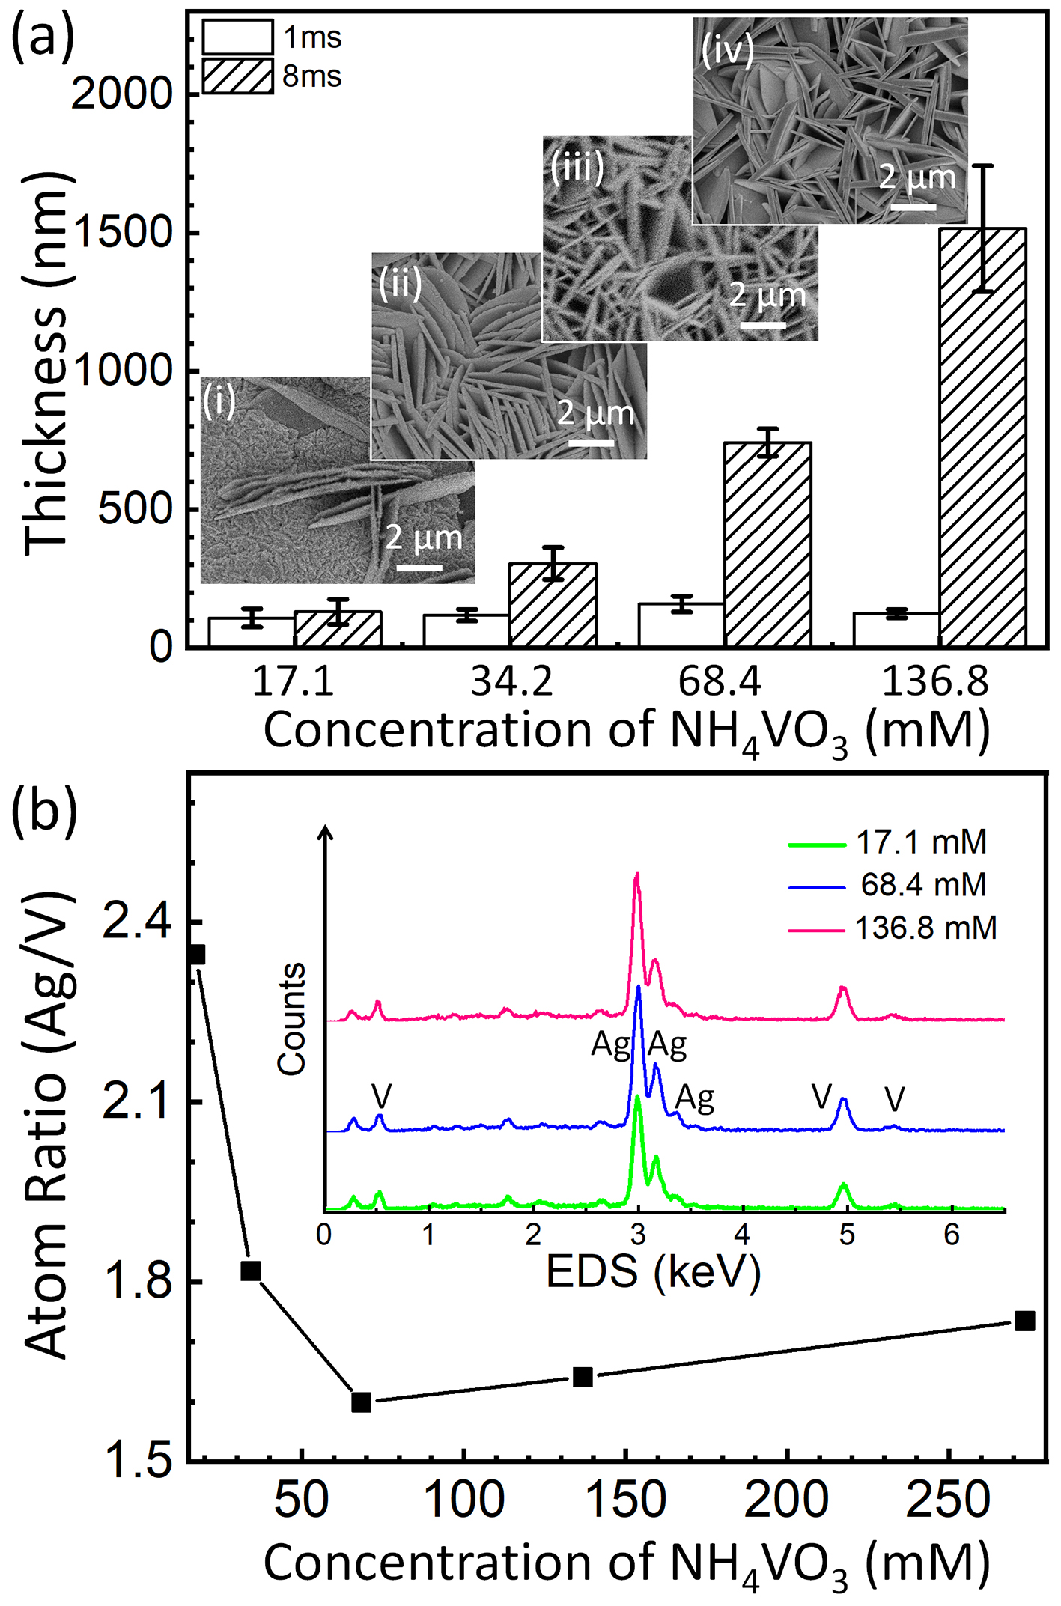
Fig. 4. Petal thickness (a) and atom ratio of Ag/V. Scale bars in the inset figures of (a) stand for 2 µm. The inset figures in (b) show the measured EDS spectrum.
appeared at the overlapped scanning region, while thicker and sparse structures were produced in the border. (Fig. 3(h)) Flower-liked structures were obtained by optimizing two circular scans with line separation of 2 µm, as shown in Fig. 3(i). All the rings of Fig. 3(a-d) were scanned with dot interval 400 nm and line interval 10 µm. The red lines represented the scanning routine and the laser power was 20 mw.
The concentration of NH₄VO₃ took the significant role in the petal thickness. As shown in Fig. 4 (a), the petals became thicker as the concentration of NH₄VO₃ increased. When it was 17.1 mmol/L (mM) at the mass of 2 mg, the atom ratio of Ag:V was found around 2.35. (Fig. 4(b), and the inset figures) The excessive silver ion and low-proportional VO₃⁻ limited the thickness of petals 100 ~ 200 nm regardless of the exposure time. (Fig. 4(A, i) If the concentration increased twice to 34.2 mM, the exposure time played a more important role in the petal growth. As shown in Fig. 4, the thickness of petals produced in different mass of NH₄VO₃ was similarly 100 - 200 nm at lower exposure time of 1 ms per dot. At the higher exposure time of 8 ms per dot, it increased to 300 ± 60 nm at the concentration of 34.2 mM, 740 ± 50 nm at the concentration of 68.4 mM and more than 1.5 ± 0.3 µm at the concentration of 136.8 mM. The thicker petals were expected but didn’t work due to the saturated solubility of NH₄VO₃ in the precursor solutions. Although the thickness and morphology changed as the exposure time when the concentration ≥ 68.4 mM, the atom ratio of Ag/V of products kept in a saturated value, ~ 1.6. All the structures were fabricated based on the square structures in Fig. 3 (h) after the threshold of laser fabrication was stable.
Further, to analyse the accurate chemical component of petals, XRD was conducted as shown in Fig. 5. According to the XRD peaks of Ag₄V₂O₇ (JCPDS card no. 77-0097), the main angles at 25.68º, 31.93º, 32.93º, 42.24º, 46.63º, 58.43º, and 59.27º are well-
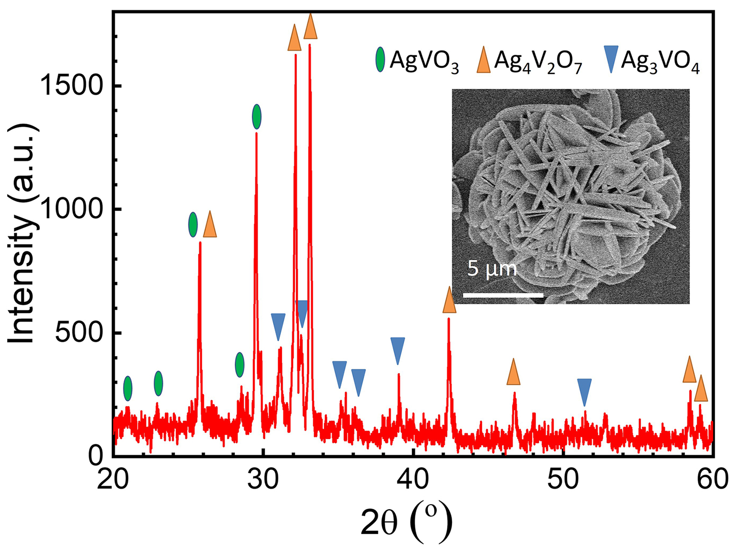
Fig. 5. XRD pattern of the SVO structures. The scale bar denotes 5 µm.
matched with the crystal planes of (224), (040), (151), (117) and (137) of Ag₄V₂O₇, respectively.[11] Due to the composites of Ag₃VO₄/Ag₄V₂O₇, the diffraction peaks at 30.86º, 32.33º, 35.07º, 35.94º, and 38.92º were matched with the crystal planes of (-121), (301), (202) and (022) according to Ag₃VO₄ (JCPDS card no. 43-0542), which implied the co-existence of Ag₃VO₄ and Ag₄V₂O₇ in the laser reduced composites. However, the amount of Ag₃VO₄ was much smaller than Ag₄V₂O₇ according to the peak intensity. Peaks of AgVO₃ was found relative to (-501), (-211) and (501) according to the JCPDS card no. 29-1154.[37] Besides, the AgVO₃ may slightly increase at a concentration more than 68.4 mM according to the tiny uptrend curve in Fig. 4(b), which needs XRD measurements for micro-region to get rid of the heating synthesis in long-time fabrication. The ratio of Ag₄V₂O₇ to AgVO₃ was roughly estimated 6:4 according to the Ag/V=1.6 of EDS. No silver crystal phase was observed.
Based on the mechanism of femtosecond laser induced SVO flowers, the complex process is probably explained by the laser assisted thermal assembling. Sodium citrate was necessary as surfactant and the reducing agent for silver seeds. Neither silver nor SVO structure was hardly formed on the substrate without sodium citrate. Two process happened, the first of which was the formation of silver seeds on the substrate through the fs-laser-induced two-photon reduction process.[9, 25, 38] Then the seeds would be quickly gathered into nanostructures by the plasmonic mediated effect - the localized electric field enhancement around the silver nanoclusters/structures.[39] Meanwhile, this effect would speed up the release of Ag⁺ and their recombination to VO₃⁻ in the solution. Further, it would also drive the nucleation of nanocrystal and the self-assembled growth of flower-liked structures through the photo-thermal effect by increasing the localized temperature up to 100 ºC.[40, 41] It was noticed that some bubbles occurred just after laser scanning, which evidenced the thermal process and implied a shorter laser wavelength around the silver resonant absorption peaks [42] would be much more efficient for the production of flower structures. Further, the products are expected different phase crystal if the raw materials were changed, as well as their morphologies of nanowires or nanodots.[43] Due to the localized laser focus in the micro-volume, the reaction accelerated chemical synthesis from tens of hours to several ms, which strains the difficulty clarifying the reactions but paves the way to produce single products by checking micro-region XRD in the next stage.
Besides, patterns of eighth note symbol, Ω symbol, triple-integral symbol, π symbol, and G clef symbols were demonstrated as shown in Fig. 6, presenting the flexibility for micropatterns.
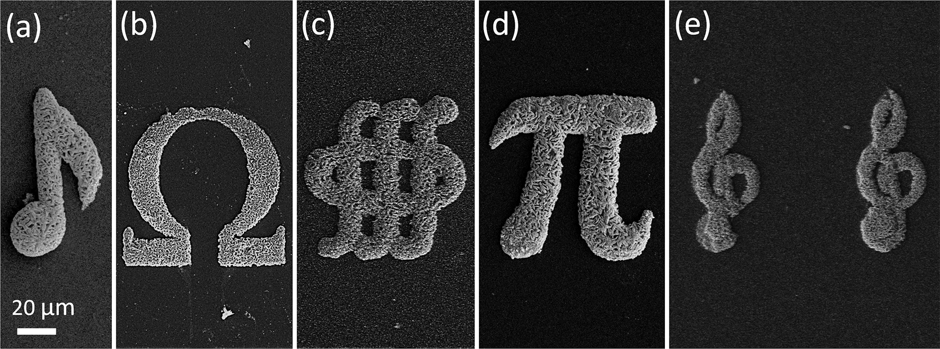
Fig. 6. fs-laser direct writing patterns of (a) eighth note symbol, (b) Ω symbol, (c) triple-integral symbol, (d) π symbol, and (e) G clef symbols. The scale bar denotes 20 µm for all the figures.
The laser power used here is 20 mw with scanning dot separation of 400 nm and line separation of 10 µm.
In conclusion, silver vanadium oxide flower-liked structures were attained by femtosecond laser direct writing from its precursor solutions. Laser induced silver seeds and their plasmonic mediated thermal effect supported the nucleation and growth of SVO. Meanwhile, laser fast scanning provides the in-situ and flexible approach for intricate patterns of structured SVO. Besides, laser exposure time and the component proportion of NH₄VO₃ were used to manipulate the petal thickness from 100 - 200 nm to microns. EDS and XRD results showed a stable reaction product of Ag₄V₂O₇, AgVO₃ and part of Ag₃VO₄. Cause the complex valence state of V, M_{x}V_{y}O_{z} (M could be Ni, Li, Cu, Ag, Bi, Mn, Y or their combinations) has a vast prospect in catalysts and batteries. The proposed protocol would benefit for the flexible SVO applications in microscale and provides potential for the fabrication of various compounds but not only limited to noble metals.
Funding. The authors acknowledge funding from the National Natural Science Foundation of China and in part the National Key Research and Development Program of China under Grant 2017YFB1104300, Grant 91860140, Grant 61825502, Grant 61590930, and Grant 61435005.
Disclosures. The authors declare no conflicts of interest.
References
1. C. Xiong, A. E. Aliev, B. Gnade, and K. J. Balkus Jr, ACS Nano 2, 293 (2008).
2. L. Mai, X. Xu, C. Han, Y. Luo, L. Xu, Y. A. Wu, and Y. Zhao, Nano Lett. 11, 4992 (2011).
3. L. Mai, L. Xu, Q. Gao, C. Han, B. Hu, and Y. Pi, Nano Lett. 10, 2604 (2010).
4. H. Fu, H. Xie, X. Yang, X. An, X. Jiang, and A. Yu, Nanoscale Res. Lett. 10, 411 (2015).
5. D. C. Bock, K. J. Takeuchi, A. C. Marschilok, and E. S. Takeuchi, PCCP 17, 2034 (2015).
6. C. Han, Y. Pi, Q. An, L. Mai, J. Xie, X. Xu, L. Xu, Y. Zhao, C. Niu, and A. M. Khan, Nano Lett. 12, 4668 (2012).
7. D. McNulty, Q. Ramasse, and C. O'Dwyer, Nanoscale 8, 16266 (2016).
8. G. Nagaraju, G. T. Chandrappa, and J. Livage, Bull. Mater. Sci. 31, 367 (2008).
9. B. B. Xu, H. Xia, L. G. Niu, Y. L. Zhang, K. Sun, Q. D. Chen, Y. Xu, Z. Q. Lv, Z. H. Li, and H. Misawa, Small 6, 1762 (2010).
10. M. Assis, E. Cordoncillo, R. Torres-Mendieta, H. Beltrán-Mir, G. Mínguez-Vega, R. Oliveira, E. R. Leite, C. C. Foggi, C. E. Vergani, E. Longo, and J. Andrés, Sci. Rep. 8, 1884 (2018).
11. F. Sauvage, V. Bodenez, J.-M. Tarascon, and K. R. Poeppelmeier, J. Am. Chem. Soc. 132, 6778 (2010).
12. S. Nagamuthu, S. Vijayakumar, and K.-S. Ryu, J. Phys. Chem. C 120, 18963 (2016).
13. J. Xu, C. Hu, Y. Xi, B. Wan, C. Zhang, and Y. Zhang, Solid State Sci. 14, 535 (2012).
14. S.-J. Bao, Q.-L. Bao, C.-M. Li, T. P. Chen, C.-Q. Sun, Z.-L. Dong, Y. Gan, and J. Zhang, Small 3, 1174 (2007).
15. M. Feng, L.-B. Luo, B. Nie, and S.-H. Yu, Adv. Funct. Mater. 23, 5116 (2013).
16. A. P. de Melo Monteiro, R. Dias Holtz, L. Carneiro Fonseca, C. H. Zanini Martins, M. de Sousa, L. A. V. de Luna, D. L. de Sousa Maia, and O. L. Alves, Chem. Rec. 18, 973 (2018).
17. J. Xiao, P. Liu, C. X. Wang, and G. W. Yang, Prog. Mater Sci. 87, 140 (2017).
18. Y. Zhang, L. Guo, S. Wei, Y. He, H. Xia, Q. Chen, H.-B. Sun, and F.-S. Xiao, Nano Today 5, 15 (2010).
19. B. Han, Y. L. Zhang, L. Zhu, Y. Li, Z. C. Ma, Y. Q. Liu, X. L. Zhang, X. W. Cao, Q. D. Chen, and C. W. Qiu, Adv. Mater. 31, 1806386 (2019).
20. L. Wang, Q.-D. Chen, X.-W. Cao, R. Buividas, X. Wang, S. Juodkazis, and H.-B. Sun, Light Sci. Appl. 6, e17112 (2017).
21. D. Wei, C. Wang, X. Xu, H. Wang, Y. Hu, P. Chen, J. Li, Y. Zhu, C. Xin, X. Hu, Y. Zhang, D. Wu, J. Chu, S. Zhu, and M. Xiao, Nature Commu. 10, 1 (2019).
22. L. Yang, X. Chen, L. Wang, Z. Hu, C. Xin, M. Hippler, W. Zhu, Y. Hu, J. Li, Y. Wang, L. Zhang, D. Wu, and J. Chu, Adv. Funct. Mater. 0, 1905745 (2019).
23. S. Jiang, Y. Hu, H. Wu, Y. Zhang, Y. Zhang, Y. Wang, Y. Zhang, W. Zhu, J. Li, D. Wu, and J. Chu, Adv. Mater. 31, 1807507 (2019).
24. E. H. Waller, and G. von Freymann, Nanophotonics (2018).
25. Z.-C. Ma, Y.-L. Zhang, B. Han, Q.-D. Chen, and H.-B. Sun, Small Methods 2, 1700413 (2018).
26. B.-B. Xu, D.-D. Zhang, X.-Q. Liu, L. Wang, W.-W. Xu, M. Haraguchi, and A.-W. Li, Opt. Lett. 39, 434 (2014).
27. S. Tabrizi, Y. Cao, H. Lin, and B. Jia, Sci. China Phys. Mech. 60, 034201 (2017).
28. D. D. Qian, L. Yang, Y. C. Zhang, C. Xin, Z. J. Hu, K. Hu, Y. L. Wang, D. Pan, J. W. Li, D. Wu, Y. L. Hu, and J. R. Chu, Opt. Lett. 43, 5335 (2018).
29. G.-C. He, H. Lu, X.-Z. Dong, Y.-L. Zhang, J. Liu, C.-Q. Xie, and Z.-S. Zhao, RSC Adv. 8, 24893 (2018).
30. Y. L. Zhang, Q. D. Chen, H. Xia, and H. B. Sun, Nano Today 5, 435 (2010).
31. X.-N. Li, X.-N. Wu, X.-L. Ding, B. Xu, and S.-G. He, Chem.: Eur. J. 18, 10998 (2012).
32. A. Beltrán, L. Gracia, J. Andrés, and E. Longo, J. Phys. Chem. C 121, 27624 (2017).
33. F. Wang, V. N. Richards, S. P. Shields, and W. E. Buhro, Chem. Mater. 26, 5 (2014).
34. H. Takeya, J. Frame, T. Tanaka, Y. Urade, X. Fang, and W. Kubo, Sci. Rep. 8, 12764 (2018).
35. G. Yuan, E. T. F. Rogers, and N. I. Zheludev, Light Sci. Appl. 8, 2 (2019).
36. L. Jiang, A.-D. Wang, B. Li, T.-H. Cui, and Y.-F. Lu, Light Sci. Appl. 7, 17134 (2018).
37. S. Liang, J. Zhou, X. Zhang, Y. Tang, G. Fang, T. Chen, and X. Tan, CrystEngComm 15, 9869 (2013).
38. D. Wei, C. Wang, H. Wang, X. Hu, D. Wei, X. Fang, Y. Zhang, D. Wu, Y. Hu, and J. Li, Nature Photon. 12, 596 (2018).
39. B.-B. Xu, L. Wang, Z.-C. Ma, R. Zhang, Q.-D. Chen, C. Lv, B. Han, X.-Z. Xiao, X.-L. Zhang, Y.-L. Zhang, K. Ueno, H. Misawa, and H.-B. Sun, ACS Nano 8, 6682 (2014).
40. L. Jauffred, A. Samadi, H. Klingberg, P. M. Bendix, and L. B. Oddershede, Chem. Rev. 119, 8087 (2019).
41. V. K. Meader, M. G. John, L. M. F. Batista, S. Ahsan, and K. M. Tibbetts, Molecules 23, 13 (2018).
42. Y.-K. Sun, L. Wang, M. Kamano, and S. Juodkazis, Opt. Lett. 43, 3786 (2018).
43. J.-q. Cao, X.-y. Wang, A. Tang, X. Wang, Y. Wang, and W. Wu, J. Alloys Compd. 479, 875 (2009).

References
1. C. Xiong, A. E. Aliev, B. Gnade, and K. J. Balkus Jr, "Fabrication of silver vanadium oxide and V2O5 nanowires for electrochromics," ACS Nano 2, 293-301 (2008).
2. L. Mai, X. Xu, C. Han, Y. Luo, L. Xu, Y. A. Wu, and Y. Zhao, "Rational synthesis of silver vanadium oxides/polyaniline triaxial nanowires with enhanced electrochemical property," Nano Lett. 11, 4992-4996 (2011).
3. L. Mai, L. Xu, Q. Gao, C. Han, B. Hu, and Y. Pi, "Single β-AgVO3 nanowire H2S sensor," Nano Lett. 10, 2604-2608 (2010).
4. H. Fu, H. Xie, X. Yang, X. An, X. Jiang, and A. Yu, "Hydrothermal Synthesis of Silver Vanadium Oxide (Ag0.35V2O5) Nanobelts for Sensing Amines," Nanoscale Res. Lett. 10, 411 (2015).
5. D. C. Bock, K. J. Takeuchi, A. C. Marschilok, and E. S. Takeuchi, "Structural and silver/vanadium ratio effects on silver vanadium phosphorous oxide solution formation kinetics: Impact on battery electrochemistry," PCCP 17, 2034-2042 (2015).
6. C. Han, Y. Pi, Q. An, L. Mai, J. Xie, X. Xu, L. Xu, Y. Zhao, C. Niu, and A. M. Khan, "Substrate-assisted self-organization of radial β-AgVO3 nanowire clusters for high rate rechargeable lithium batteries," Nano Lett. 12, 4668-4673 (2012).
7. D. McNulty, Q. Ramasse, and C. O'Dwyer, "The structural conversion from α-AgVO3 to β-AgVO3: Ag nanoparticle decorated nanowires with application as cathode materials for Li-ion batteries," Nanoscale 8, 16266-16275 (2016).
8. G. Nagaraju, G. T. Chandrappa, and J. Livage, "Synthesis and characterization of silver molybdate nanowires, nanorods and multipods," Bull. Mater. Sci. 31, 367-371 (2008).
9. B. B. Xu, H. Xia, L. G. Niu, Y. L. Zhang, K. Sun, Q. D. Chen, Y. Xu, Z. Q. Lv, Z. H. Li, and H. Misawa, "Flexible Nanowiring of Metal on Nonplanar Substrates by Femtosecond‐Laser‐Induced Electroless Plating," Small 6, 1762-1766 (2010).
10. M. Assis, E. Cordoncillo, R. Torres-Mendieta, H. Beltrán-Mir, G. Mínguez-Vega, R. Oliveira, E. R. Leite, C. C. Foggi, C. E. Vergani, E. Longo, and J. Andrés, "Towards the scale-up of the formation of nanoparticles on α-Ag2WO4 with bactericidal properties by femtosecond laser irradiation," Sci. Rep. 8, 1884 (2018).
11. F. Sauvage, V. Bodenez, J.-M. Tarascon, and K. R. Poeppelmeier, "Room-Temperature Synthesis Leading to Nanocrystalline Ag2V4O11," J. Am. Chem. Soc. 132, 6778-6782 (2010).
12. S. Nagamuthu, S. Vijayakumar, and K.-S. Ryu, "Synthesis of Ag Anchored Ag3VO4 Stacked Nanosheets: Toward a Negative Electrode Material for High-Performance Asymmetric Supercapacitor Devices," J. Phys. Chem. C 120, 18963-18970 (2016).
13. J. Xu, C. Hu, Y. Xi, B. Wan, C. Zhang, and Y. Zhang, "Synthesis and visible light photocatalytic activity of β-AgVO3 nanowires," Solid State Sci. 14, 535-539 (2012).
14. S.-J. Bao, Q.-L. Bao, C.-M. Li, T. P. Chen, C.-Q. Sun, Z.-L. Dong, Y. Gan, and J. Zhang, "Synthesis and Electrical Transport of Novel Channel-Structured β-AgVO3," Small 3, 1174-1177 (2007).
15. M. Feng, L.-B. Luo, B. Nie, and S.-H. Yu, "p-Type Beta-Silver Vanadate Nanoribbons for Nanoelectronic Devices with Tunable Electrical Properties," Adv. Funct. Mater. 23, 5116-5122 (2013).
16. A. P. de Melo Monteiro, R. Dias Holtz, L. Carneiro Fonseca, C. H. Zanini Martins, M. de Sousa, L. A. V. de Luna, D. L. de Sousa Maia, and O. L. Alves, "Nano Silver Vanadate AgVO3: Synthesis, New Functionalities and Applications," Chem. Rec. 18, 973-985 (2018).
17. J. Xiao, P. Liu, C. X. Wang, and G. W. Yang, "External field-assisted laser ablation in liquid: An efficient strategy for nanocrystal synthesis and nanostructure assembly," Prog. Mater Sci. 87, 140-220 (2017).
18. Y. Zhang, L. Guo, S. Wei, Y. He, H. Xia, Q. Chen, H.-B. Sun, and F.-S. Xiao, "Direct imprinting of microcircuits on graphene oxides film by femtosecond laser reduction," Nano Today 5, 15-20 (2010).
19. B. Han, Y. L. Zhang, L. Zhu, Y. Li, Z. C. Ma, Y. Q. Liu, X. L. Zhang, X. W. Cao, Q. D. Chen, and C. W. Qiu, "Plasmonic‐Assisted Graphene Oxide Artificial Muscles," Adv. Mater. 31, 1806386 (2019).
20. L. Wang, Q.-D. Chen, X.-W. Cao, R. Buividas, X. Wang, S. Juodkazis, and H.-B. Sun, "Plasmonic nano-printing: large-area nanoscale energy deposition for efficient surface texturing," Light Sci. Appl. 6, e17112 (2017).
21. D. Wei, C. Wang, X. Xu, H. Wang, Y. Hu, P. Chen, J. Li, Y. Zhu, C. Xin, X. Hu, Y. Zhang, D. Wu, J. Chu, S. Zhu, and M. Xiao, "Efficient nonlinear beam shaping in three-dimensional lithium niobate nonlinear photonic crystals," Nature Commu. 10, 1-7 (2019).
22. L. Yang, X. Chen, L. Wang, Z. Hu, C. Xin, M. Hippler, W. Zhu, Y. Hu, J. Li, Y. Wang, L. Zhang, D. Wu, and J. Chu, "Targeted Single-Cell Therapeutics with Magnetic Tubular Micromotor by One-Step Exposure of Structured Femtosecond Optical Vortices," Adv. Funct. Mater. 0, 1905745 (2019).
23. S. Jiang, Y. Hu, H. Wu, Y. Zhang, Y. Zhang, Y. Wang, Y. Zhang, W. Zhu, J. Li, D. Wu, and J. Chu, "Multifunctional Janus Microplates Arrays Actuated by Magnetic Fields for Water/Light Switches and Bio-Inspired Assimilatory Coloration," Adv. Mater. 31, 1807507 (2019).
24. E. H. Waller, and G. von Freymann, "From photoinduced electron transfer to 3D metal microstructures via direct laser writing," Nanophotonics (2018).
25. Z.-C. Ma, Y.-L. Zhang, B. Han, Q.-D. Chen, and H.-B. Sun, "Femtosecond-Laser Direct Writing of Metallic Micro/Nanostructures: From Fabrication Strategies to Future Applications," Small Methods 2, 1700413 (2018).
26. B.-B. Xu, D.-D. Zhang, X.-Q. Liu, L. Wang, W.-W. Xu, M. Haraguchi, and A.-W. Li, "Fabrication of microelectrodes based on precursor doped with metal seeds by femtosecond laser direct writing," Opt. Lett. 39, 434-437 (2014).
27. S. Tabrizi, Y. Cao, H. Lin, and B. Jia, "Two-photon reduction: a cost-effective method for fabrication of functional metallic nanostructures," Sci. China Phys. Mech. 60, 034201 (2017).
28. D. D. Qian, L. Yang, Y. C. Zhang, C. Xin, Z. J. Hu, K. Hu, Y. L. Wang, D. Pan, J. W. Li, D. Wu, Y. L. Hu, and J. R. Chu, "Flexible and rapid fabrication of silver microheaters with spatial-modulated multifoci by femtosecond laser multiphoton reduction," Opt. Lett. 43, 5335-5338 (2018).
29. G.-C. He, H. Lu, X.-Z. Dong, Y.-L. Zhang, J. Liu, C.-Q. Xie, and Z.-S. Zhao, "Electrical and thermal properties of silver nanowire fabricated on a flexible substrate by two-beam laser direct writing for designing a thermometer," RSC Adv. 8, 24893-24899 (2018).
30. Y. L. Zhang, Q. D. Chen, H. Xia, and H. B. Sun, "Designable 3D nanofabrication by femtosecond laser direct writing," Nano Today 5, 435–448 (2010).
31. X.-N. Li, X.-N. Wu, X.-L. Ding, B. Xu, and S.-G. He, "Reactivity Control of C-H Bond Activation over Vanadium–Silver Bimetallic Oxide Cluster Cations," Chem.: Eur. J. 18, 10998-11006 (2012).
32. A. Beltrán, L. Gracia, J. Andrés, and E. Longo, "First-Principles Study on Polymorphs of AgVO3: Assessing to Structural Stabilities and Pressure-Induced Transitions," J. Phys. Chem. C 121, 27624-27642 (2017).
33. F. Wang, V. N. Richards, S. P. Shields, and W. E. Buhro, "Kinetics and Mechanisms of Aggregative Nanocrystal Growth," Chem. Mater. 26, 5-21 (2014).
34. H. Takeya, J. Frame, T. Tanaka, Y. Urade, X. Fang, and W. Kubo, "Bolometric photodetection using plasmon-assisted resistivity change in vanadium dioxide," Sci. Rep. 8, 12764 (2018).
35. G. Yuan, E. T. F. Rogers, and N. I. Zheludev, "“Plasmonics” in free space: observation of giant wavevectors, vortices, and energy backflow in superoscillatory optical fields," Light Sci. Appl. 8, 2 (2019).
36. L. Jiang, A.-D. Wang, B. Li, T.-H. Cui, and Y.-F. Lu, "Electrons dynamics control by shaping femtosecond laser pulses in micro/nanofabrication: modeling, method, measurement and application," Light Sci. Appl. 7, 17134 (2018).
37. S. Liang, J. Zhou, X. Zhang, Y. Tang, G. Fang, T. Chen, and X. Tan, "Hydrothermal synthesis of Ag/β-AgVO3 nanobelts with enhanced performance as a cathode material for lithium batteries," CrystEngComm 15, 9869-9873 (2013).
38. D. Wei, C. Wang, H. Wang, X. Hu, D. Wei, X. Fang, Y. Zhang, D. Wu, Y. Hu, and J. Li, "Experimental demonstration of a three-dimensional lithium niobate nonlinear photonic crystal," Nature Photon. 12, 596 (2018).
39. B.-B. Xu, L. Wang, Z.-C. Ma, R. Zhang, Q.-D. Chen, C. Lv, B. Han, X.-Z. Xiao, X.-L. Zhang, Y.-L. Zhang, K. Ueno, H. Misawa, and H.-B. Sun, "Surface-Plasmon-Mediated Programmable Optical Nanofabrication of an Oriented Silver Nanoplate," ACS Nano 8, 6682-6692 (2014).
40. L. Jauffred, A. Samadi, H. Klingberg, P. M. Bendix, and L. B. Oddershede, "Plasmonic Heating of Nanostructures," Chem. Rev. 119, 8087-8130 (2019).
41. V. K. Meader, M. G. John, L. M. F. Batista, S. Ahsan, and K. M. Tibbetts, "Radical Chemistry in a Femtosecond Laser Plasma: Photochemical Reduction of Ag+ in Liquid Ammonia Solution," Molecules 23, 13 (2018).
42. Y.-K. Sun, L. Wang, M. Kamano, and S. Juodkazis, "Plasmonic nano-imprinting by photo-doping," Opt. Lett. 43, 3786-3789 (2018).
43. J.-q. Cao, X.-y. Wang, A. Tang, X. Wang, Y. Wang, and W. Wu, "Sol–gel synthesis and electrochemical properties of CuV2O6 cathode material," J. Alloys Compd. 479, 875-878 (2009).

