Communication for Trans IMF 22 November 2019

Electrodeposition of platinum on 3D-printed titanium mesh to produce tailored, high area anodes
L. F. Arenas*, N. Kaishubayeva, C. Ponce de León, F. C. Walsh
Electrochemical Engineering Laboratory, Energy Technology Group, Faculty of Engineering and Physical Sciences, University of Southampton, Southampton, SO17 1BJ, United Kingdom.
*Author for correspondence; l.f.arenas@soton.ac.uk

Abstract
Versatility and convenience of 3D printing can be used to produce tailored metal mesh electrodes, which offer a high volumetric area and good gas release properties for applications in electrochemical technology. In this work, a titanium mesh with 20 ppi triangular pores was designed and then manufactured by 3D printing. A thin coating of platinum with strong adhesion was then applied by electrodeposition in a solution of hexachloroplatinic acid in HCl at 90 °C. For this, a current of 0.1 A, corresponding to a current density of 0.92 mA cm⁻², was applied for 60 min. to the workpiece, which was etched in 10% w/v oxalic acid at 80 °C. Compact, adherent and silver-grey platinum deposits, 0.16 μm average thickness and 0.33 mg cm⁻² Pt loading, were obtained. The product can be used as inert anode in nickel plating baths and as porous electrode in organic electrosynthesis or cerium-based flow batteries.

Keywords: additive manufacturing, electroplating, mesh, metal foam, porous electrode, platinum, platinised titanium, three-dimensional electrode.

Introduction
Platinum is a very inert metal in many electrolytes and continues to enjoy use as an electrode surface in electrochemical technology, despite its high cost. Uses include oxygen evolution in electrolysis [1-3], anodes in electrodeposition [4-6], impressed current cathodic protection anodes [7], speciality organic synthesis [8], and cerium ion redox reactions for mediated electrosynthesis [9] or redox flow batteries for energy storage [10,11]. In such applications, thin platinum coatings on corrosion resistant substrates are attractive, since platinum surfaces fulfil the demanding requirements of inert electrodes in electrochemical synthesis and industrial processing [12,13], which include: a) chemical stability, b) physical robustness, c) wear and corrosion resistant, and d) catalytic to desired reactions. In surface finishing, platinised titanium mesh anodes [14] are used as oxygen evolving anodes during, e.g., electroplating of nickel from acid baths [6,15].

Titanium has been a favoured substrate, having strength and high corrosion resistance, despite its limited electrical conductivity (approx. 2.5 × 10⁴ S cm⁻¹ at 20 °C [16]). In addition to plate electrodes, perforated and louvred plates, meshes [14] and felts [17] have been used due to their lightness, high volumetric area, facility to release evolved gases, the ability to minimise ohmic drop in the electrolyte, lightness, the ease of handling a one-piece structure and ease of making electrical connections. The deposition of platinum overcomes the limitations of titanium when it forms passive oxides or hydrides on its surface.

Titanium may be coated with platinum (electrical conductivity: 9.5 × 10⁴ S cm⁻¹ at 20 °C [16]) using a wide range of chemical, thermal or vapour phase techniques. Electroplating is often preferred due to its degree of thickness control and its ability to cover profiled shapes. The ratio of real to geometric area, i.e., the roughness factor, of platinum surfaces can be substantially increased (e.g., <2000) by platinising [18], which electrodeposits a finely divided layer of platinum black. Reviews of platinum electroplating have considered progress in industrial electrochemistry [19], new generation complex baths [20] and the chemistry of complexed electrolytes [21]. The typical platinum coating thickness varies from 1 μm in short term laboratory studies via 20-30 μm for cathodic protection anodes through to 100 μm for long term synthesis in aggressive electrolytes at high current density.

3D porous metal electrodes offer a high volumetric area and moderate electrical conductivity [22]. Mesh features offer a low pressure drop in flow cells [23] and the ability to custom design the thickness, mesh size, strand size and profile. A robust, one-piece substrate facilitates gas release while providing a reasonable active surface area. Commercial metal meshes, such as Expamet [24], have become common for off-the-shelf materials for industrial applications. However, 3D printing offers considerable versatility, convenience, speed, control and the ability to deliver tailored forms of metal mesh [25,26], and could be advantageous in specialized or innovative applications. Both laser sintering of metal powder (as in the present study) and wire feeds are possible, with thermal post treatment, depending on the printer model.

Titanium provides a strong, corrosion resistant substrate but its tendency to form hydrides and passive surface oxides, together with its limited electrical conductivity restricts its use in electrochemistry without a catalytic or protecting coating [1,27]. Commercial platinum electroplating is specialised and many electrode suppliers prefer to market ready-coated titanium substrates or a service that cuts the mesh to size, pre-treats it and platinise it.

The present contribution describes the convenient and flexible 3D printing manufacture of tailored titanium alloy meshes, followed by platinum electroplating. The stages involved in the process are shown in Figure 1.

Experimental details
3D printing of titanium mesh
The 3D printed titanium substrates were manufactured by an external supplier (Proto Labs Ltd., UK) using the laser sintering technique from a Ti-6Al-4V alloy powder feedstock at a 20 micron layer resolution. A 3 mm thick titanium mesh containing regular 0.31 mm triangular pores at a pitch of 0.31 mm, designed with CAD drawing was produced, providing a linear pore grade of 20 ppi and a designed volumetric porosity of 0.79. The circular disc workpieces had a diameter of 36.0 mm and thickness of 3.0 mm, see Figure 2a). They incorporated a porous region of 29.0 mm diameter, formed by a body centred cubic arrangement of equidistant, intersecting pores. As shown in Figure 2b), the shape of each void space was an equilateral triangular prism, having a side length of 1 mm. The pores were separated by a distance of 0.13 mm. The nominal, CAD area of the porous section was 94.3 cm², the real estimated to be 109.2 cm² (15.8% larger) by X-ray computed tomography for an isotropic resolution of 0.019 mm per voxel (three-dimensional discrete element found in the digital representation of a scanned object) and a ‘ISO50%’ threshold condition. X-ray computed tomography and image post-processing were performed using a Nikon/Xtek HMX equipment (Nikon Corp., Japan) and the software suite VG Studio MAX v.2.1 (Volume Graphics GmbH, Germany), respectively.

Surface pre-treatment of titanium
In order to avoid corrosive etchants based on, e.g., boiling HCl or HF and hydrogen peroxide [28], while providing effective oxide film removal, an oxalic acid solution was chosen [29]. The titanium substrate was degreased, deoxidised, cleaned and etched using the following procedure:
a) 5 minutes in acetone at 22 °C,
b) 5 minutes in 10 mol dm⁻³ NaOH at 22 °C,
c) 2 minutes in 6 mol dm⁻³ HCl at 22 °C,
d) 45 minutes in of 10% w/v oxalic acid at 80 °C,
e) copious rinsing in deionised water.

Platinum electroplating
A 250 cm³ beaker was used as a cell, as shown in Figure 3. The 200 cm³ electrolyte contained 0.05 mol dm⁻³ (20 g dm⁻³) hexachloroplatinic acid in 8.2 mol dm⁻³ HCl at 90 °C [19], being continuously agitated by a central located 2 cm long, 5 mm diameter, PTFE coated steel magnetic stirring bar rotating at approx. 150 rpm at the bottom of the beaker. A 5.2 cm diameter, 2.0 cm height cylindrical mesh Pt/Ti anode was used. The electrodes were mounted vertically, with the 10 cm² circular disc-shaped cathode mesh in the centre of the anode. The anode-cathode gap ranged from 1.2 cm to 2.7 cm. Platinum wire was used to make electrical contact with the electrodes. A constant current of 0.1 A, corresponding to a current density of 0.92 mA cm⁻², was applied for 60 minutes using a steady direct current power supply QL355T (Thurlby Thandar Instruments Ltd. UK). The titanium mesh was electroplated ‘live’, i.e., the power supply was preconnected and set to deliver current as soon as the cathode entered the bath.

Results and Discussion
3D printed titanium mesh substrate
The 3 mm thick, titanium mesh is shown in Figure 4a), together with its surrounding, integrated current collector. An SEM image, Figure 4b), shows the periodic arrangement of interconnected triangular pores. The limited resolution of the laser sintering manufacture introduced irregularities in the struts and walls between each individual cell (arising from protruding droplets of fused metal, as it is often the case [26]). The resulting quality of the mesh features was considered adequate for the intended applications.

3D printing is a versatile technique that facilitates the manufacture of tailored metal meshes having a controlled thickness (e.g. 0.5 mm - 6 mm), pore size (0.1 mm - 5 mm), pore shape (e.g., circular, oval, square, rectangular, rhomboidal or hexagonal), pore spacing or pitch (often stated in terms of pores per linear inch, e.g. 10 - 100 ppi) and arrangement of pores (regular, including close packed, or random). The volumetric porosity for these ppi grades is typically in the range 50 - 90%. However, this manufacturing technique is limited by the achievable spatial resolution of the features, deviation from tolerances due to residual thermal stresses, microporosity and the need for scaffolding [26], although the latter is less relevant to structures of these size. Indeed, earlier tests showed that a 30 ppi triangular geometry was unsuitable for manufacturing with the current technology at our disposal, due to the requirement of a very high resolution.
Platinum electrodeposit
The oxalic acid etching pretreatment [29] and live plating procedure proved effective in facilitating an adherent deposit. As exposed in Figure 4c), a smooth and compact platinum coating, which was adherent to the titanium substrate, was obtained on the titanium mesh disc. Figure 4d) shows relatively compact platinum deposits on the triangular pores. The estimated thickness of this layer was 0.16 μm in average, with an expected variation of <10% over the titanium surface. The desired reaction of platinum deposition from the Pt(IV) hexachloroplatinate complex is:
PtCl₆²⁻ + 4e⁻ ⇄ Pt + 6Cl⁻ (1)
The deposit thickness was calculated from Faraday’s laws of electrolysis, the estimated cathode current efficiency for electrodeposition being 20%, as for the same bath at 10 mA cm⁻² [19] and assuming a platinum density of 21.45 g cm⁻³ and molar mass of 195.08 g mol⁻¹. Copious hydrogen evolution was visible at the cathode as a side reaction:
2H⁺ + 2e⁻ ⇄ H₂ (2)
As shown in Figure 5a, the compact deposit was silver grey in colour, adherent and crack-free below a scale of 10 μm, see Figure 5b), in accordance with Baumgartner and Raub [19]. Assuming uniform deposition, the platinum loading on the titanium surface can be estimated from Faraday’s laws of electrolysis as 0.33 mg cm⁻². The platinum deposit became roughened for features over 10 μm, partly due to the titanium erosion during etching. Deposits from other electroplating baths, such as tetrammineplatinum(II) ones can offer improved deposit morphology [30].

Higher cathode current efficiency (<70%) and faster plating rates (<40 μm hour⁻¹) can be achieved in alkaline chloroplatinate, featuring hydroxy chloroplatinate species [30] and other complex baths such as those based on ‘P’ and ‘Q’ salts [18,30]. In this contribution, an acid hexachloroplatinate bath was favoured due to its simplicity, stability, experience and moderate cost. The bath induces high nucleation for deposition, which tends to prompt good growth, favouring good coverage. Moreover, the complexed, highly acidic conditions help to minimise reformation of surface oxides on the titanium and hydrogen evolution continuously scours the surface during electroplating.

Conclusions
1. A uniform porosity titanium alloy mesh was conveniently produced by laser 3D printing using a powder fed device capable of 20 μm resolution.
2. The 3 mm thick mesh had a uniform distribution of triangular pores at a pitch of 0.13 mm, providing a linear porosity grade of 20 ppi; the shape of each void space was an equilateral triangular prism of 1 mm side length.
3. Following etching in 10% w/v oxalic acid at 80 ºC for 45 minutes, the mesh was electroplated at 0.92 mA cm⁻² to achieve a 0.16 μm coating of platinum, at a current efficiency of approx. 20%, from a gently stirred acid hexachloroplatinic bath at 90 ºC.
4. The compact, adherent platinum deposit provided complete coverage and was crack-free. The average platinum loading was 0.33 mg cm⁻².
5. This versatile manufacturing and surface finishing process is capable of producing tailored metal meshes coated with a controlled deposit of platinum to achieve robust, corrosion resistant mesh anodes for electrochemical synthesis, energy storage in redox flow batteries and industrial processing on a laboratory and pilot scale.

Acknowledgements
Aspects related to this study were presented by LFA in the Schwäbisch Gmünd Prize lecture under the title “Catalytic metal coatings on porous and 3D printed electrodes for electrochemical flow reactors: Prospects and the role of X-ray CT” at Electrochem 2019, Glasgow, UK, on August 28th 2019. LFA gratefully acknowledges the assistance of Ms. Berenice Miranda Alcántara in laboratory tasks during her academic visit to the University of Southampton.

Conflicts of Interest
The authors declare that there are no potential conflicts of interest.

References
[1] Y. Kamegaya, K. Sasaki, M. Oguri, T. Asaki, T. Mitamura, A newly designed titanium anode for oxygen evolution at high current densities, Denki Kagaku. 61 (1993) 802–804.
[2] J.O. Bockris, A.K.M. Shamshul Huq, The mechanism of the electrolytic evolution of oxygen on platinum, Proc. R. Soc. Lond. A. 237 (1956) 277–296.
[3] M.H. Miles, E.A. Klaus, B.P. Gunn, J.R. Locker, W.E. Serafin, S. Srinivasan, The oxygen evolution reaction on platinum, iridium, ruthenium and their alloys at 80°C in acid solutions, Electrochim. Acta. 23 (1978) 521–526.
[4] M.G. Pavlović, A. Dekanski, On the use of platinized and activated titanium anodes in some electrodeposition processes, J. Solid State Electrochem. 1 (1997) 208–214.
[5] M. Kruger, D.R. Gabe, Platinised titanium as an insoluble anode in electroplating, Trans. Inst. Met. Finish. 54 (1976) 127–132.
[6] M.A. Warne, P.C.S. Hayfield, Durability of platinized titanium anodes in electroplating, Trans. Inst. Met. Finish. 45 (1967) 83–92.
[7] A. Bahadori, Cathodic Corrosion Protection Systems, A Guide for Oil and Gas Industries, Gulf Professional Publishing, Elsevier, 2014.
[8] A.M. Couper, D. Pletcher, F.C. Walsh, Electrode materials for electrosynthesis, Chem. Rev. 90 (1990) 837–865.
[9] R. Roussel, C. Oloman, S. Harrison, Redox mediated in-cell electrosynthesis of p-anisaldehyde, J. Electrochem. Soc. 163 (2016) E414–E420.
[10] F.C. Walsh, C. Ponce de León, L. Berlouis, G. Nikiforidis, L.F. Arenas-Martínez, D. Hodgson, et al., The development of Zn-Ce hybrid redox flow batteries for energy storage and their continuing challenges, ChemPlusChem. 80 (2015) 288–311.
[11] L.F. Arenas, C. Ponce de León, F.C. Walsh, Mass transport and active area of porous Pt/Ti electrodes for the Zn-Ce redox flow battery determined from limiting current measurements, Electrochim. Acta. 221 (2016) 154–166.
[12] F. Cardarelli, Electrode materials for electrolytic cells, in: Materials Handbook: a Concise Desktop Reference, 2008: pp. 323–335.
[13] D. Pletcher, F.C. Walsh, Industrial Electrochemistry, 2nd ed., Chapman and Hall, London, 1990.
[14] L.F. Arenas, C. Ponce de León, R.P. Boardman, F.C. Walsh, Characterisation of platinum electrodeposits on a titanium micromesh stack in a rectangular channel flow cell, Electrochim. Acta. 247 (2017) 994–1005.
[15] G.A. Di Bari, Electrodeposition of Ni, in: Modern Electroplating, 2010: pp. 79–114.
[16] W.M. Haynes, ed., CRC Handbook of Chemistry and Physics, 95 ed., CRC Press, Boca Raton, 2014.
[17] L.F. Arenas, C. Ponce de León, R.P. Boardman, F.C. Walsh, Electrodeposition of platinum on titanium felt in a rectangular channel flow cell, J. Electrochem. Soc. 164 (2017) D57–D66.
[18] A.M. Feltham, M. Spiro, Platinized platinum electrodes, Chem. Rev. 71 (1971) 177–193.
[19] M.E. Baumgärter, C.J. Raub, The electrodeposition of platinum and platinum alloys, Platinum Metals Rev. 32 (1988) 188–197.
[20] P.E. Skinner, Improvements in platinum plating, Platinum Metals Rev. 33 (1989) 102–105.
[21] C.R.K. Rao, D.C. Trivedi, Chemical and electrochemical depositions of platinum group metals and their applications, 249 (2005) 613–631.
[22] L.F. Arenas, C. Ponce de León, F.C. Walsh, Three-dimensional porous metal electrodes: fabrication, characterisation and use, Curr. Opin. Electrochem. 16 (2019) 1–9.
[23] L.F. Arenas, C. Ponce de León, F.C. Walsh, Pressure drop through platinized titanium porous electrodes for cerium‐based redox flow batteries, AIChE J. 64 (2018) 1135–1146.
[24] C.Z. Smith, J.H.P. Utley, J.K. Hammond, Electro-organic reactions. Part 60[1]. The electro-oxidative conversion at laboratory scale of a lignosulfonate into vanillin in an FM01 filter press flow reactor: preparative and mechanistic aspects, J. Appl. Electrochem. 41 (2010) 363–375.
[25] G.E. Ryan, A.S. Pandit, D.P. Apatsidis, Porous titanium scaffolds fabricated using a rapid prototyping and powder metallurgy technique, Biomaterials. 29 (2008) 3625–3635.
[26] D.D. Gu, W. Meiners, K. Wissenbach, R. Poprawe, Laser additive manufacturing of metallic components: materials, processes and mechanisms, Int. Mater. Rev. 57 (2012) 133–164.
[27] P. Hayfield, Development of the noble metal/oxide coated titanium electrode. Part I: The beginning of the story, Platinum Metals Rev. 42 (1998) 27–33.
[28] Z. Jingshuang, Y. Zhelong, A. Maozhong, T. Zhenmi, L. Mengchu, A new process of electroplating on titanium and titanium alloy for aerospace, Trans. Inst. Met. Finish. 74 (1996) 25–27.
[29] C.H. Angell, Surface treatment of titanium, US Patent 3,650,861, 1972.
[30] R. Le Penven, W. Levason, D. Pletcher, Studies of platinum electroplating baths Part I: The chemistry of a platinum tetrammine bath, J. Appl. Electrochem. 22 (1992) 415–420.
Figure captions

Figures

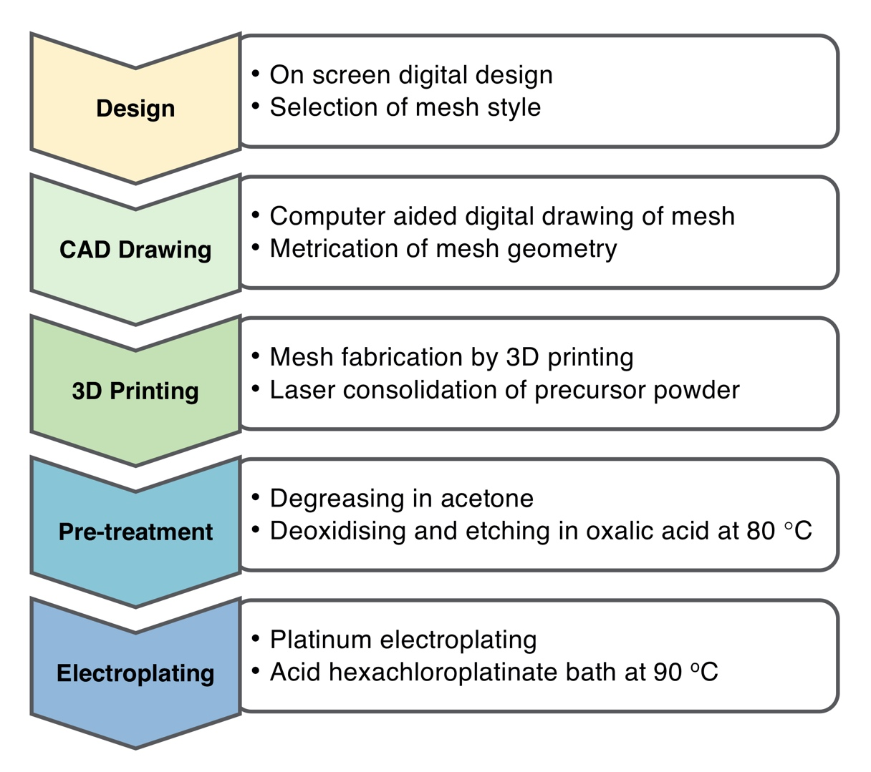
Fig. 1. The stages involved in the production and platinum electroplating of a porous, 3D printed titanium mesh electrode.
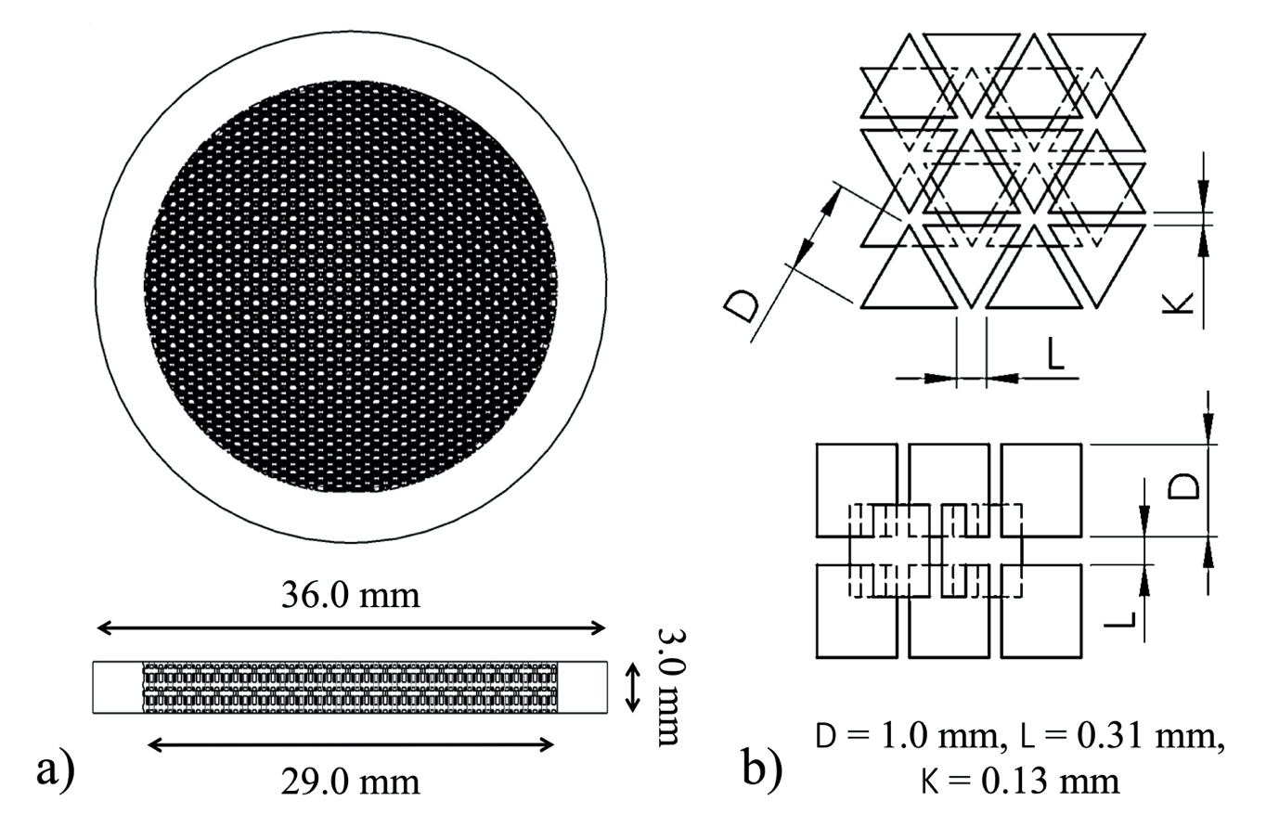
Fig. 2. 3D printed titanium mesh. a) CAD drawing of the disc and current collector, and b) the geometry of intersecting triangular pores.
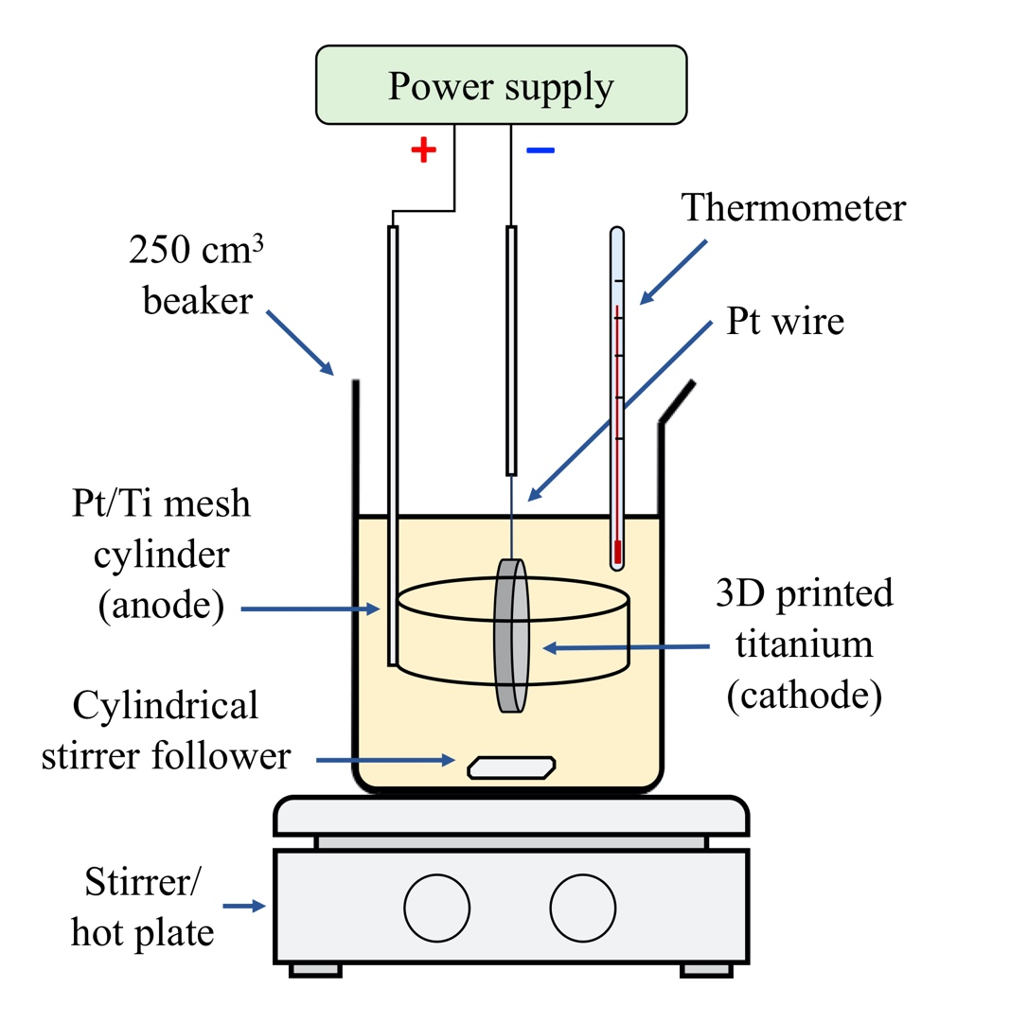
Fig. 3. Experimental arrangement for electroplating platinum from an acid solution.
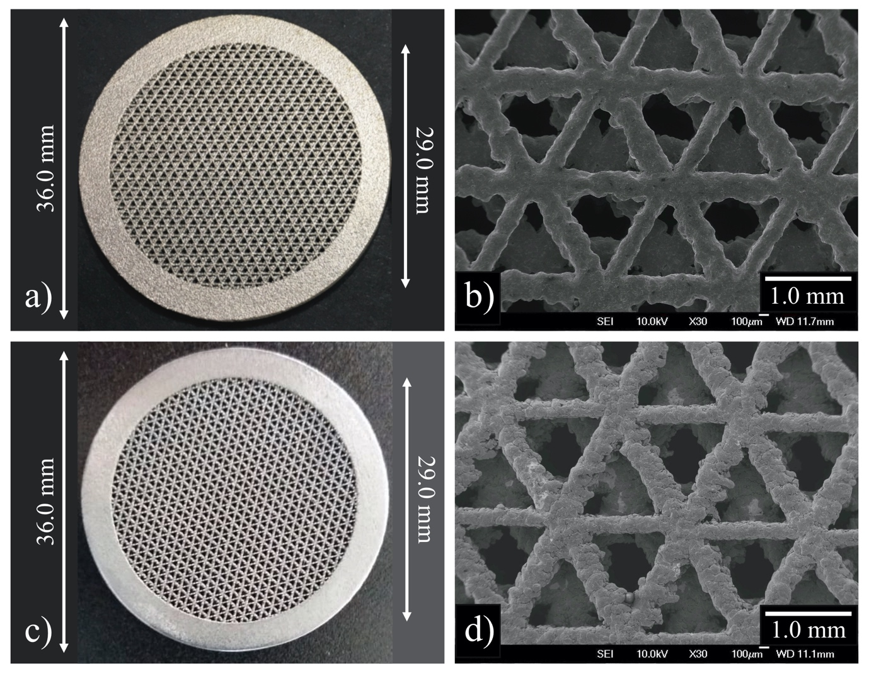
Fig. 4. 3D titanium mesh surface before and after electroplating, showing the regular arrangement of triangular pores. a) 3D printed titanium mesh, b) SEM micrograph of the bare titanium pores, c) 3D printed platinized titanium mesh, and d) SEM micrograph of the platinum coating on the pores.
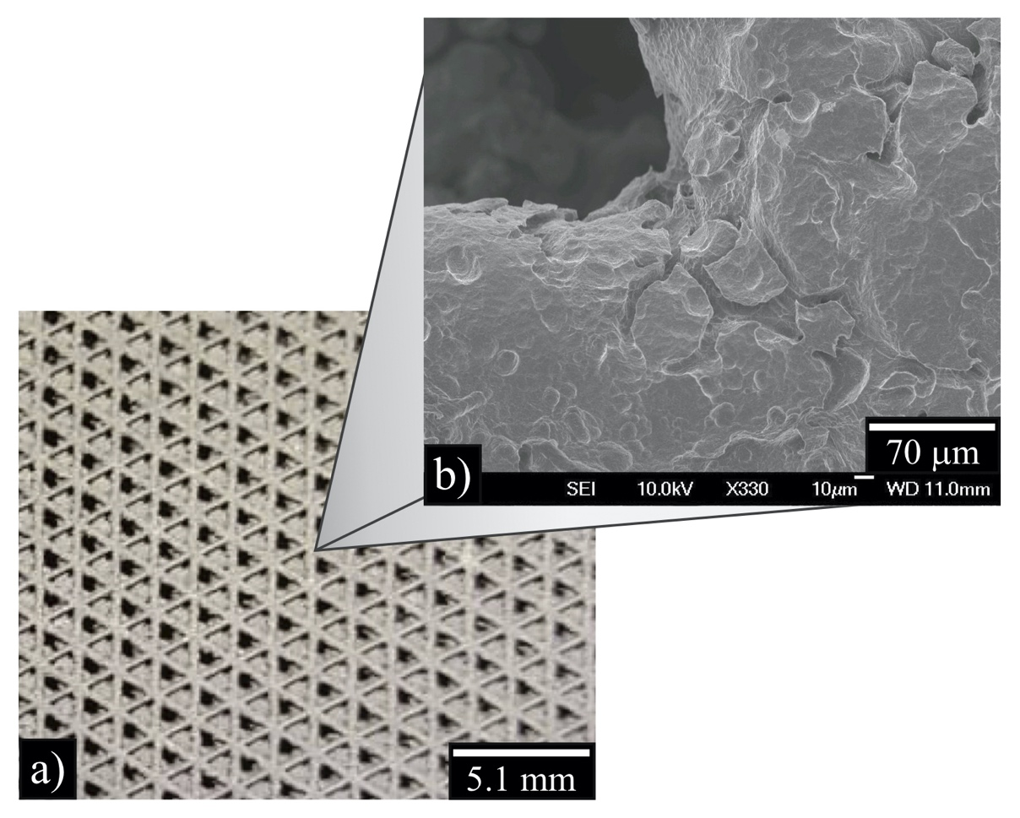
Fig. 5. The surface of a platinum electroplated 3D titanium mesh. a) Photograph of the platinized titanium triangular mesh, b) SEM micrograph of the edge of a triangular pore.

