Benefits and pitfalls of captive conservation genetic management: evaluating diversity in scimitar-horned oryx to support reintroduction planning
Rob Ogdena,*,1, Justin Chuvenb, Tania Gilbertc,d, Caroline Hoskinge, Karim Gharbif, Mark Craigg,
Shaikha Salem Al Dhaherib, Helen Sennh,1
a Royal (Dick) School of Veterinary Studies and the Roslin Institute, University of Edinburgh, Easter Bush Campus, EH25 9RG, United Kingdom
b Terrestrial & Marine Biodiversity, Environment Agency, Abu Dhabi, United Arab Emirates
c Marwell Wildlife, Thompsons Lane, Winchester, Hampshire, SO21 1JH, United Kingdom
d Biological Sciences, University of Southampton, University Road, Southampton, SO17 1BJ, United Kingdom
e Institute of Evolutionary Biology, School of Biological Sciences, The King’s Buildings, University of Edinburgh, Charlotte Auerbach Road, Edinburgh, EH9 3FL, United
Kingdom
f Edinburgh Genomics, University of Edinburgh, Charlotte Auerbach Road, Edinburgh, EH9 3FL, United Kingdom
g Life Sciences, Al Ain Zoo, Abu Dhabi, United Arab Emirates
h RZSS WildGenes Laboratory, Royal Zoological Society of Scotland, Edinburgh, EH12 6TS, United Kingdom

Abstract:
The reintroduction of the scimitar-horned oryx to Chad is a multi-disciplinary endeavour, planned and implemented over the past decade, utilizing a wide range of conservation science applications to maximise the chances of long-term population sustainability. The principle of incorporating genetic diversity information into founder selection for species reintroductions is widely recognized; however, in practice, a full assessment of available ex-situ genetic variation is rarely attempted prior to identifying individuals for release.
In this study we present the results of over ten years of research analyzing and interpreting the genetic diversity present in the key source populations for the Chad scimitar-horned oryx reintroduction. Three empirical genetic datasets (mitochondrial DNA sequence, nuclear DNA microsatellite and SNP markers) comprising over 500 individuals sampled from public and private institutions were analysed, accompanied by simulation studies to address applied questions relating to management of the reintroduction.
The results strongly demonstrate the importance of conservation genetic analysis in ensuring that founders represent the greatest breadth of evolutionary diversity available. The inclusion of both intensively and lightly managed collections allowed us to bridge the gap between studbook and group managed populations, enabling the inclusion of individuals from populations that lack historic data on their origins, but which may hold unique diversity of significant conservation value. Importantly, however, our study also reveals the potential risks of applying standard population genetic approaches to multiple captive populations, for which small founder sizes are likely to strongly bias results, with potentially serious consequences for the genetic management of conservation breeding programmes.

Key words:
Translocation; DNA; founder selection; ex situ; population structure; diversity

- Introduction
  - Reintroduction planning
The management of wildlife populations for species conservation is changing. Traditional distinctions between captive and wild populations are giving way to a range of management scenarios that may be viewed as distributed along a continuum, from intensive control of individual animals throughout their lifetime, to extensive stewardship of populations across generations. Depending on the needs of the species and the pressures they face, different management scenarios may be found in unrestricted natural habitats, and in the wide variety of captive and semi-captive programmes (e.g. fenced protected areas) employed throughout the conservation community. For many endangered species, the global population is composed of multiple sub-populations managed in very different ways, either by accident or design. Metapopulation management, which integrates population management at a strategic level across multiple locations, is seen as beneficial to the long-term conservation of individual species. International and regional studbooks that support management of zoo populations across multiple regions, and strategic planning approaches such as the IUCN-SSC Conservation Planning Specialist Group’s One-Plan (Byers et al. 2013), explicitly set out to integrate captive breeding programmes with the management of natural populations, and represent examples of such coordination (Redford et al. 2012). The greater the importance of intensive management to a species, the greater the drive to achieve integration across its global populations; programmes seeking to reintroduce species that are extinct in the wild are therefore obvious candidates to benefit most from such an approach.
The reintroduction of any species is a complex process requiring a multi-disciplinary and usually multi-partner approach. A significant body of knowledge now exists on the factors impacting reintroduction success that has resulted in the production of comprehensive guidance and policy on the subject (IUCN 2013). Nevertheless, every reintroduction is unique and the relative importance of the various biological, environmental and political criteria required to establish a sustainable wild population vary from species to species. Furthermore, bringing these conditions together in the same place at the same time can take many years. The scimitar-horned oryx (SHO), Oryx dammah, was formally distributed across north Africa, throughout countries bordering the Sahara desert, but was gradually lost through hunting and land-use competition, before finally disappearing from the Sahelo-Sahel region of Chad in the early 1980’s (Figure 1) (Durant et al. 2014). As one of the most prominent and easily recognizable large mammals in the Sahelo-Saharan landscape, it represents a flagship species and its reintroduction should therefore benefit the ecology and conservation of the ecosystem as a whole. A project to reintroduce the SHO to Chad has been under development since around 2010, led by the Environment Agency – Abu Dhabi (EAD), the Chadian Ministere de l’Environnement et de la Peche, and the Sahara Conservation Fund, with the first animals arriving in Chad in 2016 (Soorae 2018). Project activities include the application of a broad range of social and natural sciences, with a significant emphasis placed on ensuring that the most appropriate animals are available for establishing a new founder population.
Founder selection requires consideration of multiple biological factors, including taxonomy, evolutionary history, population genetic diversity, local adaptation, individual animal health and disease risk. Reintroduction guidelines emphasize the importance of genetic considerations in project planning to ensure that sufficient genetic diversity is present within the founders to minimize risks of inbreeding and to enable adaptation to future environmental change (IUCN 2013). In widely distributed species it is also important to consider local genetic adaptation as a criterion in selecting the most appropriate candidate source populations. A substantial body of literature has been built-up on these issues over the past three decades, initially describing theoretical approaches to the genetic management of captive populations (Lacy 1987; Ballou & Lacy 1995; Ivy and Lacy 2012) and founder selection (Tracy et al. 2012) before addressing the potential of molecular genetic analysis as a tools to directly inform captive management (Henkel et al. 2012; Fienieg & Galbusera 2013; Ivy et al. 2016; Sato et al. 2018) and reintroduction decisions (e.g. the Eurasian beaver (Senn et al. 2014a); northern bald ibis (Wirtz et al 2018); Tasmanian devils (Grueber et al. 2018)). While such examples are on the increase, it is still uncommon to undertake species-wide molecular genetic evaluations of candidate founders, using multiple DNA marker types to directly support conservation planning. Some previous work on SHO genetic diversity has been conducted (Iyengar et al., 2007), but relatively little is known about the level and distribution of genetic variation across the principle potential source populations. Within the development of the Chad SHO reintroduction programme, it was therefore decided that a more comprehensive characterisation of genetic diversity was required in order to meet best practice guidelines. In this paper we present a large-scale study of global molecular genetic diversity undertaken over ten years to support decisions about global transfer of scimitar-horned oryx and inform the reintroduction of SHOs to Chad.

  - Conservation genetics of scimitar-horned oryx
According to available records, the captive population of SHOs was initially founded from 48 individuals taken from the wild in the 1960’s and used to start breeding programmes in the world’s zoos. Between 1963 and 1967, individuals were captured in Chad and divided between the USA (c.29), Europe (ca.17) and Japan (n=2) (Woodfine & Gilbert, 2016). Some records exist of earlier collections from the 1930s (ca. 12), but these are not thought to have contributed to today’s international zoo populations. It is also likely that during the 1960s and 1970s further animals were obtained from the wild and held in private collections in countries on the Arabian Peninsula, such as the United Arab Emirates (UAE). Although no written documents to support this supposition appear to exist, the number of SHOs now present in the UAE strongly suggest this occurred. SHOs have bred well in captivity and over the past 40 years, the number of animals has increased to approximately 15,000 worldwide, primarily distributed in government and private holdings in the UAE and private owners in the USA, but also within the conservation breeding management programmes of Europe (European Association of Zoos and Aquariums – Endangered Species Programmes (EAZA-EEP)), the USA (Association of Zoos and Aquariums – Species Survival Plan (AZA-SSP)) and Australia (Zoo and Aquarium Association – Australasian Species Management Program (ZAA-ASMP)). While studbook records from the managed zoo programmes do exist, they are incomplete, with pedigrees containing a high percentage of unknown or uncertain relationships (Gilbert, 2018). A previous translocation of SHO to Tunisia using zoo animals from the EAZA-EEP and the AZA-SSP between 1985 and 2007 (Figure 1) resulted in a number of semi-wild herds distributed across five protected areas which also now act as a reservoir of SHO genetic diversity (Gilbert et al. unpublished). More recently, the SHO has become one of the focal species within the Conservation Centers for Species Survival (C2S2) programme (Wildt et al. 2012) that is seeking to move towards extensive herd management of threatened antelope species in the USA. Given this population management history and associated lack of detailed pedigree information, it has been necessary to employ molecular genetic analysis to be able to address many of the genetic criteria within the reintroduction planning process.
An initial population genetic study by Iyengar et al. (2007), employed mitochondrial DNA (mtDNA) control region sequencing and nuclear DNA microsatellite genotyping at six loci to investigate captive diversity, primarily in the US and Europe. While no significant structuring was found in the microsatellite data, where overall diversity was found to be quite low, the mtDNA sequence data revealed as many as 40 ancestral maternal lineages, divided into three clades thought to have evolved separately around 2 million YBP. To inform founder selection in the ongoing reintroduction project, it was necessary to significantly expand this earlier work to increase the geographic scope and number of reference samples used to assess candidate founder populations, before conducting a more in-depth comparative population genetic analysis using genome-wide SNP DNA markers.
The potential of genomic approaches to enhance population genetic studies in terms of delivering greater resolution, estimating historic demographic change and investigating local adaptation is well-established (Allendorf et al. 2010), and there are now multiple examples where modern sequencing approaches have delivered significant new biological insights in wildlife species of conservation concern (Garner et al. 2016). However, the transfer of genomics into practical application in conservation management has been gradual (Shafer et al. 2015), due in part to the resources required for projects of this scale, together with technical considerations such as the need for plentiful high molecular weight DNA. Here we employed ddRAD sequencing, a method for screening thousands of nuclear SNP DNA markers across hundreds of samples, to provide an increased level of resolution between SHO populations and individuals, and thus enable better assessment of genetic diversity ahead of founder selection for reintroduction.

In addition to direct genetic assessment of SHO herds, the study provided the opportunity to evaluate an important issue associated with the use of molecular markers to measure genetic diversity in captivity. The extent to which genetic drift drives apparent population differentiation has been investigated in some natural systems (Weeks et al. 2016), but the implications for conservation breeding programmes have received little attention. When interpreting the results of observed population structure in conservation genetic studies it is necessary to determine the likelihood that such findings indicate pre-captive population differentiation that may be associated with adaptive divergence, or that the observed structure is an artefact of much more recent captive differentiation due to the effects of genetic drift in small isolated groups of animals. To this end, we investigated the effects of drift in captive SHOs on resulting population genetic structure, through a series of simulations.

  - Specific objectives
We aimed to address the following principle management questions in relation to global genetic diversity and the reintroduction of the scimitar-horned oryx to Chad:
- How is genetic diversity distributed across geographic regions, oryx collections and among individuals throughout the world?
- How can measures of captive population genetic diversity be interpreted in relation to the roles of genetic drift or adaptive differentiation?
- At an individual level, is there any evidence of marked variation in measures of genetic diversity within source populations?
- How can these results be used to optimize the selection of founders for the Chad reintroduction programme?

2. Methods

2.1 Samples
Samples in this study were collected from six separate captive SHO populations, between the 2006 and 2014 (Table 1). Three populations are located within the United Arab Emirates at the following institutions: the Environment Agency of Abu Dhabi (EAD), Al Ain Zoo (AAZ) and the Dubai Desert Conservation Reserve (DDCR). The EAD population consists of several thousand oryx and is primarily composed of animals belonging to the late Sheikh Zayed bin Sultan Al Nahyan’s collection originally situated on Sir Bani Yas island. The AAZ and DDCR populations are much smaller in comparison; their origins include the Metro Toronto Zoo (SHO transferred into AAZ in 1982), but not all origins are known. Outside of Arabia, samples were obtained from two zoo breeding programmes: the European EEP and the Australasian ZAA-ASMP, denoted subsequently as ‘AUS’. A sixth population, TUN, was comprised of representatives from four of the five separate Tunisian sub-populations managed as semi-captive herds following historic translocations primarily from the EEP, with some additional animals from the SSP and private collections. In the absence of detailed pedigrees it is difficult to accurately estimate the representation of genetic diversity achieved for each population, however as a simple proportion of population size, the study included 10-25% of animals across each of the six collections.
Samples consisted of EDTA bloods taken during routine veterinary procedures, tissue from deceased animals or biopsy darts. All live sampling was undertaken by qualified veterinarians following a protocol approved by Marwell Wildlife Ethics Committee. DNA was extracted from the samples using Qiagen Blood and Tissue Kits (Qiagen) or Fuji Film kits and for nuclear SNP DNA marker analysis the DNA was quantified and normalized to 7 ng µl⁻¹ before further processing.

2.2 Analytical approach
Distribution of captive genetic diversity
To assess levels of genetic variation within and among captive herds we employed three different types of DNA marker: mitochondrial DNA control region (mtDNA CR) sequences, nuclear DNA microsatellite loci (microsatellites) and nuclear DNA SNP markers (SNPs).
The mtDNA CR sequencing was used to generate haplotypes that provide a qualitative picture of broad scale population diversity, reflecting maternally inherited DNA lineages. We targeted the same mtDNA CR section as used in previous studies (Iyengar et al. 2007) to enable the inclusion of the largest possible number of samples from published and current analyses. Resulting mitochondrial haplotypes were used to assess source population diversity and to reconstruct a haplotype network of extant SHO mitochondrial genetic diversity, to examine for possible structuring of genetic variation among captive herds. For detailed methods of analysis performed on novel samples see Supplementary Material 1.
The microsatellite markers were used to evaluate more recent population diversity and structure across Arabian, Australian, European and Tunisian captive populations. We employed a panel of eleven markers that were adapted from existing work on Arabian Oryx (Alqamy et al. 2012; Marshall et al. 1999). Allelic richness, which takes into account variation in population size, and observed and expected heterozygosities were calculated to compare levels of population diversity. Tests for deviation from Hardy-Weinburg equilibrium (HWE) were conducted to assess marker performance and to look for evidence of possible substructure within captive populations (Wahlund effects). The existence of genetic clusters within the global dataset were examined using the software STRUCTURE 2.3 (Pritchard et al., 2000). Assessment of genetic differentiation among pre-defined captive populations was assessed using pairwise F_{ST} statistics, and discriminant analysis of principle components (DAPC) using the R package, adegenet (Jombart 2008). For detailed laboratory and data analysis methods see Supplementary Material 2.
The SNP marker dataset was designed to focus on analysis of the large SHO population at the Abu Dhabi Environment Agency (EAD), as a key source of oryx for reintroduction. The SNP data also included comparative samples from Arabian, Australian, European and Tunisian captive populations. Analysis was conducted to assess both populations and individuals for potential reintroduction. A similar suite of population genetic analysis methods was used as for the microsatellite data, above, enabling comparison of the two marker types. For detailed methods see Supplementary Material 3. DAPC was also conducted at the level of oryx enclosures within the EAD population. In addition, individual multi-locus heteroygosities were calculated for each SHO in the SNP dataset, simply as the proportion of loci exhibiting a heterozygous genotype.
The three different empirical datasets for the three genetic markers were generated over a number of years, as part of several applied conservation genetic management projects, and consequently there is not complete correspondence between the samples used. To aid in subsequent interpretation of the data throughout this paper, the datasets are described and named below and in Table 1.

SHO_mt_Dataset: Consisting of 578 individuals sequenced for 993 base pairs of the mtDNA control region (d-loop). The dataset includes 78 EEP samples and 48 SSP samples from the publication (Iyengar et al., 2007).

SHO_µSat_Dataset: Consisting of 328 individuals genotyped using a panel of 11 variable microsatellite markers.

SHO_SNP_Dataset: Consisting of 219 individuals which were genotyped at 800 variable SNP loci.

Assessing the potential role of drift in captive population differentiation
To investigate the possibility that the cause of any observed genetic structure was recent drift within a fragmented captive breeding environment, simulations were conducted to generate population genetic datasets under different breeding conditions. Datasets were derived from a single simulated base population that was used to provide founders for pairs of identical starting populations that were grown over multiple generations under simulation. Any differentiation observed between the resulting population pairs was therefore the result of drift. Simulations were designed primarily to test the effects of time in isolation and number of founders on the rate at which population structure appears due to drift. Additionally, the effects of mating system, population growth rate and the ability of alternative marker numbers and marker types to detect population structure were investigated to ensure results were not limited to a narrow set of parameters. For full details of the simulation experimental method see the MethodsX paper associated with this publication (Hosking et al. 2019).

3. Results
3.1 Global scimitar-horned oryx diversity
Results of mitochondrial DNA sequencing revealed a total of 43 different control region haplotypes. These formed a number of self-similar clusters separated by multiple DNA nucleotide substitutions (Figure 2). The largest separation in the haplotype network corresponded to a broad division between samples from Arabia and the USA in one half and samples from Europe and Australia in the other half, although this pattern was by no means absolute. Samples from the Tunisia release sites were distributed across the network, likely reflecting their combined European and US source populations. The diversity found within specific source populations was highly variable, with collections in European EEP and the US SSP having substantially greater haplotype diversity (Figure 3; Table 1) than either the EAD alone or wider Arabian collections taken together.

3.2 Population genetic diversity within and among potential source populations
Analysis of the microsatellite genotype dataset indicated higher levels of genetic diversity in the studbook managed populations (Europe and Australia) than in the herd-managed populations in Arabia, with the Al Ain Zoo population displaying the least diversity (Table 1). The Tunisian population, being formed of a combination of European and US source populations showed relatively high diversity, as expected, while the nuclear variation within the Australian population was particularly encouraging given the very small sample size available.
The investigation of population structure revealed marked differentiation of most captive populations (Figure 4). Analysis of microsatellite data with STRUCTURE and STRUCTURE HARVESTER (delta K and Evanno methods) initially indicated that three genetic clusters were most strongly supported by the data, one directly corresponding to Al Ain Zoo (AAZ), with the other two clusters distributed among the remaining populations. To investigate genetic clustering at the level of the captive populations, the value of K was increased to K=6, whereupon each of the three populations in the United Arab Emirates (AAZ, DDCR and EAD) are distinguished from each other and from the majority of the European zoo population (EEP; light blue), which showed some internal variation among individuals. Australian animals clustered with those in Europe. The Tunisian animals divided into two clusters, one of which was associated with a subset of the EEP animals (mid-blue) while the other cluster was distinct from all other captive populations in the dataset (dark blue) (Figure 4). The DAPC results identify eleven genetic clusters in five principal groups for the microsatellite data (Figure 5 (top)), which reveal historic associations between the European (EEP) population and the EAD (Cluster 6) and Tunisian (Cluster 7) populations, corresponding to the STRUCTURE results and known oryx translocations. The DDCR animals (Cluster 10) are also plotted adjacent to an EEP group (Cluster 4).
The degree of population genetic structure among captive collections was explored by calculating pairwise F_{ST} among the six geographic regions. The Al Ain Zoo (AAZ) and Dubai Desert Conservation Reserve (DDCR) animals were most differentiated from other populations with mean pairwise F_{ST} = 12.9% and a pairwise F_{ST} between these two group of 22.2% (Table 2). By comparison the Abu Dhabi Environment Agency group showed lower differentiation overall (mean F_{ST} = 9.2%), with relatively little genetic difference from Europe (EEP) (pairwise F_{ST} = 2.6%).
The SNP dataset comprised 219 oryx genotyped at 800 SNP loci. The samples were predominantly collected from the EAD herd but the data also included samples from the same five other captive populations represented in the microsatellite data, allowing comparison among the two nuclear DNA datasets. Relative genetic diversity, as measured by expected heterozygosity, was highly correlated between the microsatellite and SNP markers (r=0.98), reinforcing the finding of variable diversity among potential founder groups (Table 1).
Comparable results were observed using the SNP dataset, with the three populations in the United Arab Emirates (AAZ (dark orange), DDCR (light orange) and EAD (gold/yellow/pale yellow)) distinguishable. The European and Tunisian samples formed a single cluster (brown) (Figure 4).

STRUCTURE analysis recovered the same distinct clusters as the microsatellite dataset with the three populations in the United Arab Emirates all distinguishable at K=6 (AAZ (single cluster - dark orange), DDCR (single cluster - light orange) and the much larger EAD population (three clusters - gold/yellow/pale yellow)). The European, Australian and Tunisian samples formed a single cluster (brown) (Figure 4).
DAPC results for the SNP data show five genetic clusters in three principal groups (Figure 5 bottom). As with the microsatellite data, the SNP data show a distinct DDCR group (Cluster 4) linked to Cluster 2 containing EEP, Tunisian, Australian and Al Ain Zoo individuals (all known to have EEP ancestry); however the majority of samples fall into Clusters 1, 3 and 5, which form a third group comprised of EAD animals. Again, this largely agrees with the STRUCTURE results for the same dataset.
Results of pairwise population differentiation were also broadly concordant with the microsatellite data (Table 2), supporting high differentiation of AAZ and DDCR populations and relative relatedness of the EEP, AUS and TUN groups. However, discordance was observed in the pairwise differentiation of the EAD population from both the AAZ and DDCR populations, with the larger EAD SNP dataset showing markedly less genetic divergence than the smaller EAD microsatellite dataset.

3.3 Simulating structure in captivity through drift
To address the effect of founder population size and the number of generations of isolated population growth on differentiation of populations through drift, three replicates of 24 scenarios covering founder population sizes 2, 5, 10 and 20 and grown over 2, 5, 10 and 15 generations were used. As anticipated, F_{ST} increased with generation number and with smaller founder sizes (no. gens: F_{1,65} = 80.60, P < 0.0001; founder size: F_{5,65} = 282.94, P < 0.0001), but results were particularly marked at founder sizes less than ten, resulting in F_{ST} values greater than 15% after 15 generations from identical starting populations (Figure 6). The change in population differentiation in the results of STRUCTURE analysis were even more marked with clear structure observed between populations after ten generations irrespective of founder size. Of particular note was the development of strong population structure (high S index) even with relatively large founder numbers (n>20) and low F_{ST} (<5%) (Figure 7). Taken collectively the simulation results for F_{ST} and STRUCTURE analysis show clear evidence of populations of identical starting composition differentiating rapidly under drift.

3.4 Genetic analysis of individual oryx
Founder selection ultimately requires individual animals to be selected for translocation and release, therefore beyond the analysis of population genetic structure, it is important to evaluate how information on individual genetic diversity can inform reintroduction management decisions. Analysis of fine-scale genetic variation within scimitar-horned oryx herds was conducted using the nuclear DNA SNP dataset focusing on the EAD population being managed in Abu Dhabi. These animals originated principally from Sir Bani Yas island, United Arab Emirates, before being moved to a series of fenced enclosures in Abu Dhabi, prior to sampling. DAPC analysis at the enclosure level revealed evidence of low-level differentiation among enclosures, particularly of enclosure numbers 10 and 11 (E10 & E11; Figure 7). Individual heterozygosity results calculated from the 800 SNP markers across all individuals ranged from 0.12 to 0.31 (mean=0.19; sd=0.03); for the largest single population (EAD, n=173), the range was slightly narrower (0.13<HE<0.25; mean=0.19; sd=0.02), but still showed a two-fold difference among individuals.

4. Discussion
The results presented here comprise multiple genetic studies performed over the past ten years with the common aim of evaluating captive genetic diversity in scimitar-horned oryx to inform their reintroduction to the wild. Their combined strength lies in bridging the gap between intensively managed zoo populations with individual pedigree data, and extensively managed animal herds, which may comprise very large numbers of rare or endangered species, but for which almost nothing is known about their history or diversity. Molecular genetic studies have enabled the SHO reintroduction into Chad to effectively rescue orphaned populations lacking ancestral data, which may otherwise be excluded from conservation translocations under current IUCN guidelines, and incorporate them into a global species-wide genetic management programme. Our findings demonstrate the value of such large-scale concerted efforts to ensure that candidate founders encompass as much extant diversity as possible. However, this study also highlights the difficulty in interpreting standard conservation genetic indices when dealing with closed populations and suggests that there is significant risk of over-stating population genetic differentiation across managed populations with small founder sizes.

4.1 Global scimitar-horned oryx diversity
The level of mitochondrial DNA control region diversity is relatively high considering the recent history of the species suggesting that captive breeding programmes have succeeded in retaining genetic variation over the past 50 years. This variation was not evenly distributed, either between US and European breeding programmes or between Arabian collections, which show a relative lack of diversity. These findings reinforce the importance of deciding to take a global approach to the SHO reintroduction programme, rather than taking the much simpler route of limiting founders to those originally present in the EAD collections prior to supplementation from international collections.
The exact severity of genetic bottleneck inflicted on the SHO as it passed into extinction in the wild is unknown, however records appear to reliably indicate that no more than 60 animals were obtained as founders for the global captive population, the majority of which were caught in a single operation in Chad in the mid 1960s (Woodfine & Gilbert, 2016). Despite this, 36 of the 43 maternally inherited mitochondrial DNA haplotypes observed in this study were found in either the EEP or SSP. This very high mtDNA diversity relative to captive founder size is highly unlikely to have been present in these founders and suggests either, i) DNA sequence error, ii) that the original founder population was much larger than recorded, or iii) the build-up of additional mtDNA haplotypes via mutations within the captive population. Bi-directional sequence quality was high and many of the same haplotypes were observed in a previous independent study (Iyengar et al. 2007), therefore sequencing error is considered unlikely. Whilst we cannot exclude the possibility of additional founders, available records suggest that all potential EEP and SSP founders have been identified. However, the nature of the haplotype variation observed, with clusters of very similar haplotypes recorded in single captive collections, supports an explanation of ex situ haplotype diversification, and raises some important questions for the interpretation of mitochondrial control region diversity. If sequence mutations in this DNA region were found to be readily occurring in captivity, the use of this DNA marker to infer evolutionary variation in oryx would need to be reviewed.
The level of nuclear genetic diversity within the six captive populations also varies by region, with Arabian herds consistently showing less diversity than the European population and the Australian and Tunisian populations that were derived from Europe. Interestingly, in Australia, relatively high diversity was observed despite the low sample number available. This is likely a result of the successful implementation of a pedigree-based mean-kinship breeding system over the past 30 years that will have effectively homogenized diversity among individuals. The small total population size in Australia (n~65) combined with the high number of SNP markers and use of rarefaction to compare microsatellite diversity will have also limited the effects of small samples size in our diversity estimates.

4.2 Strength and significance of structure among captive collections
Results of nuclear DNA analyses using both microsatellite and SNP markers indicated high levels of population structuring among collections, within and among regions. STRUCTURE analysis showed categorical separation of the different Arabian populations and, for the microsatellite data, clear divisions within the Tunisian SHOs, concordant with known European founder origins and subsequent translocations in Tunisia. DAPC results revealed an additional level of genetic grouping, with plots showing strong similarity among certain genetic clusters. This was particularly apparent for the Al Ain zoo population, which was highly differentiated under STRUCTURE analysis (both datasets) and formed its own cluster (Cluster 5) under DAPC analysis of microsatellite data; however, Cluster 5 is indistinguishable from other clusters on the corresponding DAPC plot. We suggest that these apparently contradictory results may stem from the fact that DAPC groupings, which do not assume Hardy-Weinburg Equilibrium or Linkage Disequilibrium, are less influenced by strong genetic drift likely to be experienced by these captive herds. Pairwise F_{ST} data show significant levels of substructure within the total dataset indicative of severe restrictions to gene flow among populations (Balloux and Lugon-Moulin, 2002). Where discordance was observed between the results from the microsatellite and SNP datasets in terms of pairwise F_{ST}, STRUCTURE and DAPC clusters, these are likely to be due to strong differences in the proportion of individuals from EAD and EEP/Tunisia used in each set of analyses. Dominance of EEP/Tunisian samples in the microsatellite data will have reduced pairwise differentiation and increased within-population substructure for these two populations in the microsatellite dataset, while a similar bias towards the number of EAD samples in the SNP dataset has probably had the same effect.
At first inspection, the overall nuclear DNA data appear to imply strong differentiation of the different captive collections consistent with independent genetic histories, and it might be reasonable for conservation managers to assume that such variation would be associated with a level of functional differentiation. This is important, as understanding functional differentiation that may underpin local adaptation and fitness would be a key consideration for reintroductions, both to optimize individual survival and to mitigate possible risks of outbreeding (Funk et al. 2012). These types of analysis are routinely employed to evaluate natural, in situ, population structure and identify reduced gene flow among localities, supporting designations of within-species differentiation such as Management Units (MUs) (Moritz 1994).
However, the results of our simulation study examining the speed with which genetic drift generates differentiation between identical starting populations, supports the possibility that STRUCTURE and F_{ST} results such as those observed in the empirical data may simply be a product of multiple generations of breeding in isolated populations with small founder size. It would be reasonable to expect up to fifteen generations to have bred in the past 50 years, potentially resulting in a misleading signal of contemporary population genetic structure. The implication here is that while standard measures of population substructure (STRUCTURE and pairwise F_{ST}) applied to large outbred natural populations can be used to imply separate evolutionary genetic trajectories, the same results from captive breeding programmes may be due solely to drift. Interestingly, the lack of corresponding structure among genetic clusters in the DAPC plots may suggest that DAPC analysis is less sensitive to this phenomenon. Similar extreme population structuring has been widely observed in aquaculture, where high levels of population divergence are observed among individual fish farms due to founder effects and subsequent isolated breeding (Skaala et al. 2004; Bylemans et al. 2016). Parallels have also been observed in isolated inbred natural populations, where the use of measures such as F_{ST} to infer genetic distinctiveness among populations have been found to be driven by relative levels of inbreeding and a lack of diversity within them, rather than actual genetic uniqueness (Coleman et al. 2013). This risks misleading conservation managers towards inadvertently promoting loss of diversity through maintenance of separation among fragmented groups (Weeks et al. 2016). From a management perspective this would suggest that there may be little risk of outbreeding depression and that mixing individuals from isolated captive collections would be important to overcome the rapid loss of genetic diversity in populations of small founder size. Similar conclusions have been drawn in relation to the management of the northern bald ibis (Wirtz et al. 2018) and the dama gazelle (Nanger dama), for which current subspecies status is questioned and captive genetic differentiation appears to be largely an artefact of drift due to extreme founder bottleneck events (Senn et al. 2014b). The approach of ‘lumping’ as opposed to ‘splitting’ is often resisted by captive population managers seeking to retain the genetic cohesion of captive groups, despite small founder and census numbers, potentially hastening the loss of captive diversity and reducing the potential genetic variation available for reintroductions.
This issue is part of the wider debate concerning the relative risks of outbreeding and inbreeding depression in conservation biology (Frankham et al. 2011), often played out through discussions concerning the use of genetic rescue to promote the conservation of genetic diversity in isolated, threatened populations through deliberate cross-breeding with other genetically distinct populations (Frankham, 2015 & 2016). The conservation genetics community has now largely accepted a paradigm shift in the precautionary principle for conserving genetic diversity in small populations, from maintenance of multiple isolated breeding populations to the promotion of geneflow through population cross-breeding (Ralls et al. 2018). Nowhere is this more relevant than in the ex-situ conservation breeding community, where geographic separation, isolated management programmes and a philosophy of maintaining the ‘purity’ of often marginally distinct breeding lines of ‘subspecies’ or ‘types’ are the default situation, even where population numbers and genetic diversity within such groups fall far below the level considered necessary for demographic sustainability. Our simulation results reinforce this message by demonstrating that popular conservation genetic analysis approaches may wrongly promote managed isolation over managed integration of populations.
These findings deliver a cautionary message to the interpretation of observed population genetic differentiation in captivity; however, in the absence of drift across generations, signals of population structure can still be informative. The observed minor differences among oryx in recently separated enclosures within the EAD population, is most likely the result of natural variation within the single captive EAD population, on which drift has had no opportunity to act. Such slight signals of natural genetic diversity will form the subject of future population genomic studies.

4.3 Individual genetic selection
Beyond screening-out of potential recent hybrid individuals, the application of DNA analysis to positively identify individual animals for prioritization in reintroductions is still in its infancy. This has been primarily due to the lack of analytical power required to accurately estimate individual relatedness and inbreeding using traditional conservation genetic tools, such as mtDNA sequencing and small numbers of microsatellite or SNP markers. Instead, until recently, pedigrees have provided more accurate estimates of individual genetic diversity (Pemberton 2008), limiting our ability to make informed decisions regarding individual selection in the absence of well-managed studbook breeding programmes. However, with the advent of genome-wide analysis and increased marker number, the issue of power has potentially been overcome (Hoffman et al. 2014) and molecular genetic approaches can now offer even more accurate estimates of individual genetic diversity than pedigree-based measures (Kardos et al. 2015). Our study has spanned the early phase of the transition from genetic to genomic analysis, ending in the genotyping of 800 SNP markers. While this arguably falls short of a genomic approach, it has revealed very fine scale population structure within individual captive populations (e.g. the EAD) and has provided data on individual multi-locus heterozygosity. Simulation studies have shown that 800 unlinked SNP markers are sufficient to provide reliable estimates of individual genome-wide heterozygosity (Kardos et al. 2016) and supports the use of this data to select individual oryx based on genotype in the absence of pedigree information.
The promise of conservation genomic tools for wildlife management includes the potential to understand and select individuals based on functional genetic variation (Shafer et al. 2015; Supple & Shapiro 2018). However, the lack of well-annotated genome sequence data for most wildlife species to date prevents the application of more targeted approaches to prioritise individuals based, and without significantly greater understanding of the genetic basis of adaptive variation candidate gene approaches should be approached with caution (Kardos and Schafer 2018). That said, plans to sequence and annotate the SHO genome are well-underway and it is hoped that this work will bring greater power to inform planning and to analyse the outcomes of reintroductions in the near future.

4.4 Implications for reintroduction
The overall aim of the programme of research presented here is to inform conservation biologists about the best genetic sources of founder individuals for reintroduction of the scimitar-horned oryx to Chad. The global evaluation of mitochondrial DNA haplotypes has allowed a robust examination of how evolutionary diversity is distributed throughout the world’s main captive collections. These data have directly impacted the selection of founders for the UAE reintroduction project, ensuring that the original seven haplotypes observed in the EAD herd have been supplemented using significant numbers of animals from both the European and North American populations. Additionally, the data are now being fed-back into the regional captive breeding programmes and the management of reintroduced populations in Tunisia to inform conservation action.
The results of the nuclear DNA analysis (SNPs and microsatellites) have also revealed a great deal about the average levels of genetic diversity within the different candidate populations for reintroduction. While the nuclear diversity estimates for the SHO in Abu Dhabi (EAD) are relatively high, this is likely the result of being able to maintain a large population size of many thousands over several decades, minimizing loss of diversity and inbreeding through drift. Comparable levels of diversity seen in the much smaller but intensively managed European population (EEP) support its use as a source of founders for the Chad reintroduction project. The nuclear SNP datasets provide, for the first time, a tool for the molecular genetic selection of individual SHO based on genetic diversity in the absence of pedigree records. The addition of comparative nuclear data for the SSP and private USA collections would be beneficial and is underway.
At a broader level, the work presented here forms part of a growing body of research within the zoo community to evaluate utility of captive animals in an integrated conservation management system. The international regional zoo associations (EAZA, AZA, ZAA, JAZA etc) are increasingly incorporating molecular genetics into population management (Fienieg & Galbusera 2013; Norman et al. 2019), sometimes to address individual relatedness or hybrid questions, but more often to evaluate diversity across entire captive populations to compare to historic and contemporary wild diversity (e.g. chimpanzees, Hvilsom et al 2013; zebra, Ito et al. 2017; golden eagles, Sato et al. 2018; antelope, Ogden et al. 2018; Iberian lynx, Kleinman-Ruiz et al. 2019). Research to support the conservation management and reinforcement of the Tasmanian devil in Australia has exemplified how integration of pedigree and molecular datasets (Hogg et al. 2018), and combined captive and wild population assessments (Grueber et al. 2019) has enabled a detailed understanding of how to optimize levels of genetic diversity in both in situ and ex situ populations of acute conservation concern.
As the conservation community is increasingly set to rely on ex situ populations to contribute to specific conservation activities, such as conservation translocations, our ability to correctly evaluate population genetic data generated from zoos or other breeding programmes will become more important (Sato et al. 2018). Within this context, our study has implications for the area of translocation genetics as a whole. First we have demonstrated how molecular genetics can enable much more effective use to be made of captive collections, particularly outside of the traditional zoo community, where large numbers of animals residing in so-called orphaned populations could make valuable contributions to reintroductions but which are often excluded due to the a lack any historic records. Second, we have shown how the use of neutral genetic markers to evaluate population structure in captive populations, unlike large natural populations, may be extremely misleading due to the potential for very rapid build-up of apparent structuring under extreme drift. Simplistic assessments that associate observations of neutral genetic differentiation among captive collections with functional variation related to local adaptation are likely to be wrong, leading to the provision of sub-optimal management advice and in some cases risking greater loss of valuable and diminishing genetic diversity. Lastly, the development and application of marker panels suitable for assessing individual multi-locus heterozygosity provides an example of how genetic approaches are starting to replace the need for pedigree records to estimate inbreeding in conservation management planning. As ever, realization of these potential benefits relies on careful and accurate interpretation of the data.

5. Acknowledgements
The authors are grateful to two anonymous reviewers who helped to significantly improve earlier drafts of the manuscript. The authors would like to thank the following researchers who have contributed to the production of the three datasets: Ricardo Pusey, Louis Lignereux, Maria Elena Pesci, Carlos Rojo Solis, Ross McEwing, Liz Heap, Mary-Frances Roberts, Leonie Grenfell, Jennifer Kaden & staff at Edinburgh Genomics. Marie Petretto, Gian Lorenzo D’Alterio, Chawki Najjar, Hela Guedara and the Al Ain Zoo Veterinarian and Animal Collection teams supported the collection and provision of samples in Tunisia. We would also like to thank all EAZA and ZAA institutions and Greg Simkins at the Dubai Desert Conservation Reserve, for providing samples to the project. Thanks to Robert Cooke for creating the distribution map. Funding: This research did not receive any specific grant from funding agencies in the public, commercial, or not-for-profit sectors.

- Competing Interests
The authors declare that they have no competing interest in relation to this manuscript.

7. References:
Allendorf, F. W., Hohenlohe, P. A., & Luikart, G. (2010). Genomics and the future of conservation genetics. Nature Reviews Genetics, 11, 697–709.
Alqamy H, Senn H, Roberts MF, McEwing R, Ogden R (2012) Genetic assessment of the Arabian Oryx founder population in the Emirate of Abu Dhabi, UAE: an example of evaluating unmanaged captive stocks for reintroduction. Conservation Genetics, 13 (1), 79-88
Ballou, J.D., Lacy, R.C. (1995) Identifying genetically important individuals for management of genetic diversity in pedigreed populations. In: Ballou, J.D., Gilpin, M., Foose, T.J., editors. Population management for survival & recovery. New York: Columbia Press. PP 76–111.

Balloux F. and Lugon-Moulin N. (2002) The estimation of population differentiation with microsatellite markers. Molecular Ecology 11 (2): 155-165
Boecklen W, Howard D (1997) Genetic analysis of hybrid zones: numbers of markers and power of resolution. Ecology, 78, 2611–2616.
Byers, O., Lees, C., Wilcken, J. & Schwitzer, C. (2013). The “One Plan” approach: the philosophy and implementation of CBSG’s approach to integrated species conservation planning. WAZA Magazine, 14, 2-5.
Bylemans J, Maes G, Diopere G, Cariani A, Senn H, Taylor MI, Helyar S, Bargelloni L, Bonaldo A, Carvalho G, Guarniero I, Komen H, Martinsohn JTh, Nielsen EE, Tinti F, Volckaert FAM & Ogden R (2016) Evaluating genetic traceability methods for captive‑bred marine fish and their applications in fisheries management and wildlife forensics. Aquaculture Environment Interactions, 8: 131-145
Chuven J et al (2015) Building a diverse source population of Scimitar Horned Oryx (Oryx dammah) for reintroduction. 15th Annual Sahelo-Saharan Interest Group Annual Meeting April 29-30 2015 Abu Dhabi, UAE.
Durant SM, Wacher T, Bashir S, Woodroffe R, De Ornellas P, Ransom C, Newby J, Abáigar T, Abdelgadir M, El Alqamy H, Baillie J, Beddiaf M, Belbachir F, Belbachir‐Bazi A, Berbash AA, Bemadjim NE, Beudels‐Jamar R, Boitani L, Breitenmoser C, Cano M, Chardonnet P, Collen B, Cornforth WA, Cuzin F, Gerngross P, Haddane B, Hadjeloum M, Jacobson A, Jebali A, Lamarque F, Mallon D, Minkowski K, Monfort S, Ndoassal B, Niagate B, Purchase G, Samaïla S, Samna AK, Sillero‐Zubiri C, Soultan AE, Stanley Price MR, Pettorelli N (2014) Fiddling in biodiversity hotspots while deserts burn? Collapse of the Sahara's megafauna. Diversity and Distributions, 20 (1): 114-122
Fienieg, E.S., Galbusera, P., 2013. The use and integration of molecular DNA information in conservation breeding programmes: a review. JZA 1, 44–51.
Frankham, R., Ballou, J.D., Briscoe, D.A., McInnes, K.H., 2009, Introduction to Conservation Genetics. Cambridge Univ Press, Cambridge, U.K. pp 618.
Frankham R., Ballou J., Eldridge M. et al. (2011) Predicting the probability of outbreeding depression. Conservation Biology, 25: 465–475.
Frankham, R. (2015). Genetic rescue of small inbred populations: meta-analysis reveals large and consistent benefits of gene flow. Mol. Ecol., 24, 2610-2618.
Frankham, R. (2016). Genetic rescue benefits persist to at least the F3 generation, based on a meta-analysis. Biol. Conserv., 195, 33-36.
Funk WC, McKay JK, Hohenlohe PA and Allendorf FW (2012) Harnessing genomics for delineating conservation units. Trends in Ecology and Evolution, 27(9): 489-496
Garner BA, Hand BA, Amish SJ, Bernatchez L, Foster JT, Miller KM, Morin PA, Narum SR, O’Brien SJ, Roffler G, Templin WD, Sunnucks P, Strait, Warheit KI, Seamons TR, Wenburg J, Olsen J, Luikart G (2016) Genomics in Conservation: Case Studies and Bridging the Gap between Data and Application. Trends in Ecology & Evolution, 31(2):81-83
Gilbert, T. (2018) International studbook for the scimitar-horned oryx Oryx dammah. Thirteenth edition. Marwell Wildlife, Winchester. Pp.164
Grueber CE, Fox S, McLennan EA, Gooley RM, Pemberton D, Hogg CJ, Belov K (2019) Complex problems need detailed solutions: Harnessing multiple data types to inform genetic management in the wild. Evol Appl. 12:280–291
Henkel J, Jones K, Hereford S, Savoie ML, Leibo S & Howard J (2012). Integrating microsatellite and pedigree analyses to facilitate the captive management of the endangered Mississippi sandhill crane (Grus canadensis pulla). Zoo biology. 31. 322-35. 10.1002/zoo.20399.
Hoffman JI, Simpson F, David P, Rijks JM, Kuiken T, Thorne MAS, Lacy RC, Dasmahapatra KK (2014) High-throughput sequencing reveals inbreeding depression in a natural population. PNAS, 111 (10) 3775-3780
Hogg CJ, Wright B, Morris KM, Lee AV, Ivy JA, Grueber CE & Belov K (2018) Founder relationships and conservation management: empirical kinships reveal the effect on breeding programmes when founders are assumed to be unrelated, Animal Conservation, 22, 4, (348-361), (2018).
Hvilsom, C., Frandsen, P., Børsting, C., Carlsen, F., Sallé, B., Simonsen, B., Siegismund, H., (2013). Understanding geographic origins and history of admixture among chimpanzees in European zoos, with implications for future breeding programmes. Heredity 110, 586–593.
Ito H, Langenhorst T, Ogden R, Inoue-Murayama M (2015) Population genetic diversity and hybrid detection in captive zebras. Scientific reports 5
Ito, H., Ogden, R., Langenhorst, T., Inoue-Murayama, M., 2017. Contrasting results from molecular and pedigree-based population diversity measures in captive zebra highlight challenges facing genetic management of zoo populations. Zoo Biol. 36, 87–94.
IUCN/SSC (2013) Guidelines for Reintroductions and Other Conservation Translocations. Version 1.0. IUCN Species Survival Commission, Gland, Switzerland. viiii + 57 pp.
Ivy, J.A., Lacy, R.C. (2012) A comparison of strategies for selecting breeding pairs to maximize genetic diversity retention in managed populations. J. Hered. 103, 186–196
Ivy, J.A., Putnam, A.S., Navarro, A.Y., Gurr, J., Ryder, O.A. (2016) Applying SNP-derived molecular co-ancestry estimates to captive breeding programs. J. Hered. 107 (5), 403-12
Iyengar et al. (2007). Remnants of ancient genetic diversity preserved within captive groups of scimitar-horned oryx (Oryx dammah). Molecular Ecology, 16(12), 2436–49.
Kardos, M., Luikart, G., & Allendorf, F. W. (2015). Measuring individual inbreeding in the age of genomics: Marker-based measures are better than pedigrees. Heredity, 115, 63–72.
Kardos M, Taylor HR, Ellegren H, Luikart G, Allendorf FW. Genomics advances the study of inbreeding depression in the wild. Evol Appl. 2016;9:1205–18.
Kardos M and Schafer ABA (2018) The peril of gene-targeted conservation. Trends in Ecology and Evolution, 33 (11): 827-839
Kleinman-Ruiz D, Soriano L, Casas-Marce M, Szychta C, Sánchez I, Fernández J and Godoy JA (2019) Genetic evaluation of the Iberian lynx ex situ conservation programme. Heredity doi: 10.1038/s41437-019-0217-z.
Lacy, R.C., 1987. Loss of genetic diversity from managed populations: interacting effects of drift, mutation, immigration, selection, and population subdivision. Conservation Biology, 1, 143–158.
Lorenzen E.D., Simonsen B.T., Kat P.W., Arctander P., Siegismund H.R. (2006) Hybridization between subspecies of waterbuck (Kobus ellipsiprymnus) in zones of overlap with limited introgression. Molecular Ecology, 15: 3787–3799.
Marshall TC, Sunnucks P, Spalton A, Greth A, Pemberton JM (1999) Use of genetic data for conservation management: the case of the Arabian oryx. Animal Conservation 2: 269–278
Mondol S, Moltke I, Hart J, Keigwin M, Brown L, Stephens M, Wasser SK (2015) New evidence for hybrid zones of forest and savanna elephants in Central and West Africa. Molecular Ecology 24(24): 6134-6147
Moritz C (1994) Defining ‘Evolutionary Significant Units’ for conservation. Trends in Ecology and Evolution 9: 373-375
Norman AJ, Putnam AS, Ivy JA (2018) Use of molecular data in zoo and aquarium collection management: Benefits, challenges, and best practices. Zoo Biology, DOI: 10.1002/zoo.21451
Ogden R, Baird J, Senn H, McEwing R (2012) The use of cross-species genome-wide arrays to discover SNP markers for conservation genetics: a case study from scimitar-horned and Arabian oryx. Conservation Genetics Resources, 4 (2), 471-473
Ogden R, Ghazali M, Hopper J, Čulík L, King T (2018) Genetic assessments for antelope reintroduction planning in four European breeding programmes. Journal of Zoo and Aquarium Research 6 (3), 79-84
Pemberton, J., 2008. Wild pedigrees: the way forward. Proceedings of the Royal Society Volume B, 275, 613-621.
Ralls, K., Ballou, J.D., Dudash, M.R., Eldridge, M.D., Fenster, C.B., Lacy, R.C., Sunnucks, P. and Frankham, R., 2018. Call for a paradigm shift in the genetic management of fragmented populations. Conservation Letters, 11(2), p.e12412.
Redford, K.H., Jensen, D.B., Breheny, J.J., 2012. Integrating the captive and the wild. Science 338 (6111), 1157–1158.
Sato Y, Ogden R, Komatsu M, Maeda T, Inoue-Murayama M (2017) Integration of wild and captive genetic management approaches to support conservation of the endangered Japanese golden eagle. Biological Conservation, 213, 175-184
Shafer ABA, Wolf JBW, Alves PC, Bergström L, Bruford MW, Brännström I, Colling G, Dalén L, De Meester L, Ekblom R, Fawcett KD, Fior S, Hajibabaei M, Hill JA, Hoezel AR, Höglund J, Jensen EL, Krause J, Kristensen TN, Krützen M, McKay JK, Norman AJ, Ogden R, Österling EM, Ouborg NJ, Piccolo J, Popović D, Primmer CR, Reed FA, Roumet M, Salmona J, Schenekar T, Schwartz MK, Segelbacher G, Senn H, Thaulow J, Valtonen M, Veale A, Vergeer P, Vijay N, Vilà C, Weissensteiner M, Wennerström L, Wheat CW, Zieliński P (2015) Genomics and the challenging translation into conservation practice. Trends in Ecology & Evolution, 30(2), 78–87
Senn H, Ogden R, Frosch C, Syrůčková A, Campbell‐Palmer R, Munclinger P, Durka W, Kraus RHS, Saveljev AP, Nowak C, Stubbe A, Stubbe M, Michaux J, Lavrov V, Samiya R, Ulevicius A, Rosell F (2014a) Nuclear and mitochondrial genetic structure in the Eurasian beaver (Castor fiber) – implications for future reintroductions. Evolutionary Applications, 7(6): 645–662.
Senn H., Banfield L., Wacher T., Newby J., Rabeil T., Kaden J., Kitchener A.C., Abaigar T., Silva T.L., Maunder M., Ogden R. (2014b) Splitting or Lumping? A Conservation Dilemma Exemplified by the Critically Endangered Dama Gazelle (Nanger dama). PloS one, 9 (6), e98693
Skaala Ø, Høyheim B, Glover KA, Dahle G. (2004) Microsatellite analysis in domesticated and wild Atlantic salmon (Salmo salar L.): allelic diversity and identification of individuals, Aquaculture, 240: 131-143
Soorae, P. S. (ed.) (2018). Global Reintroduction Perspectives: 2018. Case studies from around the globe. IUCN/SSC Reintroduction Specialist Group, Gland, Switzerland and Environment Agency, Abu Dhabi, UAE. xiv pp165-169.
Supple M.A. & Shapiro B. (2018) Conservation of biodiversity in the genomics era. Genome Biology 19: 131
Tracy, L. N., Wallis, G. P., Efford, M. G., & Jamieson, I. G. (2011) Preserving genetic diversity in threatened species reintroductions: How many individuals should be released? Animal Conservation, 14, 439–446. https://doi.org/10.1111/j.1469‐1795.2011.00448.x
Weeks, A. R., Stoklosa, J. & Hoffmann, A. A. Conservation of genetic uniqueness of populations may increase extinction likelihood of endangered species: the case of Australian mammals. Front. Zool. 13, 31 (2016)
Wildt, D.E., Pukazhenthi, B.S., Snodgrass, K., Shurter, S., Greene, L., Rieches, R., Beetem, D., Sawyer, R., Brown, J.L., 2012. Where will zoo animals come from – new ways to get to species sustainability. In: CONNECT Volume August 2012, American Association of Zoos and Aquaria, Silver Spring, MD, USA, pp10-12.
Wirtz S, Böhm C, Fritz J, Kotrschal K, Veith M, Hochkirch A (2018) Optimizing the genetic management of reintroduction projects: genetic population structure of the captive Northern Bald Ibis population. Conservation Genetics 19(4): 853–864
Woodfine, T. & Gilbert, T. (2016) The fall and rise of the scimitar-horned oryx: a case study of ex-situ conservation and reintroduction practice. In: (Eds. J. Bro-Jǿrgensen & D. Mallon) Antelope conservation: from diagnosis to action. John Wiley & Sons, Ltd., Chichester, UK: 280 – 296.

8. Appendix
An appendix containing Supplementary Materials (SM1 – SM4) is available online.
8. Tables

Table 1 Numbers of oryx and genetic diversity measures for the three datasets used, across the captive founder populations included in this study. Broader levels of diversity were recorded in all available genetic datasets for the larger intensively managed populations (EEP and SSP), while the lowest diversity was recorded for single herd managed groups in Arabia (AAZ and DDCR). Note that heterozygosity measured with microsatellite markers is typically higher than with SNP loci due to the greater number of alleles (variants) at each marker.

EAD = Abu Dhabi Environment Agency; AAZ = Al Ain Zoo; DDCR = Dubai Desert Conservation Reserve; EEP = European Endangered species Programme (EAZA); SSP = Species Survival Plan (AZA); TUN = Tunisia; AUS = Zoo and Aquarium Association Australasia-Australasian Species Management Program; * Mitochondrial DNA data from (Iyengar et al. 2007).

Dataset | Diversity measure | All Arabia |  | EAD | EEP | AUS | TUN | SSP*
SHO_mt_Dataset  993bp mitochondrial DNA control region | Number of oryx | 274 |  | 214 | 140 | 35 | 88 | 48
SHO_mt_Dataset  993bp mitochondrial DNA control region | Number of haplotypes | 12 |  | 7 | 20 | 4 | 16 | 20
SHO_mt_Dataset  993bp mitochondrial DNA control region | Haplotype diversity | 0.043 |  | 0.033 | 0.143 | 0.114 | 0.182 | 0.417
SHO_mt_Dataset  993bp mitochondrial DNA control region | No. polymorphic sites | 51 |  | 20 | 71 | 45 | 70 | 80
SHO_mt_Dataset  993bp mitochondrial DNA control region | % variation (994bp) | 5.11 |  | 2.00 | 7.11 | 4.51 | 7.01 | 8.02
SHO_mt_Dataset  993bp mitochondrial DNA control region | Gene diversity | 0.684 |  | 0.617 | 0.830 | 0.690 | 0.720 | 0.880
SHO_mt_Dataset  993bp mitochondrial DNA control region | sd (Gene diversity) | 0.007 |  | 0.027 | 0.019 | 0.040 | 0.050 | 0.040
SHO_mt_Dataset  993bp mitochondrial DNA control region | Nucleotide Diviversity | 0.007 |  | 0.006 | 0.019 | 0.018 | 0.018 | 0.017
SHO_mt_Dataset  993bp mitochondrial DNA control region | Sd (Nucloetide Diversity) | 0.004 |  | 0.003 | 0.009 | 0.009 | 0.009 | 0.009
 |  | AAZ | DDCR | EAD | EEP | AUS | TUN
SHO_µSat_Dataset  11 nuclear DNA microsatellites | Number of oryx | 53 | 15 | 20 | 134 | 5 | 101
SHO_µSat_Dataset  11 nuclear DNA microsatellites | Expected heterozygosity | 0.368 | 0.472 | 0.539 | 0.647 | 0.544 | 0.597
SHO_µSat_Dataset  11 nuclear DNA microsatellites | Observed heterozygosity | 0.327 | 0.479 | 0.525 | 0.583 | 0.691 | 0.538
SHO_µSat_Dataset  11 nuclear DNA microsatellites | Allelic richness | 2.26 | 2.42 | 3.10 | 3.78 | 3.31 | 3.55
SHO_µSat_Dataset  11 nuclear DNA microsatellites | Private Allelic Richness | 0.11 | 0.43 | 0.06 | 0.47 | 0.21 | 0.47
SHO_SNP_Dataset  800 nuclear DNA SNPs | Number of oryx | 5 | 7 | 173 | 16 | 8 | 10
SHO_SNP_Dataset  800 nuclear DNA SNPs | Expected heterozygosity | 0.111 | 0.162 | 0.188 | 0.212 | 0.189 | 0.209
SHO_SNP_Dataset  800 nuclear DNA SNPs | Observed heterozygosity | 0.132 | 0.177 | 0.182 | 0.203 | 0.191 | 0.202

Table 2 Pairwise F_{ST} among six groups of captive individuals, based on geographic origin for the SHO_µSat_Dataset (above diagonal) and SHO_SNP_Dataset (below diagonal). Levels of population differentiation are largely concordant among the two datasets, showing marked differentiation of the AAZ and DDCR captive Arabian populations from each other and non-Arabian groups. Low differentiation between EEP, AUS and TUN are observed in both datasets. Discordance between microsatellite data and SNPs is high in measures of differentiation between the EAD and AAZ / DDCR populations.

 | AAZ | DDCR | EAD | EEP | AUS | TUN
AAZ |  | 0.22 | 0.17 | 0.10 | 0.06 | 0.11
DDCR | 0.26 |  | 0.17 | 0.04 | 0.15 | 0.07
EAD | 0.02 | 0.02 |  | 0.03 | 0.02 | 0.04
EEP | 0.10 | 0.10 | 0.02 |  | 0.05 | 0.03
AUS | 0.17 | 0.14 | 0.09 | 0.01 |  | 0.01
TUN | 0.13 | 0.13 | 0.01 | 0.04 | 0.06

9. Figure Legends
Figure 1: Map of historic distribution (grey shade) and current release and reintroduction sites in Tunisia (black circles) and Chad (reserve outline).

Figure 2: Median-joining haplotype network showing the relationship among 43 mtDNA haplotypes observed in six regional geographic groups totaling 578 individuals. Colours refer to geographical regions where the haplotype was observed, node size is proportional to the number of individuals displaying each haplotype, hashed lines indicate the number of nucleotide substitutions between haplotypes.

Figure 3: Bar charts of mitochondrial DNA haplotype diversity in each of the main oryx source populations. Each colour indicates a different haplotype. Samples from the Abu Dhabi Environment Agency collection (EAD) are presented separately, and also included within the Arabian regional collections as a whole (‘Arabia’). It is clear that the studbook managed populations populations (EEP and SSP) have the highest number and most even diversity of haplotypes, as would be expected form the more intensive levels of population management that these populations receive.

Figure 4: Barplots showing output of STRUCTURE for the SHO_µSat_Dataset (top) and SHO_SNP_Dataset (bottom). Along the X-axis columns represent each of 328 individuals from six captive populations. The Y-axis shows the probability of assignment to each of six inferred genetic clusters (K=6). AAZ=Al Ain Zoo (UAE); DDCR=Dubai Desert Conservation Reserve (UAE); EAD=Abu Dhabi Environment Agency (UAE); EEP=European zoo population, ZAA=Australian zoo population; TUN=Tunisian semi-captive herds.
Figure 5: Results of DAPC analysis for the SHO_µSat_Dataset (top) and SHO_SNP_Dataset (bottom). The microsatellite dataset yielded eleven genetic clusters, forming five distinct groups (parentheses indicate corresponding geographic origins): Cluster 4 (EEP), Cluster 6 (EEP & EAD), Cluster 7 (EEP & Tunisia), Cluster 10 (DDCR), and a group of all other clusters). For the SNP dataset only five clusters were resolved splitting into three groups representing DDCR (Cluster 4), a mixed European origin group (Cluster 2) and a group containing all other clusters including the large EAD sample.

Figure 6: Simulated increase in F_{ST} with the number of generations of isolated population growth. Initial population differentiation and subsequent rate of increase in F_{ST} is strongly influenced by founder size, with high levels of F_{ST} (>15%) observed at founder sizes of n=2 and n=5.

Figure 7: Change in population structure index, S, with F_{ST}, displayed across: a) number of generations and, b) number of founders. Structure is generally evident after five generations and populations become strongly differentiated under Structure analysis after 15 generations, even with higher numbers of founders maintaining low F_{ST} values.

Figure 8: Results of DAPC analysis for the SHO_SNP_Dataset within the single EAD captive herd, showing evidence of three genetic clusters within the population that show some level of correspondence to fenced enclosures (E1-46 & Hilwa).

10. Figures

Figure 1

Figure 2
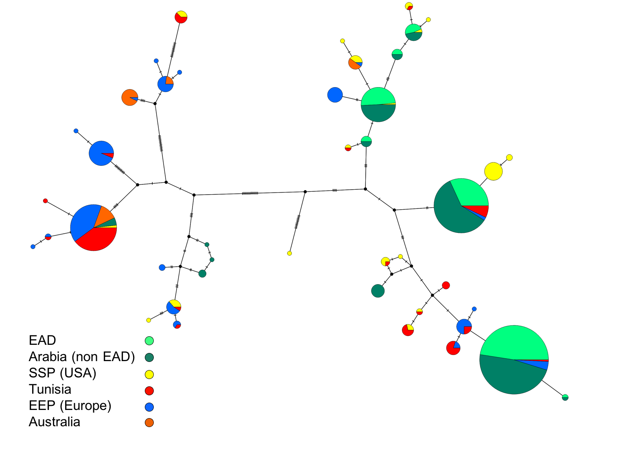

Figure 3

Figure 4

Figure 5

Figure 6
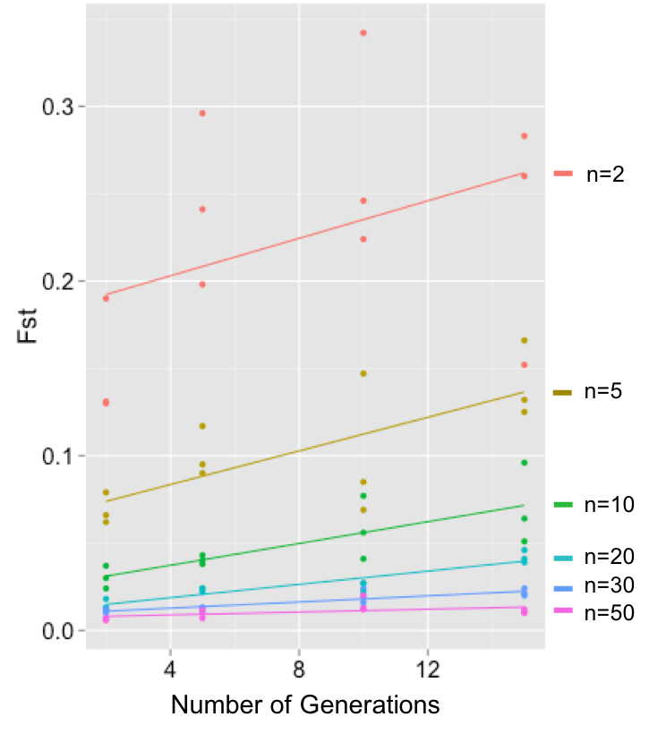

Figure 7a
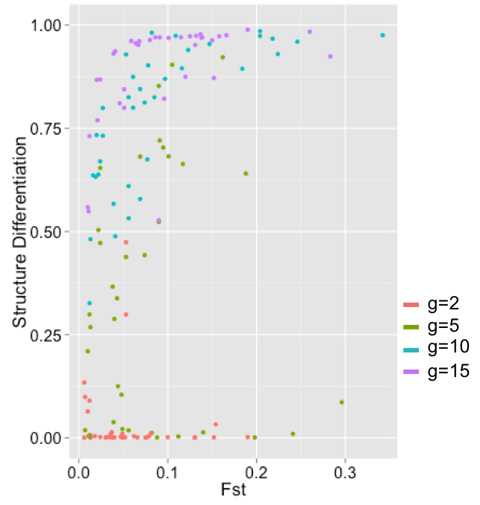

Figure 7b
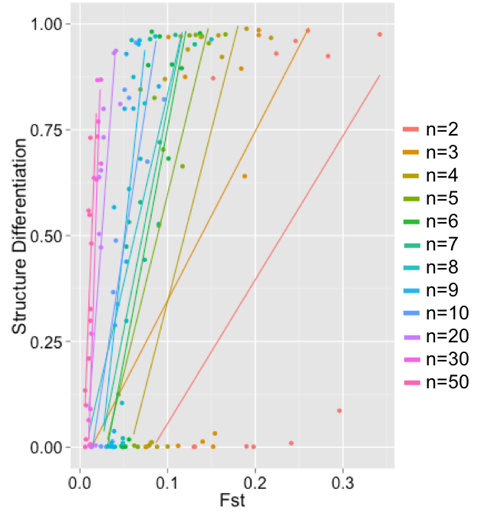

Figure 8

