Prioritising Hepatitis C treatment in people with multiple injecting partners maximises prevention: a real-world network study

Abstract

Objective
To describe an injecting network of PWID living in an isolated community on the Isle of Wight (UK) and the results of a agent-based simulation, testing the effect of Hepatitis C (HCV) treatment on transmission.

Method
People who inject drugs (PWID) were identified via respondent driven sampling and recruited to a network and bio-behavioural survey. The injecting network they described formed the baseline population and potential transmission pathways in an agent-based simulation of HCV transmission and the effects of treatment over 12 months.

Results
On average each PWID had 2.6 injecting partners (range 0-14) and 137 were connected into a single component. HCV in the network was associated with a higher proportion of positive injecting partners (p=0.003) and increasing age (p=0.011). The treatment of well-connected PWID led to significantly fewer new infections of HCV than treating at random (10 vs. 7, p<0.001). In all scenarios less than one individual was re-infected.

Conclusion
In our model the preferential treatment of well-connected PWID maximised treatment as prevention. In the real-world setting, targeting treatment to actively injecting PWID, with multiple injecting partners may therefore represent the most efficient elimination strategy for HCV.

Key words
Hepatitis C; Injecting network; Drug users; Disease transmission, infectious; Computer simulation; Directly acting antivirals

Funding
This study was conducted with support from a National Institute for Health Research (NIHR) PhD fellowship and a GILEAD research fellowship award.

Competing interests
RB has received travel grants and a consultancy fee from GILEAD Ltd. LG, JP, PvdH and SIK have no conflicts of interest with this study.

Background

In recent years treatment for Hepatitis C (HCV) has changed from interferon and ribavirin based regimes to directly acting antivirals (DAAs). DAAs lead to an effective cure (known as a sustained virological response (SVR)) in over 90% of cases and they have few side effects or contraindications.¹ However this requires novel, effective and efficient treatment strategies that target the infected population.²

Injecting drug use is the major contributor to the disease burden of HCV in high income countries and accounts for the majority of incident infection.³ DAA treatment in PWID gives SVR rates comparable to non-PWID and could prevent onward transmission and incident cases of HCV via injecting drug use.^{4,5} This phenomena is termed ‘treatment as prevention’ (TasP) and modelling studies have tested its potential impact.^{6,7} However, there are no published trials that assess the real-world effect of TasP and the majority of studies use compartmental models that make assumptions about transmission pathways between PWID, which can affect their results.⁸

An HCV positive PWID can only infect an uninfected partner with whom they actually have an injecting partnership or close physical contact, therefore defining the network of relationships between PWIDs is crucial to understanding HCV transmission and the potential for the TasP to be a successful strategy. To date three studies have tested TasP in networks of injecting relationships within a population of PWID.^{9–11} One has tested the effect of HCV treatment in a network model containing 1000 PWID connected together with a network topography that was based on real-world human social networks. They highlighted that models in which random mixing is assumed are likely to inaccurately estimate the effect of TasP.⁹ Further studies, in Australia and the United States of America (USA), have assessed HCV transmission and treatment in real-world networks of PWID.¹² The Australian study showed that the empirical network topography was protective against HCV transmission and that this tempered the effect of TasP. Both studies showed that this effect varied depending on where in the network treatment was targeted.^{11,13}

Network topography is important to HCV transmission dynamics and the real-world effect of TasP, but there is limited data describing HCV transmission and treatment within these networks. To help address this uncertainty we have studied PWID on the Isle of Wight (IoW), a geographically isolated community in the Isle of Wight (IoW) in the United Kingdom (UK). As a contained community within a relatively stable population, the IoW provides a valuable opportunity to define a network of PWID in detail and explore the effectiveness of TasP. In this paper we describe the injecting network connecting PWID living on the IoW and then test the effect of treatment within this network on disease transmission.

Method

Participant recruitment
Respondent driven sampling (RDS) was used to identify PWID for the study. Sampling was conducted according to standard procedures and is reported against the STROBE-RDS guidelines in Supplementary Appendix 1.¹⁴ All participants completed informed written consent and the study was conducted with ethical approval (East London REC office, REC reference number 15/LO/1076). The full study protocol is available at: https://pure.soton.ac.uk/admin/workspace/personal/family/upmproject/.

Social network data collection
A triangulation matrix was used to define the injecting partners of each participant.¹⁵ Participants were asked to identify each partner by giving their initials and demographic information. Similar to previous studies, this information formed a code that could be crosschecked against other matrices to identify additional relationships and PWID within the wider network that did not come forward to participate in the survey.¹⁶ The definition of an injecting relationship was injecting in the same time and place and injecting relationships were considered to be reciprocal.

Attribute data collection
Participants completed a self-administered questionnaire and interview based survey that collected demographic data, risk behaviour and engagement with harm reduction services.¹⁷ Participants self-reported their HCV status and completed a validated point of care test (OraQuick ADVANCE™) for HCV antibody.¹⁸

The attributes of non-participants identified in the network were limited to what was described via peer reporting. This included, age, gender, HCV status, engagement with harm reduction and whether they were currently injecting drugs. The accuracy of HCV status peer reporting was assessed and is described in the supplementary appendix.

Statistical analysis
The injecting network was presented as a graph using Netdraw software and the adjacency matrix was uploaded to UCInet software for further analysis.^{19,20} To test the overall network topography we used the following measures: number of components, mean degree, network diameter, average geodesic distance (AGD) and the clustering coefficient. We then compared the network against random networks generated using the Erdos-Renyi method where the probability ($p$) of two nodes having an injecting partnership is calculated from the mean degree distribution ($d$) and the total population size $(N)$ according to:²¹
$$p=\frac{d}{(N-1)}$$
We used in-degree and 2-step reach centrality to assess a node’s position within the network. Chi-squared and independent t tests were used to assess for significant associations with HCV between individual demographic and network data. Important variables and those with a p of <0·2 were added into a logistic regression model. All analyses were conducted with SPSS® for Mac, version 25.

Agent-based simulation (ABS)
The simulation was conducted using Anylogic software (https://www.anylogic.com/) and it is described in more detail in the Supplementary Appendix.

The PWID within the injecting network and their attributes formed the ‘agents’ in the simulation and the real-world injecting relationships within the network (as defined above) formed the potential transmission pathways for HCV via ‘injecting events’.

An ‘injecting event’ in the simulation occurred when two nodes injected at the same time and the same place as each other. The frequency of injecting events was ascertained from injecting frequency data in the behavioural survey responses and extrapolated to the whole network in the same frequency distribution. It was not assumed however, that all injecting partners were present at each injection, so the ‘injecting event’ frequency of HCV positive nodes within the model also accounted for the proportion of the injecting network that was typically present at the time of each drug injection.

As the bio-behavioural survey responses indicated widespread engagement with harm reduction, we did not assume that all ‘injecting events’ incorporated a transmission risk for HCV. However, from the survey the frequency of equipment sharing was known and could be applied to each injecting event with a fixed probability. Equipment sharing was then attributed a transmission risk in accordance with recent literature (Table 1).²²

HCV could be transmitted during an ‘injecting event’ if one of the nodes was HCV positive. When this occurred the susceptible individual developed acute infection, which progressed to chronic infection at 24 weeks with a fixed probability (Figure 1). In line with other studies we did not adjust the susceptibility of infection in exposed uninfected individuals.¹²

The only way an individual could become infected with HCV in the simulation was via an injecting relationship. We did not include an ‘importation’ rate where HCV could be acquired from outside the network because, 1) the PWID population was geographically stable 2) we had a high sampling fraction (see supplementary material) and 3) the time horizon for the simulation was only 12 months.

In all base-case scenarios one individual was treated per month, which is in keeping with the real-world capacity of local Hepatology services on the IoW. For the purposes of the simulation we assumed all individuals were treatment naïve, non-cirrhotic, completed the full course of treatment and received DAAs with a SVR rate in both genotypes 1 and 3 of 95% (Table 1).

In keeping with ‘injecting event’ frequency, the duration of treatment and progression of infection from acute to chronic disease, the model cycled at weekly intervals for a year. This short time horizon is important because it was assumed that: 1) relationships did not form, change or cease during the time frame; 2) injecting behaviour remained constant and 3) individuals did not leave or join the network.

The primary outcome of the model was the number of incident HCV infections at 12 months and the secondary outcome was the number of incident re-infections at 12 months in the following three scenarios:

- If no treatment was available
- If a single individual with chronic HCV was randomly selected for treatment per month
- If the individual with the greatest risk degree (the most injecting partners) was treated each month

The number of incident infections from 50 simulations of each scenario was then compared using the independent t-test in SPSS statistics for MAC version 25.

Agent-based simulation sensitivity analysis
To account for intrinsic variability within the simulation from the random assignment of injecting event frequency, treatment and HCV status (for those nodes with an undefined status at baseline), we ran 50 replications through the model until HCV incidence estimates stabilised for each scenario.

We tested the sensitivity of the outcomes to variations in five key parameters used in the simulation (Table 1). These were adjusted separately in accordance with the 95% confidence intervals or a pre-defined value where these were unavailable. We then conducted a 2^{k} factorial analysis for four important transition probabilities where 32 (2⁴) experiments were conducted with each parameter extended to its maximum or minimum value simultaneously. This allowed us to identify interactions between factors as well as their main effects.

Management of missing data
Due to the reliance on peer reporting, attribute data within the network was incomplete. To account for this we used multiple imputations - where missing data are replaced with plausible values in imputed datasets and then the statistical tests rerun with each.²³ To ascertain the values we constructed a multiple imputation model using the variables from the logistic regression model and an auxiliary variable, social network in-degree, which was inversely correlated with the likelihood of ‘missingness’.

In keeping with the proportion of missing data for HCV status 30 imputation datasets were created. From these 30 datasets the mean number of HCV cases in the 52 nodes with an unknown HCV status was 12 (standard devitation 2.5). Therefore in each simulation HCV positivity was randomly assigned to 12 of these nodes.

Results

Injecting network topography
Five PWID, acting as seeds, identified 64 other PWID for the bio-behavioural survey via RDS. The 69 survey participants then described a further 110 partners with complete codes who could be added to the adjacency matrix. The overall social network therefore contained 179 nodes within a single component which, on the basis of our population size estimates, comprises over 50% of the PWID on the IoW (see Supplementary Appendix for method and results of population size estimates).

When only injecting relationships were included, the network fragmented into one large component, four small components and 46 isolated nodes with no relationships connecting them to another node (Figure 2). The mean in-degree (number of injecting partnerships per node) was 2·6 but this had a long-tailed frequency distribution and ranged from 0-14 (Figure 3).

The large component contained 137 nodes, had a diameter of eight and an AGD (the average distance between any two nodes via injecting relationships) of 4·24. The clustering co-efficient, which in simple terms is the proportion of occasions when ‘the injecting partner of a given node’s partner is also that node’s partner’, was 0·214. We compared these measures against 1000 randomly generated Erdos-Renyi networks with the same number of nodes and relationships.²¹ The IoW network had more isolates or nodes without an injecting partner and therefore contained more components than the random networks. However, other measures including the AGD and clustering coefficient, indicated that the IoW network was more cohesive than the random networks (Supplementary Appendix - Figure 1).

Node demographics
The majority of nodes in the network were male (70%), attending the local drug support centre (64%) and currently injecting drugs (defined as within the last 30 days) (72%). Thirty-eight (30%) of nodes were HCV positive but 52 did not have a peer-reported HCV status (the person or persons that described them stated they didn’t know whether these were positive or negative). Accordingly, a multiple imputation model was used to estimate the number of these individuals that were likely to be HCV positive. When this was taken into account the prevalence dropped marginally across the network to 28%.

Associations with positive HCV status
In the injecting network increasing age and the proportion of HCV positive injecting partners was significantly associated with HCV in both univariable and multivariable analysis (both p<0·01) (Table 2 and Supplementary Appendix – Table 1). However, HCV positive nodes were not associated with the inner 2-core of the network and HCV status was independent of centrality (Table 2).

Testing treatment as prevention
To investigate the potential effect of DAA therapy on the network over 12 months we compared the number of new infections and re-infections in three scenarios. In Scenario 1 no treatment was given, in Scenario 2 nodes were treated at random and in Scenario 3 treatment was prioritised to nodes with higher degree centrality.

In the base-case analysis for Scenario 1 there was a median of 12 new HCV infections. This was compared with Scenario 2 where there were 10 new HCV infections (p=0·003) and Scenario 3 where there were 7 new HCV infections (p<0·001) (Figure 4). Treating PWID according to degree size also significantly reduced the number of incident HCV infections compared to treating at random (p<0·0001). In each scenario there was less than one re-infection.

Sensitivity analysis
Increasing treatment coverage to three treatments per month (6% of the baseline infected population) decreased the number of new HCV infections in Scenario 2 from baseline (10 vs. 8, p=0.049), although the decrease was more pronounced in Scenario 3 (7 vs. 3, p<0.0001). Both treatment scenarios significantly reduced the number of new infections per month when compared to Scenario 1 and network-based treatment remained significantly more effective at preventing new infections than treating at random (p<0.0001) (Figure 4).

The 2^{k} factorial analyses assessed which parameters at their predetermined extreme values introduced the most variation in the simulation (for values see Table 1). Changing the rate at which susceptible individuals acquired infection (the force of infection) at each injecting event accounted for 74·2% of the variation, changing treatment coverage accounted for 9·7% and injecting frequency for 5·4%. Variation in other parameters all accounted for <1% of the total variation.

Based on these results we then investigated the impact of changing the force of infection at each injecting event. In the simulation the force of infection was itself related to further parameters – the frequency of sharing behaviours and the probability of transmission with each behaviour (Parameters 2 and 3 in Table 1). We therefore altered each parameter separately to the extent of their 95% confidence intervals and repeated the simulation in seven new experiments.

As expected, the number of incident HCV cases increased with the force of infection in all three scenarios. An increase in incident infection was most pronounced when the likelihood of transmitting HCV with receptive needle sharing increased to 0·02 and at this level the statistically significant benefit of network-based treatment was lost. However in all other experiments network-based treatment remained significantly more effective at preventing incident disease than random treatment (Supplementary Appendix – Table 2). By contrast, the borderline statistically significant difference in the number of incident infections when treating at random versus not treating at all was lost in five of the experiments (Supplementary Appendix – Table 2).

Overall, the results of the simulation show that the treatment of HCV within the IoW injecting network did prevent onward transmission of HCV over a 12 month period. However, in the base-case analysis and all except one sensitivity experiment the provision of treatment to PWID with more injecting partnerships was significantly more effective at preventing incident infection.

Discussion

To design an effective elimination strategy for HCV it is necessary to understand viral transmission and the effects of HCV treatment in injecting networks connecting PWID.

The simulation showed that after 12 months, treating the most well-connected PWID (those with the highest ‘injecting degree’) was superior at preventing new HCV infections when compared to treating PWID at random. Importantly it showed only a modest decline in incident HCV when PWID were treated at random compared to not treated at all. These finding are consistent with studies that have indicated the effect of TasP in random mixing networks may be overestimated.^{9,12}

We are aware of two other studies that have used an empirical network-based model to investigate the transmission and treatment of HCV in PWID. Hellard et al. in Melbourne, Australia, demonstrated that reinfection was the main source of new infections and that therefore the treatment of positive individuals around the treated person, in a so-called ‘ring strategy’, was the most effective approach to TasP.¹³ Indeed, they and Zelenev et al. showed that prioritising treatment to the most well-connected PWID was less effective than treating at random.^{11,13} Both studies are different from ours in being set in larger, urban populations and report the effects of TasP over a longer period. However, it is possible that the contrast with our results is secondary to different underlying network topology within each model.

The network that we have defined is cohesive and has a long-tailed degree size distribution. The Melbourne study was based on a network with a short tailed degree distribution and relatively few injecting partnerships, whereas Zelenev et al. modelled transmission in a network that was over 20 times less cohesive than our own.^{11,24} Further research is required to understand whether these differences in network topology represent heterogeneity between rural and urban population of PWID or network sampling errors.

Importantly however, features of our network fit with so-called ‘scale-free’ network topography that has been observed in a wide range of real-world networks including social networks, intra-cellular molecular communication and the internet.²⁵ Furthermore, the results of our simulation are consistent with broader mathematical literature that has demonstrated the resilience of so-called ‘scale-free’ networks to random error and their paradoxical vulnerability to targeted ‘attack’ on well-connected nodes.²⁵

HCV within the IoW network was significantly associated with increasing age and having a higher proportion of positive injecting partners. In the UK the risk of HCV infection is known to be lower in recent initiates of injecting drug use and increase with age.^{26,27} Clustering of HCV positive cases has also been reported by Young et al. in a rural network of PWID in the USA and similar to our study they did not demonstrate an association between being HCV positive and a node’s overall position in the network, whether central or peripheral.²⁸

The collection of social network data in PWID is challenging. A strength of our study is that our network included a high proportion (over 50%) of the total PWID population and benefited from a natural geographical network ‘boundary’. However, we inevitably relied on self-reported and peer reported information, which, particularly in the case of sharing frequency, could have introduced bias in the simulation. However, we have limited the impact of missing network data in three ways. Firstly, we used a test for centrality (in-degree centrality), which is robust in the presence of missing nodes.²⁹ Secondly, we assumed all injecting relationships were reciprocal, which is a recognised way of dealing with missing relationship data and thirdly, we used RDS to recruit participants to the survey.³⁰ By design, this method preferentially recruits central nodes and therefore mitigates some of the impact of missing nodes and the risk of missing important relationships.

Our simulation is based on a static network connecting PWID via injecting relationships at a snapshot in time. To account for this we set the time horizon for the simulation to just a single year. We felt that any results from an extended model without allowing for a turnover of injecting partners and a transition of nodes into and out of the network could have been misleading. Empirical data describing network dynamics on which such assumptions could be based is limited and we would advocate further longitudinal network research to describe these dynamic phenomena. However, even in this short timeframe we observe significant effects of treating well-connected nodes.

This study describes the most complete injecting network of PWID to date and we use this network to test the effects of treatment through a simulation. We demonstrate that PWID on the IoW are connected via injecting relationships into a cohesive network with a long-tailed degree distribution. Importantly, in contrast to other studies we show that to maximise TasP clinicians should target therapy at PWID with large personal injecting networks.

References

1. Foster GR, Afdhal N, Roberts SK, et al. Sofosbuvir and Velpatasvir for HCV Genotype 2 and 3 Infection. N Engl J Med. 2015;373(27):2608-2617.
2. Combating hepatitis B and C to reach elimination by 2030. 2017. http://www.who.int/hepatitis/publications/hep-elimination-by-2030-brief/en/. Accessed November 7, 2016.
3. Degenhardt L, Charlson F, Stanaway J, et al. Estimating the burden of disease attributable to injecting drug use as a risk factor for HIV, hepatitis C, and hepatitis B: findings from the Global Burden of Disease Study 2013. Lancet Infect Dis. 2016;16(12):1385-1398.
4. Grebely J, Dalgard O, Conway B, et al. Sofosbuvir and velpatasvir for hepatitis C virus infection in people with recent injection drug use (SIMPLIFY): an open-label, single-arm, phase 4, multicentre trial. Lancet Gastroenterol Hepatol. 2018;3(3):153-161.
5. Innes H, Goldberg D, Dillon J, Hutchinson SJ. Strategies for the treatment of Hepatitis C in an era of interferon-free therapies: what public health outcomes do we value most? Gut. 2015;64(11):1800-1809.
6. Martin NK, Vickerman P, Foster GR, Hutchinson SJ, Goldberg DJ, Hickman M. Can antiviral therapy for hepatitis C reduce the prevalence of HCV among injecting drug user populations? A modeling analysis of its prevention utility. J Hepatol. 2011;54(6):1137-1144.
7. Cousien A, Tran VC, Deuffic-Burban S, Jauffret-Roustide M, Dhersin J-S, Yazdanpanah Y. Hepatitis C treatment as prevention of viral transmission and liver-related morbidity in persons who inject drugs. Hepatology. 2016;63(4):1090-1101.
8. Cousien A, Tran VC, Deuffic-Burban S, Jauffret-Roustide M, Dhersin J-S, Yazdanpanah Y. Dynamic modelling of hepatitis C virus transmission among people who inject drugs: a methodological review. J Viral Hepat. 2015;22(3):213-229.
9. Metzig C, Surey J, Francis M, Conneely J, Abubakar I, White PJ. Impact of Hepatitis C Treatment as Prevention for People Who Inject Drugs is sensitive to contact network structure. Sci Rep. 2017;7(1):1833. doi:10.1038/s41598-017-01862-6.
10. Rolls DA, Sacks-Davis R, Jenkinson R, et al. Hepatitis C Transmission and Treatment in Contact Networks of People Who Inject Drugs. Noymer A, ed. PLoS One. 2013;8(11):e78286. doi:10.1371/journal.pone.0078286.
11. Zelenev A, Li J, Mazhnaya A, Basu S, Altice FL. Hepatitis C virus treatment as prevention in an extended network of people who inject drugs in the USA: a modelling study. Lancet Infect Dis. 2018;18(2):215-224.
12. Rolls DA, Daraganova G, Sacks-Davis R, et al. Modelling hepatitis C transmission over a social network of injecting drug users. J Theor Biol. 2012;297:73-87.
13. Hellard M, Rolls DA, Sacks-Davis R, et al. The impact of injecting networks on hepatitis C transmission and treatment in people who inject drugs. Hepatology. 2014;60(6): 1861-1870.
14. White R, Hakim A, Salganik M, et al. Strengthening the Reporting of Observational Studies in Epidemiology for respondent-driven sampling studies: “STROBE-RDS” statement. J Clin Epidemiol. 2015;68(12):1463-1471.
15. Wald A. Triangulation and validity of network data. In: Dominguez S, Hollstein B, eds. Mixed Methods Social Networks Research. 1st Edition. New York: Cambridge University Press; 2014:65-83.
16. Klovdahl AS, Potterat JJ, Woodhouse DE, Muth JB, Muth SQ, Darrow WW. Social networks and infectious disease: the Colorado Springs Study. Soc Sci Med. 1994;38(1):79-88.
17. DRIG Guidance Module: Example questionnaire for bio-behavioural surveys in people who inject drugs. 2014. http://www.emcdda.europa.eu/attachements.cfm/att_220261_EN_DRID_module_example_questionnaire_27012014.pdf. Accessed November 4th 2015.
18. Cha YJ, Park Q, Kang E-S, et al. Performance evaluation of the OraQuick hepatitis C virus rapid antibody test. Ann Lab Med. 2013;33(3):184-189.
19. Borgatti SP, Everett M, Freeman LC. Ucinet for window: Software for social networks analysis. 2002.
20. Borgatti S. NetDraw Software for Network Visualisation. 2002.
21. ErdÕs P, Rényi A. On evolution of random graphs. Publ Math Inst Hungarian Acad Sci. 1960;(5):17-61.
22. Hahn JA, Wylie D, Dill J, et al. Potential impact of vaccination on the hepatitis C virus epidemic in injection drug users. Epidemics. 2009;1(1):47-57.
23. White IR, Royston P, Wood AM. Multiple imputation using chained equations: Issues and guidance for practice. Stat Med. 2011;30(4):377-399.
24. Rolls DA, Wang P, Jenkinson R, et al. Modelling a disease-relevant contact network of people who inject drugs. Soc Networks. 2013;35(4):699-710.
25. Albert R, Jeong H, Barabási A-L. Error and attack tolerance of complex networks. Nature. 2000;406(6794):378-382.
26. Hope VD, Hickman M, Ngui SL, et al. Measuring the incidence, prevalence and genetic relatedness of hepatitis C infections among a community recruited sample of injecting. J Viral Hepat. 2011;18(4):262-270.
27. Hepatitis C in the UK. 2016. https://www.gov.uk/government/uploads/system/uploads/attachment_data/file/538321/hpr2316_uampwid.pdf. Accessed September 20, 2016.
28. Young AM, Jonas AB, Havens JR. Social networks and HCV viraemia in anti-HCV-positive rural drug users. Epidemiol Infect. 2013;141(2):402-411.
29. Valente T. Centrality. In: Social Networks and Health. New York, USA: Oxford University Press; 2010:81-99.
30. Borgatti S, Everett M, Johnson J. Centrality. In: Analyzing Social Networks. London: SAGE Publications Ltd; 2013:163-180.

Table 1
Transition probabilities used in the agent-based simulation of Hepatitis C transmission and treatment in people who inject drugs on the Isle of Wight.
 | Parameter | Transition  (95% confidence intervals) | Value used for sensitivity analysis | Ref.
1 | Injecting event frequency | Varies according to bio-behavioural survey data | +/- 20% | †
2 | Likelihood of sharing per injecting event | AES 0·40 (0·21-0·56) | 95% confidence intervals | †
 |  | RNS 0.33 (0.16-0·51)
3 | Likelihood of developing acute infection per sharing event | AES 0·0023 (0-0.006) | 95% confidence intervals | ²²  ²²
 |  | RNS 0·0073 (0.0073-0.02) | 95% confidence intervals
4 | Likelihood of spontaneous resolution of acute infection | 0·25 (0·22-0·29) | 95% confidence intervals | ²²
5 | Treatment frequency | 1 per month (2% of cases) | 3 (6%) | ‡
6 | Treatment success | 0·95 (0.92-0.98) | 95% confidence intervals | ¹
†Values from bio-behavioural survey results. ‡Baseline value based on current real-world treatment capacity on the IoW. AES – ancillary equipment sharing, RNS – receptive needle sharing

Table 2 Results of logistic regression showing association between demographic, behavioural and social network measures and Hepatitis C status
 | HCV  n/N | No HCV  n/N(%) | p†
Gender (male %) | 27/38 (71·1) | 63/89 (70·8) | 0·90
Mean age – (SD) | 43·2 (10.9) | 37·9 (8.3) | 0·003
Attends DSC (%) | 26/35 (74·3) | 62/89 (69·7) | 0·61
Current IDU (%) | 27/37 (73·0) | 60/88 (68·2) | 0·63
Mean proportion of injecting partners HCV+ (SD) | 0·4 (0.4) | 0·2 (0.3) | 0·006
Mean injecting degree (SD) | 3·3 (3.0) | 3·3 (3.0) | 0·95
Number in 2-core (%) | 13/38 (34.2) | 25/89 (28.1) | 0.37
Mean 2 step-reach centrality  (SD) | 15·2 (12.4) | 14·6 (11.8) | 0·78

†The significant variables (p<0.05) did not change with analysis of pooled multiple imputation data. p values are calculated with SPSS for MAC version 25 using chi-squared test for categorical variables and independent t-test for continuous variables.
HCV– Hepatitis C; DSC – Drug support centre; IDU – injecting drug use (within the last 30days), SD - Standard deviation

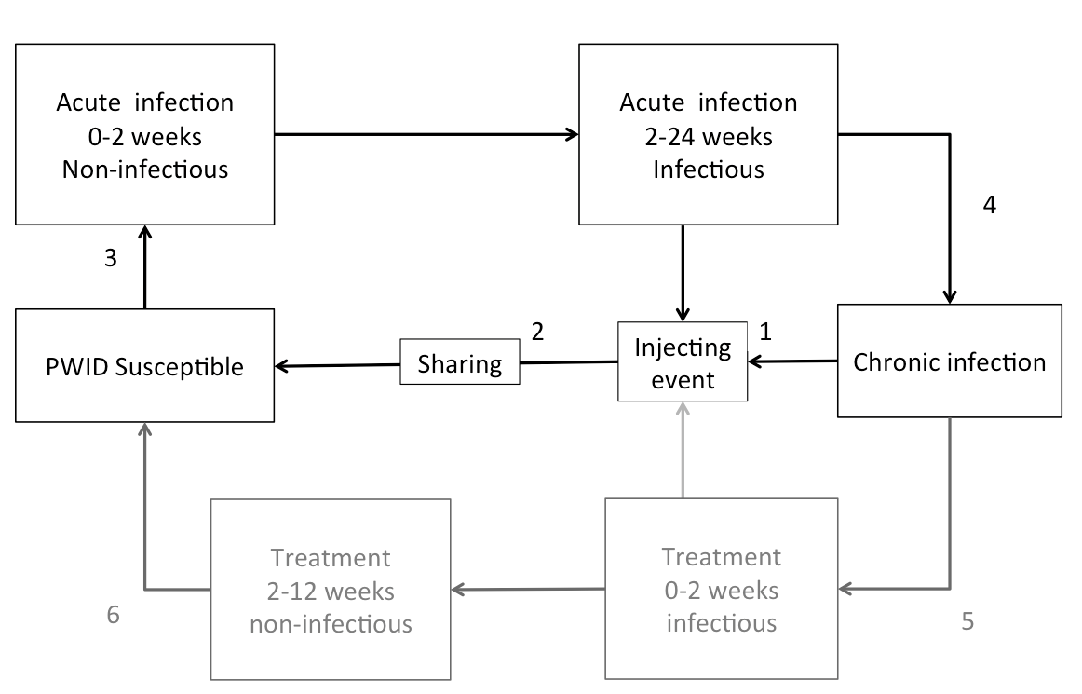

Figure 1 Stochastic model of Hepatitis C transmission and treatment. Treatment pathway (greyed out) is applicable in Scenarios 2 and 3. Numbers correspond to specific transition probabilities between states in the model.

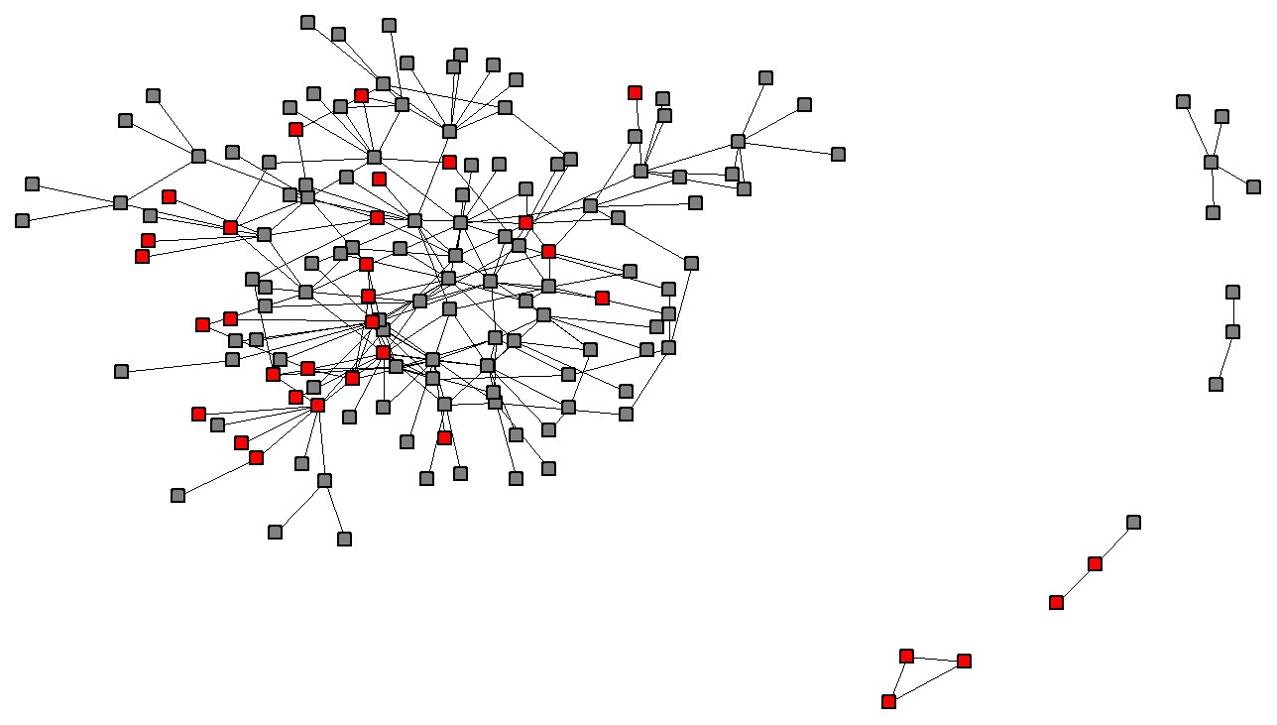

Figure 2 The injecting network. Nodes indicate a person who injects drugs and lines indicate an injecting partnership. Red nodes are Hepatitis C positive and isolated nodes are not shown.

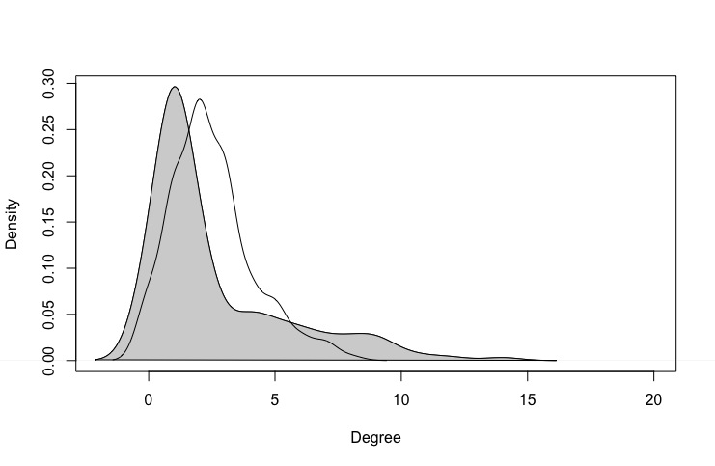

Figure 3 Kernal plots comparing the frequency distribution of the number of injecting relationships (i.e. degree size) per person in the network (shaded) and, for comparison, an Erdos-Renyi network (unshaded).

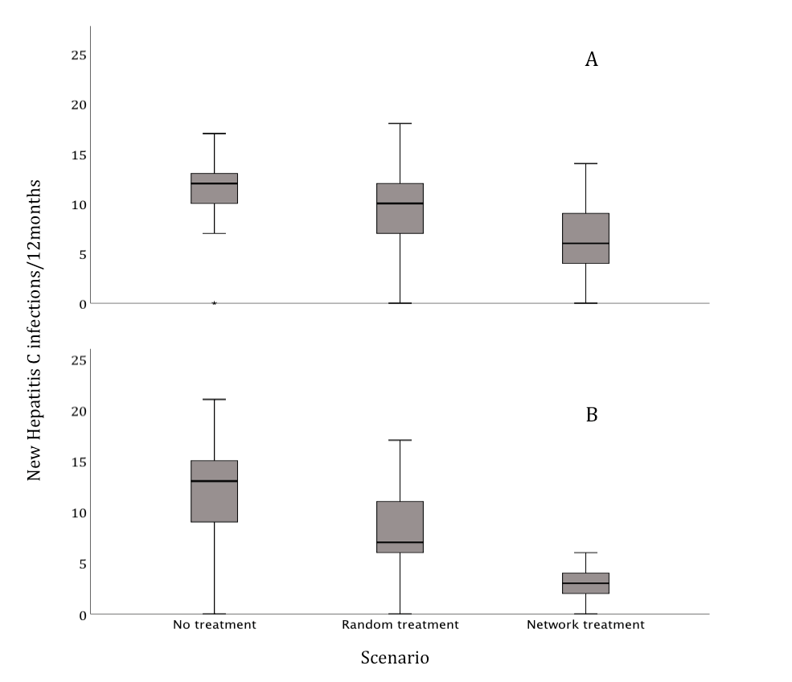

Figure 4 Plots showing the distribution of incident Hepatitis C infections after 12 months through 50 repetitions of each scenario. Plot A shows the distribution if one individual is treated per month and plot B shows the distribution if three individuals are treated per month. The ends of the boxes are the upper and lower quartiles, a horizontal line inside each box marks the median value and the whiskers extend to extreme values.

