Species interactions and environmental context affect intraspecific behavioural trait variation and ecosystem function

Camilla Cassidy¹, Laura J. Grange², Clement Garcia³, Stefan G. Bolam³, Jasmin A. Godbold¹

¹ School of Ocean and Earth Science, National Oceanography Centre Southampton, University of Southampton, European Way, Southampton, SO14 3ZH, United Kingdom
² School of Ocean Sciences, Bangor University, Bangor, United Kingdom, LL57 2DG
³ Centre for Environment, Fisheries and Aquaculture Science, Lowestoft Laboratory, Pakefield Road, Lowestoft, Suffolk, NR33 0HT, United Kingdom

Corresponding author: Camilla Cassidy, camillacassidy@soton.ac.uk

Camilla Cassidy ORCID ID: 0000-0001-7947-7458
Laura J. Grange ORCID ID: 0000-0001-9222-6848
Clement Garcia ORCID ID: 0000-0001-5916-8914
Stefan Bolam ORCID ID: 0000-0001-6604-4741
Jasmin A. Godbold ORCID ID: 0000-0001-5558-8188

Abstract
Functional trait-based approaches are increasingly adopted to understand and project ecological responses to environmental change, however most assume trait expression is constant between conspecifics irrespective of context. Using two species of benthic invertebrate (brittlestars Amphiura filiformis and A. chiajei) we demonstrate that trait expression at individual and community levels differs with biotic and abiotic context. We use PERMANOVA to test the effect of species identity, density and local environmental history on individual (righting and burrowing) and community (particle reworking and burrow ventilation) trait expression, as well as associated effects on ecosystem functioning (sediment nutrient release). Trait expression differs with context, with repercussions for the faunal mediation of ecosystem processes; we find increased rates of righting and burial behaviour and greater particle reworking with increasing density that are reflected in nutrient generation. However, the magnitude of effects differed within and between species, arising from site-specific environmental and morphological differences. Our results indicate that traits and processes influencing change in ecosystem functioning are products of both prevailing and historic conditions that cannot be constrained within typologies. Trait-based study must incorporate context-dependent variation, including intraspecific differences from individual to ecosystem scales, to avoid jeopardising projections of ecosystem functioning and service delivery.

Keywords: bioturbation, community composition, functional diversity, functional traits, intraspecific variation, trait expression

1 Introduction
Decades of empirical study, motivated by unprecedented species loss and environmental change, have provided unequivocal evidence that altering biodiversity affects ecosystem functioning (e.g. primary production, nutrient cycling, sediment stability) and, ultimately, the provision of ecosystem services (Adair et al., 2018). Current research emphasizes that rather than the number of species, ecosystem functioning is instead mediated by the functional traits (e.g. behavioural, morphological or life history characteristics) expressed within a community (Gagic et al., 2015; Read et al., 2017). As a result, functional trait-based approaches are increasingly adopted as predictive tools by ecosystem managers (Rijnsdorp et al., 2015; Bolam et al., 2017) as they incorporate species performance into projections of environmental change. In doing so, they confer understanding of the biological mechanisms underpinning faunal mediation of ecosystem functioning (Laughlin, 2014; Funk et al., 2017; Thomsen et al., 2019).

Conventional trait-based approaches and proposed frameworks implicitly assume that the expression of traits remains constant between conspecifics, irrespective of biotic or environmental context (Albert et al., 2010; Hevia et al., 2017). Studies may neglect intraspecific variability out of economic or logistical necessity, as measuring individual trait values in situ is not always possible. For management purposes, therefore, authors may rely on trait values from literature or databases to characterise the functional importance of species (Gogina et al., 2016; Bolam et al., 2017; Solan et al., 2019). In these approaches the quantification of trait values and allocation of species to functional groups is frequently based on single mean trait values per species, and does not account for the scope and importance of intraspecific trait variability (Finerty et al., 2016; Des Roches et al., 2018). If the type or value of traits expressed are understood to determine a species’ role in the ecosystem (Wohlgemuth et al., 2017), any intraspecific variation potentially alters its contributions to ecosystem functioning and renders conventional typologies unsuitable.

Individual organisms are non-identical, with differing forms of trait expression distributed unevenly throughout communities (Carmona et al., 2016; Roscher et al., 2018). It has long been appreciated that age classes, ontogenetic stages or sexes make differing contributions to ecosystem functioning. For example, individuals within a population are often grouped as being agender, despite knowledge that differing sexes can exhibit strongly distinct life strategies and energetic or resource demands (Rudolf & Rasmussen, 2013). Such physiological differences, including associated morphological differences in the mean and variance of body size, determine the scale of an individual’s contribution to ecosystem functioning (Norkko et al., 2013; Fritschie & Olden, 2016). However, intraspecific variation occurs beyond demographic influences (Mitchell & Bakker, 2014a). Some site-specific differences originate as a genetic component, stemming from long-term adaptation to historic conditions that creates distinct genetic ecotypes through multi-generational selection processes (Calosi et al., 2013; Robins et al., 2013). In addition, variation also arises over shorter temporal scales in the form of acclimation responses to prevailing biotic and abiotic conditions (Wohlgemuth et al., 2017).
Mechanisms of phenotypic plasticity result in widespread and often substantial trait variability over time and space (Roscher et al., 2018). Transient trait expression in individuals alters their activities and potential contributions to ecosystem processes in response to habitat features (Törnroos et al. 2015; Read et al., 2017), climatic drivers (Baranov et al., 2016; Nagelkerken & Munday, 2016; Landeira-Dabarca et al., 2018; Peterson et al., 2019), and resource availability (Hawlena et al., 2011; Murray et al., 2017). Incorporating the context-dependency of trait expression is vital for accuracy in the increasingly urgent quantification of ecosystem functioning under changing abiotic conditions (Landeira-Dabarca et al., 2018). Trait expression, furthermore, also shifts dramatically in response to biotic influences, primarily from neighbouring individuals and/or species (Hawlena et al., 2011; Wohlgemuth et al., 2017; Calder-Potts et al., 2018; Thomsen et al., 2019). Competitive or complementary interactions determine species coexistence and exclusion (Turcotte & Levine, 2016; Pérez-Ramos et al., 2019), and so potentially facilitate enhanced productivity, ecosystem functioning and service delivery (Finerty et al., 2016). Within species, local density-dependent effects can influence the expression of movement and life history traits, influencing habitat use as conspecifics specialise behaviourally or physiologically to exploit available space and resources (Kraft et al., 2015) or escape predation (Rosenberg & Selander, 2000). It is increasingly recognised that intraspecific differences in trait expression are not only widespread but also form an important component of biodiversity (Des Roches et al., 2018). The representation of species using single or average trait values may fail to quantify responses to numerous aspects of ecological and environmental context (Read et al., 2017), jeopardising the reliability of approaches to ecosystem study and management (Reich et al., 2014; Bennett et al., 2016).
In this study, we investigate the importance of incorporating intraspecific and individual-level trait variation into trait-based study, illustrating that faunally-mediated community processes and ecosystem functioning with which these traits are associated are subject to context-dependent change. To achieve these aims, we interrogate the effect of biotic context and differing abiotic history on communities of two co-occurring species of infaunal marine invertebrate (brittlestars Amphiura filiformis and A. chiajei). We hypothesise that i) biotic and site-specific environmental context influence the expression of individual traits and community-level behaviour, and that ii) this variability would aid in understanding concurrent differences in biogeochemical proxies (nutrient concentration) for ecosystem function. To this effect, our results show that, contrary to the assumptions of prevailing trait-based modelling approaches, the trait expression and subsequent functional contributions of conspecific individuals cannot be assumed to be constant.

2 Materials and methods
2.1 Species collection and experimental design
Two species of ophiuroid brittlestars (A. filiformis and A. chiajei) were collected from two proximate sea lochs; Kilmaronag Shoal, Loch Etive (56°27'34.20"N, 5°20'29.28"W) and the Lynn of Lorne, Loch Linnhe (56°29'49.6"N, 5°29'56.2"W), Scotland, UK (Supporting information, Fig. S1). Taxa with pelagic larvae, such as these species, have substantial distribution potential and are exchanged across landscape-scale distances and hydrographical barriers only in these early ontogenetic stages (Robins et al., 2013; Ershova et al., 2019). Given the proximate distance (~12 km) and presence of substantial changes in seabed terrain and flow conditions between sites (Gage, 1972; Friedrich et al., 2014), we infer that individuals from each site are likely not genetically distinct but will have been exposed throughout their post-larval lifetimes to differing ecological and environmental conditions (Alp et al., 2012). Loch Etive is subject to greater stratification and more frequent episodic flushing relative to Loch Linnhe that affects nutrient and organic material dynamics (Friedrich et al., 2014). Sediment at Loch Etive is finer and contains a significantly higher total organic carbon (TOC) content in comparison to the Loch Linnhe site (ANOVA: F_{2,10}= 30.78, P < 0.001, Supporting information, Table S1 and Fig. S2 & S3).

Individuals were returned to the University of Southampton in aerated water baths and acclimated to aquarium conditions (~ 12.6 ° C, 12 h light: 12 h dark cycle, continually aerated) for a 30-day period. Estuarine mud from Hamble-le-Rice, Hampshire (50°52'23.1"N 1°18'49.3"W), was sieved (500 μm mesh) in a seawater bath to retain the fine fraction and remove macrofauna and allowed to settle for 48 h before being homogenised and distributed to Perspex aquaria (internal dimensions, LWH 12 x 12 x 35 cm; settled depth ~ 10 cm overlaid with ~ 20 cm depth seawater, salinity 33). After 24 h and prior to the addition of the organisms, the seawater was replaced to remove excess dissolved nutrients associated with mesocosm assembly.

Our experiment required 102 aquaria arranged in a full factorial design (Supporting information, Table S2 & S3). Replicate faunal assemblages (hereafter referred to as ‘communities’) from each sampling site (2 levels; Loch Etive and Loch Linnhe, which represent historic exposures to discrete abiotic conditions hereafter referred to as ‘populations’) contained A. filiformis and A. chiajei in one of three species treatments (3 levels; monoculture of A. filiformis, monoculture of A. chiajei, or both species in mixture), across three naturally observed densities (3 levels; low, medium and high, between 250 - 1000 ind. m⁻², Supporting information, Table S3). These species were selected for use given their close taxonomic relation, their shared tolerance for variable biotic and abiotic contexts (Calder-Potts et al., 2018), and their widespread co-occurrence throughout European shelf waters (Gage, 1972) where they exert a dominant influence on local biochemical cycling (Murray et al., 2013). The three density levels manipulated span the range reported from across their European distribution (O’Connor et al., 1983; Duineveld et al., 1987; Munday & Keegan, 1992) and therefore are not location specific. For this study, we adjusted the densities of both species to reflect the approximate 3 A. filiformis : 2 A. chiajei ratio observed at the sample sites only as to avoid introducing novel aspects of biotic context. Each combination of factors was replicated six times, with the exception of two treatments (n = 4 and n = 5) (total n = 102, Supporting information, Table S3).

2.2 Measures of individual trait expression
Individual-level behavioural trait expression was represented through movement and burial behaviours measured at the sediment surface following incubation and the quantification of community- and ecosystem- properties. Individuals were inverted and placed on the sediment surface in a temperature-controlled tray of sediment (3 cm depth overlaid with 5 cm depth seawater) under the same density and species treatment (monoculture or mixed) conditions in which they had been previously maintained. A bench top video camera (uEYE USB camera, 1.3 MP, 25 FPS; IDS Imaging Development Systems, Obersulm, Germany) was used to record two righting and burial behaviours: i) the time taken for each individual to begin movement activity, a response trait, and ii) the time taken for each individual to right itself and bury fully into the sediment, an effect trait. Behaviour at the sediment surface reflects the strength and nature of organismal responses to their biological and physical surroundings (Rosenberg & Selander, 2000), and burial rate is indicative of functionally-relevant movement behaviours at the individual level (Nagelkerken & Munday, 2016).

As morphological traits can significantly influence an individual’s functional contribution (Norkko et al., 2013), we determined arm length (cm) and disc diameter (cm) using image analysis (ImageJ, version 1.46r; Schneider et al., 2012; Supporting information, Fig. S4), and biomass (g), for each individual. Given the strong co-linearity between the metrics (Supporting information, Fig. S5), the mean arm length (mean length of all five arms for each individual, producing an individual-level morphological trait) was used to represent morphological trait expression due to its greater relevance in brittlestar motility and feeding behaviours (Rosenberg & Selander, 2000; Astley et al., 2012).

2.3 Measures of community behaviour
Burrow ventilation behaviour (bioirrigation) was estimated from the relative change in water column concentrations of the inert tracer sodium bromide (NaBr, dissolved in 20 mL = ~ 5 mM aquaria⁻¹), over an 8 h period (NaBr, dissolved in 20 mL = ~ 5 mM aquaria-1; ∆[Br−], mg L⁻¹; negative values indicate increased activity; Forster et al., 1999). Filtered water samples (5 mL, 0.45 µm cellulose acetate membrane filter) were taken on Day 29 of the experimental period and stored at 6 °C prior to colorimetric analysis (FIAstar 5000 flow injection analyser, FOSS Tecator).

Faunally mediated particle reworking (bioturbation) was estimated non-invasively using sediment profile imaging (f-SPI) (Solan et al., 2004). To visualize particle movement 24 g dry weight aquaria⁻¹ of dyed sediment that fluoresces in UV light (green colour; < 125 μm; Brianclegg Ltd., UK) was introduced to the sediment surface on Day 23 and imaged 8 days later (Day 31). This length of time is sufficient to allow visualisation of particle movement whilst avoiding vertical homogenization of the tracers. Images of all four sides of each mesocosm were taken within a UV illuminated imaging box. Following Solan et al. (2004), images were saved in RGB colour mode with JPEG compression and analysed using a custom-made semi-automated macro that runs within ImageJ (version 1.46r), a Java-based public domain program (Schneider et al., 2012). From these data, the maximum depth of particle reworking (^{f-SPI}L_{max}) was calculated and surficial activity was estimated by quantifying surface boundary roughness (SBR), which is the maximum vertical deviation of the sediment-water interface (upper – lower limit; Hale et al., 2014).

2.4 Measures of ecosystem functioning
Ecosystem functioning was represented through the proxy of sediment nutrient release, which is mediated by the sediment movement behaviours of benthic fauna (Kristensen et al., 2014; Wohlgemuth et al., 2017). Nutrient concentrations (ammonium, NH₄- N; nitrate, NO₃-N; nitrite, NO₂-N; and phosphate, PO₄-P; μmol L¹) were determined from filtered water samples (20 mL, Fisherbrand, nylon 0.45 μm, ⌀ 25 mm) taken on the final day of the experiment (Day 30). Samples were frozen (−18 °C) and analysed using a segmented flow autoanalyser (QuAAtro39 AutoAnalyzer).

2.5 Statistical analysis
Permutational multivariate analysis of variance (PERMANOVA) and ANOVA were used to determine the independent and interacting effects of population (2 levels; Loch Etive, Loch Linnhe), density (3 levels; low, medium, high) and species identity (for intraspecific trait expression, 4 levels; A. filiformis in monoculture, A. filiformis in mixture, A. chiajei in monoculture, A. chiajei in mixture) or species mixtures treatment (for community and ecosystem measures, 3 levels; A. filiformis monoculture, A. chiajei in monoculture, A. filiformis - A. chiajei mixed treatment) on individual and community behavioural trait expression, and associated ecosystem function. All statistical analyses were performed using the R statistical and programming environment (R Core Team, 2017) and the vegan package (Oksanen et al., 2017).

2.5.1 Individual trait expression
Multivariate analyses were used to represent overall differences in the behavioural ‘personalities’ of individuals between species identities and contexts (Moran et al., 2017), integrating response (time to begin movement) and effect (time to complete burial) traits. PERMANOVA (iterations = 999) was used, as it is robust to non-normality and differing correlation structures and so is particularly suited for the detection of differences in intraspecific trait expression (Mitchell & Bakker, 2014b). Patterns of intraspecific trait expression differ between the behavioural traits, and between context treatments (Supporting information, Fig. S6). Permutational analysis of multivariate dispersion (PERMDISP) was used to test for homogeneity of variance between populations (F_{1,190} = 0.57, P = 0.45), species identities (F_{1,188} = 1.20, P = 0.31) and densities (F_{1,189} = 1.22, P = 0.30). These results support that any significant differences in PERMANOVA between treatments are due to changes in the values of trait expression, not shifts in the overall extent of variation itself. Nevertheless, to negate any dispersion effects caused by unequal numbers of individuals between groups, we standardised abundance between species treatments and density levels (n = 192) (Supporting Information, Table S3).

PERMANOVA models were developed test the independent and interacting effects of; i) community-level effects (population, species identity, density), and ii) individual-level differences in morphological trait expression (mean arm length) between communities (population, species identity), on multivariate intraspecific behavioural trait expression. Data exploration showed there were differences in morphological trait expression between populations (ANOVA: F_{1,188} = 4.03, P = 0.046) and species (ANOVA: F_{1,188} = 14.99, P < 0.001) which may contribute to observed site-specific and interspecific effects.

To quantify the extent of intraspecific trait variation, the coefficient of variation (CV; the ratio of standard deviation to the mean) was determined for the expression of each individual-level trait (time to begin movement, time to complete burial, and mean arm length).

2.5.2 Community behaviour and ecosystem functioning
4-way ANOVA was used to test the independent and interactive effects of context (population, species treatment, density) and intraspecific variation in morphological trait expression (CV of mean arm length) on each community-level behaviour (∆[Br⁻], ^{f-SPI}L_{max}, SBR), and a 3-way ANOVA was used to test the independent and interactive effects of context (population, species treatment, density) on nutrient concentration ([NH₄-N], [NO₃-N], [NO₂-N], [PO₄-P]). Model assumptions were assessed visually for normality (Q-Q plot), heterogeneity of variance (plotted residuals vs. fitted values), and the presence of outliers or overly influential data points (Cook’s Distance) and the minimal adequate effects structure was determined using backward selection informed by Akaike Information Criteria (AIC) (Zuur et al., 2009).

3 Results

3.1 Individual trait expression
With respect to all aspects of context (population, species identity, density), PERMANOVA revealed that behavioural trait expression was dependent on the independent effects of species identity (F_{3,168} = 6.08 P < 0.01), density (F_{2,168} = 3.82, P < 0.01), and population (F_{1,168} = 4.24, P = 0.025) (Fig. 1a – 1f).

When considered alongside only those aspects of context which define the identity (population, species identity) and morphological trait expression (mean arm length) of individuals, behavioural trait expression was dependent on the interactive effects of mean arm length x population of origin (PERMANOVA: F_{1,176} = 3.71, P = 0.036) (Fig. 1e – 1h), in addition to the independent effect of species identity (PERMANOVA: F_{3,176} = 5.72, P < 0.01) (Fig. 1a – 1b).

Though analysed together in a multivariate manner, both movement behaviours (time to begin activity, and time to complete burial) were visualised independently to highlight differences in expression between each trait. Overall, A. chiajei took significantly longer before beginning or completing burial than A. filiformis, however intraspecific differences are present in both species and between individuals maintained in monoculture or in a mixed community. The extent of these context-dependent differences varied depending on the trait, and patterns between treatment conditions were consistently less prominent for the time taken to begin movement. For both A. chiajei and A. filiformis, the time taken to fully complete burial was increased in mixed species treatments in comparison to monoculture, with a similar if weaker pattern suggested for A. chiajei and the time taken to begin movement (Fig. 1a – 1b). For both species, the time taken to complete burial decreased with density (Fig. 1c – 1d). Individuals from Loch Linnhe had significantly (ANOVA: F_{1,188} = 4.033, P = 0.046) larger mean arm lengths (A. filiformis mean ± SE (n = 55) 27.88 ± 11.17, A. chiajei mean ± SE (n = 51) 36.54 ± 12.85, Supporting information, Fig. S7) than those originating from Loch Etive (A. filiformis mean ± SE (n = 40) 27.06 ± 7.57, A. chiajei mean ± SE (n = 46) 30.30 ± 11.68), and completed movement behaviours more rapidly (Fig. 1e – 1h). The coefficient of variation of both behavioural traits (time to begin activity and time to complete burial) within communities did not differ significantly between variables or their interactions (ANOVA: P > 0.05 for all, Supporting information, Table S4), though trends suggest comparatively greater extents of variation may occur for both behavioural traits for individuals maintained under elevated density or in a mixed species treatment, or those originating from Loch Etive (Supporting information, Fig. S8).

3.2 Community behaviour
Community-level bioturbation and bioirrigation behaviours were differentially affected by abiotic and biotic context (species mixture treatment, density, population) and morphological trait variation. The maximum depth of particle redistribution, ^{f-SPI}L_{max}, was significantly affected by the independent effects of density (ANOVA: F_{2,60} = 5.85, P < 0.01) and population (ANOVA: F_{1,60} = 8.68, P < 0.01). ^{f-SPI}L_{max} increased with density (Fig. 2a), while remaining shallower in mesocosms with individuals from Loch Etive in comparison to Loch Linnhe (coefficient ± SE = 0.40 ± 0.51, t = 0.78, P = 0.44) (Fig. 2b). SBR differed significantly with the interactive effects of density x species treatment (ANOVA: F_{4,74} = 3.16, P = 0.018), and population of origin x morphological trait variation (ANOVA: F_{1,74} = 4.81, P = 0.031). The magnitude of differences in SBR between species treatments were increased at greater densities (Fig. 2c), with higher surface boundary roughness found in Loch Linnhe communities with greater morphological trait variation (CV mean arm length) (Fig. 2d). Though the extent of variation for average arm length did not differ significantly between densities (ANOVA: F_{2,78} = 1.76, P = 0.18), species treatments (ANOVA: F_{2,78} = 0.61, P = 0.55) or populations (ANOVA: F_{1,78} = 0.02, P = 0.88), variation in the morphology of individuals was comparatively elevated for individuals originating from Loch Linnhe or maintained under medium density (Supporting information, Fig. S9). Bioirrigation activity (Δ[Br⁻]) did not vary with abiotic or biotic context as results showed that, although the density x population interaction was included in the minimal adequate mode, its effects were non-significant (ANOVA: F_{2,90} = 1.11, P = 0.34, Supporting information, Fig. S10).

3.3 Ecosystem functioning
The effect of biotic and abiotic context on sediment nutrient release differed between nutrients (Fig. 3). [NH₄-N] was significantly influenced by the interactive effect of population x density (ANOVA: F_{2,85} = 3.15, P = 0.048). Overall, [NH₄-N] was increased in communities originating from Loch Linnhe in comparison to those from Loch Etive (coefficient ± SE = 2.31 ± 1.81, t = 1.27, P = 0.21), with clearer differences in [NH₄-N] between populations at lower densities (Fig. 3a). [NH₄-N] was also significantly affected by species treatment (ANOVA: F_{2,85} = 3.22, P = 0.045), being greatest in A. chiajei monoculture communities (Fig. 3b). [NO₃-N] was significantly affected by density (ANOVA: F_{2,89} = 16.38, P < 0.01) and population (ANOVA: F_{1,89} = 6.95, P < 0.01), decreasing with density, and with lower concentrations found in Loch Linnhe communities (coefficient ± SE = -3.95 ± 1.5, t = -2.64, P < 0.01) (Fig. 3c & 3d). [NO₂-N] was significantly affected by population (ANOVA: F_{1,83} = 5.94, P = 0.017), showing greater concentrations communities originating from Loch Linnhe (coefficient ± SE = 17.83 ± 7.43, t = 2.4 P = 0.019) (Fig. 3e). [PO₄-P] was significantly affected by the interactive effect of species treatment x density (ANOVA: F_{4,84} = 2.81, P = 0.030), with overall PO₄-P concentration, and the magnitude of difference between species treatments, decreasing with density (Fig. 3f).

4 Discussion

Overall, our results demonstrate significant influence of context on the trait expression of individuals. We show that this context-dependency then affects the functional roles and contributions of species by mechanistically underpinning concurrent change in community behaviour and ecosystem functioning.

We found site-specific and interspecific differences in morphological trait expression. By consequence, it is difficult to interrogate the role of population or species per se in determining behavioural trait expression. Body size determines the scaling relationship between the traits expressed by a species and their ecosystem role, and larger individuals are often liable to have stronger effects on ecosystem functioning (Larsen et al., 2005). Given this relationship, intraspecific morphological variability has already been incorporated into some functional trait approaches via a community average (Solan et al., 2004). Body size traits are a complex and potentially transient response to genetic influences, age, food and other resources (Liao et al., 2016). Even where two organisms are allegedly found within the same functional group, larger individuals are expected to have proportionally larger effects to ecosystem functioning (e.g. displace more sediment and pump more water (Norkko et al., 2013), and intraspecific morphological expression may be a significant influence on the functional roles of species. However, even beyond the contributions of morphological differences, individuals with shared local histories are likely to consistently express similar traits (Fisher et al., 2015; Moran et al., 2017; Peterson et al., 2019). Abiotic context influences the presence, plasticity and strength of traits expressed within a community (Calosi et al., 2013; Törnroos et al., 2015; Nagelkerken & Munday, 2016). Organic matter content and sediment grain size, which differ between Loch Etive and Loch Linnhe, notably affect organism behaviour in terms of sediment mixing and bioirrigation (Bulling et al., 2008; Godbold & Solan, 2009). Origin in the distinct conditions of either loch contributes to differences in trait expression at an individual-level, and in the community-level net effects which these traits in part underpin (Wohlgemuth et al., 2017).

Further, density and species identity influence intraspecific behavioural trait expression as community composition determines the neighbour-effects that dictate behaviours including space and resource use (De Backer et al., 2011; Kraft et al., 2015; Calder-Potts et al., 2018). These effects in turn underpin the role of shifting biodiversity in driving altered ecosystem functioning (Thomsen et al., 2019). Changes in the extent and structure of biodiversity alter not only functional diversity at the community-level, but form differing biotic contexts with influence on the trait expression and functional roles of component individuals (Wohlgemuth et al., 2017; Adair et al., 2018). Behavioural factors are among the more flexible aspects of an animal’s phenotype as they are less likely to be constrained by strict physiological tolerances, and so their variation readily reflects short- and long-term responses of each species to local conditions (Fisher et al., 2015). The competitive advantage offered by this trait dissimilarity, and so its role in determining community structure, depends on whether individuals are involved in intra- and interspecific competition, as species may benefit from expressing novel (Finerty et al., 2016) or more acquisitive phenotypes (Bennett et al., 2016). Our results show that, even where species are distinguished by interspecific differences in behavioural or morphological traits (Buchanan, 1964), each taxa may also display distinct intraspecific responses between communities of differing compositions (Zuo et al., 2017).

The potential for intraspecific variation should not be overlooked, given that it can strongly determine the functional identity and context-dependent contributions of each species (Des Roches et al., 2018). Context-dependent variation may have consequences for ecosystem functioning as it can change, expand, or narrow the distribution of relevant traits expressed and so alter the assumed functional contributions of organisms (Matesanz & Ramírez-Valiente, 2019). Differences in sediment reworking between treatments mechanistically underpin the differences in dissolved nutrient release observed between the same conditions, demonstrating that change in behavioural trait expression influences biogeochemical processes and so mediates the functioning of benthic habitats (Kristensen et al., 2014; Wohlgemuth et al., 2017). However, establishing the relative importance of intraspecific and interspecific variation has long been a focus of trait-based ecology (Albert et al., 2010; Zuo et al., 2017). The necessity of considering intraspecific variation is likely to be determined by the extent of variability within a trait (Henn et al., 2018), the strength of its relationship with ecosystem function (Mensens et al., 2017), and indeed the research question at hand. We suggest that quantifying the extent of intraspecific variation should be a particular priority where environmental conditions are changing, or where taxa are compared across gradients. Mesocosm experimental studies or sub-sampling of trait expression in situ offers ability to establish the realised functional contributions or variability of species in complement to conventional trait-based study (Henn et al., 2018). It is probable that interspecific differences will exceed intraspecific differences in terms of magnitude (Derroire et al., 2018), and that quantification of intraspecific variability will be less likely to alter projections of functioning and service delivery at ecosystem-scales with high species richness (Wright et al., 2016). Nonetheless, to do so characterises the sources, pathways, and potential consequences of altered conditions (Albert et al., 2010; Fisher et al., 2015). Intraspecific trait variation and its covariation with interspecific trait variation together determine community responses to ecological change (Zuo et al., 2017).

Given that natural systems are increasingly subject to drivers of ecological change, we highlight the need to determine the contexts in which intraspecific variability arises (Moran et al., 2017; Matesanz & Ramírez-Valiente, 2019). Within this framework, we must isolate the circumstances where it contributes to the functional integrity of ecosystems (Wright et al., 2016; Zuo et al., 2017). Failure to do so jeopardises understanding and prediction of ecosystem functioning due to inadequate characterisation of traits and, by result, biodiversity (Wohlgemuth et al., 2017; Adair et al., 2018; Des Roches et al., 2018). Trait-based models for predicting community structure across environmental gradients perform poorly when they fail to integrate the effects of intraspecific variation in functional traits, as existing typologies are insufficiently broad (Read et al., 2017). Our findings demonstrate that trait-based approaches to ecosystem study require more detailed functional metrics than has previously been assumed. Future efforts should seek to report responses under multiple ecosystem conditions, to demonstrate the potential breadth of resulting intraspecific diversity, and consider how these effects will propagate up biological scales (Carmona et al., 2016; Finerty et al., 2016; Funk et al., 2017; Matesanz & Ramírez-Valiente, 2019).

5 Conclusions
Our findings show that the expression of traits by individuals and so the net behaviour of their communities differs with biotic and abiotic context. Such changes in individual functional contributions have important implications for mediation of ecosystem functioning. Our study highlights that trait-based approaches which do not consider the context-dependency of trait expression are at risk of misrepresenting the functional roles of taxa. Quantification of intraspecific variability will offer ecologists better insight into biological responses to environmental conditions, and aid ecosystem management approaches seeking to maintain good ecosystem function and service delivery in the face of environmental change.

Data accessibility
Supporting information for this article have been uploaded as supplementary material. Raw data is archived at the Dryad Digital Repository (https://doi.org/10.5061/dryad.14t4h37).

Figures
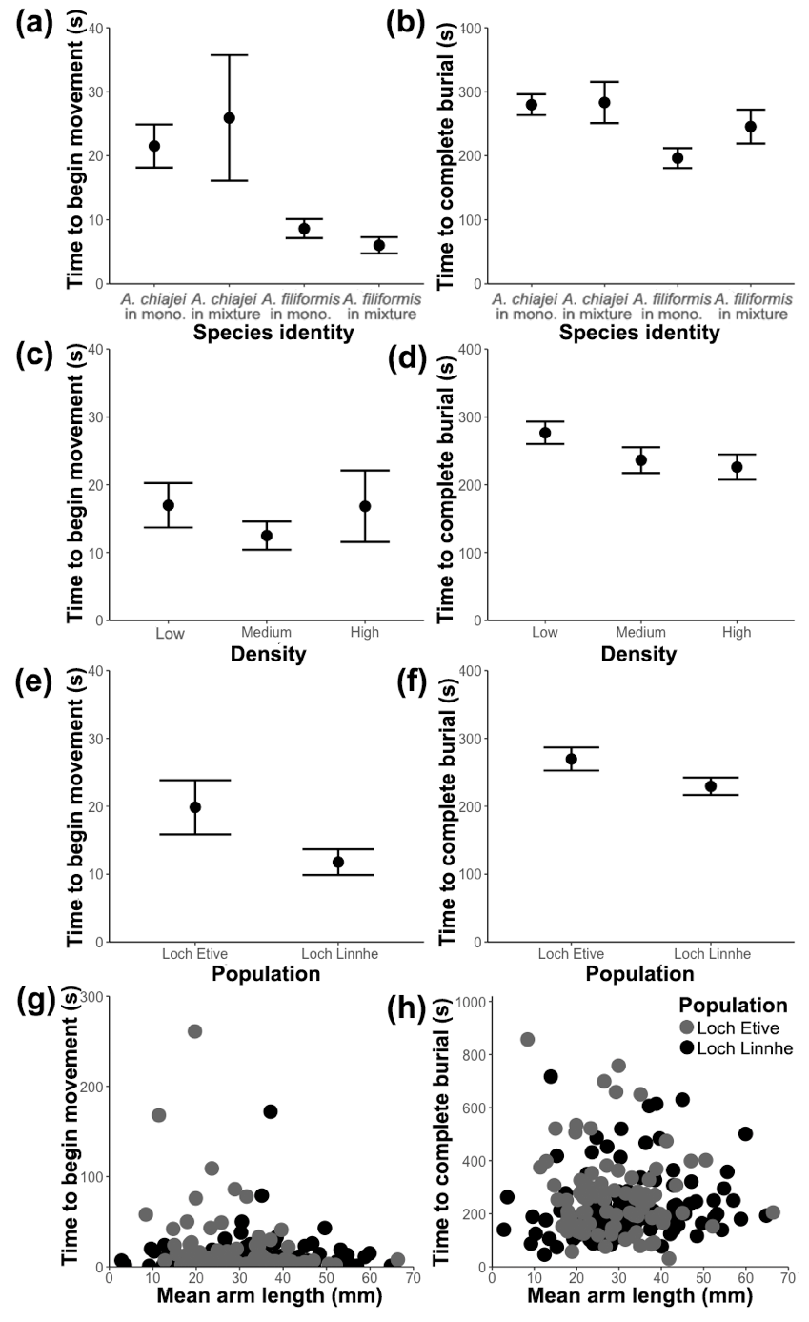
Fig. 1: The effect of biotic and abiotic context on time elapsed (mean ± SE) (s) for Amphiura chiajei and Amphiura filiformis to (a, c, e, g) begin movement and (b, d, f, h) complete burial into the sediment, where (a - b) show the independent effects of species identity, (c - d) show the independent effect of density, (e - f) show the independent effect of population of origin, and (g - h) show the interactive effect of population x mean arm length (mm).

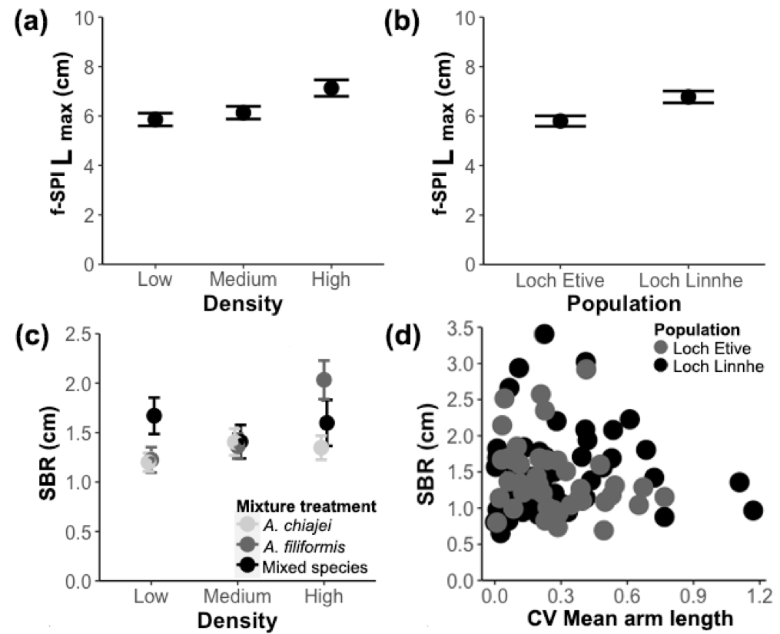
Fig. 2: The effects of biotic and abiotic context on (mean ± SE, n= 6) (a) and (b) ^{f-SPI}L_{max} (cm) and (c) and (d) surface boundary roughness (SBR) (cm) in mesocosms containing Amphiura filiformis and Amphiura chiajei in monoculture or mixture, showing the (a) independent effect of density and (b) the independent effect of population, (c) the interactive effect of density x species treatment, and (d) the interactive effect of morphological trait variation (CV of mean arm length) and population.

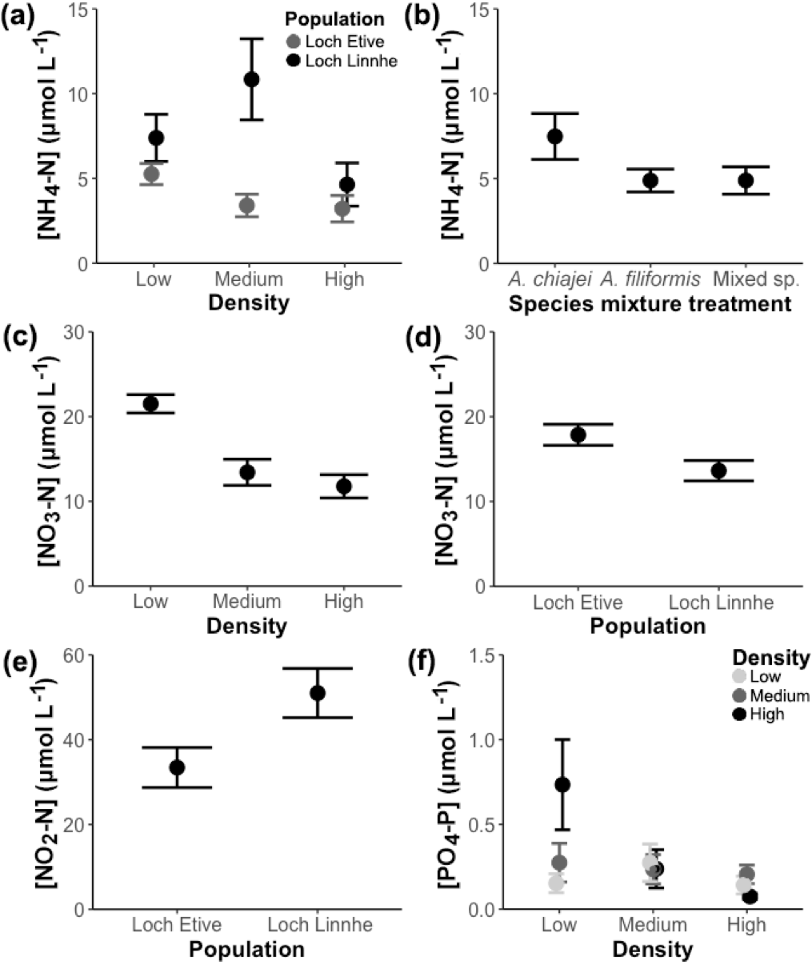
Fig. 3: The effects of differing biotic and abiotic context on (mean ± SE, n= 6) (µmol L⁻¹) (a) and (b) [NH₄-N], (c) and (d) [NO₃-N], (e) [NO₂-N], and (f) [PO₄-P] where (a) shows the interactive effects of density x population, (b) shows the independent effect of species treatment, (c) and (d) show the independent effects of density and population, respectively, (e) shows the independent effect of population, and (f) the interactive effect of density x species treatment.

References
Adair, E. C., Hooper, D. U., Paquette, A., & Hungate, B. A. (2018). Ecosystem context illuminates conflicting roles of plant diversity in carbon storage. Ecology Letters, 21, 1604-1619. doi: 10.1111/ele.13145

Albert, C. H., Thuiller, W., Yoccoz, N. G., Douzet, R., Aubert, S. & Lavorel, S. (2010). A multi‐trait approach reveals the structure and the relative importance of intra‐vs. interspecific variability in plant traits. Functional Ecology, 24, 1192-1201. doi: 10.1111/j.1365-2435.2010.01727.x

Alp, M., Keller, I., Westram, A. M., & Robinson, C. T. (2012). How river structure and biological traits influence gene flow: a population genetic study of two stream invertebrates with differing dispersal abilities. Freshwater Biology, 57, 969-981. doi: 10.1111/j.1365-2427.2012.02758.x

Astley, H.C. (2012). Getting around when you’re round: quantitative analysis of the locomotion of the blunt-spined brittle star, Ophiocoma echinata. Journal of Experimental Biology, 215, 1923-1929. doi: 10.1242/jeb.068460

Baranov, V., Lewandowski. J. & Krause, S. (2016) Bioturbation enhances the aerobic respiration of lake sediments in warming lakes. Biology Letters, 12, 20160448. doi: 10.1098/rsbl.2016.0448.

Bennett, J.A., Riibak, K., Tamme, R., Lewis, R.J. & Pärtel, M., 2016. The reciprocal relationship between competition and intraspecific trait variation. Journal of Ecology, 104, 1410-1420. doi: /10.1111/1365-2745.12614

Bolam, S.G., Garcia, C., Eggleton, J., Kenny, A.J., Buhl-Mortensen, L., Gonzalez-Mirelis, G., …. Sciberras, M. (2017). Differences in biological traits composition of benthic assemblages between unimpacted habitats. Marine Environmental Research, 126, 1-13. doi: 10.1016/j.marenvres.2017.01.004

Buchanan, J. B. (1964). A comparative study of some features of the biology of Amphiura filiformis and Amphiura chiajei [Ophiuroidea] considered in relation to their distribution. Journal of the Marine Biological Association of the United Kingdom, 44, 565-576. doi: 10.1017/S0025315400027776

Bulling, M. T., Solan, M., Dyson, K. E., Hernandez-Milian, G., Luque, P., Pierce, G. J. ... & White, P. C. (2008). Species effects on ecosystem processes are modified by faunal responses to habitat composition. Oecologia, 158, 511-520. doi: 10.1007/s00442-008-1160-5

Calosi, P., Rastrick, S. P., Lombardi, C., de Guzman, H. J., Davidson, L., Jahnke, M. ... & Gambi, M. C. (2013). Adaptation and acclimatization to ocean acidification in marine ectotherms: an in situ transplant experiment with polychaetes at a shallow CO2 vent system. Philosophical Transactions of the Royal Society B: Biological Sciences, 368, 20120444. doi: 10.1098/rstb.2012.0444

Carmona, C. P., de Bello, F., Mason, N. W., & Lepš, J. (2016). Traits without borders: integrating functional diversity across scales. Trends in Ecology & Evolution, 31, 382-394. doi: 10.1016/j.tree.2016.02.003

Calder-Potts, R., Spicer, J. I., Calosi, P., Findlay, H. S., Queiros, A. M. & Widdicombe, S. (2018). Density-dependent responses of the brittlestar Amphiura filiformis to moderate hypoxia and consequences for nutrient fluxes. Marine Ecology Progress Series, 594, 175-191. doi: 10.3354/meps12503

Des Roches, S., Post, D. M., Turley, N. E., Bailey, J. K., Hendry, A. P., Kinnison, M. T., ... & Palkovacs, E. P. (2018). The ecological importance of intraspecific variation. Nature Ecology & Evolution, 2, 57. doi: 10.1038/s41559-017-0402-5

De Backer, A., Coillie, F.V., Montserrat, F., Provoost, P., Colen, C.V., Vincx, M. & Degraer, S. (2011). Bioturbation effects of Corophium volutator: Importance of density and behavioural activity. Estuarine, Coastal and Shelf Science, 91, 306-313. doi: 10.1016/j.ecss.2010.10.031

Derroire, G., Powers, J. S., Hulshof, C. M., Varela, L. E. C., & Healey, J. R. (2018). Contrasting patterns of leaf trait variation among and within species during tropical dry forest succession in Costa Rica. Scientific Reports, 8, 285. doi: 10.1038/s41598-017-18525-1

Duineveld, G. C. A., Künitzer, A. & Heyman, R. P. (1987). Amphiura filiformis (Ophiuroidea: Echinodermata) in the North Sea. Distribution, present and former abundance and size composition. Netherlands Journal of Sea Research, 21, 317-329. doi: 10.1016/0077-7579(87)90006-8

Ershova, E., Descoteaux, R., Wangensteen, O., Iken, K., Hopcroft, R., Smoot, C., ... & Bluhm, B. A. (2019). Diversity and distribution of meroplanktonic larvae in the Pacific Arctic and connectivity with adult benthic invertebrate communities. Frontiers in Marine Science, 6, 490. doi: 10.3389/fmars.2019.00490

Fisher, D. N., David, M., Tregenza, T. & Rodríguez-Muñoz, R. (2015). Dynamics of among-individual behavioral variation over adult lifespan in a wild insect. Behavioral Ecology, 26, 975-985. doi: 10.1093/beheco/arv048

Finerty, G. E., de Bello, F., Bílá, K., Berg, M. P., Dias, A. T., Pezzatti, G. B., & Moretti, M. (2016). Exotic or not, leaf trait dissimilarity modulates the effect of dominant species on mixed litter decomposition. Journal of Ecology, 104, 1400-1409. doi: 10.1111/1365-2745.12602

Friedrich, J., Janssen, F., Aleynik, D., Bange, H.W., Boltacheva, N., Çagatay, … Gilli, A. (2014). Investigating hypoxia in aquatic environments: diverse approaches to addressing a complex phenomenon. Biogeosciences, 11, 1215-1259. doi: 10.5194/bg-11-1215-2014

Forster, S., Glud, R.N., Gundersen, J.K. & Huettel, M. (1999). In situ study of bromide tracer and oxygen flux in coastal sediments. Estuarine, Coastal and Shelf Science, 49, 813-827. doi: 10.1006/ecss.1999.0557

Fritschie, K. J., & Olden, J. D. (2016). Disentangling the influences of mean body size and size structure on ecosystem functioning: An example of nutrient recycling by a non‐native crayfish. Ecology and Evolution, 6, 159-169. doi: 10.1002/ece3.1852

Funk, J. L., Larson, J. E., Ames, G. M., Butterfield, B. J., Cavender‐Bares, J., Firn, J., ... & Wright, J. (2017). Revisiting the Holy Grail: using plant functional traits to understand ecological processes. Biological Reviews, 92, 1156-1173. doi: 10.1111/brv.12275

Gage, J. (1972). A preliminary survey of the benthic macrofauna and sediments in Lochs Etive and Creran, sea-lochs along the west coast of Scotland. Journal of the Marine Biological Association of the United Kingdom, 52, 237-276.

Gagic, V., Bartomeus, I., Jonsson, T., Taylor, A., Winqvist, C., Fischer, C., ... Tscharntke, T. (2015). Functional identity and diversity of animals predict ecosystem functioning better than species-based indices. Proceedings of the Royal Society of London B: Biological Sciences, 282, 20142620. doi: 10.1098/rspb.2014.2620

Godbold, J. A. & Solan, M. (2009). Relative importance of biodiversity and the abiotic environment in mediating an ecosystem process. Marine Ecology Progress Series, 396, 273-282. doi: 10.3354/meps08401

Gogina, M., Nygård, H., Blomqvist, M., Daunys, D., Josefson, A. B., Kotta, J., ... & Zettler, M. L. (2016). The Baltic Sea scale inventory of benthic faunal communities. ICES Journal of Marine Science, 73, 1196-1213. doi: 10.1093/icesjms/fsv265

Hale, R., Mavrogordato, M. N., Tolhurst, T. J. & Solan, M. (2014). Characterizations of how species mediate ecosystem properties require more comprehensive functional effect descriptors. Scientific Reports, 4, 6463. doi: 10.1038/srep06463

Hawlena, D., Hughes, K.M. & Schmitz, O.J. (2011). Trophic trait plasticity in response to changes in resource availability and predation risk. Functional Ecology, 25, 1223–1231. doi: 10.1111/j.1365-2435.2011.01891.x

Henn, J. J., Buzzard, V., Enquist, B. J., Halbritter, A. H., Klanderud, K., Maitner, B. S., ... & Yang, Y. (2018). Intraspecific trait variation and phenotypic plasticity mediate alpine plant species response to climate change. Frontiers in Plant Science, 9, 1548. doi: 10.3389/fpls.2018.01548

Hevia, V., Martín‐López, B., Palomo, S., García‐Llorente, M., Bello, F. & González, J. A. (2017). Trait‐based approaches to analyze links between the drivers of change and ecosystem services: Synthesizing existing evidence and future challenges. Ecology and Evolution, 7, 831-844. doi: 10.1002/ece3.2692

Kraft, N. J., Godoy, O. & Levine, J. M. (2015). Plant functional traits and the multidimensional nature of species coexistence. Proceedings of the National Academy of Sciences, 112, 797-802. doi: 10.1073/pnas.1413650112

Kristensen, E., Delefosse, M., Quintana, C. O., Flindt, M. R., & Valdemarsen, T. (2014). Influence of benthic macrofauna community shifts on ecosystem functioning in shallow estuaries. Frontiers in Marine Science, 1, 41. doi: 10.3389/fmars.2014.00041

Landeira-Dabarca, A., Pérez, J., Graça, M. A., & Boyero, L. (2019). Joint effects of temperature and litter quality on detritivore-mediated breakdown in streams. Aquatic Sciences, 81, 1. doi: 10.1007/s00027-018-0598-8

Larsen, T. H., Williams, N. M., & Kremen, C. (2005). Extinction order and altered community structure rapidly disrupt ecosystem functioning. Ecology Letters, 8, 538-547. doi: 10.1111/j.1461-0248.2005.00749.x

Laughlin, D.C. (2014). Applying trait‐based models to achieve functional targets for theory‐driven ecological restoration. Ecology Letters, 17, 771-784. doi: 10.1111/ele.12288

Liao, W. B., Luo, Y., Lou, S. L., Lu, D., & Jehle, R. (2016). Geographic variation in life-history traits: growth season affects age structure, egg size and clutch size in Andrew’s toad (Bufo andrewsi). Frontiers in Zoology, 13, 6. doi: 10.1186/s12983-016-0138-0

Matesanz, S., & Ramírez‐Valiente, J. A. (2019). A review and meta‐analysis of intraspecific differences in phenotypic plasticity: Implications to forecast plant responses to climate change. Global Ecology and Biogeography. doi: 10.1111/geb.12972

Mensens, C., De Laender, F., Janssen, C. R., Sabbe, K. & De Troch, M. (2017). Different response–effect trait relationships underlie contrasting responses to two chemical stressors. Journal of Ecology, 105, 1598-1609. doi: 10.1111/1365-2745.12777

Mitchell, R. M. & Bakker, J. D. (2014a). Intraspecific trait variation driven by plasticity and ontogeny in Hypochaeris radicata. PloS one, 9, e109870. doi: 10.1371/journal.pone.0109870

Mitchell, R. M. & Bakker, J. D. (2014b). Quantifying and comparing intraspecific functional trait variability: a case study with Hypochaeris radicata. Functional Ecology, 28, 258-269. doi: 10.1111/1365-2435.12167

Moran, N.P., Mossop, K.D., Thompson, R.M., Chapple, D.G. & Wong, B.B. (2017). Rapid divergence of animal personality and syndrome structure across an arid-aquatic habitat matrix. Oecologia, 185, pp.55-67. doi: 10.1007/s00442-017-3924-2

Munday, B.W. & Keegan, B.G. (1992). Population dynamics of Amphiura chiajei (Echinodermata: Ophiuroidea) in Killary Harbour, on the west coast of Ireland. Marine Biology, 114, 595-605. doi: 10.1007/BF00357256

Murray, F., Widdicombe, S., McNeill, C. L. & Solan, M. (2013). Consequences of a simulated rapid ocean acidification event for benthic ecosystem processes and functions. Marine Pollution Bulletin, 73, 435-442. doi: 10.1016/j.marpolbul.2012.11.023

Murray, F., Solan, M., & Douglas, A. (2017). Effects of algal enrichment and salinity on sediment particle reworking activity and associated nutrient generation mediated by the intertidal polychaete Hediste diversicolor. Journal of Experimental Marine Biology and Ecology, 495, 75-82. doi: 10.1016/j.jembe.2017.06.002

Nagelkerken, I., & Munday, P. L. (2016). Animal behaviour shapes the ecological effects of ocean acidification and warming: moving from individual to community‐level responses. Global Change Biology, 22, 974-989. doi: 10.1111/gcb.13167

Norkko, A., Villnäs, A., Norkko, J., Valanko, S. & Pilditch, C. (2013). Size matters: implications of the loss of large individuals for ecosystem function. Scientific Reports, 3, 2646. doi: 10.1038/srep02646

O'Connor, B., Bowmer, T. & Grehan, A. (1983). Long-term assessment of the population dynamics of Amphiura filiformis (Echinodermata: Ophiuroidea) in Galway Bay (west coast of Ireland). Marine Biology, 75, 279-286. doi: 10.1007/BF00406013

Oksanen, J., Blanchet, F.G., Friendly, M., Kindt, R., Legendre, P., McGlinn, D., …. & Wagner, H. (2017). vegan: Community Ecology Package. R package version 2.4-4. URL: https://CRAN.R-project.org/package=vegan

Pérez-Ramos, I. M., Matías, L., Gómez-Aparicio, L., & Godoy, Ó. (2019). Functional traits and phenotypic plasticity modulate species coexistence across contrasting climatic conditions. Nature Communications, 10, 2555. doi: 10.1038/s41467-019-10453-0

Peterson, M. L., Doak, D. F., & Morris, W. F. (2019). Incorporating local adaptation into forecasts of species’ distribution and abundance under climate change. Global Change Biology, 25(3), 775-793. doi: 10.1111/gcb.14562

R Core Team. (2017). R: A language and environment for statistical computing. R Foundation for Statistical Computing, Vienna, Austria. URL: https://www.R-project.org/.

Read, Q. D., Henning, J. A., & Sanders, N. J. (2017). Intraspecific variation in traits reduces ability of trait‐based models to predict community structure. Journal of Vegetation Science, 28, 1070-1081. doi: 10.1111/jvs.12555

Reich, P.B., Rich, R.L., Lu, X., Wang, Y.P. & Oleksyn, J. (2014). Biogeographic variation in evergreen conifer needle longevity and impacts on boreal forest carbon cycle projections. Proceedings of the National Academy of Sciences, 111, 13703-13708. doi: 10.1073/pnas.1216054110

Rijnsdorp, A.D., Bastardie, F., Bolam, S.G., Buhl-Mortensen, L., Eigaard, O.R., Hamon, K.G., … Laffargue, P. (2015). Towards a framework for the quantitative assessment of trawling impact on the seabed and benthic ecosystem. ICES Journal of Marine Science, 73, i127-i138. doi: 10.1093/icesjms/fsv207

Robins, P. E., Neill, S. P., Giménez, L., Jenkins, S. R., & Malham, S. K. (2013). Physical and biological controls on larval dispersal and connectivity in a highly energetic shelf sea. Limnology and Oceanography, 58(2), 505-524. doi: 10.4319/lo.2013.58.2.0505

Roscher, C., Gubsch, M., Lipowsky, A., Schumacher, J., Weigelt, A., Buchmann, N., … Schmid, B. (2018). Trait means, trait plasticity and trait differences to other species jointly explain species performances in grasslands of varying diversity. Oikos, 127, 865. doi: 10.1111/oik.04815

Rosenberg, R. & Selander, E. (2000). Alarm signal response in the brittle star Amphiura filiformis. Marine Biology, 136, 43-48. doi: 10.1007/s002270050006

Rudolf, V.H. & Rasmussen, N.L. (2013). Population structure determines functional differences among species and ecosystem processes. Nature Communications, 4, 2318. doi: 10.1038/ncomms3318

Schneider, C. A., Rasband, W. S. & Eliceiri, K. W. (2012). NIH Image to ImageJ: 25 years of image analysis. Nature Methods, 9, 671-675. doi: 10.1038/nmeth.2089

Solan, M., Wigham, B.D., Hudson, I.R., Kennedy, R., Coulon, C.H., Norling, K., ... & Rosenberg, R. (2004). In situ quantification of bioturbation using time lapse fluorescent sediment profile imaging (f SPI), luminophore tracers and model simulation. Marine Ecology Progress Series, 271, 1-12. doi: 10.3354/meps271001

Solan, M., Ward, E. R., White, E. L., Hibberd, E. E., Cassidy, C., Schuster, J. M., ... & Godbold, J. A. (2019). Worldwide measurements of bioturbation intensity, ventilation rate, and the mixing depth of marine sediments. Scientific Data, 6, 58. doi: 10.1038/s41597-019-0069-7

Thomsen, M. S., Godbold, J. A., Garcia, C., Bolam, S. G., Parker, R., & Solan, M. (2019). Compensatory responses can alter the form of the biodiversity–function relation curve. Proceedings of the Royal Society B, 286, 20190287. doi: 10.1098/rspb.2019.0287

Törnroos, A., Nordström, M.C., Aarnio, K. & Bonsdorff, E. (2015). Environmental context and trophic trait plasticity in a key species, the tellinid clam Macoma balthica L. Journal of Experimental Marine Biology and Ecology, 472, 32–40. doi: 10.1016/j.jembe.2015.06.015

Turcotte, M. M., & Levine, J. M. (2016). Phenotypic plasticity and species coexistence. Trends in Ecology & Evolution, 31, 803-813. doi: 10.1016/j.tree.2016.07.013

Wohlgemuth, D., Solan, M. & Godbold, J.A. (2017). Species contributions to ecosystem process and function can be population dependent and modified by biotic and abiotic setting. Proceedings of the Royal Society B: Biological Sciences, 284, 20162805. doi: 10.1098/rspb.2016.2805

Wright, J.P., Ames, G.M. & Mitchell, R.M. (2016). The more things change, the more they stay the same? When is trait variability important for stability of ecosystem function in a changing environment. Philosophical Transactions of the Royal Society B: Biological Sciences, 371, 20150272. doi: 10.1098/rstb.2015.0272

Zuo, X., Yue, X., Lv, P., Yu, Q., Chen, M., Zhang, J., … & Zhang, J. (2017). Contrasting effects of plant inter‐and intraspecific variation on community trait responses to restoration of a sandy grassland ecosystem. Ecology and Evolution, 7, 1125-1134. doi: 10.1002/ece3.271

Zuur, A., Ieno, E. N., Walker, N., Saveliev, A. A., & Smith, G. M. (2009). Mixed effects models and extensions in ecology with R. New York, Springer. doi: 10.1007/978-0-387-87458-6

