Effects of nickel-aluminum bronze pre-oxidized films on the cathodic kinetics of oxygen reduction
Siti Musabikhaª,* I K.A.P. Utama^{b}, Mukhtasorª, Julian A. Wharton^{c}, Robert J.K. Wood^{c}

- Department of Ocean Engineering, Faculty of Marine Technology, Institut Teknologi Sepuluh Nopember, Surabaya, Indonesia
- Department of Naval Architecture, Faculty of Marine Technology, Institut Teknologi Sepuluh Nopember, Surabaya, Indonesia
- National Centre for Advanced Tribology at Southampton (nCATS), Faculty of Engineering and Physical Sciences, University of Southampton, Highfield, Southampton, SO17 1BJ, UK

*Address correspondence to Siti Musabikha, Department of Ocean Engineering, Faculty of Marine Technology, Institut Teknologi Sepuluh Nopember, Gedung WA, Keputih, Sukolilo, Surabaya 60111, Indonesia. Tel/fax: +62-31-5928105. Email: siti15@mhs.na.its.ac.id

ABSTRACT
The cathodic oxygen reduction kinetics of the freshly polished and the pre-oxidized nickel-aluminum bronze surfaces were investigated in a 3.5 wt.% NaCl solution under steady-state and well-defined hydrodynamic conditions using a rotating disc electrode setup. The diffusion coefficient of the pre-oxidized film specimen of 0.72 × 10^{–5} cm² s^{–1}, was lower than that of the freshly polished surface of 2.55 × 10^{–5} cm² s^{–1}, a 3.5 fold decrease, demonstrating the extent to which the oxygen diffusion within the pre-oxidized film was hindered.

Keywords: oxygen reduction kinetics; rotating disc electrode; nickel-aluminum bronze; pre-oxidized film; oxide film.

Nomenclature

$c_{o}$ bulk concentration of dissolved oxygen, mol cm^{–3}
D diffusion coefficient of dissolved oxygen, cm² s^{–1}
$F$ Faraday constant, C mol^{–1}
$i_{lim}$ limiting current density, mA cm^{–2}
$i_{corr}$ corrosion current density, mA cm^{–2}
$k^{}$ potential dependent rate constant for the reaction
$k_{m}$ mass transport coefficient, cm s^{–1}
$k_{s}$ standard rate constant, cm s^{–1}
$ω^{}$ rotation speed, rpm
$z$ number of electrons in electrode process
$ν$ kinematic viscosity, cm² s^{–1}

Introduction
Corrosion problems often occur on metals used as structural materials in marine environments, such as atmospheric, splash, tidal and immersion zones (James and Hattingh 2015; Soares et al. 2009). Corrosion can result in failures due to loss of the material strength and lead to the performance reduction of the offshore and marine technologies (Bhandari et al. 2015; Wood 2006). Offshore and marine technologies suffer from corrosion induced by a variety of conditions, for example: ships, offshore platforms, marine energy devices, submarines, pipelines, and underwater storage and shore facilities (Bhandari et al. 2015; Phull 2010; Satrio, Utama, and Mukhtasor 2018). Thus, corrosion control should be provided to mitigate the consequences of material degradation (Musabikha, Utama, and Mukhtasor 2017).
Nickel-aluminum bronze (NAB) is a class of copper-based alloys which offers excellent wear and corrosion resistance, and is well-recognized as a marine propeller and propulsor material (Barik et al. 2005; Kear, Barker, and Walsh 2004; Rajakumar and Balasubramanian 2018; Wharton et al. 2005; Wood 2017). Also, NAB can provide good corrosion resistance and mechanical performance characteristics (Culpan and Rose 1979; Wharton et al. 2005). NAB is also considered as the most resistant of copper-based alloys to flow induced corrosion (Wharton et al. 2005) below the operational recommended value of 4.3 m s^{–1} and its general corrosion resistance of <0.025 – 0.05 mm y^{–1} (Richardson et al. 2016). Its corrosion resistance originates from the filmed surface, several hundred nanometers thick, that develops over several weeks upon first exposure to give a protective oxide film, and is reported to even self-repair (Richardson 2016; Walsh, Arenas, and Kear 2018).
Previous studies have investigated the corrosion characteristics of copper-based alloys, including NAB, which has similarities of corrosion behavior between copper-based alloys and NAB. In general, Deslouis et al. (1988) investigated the electrochemical behavior of copper in steady state conditions and reduction peak was found and identified as insoluble corrosion product (CuCl and Cu₂O) in the cathodic range. Then, King, Quinn, and Litke (1995) examined the oxygen reduction on copper in sodium chloride solutions using rotating ring-disc electrode while considering the effects of rotation rate. On copper surfaces the oxygen reduction reaction often relies on the surface condition, with an enhanced catalytic surface for oxygen reduction contain both Cu(0) and Cu(I) species than the bare metal itself, i.e., Cu(0) only. Overall, in neutral or alkaline electrolytes (seawater and 3.5 wt.% NaCl solution), the oxygen reduction can be expressed as:

$O_{2}+2H_{2}O+4e^{-}→4{OH}^{-}$ (1)

From the open literature, Kear et al. (2004) have analyzed the flow influenced electrochemical corrosion of wrought high strength NAB CA 104 (UNS C63200). The reaction of oxygen reduction was irreversible, and the overall mean diffusion coefficient was 1.7±0.1 ×10^{–5} cm² s^{–1} for both the filtered and artificial seawaters. In addition, Wharton et al. (2005) provide a comprehensive review of cast and wrought NAB corrosion in seawater that included cathodic and anodic polarizations. Kear et al. (2004) and Wharton et al. (2005) provide cathodic linear sweep voltammetry data of wrought NAB using RDE varying the rotation speed. The wrought NAB RDE corrosion rates reported as a corrosion current density (i_{corr}) were 5.6 μA cm^{–2} and 8.8 μA cm^{–2}, at 200 rpm and 1400 rpm, respectively. Kear et al. (2007) have also examined the cathodic and anodic polarization characteristic of 90–10 Cu–Ni alloy as a function of flow velocity. The cathodic reaction was considered to occur via the irreversible direct four-electron exchange and the anodic reaction governed by the selective copper dissolution of the alloy. However, for fluid flows above a critical Reynolds number, a reversible character tended to control the reduction and oxidation reaction rates.
The in-service performance of NAB relies on its protective oxide film. As such, this film plays an important role for the marine corrosion protection and consists of several chemical components, namely cuprous chloride (CuCl), cuprous oxide (Cu₂O), cupric hydroxide (Cu(OH)₂), cupric oxide (CuO), atacamite (Cu₂(OH)₃Cl), and malachite (CuCO₃.Cu(OH)₂) (Kear, Barker, and Walsh 2004). In addition, the film also significantly affects the anodic and cathodic reaction kinetics on copper alloys (Kear, Barker, and Walsh 2004).
Basumatary and Wood (2017) studied the two different NAB oxide film conditions, air-formed and 3.5% NaCl solution immersion, and their influence on the synergistic effects of cavitation erosion-corrosion of as-cast NAB UNS C95800. Higher synergistic effects were measured on NAB with a water-formed oxide film. Conversely, Schussler and Exner (1993) studied the protective layer formation and the passivation mechanism for corrosion of cast NAB. However, the cathodic polarization of freshly prepared and passive samples was examined at different oxygen concentrations. Ding et al. (2019) examined the evolution of the NAB protective film and its corrosion behavior without considering their effects on the oxygen reduction reaction. Liao et al. (2011) examined the corrosion behavior of copper under thin electrolyte layer in atmospheric environments and reported that the corrosion rate increases when the thin layer thickness decreases. When the limiting current densities were reached, the oxygen reduction reaction was under mass-transfer control.
This paper studies the cathodic reduction kinetics of NAB protective oxide films which were formed artificially. The pre-oxidized surface film differs with the previous works of Cheng et al. (2004) and Liao et al. (2011) since their thin electrolyte layers which were naturally gained and used to evaluate atmospheric corrosion behavior of copper. In addition, this study was conducted using a rotating disc electrode (RDE) setup to investigate the oxygen reduction kinetics in aerated 3.5 wt.% NaCl solutions under well-defined laminar flow conditions.
Within marine environments the oxygen reduction reaction is the predominant cathodic process. Consequently, it is important to have controlled tests when considering effects of fluid flow and mass transport of dissolved oxygen to electrochemically active surfaces. Indeed, the nature of the substrate, its surface state, electrolyte and ambient temperature all critically influence the oxygen reduction kinetics at the metal|solution interface. The entire oxygen reduction can be assessed (considering charge-, mixed- and mass-transport control) using the Koutecky-Levich approach. However, this study will focus on mass transport control, i.e., the limiting current density region. The limiting current density ($i_{lim}$) is defined as function of the averaged mass transport coefficient ($k_{m}$), and the bulk concentration of dissolved oxygen ($c_{o}$) (Kear et al. 2004):

$i_{lim}=k_{m}zFc_{o}$ (2)

where z is the number of electrons transferred in the mass transfer reaction and F is the Faraday constant. The Levich equation (Equation 3) expresses the limiting current density response as a function of the square root of the electrode rotation speed (ω^{0.5}). Thus, for the flat and smooth RDE under laminar flow conditions, it describes mass transfer phenomena through convection and diffusion processes at the electrode surface (Westbroek et al. 2000).

$i_{(RDE)}=0.62zFD^{0.667}ν^{-0.167}c_{o}ω^{0.50}$ (3)

where $ν$ is the kinematic viscosity of the fluid and D is the diffusion coefficient of dissolved oxygen.

Experimental Details
Materials
Nickel-aluminum bronze (CuAl9Ni5Fe4Mn) rotating disc electrodes were utilized conforming to British naval standard NES 747 Part 2 annealed at 675°C for 2-6 h and cooled in air. The NAB chemical composition was: Cu balance, Al 8.8–9.5, Ni 4.5–5.5, Fe 4.0–5.0, Mn 0.75–1.3 wt.% (Wharton et al. 2005). The RDE setup used a modulated speed rotator manufactured by Pine Research Instrumentation. The working electrodes were encapsulated in an inert high-density polyethylene sheath, with an exposed disc diameter and surface area of 0.40 cm and 0.13 cm², respectively.
Each sample was wet-polished using 1200 and 4000 grit SiC abrasive paper, followed by fine polishing with 6 µm and 1 µm monocrystalline diamond paste. Afterwards, the surface was washed with distilled water, degreased in acetone, and dried in cool air flow prior to testing. A 3.5 wt.% (0.6 mol L^{–1}) NaCl test solution was used that was made up using distilled water and analytical grade reagent sodium chloride (Sigma-Aldrich Co. LLC). The average values of pH, chloride ion (Cl–) concentration, and dissolved oxygen concentration for these experiments were pH 5.4±0.03, 0.599×10^{–3} mol cm^{–3}, and 7±0.02 ppm (2.188×10^{–7} mol cm^{–3}), respectively.

Experimental Methodology
All electrochemical measurements were made using the NAB discs as the working electrode, silver/silver chloride (Ag/AgCl, 3.5 M KCl, ABB Limited, UK) as the reference electrode and a graphite as the counter electrode. Tests were made using a Gamry Instruments Reference 600 Potentiostat and Gamry Framework software. All experiments were conducted within a Faraday cage. The RDE and the electrochemical measurement setup is shown in Figure 1. To generate an oxidized film on the NAB RDE, the disc was immersed without rotation in the 3.5 wt.% NaCl test solution and an anodic potentiostatic polarization (using an overpotential +0.200 V vs. E_{oc}) applied for 90 minutes. This surface condition will be called the pre-oxidized film from here on. The mean surface roughness of the test specimens for freshly polished surface and pre-oxidized film were 0.010±0.001 µm and 3.283±0.640 µm, respectively. The Vickers hardness, tensile strength, and Poisson’s ratio of NAB are 200 HV, 635 N mm^{–2} (MPa), and 0.32, respectively.
Subsequently, cathodic linear sweep voltammetry (LSV) was performed at different rotation speeds between –0.100 V and –1.200 V vs. Ag/AgCl by scanning the potential at 0.5 mV s^{–1}. The RDE rotation speed was between 500-9500 revolutions per minute (rpm), which corresponds to angular velocities between 52 rad s^{–1} and 994 rad s^{–1} and Reynolds numbers ranging from 393 to 7471. Table 1 shows the corresponding angular velocity (ω), peripheral velocity (U) and Reynolds number $(Re=Ud/ν)$ versus the applied rotation speed (rpm). All tests were carried out at an ambient temperature 21°C (with 7 ppm dissolved oxygen measured using a Hanna Instruments HI-2020 Edge and HI-764080 electrode), slightly lower than compared to 25°C for Kear et al. (2004). A M420 Macroscope with 1.25× magnification and Alicona G4 Infinitefocus microscope were used to examine the microstructure of the NAB disc surfaces, before and after testing.

Results and Discussion
Pre-oxidized film formation
The pre-oxidized film formed compact mixed oxide/hydroxide layers during the 90 minutes anodic potentiostatic polarization at a +0.200 V overpotential in a 3.5 wt.% NaCl solution. According to Schüssler and Exner (1993) and Wharton and Stokes (2008), the NAB protective oxide films typically attain thicknesses between 900 nm to 1000 nm when exposed to a corrosive environment.
The visual appearance of the pre-oxidized film is shown in Figure 2(A), where the NAB metallic luster has been replaced with a grey/green colored corrosion product layer; the protective oxide film is likely to contain a mixture of black/steel-grey cupric oxide, CuO, and green/turquoise cupric hydroxychloride, atacamite $({Cu}_{2}{\left(OH\right)}_{3}Cl)$ (Wharton and Stokes, 2008). As previously mentioned, corrosion of NAB has mutual characteristics with the corrosion on unalloyed copper. The pre-oxidized films can be formed by the dissolution of copper metal via a single electron process with three possible reactions (4) – (8) (Kear, Barker, and Walsh 2004; Liao et al. 2011). Cases I and III show the direct formation of a either a chlorocuprous ($Cu{Cl}^{-}$) or dichlorocuprous anion complex$({CuCl}_{2}^{-})$ (Neodo et al. 2013; Papež and Večerník 1984). Whereas, Case II presents the initial oxidation of copper to a cuprous cation, which then reacts with chloride ions to form the soluble ${CuCl}_{2}^{-}$ (Dhar et al. 1985).

- $Cu +2{Cl}^{-}⇌ {CuCl}_{2}^{-} + e^{-}$ (4)
- $Cu ⇌ {Cu}^{+}+ e^{-}$ (5)
${Cu}^{+} +2{Cl}^{-}⇌ {CuCl}_{2}^{-}$ (6)
- $Cu +{Cl}^{-}⇌ {CuCl}^{-}+ e^{-}$ (7)
${CuCl}^{-}+{Cl}^{-}⇌ {CuCl}_{2}^{-}$ (8)

The reactions outlined above play an important role in the formation of the NAB protective oxide films. The ${CuCl}_{2}^{-}$ can react at the metallic interface to produce either cuprous oxide or cuprite (Cu₂O) (reddish) through a precipitation reaction (9) (Kear et al., 2004). Sanchez and Schiffrin (1988) explain that the production of Cu₂O stable films is dependent on chloride cuprous complex diffusion and the precipitation process. Subsequently, cuprous oxide is oxidized to cupric oxide (CuO) (black) on reaction (10) (Kwok et al. 2009) and atacamite ${(Cu}_{2}{(OH)}_{3}Cl)$ (greenish) on reaction (11) (Bianchi et al. 1978; Liao et al. 2011; Mansfeld et al. 1994), at the outer oxide surface.

${2CuCl}_{2}^{-} +2{OH}^{-}⇌ {Cu}_{2}O + H_{2}O+{4Cl}^{-}$ (9)
${Cu}_{2}O +H_{2}O→ 2CuO+{2H}^{+}+2e^{-}$ (10)
${2CuCl}_{2}^{-}+O_{2}+2H_{2}O→ {2Cu}_{2}{(OH)}_{3}Cl+{OH}^{-}$ (11)

Figure 2(B)-(K) shows the NAB RDE surfaces after testing for 2200 s at rotation speeds between 1000 rpm and 9500 rpm. It is evident that the pre-oxidized film was almost completely removed, with the metallic NAB visible over most of the surfaces. It is also clearly apparent that the extent of film removal increases with increasing rotation speed in terms of the severity of the hydrodynamic flow across the disc surfaces. In addition, there is evidence of patchy copper redeposition that is often linked with the reduction of cupric ions (Wharton and Stokes, 2008). The appearance of the multicolor pre-oxidized film after rotating at 3000 rpm is shown in Figure 3 where the roughened metal surface is partially covered by red-orange metallic luster and grey/green layers, associated with redeposited copper, cupric oxide, and atacamite. In comparison, a freshly polished NAB surface reveals a more complex microstructurally morphology with generally three distinct phases, i.e., α-phase, β-phase, and κ-phases (Lorimer et al. 1986), as can be seen in Figure 4. The α-phase is the light areas which are copper-rich regions, and β-phase is often associated dark etched regions, (in this study the NAB conformed to NES 747 Part 2 and which minimized the β-phase). There are also several κ-phases. The κ_{I}-phase is iron-rich region that has a globular form, the κ_{II}-phase is either a dendritic rosette or a globular form that is smaller than the κ_{I}-phase. The κ_{III}-phase is a fine lamellar nickel-rich regions. Finally, the κ_{IV}-phase is a fine iron-rich intermetallic found within the α-phase.

Cathodic polarization behavior
When performing a cathodic LSV in aerated chloride media the oxygen reduction reaction is the predominant process, that comprises an overall four electrons exchange and producing hydroxide ions (Equation 1). The potential versus current density curves for the potentiodynamic cathodic reaction of the freshly polished NAB surfaces were obtained from these experiments, are shown in Figure 5.
The cathodic reduction of oxygen curves on the freshly polished surfaces have four distinct regions, as seen in Figure 5 (Frankel 2016; Kear, Walsh, Barker, and Stokes 2000; Kear, Barker, and Walsh 2004; Kear, Ponce-De-Leon, and Walsh 2005; Liao et al. 2011):
- Initially near to the open circuit potential (approx. –0.200 V vs. Ag/AgCl) and the reaction is totally governed by charge transfer/kinetics control.
- The mixed (charge- and mass-transfer) control occurs between –0.350 V and –0.600 V vs. Ag/AgCl.
- A limiting current density plateau develops between –0.600 V and –1.000 V vs. Ag/AgCl. Here the oxygen reduction reactant under mass-transfer control. When the dissolved oxygen surface concentration reaches a minimum value, this produces a condition called the limiting current in the form of a plateau (Ponce-de-León et al. 2007). This condition also depends on diffusion layer thickness which is influenced by the rotation speed. When the rotation speed increases, the limiting current will increase too.
- Beyond –1.000 V vs. Ag/AgCl the reduction of water and hydrogen evolution will predominant (12).

$2H_{2}O+2e^{-}→H_{2}+{2OH}_{}^{-}$ (12)

In Figure 5, small peaks are evident between –1.0 V and –1.2 V vs. Ag/AgCl after the cathodic limiting current plateau due to measurement instabilities. The cathodic Tafel slope of these experiments was –212 mV decade^{–1} for the freshly polished specimen. In the open literature, the cathodic slopes of –140 mV decade^{–1} were found for the cast NAB (Schüssler and Exner 1993) and –150 mV decade^{–1} for wrought NAB of were measured for RDE in the artificial seawaters (Wharton et al. 2005). For this study, the Tafel slope is slightly higher; however, it is in within range reported by Kear, Barker, and Walsh (2004), who summarized cathodic slopes for oxygen reduction reaction of pure copper in chloride solutions between – 46 to –300 mV decade^{–1} due to differences in the metallic surface conditions. Tafel slopes will also be affected by electrolyte and dissolved oxygen concentration. Overall, the kinetics of oxygen reduction is affected by many factors such as the substrate, surface films, and temperature. For the oxygen reduction at the freshly polished NAB, the mid-point potential E_{L} within the limiting current density region ranged from –0.808 V to –0.920 V vs. Ag/AgCl for rotation speeds between 500-9500 rpm. This is in good agreement with (Kear et al. 2004; Wharton et al. 2005).
Figure 6 shows the oxygen reduction polarizations of the pre-oxidized NAB surfaces for rotation speeds between 500-9500 rpm. The cathodic oxygen reduction polarization curves for the pre-oxidized films differ from the freshly polished surfaces. The filmed curves generally have a similar shape to the freshly polished surfaces; however, there are several characteristic differences. The oxygen reduction curves of the pre-oxidized surfaces consist of five sections: section (1) random peak – consistent with the uncontrolled nature of the copper redeposition (i.e., the reduction of copper cation species within the film); section (2) interchange section considered as the initiation of reduction reaction; section (3) under mixed control; section (4) the reaction under mass-transfer control; and section (5) hydrogen evolution.
In the section (1), copper redeposition is the most likely reduction reaction to occur in this region and there is evidence of metallic copper on the NAB surface after testing, see Figure 3. Since any residual copper cations within the pre-oxidized film will be cathodically reduced to yield redeposited metallic copper on the NAB surface:
${Cu}^{2+}+2e^{-}→Cu$ (13)
Within pre-oxidized films this reaction will be uncontrolled hence the random character of section (1). The actual film composition is unknown and this section can be influenced by several factors, such as the availability of residual copper cations at the NAB surface, hydrodynamic conditions and the extent to which the oxide film remains intact. When the applied potential becomes more electronegative, the section (2) emerges as interchange section considered as the initiation of reduction reaction and followed by the section (3) under mixed control. At more electronegative potentials, the oxygen reduction reaction will predominate and a limiting current plateau emerges at section (4). At –1.2 V (section 5), hydrogen evolution and hydrodynamic flow will disturb and disrupt the oxide (again uncontrolled and random). The E_{L} values for the oxygen reduction at the pre-oxidized film NAB ranged from –0.703 V to –0.861 V vs. Ag/AgCl for rotation 500–9500 rpm. The electrode potential range for kinetics in the mixed control was –0.348 V to –0.661 V vs. Ag/AgCl.
The diffusion coefficients for oxygen ($D_{O_{2}}$) were estimated via Levich slopes using Equation 3, as shown in Table 2. For the freshly polished sample, the diffusion coefficient value was 2.55 × 10^{–5} cm² s^{–1} with slopes of –13.403 × 10^{–6} A rad^{–0.5} s^{0.5}. This is consistent with literature results of 1.79 × 10^{–5} cm² s^{–1} with slopes of –9.610 × 10^{–6} A rad^{–0.5} s^{0.5} for artificial seawater (Kear et al. 2004). The small deviation from the literature values was mostly likely due to different operating temperatures. Kear, Barker, and Walsh (2004) listed the literature oxygen diffusion coefficients at several temperatures showing that the increase temperature produces an increase in diffusion coefficient values. For the pre-oxidized film, the diffusion coefficient was 0.72 × 10^{–5} cm² s^{–1} with slopes of –5.821 × 10^{–6} A rad^{–0.5} s^{0.5}. The diffusion coefficients in the freshly polished NAB were higher, therefore the diffusion processes for the pre-oxidized surfaces were slower.
The mass transfer coefficients ($k_{m}$) were also evaluated from the limiting current densities using Equation 2 ranged from 0.0087 to 0.0369 cm s^{–1} for the freshly polished NAB; compared with 0.004 to 0.029 cm s^{–1} reported by Kear et al. (2004). The mass transfer coefficients of the pre-oxidized film NAB was slightly lower than that of the freshly polished electrode’s value of 0.0065 to 0.0340 cm s^{–1}. Figure 7 presents the mass transfer coefficient as a function of the square root of RDE rotation speed, where the intercepts close to zero suggest the full mass-transfer control of oxygen reduction was almost accomplished.
The Koutecky–Levich formula of mixed controlled data can be applied to obtain a current response as a function of the RDE rotation speed:

$$\frac{1}{i}=\frac{1}{ zFkc_{o}}+\frac{1}{0.62 z F{c_{o}ν}^{-0.167}}.\frac{1}{ω^{0.5}} (14)$$

Current density (i) versus rotation speed (ω) can be utilized; however reciprocal plots ($i_{}^{-1}$ vs. ω^{–0.5}) provide an enhanced assessment of any linear correlation with intercepts along the coordinate axis. The Koutecky–Levich plots for both the freshly polished and pre-oxidized NAB surfaces were compared, see Figure 8, at –25 mV increments sequentially through the mixed control region. The plots demonstrate the linear dependence of the current on rotation speed; however, the regression lines of Figure 8 converge slightly towards the origin. Also, the reciprocal current densities under the pre-oxidized film within the mixed controlled section are slightly higher than that of the freshly polished surfaces. This also means that the current for pre-oxidized film is lower than that of the freshly polished surfaces. The mass transport process is impeded and decreasing the reduction current for the pre-oxidized film electrode.
This pre-oxidized film provided protection due to the form of the protective oxide film; a mixed oxide and cupric hydroxychloride layer. In the first instance, the oxide film initially impeded electron exchange and oxygen transportation from the bulk electrolyte to the metallic NAB surfaces. During rotation and exposure to a hydrodynamic regime, the pre-oxidized film can deteriorate as the flow structures interact with the NAB RDE surface.

Conclusions
The cathodic kinetics of the freshly polished and the pre-oxidized film NAB surface were examined by linear sweep voltammetry:
      - The oxygen reduction limiting current densities on the freshly polished NAB and the NAB pre-oxidized film were obtained. The i_{lim} were affected by the rotation speed and the diffusion coefficient of dissolved oxygen. Overall, the cathodic reaction on both polished and filmed surfaces was limited by slow kinetics.
      - The diffusion coefficients for the oxygen reduction reaction kinetics were 2.55 × 10^{–5} cm² s^{–1} for the freshly polished sample and 0.72 × 10^{–5} cm² s^{–1} for the pre-oxidized film. The diffusion coefficients of the pre-oxidized film specimen were lower than that of the freshly polished NAB, indicating that the diffusion processes for the pre-oxidized specimen were hindered. Thus, demonstrating that the pre-oxidized film acts as a protective layer on the NAB surface.

Acknowledgements
The first author, in particular, would like to convey a great appreciation to the Ministry of Research, Technology and Higher Education of the Republic of Indonesia which funded the current project under a scheme called The Education of Master Degree Leading to Doctoral Program for Excellent Graduates (PMDSU) and the sandwich program called Enhancing International Publication under the same project (462/PKS/ITS/2017) in University of Southampton, UK.

References
Barik, R.C., J.A. Wharton, R.J.K. Wood, K.S. Tan, and K.R. Stokes. 2005. Erosion and erosion–corrosion performance of cast and thermally sprayed nickel–aluminium bronze. Wear 259(1–6): 230–242.
Basumatary, J., and R.J.K. Wood. 2017. Synergistic effects of cavitation erosion and corrosion for nickel aluminium bronze with oxide film in 3.5% NaCl solution. Wear 376–377: 1286–1297.
Bhandari, J., F. Khan, R. Abbassi, V. Garaniya, and R. Ojeda. 2015. Modelling of pitting corrosion in marine and offshore steel structures – A technical review. Journal of Loss Prevention in the Process Industries 37: 39–62.
Bianchi, G., G. Fiori, P. Longhi, and F. Mazza. 1978. ‘Horse shoe’ corrosion of copper alloys in flowing sea water: Mechanism, and possibility of cathodic protection of condenser tubes in power stations. Corrosion 34(11): 396–406.
Cheng, Y.L., Z. Zhang, F.H. Cao, J.F. Li, J.Q. Zhang, J.M. Wang, and C.N. Cao. 2004. A study of the corrosion of aluminum alloy 2024-T3 under thin electrolyte layers. Corrosion Science 46(7): 1649–1667.
Culpan, E.A., and G. Rose. 1979. Corrosion behaviour of cast nickel aluminium bronze in sea water. British Corrosion Journal 14(3): 160–166.
Deslouis, C., B. Tribollet, G. Mengoli, and M.M. Musiani. 1988. Electrochemical behaviour of copper in neutral aerated chloride solution. I. Steady-state investigation. Journal of Applied Electrochemistry 18(3): 374–383.
Dhar, H.P., R.E. White, G. Burnell, L.R. Cornwell, R.B. Griffin, and R. Darby. 1985. Corrosion of Cu and Cu-Ni alloys in 0.5M NaCl and in synthetic seawater. Corrosion 41(6): 317–323.
Ding, Y. R., Zhao, Z. Qin, Z. Wu, L. Wang, L. Liu, and W. Lu. 2019. Evolution of the corrosion product film on nickel-aluminum bronze and its corrosion behavior in 3.5 wt % NaCl solution. Materials 12(2): 1–14.
Frankel, G. S. 2016. Fundamentals of corrosion kinetics. In Active Protective Coatings, ed. A.E. Hughes, J.M.C. Mol, M.L. Zheludkevich, and R.G. Buchheit, Vol. 233, 17–32. Dordrecht: Springer.
James, M.N., and D.G. Hattingh. 2015. Case studies in marine concentrated corrosion. Engineering Failure Analysis 47: 1–15.
Kear, G., F.C. Walsh, D.B. Barker, and K.S. Stokes. 2000. Electrochemical corrosion characteristics of copper in filtered and artificial seawater as a function of mass transfer conditions. In Proceedings of EuroCorr 2000, 1–10.
Kear, G., B. D. Barker, K.R. Stokes, and F.C. Walsh. 2004. Flow influenced electrochemical corrosion of nickel aluminium bronze - Part I. Cathodic polarisation. Journal of Applied Electrochemistry 34(12): 1235–1240.
Kear, G., B.D. Barker, K.R. Stokes, and F.C. Walsh. 2007. Electrochemistry of non-aged 90–10 copper–nickel alloy (UNS C70610) as a function of fluid flow: Part 1: Cathodic and anodic characteristics. Electrochimica Acta 52(5): 1889–1898.
Kear, G., B.D. Barker, and F.C. Walsh. 2004. Electrochemical corrosion of unalloyed copper in chloride media––a critical review. Corrosion Science 46(1): 109–135.
Kear, G., C. Ponce-De-Leon, and F.C. Walsh. 2005. Reduction of dissolved oxygen at a copper rotating-disc electrode. Chemical Engineering Education 39(1): 14–21.
King, F., M.J. Quinn, and C.D. Litke. 1995. Oxygen reduction on copper in neutral NaCl solution. Journal of Electroanalytical Chemistry 385(1): 45–55.
Kwok, C.T., P.K. Wong, H.C. Man, and F.T. Cheng. 2009. Effect of pH on corrosion behavior of CuCrZr in solution without and with NaCl. Journal of Nuclear Materials 394(1): 52–62.
Liao, X., F. Cao, L. Zheng, W. Liu, A. Chen, J. Zhang, and C. Cao. 2011. Corrosion behaviour of copper under chloride-containing thin electrolyte layer. Corrosion Science 53(10): 3289–3298.
Lorimer, G.W., F. Hasan, J. Iqbal, and N. Ridley. 1986. Observation of microstructure and corrosion behaviour of some aluminium bronzes. British Corrosion Journal 21(4): 244–248.
Mansfeld, F., G. Liu, H. Xiao, C.H. Tsai, and B.J. Little. 1994. The corrosion behavior of copper alloys, stainless steels and titanium in seawater. Corrosion Science 36(12): 2063–2095.
Musabikha, S., I. K. A. P. Utama, and Mukhtasor. 2017. Corrosion in the marine renewable energy: A review. International Journal of Environmental Research & Clean Energy 1–2: 1–18.
Neodo, S., D. Carugo, J.A. Wharton, and K.R. Stokes. 2013. Electrochemical behaviour of nickel–aluminium bronze in chloride media: Influence of pH and benzotriazole. Journal of Electroanalytical Chemistry 695: 38–46.
Papež, V., and J. Večerník. 1984. A polarographic method determining Cu(II), Cu(I) and metallic copper contents in copper oxide samples. Analytical Letters 17(19): 2183–2196.
Phull, B. 2010. Marine corrosion. In Shreir’s Corrosion, ed. B. Cottis, M. Graham, R. Lindsay, S. Lyon, T. Richardson, D. Scantlebury, and H. Stott, Vol. 2, 1107–1148: Elsevier.
Ponce-de-León, C., C.T.J. Low, G. Kear, and F.C. Walsh. 2007. Strategies for the determination of the convective-diffusion limiting current from steady state linear sweep voltammetry. Journal of Applied Electrochemistry 37(11): 1261–1270.
Rajakumar, S., and V. Balasubramanian. 2018. Corrosion performance of friction surfaced nickel aluminium bronze (NAB) alloy under erosion corrosion and salt fog environment. Corrosion Engineering, Science and Technology 53(sup1): 21–26.
Richardson, I. 2016. Guide to nickel aluminium bronze for engineers. No 222, Copper Development Association, Copper Alliance, Hemel Hempstead, UK. Accessed March 27, 2018. https://www.copper.org/applications/marine/nickel_al_bronze/pub-222-nickel-al-bronze-guide-engineers.pdf
Sanchez, S.R., and D.J. Schiffrin. 1988. The use of high speed rotating disc electrodes for the study of erosion-corrosion of copper base alloys in sea water. Corrosion Science 28(2): 141–151.
Satrio, D., I. K. A. P. Utama, and Mukhtasor. 2018. Numerical Investigation of Contra Rotating Vertical-Axis Tidal-Current Turbine. Journal of Marine Science and Application 17(2): 208–215.
Schüssler, A., and H.E. Exner. 1993. The corrosion of nickel-aluminium bronzes in seawater—I. Protective layer formation and the passivation mechanism. Corrosion Science 34(11): 1793–1802.
Soares, C.G., Y. Garbatov, A. Zayed, and G. Wang. 2009. Influence of environmental factors on corrosion of ship structures in marine atmosphere. Corrosion Science 51(9): 2014–2026.
Walsh, F.C., L.F. Arenas, and G. Kear. 2018. The electrode kinetics of oxygen reduction: A case study. The corrosion of copper and its alloys in aqueous chloride solution at a smooth rotating disk electrode. Encyclopedia of Interfacial Chemistry: 490–503.
Westbroek, P., F. Twagiramungu, J. De Strycker, I. Vanmoortel, and E. Temmerman. 2000. Voltammetric measurement of [Cu(II)]/[Cu(I)] at a platinum rotating disc electrode and control by electrolysis at a platinum net electrode in chloride solutions. Analytical Letters 33(11): 2243–2258.
Wharton, J.A., R.C. Barik, G. Kear, R.J.K. Wood, K.R. Stokes, and F.C. Walsh. 2005. The corrosion of nickel–aluminium bronze in seawater. Corrosion Science 47(12): 3336–3367.
Wharton, J.A., and K.R. Stokes. 2008. The influence of nickel–aluminium bronze microstructure and crevice solution on the initiation of crevice corrosion. Electrochimica Acta 53(5): 2463–2473.
Wood, R.J.K. 2006. Erosion–corrosion interactions and their effect on marine and offshore materials. Wear 261(9): 1012–1023.
Wood, R.J.K. 2017. Marine wear and tribocorrosion. Wear 376–377: 893–910.

Table 1. Conversion table for rotation speed (rpm), angular velocity ($ω$), peripheral velocity (U) and Reynolds number (Re)
Rotation speed (rpm) | Angular velocity  (rad s^{–1}) | Peripheral velocity (cm s^{–1}) | Reynolds number
500 | 52 | 10 | 393
1000 | 105 | 21 | 786
2000 | 209 | 42 | 1573
3000 | 314 | 63 | 2359
4000 | 419 | 84 | 3146
5000 | 523 | 105 | 3932
6000 | 628 | 126 | 4719
7000 | 733 | 147 | 5505
8000 | 837 | 168 | 6292
9000 | 942 | 189 | 7078
9500 | 994 | 199 | 7471

Table 2. Linear regression and diffusion coefficient calculated using Levich slopes
Surface condition | Slope ($×$10⁶)  (A rad^{–0.5} s^{0.5}) | Diffusion coefficient of dissolved oxygen ($×$10⁵) (cm² s^{–1}) | Correlation coefficient
Freshly polished | –13.403 | 2.55 | –0.988
Pre-oxidized film | –5.821 | 0.72 | –0.994

Figure 1. Scheme of the rotating disc electrode setup and the electrochemical measurement.
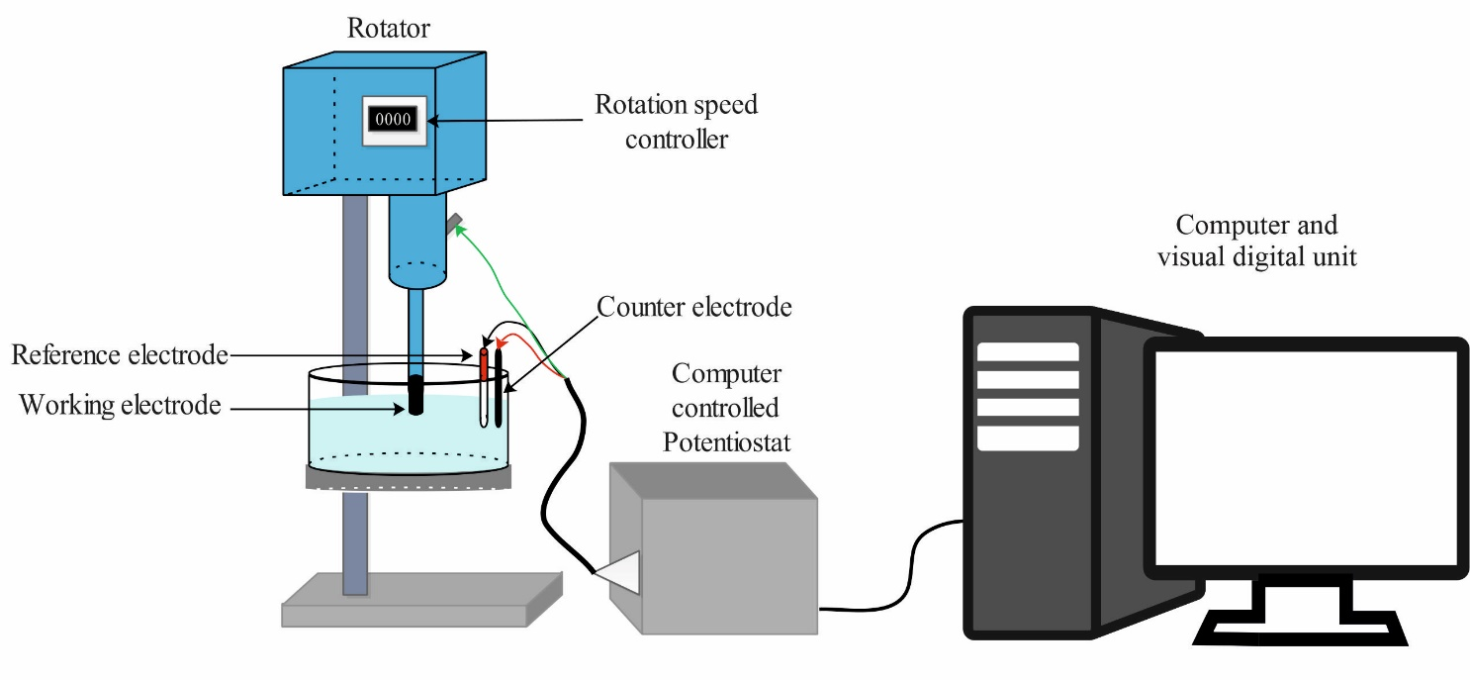

Figure 2. Optical microscopy of the nickel-aluminum bronze pre-oxidized film (formed after 90 mins at a +0.200 V overpotential vs. E_{oc}): (A) showing relatively uniform greenish corrosion products before being rotated with, (B)-(K) protective oxide removal revealing the NAB metallic surface and copper colored areas (after rotations between 1000 and 9500 rpm).
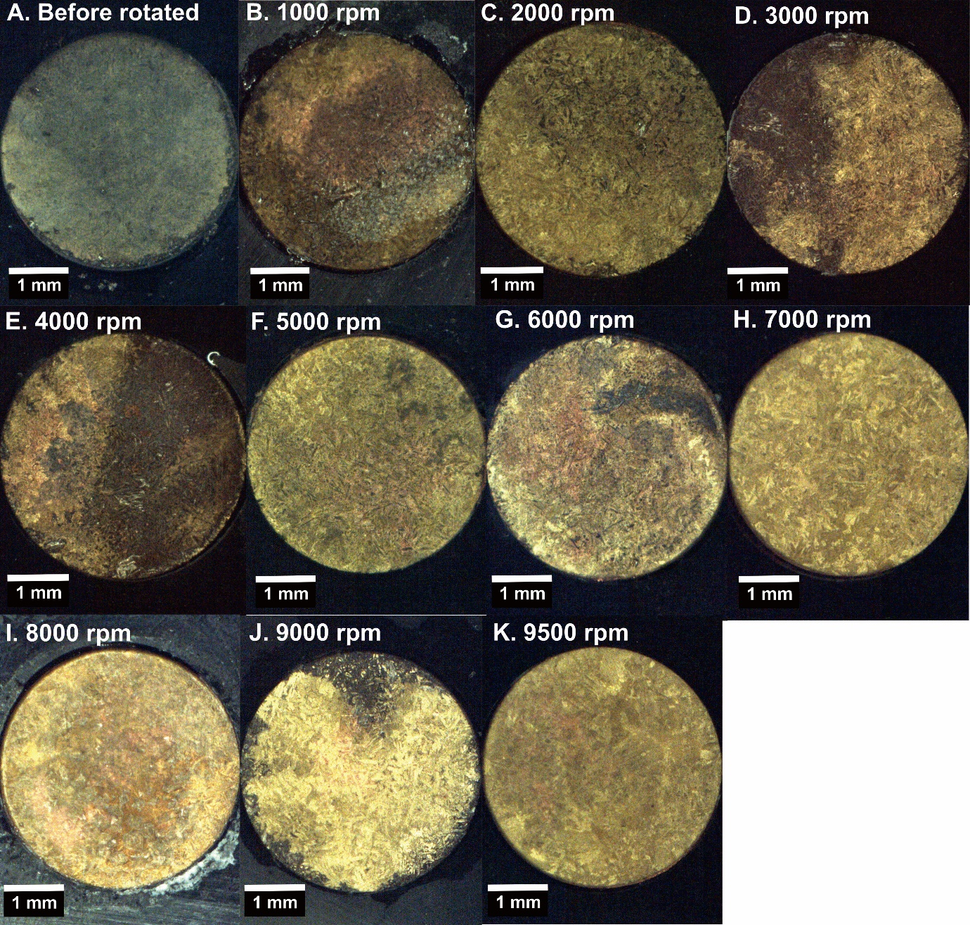

Figure 3. Optical microscopy (using Alicona Infinitefocus microscope) showing the multicolored pre-oxidized NAB surface after rotating at 3000 rpm.
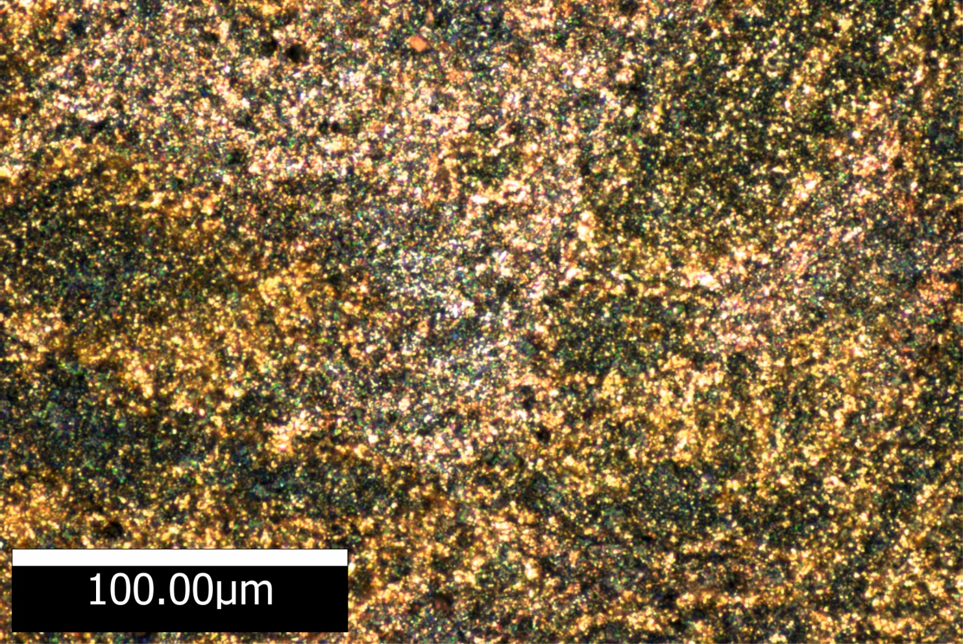

Figure 4. Optical microscopy of the freshly polished NAB surface. The microstructure of the cast NAB contains two main phases: the copper-rich α-phase; and the iron-and-nickel-rich κ-phase. The α-phase can be seen as light areas. The κ-phase consists of four forms: the κ_{I}-phase is globular shaped iron-rich region, the κ_{II}-phase is smaller globular or dendritic rosette form, the nickel rich κ_{III}-phase appears as a lamellar structure, and the κ_{IV}-phase is fine iron-rich precipitate.
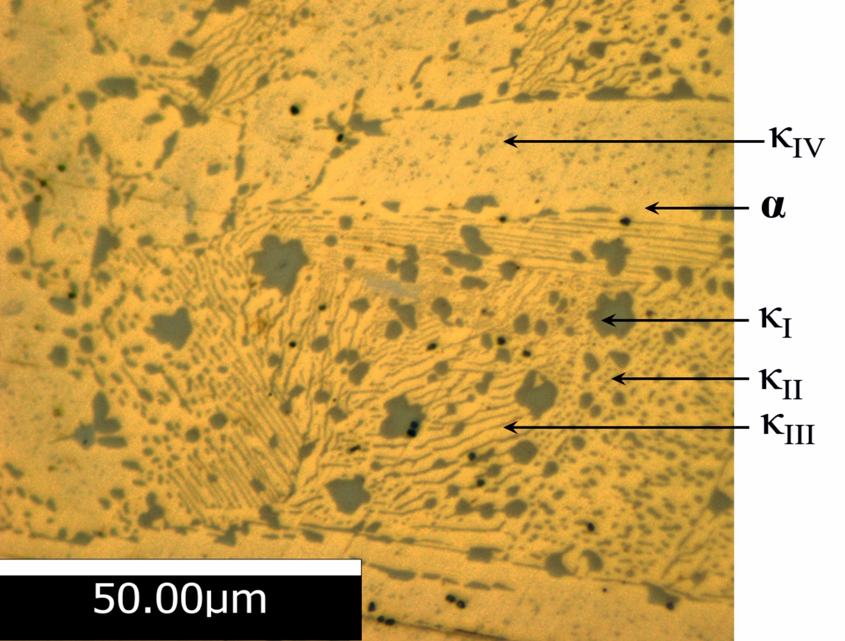

Figure 5. Linear sweep voltammetry describing oxygen reduction at the freshly polished NAB RDE. The two broken lines represent the limitations of the potential range for mass transfer control and the middle solid line represents the potential at the limiting current density (E_{L}).
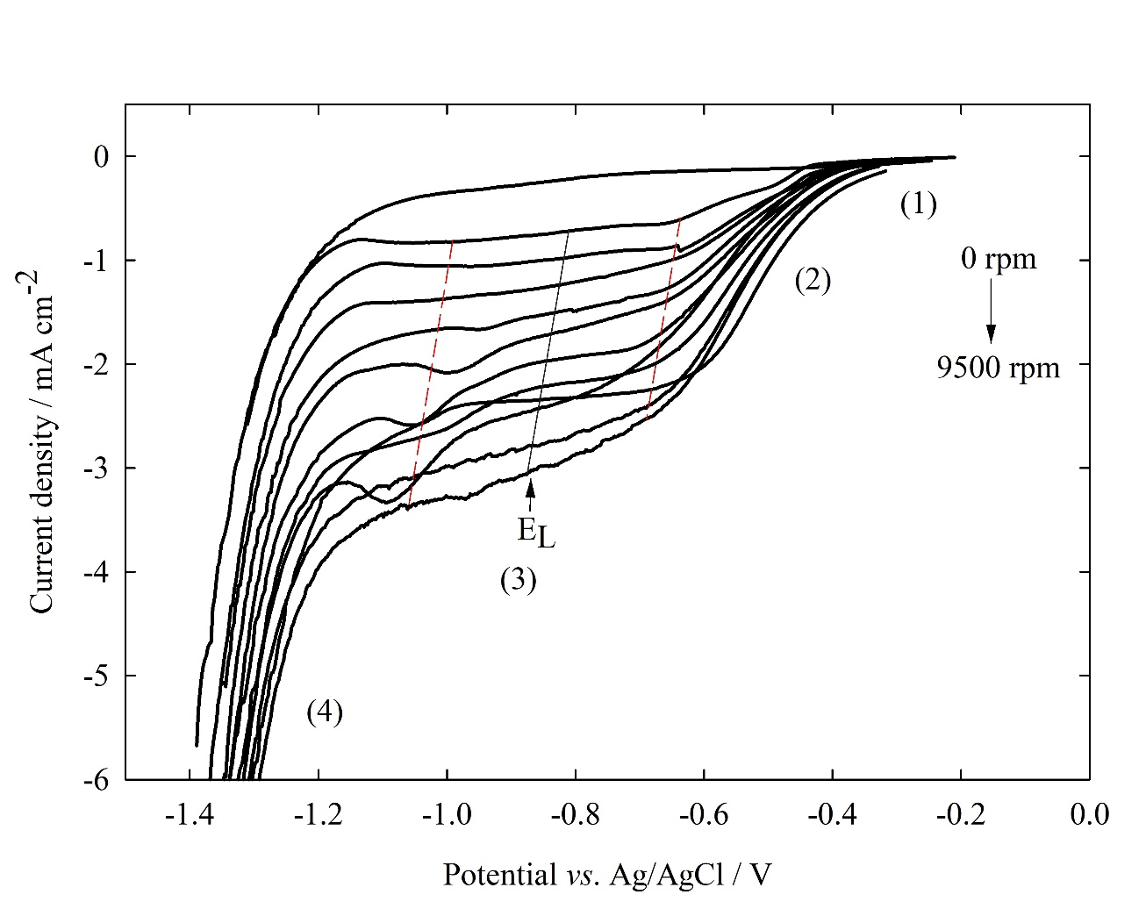

Figure 6. Linear sweep voltammetry describing oxygen reduction at the pre-oxidized NAB RDE. The two broken lines represent the limitations of the potential range for mass transfer control and the middle solid line represents the potential at the limiting current density (E_{L}).
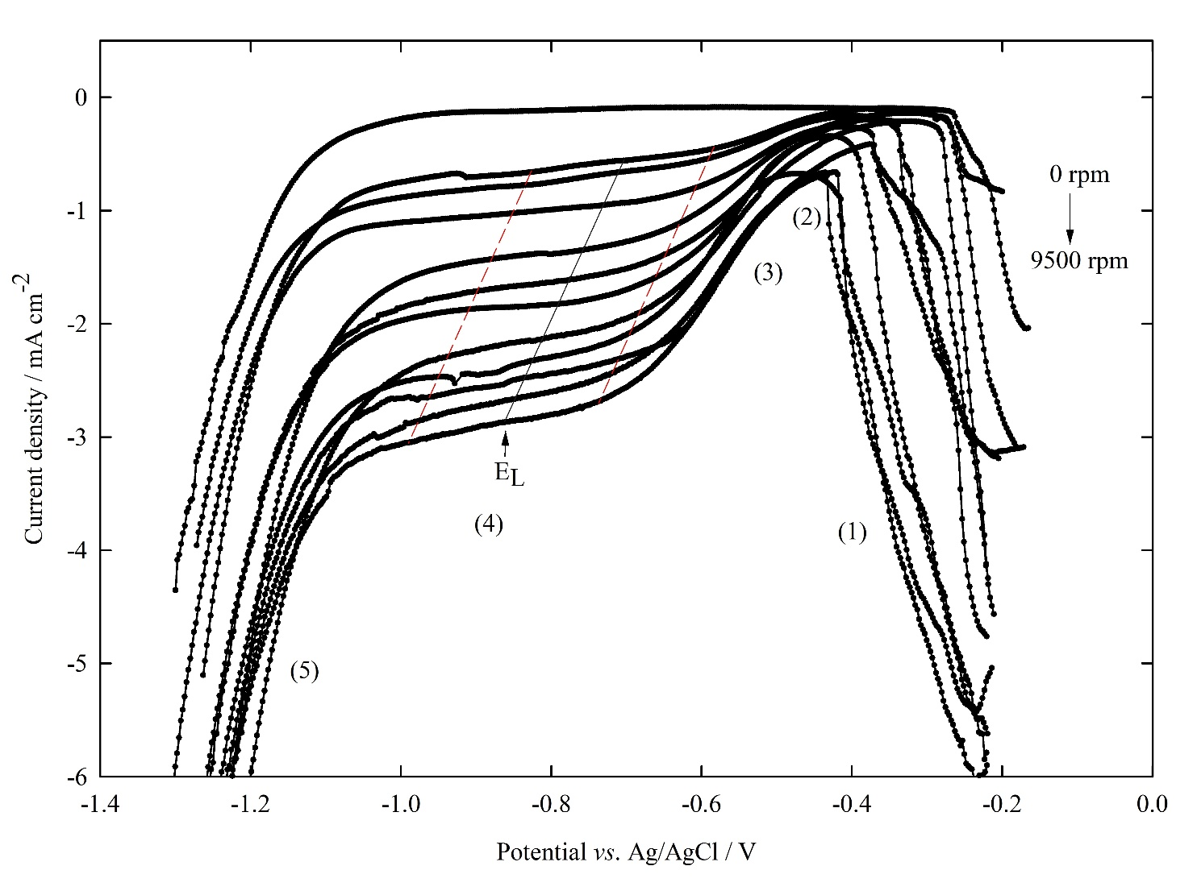

Figure 7. The mass transfer coefficient versus the square root of rotation speed.
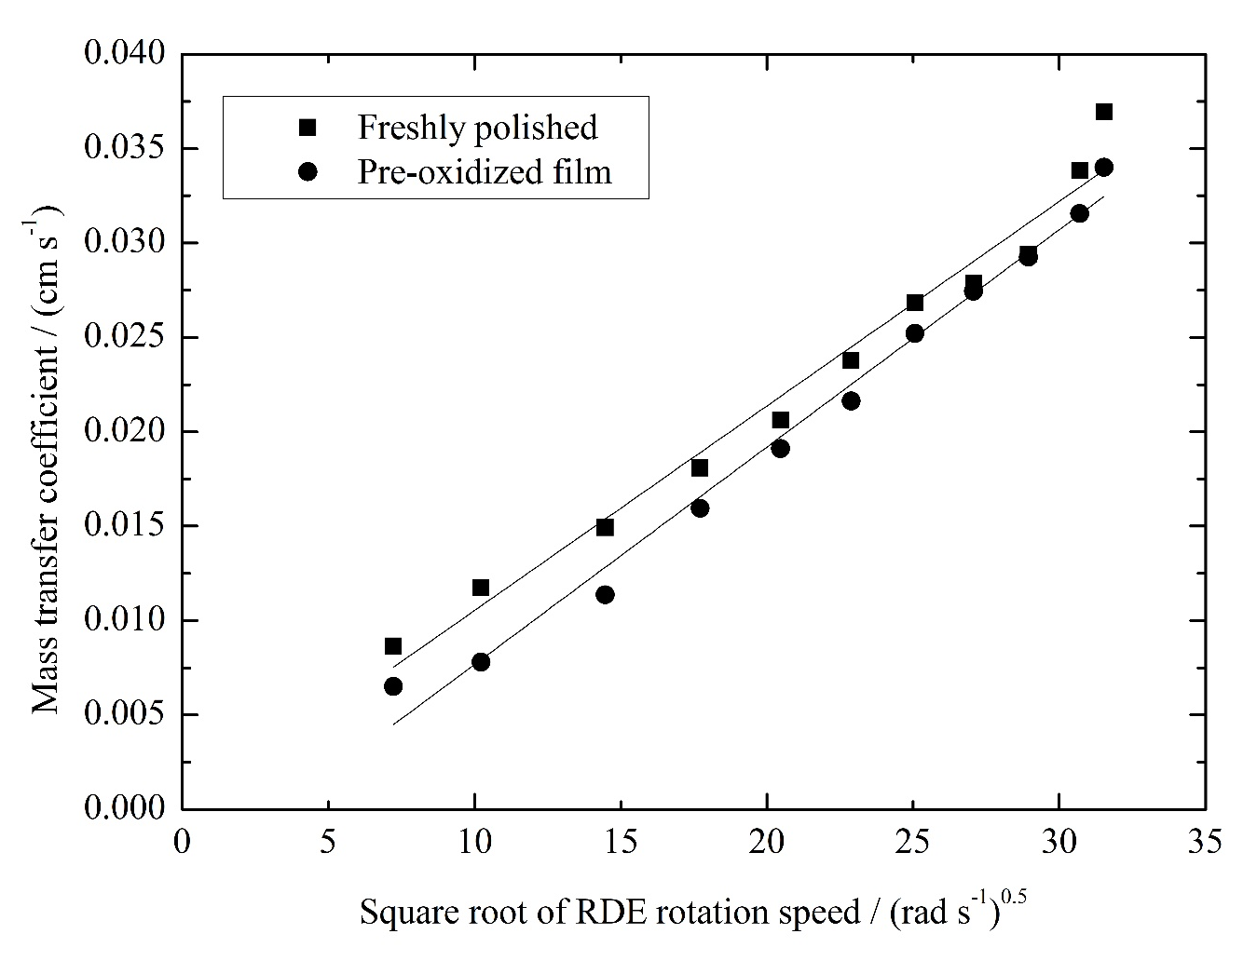

Figure 8. Comparison the current density between (A) the freshly polished and (B) the pre-oxidized NAB surfaces.

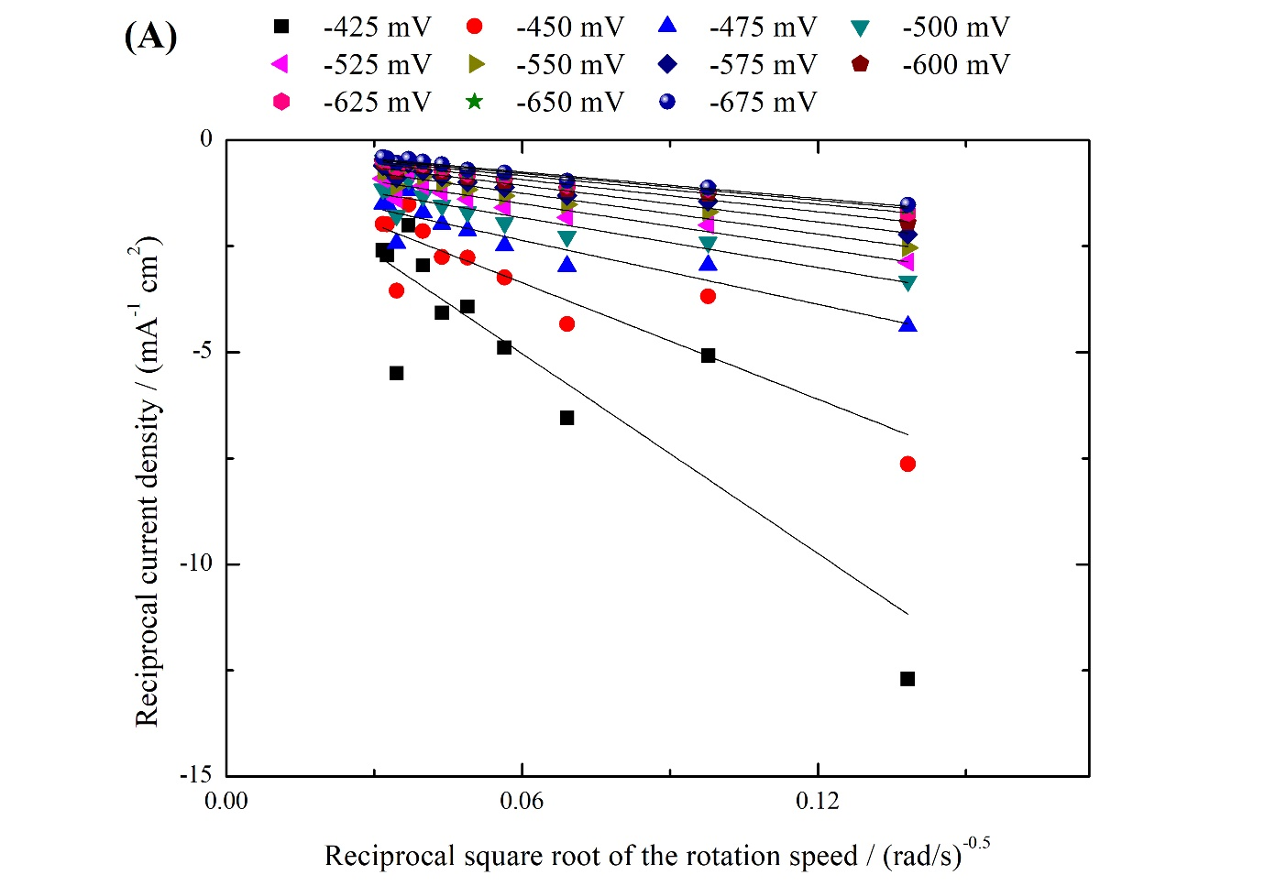
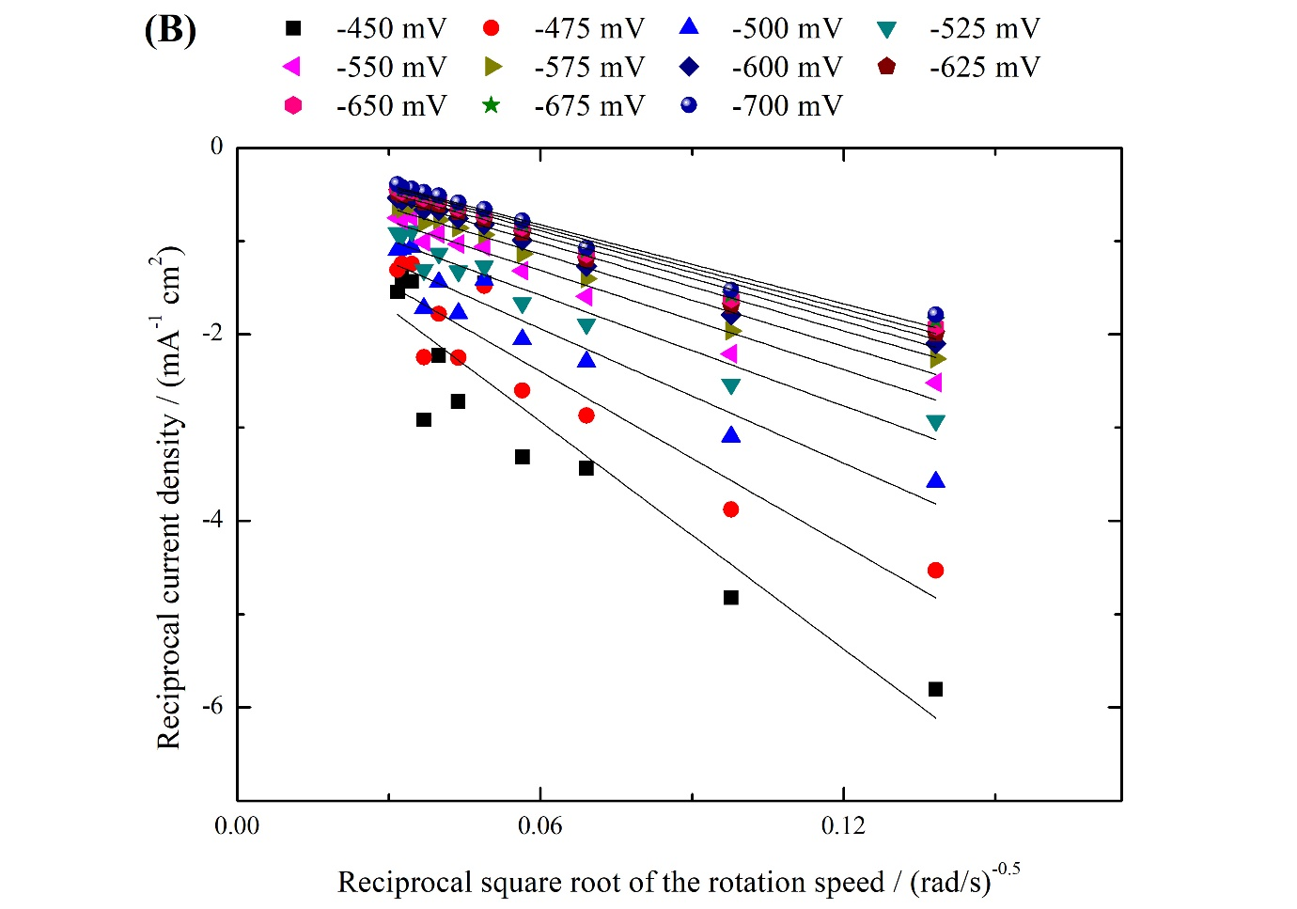
List of Figure Captions

Figure 1. Scheme of the rotating disc electrode setup and the electrochemical measurement.
Figure 2. Optical microscopy of the nickel-aluminum bronze pre-oxidized film (formed after 90 mins at a +0.200 V overpotential vs. E_{oc}): (A) showing relatively uniform greenish corrosion products before being rotated with, (B)-(K) protective oxide removal revealing the NAB metallic surface and copper colored areas (after rotations between 1000 and 9500 rpm).
Figure 3. Optical microscopy (using Alicona Infinitefocus microscope) showing the multicolored pre-oxidized NAB surface after rotating at 3000 rpm.
Figure 4. Optical microscopy of the freshly polished NAB surface. The microstructure of the cast NAB contains two main phases: the copper-rich α-phase; and the iron-and-nickel-rich κ-phase. The α-phase can be seen as light areas. The κ-phase consists of four forms: the κ_{I}-phase is globular shaped iron-rich region, the κ_{II}-phase is smaller globular or dendritic rosette form, the nickel rich κ_{III}-phase appears as a lamellar structure, and the κ_{IV}-phase is fine iron-rich precipitate.
Figure 5. Linear sweep voltammetry describing oxygen reduction at the freshly polished NAB RDE. The two broken lines represent the limitations of the potential range for mass transfer control and the middle solid line represents the potential at the limiting current density (E_{L}).
Figure 6. Linear sweep voltammetry describing oxygen reduction at the pre-oxidized NAB RDE. The two broken lines represent the limitations of the potential range for mass transfer control and the middle solid line represents the potential at the limiting current density (E_{L}).

Figure 7. The mass transfer coefficient versus the square root of rotation speed.
Figure 8. Comparison the current density between (A) the freshly polished and (B) the pre-oxidized NAB surface.

