New Horizons in Appetite and the Anorexia of Ageing
Natalie J. Cox ^{1,2}*, Leanne Morrison ^{3,4}, Kinda Ibrahim ^{1,5}, Sian M. Robinson ^{6,7}, Avan A. Sayer ^{6,7}, Helen C. Roberts ^{1,2,5}.
1. Academic Geriatric Medicine, Faculty of Medicine, University of Southampton, Southampton, UK. 2. NIHR Southampton Biomedical Research Centre, University of Southampton and University Hospital Southampton NHS Foundation Trust, Southampton, UK. 3. Department of Psychology, Faculty of Social, Human, and Mathematical Sciences, University of Southampton, Southampton, UK. 4. Primary Care and Population Sciences, Faculty of Medicine, University of Southampton, Southampton, UK. 5. NIHR Collaboration for Leadership in Applied Health Research and Care (NIHR CLAHRC) Wessex, University of Southampton, Southampton, UK. 6. AGE Research Group, Institute of Neuroscience, Newcastle University, Newcastle upon Tyne, UK. 7. NIHR Newcastle Biomedical Research Centre, Newcastle upon Tyne Hospitals NHS Foundation Trust and Newcastle University, Newcastle upon Tyne, UK.
*correspondence to n.cox@soton.ac.uk; Academic Geriatric Medicine, Faculty of Medicine, University of Southampton, Mailpoint 807, Southampton General Hospital, Tremona Road, Southampton, PO16 6YD, UK.

Key points
- Appetite is important because it drives essential oral nutritional intake.
- Appetite loss is common in older people (’anorexia of ageing’) and occurs, outside of the context of medical conditions, because of age-related changes in three major influences on appetite: physiological signalling, hedonism and external cues.
- Anorexia of ageing is associated with poor outcomes including reductions in oral intake and dietary diversity, malnutrition, sarcopenia and frailty.
- Current interventions for anorexia of ageing have a limited evidence base and at present there is no standardised tool to assess appetite.
- Looking ahead, the aim is to develop multicomponent approaches to treatment of the anorexia of ageing based on growing understanding of the role of physiological signalling, hedonism and external cues.

Abstract
Appetite drives essential oral nutritional intake. Its regulation is complex, influenced by physiology, hedonism (the reward of eating) and learning from external cues within a person’s society and culture.
Appetite loss is common in the older population and not always attributable to medical conditions or treatment. Although the physiological basis of the anorexia of ageing (loss of appetite due to the ageing process) has been established, the effect of ageing on hedonism and external cues, which may be equally important, is less well understood. The anorexia of ageing is associated with reductions in dietary diversity and oral intake, and increased risk of malnutrition, sarcopenia and frailty. Early identification of poor appetite could allow timely intervention before weight loss occurs. There is no standardised tool for assessing appetite in clinical settings at present but the 4-item Simplified Nutritional Appetite Questionnaire (SNAQ) has the potential to be used in this way.
This review, designed for clinicians, will discuss the regulation of appetite and the pathogenesis of the anorexia of ageing. It will describe the current evidence for interventions to manage the anorexia of ageing, which is limited, with little benefit reported from individual studies of education, physical activity and medication. There is some positive evidence for flavour enhancement, fortified food and oral nutritional supplements but mainly within single studies.
Looking ahead, the aim is to develop multicomponent approaches to the treatment of the anorexia of ageing, based on growing understanding of the role of physiological signalling, hedonism and external cues.

Introduction
Appetite is a collective term for the sensations that serve a bodily need for food. It is usually described as the components hunger, satiation and satiety; the sensations which drive a person to eat and then stop eating, and the length of time between meals [1]. A loss of appetite commonly occurs in older people. This can often be attributed to underlying chronic or acute medical conditions, or reported as a medication side effect. However, loss of appetite also occurs in the absence of a medical cause and can be attributed to ageing [2]. This primary loss of appetite is often referred to as the anorexia of ageing and is the focus of this review [3].
Recent studies have placed the prevalence of anorexia of ageing at 22% of community-dwelling older people, over 30% of those in care homes, and 42% of those admitted to acute care [4-7]. However estimates vary, partly because to date there has been no standardised approach to appetite assessment, with studies using oral intake as a proxy. Clinical emphasis has also been on identifying those with unintentional weight loss and poor oral intake, at risk of malnutrition, rather than those with poor appetite.
The anorexia of ageing is associated with reductions in overall energy intake, particularly the food types whole grains, fibre, vegetables and protein [5], subsequent weight loss [8], and malnutrition, sarcopenia and frailty [7, 9, 10]. Malnutrition poses a considerable health burden which disproportionately affects older people (the estimated UK prevalence is 1.3 million older people), with an overall cost to the NHS estimated at £19.6 billion in 2011-2012 [11]. Sarcopenia also contributes a sizable health burden to both individuals and the healthcare system with increased risk of falls, fractures and functional impairment, and hospital admission with higher costs of care [12]. Sarcopenia is more common in malnourished individuals, and weight loss also constitutes a key component to frailty with its well described poor healthcare outcomes [13]. Identification of those with poor appetite [8], could offer the opportunity for early intervention before loss of weight and potential prevention of these significant health challenges.
Knowledge of the mechanisms of the anorexia of ageing recognises that older people experience reduced hunger and increased satiety [2]. However, development of effective interventions for clinical practice has not been forthcoming. This may reflect a need for a holistic understanding of the determinants of appetite in older people. The aim of this review is to give a coherent viewpoint for clinicians on the multiple influences on appetite, with perspectives on how these influences may change in later life in the pathogenesis of the anorexia of ageing. We will then discuss current approaches to appetite assessment and the management of appetite loss, and suggest how using a multidimensional approach could inform future methods of treatment for the anorexia of ageing.

Appetite and the Pathogenesis of the Anorexia of Ageing
Understanding of appetite regulation has developed over more than a century from knowledge that behaviour is affected by the demands of homeostasis but also learning from past experience and social influence [14]. One way to consider the current understanding of influences on a person’s appetite is as separate categories of: physiological signalling (to achieve energy homeostasis), hedonism (the reward of eating and associated learning and behaviour) [14], and environmental and societal influences (external cues) [15].

Physiology
The physiological signalling that regulates appetite is a complex network, both central and peripheral, which interact and are processed in the arcuate nucleus within the hypothalamus (referred to as the appetite control centre) [16, 17]. This appetite control centre has a stimulatory and inhibitory circuit affecting multiple downstream pathways, including other areas of the brain, the peripheral nervous system and endocrine organs [17]. The main peripheral upstream components of appetite signalling, communicating to the appetite control centre, include energy-expenditure signalling linked to resting metabolic rate and neuro-endocrine signalling from the gut (both hunger and satiety), pancreas and adipose tissue (referred to as energy availability signalling) (summarised in Figure 1).
Resting basal metabolic rate has been proposed as a background driver for hunger, with fat free mass energy expenditure being a major contributor to this [18]. However the mechanisms of this energy-expenditure signalling are unclear and a possible relationship between hunger and loss of fat free mass seen in older people, is currently under-explored. The other chief driver of hunger is the hormone ghrelin, released during fasting as a signalling molecule of the gut-brain-axis [16]. This term describes bidirectional communication between the brain and gut, which affects multiple bodily systems, integrating digestion and nutrition into a person’s overall physical and psychological state [16]. The axis also plays a part in satiation and satiety signalling. The release of satiety hormones including cholecystokinin (CCK), glucagon like peptide-1 and peptide YY (PYY) among others, following ingestion of food, as well as neural inputs from the enteric nervous system, indicate the presence of food within the gut lumen [16]. Energy availability signalling also promotes satiety and is related to nutrient levels within the circulation [17]. Leptin release from adipose tissue and insulin from the pancreas both act centrally in a direct and indirect fashion to inhibit hunger, with levels falling during fasting [17].
Measured changes in the peripheral signalling hormones of appetite in older compared to younger individuals, are well recognised (see [9, 19, 20]). These include reductions in, and altered sensitivity to ghrelin reducing feelings of hunger; and increases in CCK, GLP-1, and insulin in fasted and post-prandial states, raised post-prandial PYY and fasting levels of leptin, leading to increased feelings of satiety [9, 19, 20]. Alongside this, mechanical effects, including decreased transit time with impaired compliance of the stomach on receiving food, act to increase rapidity of satiation [9, 19, 20].
A recent discovery in peripheral satiety signalling is the role played by the gut microbiome- the microorganisms residing in the gut. The microbiome appears relatively stable through adulthood until changes in diversity and composition are noted in later life [21]. The gut microbiome influences normal physiological activity extending the gut-brain axis concept to the ‘microbiome-gut-brain axis’ [16]. Appetite is one example of this axis where short chain fatty acids (SCFAs), produced by gut bacteria fermenting undigested dietary fibre in the colon [22], interact with enteroendocrine cells in the gut wall stimulating release of the satiety hormones PYY and GLP-1 [22]. Alongside effects in the gut, the SCFA acetate can also cross the blood brain barrier to interact directly with the appetite control centre [23]. Age related changes to satiety hormones and the alterations in the gut microbiome, now recognised in older people, may be relevant to the pathogenesis of anorexia of ageing and merit further investigation.

Hedonism
Appetite is also influenced by complex interactions between the reward, affective, cognitive and sensorimotor areas of the brain [16]. These complex interactions govern the hedonic aspect of appetite (the reward of eating and associated learning).
The taste of food (when pleasant, referred to as ‘liking’) alongside sight and smell sensations, stimulate flavour centres in the brain [24, 25]. The flavour centres, along with inputs from other brain centres determining palatability (how pleasant the eating experience is), feelings of hunger and satiety, all interact with the reward system to give food a ‘reward value’ [24, 25]. Higher reward values feedback to the appetite control centre to promote hunger, so an initial taste drives further eating [24]. It is proposed that the learning centres of the brain turn a food’s high reward value into desire to eat it, with feelings of hunger when the person is re-exposed to associated cues; whether it be the sight, smell, or the location in which it was consumed [25, 26].
It is well recognised that ageing diminishes sensory function [27]. Older people have reduced abilities in identifying different smells and tastes and perceive them less intensely; this may be related to changes in the brain, but also reductions in taste bud number and structure [27, 28]. Diminished sensory function may affect ‘liking’ of a food, impacting on the flavour and reward centres, whose activities also appear to alter in ageing [29]. Changes in reward signalling include loss of dopamine, with a less clear role for opioid and serotonin signalling [30]. Consequently a different reward value could be assigned to food in older individuals [31]. Assignment of a different reward value to food, and potentially an anticipation that ‘liking’ will be diminished, could impact the desire to eat and hunger.
Other hedonic influences include a person’s mood, which impacts their desire to eat and perceptions of hunger [32]. Functional magnetic resonance imaging of older people suffering from depression has identified changes in the flavour and reward centres of the brain [33]. These changes show that the relationship between appetite and mood is affected by ageing; echoing observations that weight loss is more common in older adults with depression, whereas younger individuals tend to gain weight [34].
The oro-sensory signalling which can drive further eating also plays a role in satiation. This is encompassed by the term sensory-specific satiety, where sensory inputs to flavour and reward centres eventually becoming saturated and reduce in activity [24]. Thus a specific food is less rewarding the more that is eaten, motivating a switch to a different food within the meal, resulting in a greater variety of food consumed and overall intake [35]. Sensory-specific satiety diminishes in ageing and may contribute to the lack of dietary diversity among many older people, as well as overall reductions in their intake [36, 37].

External Cues
There is increasing understanding of the complex interplay between a person’s external environment and their psychological response, which may impact on feelings of hunger, satiation or satiety. Cephalic phase responses are an example where environmental and contextual cues, such as sitting down in a restaurant, and related olfactory and visual stimuli drive the ‘thought of food’ due to learned associations [15]. This triggers physiological changes to prepare for digestion, and promotes hunger by increasing gastric motility and ghrelin release [38]. Cephalic phase responses are closely aligned with hedonism but also the wider context of societal and cultural influences on appetite.
In modern western societies energy-dense food is generally abundant such that experiencing extremes of hunger is less common. It has been proposed that the physiological controls of appetite are less influential outside of these extreme states and so appetite in those populations is governed more by hedonism and external cues [39].
Changes in environment and lifestyle are a common prospect for many older people. This may impact upon cues they have learned to associate with the ‘thought of food’ and hunger. For example, qualitative research has demonstrated that older people in care homes and hospital relate their poor appetite to changes in mealtimes and procedures, food not meeting their expectations or traditions, and the environment not being clean or conducive to dignified meals [40, 41].
An important societal cue for eating is the presence of others. ‘Social facilitation of eating’ is a widely accepted concept where a person will eat more when others, especially family or friends, are eating than when alone [42]. Loneliness in the older population is a growing concern, and many who desire mealtime companionship eat alone [40]. Social facilitation is also reduced by institutional and hospital environments where healthcare professionals or visitors often observe meals but do not eat themselves. This passive observation has been shown in younger individuals to inhibit amounts consumed [42] but has not been fully assessed in older people.
Eating behaviour is also shaped by culture via effects on a person’s attitudes and feelings towards certain food and meal practices. These attitudes are a part of ‘social eating norms’ or perceived standards of eating. These norms are linked to acceptance and strengthening of relationships within a social group, and feelings of self-perception and self-efficacy [43]. Qualitative research in hospital has shown older people use the circumstance they are in to validate effects on their appetite (i.e. I am unwell, so will have no appetite) [41]. This may reflect changes in social eating norms on admission to hospital, although this is under-explored.
The learning associated with external cues, important in determining the drive to eat, also plays a role in satiation. Following consumption of a meal, sensory inputs are fed-back to learning centres of the brain affecting future expectations; so an individual will have an expected effect from a certain meal size when it is prepared or presented to them[15]. The aforementioned changes to compliance and transit time of the gut during ageing may alter this feedback, impacting on subsequent learned expectations. However older people also display impaired behavioural responses to satiation signalling itself, where actual intake is unchanged following a rise in satiation hormones and reports of fullness [44, 45]. Therefore eating behaviour associated with external cues for satiation in older people appears complex and not fully understood. Qualitative research on diet choices of older adults may provide insights into the complex array of external cues and learning over time that may influence satiation. This emphasises the importance of historical influence (importance of upbringing and past experiences with food), psychological characteristics such as the need to ‘keep going’, and food-related habits [46].

Appetite change in a clinical context
The effects of ageing on appetite drive older people towards a state of reduced hunger and increased satiety in the anorexia of ageing. This is seen to some extent in healthy older people [2], reflecting changes in energy requirements [3], which creates difficulty in determining when the anorexia of ageing becomes pathological, warranting screening and intervention. This tipping point is currently undefined but is most often recognised when individuals show signs of malnutrition due to weight-loss. However interests for the clinician should pre-date the onset of malnutrition if this considerable health burden is to be prevented. The processes resulting in the anorexia of ageing remain uncertain and are likely to be complicated by individualised trajectories and multiple mechanisms. Therefore the anorexia of ageing could be considered as potentially pathological when raised as a concern by the individual or those involved with their care, regardless of whether weight-loss has occurred.
Considering the multiple influences on appetite in a structured way (Figure 2), may make addressing the anorexia of ageing more manageable. Environmental or contextual cues that an older person has come to rely upon to stimulate hunger may have been lost, alongside alterations to the hedonic dimension of appetite so that food seems less rewarding, could compound effects of altered physiology. An understanding that changes in any aspect of health or living circumstance may impact upon appetite, should lead clinicians to consider assessment.

How can we assess appetite?
Tools to assess appetite have predominantly originated from laboratory settings with the aim of understanding mechanisms. Nutritional screening tools, such as the mini-nutritional assessment (MNA) [47], include appetite but as the focus is on identifying malnutrition, those with poor appetite and no other signs of nutritional risk may be overlooked until they lose weight, potentially missing an opportunity for early intervention. Malnutrition screening and resulting guidance is well established within clinical practice however, for those individuals who raise concerns about appetite without displaying nutritional risk, a focussed assessment of appetite should be considered.
A recent systematic review of appetite assessment tools for older people receiving an intervention for poor appetite, reported that visual analogue and Likert scale methods were most common across care settings [48]. It is unclear which method would be most appropriate for use in clinical practice, but visual analogue scales have been shown to have poor compliance rates when used to assess other outcomes in older populations [49] .
A brief questionnaire with potential for clinical application is the Simplified Nutritional Appetite Questionnaire (SNAQ) (Figure 3) [8]. This four-item questionnaire was originally validated in community dwelling older people but has since been used across different settings. A lower score on the SNAQ (<14/20 points) is associated with subsequent weight loss in community-dwelling older people [8], and greater rates of nosocomial infection and mortality six months post-discharge when measured on admission to acute care [4]. The simplicity of the SNAQ means it could have potential for widespread use by healthcare professionals, older individuals and care givers to assess appetite.

What is the current evidence for management of the anorexia of ageing?
For individuals with poor appetite, initial consideration should be taken as to whether there are identifiable medical causes (Figure 2). For those without a medical cause, there is currently scarce evidence for effective treatments for the anorexia of ageing. Most interventions have been trialled in single studies [48]. Largely, interventions for older people to support environmental or social changes affecting appetite are under-researched; and although promoted in guidance for managing poor appetite, current evidence for increasing levels of physical activity is lacking [50].
A recent systematic review assessing the current evidence for treatments for the anorexia of ageing highlighted a lack of evidence and considerable overlap in management directives between anorexia and malnutrition [48]. Within the review, single studies signal flavour enhancement, fortified food and the amino acid ornithin oxoglutarate having a stimulatory effect on appetite but these results have not been replicated. Medications were also included in the review, predominantly steroids and progestogen therapy (megestrol acetate) with mixed results [48], amid concerns about the significant side effect profile of these medications which includes venous thromboembolism and adrenal suppression.
Oral nutritional supplements (ONS), are known to increase the overall energy intake of older individuals and are a current mainstay for management of malnutrition. The increases in energy intake do not appear to be mediated through improved appetite but neither do they appear to have prolonged suppressive effects [48]. So although calorie intake may increase, an improved appetite is not achieved and ONS are often poorly tolerated in clinical practice. The use of meal companionship and improving the mealtime environment, which are well-recognised in current nutritional guidance, may be more effective strategies.

Future directions
In the context of a limited evidence base, the mixed results for single interventions for anorexia of ageing are likely to reflect a need for creation and evaluation of multi-component interventions, considering the multiple influences on appetite (Figure 2). Such interventions will need to be individualised through an understanding of a person’s physical ability and clinical condition as well as their historical practices, social interactions and cultural perspectives. Approaching the multiple influences on appetite in a structured way (Figure 2), may inform research into multicomponent interventions for the anorexia of ageing in future clinical trials. Establishing a standardised approach to appetite assessment, which is feasible in a clinical setting, is central to future appetite research.
In clinical settings, a structured multi-component approach may enable clinicians to determine what aspects are impacting most on an individual’s appetite, if medical causes have been excluded. For example a person may have moved into a care setting where appetite change is noted, but their main concern is that food tastes different. So efforts should focus on hedonism (such as flavour enhancement) and external cues (such as establishing an acceptable mealtime routine through understanding historical practices) with acknowledgement of likely alterations in underlying physiology.

Conclusions
The anorexia of ageing is common and is likely due to a number of individualised influences. It is associated with malnutrition, sarcopenia, frailty and mortality. However appetite loss is under-recognised as it is not routinely assessed, in part due to a lack of a standardised approach. Identification of poor appetite could potentially prevent unintentional weight loss and associated negative health outcomes, and tools such as the four item SNAQ could be used in routine clinical practice. A structured multi-component approach to recognise the different influences on appetite might aid clinicians in managing the anorexia of ageing and researchers to develop effective interventions.

Author Contributions: Conceptualisation, N.J.C., L.M., K.I., S.M.R, and H.C.R. Original Draft Preparation, N.J.C. Review & Editing, N.J.C., L.M, K.I., A.A.S., S.M.R., and H.C.R. Supervision, H.C.R.
Funding: The National Institute for Health Research (NIHR) funded this research. The views expressed are those of the authors and not necessarily those of the NHS, the NIHR, or the Department of Health. N.J.C was supported by the University of Southampton NIHR Academic Clinical Fellowship Scheme. N.J.C and H.C.R receive support from the NIHR Southampton Biomedical Research Centre. A.A.S and S.M.R receive support from the NIHR Newcastle Biomedical Research Centre. H.C.R and K.I. receive support from the NIHR Collaboration for Leadership in Applied Health Research and Care (CLAHRC) Wessex.
Conflicts of Interest: The authors declare no conflict of interest. The funders had no role in the design of the review, interpretation of data, in the writing of the manuscript, or in the decision to publish.

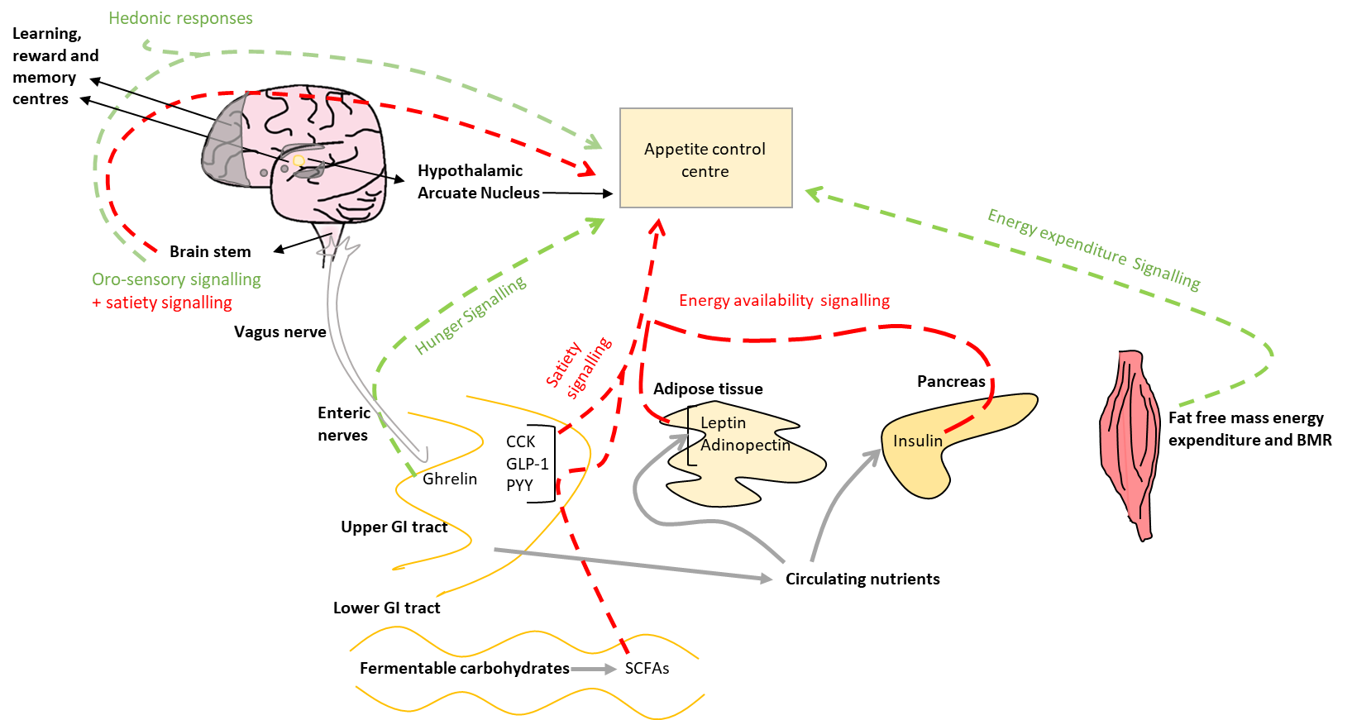
Figure 1: Pathways of appetite regulation. Orexigenic pathways in green and anorectic pathways in red. (Hedonic responses are orexigenic in the context of palatable food). BMR= basal metabolic rate, CCK= cholecystokinin, GLP-1= glucagon like peptide 1, PYY= peptide YY, SCFAs = short chain fatty acids.

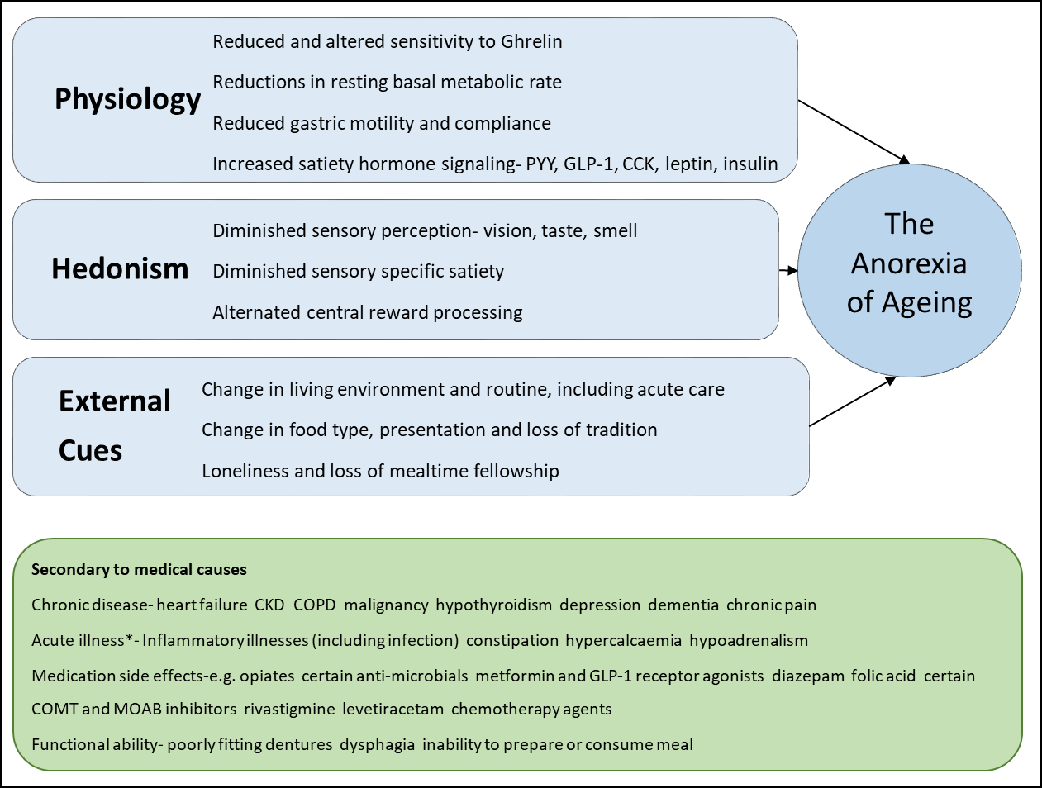
Figure 2: Mechanisms contributing to appetite loss in the older adult and a structured approach to the anorexia of ageing.
PYY= peptide YY, GLP-1= glucagon like peptide -1, CCK= cholecystokinin. CKD= chronic kidney disease, COPD= chronic obstructive pulmonary disease, COMT= Catechol-O-methyltransferase, MOAB= Monoamine Oxidase-B.
* Not including acute surgical causes

Simplified Nutritional Appetite Questionnaire (SNAQ)

- My appetite is
- very poor
- poor
- average
- good
- very good

2. When I eat
- I feel full after eating only a few mouthfuls
- I feel full after eating about a third of a meal
- I feel full after eating over half a meal
- I feel full after eating most of the meal
- I hardly ever feel full

3. Food tastes
- very bad
- bad
- average
- good
- very good

4. Normally I eat
- less than one meal a day
- one meal a day
- two meals a day
- three meals a day
- more than three meals a day

Administration Instructions: Ask the subject to complete the questionnaire by circling the correct answers and then tally the results based upon the following numerical scale: a=1, b=2, c=3, d=4, e=5.
The sum of the scores for the individual items constitutes the SNAQ score.

A SNAQ score <14 out of 20 indicates significant risk of at least 5% weight loss within six months.
Figure 3: The Simplified Nutritional Appetite Questionnaire (SNAQ); from Wilson et al [8].

References
- 1. Mattes RD, Hollis J, Hayes D, Stunkard AJ. Appetite: Measurement and Manipulation Misgivings. Journal of the Academy of Nutrition and Dietetics. 2005;105(5):87-97.
- 2. Giezenaar C, Chapman I, Luscombe-Marsh N, Feinle-Bisset C, Horowitz M, Soenen S. Ageing Is Associated with Decreases in Appetite and Energy Intake--A Meta-Analysis in Healthy Adults. Nutrients. 2016 Jan;8(1).
- 3. Morley JE, Silver AJ. Anorexia in the Elderly. Neurobiology of Aging. 1988 Jan-Feb;9(1):9-16.
- 4. Pilgrim AL, Baylis D, Jameson KA, Cooper C, Sayer AA, Robinson SM, et al. Measuring Appetite with the Simplified Nutritional Appetite Questionnaire Identifies Hospitalised Older People at Risk of Worse Health Outcomes. Journal of Nutrition Health and Aging. 2016 Jan;20(1):3-7.
- 5. van der Meij BS, Wijnhoven HAH, Lee JS, Houston DK, Hue T, Harris TB, et al. Poor Appetite and Dietary Intake in Community-Dwelling Older Adults. Journal of the American Geriatrics Society. 2017 Oct;65(10):2190-7.
- 6. Donini LM, Dominguez LJ, Barbagallo M, Savina C, Castellaneta E, Cucinotta D, et al. Senile Anorexia in Different Geriatric Settings in Italy. Journal of Nutrition, Health & Aging. 2011 Nov;15(9):775-81.
- 7. Landi F, Liperoti R, Russo A, Giovannini S, Tosato M, Barillaro C, et al. Association of Anorexia with Sarcopenia in a Community-Dwelling Elderly Population: Results From the ilSIRENTE Study. European Journal of Nutrition. 2013;52(3):1261-8.
- 8. Wilson MM, Thomas DR, Rubenstein LZ, Chibnall JT, Anderson S, Baxi A, et al. Appetite Assessment: Simple Appetite Questionnaire Predicts Weight Loss in Community-Dwelling Adults and Nursing Home Residents. American Journal of Clinical Nutrition. 2005 Nov;82(5):1074-81.
- 9. Malafarina V, Uriz-Otano F, Gil-Guerrero L, Iniesta R. The Anorexia of Ageing: Physiopathology, Prevalence, Associated Comorbidity and Mortality. A Systematic Review. Maturitas. 2013 Apr;74(4):293-302.
- 10. Tsutsumimoto K, Doi T, Makizako H, Hotta R, Nakakubo S, Makino K, et al. The Association Between Anorexia of Aging and Physical Frailty: Results from the National Center for Geriatrics and Gerontology's Study of Geriatric Syndromes. Maturitas. 2017 Mar;97:32-7.
- 11. Elia M. The Cost of Malnutrition in England and Potential Cost Savings from Nutritional Interventions (Full Report): A Report on the Cost of Disease-Related Malnutrition in England and a Budget Impact Analysis of Implementing the NICE guidelines/Quality Standard on Nutritional Support in Adults. BAPEN and NIHR Southampton Biomedical Research Centre: 2016.
- 12. Cruz-Jentoft AJ, Bahat G, Bauer J, Boirie Y, Bruyère O, Cederholm T, et al. Sarcopenia: Revised European Consensus on Definition and Diagnosis. Age and Ageing. 2019;48(1):16-31.
- 13. Clegg A, Young J, Iliffe S, Rikkert MO, Rockwood K. Frailty in Elderly People. Lancet. 2013 Mar;381(9868):752-62.
- 14. Hopkins M, Blundell J, Halford J, King N, Finlayson G. The Regulation of Food Intake in Humans. In: De Groot LJ, Chrousos G, Dungan K, Feingold KR, Grossman A, Hershman JM, et al., editors. Endotext. South Dartmouth (MA)2000.
- 15. Bilman E, van Kleef E, van Trijp H. External Cues Challenging the Internal Appetite Control System-Overview and Practical Implications. Critical Reviews in Food Science and Nutrition. 2017 Sep;57(13):2825-34.
- 16. Weltens N, Iven J, Oudenhove L, Kano M. The Gut–Brain Axis in Health Neuroscience: Implications for Functional Gastrointestinal Disorders and Appetite Regulation. Annals of the New York Academy of Sciences. 2018;1428(1):129-50.
- 17. Coll AP, Farooqi IS, O'Rahilly S. The Hormonal Control of Food Intake. Cell. 2007;129(2):251-62.
- 18. Hopkins M, Finlayson G, Duarte C, Whybrow S, Ritz P, Horgan GW, et al. Modelling the Associations Between Fat-free Mass, Resting Metabolic Rate and Energy Intake in the Context of Total Energy Balance. International Journal of Obesity. 2016 Feb;40(2):312-8.
- 19. Di Francesco V, Pellizzari L, Corrà L, Fontana G. The Anorexia of Aging: Impact on Health and Quality of Life. Geriatric Care. 2018 Jul;4(2).
- 20. Moss C, Dhillo WS, Frost G, Hickson M. Gastrointestinal Hormones: the Regulation of Appetite and the Anorexia of Ageing. Journal of Human Nutrition and Dietetics. 2012 Feb;25(1):3-15.
- 21. O’Toole PW, Jeffery IB. Microbiome–Health Interactions in Older People. Cellular and Molecular Life Sciences. 2018 Jan;75(1):119-28.
- 22. Chambers ES, Morrison DJ, Frost G. Control of Appetite and Energy Intake by SCFA: What Are the Potential Underlying Mechanisms? Proceedings of the Nutrition Society. 2014;74(3):328-36.
- 23. Frost G, Sleeth ML, Sahuri-Arisoylu M, Lizarbe B, Cerdan S, Brody L, et al. The Short-Chain Fatty Acid Acetate Reduces Appetite Via a Central Homeostatic Mechanism. Nature Communications. 2014 Apr;5:3611.
- 24. Rolls ET. Reward Systems in the Brain and Nutrition. Annual review of nutrition. 2016 Jul 17;36:435-70.
- 25. Rogers PJ, Hardman CA. Food Reward. What It Is and How to Measure it. Appetite. 2015 Jul;90:1-15.
- 26. Jager G, Witkamp RF. The Endocannabinoid System and Appetite: Relevance for Food Reward. Nutrition Research Reviews. 2014;27(1):172-85.
- 27. Roberts SB, Rosenberg I. Nutrition and Aging: Changes in the Regulation of Energy Metabolism with Aging. Physiological Reviews. 2006 Apr;86(2):651-67.
- 28. Fukunaga A, Uematsu H, Sugimoto K. Influences of Aging on Taste Perception and Oral Somatic Sensation. The journals of gerontology Series A, Biological sciences and medical sciences. 2005 Jan;60(1):109-13.
- 29. Jacobson A, Green E, Murphy C. Age-Related Functional Changes in Gustatory and Reward Processing Regions: An fMRI Study. NeuroImage. 2010 Nov 1;53(2):602-10.
- 30. de Boer A, Ter Horst GJ, Lorist MM. Physiological and Psychosocial Age-Related Changes Associated with Reduced Food Intake in Older Persons. Ageing Research Reviews. 2013 Jan;12(1):316-28.
- 31. de Graaf C, van Staveren W, Burema J. Psychophysical and Psychohedonic Functions of Four Common Food Flavours in Elderly Subjects. Chemical senses. 1996 Jun;21(3):293-302.
- 32. Leng G, Adan RAH, Belot M, Brunstrom JM, de Graaf K, Dickson SL, et al. The Determinants of Food Choice. Proceedings of the Nutrition Society. 2016;76(3):316-27.
- 33. Lavretsky H, Ballmaier M, Pham D, Toga A, Kumar A. Neuroanatomical Characteristics of Geriatric Apathy and Depression: A Magnetic Resonance Imaging Study. The American Journal of Geriatric Psychiatry. 2007;15(5):386-94.
- 34. DiPietro L, Anda RF, Williamson DF, Stunkard AJ. Depressive Symptoms and Weight Change in a National Cohort of Adults. International Journal of Obesity and Related Metabolic Disorders. 1992 Oct;16(10):745-53.
- 35. Brondel L, Romer M, Van Wymelbeke V, Pineau N, Jiang T, Hanus C, et al. Variety Enhances Food Intake in Humans: Role of Sensory-Specific Satiety. Physiology and Behavior. 2009 Apr;97(1):44-51.
- 36. Rolls BJ. Do Chemosensory Changes Influence Food Intake in the Alderly? Physiology and Behavior. 1999 Apr;66(2):193-7.
- 37. ter Borg S, Verlaan S, Hemsworth J, Mijnarends DM, Schols JMGA, Luiking YC, et al. Micronutrient Intakes and Potential Inadequacies of Community-Dwelling Older Adults: A Systematic Review. British Journal of Nutrition. 2015;113(8):1195-206.
- 38. Smeets PAM, Erkner A, de Graaf C. Cephalic Phase Responses and Appetite. Nutrition Reviews. 2010;68(11):643-55.
- 39. Herman CP, Polivy J. A Boundary Model for the Regulation of Eating. Psychiatric Annals. 1983;13(12):918-27.
- 40. Wikby K, Fagerskiold A. The Willingness to Eat. An Investigation of Appetite Among Elderly People. Scandinavian Journal of Caring Sciences. 2004 Jun;18(2):120-7.
- 41. Hope K, Ferguson M, Reidlinger DP, Agarwal E. "I Don't Eat When I'm Sick": Older People's Food and Mealtime Experiences in Hospital. Maturitas. 2017 Mar;97:6-13.
- 42. Herman CP. The Social Facilitation of Eating. A Review. Appetite. 2015 Mar;86:61-73.
- 43. Higgs S. Social Norms and their Influence on Eating Behaviours. Appetite. 2015 Mar;86:38-44.
- 44. Giezenaar C, Trahair LG, Luscombe-Marsh ND, Hausken T, Standfield S, Jones KL, et al. Effects of Randomized Whey-Protein Loads on Energy Intake, Appetite, Gastric Emptying, and Plasma Gut-Hormone Concentrations in Older Men and Women. American Journal of Clinical Nutrition. 2017 Sep;106(3):865-77.
- 45. Giezenaar C, Trahair LG, Rigda R, Hutchison AT, Feinle-Bisset C, Luscombe-Marsh ND, et al. Lesser Suppression of Energy Intake by Orally Ingested Whey Protein in Healthy Older Men Compared with Young Controls. American Journal of Physiology. 2015 Oct 15;309(8):R845-54.
- 46. Bloom I, Lawrence W, Barker M, Baird J, Dennison E, Sayer AA, et al. What Influences Diet Quality in Older People? A Qualitative Study Among Community-Dwelling Older Adults from the Hertfordshire Cohort Study, UK. Public Health Nutrition. 2017;20(15):2685-93.
- 47. Vellas B, Guigoz Y, Garry PJ, Nourhashemi F, Bennahum D, Lauque S, et al. The Mini Nutritional Assessment (MNA) and its Use in Grading the Nutritional State of Elderly Patients. Nutrition. 1999 Feb;15(2):116-22.
- 48. Cox NJ, Ibrahim K, Sayer AA, Robinson SM, Roberts HC. Assessment and Treatment of the Anorexia of Aging: A Systematic Review. Nutrients. 2019 Jan 11;11(1).
- 49. Hjermstad MJ, Fayers PM, Haugen DF, Caraceni A, Hanks GW, Loge JH, et al. Studies Comparing Numerical Rating Scales, Verbal Rating Scales, and Visual Analogue Scales for Assessment of Pain Intensity in Adults: A Systematic Literature Review. Journal of Pain and Symptom Management. 2011 Jun;41(6):1073-93.
- 50. Clegg ME, Godfrey A. The Relationship Between Physical Activity, Appetite and Energy Intake in Older Adults: A Systematic Review. Appetite. 2018 Sept;128:145-51.

