High-average-power picosecond mid-infrared OP-GaAs OPO

Qiang. Fu, Lin. Xu*, Sijing. Liang, Peter. C. Shardlow, David. P. Shepherd, Shaif-ul. Alam, and David. J. Richardson

Optoelectronics Research Centre, University of Southampton, SO17 1BJ, UK

* [l.xu@soton.ac.uk](mailto:l.xu@soton.ac.uk)

**Abstract:** We report a high-average-power mid-infrared picosecond (ps) optical parametric oscillator (OPO) based on orientation-patterned gallium arsenide (OP-GaAs), with wide wavelength tunability. The OP-GaAs OPO is synchronously pumped by a thulium-doped-fiber (TDF) master oscillator power amplifier (MOPA), seeded by a gain-switched laser diode. At a pump power of 35.3 W and a repetition rate of 100 MHz, a maximum OPO total average output power of 9.7 W (signal 5.7 W (0.60 kW peak power), idler 4.0 W (0.42 kW peak power)) is obtained at signal and idler wavelengths of 3093 nm and 5598 nm, and a thermally induced power roll-off is observed. To mitigate the thermal effects, an optical chopper is placed before the OPO to provide burst mode operation and a reduced thermal load. We achieved a linear growth in OPO output power over the full range of available pump powers in this instance confirming thermal effects as the origin of the roll-off observed under continuous pumping. We estimate the maximum peak powers of the signal and idler are estimated to be over 0.79 kW and 0.58 kW, respectively in this instance. A wide mid-infrared wavelength tuning range of 2895-3342 nm (signal) and 4935-6389 nm (idler) is demonstrated.

© 2019 Optical Society of America under the terms of the [OSA Open Access Publishing Agreement](https://doi.org/10.1364/OA_License_v1)

1. Introduction

High-average-power short-pulsed lasers in the mid-infrared (mid-IR, 2-20 μm) region are required for a diverse range of fields, including chemical and biomedical sensing, spectroscopic applications and optical countermeasures [1-4]. Optical parametric devices - generators (OPGs), amplifiers (OPAs), and oscillators (OPOs), are important sources for realizing high-power mid-IR lasers [5-7]. OPOs, in particular, have attracted much attention due to their wide tunability, high efficiency, low threshold, and good beam quality. High-quality nonlinear crystals and high-performance pump sources are key elements in OPOs. In the mid-IR region, orientation-patterned gallium arsenide (OP-GaAs) is one of the most promising nonlinear materials due to its wide transparency (0.9-17 μm), large nonlinear coefficient (94 pm/V), and engineerable quasi-phase-matching capability [8]. However, limited by the intrinsic loss of two photon absorption at short wavelengths, OP-GaAs OPOs need pump sources with wavelengths longer than 1.7 μm [9]. In this wavelengths range, commonly available pump laser solutions include thulium-doped-fiber (TDF) lasers [10-13], holmium-doped YAG (Ho:YAG) lasers [14-16], periodically poled lithium niobate (PPLN) OPOs [17, 18], Cr2+ doped II-VI compound (Cr:ZnSe, Cr:ZnS) lasers [19, 20], and other bulk lasers [21-23]. From these options, 2-µm-wavelength TDF lasers offer outstanding performance in terms of efficiency, stability, reliability, compactness and beam quality. They are also compatible with the production of ultrashort pulses at high average power [24, 25] and hence are ideal sources for pumping power-scaled ultrashort-pulsed OP-GaAs OPOs.

Although a number of OP-GaAs OPOs have already been reported, there are only a few reports on power scaling. In continuous wave (CW) operation, an OP-GaAs OPO was pumped by a 60-W Ho:YAG bulk laser, which provided a total parametric output power (signal + idler) of 5.3 W [16]. In nanosecond (ns) pulsed operation, C. Kieleck et al. demonstrated a 2.85-W OP-GaAs OPO pumped with 65 ns pulses at 20 kHz repetition rate from a Q-switched Ho:YAG laser [14]. In a later report, a higher total output power (signal + idler) of 7.7 W was obtained from a 70-ns pulsed Ho;YAG bulk laser pumped OP-GaAs OPO operating at a higher pulse repetition rate of 100 kHz [15]. In both ns-pulsed works, the OPOs provide limited wavelength tunability with signals and idlers of between 3 and 5 μm and are pumped by solid-state bulk lasers. Recently, our group reported a compact OP-GaAs OPA that was pumped with a ps-pulsed all-fiberized TDF-laser system, and demonstrated an average output power of 1.33 W [13].

Here we report a high-average-power, widely tunable, mid-infrared, picosecond OP-GaAs OPO pumped by a TDF MOPA system. A maximum total average power of 9.7 W (signal 5.7 W (0.60 kW peak power), idler 4.0 W (0.42 kW peak power)) was obtained at a 100-MHz pulse repetition rate, with signal and idler wavelengths of 3093 and 5598 nm, respectively, and a thermally induced power roll-off was observed. Tuning ranges of 2895 nm-3342 nm (signal) and 4935 nm-6389 nm (idler) were demonstrated. To the best of our knowledge, this is the highest average power OP-GaAs parametric device reported so far. Furthermore, using an optical chopper operating at 25% chopper duty cycle to provide burst mode operation, the power roll-off was eliminated giving maximum signal (3093 nm) and idler (5598 nm) peak powers of 0.79 kW and 0.58 kW, respectively in this instance.

1. Experimental setup

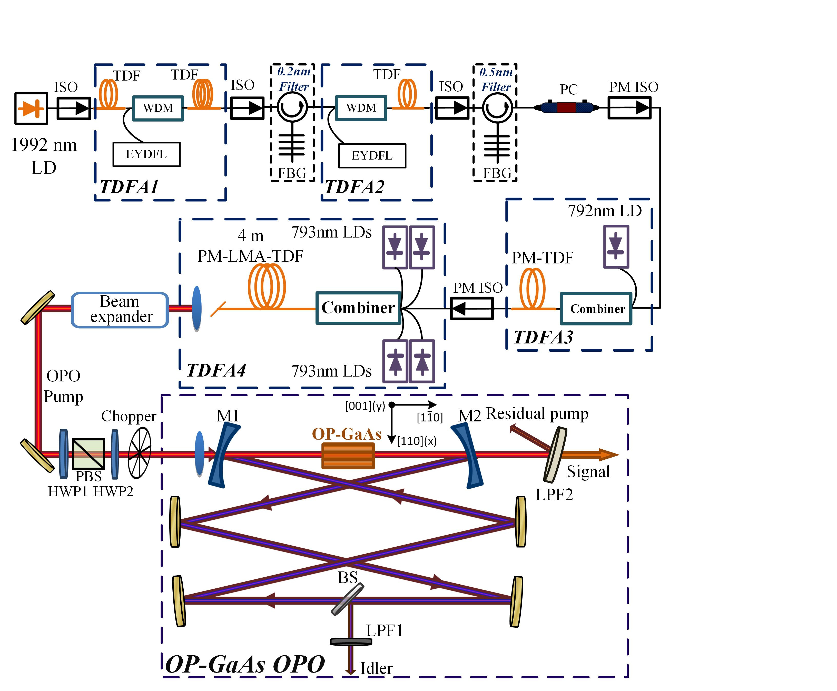

**Fig. 1.** Schematic of the TDF MOPA system and the OP-GaAs OPO. LD: laser diode; ISO: isolator; TDF: thulium doped fiber; WDM: wavelength-division multiplexer; EYDFL: erbium/ytterbium co-doped fiber laser; FBG: fiber Bragg grating; PC: polarization controller; PM: polarization maintaining; LMA: large-mode-area; HWP: half-wave plate; PBS: polarizing beam splitter; M1, M2: mirror 1,2; LPF1,2: long-pass filter 1,2.

Figure 1 illustrates the experimental setup of the TDF MOPA system and OP-GaAs OPO. The TDF MOPA system consisted of four amplifier stages. The seed laser was a polarization-maintaining (PM) fiber-pigtailed 1992-nm laser diode (Eblana Photonics) that was gain-switched by an electrical pulse generator (Agilent Technologies 8133A) with 430-ps electrical pulses at 100-MHz repetition rate and delivered ~100 μW average power. After a polarization insensitive optical isolator, the 1992-nm pulses were first amplified by a core-pumped TDF amplifier (TDFA1, Fig. 1), which consisted of a 12-m-long TDF (OFS TmDF200) forward pumped by a home-made Er/Yb co-doped fiber laser at 1565 nm through a 1565/2000nm wavelength-division multiplexer (WDM). Another piece of 4-m-long TDF was placed between the WDM and the isolator to absorb the backward amplified spontaneous emission (ASE) and to provide more gain at longer wavelengths, similar to the setup described in [26]. TDFA2 was a conventional core-pumped fiber amplifier using a 2-m-long home-made TDF (8.5-μm core, 100-μm cladding, NA=0.2) pumped by a 1565-nm Er/Yb co-doped fiber laser. The first two stages were followed with polarization insensitive isolators to prevent signal feedback, and spectral filters, consisting of fiber Bragg gratings (FBGs, reflective bandwidth of 0.2 and 0.5 nm, respectively) and circulators (insertion loss ~3dB), to suppress the ASE as well as to reduce the 1992-nm laser spectral linewidth. A polarization controller (FiberPro PC-1100-15, Fig. 1) and a PM isolator were placed before TDFA3 in order to generate and ensure a linearly polarized input into the final two stages. TDFA3 comprised a 4-m-long 10-μm-core TDF (Nufern, PM-TDF-10P/130-HE) cladding-pumped by a 792-nm laser diode via a 792/2000nm fiber-based pump combiner. The final stage (TDFA4) was also cladding-pumped, this time pumped with four 30-W 793 nm laser diodes combined via a (4+1) × 1 fiber-based pump combiner. The gain fiber used in this stage was a 4-m-long 25-μm-core PM TDF (Nufern, PLMA-TDF-25P/400-HE), and an 8° angle cleaved glass endcap was spliced to the output of the TDF to prevent back reflection and damage to the fiber end facet. The linearly polarized output beam from the TDF MOPA was collimated using an anti-reflection (AR) coated calcium fluoride lens (f=20 mm) and then expanded by a beam expander (2X). Two half-wave plates (HWP1,2) and a polarizing beam splitter were employed to provide power attenuation as well as polarization control for the OPO pump. An optical chopper was placed prior to the OPO cavity to provide for control of thermal effects during the investigation of the OPO output power characteristics (details explained in *3.2*).

The OPO was synchronously pumped and the OP-GaAs (BAE system) crystal had three gratings with periods of 57, 59 and 61 μm. Each OP-GaAs grating channel had a length of 20 mm (along crystallographic axis [1 $\overline{1}$ 0]) and an aperture of 5-mm (width, along [110]) × 1-mm (thickness, along [001]). The OP-GaAs crystal was mounted in an oven to allow temperature tuning from 20~100℃. Both end facets of the OP-GaAs crystal were AR coated at the pump (AR>99%), idler (AR>99%) and signal (AR>96%) wavelengths. The OPO consisted of a six-mirror bowtie cavity with two plane-concave mirrors (M1,2, Fig. 1, 250-mm radius of curvature) and four plane-plane gold-coated mirrors. M1 and M2 were AR coated for the pump (AR>98%), high-reflection (HR) coated for the idler (HR>99.5%) and provided partial reflection for the signal (reflectivity between ~10% and ~75% over the full signal wavelength range). The optical length of the OPO cavity was set to 3 m to match the repetition rate of pump (100 MHz). Note that active stabilization of the cavity length to the pump repetition rate was not required in the course of this work due to the relatively long duration of the pump pulses relative to the small variations in cavity round trip time that might originate from temperature/dispersion changes during the course of the experiments. The crystal was placed centrally between M1 and M2, which were spaced by 268 mm to give a calculated idler beam waist of 86~98 μm at the center of the crystal, depending on the idler wavelength. The pump beam (TDF MOPA) was focused by an AR coated calcium fluoride lens (f=200 mm) into the OP-GaAs crystal with a beam waist of 96/90 μm (1/e2 radius of intensity) in the x/y direction (Fig. 1). To maximize the first-order quasi-phase matching, the polarization of the pump beam was set to the [111] crystallographic axis of the crystal, which generates the signal and idler in the same polarization [17]. The idler beam was coupled out from the cavity by a beam splitter (Thorlabs, BSW511R) that had a reflectivity of ~23-32% over the entire idler wavelength range. The idler power was measured after a long pass filter (LPF1) with a cut-off wavelength at 3.5 μm. After passing through M2, the signal beam and residual pump beam were separated by another long pass filter (LPF2, Fig. 1, cut-off wavelength 2.5 μm). The quoted output powers of signal and idler were calculated from the direct measurements and by considering the losses of the LPFs. Note that a component of signal power would also have been available from other cavity elements (BS, M1) but this has not been accounted for in the quoted signal powers.

1. Results and discussions
   1. *2-μm high-power picosecond-pulse generation – the OPO pump system*

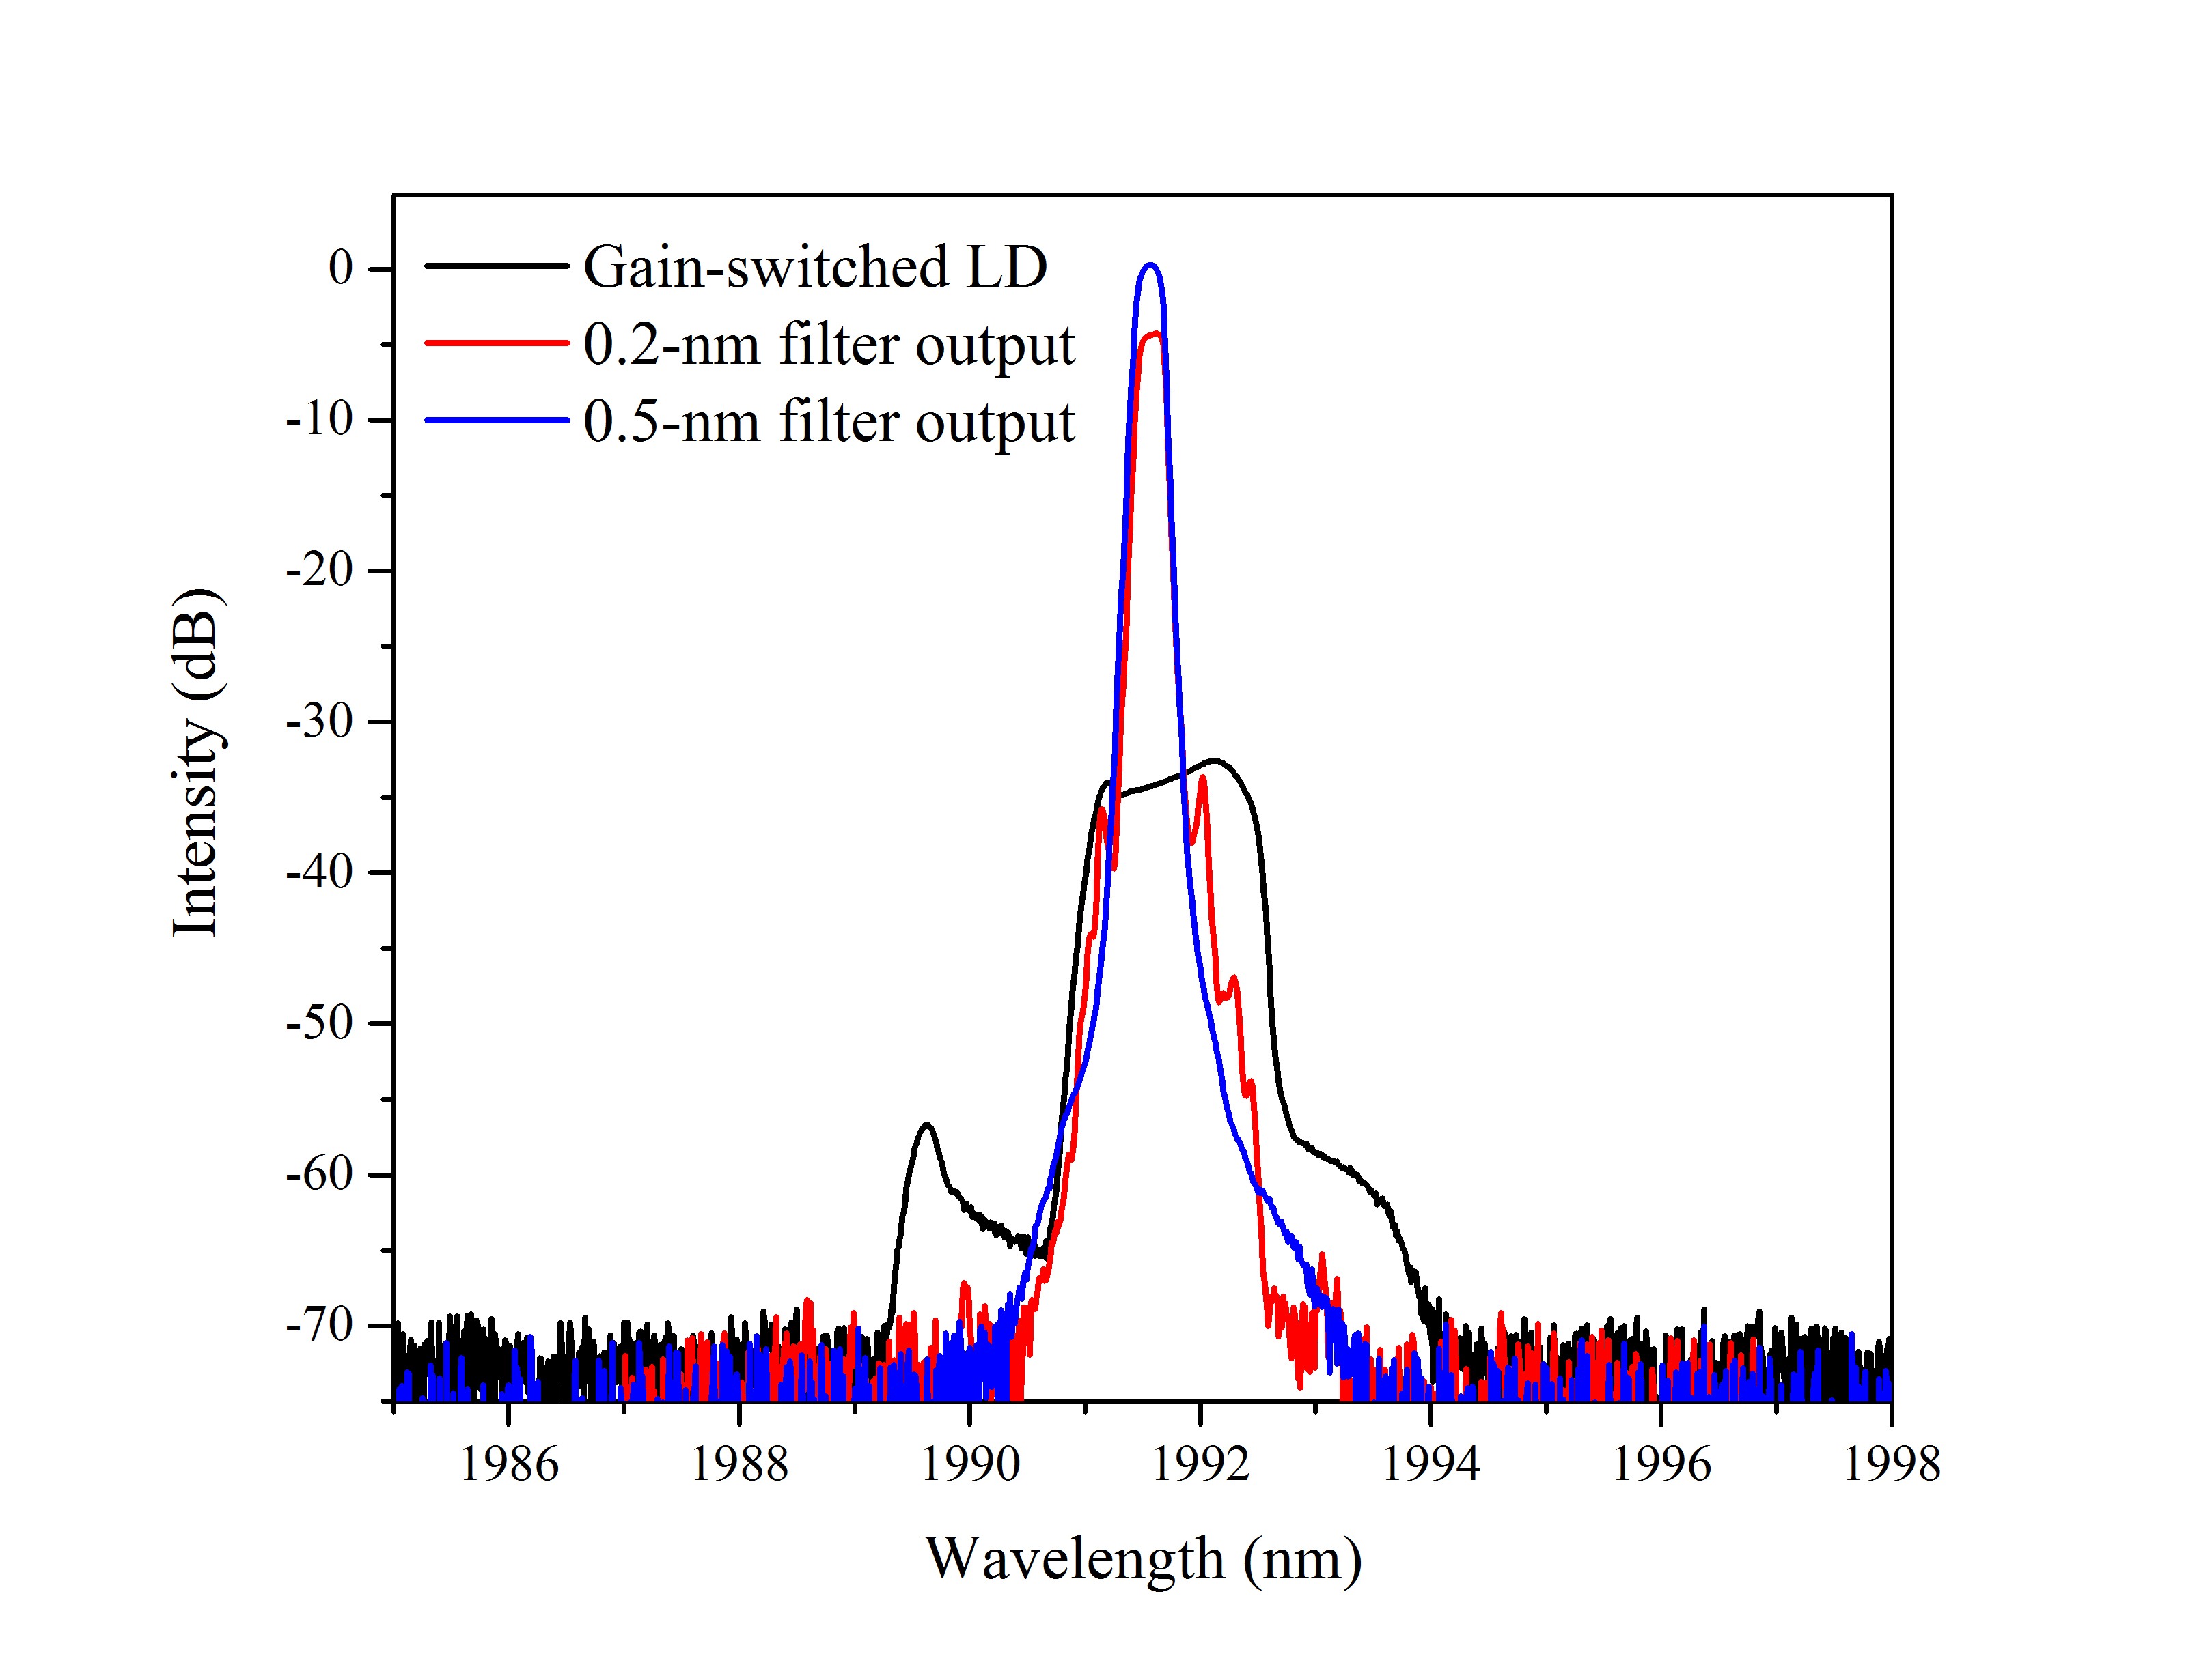

**Fig. 2.** Spectra of the gain-switched seed diode, and spectra at the outputs of the 0.2-nm and 0.5-nm spectral filter.

The seed laser to the fiber MOPA pump system was a gain-switched discrete-mode 1992-nm laser diode (LD) with an output spectrum that had a full width at half maximum (FWHM) of 1.3 nm, as depicted by the black line in Fig. 2. Thanks to the two spectral filters (Fig. 1), the spectra at the input to TDFA3 was narrowed to 0.2 nm (FWHM) with an improved signal-to-noise ratio (OSNR) of 70 dB (Fig. 2 blue line). The output power of the seed laser was ~100 μW, and this was boosted to 56 mW via TDFA1 operated at a pump power of 750 mW. After passing through the 0.2-nm spectral filter, the average power was decreased to 3 mW which was then coupled to TDFA2. The 270-mW output power of TDFA2 was obtained at a pump power of 2.5 W. Due to the losses of spectral filter, PC and PM ISO, 60 mW of linearly polarized output was measured as the input for TDFA3 and this was amplified to 200 mW at its output. Fig. 3(a) depicts the output characteristics of TDFA4. An output power of 40 W was obtained at a pump power of 107 W with a slope efficiency of 41%. A fast photodetector (EOT, ET-5000F, Bandwidth > 12.5 GHz) and an oscilloscope (Tektronix, CSA 803A, with 50 GHz bandwidth) were used to measure the pulse duration at the maximum output power, giving a FWHM of 95 ps as shown in the inset of Fig. 3(a). Fig. 3(b) shows the spectra of the final output at different power levels. The spectral bandwidth gradually broadened with increasing power due to self-phase-modulation, giving a 0.4-nm linewidth (3 dB) at the maximum output power of 40 W, while no other nonlinear effects, such as Raman scattering or modulation instability were observed providing an excellent OSNR of >60 dB, as shown in the inset of Fig. 3(b). The polarization extinction ratio was measured to be 14 dB, which was deemed adequate for the nonlinear frequency conversion.

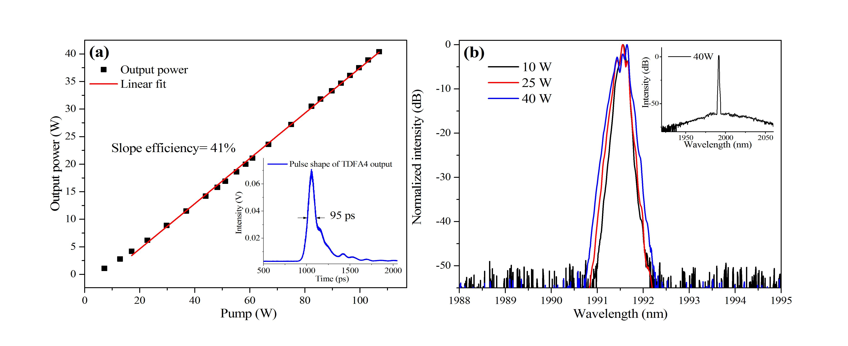

**Fig. 3.** (a) Output powers from TDFA4 and an associated linear fit. Inset: Temporal profile of the pulses from TDFA4 at maximum output power; (b) TDFA4 spectra at different output power levels. Inset: TDFA4 spectra at maximum output power shown for a wider wavelength range.

* 1. *High-power ultrafast OP-GaAs OPO*

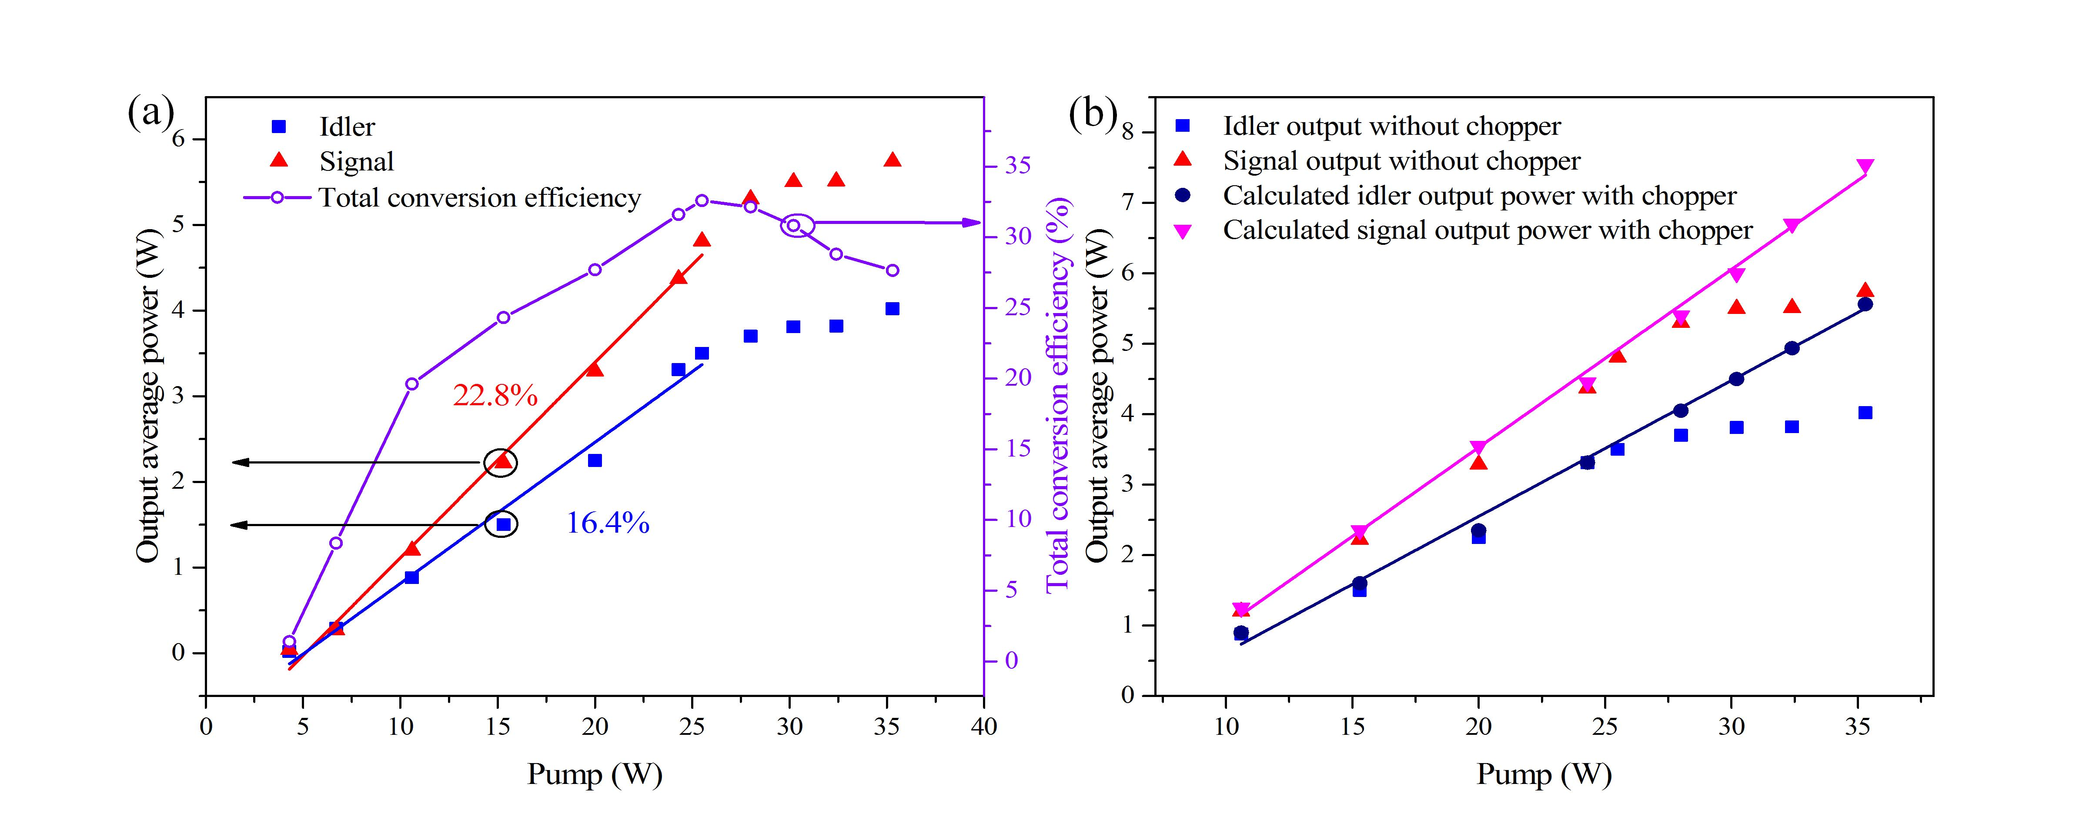

**Fig. 4.** (a) Output powers and conversion efficiencies from the OP-GaAs OPO; (b) OPO output powers comparison with chopper and without chopper.

The OPO output power characteristics and conversion efficiency were first investigated without the chopper (Fig. 1), giving the data shown in Fig. 4(a). At 40 ℃ oven temperature, a pump threshold of 4.3 W was observed from the 59-μm grating OP-GaAs with signal and idler wavelengths of 3093 and 5598 nm, respectively. The signal and idler output powers increased linearly for pump power up to 25.5 W at slope efficiencies of 22.8% and 16.4%, respectively, reaching 4.8 W and 3.5 W, and the corresponding overall power conversion efficiency reached 32.6%. However, the conversion efficiency started to drop when the pump power was increased further with a total maximal output power of 9.7 W (signal 5.7 W, idler 4.0 W) obtained with 27.6% conversion efficiency at the maximum available pump power of 35.3 W incident on the OP-GaAs crystal. In order to investigate the roll-off effect, an optical chopper was placed in front of the OPO cavity, and the output-versus-input powers were compared with and without the chopper, as shown in Fig. 4(b). The OPO operates in a burst mode with the chopper in place, and the associated OPO output powers presented are calculated quasi-continuous-wave average powers (i.e. average powers when the chopper was non-blocking) by taking the duty cycle of the chopper (25%) into consideration. The calculated quasi-continuous-wave output powers of the signal and idler were identical to the output powers without the chopper when the pump power was less than 25.5 W, but increased consistently and linearly with pump powers higher than 25.5 W. Thus, we attribute the power roll-off to average-power-induced thermal effects in the OP-GaAs crystal. A similar roll-off phenomenon has also been seen in a high-power CW OPO based on OP-GaAs [16]. The intensity of the pump pulses (maximum ~15 MW/cm2) is not considered to be a factor in the roll-off, because OP-GaAs has previously been pumped by a higher intensity beam of ~147 MW/cm2 in a picosecond OPA without any roll-off effects [13]. By mitigating the thermal effects with the aid of a chopper (25% transmission duty cycle), a maximum average output power of 3.25 W (signal 1.88 W, and idler 1.37 W) was achieved corresponding to a calculated quasi-continuous-wave average power of 13 W (signal 7.52 W, and idler 5.48 W). An overall conversion efficiency of 36.8% were achieved at a pump power of 35.3 W in the burst mode OPO operation. An 8% power drift was measured in the OPO output power over a period of 30 minutes. This is thought to be due to a measured ~3% drift in the pump power itself coupled with drift in the OPO cavity alignment. The durations of the signal and idler pulses were not measured due to the lack of suitable instruments, but they are expected to be equal to, or slightly shorter than, the pump pulses (95 ps, Fig. 3a inset) due to the parametric conversion process [6]. Therefore, the corresponding maximum peak powers of the signal and idler were estimated to be equal to or greater than 0.79 kW and 0.58 kW, respectively.

The wavelength tunability of the OPO using different OP-GaAs grating periods and range of oven temperatures was also investigated. The idler and signal wavelength could be continuously tuned from 2895-3342 nm (signal) and 4935-6389 nm (idler), and example spectra are shown in Fig. 5(a). The signal and idler spectra were characterized using an optical spectrum analyzer (Bristol instruments 721 series, 4-GHz resolution) and a monochromator (Bentham TMc300, 1-nm resolution at <5.5 μm and 3-nm resolution at >5.5 μm), respectively. A typical spectral linewidth of 1 nm (1 cm-1) and 5 nm (1.6 cm-1) were observed for the generated signal (3107 nm) and idler (5552 nm), respectively, as shown in Fig. 5(b).

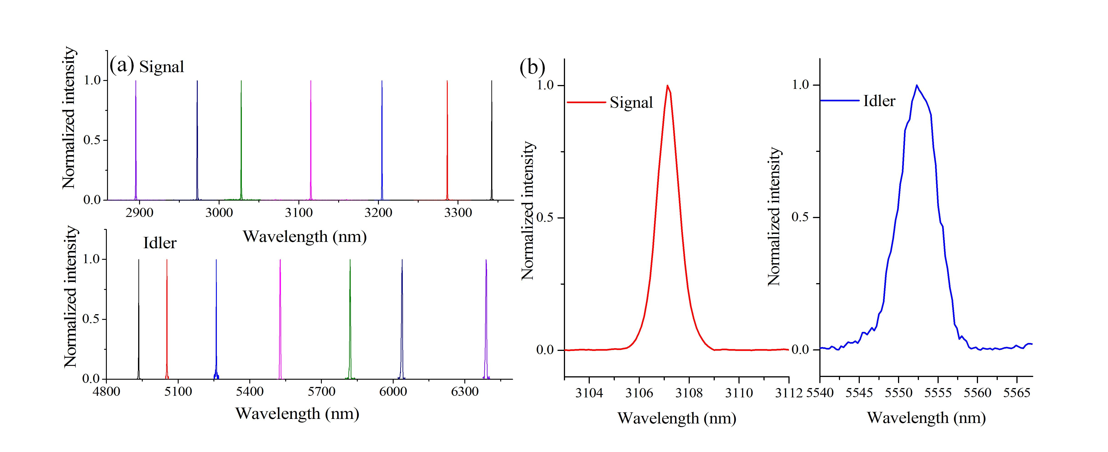

**Fig. 5.** (a) Tunability of the signal and idler from the OP-GaAs OPO; (b) Typical spectra of generated signal and idler.

The OPO signal and idler beam qualities were characterized at both low pump power (15.3 W) and high pump power (25.5 W), without the chopper in place, by using a pyroelectric scanning profiler (NanoScan, Photon). At low pump power, the beam quality of the signal and idler was measured to be M2x = 1.18 / M2y = 1.18 and M2x = 1.03 / M2y = 1.01, respectively. The better beam quality displayed by the idler was expected as it was controlled by the idler-resonant OPO cavity. At high pump power, the beam quality of the signal degraded to M2x = 1.45 / M2y = 1.21. We believe the degradation of signal beam quality was probably due to the absorption of signal in mirror M2 (Fig. 1), which had a silica substrate (limited by commercial availability). The idler beam quality at high pump power was only slightly degraded to M2x = 1.12/ M2y = 1.02. The beam qualities at or within the thermal roll-off regime were not measured due to the risk of crystal damage from long-term operation in this regime.

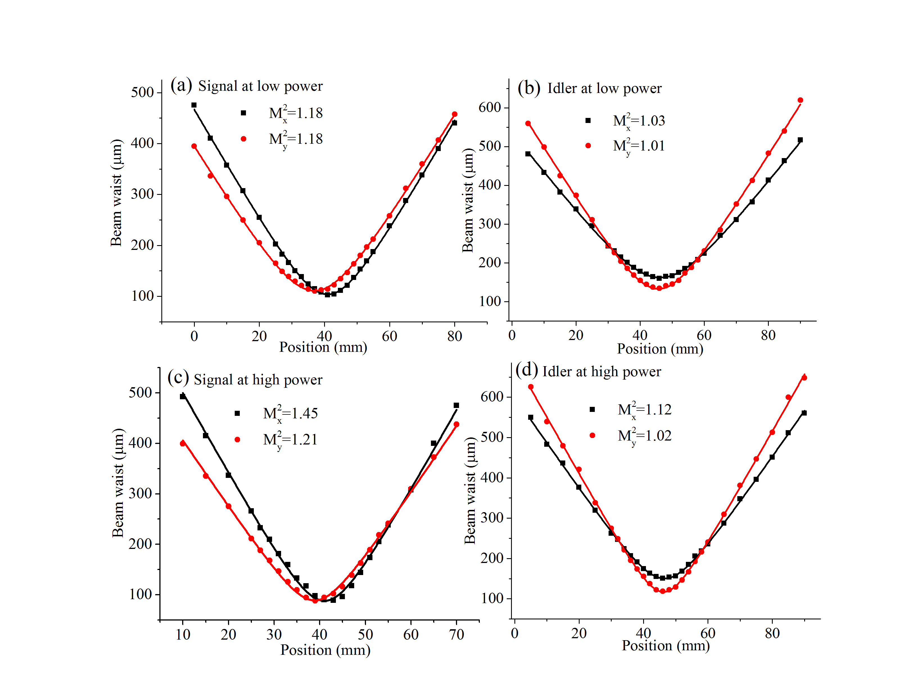

**Fig. 6.** Beam qualities of generated signal and idler both at low and high pump power.

1. Conclusion

In conclusion, we report a high-average-power, widely-tunable, mid-infrared picosecond OP-GaAs OPO. A tuning range of 2895 – 3342 nm for signal and 4935 – 6389 nm for idler was demonstrated. Thermal roll-off effect in the output power of the OPO was observed and a maximum power of 9.7 W (signal 5.7 W (0.60 kW peak power), idler 4.0 W (0.42 kW peak power)) was achieved at a pump power of 35.3 W and a repetition rate of 100 MHz. The OPO was also operated in a burst mode with a 25% duty cycle optical chopper placed in front of the OPO cavity to mitigate the thermal effects. In this regime, maximum peak powers of the signal and idler of 0.79 kW and 0.58 kW were obtained, respectively.

Funding

EPSRC AirGuide Photonics Programme Grant (Grant EP/P030181/1)

Acknowledgments

The authors acknowledge Prof. W.A. Clarkson from ORC for providing the large-mode-area thulium doped fibers, and Dr. Peter G. Schunemann from BAE Systems for growing the OP-GaAs crystals. Qiang Fu thanks the China Scholarship Council for financial support of his PhD. The data from the figures can be found in <https://doi.org/10.5258/SOTON/D1191>.

Disclosures

The authors declare no conflicts of interest.

References

1. I. T. Sorokina, and K. L. Vodopyanov, *Solid-State Mid-Infrared Laser Sources* (Springer Science & Business Media, 2003).

2. M. W. Sigrist, “Mid-infrared laser-spectroscopic sensing of chemical species,” J. Adv. Res.**6**(3), 529-533 (2015).

3. V. A. Serebryakov, É. V. Boĭko, N. N. Petrishchev, and A. V. Yan, “Medical applications of mid-IR lasers. Problems and prospects,” J. Opt. Technol.**77**(1), 6-17 (2010).

4. A. Sijan, “Development of military lasers for optical countermeasures in the mid-IR,” *Proc. SPIE 7483* 748304 (2009).

5. P. S. Kuo, K. L. Vodopyanov, M. M. Fejer, D. M. Simanovskii, X. Yu, J. S. Harris, D. Bliss, and D. Weyburne, “Optical parametric generation of a mid-infrared continuum in orientation-patterned GaAs,” Opt. Lett.**31**(1), 71-73 (2006).

6. L. Xu, H.-Y. Chan, S.-u. Alam, D. J. Richardson, and D. P. Shepherd, “High-energy, near- and mid-IR picosecond pulses generated by a fiber-MOPA-pumped optical parametric generator and amplifier,” Opt. Express**23**(10), 12613-12618 (2015).

7. B. Cole, L. Goldberg, S. Chinn, L. A. Pomeranz, K. T. Zawilski, P. G. Schunemann, and J. McCarthy, “Compact and efficient mid-IR OPO source pumped by a passively Q-switched Tm:YAP laser,” Opt. Lett.**43**(5), 1099-1102 (2018).

8. T. Skauli, K. L. Vodopyanov, T. J. Pinguet, A. Schober, O. Levi, L. A. Eyres, M. M. Fejer, J. S. Harris, B. Gerard, L. Becouarn, E. Lallier, and G. Arisholm, “Measurement of the nonlinear coefficient of orientation-patterned GaAs and demonstration of highly efficient second-harmonic generation,” Opt. Lett.**27**(8), 628-630 (2002).

9. P. G. Schunemann, “New nonlinear optical crystals for the mid-infrared,” in Advanced Solid State Lasers Conference,2015 OSA Technical Digest (Optical Society of America, 2015), paper AM2A.2.

10. N. Leindecker, A. Marandi, R. L. Byer, K. L. Vodopyanov, J. Jiang, I. Hartl, M. Fermann, and P. G. Schunemann, “Octave-spanning ultrafast OPO with 2.6-6.1µm instantaneous bandwidth pumped by femtosecond Tm-fiber laser,” Opt. Express**20**(7), 7046-7053 (2012).

11. O. H. Heckl, B. J. Bjork, G. Winkler, P. Bryan Changala, B. Spaun, G. Porat, T. Q. Bui, K. F. Lee, J. Jiang, M. E. Fermann, P. G. Schunemann, and J. Ye, “Three-photon absorption in optical parametric oscillators based on OP-GaAs,” Opt. Lett.**41**(22), 5405-5408 (2016).

12. J. Wueppen, S. Nyga, B. Jungbluth, and D. Hoffmann, “1.95  μm-pumped OP-GaAs optical parametric oscillator with 10.6  μm idler wavelength,” Opt. Lett.**41**(18), 4225-4228 (2016).

13. L. Xu, Q. Fu, S. Liang, D. P. Shepherd, D. J. Richardson, and S. U. Alam, “Thulium-fiber-laser-pumped, high-peak-power, picosecond, mid-infrared orientation-patterned GaAs optical parametric generator and amplifier,” Opt. Lett.**42**(19), 4036-4039 (2017).

14. C. Kieleck, M. Eichhorn, A. Hirth, D. Faye, and E. Lallier, “High-efficiency 20–50 kHz mid-infrared orientation-patterned GaAs optical parametric oscillator pumped by a 2 μm holmium laser,” Opt. Lett.**34**(3), 262-264 (2009).

15. A. Hildenbrand, C. Kieleck, E. Lallier, D. Faye, A. Grisard, B. Gérard, and M. Eichhorn, “Compact efficient mid-infrared laser source: OP-GaAs OPO pumped by Ho3+: YAG laser,” Proc. SPIE 8187 81870H (2011).

16. P. G. Schunemann, L. A. Pomeranz, S. D. Setzler, C. W. Jones, and P. A. Budni, “CW mid-IR OPO based on OP-GaAs,” in Conference on Lasers and Electro-Optics ***-***International Quantum Electronics Conference, 2013 OSA Technical Digest Series (Optical Society of America, 2013), paper JSII_2_3.

17. K. L. Vodopyanov, O. Levi, P. S. Kuo, T. J. Pinguet, J. S. Harris, M. M. Fejer, B. Gerard, L. Becouarn, and E. Lallier, “Optical parametric oscillation in quasi-phase-matched GaAs,” Opt. Lett.**29**(16), 1912-1914 (2004).

18. P. S. Kuo, K. L. Vodopyanov, M. M. Fejer, X. Yu, J. S. Harris, D. F. Bliss, and D. Weyburne, “GaAs optical parametric oscillator with circularly polarized and depolarized pump,” Opt. Lett.**32**(18), 2735-2737 (2007).

19. K. L. Vodopyanov, E. Sorokin, I. T. Sorokina, and P. G. Schunemann, “Mid-IR frequency comb source spanning 4.4–5.4 μm based on subharmonic GaAs optical parametric oscillator,” Opt. Lett.**36**(12), 2275-2277 (2011).

20. V. O. Smolski, S. Vasilyev, P. G. Schunemann, S. B. Mirov, and K. L. Vodopyanov, “Cr:ZnS laser-pumped subharmonic GaAs optical parametric oscillator with the spectrum spanning 3.6-5.6 μm,” Opt. Lett.**40**(12), 2906-2908 (2015).

21. D. French, R. Peterson, and I. Jovanovic, “Energy-scalable pulsed mid-IR source using orientation-patterned GaAs,” Opt. Lett.**36**(4), 496-498 (2011).

22. R. K. Feaver, R. D. Peterson, and P. E. Powers, “Longwave-IR optical parametric oscillator in orientation-patterned GaAs pumped by a 2 µm Tm,Ho:YLF laser,” Opt. Express**21**(13), 16104-16110 (2013).

23. Q. Clément, J. M. Melkonian, J. B. Dherbecourt, M. Raybaut, A. Grisard, E. Lallier, B. Gérard, B. Faure, G. Souhaité, and A. Godard, “Longwave infrared, single-frequency, tunable, pulsed optical parametric oscillator based on orientation-patterned GaAs for gas sensing,” Opt. Lett.**40**(12), 2676-2679 (2015).

24. W. Yao, Z. Shao, C. Shen, J. Tang, Y. Zhao, and D. Shen, “Gain-switched laser diode seeded TDFA with 409 W picosecond pulses and 142 W spectrally flat supercontinuum output,” Opt. Express**27**(2), 1276-1282 (2019).

25. S. Liang, L. Xu, Q. Fu, Y. Jung, D. P. Shepherd, D. J. Richardson, and S.-u. Alam, “295-kW peak power picosecond pulses from a thulium-doped-fiber MOPA and the generation of watt-level >2.5-octave supercontinuum extending up to 5 μm,” Opt. Express**26**(6), 6490-6498 (2018).

26. A. M. Heidt, Z. Li, and D. J. Richardson, “High power diode-seeded fiber amplifiers at 2 μm—from architectures to applications,” IEEE J. Sel. Top. Quant.**20**(5), 525-536 (2014).