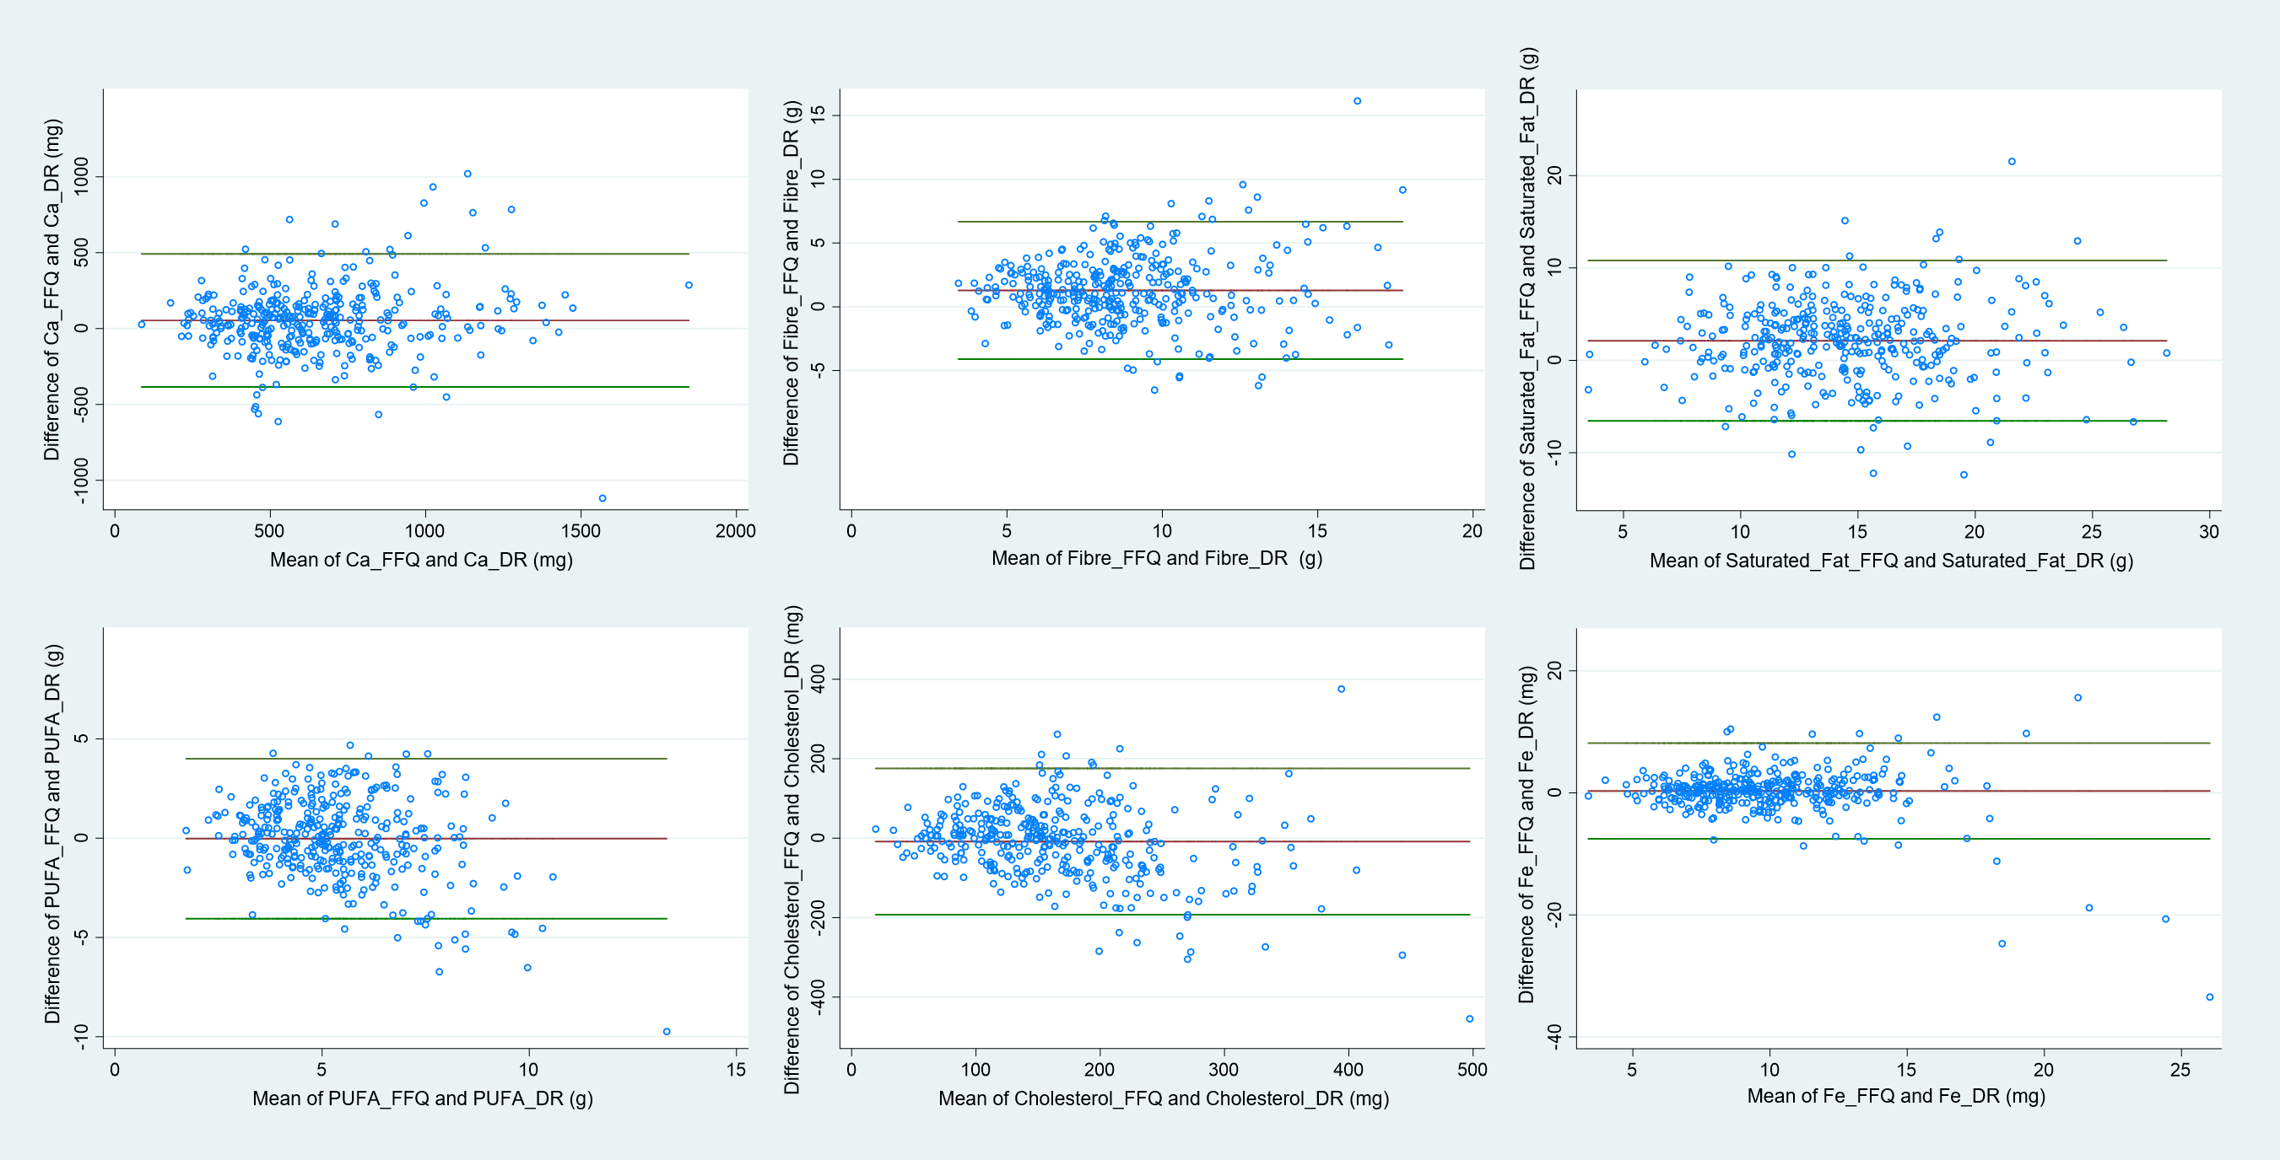

Figure 1. Bland-Altman plots of calcium (Ca), fibre, saturated fat, polyunsaturated fatty acids (PUFA), cholesterol and iron (Fe) intakes according to quantitative food frequency questionnaire (FFQ) and three-day diet record (DR), based-on log-transformed, energy adjusted values. X axis represents the average value of nutrient from FFQ and DR, and the Y axis the difference between FFQ and DR. Red horizontal line denotes the mean difference and green horizontal lines the limits of agreements. Data as reported by caregivers of five-year-old children from the Growing Up in Singapore Towards healthy Outcomes cohort (n = 361).

