Supplemental Table 1. Number (percent) reaching high fracture risk at follow-up according to fraction of treatment threshold at baseline and change in number of clinical risk factors (CRFs).

Criterion for high fracture risk | Change in CRFs | <25%  threshold | 25-49%  threshold | 50-74%  threshold | 75-99%  threshold | Combined
Fixed MOF treatment threshold | Decrease | 0 / 92 (0) | S / 312 (<1.0) | 10* / 189 (4.0) | 14 / 81 (17.3) | 22 / 674 (3.3)
(10-year fracture risk 20%) ª | No change | 0 / 1658 (0) | 15* / 4034 (<1.0) | 60* / 1320 (5.0) | 178 / 419 (42.5) | 253 / 7431 (3.4)
 | Increase | S / 545 (<1.0) | 70* / 1136 (6.3) | 155 / 332 (46.7) | 85 / 117 (72.6) | 415 / 2427 (17.1)
 | Overall | 16 / 2388 (0.7) | 142 / 5649 (2.5) | 249 / 1872 (13.3) | 283 / 623 (45.4) | 690 / 10532 (6.6)
Fixed hip fracture treatment threshold | Decrease | S / 300 (<1.0) | 15* / 146 (9.6) | 21 / 81 (25.9) | 21 / 43 (48.8) | 58 / 570 (10.2)
(10-year fracture risk 3%) ª | No change | 40* / 3986 (1.0) | 189 / 1569 (12.0) | 316 / 774 (40.8) | 316 / 433 (73.0) | 864 / 6762 (12.8)
 | Increase | 90 / 1188 (7.6) | 155 / 416 (37.3) | 164 / 214 (76.6) | 99 / 113 (87.6) | 624 / 2209 (28.2)
 | Overall | 168 / 5649 (3.0) | 412 / 2202 (18.7) | 522 / 1093 (47.8) | 444 / 597 (74.4) | 1546 / 9541 (16.2)
Age-dependent MOF treatment threshold ª | Decrease | 0 / 9 (0) | 0 / 185 (0) | 7 / 217 (3.2) | 16 / 143 (11.2) | 23 / 554 (4.2)
 | No change | 0 / 29 (0) | 6 / 3429 (0.2) | 51 / 2715 (1.9) | 204 / 880 (23.2) | 261 / 7053 (3.7)
 | Increase | 0 / 18 (0) | 59 / 1031 (5.7) | 277 / 758 (36.5) | 159 / 250 (63.6) | 648 / 2349 (27.6)
 | Overall | 0 / 58 (0) | 122 / 4804 (2.5) | 414 / 3801 (10.9) | 396 / 1293 (30.6) | 932 / 9956 (9.4)
S, suppressed small numbers or * rounded due to small numbers. ª Major osteoporotic fracture (MOF) and hip fracture risk computed using the FRAX tool with bone mineral density (BMD).

Supplemental Table 2. Time in years (95% confidence interval) for 5% of the population to reach high fracture risk according to fraction of treatment threshold at baseline and change in number of clinical risk factors (CRFs).
 | Fixed MOF threshold 20%
Change in CRFs | <25% threshold | 25-49% threshold | 50-74% threshold | 75-99% threshold
Decrease | >15 (>15, >15) | 14.6 (12.5, >15) | 6.4 (4.9, 10.4) | 3.3 (2.9, 4.1)
No change | >15 (>15, >15) | 14.6 (14.3, >15) | 5.2 (4.7, 5.9) | 2.5 (2.3, 2.8)
Increase | 10.2 (8.8, 13.1) | 5.2 (4.8, 5.8) | 2.9 (2.8, 3.0) | 2.4 (2.3, 2.8)
Overall | 14.5 (13.1, >15) | 8.5 (7.8, 9.1) | 3.8 (3.6, 4.0) | 2.7 (2.4, 2.8)
 | Fixed hip fracture threshold 3%
Change in CRFs | <25% threshold | 25-49% threshold | 50-74% threshold | 75-99% threshold
Decrease | 14.0 (10.3, >15) | 4.6 (3.9, 6.4) | 2.9 (2.8, 3.4) | 2.7 (2.4, 3.0)
No change | 11.8 (11, 13.6) | 4.0 (3.8, 4.3) | 2.7 (2.6, 2.8) | 2.1 (1.9, 2.3)
Increase | 6.0 (5.6, 6.5) | 3.0 (2.9, 3.1) | 2.7 (2.4, 2.8) | 2.5 (2.3, 2.7)
Overall | 8.5 (8, 9) | 3.5 (3.4, 3.7) | 2.7 (2.6, 2.8) | 2.3 (2.1, 2.4)
 | Age-dependent MOF threshold
Change in CRFs | <25% threshold | 25-49% threshold | 50-74% threshold | 75-99% threshold
Decrease | >15 (>15, >15) | >15 (>15, >15) | 6.8 (5.0, 13.1) | 3.7 (3.2, 5)
No change | >15 (>15, >15) | >15 (>15, >15) | 8.8 (7.6, 10.8) | 2.7 (2.6, 2.9)
Increase | >15 (>15, >15) | 4.7 (4.3, 5.2) | 2.7 (2.5, 2.8) | 2.2 (2.0, 2.4)
Overall | >15 (>15, >15) | 8.8 (8.1, 9.8) | 3.9 (3.7, 4.1) | 2.7 (2.5, 2.8)
>15 indicates that less than 5% of the population reached high fracture risk by 15 years.
Supplemental Table 3. Time in years (95% confidence interval) for 20% of the population to reach high fracture risk according to fraction of treatment threshold at baseline and change in number of clinical risk factors (CRFs).

 | Fixed MOF threshold 20%
Change in CRFs | <25% threshold | 25-49% threshold | 50-74% threshold | 75-99% threshold
Decrease | >15 (>15, >15) | >15 (>15, >15) | 11.9 (9.2, 14.6) | 5.6 (4.6, 7.4)
No change | >15 (>15, >15) | >15 (>15, >15) | 9.7 (8.9, 11.4) | 3.7 (3.5, 4)
Increase | 14.6 (14.4, >15) | 9.7 (9.1, 10.6) | 4.4 (4.1, 4.8) | 3.7 (3.4, 4)
Overall | >15 (>15, >15) | 13.7 (13.2, 14.5) | 6.7 (6.4, 7.1) | 3.9 (3.7, 4.1)
 | Fixed hip fracture threshold 3%
Change in CRFs | <25% threshold | 25-49% threshold | 50-74% threshold | 75-99% threshold
Decrease | >15 (14.9, >15) | 8.7 (7.3, 11.1) | 4.8 (4.1, 6) | 4.0 (3.4, 4.9)
No change | >15 (14.9, >15) | 7.5 (7.1, 8) | 4.0 (3.8, 4.2) | 3.2 (3.1, 3.3)
Increase | 10.9 (10.2, 11.6) | 4.9 (4.5, 5.3) | 3.8 (3.6, 4.1) | 3.6 (3.4, 3.9)
Overall | 14.5 (13.9, 14.9) | 6.4 (6.2, 6.7) | 4.0 (3.8, 4.1) | 3.3 (3.2, 3.5)
 | Age-dependent MOF threshold
Change in CRFs | <25% threshold | 25-49% threshold | 50-74% threshold | 75-99% threshold
Decrease | >15 (>15, >15) | >15 (>15, >15) | 14.5 (11.7, 15) | 7.9 (6.2, 11.3)
No change | >15 (>15, >15) | >15 (>15, >15) | >15 (14.9, >15) | 4.7 (4.4, 5.0)
Increase | >15 (>15, >15) | 10.8 (9.6, 12) | 4.6 (4.3, 4.9) | 3.5 (3.3, 3.8)
Overall | >15 (>15, >15) | >15 (14.9, >15) | 8.0 (7.5, 8.5) | 4.6 (4.3, 4.8)
>15 indicates that less than 20% of the population reached high fracture risk by 15 years.
Supplemental Table 4. Time in years (95% confidence interval) for 50% of the population to reach high fracture risk according to fraction of treatment threshold at baseline and change in number of clinical risk factors (CRFs).

 | Fixed MOF threshold 20%
Change in CRFs | <25% threshold | 25-49% threshold | 50-74% threshold | 75-99% threshold
Decrease | >15 (>15, >15) | >15 (>15, >15) | 14.6 (13.5, >15) | 9.2 (7.4, 11.6)
No change | >15 (>15, >15) | >15 (>15, >15) | 14.5 (13.3, 14.6) | 5.9 (5.4, 6.2)
Increase | >15 (>15, >15) | 14.5 (13.5, 14.6) | 7.4 (6.8, 7.7) | 5.9 (5.2, 6.4)
Overall | >15 (>15, >15) | >15 (>15, >15) | 10.9 (9.9, 11.5) | 6.2 (5.8, 6.5)
 | Fixed hip fracture threshold 3%
Change in CRFs | <25% threshold | 25-49% threshold | 50-74% threshold | 75-99% threshold
Decrease | >15 (>15, >15) | 13.5 (11.2, 14.9) | 8 (6.6, 9.2) | 6.6 (5.5, 7.7)
No change | >15 (>15, >15) | 11.8 (11.1, 12.3) | 6.7 (6.2, 6.8) | 5 (4.5, 5.2)
Increase | 14.9 (14.7, 14.9) | 8.0 (7.4, 8.3) | 6.4 (5.8, 6.6) | 6 (5.4, 6.4)
Overall | >15 (>15, >15) | 10.3 (9.7, 10.5) | 6.6 (6.2, 6.7) | 5.4 (5.0, 5.5)
 | Age-dependent MOF threshold
Change in CRFs | <25% threshold | 25-49% threshold | 50-74% threshold | 75-99% threshold
Decrease | >15 (>15, >15) | >15 (>15, >15) | >15 (>15, >15) | 14.5 (12, >15)
No change | >15 (>15, >15) | >15 (>15, >15) | >15 (>15, >15) | 9 (8.1, 9.5)
Increase | >15 (>15, >15) | >15 (14.9, >15) | 8.7 (8.0, 9.0) | 6.1 (5.5, 6.5)
Overall | >15 (>15, >15) | >15 (>15, >15) | 14.1 (13, 14.5) | 8.3 (7.5, 8.5)
>15 indicates that less than 50% of the population reached high fracture risk by 15 years.
Supplemental Table 5. Number (percent) reaching high fracture risk at follow-up according to fraction of treatment threshold at baseline and change in number of clinical risk factors (CRFs) stratified as decreases (-1), no change (0), or increase (+1, +2 or more).
Criterion for high fracture risk | Change in CRFs | <25%  threshold | 25-49%  threshold | 50-74%  threshold | 75-99%  threshold | Combined
Fixed MOF treatment threshold 20% ª | -1 | 0 / 92 (0) | S / 312 (<1) | ~10 / 189 (4) | 14 / 81 (17.3) | 22 / 674 (3.3)
 | 0 | 0 / 1658 (0) | ~15 / 4034 (<1) | ~60 / 1320 (5) | 178 / 419 (42.5) | 253 / 7431 (3.4)
 | +1 | S / 545 (<1) | ~70 / 1136 (6.3) | 155 / 332 (46.7) | 85 / 117 (72.6) | 313 / 2130 (14.7)
 | +2 | ~15 / 93 (15) | 57 / 167 (34.1) | 25 / 31 (80.6) | 6 / 6 (100.0) | 102 / 297 (34.3)
 | Overall | 16 / 2388 (0.7) | 142 / 5649 (2.5) | 249 / 1872 (13.3) | 283 / 623 (45.4) | 690 / 10532 (6.6)
Fixed hip fracture treatment threshold 3% ª | -1 | S / 300 (<1) | ~15 / 146 (9.6) | 21 / 81 (25.9) | 21 / 43 (48.8) | 58 / 570 (10.2)
 | 0 | ~40 / 3986 (1) | 189 / 1569 (12.0) | 316 / 774 (40.8) | 316 / 433 (73.0) | 864 / 6762 (12.8)
 | +1 | 90 / 1188 (7.6) | 155 / 416 (37.3) | 164 / 214 (76.6) | 99 / 113 (87.6) | 508 / 1931 (26.3)
 | +2 | 33 / 175 (18.9) | 54 / 71 (76.1) | 21 / 24 (87.5) | 8 / 8 (100) | 116 / 278 (41.7)
 | Overall | 168 / 5649 (3.0) | 412 / 2202 (18.7) | 522 / 1093 (47.8) | 444 / 597 (74.4) | 1546 / 9541 (16.2)
Age-dependent MOF treatment threshold ª | -1 | 0 / 9 (0) | 0 / 185 (0) | 7 / 217 (3.2) | 16 / 143 (11.2) | 23 / 554 (4.2)
 | 0 | 0 / 29 (0) | 6 / 3429 (0.2) | 51 / 2715 (1.9) | 204 / 880 (23.2) | 261 / 7053 (3.7)
 | +1 | 0 / 18 (0) | 59 / 1031 (5.7) | 277 / 758 (36.5) | 159 / 250 (63.6) | 495 / 2057 (24.1)
 | +2 | 0 / 2 (0) | 57 / 159 (35.8) | 79 / 111 (71.2) | 17 / 20 (85.0) | 153 / 292 (52.4)
 | Overall | 0 / 58 (0) | 122 / 4804 (2.5) | 414 / 3801 (10.9) | 396 / 1293 (30.6) | 932 / 9956 (9.4)
S, suppressed small numbers and ~, rounded due to small numbers. ª Major osteoporotic fracture (MOF) and hip fracture risk computed using the FRAX tool with bone mineral density (BMD).
Supplemental Figure 1. Absolute and relative change in major osteoporotic fracture (MOF) risk and hip fracture risk for increasing intervals between fracture risk assessments according to change in the number of clinical risk factors (CRFs) stratified as decrease (-1), no change (0), or increase (+1, +2 or more). Solid lines are loess smoothed curves fitted to the dots which are individual patient observations. Dashed line (right hand) indicates a doubling in baseline fracture risk.

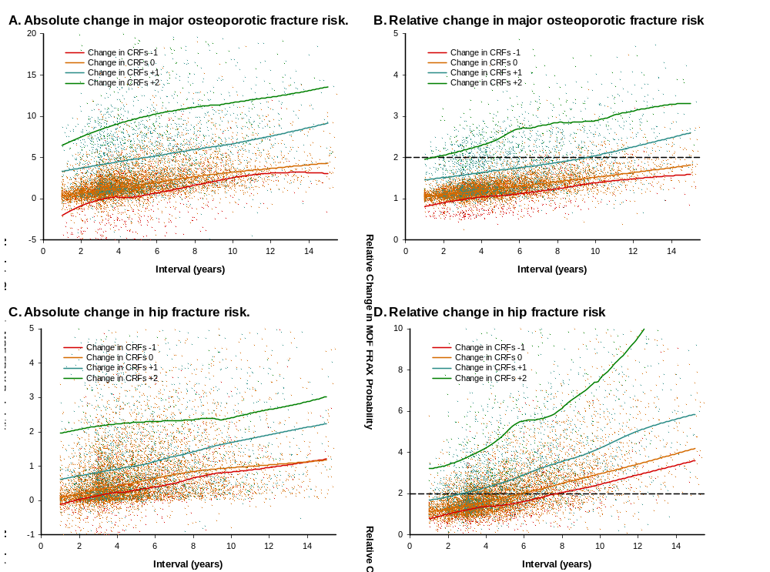
Supplemental Figure 2. Importance of variables predicting transition to high fracture risk according to fixed 20% major osteoporotic fracture (MOF) risk, fixed 3% hip fracture risk, and age-dependent MOF risk. Data from Cox regression models. Rank ordered, highest to lowest model Chi-square statistic.



