Modelling Space Charge in HVDC Cable Insulation

Yunpeng Zhan1[0000-0002-8171-8107], George Chen1[0000-0002-7121-1368], Miao Hao1[0000-0002-5307-1158], Zhiqiang Xu1[0000-0002-6640-7335] and Lu Pu2[0000-0002-8538-5127], Xuefeng Zhao2[0000-0002-1047-1485], Haofei Sun2[0000-0002-9799-7331], Sen Wang2[0000-0003-1758-8886], Anxiang Guo2[0000-0002-1643-4781], Jian Liu2[0000-0002-0079-5435]

1 University of Southampton, Southampton, United Kingdom

2 State Grid Shaanxi Electric Power Research Institute, Xi’an, China  
yz10n16@soton.ac.uk

**Abstract.** The design of high-voltage direct-current extruded cable is one of the most challenging issues in the cable industry, as the electric field distribution across the insulation can be strongly affected by the presence of space charge, which can subsequently affect its long-term reliability and life expectancy. In this study, the bipolar charge transport model was utilized to calculate space charge and field distribution in a polymeric cable insulation, and the result was compared with the one obtained by the conductivity model which is commonly used in the cable industry. It is shown that the simulation results of the bipolar charge transport model are more comparable with the previous experimental work, and the shortcomings of the conductivity model are presented. At last, the feasibility and potential issues of the new method are discussed for further development.

**Keywords:** HVDC cable, field distribution, bipolar charge transport model

1. Introduction

In recent decades, the market for high-voltage direct-current (HVDC) transmission systems is booming, as this technology contributes large power delivery over long distance and the integration of renewable electricity sources [1]. Due to its excellent electrical and thermal properties, extruded cable becomes the key component for HVDC transmission system [2]. However, the design of HVDC extruded cable requires special considerations, as it is reported that the electric field distribution across the insulation thickness can be distorted by the presence of space charge accumulation [3]. Indeed, space charge can easily accumulate in the polymeric insulation under DC field, due to charge injection at electrodes and to dissociation of by-products and impurities within the insulation bulk. If the space charge density becomes sufficiently high, the local electric field strength may exceed the breakdown strength of the dielectric, leading to insulation ageing and even failure [1].

With the assumptions of the conductivity/resistivity of the insulation depending on temperature and field, some methods of calculating field distribution in DC cable have been developed [4], and this kind of methods is serving as an important reference for DC cable design. Nevertheless, these models cannot predict charge generation and transport, and the space charge is only derived from the conductivity gradient, which could limit its performance [5]. Since the work proposed by Alison et al on charge transport modelling in polyethylene based material in 1994 [6], the bipolar charge transport model has been applied to simulate charge dynamics by many researchers, achieving a good fit when compared with the experimental results, but few attempts have been made to investigate the space charge behaviour in cable geometry [7-9].

By using the COMSOL Multiphysics software, we compare the simulation results obtained using the above two models in a polyethylene-insulated cable, considering a temperature gradient across the cable insulation. Differences have been shown between the conductivity model and the charge transport model, as the charge injection and transport are not considered in the macroscopic model. Besides, some suggestions for the further improvement of the bipolar charge transport model are given.

1. Descriptions of the two methods

From a macro perspective, a weak current could be formed in polyethylene-based materials under DC field, and this current may not be uniform due to the non-homogeneity of the insulating material. On the basis of the current continuity equation, a dielectric sample where a DC current of density *j* is flowing, and where a divergence takes place between the incoming and outgoing charge flow, will acquire a space charge density 𝜌.

 (1)

By combing the other three essential equations i.e.: Gauss law, Ohm’s law and the electrostatic electric field,

 (2)

 (3)

 (4)

where *E* is the electric field strength, *σ* is the conductivity , *ε0* is the vacuum permittivity, *εr* is the relative permittivity, *µ* is the mobility of charge carriers and *V* is the electrical potential, space charge density can be described in the non-homogeneous weakly conductive material as:

 (5)

* 1. The conductivity model

By assuming the volume conductivity of the insulation depends on temperature and field, the conductivity model was developed to anticipate the field distribution in loaded cable systems [4]. From equation (5), space charge would accumulate if the ratio permittivity/conductivity varies with position. Indeed, the permittivity of the insulation could be treated as a constant within the working range of temperatures and fields, however, the conductivity is generally considered to be dependent on both temperature and field. The conductivity expression of Arrhenius’ law has been widely used to describe such relationship in the synthetic insulation material [10] [11]:

 (6)

where *kB* is the Boltzmann’s constant, *E* is the electric field, *T* is the temperature. Constants *A*, *B* and *Ea* are obtained by fitting the conductivity equation with the conduction current measurements on the planar samples of the material under a range of temperatures and fields. In this model, the conductivity gradient formed across the insulation drives the charge dynamics, therefore the field distribution can be obtained straightforward.

* 1. The bipolar charge transport model

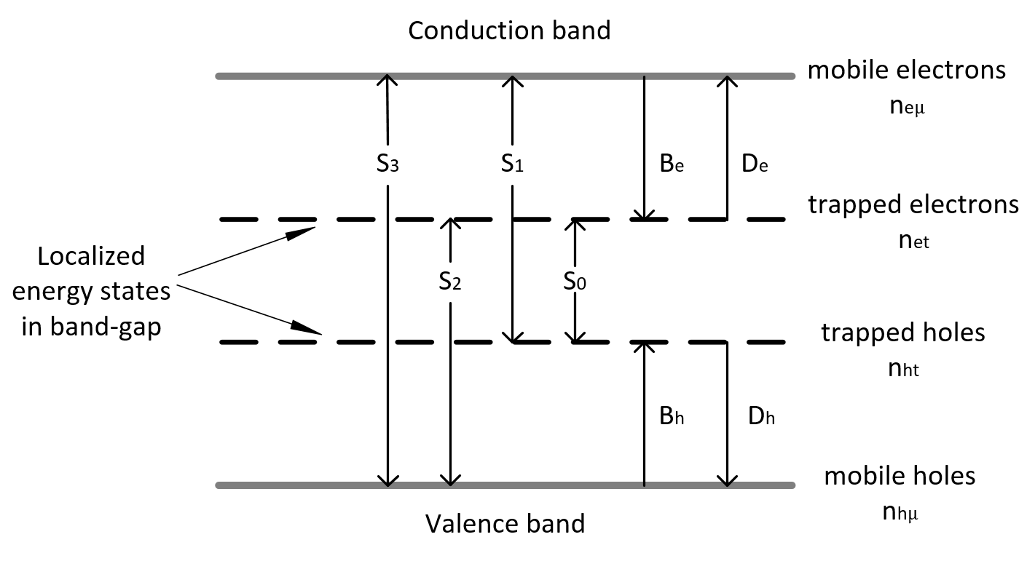

**Fig. 1.** Four kinds of charge carriers in bipolar charge transport model. *Si*, *Bi* and *Di* are recombination, trapping and de-trapping coefficients respectively. *ni* is the charge density. Indexes *e* and *h* refer to electrons and holes; *μ* and *t* refer to mobile and trapped charge carriers [7].

Differently from the conductivity model, the bipolar charge transport model features the bipolar injection of electronic charge carriers from the electrodes when the DC field exceeds the threshold. As shown in Figure 1, four species are considered in the bipolar charge transport model. Under the force of the electric field, these injected positive and negative charge carriers shift to the reversed polarity electrodes. For the big band-gap material, polyethylene, the localized energy states which originated from physical or chemical defects can trap charge carriers, and these captured charge carriers can also escape from these traps. Additionally, these charge carriers with opposite polarity have the possibility to recombine, resulting in electroluminescence. A hopping type of mobility, which is field and temperature dependent, is used to describe the conduction of charge carriers [8]. For sake of simplification, space charge generation only depends on the injection from semi-conductive electrodes, and the ionization process is not taken into account. The boundary condition has already been reported in the previous work [9].

It should be noted that in the bipolar charge transport model, the source terms *si*, which are defined to describe the local variations of density of given specie, are introduced for solving the current continuity equation. The source terms encompass the trapping, de-trapping and recombination processes, for mobile electrons, *seµ* can be presented as:

 (7)

1. Simulated results

As shown in Figure 2, a medium voltage cross-linked polyethylene (XLPE) cable of 4.5 mm insulation thickness, is used for simulation by the both models. The average electric field is around 20 kV/mm, and a 20°C temperature gradient is applied along the radial direction. The electrical and thermal setting are following the previous experimental work [11].

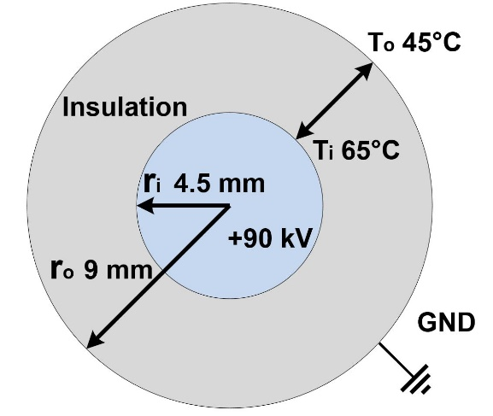

**Fig. 2.** Schematic representation of the medium voltage cable sample.

Table 1 gives the parameters which used in the macroscopic model, and they were also from literature [11].

**Table 1.** Symbols used for the macroscopic model [11].

|  |  |  |
| --- | --- | --- |
| Symbol | Value | Unit |
| A | 1*1014 | A/m2 |
| B | 2*10-7 | V-1m |
| Ea | 1.48 | eV |

Figure 3 presents the time-dependent charge distribution simulated by the conductivity model. It should be claimed first that the charge accumulation in such model could be contributed by all types of charge carriers, including ions, holes and electrons. With the positive voltage applying at the inner electrode, only one-polarity (positive) charge can be observed in the insulation. The accumulation of charge is believed to originated from the nonuniform current density along the radius. At first, due to the presence of temperature gradient and the Laplacian field, a very large conductivity gradient could be formed along the insulation, therefore charges accumulates very quickly at this stage, especially at the inner part. As the steady field distribution is resistive under DC stress, the outer part of the insulation shall bear more electric stress due to a lower conductivity, as shown in Figure 4. The field variation could decrease the conductivity gradient and slow the charge accumulation. At last, the steady state is reached till 20000 s.

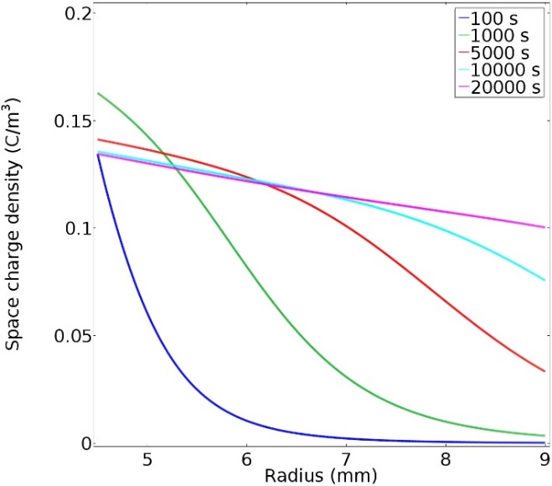

**Fig. 3.** The distribution of charge density simulated by the conductivity model.

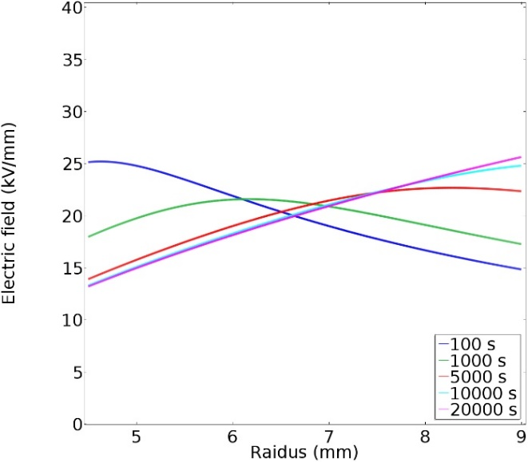

**Fig. 4.** Field distribution in the cable insulation predicted by the conductivity model.

For bipolar charge transport model, in order to simulate the transport process of holes and electrons respectively, the module of “Transport of Diluted Species (TDS)” has been selected in the COMSOL, a finite element method software, to calculate the density of each specie migrating in the electric field. The parameters used in this model are listed in Table 2 [8].

**Table 2.** Parameters applied in the bipolar charge transport model [8].

|  |  |  |
| --- | --- | --- |
| Parameter | Value | Unit |
| **Injection barrier heights** |  |  |
| Wei for electrons | 1.27 | eV |
| Whi for holes | 1.16 | eV |
| **Trapping coefficients** |  |  |
| Be for electrons | 0.05 | s-1 |
| Bh for holes | 0.05 | s-1 |
| **Trap depths** |  |  |
| wµe for electrons | 0.71 | eV |
| wµh for holes | 0.65 | eV |
| **Trap densities** |  |  |
| noet for electrons | 100 | C/m3 |
| noht for holes | 100 | C/m3 |
| **De-trapping barrier height** |  |  |
| Wtre for electrons | 0.96 | eV |
| Wtrh for holes | 0.99 | eV |
|  |  |  |

As shown in Figure 5, the space charge distribution is very different from the result of the conductivity model, because different processes dominate the charge accumulation in the bipolar charge transport model together. At the beginning, the charge injection is accountable for the charge accumulation at the interface. Compared with electrons, more holes are injected into the bulk, this is not only because the higher temperature at the inner side but also the assumption of lower injection barrier for holes. The large amount of homo-charges decreases the field at the anode severely, as shown in Figure 6, resulting in a nearly zero field. For longer polarization time, the trapping/de-trapping processes seem to have a bigger impact on the charge distribution. The charge deep penetration and these trapped charges affect the field distribution greatly, making the maximal electric field transfers from inner part to the outer gradually.

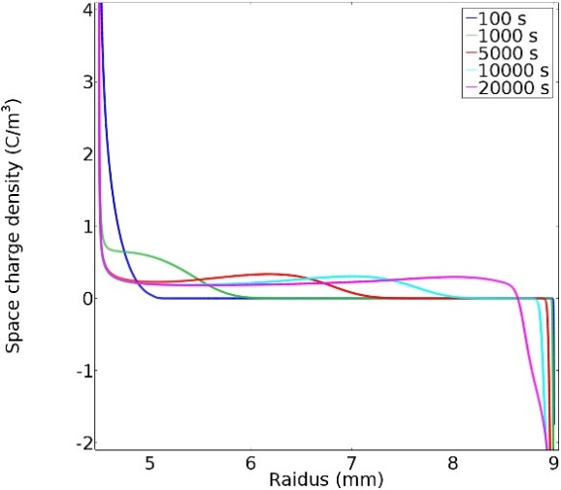

**Fig. 5.** Simulated space charge distribution within the insulation bulk evolving with time.

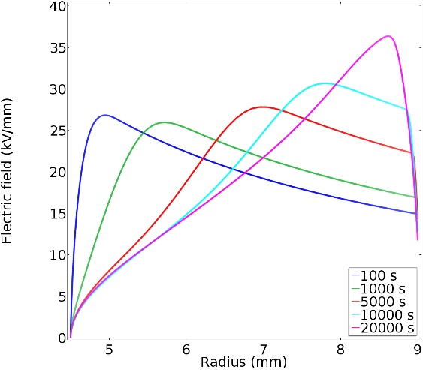

**Fig. 6.** Computed field distribution within the insulation by the bipolar charge transport model.

1. Comparisons of the results

Both models are able to anticipate the field inversion in the cable with the presence of temperature gradient, but there are many differences between their results and the experimental observation. First, the space charge distribution performed by the conductivity model is very different from the experimental data shown in Figure 7, as the conductivity model can only provide an overall contribution from all types of charge carriers, while it lacks specific transport information of each kind of charge carriers.

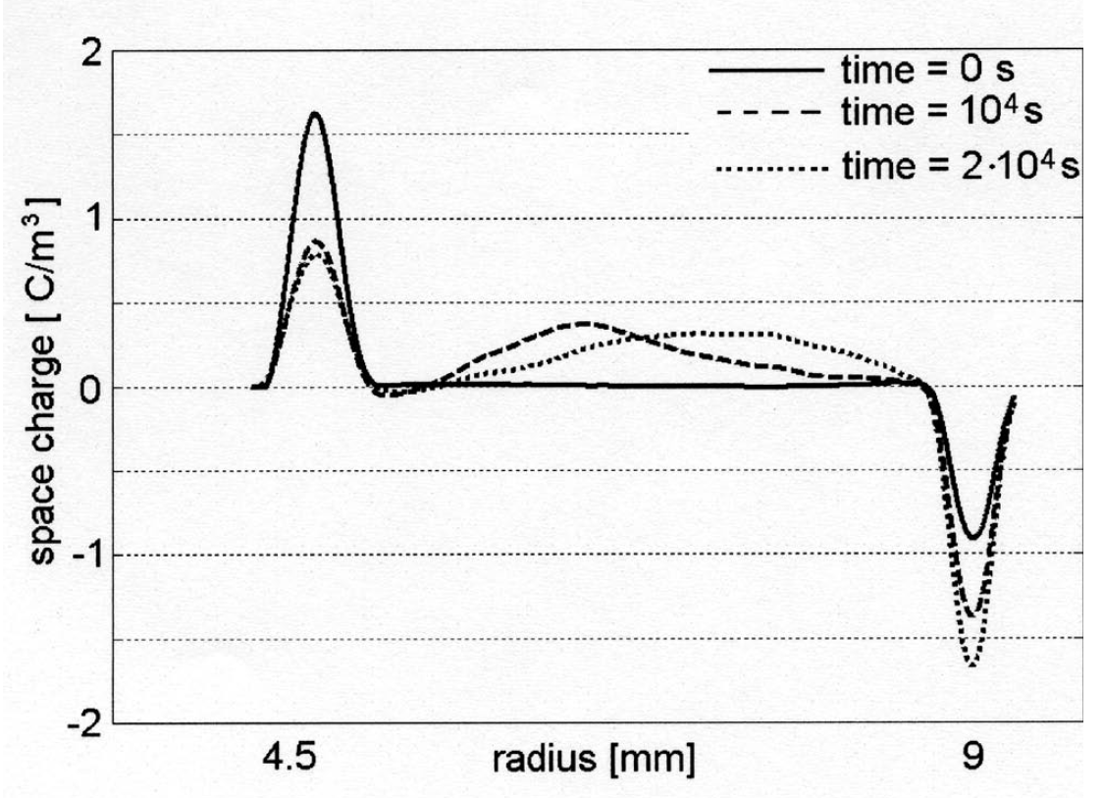

**Fig. 7.** Space charge profiles obtained by PEA techniques with the presence of a 20°C temperature gradient [11].

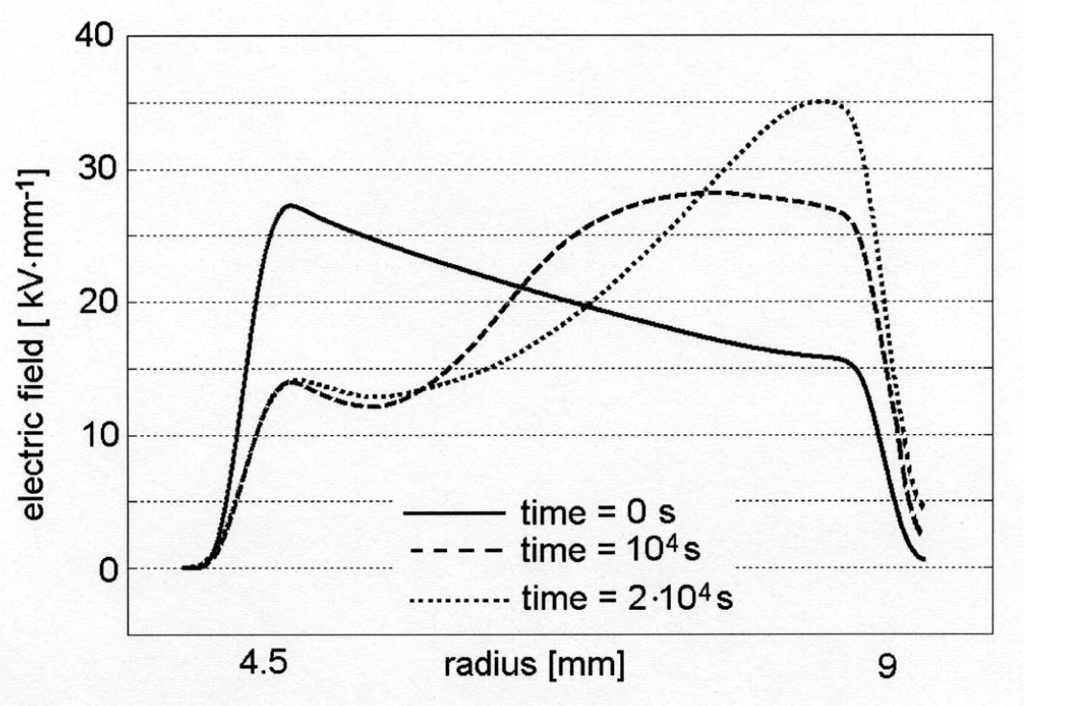

**Fig. 8.** Field distribution in the cable insulation (applied voltage 90 kV). [11].

Meanwhile, the last electric field distribution predicted by the macroscopic model at the outer side is 25 kV/mm, which is fairly underestimated compared with the results shown in Figure 8. In contrast, the charge movement simulated by the bipolar charge transport model is very consistent with the experimental observation, it is believed that the well descriptions on charge injection and transport processes are very useful. However, the large amount of accumulated charge at the vicinity of electrodes can reduce the field strength there badly, resulting in a surprisingly low electric field at the beginning of the simulation. The maximum electric field at the outer electrode predicted by the bipolar charge transport model is about 36 kV/mm, which is also very closed to the experimental data.



**Fig. 9.** The total accumulated charge amount calculated by the macroscopic model.

Figure 9 shows the total charge amount inside the bulk of the conductivity model, it can be observed that the charge amount increased gradually in the first 10000s, and the final total charge amount was maintained at about 5.2×10-4 C/m2. The charge amount of holes and electrons is shown in Figure 10 separately. Differently from the prediction of the conductivity model, the amount of holes was increased very fast in the first 100 s, then it continued slightly increasing until 30000 s, as the nearly zero field at the anode prevent further injection of holes. The amount of electrons increased more gently, so the total net charge amount first increased, then decreased and maintained at about 5.1×10-4 C/m2. It should be noted that the hetero-charge build-up is not considered in the bipolar charge transport model, which may be accountable for the difference.



**Fig. 10.** The charge amount for holes and electrons separately during the polarization simulated by the bipolar charge transport model.

Another drawback of the conductivity model is found that the parameters of the conductivity equation are not dependent on position. On the one hand, the surface effect could affect the conductivity at the interface [12], making it differ from the one insider the bulk. On the other hand, the impurity concentration could be nonuniform along the radius, which also affects the inhomogeneity of the cable insulation.

Due to the well descriptions of charge injection and transport in the bipolar charge transport model, the simulation is more complicated and can cost much more time than the conductivity model. In spite of that, both the charge movement and the field variation seem to be more consistent when compared with the experimental data. However, it still need to be further developed before it can be applied in practical applications. The parameters that related to charge generation and transport mechanisms cannot be obtained by independent experiments straightforward. The estimation of parameters based on experimental data still need to be developed. Additionally, the ionization mechanism should be considered in the charge transport model in order to expand its application.

1. Conclusions

Field estimation in HVDC cable insulation has been made by the macroscopic model and the bipolar charge transport model. With the presence of a temperature gradient, the stress inversion has been observed by both models. Compared with the experimental observations, the results of the bipolar charge transport model were more consistent, even with parameters that are not optimized for a XLPE material. The well descriptions on the charge injection at the interface and the complicated transportation processes were believed as the main reasons for the better performance of the bipolar charge transport model. It is suggested that the ionization mechanism requires to be considered in the new approach for the further development, and the parameterization for XLPE is still needed.

Acknowledgments

We would like to acknowledge the financial support from the technology project of State Grid Shaanxi Electric Power Company [5226KY16001G] and [2018GY-001].

References

1. G. Mazzanti and M. Marzinotto, “Extruded Cables for High-voltage Direct-current Transmission: Advances in Research and Development”, Power Engineering Series, Wiley-IEEE Press, (2013)
2. H. Ghorbani, M. Jeroense, C.-O. Olsson, and M. Saltzer, “HVDC cable systems—highlighting extruded technology,” IEEE Trans. Power Deliv., vol. 29, no. 1, pp. 414–421, (2014)
3. G. Chen, M. Hao, Z. Xu, A. Vaughan, Cao, Junzheng, and H. Wang, “Review of High Voltage Direct Current Cables,” 10 Csee J. Power Energy Syst*.*, vol. 1, no. 2, pp. 9–21, (2015)
4. P.H.F. Morshuis, R. Bodega, D. Fabiani, G. C. Montanari, L. A. Dissado, and J. J. Smit, “Calculation and Measurement of Space Charge in MV-size Extruded Cables Systems under Load Conditions,” IEEE International Conference in Solid Dielectrics, ICSD2007, pp. 502–505. (2007)
5. T.T.N. Vu, G. Teyssedre, B. Vissouvanadin, S. Le Roy, C. Laurent, M. Mammeri, I. Denizet, “Field distribution in polymeric MV-HVDC model cable under temperature gradient: simulation and space charge measurements,” Eur. J. Electr. Engg*.*, vol. 17, pp. 307–325, (2014)
6. J.M. Alison and R. M. Hill, “A model for bipolar charge transport, trapping and recombination in degassed crosslinked polyethene,” J. Phys. D: Appl. Phys*.*, vol. 27, pp. 1291–1299, (1994)
7. S. Le Roy, G. Teyssedre, C. Laurent, G. C. Montanari, and F. Palmieri, “Description of charge transport in polyethylene using a fluid model with a constant mobility: fitting model and experiments,” J. Phys. D. Appl. Phys*.*, vol. 39, no. 7, p. 1427,(2006)
8. S. Le Roy, G. Teyssedre, and C. Laurent, “Modelling space charge in a cable geometry,” IEEE Trans. Dielectr. Electr. Insul*.*, vol. 23, no. 4, pp. 2361–2367, (2016)
9. Y. Zhan, G. Chen, and M. Hao, “Space charge modelling in HVDC extruded cable insulation,” IEEE Trans. Dielectr. Electr. Insul*.*, vol. 26, no. 1, pp. 43–50, (2019)
10. S. Boggs, D. H. Damon, J. Hjerrild, J. T. Holboll, and M. Henriksen, “Effect of insulation properties on the field grading of solid dielectric DC cable,” IEEE Trans. power Del*.*, vol. 16, no. 4, pp. 456–461, (2001)
11. R. Bodega, “Space charge accumulation in polymeric high voltage DC cable systems”, PhD dissertation, Delft University of Technology, (2006)
12. S. Boggs, “A rational consideration of space charge,” IEEE Electr. Insul. Mag*.*, vol. 20, no. 4, pp. 22–27, (2004)