**Archimedes’ Water Fountain; A Water Droplet Energy Harvesting System Utilising Piezoelectric Spiral Transducers**

Samuel C. J. Jellard1,, Suan Hui Pu2, Neil M. White1

1 Smart Electronic Materials and Systems Research Group, Electronics and Computer Science, University of Southampton, Southampton, United Kingdom, SO17 1BJ

2Mechatronics Research Group, University of Southampton, Southampton, SO17 1BJ, U.K. and the University of Southampton Malaysia, 79200 Iskandar Puteri, Johor, Malaysia

E-mail: samcjjellard@gmail.com

Received xxxxxx

Accepted for publication xxxxxx

Published xxxxxx

Abstract

The arithmetic, or Archimedean spiral, was originally described by the Greek mathematician, Archimedes. In this research, the design, characterisation and fabrication of piezoelectric transducers inspired by double-armed Archimedean spirals for harvesting water droplet impact energy is presented. Such designs present a highly tuneable, self-supporting structure with multiple degrees of freedom, encouraging high sensitivity to droplet impact. It was found that spiral designs with droplet impact area bending stiffness within the range 7.9 – 9.9 N/m produced the highest peak energy outputs. However, samples with lower bending stiffness produced a greater average energy output, highlighting the significant influence of geometry design on energy transfer efficiency. A tiered tank system is presented which collects an input volume of water, before dispensing this water as a series of frequency and diameter regulated droplets onto the impact energy harvesting spirals. Controlling such aspects significantly increases system efficiency – a total energy output of 58.9 μJ was generated by a single spiral transducer arm driven by 1 litre of water dispensed as droplets of 6 mm diameter, 1 m release height and impact frequency 0-40 Hz, representing an energy density of 16 mJ/ ${cm}^{2}$.

Keywords: Piezoelectric, Energy Harvesting, Spiral, Transducer, Droplet

1. Introduction

Harvesting energy from ambient sources using piezoelectric transducers is a topic which has seen a tremendous amount of interest from the scientific community, with research into lead-free piezoelectric materials seeing increased activity in recent times [1]–[6]. The practicality of energy scavenging technology looks set to see continued relevance with decreasing power demands of electrical systems, such as Wireless Sensor Networks (WSN), allowing such technology to progressively act as an energy source to drive and sustain them independently [7]-[8]. Furthermore, energy harvesting technology is likely to play both an exciting and critical role in the growth of the Internet of Things (IoT) concept. This is particularly true in the case of remote/hard to access applications which require a power source – energy harvesting technologies such as piezoelectric materials offer an opportunity to prolong, or even replace, battery powered applications, providing a solution which lowers servicing requirements.

In this research, the opportunities for utilising piezoelectric transducers for converting the kinetic impact energy of falling water droplets into useful electrical energy are investigated, following a previous initial study [9]. It has been demonstrated that falling water droplets can impart forces of over a thousand times their resting weight upon impact with solid objects [10]. Tropical countries such as Colombia, Papua New Guinea and Malaysia experience heavy rainfall throughout the year, with total annual rainfall amounts in the region of 3,000 mm [11].

As a result of their inherent multiple degrees of freedom, spirals are naturally very sensitive to vibration. For example, an array of 16 spiral cantilevers to serve as a highly sensitive cochlear multielectrode implant has been demonstrated in the literature [12]. Such applications illustrate the versatility of the spiral design, whilst minimising the surface area required by the transducer array.

Similarly, such geometries have been demonstrated to reliably harvest mechanical energy from the wing movement of Green June Beetles [13]. In this example, spiral geometry cantilevers were advantageous due to the requirement for a compliant structure in a limited area. Such mechanical sensitivity is an attractive characteristic for water droplet harvesting, as it allows a wide range of droplet diameters to be efficiently harvested.

In addition to vibration sensitivity, spiral shapes can exhibit both very low and multi-modal resonant frequency. Tikani et al. proposed a design for a spiral, multimode piezoelectric energy harvester which exhibited its first three natural frequencies at 4.2Hz, 6.2Hz, 10.2Hz [14]. This is considered an attractive feature for utilising such designs for droplet energy harvesting; assuming that the likelihood of a harvester undergoing greater than 10 droplet impacts per second is unlikely [15][16]. Bai *et al* presented a multi-model vibration energy harvester in the form of a spiral-shaped cantilever with magnetic tip mass. The spiral-shaped nature of the beam was reported to lower the natural frequencies of the harvester, with five clear frequency peak values recorded within the 15-70 Hz range [17].

However, spiral designs presented in the literature to-date are typically fragile in order to encourage sensitivity to vibration, or require proof mass attachments in order to oscillate without requirement for undue driving forces. In this work, spiral designs are demonstrated that balance the sensitivity necessary to harvest a significant droplet impact range, without compromising on harvester robustness against the upper limit of anticipated impact forces.

Furthermore, relying on direct raindrop impacts for harvesting energy is impractical, given the random nature of both the incident droplets impact frequency, location and magnitude. It is considerably more efficient to collect the droplets first from a large surface area, such as a rooftop, before introducing them to the energy harvesting transducer as illustrated in Fig. 1.

In this paper, a system which collects and dispenses water volumes as a series of droplets with controlled diameter and frequency onto spiral impact energy harvesters is reported. This system presents the opportunity for energy harvesting applications to be deployed in guttering, drainage or internal water management systems. The key reason for the current absence of such systems relates to the lack of downward pressure generated by gravity. This makes it very difficult for environments such as house guttering to drive a hydroelectric turbine efficiently.

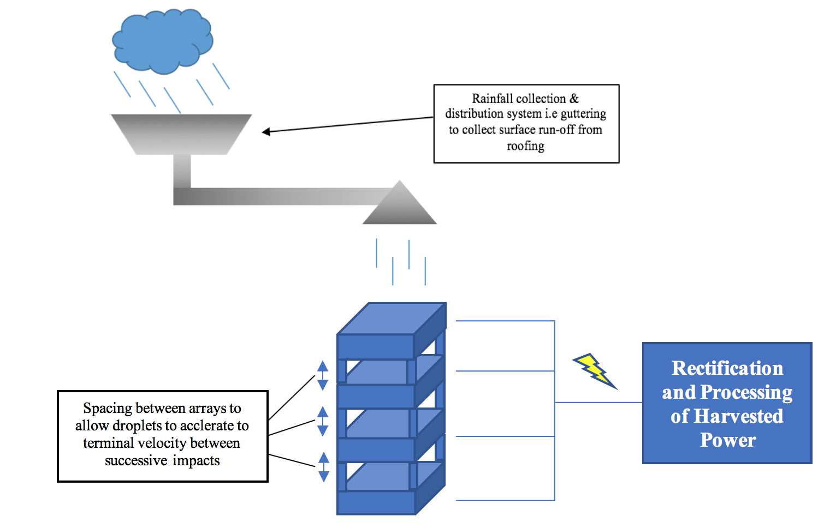

Rainfall collection & distribution system i.e. guttering to collect surface run-off from house roofing

Spacing between arrays to allow droplets to accelerate to terminal velocity between successive impacts

Fig. 1 Illustration of tiered droplet energy harvesting system, driven by a collected rain water volume

1. Archimedean Spiral Design and Simulation

The Archimedean spiral, or arithmetic spiral, can be defined with a polar equation, outlined in Equation 1. Here, $r$ is the radial distance, $a$ and $b$ are real number constants (varying $a$ turns the spiral, whilst varying $b$ controls the distance between successive turnings), $θ$ is the polar angle and $n$ is a constant which determines how tightly the spiral is wrapped around the centre point [18].

$R=a+bθ^{\frac{1}{n}}$ (1)

A number of analytical investigations into the mechanical behaviours of Archimedean spiral-based springs and bimorphs have taken place [19][20]. Considering out-of-plane vibration dynamics, the moment-displacement relationships for the curved beam displayed in Fig. 2. are shown in Equations 2 and 3 [21][22].

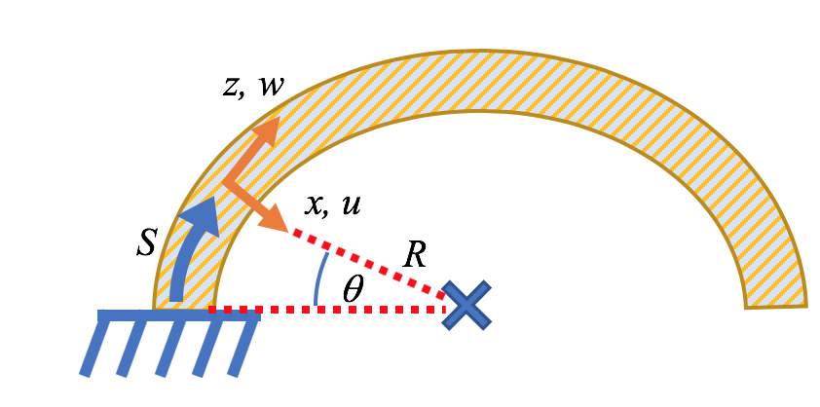

Fig. 2. Curved beam with co-ordinates notation

$M_{x}=EI_{x}κ$ (2)

$M_{z}=GJτ$ (3)

Where $M_{x}$ is the bending moment, $EI_{x}$ is the arc bending stiffness, $M_{z}$ is the twist torque and $GJ$ is the torsional stiffness. $κ$ and $τ$ are defined in Equations 4 and 5.

$κ= \frac{β}{R}- \frac{∂^{2}v}{∂S^{2}}$ (4)

$τ= \frac{∂β}{∂S}+ \frac{1}{R}$ (5)

Where $β$ is the twist angle, $R$ is the radius of the curved beam, $v$ is the out of plane deflection and $S$ is the position coordinate along the arc. The strain energy $U$ and the kinetic energy $T$ of the curved beam for out-of-plane motion are displayed in Equations 6 and 7.

$U=\frac{1}{2}\int_{0}^{S_{L}}{(M_{x}κ+M_{z}τ-Yv-Φβ})dS$ (6)

$T=\frac{1}{2}\int_{0}^{S_{L}}{(m{\dot{v}}^{2}+i}{\dot{β}}^{2})dS$ (7)

Where $S_{L}$ is the total arc length, $i$ is the mass moment of inertia per unit length of the curved beam, $Y$ is the external force and Φ is the twisting moment. The radius of an Archimedean spiral varies linearly with the polar angle. An example of the double armed variant is illustrated in Fig. 3.

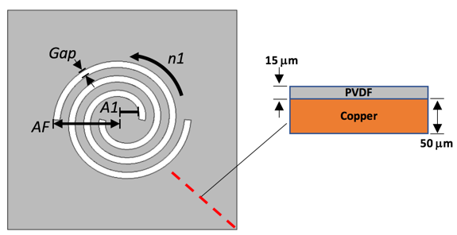

Fig. 3 Diagram to illustrate spiral mechanical parameters of interest

The influence of design parameters on the mechanical behaviours of the spiral were investigated using COMSOL multiphysics. Key parameters affecting the energy transfer efficiency between the droplet and the transducer, considered to be the spirals’ axial/torsional stiffness and resonant frequency, can be precisely tuned depending on a combination of the following parameters, as illustrated in Fig. 3 - spiral final radius *AF,* spiral initial radius *A1*, number of turns *n1* and spiral gap spacing, defined by *Gap*.

The variation of these parameters in order to tailor the spiral’s mechanical behaviour does not require a larger surface area to be fabricated. For comparison, to reduce the resonant frequency of a cantilever beam design transducer, the beam length would need to be increased, creating a larger transducer overall. Alternately, a mass could be added to the cantilever beam end, however this would significant reduce the sensitivity and intrinsic responsiveness of the harvester. As such, it is found that the spiral geometry is both a highly tuneable design that promotes efficient space usage, making it a useful design for applications where space is limited, e.g. drain pipes, or internal water management systems.

The material properties used in the FEA investigation are displayed in Table I. In each case, the edges of the geometry were clamped, and gravity was applied across the entire volume in the -z axis direction.

* 1. Key parameter influence on spiral axial stiffness

The effect of varying the aforementioned parameters (*AF, A1, n1* and *Gap*) on axial stiffness was investigated. A spiral’s inherent multiple degrees of freedom makes gauging the mechanical stiffness a coupled problem, as both direct bending and torsional stiffness contribute. To simplify, each spiral’s reaction force to a prescribed displacement applied along the y-axis to the centre is analysed. Equation 8 is used to calculate the estimated bending stiffness, where $k$ is the estimated spiral axial stiffness, $F$ is the reaction force, and $δ$ is the prescribed displacement.

TABLE I

Simulation material properties

|  |  |
| --- | --- |
| Parameter | Value |
| Copper Foil Thickness | 50 μm |
| Copper Foil Density | 8960 kg/ m3 |
| Copper Foil Young’s modulus | 110 GPa |
| Polyvinylidene fluoride (PVDF) Thickness | 15 μm |
| Polyvinylidene fluoride (PVDF) Density | 1780 kg/ m3 |
| PVDF Young’s modulus | 4 GPa |
| Polyvinylidene fluoride (PVDF) Piezoelectric Strain Constant $d_{31}$ (shear mode direction 1) | 13.6 pC/N |
| Polyvinylidene fluoride (PVDF) Piezoelectric Strain Constant $d_{33}$ (thickness mode direction 3) | 29.7 pC/N |

$k= \frac{F}{δ}$ (8)

The resulting y-component reaction force of the spiral resisting each displacement was used to estimate the axial stiffness of each spiral tested. Two studies were carried out – the first studied the effect of varying turn number on estimated stiffness for a variety of spirals with different final and initial radii, with the second study looking at the effect of varying the Gap parameter in isolation. These results are displayed in Fig. 4 and Fig. 5.



Fig. 4. Effect of turn number, spiral final radius and spiral initial radius variation on estimated axial stiffness

The simulation results demonstrated that increasing the turn number *n1* can result in a magnitude change of axial stiffness. For example, the *AF* = 20 mm, *A1* = 6 mm, *Gap* = 2 mm samples exhibited a stiffness of 2.01 N/m with 0.5 turns, and stiffness of 0.07 N/m with 1.5 turns, representing a difference of 1.94 N/m or approximately 97% decrease in bending stiffness.



Fig. 5. Effect of spiral arm “Gap” distance on estimated axial stiffness

Increasing the spiral initial radius *A1* decreases stiffness to a lesser extent, aside from when the turn number is low. It is hypothesised that this is because, with higher turn number, the spiral arm distance is longer and a larger initial radius acts as a proof mass at the centre of the spiral. In the case of low turn number, the spiral distance is short, therefore by increasing initial radius we increase the arm width, resulting in an increase of the axial stiffness, as illustrated in Fig. 6.

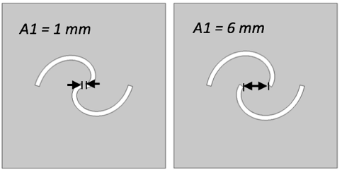

Fig. 6. Illustration of geometry changes when increasing the initial spiral radius, “A1”, at low spiral turn number

It was found that increasing the *Gap* also decreases stiffness by decreasing the spiral arm width, as illustrated in Fig. 7. For example, the *AF* = 20 mm, *A1* = 6 mm, *Gap* = 2 mm sample has a stiffness of 0.029 N/m with a *Gap* of 1 mm, compared to 0.0053 N/m with a *Gap* of 6 mm. This represents a change of 0.024 N/m, or approximately a decrease of 82 %.

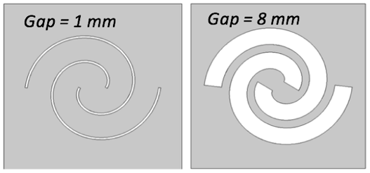

Fig. 7. Illustration of geometry with varying arm gap thickness

It is clear the variation of the spiral turn number has the most significant influence on estimated bending stiffness, with stiffness changes being in the 1 N/m magnitude range. Whilst it is useful to be aware of the impact of varying initial radius or gap distance, stiffness changes from these parameters were in the 0.01 N/m magnitude range

* 1. Key parameter influence on spiral first order resonant frequency

The effect of varying the aforementioned parameters (*AF, A1, n1* and *Gap*) on each spiral’s first order resonant frequency is investigated next. Parameters of interest were incrementally varied, with an Eigenfrequency study carried out at each step. As before, two studies were carried out – the first studied the effect of varying turn number on the first order resonant frequency for a variety of spirals with different final and initial radii, with the second study looking at the effect of varying the *Gap* parameter in isolation. These results are displayed in Fig. 8 and Fig. 9.

The simulation results demonstrated that altering the spiral turn number once again produces the greatest variation in mechanical behaviour. For example, the *AF* = 20 mm, *A1* = 1 mm, *Gap* = 2 mm sample has a resonant frequency of 55.9 Hz with 0.5 turns, compared to 12.3 Hz with 1.5 Turns. Sample first order modal shapes from a plan view perspective are shown in Fig. 10.



Fig. 8. Effect of turn number, spiral final radius and spiral initial radius variation on spiral first order resonant frequency



Fig. 9. Effect of spiral arm “Gap” distance on spiral first order resonant frequency

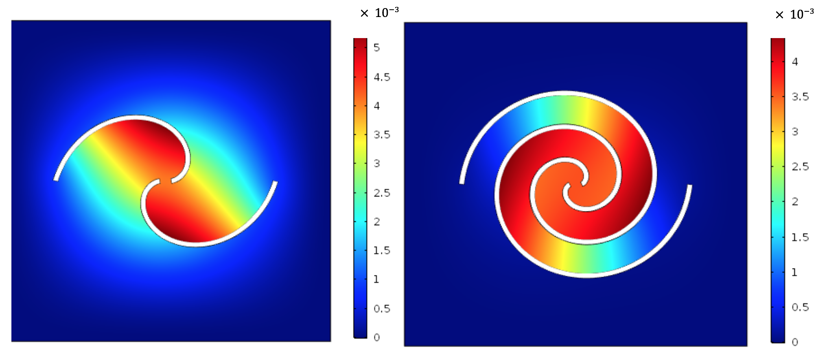

Fig. 10. Images of AF = 20 mm, A1 = 1 mm, Gap = 2 mm sample first order modal shapes, with 0.5 turns (left) and 1.5 turns (right). The colour scale chart indicates total displacement, mm

Furthermore, increasing *AF* significantly decreases the spiral’s resonant frequency . For example, the *AF* = 20 mm, *A1* = 1 mm, *Gap* = 2 mm, 0.5 turns sample has a resonant frequency of 55.9 Hz, compared to the *AF* = 50 mm, *A1* = 1 mm, *Gap* = 2 mm, 0.5 turns sample of resonant frequency 10.7 Hz. Increasing *A1* decreases the spiral’s resonant frequency but to a lesser extent; a resonant frequency decrease in the region of 1-2 Hz was observed for spirals when the initial radius was increased from 1 mm to 6 mm.

The *Gap* variation results yielded noteworthy conclusions. As illustrated in Fig. 16, the *Gap* distance has little effect on spiral resonant frequency in most cases. For example, a spiral with *AF* = 40 mm, *A1* = 1 mm, 1 Turn sample, 1 mm *Gap* exhibits a first order resonance of 16.9 Hz, compared to 15.3 Hz with a 6 mm *Gap* distance. The significance of these findings relates to the disproportionate change in spiral resonant frequency and stiffness when *Gap* is varied.

It was found that axial stiffness varied at much greater magnitude than resonant frequency; for example, in the case of the *AF* = 50 mm, *A1* = 1 mm, 1 Turn sample, increasing the *Gap* distance from 1 mm to 8 mm resulted in a change of resonant frequency from 11.4 Hz to 10 Hz, or an approximate 12% decrease. However, the corresponding change in stiffness for the same sample was an approximate 45.6% decrease, from 0.0182 N/m to 0.0099 N/m. Such results serve to outline the adaptability and tunability of the Archimedean spiral geometry, allowing the transducer design which can be tuned to the excitation source without the spiral stiffness and frequency parameters being directly proportional to each other.

1. Fabrication and optimisation of P(VDF-TrFE) on copper foil spiral transducers
   1. Sample fabrication

Two groups of five samples were fabricated – the first five focused on the effect of turn number *n1* on the transducer mechanical behaviour, whilst maintaining a consistent final radius *AF*. The second group of five samples varied both *AF* and *n1* values. A solution was prepared by dissolving 20% weight P(VDF-TrFE) co-polymer powder (70/30 mol ratio) in a solvent of dimethylformamide and acetone (volume ratio 20/80). The solution was heated at 55°C in an oil bath and mechanically stirred for approximately 1 hour, before being degassed in an ultrasonic water bath for 1-2 hours. A micrometre adjustable applicator blade was used to uniformly spread the P(VDF-TrFE) solution onto 50 μm thick copper foil sheets, producing an estimated 20-25 µm thick film post heat treatment. After deposition, the sheet was placed in an oven at 100 °C for 5 minutes to allow the solution to dry. The sheet was then annealed for 2-3 hours at a temperature of 135 °C in order to increase the piezoelectric material’s crystallinity.

Following the heat treatment, the sheet was poled using a custom built surface charge poling rig, consisting of an array of brass pins, length 5 mm, spacing 10 mm, to create an evenly distributed poling field, illustrated in Fig. 11. Positioned parallel to the P(VDF-TrFE) upper surface, the distance between the sample and the pin tips was approximately 20 mm. A voltage of 13-13.5 kV was supplied to the poling rig for 5 minutes to pole each sample, with the surface charge measured after each poling period to check that adequate poling had occurred.

TABLE II

Experimental Test Spiral Sample Properties

|  |  |  |  |  |  |  |  |
| --- | --- | --- | --- | --- | --- | --- | --- |
| Sample Parameters (*A1* = 6mm and *Gap* = 2 mm for all samples) | Sample Thickness / mm | | Resonant Frequency / Hz | | Active Electrode Length, Width, Thickness per Spiral Arm | Electrically impedance matched load / MΩ | |
| *AF* = 35 mm, *n1* = 0.50 | 0.09 – 0.12 | 20 | | 37.5 mm / 1.5 mm / 200 nm | | | 6.7 | |
| *AF* = 35 mm, *n1* = 0.75 | 0.08 – 0.17 | 16 | | 27.5 mm / 1.5 mm / 200 nm | | | 4 | |
| *AF* = 35 mm, *n1* = 1.00 | 0.08 – 0.10 | 15 | | 14 mm / 1.5 mm / 200 nm | | | 8.7 | |
| *AF* = 35 mm, *n1* = 1.25 | 0.08 – 0.11 | 15 | | 26 mm / 1.5 mm / 200 nm | | | 8.7 | |
| *AF* = 35 mm, *n1* = 1.50 | 0.10 – 0.14 | 8 | | 92.5 mm / 1.5 mm / 200 nm | | | 6.7 | |
| *AF* = 20 mm, *n1* = 0.75 | 0.07 – 0.09 | 16 | | 17 mm / 1.5 mm / 200 nm | | | 5 | |
| *AF* = 30 mm, *n1* = 0.75 | 0.05-0.08 | 16 | | 17 mm / 1.5 mm / 200 nm | | | 2 | |
| *AF* = 30 mm, *n1* = 1.00 | 0.07-0.08 | 18 | | 17 mm / 1.5 mm / 200 nm | | | 5 | |
| *AF* = 30 mm, *n1* = 2.00 | 0.07 – 0.09 | 8 | | 34 mm / 1.5 mm / 200 nm | | | 3.5 | |
| *AF* = 60 mm, *n1* = 0.50 | 0.06-0.07 | 20 | | 35 mm / 1.5 mm / 200 nm | | | 4 | |

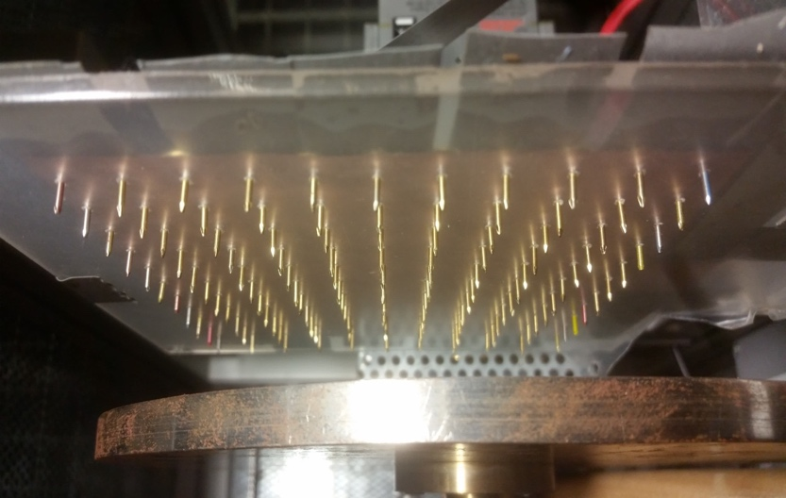

**10 mm**

Fig. 11. Photograph of custom built surface charge array used to polarize P(VDF-TrFE) on copper foil samples

Due to the inherent multiple degrees of freedom exhibited by spiral geometries, care must be taken over electrode placement; it has been found that charge cancellation can occur if a continuous electrode layer is applied to a uniformly polarised upper piezoelectric layer [23]. In this research shadow masks were used to deposit individual silver electrodes on each spiral arm. The electrodes were 200 nm thick, 2 mm wide, and initially ran the full spiral arm length for each design. A thin electrode width was chosen so that it could remain consistent, as increasing the spiral turn number decreases spiral arm width.

Wire connections were attached using silver conductive paint, before each sample was clamped along the edges in an acrylic frame. Finally, the samples were encapsulated using NeverWet® superhydrophobic surface treatment [24] in order to isolate all electrical connections from water, with the resulting difference in water droplet contact angle illustrated in Fig. 12. Some examples of the fabricated sample designs are displayed in Fig. 13, with a summary of fabricated sample properties shown in Table II.

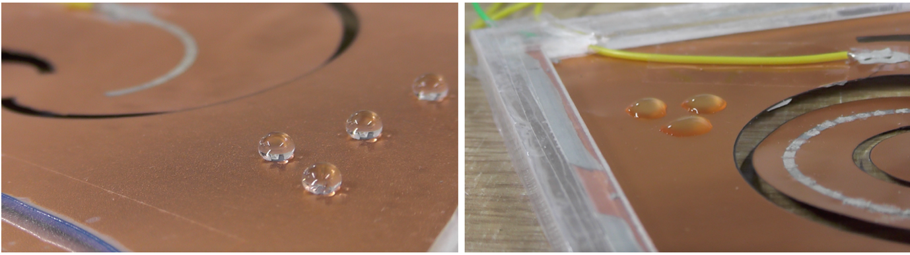

Fig. 12. Photographs to illustrate the effect of NeverWet® superhydrophobic surface treatment on water droplet contact angle, post-treated sample (left) and pre-treated sample (right)

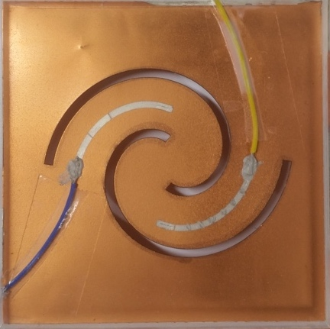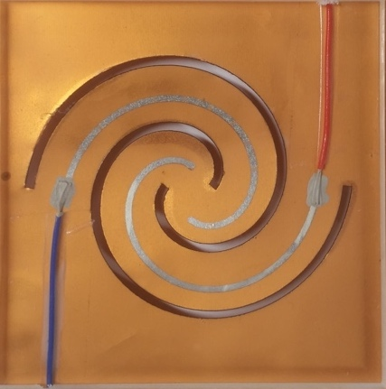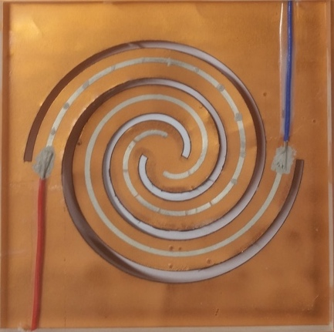

Fig. 13. Photographs displaying some of the fabricated spirals

* 1. *Optimisation of spiral active electrode area and electrical impedance matching*

It has been reliably shown that the dimensions of the active electrode area used as the top electrode on piezoelectric devices significantly contributes to the device power output. Careful consideration of device strain mechanics is required; perhaps counter-intuitively, maximising the active electrode area does not always result in an increase of output power, with power output being detrimentally affected if low strain areas are covered. In an experiment which investigated the optimal electrode area for a piezoelectric cantilever beam, an electrode area coverage of approximately 50% generated 30.8% greater power output than 100% electrode coverage [23]. With this in mind, the electrode lengths for each fabricated spiral sample were optimised.

Practical variation of electrode length was carried out by driving each sample at resonance, with 0.5 cm sections of the electrodes disconnected at intervals by mechanical abrasion, in order to measure the effect on the output voltage. Once an optimal electrode length is identified, the sample electrodes are repaired using silver conductive paint. The electrodes are optimised with the samples being driven at resonance due to the anticipated sample post-impact mechanics – after the droplet collides with the sample upper surface, it rolls off the sample due to the hydrophobic coating, leaving the sample to oscillate at its natural frequency. The experimental results for electrode length variation for the two groups of five samples are shown in Fig. 14. and Fig. 15. At this stage, the output power is normalized as electrical impedance matching has yet to take place. Once the ideal electrode length for energy output had been identified, electrical impedance matching took place by driving the samples at a steady vibration frequency and observing the peak output power across a variety of resistances.



Fig. 14. Output power of fabricated samples (consistent AF, varied n1) as a function of electrode length



Fig. 15. Output power of fabricated samples (varied AF and n1) as a function of electrode length

1. Experimental validation of key parameter influence on spiral axial stiffness and first order resonant frequency

The simulation results achieved in section 2.1 and 2.2 were validated experimentally. The effect of turn number, spiral final radius and spiral initial radius variation on spiral axial stiffness is verified in Fig. 17.

In order to validate the effect of spiral arm “Gap” distance on axial stiffness, 5 mm diameter droplets were dispensed onto the centre of selected samples, with the average energy output recorded, before the spiral arm widths were progressively trimmed using a laser cutter. An example of this is illustrated in Fig. 16, with the experimental results displayed in Fig. 17, validating that decreasing arm Gap distance results in decreasing axial stiffness.

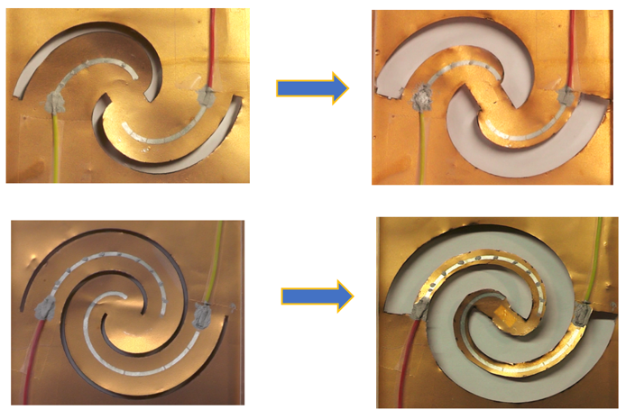

Fig. 16 Photograph to illustrate sample trimming process for AF = 35 mm, 1.0 turn sample.

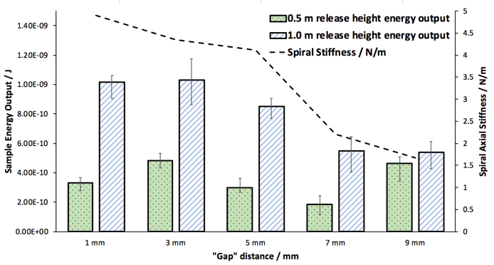

Fig. 17 Experimental results of progressive arm width testing for AF = 35 mm, 1.0 turn sample. Each gap width configuration was tested with at least 8 droplet impact repetitions, the average energy is displayed here.

The corresponding effect of varying turn number, spiral final radius and spiral initial radius variation on spiral first order resonant frequency was validated experimentally, with the results displayed in Table II. Furthermore, the effect of varying spiral arm “Gap” distance on spiral first order resonant frequency was validated during the aforementioned sample trim testing; sample resonant frequency did not vary beyond ± 1 Hz throughout testing.

1. Effect of droplet impact location on energy output

The effect of droplet impact location variation on each sample was studied. Multiple 5 mm diameter droplets were released from a height of 0.5 and 1.0 m onto each position, with the average energy output calculated using the output of one arm only. Illustrations of the chosen impact locations and energy output for all locations of each sample are shown in the supplementary information, with an example given in Fig. 16.

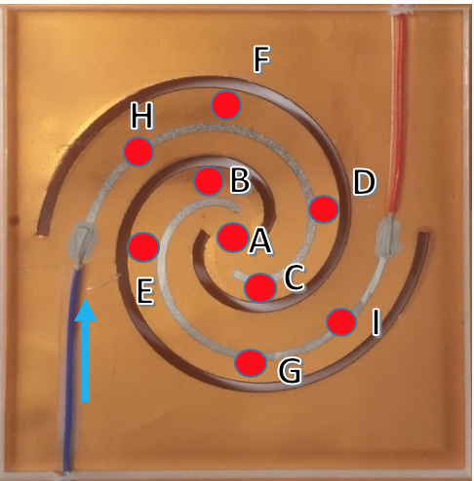

Fig. 18. Example of impact location selections for 1 turn sample. The energy output was measured from the left-hand side arm connection, illustrated by the arrow.

Graphs displaying the impact location which produced the greatest energy output for both sample sets are shown in Fig. 17 and Fig. 18. Results depicting the overall average energy output of all impact locations on each sample are presented in the supplementary material. Error bars are used to illustrate the highest to lowest range in energy output from all droplet impacts used to test the samples. Following the identification of impact locations which produced a peak energy output, the axial stiffness of these locations was measured. It was found that the energy output was highest for impact location stiffness values in the range of 7.9 – 9.9 N/m for the range tested, with a peak energy output of 15 nJ being produced from a single droplet impact by the *AF* = 35 mm, 0.5 turns sample.

However, samples with lesser bending stiffness produced a greater average energy output. For example, the average energy output of the *AF* = 60 mm, 0.5 turns sample (which produced the highest peak energy output for the mixed radii sample set of 2.5 nJ per single impact) was 0.8 nJ, compared to the average energy output of the *AF* = 30 mm, 1 turn sample which was 1.2 nJ, highlighting the complementary influence of geometry and bending stiffness on energy transfer efficiency.

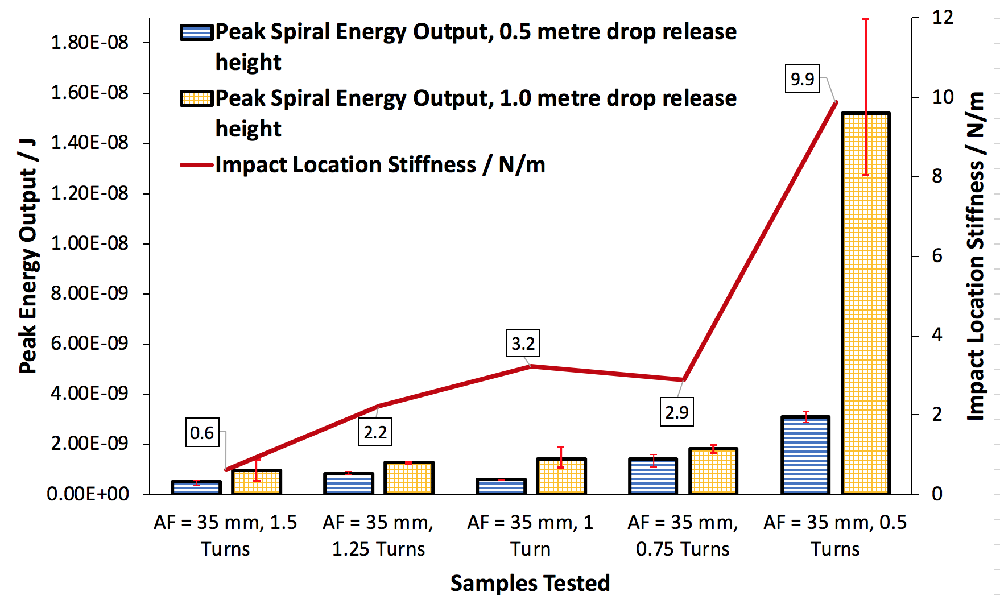

Fig. 19. Graph displaying peak energy output from the tested impact locations for consistent AF, varied n1 samples. Impact location stiffness value is obtained by measuring displacement at the location with a variety of known masses, verifying the results previously simulated in Fig. 4.

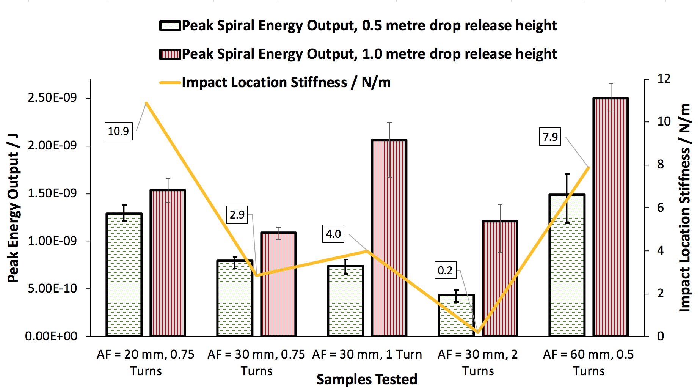

Fig. 20. Graph displaying peak energy output from the tested impact locations for varied AF, varied n1 samples. Impact location stiffness value is obtained by measuring displacement at the location with a variety of known masses.

1. Demonstration of tiered droplet impact control system

Attempting to harvest water droplet impact energy through direct exposure of harvesting transducers to the excitation source is an inefficient process. Random impacts of incident water droplets, both in periodicity and impact location, are likely to result in an inefficient energy output.

It is proposed more beneficial to collect incident droplets first, before guiding them to optimal impact locations upon the transducer surface in order to achieve an efficient response from the piezoelectric elements. Whilst this approach may compromise on the impact energy available from the droplet’s initial descent, it is theorised that controlled dispensing of droplets allows for more precise tailoring of the energy harvesting elements, in order to ultimately encourage greater energy transfer efficiency.

Furthermore, controlling the excitation stimulus allows the designer much greater flexibility in terms of the materials, dimensions and geometry that can be utilised to fabricate the energy harvesting transducer depending on the application.

It is possible to control the droplet diameter dispensed from a nozzle by controlling the diameter of the nozzle aperture. Droplet diameter can be estimated by using the relation shown in Equation 13, Where $R_{droplet}$ represents the incident droplet radius, $R_{capillary}$ is the radius of the dispensing capillary or syringe tip, γ is the water surface tension, g is the acceleration due to gravity and ρ is the water density [25]. This relationship is valid in the cases where there is a pressure, such as water weight, forcing droplet expulsion from the nozzle

$R_{droplet}={\left(\frac{3R_{capillary}γ}{2gρ}\right)}^{\frac{1}{3}}$ (13)

A tiered system of two acrylic containers is fabricated with outlets laser cut into their bases, illustrated in Fig. 19. It was found that gradually dispensing a stored water volume from the upper stage through the 1 mm outlets at the stage base allowed a thin water film to form along the bottom of the lower stage.

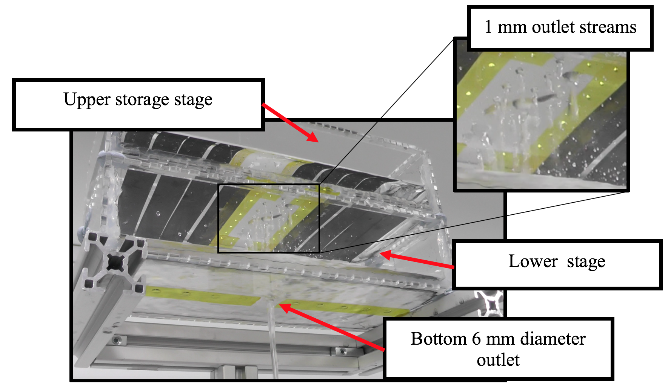

Fig. 21. Tiered tank stages to control droplet formation and impact frequency. A series of 1 mm diameter outlet holes are laser cut into the base of the upper storage stage to elicit a gradual draining of the collected water into the lower stage.

This encouraged droplets to form and fall from the 6 mm outlet with predictable frequency, providing an opportunity to increase energy transfer efficiency through matching the resonant frequencies of the samples being driven by the droplet stream. Additionally, it was found that modifying the ratio of open upper stage 1 mm diameter outlets to the lower stage 6 mm diameter outlet controlled the volume flow of the droplets, altering both the drip frequency and time scale with which the stored water was dispensed. The upper stage was filled with 1 litre of water, before being allowed to run dry into the lower stage – the resulting drip frequency over time produced by the lower stage outlet for a varied number of open 1 mm outlets is illustrated in Fig. 21.

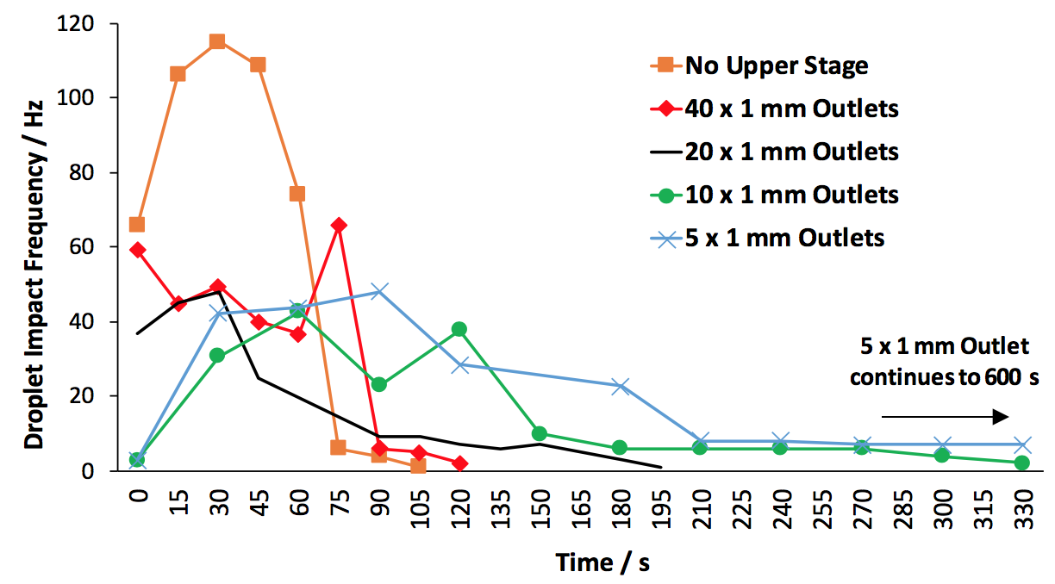

Fig. 22. Tiered system drip frequency rates depending on number of open upper stage 1 mm outlets

Fabricated samples were aligned beneath the 6 mm outlet so that the droplets impacted upon locations shown to produce the largest energy output from previous testing. It was found that, at a position of 1.0 m below the 6 mm outlet, the AF = 60 mm, 0.5 turns sample produced the greatest power output for the ratios of open upper 1 mm diameter outlets tested, with the power output over time displayed in Fig. 22.

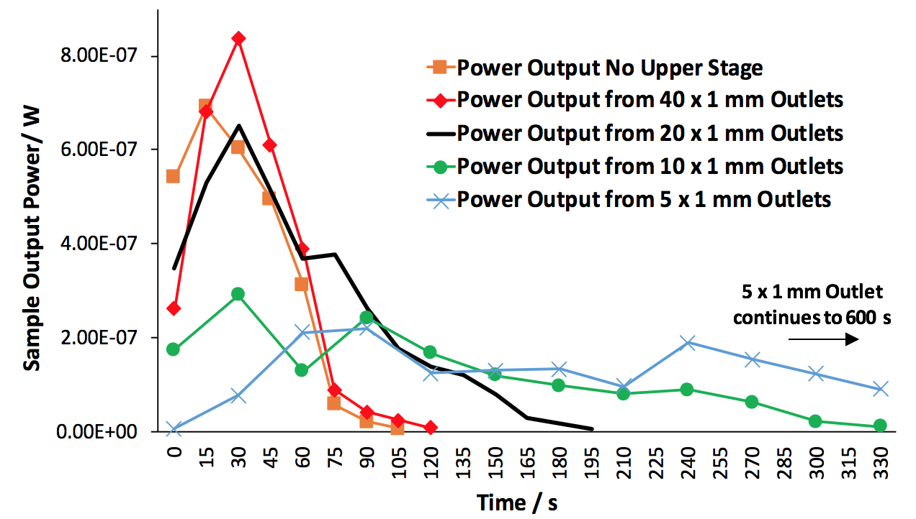

Fig. 23. Power output for the AF = 60 mm, 0.5 turns sample driven with a variety of different upper stage outlets open at a position of 1.0 m beneath the lower 6 mm outlet.

The *AF* = 60 mm, 0.5 turns sample produced an accumulated output energy of 58.9 μJ from 1 litre of water dispensed through 5 x 1 mm outlets into the lower stage. This generated energy, measured from a single spiral arm electrode of the transducer, relates to a energy density of 16 mJ/ ${cm}^{3}$. To contextualise the results in terms of a useful real world application, it is assumed that a typical two-storey building has a downspout gutter length of 5.7 m [26]. Such a system could contain 13 stacked stages, which accounts for the 0.12 mm two stage system height and a 0.3 m droplet fall height between the bottom stage system outlet and the sample. It is estimated that such a system could produce an accumulated output energy of 0.33 mJ for every litre of water which drains through the system, considering the output from one spiral arm of each transducer only. Such a power output is sufficient to drive low power systems such as IoT sensors.

1. Conclusion

A novel droplet impact energy harvesting system has been reported, composed of double-armed, lead-free piezoelectric spiral transducers and a collection tank system which passively regulates droplet diameter and impact frequency.

The variation of impact location upon the sample range is investigated. It is found that samples with localised bending stiffness in the range 7.9 – 9.9 N/m produced the highest energy outputs. However, samples with lesser bending stiffness produced a higher average energy output, highlighting the significant influence of geometry design on energy transfer efficiency.

Finally, it was demonstrated how a litre of collected water can be dispensed onto tailored piezoelectric transducers in order to produce 58.9 μJ from the single arm of one transducer. These results indicate how a series of cascaded spiral energy harvesters could produce an estimated 0.33 mJ when installed in common vertical water flow infrastructures, such as a two-storey building downspout.

Acknowledgements

S. C. J. Jellard would like to thank the University of Southampton’s Faculty of Engineering and Physical Sciences for supporting this research through the Tizard studentship.

References

[1] H. Wei, H. Wang, Y. Xia, D. Cui, Y. Shi, M. Dong, C. Liu, T. Ding, J. Zhang, Y. Ma, N. Wang, Z. Wang, Y. Sun, R. Wei, and Z. Guo, “An Overview of Lead-Free Piezoelectric Materials and Devices,” *J. Mater. Chem. C*, no. c, pp. 12446–12467, 2018.

[2] Q. Liu, Y. Zhang, J. Gao, Z. Zhou, H. Wang, K. Wang, X. Zhang, L. Li, and J.-F. Li, “High-performance lead-free piezoelectrics with local structural heterogeneity,” *Energy Environ. Sci.*, vol. 11, no. 12, pp. 3531–3539, 2018.

[3] G. Z. Zang, J. F. Wang, H. C. Chen, W. Bin Su, C. M. Wang, P. Qi, B. Q. Ming, J. Du, L. M. Zheng, S. Zhang, and T. R. Shrout, “Perovskite (Na 0.5 K 0.5) 1-x (LiSb)x Nb1-x O 3 lead-free piezoceramics,” *Appl. Phys. Lett.*, vol. 88, no. 21, pp. 1–4, 2006.

[4] K. A. Razak, W. C. Song, and C. Y. Ng, “Properties of Ce-doped Bi0.5Na0.5TiO3 Synthesized using the Soft Combustion Method,” *Procedia Chem.*, vol. 19, pp. 816–821, 2016.

[5] H. Irie, M. Miyayama, and T. Kudo, “Structure dependence of ferroelectric properties of bismuth layer-structured ferroelectric single crystals,” *J. Appl. Phys.*, vol. 90, no. 8, pp. 4089–4094, 2001.

[6] A. B. Djurišić, X. Chen, Y. H. Leung, and A. Man Ching Ng, “ZnO nanostructures: Growth, properties and applications,” *J. Mater. Chem.*, vol. 22, no. 14, pp. 6526–6535, 2012.

[7] S. P. Beeby, M. J. Tudor, and N. M. White, “Energy harvesting vibration sources for microsystems applications,” *Meas. Sci. Technol.*, vol. 17, no. 12, 2006.

[8] S. Roundy and P. K. Wright, “A piezoelectric vibration based generator for wireless electronics,” *Smart Mater. Struct.*, vol. 13, no. 5, pp. 1131–1142, 2004.

[9] ﻿S. C. J. Jellard, S. H. Pu, S. Chen, and K. Yao, “Water droplet impact energy harvesting with P(VDF-TrFE) piezoelectric cantilevers on stainless steel substrates,” Smart Mater. Struct., vol. 28, no. 9, 2019.

[10] D. Soto, A. B. De Larivière, X. Boutillon, C. Clanet, and D. Quéré, “The force of impacting rain,” *Soft Matter*, vol. 10, no. 27, pp. 4929–4934, 2014.

[11] “Top 10 World’s Highest Rainfall Countries 2018,” *World’s Top*, 2019. [Online]. Available: https://top10-world.org/top-10-worlds-highest-rainfall-countries-2018/. [Accessed: 13-Jan-2019].

[12] P. Udvardi, “Spiral-Shaped Piezoelectric MEMS Cantilever Array for Fully Implantable Hearing Systems,” Micromachines, vol. 8, no. 311, 2017

[13] E. E. Aktakka, H. Kim, and K. Najafi, “Energy scavenging from insect flight,” *J. Micromechanics Microengineering*, vol. 21, no. 9, p. 095016, 2011.

[14] R. Tikani, L. Torfenezhad, and M. Mousavi, “Optimization of spiral-shaped piezoelectric energy harvester using Taguchi method,” no. September 2016, 2017.

[15] A. W. Jayawardena and R. B. Rezaur, “Drop size distribution and kinetic energy load of rainstorms in Hong Kong Abstract :,” vol. 1082, no. August 1999, pp. 1069–1082, 2000.

[16] Y. Jiuqin, L. Yin, and C. Longxi, “Preliminary study on mechanics-based rainfall kinetic energy,” *Int. soil water Conserv. Res.*, vol. 2, no. 3, pp. 67–73, 2014.

[17] X. Bai, Y. Wen, P. Li, J. Yang, X. Peng, and X. Yue, “Multi-modal vibration energy harvesting utilizing spiral cantilever with magnetic coupling,” Sensors Actuators A. Phys., vol. 209, pp. 78–86, 2014.]

[18] E. W. Weisstein, “Archimedean Spiral,” *Mathworld--A Wolfram Web Resource*. [Online]. Available: http://mathworld.wolfram.com/ArchimedeanSpiral.html.

[19] H. Hu, H. Xue, and Y. Hu, “A spiral-shaped harvester with an improved harvesting element and an adaptive storage circuit,” *IEEE Trans. Ultrason. Ferroelectr. Freq. Control*, vol. 54, no. 6, pp. 1177–1187, 2007.

[20] J. S. Chen and I. S. Chen, “Deformation and vibration of a spiral spring,” *Int. J. Solids Struct.*, vol. 64, pp. 166–175, 2015.

[21] A. E. H. Love, “A Treatise on the Mathematical Theory of Elasticity,” *HAL*, vol. 1, 1892.

[22] M. A. Karami, B. Yardimoglu, and D. J. Inman, “Coupled out of plane vibrations of spiral beams,” *Struct. Struct. Dyn. Mater. Conf.*, no. May, pp. 1–17, 2009.

[23] S. Du, Y. Jia, S. T. Chen, C. Zhao, B. Sun, E. Arroyo, and A. A. Seshia, “A new electrode design method in piezoelectric vibration energy harvesters to maximize output power,” *Sensors Actuators, A Phys.*, vol. 263, pp. 693–701, 2017.

[24] NeverWet LLC, “Product Characteristics,” *NeverWet*, 2016. [Online]. Available: https://www.neverwet.com/applications/product-characteristics.php. [Accessed: 15-Apr-2019].

[25] R. Guigon, J.-J. Chaillout, T. Jager, and G. Despesse, “Harvesting raindrop energy: theory,” *Smart Mater. Struct.*, vol. 17, no. 1, p. 015038, 2008.

[26] S. Smith, “How to clean gutters using a ladder safely,” *Ladderstore*. [Online]. Available: https://www.ladderstore.com/blog/gutter-clearing-ladder-advice. [Accessed: 03-Mar-2019].