Promoting Pre-service Teachers’ Engagement in an Online Professional Learning Community: Support from Practitioners
Enas Alwafi, Christopher Downey & Gary Kinchin (Southampton Education School, University of Southampton)
Journal of Professional Capital and Community (in press - DOI 10.1108/JPCC-10-2019-0027)

Abstract
Purpose: This study investigated the role of experienced practitioners in promoting pre-service teachers’ knowledge construction and social interaction in an online professional learning community.
Design/methodology/approach: A repeated-measures design with control and experimental groups was adopted. Two practitioners supported pre-service teachers in the experimental group to discuss issues around teaching practice. Social network analysis (SNA) and content analysis (CA) were used in the analytical approach.
Findings: CA revealed that the practitioners increased pre-service teachers’ levels of knowledge construction and high-cognitive discourse. SNA showed that the practitioners enhanced pre-service teachers’ professional ties. Though collaboration in high-level knowledge-building occurred predominantly with peers in the same discipline, the presence of the practitioners facilitated the development of more cross-disciplinary ties in the experimental group.
Practical implications: The practitioners can be used as a pedagogical tool to enhance pre-service teachers’ engagement in the process of professional learning. This study suggests that in order to enhance the collaboration among pre-service teachers from different departments, the online activity should be designed to enhance interdisciplinary collaboration.
Originality/value: The study contributes to new knowledge about the ways in which practitioners can enhance the collaboration among pre-service teachers in an online PLC. It also provides insight on how to combine CA and SNA to examine professional learning.
Keywords: Online professional learning community, Practitioners, Pre-service teachers, SNA, Knowledge-building, Social interaction

Introduction
In recent years, the online professional learning community (PLC) has been recognised as a useful collaborative learning environment to enhance pre-service teachers’ professional growth (Kirschner and Lai, 2007). Pre-service teachers’ collaboration in an online PLC can enhance their sense of collective responsibility for improving learning and teaching (Bond, 2011). The collaboration of pre-service teachers with experienced practitioners, such as expert, in-service teachers who are actively involved in the teaching profession and have experience in teaching, can engage pre-service teachers in the process of learning to teach (Dorner and Kumar, 2016). Prior studies concerning pre-service teachers have shown that networking and establishing social relations with other practitioners can provide pre-service teachers with access to knowledge regarding the practice of teaching (Risser, 2013). Engaging with practitioners can provide cognitive and emotional support, which can prepare novice teachers to teach (Feiman-Nemser, 1998). Studies on engaging experienced practitioners with pre-service teachers found that practitioners enhanced pre-service teachers’ satisfaction in engaging in online learning (Dorner and Kumar, 2017) and developed both their computer skills (Dorner and Kumar, 2016) and practical knowledge (Alebaikan, 2016).
By contrast, there has been limited empirical research to evaluate the practitioners’ effect on developing pre-service teachers’ knowledge and network development in an online PLC. Recent attention has focused on how and why pre-service teachers within a PLC form networks (Risser, 2013). Van Waes et al. (2018) recommended the use of interventions to strengthen teachers’ networks to improve teaching and learning. In fact, most research on pre-service teachers’ programmes has concentrated on enhancing knowledge acquisition (e.g. Al-Abdullatif, 2019). There has been limited focus on their development of cognition (knowledge construction) and social network growth (e.g. Bokhove and Downey, 2018; Liou et al., 2016). Liou et al. (2016) argue that both social and cognitive aspects of pre-service teachers’ professional learning play an important role in developing their teaching skills. There has been limited empirical research to examine the impact of practitioners on pre-service teachers’ collaboration and engagement in an online PLC (Li et al., 2014). Therefore, this study responds to the paucity of research into the role of experienced practitioners in enhancing both the cognitive (knowledge construction) and social engagement (interaction) of pre-service teachers.

2. Literature Review

2.1 Knowledge-building in an Online PLC
Due to increased recognition of social interaction in professional learning, a key theme of recent literature has been how technology can promote the cognitive processes in knowledge construction among teachers (Zhang et al., 2017). Garrison et al. (2001) define this as the learners’ ability to construct and confirm meaning collaboratively through ongoing interaction. Studies focused on cognitive engagement and knowledge construction in online environments have deployed content analysis (CA) to assess the quality and level of knowledge construction taking place in these spaces. For example, Garrison et al. (1999) developed the community of inquiry framework, which regards cognitive presence as a one element. The cognitive presence coding schema was developed to evaluate the level of knowledge construction in a learning process, comprising four phases (Garrison et al., 1999):
- Triggering: This phase focuses on the posts involving some sort of identification of the problem;
- Explanation: This phase focuses on sharing information;
- Exploration: This process focuses on connecting ideas and creating solutions; and
- Resolution: This involves testing and critically assessing the solution.
These successive phases, as experienced by learners, represent a shift from lower to higher cognitive demand. The first two describe the process of knowledge-sharing, which involves a lower level of cognitive demand, while the latter two are knowledge-building processes and represent higher-level cognitive discourse (Hemphill and Hemphill, 2007). In recent years, studies have used cognitive presence to investigate the level of knowledge construction in the context of teacher education. Some studies have shown that most online posts are in the Trigger and Explanation phases and are limited in the Exploration and Resolution phases (Redmond and Mander, 2006). Therefore, several factors need to be considered in promoting knowledge construction. Garrison and Cleveland-Innes (2005) recommend appropriate activities to promote challenging questions and deep discussion, allowing people to examine their ideas to generate an environment that supports deep levels of knowledge construction. Zhang et al. (2017) found that facilitating discussions with expert teachers can allow teachers to engage in knowledge-building. Overall, it appears that online activities should promote a high level of knowledge construction among pre-service teachers by designing activities and facilitating discussions that support the co-construction of knowledge through enhancing both the extent and quality of their social networks. Thus, our focus now shifts to networking within a PLC.

Teacher Networking within a PLC
Studies on knowledge-building among teachers in an online PLC have typically focused on social interaction (Zhang et al., 2017). Teachers’ professional learning is not regarded as an isolated learning process, but rather a web of social interaction (Moolenaar, 2012). Both social capital and social network theory are increasingly used by researchers to understand the professional learning of teachers. Lin (2001, p.12) defined social capital as “resources embedded in a social structure which are accessed and/or mobilised in purposive action”. Studies have shown that social capital can play a role in knowledge-sharing (Quinn and Kim, 2018) and construction (Daniel et al., 2003). Application of social capital theory can facilitate knowledge-building among pre-service teachers. In the context of teachers’ education, most social network studies use social capital theory to understand how teachers can develop relationships with others regarding professional learning (e.g. Rienties and Kinchin, 2014). Teacher networks can provide several cognitive and affective advantages to enhance group outcomes through allowing teachers access to different resources and the opportunity to apply them, while affective benefits emerge from encouragement and support (Fox and Wilson, 2015).
Social network theory supposes that the behaviour and outcomes of individuals can be related to the larger network of social relations (Burt, 1992). A teacher’s social network includes nodes (i.e., members of an online PLC) and ties (connections) between them. This theory relies on examining the relations between members in the community (PLC). Social network studies in teacher education usually focus on two key features in order to understand the quality of the network: network size and diversity (Van Waes et al., 2018). Regarding network size, teachers with many social ties can access useful resources through these social relations (Moolenaar and Daly, 2012). The diversity is considered a significant factor that positively influences teachers’ professional learning (Van Waes et al., 2015).
However, according to Van Waes et al. (2015), contacting teachers with similar interests may not result in the acquisition of new teaching practice ideas. Van Waes et al. (2015) found that teachers who achieved high teaching performance usually had a large and diverse network in terms of teaching experience and expertise. Engaging in an online PLC does not automatically develop teachers' networks. Liou and Daly (2018) emphasise the importance of intentionally creating an atmosphere within teacher education programmes that foster the professional network of relationships in order to enhance pre-service teachers learning experience. Van Waes et al. (2018) suggest that there is a need to strengthen teachers’ networks by applying some sort of network-based intervention. Several studies (Fox and Wilson, 2015; Liou et al., 2016) recommend that future research should focus on how to support network development among pre-service teachers in the online environment and, more specifically, in constructing their knowledge.

Experienced Practitioners as a Tool to Engage Pre-service Teachers in Knowledge-building and Social Interaction
The involvement of practitioners, such as expert in-service teachers who have experience in teaching and are involved in the teaching profession, may bring about many benefits for pre-service teachers. Their presence is considered a way of enculturating pre-service teachers into professional communities, which can engage them in the process of learning to teach. Li et al. (2014) indicated that the presence of practitioners not only improves learning outcomes but strengthens engagement in the process of learning. Liu (2005) argues that both the cognitive and collaborative skills of pre-service teachers can be improved through conversation with expert teachers. Alebaikan (2016) found that engaging with experts online was more flexible than meeting them face-to-face, since learners could discuss with them anytime and anywhere.
Although the benefits of expert practitioners’ involvement for pre-service teachers’ learning have been noted, empirical research evaluating their effect on online PLCs has so far been limited. Wearmouth et al. (2004) found that practitioners facilitated the reflection of pre-service teachers in an online PLC. Dorner and Kumar (2016) surveyed pre-service teachers’ satisfaction with the participation of expert teachers in an online environment and found that they were satisfied with experts’ activity and their role in enhancing their collaboration. However, one of the limitations in these previous studies is that they did not explore the pattern of collaboration such as the number of ties that pre-service teachers developed, nor the interaction of network members across departments. Moreover, only two studies (Hemphill and Hemphill, 2007; Redmond and Mander; 2006) investigated the role of practitioners’ experience in their interactions with pre-service teachers in online learning environments. These studies found that experienced practitioners enhanced the level of knowledge construction of pre-service teachers. However, Redmond and Mander (2006) found that the extent of high-level cognitive discourse could be restricted by practitioners’ limited experience of online collaboration. This means that subject experience alone is not sufficient, without the experience of facilitating online collaboration. According to Dorner and Kumar (2017), the role of the experts should be considered during the design of the activity. Although these two studies investigated knowledge-building, there are limitations since neither included a control group, making it difficult to isolate the role played by the practitioners, nor did they prepare the practitioners to facilitate pre-service teachers’ knowledge construction. This current study therefore seeks to enhance practitioner involvement through providing preparation for practitioners to develop their online facilitation skills.
From the above discussion, it appears that most studies do not explain how pre-service teachers become engaged in the learning process. This is consistent with Costello (2012), who found that studies investigating the presence of online experts have not examined their impact on the community’s group activity. Li et al. (2014) recommend that future studies focus on the mechanism by which learners engage in the learning process with practitioners. Previous studies have focused on only one type of engagement, typically cognitive engagement, without considering social interaction, and have methodological limitations. For example, most have relied on a single research method, such as interviews, survey or CA, not a combination of more powerful methods, such as social network analysis (SNA) and CA. Therefore, this study seeks to address these gaps identified in the literature on the impact of practitioners’ presence on engaging pre-service teachers’ in an online PLC. First, it attempts to investigate the role of experienced practitioners in promoting pre-service teachers’ knowledge construction and social interaction in an online PLC. Second, it seeks to fill the methodological gap by combining research methods, including CA and SNA, to examine professional learning. The study seeks to investigate the following research questions:
RQ1. To what extent does the involvement of practitioners increase the level of cognitive discourse in a pre-service teachers’ online PLC?
RQ2. To what extent does introducing the practitioners lead to developing pre-service teachers’ online professional interaction?
RQ3. To what extent does the involvement of practitioners lead to developing knowledge ties across the boundary between subject disciplines in an online PLC?

3. Methodology

Research Design
This study employed a repeated-measures design with control and experimental groups. The main reason for using this design is that this helps both to adjust for the prior level of knowledge-building and network development of the control and experimental groups and to account for the change overtime that would occur in the absence of practitioners. Figure 1 shows the procedure of the experimental design. The random allocation process was conducted as follows. Each of the pre-service teachers who agreed to participate in the research were listed in an Excel spreadsheet. A RAND function was used to generate random ID number for each of the participants. The ID numbers were then ordered and the 38 pre-service teachers linked to the first set of IDs were assigned to the experimental group. The remaining pre-service teachers were assigned to the control group.

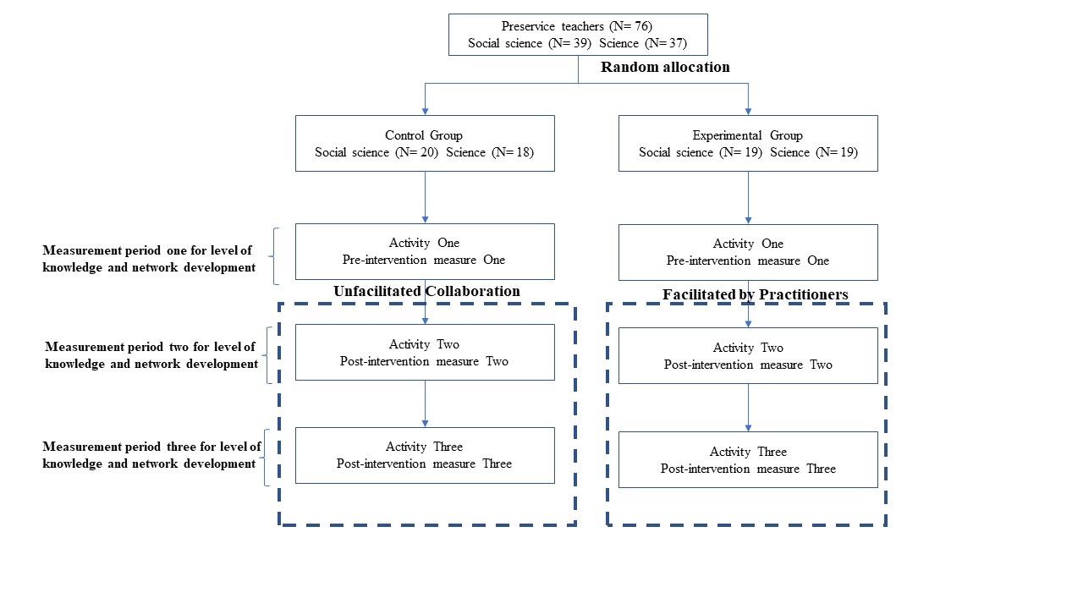
Figure 1: Experimental procedure

Participants and Settings
The study was conducted at a Saudi University during Fall Semester 2017. The pre-service teacher education programme is a one-year programme. Pre-service teachers in the first semester take around seven modules and in the second semester, they engage in school placement. The educational technology module was selected for this study. It focuses on the use of ICT in education. These teachers were training to teach upper elementary, middle or secondary school.
In total, 76 pre-service teachers were registered on the module, all female with different majors; either social science (39) or science (37). These majors are related to the subject disciplines that the pre-service teachers intend to teach. Two experienced female practitioners in educational technology participated. Both of the practitioners were expert in-service teachers and had experience in working with interdisciplinary teams.

Online Environment and Activities
In the present study, the module was implemented via Facebook for eight weeks during the last few months of 2017. A private group was created for each group. The module comprised three online activities based on the three topics of the module (interactive whiteboards, multimedia applications and online learning tools). The activities focused on teaching pre-service teachers how to use technology in their classroom practice. Activity one for both groups was conducted without facilitation by practitioners (see Figure 2). Activity two and three in the experimental group were facilitated by practitioners (see Figure 3), while unfacilitated collaboration continued in the control group (Figure 2). A training programme for the practitioners was provided before they joined the group which included information on the context of the pre-service teachers, and training on facilitating interactions in online discussions.

Figure 2: Unfacilitated collaboration
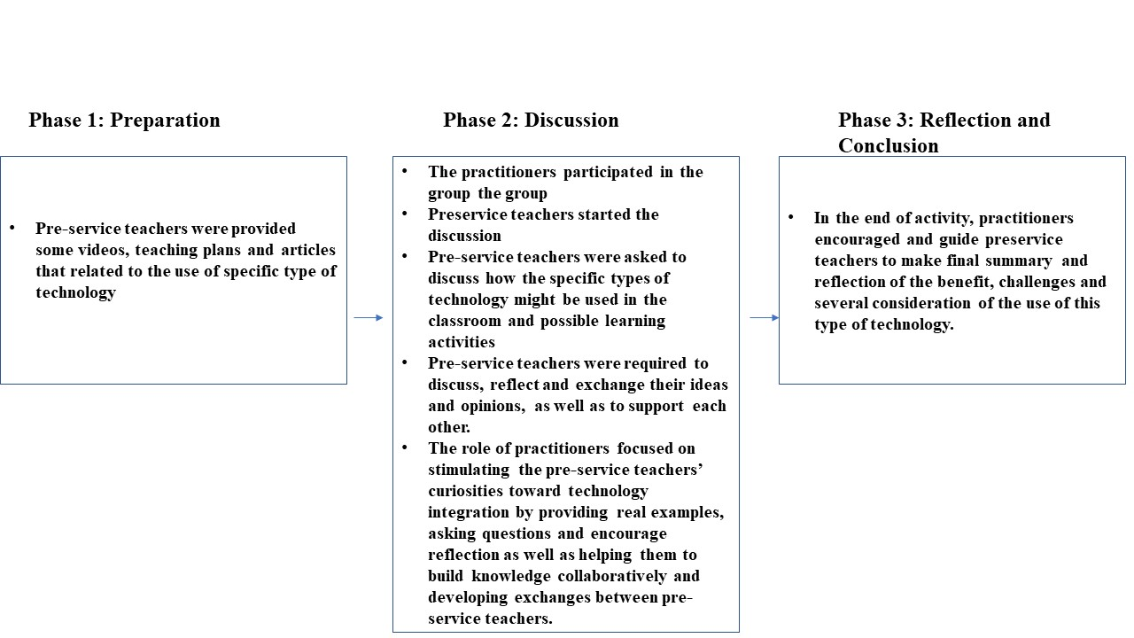
Figure 3: Facilitated collaboration

Data Collection and Analysis
3.4.1 Content analysis of knowledge construction. The main objective was to examine the level of knowledge construction among pre-service teachers in an online PLC. Cognitive presence, developed by Garrison et al. (2001), was used as the coding scheme for this study. Garrison et al. developed it specifically to examine knowledge construction in computer-mediated communication environments. Table 1 provides the description of each element of the coding schema.
Table 1: Coding schema (Garrison et al., 2001)
Category | Description
Trigger | Messages involving sort of identification of the problem
Explanation | Messages on sharing information such as providing opinions, exchanging experience without justifying.
Exploration | Connecting ideas with previous messages.
Resolution | Messages involving some sort of testing the solution.

CA can provide insight into the level of knowledge construction. The unit of analysis to code the transcripts was chosen to be a complete message (post). Figure 4 provides example of the coding analysis procedure. Inter-rater reliability tests were conducted to assess the objectivity of the analysis. Two independent coders, both Saudi educational technology lecturers with CA experience, were asked to code a random sample of a transcript independently (see Figure 5 for more an exemplar output of this process). Cohen’s kappa was used to determine the level of agreement. The inter-rater reliability between Coder 1 and 2, 2 and 3 and 1 and 3 was 0.827, 0.844 and 0.817 respectively, which represents excellent agreement (Krippendorff, 1980). An independent t-test was used to examine the change between groups (see Table 2).
Figure 4: Coding analysis procedure
Figure 5: Process of inter-rater reliability
3.4.2 Social network analysis (SNA). One means of identifying social capital and social networks within an online PLC is through SNA. SNA was used to identify the pattern of social interaction among pre-service teachers. The interaction identified by CA was represented in the SNA as a tie linking two individuals. The network in this study is a directed network which is determined by observing who responded to other ideas within the network. The analysis of directed network focuses on the direction of interactions, in terms of sending (out-degree) and receiving posts (in-degree).There are two networks in the study: knowledge-sharing (low cognitive interaction), which focuses on integrating Trigger and Explanation, and knowledge-building (high-cognitive interaction), which focuses on integrating Exploration and Resolution.
This study measured the whole network density, ego-network size and the extent of network homophily, known as the E-I index. Studies have used these measures with pre-service teachers (Bokhove and Downey, 2018) and in intervention studies to compare network development (Van Waes et al., 2018; Rienties and Héliot, 2018). An understanding of network density and pre-service teachers’ network sizes (average degree) can gauge the level of engagement in an online PLC, and seeks to answer RQ2. The density of the network is the sum of existing ties divided by the number of all possible ties. This study employed permutation methods to compare change in network density over time (paired t-test). Premutation tests adjust for the interdependent nature of network data. The average degree within each network was used to measure the mean number of participants to which each actor is directly linked (Rienties et al., 2009).
To measure the diversity of the network, the E–I index was used to examine whether pre-service teachers interact with peers in their same department (internal tie – I) or other departments (external tie – E). Krackhardt and Stern (1988) state that the value of the index ranges from –1 (all ties are only within the same department, or homophily) to +1 (all ties are to individuals outside the ego’s own department, or heterophily). The measure of network homophily seeks to answer RQ3. To measure the E–I index, the following formula was used (Krackhardt and Stern, 1988):
$$E-I Index=\frac{E-I}{E+I}$$
The social-network data were analysed using the network analysis software packages UCINET v6.658 (Borgatti et al., 2002) and NetDraw v2.163 (Borgatti, 2002).

4. Results

Research Question 1
Table 2 shows that both groups posted a similar volume of messages in each of the categories at Time 1 (T1). At the lower cognitive level of ‘explanation’, Table 2 shows that a modest growth in volume of communication, as indicated by the mean number of posts, was observed in both the experimental and control groups. By contrast, Table 2 indicates that the experimental group, after introduction of the practitioner, saw a much greater increase in the volume of communication at the higher cognitive levels of ‘exploration’ and ‘resolution’. The mean number of posts at these levels for the experimental group more than doubled between T1 and T2, and then continued to grow by a factor of approximately 1.5 between T2 and T3. For the control group any growth observed in volume of communication at these higher cognitive levels was more modest in scale and was not sustained between T2 and T3. Independent samples t-tests indicated there were no significant differences between groups in terms of the total volume of communication during T1, prior to the practitioners engaging with the experimental group. However, at T2 and at T3, there was evidence of significantly more messages in total and more messages coded at the highest two levels, ‘exploration’ and ‘resolution’, being posted by the experimental group compared to the control group. At T3 there was also a significant difference in the number of messages coded at the ‘explanation’ level in favour of the experimental group.
Table 2: The level of knowledge construction
Time | Level of Knowledge | Experimental |  | Control |  | T-test  Statistic
 |  | M | SD | M | SD
Time 1 | Trigger | 0.81 | 0.60 | 0.94 | 0.51 | -1.01
 | Explanation | 2.92 | 1.45 | 2.86 | 1.25 | -0.16
 | Exploration | 1.86 | 1.18 | 2.05 | 1.29 | -0.64
 | Resolution | 0.44 | 0.55 | 0.50 | 0.56 | -0.41
 | Total | 6.05 | 2.82 | 6.36 | 2.67 | -0.50
Time 2 | Trigger | 1.13 | 0.66 | 1.21 | 0.74 | -0.48
 | Explanation | 3.84 | 1.93 | 3.65 | 1.56 | 0.45
 | Exploration | 4.52 | 1.48 | 2.00 | 1.19 | 8.20**
 | Resolution | 1.42 | 0.82 | 0.79 | 0.66 | 3.67**
 | Total | 10.92 | 3.51 | 7.65 | 3.08 | 4.30**
Time 3 | Trigger | 1.18 | 0.69 | 1.26 | 0.72 | -0.48
 | Explanation | 5.05 | 1.45 | 4.10 | 1.79 | 2.52*
 | Exploration | 7.47 | 1.85 | 2.63 | 1.69 | 11.86**
 | Resolution | 2.49 | 1.35 | 0.71 | 0.73 | 7.18**
 | Total | 16.15 | 3.56 | 8.71 | 3.46 | 9.24**

*p< 0.05, **p< 0.001

Research Question 2
Table 3 shows changes in the density of the knowledge-sharing and knowledge-building networks for both control and experimental group across the three different time points.
Table 3: Densities of the networks
Network | Group | T1 | T2 | T3
Knowledge-Sharing Network | Experiment | 0.0910 | 0.1378 | 0.1622
 | Control | 0.0989 | 0.1358 | 0.1373
Knowledge-Building Network | Experiment | 0.0577 | 0.1532 | 0.2506
 | Control | 0.0690 | 0.0683 | 0.0882

The control and experimental groups in the first time point have similar network density for both knowledge-sharing and knowledge-building. By T2 and T3, the density of the knowledge-building network of experimental group was higher than that of control group. Figures 6 and 7 demonstrate this through visualisations of the networks at different time points. Within-group, paired sample t-tests across each successive pair of timepoints were implemented, using permutation methods suitable for network data (Table 4). The results indicate that the control group did not experience significant change in density in the knowledge-building network over time. However, the experimental group experienced significant growth in density through the time at the higher cognitive level of knowledge-building. At the lower cognitive level of knowledge-sharing, in both experimental and control groups, there was significant growth in network density from T1 to T2 and then the density did not change significantly between T2 and T3.
Table 4: T-test of the network density
 | Group | Knowledge-sharing |  | Knowledge-building
 |  | Density difference | T-test | Density difference | T-test
Time 1 to Time 2  (T2-T1) | Experiment | -0.04 | -3.93* | -0.09 | -8.25**
 | Control | -0.03 | -3.03* | 0.001 | 0.069
Time 2 to Time 3  (T3-T2) | Experiment | -0.02 | -1.87 | -0.09 | -6.30**
 | Control | -0.001 | -0.10 | -0.01 | -1.82
*p< 0.05, **p< 0.001

The mean size (average degree) of pre-service teachers’ individual (ego) networks helps gauge the level of engagement in an online PLC. At the lower cognitive levels, focused on ‘knowledge-sharing’ a modest growth in average degree was observed in both the experimental and control groups, which accounts for some of the growth in engagement demonstrated by the increases in overall network density over time. Table 5 indicates that main growth in engagement, as observed in the network density for the experimental group after introduction of the practitioner, is largely due to an increase in engagement at the higher cognitive level of ‘knowledge-building’. The average degree at this level for the experimental group more than doubled in value between T1 and T2, and then increased by more than a factor of 1.5 between T2 and T3. By comparison, in the control group the increase in engagement observed at the higher cognitive level was more modest in scale and also delayed to the later, T2 to T3 time period. The network visualisations in Figures 6 and 7 below illustrate this clearly, especially at the knowledge-building level (Figure 7).
Table 5: Comparison of network size for the two groups
Time | Type of Network | Experimental  (Exp) |  | Control  (Con) |  | Difference in average degree (Exp-Con)
 |  | M | SD | M | SD
Time 1 | Knowledge-sharing | 6.32 | 3.26 | 6.79 | 3.10 | -0.47
 | Knowledge-building | 3.89 | 2.96 | 4.21 | 2.92 | -0.32
Time2 | Knowledge-sharing | 9.05 | 2.39 | 8.84 | 2.81 | 0.21
 | Knowledge-building | 9.45 | 2.37 | 4.26 | 2.65 | 5.19
Time3 | Knowledge-sharing | 11.18 | 3.48 | 8.94 | 2.81 | 2.24
 | Knowledge-building | 15.15 | 2.78 | 5.37 | 3.03 | 9.78

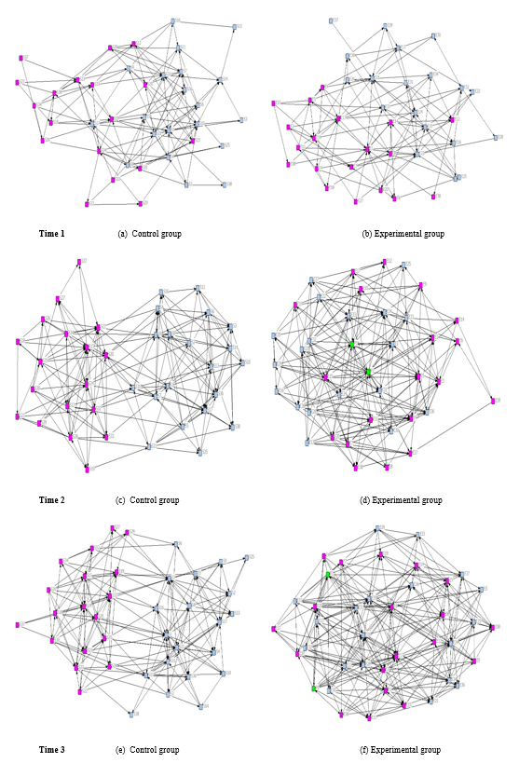
Figure 6: Knowledge-sharing network for different three points
Note: Blue node represents science pre-service teachers, pink social science pre-service teacher and green practitioners
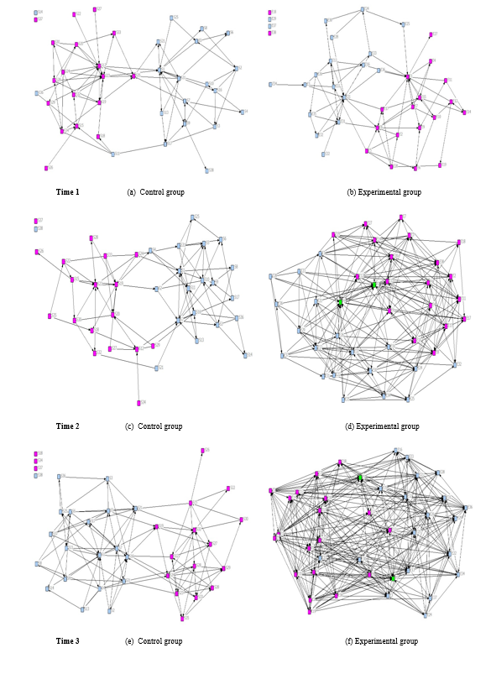
Figure 7: Knowledge-building network for different three points
Note: Blue nodes represent science pre-service teachers, pink nodes represent social science pre-service teachers and green nodes represent practitioners

Research Question 3
For the higher cognitive level knowledge-building network, Table 6 shows that the experimental group exhibited growth over time in engagement, both within each subject discipline (internal ties) and across the boundary between subject disciplines (external ties). By contrast no consistent pattern of growth in engagement was observed for the control group over time. The negative values of E-I index at T1 indicate that engagement within both control and experimental groups followed was largely homophilous with most activity occurring within the same subject discipline. The decreasing value of the negative E-I index for the experimental group at T2 indicates that the engagement of pre-service teachers allocated to the experimental group became more heterogeneous over time. Between T1 and T2 the greater proportion of the growth in engagement was through cross-disciplinary ties, as pre-service teachers engaged with more of their peers across the boundary between subject disciplines. Between T2 and T3 the growth in engagement was shared between increases in intra- and interdisciplinary ties. This meant that the increase in heterogeneity of engagement after introduction of the practitioners was sustained, as demonstrated by the value of the E-I index at T3.

Table 6: Internal, external ties and E-I index for the knowledge-building network
 |  | Experimental  (Exp) |  | Control  (Con) |  | Difference in average degree (Exp-Con)
 |  | M | SD | M | SD
Time 1 | Internal | 3.47 | 2.39 | 3.68 | 2.63 | -0.21
 | External | 0.42 | 0.83 | 0.53 | 0.89 | -0.11
 | E-I | -0.74 | 0.37 | -0.72 | 0.48 | ---
Time 2 | Internal | 6.55 | 1.92 | 3.89 | 2.44 | 2.66
 | External | 2.89 | 1.39 | 0.37 | 0.59 | 2.16
 | E-I | -0.39 | 0.25 | -0.79 | 0.33 | ---
Time 3 | Internal  External  E-I | 10.02 | 2.48 | 2.44 | 4.78 | 7.58
 |  | 5.24 | 1.95 | 0.57 | 0.83 | 4.67
 |  | -0.32 | 0.23 | -0.75 | 0.34 | ---

In terms of the lower cognitive level knowledge-sharing network, Table 7 shows that in the experimental group, any growth in engagement was predominantly due to an increase in interdisciplinary ties. The E-I index become less negative over time indicating increasing heterogeneity of engagement, until T3 when the near zero value of the E-I index indicates an equal volume of intra and interdisciplinary engagement. However, for the control group, the pre-service teachers increased the number of their ties with peers within the same department from T1 to T2, which led to a more negative E-I index score from T1 to T2. This indicates greater heterogeneity in engagement, which was sustained to T3. The network visualisations in Figure 6 show that for the control group, a relatively clear boundary remained between pre-service teachers in the two departments, while in the experimental group the boundary grew less distinct over time as the volume of interdisciplinary ties increased.
Table 7: Internal, external ties and E-I for the knowledge-sharing network
 |  | Experimental (Exp) |  | Control  (Con) |  | Difference in average degree (Exp-Con)
 |  | M | SD | M | SD
Time 1 | Internal | 4.53 | 2.02 | 4.89 | 2.31 | -0.36
 | External | 1.78 | 1.67 | 1.89 | 1.64 | -0.11
 | E-I | -0.52 | 0.33 | -0.51 | 0.39 | ---
Time 2 | Internal | 5.50 | 2.00 | 7.63 | 2.01 | -2.13
 | External | 3.55 | 1.34 | 1.21 | 1.4 | 2.34
 | E-I | -0.21 | 0.27 | -0.77 | 0.24 | ---
Time 3 | Internal  External  E-I | 5.26 | 1.50 | 7.36 | 2.70 | -2.10
 |  | 5.92 | 2.11 | 1.57 | 2.11 | 4.35
 |  | 0.04 | 0.26 | -0.67 | 0.23 | ---

5. Discussion
In term of RQ1, which focused on the cognitive level of knowledge constructed by the pre-service teachers, after the involvement of practitioners, the experimental group posted on average more cognitive messages coded at the higher cognitive levels than the control group. One possible explanation may relate to the presence of the practitioners. Liu (2005) found that the online environment was appropriate for expert teachers to support pre-service teachers to collaboratively develop knowledge and enhance cognitive thinking skills. Liu (2005) argues that pre-service teachers’ cognitive skills can be improved through engaging in conversation with experienced teachers. Zeichner (1996) points out that pre-service teachers during campus-based experience lack access to the thinking and decision-making process of experienced practitioners, which is considered extremely important if they are to learn. It appears that, in this current study, pre-service teachers had opportunities to interact with experts and to learn how they think, which in turn may lead to an increase in higher level cognitive exchange. By contrast, Redmond and Mander (2006) found no increase in high-level cognitive discourse in the presence of experts, inferring that the experts had difficulty in coaching pre-service teachers to achieve a high level of cognitive engagement. They recommended work on enhancing the experts’ role to develop higher-level cognitive exchange. It seems that the training programme for practitioners in this current study may have allowed them to establish how to facilitate pre-service teachers’ higher-level cognitive thinking. The results demonstrate that, although the experimental group increased the volume of messages coded at the highest ‘resolution’ level, the number was low compared to other cognitive levels. Redmond and Mander (2006) found that restricted opportunity to test a solution was one reason for the limited number of resolution level messages. In this current study, pre-service teachers had no opportunity to test any solutions in a classroom of pupils, due to their lack of engagement in teaching practice. Engaging pre-service teachers in micro-teaching within the university context to help them to test solutions prior to gaining classroom experience. According to Saban and Coklar (2013), microteaching can allow pre-service teachers to trial different teaching strategies which play role in enhancing their learning.
Regarding RQ2, which focused on the level of professional collaboration, the findings show that individuals in the experimental group exhibited growth over time in the average size of their networks in both knowledge-sharing and knowledge-building when compared to the control group. This was in line with significant growth in overall network density for the experimental group at the level of knowledge-building, while the overall network density of the control group remained constant. This finding is consistent with a qualitative study by Willegems et al. (2018), who found that in-service teachers played a role in engaging and coaching peers in collaborative activity and supported them to work as a team. The low level of engagement in the control group, in terms of developing their ties in a collaborative environment, may relate to the lack of coaching from experts. Kervinen et al. (2016) found that some pre-service teachers lacked experience in engaging in collaborative planning of a science lesson and needed support to collaborate. The result of this current study suggests that the presence of expert practitioners, with appropriate training, can play role in establishing the norm of collaboration and reaching out for support in sharing and building knowledge among pre-service teachers. Several researchers found that skilful online practitioners provided effective coaching and scaffolding techniques in pre-service curricular to enhance the engagement (Dorner and Kumar, 2017; Redmond and Mander, 2006). They also placed an emphasis on the practitioners needing to have both expert disciplinary knowledge, coupled with awareness of facilitation techniques in order to enhance the level of collaboration.
In terms of developing ties with pre-service teachers both within and outside their departmental disciplines (RQ3), the presence of practitioners in the experimental group, led to increased knowledge-sharing across the two departments resulting in decreased homophily of exchange over time. By contrast the control group decreased its collaboration between the two departments and thus increased the homophilous level of exchange. One explanation for this result is that practitioners may have tried to enhance the norm of sharing resources by engaging pre-service teachers in interdisciplinary activities. Brown et al. (2018) argue that the lack of engaging experts with experience in an interdisciplinary environment with teachers may act as an obstacle in design of interdisciplinary team collaboration. In this current study, both practitioners had experience of working with teachers from different departments and of interdisciplinary team activities.
Regarding the higher cognitive level of knowledge-building, the results of this study indicate that pre-service teachers in the experimental group increased their external and internal ties over time while the control group did hardly change over time. Although the experimental group saw development of both internal and external ties, the pre-service teachers still interacted more with peers from the same department, as indicated by the negative value of the E-I index. It would seem, therefore, that it is more challenging to promote growth in interdisciplinary engagement at higher cognitive levels. One possible explanation for this result in this current study is the type of online learning activity. In this study there was no specific interdisciplinary task employed, which may have increased the level of collaboration with different departments (Rienties and Kinchin, 2014). Perhaps dividing the pre-service teachers into small groups and mixing them would encourage engagement with teachers from different departments (Rienties and Kinchin, 2014). Moreover, Rienties and Héliot (2018) argue that mixing participants without providing effective coaching techniques may not enhance learning ties between departments. Although in this study the practitioners may have attempted to increase the interdisciplinary interactions of the pre-service teachers, their training did not include specific guidelines on enhancing interdisciplinary activity in higher level cognitive thinking with those outside their department.

6. Limitations
Several limitations of the current study need to be considered. First, this study had a relatively small sample, as is typical within experimental studies. It is important therefore, that future research is undertaken to replicate and build upon this work. Also, the current study only examined interactions within an online PLC, not face-to-face, nor those in any external support networks outside this online PLC, that pre-service teachers build to enhance their learning. Several studies found that teachers developed external networks to develop their learning and teaching with people outside the professional development programme (e.g. Rienties and Kinchin, 2014). Another limitation is that this study did not examine any pre-existing relationships between pre-service teachers prior to engaging in the online PLC. Rienties and Kinchin (2014) found that existing friendships can play a role in forming groups.

7. Conclusion
In this investigation, the aim was to assess the role of experienced practitioners in developing pre-service teachers’ social interaction and knowledge construction in an online PLC. It has shown that practitioners with proper training play a role in increasing pre-service teachers’ cognitive engagement and higher-level cognitive discourse. Practitioners’ presence increases the social interaction among pre-service teachers; the experimental group experienced faster and greater levels of growth in the size of both its knowledge-sharing and knowledge-building networks, over time. Furthermore, the involvement of practitioners enhanced the collaboration between departments in the experimental group. Nevertheless, both groups were more likely to build knowledge with participants from the same department in the higher cognitive level knowledge-building network. This study has adopted a quantitative approach to assess knowledge construction and network development. This research could be extended in future to gain further insight into the qualitative nature of these interactions in an online PLC and to elicit the mechanisms by which practitioners influence these interactions.

References
Al-Abdullatif, A. (2019), “Auditing the TPACK confidence of pre-service teachers: The case of Saudi Arabia”, Education and Information Technologies, Vol. 24 No .6, pp. 3393-3413.‏
Alebaikan, R. (2016), “Online and face-to-face guest lectures: graduate students' perceptions”, Learning and Teaching in Higher Education: Gulf Perspectives, Vol. 13 No .2, pp. 1-13.
Bokhove, C., and Downey, C. (2018), “Mapping changes in support: a longitudinal analysis of networks of pre-service mathematics and science teachers”, Oxford Review of Education, Vol. 44 No. 3, pp. 383-402.
Bond, N. (2013), “Developing a Professional Learning Community among Preservice Teachers”, Current issues in Education, Vol. 16 No. 2, pp. 1-15
Borgatti, S. P. (2002). Netdraw Network Visualization [Computer software]. Harvard, MA: Analytic Technologies.
Borgatti, S. P., Everett, M. G., & Freeman, L. C. (2002). UCINET 6 for Windows: Software for social network analysis [Computer software]. Harvard, MA: Analytic Technologies.
Brown, B., Hartwell, A., and Thomas, C. (2018), “Interdisciplinary design teams of pre-service and in-service teachers: Issues with collaboration”, The Canadian Journal of Action Research, Vol. 19, pp. 3-21.‏
Burt, R. (1992), Structural Holes: The Social Structure of Competition. Harvard University Press, Cambridge.
Costello, J. (2012), “Perceptions of guest lecturers' impact on online learning communities”, in Proceedings of the 8th International Conference on Networked Learning, pp. 482-487.
Daniel, B., Schwier, R., and McCalla, G. (2003), “Social capital in virtual learning communities and distributed communities of practice”, Canadian Journal of Learning and Technology, Vol. 29 No. 3, pp. 113-139.
Dorner, H., and Kumar, S. (2016), “Online Collaborative Mentoring for Technology Integration in Pre-Service Teacher Education”, Techtrends, Vol. 60, pp. 48-55.
Dorner, H., and Kumar, S. (2017), “Pre- and inservice teacher satisfaction with online collaborative mentoring for technology integration: Applying the Kano quality attributes”, Online Learning Journal, Vol. 21 No. 4, pp. 283-301.
Feiman-Nemser, S. (1998), “Teachers as teacher educators”, European Journal of Teacher Education, Vol. 21, pp. 63-74.
Fox, A., and Wilson, E. (2015), “Networking and the development of professionals: beginning teachers building social capital”, Teaching and Teacher Education, Vol. 47, pp. 93-107.
Garrison, D., and Cleveland-Innes, M. (2005), “Facilitating Cognitive Presence in Online Learning: Interaction Is Not Enough”, American Journal of Distance Education, Vol. 19 No. 3, pp. 133-148.
Garrison, D., Anderson, T., and Archer, W. (1999), “Critical inquiry in a text-based environment: Computer conferencing in higher education model”, The Internet and Higher Education, Vol. 2 No. 2-3, pp. 87-105.
Garrison, D., Anderson, T., and Archer, W. (2001), “Critical thinking, cognitive presence and computer conferencing in distance education”, American Journal of Distance Education, Vol. 15, pp. 7-23.
Hemphill, L., and Hemphill, H. (2007), “Evaluating the impact of guest speaker postings in online discussions”, British Journal of Education Technology, Vol. 38 No. 2, pp. 287-298.
Kervinen, A., Uitto, A., Kaasinen, A., Portaankorva-Koivisto, P., Juuti, K., and Kesler, M. (2016), “Developing a collaborative model in teacher education”. LUMAT, Vol. 4 No. 2, pp. 67-86.
Kirschner, P., and Lai, K. (2007), “Online communities of practice in education”, Technology, Pedagogy and Education, Vol. 16 No. 2, pp. 127-131.
Krackhardt, D., and Stern, R. (1988), “Informal networks and organizational crises: An experimental simulation”, Social Psychology Quarterly, Vol. 51 No. 2, pp. 123-140.
Krippendorff, K. (1980), “Content analysis: An introduction to its methodology”, Sage, Thousand Oaks.
Li, L., Conn, S., and Markham, C. (2014), “Promoting Active Learning in Distance Education: A Case of Student-Centered Guest Lecturing”, in Proceedings of the Southern Association for Information Systems Conference, Macon, USA.
Lin, N. (2001), Social capital. A theory of social structure and action. Cambridge University Press, Cambridge.
Liou, Y., & Daly, A. (2018), “Evolving relationships of pre-service teachers”, in Yoon, S. A. and Baker-Doyle, K. J. (Eds.), Networked by design: Interventions for teachers to develop social capital, Routledge, New York, NY, pp. 85–110.
Liou, Y., Daly, A., Canrinus, E., Forbes, C., Moolenaar, N., Cornelissen, F., Van Lare, M., and Hsiao, J. (2016), “Mapping the social side of pre-service teachers: Connecting closeness, trust, and efficacy with performance”, Teachers and Teaching: Theory and Practice, Vol. 23, pp. 635–657.
Liu, T. (2005), “Web-based Cognitive Apprenticeship Model for Improving Pre-service Teachers’ Performances and Attitudes towards Instructional Planning: Design and Field Experiment”, Educational Technology & Society, Vol. 8, No. 2, pp. 136-149.
Moolenaar, N. (2012). “A Social Network Perspective on Teacher Collaboration in Schools: Theory, Methodology, and Applications”, American Journal of Education, Vol. 119, pp. 7-39.
Moolenaar, N. and Daly, A. (2012), “Social Networks in Education: Exploring the Social Side of the Reform Equation”, American Journal of Education. Vol. 119, pp. 1-6.
Quinn, D., and Kim, J. (2018), “Experimental effects of program management approach on teachers’ professional ties and social capital”, Educational Evaluation and Policy Analysis, Vol. 40 No. 2, pp. 196-218.
Redmond, P., and Mander, A. (2006), “Online Mentoring Of Pre-Service Teachers: Exploring Cognitive Presence”, in Proceedings of SITE 2006--Society for Information Technology & Teacher Education International Conference, Orlando, USA, pp. 2643-2650.
Rienties, B., and Héliot, Y. (2018), “Enhancing (in)formal learning ties in interdisciplinary management courses: a quasi-experimental social network study”, Studies in Higher Education, Vol. 43 No. 3, pp. 437-451.
Rienties, B., and Kinchin, I. (2014), “Understanding (in)formal learning in an academic development programme: A social network perspective”, Teaching and Teacher Education, Vol. 39, pp. 123-135.
Rienties, B., Tempelaar, D., Van den Bossche, P., Gijselaers, W., and Segers, M. (2009), “The role of academic motivation in Computer-Supported Collaborative Learning”, Computers in Human Behavior, Vol. 25 No. 6, pp. 1195-1206.
Risser, H. (2014). “Virtual induction: A novice teacher's use of Twitter to form an informal mentoring network”, Teaching and Teacher Education, Vol. 35, pp. 25-33.
Saban, A., and Çoklar, A. (2013), “Pre-Service Teachers' Opinions about the Micro-Teaching Method in Teaching Practise Classes”, TOJET, Vol. 12 No. 2, pp. 234-240.‏
Van Waes, S., De Maeyer, S., Moolenaar, N. M., Van Petegem, P., and Van den Bossche, P. (2018), “Strengthening networks: A social network intervention among higher education teachers”, Learning and Instruction, Vol. 53, pp. 34-49.‏
Van Waes, S., Van den Bossche, P., Moolenaar, N., De Maeyer, S., & Van Petegem, P. (2015), “Know-who? Linking faculty's networks to stages of instructional development”, Higher Education, Vol. 70 No. 5, pp. 7-9
Wearmouth, J., Smith, A., and Soler, J. (2004), “Computer conferencing with access to a ‘guest expert’ in the professional development of special educational needs coordinators”, British Journal of Educational Technology, Vol. 35, pp. 81–93.
Willegems, V., Consuegra, E., Struyven, K., and Engels, N. (2018), “Pre-service teachers as members of a collaborative teacher research team: A steady track to extended professionalism?”, International Journal of Research and Studies, Vol. 76, pp. 126-139.
Zeichner, K. (1996), “Designing educative practicum experiences for prospective teachers”, in Zeichner, K. Melnick, S. and Gomez, M. (Eds.), Currents of reform in preservice teacher education, Teachers College Press, New York, pp. 215-234.
Zhang, S., Liu, Q., Chen, W., Wang, Q., and Huang, Z. (2017), Interactive networks and social knowledge construction behavioral patterns in primary school teachers' online collaborative learning activities, Computers & Education, Vol. 104, pp. 1-17.‏

