δ¹³C values of bacterial hopanoids and leaf waxes as tracers for methanotrophy in peatlands

Gordon N. Inglisª, B. David A. Naafsª, Yanhong Zheng^{b}, Judith Schellekens^{c}, Richard D. Pancostª and the ‘T-GRES Peat Database collaborators’

ª Organic Geochemistry Unit, School of Chemistry, School of Earth Sciences, and Cabot Institute, University of Bristol, Bristol, UK
^{b} State Key Laboratory of Continental Dynamics, Department of Geology, Northwest University, Xi’an, PR China
^{c} Department of Soil Science, University of São Paulo, Piracicaba, Brazil

Corresponding author: Gordon N. Inglis

Email: gordon.inglis@bristol.ac.uk. Telephone: +44 (0)117 954 6395

Abstract
Methane emissions from peatlands contribute significantly to atmospheric CH₄ levels and play an essential role in the global carbon cycle. The stable carbon isotopic composition (δ¹³C) of bacterial and plant lipids has been used to study modern and past peatland biogeochemistry, especially methane cycling. However, the small number of recent peatlands that have been characterised and the lack of consistency between target compounds means that this approach lacks a rigorous framework. Here, we undertake a survey of bacterial and plant lipid δ¹³C values in peatlands from different geographic regions, spanning a wide range of temperature (-8 to 27°C) and pH (~3 to 8), to generate a reference dataset and probe drivers of isotopic variability. Within our dataset, the carbon fixation pathway predominantly determines leaf wax (n-alkane) δ¹³C values. Bacterial-derived C₃₁ hopane δ¹³C values track those of leaf waxes but are relatively enriched (0 to 10‰), indicating a heterotrophic ecology and preferential consumption of ¹³C-enriched substrates (e.g. carbohydrates). In contrast, ≤ C₃₀ hopanoids can be strongly ¹³C-depleted and indicate the incorporation of isotopically light methane into the bacterial community, especially at near neutral pH (~5-6 pH). Previous analysis of Eocene sediments has suggested isotopic decoupling between C₃₁ and ≤ C₃₀ hopanoid δ¹³C values. Our work suggests a globally widespread decoupling in recent peatlands; this persists despite the profound diversity of hopanoid producing bacteria and associated controls on their δ¹³C values and it has significant implications for future work. Re-analysis of published data from: 1) the (mid-to-early) Holocene and late Glacial, and 2) latest Paleocene and earliest Eocene in this revised context highlights that perturbations to the peatland methane cycle occurred during the past, and we envisage that this approach could provide unique (qualitative) insights into methane cycling dynamics throughout the geological record.

1. Introduction
Wetlands play an essential role in the global carbon cycle and are one of the largest carbon stores on land (> 600 PgC) (Yu et al., 2010). They are also the largest natural source of atmospheric methane (CH₄) (Dean et al., 2018), with current emissions ranging between 55 and 230 Tg CH₄ yr⁻¹ (Turetsky et al., 2014). Increasing (tropical) wetland CH₄ emissions could also be responsible for the unexpected increase in atmospheric CH₄ concentrations since 2007 (Nisbet et al., 2016). This could have implications for tackling future global warming and highlights the importance of understanding wetland methane cycling during past warm climates.
Temperature, hydrology, pH and vegetation primarily govern wetland CH₄ emissions (Bridgham et al., 2013; Turetsky et al., 2014). CH₄ emissions are further regulated by the interplay between methanogenesis and methanotrophy, all of which are controlled by a range of physical, biological and chemical processes (Segers, 1998). These disparate processes will exert complex controls on the stable carbon isotopic composition (δ¹³C) of wetland organic matter, which when untangled could serve as powerful tools for reconstructing the carbon cycle and microbial ecology in modern and ancient wetlands.
Plant (e.g. leaf wax) δ¹³C values are governed by the concentration and carbon isotopic composition of ambient CO₂ (which can deviate from atmospheric values), relative humidity and vegetation type (Collister et al., 1994; Diefendorf et al., 2011; Farquhar et al., 1989). However, plant δ¹³C values can also be influenced by aerobic methanotrophy. Previous studies indicate that ¹³C-depleted CH₄ can be converted to carbon dioxide (CO₂) within the water-filled hyaline cells of Sphagnum moss and subsequently incorporated into biomass (Kip et al., 2010; Raghoebarsing et al., 2005) and plant lipids such as phytosterols (up to -32‰; Elvert et al., 2016; Liebner et al., 2011) and mid-chain C₂₁-C₂₅ n-alkanes (e.g. C₂₃ n-alkane: up to -43‰; Elvert et al., 2016; van Winden et al., 2010). As such, the occurrence of ¹³C-depleted plant lipids in wetland environments could be a useful tool to reconstruct Sphagnum-associated methanotrophy. However, more ground truthing is needed to upscale this approach globally.
The interplay of plant biomass δ¹³C values, heterotrophy and methanotrophy will also govern the δ¹³C values of bacterial-derived hopanoid biomarkers. Hopanoids are produced by a wide range of bacteria (Talbot and Farrimond, 2007; Talbot et al., 2016b) and δ¹³C values of the C₃₁ hopane range from -22 to -26‰ in recent wetlands (Pancost et al., 2003; Xie et al., 2004). This indicates a predominantly heterotrophic source (Pancost and Sinninghe Damsté, 2003; Pancost et al., 2000) and supports previous studies that have shown that the majority of precursor organisms biosynthesising hopanoids in peat-forming environments are heterotrophs (see Talbot et al., 2016a and ref. therein). Methanotrophy appears (perhaps unexpectedly) to be a minor control on hopanoid δ¹³C values. However, recent work on a limited set of recent wetland samples has shown that C₃₀ hopenes can yield lower values (e.g. -up to -38‰; van Winden et al., 2010; Zheng et al., 2014). Low C₃₀ hopene δ¹³C values (up to -60‰) have also been identified in lacustrine settings (Davies et al., 2015; Naeher et al., 2014), indicating incorporation of isotopically light CH₄ into the bacterial community. As C₃₀ hopenes are produced by a variety of organisms (including methanotrophs; e.g. Rohmer et al., 1984), these compounds may be suitable candidates for tracking changes in wetland CH₄ cycling. However, due to the small number of recent wetlands that have been studied, as well as a lack of consistency between target compounds and the narrow range of wetland diversity sampled, our understanding of the impact of methanotrophy upon hopanoid δ¹³C values in wetland - and hence the CH₄ cycle - remains limited.
Here we undertake a survey of n-alkane and hopanoid δ¹³C values from the upper meter of sediment in a range of peatlands (n = 199 samples from 37 peatlands in boreal, temperate and tropical regions), spanning a wide range of temperature (-8 to 27°C), pH (~3 to 8) and vegetation. We focus on peatlands as these contribute significantly to atmospheric CH₄ levels. We use this to generate a reference dataset and assess the controls on n-alkane (C₂₁ to C₃₃) and hopane/hopene (C₂₇ to C₃₂) δ¹³C values, including heterotrophy, methanotrophy, temperature, pH and vegetation. Guided by these results, we use our dataset to re-interpret previously published hopanoid and n-alkane δ¹³C values from the mid-to-early Holocene and late Glacial (4 to 18 thousand years ago) and early Eocene and latest Paleocene (48 to 56 million years ago) and use these new interpretations to constrain the operation of the CH₄ cycling during the past.

2. Methods

2.1. Peat material
To expand the existing data and build a significantly larger database of hopanoid and n-alkane δ¹³C values, we analysed samples from a subset of the peatland database we developed previously (Naafs et al., 2017). This includes samples (n = 157) from 34 peatlands from boreal (Iceland, Finland, Norway, Sweden, Russia), temperate (Argentina, Canada, USA, Germany, Iceland, Iran, Spain) and tropical (Brazil, Peru, Indonesia, Kenya) geographic locations (Fig. 1; SI Appendix). Samples (n = 42 from 3 sites) were also compiled from published studies (van Winden et al., 2012b; Xie et al., 2004; Zheng et al., 2014).
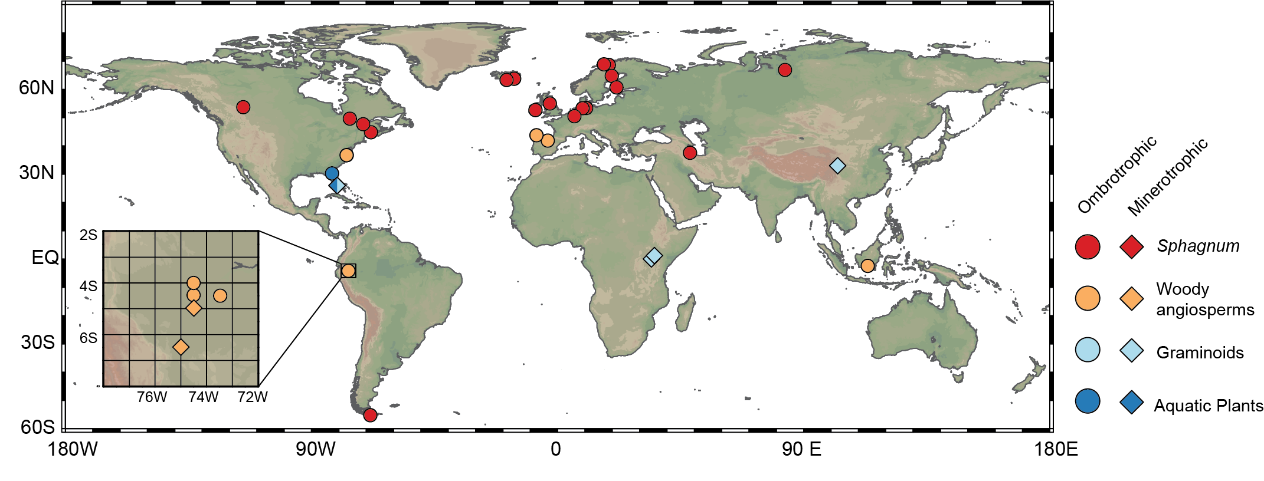
Figure 1. Map with the location of all recent peatlands used in this study.

2.1.1. Sampling approach
Samples for the reference dataset (n = 199; section 2.1) were collected from different horizons within the top 50 to 100cm of peat. Our dataset includes: 1) surface samples, 2) samples above and below the acrotelm/catotelm boundary and 3) samples distributed throughout the peat. This approach allows us to assess both spatial and downcore variability. Our dataset also spans important biogeochemical gradients (e.g. acrotelm/catotelm boundary).
Variations in peat accumulation rates differ between sites, implying that the age of lipid biomarkers (and their δ¹³C values) might differ. However, the available age models indicate that the top 100cm of peat in our reference dataset range between 800 to 2000 years in age (Chambers et al., 2014; De Vleeschouwer et al., 2012; Lӓhteenoja et al., 2009; Page et al., 2004; Rydberg et al., 2010; Vӓliranta et al., 2007; Xie et al., 2004; Zheng et al., 2014). For sites without an age model, we use published accumulation rates (Aaby and Tauber, 1975; Gorham, 1991; Page et al., 2004; Sorensen, 1993) to estimate the approximate time interval captured by 100 cm of peat deposition. These estimates strongly suggest that the majority of our sites (all of which are < 100cm, and typically < 60cm) span the last 2000 years. Crucially, this means that our compilation reflects recent rather than modern processes. Hereafter, the data obtained from these upper 100 cm will be referred to as our “recent” reference dataset.

2.2. Environmental parameters
Environmental parameters (e.g. latitude, longitude, altitude, mean annual air temperature, pH and vegetation) were obtained for each site. This data is included within the supplementary information. Mean annual air temperature (MAAT) and altitude were calculated using the simple bioclimatic model PeatStash, which computes MAAT and altitude globally with a 0.5-degree spatial resolution (see Naafs et al., 2017). Directly measured pH data was used as reported (Naafs et al., 2017; Huang et al., 2018). Vegetation information was obtained from published studies (Broder and Biester, 2015; De Vleeschouwer et al., 2012; Huang et al., 2018; Jauhiainen et al., 2005; Lähteenoja and Page, 2011; Mauquoy et al., 2004; Pancost et al., 2011; Pancost et al., 2000; Souto et al., 2016; Souto et al., 2017; Zheng et al., 2014) or via personal communication (L. Rochefort, F. De Vleeschouwer, A. Rizzuti, A. Gallego-Sala, A. Sharifi, R. Bindler, L. Gandois). Each peatland is characterised by a wide variety of plants, including mosses, woody angiosperms, woody gymnosperms, graminoids and aquatic plants; as such, we have classified sites based upon the dominant plant type in each setting (see Fig. 1; SI Appendix). However, we note that other types of plants can be present and can be dominant in some depth intervals. There are also other parameters that may be important but are not considered here due to the methodological design (e.g. hydrology, substrate availability and microbial ecology).

2.3. Organic Geochemistry
2.3.1. Extraction and separation
New peat material (see section 2.1) was extracted using an Ethos Ex microwave extraction system using 15 ml of dichloromethane (DCM) and methanol (MeOH) (9:1, v/v, respectively) at the Organic Geochemistry Unit in Bristol. These were all previously extracted by Naafs et al. (2017). The microwave program consisted of a 10 min ramp to 70 °C (1000 W), 10 min hold at 70 °C (1000 W), and 20 min cool down. Samples were centrifuged at 1700 rounds per minute for 3-5 min, and the supernatant was removed and collected. A further 10 ml of DCM:MeOH (9:1, v/v) was added to the remaining sample and centrifuged again, after which the supernatant was removed and combined with the previously obtained supernatant. This process was repeated 3-6 times, depending on the volume of sample, to ensure that all extractable lipids were retrieved. The total lipid extract (TLE) was initially separated over silica into apolar and polar fractions using hexane:dichloromethane (9:1, v/v) and dichloromethane:methanol (1:2, v/v), respectively. In some tropical peatlands (e.g. Peru), an unknown pentacyclic triterpene methyl ether (Jacob et al., 2005) co-eluted with the C₃₁ ββ hopane. To enable subsequent δ¹³C analysis of the C₃₁ ββ hopane, we therefore separated the apolar fraction over silica into a hydrocarbon and aromatic/ether fraction using hexane (100%) and hexane:dichloromethane (3:1, v/v) respectively.
Urea adduction was used to separate cyclic (i.e. non-adduct) and aliphatic (i.e. adduct) hydrocarbons. This was performed on a subset of samples which contained a wide range of hopanoid lipids. To achieve this, 200 μl of hexane, 200 μl of acetone and 200 μl of urea (10% in MeOH) were successively added to the saturated hydrocarbon fraction. The sample was frozen for ca. 60 minutes until urea crystals formed. Solvent was then removed under a gentle stream of N₂ and the urea extracted (×5) with ca. 1 ml of n-hexane (cyclic fraction). The urea crystals were then dissolved in 500 μl of MeOH and 500 μl of water and the aliphatic fraction was extracted (×5) with ca. 1 ml of n-hexane. The adduction procedure was repeated on the adduct fraction once more to ensure all non-adduct material was removed (Pancost et al., 2008).

2.3.2 GC-MS analysis
Gas chromatography-mass spectrometry (GC-MS) was performed using a Thermo Scientific ISQ Single Quadrupole gas chromatography-mass spectrometer. Using helium as the carrier gas, 1 μl of sample (dissolved in hexane) was injected at 70 °C using an on-column injector. The temperature program included four stages: 70 °C hold for 1 min, 70–130 °C at 20 °C/min rate; 130–300 °C at 4 °C/min; and temperature hold for 20 min at 300 °C. The electron ionisation source was set at 70 eV. Scanning occurred between m/z ranges of 50–650 Daltons. The GC was fitted with a fused silica capillary column (50 m × 0.32 mm i.d.) coated with a ZB1 stationary phase (dimethylpolysiloxane equivalent, 0.12 μm film thickness). Hopanoids and n-alkanes were identified based upon published spectra, characteristic mass fragments and retention times (e.g. Van Dorsselaer et al., 1974, Rohmer et al., 1984, Uemura and Ishiwatari, 1995, Sessions et al., 2013).

2.3.3. GC-C-IRMS analysis
Gas chromatography-combustion-isotope ratio mass spectrometry (GC-C-IRMS) was performed using an Isoprime 100 GC-combustion-isotope ratio mass spectrometer system. Samples were measured in duplicate with a reproducibility of <0.5‰ and δ¹³C values were converted to VPDB by bracketing with an in-house gas (CO₂) of known δ¹³C value. The Instrument stability was monitored by regular analysis of an in-house standard; long-term precision is ± 0.3‰. Injection volume was 1 μl onto to a Zebron-I nonpolar column (50 m × 0.32 mm i.d., 0.10 μm film thickness). GC conditions were the same as described above for GC-MS analysis (see 2.3.2).

2.4. Statistical analysis
To assess the correlation between different lipid biomarker δ¹³C values (e.g. C₂₃ vs C₂₅ n-alkanes) we calculated Pearson product correlation coefficients (r), residuals and probability plots. To determine whether two means are significantly different (p < 0.05), we used independent sample t-tests. To estimate the relationship between δ¹³C lipid values and environmental parameters we calculated Deming regressions and calibration coefficients of determination (R²) using the R software package (http://www.R-project.org/; see Inglis et al., 2018 for full code). Deming regressions differ from simple linear regressions as they consider the error on both the x- and y-axis (Adcock, 1878). Here, we assume that the error associated with proxy measurements and environmental parameters is independent and normally distributed. To calculate a Deming regression, we must define the standard deviation (σ) for both the x- and y-axis. For MAAT, the standard deviation is defined as 1.5 °C (see Naafs et al., 2017). For pH, the standard deviation is defined as 0.5 pH units (see Naafs et al., 2017). For the δ¹³C lipid values, the standard deviation and ratio of variance must also be defined. Residuals are used to evaluate the performance of the linear model and were calculated for the full dataset using the following equation:

$${Residual}_{y}=y_{observed}-y_{predicted}$$

3. Results

3.1. n-alkane δ¹³C values
Saturated hydrocarbon fractions (n = 199) contained the range of n-alkanes (C₁₉-C₃₃) typically found in such settings (Pancost et al., 2003; Quirk et al., 1984; Xie et al., 2004) and were dominated by mid-chain (C₂₁ to C₂₅) and long-chain n-alkanes (C₂₇ to C₃₃). Mid-chain n-alkane (C₂₁-C₂₅) δ¹³C values average -33 ‰ and range from -27 to -39‰ (n = 286, σ = 2.0, skewness = - 0.4; Fig. 3). Long-chain n-alkane (C₂₇-C₃₃) δ¹³C values average -32 ‰ and range from -28 to -38‰ (n = 621; σ = 1.8, skewness = -0.7; Fig. 2). Although the two n-alkane groups have similar carbon isotopic averages and ranges, the skewness and hence distribution profiles slightly differ. The δ¹³C values of compounds derived from similar sources are expected to be linearly correlated and with slopes of 1. Significant linear correlations do exist between mid-chain (C₂₁-C₂₅) n-alkane δ¹³C values (r = 0.73 to 0.90; p < 0.001; Supplementary Information) and between long-chain (C₂₉-C₃₃) n-alkane δ¹³C values (r = 0.76 to 0.91; p < 0.001; Supplementary Information). However, the correlation between mid-chain (C₂₁-C₂₅) and long-chain (C₂₉-C₃₃) n-alkane δ¹³C values is low (r = 0.07 to 0.29).
Within a single peatland, mid-chain n-alkanes exhibit minor variations in δ¹³C values (σ = 0.6 to 1.6‰; Fig. S1-S2) and the average downcore variability (σ = 1.1‰) is significantly lower than the global range (σ = 3.0‰). Long-chain n-alkanes also exhibit minor variations in δ¹³C values (σ = 0.7 to 2.0‰; Fig. S1-S2) and the average downcore variability (σ = 1.0‰) is lower than the global range (average σ = 1.8‰). Consistent with previous studies (e.g. Xie et al., 2004), there is also no significant variation in long-chain and mid-chain n-alkanes δ¹³C values between deep (>15 cm) and shallow (<15 cm) sections of the peat (Fig. S1-S2).
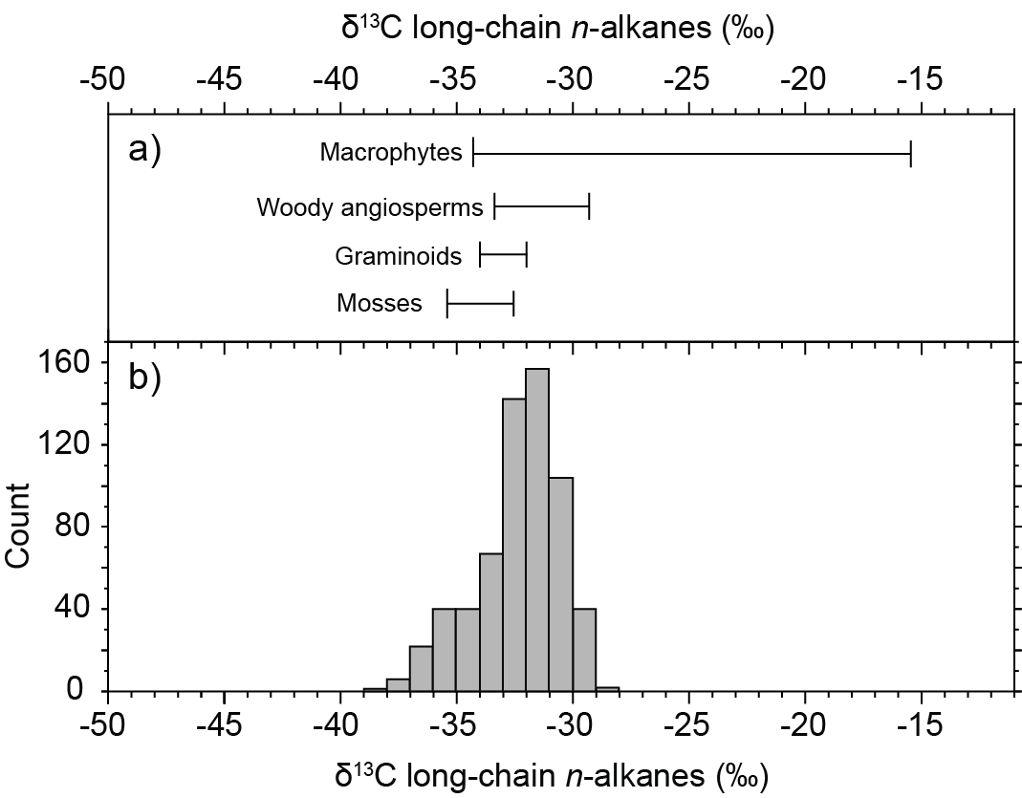
Figure 2. Compilation of long-chain (C₂₇-C₃₃) n-alkane δ¹³C values in (a) modern peatland plants (Aichner et al., 2010, Brader et al., 2010, Ficken et al., 1998, Huang et al., 2010, Huang et al., 2012, Mead et al., 2005, van Winden et al., 2010, Xie et al., 2004) and (b) recent peatlands (this study). Peatland n-alkane δ¹³C values reported from the upper 100 cm only.

3.2. Hopanoid δ¹³C values
Saturated hydrocarbon fractions (n = 199) contained the range of hopanes and hopenes typically found in such settings (Pancost et al., 2003; Quirk et al., 1984; Xie et al., 2004) and are described in detail in Inglis et al. (2018). The C₃₁ αβ hopane - one of the most abundant hopanoids in peat (Inglis et al., 2018) - yields an average δ¹³C value of -26‰ with a range from -17 to -32‰ (n = 102, σ = 2.8, skewness = -0.49; Fig. 4). The average δ¹³C value of the C₃₁ ββ hopane is similar with a value of -26‰ (n = 61; σ = 3.8, skewness = -1.1; Fig. 4). δ¹³C values of the C₃₁ ββ and C₃₁ αβ hopanes are positively correlated (r = 0.87; p < 0.001). There is also a linear correlation between δ¹³C values of the C₃₁ hopane (both αβ and ββ) and long-chain n-alkanes (Fig. S3).

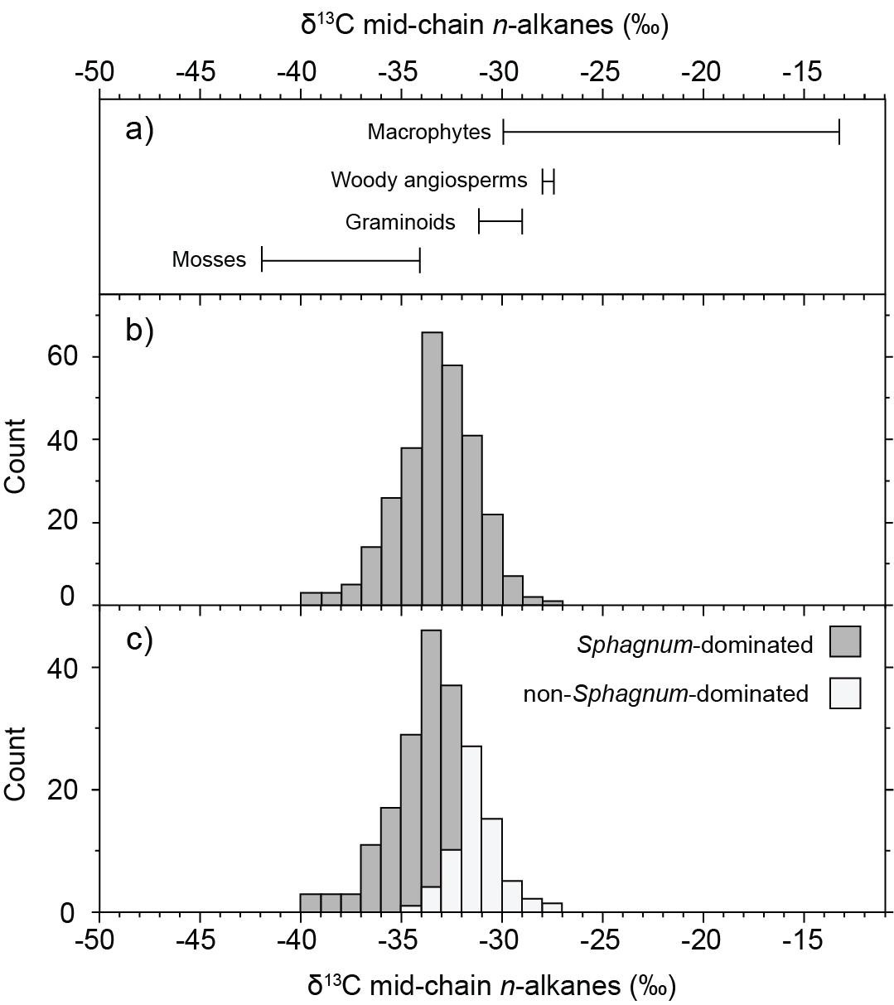
Figure 3: Compilation of mid-chain (C₂₃-C₂₅) n-alkane δ¹³C values in (a) modern peatland plants (Aichner et al., 2010; Brader et al., 2010; Ficken et al., 1998; Huang et al., 2010; Huang et al., 2012; Mead et al., 2005; van Winden et al., 2010; Xie et al., 2004a), (b) Sphagnum-dominated peatlands (this study), and c) non-Sphagnum dominated peatlands (this study). Peatland n-alkane δ¹³C values reported from the upper 100 cm only.

Diploptene δ¹³C values average -33‰ and range from -29 to -45‰ (n = 66, σ = 3.8‰, skewness = - 1.3; Fig. 4). There is only a weak correlation between the δ¹³C value of diploptene and those of C₃₁ hopanes (r = 0.05), mid-chain n-alkanes (r = 0.18) and long-chain n-alkanes (r = 0.17) δ¹³C values. Where present, other C₂₇ to C₃₀ hopanoids (≤ C₃₀ hopanoids, hereafter; Fig. 4) also have relatively ¹³C-depleted values. This includes the C₂₇ hopene (-29.5‰; n = 4; σ = 1.8), C₂₇-α hopane (-31.7‰; n = 11; σ = 0.95), C₂₉₋βα hopane (-32.4‰; n =13; σ = 2.4), C₂₉-ββ hopane (-31.7‰; n = 10; σ = 1.7), C₃₀-ββ hopane (-27.7‰; n = 3; σ = 0.7) and two C₃₀ hopenes with unknown structures (see Inglis et al,. 2018). The earlier eluting C₃₀ hopene δ¹³C has an average value of -26.8‰ (n = 52; σ = 2.3). The later eluting C₃₀ hopene is relatively ¹³C-depleted (-29.2‰; n = 59; σ = 1.7).
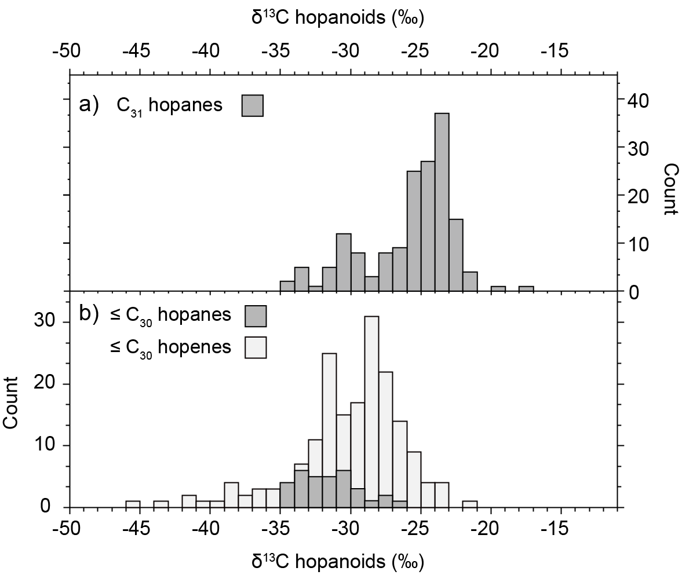
Figure 4: Compilation of hopanoid δ¹³C values in recent peatlands. a) C₃₁ hopane δ¹³C values, and b) ≤ C₃₀ hopanoid δ¹³C values. The latter includes the following hopanoids: hop-22(29)-ene, C₃₀ hopene(s), C₂₇-α hopane, C₂₉₋βα hopane, C₂₉-ββ hopane and C₃₀-ββ hopane. Peatland hopanoid δ¹³C values reported from the upper 100 cm only.

Within a single peatland, C₃₁ hopanoids exhibit minor variations in δ¹³C values (σ = 0.2 to 1.7‰; Fig. S1-S2) and the downcore variability (average σ = 1.2‰) is lower than the global range (average σ = 2.6‰). There is no significant variation in C₃₁ δ¹³C values between deep and shallow sections of the peat (Fig. S1-S2). Although ≤ C₃₀ hopanoid δ¹³C values can exhibit more variation within a single peatland (e.g. Tibet; Fig. S2), the downcore variation (average σ: 2.1‰) remains lower than the global range (average σ = 3.7‰) with no significant variation in ≤ C₃₀ hopanoid δ¹³C values between deep (>15 cm) and shallow (<15 cm) sections of the peat (Fig. S1-S2).

4. Discussion

4.1 Photosynthetic pathway determines long-chain n-alkane δ¹³C values
Within our dataset, long-chain (C₂₉ to C₃₃) n-alkane δ¹³C values exhibit a unimodal distribution and range between -29 and -37‰ (Fig. 2). This is consistent with previous studies in peatlands (Xie et al., 2004) and suggests that plants with the C₃ carbon fixation pathway dominated in the peat samples. However, long-chain n-alkane δ¹³C values can also be influenced by a range of secondary environmental (e.g. δ¹³C_{CO2}, temperature, moisture content, altitude) and biosynthetic (e.g. plant functional type; PFT) controls (Diefendorf and Freimuth, 2017).
As peatlands are mostly water saturated, the influence of moisture content is likely to be relatively minor. However, moisture content can exert an indirect control on peatland vegetation and PFT. Here, we show that long-chain n-alkane δ¹³C values in recent peatlands (-29 to -37‰; Fig. 2b) are comparable to n-alkanes extracted from key wetland plants (-29 to -36‰; Fig. 2a). This implies that changes in PFT are unlikely to significantly influence long-chain n-alkane δ¹³C values. The only exception are aquatic macrophytes which can be significantly ¹³C-enriched (Fig. 2a). However, we observe little evidence for macrophyte input in our peatland dataset (Fig. 2b; Supplementary Information).
Within our recent peatland dataset, long-chain n-alkane δ¹³C values are linearly correlated with MAAT (0.12 < R² < 0.39). However, we argue that our relationship is partly driven by changes in the δ¹³C composition of ambient CO₂ in the plant's immediate growth environment (i.e. the “canopy effect”, characterised by a decrease in the δ¹³C of plant biomass from the canopy to the forest floor) (Kohn, 2010). Confirming this, it is the samples from ¹³C-depleted closed-canopy tropical forests (e.g. Peru, Indonesia) that dictate the relationship between long-chain n-alkane δ¹³C values and MAAT in our dataset, and the correlation is negligible when these are removed (R² < 0.1). Altitude may also exert a control on n-alkane δ¹³C values, with more ¹³C-enriched values expected at higher altitude (Wu et al., 2017). However, due to the relatively large intra-site (up to 4‰) and inter-site variability (up to 10‰), long-chain n-alkane δ¹³C values are poorly correlated with altitude in our dataset (R² < 0.02).

4.2 Aerobic methanotrophy influences mid-chain n-alkane δ¹³C values
Within our recent peatland dataset, the weak correlation between mid-chain (C₂₃ and C₂₅) and long-chain (C₂₉ to C₃₃) n-alkane δ¹³C values (r = 0.07 to 0.29) implies that mid-chain n-alkanes and long-chain n-alkanes are derived from different plant species. Indeed, within Sphagnum-dominated peatlands, mid-chain n-alkane δ¹³C values range from -30 to -37‰ (Fig. 3b) and are ¹³C-depleted (up to 5‰) relative to co-occurring long-chain n-alkanes. In contrast, mid-chain n-alkane δ¹³C values within graminoid- and woody angiosperm-dominated peatlands range between -28 and 34‰ (Fig. 3b) and up to 6‰ enriched relative to co-occurring long-chain n-alkanes. Crucially, mid-chain n-alkane δ¹³C values from Sphagnum- and non-Sphagnum-dominated peatlands are statistically different (p < 0.01). Taken together, this indicates preferential incorporation of ¹³C-depleted CO₂ into mid-chain n-alkanes within Sphagnum-dominated peatlands and provides evidence that Sphagnum-associated methanotrophy is widespread (Kip et al., 2010; Raghoebarsing et al., 2005).
To explore changes in Sphagnum-associated methanotrophy, we calculated ∆¹³C_{alk} values (=$\overline{x}$(δ¹³C₂₃₋₂₅) - $\overline{x}$(δ¹³C₂₉₋₃₁)) using our peatland dataset (following Yamamoto et al., 2010). We show that ∆¹³C_{alk} values from within Sphagnum-dominated peatlands are negative and average -2.1 ± 1.6‰ (n = 112), indicating the incorporation of ¹³C-depleted carbon into mid-chain n-alkanes. This is consistent with Elvert et al (2016) who report negative Δ¹³C_{alk} values (-1.6 ± 0.7‰; n = 10) in a thermokarst lake environment dominated by brown mosses. In contrast, within woody angiosperm- and graminoid-dominated peatlands, ∆¹³C values are positive (+2.6 ±1.6‰ and +1.3 ±0.6‰, respectively), indicating the absence of methanotrophy and/or partially sub-aqueous growth (Ficken et al., 2000). To explore whether this offset is mediated by other environmental controls, we examined the impact of temperature, pH and altitude upon ∆¹³C_{alk} values. Our results indicate that MAAT (R² < 0.01), pH (R² < 0.01) and altitude (R² = 0.02) do not exert an important control on mid-chain n-alkane δ¹³C values. Instead, it is likely that water table level - via its influence on Sphagnum-associated methanotrophy and carbon dioxide availability (e.g. Kip et al., 2010; Raghoebarsing et al., 2005) - exerts an important control on ∆¹³C_{alk} values. Waterlogged conditions have been shown to enhance the activity of symbiotic methanotrophs (Kip et al., 2010) and we suggest that a high water table will be associated with the most negative ∆¹³C_{alk} values. However, we note that excessively waterlogged conditions can partially reduce CO₂ availability and will yield positive ∆¹³C_{alk} values (Brader et al., 2010; van Winden et al., 2010). The geological record provides support for this observation with positive ∆¹³C_{alk} values reported from an early Eocene, waterlogged, Sphagnum-dominated bog (Inglis et al., 2015).

4.3. Heterotrophy is the primary control upon the δ¹³C value of C₃₁ hopanoid-producing bacteria
C₃₁ hopanoids derive from a vast variety of bacteriohopanepolyols (BHPs), which in turn derive from diverse bacteria of highly variable ecology (Rohmer et al., 1984; Talbot and Farrimond, 2007). Despite this, previous studies in peatlands indicate that C₃₁ hopanoid δ¹³C values have a narrow range from -22 to -32‰ and are typically ¹³C-enriched relative to bulk organic matter (e.g. Xie et al., 2004; Pancost et al., 2000; Pancost et al., 2003). In our dataset, δ¹³C values of C₃₁ hopanoids range between -20 and -35‰ (Fig. 4a), expanding the known range as might be expected for a compound with such diverse sources. δ¹³C values of C₃₁ hopane stereoisomers (i.e. ββ and αβ) are positively correlated (r = 0.87), indicating they are likely derived from the same bacterial source. Intriguingly, the observation that C₃₁ hopanoid δ¹³C values are ¹³C-enriched relative to co-occurring leaf wax biomarkers (long-chain n-alkanes) is universally retained, despite the significant variety of precursor compounds and organisms (see Talbot et al., 2016a and ref. therein). This supports previous suggestions (Pancost et al., 2003), based on limited data, that C₃₁ hopanoids are derived from heterotrophic bacteria consuming ¹³C-enriched substrates (e.g. carbohydrates) and confirms that organic substrate exerts an important control on C₃₁ hopane δ¹³C values. We note that the magnitude of this offset is not constant, ranging from 0 to 10‰ (Fig. S3) and likely records varying degrees of substrate preference.
These interpretations are supported by the dominance of bacteriohopanetetrol (BHT) and BHT cyclitol ether in recent peatlands (Kim et al., 2011; van Winden et al., 2012; Talbot et al., 2016a; Fig. S4). Multiple heterotrophic (but also other) sources are expected for both compounds. However, most heterotrophs synthesise BHT whilst BHT cyclitol ether is the most commonly occurring BHP in members of the Alpha-, Beta-, Gamma and Deltaproteobacteria (e.g. Burkholderia, Bradyrhizobium, Rhodoblastus, as well as other phyla including the Cyanobacteria, Acidobacteria and Acetobacteria; Talbot et al., 2016a). A largely heterotrophic bacterial community is also consistent with the low abundance of BHPs assigned to methane oxidising bacteria (35-aminobacteriohopanepentol and 35-aminobacteriohopanetetrol). Taken together, this suggests that the majority of hopanoid-producing bacteria in peatlands are heterotrophs. It is unclear what the δ¹³C signature of autotroph-derived hopanoids would be; however, given the discrimination between biomass and CO₂ substrate during autotrophy (Pancost and Sinninghe Damsté, 2003 and ref. therein), it is expected to be somewhat depleted relative to the associated sedimentary organic matter.
Using our recent dataset, we examined the impact of temperature, pH and altitude upon the δ¹³C value of C₃₁ hopanoid-producing bacteria. There is a weak correlation between C₃₁ hopane δ¹³C values and pH (R² = 0.09) and altitude (R² < 0.01). There is a linear correlation between C₃₁ hopanoid δ¹³C values and MAAT (R² = 0.68), with lower values occurring in tropical settings. However, C₃₁ hopanoid δ¹³C values are also significantly correlated with C₂₉, C₃₁ and C₃₃ n-alkane δ¹³C values (r = 0.37, 0.71 and 0.62 respectively) and we argue that this relationship is partly driven by the aforementioned controls on plant δ¹³C (i.e. the “canopy effect”; see 4.1). This agrees with previous studies which document a close relationship between bulk organic matter, long-chain n-alkane and C₃₁ hopane δ¹³C values in peatland environments (e.g. Pancost et al., 2003). Collectively, this implies that C₃₁ hopanoids are unsuitable, low-sensitivity candidates for tracing modern and past changes in the CH₄ cycle (but see below).

4.4. Methanotrophy and heterotrophy exert a control on the δ¹³C value of ≤ C₃₀ hopanoid-producing bacteria
In our dataset, C₂₇ to C₃₀ hopanoids (i.e. ≤ C₃₀ hopanoids, including αβ, βα and ββ stereoisomers) exhibit a larger range and have lower values compared to the C₃₁ hopanoids (Fig. 4b). In most settings, ≤ C₃₀ hopanoid δ¹³C values range between -28 and -35‰, suggesting that they are derived from a largely heterotrophic bacterial community. This is consistent with the dominance of saturated tetrafunctionalised BHPs (e.g. BHT, BHT cyclitol ether, aminotriol) in two of the peatlands studied here (Bissendorfer Moor, Germany, and Misten Bog, Belgium; Fig. S4) and the interpretation of C₃₁ hopanoid δ¹³C values. However, ≤ C₃₀ hopanoids δ¹³C values are always lower than those of the corresponding C₃₁ hopanoids, suggesting a minor methanotroph contribution.
Crucially, in some settings, ≤ C₃₀ hopanoids are strongly ¹³C-depleted (up to -45‰; Fig. 4b) and are up to 15‰ more negative than relative to co-occurring long-chain n-alkanes and C₃₁ hopanes. In the context of peatlands, it is therefore clear that ≤ C₃₀ hopanoids can be derived from a mixed bacterial population consuming plant biomass but also more ¹³C-depleted carbon (e.g. recycled CO₂ and/or CH₄). This indicates a strong source decoupling between ≤ C₃₀ and C₃₁ hopanoids. Previous analyses of Eocene-aged lacustrine sediments have suggested such decoupling (Freeman et al., 1990; Volkman et al., 2015), as have analyses of modern cyanobacterial mats and cultures (Jahnke et al., 1999; Summons et al., 1994). Our work suggests a more profound and widespread decoupling in peatlands that has significant implications for future hopanoid δ¹³C interpretation.
Carbon isotopic decoupling is not expected but is consistent with and can be attributed to the different sources of ≤ C₃₀ and C₃₁ hopanoids. C₃₁ hopanoids are derived exclusively from oxidation and decarboxylation of saturated tetrafunctionalised BHPs (Inglis et al., 2018 and ref. therein). Multiple bacterial sources are expected for these compounds; however, heterotrophs are the most likely source in peatlands (Talbot et al., 2016a). In contrast, C₂₇ to C₃₀ hopanoids can be derived from a more diverse suite of precursor compounds (e.g. penta- and hexafuntionalised BHPs, diplopterol, diploptene; Talbot and Farrimond, 2007; Talbot et al., 2014). These compounds can be derived from a wider range of source bacteria (including methanotrophs) and provides an explanation for why ≤ C₃₀ hopanoids have more negative δ¹³C values and are the more sensitive recorder of terrestrial CH₄ cycling (c.f. C₃₁ hopanes). By extension, the sources of C₃₁ hopanes means they likely have limited utility as a methanotroph biomarker in such settings, both in terms of distributions and isotopic composition, revealing why previous BHP analyses in peat (Talbot et al., 2016a) and lignite deposits (Talbot et al., 2016b) failed to detect a strong methanotroph signal.

4.5. Influence of environmental processes on the δ¹³C value of ≤ C₃₀ hopanoid producing bacteria
Using our global dataset, we also examined the impact of temperature, pH and altitude upon the δ¹³C value of ≤ C₃₀ hopanoid-producing bacteria. Previous studies indicate that CH₄ oxidation rates and temperature are closely coupled (Dunfield et al., 1993; Segers, 1998; van Winden et al., 2012a). This implies that ≤ C₃₀ hopanoid δ¹³C values and temperature will be related, as found by Elvert et al. (2016). A close correspondence between δ¹³C values and temperature was previously observed within a mesocosm study, with lower δ¹³C values (indicating greater incorporation of CH₄) at higher temperatures (van Winden et al., 2011). However, there is only a weak relationship between ≤ C₃₀ hopanoid δ¹³C values and temperature (R² = 0.02) in our dataset (Fig. S5) and recent studies have argued that substrate availability (rather than temperature) is the primary control upon CH₄ oxidation rates (Lofton et al., 2014; Megonigal and Schlesinger, 2002; Yvon-Durocher et al., 2014).
To explore other potential environmental drivers, we compared ≤ C₃₀ hopanoid δ¹³C values alongside key environmental parameters (including altitude, pH and vegetation). Our results indicate that altitude does not exert a strong control and there is only a weak relationship between ≤ C₃₀ hopanoid δ¹³C values and altitude (R² = 0.22). Instead, low ≤ C₃₀ hopanoid δ¹³C values are closely related to measured pH and the lowest ≤ C₃₀ hopanoid δ¹³C values occur in peatlands with pH 5 to 6.5 (Fig. S5). This is the optimum pH for peatland methanogenesis (Kotsyurbenko et al. 2004) and suggests that low ≤ C₃₀ hopanoid δ¹³C values reflect an increase in CH₄ availability to the source bacteria.
It is also likely that a range of other factors will exert a control upon the δ¹³C value of ≤ C₃₀ hopanoid-producing bacteria in peatlands. Local hydrology could exert an indirect control because minerotrophic (i.e. rainwater and groundwater-fed) fens are characterised by higher CH₄ emissions compared to ombrotrophic (i.e. rainwater-fed) bogs (Moore and Knowles, 1990; Turetsky et al., 2014). This is consistent with the occurrence of the lowest ≤ C₃₀ hopanoid δ¹³C values in minerotrophic fens, including Huanyuan, China (up to -44‰), Tamiami Sawgrass, USA (-38‰), Buena Vista del Maquia, Peru (up to -45‰) and Tacshacocha, Peru (-39 ‰). Vegetation can also exert an indirect control on methanotrophy because non-woody vascular plants (e.g. sedges) can transport oxygen from the atmosphere to the rhizosphere, helping to promote CH₄ oxidation at depth (King et al., 1998; Zheng et al., 2014). This is consistent with low ≤ C₃₀ hopanoid δ¹³C values in graminoid-dominated peatlands, including Huanyuan, China (up to -44‰) and Tamiami Sawgrass, USA (-38‰). However, vegetation can also act as a conduit for CH₄ release, thereby reducing the probability of CH₄ oxidation (Schuldt et al., 2013).
Differences in methanotroph assimilation pathways may also exert an indirect control upon hopanoid δ¹³C values. For example, methanotrophs using the ribulose monophosphate pathway (i.e. Type I methanotrophs) typically exhibit much more depleted δ¹³C lipid values than methanotrophs using the serine pathway (i.e. Type II methanotrophs). The absence of very low (< -60‰) δ¹³C lipid values in our dataset suggests that Type II methanotrophs dominate. This is consistent with microbiological studies (e.g. Dedysh et al., 2001; 2009; Kip et al., 2011) and the low abundance of aminopentol (a biomarker for Type I methanotrophs) in most peatlands (e.g. Talbot et al., 2016a). Finally, the δ¹³C value of CH₄ will also influence ≤ C₃₀ hopanoid δ¹³C values; for example, CH₄ produced in ombrotrophic peatlands has a δ¹³C composition that is significantly more negative than that of CH₄ formed in fens (Hornibrook and Bowes, 2007). However, the lowest δ¹³C lipid values in our study are associated with fen environments, confirming that low ≤ C₃₀ hopanoid δ¹³C values, at least in this reference set, primarily reflect an increase in CH₄ availability to the source bacteria (rather than changes in its isotopic composition).
Collectively, our dataset indicates that ≤ C₃₀ hopanoid δ¹³C values are influenced by a range of environmental (e.g. pH, vegetation, trophic status) and biological variables (e.g. diverse biohopanoid precursors and ecologies of source bacteria). Given that, it is remarkable that isotopic relationships are consistent over a wide range of ecologically and climatically diverse sites. The ≤ C₃₀ hopanoids are always depleted relative to co-occurring C₃₁ hopanoids and are depleted relative to plant biomarkers only in settings with elevated, near neutral pH with inferred relatively high rates of methanogenesis. Such complexity of environmental and biological controls probably explains the lack of other clear relationships, i.e. with temperature; this could be explored by future targeted studies that include microbiological characterisation. Nonetheless, the occurrence of ¹³C-depleted ≤ C₃₀ hopanoids (up to -45‰) in peatlands provides clear evidence for the incorporation of isotopically light CH₄ into the bacterial community and confirms that ≤ C₃₀ hopanoids have potential for qualitatively tracking changes in peatland CH₄ cycling.

4.6. Re-evaluating methane cycling in the geological record
Here we revisit previously published hopanoid δ¹³C records in (fossilised) peat archives from: 1) the early-to-middle Holocene and late Glacial (4 to 18 thousand years ago; Zheng et al., 2014; Elvert et al., 2016; Huang et al., 2018), and 2) the early Eocene and latest Paleocene (48 to 56 million years ago; Pancost et al., 2007; Inglis et al., 2015). Here we adopt an approach based on coupled hopanoid-leaf wax δ¹³C values because it is evident, especially for the C₃₁ hopanoids, that hopanoid δ¹³C values are partly governed by those of associated plant matter. To provide a baseline for interpreting past variations in the CH₄ cycle, we calculate ∆¹³C_{hop-alk} values (= δ¹³C_{hopanoid} - δ¹³C_{alkane}). This removes the impact of vegetation upon hopanoid δ¹³C values (e.g. the “canopy effect”). Note that we have normalised hopanoid values to the C₂₉ n-alkane (Fig. 5); however, similar results are obtained when other long-chain n-alkanes are used (i.e. C₃₁ and C₃₃). This approach: 1) draws an even sharper contrast between the isotopic behaviour of ≤ C₃₀ hopanoids and C₃₁ hopanoids (Fig. 5); and 2) reveals that ∆¹³C_{hop-alk} values below -10‰ are indicative of more intense aerobic methanotrophy than observed in our recent peatland dataset. Crucially, as methanotrophy and methanogenesis can be tightly coupled in modern peatlands (van Winden et al., 2012a), low ∆¹³C_{hop-alk} values can be interpreted as evidence for an invigorated CH₄ cycle. Importantly, this approach can be used to re-interpret published hopanoid δ¹³C data from (fossilised) peat archives, especially where n-alkane δ¹³C values had been published or could be obtained for this study (Figure 6).
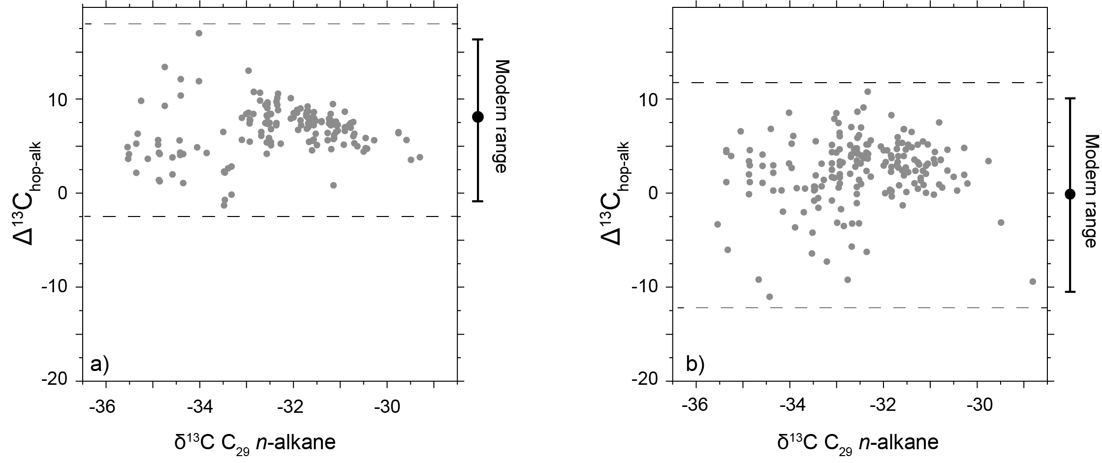
Figure 5: Compilation of ∆¹³C_{hop-alk} values (= δ¹³C_{hopanoid} - δ¹³C_{alkane}) in recent peatlands. a) C₃₁ hopanoid δ¹³C values normalised to C₂₉ n-alkane δ¹³C value, and b) ≤ C₃₀ hopanoid δ¹³C values normalised to C₂₉ n-alkane δ¹³C value. Values which are negative and fall outside the modern range provide evidence for enhanced methane cycling relative to the ‘recent’ peatland dataset.

4.6.1. Mid-to-Early Holocene and latest Glacial (4 to 18 ka)
Here, we revisit published δ¹³C_{lipid} values from peat archives spanning the middle-to-early Holocene and last glacial termination (ca. 4 to 18 thousand years ago; ka). These peats are located in eastern China (ca. 4 to 13 ka; Zheng et al., 2014), central China (ca. 4 to 18 ka; Huang et al, 2018) and Alaska (ca. 4 to 12 ka; Elvert et al., 2016). It is evident from these published studies that ≤ C₃₀ hopanoids can be ¹³C-depleted and ∆¹³C_{hop-alk} values low within late Glacial and mid-to-early Holocene peat archives (Zheng et al., 2014; Elvert et al., 2016; Huang et al., 2018; Fig. 6b) For example, low ≤ C₃₀ hopanoid δ¹³C values (up to -40‰) and low ∆¹³C_{hop-alk} values (up to -8‰) are reported from central China during the mid-Holocene (~5 to 8 ka; Huang et al., 2018). In exceptional circumstances, these values can be far lower than in our recent dataset. In southwest China, ≤ C₃₀ hopanoid δ¹³C values decrease to -50‰ (Zheng et al., 2014) and ∆¹³C_{hop-alk} values decrease to -17‰ during the middle Holocene (~5 ka). Low ≤ C₃₀ hopanoid δ¹³C values (as low as -55‰) and low ∆¹³C_{hop-alk} values (as low as -26‰) are also reported from an Alaskan peat during the early Holocene (~10 to 12 ka; Elvert et al., 2016). In both cases, these light values were previously interpreted as evidence for an enhanced CH₄ cycle. However, because absolute values and ∆¹³C_{hop-alk} values are well below the modern range, they can now be interpreted as evidence for enhanced CH₄ cycling. In contrast, C₃₁ hopanoid δ¹³C values in mid-to-early Holocene samples typically range between -22 and -30‰ (Fig. 6). This is consistent with our “recent” peatland dataset and emphasises the differing isotopic behaviour of ≤ C₃₀ and C₃₁ hopanoids in natural settings. However, there are exceptions (see 4.6.2 below).
Our “recent” peatland dataset also helps us to understand the mechanistic link between past climate change and CH₄ cycle perturbations. In particular, the association of ¹³C-depleted hopanoids in recent peats with relatively high pH (5 to 6) – and the hydrological and ecological conditions that yield such pH conditions – appears to also explain past records. For example, during the early Holocene, low hopanoid δ¹³C values in Alaska coincide with more negative long-chain n-alkane δ²H values (Elvert et al., 2016), suggesting enhanced moisture transport and a microbial response to wetter conditions. Intriguingly, the opposite is observed during the mid-Holocene in central China, where low hopanoid δ¹³C values coincide with inferred dryer (but variable) conditions and near neutral pH (pH 5 to 6) (Huang et al., 2018). Inferred dry conditions and near neutral pH values (pH 5 to 6) are also associated with low hopanoid δ¹³C values in eastern China during the mid-Holocene (Zheng et al., 2014). Within eastern China, low values hopanoid δ¹³C values coincide with a decrease in methanogen biomass (Zheng et al., 2014). This is somewhat counter-intuitive and therefore suggests a change in CH₄ flux pathways at a time where overall CH₄ production was lower and the region experienced a sustained drying event (Chen et al., 2006; Zhao et al., 2007). Thus, in this setting, decreased methanogenesis is attributed to drier and more oxidising conditions caused by weakening of the Asian summer monsoon, and increased methanotrophy is attributed to the development of longer and thicker sedge roots and more diffusive CH₄ flux as the water table deepened. Collectively, this demonstrates the complexity of the terrestrial CH₄ cycle and its sensitivity to hydrological perturbations, especially as a transient response to climate change (e.g. drying/rewetting cycles; Knorr et al., 2008; Mitsch et al., 2010; Turetsky et al., 2014).

4.6.2. Latest Paleocene and early Eocene (48 to 56 Ma)
We also revisit published δ¹³C values from fossilised peat archives (lignites) spanning the latest Paleocene and early Eocene (56 to 48 Ma). These peats were deposited in the UK (Pancost et al., 2007) and Germany (Inglis et al., 2015). The lowest reported δ¹³C values (-75‰) and ∆¹³C values (-46‰) are observed within the UK during the onset of the Paleocene-Eocene Thermal Maximum (PETM; 56 Ma; Pancost et al., 2007). These values are significantly lower than those obtained from the Holocene and indicate a particularly exceptional response of the CH₄ cycle. The Paleocene-Eocene Thermal Maximum is also associated with the unusual occurrence of low C₃₁ hopanoid δ¹³C values (as low as -47‰; Pancost et al., 2007) and low ∆¹³C_{hop-alk} values (as low as -19‰) (Fig. S6). Crucially, both coincide with an increase in the occurrence of bacteriohopanepolyols assigned directly to methanotrophic bacteria (Talbot et al., 2016a).
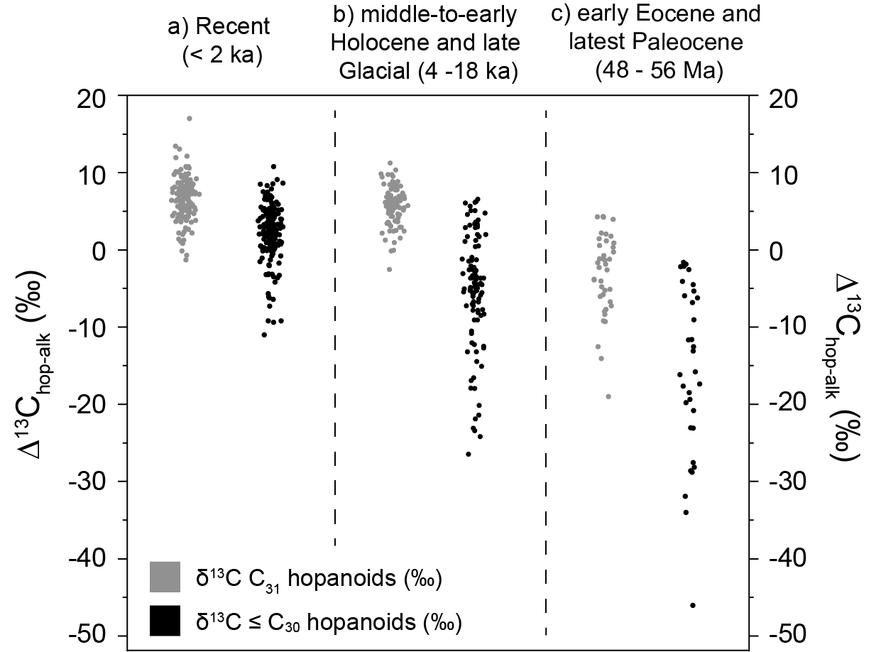
Figure 6: Compilation of ∆¹³C_{hop-alk} values in: a) recent peatlands (this study), b) middle-to-early Holocene and late Glacial peat archives (4 to 18 ka) (Elvert et al., 2016; Huang et al., 2018; Zheng et al., 2014; n = 108), and c) early Eocene and latest Paleocene lignites (48 to 56 Ma) (Inglis et al., 2015; Pancost et al., 2007; n = 59).

During the Paleocene-Eocene Thermal Maximum (Pancost et al., 2007), low ≤ C₃₀ and C₃₁ hopanoid δ¹³C values coincide with the onset of waterlogged conditions and a shift in reconstructed pH towards near neutral values (Fig. S6). The PETM is also associated with an increase in 35-aminobacteriohopanepentol (aminopentol), indicating an increase in Type I methanotrophic bacteria (i.e. Gammaproteobacteria). As Type I methanotrophs typically exhibit much more depleted δ¹³C lipid values, this likely explains why we observe low δ¹³C values and ∆¹³C_{hop-alk} values within both the ≤C₃₀ and C₃₁ hopanoids. Although there have been few subsequent investigations on peatland CH₄ cycling during the PETM, early Eocene and late Paleocene peatlands were far more extensive than today (up to ~3 times greater) and modelled CH₄ emissions far exceed those for the modern pre-industrial world (Beerling et al., 2011). As CH₄ is a potent greenhouse gas, enhanced peatland methane emissions could have helped to amplify warming to a greater degree than estimated using existing model simulations and should be incorporated into future studies.
Taken together, this highlights the importance of pH, hydrology and ecology (rather than temperature; see Pancost et al., 2007) in regulating hopanoid δ¹³C values in peatland environments, including during episodes of environmental change. Future work tracing past changes in the CH₄ cycle, therefore, would benefit from accompanying proxy-based pH and hydrological reconstructions based on, for example, the distribution of hopanes (Inglis et al., 2018) or branched glycerol dialkyl glycerol tetraethers (brGDGTs) (Naafs et al., 2017) and the hydrogen isotope composition of leaf wax biomarkers (Sachse et al., 2012)

5. Conclusions
Using samples from peatlands from different geographic regions we demonstrate the incorporation of ¹³C-depleted CO₂ and/or CH₄ into mid-chain n-alkanes and ≤ C₃₀ hopanoids. Our results confirm that both are suitable candidates for tracking changes in peatland CH₄ cycling. Re-analysis of published data from the mid-to-early Holocene and late Glacial (4 to 18 ka) and early Eocene and latest Paleocene (48 to 56 Ma) indicates that ≤ C₃₀ hopanoids can be extremely ¹³C-depleted within both peat archives and lignite deposits (up to -75‰). Such values are well below the recent (<2 ka) range and can now be interpreted as particularly exceptional responses of the methane cycle to past climate perturbations. These results indicate that lipid biomarkers are important tools for evaluating modern and ancient biogeochemical processes and could potentially provide insights into terrestrial CH₄ cycling over the Cenozoic and Mesozoic.

Acknowledgements
This research was funded through the advanced ERC grant ‘The Greenhouse Earth System’ (T-GRES. Project reference: 340923). RDP acknowledges the Royal Society Wolfson Research Merit Award. BDAN also received funding through a Royal Society Tata University Research Fellowship. YZ acknowledges the National Natural Science Foundation of China Grants (41872031). GNI thanks X. Huang, S. Yamamoto, J. van Winden for providing raw data and J. Blewett, K. Freeman R.P. Evershed for useful discussions. We also thank the NERC Life Sciences Mass Spectrometry Facility (Bristol) for analytical support and D. Atkinson for help with the sample preparation. Members of the T-GRES Peat Database collaborators are M.J. Amesbury, H. Biester, R. Bindler, J. Blewett, M.A. Burrows, D. del Castillo Torres, F.M. Chambers, A.D. Cohen, S.J. Feakins, M. Gałka, A. Gallego-Sala, L. Gandois, D.M. Gray, P.G. Hatcher, E.N. Honorio Coronado, P.D.M. Hughes, A. Huguet, M. Könönen, F. Laggoun-Défarge, O. Lähteenoja, M. Lamentowicz, R. Marchant, X. Pontevedra-Pombal, C. Ponton, A. Pourmand, A.M. Rizzuti, L. Rochefort, J. Schellekens, F. De Vleeschouwer. Finally, we thank Ed Hornibrook, Sabine Kasten, Marcus Elvert and two anonymous reviewers whose thoughtful comments significantly improved the manuscript.

References
Aaby, B. and Tauber, H. (1975) Rates of peat formation in relation to degree of humification and local environment, as shown by studies of a raised bog in Deninark. Boreas 4, 1-17.
Aichner, B., Wilkes, H., Herzschuh, U., Mischke, S. and Zhang, C. (2010) Biomarker and compound-specific δ¹³C evidence for changing environmental conditions and carbon limitation at Lake Koucha, eastern Tibetan Plateau. Journal of Paleolimnology 43, 873-899.
Beerling, D.J., Fox, A., Stevenson, D.S. and Valdes, P.J. (2011) Enhanced chemistry-climate feedbacks in past greenhouse worlds. Proceedings of the National Academy of Sciences. 108. 9770-9775
Brader, A.V., van Winden, J.F., Bohncke, S.J., Beets, C.J., Reichart, G.-J. and de Leeuw, J.W. (2010) Fractionation of hydrogen, oxygen and carbon isotopes in n-alkanes and cellulose of three Sphagnum species. Organic Geochemistry 41, 1277-1284.
Bridgham, S.D., Cadillo-Quiroz, H., Keller, J.K. and Zhuang, Q. (2013) Methane emissions from wetlands: biogeochemical, microbial, and modeling perspectives from local to global scales. Global Change Biology 19, 1325-1346.
Broder, T. and Biester, H.(2015) Hydrologic controls on DOC, As and Pb export from a polluted peatland–the importance of heavy rain events, antecedent moisture conditions and hydrological connectivity. Biogeosciences. 12, 4651-4664.
Chambers, F.M., Brain, S.A., Mauquoy, D., McCarroll, J. and Daley, T.J.T.H. (2014) The ‘Little Ice Age’in the Southern Hemisphere in the context of the last 3000 years: Peat-based proxy-climate data from Tierra del Fuego. The Holocene. 24, 1649-1656.
Chen, F.-H., Cheng, B., Zhao, Y., Zhu, Y. and Madsen, D.B. (2006) Holocene environmental change inferred from a high-resolution pollen record, Lake Zhuyeze, arid China. The Holocene. 16, 675-684.
Collister, J.W., Rieley, G., Stern, B., Eglinton, G. and Fry, B. (1994) Compound-specific δ¹³C analyses of leaf lipids from plants with differing carbon dioxide metabolisms. Organic Geochemistry 21, 619-627.
Davies, K., Pancost, R., Edwards, M., Walter Anthony, K., Langdon, P. and Chaves Torres, L. (2015) Diploptene δ¹³C values from contemporary thermokarst lake sediments show complex spatial variation. Biogeosciences. 13, 2611-2621.
De Vleeschouwer, F., Pazdur, A., Luthers, C., Streel, M., Mauquoy, D., Wastiaux, C., Le Roux, G., Moschen, R., Blaauw, M. and Pawlyta, J., Sikorski, J., Piotrowska, N (2012) A millennial record of environmental change in peat deposits from the Misten bog (East Belgium). Quaternary International. 268, 44-57.
Dean, J.F., Middelburg, J.J., Röckmann, T., Aerts, R., Blauw, L.G., Egger, M., Jetten, M.S., Jong, A.E., Meisel, O.H. and Rasigraf, O., Slomp, C.P in’t Zandt, M.H. and Dolman, A.J. (2018) Methane feedbacks to the global climate system in a warmer world. Reviews of Geophysics, 56, 207-250
Diefendorf, A.F., Freeman, K.H., Wing, S.L. and Graham, H.V. (2011) Production of n-alkyl lipids in living plants and implications for the geologic past. Geochimica et Cosmochimica Acta 75, 7472-7485.
Diefendorf, A.F. and Freimuth, E.J. (2017) Extracting the most from terrestrial plant-derived n-alkyl lipids and their carbon isotopes from the sedimentary record: A review. Organic Geochemistry 103, 1-21.
Dunfield, P., Dumont, R. and Moore, T.R. (1993) Methane production and consumption in temperate and subarctic peat soils: response to temperature and pH. Soil Biology and Biochemistry 25, 321-326.
Elvert, M., Pohlman, J.W., Becker, K.W., Gaglioti, B., Hinrichs, K.-U. and Wooller, M.J. (2016) Methane turnover and environmental change from Holocene lipid biomarker records in a thermokarst lake in Arctic Alaska. The Holocene. 26, 1766-1777.
Farquhar, G.D., Ehleringer, J.R. and Hubick, K.T. (1989) Carbon isotope discrimination and photosynthesis. Annual Review of Plant Biology 40, 503-537.
Ficken, K., Barber, K. and Eglinton, G. (1998) Lipid biomarker, δ¹³C and plant macrofossil stratigraphy of a Scottish montane peat bog over the last two millennia. Organic Geochemistry 28, 217-237.
Ficken, K., Li, B., Swain, D. and Eglinton, G. (2000) An n-alkane proxy for the sedimentary input of submerged/floating freshwater aquatic macrophytes. Organic Geochemistry 31, 745-749.
Freeman, K.H., Hayes, J., Trendel, J.-M. and Albrecht, P. (1990) Evidence from carbon isotope measurements for diverse origins of sedimentary hydrocarbons. Nature 343, 254.
Gorham, E. (1991) Northern peatlands: role in the carbon cycle and probable responses to climatic warming. Ecological Applications. 1, 182-195.
Hornibrook, E.R. and Bowes, H.L. (2007) Trophic status impacts both the magnitude and stable carbon isotope composition of methane flux from peatlands. Geophysical Research Letters. 34. L21401
Huang, X., Pancost, R.D., Xue, J., Gu, Y., Evershed, R.P. and Xie, S. (2018) Response of carbon cycle to drier conditions in the mid-Holocene in central China. Nature Communications 9, 1369.
Huang, X., Wang, C., Xue, J., Meyers, P.A., Zhang, Z., Tan, K., Zhang, Z. and Xie, S. (2010) Occurrence of diploptene in moss species from the Dajiuhu Peatland in southern China. Organic Geochemistry 41, 321-324.
Huang, X., Xue, J., Zhang, J., Qin, Y., Meyers, P.A. and Wang, H. (2012) Effect of different wetness conditions on Sphagnum lipid composition in the Erxianyan peatland, central China. Organic Geochemistry 44, 1-7.
Inglis, G.N., Collinson, M.E., Riegel, W., Wilde, V., Robson, B.E., Lenz, O.K. and Pancost, R.D. (2015) Ecological and biogeochemical change in an early Paleogene peat-forming environment: Linking biomarkers and palynology. Palaeogeography, Palaeoclimatology, Palaeoecology 438, 245-255.
Inglis, G.N., Naafs, B.D.A., Zheng, Y., McClymont, E.L., Evershed, R.P. and Pancost, R.D. (2018) Distributions of geohopanoids in peat: Implications for the use of hopanoid-based proxies in natural archives. Geochimica et Cosmochimica Acta 224, 249-261.
Jacob, J., Disnar, J.-R., Boussafir, M., Albuquerque, A.L.S., Sifeddine, A. and Turcq, B. (2005) Pentacyclic triterpene methyl ethers in recent lacustrine sediments (Lagoa do Caçó, Brazil). Organic Geochemistry. 36, 449-461.
Jahnke, L.L., Summons, R.E., Hope, J.M. and Des Marais, D.J. (1999) Carbon isotopic fractionation in lipids from methanotrophic bacteria II: The effects of physiology and environmental parameters on the biosynthesis and isotopic signatures of biomarkers. Geochimica et Cosmochimica Acta 63, 79-93.
Jauhiainen, J., Takahashi, H., Heikkinen, J.E., Martikainen, P.J. and Vasander, H. (2005) Carbon fluxes from a tropical peat swamp forest floor. Global Change Biology. 11, 1788-1797.
King, J.Y., Reeburgh, W.S. and Regli, S.K. (1998) Methane emission and transport by arctic sedges in Alaska: results of a vegetation removal experiment. Journal of Geophysical Research: Atmospheres 103, 29083-29092.
Kip, N., van Winden, J.F., Pan, Y., Bodrossy, L., Reichart, G.-J., Smolders, A.J.P., Jetten, M.S.M., Damste, J.S.S. and Op den Camp, H.J.M. (2010) Global prevalence of methane oxidation by symbiotic bacteria in peat-moss ecosystems. Nature Geoscience 3, 617-621.
Knorr, K.-H., Oosterwoud, M.R., Blodau, C. (2008) Experimental drought alters rates of soil respiration and methanogenesis but not carbon exchange in soil of a temperate fen. Soil Biology and Biochemistry. 40, 1781-1791.
Kohn, M.J. (2010) Carbon isotope compositions of terrestrial C₃ plants as indicators of (paleo) ecology and (paleo) climate. Proceedings of the National Academy of Sciences 107, 19691-19695.
Kotsyurbenko, O. R., Chin, K. J., Glagolev, M. V., Stubner, S., Simankova, M. V., Nozhevnikova, A. N., and Conrad, R (2004) Acetoclastic and hydrogenotrophic methane production and methanogenic populations in an acidic West‐Siberian peat bog. Environmental Microbiology, 6, 1159-1173.
Lähteenoja, O. and Page, S. (2011) High diversity of tropical peatland ecosystem types in the Pastaza‐Marañón basin, Peruvian Amazonia. Journal of Geophysical Research, 116, G02025
Lähteenoja, O., Ruokolainen, K., Schulman, L. and Oinonen, M. (2009) Amazonian peatlands: an ignored C sink and potential source. Global Change Biology. 15, 2311-2320.
Liebner, S., Zeyer, J., Wagner, D., Schubert, C., Pfeiffer, E.M. and Knoblauch, C. (2011) Methane oxidation associated with submerged brown mosses reduces methane emissions from Siberian polygonal tundra. Journal of Ecology. 99, 914-922.
Lofton, D.D., Whalen, S.C. and Hershey, A.E. (2014) Effect of temperature on methane dynamics and evaluation of methane oxidation kinetics in shallow Arctic Alaskan lakes. Hydrobiologia. 721, 209-222.
Mauquoy, D., Blaauw, M., van Geel, B., Borromei, A., Quattrocchio, M., Chambers, F.M. and Possnert, G. (2004) Late Holocene climatic changes in Tierra del Fuego based on multiproxy analyses of peat deposits. Quaternary Research. 61, 148-158.
Mead, R., Xu, Y., Chong, J. and Jaffé, R. (2005) Sediment and soil organic matter source assessment as revealed by the molecular distribution and carbon isotopic composition of n-alkanes. Organic Geochemistry 36, 363-370.
Megonigal, J.P. and Schlesinger, W. (2002) Methane‐limited methanotrophy in tidal freshwater swamps. Global Biogeochemical Cycles. 16. 35-1
Mitsch, W.J., Nahlik, A., Wolski, P., Bernal, B., Zhang, L., Ramberg, L. (2010) Tropical wetlands: seasonal hydrologic pulsing, carbon sequestration, and methane emissions. Wetlands ecology and management. 18, 573-586.
Moore, T. and Knowles, R. (1990) Methane emissions from fen, bog and swamp peatlands in Quebec. Biogeochemistry 11, 45-61.
Naafs, B.D.A., Inglis, G.N., Zheng, Y., Amesbury, M.J., Biester, H., Bindler, R., Blewett, J., Burrows, M.A., del Castillo Torres, D., Chambers, F.M., Cohen, A.D., Evershed, R.P., Feakins, S.J., Gałka, M., Gallego-Sala, A., Gandois, L., Gray, D.M., Hatcher, P.G., Honorio Coronado, E.N., Hughes, P.D.M., Huguet, A., Könönen, M., Laggoun-Défarge, F., Lähteenoja, O., Lamentowicz, M., Marchant, R., McClymont, E., Pontevedra-Pombal, X., Ponton, C., Pourmand, A., Rizzuti, A.M., Rochefort, L., Schellekens, J., De Vleeschouwer, F. and Pancost, R.D. (2017) Introducing global peat-specific temperature and pH calibrations based on brGDGT bacterial lipids. Geochimica et Cosmochimica Acta 208, 285-301.
Naeher, S., Niemann, H., Peterse, F., Smittenberg, R.H., Zigah, P.K. and Schubert, C.J. (2014) Tracing the methane cycle with lipid biomarkers in Lake Rotsee (Switzerland). Organic Geochemistry. 66, 174-181.
Nisbet, E., Dlugokencky, E., Manning, M., Lowry, D., Fisher, R., France, J., Michel, S., Miller, J., White, J. and Vaughn, B., Bousquet, P., Pyle, J.E., Warwick, N.J., Cain, M., Brownlow, R., Zazzeri, G., Lanoiselle, M., Manning, A.C., Gloor, E., Worthy, D.E.J., Brunke, E-J., Labuschagne, C., Wolff, E and Ganesan, A.L (2016) Rising atmospheric methane: 2007–2014 growth and isotopic shift. Global Biogeochemical Cycles. 30, 1356-1370.
Page, S.E., Wűst, R., Weiss, D., Rieley, J.O., Shotyk, W. and Limin, S.H. (2004) A record of Late Pleistocene and Holocene carbon accumulation and climate change from an equatorial peat bog (Kalimantan, Indonesia): implications for past, present and future carbon dynamics. Journal of Quaternary Sciences. 19, 625-635.
Pancost, R.D., Baas, M., van Geel, B. and Sinninghe Damsté, J.S. (2003) Response of an ombrotrophic bog to a regional climate event revealed by macrofossil, molecular and carbon isotopic data. The Holocene 13, 921-932.
Pancost, R.D., Coleman, J.M., Love, G.D., Chatzi, A., Bouloubassi, I. and Snape, C.E. (2008) Kerogen-bound glycerol dialkyl tetraether lipids released by hydropyrolysis of marine sediments: A bias against incorporation of sedimentary organisms? Organic Geochemistry 39, 1359-1371.
Pancost, R.D., McClymont, E.L., Bingham, E.M., Roberts, Z., Charman, D.J., Hornibrook, E.R.C., Blundell, A., Chambers, F.M., Lim, K.L.H. and Evershed, R.P. (2011) Archaeol as a methanogen biomarker in ombrotrophic bogs. Organic Geochemistry 42, 1279-1287.
Pancost, R.D. and Sinninghe Damsté, J.S. (2003) Carbon isotopic compositions of prokaryotic lipids as tracers of carbon cycling in diverse settings. Chemical Geology 195, 29-58.
Pancost, R.D., Steart, D.S., Handley, L., Collinson, M.E., Hooker, J.J., Scott, A.C., Grassineau, N.V. and Glasspool, I.J. (2007) Increased terrestrial methane cycling at the Palaeocene–Eocene thermal maximum. Nature 449, 332-335.
Pancost, R.D., van Geel, B., Baas, M. and Damsté, J.S.S. (2000) δ¹³C values and radiocarbon dates of microbial biomarkers as tracers for carbon recycling in peat deposits. Geology 28, 663-666.
Quirk, M., Wardroper, A., Wheatley, R. and Maxwell, J. (1984) Extended hopanoids in peat environments. Chemical Geology 42, 25-43.
Raghoebarsing, A.A., Smolders, A.J.P., Schmid, M.C., Rijpstra, W.I.C., Wolters-Arts, M., Derksen, J., Jetten, M.S.M., Schouten, S., Sinninghe Damste, J.S., Lamers, L.P.M., Roelofs, J.G.M., Op den Camp, H.J.M. and Strous, M. (2005) Methanotrophic symbionts provide carbon for photosynthesis in peat bogs. Nature 436, 1153-1156.
Rohmer, M., Bouvier-Nave, P. and Ourisson, G. (1984) Distribution of hopanoid triterpenes in prokaryotes. Microbiology 130, 1137-1150.
Rydberg, J., Klaminder, J., Rosén, P. and Bindler, R. (2010) Climate driven release of carbon and mercury from permafrost mires increases mercury loading to sub-arctic lakes. Science of the Total Environment. 408, 4778-4783.
Sachse, D., Billault, I., Bowen, G.J., Chikaraishi, Y., Dawson, T.E., Feakins, S.J., Freeman, K.H., Magill, C.R., McInerney, F.A., Van der Meer, M.T., Polissar, P., Robins, R.J., Sachs, J.P., Schmidt, H-L., Sessions, A.L., White, J.W.C., West, J.B and Kahmen, A. (2012) Molecular paleohydrology: interpreting the hydrogen-isotopic composition of lipid biomarkers from photosynthesizing organisms. Annual Review of Earth and Planetary Sciences. 40. 221-249
Schuldt, R., Brovkin, V., Kleinen, T. and Winderlich, J. (2013) Modelling holocene carbon accumulation and methane emissions of boreal wetlands: an earth system model approach. Biogeosciences 10, 1659-1674.
Segers, R. (1998) Methane production and methane consumption: a review of processes underlying wetland methane fluxes. Biogeochemistry 41, 23-51.
Sorensen, K.W. (1993) Indonesian peat swamp forests and their role as a carbon sink. Chemosphere. 27, 1065-1082.
Souto, M., Castro, D., Pontevedra-Pombal, X., Garcia-Rodeja, E. and Fraga, M. (2016) Characterisation of Holocene plant macrofossils from North Spanish ombrotrophic mires: vascular plants. Mires and Peat. 18. 1-21
Souto, M., Castro, D., Pontevedra-Pombal, X., Garcia-Rodeja, E., Fraga, M.J. (2017) Characterisation of Holocene plant macrofossils from North Spanish ombrotrophic mires: bryophytes. Mires and Peat. 19. 1-12
Summons, R.E., Jahnke, L.L. and Roksandic, Z. (1994) Carbon isotopic fractionation in lipids from methanotrophic bacteria: relevance for interpretation of the geochemical record of biomarkers. Geochimica et Cosmochimica Acta 58, 2853-2863.
Talbot, H.M., Bischoff, J., Inglis, G.N., Collinson, M.E. and Pancost, R.D. (2016a) Polyfunctionalised bio- and geohopanoids in the Eocene Cobham Lignite. Organic Geochemistry 96, 77-92.
Talbot, H.M. and Farrimond, P. (2007) Bacterial populations recorded in diverse sedimentary biohopanoid distributions. Organic Geochemistry 38, 1212-1225.
Talbot, H.M., Handley, L., Spencer-Jones, C.L., Dinga, B.J., Schefuß, E., Mann, P.J., Poulsen, J.R., Spencer, R.G., Wabakanghanzi, J.N. and Wagner, T. (2014) Variability in aerobic methane oxidation over the past 1.2 Myrs recorded in microbial biomarker signatures from Congo fan sediments. Geochimica et Cosmochimica Acta 133, 387-401.
Talbot, H.M., McClymont, E.L., Inglis, G.N., Evershed, R.P. and Pancost, R.D. (2016b) Origin and preservation of bacteriohopanepolyol signatures in Sphagnum peat from Bissendorfer Moor (Germany). Organic Geochemistry 97, 95-110.
Turetsky, M.R., Kotowska, A., Bubier, J., Dise, N.B., Crill, P., Hornibrook, E.R., Minkkinen, K., Moore, T.R., Myers‐Smith, I.H. and Nykänen, H, Olefeldt, D., Rinne, J., Saarnio, S., Shurpali, N., Tuittila, E-S., Waddington, J.M., White, J.R., Wickland, K.P. and Wilmking, M (2014) A synthesis of methane emissions from 71 northern, temperate, and subtropical wetlands. Global Change Biology 20, 2183-2197.
Väliranta, M., Korhola, A., Seppä, H., Tuittila, E.-S., Sarmaja-Korjonen, K., Laine, J. and Alm, J. (2007) High-resolution reconstruction of wetness dynamics in a southern boreal raised bog, Finland, during the late Holocene: a quantitative approach. The Holocene. 17, 1093-1107.
van Winden, J.F., Kip, N., Reichart, G.-J., Jetten, M.S.M., Op den Camp, H.J.M. and Sinninghe Damsté, J.S. (2010) Lipids of symbiotic methane-oxidizing bacteria in peat moss studied using stable carbon isotopic labelling. Organic Geochemistry 41, 1040-1044.
van Winden, J.F., Reichart, G.-J., McNamara, N.P., Benthien, A. and Sinninghe Damsté, J.S. (2012a) Temperature-Induced Increase in Methane Release from Peat Bogs: A Mesocosm Experiment. PLoS ONE 7, e39614.
van Winden, J.F., Talbot, H.M., De Vleeschouwer, F., Reichart, G.-J. and Sinninghe Damsté, J.S. (2012b) Variation in methanotroph-related proxies in peat deposits from Misten Bog, Hautes-Fagnes, Belgium. Organic Geochemistry 53, 73-79.
Volkman, J.K., Zhang, Z., Xie, X., Qin, J. and Borjigin, T. (2015) Biomarker evidence for Botryococcus and a methane cycle in the Eocene Huadian oil shale, NE China. Organic Geochemistry 78, 121-134.
Wu, M.S., Feakins, S.J., Martin, R.E., Shenkin, A., Bentley, L.P., Blonder, B., Salinas, N., Asner, G.P. and Malhi, Y. (2017) Altitude effect on leaf wax carbon isotopic composition in humid tropical forests. Geochimica et Cosmochimica Acta 206, 1-17.
Xie, S., Nott, C.J., Avsejs, L.A., Maddy, D., Chambers, F.M. and Evershed, R.P. (2004) Molecular and isotopic stratigraphy in an ombrotrophic mire for paleoclimate reconstruction. Geochimica et Cosmochimica Acta. 68, 2849-2862.
Yamamoto, S., Kawamura, K., Seki, O., Meyers, P.A., Zheng, Y. and Zhou, W. (2010) Environmental influences over the last 16 ka on compound-specific δ¹³C variations of leaf wax n-alkanes in the Hani peat deposit from northeast China. Chemical Geology 277, 261-268.
Yu, Z. (2012) Northern peatland carbon stocks and dynamics: a review. Biogeosciences 9, 4071-4085.
Yu, Z., Loisel, J., Brosseau, D.P., Beilman, D.W. and Hunt, S.J. (2010) Global peatland dynamics since the Last Glacial Maximum. Geophysical Research Letters 37.
Yvon-Durocher, G., Allen, A.P., Bastviken, D., Conrad, R., Gudasz, C., St-Pierre, A., Thanh-Duc, N. and del Giorgio, P.A. (2014) Methane fluxes show consistent temperature dependence across microbial to ecosystem scales. Nature 507, 488.
Zhao, Y., Yu, Z., Chen, F., Ito, E., Zhao, C. (2007) Holocene vegetation and climate history at Hurleg Lake in the Qaidam Basin, northwest China. Review of Palaeobotany and Palynology. 145, 275-288.
Zheng, Y., Singarayer, J.S., Cheng, P., Yu, X., Liu, Z., Valdes, P.J. and Pancost, R.D. (2014) Holocene variations in peatland methane cycling associated with the Asian summer monsoon system. Nature Communications. 5. 4631

