Clinical trials in oncology

Gareth Griffiths

Gareth Griffiths PhD is Professor of Clinical Trials at the University of Southampton and Director of the Southampton Clinical Trials Unit, UK. He is a statistician and his area of expertise is the design and conduct of clinical trials. Competing interests: none declared.

Abstract
The development of a new treatment in cancer generally involves its assessment in Phase I, II and III prospective clinical trials. This article gives an overview of these phases of clinical trials, through which almost every new treatment must pass on the journey from its discovery in the laboratory to its routine use in clinical practice. The aim of the Phase I trial is to establish a dose, that of Phase II to evaluate activity, safety and feasibility, and that of Phase III to compare the new treatment against a suitable comparator.

Keywords
Clinical trials; oncology; Phase I; Phase II; Phase III

Key points
- The objective of a Phase I clinical trial is to establish the dose of a new treatment
- The objective of a Phase II clinical trial is to evaluate the activity, safety and feasibility of a new treatment
- The objective of a Phase III clinical trial is to evaluate the efficacy of a new treatment

Introduction
The development of a new treatment in cancer generally involves its assessment in Phase I, II and III prospective clinical trials. These phases of clinical trials are carried order to generate sufficient evidence on the safety, dosing, activity, feasibility and efficacy of a treatment, to justify its use in the treatment of patients with cancer.

Planning a clinical trial
All trials must be designed and conducted in compliance with the national ethical and scientific standards, the research governance framework and regulatory requirements within the country where the research is being undertaken. All academic trials must comply with the principles of Good Clinical Practice on which all legal legislation is based. In the UK, for example, for drug trials this is currently the Medicines for Human Use (Clinical Trials) Regulations 2004 (SI 2004/1031) and its amendments, which has been transposed into law from the European Clinical Trials Directive 2001/20/EC. These guidelines ensure the safety, rights and well-being of participants, as well as the credibility of data, and harmonize how trials are conducted.
Before designing a clinical trial the trialist needs to be aware of all the available evidence on the treatment they wish to investigate. A review of the medical literature ensures that the proposed research question and format is justified. This review also informs on the feasibility of any study, previous populations researched and treatment details. Data on activity and any safety concerns are also identified.

Phase I trials
There will have been extensive preclinical development of the new treatment before a Phase I trial can even be considered. The preclinical stage will have proven that the treatment is not lethal to humans, is safe to use and has some activity to justify its further evaluation in a clinical trial.

Aims
The aim of a Phase I trial is to determine the maximum tolerated dose (MTD) of the new treatment. The MTD is found by escalating the treatment dose until the dose-limiting toxicity (DLT) is reached.

Patients
Phase I trials are often carried out in advanced cancer patients who cannot necessarily be given another treatment as part of standard care. However, healthy volunteers are used in some instances.

The dose-limiting toxicity and maximum tolerated dose
The definition of DLT varies between trials and needs to be clearly specified in the protocol. For example, for a trial where continuous treatment is given, the DLT may be defined as a National Cancer Institute Common Terminology Criteria for Adverse Events (CTCAE v 5.0) grade 4 non-haematological toxicity or a grade 3 or more haematological toxicity. In a trial with intermittent dosing, the patient may be able to tolerate higher toxicity (DLT) because the breaks allow recovery. The definition of MTD varies¹ and needs to be clearly stated in the trial protocol. The dose identified in Phase I and taken forward into Phase II is often referred to as the recommended Phase II dose (RP2D).

Starting dose and dose escalation
The calculation of starting dose should use all relevant information and is usually based on the preclinical data. There are several Phase I designs; examples include cumulative 3 + 3 dose, continual reassessment methods (CRMs),² accelerated titration designs and pharmacologically guided designs. Most designs start with large increases in dose, progressing to smaller dose increments as the dose at which toxicity is expected to occur is reached. There are usually 6–8 dosing levels, with typically only three patients entered at any one time to each dosing level. More novel trial designs have started to be used for certain situations, such as time to event (TTE) CRM for late-onset toxicity (e.g. as later toxicities can be observed in some treatments such as immunotherapy and radiotherapy), although these designs are likely to need the involvement of an experienced statistician.

Phase II trials
Phase II trials act as a screening stage. Many new treatments are found to have insufficient activity at this stage, therefore ending their journey of development.

Aim
The aim is to assess the activity, safety and feasibility of the new treatment, using the RP2D identified in Phase I.

Patients
Phase II trials are often carried out in patients with a specific type of cancer.

Endpoints
Activity: this is a measure of the treatment's anti-cancer effect and is usually a binary endpoint (e.g. response or no response to treatment according to Response Evaluation Criteria In Solid Tumors (RECIST v1.1) criteria). A screening Phase II design can use a TTE endpoint (e.g. progression-free survival).

Safety: the toxicity caused by the new treatment should be collected using appropriate measures (e.g. CTCAE v5.0).

Feasibility: data should be collected on whether patients are compliant with treatment. An active drug with acceptable toxicity should not be taken forward if there are significant problems with feasibility.

Trial design
There are numerous Phase II designs. Historically, most Phase II trials were designed as single-arm studies with no control group. Some of the most common use a Fleming's single-stage design or a two-stage optimal or minimax Simon design to assess activity (or in some cases safety) and are based on hypothesis-testing. Some alternative designs are the Bryant and Day design, which has the same process as above but uses both activity and safety in its design, and the Gehan two-stage design, which is based on precision of estimation rather than hypothesis-testing. However, as increasing numbers of novel agents have become available, there has more recently been a move towards using randomized Phase II designs.³

Randomized Phase II trials
Randomized Phase II trials are increasingly used in oncology. In these, patients are randomly allocated to either a standard or a new/number of new treatments. The randomized Phase II trial can be designed to be comparative or non-comparative. For trials with multiple experimental arms, the two main approaches are: (1) the multiple single-arm design, which uses the randomized design for administrative advantage, not direct comparison; and (2) the selection design,⁴ in which patients are randomized between two or more arms and a pick-the-winner approach is used.
For non-comparative multiple single-arm trials (including those with a control arm), a single-arm Phase II design (e.g. Fleming's design) can be applied to the experimental arm(s) with the control arm acting just as a check. For a direct comparison, approaches include: (1) selection designs (see above); (2) Jung's design,⁵ which is an extension of Simon's two-stage design for a single-arm Phase II trial, and directly compares experimental with control participants; and (3) designs based on hypothesis tests with relaxed criteria (e.g. Phase II screening trials), where care is needed to ensure it is not a ‘poor man's Phase III’. In general, significance levels of 0.2 are used, compared with 0.05 in Phase III trials.
The information obtained in a Phase II trial on activity, safety and feasibility should be used to make a judgement about whether one or more treatments should be taken forward as the experimental arm in a Phase III trial; the trials are not designed to lead to a change in routine care. An example of a randomized Phase II screening trial is the Cancer Research UK TOUCAN trial (Figure 1).

Phase III trials
These are often referred to as randomized controlled trials (RCTs).

Aim
Phase III trials aim to compare the new treatment against a suitable comparator (the control arm). Patients are generally randomized to be given either the new treatment or the control (usually the standard routine treatment) via an appropriate method (e.g. minimization, permuted blocks).

Why randomize?
Randomization reduces bias by ensuring that differences found between treatment groups are the result of the treatment and not factors that could be imbalanced between groups (i.e. genetic or environmental factors).

Issues to consider when designing a Phase III trial
•Does the trial address a relevant question? Is the patient population appropriate?
•Is the trial ethical, realistic and feasible to run?
•How should the new treatment be given? What is the most appropriate control?
•Will the result persuade clinicians to use the new treatment? Clinical significance as well as statistical significance should be considered. What power (probability of detecting a difference given that one exists) and significance level (probability of detecting a difference given that there is not one) should be used?
•Is the research question one of superiority, equivalence or non-inferiority?
•What are the outcomes of interest, for example response (binary), reduction in tumour mass (continuous) or survival (TTE)?
•Should quality of life, health economic and blood/tissue samples be collected?

Type of design
There are several different clinical trial designs, including the following.

Parallel-group designs: these are the most commonly used. They randomize patients to two or more treatment groups (e.g. the Cancer Research UK FRAGMATIC trial; Figure 2).

Cross-over designs: patients are given both the new and the control treatment but receive the treatments in a different order.

Factorial designs: these include a double randomization so that the same patients can be used to answer two research questions.

Adaptive designs: these start with a number of new treatments, some of which can be dropped at early stages if found to be inactive.

Discontinuation trials: only patients who respond to treatment remain in the trial and are then randomized to a continuation or discontinuation of the treatment.

Future design of trials
Designs including multiple phases: although the above outlines each clinical trial Phase, there is an increased use of designing trials that include multiple phases. Examples include: (1) Phase I/II designs where, after determining the dose, the trials continue into an expanded Phase II cohort to give a signal of activity and safety and; (2) Phase II/III designs that may first recruit sufficient patients to access activity (e.g. response) and, if there is sufficient activity, continue straight into a Phase III to investigate any difference in overall survival against a randomized control.

The use of biomarkers within clinical trial designs: with the increasing development of targeted agents, more novel biomarker-guided trial designs are being developed in Phase II and III. Further information can be found at http://www.bigted.org.

The aims of the different phases of trials are summarized in Figure 3.
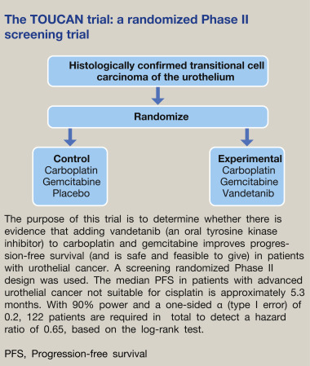
Figure 1

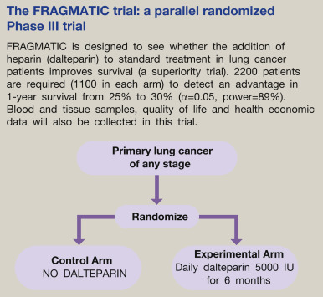
Figure 2

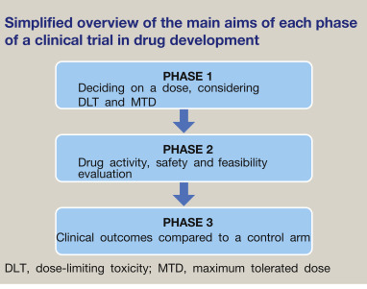
Figure 3

KEY REFERENCES
1 Eisenhauer AE, Twelves C, Buyse M. Phase I cancer clinical trials: a practical approach. Oxford: Oxford University Press, 2006.
2 O’Quigley J, Pepe M, Fisher L. Continual reassessment methods: a practical design for phase I cancer trials. Biometrics 1990; 46: 333–48.
3 Gan HK, Grothey A, Pond GR, Moore MJ, Siu LL, Sargent D. Randomized phase II trials: inevitable or inadvisable? J Clin Oncol 2010; 28: 2641–7.
4 Simon R, Wittes RE, Ellenberg SS. Randomized phase II clinical trials. Cancer Treat Rep 1985; 69: 1375–81.
5 Jung S-H. Randomised phase II trials with a prospective control. Stat Med 2008; 28: 568–83.

FURTHER READING
Girling D, Parmar M, Stenning S, Stephens R, Stewart L. Clinical trials in cancer: principles and practice. Oxford: Oxford University Press, 2003.

TEST YOURSELF
To test your knowledge based on the article you have just read, please complete the questions below. The answers can be found at the end of the issue or online here.

Question 1
A Phase I trial has been conducted for a new treatment for lung cancer. The recommended Phase II dose has been established. A Phase II trial is now being planned.
What is the most appropriate endpoint to determine activity in this trial?
A Response
B Quality adjusted life year (QALY)
C Adverse event rate
D Maximum tolerated dose (MTD)
E Treatment compliance

Correct answer: A
Response - measured using a tool such as RECIST (Response Evaluation Criteria in Solid Tumors) - is an appropriate endpoint to determine activity in a phase II trial. The other options are not as: MTD (D) is an outcome used in phase Is to establish the phase II dose; adverse events (C) are used to access safety not activity; treatment compliance (E) only determines the feasibility of giving the new treatment and; QALYs (B) are usually an endpoint of phase III trials that is used to access cost effectiveness of the new treatment.

Question 2:

A clinician in infectious diseases was approached by the Chief Investigator of a trial of a new antibiotic. The Chief Investigator was seeking subjects for a single arm Phase ll trial.
What is the main characteristic of this Phase ll trial?
A To assess the activity, safety and feasibility of the new treatment
B To compare the new treatment against current best treatment
C To compare the new treatment against a placebo
D To determine the Recommended Phase II Dose of the new treatment
E To determine the cost-effectiveness of the new treatment

Correct answer: A
The aim of a Phase II is to assess the activity, safety and feasibility of the new treatment. The other options are not as: a Recommended Phase II Dose (D) is an outcome of Phase I trials; cost-effectiveness (E) is an outcome of Phase III trials and; although some Phase II designs do compare treatment approaches (B & C) with very relaxed statistical parameters this is usually the main aim of a Phase III and in this design there is only a single arm of new treatment.

