The photographic city: Modernity and the origin of urban photography
Vladimir Rizov

Abstract
The concern of this text is the relationship between the city and photography. In order to examine the interrelation between the two, a significant case has been identified with Paris in mid-Haussmannisation in the period of mid to late 19th century. However, the particular focus utilised here is that of the structural logic of space and visibility in relation to photography. Photographs by the photographer commissioned to document the changes of Haussmannisation, Charles Marville, are used to illustrate the interrelations between street, façade, map and photograph. Key to this discussion is the context of modernity and its inheritance from the Enlightenment. Ultimately, this article puts forward a notion of the photographic city as the idea that modern Western cities are constructed on principles of transparency, order and legibility, which not only facilitated modern photography, but also allowed it to reproduce the city as exemplary of those same principles.
Keywords
Photography, urban space, modernity, urban planning, cartography, Paris, Haussmann, photographic city, critical visual theory

Introduction
The main concern of this paper is developing further the understanding of urban and photographic history as interlinked. The concept of the photographic city that I put forward here is an ontological claim, but one that privileges neither photography nor urban space. Rather, the idea of the photographic city is a position that takes both of its constituent discourses/practices/spaces to be aligned on an interwoven continuum. The paper begins with a look at the necessary definitions of urban photography and the city of Modernity. Following this, I will then look at the particular case of Paris by highlighting the focus on visibility, order and legibility in the urban planning implemented in the process of Haussmannisation. Finally, I will argue in defence of the photographic as a principle, along the lines of the panoptic. By doing so I will rely on illustration in the form of photographs by Charles Marville, an early documentary photographer commissioned by Haussmann himself to document the urban changes.
With Marville’s photographs, the abstract cartography of state planners saw itself reflected in an equally abstracted form, which simultaneously homogenised the city, and omitted any engagement with its human inhabitants. The ways in which this has been done is through the photographic principles that were utilised in the production of space – lines of sight, uniform façades, mass ornamentation and centralised urban planning – so as to render space legible, transparent and easy to manipulate. I intend to demonstrate this by first defining those principles of photographic practice, subsequently situating them in the particular urban context, and finally relating them to the congruent logic of cartography. By doing so, I aim to contribute to a literature of politicising urban space (Marcuse 2009), and one that invokes a spirit of critical visual theory (Wyly 2010). Ultimately, the utility and significance of the notion of the photographic city lies in its capability to combine the spatial and the visual, as well as engage with the constructivist nature of urban space through an understanding of photographic discourse that is deeply political.

The principles of photography
Photography tends to be understood as one of: the image, its production, or reception (Rose 2007). Zylinska notes (2016) that all three of those elements can be understood through two dominant perspectives for understanding photography - photography as art or photography as social practice. In this article I will try to understand photography primarily through the image and its production. By doing this, photography will be treated as a productive social practice, but some consideration will still be necessary of the potential reception of images.
In order to understand both photographs and the process of their production, I will first define the type of photography in which I am interested here and then outline three main principles that came to be of central importance to its practice. By the term ‘urban photography’, I am broadly referring to an early form of documentary photography that was concerned with the growing prevalence of urban change in modern Western European cities shortly after the creation of photography in the mid- to late 19th century. Understood this way, the term is slightly ahistorical, as it did not exist at the time of the production of the photographs discussed here. However, the term is an evocative one and it offers ample analytic grounds for the analysis of photographs on the basis of topic and context of production, rather than genre conventions. As such, it has been noted that the term offers multiple uses for fields such as cultural geography (Hunt 2014) and urban studies more generally.
The three main principles that I would like to highlight with regards to ‘urban photography’ are the issues of objectivity, legibility/transparency of meaning, and access. While the former two are characteristics largely pertinent to the domain of photography as a whole at the time (mid to late 19th century, see Marien 1997), the latter is a main characteristic primarily of photographic genres such as documentary and street photography. It is those two genres of photography, in following with Rose’s definition of genre as a set of ‘codified expectations’ (Rose 2007), that I define here broadly as urban photography. Granted, not all documentary photography is urban, but in the mid to late 19th century, Parisian documentary took predominantly the shape of urban focused projects (Vassallo 2014a; 2014b).
Before setting the stage in which urban photography developed, it is important to outline the three main photographic principles pertinent here. First, urban photography largely had an objective character in the sense that its subject was the objective character of the city. Due to slow photographic exposure in the 19th century, most urban photography was primarily of a survey or architectural character. People were rarely present in photographs, and if they were, they were seldom considered important (see Doucet 2019). The value of such photographs consisted in their ability to document the architectural detail of ornamentation, the edifice in its totality, or the newly built boulevards and streets that crossed the city. This value, in turn, was based on the ‘historic desire’ to document social and historical change (see Edwards 2009; 2016), the arena of which tended to be urban centres. Especially so in the 19th century with regards to urban planning, cartography and the formalisation of both (Söderström 1996; Lee 2013).
Second, the objective character of the built environment of the city required more than simple documentation. It needed to be coded as legible in a particular way. In most cases, this consisted of what became classical ‘straight photography’, where a camera is pointed straight at an object, in this case a building or boulevard, and the photographic object is captured ‘as it really is’ (Tagg 1988). This is more than a simple aesthetic codification of how to do photography, but a mechanism for the construction of reading both photograph and space (see figures 4 and 5 discussed below). Namely, the idea of looking straight at a building as the way in which one captures the totality of an edifice is as much an ideological conviction as a practical one. This construction is at the core of ‘the conditions [under which] the photographic images would appear “realistic”’ (Tagg 1988, 156). This legibility of the photograph leads to an understanding of images as transparent bearers of meaning i.e. realistic. Sekula defines this as ‘a notion of proximity to and verification of an original event’ (Sekula 1999, 447, emphasis in original). Furthermore, as it will be demonstrated below, this principle of legibility and transparency was facilitated by the development of façades and their architectural and semiotic importance in 19th Century Paris during Haussmannisation.
Third, the issue of access is one to do with information. Benjamin (1979) has aptly pointed out that photography surpassed painting at the very moment in which it became a much more efficient way of transmitting information. In terms of the focus of this article, the information transmitted is that of the urban landscape and its meaning, namely its legibility and transparency. However, it is important to note that, as a practice, photography has been, to a great extent, associated with the privileged classes historically. For example, documentary photography is simultaneously an ideological discourse that is intimately involved in the social distribution of power, as well as the delimitation of permissible action.
In order to produce the legible meaning of a photograph, the photographer requires physical access to the objective world of the city. From its very beginning this constructed a distribution of power that privileged the institution and the photographer over the working-class or colonial other. In fact, it was often the case that the affluent, recipient classes were the ones whose affective engagement was managed and exercised through the proxy of the document, while the exploited and documented classes were reified and objectified as an image to be sold. The subject/object relations in the practice, as evident in the photographer/photographed relation, are particularly evocative of this issue. Considering the presupposed ‘objective,’ or ‘straight,’ reading of the documentary photograph, as well as the underlying assumption of its production, it is important to note that the domain is, and has been:
‘fueled by the dedication to reform [which] has shaded over into combinations of exoticism, tourism, voyeurism, psychologism and metaphysics, trophy hunting – and careerism’ (Rosler 2004, 263)
The example of Rosler’s description demonstrates both the affective nature of the representation and the already distributed positions of power – unequally so between the photographing and the photographed, as well as the recipients of the photograph and the photographed. This leads Solomon-Godeau to claim that the notion of the documentary, and its practice, involves a double act of subjugation:
‘[F]irst, in the social world that has produced its victims; and second, in the regime of the image produced within and for the same system that engenders the conditions it then re-presents’ (1991, 176)
This is also intimately tied to the connotation of the camera as linked to ‘mastery, possession, appropriation, and aggression’ (Solomon-Godeau 1991, 181). The city, as the place par excellence of social, economic and cultural change, was one of the key sites for the exercise of the camera as a tool of power.

Urban planning in the modernised city
It was in the modern city that one could find the peak of the Enlightenment ideals of objectivity, transparency and legibility. In the Enlightenment, Western man’s gaze was placed, both in an anthropocentric and androcentric sense, at the centre of the imagined universe. This is evident in what according to Wagner is a key characteristic of Modernity – the very paradigm of ‘interpret[ing] and reinterpret[ing] observable social practices in the light of this imaginary signification’ of freedom and autonomy (Wagner 2003, 5). This new ‘discursive rupture’ of Modernity and modernization brought about a new way of understanding ‘both individuals and society, and as such, it instituted new kinds of social and political issues and conflicts’ (Wagner 2003, 4). Specifically, the idea of ‘being modern’ was guided by the growing prevalence of science and its reliance on rationality, ultimately resulting in the idea of ‘the infinite progress of knowledge and in infinite advance towards social and moral betterment’ (Habermas 1987, 4). According to Habermas, this took shape in the 18th century Enlightenment philosophers’ ‘efforts to develop objective science, universal morality and law, and autonomous art according to their inner logic’ (Habermas 1987, 9). At the core of this was control and the perceived security that a system of total knowledge would bring. Granted, the security was one of a limited kind, and extended itself primarily to the growing middle classes, meanwhile largely omitting underprivileged intersections of society.
What was seen as outmoded also came to be seen as potentially dangerous, not of the times, and unsuitable for the modern age of newfound maturity and rationality. In the case of cities, this meant that the old city had to be reined in, sometimes forcefully. This was supposed to be done by means of the newly available technology (for example, see Fraser 2011; Choay 1969), thus revealing the city itself to be the site for a project of modernisation. Gilloch argues that the modern city endeavoured ‘to present itself through its monumental façades and structures as the zenith or culmination of progress’ (1997, 75). As Scott comments, the Enlightenment ‘fostered a strong aesthetic that looked with enthusiasm on straight lines and visible order’, since ‘the city laid out according to a simple, repetitive logic will be easiest to administer and to police’ (Scott 1998, 55).
Modernity saw the old cities grow exponentially at unprecedented rates. Sociologists have highlighted the significance of urbanisation on the modern individual and society (see Frisby 2013; Gilloch 1997). However, the cities in which modern societies found themselves were often ancient and unfit for the new technologies of the 18th and 19th centuries – railways, the carriage, gaslight, sanitation, etc. Unsurprisingly, the old cities were quickly deemed unsafe, unfit, and unhealthy. Foucault describes this as the fear so common to the Enlightenment of ‘darkened spaces, of the pall of gloom which prevents the full visibility of things, men and truth’ (as cited in Vidler 1993, 84). Vidler comments on Foucault’s claim and asserts that:
‘It was this very fear of the dark that led, in the late eighteenth-century, to the fascination with those same shadowy areas what Foucault calls the "fantasy-world of stone walls, darkness, hideouts and dungeons” - the precise "negative of the transparency and visibility which it is aimed to establish.”’ (Vidler 1993, 84)
In response to this fear, transparency was seen as the desired goal in the field of urban planning. Vidler sees Jeremy Bentham’s, as much as Foucault’s, Panopticon as one such example of ‘that transparent space theorized as a paradigm of total control’ (1993, 84, emphasis in original). Foucault described it as ‘a generalizable model of functioning’ that is interwoven with observation, discipline, and analysis of subjects occupying the said transparent space (1995, emphasis in original). Vidler aptly describes the extent of the phenomenon of transparent space:
‘The rational grids and hermetic enclosures of institutions from hospitals to prisons; the surgical opening up of cities to circulation, light and air; the therapeutic design of dwellings and settlements; these have now all been subjected to analysis for their hidden contents, their capacity to instrumentalize the politics of surveillance through what Bentham termed "universal transparency."’ (Vidler 1993, 84, emphasis added)
Moreover, it is this that Tagg has referred to as the ‘expanded state complex’ (1988), of which the archive and its photographic records, as well as the police, the ordnance survey, the hospital, the prison, etc., are key parts. However, in order for these institutions and instruments to function properly in keeping with the principles of transparency, rationality, and minimising of danger, the city itself had to be reshaped in order to provide better lines of communication between institutions, as well as dealing with the inevitable issues of industrialisation and rapid urbanisation. It is at this point that photography rose to prominence in its documentary and proto-forensic forms. Mugshots, documents of criminals’ height, weight, and distinctive marks, typifications of classes, races, and ‘abnormality’ - all objects of the new social and urban world were documented, analysed and simultaneously produced as meaningful. The body, as much as the city was inscribed with meaning with regards to security, hygiene, predictability and control. Both inscriptions were facilitated and conducted through the means of visualisation. One such example was Charles Booth’s cartographic social inquiries (Vaughan 2018), in which the complexity, inequality, and everyday experience in a city were abstracted into a singular and total visual representation. Documentary photography, just as much as cartography, offered a way of visualising social issues through a detached, supposedly unsentimental way that differs from aestheticized and pictorial melodramatic images of indigence in the same way that totalising statistics differed from partial anecdotal evidence (see Söderström 1996).

Changing Paris
In the case of my particular focus in this article, Paris has been widely referred to as the ‘capital of modernity’ (Harvey 2005). Upon inauguration in 1853 as the Prefect of the Seine, Haussmann initiated a process of urban demolition, displacement, and ‘amelioration’ on such a grand scale that his name has become eponymous of such changes (see Engels 1970; Harvey 2005; Merrifield 2014). It must be noted that here I take a broad view of Haussmannisation and consider it a process that is not exclusively linked to Haussmann’s choices or plans. Haussmann’s tenure started in 1853 and ended in 1870. My approach to this process of urban change will be further contextualised below. At this point, it is important to note that a key factor for these changes was that large part of Paris’s central areas were dating back to the Middle Ages (primarily the central area of the Île de la Cité) and consisted of ‘dwellings irregularly crammed together defying all rational plan’ (Vidler 2011, 75; also see Choay 1969; Benjamin 1979).
Paris has continuously been discussed as the modern city par excellence. The history of urban change in Paris is complex and much of it predates Haussmann (see Paccoud 2012a; 2012b; 2016), even what is often referred to as Haussmannisation tends to include developments that preceded his appointment (for example, see Bourillon 1999) or that followed his death. However, for the purposes of this text, the work of the photographer Charles Marville occurred during the period of Haussmannisation and was commissioned by Haussmann himself (Vassalo 2014a; 2014b; Sramek 2013). Marville’s work is exceptional in a photographic sense, as he was explicitly commissioned by an urban planning authority in contrast to other figures such as Atget or Annan (see Rizov 2018). Moreover, as Lee points out (2013; also, see 2012), Marville’s method of documenting Paris was a unique combination of photography and cartography, where both maps and photographs were used in order to conceptualise the existing city of Paris into a flat, visual and geometric representation that is easily modifiable. Considering this, Marville stands out as a unique figure in the history of photography in terms of the centrality of his work with regards to an ongoing urban project of such scale and significance (Lee 2013; also, Nilsen 2011; Vassalo 2014a).
Haussmann’s plan for modernization consisted of an almost complete overhaul, or disembowelling, of the medieval centre – Île de la Cité – at this point ‘a collection of juxtaposed parts’ (Choay 1969, 16), narrow streets, overpopulated houses, and a characteristic lack of any sanitation infrastructure or gaslight. Haussmannisation meant a carving out of a series of boulevards in the spirit of London’s Regent Street, as well as a construction of a series of squares, parks and green spaces. In 1872, after the end of Haussmann’s career, Friedrich Engels (1970, 70) summarized Haussmann’s wide-reaching notoriety:
‘By "Haussmann" I mean the practice, which has now become general, of making breaches in the working-class quarters of our big cities, particularly in those which are centrally situated, irrespective of whether this practice is occasioned by considerations of public health and beautification or by the demand for big centrally located business premises or by traffic requirements, such as the laying down of railways, streets, etc.’
I follow Engels’ formulation and I emphasise that the issue with which I am concerned here is not so much what Haussmann intended or how much of a role he had in what is termed the Haussmannisation of Paris (for example, see Paccoud 2012a), but rather the effects of the process described with that name. Paccoud (2012b) identifies four subsets of literature on Haussmann and Paris – those based on Haussmann’s Mémoires, in the tradition of Durkheimian sociology, Marxist scholarship, and those situating Haussmann in the history of urban planning. My position is closely aligned with the Marxist interpretation (Berman 2010; Harvey 2005; Benjamin 1979; Engels 1970), in which Haussmann’s work has had a largely negative effect on indigent populations. Nevertheless, it is important to stress that Haussmann’s work is too complicated for a simple evaluation, as most modernising projects tend to be, having both clear detriments and benefits (Berman 2010). For example, the negative effect and scale of the displacement of working-class populations has been challenged (Bourillon 1996); other evidence has also showed that Haussmannisation, e.g. on the left bank, was in fact desired (Paccoud 2012b).
Understood this way, the effect of Haussmannisation had a strategic effect that bolstered the power of the state and the police as well as further commercialized the centre of Paris in a process of embourgeoisement. In the process of doing so, Haussmannisation involved the destruction of the communities of working-class neighbourhoods at the centre of the city. It has been argued that this was done so intentionally, with an often-acknowledged consideration for the prevention of urban political unrest (see Benjamin 1979; Choay 1969, 15; Jordan 1996); of particular significance had been the recent June Days revolution in 1848 at the time of taking the position of Prefect of the Seine. Although disputed as the singular motivation behind Haussmannisation, considerations of security and unrest were present in the discourse at the time (see Bourillon 1999).
As described by Haussmann himself, a key part of his plan was:
‘to cut a cross, north to south and east to west, through the center of Paris, bringing the city’s cardinal points into direct communication’ (as cited in Choay 1969, 18)
This ‘great cross’ (grande croisée) was the Prefect’s inaugural project, and it fulfilled both symbolic and practical purposes (Jordan 1996, 186). This was the case in most, if not all of the process of Haussmannisation: a straight street would be carved into a working-class neighbourhood with the purpose of destroying the insulated area that had in the past proven easily defendable from the army (see Hazan 2011; 2015; Ross 2016) as much as opening up the street to business and commerce. Moreover, the Haussmannisation of Paris consisted of an aesthetic of, as Choay describes it, ‘uniform frontage lines along broad, straight streets, [and it included] research into perspective effects and location of monuments on a perspective axis’ (1969, 19). Often, modern functionality and technology would be aestheticized (according to Choay 1969, as an afterthought only) with reference to an imperial past. As Jordan describes the ‘great cross’:
‘The great cross was to be the north-south, east-west axes of the new city: respectively the boulevards Strasbourg-Sebastopol and Champs-Elysée-Rivoli (the former continued by the boulevard St. Michel, the later by the rue St. Antoine), and made reference to the Roman foundations of Paris as well as the city’s medieval heritage. Myth and reality were loosely intermingled’ (Jordan 1996, 186, emphasis added; also, see Gilloch 1997)
Both surpassing and succeeding the outmoded past, the newly Haussmannised Paris consisted of a newly constructed legibility and transparency of space. The already existing, and to an extent implemented, ‘principles of axial symmetry and vistas for monumental effects’ (Moses 1942, 58) were ‘further emphasised and expanded’ (ibid) in Haussmann’s work. The ‘strategic lines of the boulevards’ being constructed (Haussmann as cited in Vidler 2011, 95) were seen and treated as forms of technology for redoing the city: all secondary streets were constructed in reference to the boulevards. Even more importantly, the city was made legible – one had to quickly adapt to the new grammar of safety, visibility, and commerce in the boulevards that stood in opposition to the darkness and uncertainty of the small streets that had stood in their place. Furthermore, Haussmann considered it necessary to have a monument of some kind at the end of each boulevard, often a church – if there was none, he would build one.

Managing the visualised city: photography and cartography
Ultimately, Haussmann’s efforts created a ‘holistic vision of an entire city brought into line,’ in a manner typical for the Enlightenment, through the combination of technical knowledge and research with a conviction of achievable progress through amelioration (Vidler 2011, 94-95). In fact, the project of urban change relied to a great extent on, and according to Vidler ‘had waited’ for (2011: 95), the development of modern photography and cartography. The former emerged as a novel form of transmitting visual information in a manner that allowed the state, or its institutions, to implement measures of control, policing, and surveillance. As such, it was superior to painting with regards to its utility in governance. In fact, it has been argued that photography’s surpassing of painting was so completely thorough that painting, such as Impressionism, started to take on the subject matter of the ephemeral, the chaos of street life, or the fleeting experience of the Modern (see Rubin 2008). With regards to cartography, its utility has been largely argued to be along similar lines (Söderström 1996). Although much older as a technology than photography, it nevertheless achieved new-found prominence with the formation of the modern state in the 18th and 19th century. It proved the ideal instrument for the perpetuation of disparities of knowledge along class, gender and race lines as well as allowed for central planning that perpetuates the dominance of the state (Vaughan 2018). An interesting convergence of both photography and cartography with regards to their role in urban planning is the notion of the horizon. The term horizon, on which the horizontal gaze of a boulevard relied heavily, ‘is a pictorial, but also a strategic notion’ (Foucault 1980: 68). While the horizontal gaze situates one on the street, the zenithal perspective of the map, on which a line was drawn by Haussmann and Napoleon III, effectively ‘totalizes a plural experience, concentrating into one gaze a multiplicity of particular visions of the city’ (Söderström 1996, 259). This aesthetic and pictorial, yet ultimately strategic, dimension of Haussmann’s Paris consisted of:
‘…beautiful perspectives, by the disengaging of ancient monuments and the isolation of new ones: by the opening of planted avenues, vast promenades, parks and public gardens, filling the eyes with a luxury of greenery and flowers without parallel’ (Haussmann as cited in Vidler 2011, 101-102)
Similarly to Engels (1970), Merrifield has described Haussmannisation as a ‘process of divide and rule, of class expulsion through spatial transformation, of social polarization through economic and political gerrymandering’ (2014, 29). Haussmann worked by mobilising public money to support private entrepreneurs and builders (Merrifield 2014), effectively commercialising the city of Paris on a scale that was unprecedented at the time (Jordan 1996). One example of this is the line of the Champs-Elysée – Rivoli and the adjacent Tuileries Gardens. Originally designed by Napoleon I, the boulevard was made so that:
‘A continuous height of four stories plus attic floors combined with the sloping roof, unbroken lines of balconies with uniform fenestration, arcaded sidewalks which protect shoppers and conceal the commercial obtrusiveness of shops, have brought about a simple dignity and charm which have been widely copied elsewhere. […] A typical "tenement" of uniform facade without arcaded walks on the Boulevard de Sebastopol [see figure 1] includes shops on the ground floor, a mezzanine, three main floors with apartments for upper middle class tenants, and two attic floors in the sloping roof for servants and tenants of the poorer classes.’ (Moses 1942, 61)
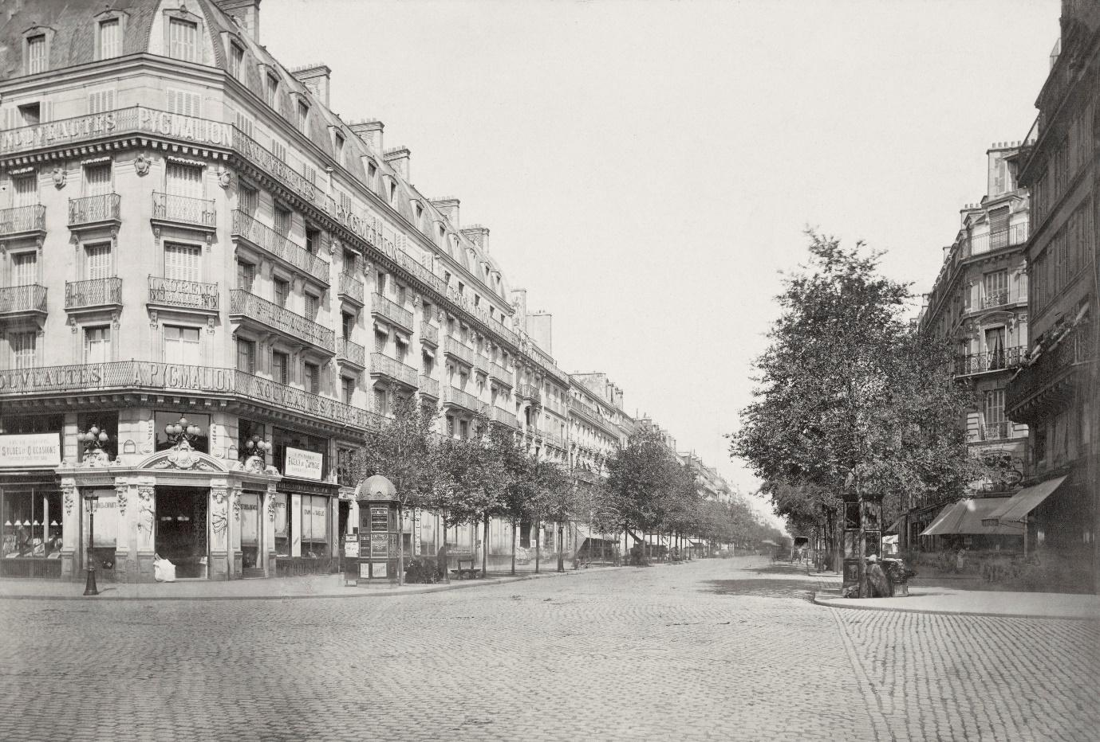
Figure 1 Boulevard Sébastopol, ca. 1853–70. Boulevard Sébastopol starts at Pont au Change at the Seine and heads north of the river, where it becomes Boulevard de Strasbourg at its crossing with Boulevard Saint-Denis, ending at Gare de l’Est. Originally, it was referred to as Boulevard de Centre at its opening in 1854, due to its central location and its role as a separator between Le Marais and Les Halles. The taking of this photo by Marville is unclear in its dating (circa 1953-1970), but despite this, and perhaps because of it to an extent, the photograph remains a clear image of the new boulevards that emerged in the period of Haussmannisation. Source: Charles Marville, copyright – Wikicommons.
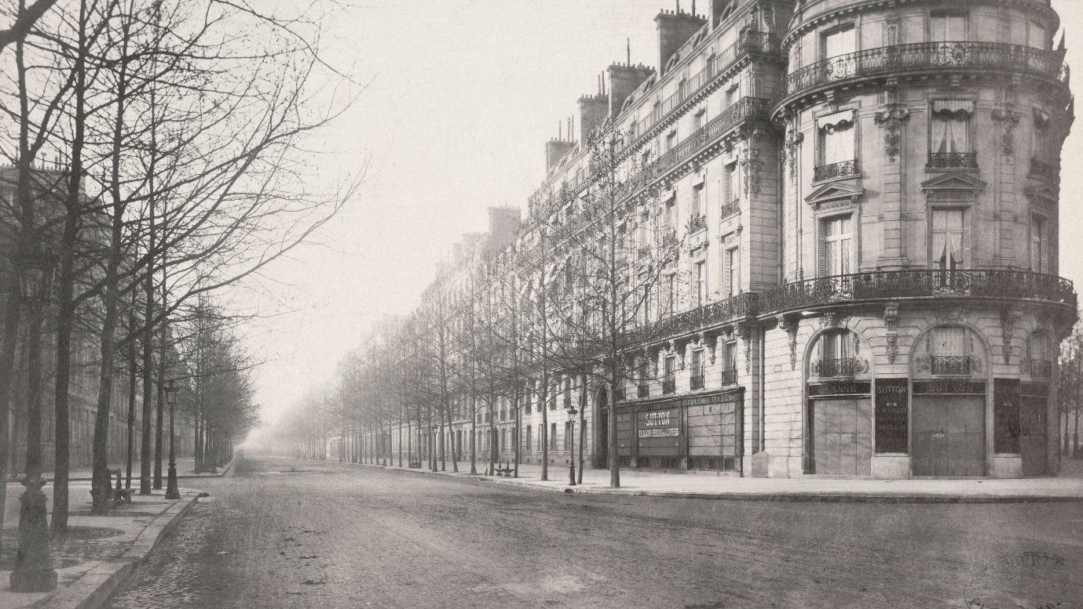
Figure 2 Boulevard Haussmann, crossing rue Miromesnil, ca. 1853–70. The boulevard finds its beginning at Place de Charles de Gaulle and the Arc de Triomphe. It is a boulevard of significant length, here shown with its apparent endless line of sight. Source: Charles Marville, copyright – Wikicommons.
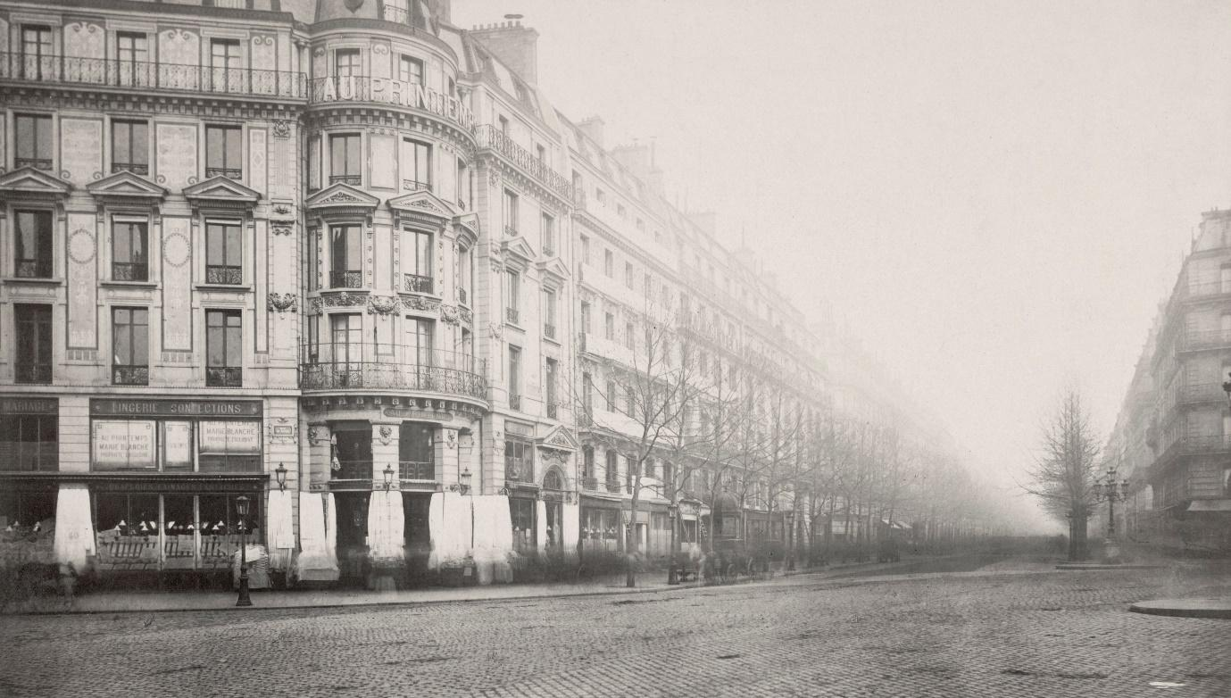
Figure 3 Boulevard Haussmann, crossing rue du Havre, ca.1853-70. As above, Boulevard Haussmann’s length was particularly suited to Marville’s manner of photographing the grand thoroughfares being cut into the fabric of the city. Most notably, on the left of the photograph, in addition to evidencing the desired effect of near-uniform façades, one can see the department store Au Printemps. In The Arcades Project, Benjamin (2002, 40) aptly links Giedion’s axiom of ‘welcome the crowd and keep it seduced’ to Au Printemps. Painters such as Caillebotte, for example, have frequently depicted the commercial life of the boulevard – images that differ vastly from the depopulated abstractions of Marville. Source: Charles Marville, copyright – Wikicommons.
Boulevard Sebastopol (see figure 1) exemplifies the typical boulevard of Haussmann as described by one of his disciples – Robert Moses (1942). In Marville’s photographs, Paris is rendered vacant, monumental, and nearly uniform. This is typical for the period and many documentary photographs, due to their focus on some element of urban material culture and space, tended to omit people (for example, Doucet’s work [2019] provides a discussion of streetcars in Toronto through an acknowledgement of the city as background; Jacobs [2006] provides a more general discussion).Often, Marville’s photographs of boulevards present an abstracted Paris that is uninhabited and immobile, comprised entirely of its built environment – something completely opposite to the chaos of modern life described by Charles Baudelaire (2009) in poems such as ‘Loss of A Halo’ that convey the dangers of crossing the tarmacadam-covered boulevards (see figure 2 for reference). The abstraction of the particular boulevards is so extreme that one can be easily forgiven for confusing one boulevard with another. As such, it can be posited that the abstraction of space through the means of photographic representation played a role in the justification of space as something pliable and modifiable, such as an image or a product – an example of what Scott (1998) calls a ‘state simplification’. The famous example of Haussmann and Napoleon III drawing lines on a map through existing neighbourhoods in the process of planning future boulevards appears similar and related to Marville’s photographs. In fact, the uniformity of façades was a product of this very process of percements (or percée) [openings] envisioned on the map.
In every part of Haussmann’s Paris, form and function, aesthetics and bourgeois capitalism, panoptic principles and transparent order, were made to ‘remind the citizen of one, uniformly governed Paris’ (Vidler 2011, 100). The public pissoir, the railing, tree guards, or gas lights were all standardised and typified to an extreme; as Vidler evocatively summarises, a ‘bench in the Faubourg Saint Antoine was the same as that in the Champs-Elysée’ (Vidler 2011, 100). According to Rubin, it can be argued that Haussmann’s Paris ‘at some level itself embodies the vision of the city propagated by photography’ with its focus on ‘vistas, focal monuments, light and open spaces’ which were all ‘constructed for the gaze’ (Rubin 2008, 49). With its ‘cannonshot boulevard, seemingly without end’ (Giedion as cited in Rice 2000, 43) Paris is ‘the site of modernity, the place where modern vision was developed’ (Rubin 2008, 17).
With regards to urban planning, this meant that the consideration of safety and hygiene, both of which had a pronounced class dimension, was central to utilising the streets of the new Paris in a comprehensive urban strategy. The boulevard Richard Lenoir or the canal St. Martin were intentionally redesigned with the prospect in mind to prevent the events of the June Days’ of 1848 possible repetition (Jordan 1996, 188). Often, this type of urban restructure was double in function, both military and bourgeois, making Haussmann’s Paris a markedly classed city:
‘…at exactly the same time [when] Haussmann constructed a barracks near the Place de la République, he was building the gardens of the boulevard Richard Lenoir. In truth, gardens and barracks were compatible. […] Imperial urban politics was to contain the working-class quarters, not transform them, to preserve private property while assuring the stability of the authoritarian state.’ (Jordan 1996, 191)
The boulevards carved through the city were similarly manifold and inherently political in their function: they connected areas, divided and segregated areas, aestheticized the city space as well as facilitated military access and the use of police force; simultaneously they commercialised the centre and made it uniform, recognisable, and legible. Jordan (1996) provides a clear example of this when discussing Haussmann’s restructuring of the Left Bank of the Seine in relation to the boulevard Strasbourg-Sebastopol (see figure 1) – in order to continue the axis of sight from the Gare de L’Est to the boulevard St. Michel and the infamous St. Michel fountain, Haussmann had the task of legibility and the conveyance of significance. Namely, the problem was that the boulevard St. Michel (figure 4, left of fountain) and rue Danton (figure 4, right) appeared equal in significance (see figure 5). This necessitated tools for distinguishing between the two – a whole assemblage of architecture, façades, and trees were used to demarcate boulevard St. Michel as the continuance of ‘the illusion that his great north-south axis ran in a straight line through the center of Paris’ (Jordan, 1996: 197). Put simply, Haussmann’s urban planning relied on a markedly visual logic in order to ensure a desired legibility.
A particularly interesting example that illustrates one of the ways in which photography facilitated the production of urban space are the aforementioned photographs of boulevards by Haussmann. It has already been noted that early documentary photography, the larger umbrella term in which Marville’s work is seen, often relied on the principles of ‘straight photography’, where a given object (or building) is photographed from a straight perspective. Architecturally it is heavily linked to photographic collectives such as Missions Heliographique, but theoretically it is linked to a very particular period in the representation of architecture that predominantly focused on a building’s façade. However, with Marville’s photographs an interesting development can be observed. His photographs of boulevards appear to produce a form of ‘straight photography’ that places a boulevard itself as the ‘object’ being photographed (Lee 2013). Compare, for example, figure 4 and figure 5. In the former, the fountain of St Michel, at which point the boulevard begins and in direct opposition to the river Seine, is clearly placed as the most significant element of the particular photograph. The already noted planned difference in façades on either side of the fountain – boulevard St Michel (left) and rue Danton (right) – is difficult to discern and appears of no concern in Quinet’s photograph.
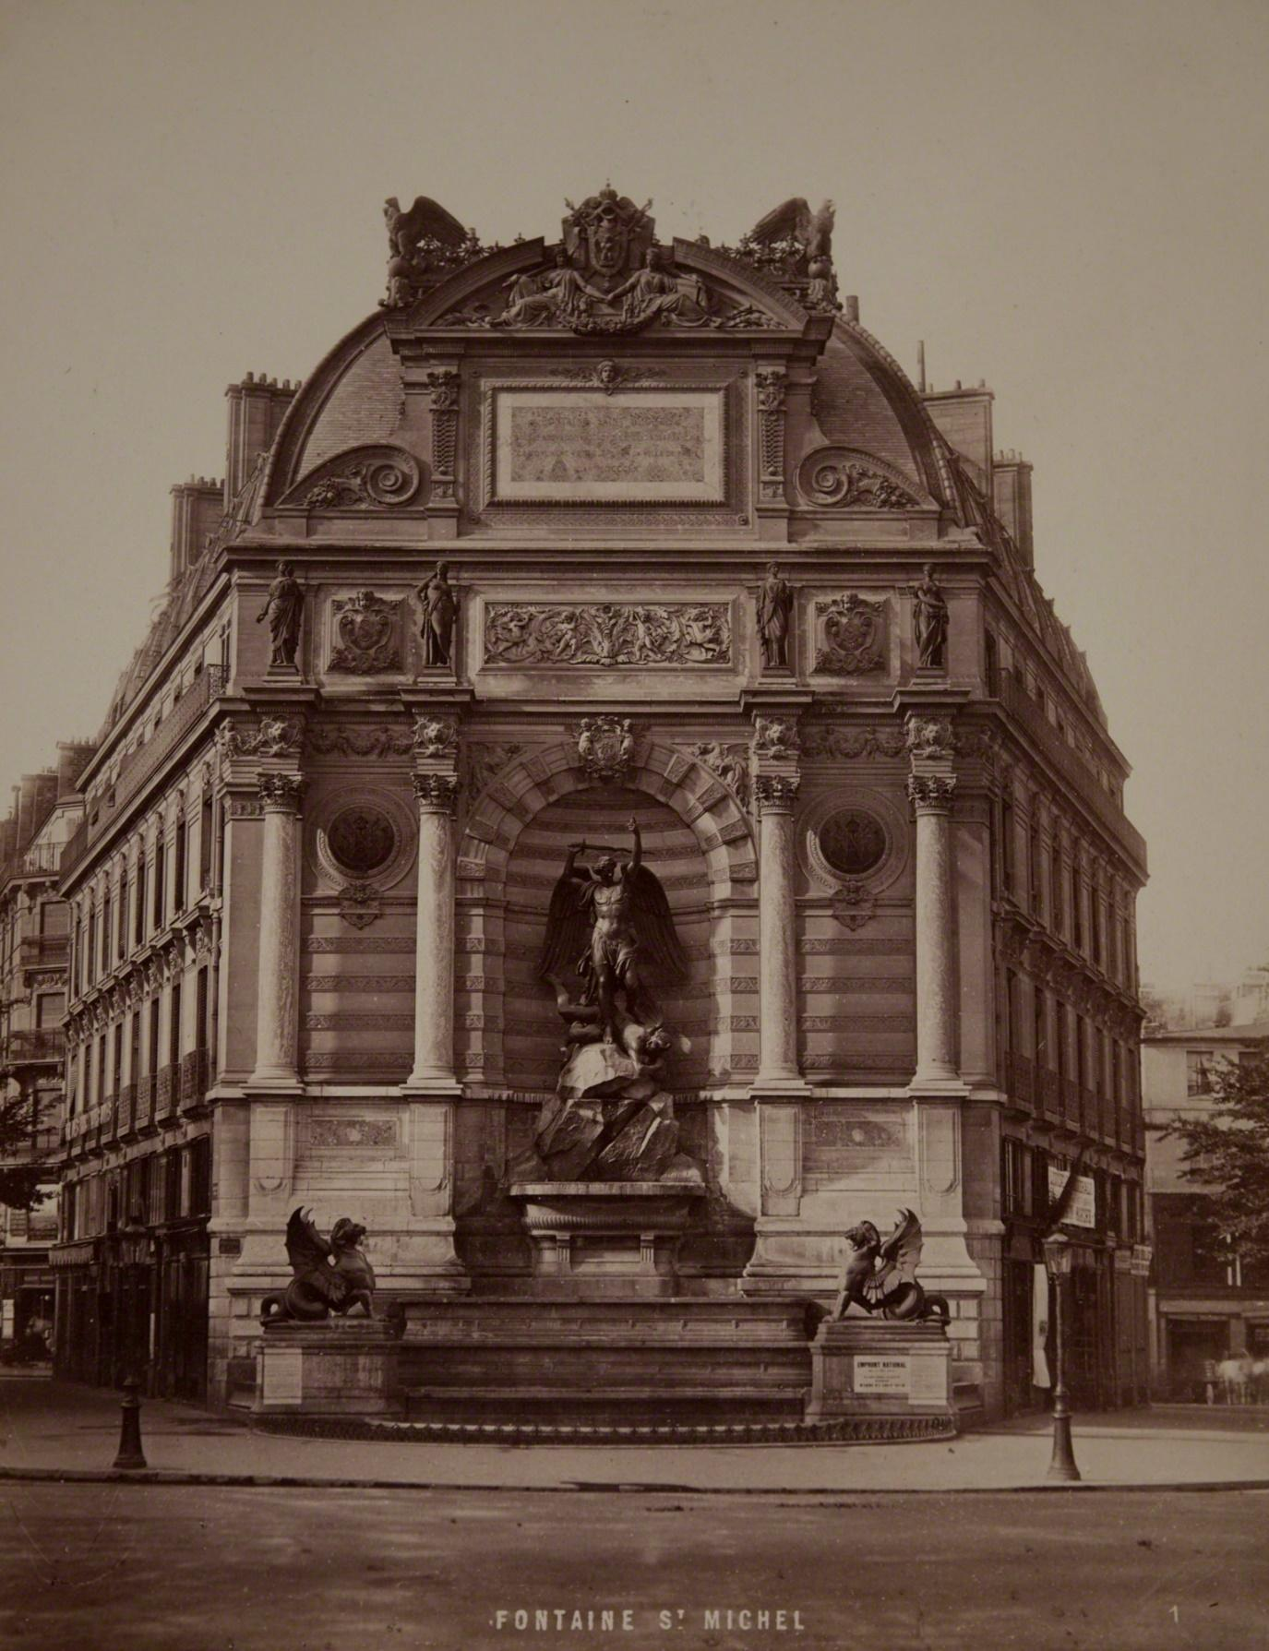
Figure 4 Fontaine St. Michel, ca.1870. The Fountain of St. Michel is central to Paris, at Place de Saint-Michel, facing the River Seine, and is the continuation of Boulevard Sébastopol from the other side of the river Seine. Moreover, Quinet’s photo seen here is an example of ‘straight photography’ – the image is centred on the material object of interest, the statue of Saint Michael defeating Satan. As in all illustrations to this essay, people are not present and can only be vaguely discerned as an amorphous blur on the sidewalks (e.g. on the right); this is partly due to the exposure time with which Marville worked (see Le Gall 2013, 56), as well as a seeming lack of interest in people (see Doucet 2019 for an example unrelated to Marville). Source: Achille Quinet, copyright – WikiCommons.
However, in figure 5, one sees the boulevard itself as the main object of interest. The fountain of St Michel (on the right in the photograph) is seen only partially and is clearly of little concern (with reference to the typical for the period need to document a monument in its detail) to the photographer beyond a point of interest for recognising the boulevard – note too, that there is no identifying sign beyond the partial fountain. Interestingly, in Marville’s photos straight photography appears to produce the boulevards as objects, an objectification where built environment, line of sight and architecture coalesce into an urban landscape. This aesthetic was also evident in photographs depicting the soon to be destroyed spaces of Paris (for example, see figure 6) – one can speculate that the objectification of the ‘straight photography’ discourse facilitated the rendering of spaces as removable and manipulable.
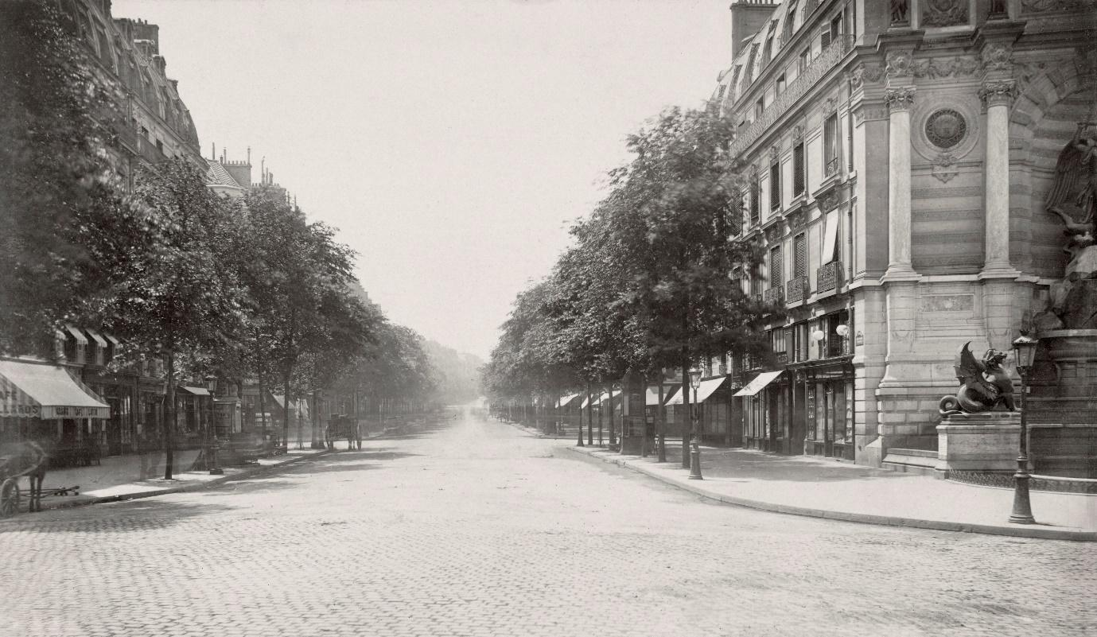
Figure 5 Boulevard Saint-Michel, with partial view of Fontaine Saint Michel (on the right), ca. 1853–70. Boulevard Saint-Michel appears to have been taken at some point before Quinet’s ‘straight photograph’ of the fountain (see figure 4), as the road surface, supposedly tarmacadam, is missing here. Moreover, the contrast between a straight photograph of a material object, such as the statue, and of a boulevard’s endless line of sight is rendered evident here. Source: Charles Marville, copyright –Wikicommons.
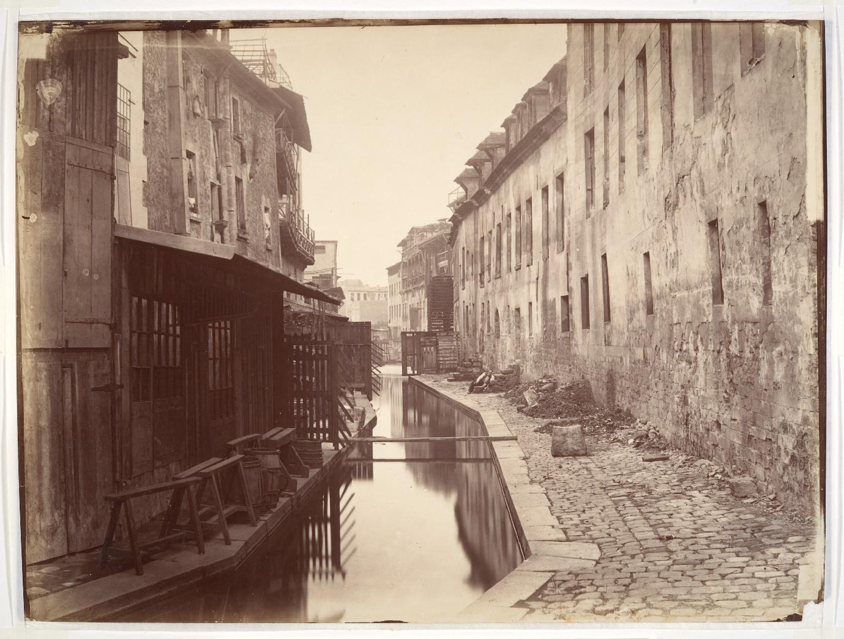
Figure 6 The Bièvre river seen here was considered one of Paris’ many problems with regards to sanitation and public hygiene (see Gandy 1999). As the image above is described by the Metropolitan Museum of Art’s own collection catalogue, the Bièvre was ‘essentially a waste system for twenty-four tanneries, twenty-one leather factories, nine starch and three dye manufacturers, a paper mill, two cotton and two flour mills, four laundries, a soap and candle factory, and assorted other industries’ (MET n.d., n.p.). Shortly after the taking of this photograph, the stretch seen here was covered up and transformed into the new sewage system of Paris. Source: Charles Marville, copyright – WikiCommons/Metropolitan Museum of Art (Public Domain).

The city becomes photographic
My argument is that the projects of modernising the cities in the 19th century, and Paris in particular, produced cities that are photographic. The modernisation of big cities was based to a large extent on the Enlightenment and the fears of darkness and desire for order and visibility that it brought into Modernity. A key tool for this modernising project was the scientific endeavour of cartography and its mission of standardising the representation of a given city. Historically, this meant that individual or subjective perspectives that are rooted in the street or the lived experience of the city are omitted. With Marville’s photographs, however, the lines on the map drawn by Haussmann and Napoleon III see their geometric representation conveyed in a situated form, which simultaneously homogenises the city, i.e. all boulevards look the same, and avoids the everyday and ordinary experience of urban space. The ways in which this has been done is that photographic principles were utilised in the production of space – lines of sight, uniform façades, mass ornamentation and centralised urban planning are but a few key examples.
I have so far focused on some of the key literature on the topic in order to demonstrate that the process of modernisation of cities has been one of producing transparent spaces according to the principle of the inspecting gaze of panopticism. The central working-class areas of Paris with their darkness and disease needed to be ‘opened up’ to the fresh air and light just as much as its large population occupying a virtually unpoliced area needed to be controlled. Similarly, the entire city of Paris with its labyrinthine streets had to be cut into separate parts with identifiable functions, thus becoming a singular aesthetic totality that entrenches class privilege, prevents revolt, and reinforces the power of the state. It is not surprising that the state had to become able to see into its territory, make visible its subjects, and legitimise itself through a discourse of privileged knowledge-production in specific institutions. With Marville’s photographs, the state managed to impose the zenithal gaze of the map on the horizontal gaze of the street level, ultimately resulting in the production of a photographic embodiment of the urban planner’s gaze. As Lee (2013, 102) states, ‘the construction of a future city was accompanied by the projection of its past through photography, whose subjects were conditioned by new cartographic modes of orthogonal planning.’ Marville’s photographs served as simple before-and-afters that obfuscated the process of Haussmannisation in its photographic historicization.
According to Foucault, this need for the ordering of the city marked a change in understanding space – from the 18th century onwards, ‘the cities [of a state] served as the models for the governmental rationality that was to apply to the whole of the territory’ (Foucault 2001, 351). James C. Scott has also commented on the modern state’s proclivity for constructing a dominant vision of its territory and resources (1998), effectively simplifying the reality of its domain according to abstract principles of order and legibility. The point, however, is that the state needed to simplify urban space in order to make it legible to itself, not necessarily to the space’s inhabitants. This, in turn, was a strategic solidification of power – territory itself becoming a ‘political technology’ (Elden 2013, 322) which ultimately had as its goal ‘the extension of the state’ (Elden 2013, 322). An example of this in urban planning is the development of zoning, in which cities were further systematised and dissected into separate parts. This, in turn, facilitated control – namely, by highlighting which zones are to be controlled (for a more contemporary example than Haussmannisation, see Wyly 2010). The parallel to photography such as Marville’s, or others such as Eugene Atget and Thomas Annan (Rizov 2018), or Georg Koppmann (Nilsen 2011), is clear considering the explicit focus on particular areas of the city (Sramek 2013).
This development in the convergence of the governmental instruments of cartography and photography was ultimately tied to the ‘entropic anxiety’ of the archive and the historic desire for documenting photographically what could be easily lost to history. According to Edwards, ‘the ordering of the archive was itself premised on homogenizing ideas of historical significance, framing the desired mode of attention’ (Edwards 2009, 142). This, in turn, has resulted in a reduction of ‘all possible sights to a single code of equivalence [which is] grounded in the metrical accuracy of the camera’ (Sekula 1992, 352). Sekula further adds that the significance of this should not be underestimated, since ‘photography doubly fulfilled the Enlightenment dream of a universal language’ by promising ‘to reduce nature to its geometrical essence’ of straight lines and infinite horizons (Sekula 1992, 352, emphasis added), much like the boulevards in Marville’s photographs.
This process of reduction had other victims as well. The ‘state simplifications’ outlined by Scott (1998) consisted of the reduction of people into numbers, documents, and paper trails. Photography, while documenting the working-class areas of the city, allowed the social engineers’ gaze to enter spaces that had been unavailable to them. With this access of the privileged to an underprivileged space, inevitably the inhabitants of such spaces suffered displacement and homelessness. This also had an aspect of visibility, bearing in mind that few, if any, of Marville’s images of boulevards have people in them. This photographic invisibility is mirrored physically, considering that the undesired population was removed from sight and banished to the periphery of the city – in the case of Paris, this occurred in the Zone, an area of temporary housing outside the city (Jordan 1996).
It has already been noted that Haussmann’s city planning was centred on perspective, vision, and order. This was the period in which Paris became ‘the place where modern vision was developed’ (Rubin 2008, 17). On an abstract level, the modern city is photographic exactly due to its architecture and urban planning. Eric Hazan (2011) has noted that for early photographers there was a clear connection between architecture, urban space, and photography. The very first photographs were of cities and relied on urban architecture and infrastructure. Perego (1998) has commented in an essay exploring the work of Charles Marville, that quite often the words edifice and machine were used interchangeably in urban environments. This indicates a deep connection between photography and architecture. For example, Foucault has already pointed out that, although based in architecture, the Panopticon is much more than a type of building (1980). Photography itself traces its roots to the panoptic principle; in his comparison between the photographs of Charles Marville and Eugène Atget, Sramek argues (2013) that Marville’s work was not in line with the Panopticon, as it did not document the entirety of a street, area, or Paris. However, panopticism is not literal, it works in principle – it is the potentiality of seeing all as much as it is the power associated with the subjective feeling of being able to see all (Foucault, 1980: 71). Foucault’s famous treatise on the matter points to this exactly, the ‘panoptic mechanism arranges spatial unities that make it possible to see constantly and to recognize immediately’; put succinctly and aptly by Foucault, ‘visibility is a trap’. In this sense, the photographic can be understood as much as a principle of rendering the city controllable and perpetuating power inequality as the panoptic.

Acknowledgements
Thanks are due to my PhD supervisors, Daryl Martin and Darren Reed, as well as my examiners, Gareth Millington and Graeme Gilloch, for their guidance and feedback. Also, thanks to Rafe McGregor and Aurėja Stirbytė for reading early drafts of the text, as well as providing feedback. Finally, I am thankful to two anonymous reviewers and the editorial board of this journal for the exceedingly thoughtful feedback.

References
Azoulay, Ariella. 2018. “Unlearning Decisive Moments of Photography”. Foto Aisthesis Museum, available at < https://www.fotomuseum.ch/en/explore/still-searching/series/155238_unlearning_decisive_moments_of_photography>.
Baudelaire, Charles. 2009. Paris Spleen. Wesleyan University Press.
Benjamin, Walter. 1979. One-Way Street and Other Writings. Suhrkamp Verlag and Lowe & Brydone Printers.
Benjamin, Walter. 2002. The Arcades Project. Transl. by Howard Eiland and Kevin McLaughlin. The Belknap Press of Harvard University Press: London.
Berger, John. 1972. Ways of Seeing. Penguin.
Berger, Martin. 2011. Seeing through Race: A Reinterpretation of Civil Rights Photography. University of California Press.
Berman, Marshall. 2010. All that is Solid Melts into Air: Experiences of Modernity. Verso Books.
Bourillon, Florence. 1996. “Renovation ‘Haussmannienne’ et Ségrégation Urbaine” [Haussmannian Renovation and Urban Segregation]. In La Ville Divisée : les Ségrégations Urbaines en Question, France XVIIIe-XXe Siécles [The Divided City : Urban Segregations in Question, France 18th-20th Centuries], edited by Annie Fourcaut, pp.91-104. Créaphis.
Bourillon, Florence. 1999. “Changer la ville : la question urbaine au milieu du 19e siècle”. Vingtième Siècle. Revue d'histoire Année, 64, pp. 11-23.
Choay, Françoise. 1969. The Modern City: Planning in the 19th Century. Transl. by Marguerite Hugo and George R. Collins. George Braziller Inc.
Doucet, Brian. 2019. “Repeat Photography and Urban Change: Streetcar Photographs of Toronto Since the 1960s.” City, available at [https://doi.org/10.1080/13604813.2019.1684039].
Edwards, Elizabeth. 2009. “Photography and the Material Performance of the Past”. History and Theory, 48, pp.130-150.
Edwards, Elizabeth. 2016. “The Colonial Archival Imaginaire at Home”. Social Anthropology, 24 (1), pp.52-66.
Elden, Stuart. 2013. The Birth of Territory. The University of Chicago press.
Engels, Friedrich. 1970. The Housing Question. Progress Publishers.
Foucault, Michel. 1980. Power/Knowledge: Selected Interviews and Other Writings 1972-1977. Ed. Colin Gordon. Pantheon Books.
Foucault, Michel. 1995. Discipline and Punish: The Birth of the Prison. Vintage Books.
Foucault, Michel. 2001. Essential Works of Foucault 1954-1984, Volume 3: Power. Ed. James D. Faubion. The New Press.
Fraser, Benjamin. 2011. “Ildefons Cerda’s Scalpel: A Lefebvreian Perspective on Nineteenth-Century Urban Planning”. Catalan Review, XXV, pp181-200.
Frisby, David. 2013. Fragments of Modernity: Theories of Modernity in the Work of Simmel, Kracauer and Benjamin. Routledge.
Gandy, Matthew. 1999. “The Paris Sewers and the Rationalization of Urban Space.” Transactions of the Institute of British Geographers 24, No. 1 , pp. 23-44.
Gilloch, Graeme. 1997. Myth & Metropolis: Walter Benjamin and the City. Polity.
Habermas, Jürgen. 1987. “Modernity – An Incomplete Project”. In The Anti-Aesthetic: Essays on Postmodern Culture, ed. Hal Foster. Bay Press.
Hazan, Eric. 2011. The Invention of Paris: A History in Footsteps. Verso Books,
Hazan, Eric. 2015. A History of the Barricade. Verso Books.
Hunt, Mia. 2014. “Urban Photography/Cultural Geography: Spaces, Objects, Events.” Geography Compass, vol. 8 (3), pp.151-168.
Jacobs, Steven. 2006. “Amor Vacui: Photography and the image of the empty city.” History of Photography 30, 2, pp.107-118.
Le Gall, Shalini. 2013. “Le Percement de l’avenue de l’Opéra: Charles Marville and the Aesthetics of Ruins.” In Sramek (ed), Piercing Time: Paris after Marville and Atget 1865-2012. Intellect Books.
Lee, Min Kyung. 2012. “An Objective Point of View: The Orthogonal Grid in 18th-Century Plans of Paris.” Journal of Architecture, 17:1.
Lee, Min Kyung. 2013. “Constructing Nineteenth-Century Paris through Cartography and Photography.” In Sramek (ed), Piercing Time: Paris after Marville and Atget 1865-2012. Intellect Books.
Marcuse, Peter. 2009. “From Critical Urban Theory to the Right to the City.” City 13 (2–3): 185–197.
Marien, Mart Warner. 1997. Photography and its Critics: A Cultural History, 1839-1900. Cambridge University Press.
Merrifield, Andy. 2014. The New Urban Question. Pluto Press.
MET. No date. La Bièvre [ca.1865]. Object Details, available at [https://www.metmuseum.org/art/collection/search/265932].
Moses, Robert. 1942. “What Happened to Haussmann?” The Architectural Forum 77, pp.57-66.
Nilsen, Micheline. 2011. Architecture in Nineteenth-Century Photographs: Essays on Reading a Collection. Routledge.
Paccoud, Antoine. 2012a. A Politics of Regulation: Haussmann’s Planning Practice and Badiou’s Philosophy. Doctoral Thesis, The London School of Economics and Political Science, available at [http://etheses.lse.ac.uk/652/].
Paccoud, Antoine. 2012b. “Paris, Haussmann and Property Owners (1853-1860): Researching Temporally Distant Events.” In Distance and Cities: Where Do We Stand? Writing Cities: Working Papers (2), ed. G. Gassner, A. Kaasa, and K. Robinson. Cities Programme, London School of Economics and Political Science, London, UK, pp.24-32.
Paccoud, Antoine. 2016. “Planning Law, Power, and Practice: Haussmann in Paris (1853-1870). Plannign Perspectives, 31:3, pp.341-361.
Perego, Elvire. 1998. “Architecture and Industry.” In A New History of Photography, ed. Michel Frizot. Könemann.
Pinon, Pierre. 2002. “Atlas du Paris haussmannien.” Parigramme: Paris.
Rice, Shelley. 2000. Parisian Views. MIT Press.
Richards, Thomas. 1992. The Imperial Archive: Knowledge and the Fantasy of Empire. Verso Books.
Rizov, Vladimir. 2016. “The Dialectics of Documents: The Case of the Real and the Fantastic.” The Luminary, 7.
Rizov, Vladimir. 2018. Photographic Cities and the Photographic Production of Space: Eugène Atget’s Paris and Thomas Annan’s Glasgow. PhD thesis, University of York.
Rose, Gillian. 2007. Visual Methodologies: An Introduction to the Interpretation of Visual Materials. Sage Publications.
Rosler, Martha. 1982. “Political Aspects of Documentary Photography.” Camera Austria, 10. Manfred Willmann/Forum Stadtpark.
Rosler, Martha. 2004. Decoys and Disruptions: Selected Writings, 1975-2001. MIT Press.
Ross, Kristin. 2016. Communal Luxury: The Political Imaginary of the Paris Commune. Verso Books.
Rubin, James. 2008. Impressionism and the Modern Landscape: Productivity, Technology, and Urbanization from Manet to Van Gogh. University of California Press.
Scott, James C. 1998. Seeing Like a State: How Certain Schemes to Improve the Human Condition Have Failed. Yale University Press.
Sekula, Allan. 1992. “The Body and the Archive.” In The Contest of Meaning: Critical Histories of Photography, ed. R. Bolton. Cambridge University Press.
Sekula, Allan. 1999. “Reading an Archive: Photography between Labour and Capital.” In The Photography Reader, ed. Liz Wells. Routledge.
Sekula, Allan. 2016. Photography against the Grain: Essays and Photo Works, 1973-1983. Mack.
Sennett, Richard. 1976. Flesh and Stone: The Body and the City in Western Civilization. W.W. Norton & Company.
Söderström, Ola. 1996. “Paper Cities: Visual Thinking in Urban Planning.” Ecumene 3 (3), pp.249-281.
Solomon-Godeau, Abigail. 1991. Photography at the Docks: Essays on Photographic History, Institutions, and Practices. University of Minnesota Press.
Sramek, Peter. 2013. Piercing Time: Paris after Marville and Atget 1865-2012. Intellect Books.
Stoler, Ann Laura. 2008. “Imperial Debris: Reflections on Ruins and Ruination.” Cultural Anthropology, 23 (2), pp.191-219.
Tagg, John. 1988. The Burden of Representation: Essays on Photographies and Histories. University of Minnesota Press.
Vassallo, Jesus. 2014a. “Documentary Photography and Preservation, or The Problem of Truth and Beauty.” Future Anterior, 11 (1), pp.14-33.
Vassallo, Jesus. 2014b. Reality bites: Documentary photography and architectural realism = Fragmentos de realidad: Fotografía documental y realismo en arquitectura. Doctoral Thesis, available at [http://oa.upm.es/30896/].
Vaughan, Laura. 2018. Mapping Society: The Spatial Dimensions of Social Cartography. UCL Press.
Vidler, Anthony. 1993. “Spatial Violence.” Assemblage 2, pp.84-85.
Vidler, Anthony. 2011. The scenes of the street and other essays. The Monacelli Press.
Wagner, Peter. 2003. A Sociology of Modernity: Liberty and Discipline. Routledge.
Wyly, Elvin. 2010. “Things pictures don’t tell us: In search of Baltimore.” City 14, 5, pp.497-528.
Zylinska, Joanna. 2016. “Photomediations: An Introduction.” In Photomediations, eds. J. Zylinska and K. Kuc. Liquid Books.

Vladimir Rizov is a Lecturer in the department of Sociology, Social Policy and Criminology at The University of Southampton. Email: v.rizov@soton.ac.uk

Often, this had a profound dimension of colonialism in the sense of what Azoulay (2018, np) describes as: ‘the right to destroy existing worlds, the right to manufacture a new world in their place, the rights over others whose worlds are destroyed together with the rights they enjoyed in their communities’ (emphasis in original)
Sekula (2016, 57), echoing the work of Rosler, has focused on the genre’s contribution to ‘spectacle, retinal excitation, to voyeurism, to terror, envy and nostalgia, and only a little to the critical understanding of the social world’ despite its ‘amassed mountains of evidence’. This is only exacerbated by the stylistic emphasis identified by Rosler (1982), where the observer’s attention is diverted towards the sensibility of the artist, the difficulties of accomplishing the project and gaining access to the story or subjects. This aestheticisation of the documentary domain simultaneously drains it of its social conscience, which leads to a documentary photography that operates on an aesthetics of compassion rather than collective struggle, where ‘an appreciation of “great art” […] supplants political understanding’ (Sekula 2016, 67). Similar considerations have led Wyly (2010) to write on the importance of captions as a way of inscribing political understanding with regards to images of the city.
As Stoler (2008, 199), citing Renalto Rosaldo, has aptly noted, ‘[…] imperialist nostalgia is not a postcolonial pleasure but a concerted colonial one, a mourning contingent on what colonialism has destroyed’. Also, see Azoulay on photography’s historical basis in colonialism (2018).
Good literary examples of this are Baudelaire’s prose poems in Paris Spleen (2009), for example – ‘The Eyes of the Poor’ or ‘Loss of A Halo’. For an insightful engagement with both poems with regards to changing urban reality see Berman 2010.
‘Boulevards were, in keeping with their monumental status, far from being lines to infinity; at each end was the proper culmination of the axis: "ln effect I have never ordered the tracing of any way whatsoever ... without concerning myself with the point of view that one could give to it”’ (Haussmann as cited in Vidler 2011, 102)
It is important to note that Haussmannisation largely was made possible by expropriation legislation from earlier on in the century that was the result of cholera epidemics (see Bourillon 1999; Paccoud 2016).
For instance, in an interview on the topic of geography, Foucault has commented the following: ‘By the term 'Panoptism', I have in mind an ensemble of mechanisms brought into play in all the clusters of procedures used by power.’ (1980: 71)

