Some young adults with cystic fibrosis-related diabetes may safely stop insulin without any adverse clinical sequelae
Article type: Letter

Key words: cystic fibrosis, cystic fibrosis-related diabetes, diabetes mellitus, insulin

Cystic Fibrosis (CF) is a genetic condition that presents with reduced lung function and pancreatic exocrine and endocrine insufficiency. Although insulin sensitivity is generally normal or only mildly impaired in people with CF [1], reduced insulin secretion occurs frequently and cystic fibrosis related diabetes (CFRD) is one of the commonest comorbidities, with an estimated prevalence of 12.4% in Europe [2]. It is most often diagnosed between the ages of 18 and 25 years.
During puberty there is a 25-30% physiological decline in insulin sensitivity that recovers post puberty and is on par with that seen during pregnancy [3]. Many people with CFRD start insulin therapy during puberty or early adulthood to maintain normoglycaemia, prevent decline in lung function and support growth and weight gain. Once started, insulin is seldomly stopped. Although pubertal insulin resistance is rarely the reason for insulin initiation, once insulin sensitivity improves post-puberty, the need for insulin may diminish. In this study, we examined whether young adults with CFRD who had started insulin during puberty or early adulthood could stop their treatment without any clinical deterioration. The study protocol was approved by the University of Southampton Ethics and Research Governance Online committee (ID 41862).
University Hospital Southampton NHS Foundation Trust hosts the Wessex regional CFRD service. In 2018, there were 45 men and 31 women aged 18-25 years old attending the service. 34 had CRFD, 12 had impaired glucose tolerance and 30 had normal glucose tolerance. 29 of the 34 with CFRD were treated with insulin at transition from the paediatric to adult services. The organisation of care across our region means that children are seen by paediatric teams at different hospitals prior to transition to adult services in Southampton. We were therefore unable to determine why insulin was initiated as we did not have access to the paediatric records. The remaining 5 people with CFRD were managing their diabetes with lifestyle modification alone.
With their verbal consent, individuals with CF stopped their insulin if they were taking less than 15 units of insulin per day, had an HbA_{1c} below 48 mmol/mol (6.5%), and their body weight and lung function had remained stable for at least two successive visits at least 3 months apart. We continued to monitor the clinical status for up to 3 years to assess whether there was any deterioration following the decision to stop insulin.
The baseline characteristics between those who stopped or continued insulin treatment were compared by unpaired t-test or Chi Squared analysis. We assessed the effects of stopping insulin by ANOVA. The annual change in lung function was calculated for each individual and pre- and post-insulin cessation was compared using ANOVA. Results are reported as mean or SD.
14 (53%) of the 26 people treated with insulin at the point of transition stopped taking insulin at a mean age of 20.6 ± 2.4 years (SD). The mean dose of insulin and HbA_{1c} at insulin cessation were 5.8 ± 1.3 units/day and 38 ± 6 mmol/mol (5.7 ± 0.7%) respectively. 1-year post-insulin cessation assessments were available for all 14 people; 12 were followed for 2 years and 8 had 3-year post-insulin cessation data. There was no differences in sex, gene mutation, baseline body mass index or lung function between those who stopped insulin compared with those who continued but those who stopped insulin were older when CFRD was diagnosed (table 1). After the insulin was stopped, there was no deterioration in HbA_{1c} (p=0.923) or decrease in body weight (p=0.588) (figures 1a and b). No-one needed to re-start insulin. Figure 1c shows a small expected decline in lung function with time but the rate of decline was unaffected by the decision to stop insulin (p=0.135).
We did not formally assess treatment burden and quality of life but feedback from our patients was that any time off insulin was well received, with some reporting that it allowed them to improve self-management of other aspects of their care.
The self-management of CF is demanding as individuals with CF need to take complex medication regimens as well as perform regular respiratory physiotherapy to reduce the risk of infection. Life is often interrupted by frequent admissions for intravenous antibiotics. It is therefore unsurprising that the diagnosis of CFRD can be “the straw that breaks the camel’s back” in terms of treatment burden and psychological well-being. Indeed, the James Lind Alliance has identified that the single most important research priority for people with cystic fibrosis is “What are the effective ways of simplifying the treatment burden [3]?”
Insulin therapy is the treatment of choice for someone with CFRD whose glucose concentrations remain above target despite lifestyle modification to increase physical activity and reduce refined sugar intake while maintaining total calorie intake. Although there is some debate about the effectiveness of insulin therapy, the improvements in glycaemic control that follow insulin therapy are associated with average gains in body weight of 1-3 Kg/m² BMI [3]. Insulin therapy may also reduce the frequency of chest infection [4], although not all studies have shown this.
Nevertheless, insulin therapy adds to the treatment burden [5] and risk of hypoglycaemia for the individual with CFRD and so it is important that any benefits of insulin outweigh these adverse effects. Our study suggests that for some young adults with CFRD, at least, it may be possible to stop insulin therapy in early adulthood without any adverse clinical sequelae. Definitive conclusions cannot be drawn from this service evaluation because of several limitations. First, the sample size is small, and the study did not have the power to detect small changes in the trajectory of HbA_{1c}, weight and lung function that could be clinically relevant in the long-term. HbA_{1c} is a relatively crude assessment of glycaemic status in CFRD and often does not capture modest post-prandial hyperglycaemia whereas measurement of glycaemic excursions with continuous glucose monitoring would have provided useful additional information. The lack of a well-matched control group meant that it is not possible to determine whether the clinical measurements would have been different if insulin had been continued. Finally, it is important to recognise that all the participants were post-pubertal and these findings cannot be extrapolated to younger individuals for whom insulin cessation may be unwise.
Larger randomised controlled studies that include better measurements of glycaemic status and quality of life are needed to confirm these results before firm recommendations can be made to change clinical practice. In some people with CFRD, there is a clear need for insulin and so if the findings of this study are confirmed, CF centres will need to develop clear stopping rules to ensure that those who need insulin continue to take it.
In conclusion, although further work is needed to ascertain who can stop insulin safely in early adulthood, our results suggest that stopping insulin in selected people with CFRD may be one way to simplify their treatment burden.
Chigoziem Ogbolu¹, Irantzu Arregui-Fresneda², Thomas Daniels², Richard I G Holt¹
- Human Development and Health Academic Unit, Faculty of Medicine, University of Southampton, Southampton, UK
- Southampton NHS Foundation Trust, Wessex Adult Cystic Fibrosis Service, Southampton, UK

Correspondence to: Richard Holt, Professor in Diabetes and Endocrinology, University Of Southampton, IDS Building (MP887), Southampton General Hospital, Tremona Road, Southampton SO16 6YD
Tel: 023 8120 4665
Email: righ@soton.ac.uk
No conflicts of interest to declare.

REFERENCES
- Raquel Barrio R. Cystic fibrosis-related diabetes: novel pathogenic insights opening new therapeutic avenues. European Journal of Endocrinology 2015; 172(4): 131-141.
- Bridges N, Rowe R, Holt RIG. Unique challenges of cystic fibrosis-related diabetes. Diabetic Medicine 2018; 35: 1181-1188.
- Kelsey MM, Zeitler PS. Insulin Resistance of Puberty. Current Diabetes Reports 2016; 16(7): 64.
- Taylor-Robinson D, Whitehead M, Diderichsen F, Vebert Olesen H, Pressler T, Smyth RL et al. Understanding the natural progression in %FEV₁ decline in patients with cystic fibrosis: a longitudinal study. Thorax 2012; 67: 860-866.
- Rowbotham NJ, Smith S, Leighton PA, Rayner OC, Gathercole K, Elliot ZC, et al. The top 10 research priorities in cystic fibrosis developed by a partnership between people with CF and healthcare providers. Thorax 2018 Apr; 73(4): 388-390.

Table 1: Comparison of those with CFRD who stopped or continued insulin therapy at the point of transition to the young adult clinic and at the time of the study. HbA_{1c} data are mean ± SD, number (%) and age and BMI data are presented as median and range.

 | Stopped Insulin | Continued Insulin | P-value
Number | 14 | 15
Age (years) at the time of assessment | 22.3 ± 2.2 | 21.7 ± 2.2
Sex  Male  Female | 10 (71%)  4 (29%) | 8 (53%)  7 (47%) | 0.316
Mutations  2 mutations in class I-III  1 mutation in class I-III and one in class IV-VI or unidentified/unclassified  2 mutations in class IV-VI or unidentified/unclassified | 10 (71%)  2 (14%)  2 (14%) | 10 (66%)  5 (33%) | 0.196
Age at diagnosis of diabetes (yrs) | 18 [12 – 20] | 14 [0 – 19) | 0.049
Clinical characteristics at transition to the adult CFRD service
HbA_{1c} (mmol/mol) | 39 ± 6 | 63 ± 23 | P value not calculated*
HbA_{1c} (%) | 5.7 ± 2.0% | 7.9 ± 0.7% | P value not calculated*
Insulin Regimen  Daily dose (units)  Once daily insulin  Twice daily insulin  Other | 5.5  8  1  5 | 16.0  10  9  1 | P value not calculated*
BMI (kg/m²) | 19.3 [ 15.0 – 25.2] | 20.0 [16.2 – 28] | 0.571
Clinical characteristics at time of study
Duration of diabetes at insulin cessation (years) | 2.5 [0 – 7]
Current HbA_{1c} (mmol/mol) | 40 ± 4 | 58 ± 21 | P value not calculated*
Current HbA_{1c} (%) | 5.8 ± 0.4% | 7.6 ± 1.9% | P value not calculated*
*P value not calculated for HbA_{1c} and insulin as these were different by design

Figure legend:
Figure 1a: Change in HbA_{1c} (mmol/mol and %), 3 years prior to insulin cessation and 3 years after insulin cessation. Data show individual data plots (light blue) and mean ± SD (dark blue)
Figure 1b: Change in BMI (kg/m²), 3 years prior to insulin cessation and 3 years after insulin cessation. Data show individual data plots (light blue) and mean ± SD (dark blue)
Figure 1c: Change in FEV1 (% of predicted), 3 years prior to insulin cessation and 3 years after insulin cessation. Data show individual data plots (light blue) and mean ± SD (dark blue)

Figure 1a:
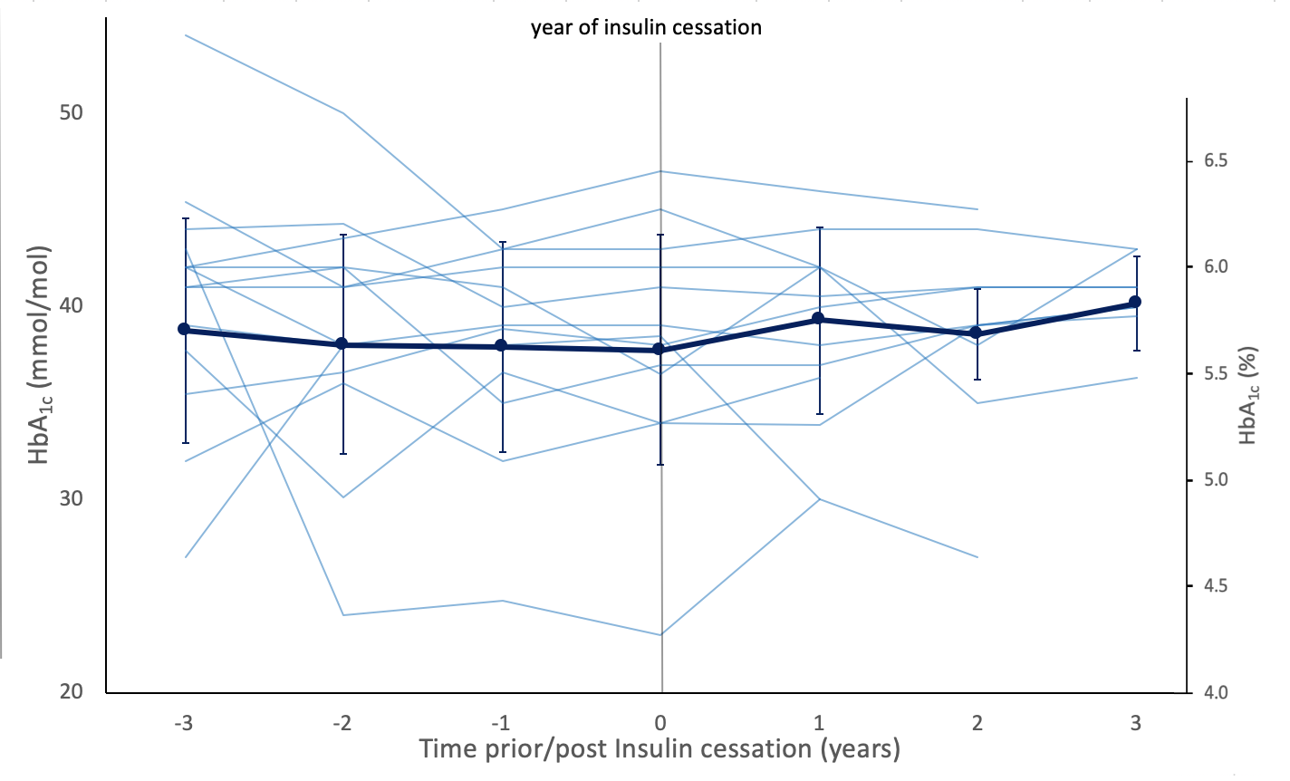

Figure 1b
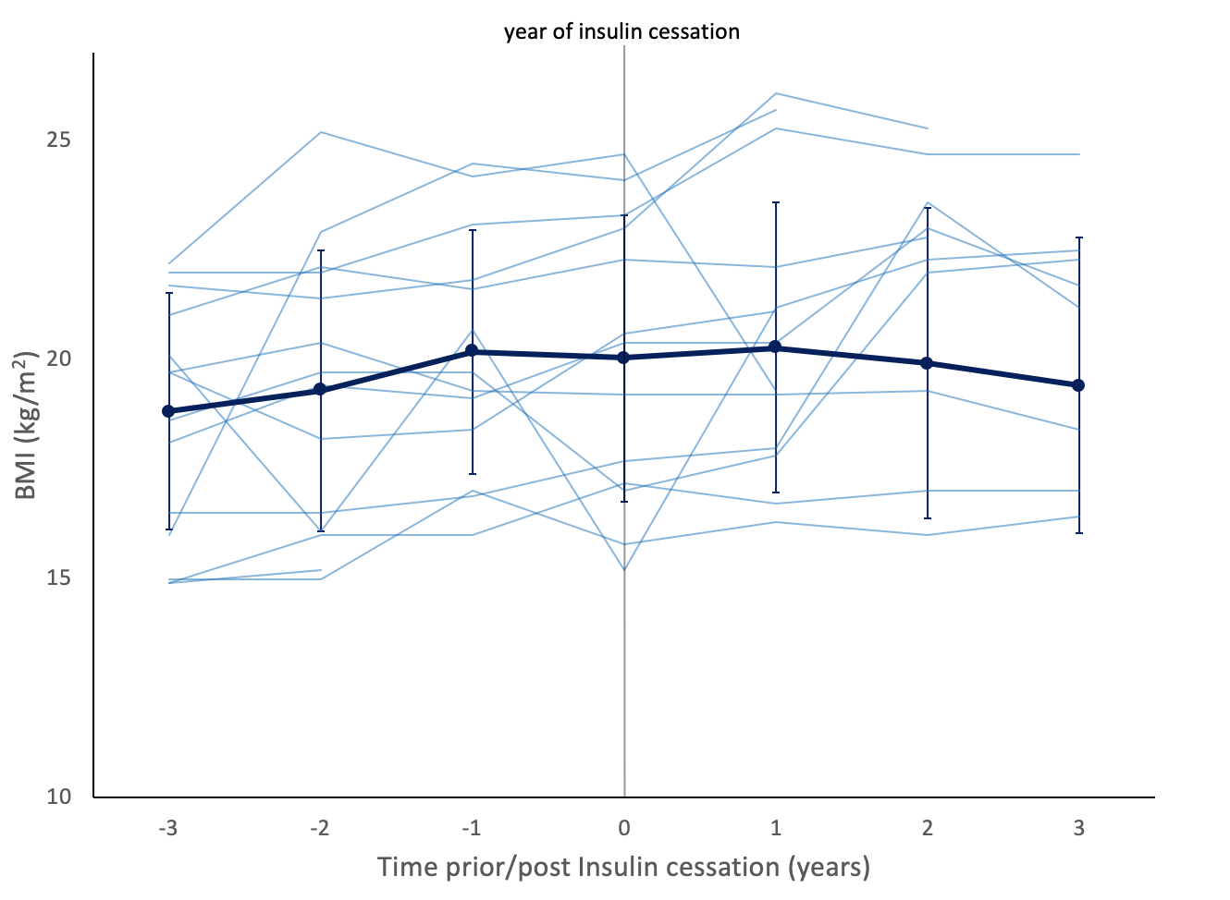
Figure 1c
