Laser-patterned paper-based sensors for rapid point-of-care detection and antibiotic-resistance testing of bacterial infections

Peijun J. W. He^{1*}, Ioannis N. Katis¹, Anto J. U. Kumar¹, Catherine A. Bryant², Charles W. Keevil², Bhaskar K Somani³, Nitin Mahobia⁴, Robert W. Eason¹ and Collin L. Sones¹
1 Optoelectronics Research Centre, University of Southampton, Highfield, Southampton, SO17 1BJ, UK
2 School of Biological Sciences, University of Southampton, Highfield, Southampton, SO17 1BJ, UK
3 Department of Urology, University Hospital Southampton NHS Trust, Southampton, SO16 6YD, UK
4 Department of Infection, University Hospital Southampton NHS Trust, Southampton, SO16 6YD, UK
*Correspondence: P.He@soton.ac.uk; Tel.: + +442380599091
Abstract
Antimicrobial resistance (AMR) has been identified by the World Health Organisation as a global threat that currently claims at least 25,000 deaths each year in Europe and 700,000 globally; the number is projected to reach 10 million per year between 2015 and 2050. Therefore, there is an urgent need for low-cost but reliable point-of-care diagnostics for early screening of infections especially in developing countries lacking in basic infrastructure and trained personnel. This work is aimed at developing such a device, a paper-based microfluidic device for infection testing by an unskilled user in a low resource setting. Here, we present our work relating to the use of our laser-patterned paper-based devices for detection and susceptibility testing of Escherichia coli, via a simple visually observable colour change. The results indicate the suitability of our integrated paper devices for timely identification of bacterial infections at the point-of-care and their usefulness in providing a hugely beneficial pathway for accurate antibiotic prescribing and thus a novel route to tackling the global challenge of AMR.
Keywords: Antimicrobial resistance; Escherichia coli; Point-of-care; Bacterial pathogen detection; Antibiotic-resistance testing; Paper-based device
- Introduction
Antimicrobial resistance (AMR) has been identified by the World Health Organisation as a global threat that currently claims at least 50,000 lives each year across Europe and the US, with many hundreds of thousands more dying in other areas of the world (O’neill 2014). Multi-drug resistant Gram-negative bacteria (MDR-GNB) are a major health problem and the growing resistance to multiple antibiotics in GNB organisms such as Escherichia, Klebsiella and Pseudomonas species poses a clinically significant challenge in hospital medicine. Worldwide, an estimated 250 million urinary tract infections (UTIs) are reported per year and these represent about 40% of all hospital acquired infections (Ronald et al. 2001). They are caused by a wide range of pathogens, including bacteria, fungi, viruses and parasites (Flores-Mireles et al. 2015). UTIs are the most common healthcare associated infections (HCAI) accounting for 17% of all HCAIs, costing approximately £170 million per year in England (Haque et al. 2018). In particular, coliform bacteria (such as E. coli) contribute 50-70% of all such UTIs

Early diagnosis and prompt, targeted antibiotic treatment of any such infection is crucially important for clinical recovery, and prevention of serious antibiotic resistance. Current routine diagnostic protocols involve a preliminary laboratory-based, bacterial-culture using agar plates or broths for up to 2-3 days (Mantle and England 2015). To guide therapy, microorganisms cultured then further undergo antibiotic-susceptibility testing, which takes another 24 hours, to indicate susceptibility/resistance (Schwalbe et al. 2007). Thus, the only available option is often empirical, i.e. broad-spectrum antibiotics prescribed to cover this undesirably prolonged lead-time prior to the availability of the results. Such treatments may be ineffective and associated with a worsening of the patient’s condition, whilst also exacerbating the prevalence of AMR. Moreover, preparation and culture of microorganisms in Petri dishes hinges on aseptic conditions and environments with controlled temperatures and humidity; these conditions could be difficult to achieve in remote settings and low-resource environments. In addition, a sterilization step using an autoclave is always compulsory before they can be disposed of.

On the other hand, rapid bacterial detection tests are also available in market, e.g., the FLEXICULT™ SSI-Urinary Kit (Blom et al. 2002). However, this kit is still expensive and requires one day for bacterial culturing. To date, molecular based biology techniques have also been used to detect microorganisms and in epidemiological studies (Mach et al. 2011), such as multiplex PCR methods used to detect E. coli serogroups (Li et al. 2010). Nevertheless, molecular techniques are limited to the laboratory and should be performed in a closed system to prevent contamination (Liao et al. 2006; Mach et al. 2011), while also requiring expensive equipment and reagents. Further sterilization procedures are again required to dispose of the used devices.

There is an urgent need, therefore for low-cost but reliable point-of-care (POC) diagnostics for early screening of infections especially in developing countries lacking in basic infrastructure and trained personnel (Drain et al. 2014; Sher et al. 2017). Such testing gives immediate results in non-laboratory settings, does not require any technical skills from the user and is relatively inexpensive, making it ideal for use not only in poorly-resourced, remote areas of developing countries, but also in hospitals and at the bedside within well-developed nations. To adhere to the guidelines recommended by the World Health Organization (WHO), an ideal diagnostic test should follow the ASSURED criteria, therefore being affordable, sensitive, specific, user-friendly, rapid and robust, equipment-free and deliverable (Kosack et al. 2017). One example of such POC diagnostics are paper-based fluidic devices, that were first proposed by Whitesides’ group in 2007 (Martinez et al. 2007). Paper-based devices are inexpensive and easy to store, transport, operate and finally dispose of through simple incineration. The demand for low-cost alternatives to conventional diagnostic tools has been the driving force that has spurred significant developments in this field. A range of medical diagnostic assays, ranging from lateral flow type semi-quantitative diagnostic assays to multiplexed tests have already been implemented using such paper-based fluidic devices for diagnosis of not only biomolecules and small molecules such as proteins (Jagadeesan et al. 2012), glucose (Chen et al. 2012) but also nucleic acid (Tang et al. 2017). Moreover, paper-based devices have also been widely studied for diagnosis of infectious diseases (Dirkzwager et al. 2016), detection of viruses (Magro et al. 2017) and bacteria (Shih et al. 2015) and early diagnosis of cancer (Akyazi et al. 2018; Preechakasedkit et al. 2018). In addition, the concept of paper-based analytical devices has also been developed for a range of analytical assays in other areas such as food security (Jokerst et al. 2012; López-Marzo and Merkoçi 2016), environmental monitoring (Meredith et al. 2016) and veterinary diagnostics (Busin et al. 2016).

During the last two decades, various novel paper-based devices have been presented and mostly used for analytical and clinical chemistry, and chromatographic tests for the detection of different chemical species (Berry et al. 2016; Lu et al. 2009; van Amerongen et al. 1994). Two of the most commonly known paper-based clinical tests that involve the lateral flow of bodily fluids, i.e. urine, are the pregnancy test (van Amerongen et al. 1994) and the urine dipsticks that can simultaneously detect glucose, pH, ketone etc.(Ra et al. 2017) Recently, several studies have also reported on the use of paper-based analytical devices for bacteria detection. Lateral flow test strips are the simplest version of paper-based device and have been successfully developed for multiplex analysis of whole bacterial cells, which were applied in POC diagnostics tests. These tests allow real-time, simultaneous detection of bacteria with short analysis times (Li et al. 2011; Zhao et al. 2016). However, due to the lack of sensitivity, a sample pre-concentration or enrichment step is normally required prior to application of the sample onto the device. In addition, such antibody-based detection cannot distinguish between living and dead cells, which is an important requirement for antibiotic treatment (Burnham et al. 2014). In addition to lateral flow devices, paper-based devices have also been reported for culture-based bacteria identification using chromogenic agars (Funes-Huacca et al. 2012; Jokerst et al. 2012; Noiphung and Laiwattanapaisal 2019; Shih et al. 2015) and susceptibility testing (Deiss et al. 2014). However, they can only be used for either detection of bacteria or susceptibility testing against a single antibiotic. To the best of our knowledge, no study has reported on the development of paper-based devices for simultaneous culturing and identification of bacterial species together with multiplexed antibiotic-resistance testing.
- Materials and methods
The work presented here is aimed at developing unique paper-based microfluidic devices for infection testing by an unskilled user in a low resource setting. The device, fabricated using a laser-based technique (He et al. 2018; Katis et al. 2018a), enables both the identification of an infection-causing pathogen (E. coli) and subsequently its susceptibility to various antibiotics, via a simple visually observable colour change. The three-layer paper devices were fabricated using a laser direct-write (LDW) procedure and consist of: a bottom layer containing a chromogenic agar that enables the permissive growth and therefore identification of the desired bacterial pathogen; a middle layer with an inlet port extending out of the device for introduction of the urine sample; and, finally, a top layer with an array of wells containing different antibiotics in different doses for the final susceptibility testing. To enable direct comparison of our method, E. coli growth on a conventional agar plate has been used as a control. For this study, samples with different bacterial concentrations were trialled and the results were based on the counting of the colony number, and bacterial growth was identical on both platforms. Following this, to examine the device performance for susceptibility testing, four antibiotics (amoxicillin, ciprofloxacin, gentamicin and nitrofurantoin) commonly used for treating UTIs were tested. A conventional agar disk diffusion-based susceptibility testing protocol was used as a control and allowed for a direct comparison of the performance of our devices.

2.1 Reagents and materials

The fluidic devices were fabricated within cellulose-based filter papers (CF1) purchased from GE Healthcare, USA. The cover tape used to seal the device was from Kenosha, Netherlands. The transparency film used as the base of the device was from Office Depot, UK. The photopolymer used for creating the boundary walls on transparency film and within cellulose-based filter paper was DeSolite® 3471-3-14 from DSM Desotech, Germany, which is an acrylate-based photopolymer with a viscosity of 10,000 mPa·s at 25°C.

The chromogenic agar used for growing E. coli was CHROMagar E. coli from CHROMagar Microbiology, France. The antibiotics used were amoxicillin (A8523), ciprofloxacin (11850), gentamicin (G1397) and nitrofurantoin (N7878) from Sigma Aldrich, UK. The antibiotic discs used as control were amoxicillin (CT0223B), ciprofloxacin (CT0425B), gentamicin (CT0024B) and nitrofurantoin (CT0034B) from ThermoFisher, UK. The Tryptic Soy Broth (TSB) used was from Sigma Aldrich (22092), UK. The BSA and PBS used in the solutions were obtained from Sigma Aldrich (A2058, P3813), UK.

The artificial urine was made with the recipe that has been previously reported by Keevil (Brooks and Keevil 1997). The components are described in Table 1. The reagents were added to distilled water on a hotplate at 50 ⁰C and left until completely dissolved. The solution was then sterilised by autoclaving at 121⁰C for 25 minutes, then filtered through a disposable filter unit and a vacuum pump into sterile bottles. All the components were purchased from Sigma Aldrich, UK.

Table 1 A list of reagents used to make the artificial urine medium.
Reagent | Amount (g/l) | Reagent | Amount (g/l)
Urea | 10 | Bacteriological peptone (L37) | 1.0
Sodium chloride | 5.2 | Creatinine | 0.8
Sodium sulphate.10H₂O | 3.2 | Magnesium sulphate.7H₂O | 0.49
Sodium bicarbonate | 2.1 | Citric acid | 0.4
Ammonium chloride | 1.3 | Calcium chloride.2H₂O | 0.37
DI-potassium hydrogen phosphate | 1.2 | Lactic acid | 0.1
Potassium hydrogen phosphate | 1.2 | Uric acid | 0.07
Yeast extract | 0.005 | Iron (II) sulphate.7H₂O | 0.0012

  - Fabrication of paper-based device

The basic LDW setup is the same as described in our previous publications where we have demonstrated the usefulness and versatility of this approach in both the manufacturing of diagnostic devices in porous materials (He et al. 2015; Sones et al. 2014), and lateral flow assays with improved performance, i.e. enhance sensitivity(Katis et al. 2018b) and multiplexed detection (He et al. 2018). The schematic of this local-deposition-assisted LDW setup is shown in Figure 1. A photo-polymer was first locally deposited onto the substrate (cellulose filter) with a deposition nozzle at locations pre-defined by the device design. A laser beam that follows the deposition head subsequently illuminated the deposited polymer pattern inducing photo-polymerisation. These laser-cured patterns then define the solid walls of the fluidic structures that confine and transport liquid flows.

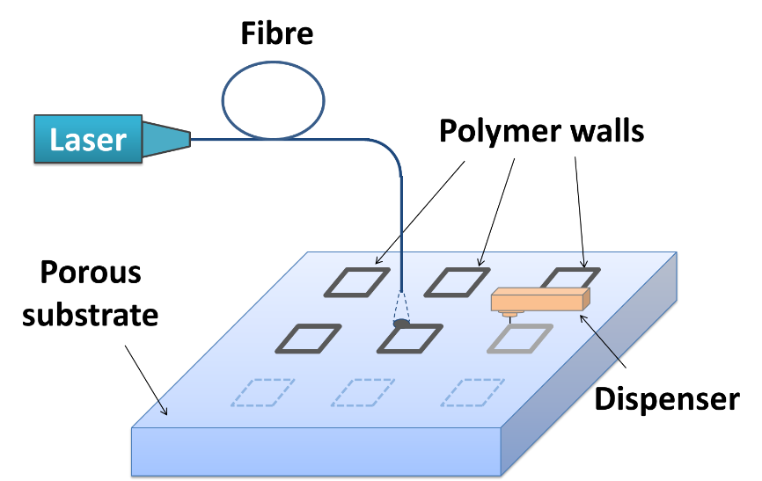
Figure 1 Schematic of the laser-based direct-write setup which shows the local deposition of photo-polymer that is subsequently illuminated by exposure from a 405nm c.w. laser.

The laser used for this LDW process was a 405 nm continuous wave (c.w.) diode laser (MLDTM 405 nm, Cobolt AB, Sweden) with a maximum output power of 110 mW). The dispenser platform used for the local deposition of the photopolymer onto the various substrates was a PICO® Pµlse™ dispensing system from Nordson EFD, UK.

As shown in the schematic in Figure 2, our paper-based device consist of three layers. A bottom layer built of a transparency film with a LDW patterned surface relief frame that contains a chromogenic agar that enables the permissive growth and therefore identification of the desired bacterial pathogen. A middle layer, based on a cellulose-based filter paper, with an inlet port extending out of the device for introduction of the sample. The sample, once introduced via the inlet port, is uniformly distributed into the device via the capillary action. Finally, a top layer, again a cellulose-based filter paper, with an array of laser-patterned wells containing different antibiotics in different doses for the susceptibility testing.

To prepare the device, the designed patterns were first created within the individual layers via the local-deposition-assisted LDW procedure as described above. In the bottom layer, a square frame is defined by the polymer structure, to contain the agar. In the top layer, an array of multiple wells is patterned in order to contain the different antibiotics. After the patterning, all components were sterilised by autoclaving at 121⁰C for 25 minutes. After autoclaving, 1 mL of liquid agar was pipetted into the square of the bottom layer and this volume is just enough to cover the whole area. The bottom layer is then left at room temperature for 10 minutes for the agar to solidify. Twenty microlitres of solutions with different antibiotics at different concentrations were then pipetted into the individual wells within the top layer. This layer was again then left at room temperature to dry for an hour. Finally, to assemble the device, as shown in the schematic in Figure 2, the three individual layers were stacked together in their order and a cover tape was used to seal the device from the top in order to stop evaporation and avoid the contamination both to the device from ambient and to the ambient from the device. A resealable tape was also applied to seal the inlet point that extends out of the device. This resealable tape allows easy introduction of the sample when needed by simple peeling off the tape and then reapplying it to keep the device securely sealed.

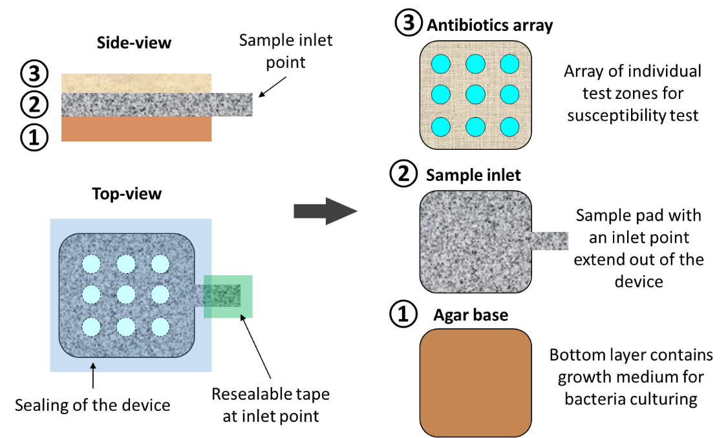
Figure 2 Schematic of the LDW fabricated three-layer paper device for bacteria identification and antibiotic-resistance testing.

  - Preparation of bacteria sample

The E. coli strain used was normally stored in a vial using porous beads under - 20⁰C in the freezer. To make the bacterial solution, the vial was removed from the freezer and moved to an aseptic environment. Under aseptic conditions, one of the beads was removed using a sterile loop. This was followed by inoculation of the bead into a broth medium (TSB). To help mixing of the microorganisms into the medium, the tube was inverted a few times. The beads were removed from the broth medium and the tube was incubated at 37⁰C for 24 hours. The bacterial suspension was then ready to use. Both PBS and artificial urine were used for making different sample dilutions. To determine the bacterial concentration, different dilutions were tested on the agar plate and the concentration was determined using the colony counting method.
- Results and discussion
3.1. Bacteria growth on paper

The initial set of experiments involved studying the growth pattern of bacteria on paper. This was examined by transferring a suspension of bacteria and comparing the growth on an agar plate and on paper impregnated with a hydrolysed agar medium. The stock bacterial suspension was first diluted by 10⁴, 10⁵ and 10⁶ times using PBS to make sure that a countable number of individual colonies will be formed after growth, which is required for quantification. Ten microlitres of these bacterial suspensions were then pipetted onto both an agar plate and a paper-device. An inoculation loop was used to spread the bacteria uniformly across the whole agar plate. For the paper-device, it is assumed that the bacteria are uniformly distributed due to the capillary action of the paper, hence no additional spreading step was performed. To avoid evaporation, the paper-devices were sealed from the top using a cover tape. Finally, the agar plates and paper-devices were stored in an incubator at 37⁰C overnight (~ 18 hours) to allow for bacterial growth.

The results for above are shown in Figure 3 and allow for a direct comparison of the bacterial growth on conventional agar plates and our paper-devices. It can be seen that the growths are very similar on both agar plates and paper-devices. For the stock and 10⁴ sample dilutions, confluent growth with complete films of bacterial colonies, and no identifiable individual colonies were formed, precluding quantification. For a value of 10⁵ sample dilution, individual colonies started to form. Finally, for the 10⁶ dilution, individual colonies are completely separated from each other which makes them easy to count. Hence, this colony counting condition was chosen for further quantification of the bacteria concentration.

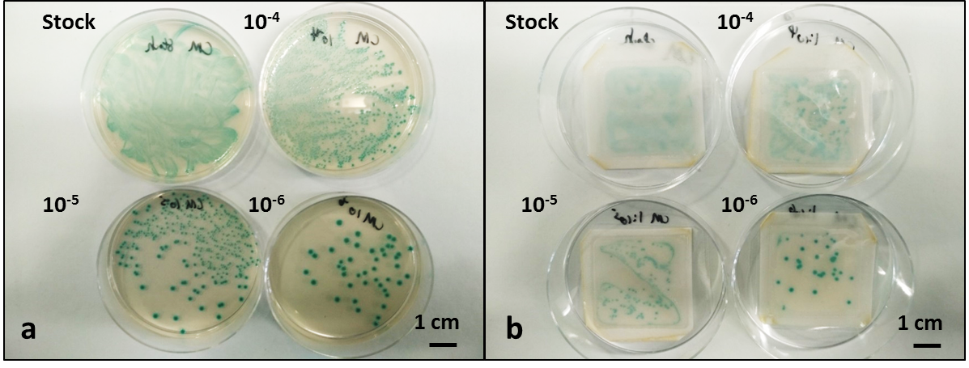
Figure 3 Images showing the growth of E. coli on a) agar plates and b) filter papers under various dilutions after an overnight (of ~ 18 hours) incubation at 37⁰C.

Five repetitions were performed and table 2 shows five colony counts and the corresponding average number of counted colonies. The average number of colonies formed on agar plates and paper-devices are 25 and 24.8 respectively, and the numbers for each of those repetitions are highly consistent.

Table 2 Summary of colony counting for the growth of 10⁶ times diluted bacterial suspensions on both agar plates and paper-devices
Number of colonies | A | B | C | D | E | Average count
Agar plate | 25 | 26 | 27 | 24 | 23 | 25.0
Paper-device | 24 | 27 | 25 | 24 | 24 | 24.8

In microbiology, the concentration of the bacteria is normally defined in terms of a colony-forming unit (CFU), which is an estimate of the number of viable bacteria in a sample. The stock concentration of the bacteria suspension can then be back-calculated using the following equation:
$$Bacteria concentration (CFU/mL) =\frac{Average CFU counting ×dilution factor}{volume of bacterial suspension }$$

Based on the average CFU counts shown in Table 2, for 10 µl of the bacterial suspension with a dilution factor of 10⁶, the concentration of the stock bacteria suspension was evaluated to ~ 2.5 x10⁹ and 2.48 x 10⁹ CFU/ml for the agar plates and paper-based devices, respectively. In conclusion, the growth of the bacteria on our paper-devices is very similar to the growth on conventional agar plates.

  - Antibiotic susceptibility testing on paper

After this first successful trial of growth and identification E. coli on our paper-devices, the next step was to implement antibiotic susceptibility testing. To begin with, instead of directly testing this via an integrated three-layer device, a simpler format, laser-patterned paper-device with antibiotics on an agar plate, was applied to eliminate other possible variations that might accrued from changing the culture base. As shown in Figure 4, the patterned paper-device with an antibiotic array was first tested by laying it on an agar plate. To perform the test, multiple square wells (1 cm by 1 cm) were first patterned in a cellulose paper using the LDW technique shown in Figure 4 to introduce and contain antibiotics. Solutions of different antibiotics or of the same antibiotic with different concentrations were then introduced into these isolated wells and the device was left at room temperature for one hour to dry. An agar plate was prepared by inoculating it with 10 µl of 10⁵ diluted E. coli bacterial suspension followed with a uniform spread using a loop. The paper-device with the antibiotic array was then placed onto the surface of the bacteria-inoculated agar and the plate was then transferred into the incubator for overnight incubation (of ~ 18 hours).

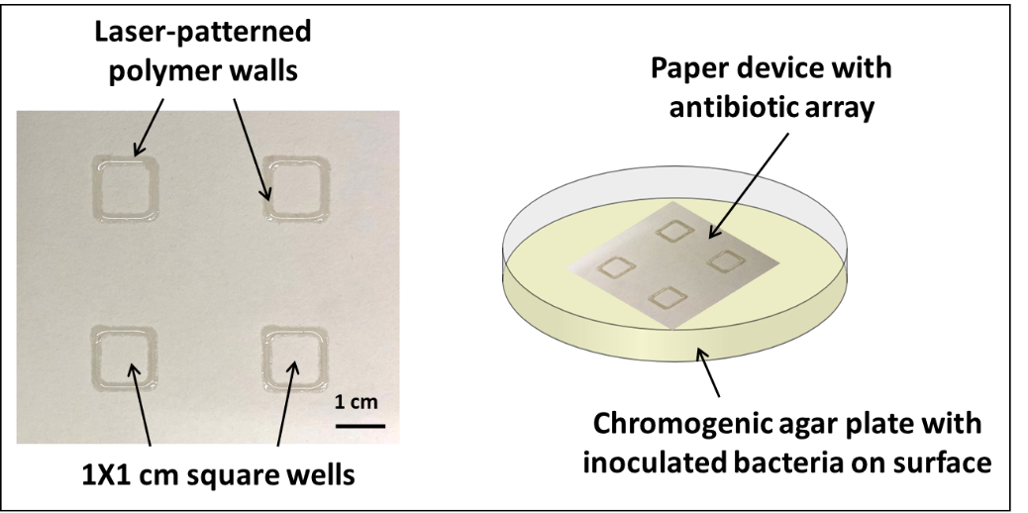
Figure 4 Schematic showing the design of the laser-patterned antibiotic devices and the protocol for implementing of the susceptibility testing.

Four common antibiotics, namely amoxicillin, nitrofurantoin, ciprofloxacin and gentamicin, which are routinely prescribed against E. coli to treat bacterial UTIs were tested (Bean et al. 2008). Different volumes (5, 15, 25 and 35 µl) of the antibiotic solutions with concentrations of 80, 200, 20 and 500 mg/ml for amoxicillin, nitrofurantoin, ciprofloxacin and gentamicin were pipetted into individual laser-patterned wells of four different devices. As shown in the images in Figure 5, at larger volumes, circular inhibition zones were formed due to the diffusion of the antibiotics on the agar surface. This is similar to the conventional disk diffusion test, wherein the size of this inhibition zone is measured in order to determine whether the bacterium being studied is susceptible, moderately susceptible or resistant to the tested antibiotic. A minimum inhibitory concentration (MIC) is defined as the lowest concentration (in mg/L) of an antibiotic that inhibits the growth of a given strain of bacteria.

Since our individual laser-patterned wells allow introduction of antibiotics with different volumes/concentrations, which lead to different final doses in each well, the reading on our devices is simplified to only the identification of the bacteria growth/inhibition within the area of the laser-patterned well. The presence of the bacterial colonies within the wells indicates the resistance of the bacteria to that antibiotic at a certain dose, while a complete inhibition of the growth means the bacteria are sensitive to the antibiotic at this defined dose. As shown in Figure 5, the bacteria were sensitive to amoxicillin and ciprofloxacin for all four volumes and the inhibition zones that extended outside of the square wells increased with the increase of the antibiotic volume. For nitrofurantoin and gentamicin, growth was inhibited with antibiotic volumes at 15 µl and above, while some growths and therefore resistance were observed in the 5 µl wells.

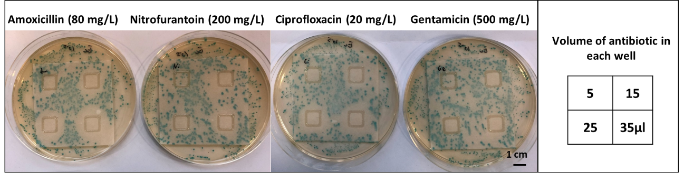
Figure 5 Results showing the E. coli susceptibility test against four antibiotics using our paper-based antibiotic arrays: from left to right: amoxicillin, nitrofurantoin, ciprofloxacin and gentamicin.

  - Comparison of the paper-based device with conventional agar method

The next step was to compare our results for the paper-based device to those obtained using the conventional laboratory-based culture method on agar plates. As a first step, in order to eliminate more than one variation, commercially available antibiotic disks were used with both our paper-devices and agar plates to allow a direct comparison of their performance.

For the testing on agar plates, 10 µl of 10⁵ diluted E. coli bacterial suspension was first pipetted onto the agar surface and then a loop was used to uniformly spread the bacteria across the whole plate. An antibiotic disk was then positioned in the middle of the plate. For the testing on paper-devices, a bottom layer was first prepared via introduction of 500 µl of agar solution into a 3.5 x 3.5 cm square well laser-patterned on a transparency and then left at room temperature for 5 minutes for the agar to solidify. A 3.5 x 3.5 cm square filter paper was then aligned and positioned on top of the solidified agar as a sample inlet layer. Following this, 10 µl of sample was introduced in the middle of the sample layer, for uniform delivery of the sample across the device via capillary action. Lastly, an antibiotic disk was simply added on top of the sample layer and the whole device was sealed using a cover tape. Both the agar plate and the paper-device were then transferred into an incubator at 37 ⁰C for overnight incubation.

The susceptibility testing was preformed against the same four antibiotics - amoxicillin, ciprofloxacin, gentamicin and nitrofurantoin, and these results are shown in Figure 6. The diameters of the inhibition zones formed both on agar plates and paper-device were measured and compared. Ten replicates were performed at each condition and an average value for the diameters were calculated. According to these results, it was found that the E. coli strain used is resistant to gentamicin with inhibition diameter zones smaller than the EUCAST breakpoint (14mm) (diameter of 11.3 and 11.7 mm, respectively, for agar plates and paper-devices). On the other hand, the strain is sensitive to the other three antibiotics with diameters of 28.3, 28.65 and 28.4 mm on agar plates for amoxicillin, ciprofloxacin and nitrofurantoin, respectively, compared to 33.3, 24.95 and 23 mm in paper-devices. Overall, the diameter of the inhibition zones are slightly different on paper-devices to the conventional agar plates, however, with very small variations of less than 1 mm under the same condition. This is due to the different diffusion mechanisms of the antibiotic on an agar surface and in cellulose paper (Bonev et al. 2008).

For the next step, another comparison was also made between paper-devices using commercial antibiotic disks with paper-devices using our laser-patterned antibiotic pads. To implement these experiments, based on the same device design, commercial antibiotic disks were simply replaced by the antibiotic pads that were fabricated using our laser-patterning procedure. To fabricate these antibiotic pads, 1 x 1 cm square wells were first laser-patterned in cellulose paper. Antibiotic solution was then pipetted into the well and left to dry at room temperature. To make our antibiotic pads similar to the commercial ones, the same amount of the antibiotic (30, 5, 10 and 100 µg for amoxicillin, nitrofurantoin, ciprofloxacin and gentamicin, respectively) were used for our wells. The devices were assembled and operated in the same manner as above and these results are as shown in Figure 6. The inhibition zones on our paper-device with laser-patterned antibiotic pads are seen to be very similar to those on the paper-devices with commercial antibiotic disks. As shown in the table in Figure 6, the average diameter over 10 measurements of the inhibition zones for all four antibiotics are almost identical in both cases, with the difference between the two averages being less than the variation of each of the two sets of 10 replicates.

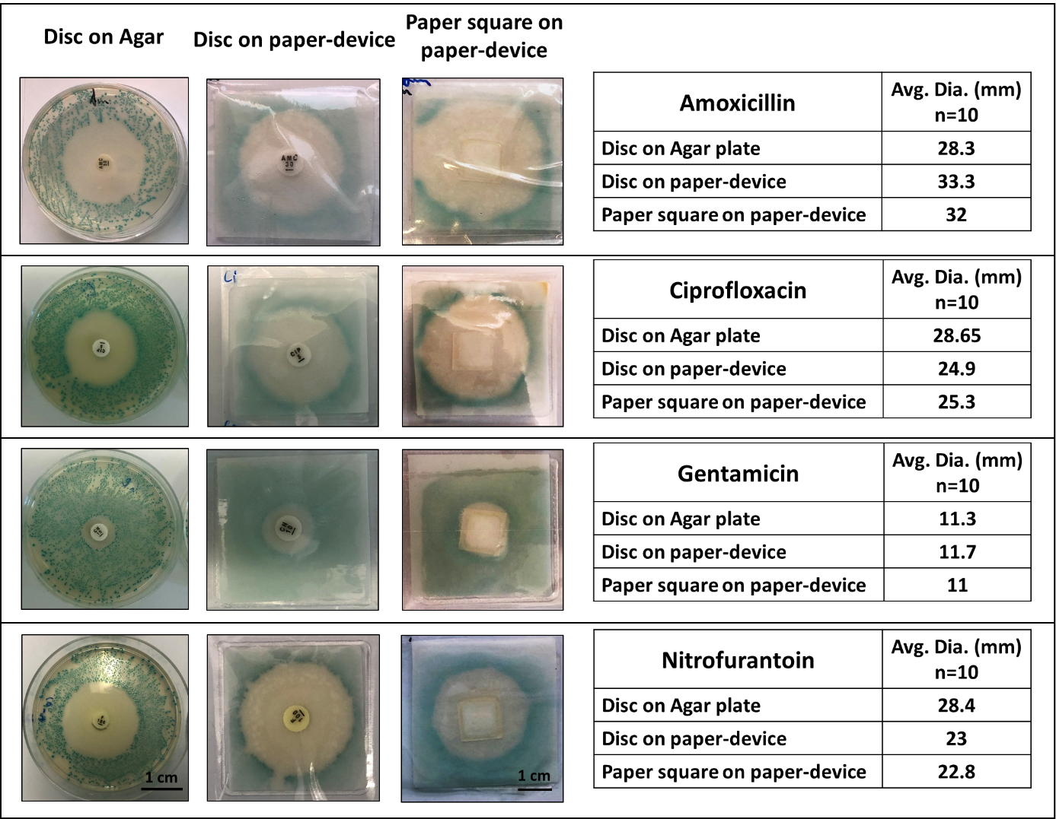
Figure 6 Results of direct comparisons of antibiotic susceptibility testing (E. coli against four antibiotics: amoxicillin, nitrofurantoin, ciprofloxacin and gentamicin) performed on our paper-devices using both commercial antibiotic disks and laser-patterned antibiotic pads with a conventional agar plate.

3.4 Testing of the integrated paper-based devices

After successful implementation and comparison of both bacteria growth and antibiotic susceptibility testing on our paper-device, the next step is to combine them together into a single integrated device. To do this, the design shown previously in Figure 2 was used, with the middle sample layer having an inlet port that extends outside the main reaction area for simple introduction of the sample. The device was assembled as described in Figure 2. When the test was performed, the small sealing tape at the inlet section was peeled off and 50 µl of sample was pipetted onto the inlet port, then the tape was replaced to seal the device to avoid any evaporation as well as contamination.

As an example, the antibiotic chosen for this test was amoxicillin and the results are shown in Figure 7. As shown in the images, three devices were prepared: two with empty antibiotic pads for identification of the bacteria (one for use as a control) and the third with an antibiotic pad that contains 30 µg of amoxicillin for susceptibility testing. Artificial urine spiked with E. coli was used as the sample for testing and un-spiked artificial urine was used as the negative control. As shown in Figure 7, no growth is seen in the control device, while blue colonies can be clearly observed in the device with the E. coli spiked urine sample. In addition, the last device shows the susceptibility testing against amoxicillin. A large inhibition zone can be observed with a diameter of 32 mm. According to the number in Figure 6, we can therefore conclude that this strain is sensitive to amoxicillin.

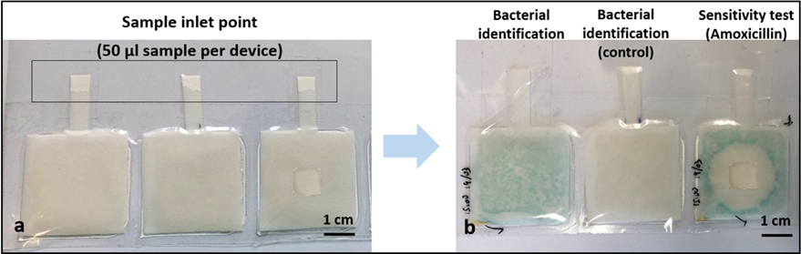
Figure 7 Results of our integrated paper-devices a) before and b) after the testing of E. coli pathogen and antibiotic susceptibility testing against amoxicillin.
- Conclusion
We have developed a unique paper-based microfluidic device that can be used for bacterial infection testing by an unskilled user. The device, fabricated using a laser-based technique, enables both the identification of an infection-causing pathogen, which in this paper used E. coli, and subsequently its susceptibility to antibiotics, via a simple visually observable colour change. A direct comparison of the E. coli growth on a conventional agar plate and our paper-based device was performed. Following this, to examine the device`s usefulness for susceptibility testing, four antibiotics (amoxicillin, ciprofloxacin, gentamicin and nitrofurantoin) commonly used for treating UTIs were tested. A conventional agar-plate based disk diffusion susceptibility testing protocol was used as a control and allowed for a direct comparison of the performance of our devices. The results indicate the suitability of our integrated paper devices for timely identification of bacterial infections at the POC and hence also their potential usefulness in providing a hugely beneficial pathway for accurate antibiotic prescribing and thus a novel route to tackling the global challenge of AMR.
Conflicts of interest
There are no conflicts to declare.
Acknowledgements
We acknowledge Prof. Jane Davies and Mr. Ronan Murphy at Imperial College London for their support and advice in this study. The authors also acknowledge the funding received via the Engineering and Physical Sciences Research Council (EPSRC) under Grant Nos. EP/P025757/1, EP/N004388/1, EP/M027260/1 and EP/S003398/1. The underpinning RDM data for this paper can be found at https://dor.org/10.5258/SOTON/D1174.
References
Akyazi, T., Basabe-Desmonts, L., Benito-Lopez, F., 2018. Review on microfluidic paper-based analytical devices towards commercialisation. Analytica chimica acta 1001, 1-17.
Bean, D.C., Krahe, D., Wareham, D.W., 2008. Antimicrobial resistance in community and nosocomial Escherichia coli urinary tract isolates, London 2005–2006. Annals of clinical microbiology and antimicrobials 7(1), 13.
Berry, S.B., Fernandes, S.C., Rajaratnam, A., DeChiara, N.S., Mace, C.R., 2016. Measurement of the hematocrit using paper-based microfluidic devices. Lab Chip 16(19), 3689-3694.
Blom, M., Sørensen, T.L., Espersen, F., Frimodt-Møller, N., 2002. Validation of FLEXICULT™ SSI-Urinary Kit for Use in the Primary Health Care Setting. Scandinavian journal of infectious diseases 34(6), 430-435.
Bonev, B., Hooper, J., Parisot, J., 2008. Principles of assessing bacterial susceptibility to antibiotics using the agar diffusion method. Journal of antimicrobial chemotherapy 61(6), 1295-1301.
Brooks, T., Keevil, C., 1997. A simple artificial urine for the growth of urinary pathogens. Letters in applied microbiology 24(3), 203-206.
Burnham, S., Hu, J., Anany, H., Brovko, L., Deiss, F., Derda, R., Griffiths, M.W., 2014. Towards rapid on-site phage-mediated detection of generic Escherichia coli in water using luminescent and visual readout. Anal. Bioanal. Chem. 406(23), 5685-5693.
Busin, V., Burgess, S., Shu, W., 2016. A novel multi-pad paper plate (MP3) based assays for rapid animal disease diagnostics. Procedia Engineering 168, 1418-1421.
Chen, X., Chen, J., Wang, F., Xiang, X., Luo, M., Ji, X., He, Z., 2012. Determination of glucose and uric acid with bienzyme colorimetry on microfluidic paper-based analysis devices. Biosensors and Bioelectronics 35(1), 363-368.
Deiss, F., Funes-Huacca, M.E., Bal, J., Tjhung, K.F., Derda, R., 2014. Antimicrobial susceptibility assays in paper-based portable culture devices. Lab on a Chip 14(1), 167-171.
Dirkzwager, R.M., Liang, S., Tanner, J.A., 2016. Development of aptamer-based point-of-care diagnostic devices for malaria using three-dimensional printing rapid prototyping. Acs Sensors 1(4), 420-426.
Drain, P.K., Hyle, E.P., Noubary, F., Freedberg, K.A., Wilson, D., Bishai, W.R., Rodriguez, W., Bassett, I.V., 2014. Diagnostic point-of-care tests in resource-limited settings. The Lancet infectious diseases 14(3), 239-249.
Flores-Mireles, A.L., Walker, J.N., Caparon, M., Hultgren, S.J., 2015. Urinary tract infections: epidemiology, mechanisms of infection and treatment options. Nature reviews microbiology 13(5), 269.
Funes-Huacca, M., Wu, A., Szepesvari, E., Rajendran, P., Kwan-Wong, N., Razgulin, A., Shen, Y., Kagira, J., Campbell, R., Derda, R., 2012. Portable self-contained cultures for phage and bacteria made of paper and tape. Lab on a Chip 12(21), 4269-4278.
Haque, M., Sartelli, M., McKimm, J., Bakar, M.A., 2018. Health care-associated infections–an overview. Infection and drug resistance 11, 2321.
He, P., Katis, I., Eason, R., Sones, C., 2018. Rapid Multiplexed Detection on Lateral-Flow Devices Using a Laser Direct-Write Technique. Biosensors 8(4), 97.
He, P.J., Katis, I.N., Eason, R.W., Sones, C.L., 2015. Laser-based patterning for fluidic devices in nitrocellulose. Biomicrofluidics 9(2), 026503.
Jagadeesan, K.K., Kumar, S., Sumana, G., 2012. Application of conducting paper for selective detection of troponin. Electrochemistry Communications 20, 71-74.
Jokerst, J.C., Adkins, J.A., Bisha, B., Mentele, M.M., Goodridge, L.D., Henry, C.S., 2012. Development of a paper-based analytical device for colorimetric detection of select foodborne pathogens. Analytical chemistry 84(6), 2900-2907.
Katis, I.N., He, P.J., Eason, R.W., Sones, C.L., 2018a. Improved sensitivity and limit-of-detection of lateral flow devices using spatial constrictions of the flow-path. Biosensors and Bioelectronics 113, 95-100.
Katis, I.N., He, P.J., Eason, R.W., Sones, C.L., 2018b. Improved sensitivity and limit-of-detection of lateral flow devices using spatial constrictions of the flow-path. Biosensors and Bioelectronics.
Kosack, C.S., Page, A.-L., Klatser, P.R., 2017. A guide to aid the selection of diagnostic tests. Bulletin of the World Health Organization 95(9), 639.
Li, C.-z., Vandenberg, K., Prabhulkar, S., Zhu, X., Schneper, L., Methee, K., Rosser, C.J., Almeide, E., 2011. Paper based point-of-care testing disc for multiplex whole cell bacteria analysis. Biosensors and Bioelectronics 26(11), 4342-4348.
Li, D., Liu, B., Chen, M., Guo, D., Guo, X., Liu, F., Feng, L., Wang, L., 2010. A multiplex PCR method to detect 14 Escherichia coli serogroups associated with urinary tract infections. Journal of microbiological methods 82(1), 71-77.
Liao, J.C., Mastali, M., Gau, V., Suchard, M.A., Møller, A.K., Bruckner, D.A., Babbitt, J.T., Li, Y., Gornbein, J., Landaw, E.M., 2006. Use of electrochemical DNA biosensors for rapid molecular identification of uropathogens in clinical urine specimens. Journal of clinical microbiology 44(2), 561-570.
López-Marzo, A.M., Merkoçi, A., 2016. based sensors and assays: a success of the engineering design and the convergence of knowledge areas. Lab on a Chip 16(17), 3150-3176.
Lu, Y., Shi, W., Jiang, L., Qin, J., Lin, B., 2009. Rapid prototyping of paper‐based microfluidics with wax for low‐cost, portable bioassay. Electrophoresis 30(9), 1497-1500.
Mach, K.E., Mohan, R., Baron, E.J., Shih, M.-C., Gau, V., Wong, P.K., Liao, J.C., 2011. A biosensor platform for rapid antimicrobial susceptibility testing directly from clinical samples. The Journal of urology 185(1), 148-153.
Magro, L., Jacquelin, B., Escadafal, C., Garneret, P., Kwasiborski, A., Manuguerra, J.-C., Monti, F., Sakuntabhai, A., Vanhomwegen, J., Lafaye, P., 2017. based RNA detection and multiplexed analysis for Ebola virus diagnostics. Scientific reports 7(1), 1347.
Mantle, S., England, N., 2015. Reducing HCAI-What the Commissioner needs to know. NHS England 8.
Martinez, A.W., Phillips, S.T., Butte, M.J., Whitesides, G.M., 2007. Patterned Paper as a Platform for Inexpensive, Low Volume, Portable Bioassays. Angewandte Chemie (International ed. in English) 46(8), 1318-1320.
Meredith, N.A., Quinn, C., Cate, D.M., Reilly, T.H., Volckens, J., Henry, C.S., 2016. based analytical devices for environmental analysis. Analyst 141(6), 1874-1887.
Noiphung, J., Laiwattanapaisal, W., 2019. Multifunctional Paper-Based Analytical Device for In Situ Cultivation and Screening of Escherichia coli Infections. Scientific reports 9(1), 1555.
O’neill, J., 2014. Antimicrobial resistance: tackling a crisis for the health and wealth of nations. Review on antimicrobial resistance 1(1), 1-16.
Preechakasedkit, P., Siangproh, W., Khongchareonporn, N., Ngamrojanavanich, N., Chailapakul, O., 2018. Development of an automated wax-printed paper-based lateral flow device for alpha-fetoprotein enzyme-linked immunosorbent assay. Biosensors and Bioelectronics 102, 27-32.
Ra, M., Muhammad, M.S., Lim, C., Han, S., Jung, C., Kim, W.-Y., 2017. Smartphone-based point-of-care urinalysis under variable illumination. IEEE journal of translational engineering in health and medicine 6, 1-11.
Ronald, A., Nicolle, L., Stamm, E., Krieger, J., Warren, J., Schaeffer, A., Naber, K., Hooton, T., Johnson, J., Chambers, S., 2001. Urinary tract infection in adults: research priorities and strategies. International journal of antimicrobial agents 17(4), 343-348.
Schwalbe, R., Steele-Moore, L., Goodwin, A.C., 2007. Antimicrobial susceptibility testing protocols. Crc Press.
Sher, M., Zhuang, R., Demirci, U., Asghar, W., 2017. based analytical devices for clinical diagnosis: recent advances in the fabrication techniques and sensing mechanisms. Expert Review of Molecular Diagnostics 17(4), 351-366.
Shih, C.-M., Chang, C.-L., Hsu, M.-Y., Lin, J.-Y., Kuan, C.-M., Wang, H.-K., Huang, C.-T., Chung, M.-C., Huang, K.-C., Hsu, C.-E., 2015. based ELISA to rapidly detect Escherichia coli. Talanta 145, 2-5.
Sones, C., Katis, I., He, P., Mills, B., Namiq, M., Shardlow, P., Ibsen, M., Eason, R., 2014. Laser-induced photo-polymerisation for creation of paper-based fluidic devices. Lab Chip 14(23), 4567-4574.
Tang, R., Yang, H., Gong, Y., You, M., Liu, Z., Choi, J.R., Wen, T., Qu, Z., Mei, Q., Xu, F., 2017. A fully disposable and integrated paper-based device for nucleic acid extraction, amplification and detection. Lab on a Chip 17(7), 1270-1279.
van Amerongen, A., van Loon, D., Berendsen, L.B., Wichers, J.H., 1994. Quantitative computer image analysis of a human chorionic gonadotropin colloidal carbon dipstick assay. Clinica chimica acta 229(1-2), 67-75.
Zhao, Y., Wang, H., Zhang, P., Sun, C., Wang, X., Wang, X., Yang, R., Wang, C., Zhou, L., 2016. Rapid multiplex detection of 10 foodborne pathogens with an up-converting phosphor technology-based 10-channel lateral flow assay. Scientific reports 6, 21342.

