Enhanced Creep Resistance of an Ultrafine-grained Ti-6Al-4V Alloy with Modified Surface by Ion Implantation and (Ti+V)N Coating

Irina P. Semenova*, Konstantin S. Selivanov, Roman R. Valiev, Iulia M. Modina, Marina K. Smyslova, Alexander V. Polyakov, Terence G. Langdon

Prof. I. P. Semenova, Ph.D. K. S. Selivanov, Ph.D. R. R. Valiev, I. M. Modina, Ph.D. M. K. Smyslova, Ph.D. A. V. Polyakov
Institute of Physics of Advanced Materials, Ufa State Aviation Technical University, 12 K. Marx St., Ufa, 450008, RF
E-mail: semenova-ip@mail.ru

Prof. T. G. Langdon
Materials Research Group, Department of Mechanical Engineering, University of Southampton, Southampton SO17 1BJ, UK

Keywords: Ti-6Al-4V alloy, ultrafine-grained structure, ion implantation, (Ti+V)N coating, creep behavior.

This research examines the creep behavior of an ultrafine-grained (UFG) Ti-6Al-4V alloy processed by equal-channel angular pressing followed by extrusion. It is shown that modifying the surface of the UFG alloy with nitrogen ions and then applying of a coating of (Ti + V) N inhibits the softening of the UFG alloy at temperatures up to 700 K due to a barrier effect in which the coating hinders the release of dislocations onto the surface. The differences in the mechanisms of crack initiation and failure of UFG samples were also examined both with and without a coating. The prospects of the proposed approach to the improvng of titanium alloys are discussed, including the formation of an UFG structure in the bulk of the material and subsequent modification by ion-plasma methods for the manufacture of highly loaded parts operating at elevated operating temperatures.
1. Introduction
Titanium alloys are widely used in the construction of aircraft engines due to their high specific strength and corrosion resistance. Critical parts of the gas-turbine engines, such as the blades from Ti alloys, are subjected to high tensile cyclic stresses and erosive wear at elevated temperatures in the aggressive environments. Therefore, numerous requirements are imposed on the mechanical properties of these parts, including a high fatigue strength, an erosive wear resistance and a creep rupture strength.
In practice, it is well established that Ti alloys may have a wide range of properties depending on the alloying components and the associated control over processing and microstructure. In the last two decades, much attention has been devoted to the potential for enhancing the mechanical properties of a wide range of metals and alloys by forming ultrafine-grained (UFG) and nanocrystalline structures using severe plastic deformation (SPD) techniques.^{[1-3]} The Ti-6Al-4V alloy, due to its favorable combination of alloying elements, is used widely as a structural material in aircraft and engine building and the formation of UFG structures in this alloy by different SPD techniques provides an opportunity for balancing the mechanical properties including the overall strength, ductility, fatigue resistance, fracture toughness and impact strength.^{[4-10]} It should be noted that most research to date has involved examinations of the creep properties of the Ti-6Al-4V alloy at temperatures of the order of 823 and 873 K in different structural states including the submicrocrystalline state produced by SPD techniques.^{[11,12]} Thus, there have been no earlier studies on the creep behavior at relatively low temperatures close to the operating temperatures for this alloy in the range from 473 to 673 K.^{[13]} It was previously shown that the Ti-6Al-4V alloy in the UFG state demonstrates the thermal stability of the structure and creep resistance at temperatures up to 573 K, however, at higher test temperatures, the alloy softens due to the development of grain recovery and enlargement processes.^{[11,14]} This means that studies of the creep resistance of Ti alloys remain an important task for use of these alloys in aerospace applications.
A possible method for increasing the creep resistance in Ti alloys is by employing a surface modification using ion-plasma techniques.^{[15-18]} In particular, an ion implantation of the surface of Ti alloys with nitrogen or carbon creates a subsurface layer containing a TiN or TiC phase and this introduces a barrier for the emission of dislocations from the internal volume onto the surface.^{[16]} A creep resistance enhancement may be expected also by applying different films and coatings using vacuum-plasma techniques. In this latter case the barrier will be the coating which, having a high elastic modulus compared to the substrate, will contribute to the blocking of surface dislocation sources and/or the creation of a barrier for dislocations approaching the surface.^{[19,20]}
Thus, a new approach for enhancing properties, both at room and elevated temperatures, is by combining a UFG structure in the material volume with a coating applied on the surface by a vacuum-plasma technique.^{[21-23]} A recent report documented a positive impact for using a coating of (Ti+V)N with a retention of enhanced strength in a UFG Ti-6Al-4V alloy in tension at temperatures of 600 to 700 K.^{[24]} At these temperatures it was shown that the ultimate tensile strength of a UFG sample with a coating was much higher than for UFG or CG samples without coatings. This suggests that in the long-term the coating may restrict any softening of the UFG alloy and thereby facilitate an improvement in creep resistance.
The aim of the present research was to study the impact of creep resistance of a UFG Ti-6Al-4V alloy processed by equal-channel angular pressing (ECAP) with subsequent extrusion and to include a combination of (Ti+V)N coatings applied on the sample surface by a vacuum-plasma technique. In this work prior to the coating application, the surface of samples was prepared by ion implantation with N⁺ to create a diffusion layer which increased the adhesive strength of the coating. The results obtained are examined in order to evaluate the potential application perspectives for the production of high-load parts using the UFG alloy with an appropriate coating.
2. Materials and procedures
The experiments were conducted with a Ti-6Al-4V alloy produced in the form of hot-rolled rods with a diameter of 20 mm and with the following chemical composition (in wt.%): 6.2 Al, 4.3 V, 0.02 Zr, 0.039 Si, 0.16 Fe, 0.06 C, 0.168 O, 0.015 N, 0.003 H, Ti-base. The initial samples having diameters of 20 mm and lengths of 105 mm were subjected to processing following a pre-developed technique consisting of a preliminary heat treatment (HT) by quenching from 1223 K (heating during 20 min) and subsequent annealing at 948 K for 4 hours, ECAP at a temperature of 973 K on a die-set having a channel intersection angle of 120° and then further extrusion at 573 K.^{[8]}
The microstructures of the samples were examined by transmission electron microscopy (TEM). The samples for foils were cut using electrical discharge machining and then mechanically thinned to a thickness of ~100 μm and electro-polished using a TenuPol-5 facility with a solution of 5% perchloric acid, 35% butanol, and 60% methanol, at a polishing temperature within the range from 293 to 238 K. The microstructures were examined using a JEOL JEM 2100 microscope operating with an accelerating voltage of 200 kV.
Each sample surface was subjected to an electrolyte-plasma treatment (EPT), a subsequent ion implantation (designated as ii) with nitrogen N⁺. Processing details are described in previous work.^{[25]} The physical vapor deposition (PVD) coating of (Ti+V)N was applied on the cylindrical samples in a vacuum plant WATT-900-3D.^{[24]} The PVD coating consisted of two alternating intermediate Ti layers and two main layers of (Ti + V)N with a total thickness of ~5 μm.^{[24]}
Cylindrical samples with a gauge length of 15 mm and a diameter of 3 mm were subjected to tensile testing on an Instron testing machine at an initial strain rate of έ = 1∙10⁻³ s⁻¹ with at least 3 samples tested separately for each state. Creep tests were conducted to evaluate the life duration of the UFG alloy at a constant stress and at temperatures of 573, 623 and 673 K in accordance with the appropriate ASTM standard.^{[23]} The surface fracture features were examined after testing using a scanning electron microscope JEOL JSM 6390 (SEM).
3. Experimental results
3.1 Samples microstructure and surface characterization.
Figure 1 displays the microstructural images of the Ti-6Al-4V alloy in 2 states: (a) as-received, and (b) after HT+ECAP+extrusion. The microstructure in the initial state consisted of deformed α-phase plates in the β-matrix after hot rolling at the temperature below the β-transus (Figure 1a).
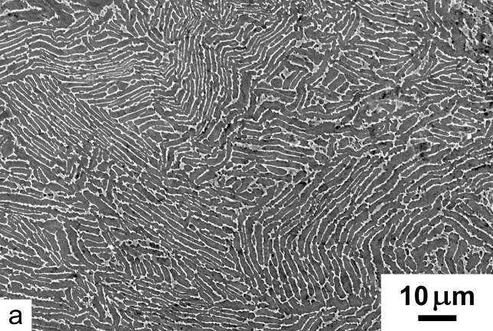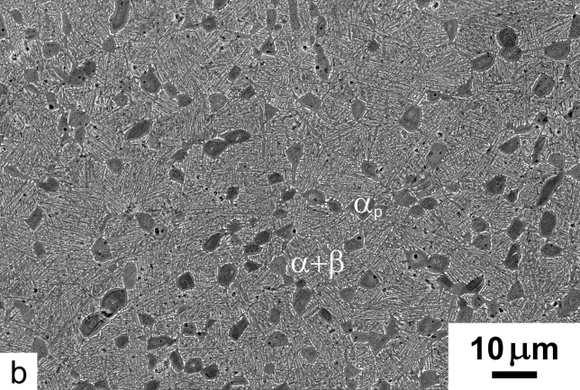
Figure 1. SEM-images of the Ti-6Al-4V microstructure (а) in the initial state, (b) after ECAP+extrusion.

After ECAP and extrusion, grains of the primary α-phase are elongated along the deformation direction in the longitudinal section of the billet with boundaries having an indistinct configuration (Figure 1b). In the two-phase areas of the microstructure, the α-phase grains also have an elongated shape (Figure 2a) and in the transverse section of the sample the size of grains and subgrains of the α-phase was on average ~250 nm (Figure 2b).
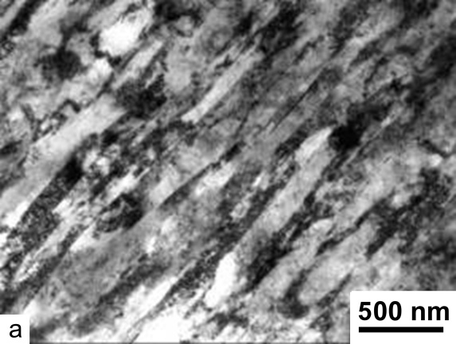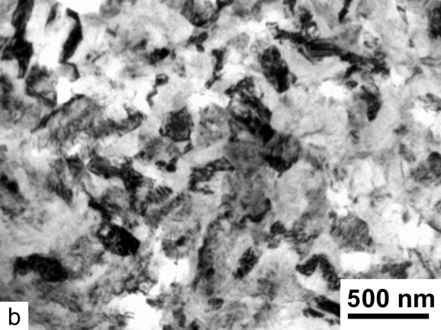
Figure 2. TEM-images of the Ti-6Al-4V alloy microstructure after ECAP and extrusion: а – longitudinal section; b – cross section.

According to X-ray analysis, the dislocation density, ρ, increases from ~0.19 to ~4.73 ×10¹⁵ m⁻² and the internal elastic stresses, <ε²>, increase almost 8 times in the alloy microstructure (Table 1). The size of the coherent scattering regions (CSR) decreases from ~77 nm in the initial state to ~23 nm after ECAP but subsequent extrusion produces no significant additional reduction in the CSR size.
Table 1. Substructure parameters obtained by X-ray analysis.
State | CSR [nm] | <ε ²> [×10⁻⁴] | ρ [×10¹⁵ m⁻²]
Initial | 77±16 | ∼11 | ∼0.19
After ECAP+extrusion | 23±3 | ∼80 | ∼4.73

Usually at ion implantation the penetration depth of nitrogen in the surface of the Ti-6Al-4V alloy does not exceed ~6 µm.^{[25]} The microstructure and chemical composition of the coating were described in an earlier report.^{[24]}
3.2 Mechanical properties at room temperature.
Figure 3 displays the typical tensile curves of the Ti-6Al-4V samples in 3 states: in the initial CG state, after ECAP and extrusion (UFG state) and the UFG samples with ion implantation +coating (UFG+ii+coating) state.
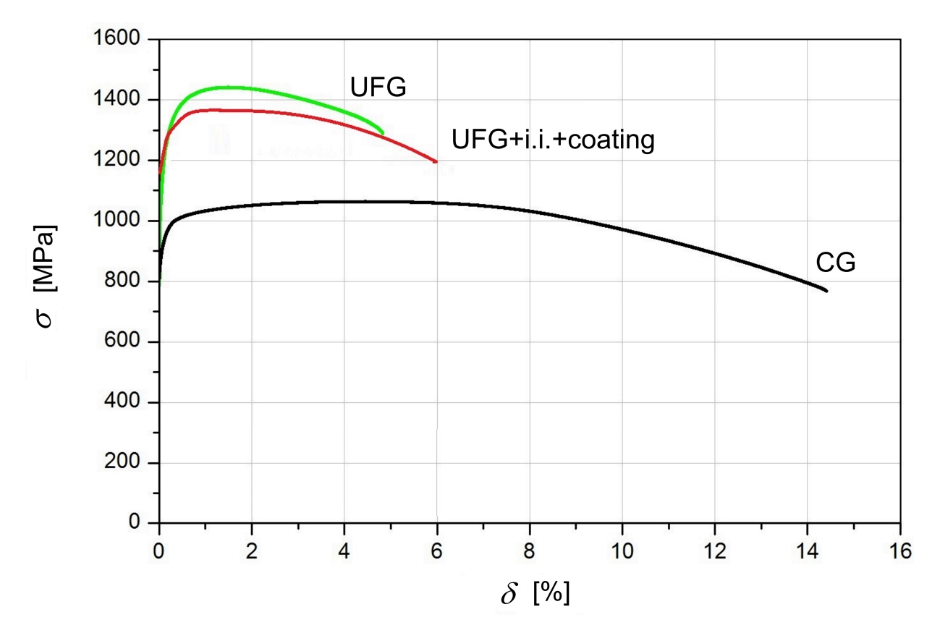
Figure 3. Typical tensile curves of Ti-6Al-4V samples in 3 states: CG, UFG and UFG with i.i.+coating.

Table 2 lists the values of the mechanical properties of samples and the surface microhardness. The formation of a UFG structure in the Ti-6Al-4V alloy by ECAP and extrusion gives an increase in the ultimate tensile strength from ~1065 to ~1446 MPa.
Table 2. Mechanical properties of Ti-6Al-4V alloy.
States | UTS [MPa] | YS0.2 [MPa] | Elong. [%] | HV of surface [GPa]
CG | 1065±35 | 980±30 | 14.0±1.0 | 3.2±0.1
UFG | 1446±30 | 1300±30 | 6.0±0.5 | 4.4±0.1
UFG+i.i.+coating | 1350±20 | 1280±25 | 8.5±0.7 | 12.0±0.5

The relative elongation decreases by more than two times due to the accumulation of both a high dislocation density and internal elastic stresses which are typical of many materials subjected to severe plastic deformation.^{[2]}
After the (ii+coating) application on the sample surface, there was some increase in the relative elongation from 6 to 8% which was accompanied by an insignificant (<10%) drop in the ultimate tensile strength to ~1350 MPa (Table 2). Such behavior of samples is attributed to the relaxation of internal stresses as a result of an enhancement of the dislocation mobility during ion implantation and local heating of the surface during the vacuum-plasma sputtering.^{[22]} The microhardness values, HV, of the surfaces of the CG and UFG samples were ~3.2±0.1 and ~4.4±0.1 GPa, respectively. The microhardness of the coating was ~12±0.5 GPa which is about 3 times higher than the value of HV in the UFG material (Table 2).
3.3 Impact of ii+(Ti+V)N coating on creep behavior of the UFG alloy
Figure 4 sums up the experimental results of the 100 hour tests at 573, 623 and 673 K at different constant stresses in CG and UFG Ti-6Al-4V alloy, shown earlier and in UFG samples after ii+coating in the present work.^{[14]} It is seen that the creep rupture strength of the alloy in all states reduces with the testing temperature increasing from 573 to 723 K.
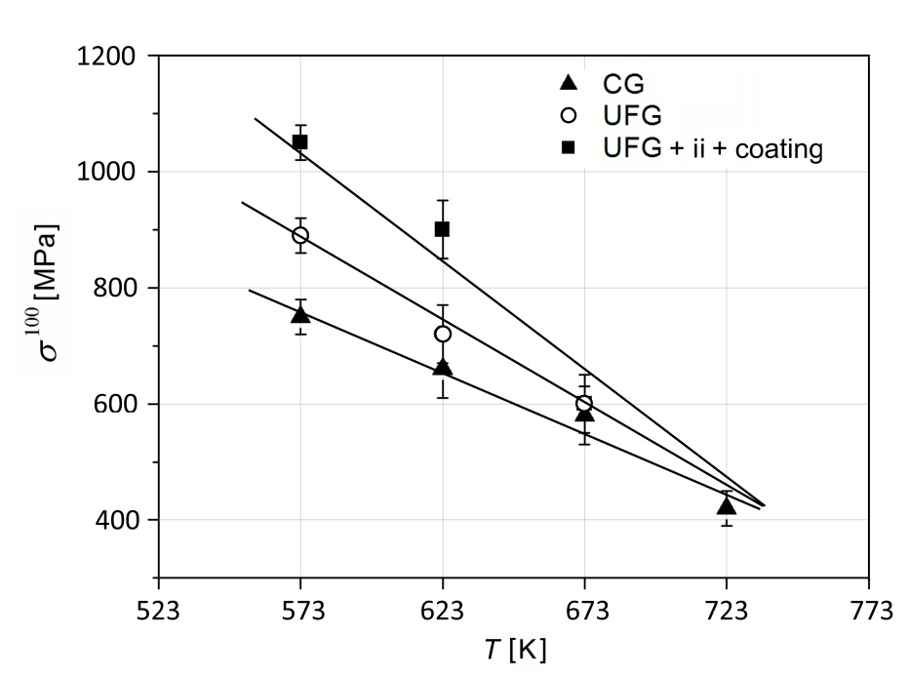 /
Figure 4. 100-hour creep rupture strength of Ti-6Al-4V in the CG and UFG states [25] and UFG with i.i.+coating.

In the temperature range that does not exceed 673 K, the UFG alloy demonstrates the enhanced heat resistance as compared to the CG material, and at a temperature of 723 K the creep rupture strength of the CG and UFG alloy is practically the same, which is conditioned by the recovery and recrystallization processes during long-term dwelling under stress.^{[14]} Evidently these processes in the UFG alloy occur more actively, as different slopes of the curves point at that in Figure 5.
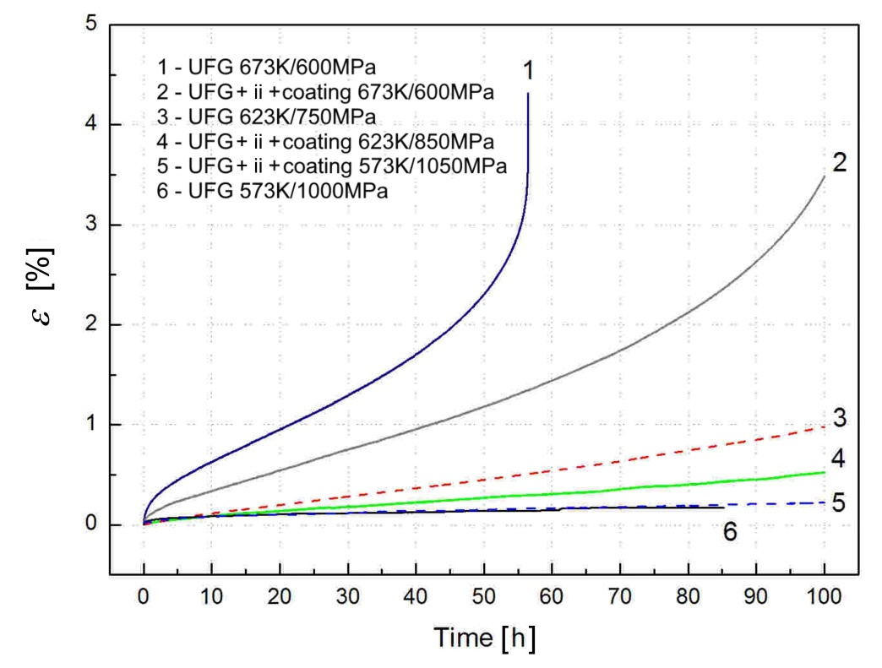
Figure 5. “Strain-time” creep curves of samples with (1,3,6) UFG structure and (2,4,5) UFG with coating

The coated UFG samples withstand 100 hours without failure at much higher stresses. For example, at 573 K the UFG sample withstood a stress of 900 MPa, whereas the coated sample withstood 1050 MPa. At 673 K the coated UFG sample dwelt over 100 hours at 600 MPa, whereas the UFG sample without coating failed after 56 hours of testing.
In order to estimate the creep resistance of UFG samples with and without coating, Figure 5 was prepared to provide a summary of the typical creep curves for tests conducted at 573, 623 and 673 K performed in both conditions. The UFG alloy without and with a coating demonstrates a good creep resistance at 623 and 573 K (curves 3,4 and 5,6 in Figure 5, respectively) as a constant creep rate prevails which is probably associated with a stable dislocation configuration due to the recovery and hardening processes.
The creep curves of the samples in both states at 673 K (curves no. 1 and 2 in Figure 5) are characterized by typical creep stages consisting of the conventional primary, secondary (steady-state) and tertiary regions. In practice, the UFG sample (no. 1) shows a lower creep resistance at 673 K than the UFG sample with coating (no. 2) which is connected with differences in the mechanisms of crack initiation in the coating and metal surface. This is confirmed by the occurrence of different deformation relief of the samples with and without coating after testing (Figure 6a,b).
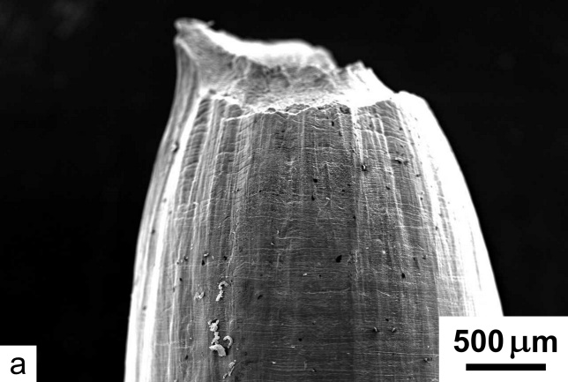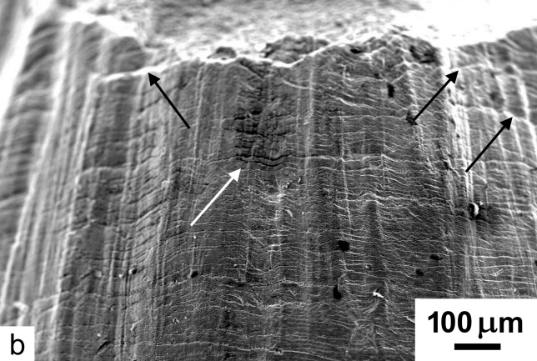
Figure 6. SEM-images of the surface of UFG samples without coating after testing: (a) general view of the gauge part and (b) deformation relief.

It is evident that in the uncoated sample under conditions of tension and temperature impact, there is a continuous increase in the numbers of dislocations and slip bands. As a result of the work of plastic strain, a typical relief with Chernov-Lüders bands and ring-shaped microcracks forms on the surface (Figure 6). The coated sample under loading has evidently a more complex stress-strain state and it is apparent in Figure 7a,b that the coated sample surface has a net of microcracks which develop at an angle of about 45º to the sample axis and thus confirm the development of shear strains and subsequent coating failure.
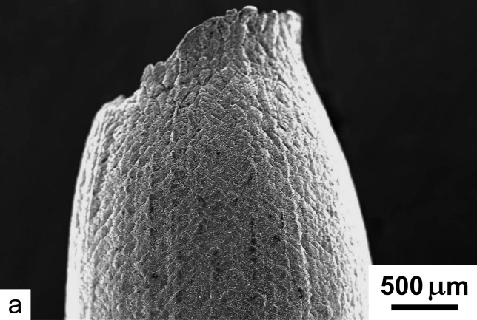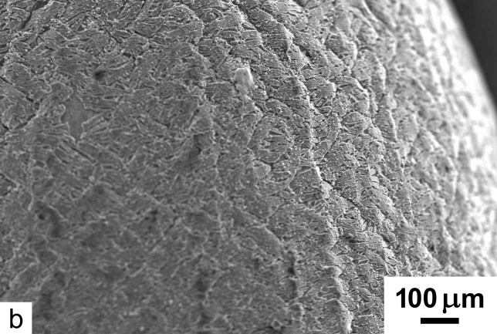
Figure 7. SEM-images of the surface of UFG samples with (Ti+V)N coating after testing: (a) general view of the gauge zone and (b) deformation relief.

To show this effect in more detail, Figure 8a,b displays the peeling of the coating from the sample surface after testing.
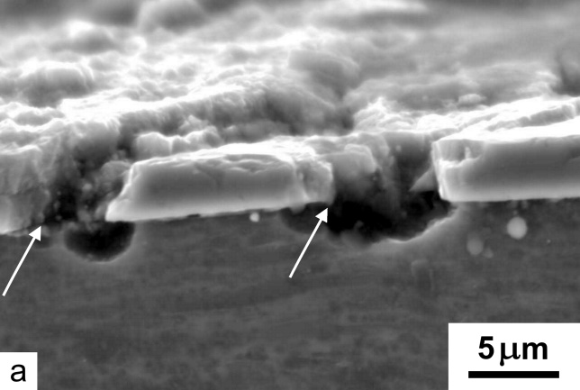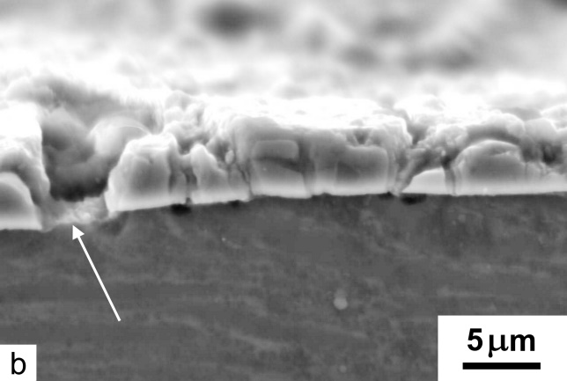
Figure 8. SEM-images of the section of the coated sample: coating microcracks and adhesive peel-off of the coating are shown with arrows.

In the peel-off spots at the coating-substrate interface, the plastic strain of the base material appears as dimples (marked by arrows) which perhaps are a result of an abnormal increase in the dislocation density.
4. Discussion
Structural Ti alloys operating at elevated temperatures are subjected to oxidation and erosive wear. Therefore, coatings of various compositions are often applied to protect the surface of the components. In the present research special attention was paid to the impact of the surface modification including EPT, ion implantation and vacuum-plasma sputtering of the (Ti+V)N coating on the creep behavior of the UFG Ti-6Al-4V alloy. The test results show that there is a considerable increase in the 100 hour creep rupture strength of the UFG samples with a coating at temperatures of about 600-700 K by comparison with a UFG alloy without any coating. A similar effect was observed in an earlier single tensile test.^{[21]} Evidently this represents the so-called “barrier effect” of the coating and a number of investigations have been conducted to explain this phenomenon in the following ways:
(1) Much higher stresses are required for microcrack initiation in the case of a coating with a much higher elastic modulus compared to that of the substrate;
(2) Plastic straining occurs mainly in the coating leading to an accumulation of dislocations;
(3) There is an implementation of the blocking mechanism when the coating hinders the release of dislocations onto the surface;
(4) There is an elastic repulsion between dislocations in the substrate at the boundary with the coating.^{[19,20,22,26]}
In the present research the values of the elastic modulus of the UFG alloy and the alloy with the coating were about 112 and 256 GPa.^{[24]} The prevailing accumulation of strain in the coating was confirmed by the occurrence of multiple microcracking, part of which did not spread in the substrate. In fact, when the acting stress was higher than the adhesive strength of the coating, the coating peeled off the substrate (Figure 8). The formation of plastic zones in the crack tips, which do not spread in the substrate, represent potential barriers for dislocation motion.^{[26]}
Furthermore, this barrier effect of the coating may be implemented not only at room temperature but also at relatively low temperatures when the recovery and recrystallization processes of the structure are not dominant. This contrasts with testing at temperatures above 673 K where there is considerably more softening of the alloy including the coated samples (Figure 4).
Considering the creep behavior of the UFG samples with and without a coating, it is observed that the coating on the substrate from the UFG alloy changes the surface failure mechanism during the long-term temperature impact and tensile stresses which produces different deformation relief of the sample surfaces (Figures 6 and 7). Figure 9а displays the deformation scheme of the sample with the coating during the creep test and its microstructure during testing is shown in Figure 9b.
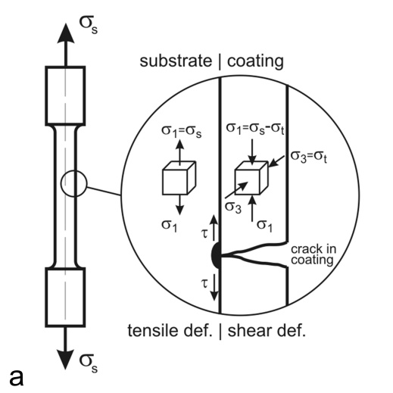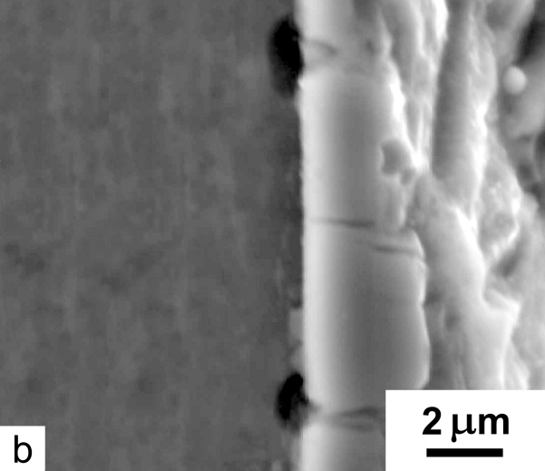
Figure 9. Deformation scheme of the coated samples during creep tests (a) and a view on the “coating-substrate” interface (b), where σ_{s} – tensile stress and σ_{t} – residual thermal stresses in the coating;

It was noted in section 3 that the coated sample under a constant stress suffers a complex stress-strain state unlike the uncoated sample and on the surface there is a typical relief (Figure 6) including Chernov-Lüders bands and ring-shaped microcracks. Considering the deformation scheme of the coated sample in Figure 9a, it is possible to identify three specific areas:
1) The base material at some distance from the coating suffers tensile stresses, and in this case the yield strength in shear is given by the maximum shear stress theory (MSST) so that it is equal to one-half of the tensile stress where τ_{y} = 0.5σ_{s}.^{[28]};
2) Due to the simultaneous action of the tensile stress, σ_{s}, and considerable compressing residual thermal stresses (σ_{t} = -1379 MPa) forming in it, the coating suffers pure shear.^{[24]} In this case, the yield strength in shear is given by MSST as τ_{y} = 0.5 max(|σ_{s}|, |σ_{t}|).^{[27]} The shear strains on the coating surface then appear as a net of microcracks developing under an angle of about 45° to the sample axis (Figure 7b);
3) Tangential tensile stresses occur at the coating-substrate interface in the area of the coating failure (τ in Figure 9а) and the sign of the tangential tensile stresses is opposite to that of the internal compression stresses (σ_{t}) which are acting in the coating. When the stress values surpass the adhesive strength, the coating peels off the sample surface (Figure 8). In addition, the tangential stresses may enforce the development of local plastic strain in the substrate material at places where dislocations accumulate in the boundaries with the coating which results in formation of dimples (Figure 8a).
Thus, the coating applied on the sample surface hinders free deformation due to the formation of adhesive bonds with the substrate. When the applied tensile stress and dwelling times are the same, as in the linear part of the dependence of e=f(h) in Figure 5, the strain of the coated samples is almost two times lower than the strain of the uncoated samples. This is due to much higher elastic modulus of the alloy with the coating.
The data on the creep behavior of the UFG alloy at temperatures below 673 K, including the combination of a UFG structure with a ion implantation and vacuum-plasma coating (Ti+V)N, gives grounds for concluding that this combination has advantages for use in compressor blades fabricated from the Ti-6Al-4V alloy provided the operating temperature is not higher than about 600 K.
5. Conclusion
1. The formation of a UFG structure in the Ti-6Al-4V alloy and a surface modification by ion implantation and sputtering of a (Ti+V)N coating contributes to an increase in the 100-hour creep rupture strength from 750 to 850 MPa at temperature 623 K due to the implementation of a barrier effect where the coating has a higher elastic modulus than the substrate.
2. The surface treatment of the UFG samples by ion implantation with nitrogen and the application of a protective coating considerably affects the mechanisms of crack initiation during creep testing and also the creep resistance at temperatures up to about 650 K, as shown by the occurrence of different deformation relief on the surfaces of tested samples with and without a coating.
Acknowledgements
This work was supported by the Russian Science Foundation, grant No 18-79-10158 (AVP), (sections 2; 3.2; 3.3; 3.5; 4.2). IPS thanks the Ministry of Education and Science of the Russian Federation within the scope of the project part of the State Assignment No 11.1235.2017 (sections 1; 3.1; 3.4; 4.1). Additional support was provided by the Royal Society of the U.K. under International Exchange Grant No. IE160092.
References
[1] R. Z. Valiev, Y. Estrin, Z. Horita, T. G. Langdon, M. J. Zehetbauer, Y. T. Zhu, Mater. Res. Lett. 2015, 4, 1.
[2] Y. Estrin, A. Vinogradov, Acta Mater. 2013, 61, 782.
[3] T. G. Langdon, Acta Mater. 2013, 61, 7035.
[4] R. S. Mishra, V. V. Stolyarov, C. Echer, R. Z. Valiev, A. K. Mukherjee, Mater. Sci. Eng. A Struct. Mater. 2001, 298, 44.
[5] S. Zherebtsov, G. Salishchev, R. Galeyev, K. Maekawa, Mater. Trans. 2005, 46(9), 2020.
[6] V. Zherebtsov, Mater. Sci. Eng. A Struct. Mater. 2012, 536, 190.
[7] I. P. Semenova, E. B. Yakushina, V. V. Nurgaleeva, R. Z. Valiev, Int. J. Mater. Res. 2009, 100, 1691.
[8] I. P. Semenova, A. V. Polyakov, V. V. Polyakova, Y. Huang, R. Z. Valiev, T. G. Langdon, Adv. Eng. Mater. 2016, 18, 2057.
[9] I. P. Semenova, A. V. Polyakov, V. V. Polyakova, Yu. F. Grishina, Yi Huang, R. Z. Valiev, T. G. Langdon, Mater. Sci. Eng. A Struct. Mater. 2017, 696, 166.
[10] I. P. Semenova, J. Modina, A. V. Polyakov, G. V. Klevtsov, N. A Klevtsova, I. N. Pigaleva, R. Z. Valiev, T. G. Langdon, Mater. Sci. Eng. A Struct. Mater. 2018, 716, 260.
[11] L. A. N. S. Briguente1, A. A. Couto, N. M. Guimarães, D. A. P. Reis, C. M. Neto, M. J. R. Barboza, Defect Diffus. Forum 2012, 326-328, 520.
[12] Y. R. Kolobov, G. P. Grabovetskaya, K. V. Ivanov, R. Z. Valiev, Y. T. Zhu, in Ultrafine Grained Materials III (Eds: Y. T. Zhu, T. G. Langdon, S. L. Semiatin, D. H. Shin, T. C. Lowe), Minerals, Metals & Materials Society, Warrendale, USA 2004, pp. 621-628.
[13] C. Veiga, J. P. Davim, A. J. R. Loureiro, Rev. Adv. Mater. Sci. 2012, 32, 133.
[14] I. P. Semenova, G. I. Raab, E. R. Golubovskiy, R. R. Valiev, J. Mater. Sci. 2013, 48, 4806.

[15] V. M. C. A. de Oliveira, M. C. L. da Silva,, C. G. Pinto, P. A. Suzuki, J. P. B. Machado, V. M. Chad, M. J. R. Barboza, J. Mater. Res. Tech. 2015, 4(4), 359.
[16] S. Zepka, D. A. P. Reis, M. M. Silva, M. Ueda, A. A. Couto, G. Reis, in Properties and Characterization of Modern Materials. Advanced Structured Materials, Vol. 33 (Eds: A. Öchsner, H. Altenbach), Springer, Singapore 2017, pp. 185-195.
[17] A. Zhecheva, W. Sha, S. Malinov, A. Long, Surf. Coat. Technol. 2005, 200(7), 2192.
[18] M. Castagnet, L. M. Yogi, M. M. Silva, M. Ueda, A. A. Couto, D. A. P. Reis, C. M. Neto, Mater. Sci. Forum 2012, 727–728, 50.
[19] V. E. Panin, Phys. Mesomech. 1999, 2(6), 5.
[20] V. A. Klimenov, S. V. Panin, V. P. Bezborodov, Phys. Mesomech. 1999, 2(1-2), 141.
[21] C. T. Wang, A. Escudeiro, T. Polcar, A. Cavaleiro, R. J. K. Wood, N. Gao, T. G. Langdon, Wear 2013, 306(1-2), 304.
[22] C. T. Wang, T. J. Hakala, A. Laukkanen, H. Ronkainen, K. Holmberg, N. Gao, R. J. K. Wood, T. G. Langdon, J. Mater. Sci. 2016, 51(9), 4390.
[23] C. T. Wang, N. Gao, M. G. Gee, R. J. K. Wood, T. G. Langdon, J. Mech. Behav. Biomed. Mater. 2013, 17, 166.
[24] I. P. Semenova, R. R. Valiev, K. S. Selivanov, Yu. M. Modina, A. V. Polyakov, M. K. Smyslova, R. Z. Valiev. Rev. Adv. Mater. Sci. 2017, 48, 62.
[25] I. P. Semenova, M. K. Smyslova, K. S. Selivanov, R. R. Valiev, Yu. M. Modina, IOP Conf. Ser.: Mater. Sci. Eng. 2017, 194, 012035.
[26] K. Katahira, H. Suzuki, M. Okada, Trans. Soc. Mech. Eng. A 1998, 64(622), 1475.
[27] E. J. Hearn, Mechanics of Materials 1, Butterworth-Heinemann, 1997, p. 450.

