**Aluminium deposition in EMImCl-AlCl3 ionic liquid and ionogel   
for improved aluminium batteries**

T. Schoetza[1]*, O. Leunga, C. Ponce de Leona, C. Zaleskib and I. Efimovc

*aFaculty of Engineering and the Environment; University of Southampton; Highfield Southampton SO17 1BJ; United Kingdom*

*bCentre for Biological Engineering; Loughborough University; Loughborough Leicestershire LE11 3TU; United Kingdom*

*cMaterials Centre; School of Chemistry; University of Leicester; Leicester, LE1 7RH; United Kingdom*

Abstract

Aluminium batteries with non-aqueous electrolyte have initially focused on Lewis acidic ionic liquid systems with heavy Al2Cl7- anions that limit the specific capacity, energy and power. In order to develop the secondary aluminium batteries further for future energy storage beyond lithium-ion, high performance electrolytes that enable efficient aluminium deposition/dissolution must be developed. This work studied the electrodeposition of aluminium from both 1-ethyl-3-methylimidazolium chloride aluminium chloride (EMImCl-AlCl3) *ionic liquids* with different Lewis acidities, and their gel form- *the ionogel*. Thereby, cyclic voltammetry, in-operando atomic force microscopy and scanning electron microscopy coupled with energy dispersive X-ray diffraction measurements were used to determine the characteristics of aluminium deposition in the ionic liquid depending on the ratio of AlCl3 to EMImCl. Based on these insights, Lewis acidic and neutral ionic liquids were gelified with polyethylene oxide. The focus was on the feasibility of aluminium deposition in Lewis neutral ionogels containing only lightweight AlCl4- anions. It was proven for the first time that aluminium can be deposited from a Lewis neutral ionogel without any dendrite growth within a very wide potential stability window of 5 V but at a low coulombic efficiency of ≤60%.



Keywords

Aluminium deposition; batteries; EMImCl-AlCl3; energy storage; ionogel; ionic liquids

1. **Introduction**

The majority of non-aqueous aluminium battery systems are based on the reversible deposition/dissolution of aluminium at the anode, and the intercalation or insertion of an ionic aluminium species into a porous or layered material at the cathode (e.g. graphite, sulphides, oxides and conductive polymers) 1–3. Electrolytes such as inorganic molten salts, eutectic liquids, organic solvents and room temperature ionic liquids have been investigated for aluminium battery applications. The first reported non-aqueous aluminium battery systems employed inorganic molten salts as electrolytes but suffered from dendrite growth and required temperatures above 140 °C to enable ion flow and therefore had limited practical applications 4. Both eutectic liquids and organic solvents, containing dissolved aluminium salts, require elevated operational temperatures due to poor conductivity, although the inclusion of additives can improve performance in eutectic liquids 5. The low solubility of aluminium salts in organic solvents and the risk of flammability further limit their use in practical systems 6.

From all the electrolytes explored, room temperature ionic liquids have been the most extensively studied for electrochemical storage applications due to their high ionic conductivity, low vapour pressure, non-flammability and relatively wide electrochemical window. The first generation of ionic liquids contained tetrahedral aluminium anions and planar heterocyclic imidazolium cations 7, such as a binary mixture of 1-ethyl-3-methylimidazolium chloride-aluminium chloride (EMImCl-AlCl3). When the two solid components are mixed together, they melt to a liquid phase in which the ionic species are fully dissociated. This mean that all ionic species are able to take an active part in the battery’s charge-discharge reactions. Chloroaluminate ionic liquids are highly hygroscopic, decomposing under an exothermic reaction to hydrochloric acid when exposed to moisture 8,9. Therefore, they need to be carefully handled in an inert atmosphere like argon or nitrogen with water levels below 100 ppm. The Lewis acidity of the ionic liquid depends on the molar ratio of AlCl3 to EMImCl, determining properties such as viscosity, conductivity and potential stability window 10. A mixture of more than 50 mol-% AlCl3 is considered as Lewis acidic, while those with a 1:1 (50 mol-% EMImCl to 50 mol-% AlCl3) composition are Lewis neutral and less than 50 mol-% are Lewis basic. Each composition contains a different predominant anion species. Lewis acidic liquids are characterised by Al2Cl7-, neutral by AlCl4- and basic by Cl- anions 11–13. The deposition of metallic aluminium from an EMImCl-AlCl3 ionic liquid is only possible in a Lewis acidic composition in which the Al2Cl7- anion can be reduced (-0.2 V *vs.* Al|Al(III); (Equation 1) 11,13.

( 1 )

Current aluminium batteries with graphite and conductive polymer cathodes reach a specific energy ranging between 40 and 70 Wh kg-1 (≡ lower specific energy of nickel-metal hydride batteries) with cell potentials between 1.3 and 1.7 V 1,2,14–16.

* 1. **Improvement of the aluminium battery performance with ionogel electrolytes**

The limiting factor in terms of battery performance of current aluminium-based batteries is the Lewis acidic chloroaluminate ionic liquid with heavy Al2Cl7- anions and a potential stability window of ≤4 V, which does not allow the aluminium deposition from lighter AlCl4- In order to improve the battery performance with a chloroaluminate electrolyte, the cell potential has to be increased and aluminium deposited from the lighter AlCl4- anion below -2 V *vs.* Al|Al(III) (Equation 2) which has less than half of the molar mass of the Al2Cl7- anion.

( 2 )

The aluminium deposition from AlCl4- occurs below -2 V *vs.* Al|Al(III). However, a Lewis acidic EMImCl-AlCl3 ionic liquid decomposes before -2 V *vs.* Al|Al(III) 17 so that the aluminium deposition from AlCl4- in a Lewis acidic ionic liquid is not possible. The electrochemical stability window of ionic liquids is bounded by the anodic and cathodic limiting potentials of the constituent ions. At the anodic limit, the oxidation of the chloroaluminate anion leads to the evolution of chlorine gas, while the imidazolium rings are decomposed at the cathodic limit 17. Nonetheless, the aluminium deposition from AlCl4- can be achieved by modifications of the Lewis neutral EMImCl-AlCl3 ionic liquid by its gelification with a polymer such as polyethylene oxide (PEO), increasing significantly the total potential stability window beyond -2 V *vs.* Al|Al(III).

The concept of polymer-based electrolytes has been widely explored and applied in various areas of energy storage research due to the many advantages that they present in a battery system. While there is no universal definition of a polymer electrolyte, they are generally accepted to be of a semi-solid gel consistency or in a solid state 18. The most prominent application of polymer electrolytes can be considered to be in lithium-polymer batteries (LiPo), which have enjoyed great success in a vast variety of applications, from electric vehicles to mobile devices and other consumer electronics. In LiPo systems, gel polymer electrolytes have shown to suppress dendrite growth, reduce unwanted reactivity and increase structural integrity, shape flexibility and manufacturability 19.

Applying this concept to ionic liquids, their immobilisation forms ionogels (ionic liquid+gel) by trapping them within a gelating agent or polymer matrix which allows them to retain their specific properties while increasing their structural integrity 20. Additionally, a study by Noor et al. revealed the retention of thermal stability following polymerisation 21, while Sun et al. reported improved moisture sensitivity 22, which would improve the ease of handling during manufacture and reduce costs. Ionogels have been applied in lithium battery systems, in which ionic liquids are used to enhance the ionic conductivity of polymer electrolytes 9.

The preparation of ionogels can be categorised into three types- organic, inorganic, and hybrid organic-inorganic preparation methods. Organic ionogels may be synthesised by adding low molecular weight gelating agents, such as polymers or biopolymers, to the ionic liquid, while inorganic gels may use ceramic nanoparticles, carbon nanotubes and sol-gel processes to trap the liquid within a microstructure network. Hybrid organic-inorganic preparation methods involve biopolymers and nanofillers to form a hybrid solid network 20. In organic polymer ionogel preparation, low molecular weight gelating agents may be added directly to the ionic liquids at elevated temperatures, which induces physical gelation upon cooling. Other methods involve the use of a solvent to mix the polymer and ionic liquid, which is subsequently removed. The polymers commonly used to prepare ionogels include polyethylene oxide (PEO), polyacrylonitrile (PAN), polymethyl methacrylate (PMMA) and polyvinylidene fluoride (PVdF), which need to be selected carefully to ensure compatibility, and that there is no reaction between the solvent (if used), polymer and ionic liquid which could influence electrochemical activity. The anion Al2Cl7- has a tendency to complex with organic solvents bearing lone electrons, such as acetone, acetonitrile or tetrahydrofouran (THF). It is understood that PEO and PAN have the same functional group as THF and acetonitrile respectively, while PMMA and PVdF have functional groups stronger than acetone and dichloromethane (DCM) respectively. Wang et al. 23 showed the incompatibility of chloroaluminate ionic liquids with PVdF, and Sun et al. 22 demonstrated the effects of the addition of several solvents on the reversible deposition/dissolution of aluminium, revealing significantly hindered electrochemical activity in Lewis acidic EMImCl-AlCl3 ionic liquids mixed with acetone, acetonitrile and THF. A polyacrylamide‐EMImCl–AlCl3 ionogel obtained by the direct polymerisation of acrylamide in a dichloromethane‐EMImCl‐AlCl3 solution was then proposed, showing good ionic conductivity and reversible aluminium deposition/dissolution at 50°C. In addition, the ionogel exhibited an improved stability to air and moisture, as its electrochemical properties were retained following exposure to air.

The ionogel electrolyte can thus improve the aluminium battery performance due to the following reasons:

1. A wider potential stability window which enables the aluminium deposition from AlCl4- anions below -2 V *vs.* Al|Al(III) and results in a higher overall cell potential of the battery.
2. A reduction of battery mass and an increase in specific capacity, energy and power as aluminium batteries typically employ the intercalation or insertion of chloroaluminate anions in the cathode during battery cycling. The intercalation/insertion of AlCl4- anions in contrast to the bulky Al2Cl7- anions can produce higher storage capacities and charge/discharge rates, due to their higher mobility and smaller ionic radii. Hypothetically, the performance of an aluminium-conductive polymer (PEDOT) battery, with Lewis acidic (at anode) and neutral (at cathode) EMImCl-AlCl3 ionic liquid electrolyte could be improved with a Lewis neutral ionogel at both electrodes, increasing the specific capacity, energy and power by a factor of 1.4. The battery could reach up to 260 Ah kg-1, 338 Wh kg-1 and 211 W kg-1 (referring to mass *ma* of species which actively take part in the battery reaction) 16. Considering an additional increase of cell potential by at least 1 V so that the average discharge potential increases to 2.3 V, the performances can be improved further to 260 Ah kg-1, 598 Wh kg-1 and 374 W kg-1. If realised, this level of performance would compete with state-of-the-art lithium-based batteries.
3. A lower electrolyte resistance based on the elimination of the separator between the electrodes, decreasing the internal ohmic drop. Additionally, the total battery mass and volume can be decreased.
4. A higher cycle life as the ionogel is not sensitive to moisture or oxygen in contrast to the hygroscopic nature of chloroaluminate ionic liquids, stabilising the potential stability window. The absence of highly nucleophilic Al2Cl7- anions, present in Lewis acidic ionic liquids, eliminate the corrosion of the cell components such as current collectors and cell casing. Additionally, there is no risk of electrolyte leakage due to the semi-solid state of the ionogel.

This study investigates the aluminium deposition in ionic liquids with different Lewis acidities demonstrating the electrode potential limits of chloroaluminate ionic liquids. These limitations lead to the subsequent investigation of ionogels, prepared from the same ionic liquid, as potential electrolytes for improved aluminium batteries. Thereby, the potential stability windows depending on the degree of gelification and resulting ability to deposit aluminium is studied by cyclic voltammetry, scanning electron microscopy and energy dispersive X-ray diffraction measurements.

1. **Experimental**
   1. **Ionic liquid and ionogel preparation**

Lewis acidic, neutral and basic imidazolium-based ionic liquids were prepared using the following components; 1-ethyl-3-methylimidazolium chloride (EMImCl; Merck, purity ≥98 %, water   
≤1.0 %) and aluminium chloride (AlCl3; Alfa Aesar, anhydrous, ultra-dry, metal basis 99.99 %). The Lewis acidity of the ionic liquid was controlled by the molar ratio of EMImCl to AlCl3 (Table 1). 17

*Table 1: Molar ratio χ and mass m of EMImCl to AlCl3 for 25 mL EMImCl-AlCl3 ionic liquids with different Lewis acidity and dominant anion species, respectively* 11*.* 17

|  |  |  |  |  |  |
| --- | --- | --- | --- | --- | --- |
| *χ*(EMImCl)  / mol-% | *χ*(AlCl3)  / mol-% | *m*(EMImCl)  / g | *m*(AlCl3)  / g | Lewis acidity | Predominant anions in ionic liquid |
| 33.3 | 66.7 | 12.0 | 21.9 | acidic | Al2Cl7-, AlCl4- |
| 50 | 50 | 16.6 | 15.1 | neutral | AlCl4- |
| 66.7 | 33.3 | 20.8 | 9.4 | basic | AlCl4-, Cl- |

The components EMImCl and AlCl3 were dried before use in a vacuum oven at 60 °C for 24 h and subsequently transferred into a glove box (MBraun, Workstations UNIlab Plus/Pro - SP/DP) with a nitrogen atmosphere (≤0.5 ppm water and ≤0.5 ppm oxygen). 17

The amount of AlCl3 *mA* (Equation 3) and EMImCl *mE* (Equation 4) for the synthesis of a Lewis acidic, neutral and basic ionic liquid was calculated based on the molar ratio *χ*, molar mass *M* of AlCl3 and EMImCl and density *ρ* as well as the volume *V* of the binary solution. 17

( 3 )

( 4 )

The density of the solution *ρ* (Equation 5) was calculated by using the reported density *ρa* and corrected by a temperature dependent density coefficient *ρb* at 30 °C (Table 3) 24. 17

( 5 )

*Table 2: Density of EMImCl-AlCl3 ionic liquid mixture ρ depending on the acidity at 30 °C* 24*.* 17

|  |  |  |  |
| --- | --- | --- | --- |
| Lewis  acidity | *ρb*·10-4  / g cm-3 °C-1 | *ρa*  / g cm-3 | *ρ*  / g cm-3 |
| acidic | 9.1767 | 1.3567 | 1.36 |
| neutral | 8.0268 | 1.2660 | 1.27 |
| basic | 6.8555 | 1.2089 | 1.21 |

The calculated amounts of EMImCl and AlCl3 were weighed inside the glove box and transferred into a clean dry beaker. The ionic liquid was prepared by adding AlCl3 slowly to EMImCl during continuous stirring and cooling in a Peltier controlled cooling device with ceramic-coated beads (Techne, Bibby Scientific, No ICE, 0-40 °C). The ionic liquid reached temperatures between 20 °C to 40 °C during the mixing. Afterwards, the solution was transferred into a glass bottle and stirred for another 24 h, resulting in translucent brown to yellowish solutions.

The ionogels (Figure 1) were prepared in an argon-filled glove box by adding pre-weighed amounts of PEO in the range from 2 wt.-% to 20-wt.-% (Acros Organics) to the respective Lewis acidic and neutral ionic liquid in a sealed vessel. The mixtures were magnetically stirred at 80 °C until the PEO was completely dissolved and a homogeneous mixture was formed. The ionogels were left to cool completely before further testing was performed because the gel forms only when the mixture cools down to room temperature.

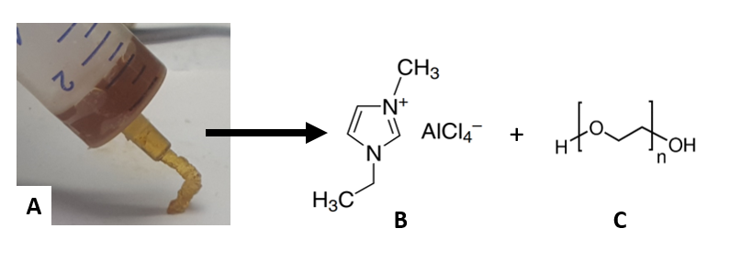

*Figure 1: (A) Prepared ionogel from (B) Lewis neutral EMImCl-AlCl3 and (C) 6 wt.-% PEO.*

* 1. **Characterisation of ionic liquids, ionogels and aluminium deposits**

Cyclic voltammetry (CV):

The cyclic voltammetry experiments characterising the ionic liquids and ionogels were performed in a PTFE-cell with a vitreous carbon disc working electrode (Micro-to-Nano, high purity, surface area 6.3 cm2 for ionic liquids, 4.5 cm2 for ionogels), which faced a counter electrode of the same material and area. Thereby, the electrolyte was sandwiched between both vitreous carbon discs. The cell was equipped with an aluminium wire reference electrode (Alfa Aesar; 0.5 mm, 99.999%). The vitreous carbon electrode surfaces were cleaned with ethanol (Fluka, absolute, analytical reagent grade) and dried under vacuum at 60 ºC before transferring into the glove box. The tip of reference electrode was polished with very fine abrasive paper inside the glove box in order to remove possible oxides on the aluminium surface.

Scanning electron microscopy coupled with energy dispersive X-ray diffraction (SEM-EDX):

Aluminium deposits from ionic liquids were obtained in the same cell used for CV experiments at -1 mA for 30 min at 25 °C on pure aluminium substrates. This corresponds to a capacity of 1800 mAs (0.5 mAh). In order to demonstrate the feasibility of the aluminium deposition from a Lewis neutral ionogel, constant potential deposition from a gel with 10 wt.-% PEO was performed at -1.9 V for 20 min *vs.* Al|Al(III) at 25 °C on vitreous carbon. This corresponds to a capacity of 10332 mAs (2.87 mAh). The deposits obtained in the ionic liquids and ionogels were investigated by SEM-EDX (JEOL JCM-6000 Benchtop and JEOL JSM 6500F). Samples were prepared from ionic liquids of different Lewis acidities *χ*(EMImCl):*χ*(AlCl3), from Lewis neutral (50 mol-%:50 mol-%) to ultra-acidic (30 mol-%:70 mol-%) and from Lewis neutral ionogels with 8 wt.-%, 10 wt.-% and 12 wt.-% PEO. The samples were rinsed beforehand with dimethyl carbonate (Acros Organics; 99+%, extra dry) and dried in a vacuum for at least 1 h in order to remove residual electrolyte, which would interfere with microscopic analysis.

In-operando atomic force microscopy (AFM):

The deposition of aluminium in Lewis acidic EMImCl-AlCl3 ionic liquid was visualised by in-operando atomic force microscopy (AFM) in an in-house-designed PTFE three-electrode cell. The cell was fitted with a vitreous carbon disc (Micro to Nano, 6.3 cm2) as the substrate/working electrode, a vitreous carbon ring (Micro to Nano, diameter 3 cm) as the counter electrode and an aluminium wire (Alfa Aesar, 0.5 mm, 99.999%) as the reference electrode. The AFM (Dimension ICON, Bruker Co., Billerica, MA, USA) was located inside a glove box (MBraun, Inertgas-Systeme GmbH), in an argon atmosphere (water and oxygen level ≤10 ppm). The AFM measurements were carried out with a silicon probe coated with diamond-like carbon and a reflective aluminium layer at the back (Windsor Scientific, Multi75DLC, spring constant 3 N m-1, resonance frequency 75 KHz, tip radius <10 nm). The probe was entirely covered by the electrolyte for the duration of the electrochemical experiment. Prior to the aluminium deposition, an initial AFM image of the bare vitreous carbon surface was captured. The deposition area was scanned horizontally over an area of 5 µm × 5 µm at 0.5 Hz, with 512 samples per line and a 0.1 V force set point. The feedback gain has been adapted automatically as the images were taken in ScanAsyst mode (peak force tapping mode). Aluminium was deposited by linear sweep voltammetry (LSV) at 100 mV s-1 from 0 V to -1.0 V *vs.* Al|Al(III). The LSV was stopped at 0 V (before aluminium deposition), -0.2 V, -0.4 V, -0.5 V, -0.6 V and -1.0 V *vs.* Al|Al(III). The potential was held respectively at the OCP to capture the AFM image with the same set of parameters as in the initial image of the bare aluminium surface. The OCP remained stable for the time spent to capture the image. All AFM images were post-edited by a third-order polynomial flattening procedure using the Nanoscope Analysis software (Bruker Co., Billerica, MA, USA) to remove tilt and curvature.

1. **Results and Discussion**
   1. **Aluminium deposition in EMImCl-AlCl3 ionic liquid**

A Lewis acidic EMImCl-AlCl3 ionic liquid contains an excess of AlCl3 and therefore Al2Cl7- ions, which can be reduced to metallic aluminium (Equation 1) with no additives in the electrolyte at room temperature. The cyclic voltammogram (Figure 2 A) shows a typical cycle of the deposition and dissolution of aluminium on a vitreous carbon electrode between -1.0 V and 1.0 V *vs.* Al|Al(III). The reduction of the complex aluminium ion Al2Cl7- starts at -0.2 V *vs.* Al|Al(III) and is accompanied by the nucleation and growth of bulk aluminium on the vitreous carbon surface, showing a peak at -0.25 V *vs.* Al|Al(III) 3. The deposition occurs with some overpotential of 0.2 V to 0.25 V (E0Al(Al(III)= -1.66 V *vs.* SHE) due to the nucleation process but shows the characteristic current steep increase due to the increase of available area for the aluminium deposition. The aluminium dissolution is characterised by a broad anodic peak with a maximum of around 0.25 V *vs.* Al|Al(III) 3. The aluminium deposition and dissolution were performed in a nitrogen atmosphere with water and oxygen levels below 0.5 ppm. Therefore, a passivation layer on the aluminium surface cannot be formed. The coulombic efficiency of aluminium deposition to dissolution (ratio of cathodic to anodic charge) is 85% because the aluminium dissolution is not entirely reversible.

Aluminium obtained at a constant potential of -1 V *vs*. Al|Al(III) on vitreous carbon (Figure 2 B and C) appears as circular deposits with an average grain size of ~100 nm, which tend to agglomerate into clusters on the substrate surface.

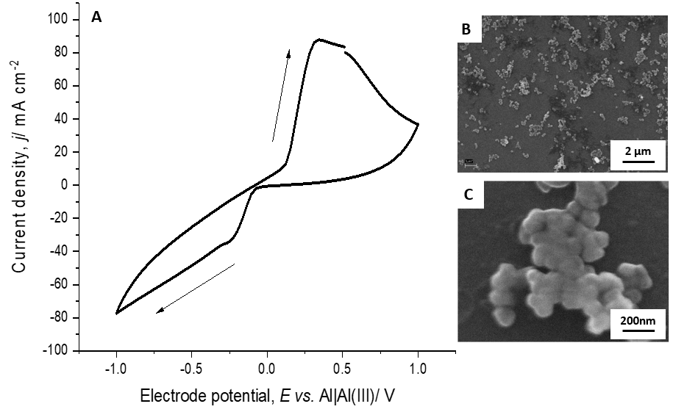

*Figure 2: (A) Cyclic voltammogram of the aluminium deposition and dissolution on vitreous carbon (A=6.3 cm2) in Lewis acidic EMImCl-AlCl3 ionic liquid at 100 mV s-1 and 25 °C. The micrographs (B and C) show typical aluminium deposits on vitreous carbon obtained at constant potential of   
-1 V vs. Al|Al(III) at 25 °C.*

The in-operando AFM measurements of the aluminium deposition in Lewis acidic chloroaluminate ionic liquid provided information about the morphological growth while decreasing the cathodic potential from -0.2 to -1.0 V *vs.* Al|Al(III). Aluminium grows as hemispherical grains along the surface features of the vitreous carbon such as particles and scratches (Figure 3). The average diameter of the hemispherical grains increases gradually from 30 nm to 90 nm with decreasing deposition potential from -0.2 V to -1.0 V *vs.* Al|Al(III). The surface appears to be very smooth with the average surface roughness *Ra* ranging from 1.04 nm to 1.12 nm. The maximum height difference of grainy morphology is 10 nm. Dendrite growth cannot be observed.



*Figure 3: In-operando AFM images of the aluminium deposition on (A) bare vitreous carbon (A=6.3 cm2) at (B) -0.2 V, (C) -0.4 V, (D) -0.5 V, (E) -0.6 V and (F) -1.0 V vs. Al|Al(III) in Lewis acidic EMImCl-AlCl3 at 25 °C. The white rectangles indicate the same position on the surface.*

* + 1. **Influence of the Lewis acidity on aluminium deposition**

The influence of the Lewis acidity from neutral (50 mol-%: 50 mol-%) to ultra-acidic (30 mol-%:70 mol-%) on the aluminium deposition was investigated, looking at morphology and coulombic efficiency. The increase in Lewis acidity (increased ratio of AlCl3 to EMImCl) is also visible in the change of colour of the ionic liquid (Figure 4) from light yellow (neutral, Figure 4 A) to dark brown (ultra-acidic, Figure 4 E).



*Figure 4: Changes in colour of EMImCl-AlCl3 from Lewis neutral to ultra-acidic.  
 (a) 50 mol-%:50 mol-% (neutral), (b) 45 mol-%:55 mol-%, (c) 40 mol-%:60 mol-%,   
(d) 35 mol-%:65 mol-% (acidic) and (e) 30 mol-%:70 mol-% (ultra-acidic).*

Cyclic voltammograms of the aluminium deposition and dissolution in EMImCl-AlCl3 with increasing Lewis acidity from neutral to ultra-acidic (Figure 5) show that there is no deposition of aluminium in a Lewis neutral composition. The predominant anion in the neutral composition is AlCl4-, which can only be reduced to metallic aluminium at potentials below -2 V *vs.* Al|Al(III). This overlaps with the decomposition of the ionic liquid. The CV of a 45 mol-%:55 mol-% composition, containing slightly more AlCl3, shows a typical nucleation loop of deposited aluminium on the vitreous carbon surface. The nucleation loop starts from -0.2 V *vs.* Al|Al(III) due to a high nucleation overpotential, forming a crossover when the aluminium dissolution occurs already. However, the coulombic efficiency is only 63%. Significant higher current densities during the aluminium deposition and dissolution occur in a slightly acidic composition of 40 mol-%:60 mol-%, showing a nucleation loop as well but with a lower overpotential than in the 45 mol-%:55 mol-% EMImCl-AlCl3. Dissolution occurs at 0.3 V *vs.* Al|Al(III). A full deposition peak at -0.25 V and -0.3 V *vs.* Al|Al(III) appears for an acidic 35 mol-%:65 mol-% and ultra-acidic 30 mol-%:70 mol-% composition. The aluminium deposits are dissolved between 0.1 V to 0.4 V *vs.* Al|Al(III), respectively, whereas the coulombic efficiency for a Lewis acidic composition is over 80% and for an ultra-acidic composition only 65%.



*Figure 5: Cyclic voltammograms of the aluminium deposition and dissolution on vitreous carbon (A=6.3 cm2) in EMImCl-AlCl3 (black line; a) 50 mol-%:50 mol-% (neutral), (red line; b)   
45 mol-%:55 mol-%, (green line; c) 40 mol-%:60 mol-%, (blue line; d) 35 mol-%:65 mol-% (acidic) and (pink line; e) 30 mol-%:70 mol-% (ultra-acidic) at cycle 3, 100 mV s-1 and 25 °C.*

Aluminium was deposited at -1 mA for 30 min at 25 °C on bare aluminium in order to investigate the differences in morphology when using EMImCl-AlCl3 with increasing Lewis acidity (Figure 6). The aluminium substrate and current was chosen with regards to aluminium battery applications, using metallic aluminium as anode material. During the aluminium deposition at the anode (charging reaction, Equation 1) the Lewis acidity shifts from Lewis acidic towards neutral. Therefore, the aluminium deposition was investigated at different Lewis acidities by SEM.

The bare aluminium substrate surface (Figure 6 A) shows parallel scratches from cleaning and polishing. As expected, aluminium was not deposited in a Lewis neutral ionic liquid composition because the Al2Cl7- ions required for the deposition of metallic aluminium are not present (Equation 1). There is only a film of ionic liquid left (Figure 6 B) which appears as light patches on the surface. A slight increase in Lewis acidity (45 mol-%:55 mol-%) enables the deposition of single distributed aluminium nuclei with an average grain size of 200 nm (Figure 6 C). A noticeable aluminium deposit grows from a slightly acidic composition (40 mol-%:60 mol-%). The aluminium grains (~500 nm) are distributed homogeneously over the whole surface (Figure 6 D). The grain size increases with an increase in Lewis acidity (Figure 6 D-F) from slightly acidic (40 mol-%:60 mol-%) to acidic (35 mol-%:65 mol-%) to ultra-acidic (30 mol-%:70 mol-%), whereas the shape becomes more hemispherical and smaller grains (~200-300 nm) agglomerate to bigger grains (up to 1 µm) in a Lewis acidic composition (Figure 6 E). Aluminium obtained in the Lewis ultra-acidic ionic liquid appears as big cauliflower-like agglomerates with a size ranging from 1 µm to 2 µm (Figure 6 F). It can be seen that aluminium dendrites are not formed in any composition of EMImCl-AlCl3, demonstrating no risk of a potential short circuit in the aluminium batteries, if pure aluminium foils are used as anodes.



*Figure 6: SEM images of (A) bare aluminium foil surface (A=6.3 cm2) and pure aluminium deposit obtained at -1.0 mA at 25 °C in EMImCl-AlCl3 (B) 50 mol-%:50 mol-% (neutral),   
(C) 45 mol-%:55 mol-%, (D) 40 mol-%:60 mol-%, (E) 35 mol-%:65 mol-% (acidic) and   
(F) 30 mol-%:70 mol-% (ultra-acidic).*

During the aluminium deposition, Al2Cl7- ions are depleted and AlCl4- ions are formed, which means a shift in Lewis acidity towards neutral. The aluminium deposition in Lewis acidic EMImCl-AlCl3 ionic liquid generally forms nanocrystalline deposits 11. Dendrite growth can only be observed at very high current densities ≥100 mA cm-2 due to the depletion of Al2Cl7- ions and the subsequent localised change of Lewis acidity 13, causing preferential deposition on parts of the electrode surface protruding further into the electrolyte. Furthermore, a passivation layer of aluminium oxide is not formed in a dry chloroaluminate ionic liquid, showing high reversibility and a coulombic efficiency of aluminium deposition/dissolution of ≥ 80% 25.

* 1. **Aluminium deposition in EMImCl-AlCl3-PEO ionogel**

The addition of PEO to a Lewis acidic and neutral ionic liquid created ionogels with increasing viscosity as greater amounts of PEO were added. No colour changes were seen and the Lewis neutral ionogels remained homogeneous with no obvious change in physical characteristics observed since their synthesis. Conversely, the acidic ionogels containing greater than 8 wt.-% PEO tended to crystallise after two weeks of storage. One sample containing 6 wt.-% PEO showed separation of the PEO and ionic liquid but could be homogenised upon re-heating and mixing.

In order to understand the effects on electrochemical properties caused by the addition of PEO, the potential stability windows and behaviour of both Lewis acidic 35 mol-%:65 mol-% (Figure 7) and neutral 50 mol-%:50 mol-% (Figure 8) ionogels containing increasing amounts of PEO were investigated by cyclic voltammetry. The ionogels were cycled at a scan rate of 100 mV s-1, starting at a potential range of -0.5 V to 0.5 V *vs.* Al|Al(III) and increased incrementally until the resulting current showed a significant magnitude, indicating the decomposition of the ionogel.

The cyclic voltammogram for 4 wt.-% PEO Lewis acidic ionogel (Figure 7, black curve) shows that the deposition of aluminium due to the reduction of Al2Cl7- begins at -0.05 V *vs.* Al|Al(III) with some nucleation overpotential, followed by the onset of electrolyte decomposition of the organic cation at -0.35 V *vs.* Al|Al(III). A significant aluminium dissolution peak occurs in the reverse scan between 0 V and 1 V *vs.* Al|Al(III). The coulombic efficiency is 87% which is similar to the Lewis acidic ionic liquid. Examining the voltammetric behaviour of the 10 wt.-% PEO Lewis acidic ionogel (Figure 7, red curve), a markedly wide stability window of 4.8 V (≤4 V Lewis acidic ionic liquid 17) and vastly different behaviour is recorded. A large peak at -0.7 V *vs.* Al|Al(III) is likely to associated with the deposition of aluminium. Cathodic and anodic decomposition of the ionogel occurs at -2.5 V and above 5 V *vs.* Al|Al(III), respectively. In the anodic direction, the current density of the aluminium dissolution peak at 0.1 V *vs.* Al|Al(III) is significantly smaller than that of the 4 wt.-% PEO Lewis acidic ionogel. The minor peak at 1.8 V *vs.* Al|Al(III) is unidentified, however the peak at 3.1 V *vs.* Al|Al(III) is likely to be attributed to PEO oxidation, as it is absent in the CV of the neat ionic liquid (without PEO). The coulombic efficiency of the Lewis acidic ionogels with 10 wt.-% PEO is 81%



*Figure 7: Cyclic voltammograms of Lewis acidic ionogels on vitreous carbon (A=4.5 cm2) containing 4 wt.-% (black curve) and 10 wt.-% (red curve) PEO at 100 mV s-1 and 25 °C.*

The cyclic voltammograms of Lewis neutral ionogels (Figure 8 A) show a clear increase of the potential stability windows with an increasing amount of PEO. The potential stability windows of 2 wt.-%, 6 wt.-% and 10 wt.-% PEO neutral ionogels are 3.7 V, 4.7 V and 4.9 V, respectively. Thus a 10 wt.-% PEO neutral ionogel has a 1 V wider potential stability window than a Lewis neutral ionic liquid 17. An anodic peak between 0 V and 1 V *vs.* Al|Al(III), absent in the 2 wt.-% PEO curve, can be observed from the cyclic voltammograms of the neutral ionogels containing 6 wt.-% and 10 wt.-% PEO. It is assumed that this peak is associated with the dissolution of aluminium from the vitreous carbon working electrode. All three curves exhibit a shoulder peak at approximately -1.9 V *vs.* Al|Al(III), which might indicate aluminium deposition from AlCl4-. Following cycling, darkening of the ionogel near the surfaces of the electrodes was observed, indicating decomposition of the electrolyte due to cycling to the limiting potentials. The complexity of the electrochemical behaviour of the Lewis neutral ionogel system evolves with increasing amounts of PEO (Figure 8 B). The cyclic voltammograms of Lewis neutral ionogels with 12 wt.-%, 15 wt.-% and 20 wt.-% PEO exhibit vastly different behaviour and stability windows. The 15 wt.-% Lewis neutral ionogel has a potential stability window narrower than both the 12 wt.-% and 20 wt.-% ionogels, which does not follow the trend of increasing potential stability. This could be attributed to the formation of other ionic species or interactions with the PEO within the electrolyte, leading to the existence of several other peaks which are not observed in other ionogel samples. In the anodic direction, two small peaks at 0 V and 1.4 V *vs.* Al|Al(III), and a significant double anodic peak between 2 V and 4 V *vs.* Al|Al(III) can be found, while a small cathodic peak at 0.6 V *vs.* Al|Al(III) also exists in addition to the characteristic aluminium deposition peak at approximately -1.9 V *vs.* Al|Al(III). Although the 20 wt.-% Lewis neutral ionogel appears to have the widest stability window, it does not exhibit any electrochemical activity apart from an anodic peak at 3.8 V *vs.* Al|Al(III), making it unsuitable as an electrolyte for aluminium batteries. This is likely to be caused by the restriction of ionic movement through the electrolyte at a relatively high PEO content, which prevents reactions from taking place at the electrodes.

 

Figure 8: Cyclic voltammograms of the electrochemical stability windows of Lewis neutral ionogels on vitreous carbon (A=4.5 cm2) containing (A) 2 wt.-% (black curve), 6 wt.-% (red curve) and 10 wt.-% (blue curve) and (B) 12 wt.-% (black curve), 15 wt.-% (red curve) and 20 wt.-% (blue curve) PEO at 100 mV s-1 and 25°C.

* + 1. **Aluminium deposition in Lewis neutral ionogel**

The deposition of aluminium in a Lewis neutral ionogel (with 4 wt.-% PEO) in comparison to Lewis neutral and acidic ionic liquids is demonstrated by cyclic voltammetry (Figure 9). The Lewis neutral ionic liquid starts to decompose before -2 V *vs.* Al|Al(III) (Figure 9, blue curve), so that the reduction of AlCl4- to metallic aluminium at ≤-2 V *vs.* Al|Al(III) cannot occur. The cyclic voltammogram of the Lewis neutral ionogel shows a potential stability window of -2.7 V to 2.5 V *vs.* Al|Al(III) (Figure 9, black curve) with significantly higher current densities than the liquid alone. An anodic peak at around 0 V *vs.* Al|Al(III) in the ionogel indicates the dissolution of previously deposited aluminium below -2 V *vs.* Al|Al(III) (Figure 9, red curve).

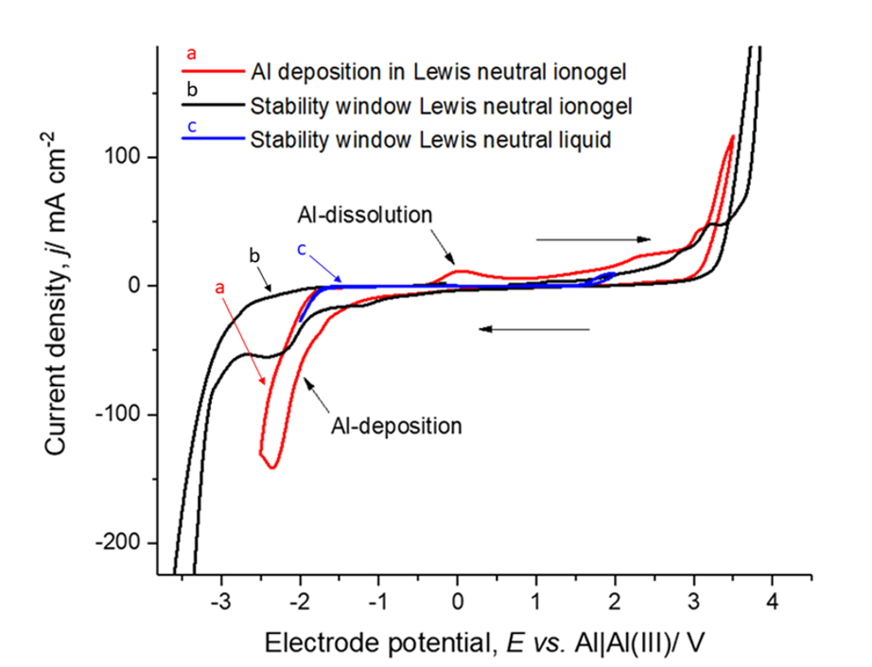

*Figure 9: Cyclic voltammograms on vitreous carbon (A=6.3 cm2) of Lewis neutral EMImCl-AlCl3 liquid (blue curve) and ionogel with 4 wt.-% PEO (black and red curve) at 100 mV s-1 and 25 °C.*

The cyclic voltammogram (Figure 10 A) shows a representative cycle of the deposition and dissolution of aluminium on vitreous carbon in a Lewis neutral EMImCl-AlCl3 ionogel with 10 wt.-% PEO. The reduction of the AlCl4- anion (Equation 2) occurs at -1.9 V *vs.* Al|Al(III). The aluminium dissolution is characterised by a broad anodic peak, which is similar to the aluminium dissolution in the ionic liquid, with a maximum at 0.5 V *vs.* Al|Al(III). The aluminium deposition and dissolution in the ionogel takes place within a potential stability window of 5 V from -2 V to 3 V *vs.* Al|Al(III).

The SEM image (Figure 10 B) shows aluminium deposits on the vitreous carbon surface obtained by constant potential deposition at -1.9 V *vs.* Al|Al(III). Circular aluminium deposits, which are uncovered (light spots) and covered (dark spots) by a residual film of ionogel electrolyte, can be observed in the SEM images. The sample preparation after the electrodeposition is rather difficult as the ionogel can hardly be removed from the substrate without also removing the deposited aluminium film. The vitreous carbon discs were rinsed with dimethyl carbonate in the glove box after electrodeposition, which removed most of the ionogel but also part of the visible deposit so that only circular spots of the deposit remain for the SEM-EDX investigation. The spots are agglomerates (≤30 μm) of smaller circular grains with an average size of 100 nm, similar to the aluminium deposits obtained in Lewis acidic ionic liquid (Figure 2 B and 2 C) but much more densely packed on the surface.

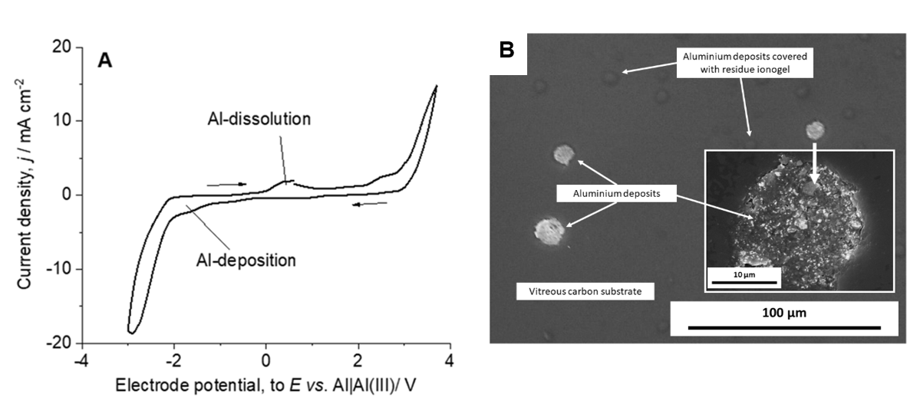

*Figure 10: (A) Cyclic voltammogram of the aluminium deposition and dissolution on vitreous carbon (A=4.5 cm2) in Lewis neutral EMImCl-AlCl3 ionogel with 10 wt.-% PEO at 100 mV s-1 and 25 °C. (B) SEM images of aluminium deposits on vitreous carbon obtained by constant potential -1.9 V vs. Al|Al(III) at 25 °C.*

The complementing EDX measurements (Figure 11) prove that the deposits on the vitreous carbon surface (carbon signal) are aluminium and not ionogel residues because the spot (Figure 11 A) and line analyses (Figure 11 B) show strong aluminium signals with only a minimal amount of chlorine detected. Ionogel residue would appear as aluminium and chlorine peaks in the ratio of 1:4, representing the AlCl4- anion of the Lewis neutral ionogel. Although oxygen is always detected in EDX analysis, the small amount of oxygen detected in the EDX line spectra of the aluminium deposit may be attributed to the aluminium oxide layer formed after the exposure of the sample to air following electrodeposition.

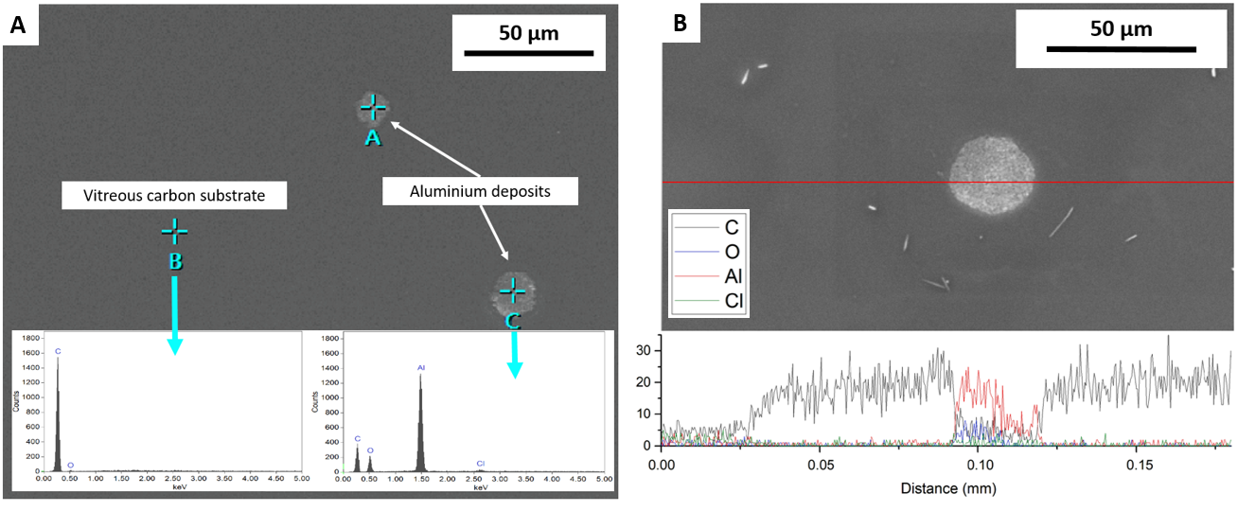

*Figure 11: SEM image of aluminium deposits on a vitreous carbon substrate (A=4.5 cm2) from a 10 wt.-% PEO Lewis neutral ionogel after constant potential electrodeposition -1.9 V vs. Al|Al(III) at 25 °C. and corresponding EDX spectra. (A) Spot analysis of the vitreous carbon substrate (measurement point B) and of an aluminium deposit (measurement point C). (B) Line analysis of a section of the vitreous carbon substrate and aluminium deposit without residue ionogel electrolyte.*

The current density of the anodic peak increases with progressing number of cycles (Figure 12 A). The coulombic efficiency (Figure 12 B) is the ratio of anodic transferred charge to cathodic charge during one cycle and is calculated to be 26 % at the first cycle, increasing to 52 % after 50 cycles. These values indicate that the reversibility of aluminium deposition and dissolution is rather low in the ionogel in comparison to a Lewis acidic ionic liquid which is over 80%. The response to different scan rates (Figure 12 C) from 10 mV s-1 to 200 mV s-1 of the Lewis neutral ionogel containing 10 wt.-% PEO was studied within the potential window of -3 V to 2.5 V *vs.* Al|Al(III). The anodic peak shifts towards higher potentials with increasing scan rate whereas the cathodic current remains almost stable, pointing to migration limitation. However, the small increase in cathodic current density at -1.9 V *vs.* Al|Al(III), where the aluminium deposition occurs, with increasing scan rate indicates a small diffusion-limited contribution as well (Figure 12 D).



*Figure 12: (A) Cyclic voltammograms on vitreous carbon (A=4.5 cm2) of 50 cycles and related (B) coulombic efficiency of 10 wt.-% PEO Lewis neutral ionogel at 100 mV s-1 and 25 °C. (C) Cyclic voltammograms of a Lewis neutral ionogel containing 10 wt.-% PEO cycled at scan rates of 200 mV s-1, 100 mV s-1, 50 mV s-1 and 10 mV s-1 between -3 V to 2.5 V vs. Al|Al(III) at 25°C with (D) peak current densities at -1.9 V vs. Al|Al(III) as a function of the square root of scan rate..(E) Part of cyclic voltammogram (C) corresponding to positive scan at 100 mV s-1; (black curve) experimental data and (red curve) fitting to the model with parameters:   
=0.2 mS cm-1, =0.55, I0=7.6×10-3 mA cm-2, =16. The potential refers to -1 V  
 vs. Al|Al(III), where I=0.*

The magnitudes of the cathodic current density increase linearly with the square root of the scan rate, indicating that the aluminium deposition reaction is rather limited by the diffusion of AlCl4- anions. The Randles-Sevcik relationship (Equation 6) describes how the peak current *ip* increases linearly with the square root of the scan rate.

${i_{p}=0.4463nFAc}^{0}({\frac{nFvD}{RT})}^{1/2}$ ( 6 )

where *n* is the number of electrons transferred, *A* is the electrode surface area, *c0* is the anion concentration, *v* is the scan rate, *D* is the diffusion coefficient, *F* is the Faraday constant, *R* is the universal gas constant and *T* is the temperature at which the experiment was performed. The slope of the curve describing the relationship between *ip* (or *jp* current density) and *v1/2* (Figure 12 D) was used to calculate the diffusion coefficient of the AlCl4- in ionogel. The slope is -0.02025 mA s1/2 mV-1/2 cm-2, based on the aluminium deposition at -1.9 V *vs.* Al|Al(III) in a 10 wt.-% neutral EMImCl-AlCl3 ionogel. The diffusion coefficient of the AlCl4- anions partaking in the aluminium deposition reaction is calculated to be *D*AlCl4 = 1.03 × 10-18 m2 s-1. This value is about eight orders of magnitude lower than that of a Lewis neutral EMImCl-AlCl3 ionic liquid reported in literature (4.45 × 10-10 m2 s-1 at 298 K) 26, due to the reduced mobility of ions in the gel matrix. The ionogel has a viscosity of 7.1 × 108 mPa s (comparable to raw honey) which is eight orders of magnitude larger than the ionic liquid with 20 mPa s (at 20°C) 22, derived from the Stokes-Einstein Equation (Equation 7) with the calculated diffusion coefficient, the Boltzmann constant *kB* = 1.38×10-23 J K-1, Temperature *T* at 293.15 K and AlCl4- radius of 295 pm.

$D=\frac{k_{B}T}{6πηr}$ ( 7 )

All electrolytes based on AlCl3 with a hydrogen bond donor have essentially the same shape. During the aluminium deposition the current depends almost linearly on the potential (Figure 12 E). Therefore, it is reasonable to consider rather the competition of two processes: a) the migration of particles in the electrical field, which results in a linear dependence of the cyclic voltammogram and b) the Butler-Volmer dependence 27. There is no polar solvent in the ionic liquid. All components are charge carriers. In this sense, there is no molecular size double layer where potential drops and therefore potential should be considered as spread across electrolyte. As the current increases, either the cathodic or the anodic, the exponential behaviour is predominant and the Butler-Volmer kinetics is limited by migration in the electric field. In the opposite case, at small overpotentials, the current is determined by the electrode reaction. It is straightforward to arrive to the equation which describes both processes: Let *ϕ* denote the potential at *I*=0. Each aluminium ion must pass two consecutive processes: a) migration in the field, with characteristic time **ohm and b) reaction with the time **BV. The total time will be **tot=* *ohm+* *BV. It is convenient to use rate constants defined as **ohm-1=*k*ohm, **BV-1=*k*BV with an introduced unit conversion factor *C*:

$k_{ohm}=C$ ( 8 )

$k_{BV}=CI_{0}\left(exp\left(\frac{3\left(1-α\right)φ}{RT}\right)⁡-exp\left(\frac{-3αφ}{RT}\right)\right)$ ( 9 )

σ (Equation 8) is the conductivity of the electrolyte multiplied by geometrical factor of the cell, which depends on electrode arrangement and distance. Equation (9) refers to Al(III) oxidation with exchange current *I*0 and symmetry factor **. The total rate of the reaction *k*tot=* *tot-1 which is equivalent to the measured current *C Ieff* is:

$I_{eff}=\frac{k_{ohm}k_{BV}}{C {(k}_{ohm}+k_{BV})}=\frac{{ I}_{0}\left(exp\left(\frac{3\left(1-α\right)φ}{RT}\right)⁡-exp\left(\frac{-3αφ}{RT}\right)\right)}{{+I}_{0}\left(exp\left(\frac{3\left(1-α\right)φ}{RT}\right)⁡-exp\left(\frac{-3αφ}{RT}\right)\right)}$ ( 10 )

Equation 10 does not describe the scan in cathodic direction, since the formation of a new phase has to be considered. However, it represents the reverse scan as both negative and positive overpotentials with respect to *ϕ* including correct sign) are considered. The denominator is zero at *ϕ* owever, the nominator is zero at second order, so there is no singularity. One can see that at a large overpotential, Equation (10) describes that the ohmic current and the Butler-Volmer dependence is small. The convenience of Equation (10) is that it allows ohmic dependence to be factored out, which is defined by the geometry of the cell. Therefore, the kinetic parameters (exchange current *I*0 and symmetry factor *** *can be obtained by curve fitting. In electrolytes containing a polymer, the potential in the Butler-Volmer equation should be divided by the dielectric permittivity of the polymer solution   *ϕ * *ϕ* . As stated above, without the gelification polymer there is no solvent, therefore the dielectric constant **=1. It is important that only static * *is considered here. The addition of the gelification polymer re-scales the potential by a value of **>1 and effectively decreases the electric field and thus the potential. This accounts for the widening of the potential window as for the same current one needs to apply more potential. For instance, an applied potential of 1 V results in an actual cell potential of 60 mV (for **=16, Figure 12 D), increasing the potential window.

The experimental and fitted data of the aluminium deposition in the Lewis neutral ionogel at 100 mV s-1 are in good agreement, which means that the aluminium deposition in the ionogel is dominated by migration rather than diffusion.

1. **Conclusions**

This project investigated the aluminium deposition in EMImCl-AlCl3 ionic liquids with different Lewis acidities and the feasibility of a Lewis neutral EMImCl-AlCl3-PEO ionogel as an improved electrolyte for non-aqueous aluminium batteries.

It has been shown that:

1. Aluminium forms circular deposits with an average grain size of 100 nm, independent of the Lewis acidity of the ionic liquid. Dendrite growth was not observed under any conditions.
2. The coulombic efficiency of the aluminium deposition/dissolution is best in a Lewis acidic ionic liquid (35 mol-% EMImCl : 65 mol-% AlCl3) with over 80%.
3. The potential stability window widens significantly from ≤4 V (Lewis acidic ionic liquid) to ≤5 V (Lewis neutral ionogel, 10 wt.-% PEO) by gelification of the Lewis acidic and neutral EMImCl-AlCl3 ionic liquids by adding increasing amounts of PEO.
4. The proof-of-concept of the aluminium deposition/dissolution from a Lewis neutral ionogel with AlCl4- anions was shown by CV, SEM and EDX measurements.
5. Aluminium forms circular deposits in a Lewis neutral ionogel that are similar to those from a Lewis acidic ionic liquid, whereas the grain density is much higher.
6. However, the coulombic efficiency of the aluminium deposition/dissolution from the ionogel is currently below 60%.

The feasibility of the aluminium deposition from a Lewis neutral ionogel demonstrates the timely approach for the improvement of current non-aqueous aluminium batteries for future energy storage. The ionogel electrolytes have the potential to significantly decrease the limiting active mass of the electrolyte and push the specific capacity, energy and power of the whole aluminium battery system to make it compatible with state-of-the-art batteries.

Acknowledgement

This study was supported by the Centre for Doctoral Training in Sustainable Infrastructure Systems from the University of Southampton [EP/L01582X/1] and the International Consortium of Nanotechnology of the Lloyd’s Register Foundation. We thank Dr Richard Pearce from the National Oceanography Centre of the University of Southampton for the assistance of the scanning electron microscopy measurements. Efimov and Zaleski acknowledge the funding provided by SAlBaGE.

**References**

1. M.C. Lin, M. Gong, B. Lu, Y. Wu, D.Y. Wang, M. Guan, M. Angell, C. Chen, J. Yang, B.J. Hwang & H. Dai. An ultrafast rechargeable aluminium-ion battery. Nature, Letter 520, 325–328 (2015).

2. N.S. Hudak. Choroaluminate-doped conducting polymers as positive electrodes in rechargeable aluminium batteries. The Journal of Physical Chemistry 118, 5203–5215 (2014).

3. T. Schoetz, C. Ponce de Leon, A. Bund & M. Ueda. Preparation and characterization of a rechargeable battery based on poly-(3,4-ethylenedioxythiophene) and aluminum in ionic liquids. Journal of Solid State Electrochemistry 21, 3237–3246 (2017).

4. Y. Hu, D. Sun, B. Luo & L. Wang. Recent Progress and Future Trends of Aluminum Batteries. Energy Technology 7, 86–106 (2019).

5. H. Jiao, C. Wang, J. Tu, D. Tian & S. Jiao. A rechargeable Al-ion battery: Al/molten AlCl3 – urea/graphite. Chemical Communications 53, 2331–2334 (2017).

6. C. Ferrara, V. Dall’Asta, V. Berbenni, E. Quartarone & P. Mustarelli. Physicochemical Characterisation of AlCl3-1-Ethyl-3-methylimidazolium Chloride Ionic Liquid Electrolytes for Aluminium Rechargable Batteries. Journal of Physical Chemistry 121, 26607–26614 (2017).

7. B. Wang, L. Qin, T. Mu, Z. Xue & G. Gao. Are Ionic Liquids Chemically Stable? Chemical Reviews 117, 7113–7131 (2017).

8. T. Welton. Ionic liquids: a brief history. Biophysical Reviews 10, 691–706 (2018).

9. M. Galiński, A. Lewandowski & I. Stępniak. Ionic liquids as electrolytes. Electrochimica Acta 51, 5567–5580 (2006).

10. C. Dai, J. Zhang, C. Huang & Z. Lei. Ionic Liquids in Selective Oxidation: Catalysts and Solvents. Chemical Reviews 117, 6929–6983 (2017).

11. H. Ohno. Electrochemical aspects of ionic liquids. John Wiley & Sons, Hoboken, New Jersey (2005).

12. K.R. Seddon. Ionic Liquids for Clean Technology. Journal of Chemical Technology and Biotechnology 68, 351–356 (1997).

13. T. Tsuda, G.R. Stafford & C.L. Hussey. Review—Electrochemical Surface Finishing and Energy Storage Technology with Room-Temperature Haloaluminate Ionic Liquids and Mixtures. Journal of the Electrochemical Society 164, H5007–H5017 (2017).

14. K.V. Kravchyk, S. Wang, L. Piveteau & M.V. Kovalenko. Efficient aluminum chloride−natural graphite battery. Chemistry of Materials 29, 4484–4492 (2017).

15. S. Wang, K.V. Kravchyk, F. Krumeich & M.V. Kovalenko. Kish Graphite Flakes as a Cathode Material for an Aluminum Chloride-Graphite Battery. ACS Applied Materials and Interfaces 9, 28478–28485 (2017).

16. T. Schoetz, B. Craig, C. Ponce de Leon, A. Bund, M. Ueda & C.T.J. Low. Aluminium-poly(3,4-ethylenedioxythiophene) rechargeable battery with ionic liquid electrolyte. Journal of Energy Storage 28, 101176 (2020).

17. T. Schoetz, C. Ponce de Leon, A. Bund & M. Ueda. Electro-polymerisation and characterisation of PEDOT in Lewis basic, neutral and acidic EMImCl-AlCl3 ionic liquid. Electrochimica Acta 263, 176–183 (2018).

18. I. Osada, H. de Vries, B. Scrosati & S. Passerini. Ionic-Liquid-Based Polymer Electrolytes for Battery Applications. Angewandte Chemie International Edition 55, (2015).

19. J. Y. Song, Y. Y. Wang & C. C. Wan. Review of gel-type polymer electrolytes for lithium-ion batteries. Journal of Power Sources 77, 183–197 (1999).

20. J. Le Bideau, L. Viau & A. Vioux. Ionogels, ionic liquid based hybrid materials. Chemical Society Reviews 40, 907–925 (2011).

21. S.A.M. Noor, P. M. Bayley, M. Forsyth & D. R. MacFarlane. Ionogels based on ionic liquids as potential highly conductive solid state electrolytes. Electrochimica Acta 91, 219–226 (2013).

22. X. Sun, Y. Fang, X. Jiang, K. Yoshii, T. Tsuda & S. Dai. Polymer gel electrolytes for application in aluminum deposition and rechargeable aluminum ion batteries. Chemical Communications 52, 292–295 (2016).

23. H. Wang, Y. Bai, S. Chen, X. Luo, C. Wu, F. Wu, J. Lu & K. Amine. Binder-free V2O5 cathode for greener rechargeable aluminum battery. ACS Applied Materials and Interfaces 7, 80–84 (2015).

24. A.A. Fannin Jr., D.A. Floreani, L.A. King, J.S. Landers, B.J. Piersma, D.J. Stech, R.L. Vaughn, J.S. Wilkes & J.L. Williams. Properties of 1,3-dialkylimidazolium chloride-aluminum chloride ionic liquids. 2. phase transitions, densities, electrical conductivities and viscosities. Journal of Physical Chemistry 12, 2614–2621 (1984).

25. A.P. Abbott & K.J. McKenzie. Application of ionic liquids to the electrodeposition of metals. Physical Chemistry Chemical Physics 8, 4265–4279 (2006).

26. M. Salanne, L.J.A. Siqueira, A.P. Seitsonen, P.A. Madden & B. Kirchner. From molten salts to room temperature ionic liquids: Simulation studies on chloroaluminate systems. Faraday Discussions 154, 171–188 (2012).

27. A.J. Bard & L.R. Faulkner. Electrochemical Methods: Fundamentals and Applications. Wiley 2nd edition, (2000).

1. * Corresponding author.

   E-mail: T.Schoetz@soton.ac.uk, Tel: +44 (0) 2380 5989 31, Fax: +44 (0) 2380 5970 51