Thermal Performance and Physicochemical Stability of Silver Nanoprism-based Nanofluids for Direct Solar Absorption
Harriet Kimpton^{ab}, Domenico Andrea Cristaldi^{ab}, Eugen Stulz^{b*}, Xunli Zhang^{a*}
ª School of Engineering, University of Southampton, University Road, Southampton, SO17 1BJ, UK
^{b} School of Chemistry, University of Southampton, University Road, Southampton, SO17 1BJ, UK

Submitted to: Solar Energy
Type of paper: Full Research Article
No. of Figures: 13
No. of Tables: 1

* Corresponding Authors: Prof Xunli Zhang
School of Engineering, University of Southampton, University Road, Southampton, SO17 1BJ, UK
Email: XL.Zhang@soton.ac.uk

Dr Eugen Stulz
School of Chemistry, University of Southampton, University Road, Southampton, SO17 1BJ, UK
Email: est@soton.ac.uk

ABSTRACT
To utilize nanofluids for direct absorption solar collectors (DASCs), they need to maintain their performance and physicochemical stability with exposure to solar radiation. In the present studies, three water-based nanofluids were characterized under light exposure, including silver nanoprisms (AgNPrs), silica coated silver nanoprisms (SiO₂@AgNPr) and silica (SiO₂) nanoparticles. Their temperature profiles and stability were monitored using simulated sunlight (SSL) and natural sunlight exposure (NSL), quantified by UV-vis spectroscopy and, in the case of SSL, characterized by transmission electron microscopy (TEM). With SSL both silver nanofluids showed an increase in maximum temperature of approximately 40 – 45°C, with a photo-conversion efficiency of about three times greater than the SiO₂ nanofluid and water base-fluid. Stability tests showed the SiO₂@AgNPr nanomaterial to be morphologically unstable, with the AgNPrs etching over a period of several hours. The AgNPrs showed a higher tendency to aggregation than SiO₂@AgNPr nanofluids when exposed to NSL sunlight over a two-week period. Contrarily, the latter exhibited notable changing in shape, consequently effecting the absorption band position. The results highlight strongly the need for stability trials under realistic conditions for the development of nanofluids for direct solar absorption.
Keywords: Nanofluid; Stability; Silver; Silica; Solar thermal; Nanoprisms.
Author declaration:
There are no known conflicts of interest associated with this publication and there has been no significant financial support for this work that could have influenced its outcome.

Abbreviations:
A Surface area
AgNP Silver nanoparticle
AgNPr Silver nanoprisms
AM_{w} Average molecular weight
ANOVA Analysis of variance
CI Confidence interval
C_{w} Heat capacity of base-fluid
DASC Direct absorption solar collector
DMA Dimethylamine
I Incident radiative intensity
IR Infra-red
MHA 16-mecaptohexadecanoic acid
M_{w} Mass of base-fluid
NSL Natural sunlight
OD Optical density
OD_{max} Maximum optical density
PE Photo-conversion efficiency
PVP Polyvinylpyrrolidone
P-A Procedure A
P-B Procedure B
P-C Procedure C
P-D Procedure D
SD Standard deviation
SiO₂@AgNPr Silica coated silver nanoprisms
SSL Simulated sunlight
TEM Transition electron microscopy
TEOS Tetraorthosilicate
TSCD Tri-sodium citrate dihydrate
∆T Change in Temperature
∆t Change in time
WP Wavelength of maximum absorption peak

INTRODUCTION
Direct absorption solar collectors (DASCs), which were developed during the 1970s, utilize a volume of liquid as the working fluid to collect solar thermal energy. At their most basic, a DASC consists of a flowing working fluid protected by a glass or glazed front face, which absorbs the solar radiation directly without the need for a conventional selective surface absorber. Compared to selective absorbing surface solar collectors (Gupta et al., 2015a), DASCs exhibit advantages such as simpler manufacturing, saving raw material (in particular copper) (Otanicar and Golden, 2009; Otanicar et al., 2010; Tyagi et al., 2009), improving heat transfer (Iyahraja and Rajadurai, 2015; Lee et al., 2016) and generating an even distribution of the rising temperature through the fluid system, which reduces overall heat loss (Luo et al., 2014; Xu et al., 2015). These factors have led to an overall increase in efficiency of ~10% (Nasrin et al., 2015; Turkyilmazoglu, 2016). Since water-based DASCs absorb only about 13% of the solar radiation (Otanicar et al., 2009), highly solar absorbing additives such as micro particulate carbon black or Indian ink were explored (Gorji and Ranjbar, 2016). However, this addition can cause operational issues such as pump blockage, erosion and sedimentation (Kazemi-Beydokhti et al., 2014; Khullar et al., 2014). In this regard, following the advanced development of nanotechnology, the addition of nanoparticles having notable absorption characteristics has led to the realization of working-nanofluids (i.e. nanoparticles suspended in base-fluid) providing great potential for the improvement of DASC performances.
A nanofluid is an engineered dilute colloid consisting of nanoparticles suspended in a suitable base-fluid (such as water or ethylene glycol) normally with the addition of various stabilizing agents (such as surfactants) to prevent aggregation and sedimentation of the nanoparticles. A wide range of nanomaterials have been adopted for such applications, including carbon based nanomaterials (e.g. graphite, graphene oxide, nanotubes) (Delfani et al., 2016; Gorji and Ranjbar, 2017b; Hordy et al., 2014; Karami et al., 2014; Khosrojerdi et al., 2017; Li et al., 2020; Luo et al., 2014; Otanicar et al., 2010; Shende and Ramaprabhu, 2016), metal oxides (e.g. Al, Ti, Cu, Fe, Zn, Ce and Si oxides) (Gorji and Ranjbar, 2017b; Gupta et al., 2015b; Hatami and Jing, 2017; Karami et al., 2015; Milanese et al., 2016; Turkyilmazoglu, 2016; Xu et al., 2015) and metallic nanoparticles. Nanofluids containing more than one type of nanomaterials, or composite nanomaterials, have been found to be more adaptable, offering potential performance improvements (Akilu et al., 2018; Dhinesh Kumar and Valan Arasu, 2018; Menbari et al., 2017; Ranga Babu et al., 2017; Yu and Xuan, 2018). For the metallic nanoparticle based additives, most work has been focused on gold (Gorji and Ranjbar, 2017a; Sharaf et al., 2019; Zeiny et al., 2018), copper (Luo et al., 2014), nickel (Gorji and Ranjbar, 2017a) and silver (Abdelrazik et al., 2019; Bandarra Filho et al., 2014; Chen et al., 2016; Gorji and Ranjbar, 2016, 2017b; Otanicar et al., 2010). In particular for silver, hybrids have also been studied, including carbon nanohorns (Sani et al., 2015), SiO₂ coating (Hjerrild et al., 2016; Hjerrild et al., 2018) and TiO₂ (Xuan et al., 2014).
Studies on DASCs containing silver nanoparticles (AgNPs) have shown efficiency improvements between 5% and 144% (Bandarra Filho et al., 2014; Otanicar et al., 2010; Walshe et al., 2019). Currently, most of AgNPs related studies have been focused on silver nanospheres, with limited attention paid to anisotropic silver nanomaterials for volumetric absorption (Crisostomo et al., 2017; Hjerrild et al., 2018; Taylor et al., 2018). In our series of research on silver nanoparticles (Carboni et al., 2013; Carboni et al., 2016; Mabey et al., 2019; Zmijan et al., 2014), silver nanoprisms (AgNPrs) that exhibited a strong absorbance of near infra-red (NIR) wavelengths attributed to surface plasmon resonance were used. These may be beneficial for DASC performance. In order to preserve the physical and mechanical properties of AgNPs, a coating strategy using silica as an inert yet optically transparent material has been further developed by our research group (Carboni et al., 2016) and others (Hjerrild et al., 2018). However, there still remains the challenge of maintaining their physicochemical stability as a working-nanofluid during operation of DASCs, due to the possibility of photo-induced chemical processes occurring on exposure to sunlight (Tang et al., 2013). These lead to changes in the absorption spectra of the nanofluid with time effecting the efficiency of the DASC.
To be suitable for DASCs, the nanofluid employed needs to be physically and chemically stable during thermal cycling (Goel et al., 2020), pumping and under sunlight exposure. This includes maintaining the same viscosity, thermal conductivity and freezing / boiling temperature with no particle aggregation, as well as showing no reactions between chemicals within the nanofluid or externally with any material used for the DASC. This is challenging for silver nanofluids due to photo conversion that can change the nanoparticle shape and size, hence the need for protection such as using a coating. Many parameters influence the physicochemical stability of the nanofluid. The base-fluid’s composition is crucial, and pH, contaminants, additives or presence of oxygen may lead to disintegration of the nanoparticles (at high pH) or aggregation (absence of solubilizing and stabilizing agents). In addition, the nature, size, shape and presence of coating or additional stabilizing agents can affect the colloidal or nanofluid stability. Currently there is a lack of knowledge on the stability of AgNPr nanofluids; only very few reports can be found on the investigation of related non-spherical silica coated silver nanodiscs (Hjerrild et al., 2018; Taylor et al., 2018).
Although thermophysical properties of nanofluids such as viscosity, thermal conductivity and specific heat are important for DASC applications, this study has been focused on optical properties. This is primarily because of the significant possibility of photo-induced chemical processes having a detrimental effect on the optical properties and hence performance and secondly because optical properties have traditionally received less attention in the literature (Khanafer and Vafai, 2018).
Here, we have investigated silver and SiO₂ coated silver nanoprism, water-based nanofluids for their suitability for DASC applications. By utilizing a solar simulator, real-time temperature profiles were obtained for these nanofluids which exhibited strong absorbance in the near-IR wavelength band (>750 nm). The thus obtained photo-conversion efficiency (PE) was compared to silicon-based nanofluids and to water itself. The stability of the optical properties of the nanofluids were evaluated under real-world application relevant conditions using a static DASC system exposed to SSL in the visible to near IR range, and under natural sunlight exposure. This is the first time that nanofluids containing silver nanoprisms with a maximum absorption peak at a wavelength >750 nm and SiO₂ coatings of about 50 nm thickness have been evaluated for optical and morphological stability in such a manner.
Although other SiO₂ coated non-spherical silver nanoparticle based nanofluids have been investigated by other researchers for their optical stability (Taylor et al., 2018), the results presented in this paper differ considerably, highlighting the importance of further research into stability for these and other nanofluids.

EXPERIMENTAL METHODS

Chemicals
Silver nitrate (AgNO₃ 99%), tri-sodium citrate dihydrate (TSCD), Polyvinylpirrolidone (PVP, average molecular weight AM_{w} ≈ 29,000 gmol⁻¹), hydrogen peroxide (H₂O₂ 30wt-%), sodium borohydride (NaBH₄, 99%), 16-mecaptohexadecanoic acid (MHA), tetraethoxysilane (TEOS), and dimethylamine (DMA) solution (40% v/v) were obtained from Sigma Aldrich and used as purchased. Absolute ethanol was obtained from Fisher Scientific. All water employed was of Milli-Q quality.

Synthesis of silver nanoprisms (AgNPrs)
Silver nanoprisms can be prepared by different methods (Bandarra Filho et al., 2014; Carboni et al., 2013; Chen et al., 2016; Crisostomo et al., 2017; Gorji and Ranjbar, 2016; Haber and Sokolov, 2017; Ledwith et al., 2007; Otanicar et al., 2010; Roy et al., 2015). We used the one-step reducing-oxidizing method modified from (Zhang et al., 2011) to obtain AgNPrs which are stabilized, in water, electrostatically by citrate and sterically by polyvinylpirrolidone (PVP). The produced AgNPrs were expected to exhibit a strong plasmonic absorption with a peak at a wavelength >750 nm and to be mainly comprised of small triangular nanoparticles.
Procedure A (P-A): Briefly, 48 mL of solution containing TSCD (100 mM, 0.75 mL), silver nitrate (AgNO₃, 50 mM, 0.10 mL), PVP (0.70 mM, 0.75 mL) and hydrogen peroxide (H₂O₂, 30 wt.%, 0.25 mL) was stirred vigorously at room temperature. After 7 minutes a freshly prepared solution of sodium borohydride (NaBH₄, 25 mM, 2.00 mL) was rapidly injected. After about 30 minutes, the solution color changed through yellow to orange-brown, then green-blue through to blue after a further 5-10 minutes.
With three 50 mL batches (denoted P-A1, P-A2 and P-A3) of TSCD and PVP stabilized AgNPrs produced, UV-vis spectra (using a Varian Cary 300 Bio spectrophotometer) of each batch were recorded. Half of each batch sample (25 mL) was then set aside for the next step, i.e. SiO₂ coating.
Procedure B (P-B): The remaining 25 mL samples were centrifuged at 13,000 rpm (16168 r.c.f.) for 30 minutes, the supernatant removed, and the AgNPrs re-dispersed in 6 mL of water to give 3 batches of AgNPrs with a higher absorbance (denoted P-B1, P-B2 and P-B3).

Coating AgNPr with SiO₂
The coating of the AgNPrs was achieved using tetraorthosilicate (TEOS) in basic ethanolic solution (Graf et al., 2003; Lismont et al., 2015), which was superior to the water glass method (Ung et al., 1998), to give SiO₂@AgNPr. The stabilization of the AgNPrs with MHA, as obtained after synthesis, proved crucial to avoid degradation upon transfer to the basic ethanolic solution (Carboni et al., 2013). For comparison, pure SiO₂ nanoparticles were also produced, in order to measure their effect on nanofluid performance when they were present simultaneously with coated AgNPrs in the nanofluid.
Procedure C (P-C): One mL of an ethanolic solution of MHA (1.0 mM) was added to the PVP and TSCD stabilized AgNPr solution from P-A (25 mL) obtaining a final MHA concentration of 40.0 µM. This was centrifuged at 16168 r.c.f. for 30 minutes to remove the excess of PVP and TSCD. The supernatant was removed and the sample re-dispersed in 1.5 mL milli-Q water. To this, 67.5 µL of TEOS was added. This was mixed and then injected into 25 mL of absolute ethanol containing 2.66 mL of 40% DMA solution. The reaction was allowed to proceed for 30 minutes with stirring (600 rpm). After 30 minutes the reaction was stopped by adding excess ethanol (20 mL). The resultant solution was centrifuged at 12857 r.c.f. for 15 minutes and the nanoparticles re-dispersed three times into ethanol to remove as much of the excess SiO₂ as possible. Finally, the sample was diluted with water to give 6 mL of SiO₂@AgNPrs (denoted P-C1, P-C2 and P-C3). UV-vis spectroscopy and TEM analysis were undertaken.
Procedure D (P-D): Three batches of nanofluids containing SiO₂ only were also prepared following the same procedure mentioned above, but using the addition of TEOS as the starting step (denoted P-D1, P-D2 and P-D3).

Performance of nanofluids under simulated sunlight (SSL)
With three batches of the AgNPrs, SiO₂@AgNPrs and SiO₂ samples prepared, their solar absorption performances were evaluated with a solar simulator. The resulting nanofluids were further examined by UV-vis spectroscopy and TEM, before and after exposure.
The solar simulator (labelled 1 in Fig. 1) that was employed consists of a xenon light source (type PLS SXE300) and stabilized power supply (type CHF-XM-500W) both manufactured by “Perfect Light” (China). The light has an output power of 50W over a spectral range of 300-2500 nm and a light spot diameter of 30-63 mm. It is cooled by a radial cooling module and metal fan and when used in conjunction with the stabilized power supply has a light instability of ±6 % (dimensions of metal light box are 160 x 210 x 200 mm). The setting on the power supply was kept constant throughout the experiment. The solar flux incident on the samples from the lamp at this setting was measured using a Voltacraft PL110 SM solar meter and found to be 1500 W/m². The spectra obtained from the Xenon lamp was also measured using a portable spectroscope (An Avantes AvaSpec-ULS2048 portable spectroscope with a range of 360 to 1100 nm and AvaSoft 8 software) and compared to sunlight to show that the lamp gave a good approximation to sunlight exposure. In order to prevent saturation of the spectroscope the aperture was reduced from 9 mm to 1 mm.
A Schneider Electric NSYCRN325150 steel box (labelled 2 in Fig. 1) from Farnell (dimensions 300L x 250H x 150D mm) was modified to cover the light source and provide consistent placement of the sample test holder. The distance from the light source to the front face of the samples was 180 mm.
An 80 x 80 x 10mm sample holder (labelled 3 in Fig. 1) was designed (Fig. 2(a)) and laser cut from Perspex and bolted to the steel box using 10 mm bolts (not shown) so that the center of the sample holder was in the center of the light beam. The front face of the holder was 182 mm from the lamp.
The temperature of the samples was monitored in real time using RS PRO type K thermocouples (labelled 4 in Fig. 1) of 0.6mm diameter (temperature range -50 to +250°C) with a welded grounded junction conforming to IEC 60584 standard. The thermocouples were placed 10 mm from the front face of the three samples as detailed in Fig. 2(b). The thermocouples were connected to a National Instruments NI9211 thermocouple data logger utilizing Labview software (labelled 5 in Fig. 1). This was connected to a computer.
1.5 ml of each sample was placed in a disposable solvent resistant micro cuvette (Malvern instruments ZEN0040 – wavelength range 230 - 900 nm), labelled 6 in Fig. 1. The minimum volume of the cuvette was 40 µl with a path length of 10 mm. A thermocouple was placed at the back of each cuvette and the cuvette lid added. The samples were then sealed with PTFE tape, parafilm and o-rings to reduce evaporation. A schematic of the cuvette is given in Fig. 2(b).
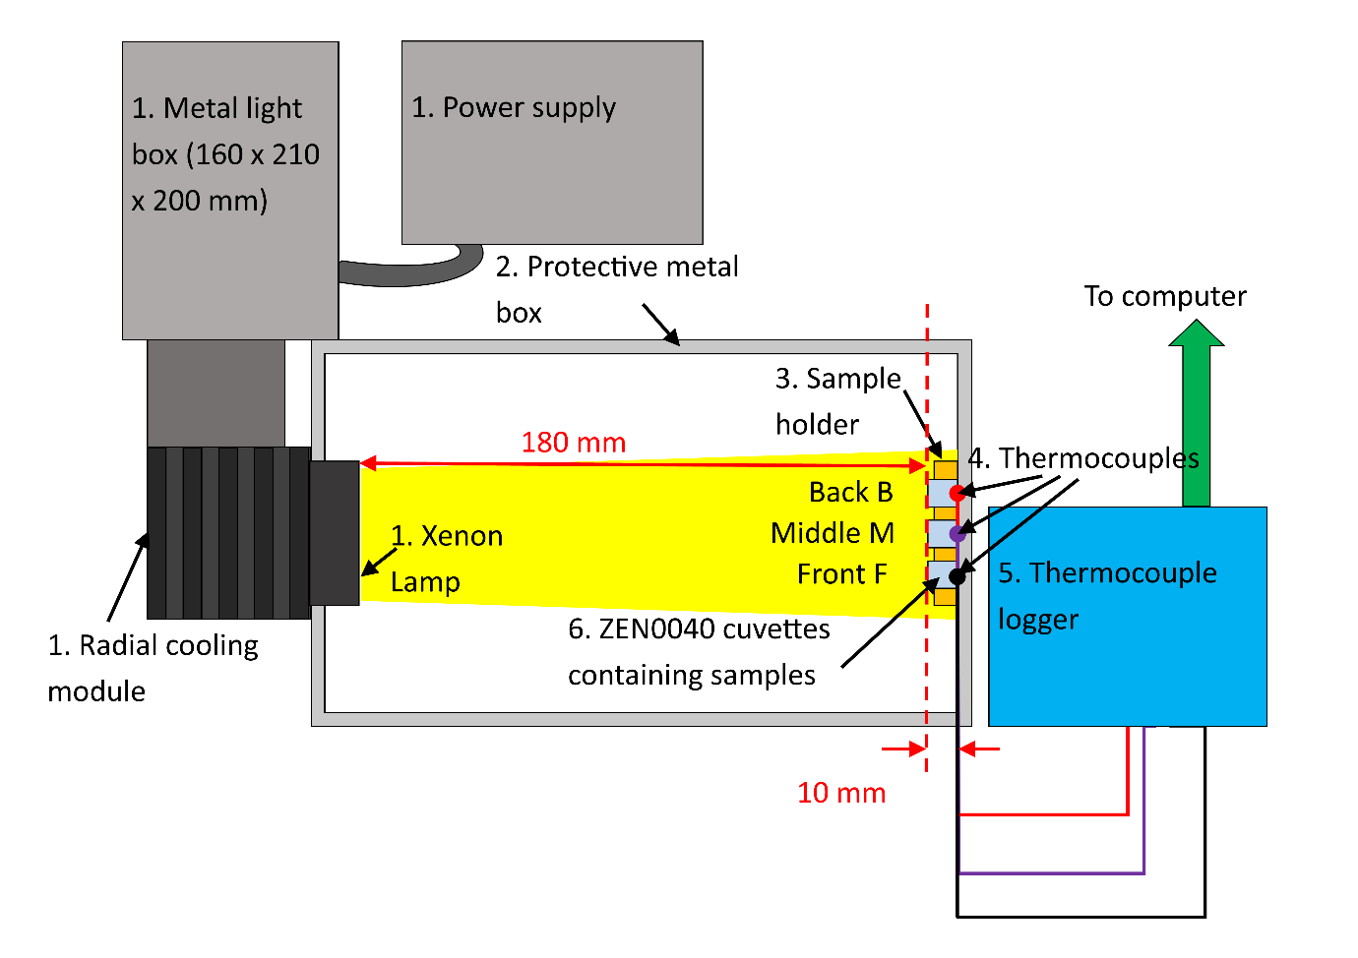
Fig. 1 Schematic of solar simulator testing setup
The testing procedure was as follows: three 1.5 ml samples of the same nanofluid type were placed in three cuvettes and the UV-vis spectra recorded by rotating the cuvette through 90º giving a path length of 4 mm (to prevent saturation of the Varian Cary spectrophotometer). The thermocouples were added and the cuvettes sealed. These were placed in the sample holder bolted to the steel box with one sample in the front (F) position, one in the middle (M) and the final sample at the back (B). The starting temperature of the nanofluids was recorded for a minimum of 30 seconds prior to switching on the simulator for one hour while the temperature was monitored. The samples were allowed to cool and removed from the sample holder. The UV-vis spectra were recorded using the Varian Cary spectrometer in the same manner as the initial spectra. The samples were then placed back in the sample holder with each sample moved by one position and the procedure repeated to give 6, 9 or 12 hours total exposure (moving each sample by one position following each hour of exposure).
The change in temperature (∆T) was calculated taking the starting temperature as the average of the 30 seconds prior to the lamp being switched on. The slope of the graph ∆T/∆t was calculated in the linear region between t= 90 and t = 150 seconds. For a dilute nanofluid the heat capacity and the mass of nanofluid can be approximated by the heat capacity and mass of the base-fluid. Hence (Equation 1):
$$PE= \frac{C_{w}M_{w}∆T}{IA∆t}$$
Equation 1
Where PE is the photo-conversion efficiency (%), which is a ratio of the internal energy increase to the total incident solar radiation. C_{w} is the heat capacity of the base-fluid (J/kg K), M_{w} is the mass of the base-fluid (kg), ∆T is the change in temperature (K), I is the incident radiative intensity (W/m²), A is the surface area exposed (m²) and ∆t is the change in time (s) (Jin et al., 2016). Hence, for a given system where I, A, C_{w} and M_{w} are constant the PE is proportional to the rate of temperature rise in the linear part of the graph.
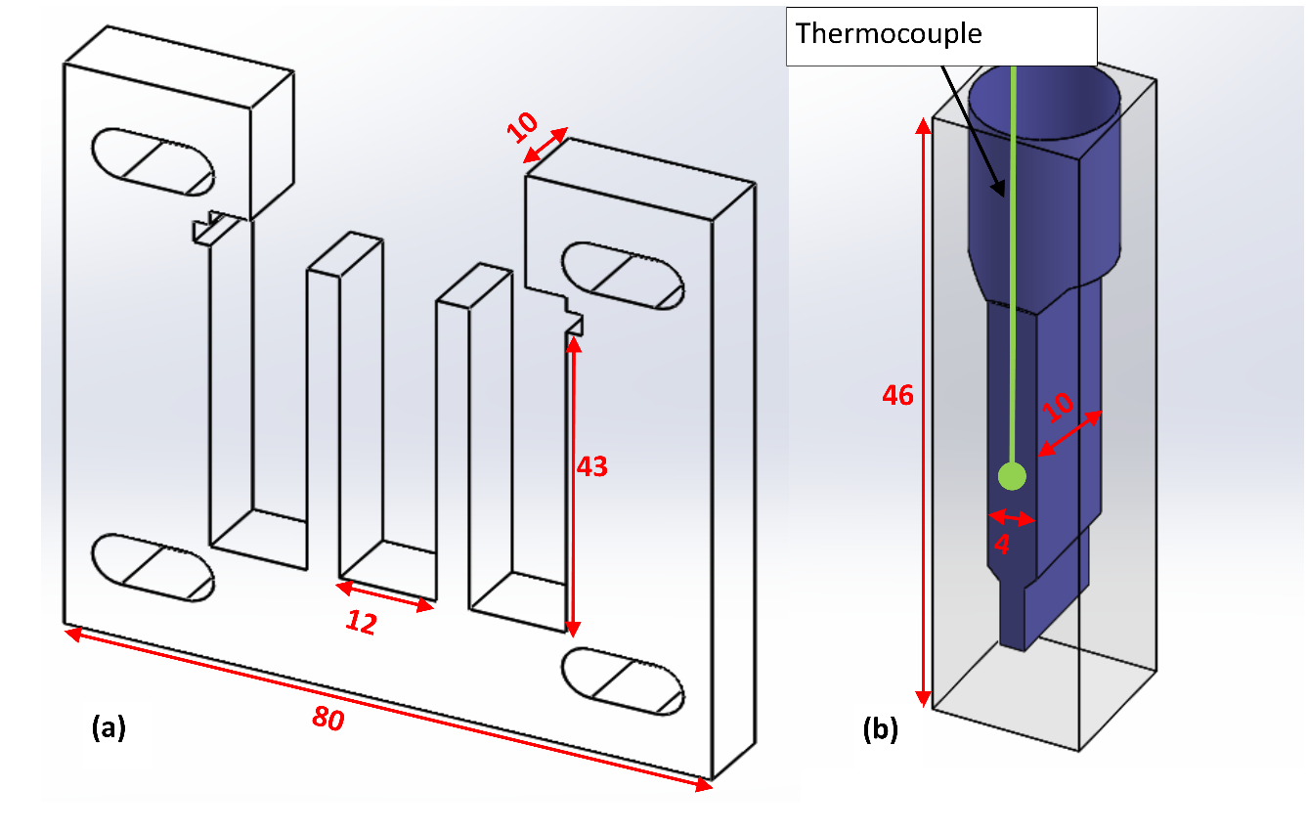
Fig. 2 Detail of (a) sample holder and (b) ZEN0040 cuvette. All dimensions in mm

Exposure of nanofluids to sunlight
To ascertain the longer-term stability of the AgNPr and SiO₂@AgNPr nanofluids, outdoor exposure tests were undertaken on the six samples (P-B and P-C). Samples were exposed for 2 weeks over the period of 2nd June to 16th June 2018 in Southampton, UK. The samples faced due south and were angled at 30º to the horizontal. The sample volume was 3 mL and the sample containers (diameter 23 mm, total height 48 mm) were made of glass with a plastic lid to prevent evaporation (typically 80% transmittance over the range of 250 - 2000 nm). UV-vis spectroscopy was undertaken prior to and after exposure.

Characterization of nanoparticles and nanofluids
UV-vis spectroscopy analysis employed a Varian Cary 300 Bio spectrophotometer over a wavelength of 200 to 900 nm with either a 10 mm (quartz cuvette) or 4 mm (ZEN0040 micro cuvette) path length for the more concentrated samples. The scan rate was 600 nm/min with a step of 1 nm and a time per step of 0.1 s. All initial values of maximum absorbance were kept below 2 au by choosing the appropriate cuvette. Samples from P-A were directly characterized without the need of intermediate steps, and they were considered as references for optical density (OD) comparison. All the results were normalized in OD, corrected for path length, and compared directly to the same P-A batch (P-A1 used to calculate P-B1 OD, P-A2 for P-B2 OD and P-A3 for P-B3 OD). Two main criteria were used to assess the UV visible spectra, i.e. the wavelength of the maximum absorption peak (WP) and the height of that peak in terms of OD (OD_{max}).
Transmission electron microscope (TEM), analysis utilized a Hitachi HT7700 100 kV TEM. Preparation of samples involved drop casting onto carbon and Formvar coated Cu/Pd 200 mesh grids and subsequent base-fluid evaporation. Further TEM picture analysis entailed Digimizer image analysis software and Minitab 17.3.1 statistical analysis software. The scale bar on the TEM image was used to calibrate the line length employed in the Digimizer image analysis software and the size of the individual nanoparticles then measured manually for each particle of the same type. Multiple images were used to increase the number of measurements taken to determine the size distribution. The resulting lists of lengths were then input into the Minitab statistical analysis software to obtain the distribution, means and standard deviations. For the SiO₂ coated particles, the whole width of each particle was measured.

Measurement uncertainty
The measurement uncertainty was determined according to the method described in (Bell, 2001). For each measurement type (UV-vis spectroscopy, TEM and SSL) the relative uncertainty was calculated for each of the type B (equipment calibration / resolution) uncertainties and combined with the type A (sample variation) uncertainties to give a combined relative uncertainty. A coverage factor of 2 (approximately 95% confidence) was then used to give a final expanded uncertainty.
For the SSL tests, uncertainties in the constant C_{w}M_{w}/IA (Equation 1) range gave an expanded uncertainty of 8.35% for the type B uncertainties (see SI Table S1) and a range of total expanded uncertainties of 9.45 – 9.62% for water in the three positions (see SI Tables S2, S3 and S4.)
For the uncertainty in the measurement of WP in the UV-vis spectroscopy, the type B uncertainties were smaller (<1%) leading to an overall lower uncertainty in general (see SI Table S5 for an example calculation using the data presented in Fig. 3a, which gave an expanded uncertainty of 1.93%). Similarly the type B uncertainties for the absorption maxima were again <1%. However, there was typically more variation in the height of the absorption maxima (this is illustrated for Fig. 3a in SI Table S6, which gave an expanded uncertainty of 5.80%).
For the TEM measurements, type B uncertainties were <3%. However, although multiple measurements were employed there was still considerable variation in particle sizes leading to a higher typical expanded uncertainty (illustrated in SI Table S7 for the triangular P-B1 sample measurements from SI Table S11 – giving an expanded uncertainty of 4.41%). It was also not possible to quantify the uncertainty associated with manually selecting which particle had a particular shape.

Results and Discussion
In the present study, the variation in temperature on repeated exposure to SSL was measured in real time for AgNPrs, SiO₂@AgNPr and SiO₂ nanofluids. These were compared to the water base-fluid to show the potential of these nanofluids to improve the PE. The stability of the nanofluids was assessed by measuring the change in UV-vis spectra with different exposure time, and by examining the shape of nanoparticles via TEM. NSL trials over a longer period were also carried out to contextualize the SSL exposure results.

AgNPrs-based nanofluids
The synthesis for P-A was based on (Zhang et al., 2011) with some modifications, where AgNPrs were stabilized with both TSCD and PVP. The ratio of silver ions to sodium borohydride in this synthesis was 1:10, similar to that employed previously (Carboni, 2014; Panzarasa, 2015; Tang et al., 2015; Zhang et al., 2011).
The U-V visible characterisation of the AgNPrs synthesised from procedure P-A is shown in Fig. 3a. The comparison in terms of OD with procedure P-B is given in Fig. 3b. Initially the maximum absorbance for P-A was on average 1.6 ± 0.08 a.u.) with an average WP of 851 ± 13.6 nm for an initial silver concentration of 0.1 mM. After concentration (P-B) the average OD_{max} was 2.87 ± 0.18 (In all cases the original absorption value was kept below 2 au see SI Table S8). If no material had been lost on centrifuging the value of OD_{max} should have been ≈ 4 au, hence, this represents about a 28% reduction in OD_{max}. The WP had also blue shifted to an average of 801 ± 5.0 nm. This shows the non-linear variation of OD_{max} due to both the possible loss of product during the purification procedure,the effect of mechanical damage and aggregation, and the effect of particle size and concentration on the optical output. It should be noted that a higher than 0.1 mM silver concentration was employed for this work to make the results more application relevant. This can have a small effect on the absorption due to electronic effects between particles.
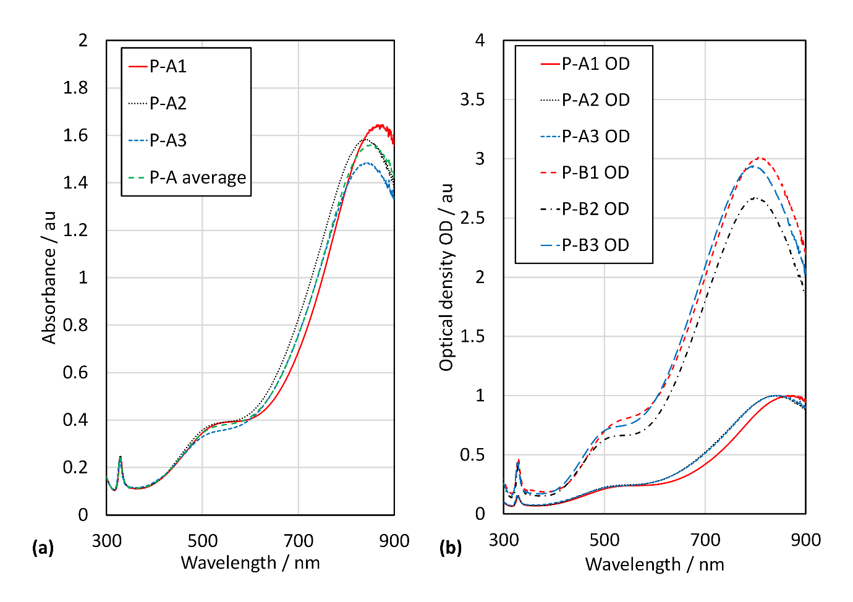
Fig. 3. (a) UV-vis results for P-A (10 mm quartz cuvette), and (b) OD (absorbance normalized to procedure P-A) results for P-A and P-B.
To confirm the morphology, samples from P-B were examined with TEM (Fig. 4). Further size analysis was performed on multiple TEM images and the results are reported in SI Tables S11. The majority of the particles were triangular in shape, with some rounded corners. A range of sizes was seen, but the mean side length was similar for the three batches at about 30 - 45 nm. This mean size is slightly smaller than we obtained previously (Carboni et al., 2016) for a WP of 750 nm and confirms that the position of the WP is affected by the sample geometry as well as the size (Kelly et al., 2003).
Fig. 4. TEM images for P-B1 (a), P-B2 (b) and P-B3 (c) AgNPrs. All scale bars = 100 nm.

Coating AgNPrs with SiO₂
Aiming at the silica coating of AgNPrs, significant modification to the protocol of Lismont et al (Lismont et al., 2015) (for nanospheres) were carried out. Specifically, DMA was used to replace ammonia hydroxide in order to prevent etching of the triangular AgNPrs (Carboni, 2014), while MHA was added to cap the surface (Fig. 5).
Fig. 5. Modified coating procedure for AgNPrs.
The UV-vis spectra of the SiO₂@AgNPrs (obtained from P-C) and the SiO₂ (from P-D) nanofluids are shown in Fig. 6. The WP for the SiO₂@AgNPr nanofluids averaged 832 ± 8.2 nm with an OD_{max} of 3.20 ± 0.26 a.u (see SI Table S8 for absorbance maxima data). The SiO₂ coating therefore red shifted the peak position by approximately 30 nm, in agreement with what we reported earlier (Carboni, 2014). The peak height was not significantly different (according to a statistical two-sample T-test – a hypothesis test allowing the comparison of two means – see SI Equations S1 & S2 for further details) to the P-B samples showing that the coating had no detrimental effect on the absorption. This clearly demonstrated the advantage of SiO₂ coating as it is optically transparent (Guerrero-Martinez et al., 2010; Li et al., 2015). The presence of SiO₂ in the nanofluid samples is identified by its typical absorption below 350-450 nm, which is also shown for the nanofluid containing pure-SiO₂ nanoparticles (P-D).
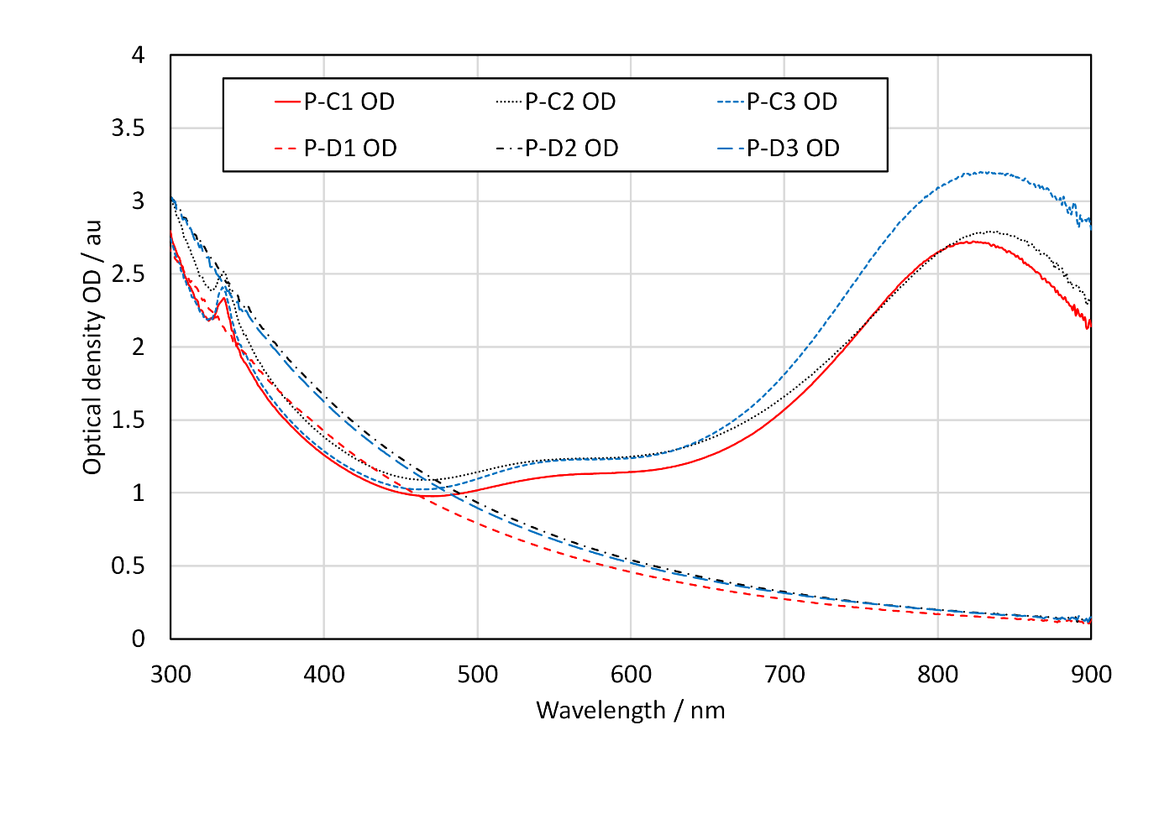
Fig. 6. SiO₂@AgNPr (P-C) and SiO₂ (P-D) nanofluids prior to solar testing (original values of maximum absorption and cuvette details given in SI Table S1).
TEM characterization of the SiO₂@AgNPrs (P-C) showed a consistent thickness of the coating of SiO₂ onto the AgNPrs (Fig. 7 and SI Table S12). The mean size of the SiO₂@AgNPrs was similar for the three batches at 141.4 nm. Although nanoparticles may be generally considered as having structural dimensions of less than 100 nm, other authors still use the terminology of nanoparticles or nanofluids to describe hybrid nanoparticles ≤ 200 nm (De Matteis et al., 2017; Kang et al., 2015; Lismont et al., 2015). The presence of SiO₂ nanoparticles without an Ag core was also confirmed. It also showed that the majority of SiO₂@AgNPrs were well monodispersed individually, with a low percentage of multi-cored silver. This and the enhanced stability of SiO₂ nanofluids in aqueous solutions (Guerrero-Martinez et al., 2010) suggest that aggregates reaching the micron scale are unlikely. The thickness of the SiO₂ coating was similar but slightly lower to that obtained after 25 minutes reaction time by Lismont et al of 177.8 nm (Lismont et al., 2015). The coating was thicker than that produced using different coating procedures reported on silver nanodiscs (Hjerrild et al., 2018; Taylor et al., 2018). This could potentially be beneficial for our applications.
Fig. 7. TEM images for P-C1 (a), P-C2 (b) and P-C3 (b) SiO₂@AgNPr, before solar testing. All scale bars = 100 nm. The yellow line on (a) shows how the measurement of the SiO₂@AgNPr particles was undertaken.

Performance of nanofluids under simulated sunlight (SSL)
The emission spectra of the solar simulator was compared to sunlight and shown to be similar (See SI Fig. S2), and hence suitable for these comparative tests. The reproducibility of the solar simulator test method was tested by repeat measurements of the water base-fluid (SI Table S13). The pooled standard deviation (pooled SD) for ∆T was 1.096 °C, and 0.0015 °Cs⁻¹ for the slope ∆T/∆t. However, the position of the sample in the simulator was found to be a significant factor with the sample in the middle (M) position having consistently higher values. It was therefore necessary to rotate the batches in the simulator in a consistent manner to ensure that each batch of each type of nanofluid had the same amount of time in each position over the total number of testing cycles. This allowed a statistical analysis of the results.
The measurements of mean changes in temperature ∆T on exposure to SSL are depicted in Fig. 8. All the fluids showed an initial linear increase in temperature, followed by a levelling out of the temperature rise. The results from the SSL exposure were analyzed using response surface methodology utilizing Minitab 17.3.1. This showed that the batch number (1 – 3) and time (0-12 hours) did not significantly affect ∆T. On the other hand, the nature of the nanofluid and the position in the solar simulator caused ∆T variations. The mean results (mean of all results for that sample type in a given position in the solar simulator) (Fig. 8) showed that the middle sample position in the solar simulator (see Fig. 1) gave a larger ∆T than the other two positions. In addition, both the SiO₂@AgNPr (P-C) and the AgNPr (P-B) nanofluid had a much higher final temperature than the SiO₂ (P-D) nanofluid and the base-fluid water.
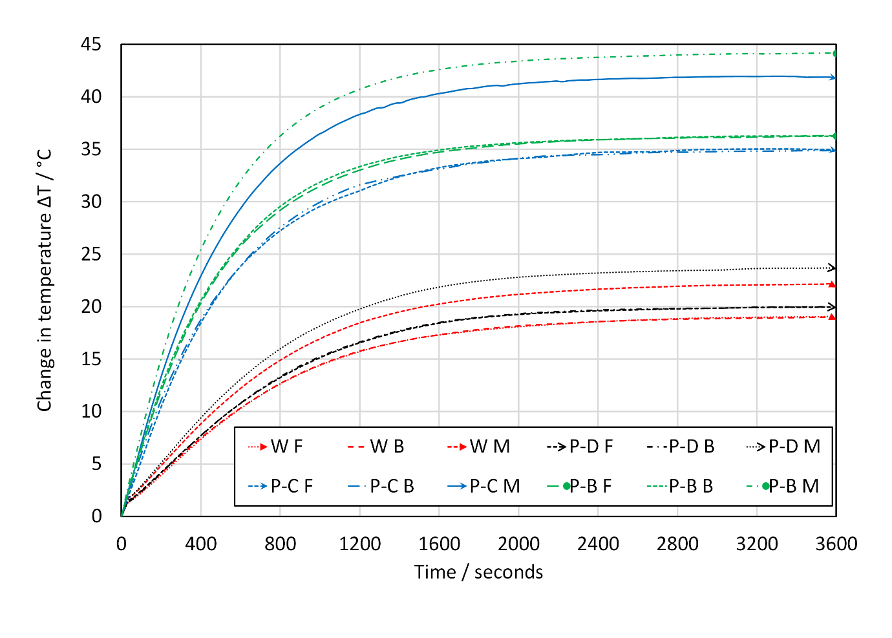
Fig. 8. Mean ∆T as a function of SSL exposure time. W = water, P-D = SiO₂, P-C = SiO₂@AgNPr, P-B = AgNPr. Position in solar simulator = Back (B), middle (M) or front (F).
After 1 hour exposure to SSL, analysis of variance (ANOVA) showed the AgNPr (P-B) nanofluid to have a slightly higher maximum ∆T (stagnation temperature) than the SiO₂@AgNPr (P-C) nanofluid. Both the silver containing nanofluids had a ∆T significantly greater by about 20°C than the SiO₂ (P-D) nanofluid and the water (W) base-fluid. The value of ∆T for the AgNPr nanofluids was about double that of the water base-fluid and the SiO₂ nanofluid, showing the potential of the AgNPr nanofluid for solar applications. Even when the uncertainty of the experiment (see Section 2.7) is taken into consideration, there is still a measureable increase in ∆T for the AgNPrs and SiO₂@AgNPrs compared to water and SiO₂.
When the same ANOVA was undertaken on the rate of change in temperature, ∆T/∆t (i.e. the slope) the water and SiO₂ nanofluid were comparable with a lower slope than the two AgNPr nanofluids. Again, the AgNPrs (P-B) had a slightly larger value of ∆T/∆t than the SiO₂@AgNPrs (P-C). The statistical results are summarized in Table 1 for samples in the middle position (M). The slope of the AgNPr containing nanofluids was about three times the other samples, giving a better indication of the potential improvement that these nanofluids could offer (as slope is directly related to PE, according to Equation 1 (Jin et al., 2016; Otanicar et al., 2010)).
The results obtained were higher than those observed by Otanicar et al (Otanicar et al., 2010) and Hjerrild et al (Hjerrild et al., 2016), but of a similar magnitude to others (Al-Nimr and Al-Dafaie, 2014; Bandarra Filho et al., 2014; Chen et al., 2016). This may be attributed to the test geometry and nanofluid silver concentration used in this work that was optimized to maximize the nanofluid absorption of the solar radiation. In contrast, silver nanoparticles are known to increase the thermal conductivity of the fluid (Lee et al., 2016; Roy et al., 2015; Salehi et al., 2013). This is likely to have a detrimental effect on ∆T at 3600 s with an increase in thermal conductivity leading to an enhancement of losses to the surroundings and a lower stagnation temperature. This may explain why the improvement in the PE was larger than the improvement in ∆T.
Table 1 SSL results for samples in the middle (M) position
Nanofluid | ∆T after 1 hour/ °C |  |  |  |  | Slope (∆T/∆t) / °Cs⁻¹
 | Mean | SD | Grouping | N | % improvement | Mean | SD | Grouping | N | % improvement
AgNPr (P-B) | 44.1 | 1.37 | A | 12 | 102 | 0.074 | 0.006 | A | 12 | 270
SiO₂@AgNPr (P-C) | 41.7 | 1.16 | B | 6 | 91 | 0.068 | 0.004 | B | 6 | 240
SiO₂ (P-D) | 23.6 | 1.16 | C | 9 | 8 | 0.021 | 0.002 | C | 9 | NA
Water (W) | 21.8 | 1.25 | D | 9 | NA | 0.020 | 0.002 | C | 9 | NA

To assess the stability of the nanofluids repeated exposures to SSL were carried out (Fig. 9 & 10). Fig. 9 shows the change in position of the maximum absorption peak on exposure to SSL, while Fig. 10 shows the average spectra for the three batches before and after exposure. The WP for the AgNPrs (P-B), blue shifted by about 100 nm, with a drop in OD_{max} of about 10% whereas the SiO₂@AgNPrs (P-C) had a change in WP of about 200 nm (from about 800 to 600 nm), and a similar drop in OD_{max} of 9% (For absorption maxima values please see SI Table S10). All SiO₂@AgNPr (P-C) nanofluids appeared to show a reduction in stability when compared to the AgNPr (P-B) nanofluid. This reduction in stability was not expected from reviewing the literature (Hjerrild et al., 2016; Taylor et al., 2018). There was some variation in the results obtained for the different batches with P-C2 being especially unstable, although its uncoated counterpart (P-B2) was the most stable.
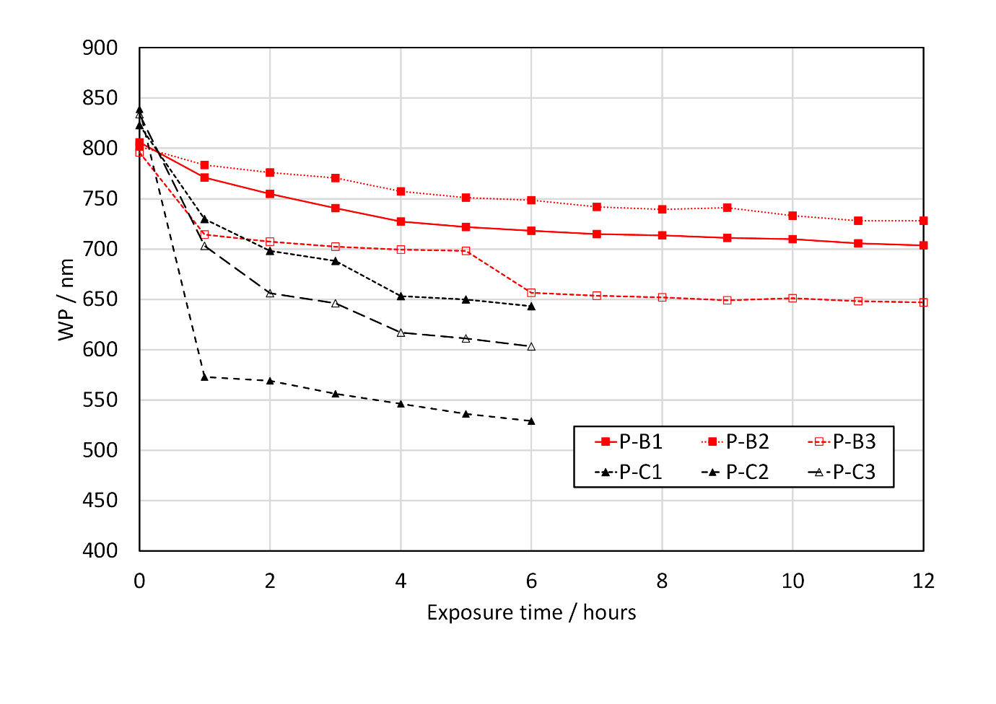
Fig. 9. Change in WP with SSL exposure time for AgNPr (P-B) and SiO₂@AgNPr (P-C) nanofluids.
It was noted that the SiO₂@AgNPr P-C2 appeared to change color before testing. To investigate this, UV-vis spectra of the coated samples were recorded after storage in the dark at 4 °C for three weeks (Fig. 11). A blue shift of 15, 98 and 23 nm was observed for the WP of P-C1, P-C2 and P-C3 respectively. OD_{max} decreased by 5% for P-C1, 46% for P-C2 and 17% for P-C3 (for absorption maxima values see SI Table S10). The order of stability in the dark for the three batches was hence P-C1 > P-C3 > P-C2, in line with that obtained in SSL for the same three batches (Fig. 9). The change in the position of the peak in the dark was not as enhanced as for the SSL exposed samples.
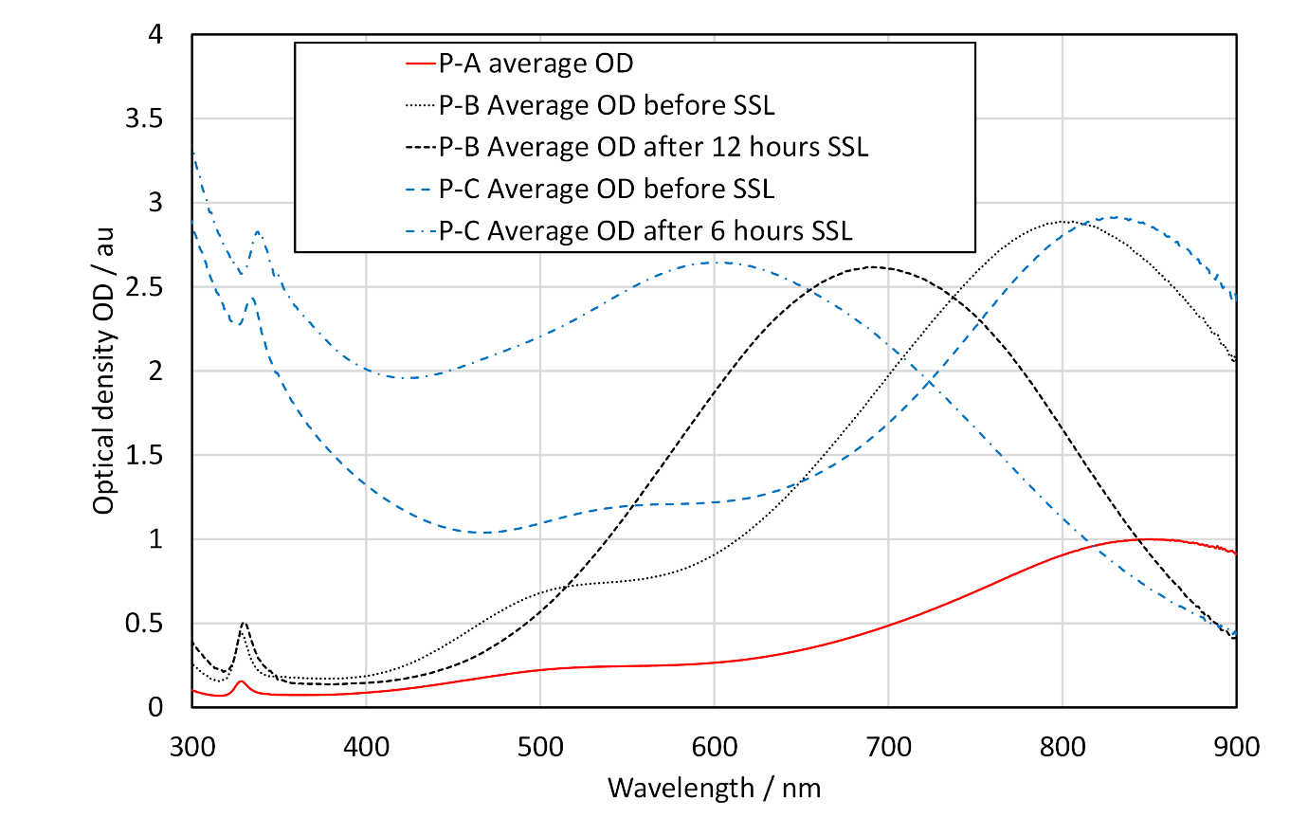
Fig. 10. UV-vis spectra after exposure to SSL (Average OD results shown).
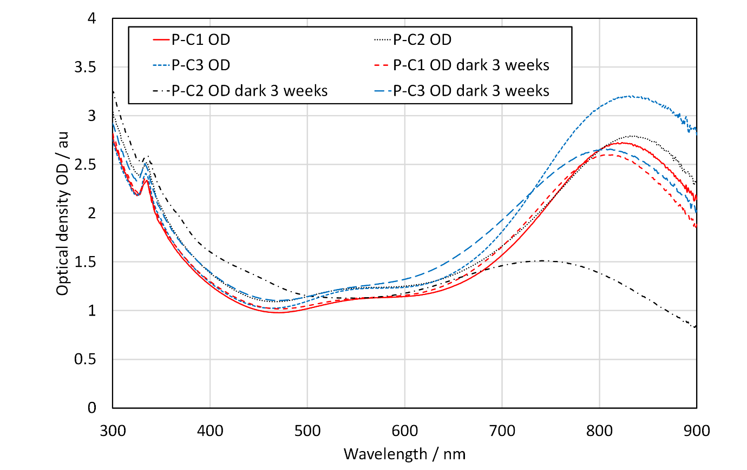
Fig. 11. UV-vis spectra of SiO₂@AgNPr (P-C) initially and after storage in the dark for 3 weeks.
TEM characterization further demonstrated the morphological change of the SiO₂@AgNPrs (P-C), indicating the lack of stability. TEM images of the P-B and P-C nanofluids following SSL exposure are depicted in Fig. 12 (and the results of the size analysis are reported in SI Table S14). To further understand the stability, the size of the silver particles inside the SiO₂ shells were measured, where a smaller size would indicate that the silver was being etched. In addition, particles present in the P-C samples which are no longer coated would indicate that the SiO₂ coating is not stable.
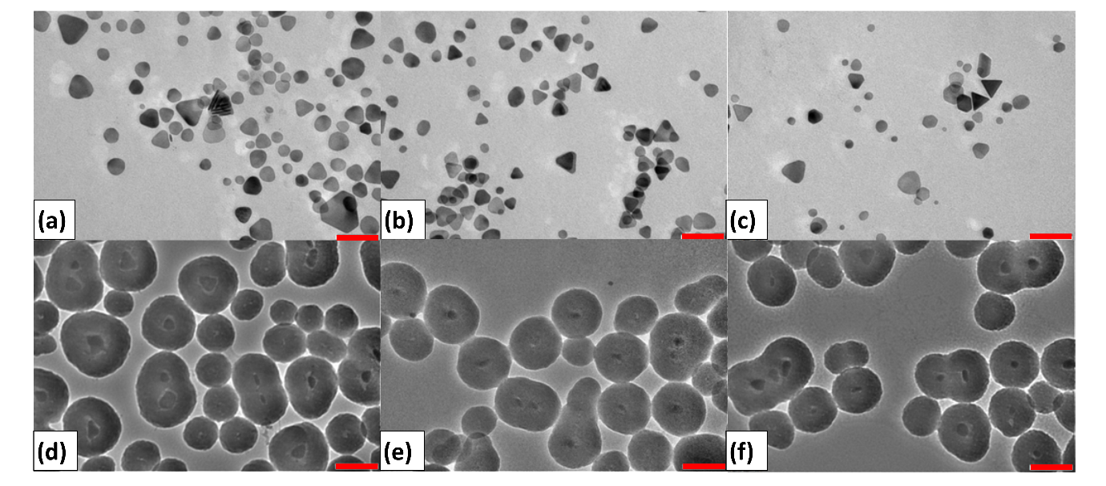
Fig. 12. TEM pictures of AgNPr (a: P-B1, b: P-B2, c: P-B3) and SiO₂@AgNPr nanofluids (d: P-C1, e: P-C2, f: P-C3) after SSL exposure (P-B = 12 hours, P-C = 6 hours). All scale bars = 100 nm.
As can be seen from Fig. 12, the AgNPrs (P-B) are all more rounded. The increase in the number of non-triangular (other) particles in the size analysis also confirms this. The size of the particles has, however, remained about the same at 30-45 nm (diameter of rounded particles compared with edge length of prisms) showing that the predominate process is the rounding of the corners of the AgNPrs rather than a breaking up of AgNPrs into smaller particles. This phenomenon is largely the cause of the blue shifted absorption maxima.
For the SiO₂@AgNPrs (P-C), the AgNPrs inside the SiO₂ shells all appear to have more rounded corners. The size analysis also shows that the AgNPrs are smaller on average than the initial uncoated AgNPrs reducing in size by about 10 nm, suggesting that the AgNPrs are continuing to etch inside the coating. In addition, the size of the SiO₂ shells has reduced slightly (between on average 4 - 9 nm), suggesting that the SiO₂ shell is also degrading. There is, however, a lack of free silver particles showing that this is a slow process (no free silver particles were seen in the TEM pictures taken before SSL exposure). The main cause of the lack of stability would therefore likely be the etching of the AgNPrs inside the SiO₂ shell.
With our modified synthesis, we produced thick SiO₂ coatings, which should have reduced instability caused by SiO₂ dissolution of thin SiO₂ coatings seen by others (Hjerrild et al., 2018). However, in doing so we seem to have accelerated the shape conversion of the silver on exposure to light. This acceleration in shape conversion was not seen with SiO₂ coated silver nanodiscs in water, produced using a different synthesis (Taylor et al., 2018). This highlights the complex nature of the interactions within the nanofluid and clearly demonstrates the need for further testing and understanding of nanofluid stability.

Exposure of nanofluids to sunlight
To further characterize the stability of SiO₂@AgNPr fluids under application relevant conditions, NSL exposures were conducted to compare with and contextualize the SSL test results.
The results of UV-vis spectral measurements, before and after exposure to NSL, are presented in Fig. 13 (for absorption maxima data see SI Table S9). These show the complexity of the stability issue with the P-B samples exhibiting a large decrease in OD_{max} of 75% (possible aggregation), with a smaller blue shift in WP (80 nm). This aggregation of the particles in bigger clusters was confirmed by the presence of eye-visible seeds. The P-C samples in contrast were more stable against aggregation (OD_{max} diminished by 12%) but were less shape-stable (200 nm blue shift in WP). There was no evidence of UV light leading to a densification of the SiO₂ shell on the SiO₂@AgNPrs resulting in an increase in peak height (or OD_{max}) as suggested by others (Taylor et al., 2018). The increased stability of the SiO₂@AgNPrs (P-C) to aggregation showed one of the benefits of coating silver with silica.
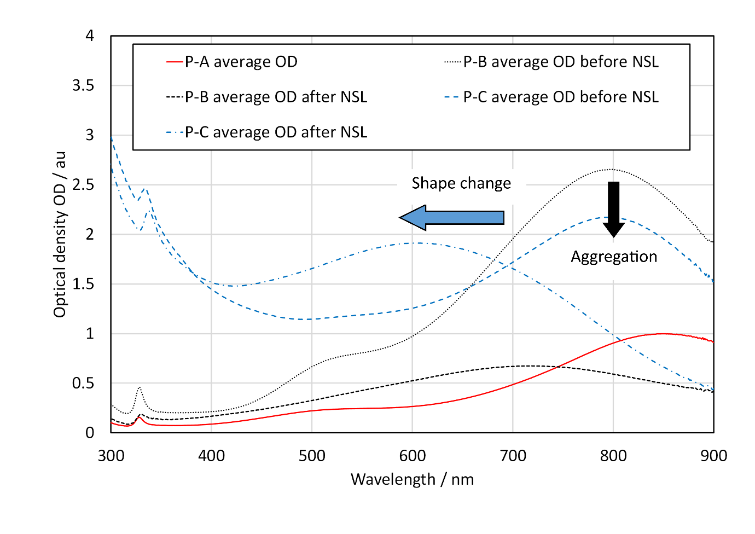
Fig. 13. Change in UV-vis spectra following exposure to NSL for 2 weeks for P-B and P-C (average OD shown).
Comparison with the SSL results (Fig. 10) showed that the shift in WP for the two types of nanofluids were similar to that observed for the NSL exposure trials in Fig. 13, but the drop in OD_{max} was not. This suggests that initial shape modification of the nanoparticles was a faster process than aggregation, occurring within the time-period of the SSL trials, whilst aggregation took longer to occur becoming only obvious after the prolonged NSL exposure trials. It also indicates that the rate of shape alteration was fastest when it was first exposed to solar radiation, as the shift in peak position was similar for both the SSL and natural exposure trials. The results in Fig. 9 also support the hypothesis that the initial shape change for the SiO₂@AgNPrs is rapid and occurs in the first few hours of exposure.

Conclusions
Following a modified Stöber procedure to form thick consistent coatings of SiO₂ AgNPrs, two types of nanofluids in water base-fluid were produced with either uncoated AgNPrs or SiO₂@AgNPrs. By using a solar simulator, real time temperature profiles were obtained for AgNPrs and SiO₂@AgNPr nanofluids with strong absorbance in the near-IR wavelength band. The results showed an almost doubling in maximum temperature compared to that using only water base-fluid or a SiO₂ nanofluid, and an approximately three times increase in PE. This illustrates the potential for enhanced solar capture that is possible using these nanofluids. Compared to SiO₂ based nanofluid, the advantage of utilizing silver nanoparticles having a strong plasmonic absorption was hence demonstrated. Even when the measurement uncertainty is taken into consideration, this result is still significant. However, the magnitude of the improvement is limited to these specific nanofluids tested and the static geometry employed in this study. More realistic solar testing under flow conditions with larger nanofluid volumes and different silver concentrations will be needed to ascertain and then optimize the actual magnitude of the improvement in PE.
This is the first attempt to examine the stability of these nanofluids under natural sunlight exposure (NSL). The NSL results indicated the importance of SiO₂ coating to prevent aggregation. The change in position of the maximum absorbance peak was similar in both the SSL and NSL tests, revealing that in the case of the nanofluids measured the shape change occurred more rapidly than aggregation. The similarity between SSL and NSL tests in terms of WP was encouraging and showed the potential of SSL tests as a means of assessing real world performance. The relative rates of the different processes (aggregation versus shape change) is limited to the specific nanofluids investigated here but could have implications to understand and improve stability of other nanofluids for related applications; this is currently under active investigation in our laboratories.
The rapid change in position of the WP with exposure to simulated sunlight (SSL) for the SiO₂@AgNPr nanofluids indicate challenges for improving shape stability. Therefore, further work is required on the coating procedure to firstly understand, measure and then improve the shape stability of the coated nanoparticles.

Acknowledgements
The authors would like to acknowledge the support of the Faculty of Engineering and Physical Sciences, and CDT in Energy Storage and Its Application at the University of Southampton, and especially Prof Andrew Cruden, Head of the Energy Technology Research Group, for helpful discussion on the results.

References
Abdelrazik, A.S., Al-Sulaiman, F.A., Saidur, R., 2019. Optical behavior of a water/silver nanofluid and their influence on the performance of a photovoltaic-thermal collector. Solar Energy Materials and Solar Cells, 201, 110054, https://doi.org/10.1016/j.solmat.2019.110054.
Akilu, S., Baheta, A.T., M.Said, M.A., Minea, A.A., Sharma, K.V., 2018. Properties of glycerol and ethylene glycol mixture based SiO₂-CuO/C hybrid nanofluid for enhanced solar energy transport. Solar Energy Materials and Solar Cells, 179, 118-128, https://doi.org/10.1016/j.solmat.2017.10.027.
Al-Nimr, M.d.A., Al-Dafaie, A.M.A., 2014. Using nanofluids in enhancing the performance of a novel two-layer solar pond. Energy, 68, 318-326, https://doi.org/10.1016/j.energy.2014.03.023.
Bandarra Filho, E.P., Mendoza, O.S.H., Beicker, C.L.L., Menezes, A., Wen, D., 2014. Experimental investigation of a silver nanoparticle-based direct absorption solar thermal system. Energy Conversion and Management, 84, 261-267, https://doi.org/10.1016/j.enconman.2014.04.009.
Bell, S., 2001. A Beginner's Guide to Uncertainty of Measurement. NPL, UK TW11 0LW, https://www.dit.ie/media/physics/documents/GPG11.pdf. (Accessed 20 November 2019).
Carboni, M., 2014. Silver Nanoprisms Embedded in a Polymeric Matrix for Energy Saving Glazing. PhD thesis, Southampton.
Carboni, M., Capretto, L., Carugo, D., Stulz, E., Zhang, X., 2013. Microfluidics-based continuous flow formation of triangular silver nanoprisms with tuneable surface plasmon resonance. Journal of Materials Chemistry C, 1(45), 7540, https://doi.org/10.1039/c3tc31335b.
Carboni, M., Carravetta, M., Zhang, X.L., Stulz, E., 2016. Efficient NIR light blockage with matrix embedded silver nanoprism thin films for energy saving window coating. J. Mater. Chem. C, 4(8), 1584-1588, https://doi.org/10.1039/c6tc00026f.
Chen, M., He, Y., Zhu, J., Wen, D., 2016. Investigating the collector efficiency of silver nanofluids based direct absorption solar collectors. Applied Energy, 181, 65-74, https://doi.org/10.1016/j.apenergy.2016.08.054.
Crisostomo, F., Hjerrild, N., Mesgari, S., Li, Q., Taylor, R.A., 2017. A hybrid PV/T collector using spectrally selective absorbing nanofluids. Applied Energy, 193, 1-14, https://doi.org/10.1016/j.apenergy.2017.02.028.
De Matteis, V., Rizzello, L., Di Bello, M.P., Rinaldi, R., 2017. One-step synthesis, toxicity assessment and degradation in tumoral pH environment of SiO₂@Ag core/shell nanoparticles. Journal of Nanoparticle Research, 19(6), https://doi.org/10.1007/s11051-017-3870-2.
Delfani, S., Karami, M., Behabadi, M.A.A., 2016. Performance characteristics of a residential-type direct absorption solar collector using MWCNT nanofluid. Renewable Energy, 87, 754-764, https://doi.org/10.1016/j.renene.2015.11.004.
Dhinesh Kumar, D., Valan Arasu, A., 2018. A comprehensive review of preparation, characterization, properties and stability of hybrid nanofluids. Renewable and Sustainable Energy Reviews, 81, 1669-1689, https://doi.org/10.1016/j.rser.2017.05.257.
Goel, N., Taylor, R.A., Otanicar, T., 2020. A review of nanofluid-based direct absorption solar collectors: Design considerations and experiments with hybrid PV/Thermal and direct steam generation collectors. Renewable Energy, 145, 903-913, https://doi.org/10.1016/j.renene.2019.06.097.
Gorji, T.B., Ranjbar, A.A., 2016. A numerical and experimental investigation on the performance of a low-flux direct absorption solar collector (DASC) using graphite, magnetite and silver nanofluids. Solar Energy, 135, 493-505, https://doi.org/10.1016/j.solener.2016.06.023.
Gorji, T.B., Ranjbar, A.A., 2017a. A review on optical properties and application of nanofluids in direct absorption solar collectors (DASCs). Renewable and Sustainable Energy Reviews, 72, 10-32, https://doi.org/10.1016/j.rser.2017.01.015.
Gorji, T.B., Ranjbar, A.A., 2017b. Thermal and exergy optimization of a nanofluid-based direct absorption solar collector. Renewable Energy, 106, 274-287, https://doi.org/10.1016/j.renene.2017.01.031.
Graf, C., Vossen, D., Imhof, A., Blaaderen, A., 2003. A General Method To Coat Colloidal Particles with Silica. Langmuir, 19, 6693-6700.
Guerrero-Martinez, A., Perez-Juste, J., Liz-Marzan, L.M., 2010. Recent progress on silica coating of nanoparticles and related nanomaterials. Adv Mater, 22(11), 1182-1195, https://doi.org/10.1002/adma.200901263.
Gupta, H.K., Agrawal, G.D., Mathur, J., 2015a. Experimental Evaluation of Using Nanofluid in Direct Absorption Solar Collector, Energy Technology & Ecological Concerns: A Contemporary Approach. 150-154.
Gupta, H.K., Agrawal, G.D., Mathur, J., 2015b. Investigations for effect of Al₂O₃–H₂O nanofluid flow rate on the efficiency of direct absorption solar collector. Case Studies in Thermal Engineering, 5, 70-78, https://doi.org/10.1016/j.csite.2015.01.002.
Haber, J., Sokolov, K., 2017. Synthesis of Stable Citrate-Capped Silver Nanoprisms. Langmuir, 33(40), 10525-10530, https://doi.org/10.1021/acs.langmuir.7b01362.
Hatami, M., Jing, D., 2017. Evaluation of wavy direct absorption solar collector (DASC) performance using different nanofluids. Journal of Molecular Liquids, 229, 203-211, https://doi.org/10.1016/j.molliq.2016.12.072.
Hjerrild, N.E., Mesgari, S., Crisostomo, F., Scott, J.A., Amal, R., Taylor, R.A., 2016. Hybrid PV/T enhancement using selectively absorbing Ag–SiO₂/carbon nanofluids. Solar Energy Materials and Solar Cells, 147, 281-287, https://doi.org/10.1016/j.solmat.2015.12.010.
Hjerrild, N.E., Scott, J.A., Amal, R., Taylor, R.A., 2018. Exploring the effects of heat and UV exposure on glycerol-based Ag-SiO₂ nanofluids for PV/T applications. Renewable Energy, 120, 266-274, https://doi.org/10.1016/j.renene.2017.12.073.
Hordy, N., Rabilloud, D., Meunier, J.-L., Coulombe, S., 2014. High temperature and long-term stability of carbon nanotube nanofluids for direct absorption solar thermal collectors. Solar Energy, 105, 82-90, https://doi.org/10.1016/j.solener.2014.03.013.
Iyahraja, S., Rajadurai, J.S., 2015. Study of thermal conductivity enhancement of aqueous suspensions containing silver nanoparticles. AIP Advances, 5(5), 057103, https://doi.org/10.1063/1.4919808.
Jin, H., Lin, G., Bai, L., Amjad, M., Bandarra Filho, E.P., Wen, D., 2016. Photothermal conversion efficiency of nanofluids: An experimental and numerical study. Solar Energy, 139, 278-289, https://doi.org/10.1016/j.solener.2016.09.021.
Kang, J., Li, Y., Chen, Y., Wang, A., Yue, B., Qu, Y., Zhao, Y., Chu, H., 2015. Core–shell Ag@SiO₂ nanoparticles of different silica shell thicknesses: Preparation and their effects on photoluminescence of lanthanide complexes. Materials Research Bulletin, 71, 116-121, https://doi.org/10.1016/j.materresbull.2015.07.017.
Karami, M., Akhavan-Bahabadi, M.A., Delfani, S., Raisee, M., 2015. Experimental investigation of CuO nanofluid-based Direct Absorption Solar Collector for residential applications. Renewable and Sustainable Energy Reviews, 52, 793-801, https://doi.org/10.1016/j.rser.2015.07.131.
Karami, M., Akhavan Bahabadi, M.A., Delfani, S., Ghozatloo, A., 2014. A new application of carbon nanotubes nanofluid as working fluid of low-temperature direct absorption solar collector. Solar Energy Materials and Solar Cells, 121, 114-118, https://doi.org/10.1016/j.solmat.2013.11.004.
Kazemi-Beydokhti, A., Heris, S.Z., Moghadam, N., Shariati-Niasar, M., Hamidi, A.A., 2014. Experimental Investigation of Parameters Affecting Nanofluid Effective Thermal Conductivity. Chemical Engineering Communications, 201(5), 593-611, https://doi.org/10.1080/00986445.2013.782291.
Kelly, K., Coronado, E., Zhao, L., Schatz, G., 2003. The Optical Properties of Metal Nanoparticles: The Influence of SIze, Shape, and Dielectric Environment. Journal of Physical Chemistry B, 107, 668-677.
Khanafer, K., Vafai, K., 2018. A review on the applications of nanofluids in solar energy field. Renewable Energy, 123, 398-406, https://doi.org/10.1016/j.renene.2018.01.097.
Khosrojerdi, S., Lavasani, A.M., Vakili, M., 2017. Experimental study of photothermal specifications and stability of graphene oxide nanoplatelets nanofluid as working fluid for low-temperature Direct Absorption Solar Collectors (DASCs). Solar Energy Materials and Solar Cells, 164, 32-39, https://doi.org/10.1016/j.solmat.2017.02.007.
Khullar, V., Tyagi, H., Hordy, N., Otanicar, T.P., Hewakuruppu, Y., Modi, P., Taylor, R.A., 2014. Harvesting solar thermal energy through nanofluid-based volumetric absorption systems. International Journal of Heat and Mass Transfer, 77, 377-384, https://doi.org/10.1016/j.ijheatmasstransfer.2014.05.023.
Ledwith, D.M., Whelan, A.M., Kelly, J.M., 2007. A rapid, straight-forward method for controlling the morphology of stable silver nanoparticles. Journal of Materials Chemistry, 17(23), 2459, https://doi.org/10.1039/b702141k.
Lee, S.Y., Jin, S.H., Kim, S.M., Kim, J.W., 2016. Solution plasma process to synthesize silver nanofluids and their thermal conductivity behaviors. Metals and Materials International, 20(4), 695-699, https://doi.org/10.1007/s12540-014-4014-1.
Li, X., Chen, W., Zou, C., 2020. An experimental study on β-cyclodextrin modified carbon nanotubes nanofluids for the direct absorption solar collector (DASC): Specific heat capacity and photo-thermal conversion performance. Solar Energy Materials and Solar Cells, 204, https://doi.org/10.1016/j.solmat.2019.110240.
Li, Z., Jia, L., Li, Y., He, T., Li, X.-M., 2015. Ammonia-free preparation of Ag@SiO₂ core/shell nanoparticles. Applied Surface Science, 345, 122-126, https://doi.org/10.1016/j.apsusc.2015.03.159.
Lismont, M., Paez, C.A., Dreesen, L., 2015. A one-step short-time synthesis of Ag@SiO₂ core-shell nanoparticles. J Colloid Interface Sci, 447, 40-49, https://doi.org/10.1016/j.jcis.2015.01.065.
Luo, Z., Wang, C., Wei, W., Xiao, G., Ni, M., 2014. Performance improvement of a nanofluid solar collector based on direct absorption collection (DAC) concepts. International Journal of Heat and Mass Transfer, 75, 262-271, https://doi.org/10.1016/j.ijheatmasstransfer.2014.03.072.
Mabey, T., Andrea Cristaldi, D., Oyston, P., Lymer, K.P., Stulz, E., Wilks, S., William Keevil, C., Zhang, X., 2019. Bacteria and nanosilver: the quest for optimal production. Crit Rev Biotechnol, 39(2), 272-287, https://doi.org/10.1080/07388551.2018.1555130.
Menbari, A., Alemrajabi, A.A., Rezaei, A., 2017. Experimental investigation of thermal performance for direct absorption solar parabolic trough collector (DASPTC) based on binary nanofluids. Experimental Thermal and Fluid Science, 80, 218-227, https://doi.org/10.1016/j.expthermflusci.2016.08.023.
Milanese, M., Colangelo, G., Cretì, A., Lomascolo, M., Iacobazzi, F., de Risi, A., 2016. Optical absorption measurements of oxide nanoparticles for application as nanofluid in direct absorption solar power systems – Part I: Water-based nanofluids behavior. Solar Energy Materials and Solar Cells, 147, 315-320, https://doi.org/10.1016/j.solmat.2015.12.027.
Nasrin, R., Parvin, S., Alim, M.A., 2015. Heat Transfer and Collector Efficiency through a Direct Absorption Solar Collector with Radiative Heat Flux Effect. Numerical Heat Transfer, Part A: Applications, 68(8), 887-907, https://doi.org/10.1080/10407782.2015.1023122.
Otanicar, T.P., Golden, J.S., 2009. Comparative Environmental and Economic Analysis of Conventional and Nanofluid Solar Hot Water Technologies. Environ Sci Technol, 43, 6032-6037.
Otanicar, T.P., Phelan, P.E., Golden, J.S., 2009. Optical properties of liquids for direct absorption solar thermal energy systems. Solar Energy, 83(7), 969-977, https://doi.org/10.1016/j.solener.2008.12.009.
Otanicar, T.P., Phelan, P.E., Prasher, R.S., Rosengarten, G., Taylor, R.A., 2010. Nanofluid-based direct absorption solar collector. Journal of Renewable and Sustainable Energy, 2(3), 033102, https://doi.org/10.1063/1.3429737.
Panzarasa, G., 2015. Just What Is It That Makes Silver Nanoprisms so Different, so Appealing? Journal of Chemical Education, 92(11), 1918-1923, https://doi.org/10.1021/acs.jchemed.5b00320.
Ranga Babu, J.A., Kumar, K.K., Srinivasa Rao, S., 2017. State-of-art review on hybrid nanofluids. Renewable and Sustainable Energy Reviews, 77, 551-565, https://doi.org/10.1016/j.rser.2017.04.040.
Roy, S., Asirvatham, L., Kunhappan, D., Cephas, E., Wongwises, S., 2015. Heat Transfer Performance of Silver/Water Nanofluid in a Solar Flat-Plate Collector. Journal of Thermal Engineering, 1(2), 104-112.
Salehi, J.M., Heyhat, M.M., Rajabpour, A., 2013. Enhancement of thermal conductivity of silver nanofluid synthesized by a one-step method with the effect of polyvinylpyrrolidone on thermal behavior. Applied Physics Letters, 102(23), 231907, https://doi.org/10.1063/1.4809998.
Sani, E., Ninni, P.D., Colla, L., Barison, S., Agresti, F., 2015. Optical properties of mixed nanofluids containing carbon nanohorns and silver nanoparticles for solar energy applications. Journal of Nanoscience and Nanotechnology, 15, 3568-3573, https://doi.org/10.1166/jnn.2015.9838.
Sharaf, O.Z., Rizk, N., Joshi, C.P., Abi Jaoudé, M., Al-Khateeb, A.N., Kyritsis, D.C., Abu-Nada, E., Martin, M.N., 2019. Ultrastable plasmonic nanofluids in optimized direct absorption solar collectors. Energy Conversion and Management, 199, https://doi.org/10.1016/j.enconman.2019.112010.
Shende, R.C., Ramaprabhu, S., 2016. Thermo-optical properties of partially unzipped multiwalled carbon nanotubes dispersed nanofluids for direct absorption solar thermal energy systems. Solar Energy Materials and Solar Cells, 157, 117-125, https://doi.org/10.1016/j.solmat.2016.05.037.
Tang, B., Sun, L., Li, J., Zhang, M., Wang, X., 2015. Sunlight-driven synthesis of anisotropic silver nanoparticles. Chemical Engineering Journal, 260, 99-106, https://doi.org/10.1016/j.cej.2014.08.044.
Tang, B., Xu, S., Hou, X., Li, J., Sun, L., Xu, W., Wang, X., 2013. Shape evolution of silver nanoplates through heating and photoinduction. ACS Appl Mater Interfaces, 5(3), 646-653, https://doi.org/10.1021/am302072u.
Taylor, R.A., Hjerrild, N., Duhaini, N., Pickford, M., Mesgari, S., 2018. Stability testing of silver nanodisc suspensions for solar applications. Applied Surface Science, 455, 465-475, https://doi.org/10.1016/j.apsusc.2018.05.201.
Turkyilmazoglu, M., 2016. Performance of direct absorption solar collector with nanofluid mixture. Energy Conversion and Management, 114, 1-10, https://doi.org/10.1016/j.enconman.2016.02.003.
Tyagi, H., Phelan, P., Prasher, R., 2009. Predicted Efficiency of a Low-Temperature Nanofluid-Based Direct Absorption Solar Collector. Journal of Solar Energy Engineering, 131(4), 041004, https://doi.org/10.1115/1.3197562.
Ung, T., Liz-Marzan, L., Mulvaney, P., 1998. Controlled Method for Silica Coating of Silver Colloids. Influence of Coating on the Rate of Chemical Reactions. Langmuir, 14, 3740-3748.
Walshe, J., Amarandei, G., Ahmed, H., McCormack, S., Doran, J., 2019. Development of poly-vinyl alcohol stabilized silver nanofluids for solar thermal applications. Solar Energy Materials and Solar Cells, 201, https://doi.org/10.1016/j.solmat.2019.110085.
Xu, G., Chen, W., Deng, S., Zhang, X., Zhao, S., 2015. Performance Evaluation of a Nanofluid-Based Direct Absorption Solar Collector with Parabolic Trough Concentrator. Nanomaterials, 5(4), 2131-2147, https://doi.org/10.3390/nano5042131.
Xuan, Y., Duan, H., Li, Q., 2014. Enhancement of solar energy absorption using a plasmonic nanofluid based on TiO₂/Ag composite nanoparticles. RSC Advances, 4(31), 16206, https://doi.org/10.1039/c4ra00630e.
Yu, X., Xuan, Y., 2018. Investigation on thermo-optical properties of CuO/Ag plasmonic nanofluids. Solar Energy, 160, 200-207, https://doi.org/10.1016/j.solener.2017.12.007.
Zeiny, A., Jin, H., Bai, L., Lin, G., Wen, D., 2018. A comparative study of direct absorption nanofluids for solar thermal applications. Solar Energy, 161, 74-82, https://doi.org/10.1016/j.solener.2017.12.037.
Zhang, Q., Li, N., Goebl, J., Lu, Z., Yin, Y., 2011. A systematic study of the synthesis of silver nanoplates: is citrate a "magic" reagent? J Am Chem Soc, 133(46), 18931-18939, https://doi.org/10.1021/ja2080345.
Zmijan, R., Carboni, M., Capretto, L., Stulz, E., Zhang, X., 2014. In situ microspectroscopic monitoring within a microfluidic reactor. RSC Adv., 4(28), 14569-14572, https://doi.org/10.1039/c4ra01650e.

