SUPPLEMENTARY INFORMATION

Thermal Performance and Physicochemical Stability of Silver Nanoprism-based Nanofluids for Direct Solar Absorption

Harriet Kimpton, Domenico Andrea Cristaldi, Xunli Zhang, Eugen Stulz

No. of Figures: 2
No. of Tables: 14

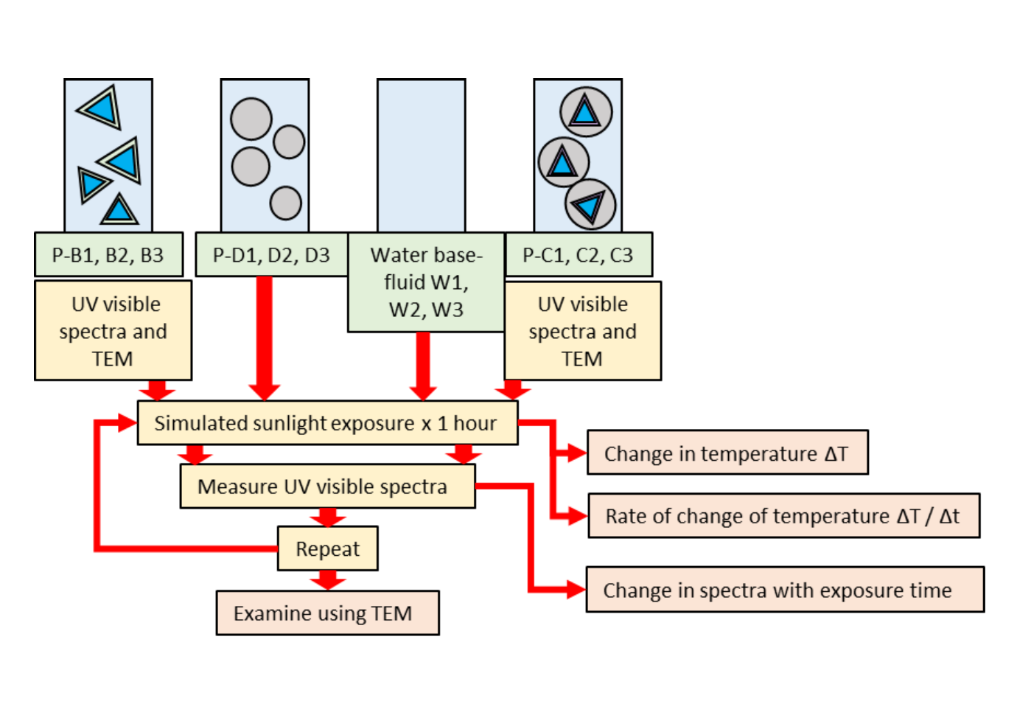
Figure S1 Schematic of experimental procedure

Uncertainty of Measurements
Table S1 Uncertainty of constant C_{w}M_{w}/IA for SSL tests. The half width between the upper and lower limits is denoted by a. The standard deviation is denoted by s and n is the number of measurements
Source of uncertainty | Comment | Value / ±% | Probability distribution | Divisor | Standard uncertainty | Unit
Change in C_{w} with temperature | C_{w} changes from 4.182 to 4.190 KJKg⁻¹K⁻¹ over temperature range 20 - 70 °C | 0.19 | rectangular | a/√3 | 0.11 | %
Uncertainty in measuring M_{w} | 1000 µl Micropipette used to measure amount with accuracy of ± 0.3% | 0.3 | rectangular | a/√3 | 0.17 | %
Change in A with temperature | Due to thermal expansion of liquid | 4.0 | rectangular | a/√3 | 2.31 | %
Variation in I due to lamp output variation | Lamp output varies by ± 6% | 6.0 | rectangular | a/√3 | 3.46 | %
Combined standard uncertainty |  |  | Assumed normal |  | 4.17 | %
Expanded uncertainty |  |  | assumed normal (k = 2) |  | 8.34 | %

Table S2 Uncertainty of the water measurements under SSL for the middle M position. Abbreviations as in Table S1.
Source of uncertainty | Comment | Value / ±% | Probability distribution | Divisor | Standard uncertainty | Unit
uncertainty of temperature measurement because of thermocouples | Assumed to be ± 0.5°C | 2.5 | rectangular | a/√3 | 1.44 | %
Combined standard uncertainty of constant | Calculated as 4.2 % (see Table S1) |  | rectangular | a/√3 | 4.17 | %
Result of 9 measurements of temperature | value obtained is 21.83°C ± 1.253°C | 5.74 | normal | s/√n | 1.91 | %
Combined standard uncertainty |  |  | Assumed normal |  | 4.81 | %
Expanded uncertainty |  |  | assumed normal (k = 2) |  | 9.62 | %

Table S3 Uncertainty of the water measurements under SSL for the front F position. Abbreviations as in Table S1.
Source of uncertainty | Comment | Value / ±% | Probability distribution | Divisor | Standard uncertainty | Unit
uncertainty of temperature measurement because of thermocouples | Assumed to be ± 0.5°C | 2.5 | rectangular | a/√3 | 1.44 | %
Combined standard uncertainty of constant | Calculated as 4.2 % (see Table S1) |  | rectangular | a/√3 | 4.17 | %
Result of 9 measurements of temperature | value obtained is 18.68°C ± 0.952°C | 5.10 | normal | s/√n | 1.70 | %
Combined standard uncertainty |  |  | Assumed normal |  | 4.73 | %
Expanded uncertainty |  |  | assumed normal (k = 2) |  | 9.45 | %

Table S4 Uncertainty of the water measurements under SSL for the back B position. Abbreviations as in Table S1.
Source of uncertainty | Comment | Value / ±% | Probability distribution | Divisor | Standard uncertainty | Unit
uncertainty of temperature measurement because of thermocouples | Assumed to be ± 0.5°C | 2.5 | rectangular | a/√3 | 1.44 | %
Combined standard uncertainty of constant | Calculated as 4.2 % (see Table S1) |  | rectangular | a/√3 | 4.17 | %
Result of 9 measurements of temperature | value obtained is 18.75°C ± 1.063°C | 5.67 | normal | s/√n | 1.89 | %
Combined standard uncertainty |  |  | Assumed normal |  | 4.80 | %
Expanded uncertainty |  |  | assumed normal (k = 2) |  | 9.60 | %

Table S5 Uncertainty in WP for the UV-vis spectroscopy data presented in Figure 3a (P-A). Abbreviations as in Table S1.
Source of uncertainty | Comment | Value / ±% | Probability distribution | Divisor | Standard uncertainty | Unit
Resolution of wavelength | Step-rate 1 nm. Max uncertainty is at 200 nm | 0.5 | rectangular | a/√3 | 0.29 | %
For Figure 3a P-A uncertainty in WP | value of 851 ± 13.6 nm for 3 samples | 1.60 | normal | s/√n | 0.92 | %
Combined standard uncertainty |  |  | Assumed normal |  | 0.97 | %
Expanded uncertainty |  |  | assumed normal (k = 2) |  | 1.93 | %

Table S6 Uncertainty in absorption maxima for the UV-vis spectroscopy data presented in Figure 3a (P-A). Abbreviations as in Table S1.
Source of uncertainty | Comment | Value / ±% | Probability distribution | Divisor | Standard uncertainty | Unit
Uncertainty in value due to spectroscope resolution | Assumed to be same % uncertainty as wavelength | 0.5 | rectangular | a/√3 | 0.29 | %
For Figure 3a P-A uncertainty in WP | value of 1.6 ± 0.08 au for 3 samples | 5.00 | normal | s/√n | 2.89 | %
Combined standard uncertainty |  |  | Assumed normal |  | 2.90 | %
Expanded uncertainty |  |  | assumed normal (k = 2) |  | 5.80 | %

Table S7 Uncertainty of TEM measurements for the triangular P-B1 nanoparticle measurements depicted in Table S11. Abbreviations as in Table S1.
Source of uncertainty | Comment | Value / ±% | Probability distribution | Divisor | Standard uncertainty | Unit
Calibration of line length | Assumed to be ± 1 nm on a line length of 100 nm | 1.0 | rectangular | a/√3 | 0.58 | %
Resolution of TEM | Assumed to be ± 1 nm - for a particle of 50 nm | 2.0 | rectangular | a/√3 | 1.15
For Table S11 P-B1 before solar testing - Triangles | Mean = 43.7 ± 11.25 where n = 208 | 25.74 | normal | s/√n | 1.79 | %
Combined standard uncertainty |  |  | Assumed normal |  | 2.20 | %
Expanded uncertainty |  |  | assumed normal (k = 2) |  | 4.41 | %

Table S8 Absorption maxima and OD_{max} before solar testing
Sample ID | Cuvette employed | Max absorption  (between 400 – 900 nm) / au | OD_{max} / au
P-A1 | 10 mm quartz | 1.65 | 1
P-A2 |  | 1.58 | 1
P-A3 |  | 1.48 | 1
P-B1 | 4 mm ZEN0040 | 1.98 | 3.01
P-B2 |  | 1.69 | 2.67
P-B3 |  | 1.74 | 2.94
P-C1 |  | 1.79 | 2.72
P-C2 |  | 1.77 | 2.79
P-C3 |  | 1.90 | 3.20
P-D1 |  | 0.94 | 1.43
P-D2 |  | 1.06 | 1.67
P-D3 |  | 0.96 | 1.62

Table S9 Absorption maxima and OD_{max} before and after NSL testing
Sample ID | Cuvette employed | Max absorption  (between 400 – 900 nm) / au | OD_{max} / au
P-A_{mean} | 10 mm quartz | 1.56 | 1
P-B_{mean} before NSL | 4 mm ZEN0040 | 1.66 | 2.66
P-B_{mean} after NSL |  | 0.42 | 0.67
P-C_{mean} before NSL |  | 1.36 | 2.17
P-C_{mean} after NSL |  | 1.19 | 1.91

Table S10 Absorption maxima and OD_{max} before and after SSL testing, and after being stored in the dark for 3 weeks
Sample ID | Cuvette employed | Max absorption  (between 400 – 900 nm) / au | OD_{max} / au
P-B_{mean} before SSL | 4 mm ZEN0040 | 1.80 | 2.89
P-B_{mean} after 12 hours SSL |  | 1.63 | 2.62
P-C_{mean} before SSL |  | 1.82 | 2.91
P-C_{mean} after 6 hours SSL |  | 1.65 | 2.65
P-C1 dark |  | 1.71 | 2.60
P-C2 dark |  | 1.01 | 1.60
P-C3 dark |  | 1.58 | 2.66

Size analysis of nanoparticles

Table S11 Size analysis for AgNPr before solar testing
P-B1 before solar testing
 | Triangles | Other
Mean / nm | 43.7 | 29.2
SD / nm | 11.25 | 11.41
N | 208 | 145
P-B2 before solar testing
 | Triangles | Other
Mean / nm | 38.2 | 27.8
SD / nm | 11.31 | 15.12
N | 414 | 121
P-B3 before solar testing
 | Triangles | Other
Mean / nm | 38.5 | 27.5
SD / nm | 10.84 | 13.85
N | 773 | 421

Table S12 Size analysis for SiO₂@AgNPr before solar testing
P-C1 before solar testing
 | Silver cored | Silica only | Silver Multi-cored
Mean / nm | 143.0 | 86.8 | 152.4
SD / nm | 13.29 | 13.79 | 17.25
N | 185 | 465 | 7
P-C2 before solar testing
 | Silver cored | Silica only | Silver Multi-cored
Mean / nm | 142.7 | 91.0 | 138.2
SD / nm | 11.95 | 12.43 | 6.68
N | 234 | 274 | 10
P-C3 before solar testing
 | Silver cored | Silica only | Silver Multi-cored
Mean / nm | 138.6 | 88.9 | 138.2
SD / nm | 12.5 | 12.53 | 11.72
N | 183 | 208 | 19

Definition of T-test

A T-test is a hypothesis test that allows you to compare means. A two-sample T-test allows the comparison between two means from two different sets of samples. The null hypothesis is that the two means are the same. The formula is:

$$t= \frac{{\overline{X}}_{2}-{\overline{X}}_{1}}{\sqrt{s^{2}\left(\frac{1}{n_{1}}\right.}+\left.\frac{1}{n_{2}}\right)}$$
Equation S1
Where t = T value (which can be looked up in standard T-tables or using a statistical software package to determine significance). ${\overline{X}}_{1}$ = Mean of sample 1 and ${\overline{X}}_{2}$ = Mean of sample 2, n₁ and n₂ are the number of results in each sample set and s² is the pooled sample variance given by the equation:

$$s^{2}= \frac{\sum_{i=1}^{n_{1}}{{\left(X_{i}-{\overline{X}}_{1}\right)}^{2}+\sum_{j=1}^{n_{2}}{{\left(X_{j}-{\overline{X}}_{2}\right)}^{2}}}}{n_{1}+n_{2}-2}$$
Equation S2

Solar Simulator results
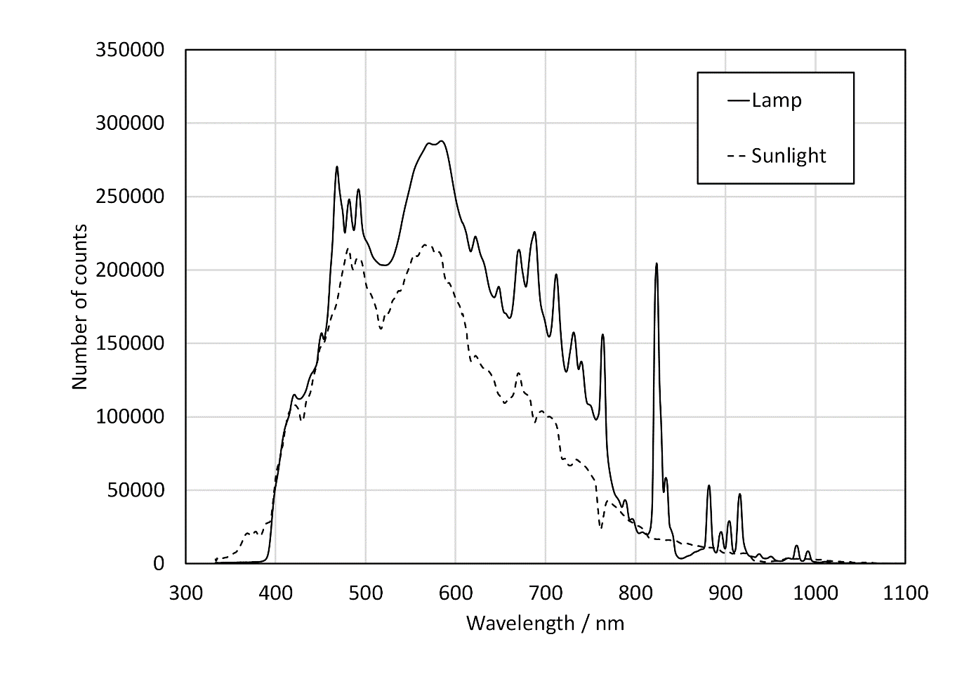
Figure S2 Spectra obtained from the solar simulator lamp and from sunlight
The wavelengths and absorption of the lamp is close to that of sunlight over the range measured. However, there are some large peaks in the lamps output especially the one at 825 nm. Other researchers have used similar lamps with large peaks in their output to test nanofluids (Gorji and Ranjbar, 2016).

Table S13 Solar simulator results for repeat measurements on the base-fluid water. The confidence interval (CI) shows the range of possible values for the mean
Position | B | F | M
N | 9 | 9 | 9
Grouping (different letters = significantly different) | B | B | A
∆T after 3600 s
Mean / ºC | 18.75 | 18.68 | 21.83
SD / ºC | 1.063 | 0.952 | 1.253
95% CI of mean / ºC | 18.00-19.50 | 17.92-19.43 | 21.08-22.59
Slope (∆T/∆t) / ºCs⁻¹
Mean / ºCs⁻¹ | 0.017 | 0.016 | 0.020
SD / ºCs⁻¹ | 0.0016 | 0.0012 | 0.0017
95% CI of mean / ºCs⁻¹ | 0.016-0.018 | 0.015-0.018 | 0.019-0.021

Size analysis after simulated sunlight exposure

Table S14 Size analysis from the TEM photographs after exposure for 12 hours (P-B1, B2 and B3) and 6 hours (P-C1, C2 and C3). Note that the number of silver only particles is greater than the total of multi-cored and silver coated with SiO₂ particles as the multi-cored particles contain more than one silver
 | P-C1 | P-C2 | P-C3
Silver coated with SiO₂
Mean / nm | 137.8 | 133.6 | 134.7
SD / nm | 16.45 | 12.45 | 12.36
N | 65 | 46 | 96
Silica only
Mean / nm | 98.3 | 92.8 | 96.9
SD / nm | 13.99 | 12.42 | 12.30
N | 110 | 59 | 111
Multi-cored
Mean / nm | 124.9 | 139.1 | 138.1
SD / nm | 22.23 | 11.53 | 16.64
N | 18 | 20 | 24
Silver only
Mean / nm | 26.4 | 21.1 | 27.0
SD / nm | 12.07 | 9.03 | 9.28
N | 102 | 97 | 153
Free silver particles
Mean / nm | 50.6 | 33.4 | 29.9
SD / nm | 5.46 | 24.23 | 8.08
N | 3 | 6 | 3
 | P-B1 | P-B2 | P-B3
Triangles
Mean / nm | 45.5 | 42.2 | 37.8
SD / nm | 10.93 | 11.34 | 10.64
N | 234 | 218 | 40
Other
Mean / nm | 33.5 | 33.3 | 28.5
SD / nm | 11.19 | 12.04 | 10.98
N | 770 | 256 | 329

References
Gorji, T.B., Ranjbar, A.A., 2016. A numerical and experimental investigation on the performance of a low-flux direct absorption solar collector (DASC) using graphite, magnetite and silver nanofluids. Solar Energy, 135, 493-505, https://doi.org/10.1016/j.solener.2016.06.023.

