Original Paper

A longitudinal study on the variation of patient turnover and patient-to-nurse ratio: Descriptive analysis of a Swiss University Hospital

Sarah N. Musy^{1,2}; Olga Endrich³; Alexander B. Leichtle^{4, 5}; Peter Griffiths^{6, 7, 8}; Christos T. Nakas^{4,9}; Michael Simon^{1,2}

¹ Institute of Nursing Science, University of Basel, Basel, Switzerland
² Nursing & Midwifery Research Unit, Inselspital, Bern University Hospital, University of Bern, Bern, Switzerland
³ Medical Directorate, Inselspital, Bern University Hospital, University of Bern, Bern, Switzerland
⁴ Institute of Clinical Chemistry, Inselspital, Bern University Hospital, University of Bern, Bern, Switzerland
⁵ Insel Data Science Center (IDSC), Inselspital, Bern University Hospital, University of Bern, Bern, Switzerland
⁶ Health Sciences, University of Southampton, Southampton, UK
⁷ University of Southampton National Institute for Health Research Collaboration for Leadership in Applied Health Research & Care Wessex, Southampton, UK
⁸ LIME Karolinska Institutet, Stockholm, Sweden
⁹ Laboratory of Biometry, University of Thessaly, Volos, Greece

Corresponding Author:
Prof. Dr. Michael Simon
Institute of Nursing Science
Faculty of Medicine, Department of Public Health
University of Basel
Bernoullistrasse 28
4057 Basel
Switzerland
Phone: +41 61 267 09 12
E-mail: m.simon@unibas.ch

Abstract
Background: Variations in patient demand increase the challenge of balancing high-quality nursing skill mixes against budgetary constraints. Developing staffing guidelines that will allow high quality care at minimal cost requires first exploring the dynamic changes in nursing workload over the course of a day.
Objectives: Accordingly, this longitudinal study analyzed nursing care supply and demand in 30-minute increments over a period of three years. We assessed five care factors: 1) patient count (care demand); 2) nurse count (care supply); 3) patient-to-nurse ratio for each nurse group; 4) extreme supply-demand mismatches; and 5) patient turnover, i.e., number of admissions, discharges, and transfers.
Methods: Our retrospective analysis of data from the Inselspital University Hospital Bern, Switzerland included all inpatients and nurses working on their units from 1 January 2015 to 31 December 2017. Two data sources were used: 1) The nurse staffing system (tacs®) (including information about nurses and all care they provided to patients, alongside their working time and admission, discharge, and transfer dates/times); and 2) medical discharge data (including patient demographics, further admission/discharge details, and diagnoses). Based on several identifiers, these two data sources were linked.
Results: Our final dataset included more than 58 million data points on 128,484 patients and 4,633 nurses across 70 units. Compared with patient turnover, fluctuations in the number of nurses were less pronounced: differences mainly coincided with shifts (night, morning, afternoon). While the percentage of shifts with extreme staffing fluctuations ranged from fewer than 3% (mornings) to 30% (evenings and nights), the percentage lying within “normal” ranges ranged from fewer than 50% to more than 80%. Patient turnover occurred throughout the measurement period, but was lowest at night.
Conclusions: Based on measurements of patient-to-nurse ratio and patient turnover at 30-minute intervals, our findings indicate that the patient count, which varies considerably through the day, is the key driver of patient-to-nurse ratio changes. This demand-side variability challenges the supply-side mandate to provide safe and reliable care. Detecting and describing variability patterns such as these are key to appropriate staffing planning. This descriptive analysis was a first step towards identifying time-related variables to be considered for a predictive nurse staffing model.

Keywords: patient safety; electronic health records; nurse staffing; workload; routine data

Introduction
Determining appropriate nursing staff numbers and skill mixes in hospital units is vital both to ensure quality of care [1-4] and to maintain healthcare budgets [5]. Understaffing or poor skill mixes can lead to adverse patient outcomes; overstaffing –leading to budgetary overruns– can ultimately close hospitals. In economic terms, the relationship between patients and nurses is one respectively of supply and demand: the amount of care required by the patients versus the nursing staff’s capacity to provide that care.
Undoubtedly, care demands –and staffing requirements– vary widely across departments, units, seasons, months, days of the week, shifts (morning vs evening vs night) and even hours [6-8]. Each unit’s patient count fluctuates with patient turnover (admissions, discharges and transfers within and between units) [9-12]. In turn, turnover affects the volume of nurses’ clinical and administrative duties [13, 14].
Another notable factor is patient acuity, i.e. the amount of time each patient requires. As newly admitted or transferred patients tend to require baseline assessments and treatments, they have high levels of acuity [15, 16]. Specific patient characteristics, including demographics (e.g. age, gender, family support, socioeconomic factors), personal background, diagnoses, and treatment regimes can also increase acuity. For example, those with advanced age [17-19], a lack of family support [18], and/or limited knowledge of their health conditions [20] have more complex care needs, with strong implications for nurse staffing. Depending on each shift’s patient numbers and combined acuity, nursing workloads can vary across and within wards. Meeting their specific needs requires an appropriate number and skill mix of nurses, i.e., registered nurses (RNs), licensed practical nurses (LPNs), and unlicensed personal. Some studies have used nursing staff with or without qualification in their analyses [21, 22]. In Switzerland, RNs typically represent the major proportion of hospital nursing staff; however, patient care –whether direct or indirect– typically involves collaborations between nurses with a broad range of qualifications.
To date, the majority of research about nurse staffing has fit into two categories: 1) longitudinal studies conducted over relatively long periods (e.g., years) and/or across locations; and 2) cross-sectional studies, often across multiple locations. However, in both cases, large-scale views fail to capture shift-level or daily variations in either supply or demand. This lack of detail limits the understanding of the association between staffing, patient turnover and relevant human and economic outcomes [7]. Noting that these limitations severely limit the value of research findings vis à vis staffing guidelines [22], studies have begun to highlight the advantages both of focusing on unit-level dynamics and of using hospital record data longitudinally rather than cross-sectionally [21, 23, 24].
Every nursing unit manager’s job includes assuring patient safety and quality of care every hour of the day. However, due to the limitations noted above, and considering the principle that nurse-patient relationships occur on the individual level [25], previous studies have offered a limited view of the small-scale supply/demand dynamic of nursing workload. Nurse staffing planners are particularly challenged by demand-side variability, which occurs over very short periods. Therefore, both to optimize staffing levels (i.e., to maintain levels that will allow safe patient care while minimizing personnel costs) and to develop reliable staffing guidelines, it is necessary to record and explore fluctuations in nursing workload throughout the day rather than simply considering daily or shift averages.
Therefore, this study’s overall aims are to describe the supply and demand dynamics of nursing care and to identify mismatches between them from a longitudinal perspective. Specifically, in 30-minute increments, across a range of units in a Swiss University Hospital (Inselspital, Bern), we describe every recorded change in 1) patient numbers, i.e. care demand; 2) nurse numbers, i.e. supply; 3) patient-to-nurse ratios for the various nurse groups; 4) extreme supply-demand mismatches; and 5) patient turnover, i.e. numbers of admissions, discharges, and transfers.

Methods

Study Design and Setting
This is a retrospective descriptive observational study using routinely collected patient data from the Inselspital University Hospital, Bern in Switzerland. As one of Switzerland’s five University Hospitals, the Inselspital treats approximately 48,000 inpatients annually [26]. Only inpatient units with data for the full three years were included. Our data were drawn from 10 departments: 1) Internal Medicine; 2) Cardiology & Cardiovascular Surgery; 3) Orthopaedics & Plastic Surgery; 4) Neurology, Neurosurgery, Otolaryngology, Head and Neck Surgery, & Ophthalmology; 5) Visceral Surgery and Medicine, Gastroenterology, Thoracic Surgery, & Pulmonology; 6) Dermatology, Urology, Rheumatology, & Nephrology; 7) Haematology & Oncology; 8) Maternity & Gynaecology; 9) Paediatrics; and 10) Intensive Care. Full data (2015–2017) were available for all of these departments for the full study period.

Participants

Patients

All inpatients were included. No further specific eligibility criteria were applied.

Nurses

All staff providing direct and/or indirect nursing care were considered in the analysis, independent of educational background. We divided nursing staff into five groups: 1) RNs, including nurses in supervisory positions; 2) LPNs; 3) Others, including unlicensed and administrative personnel; 4) Students; and 5) External nurses (agency staff). In Switzerland, RNs complete a 3-4 year tertiary professional or university-based education (group 1). Unlike in other countries, Switzerland also offers 3 years of secondary-level professional training for nursing assistants (group 2). Group 3 contains unlicensed personnel, including nursing aides with minimal education/training, and administrative staff. Group 4, students, includes both nursing and medical students working as nursing aides.

Data sources and variables
We extracted our data from two sources: 1) The tacs® nurse staffing system, i.e. datasheets organized in a relational database, and 2) medical discharges. From tacs®, we extracted four care-relevant factors (a) nurses, b) patients, c) activities, and d) care-related working hours. The tacs® system records time allocations provided by every nurse at the end of every shift. In addition to administrative work, teaching duties, and continuous education, each record specifies time devoted to each patient’s direct and indirect care. No further details about the type of activity such as medication, mobility, respiratory therapy, etc. are currently available. Nurses’ absences such as holidays, illnesses, or accidents are also recorded. Patient turnover information is provided with the nursing unit, date, and time, as well as whether in- or outpatient services were provided. Finally, medical discharge data include patient demographics, admission and discharge details, and diagnoses. Each data record identifies the relevant unit, and includes identifiers for the nurse (and her/his contract) and/or each case (patient) dealt with during that shift. Based on these identifiers, the five datasheets were linked at the patient, nurse, and unit levels in a single dataset; then all patient, nurse and unit identifiers were deidentified, leaving only department names. Table 1 describes the 17 variables used in the analysis.
Table 1. Description of the 17 variables used for the current analysis (alphabetically)
Variable | Short description | ªSources
Type of activity performed by the nurse
 | Indirect and direct care | A
 | Administrative work | A
 | Teaching assignments | A
 | Continuous education | A
 | Absences (i.e. holidays, illnesses, accidents) | A
Admission date | The patient’s admission date at the hospital | P
Admission time | The patient’s admission time at the hospital | P
Age | The patient’s age at admission | M
Case identifier | Unique code for a patient’s case (deidentified into “Patient1”, “Patient2”, …) | A, P and M
Departments of the Inselspital, Bern University Hospital
 | Cardiology & Cardiovascular Surgery | A and M
 | Neurology, Neurosurgery, Otolaryngology, head and neck surgery, & Ophthalmology | A and M
 | Intensive Care | A and M
 | Paediatrics | A and M
 | Dermatology, Urology, Rheumatology, & Nephrology | A and M
 | Visceral Surgery and Medicine, Gastroenterology, Thoracic Surgery & Pulmonology | A and M
 | Internal Medicine | A and M
 | Maternity & Gynecology | A and M
 | Orthopaedics & Plastic Surgery | A and M
 | Haematology & Oncology | A and M
Contract identifier | Unique code for each nursing position/contract (a nurse can have multiple contracts within the hospital involving various qualifications or working units). Deleted after merging. | A, N, W and M
Date | Working date of the nurse | A and W
Discharge date | The patient’s discharge date from the hospital | P and M
Discharge time | The patient’s discharge time from the hospital | P
End time | Time at which the nurse stopped work for the shift or started a break | W
Group ( classifications of nurse qualifications)
 | Registered nurses (RNs) | N
 | Licensed practical nurses (LPNs) | N
 | Others (e.g., unlicensed & administrative personnel) | N
 | Students | N
 | External nurses | N
Main diagnosis | ICD-10-GM codes for the main diagnosis of the patients | M
Nurse identifier | Unique code for a nurse (deidentified into “Nurse1”, “Nurse2”,…) | A, N, and W
Start time | Time at which the nurse begins work or returns from a break | W
Transfer date | Transfer date of the patient within and between departments | P
Transfer time | Transfer time of the patient within and between departments | P
Unit identifier | Unique code for the unit (deidentified into “Unit1”, “Unit2”, … within each department) | A, N, and P
ªSources: 1) Nurse staffing system (tacs®): A = activity data; N = nurse data; P = patient data; and W = working hours data; 2) Medical discharge data = M.

Ethical considerations

Our acquisition of data from the Inselspital (University Hospital of Bern) was outside the purview of the Cantonal Ethic Commission of Bern based on the Swiss legislation on research with humans (Req-2016-00618). All data involving patients, nurses, and units were deidentified.

Statistical analyses
All statistical analyses were conducted using R, version 3.5.1 for Mac OS and Linux [27]. The following packages were used to: 1) handle and manipulate data: purrr [28], dplyr [29], tidyr [30], and data.table [31]; 2) manipulate time and date: lubridate [32], chron [33], and padr [34]; and 3) create plots: ggplot2 [35] and scales [36].

Linking procedure

Data were merged based on six key variables: patient identifier, nurse identifier, contract identifier, unit identifier, time, and date. First, a subset of activity data was created for data on inpatient units and direct and indirect care. This subset was then divided into nurse and patient activity fields, and any duplicate records deleted. Each nurse’s activities were merged first with her/his other data, then with the data she/he supplied regarding time use, contract identifier and date. Contract identifiers were deleted and nurses and units deidentified. Similarly, each patient’s activity data were merged first with their other data, then with medical controlling data by case identifier. To maintain consistent patient counts, healthy newborn babies in the Maternity & Gynecology department were excluded. Patients and units were then deidentified. Finally, the merged nurse and patient data were expanded to allow assessment of the number of nurses, patients, admissions, discharges and transfers in 30-minute increments.

Descriptive overview

For each department, total numbers of units and patients were recorded. Means (with standard deviations) and medians (with interquartile ranges (IQR)) were calculated for patient ages. Length of stay (LOS) in days was computed by subtracting the discharge date from the admission date. Median and IQR were calculated for LOSs and for the number of patients per day per unit. Finally, for each department, we identified the two most common diagnoses by percentage incidence.

Number of patients (i.e. demand)

In order to keep computational complexity to a reasonable limit, patient numbers were calculated at 30-minute intervals. Alternative increments (20, 40, 60 minutes) had no relevant effect on the results. However, as patients rarely arrive or leave at shift divisions, and some do not stay on the unit one full shift, a short interval length ensures precise patient numbers. Unit-level calculations correspond to every 30-minute interval, i.e., 48 data points per day, totaling 153,792 points per unit during the study period.

Number of nurses (i.e. supply)

As with the number of patients, the number of nurses in each group was calculated for each 30-minute increment. As nurses may work only half shifts or overlapping shifts, this increment length ensured precise numbers. For each of the 48 daily data points for the three years covered by the study, the numbers of RNs, LPNs, and Others staff were calculated. Unfortunately, as external nurses and students are not classified as typical employees, our datasets included no breakdown of their time allocation. As only daily information was available for these groups, their total numbers over the three-year study period, as well as their daily means and medians, were calculated to provide an image of their effects across each unit.

Patient-to-Nurse ratio

The patient-to-nurse ratio was computed by dividing the number of patients by the number of nurses at every data point. Along with numbers of patients and nurses, patient-to-nurse ratios were plotted separately for each day’s 48 data points and for each day of the week using each unit’s and each department’s mean with confidence intervals.

Extreme mismatch between supply-demand

Additionally, for three key time points of each day, namely at 2am, 10am, and 6pm, the unit-level median and IQR of the patient-to-nurse ratio were calculated for weekdays and weekends and divided by department. Further, calculations were made to compute when 50% more or less work was required per nurse for every data point and unit based on the above median. Two variables were created, where once the median divided by two was added to the median (= extreme lower threshold) and once subtracted to the median (= extreme higher threshold). This arbitrary cut-off is set to illustrate extreme staffing situations. Extreme staffing situations are important to detect to identify times where supply and demand do not match, e.g. the demand is too high for the given supply or vice versa. This is an indicator to see how supply-demand is staying within “normal” range throughout the year. For the three years of the study period, percentages of data points falling far below or far above the aforementioned thresholds were calculated. Medians (with IQRs) and extreme higher and lower thresholds (with percentages) were plotted with bar charts to highlight variations in patient-to-nurse ratios. Graphics and calculations were computed separately for each of the three nurse groups (RNs, LPNs, and Others).

Patient turnover

For every unit, the numbers of admissions, discharges, and transfers were computed for every 30-minute data point of the three-year study period. Admission corresponds to any entry of a patient to the hospital and discharge to any exit from the hospital. Transfers, corresponding to movement of admitted patients from one unit to another, were divided into “Transfers in” and “Transfers out” of each relevant unit. As the units have different sizes, the number of admissions, discharges, transfers in and out were divided by the number of patients present at each specific data point. This allowed us to obtain a ratio for patient turnover that could be plotted on the same scale for all the units. Finally, vertical bar charts were created for weekdays and weekends by taking the mean of the units for the departments. The left side of the vertical bar charts represents patients leaving the unit (i.e., discharges and transfers out); those on the right side represent incoming patients (i.e., admissions and transfers in).

Results

Linkage procedure

The main activity data were drawn from 688,730 cases and 6,834 nurses on 152 units. After the exclusion of outpatient units and non-care activities (whether direct or indirect), the activity data reflected 153,456 cases (22.2%) and 5,736 nurses (83.9%), on 70 units (46.1%). Of the remaining 5,736 nurses, data from 4,633 (80.8%) were usable for the final analyses. A number of nurses (1,270) were excluded for specific days only, as they had recorded no working time data. Those exclusions correspond to 11,251 (1.5%) person-days. Another main reason for exclusion was that 1,109 students and 227 external nurses did not have exact working hours. However, both groups’ data were usable for our descriptive analyses. Numerous students and external nurses became RNs over the three years of the study period. This largely explains why the final number of nurses was higher than 5,736. Regarding the number of cases, a total of 128,484 (83.7%) were used. Two main factors explain this reduction: 1) Outpatients (19,442 cases; 12.7%); and 2) Healthy newborn babies (3,779 cases; 2.5%) from the Maternity & Gynaecology department. Further details of the linking procedure are shown in Figure 1. For patient-to-nurse ratios and patient turnover analyses, we included 10 departments, including 70 inpatient units, in which 4,633 nurses (> 22 million data points) provided care to 128,484 cases (> 35 million data points).

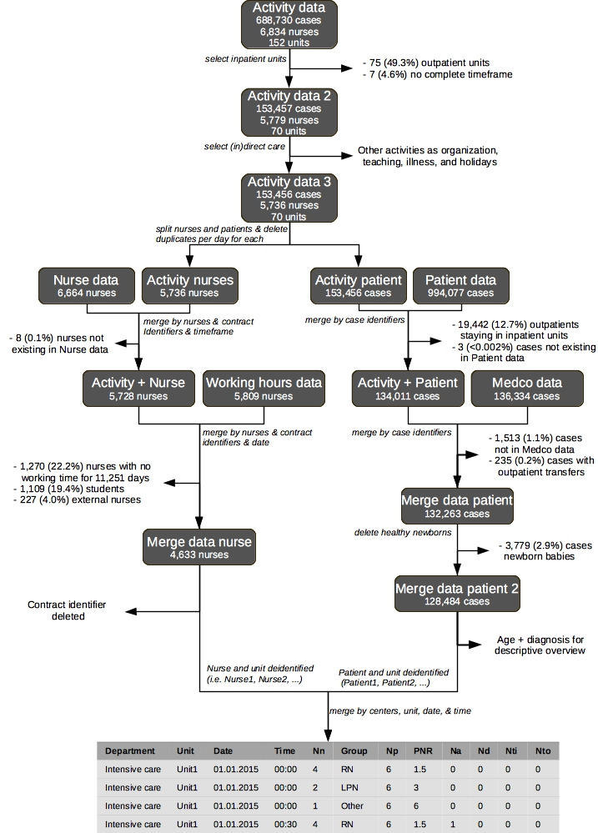
Figure 1. Linkage process with the two datasets and variables used for the analysis. Nn = number of nurses; Np = number of patients; PNR = patient-to-nurse ratio; Na = number of admissions; Nd = number of discharges; Nti = number of transfers in; Nto = number of transfers out; RN = registered nurse; LPN = licensed practical nurse.

Descriptive overview
The number of patient cases on the included units over the study period (2015 to 2017) for each department ranged from 5,007 for Haematology & Oncology to 28,377 for Cardiology & Cardiovascular Surgery. In almost all departments, patients’ mean and median ages were above 54 years. The exceptions were Maternity & Gynaecology, with a mean patient age of 36.5 (±15.4) and a median ages of 33 [28-40] and Paediatrics, with mean and median ages respectively of 3.8 (±5) and 1 [0-7]. The highest median LOSs were in Haematology & Oncology, Internal Medicine, and Orthopaedics & Plastic Surgery with 7 days [4-14], 6 days [3-10], and 5 days [3-9], respectively. The lowest LOSs were in Cardiology & Cardiovascular Surgery, with a median of 2 [1-7] days and in Intensive Care, with a median of 2 [2-3]. The most common diagnoses were: 1) tumours, predominantly in Haematology & Oncology (83.1% of patients); 2) circulatory system diseases mainly in Cardiology & Cardiovascular Surgery (85.3% of patients); and 3) traumatic injuries, poisonings and other consequences of external causes, which were highest in Orthopaedics & Surgery (49.7% of patients). Further details are provided in Table 2.
Table 2. Descriptive overview of each department, classified by the overall number of patients for 2015 to 2017.
 | Mean Age  (^{b}SD) | Median Age  [^{c}IQR] | Median ^{d}LOS  [^{c}IQR] | Median patients/ day/unit  [^{c}IQR] | Diagnoses (top 2)  [%]
Cardiology & Cardiovascular Surgery (28,377 patients and 12 units)
 | 67.3  (14.4) | 70  [59-78] | 2  [2-5] | 10  [7-12] | 85.3% Circulatory system diseases
 |  |  |  |  | 4.3% Traumatic injuries, poisonings and other consequences of external causes
Neurology, Neurosurgery, Otolaryngology, Head and Neck Surgery, & Ophthalmology (27,916 patients and 10 units)
 | 58.5  (18.5) | 61  [47-73] | 4  [3-6] | 13  [11-17] | 23% Circulatory system diseases
 |  |  |  |  | 15.5% Nervous system diseases
Intensive Care (21,359 patients and 8 units)
 | 61.6  (16.6) | 64  [52-74] | 2  [2-3] | 8  [7-10] | 37.9% Circulatory system diseases
 |  |  |  |  | 16.4% Tumors
Paediatrics (19,543 patients and 10 units)
 | 3.8  (5) | 1  [0-7] | 3  [2-7] | 11  [8-14] | 20.4% Some conditions whose origin is the perinatal period
 |  |  |  |  | 17.8% Respiratory system diseases
Dermatology, Urology, Rheumatology, & Nephrology (16,381 patients and 7 units)
 | 59.6  (17.3) | 62  [48-73] | 4  [3-7] | 12  [6-17] | 31.5% Genitourinary system diseases
 |  |  |  |  | 21.2% Tumors
Visceral Surgery and Medicine, Gastroenterology, Thoracic Surgery, & Pulmonology (14,250 patients and 5 units)
 | 58.2  (17.1) | 61  [48-71] | 4  [3-7] | 17  [12-21] | 35.6% Digestive system diseases
 |  |  |  |  | 29.4% Tumors
Internal Medicine (12,506 patients and 6 units)
 | 66  (18.3) | 70  [54-80] | 6  [3-10] | 15  [13-18] | 19.1% Circulatory system diseases
 |  |  |  |  | 9.3% Infectious and parasitic diseases
Maternity & Gynaecology (11,894 patients and 3 units)
 | 36.5  (15.4) | 33  [28-40] | 4  [3-5] | 18  [14-21] | 60.3% Pregnancy, childbirth and the puerperium
 |  |  |  |  | 16.8% Tumors
Orthopaedics & Plastic Surgery (10,489 patients and 5 units)
 | 52.9  (19.6) | 54  [37-68] | 5  [3-9] | 14  [12-16] | 49.7% Traumatic injuries, poisonings and some other consequences of external causes
 |  |  |  |  | 31.9% Diseases of the osteo-articular system, muscles and connective tissue
Haematology & Oncology (5007 patients and 4 units)
 | 59.2  (15.5) | 61  [51-70] | 7  [4-14] | 11  [7-18] | 83.1% Tumors
 |  |  |  |  | 4.5% Endocrine, nutritional, and metabolic diseases
ªn = number; ^{b}SD = standard deviation; ^{c}IQR = interquartile range; ^{d}LOS = length of stay.

Number of patients
Numbers of patients and nurses and patient-to-nurse ratios were plotted against the 48 data points per day for each day of the week, for each of the 10 departments and for each of the three groups of nurses. Considering the large number of plots this generated, we show only three plots here: the RN groups for Intensive Care, Maternity & Gynaecology, and Internal Medicine, as they show key characteristic patterns (see Figure 2). All plots can be found in Multimedia Appendix 1, 2, and 3 for RNs, LPNs, and Others, respectively.
On the demand side, a number of broad patterns emerged, several of which occurred across departments. Demand fluctuated not only throughout the day (with various clear peaks), but also through the week as shown by Maternity & Gynaecology, where patient numbers peeked Thursday and Friday. Overall, 6 departments’ (60%) patient numbers increased from Monday to Thursday or Friday; and patient numbers peaked daily between 08:00 and 10:00, then either stabilized or decreased. Friday mornings, patient numbers decreased in preparation for the weekend. The exception was in Internal Medicine, where the number of patients increased continuously from Friday evening until Monday morning (see Figure 2).

Number of nurses
From the care supply perspective, variation was far less pronounced than on the demand side. Three main variations were apparent: 1) fewer nurses were present through the weekends (and occasionally on Friday as well); 2) Sundays generally had lower staff numbers (i.e., fewer nurses) than Saturdays; and 3) nurse numbers were highest in the morning, then dropped for the afternoon and again for the night shifts. These patterns where quite stable throughout the week. In 6 (60%) of the departments, gaps of one or two nurses were clearly discernible between 11:00 and 13:00.
LPNs were mainly present between 06:00 and 17:00 in numbers varying from one to two, except for 3 (30%) of the departments with almost none on staff weekends. The Others group (e.g., unlicensed & administrative personnel) showed a pattern similar to that of LPNs, though generally with roughly one care staff more. All departments had increases of approximately one to three nurses for all or several of the following times: 07:00-08:00, 14:00-16:30, and 22:00-00:00 (see Figure 2). As mentioned above, apart from daily information, no records of working time were available either for students or for external nurses. For external nurses and students, the daily median number was 0, except in Internal Medicine, where the median for students was one. The daily number of external nurses ranged from 0-9 and for students from 0-12. For both, the maxima occurred only once, on a Sunday, during the three years studied.

Patient-to-Nurse ratio
Figure 2 shows the plots and Figure 3 the median and IQR of the patient-to-RN ratio for three key time points weekdays and weekends. For RNs, the ratio was highest at night and the lowest in the morning. During the night the median ratio was between 4 to 11 patients per RN, except in Intensive Care, which had a ratio of 1.1 patients per nurse. In the morning, the ratio ranged from 0.6 [IQR: 0.4-0.8] and 0.8 [IQR: 0.6-1] in Intensive Care to 2.8 [IQR: 2-3.5] and 4 [IQR: 3-5] in Maternity & Gynaecology for weekdays and weekends, respectively. For LPNs, the median was always 0 [IQR: 0-0] at night; the morning median ranged between 3 and 8. For the Others group, a night-shift median of 0 [IQR: 0,0] was generally present. In the morning shifts, the 7 departments’ (70%) median ratios increased for this group from weekdays (4.3 to 8) to weekends (6 to 12). In the afternoon shifts, all medians decreased (see Multimedia Appendix 4).
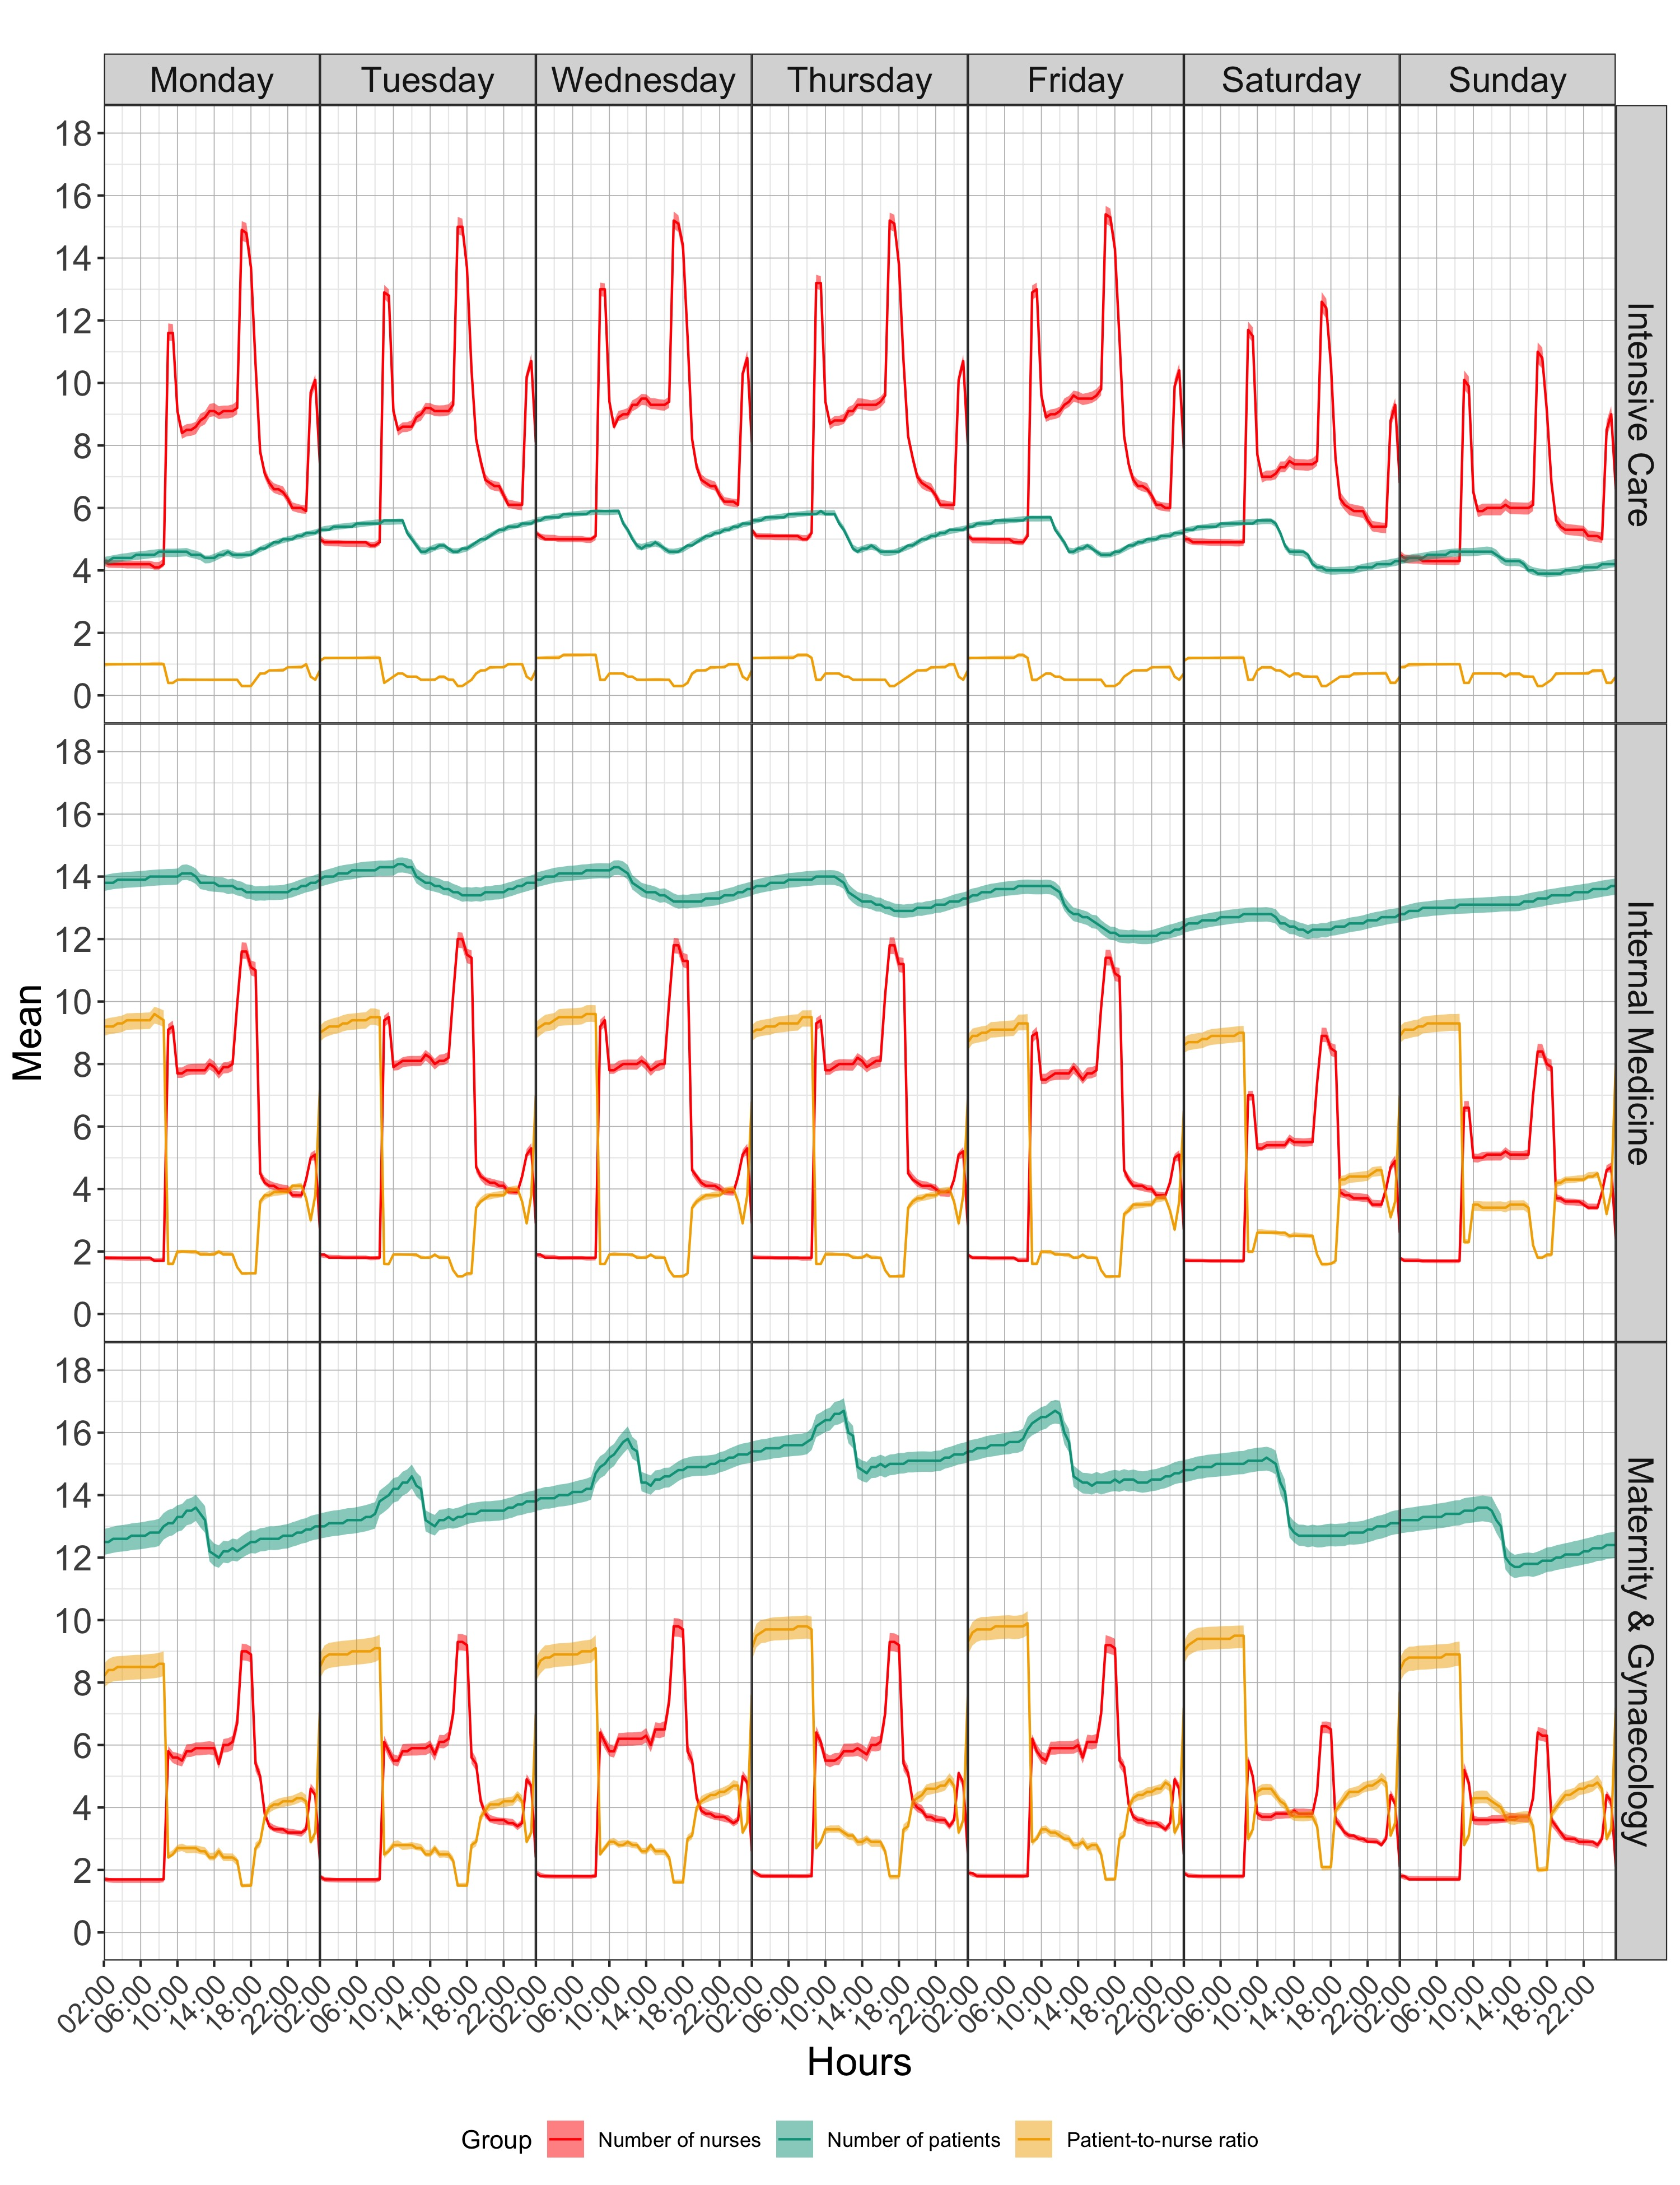
Fig 2. Number of patients and nurses with patient-to-nurse ratio plotted with confidence intervals for RNs group. X-axis showed the 48 time points of the day split for each day of the week (Monday to Sunday), where y-axis represented the mean number of units for each of the ten departments.

Extreme mismatch between supply-demand
Figure 3 shows not only the weekday and weekend medians and IQRs of patient-to-RN ratios for three key time points (namely at 2am, 10am, and 6pm), but also threshold values and percentages of shifts with extreme supply-demand mismatches. Complete results can be found in Multimedia Appendix 4. For 7 departments (70%), percentages of shifts with extreme staffing increased from morning to night and from weekdays to weekends. For the RNs, the lowest percentages of extreme under- and over-staffing happened on 2.5% and 0.1% of weekday and weekend mornings, respectively. For both extremely high and extremely low patient/nurse ratios, the highest incidence (around 30% of shifts) occurred in the evening and at night on weekends. They took place in the departments of Cardiology & Cardiovascular Surgery (lower), Dermatology, Urology, Rheumatology, & Nephrology (lower), and Haematology & Oncology (higher). The same three departments had the lowest incidence of shifts with “normal” staffing levels (below 55%) for weekend nights. On the other hand, more than 80% of all Orthopaedics & Plastic Surgery shifts fell within “normal” staffing levels. For LPNs and Others, the incidence of extreme staffing ranged from very high (49.5%) to very low (1.5%) to none (0%). Possibly because of these groups’ low numbers, no clear patterns were apparent.

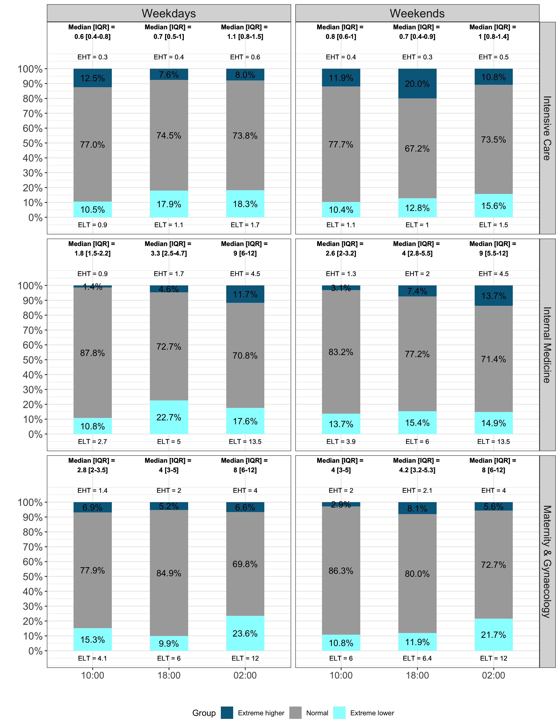
Figure 3. Median patient−to−RN ratios for key time points with percentages of shifts with extremes. Three departments are displayed split by weekdays and weekends. IQR = interquartile range; EHT = extreme higher threshold; ELT = extreme lower threshold.

Patient turnover
Similarly, to the patient-to-nurse ratio, bar charts are displayed for Intensive Care, Maternity & Gynaecology, and Internal Medicine only (see Figure 4). Bar charts for the ten departments are displayed in Multimedia Appendix 5. All departments showed reductions in patient turnover during weekends. Entries (admissions and transfers in) and exits (discharges and transfers out) of patients occurred at very similar times for all departments: 09:00-11:00 and 13:00-15:00. Intensive Care had the highest percentage of transfers (peaking at almost 13% at 09:30). As shown in Figure 3, the numbers of extreme staffing mismatches also fluctuated as a result of the number either of nurses or of patients present. Nevertheless, Figure 4 shows variation of patterns throughout the day influencing patient-to-nurse ratio. For example, if on a given day a peak of discharges occurs at 10:00 with no or few admissions or transfers in, the patient-to-nurse ratio will decrease, potentially leading to extreme over-staffing. The same is true for the inverse: a peak of admissions or transfers in can increase the patient-to-nurse ratio, leading to extreme under-staffing.
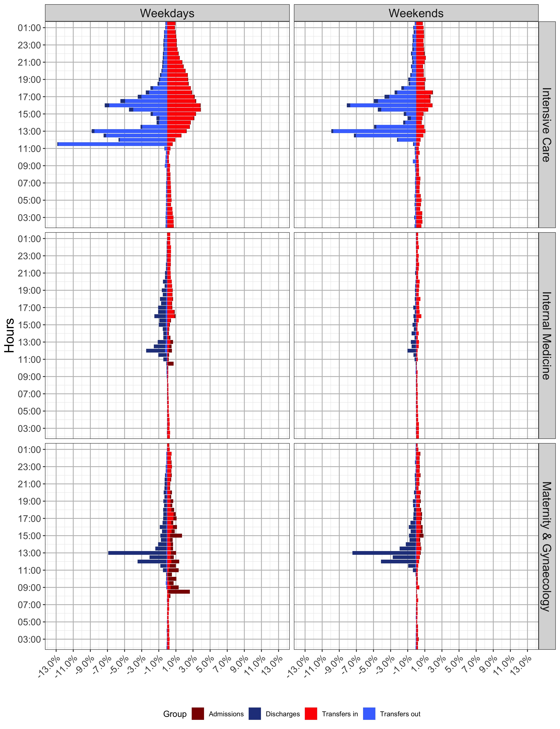
Figure 4. Patient turnover percentages for the 48 data points split for weekdays and weekends.

Discussion

Main Results
For the first time, we analyzed care demand and supply longitudinally in 30-minute intervals 24 hours per day over a period of three years in a large University Hospital. Data from the nurse staffing system (tacs®) and medical discharge records were used to explore patient-to-nurse ratio and patient turnover. The 10 included departments belonged to the Inselspital (Bern University Hospital), and varied by purpose, size, number of units, and patient population.

From the demand side, continuous turnover meant patient numbers fluctuated across each day and varied across units. Less variation was seen in the supply side, where change in the number of nurses occurred mainly for each shift (night, morning, afternoon). RNs accounted for roughly three-quarters of the nurse workforce, making them the largest staff subgroup involved with patient care. The remaining quarter was comprised of Others (including unlicensed personnel and administrative staff) and LPNs. These smaller groups were mainly present during day shifts on weekdays.

Simultaneous longitudinal data on patient and nurse numbers allowed us to determine which had the greater influence on patient-to-nurse ratios; i.e. the effects variations in the numbers of nurses and of patients had on nurse workload. Most published studies have shown that during weekends patient-to-nurse ratios tend to increase [6, 7]. We confirmed this observation, not only because the nursing staff was reduced over weekends, but also because in many departments (e.g. Internal Medicine), patient numbers tended to increase Saturday and Sunday. In fact, we found that the supply side remained quite constant; it was mainly the demand side that drove patient-to-nurse ratios.

The ramifications of a demand-driven workload are particularly clear regarding weekend staff planning. Reducing staffing for reduced weekend demand might be justified on Friday nights, as a surge in discharges Thursday and Friday exerts a downward force on the patient census. However, several departments showed increases in patient numbers over weekends, as patient entries outnumbered exits.

To set the patient-to-nurse ratios we report into context, the European cross-sectional study RN4CAST, which was conducted in 2009 to 2011 with 35 Swiss acute care hospitals reported an average of 7.9 patients per nurse in medical and surgical units [37, 38]. However, the reported ratios are aggregated on the hospital level ignoring ratios per shift. In 2015, the Swiss cross-sectional Match^{RN} study followed up the same hospitals that participated in RN4CAST [39]. The overall average of patient-to-nurse ratio of the 23 participating hospitals was 7.8 and the shift average was 5.9 for the morning, 7.3 for the evening, and 14.2 for the night shift [40, 41]. Both cross-sectional studies surveyed only RNs. From our study, the median patient-to-nurse ratio for RNs ranged between 2-3 for morning, 3-5 for evening, and 4-10 for night shifts (excluding Paediatrics, Maternity & Gynaecology, and Intensive Care). The ratios are difficult to compare with the overall average of RN4CAST and Match^{RN}. On shift-level, our patient-to-nurse ratios are below the Match^{RN} ratios, suggesting an above average staffed hospital. High patient-to-nurse ratios have been associated with worse patient outcomes, but with conflicting results: the relationship remains unclear [42, 43]. One main reason for the lack of conclusive evidence is researchers’ tendency to seek associations between mean patient-to-nurse ratios and patient outcomes [44]; but means obscure sharp changes in supply and demand, thereby concealing periods when staffing levels are low. As no consensus exists concerning the definition of an extreme staffing situation, we chose an arbitrary cut-off of double or half of the median work per nurse based to define extremely high or low patient-to-nurse ratios. These cut-offs showed that our extreme thresholds were commonly crossed during certain shifts and in certain departments.

This observation underscores the potential volatility of nurse workload–even over a single shift–and the need for longitudinal approaches to staffing research to help identify and counter it [45]. The distribution of extreme shifts also indicated that individual departments, e.g., Orthopaedics & Surgery (with more than 80% of units and shifts staffed falling within the “normal” range), can maintain their patient-to-nurse ratio quite effectively. Identifying the most meaningful thresholds to define extreme staffing will require further research.

As illustrated by Figure 4, while patient turnover was continuous, it was concentrated at various times throughout the day. Consistent with previous findings, entries and exits were both rare during the night [46, 47]. Moving patients to the units where they can receive the most appropriate care is essential for their recovery. Also, as demand is independent of available resources, patient turnover occurs when units are short either on staff or on beds. For the former, the unit is closed and the patient moved to a similar one; for the latter, the patient is placed on an intermediate unit until a bed becomes available [48]. However, both cases lead to increases in administrative work; and even where beds are available and staff sufficient, transfers, admissions and discharges all entail higher volumes of administrative requirements and patient care needs; therefore, our analyses confirmed that patient turnover is one factor of nursing workload [5, 47, 49].

The impact of turnover can be greater when entries and exits occur at the same time, as illustrated in Figure 4, first row (Intensive Care). Between 1.6% and 32.3% of nursing time is spent on patient turnover-related activities [50, 51]. Associations between patient turnover and nursing care quality have been documented, where higher turnover led to higher nursing workload, possibly compromising nursing care quality [13, 38, 52]. High patient turnover is associated with: 1) more adverse events, including mortality [53], nosocomial infections [54], and medication errors [52]; and 2) more readmissions [55, 56]. The current approach is somewhat unrealistic: where each patient case or event is rooted in a unique context, much of the current literature treats all patient turnover and patients as the same [47, 57]. Against this trend, Tierney, Seymour-Route [58] used weighted patient acuity and patient turnover variables to account for inter-case variation. Studies also showed that death was a more likely outcome in contexts featuring high patient-to-nurse ratios and patient turnover [13, 59, 60].

Potential implications
Because of the granularity of the analysis, patient-to-nurse ratios were analyzed alongside patient turnover, as even in cases where the patient-to-nurse ratio might appear normal, both entries and exits increase nurse workload. During periods of high turnover, then, the time available for patient care can be severely reduced. Hospitals or departments that fail to account for this additional burden commonly operate with suboptimal nursing staff levels [51-53].
Previous research has suggested a relationship between higher patient-to-nurse ratios and worse patient outcomes [61-66]. Mandatory minimum patient-to-nurse ratios are often suggested as an approach to ensure safe staffing levels. As the nursing supply is quite constant at the level of individual shifts, the question may arise as to whether that supply can realistically be changed in response to mid-shift fluctuations in demand. The patient turnover variability illustrated in this study showed: 1) Where entries matched exits, patient numbers remained reasonably constant; and 2) Where imbalances occurred between entries and exits, patient numbers fluctuated.
However, neither of these cases adequately reflects nurse workload. In the first, even while a balanced turnover resulted in a constant patient-to-nurse ratio, if both sides were elevated, the additional work required for each incoming and outgoing case would represent a considerable burden. In the second, records of patient numbers alone give no indication as to whether the supply of nurses was adjusted accordingly. These two examples illustrate the necessity of considering data of both supply and demand for staffing purposes.
Certain patterns were clearly associated with routines that applied to specific days and times of the week. Defining and clarifying those periods for each unit would help improve assessment of staffing levels. Given that some hospital departments do not operate at weekends, further detailed analysis of weekend work for nurses is needed in order to determine how the workload increases. Current research on hospital staffing is predominantly based on cross-sectional data, which cannot show fluctuations of patient turnover [67]. Lacking longitudinal data, it is extremely difficult to match the rather constant nurse supply to the varying patterns of patient demand.
To our knowledge, only one previous study has examined the longitudinal associations between nurse staffing and patient turnover. Its findings indicated large variations in patient turnover [68]. As the demand side is quite volatile, anticipating when the nurse supply should be changed to match changes in workload, it is important to identify the times of day, days of the week, and even months during which specific entry and exit patterns occur. Armed with this information, staffing levels might differ not only across units and hospitals, but also across countries. Thus, unit-level analysis offers the best chance to detect patterns of supply and demand. First identifying the complex relationships involved, then building more efficient predictive models that capture all meaningful variations will require further studies examining longitudinal nurse and patient data.

Limitations

Certain limitations were encountered during our analyses. One of these concerned the tacs® nurse staffing system, as this was the first time that routine data were used for research and linkage purposes. During the process, we found that a small minority of nurses (ca. 1%) were not using the system consistently. Also, due to issues with data merging, a number of nurses and patients were excluded from the analysis. To maximize the quality of the data for this and future studies, these issues were discussed with the nurse staffing system software developers.

Also, while we selected persons providing direct or indirect care for the analysis, it was impossible to know whether those people also performed tasks not associated with patient care, e.g. organizational tasks or teaching. Patient-nurse ratios were calculated for all persons present on each unit studied. Although we measure variation in nurses workload with a high level of granularity the significance of the short peaks in demand relative to supply over short periods is hard to judge because nurses’ work involves multitasking and they can prioritize urgent tasks and delay others without necessarily harming patients [69]. Minutes of care were also available from the data; however, due to data quality concerns regarding the time allocated to each patient, these data were excluded, and metadata included in their place. This may have solved the patient care time data limitation by providing the exact time invested for each patient during working hours.

Further, the results were limited by the absence of accurate working time data for external nurses and students. Even if these groups had a daily median presence of 0, their assistance might have been crucial when they were present, as for night shift support. This type of task-shifting between individuals and departments to compensate for staffing shortfalls is a key tool to handle demand and avoid gaps in supply but was not recorded in the available data.

Our study looked only at nurses, but hospitals environment is multi-disciplinary. All health-care providers play an important role and their collaboration is crucial for patients [70]. For example, studies showed the positive impact on patients’ outcome by incorporating or improving nurse-physician or pharmacist-physician collaborative practices [71-73].

Finally, the study was undertaken in a single hospital and we explored many sources of variation, but not patient acuity and severity. Nursing workload does not only depend on the amount of direct and indirect care, patient turnover, and patient-to-nurse ratio, but also on patient acuity and severity [74, 75]. Further investigations will thus be needed.

Conclusions
To our knowledge, this is the first detailed study to employ data on patient-to-nurse ratios and patient turnover in time increments as low as 30 minutes. The goal was to illustrate fluctuations in these two variables between and within departments and days of the week. The choice of 30 minutes was subjective and based on available computational resources. While the literature includes references to the fluctuations studied, no study to date had illustrated those fluctuations in such fine detail. The key driver for care was clearly patient demand, which showed high variability even during individual shifts. This volatility challenges healthcare suppliers to provide safe and reliable care when demand is high while avoiding overstaffing when it is low. Detecting patterns of variation will help optimize staffing. This descriptive analysis was a first step towards detecting fluid variables to be considered in developing a predictive model on which to base healthcare staff planning, possibly including the introduction of innovative working/shift schemes in this sensitive sector.

Acknowledgements
MS and SNM developed the idea for the study. MS, ABL, PG and CTN contributed to the concept, design and supervision of the project. SNM conducted the analysis and contributed to the drafting of the manuscript. All authors contributed to the interpretation of the data and the critical revision of the manuscript. All authors approved the final version.
We would like to thank Barbara Ammann, Wilco Laan and Elias Panizza from Wigasoft for helping us to understand the nurse staffing system and for delivering additional variables necessary to conduct the analysis.

Competing interests
None declared.

Abbreviations
IQR: interquartile range
LOS: length of stay
LPNs: licensed practical nurses
RNs: registered nurses

Multimedia Appendix

Multimedia Appendix 1
Number of patients and nurses with patient-to-nurse ratios plotted (with confidence intervals) for RN group. The x-axis shows the 48 time points of the day split for each day of the week (Monday to Sunday); the y-axis represents the mean number of units for each of the ten departments.

Multimedia Appendix 2
Number of patients and nurses with patient-to-nurse ratios plotted (with confidence intervals) for LPN group. The x-axis shows the 48 time points of the day split for each day of the week (Monday to Sunday); the y-axis represents the mean number of units for each of the ten departments.

Multimedia Appendix 3
Number of patients and nurses, with patient-to-nurse ratios plotted (with confidence intervals) for Others group. The x-axis shows the 48 time points of the day split for each day of the week (Monday to Sunday); the y-axis represents the mean number of units for each of the ten departments.

Multimedia Appendix 4

Median of patient−to−nurse ratio for key time points, split by weekdays/weekends for each group of nurses, together with percentages of shifts with extreme patient−to−nurse ratios

Multimedia Appendix 5
Patient turnover in percentages for the 48 data points, split for weekdays and weekends.

References
1. Aiken LH, Clarke SP, Sloane DM, Sochalski J, Silber JH. Hospital nurse staffing and patient mortality, nurse burnout, and job dissatisfaction. JAMA. 2002;288(16):1987-93. PMID: 12387650. doi: 10.1001/jama.288.16.1987.
2. Mark BA, Hughes LC, Belyea M, Chang Y, Hofmann D, Jones CB, Bacon CT. Does safety climate moderate the influence of staffing adequacy and work conditions on nurse injuries? Journal of safety research. 2007;38(4):431-46. PMID: 17884430. doi: 10.1016/j.jsr.2007.04.004.
3. Manojlovich M, Sidani S, Covell CL, Antonakos CL. Nurse dose: linking staffing variables to adverse patient outcomes. Nurs Res. 2011;60(4):214-20. PMID: 21691239. doi: 10.1097/NNR.0b013e31822228dc.
4. Fasoli DR, Haddock KS. Results of an integrative review of patient classification systems. Annual Review of Nursing Research. 2010;28:295-316. PMID: 21639031. doi: 10.1891/0739-6686.28.295.
5. Swiger PA, Vance DE, Patrician PA. Nursing workload in the acute-care setting: A concept analysis of nursing workload. Nursing outlook. 2016;64(3):244-54. PMID: 26944266. doi: 10.1016/j.outlook.2016.01.003.
6. Palese A, Petean M, Cerne D. Unexpected deaths in medical wards during night shifts: a narrative analysis of nursing experiences. J Clin Nurs. 2014;23(17-18):2599-608. PMID: 24354422. doi: 10.1111/jocn.12477.
7. Patrician PA, Loan L, McCarthy M, Fridman M, Donaldson N, Bingham M, Brosch LR. The association of shift-level nurse staffing with adverse patient events. J Nurs Adm. 2011;41(2):64-70. PMID: 21266884. doi: 10.1097/NNA.0b013e31820594bf.
8. Aspden P, Wolcott J, Bootman JL, Cronenwett LR, Committee on Identifying and Preventing Medication Errors. Preventing medication errors: quality chasm series. Washington (DC): The National Academies Press; 2007.
9. Blay N, Duffield CM, Gallagher R. Patient transfers in Australia: implications for nursing workload and patient outcomes. Journal of nursing management. 2012;20(3):302-10. PMID: 22519607 doi: 10.1111/j.1365-2834.2011.01279.x.
10. Blay N, Roche MA, Duffield C, Gallagher R. Intrahospital transfers and the impact on nursing workload. Journal of clinical nursing. 2017;26(23-24):4822-9. PMID: 28382638 doi: 10.1111/jocn.13838.
11. Duffield C, Diers D, Aisbett C, Roche M. Churn: patient turnover and case mix. Nursing economic. 2009;27(3):185-91. PMID: 19558079.
12. Hall LM, Kiesners D. A narrative approach to understanding the nursing work environment in Canada. J Social science. 2005;61(12):2482-91. PMID: 15964672. doi: 10.1016/j.socscimed.2005.05.002.
13. Needleman J, Buerhaus P, Pankratz VS, Leibson CL, Stevens SR, Harris M. Nurse staffing and inpatient hospital mortality. New England Journal of Medicine. 2011;364(11):1037-45. PMID: 21410372. doi: 10.1056/NEJMsa1001025.
14. Griffiths P, Maruotti A, Saucedo AR, Redfern OC, Ball JE, Briggs J, Dall'Ora C, Schmidt PE, Smith GB. Nurse staffing, nursing assistants and hospital mortality: retrospective longitudinal cohort study. BMJ Quality & Safety. 2018;28(8):609-17. PMID: 30514780. doi: 10.1136/bmjqs-2018-008043.
15. Huber E, Kleinknecht‐Dolf M, Müller M, Kugler C, Spirig R. Mixed‐method research protocol: defining and operationalizing patient‐related complexity of nursing care in acute care hospitals. Journal of advanced nursing. 2017;73(6):1491-501. PMID: 27878843. doi: 10.1111/jan.13218.
16. Welton JM. Measuring Patient Acuity: Implications for Nurse Staffing and Assignment. Journal of Nursing Administration. 2017;47(10):471. PMID: 28957863. doi: 10.1097/NNA.0000000000000516.
17. Halm M, Peterson M, Kandels M, Sabo J, Blalock M, Braden R, Gryczman A, Krisko-Hagel K, Larson D, Lemay D, Sisler B, Strom L, Topham D. Hospital nurse staffing and patient mortality, emotional exhaustion, and job dissatisfaction. Clinical Nurse Specialist. 2005;19(5):241-51. PMID: 16179855. doi: 10.1097/00002800-200509000-00008.
18. Titler M, Dochterman J, Xie XJ, Kanak M, Fei Q, Picone DM, Shever L. Nursing interventions and other factors associated with discharge disposition in older patients after hip fractures. Nursing Research. 2006;55(4):231-42. PMID: 16849975. doi: 10.1097/00006199-200607000-00003.
19. Weiss ME, Piacentine LB, Lokken L, Ancona J, Archer J, Gresser S, Holmes SB, Toman S, Toy A, Vega-Stromberg T. Perceived readiness for hospital discharge in adult medical-surgical patients. Clinical Nurse Specialist. 2007;21(1):31-42. PMID: 17213738. doi: 10.1097/00002800-200701000-00008.
20. Hripcsak G, Friedman C, Alderson PO, DuMouchel W, Johnson SB, Clayton PD. Unlocking clinical data from narrative reports: a study of natural language processing. Annals of Internal Medicine. 1995;122(9):681-8. PMID: 7702231. doi: 10.7326/0003-4819-122-9-199505010-00007.
21. Augurzky B, Bünnings C, Wübker A. The relationship between nurse staffing levels and objective and subjective quality of care: A panel data approach for Germany: RWI - Leibniz-Institut für Wirtschaftsforschung; 2017. isbn: 978-3-86788-844-8
22. Griffiths P, Ball J, Drennan J, Dall’Ora C, Jones J, Maruotti A, Pope C, Saucedo AR, Simon M. Nurse staffing and patient outcomes: strengths and limitations of the evidence to inform policy and practice. A review and discussion paper based on evidence reviewed for the National Institute for Health and Care Excellence Safe Staffing guideline development. International journal of nursing studies. 2016;63:213-25. PMID: 27130150. doi: 10.1016/j.ijnurstu.2016.03.012.
23. Welton JM. Nurse staffing and patient outcomes: Are we asking the right research question? International journal of nursing studies. 2016;63:A1-A2. PMID: 27599693. doi: 10.1016/j.ijnurstu.2016.08.015.
24. Clarke SP, Donaldson NE. Chapter 25. Nurse Staffing and Patient Care Quality and Safety. In: Hughes RG, editor. Patient Safety and Quality: An Evidence-Based Handbook for Nurses. Advances in Patient Safety. Rockville (MD)2008.
25. Yakusheva O, Lindrooth R, Weiss M. Economic evaluation of the 80% baccalaureate nurse workforce recommendation: a patient-level analysis. Med Care. 2014;52(10):864-9. PMID: 25215646. doi: 10.1097/MLR.0000000000000189.
26. Insel Gruppe AG. Leistung: Unsere Spitäler stehen allen offen 2018 [Available from: https://jahresbericht.inselgruppe.ch/#leistung; Accessed on: 09.05.2019]
27. R Core Team. R: A language and Environment for Statistical Computing. 2017.
28. Henry L, Wickham H. purrr: Functional Programming Tools. R package version 025. 2018.
29. Wickham H, François R, Henry L, Müller K. dplyr: A Grammar of Data Manipulation. R package version 076. 2018.
30. Wickham H, Henry L. tidyr: Easily Tidy Data with `spread()`and `gather()`Functions. R package version 081. 2018.
31. Dowle M, Srinivasan A. data.table: Extension of `data.frame`. R package version 1104-3. 2017.
32. Gromelund G, Wickham H. Dates and Times Made Easy with {lubridate}. Journal of Statistical Software. 2011;40(3):1-25.
33. James D, Hornik K. chron: Chronological Objects which Can Handle Dates and Times. R package version 23-53 S original by David James, R port by Kurt Hornik. 2018.
34. Thoen E. padr: Quickly Get Datetime Data Ready for Analysis. R package version 041. 2018.
35. Wickham H. ggplot2: Elegant Graphics for Data Analysis: Springer-Verlag New York; 2016. isbn: 978-3-319-24277-4
36. Wickham H. scales: Scale Functions for Visualization. R package version 100. 2018.
37. Sermeus W, Aiken LH, Van den Heede K, Rafferty AM, Griffiths P, Moreno-Casbas MT, Busse R, Lindqvist R, Scott AP, Bruyneel L, Brzostek T, Kinnunen J, Schubert M, Schoonhoven L, Zikos D. Nurse forecasting in Europe (RN4CAST): Rationale, design and methodology. BMC nursing. 2011;10:6. PMID: 21501487. doi: 10.1186/1472-6955-10-6.
38. Aiken LH, Sloane DM, Bruyneel L, Van den Heede K, Sermeus W, Consortium RC. Nurses' reports of working conditions and hospital quality of care in 12 countries in Europe. Int J Nurs Stud. 2013;50(2):143-53. PMID: 23254247. doi: 10.1016/j.ijnurstu.2012.11.009.
39. Bachnick S, Ausserhofer D, Januel JM, Schubert M, Schwendimann R, De Geest S, Simon M. Matching Registered Nurse services with changing care demands (Match RN): study protocol of a natural experiment multi‐centre study. Journal of advanced nursing. 2017;73(7):1735-46. PMID: 28251690. doi: 10.1111/jan.13287.
40. Bachnick S, Ausserhofer D, Baernholdt M, Simon M, group MRs. Patient-centered care, nurse work environment and implicit rationing of nursing care in Swiss acute care hospitals: A cross-sectional multi-center study. International journal of nursing studies. 2018;81:98-106. PMID: 29554590. doi: 10.1016/j.ijnurstu.2017.11.007.
41. Dhaini SR, Denhaerynck K, Bachnick S, Schwendimann R, Schubert M, De Geest S, Simon M, studies MRsgJIjon. Work schedule flexibility is associated with emotional exhaustion among registered nurses in Swiss hospitals: A cross-sectional study. 2018;82:99-105. PMID: 29626703. doi: 10.1016/j.ijnurstu.2018.03.019.
42. Sales A, Sharp N, Li YF, Lowy E, Greiner G, Liu CF, Alt-White A, Rick C, Sochalski J, Mitchell PH, Rosenthal G, Stetler C, Cournoyer P, Needleman J. The association between nursing factors and patient mortality in the Veterans Health Administration: the view from the nursing unit level. Medical care. 2008;46(9):938-45. PMID: 18725848. doi: 10.1097/MLR.0b013e3181791a0a.
43. Numata Y, Schulzer M, Van Der Wal R, Globerman J, Semeniuk P, Balka E, FitzGerald JMJJoan. Nurse staffing levels and hospital mortality in critical care settings: literature review and meta‐analysis. 2006;55(4):435-48. PMID: 16866839. doi: 10.1111/j.1365-2648.2006.03941.x.
44. Lee A, Cheung YSL, Joynt GM, Leung CCH, Wong W-T, Gomersall CDJAoic. Are high nurse workload/staffing ratios associated with decreased survival in critically ill patients? A cohort study. 2017;7(1):46. PMID: 28466462. doi: 10.1186/s13613-017-0269-2.
45. Schubert M, Glass TR, Clarke SP, Aiken LH, Schaffert-Witvliet B, Sloane DM, De Geest S. Rationing of nursing care and its relationship to patient outcomes: the Swiss extension of the International Hospital Outcomes Study. Int J Qual Health Care. 2008;20(4):227-37. PMID: 18436556. doi: 10.1093/intqhc/mzn017.
46. Baernholdt M, Cox K, Scully K. Using clinical data to capture nurse workload: implications for staffing and safety. Comput Inform Nurs. 2010;28(4):229-34. PMID: 20571375. doi: 10.1097/NCN.0b013e3181e1e57d.
47. Jennings BM, Sandelowski M, Higgins MK. Turning over patient turnover: an ethnographic study of admissions, discharges, and transfers. Res Nurs Health. 2013;36(6):554-66. PMID: 24242196. doi: 10.1002/nur.21565.
48. VanFosson CA, Yoder LH, Jones TL. Patient Turnover: A Concept Analysis. ANS Adv Nurs Sci. 2017;40(3):298-310. PMID: 28266962. doi: 10.1097/ans.0000000000000171.
49. Myny D, Van Hecke A, De Bacquer D, Verhaeghe S, Gobert M, Defloor T, Van Goubergen D. Determining a set of measurable and relevant factors affecting nursing workload in the acute care hospital setting: a cross-sectional study. Int J Nurs Stud. 2012;49(4):427-36. PMID: 22030021. doi: 10.1016/j.ijnurstu.2011.10.005.
50. Abbey M, Chaboyer W, Mitchell M. Understanding the work of intensive care nurses: a time and motion study. Australian critical care : official journal of the Confederation of Australian Critical Care Nurses. 2012;25(1):13-22. PMID: 21937236. doi: 10.1016/j.aucc.2011.08.002.
51. Cornell P, Herrin-Griffith D, Keim C, Petschonek S, Sanders AM, D'Mello S, Golden TW, Shepherd G. Transforming nursing workflow, part 1: the chaotic nature of nurse activities. J Nurs Adm. 2010;40(9):366-73. PMID: 20798619. doi: 10.1097/NNA.0b013e3181ee4261.
52. Duffield C, Diers D, O'Brien-Pallas L, Aisbett C, Roche M, King M, Aisbett K. Nursing staffing, nursing workload, the work environment and patient outcomes. Applied nursing research : ANR. 2011;24(4):244-55. PMID: 20974086. doi: 10.1016/j.apnr.2009.12.004.
53. Wagner J, Gabler NB, Ratcliffe SJ, Brown SE, Strom BL, Halpern SD. Outcomes among patients discharged from busy intensive care units. Ann Intern Med. 2013;159(7):447-55. PMID: 24081285. doi: 10.7326/0003-4819-159-7-201310010-00004.
54. Cunningham JB, Kernohan WG, Rush T. Bed occupancy, turnover intervals and MRSA rates in English hospitals. Br J Nurs. 2006;15(12):656-60. PMID: 16835541. doi: 10.12968/bjon.2006.15.12.21398.
55. Heggestad T. Operating conditions of psychiatric hospitals and early readmission--effects of high patient turnover. Acta psychiatrica Scandinavica. 2001;103(3):196-202. PMID: 11240576.
56. Wagner C, Budreau G, Everett LQ. Analyzing fluctuating unit census for timely staffing intervention. Nurs Econ. 2005;23(2):85-90, 55. PMID: 15881494.
57. Fieldston ES, Ragavan M, Jayaraman B, Allebach K, Pati S, Metlay JP. Scheduled admissions and high occupancy at a children's hospital. Journal of hospital medicine : an official publication of the Society of Hospital Medicine. 2011;6(2):81-7. PMID: 21290580. doi: 10.1002/jhm.819.
58. Tierney SJ, Seymour-Route P, Crawford S. Weighted staffing plans for better prediction of staffing needs. J Nurs Adm. 2013;43(9):461-7. PMID: 23979036. doi: 10.1097/NNA.0b013e3182a23e41.
59. Neuraz A, Guérin C, Payet C, Polazzi S, Aubrun F, Dailler F, Lehot J-J, Piriou V, Neidecker J, Rimmelé TJCcm. Patient mortality is associated with staff resources and workload in the ICU: a multicenter observational study. 2015;43(8):1587-94. PMID: 25867907. doi: 10.1097/CCM.0000000000001015.
60. Griffiths P, Ball J, Bloor K, Böhning D, Briggs J, Dall'Ora C, De Iongh A, Jones J, Kovacs C, Maruotti A, Meredith P, Prytherch D, Saucedo A, Redfern O, Schmidt P, Sinden N, Smith G. Nurse staffing levels, missed vital signs observations and mortality in hospital wards: retrospective longitudinal observational study. Health Services and Delivery Research. 2018;6(38):1-120. PMID: 30516947. doi: 10.3310/hsdr06380.
61. Needleman J, Buerhaus P, Mattke S, Stewart M, Zelevinsky K. Nurse-staffing levels and the quality of care in hospitals. The New England journal of medicine. 2002;346(22):1715-22. PMID: 12037152. doi: 10.1056/NEJMsa012247.
62. Blegen MA, Goode CJ, Reed L. Nurse staffing and patient outcomes. Nurs Res. 1998;47(1):43-50. PMID: 9478183.
63. Kovner C, Gergen PJ. Nurse staffing levels and adverse events following surgery in US hospitals. Image: The Journal of Nursing Scholarship. 1998;30(4):315-21. doi: 10.1016/s1075-4210(99)90040-8.
64. Rafferty AM, Clarke SP, Coles J, Ball J, James P, McKee M, Aiken LH. Outcomes of variation in hospital nurse staffing in English hospitals: cross-sectional analysis of survey data and discharge records. Int J Nurs Stud. 2007;44(2):175-82. PMID: 17064706. doi: 10.1016/j.ijnurstu.2006.08.003.
65. McCloskey JM. Nurse staffing and patient outcomes. Nurs Outlook. 1998;46(5):199-200. PMID: 9805336.
66. Weissman JS, Rothschild JM, Bendavid E, Sprivulis P, Cook EF, Evans RS, Kaganova Y, Bender M, David-Kasdan J, Haug P, Lloyd J, Selbovitz LG, Murff HJ, Bates DW. Hospital workload and adverse events. Med Care. 2007;45(5):448-55. PMID: 17446831. doi: 10.1097/01.mlr.0000257231.86368.09.
67. Driscoll A, Grant MJ, Carroll D, Dalton S, Deaton C, Jones I, Lehwaldt D, McKee G, Munyombwe T, Astin F. The effect of nurse-to-patient ratios on nurse-sensitive patient outcomes in acute specialist units: a systematic review and meta-analysis. European Journal of Cardiovascular Nursing. 2018;17(1):6-22. PMID: 28718658 doi: 10.1177/1474515117721561
68. He J, Staggs VS, Bergquist-Beringer S, Dunton N. Nurse staffing and patient outcomes: a longitudinal study on trend and seasonality. BMC nursing. 2016;15:60. PMID: 27757068. doi: 10.1186/s12912-016-0181-3.
69. Patterson ES, Ebright PR, Saleem JJ. Investigating stacking: How do registered nurses prioritize their activities in real-time? International Journal of Industrial Ergonomics. 2011;41(4):389-93.
70. Morley L, Cashell A. Collaboration in health care. Journal of medical imaging
radiation sciences. 2017;48(2):207-16. PMID: 31047370. doi: 10.1016/j.jmir.2017.02.071.
71. Brown SS, Lindell DF, Dolansky MA, Garber JS. Nurses’ professional values and attitudes toward collaboration with physicians. Nursing Ethics. 2015;22(2):205-16. PMID: 24878573. doi: 10.1177/0969733014533233.
72. Matzke GR, Moczygemba LR, Williams KJ, Czar MJ, Lee WT. Impact of a pharmacist–physician collaborative care model on patient outcomes and health services utilization. he Bulletin of the American Society of Hospital Pharmacists. 2018;75(14):1039-47. PMID: 29789318. doi: 10.2146/ajhp170789.
73. Sabone M, Mazonde P, Cainelli F, Maitshoko M, Joseph R, Shayo J, Morris B, Muecke M, Wall BM, Hoke L. Everyday ethical challenges of nurse-physician collaboration. Nursing ethics. 2019:0969733019840753. PMID: 31014168. doi: 10.1177/0969733019840753.
74. Acar I, Butt SE. Modeling nurse-patient assignments considering patient acuity and travel distance metrics. Journal of biomedical informatics. 2016;64:192-206. PMID: 27742350. doi: 10.1016/j.jbi.2016.10.006.
75. Alghamdi MG. Nursing workload: a concept analysis. Journal of nursing management. 2016;24(4):449-57. PMID: 26749124. doi: 10.1111/jonm.12354.

