Supporting the development of evidence-informed coverage decisions: an economic evaluation of hypertension management options in Ghana
Draft submitted 12 July 2019
Authors: Mohamed Gad (MG), Joanne Lord (JL), Kalipso Chalkidou (KC), Brian Asare (BA), Martha Gyansa Lutterodt (MGL), and Francis Ruiz (FR)
Keywords
Ghana, Health Technology Assessment, HTA, Hypertension, Hypertension, Cardiovascular, Universal Health Coverage, UHC, Evidence based decision making, Cost Effectiveness Analysis

Acknowledgments
This research was supported by the UK’s Department for International Development (DFID) and the Rockefeller foundation. In country work including data collection, analysis and local meetings of the Technical Working Group have been supported by the Ghanaian Ministry of Health (MoH) through the UK’s DFID Technical Assistance Funds.
The Director of the Ghana National Drugs Programme (GNDP) has been a founding member of the Board of NICE International and more recently the International Decision Support Initiative (iDSI). Otherwise, the authors declare no conflict of interest, and they have no other relevant affiliations or financial involvement with any organization or entity with a financial interest in or financial conflict with the subject matter or materials discussed in the manuscript apart from those disclosed. We would like to acknowledge efforts and insights of individual contributors of the Technical Working Group (TWG) to this work (See Supplementary material for full list), this includes: Francoise Cluzeau from Imperial College London, Saviour Yevutsey from Ghana Ministry of Health, Damian Bishop for his help with sharing data from his work on hypertension in Ghana, and contributors from the National Health Insurance Authority (NHIA), the School of Public Health at University of Ghana, and Kwame Nkrumah University of Science and Technology (KNUST).

Financial Declaration
Imperial College’s Global Health and Development group (GHD) (formerly NICE International) has been working closely with Ghana, starting in 2008 with UK’s Department for International Development (DFID) and World Bank support including through the Medicines’ Transparency Alliance, and more recently the International Decision Support Initiative (iDSI) funded by Bill and Melinda Gates Foundation (BMGF), Department for International Development (DFID), and the Rockefeller Foundation, in parallel to work sponsored by Access Delivery Partnership (ADP) through PATH and United Nations Development Programme (UNDP).58 Local meetings of the Technical Working Group have been supported by the Ghanaian Ministry of Health (MoH) through the DFID Technical Assistance Funds.

Background & Objectives
Universal Health Coverage (UHC) in low and middle-income countries requires challenging resource allocation decisions. Health Technology Assessment (HTA) is one important tool to support such decision-making. The International Decision Support Initiative worked with the Ghanaian Ministry of
Health to strengthen HTA capacity building, identifying hypertension as a priority topic area for a relevant case study.
Methods
Based on guidance from a Technical Working Group (TWG) comprised mainly of Ghanaian researchers and policy makers, an economic evaluation and budget impact analysis was undertaken for the main antihypertensive medicines used for uncomplicated, essential hypertension in Ghana. The analysis aimed to address specific policy questions relevant to the National Health Insurance
Scheme highlighted by the TWG.
Results
The economic evaluation found that first-line management of essential hypertension with diuretics has an incremental cost per Disability Adjusted Life year (DALY) avoided of 276 GH₵ ($179 US 2017, 4% of GNI per capita) compared with no treatment. Calcium channel blockers were more effective than diuretics, but at higher cost: 11,061 GH₵ per DALY avoided ($7,189 US 2017; 160% of GNI per capita). Diuretics provide better health outcomes at lower cost than ACE inhibitors, ARBs or beta blockers. Budget impact analysis highlighted the potential for cost-saving through enhanced price negotiation and increased use of better value drugs. We illustrate how savings could be reinvested to improve population health through active case finding and treatment.
Conclusions
Economic evaluation enabled decision makers to assess hypertension medicines in a Ghanaian context and estimate the impact of using such evidence to change policy. This study contributes to ongoing work on HTA implementation in the region as a means to address challenges associated with the drive to UHC in the context of particularly constrained health budgets.

Introduction
Ghana is a West African lower middle-income country with an estimated gross national income per capita of $4,490 in 2017 [1]. The country has a long-standing commitment to achieving Universal
Healthcare Coverage (UHC). In 2003, Ghana was the first Sub Saharan African country to introduce a National Health Insurance Scheme (NHIS) [2], aiming to improve access to services and promote better health outcomes for the 28.2 million Ghanaians [3]. The NHIS, which represents a significant milestone on the country’s path towards UHC claims to cover over 95% of disease conditions currently prevalent in Ghana [2]. A number of studies suggest that the NHIS has reduced out of pocket expenditure [4] and improved uptake of antenatal services [5, 6], thus contributing towards meeting Millennium Development Goals (MDGs) on child mortality and maternal health [7].
Despite this progress, the NHIS faces considerable challenges relating to its financial sustainability. More than 60% of NHIS members are exempt from paying full premiums. In addition, provider payment delays lead major providers to threaten to leave the scheme, causing a regular interruption of drug supplies [8]. Patient satisfaction is low, in part due to long waiting times, and poor staff attitudes towards NHIS members compared to those prepared to pay fully out of pocket [9]. With approximately 45% of population coverage, the NHIS continues to make an important contribution to the country’s UHC ambitions, particularly with regard to providing financial protection to its citizens [10]. However, the future of the scheme may well depend on re-structuring its financing mechanisms and adjusting its policies and coverage decisions. In this context, the use of resource allocation tools, such as health technology assessment (HTA), combined with carefully designed quality improvement strategies may be critical.
As Ghana transitions away from development assistance funds, its co-financing obligations are expected to rise. When an income threshold is reached by an aid receiving country, development funds are gradually phased out [11, 12]. Consequently, the challenge of NHIS financing is expected to escalate and grow more complex as budgetary constraints are forced to be confronted in the absence of donor support in major disease areas. This is likely to be more difficult given the potential loss of relevant technical capacity as donors depart.
Despite a growing economy, the increase in national income may not necessarily translate into better health outcomes. The changes needed to ensure the NHIS is financially sustainable and progress on UHC is maintained, raises urgent technical, institutional, and political challenges. To address this, international collaboration has an important role to play. An example is the International Health Partnership for UHC 2030 (UHC 2030) which was established in 2016, and includes the working group on ‘Sustainability, transition from aid, and health system strengthening’ which aims to engage with development partners, technical networks and recipient countries to build a strategy for transition planning and health systems strengthening [13].
External funding for health in Ghana is currently relatively high at 10%, compared with 2.8% for Nigeria (lower middle income) and 1.2% for South Africa (upper middle income) [14]. The majority of NHIS funding (70-75%) comes from hypothecated taxes and premiums [9], but donors pay for some investment items, service delivery and specific projects (vertical programs), and also provide benefits in kind (such as vaccines and debt relief). Ghana is set to “graduate” from Gavi support within the next 5 years. As such, it will have to pay for an immunisation programme costing around $250 million per annum [15]. Moreover, Ghana no longer features on the list of the UK Department for International Development (DFID) priority countries for bilateral programmes, and other donors have indicated that they will be reducing aid to Ghana. When donors depart, the NHIS will be expected to fill this funding gap while continuing to provide financial risk protection to a growing number of NHIS members against inevitably constrained public sector resources (see Figure 1).
Going forward, the Ghanaian government will need to divert resources from other priorities and/or develop a smarter approach as a healthcare purchaser, to achieve better value for money spent. Sustaining the current system and progressing towards UHC in Ghana may well depend on the system’s ability to make some tough trade-offs. This can only be achieved with an evidence-formed, transparent, deliberative (and therefore defensible) decision-making process.
This paper describes an initial attempt to support the use of evidence in achieving better value for money as part of an ongoing process to institutionalise HTA. A multi-stakeholder Technical Working Group (TWG) was convened in 2016, with members from across the government, health insurance, providers, academics, and civil society. This TWG provided strategic leadership in the development of a policy oriented economic evaluation focusing on a high priority disease area (hypertension) as a case study on HTA. International support was provided by the Global Health and Development group (GHD, formerly NICE International) at Imperial College London and the University of Southampton HTA centre. The focus of this paper is on the economic evaluation and budget impact analysis conducted examining the impact of interventions (principally medicines) in the management of hypertension in the Ghanaian population.

Aim and objectives
Hypertension was highlighted as a top priority by the Ghanaian Ministry of Health (MoH) and National Health Insurance Authority (NHIA). Cerebrovascular events, ischaemic heart disease and diabetes mellitus occupy the second, third and seventh ranked causes of death in Ghana, respectively [16]. Hypertension is a prominent risk factor for these conditions, as well as for other non-communicable diseases. It is widely recognized that better control of high blood pressure can save lives and money. Notably, hypertension is ranked first among the five leading global risks for mortality [17].
This paper describes the approach taken in carrying out an HTA pilot study in Ghana, focusing on the assessment of the cost effectiveness of five main classes of medicines for the treatment of uncomplicated essential hypertension. We also modelled a number of policy scenarios and provide a budget impact analysis from the perspective of the NHIS. We believe that the issues raised in this paper will resonate with LMIC policy makers from countries in a similar situation as Ghana.

Methods

The development process
The hypertension model was based on an analysis developed initially for the 2006 update of the UK, National Institute for Health and Care Excellence (NICE) clinical guideline on hypertension [18], updated and adapted for the Ghanaian context and extended to address a wider range of questions. In developing the analysis, a number of workshops and in-country visits were undertaken, supported by teleconferences and email exchanges. In partnership with the UK team, members of the Ghana-based TWG specified the decision problem to be addressed, advised on the adaptation process, the quality and relevance of data sources, the appropriateness and acceptability of assumptions and set out policy makers’ decision needs.

Population and subgroups
The analysis focused on adults aged 20 and over with uncomplicated primary (essential) hypertension as a target population. We did not consider hypertension secondary to clinical conditions (such as kidney disease or endocrine disorder) or hypertension during pregnancy. Hypertension was defined as systolic blood pressure of 140 mmHg or more or diastolic blood pressure of 90 mmHg or more, with four levels of severity: controlled (<140/90 on treatment); mild (140-159/90-99); moderate (160-179/100-109); and severe (180+/110+).
The population was stratified by sex, age (6 ten-year bands), level of blood pressure (normal, mild, moderate and severe), hypertension awareness and treatment status (treated, aware but not treated, and not aware). This defined 120 subgroups with hypertension for the population in question.

Study Perspective
A third-party payer/health system (NHIS) perspective was adopted in line with the policy context in undertaking this work. The Ghanaian 2010 Standard Treatment Guidelines (STGs) notes appropriate indications and contra-indications of the drug classes but does not make specific recommendations about which class or combination should be preferred for particular groups of patients. Our aim was to estimate future healthcare costs, clinical and patient outcomes associated with the STGs treatment options, to inform more specific recommendations about clinically significant, cost-effective, and affordable drug choices for NHIS coverage decisions.

Comparators and policy options
A core treatment model was used to estimate the long-term costs and health effects of the five main classes of antihypertensive drugs and a ‘no intervention’ comparator:
- Angiotensin-converting enzyme (ACE) inhibitors.
- Angiotensin receptor blockers (ARB).
- Beta-blockers (BB).
- Calcium channel blockers (CCB).
- Thiazide-like diuretics (TZD).
- No intervention (NI).
We excluded other agents because they are not commonly used for patients with primary hypertension [19]. For simplicity, we did not model sequential or multiple treatment combinations.
We also modelled a broader range of policy options, including:
- Mechanisms to increase use of more cost-effective antihypertensive drugs (e.g. changes to essential drug listing, negotiation of price reductions, or more prescriptive STGs recommendations)
- Active case-finding to identify people with high blood pressure to refer for diagnosis and appropriate treatment (e.g. opportunistic screening in pharmacies [20]).
The particular scenarios evaluated in the pilot study are described in the results section below.

Model structure and assumption
The structure of the core treatment model is illustrated in Figure 2. Patients start in the ‘no prior event’ state, and over time may experience one or more adverse event. At any point in time, patients must be in one and only one of the six health states, but they can move between health states in successive time periods as new events occur. If patients survive a first event, they are then at increased risk of a second event.
The model uses a cycle length of one year. Patients’ risks of an event depend on their current health state and also risk factors including age, sex and severity of hypertension. Two costs are associated with each non-fatal event: one for treatment in the first cycle after the event; and one for subsequent care for each cycle that the patient remains in the health state. Costs are therefore high in the first year after a stroke, as they include costs for acute admissions and rehabilitation. If the patient survives for the first year, on-going costs for outpatient follow-up and preventive treatment are lower. The time horizon chosen for this analysis was that of a life time based on an upper limit of achievable life expectancy. Costs and outcomes were both discounted at 3% per year. Due to absence of locally adopted discount rates, 3% was chosen based on international literature recommendations, keeping the rate constant over time [21]. All results are displayed in 2017 Ghana Cedis (GH₵) (1.5387 US dollars, purchasing power parity exchange rate) [1].

Health outcomes
The model estimates the number of clinical events expected for a defined population over a lifetime time horizon under each comparator. The included events were chosen to reflect the main negative consequences of high blood pressure (non-fatal acute coronary events and strokes, and mortality) and also events for which some antihypertensive drugs have a protective effect (new onset of diabetes and heart failure). The impact of these clinical events on individuals was quantified using Disability Adjusted Life Years (DALYs) [22, 23].

Model inputs

Population and baseline risks
The total size of Ghanaian population by sex and age was estimated from the 2010 census [24]. Prevalence of hypertension in Ghana is taken from the 2014 Ghana Demographic and Health Survey (GDHS 2014) [25, 26]. Hypertension prevalence in children and teenagers was assumed to be negligible, hence we excluded people under the age of 20. The annual probabilities of first incidence of CHD, stroke, heart failure and diabetes for each subgroup in the absence of treatment were estimated from international data [27-31]. The baseline risks of CHD, stroke, heart failure, diabetes, and all-cause mortality were assumed to double following an initial non-fatal event.

Treatment effects and transition probabilities
The effects of antihypertensive treatment were estimated from high quality meta-analyses of international trial data. There is a good evidence that the effects of the main classes of antihypertensive drugs vary by ethnicity and by relative effects on clinical end points [32] [27] [33]. The model therefore combines estimates of the effect of antihypertensive class on blood pressure lowering in black patients [34], the overall effect of blood pressure lowering on the incidence of adverse outcomes, and the relative effect of different antihypertensive class on these outcomes.

Resource use and costs
Medication costs
The costs of antihypertensive medications are based on the NHIS price for drugs on the essential medicines list (extracted in 2017, and assuming a daily dose as recommended in the Ghanaian STGs (median of range) [19].
Based on the NHIS price and estimated use within class, the mean cost per year ranged from GH₵ 26 per year for diuretics to GH₵ 399 per year for CCBs. In sensitivity analysis, we also tested the impact of using the least and most expensive drug and formulation within each class.
Adverse event costs
The unit costs of services were based on a weighted average of NHIS tariffs for public hospitals, private hospitals and tertiary hospitals) [35-37]. For the base case analysis, we assumed a distribution of 40%, 40% and 20% for public, private and tertiary hospitals respectively. The analysis assumes a ceiling of current NHIS coverage at 42% with an average utilisation rate of 80% for those insured [9]. Other sources of data on resource use and clinical management include NHIA Diagnosis Related Group (DRG) schedule data and, where necessary, clinical judgement.
The package of services for stroke was based on recommended outpatient follow up every 2 weeks for 4 times after discharge, then every month for 3 times, then every six months for at least 3 years. We assumed similar follow up after acute admission for Coronary Heart Disease (CHD) and heart failure.
Valuation of health outcomes
Health outcomes were summarised in the form of Disability Adjusted Life Years (DALYs). Years of life lost by age are based on standard life expectancy, discounted at 3% per year. Disability weights for CHD, stroke, heart failure and type 2 diabetes were 0.124, 0.266, 0.201 and 0.015 respectively, from the 2003 World Health Organisation (WHO) estimates [38]. More recent estimates are not available at the level required for the model: for example, as an average for all people surviving a stroke [39]. In the base case, the model uses the default constant of 0.1658.
Analyses
Analyses were carried out in Microsoft Excel 2013. The model is available under a Creative Commons Attribution-Non Commercial-Share Alike License (CC BY-NC-SA 4.0). Long-term estimates of cost-effectiveness (incremental cost per DALY avoided) and budget impacts of alternative treatment scenarios over five years were presented. A deterministic model was run and the total costs in the different antihypertensive classes were calculated and compared. Results can be calculated for the whole hypertensive population, or for particular cohorts (e.g. just for patients who are currently receiving treatment).
Uncertainty was explored both deterministically and probabilistically [40]. Further details on model inputs (which includes assigned distributions on relevant parameters), can be found in the supplementary material.

Results

Base Case results
The model estimated that there are 2.8 million Ghanaians with hypertension, of whom about a fifth (0.5 million) have their blood pressure effectively controlled with medication. Of those with severe hypertension, who are at the greatest risk of an adverse event such as a stroke or a myocardial infarction, 82% are unaware of their condition and a further 4% are not receiving any treatment.
Results are presented for the approximately 340,000 people estimated to be covered by the NHIS (based on 42% NHI coverage rates) and receiving treatment for hypertension, including those with adequately controlled blood pressure and those with mild, moderate and severely raised blood pressure despite treatment (see Table 2). About 35% of those on treatment do not have good blood pressure control, and over 17,000 have severe disease despite treatment.
The estimated numbers of adverse events over the time horizon per 1,000 patients treated are shown in Figure 3. Compared with no intervention, all classes of antihypertensive are expected to reduce the number of coronary events, strokes and incident cases of heart failure. CCBs, ACEi and ARBs are also expected to reduce incidence of type 2 diabetes, but TZD and BB are estimated to increase diabetes incidence. CCBs are most effective at preventing coronary events and strokes, although TZD are better at preventing heart failure.
The additional costs and DALYs avoided for each drug class compared with no intervention are shown in Table 3. TZD resulted in an additional cost of about GH₵ 300,000 per 1,000 patients treated and about 1,000 additional DALYs avoided compared with no intervention, giving an incremental cost-effectiveness ratio (ICER) of 276 cedi per DALY avoided. Using a CCB rather than diuretic costs an additional 5.2 million cedi and avoids a further 471 DALYs, giving an ICER of over 11,000 cedi per DALY avoided. ACEi, ARB and BB were estimated to be more costly and less effective (fewer DALYs avoided) than TZD.
The estimated impact on the NHIS budget is shown in Table 4. For the whole NHIS-covered population treated for hypertension, the estimated cost of TZD would be 28.9 million cedi over five years compared to no intervention. The additional cost of prescribing a CCB is much higher (over 531 million cedi over five years).

Probabilistic Sensitivity Analysis
We used probabilistic sensitivity analysis (PSA) to assess the impact of uncertainties over input parameters, including: prevalence of hypertension by treatment status; baseline risks of cardiovascular events (CHD and stroke) and onset of heart failure and type 2 diabetes; effectiveness of treatment with the five classes of antihypertensives; and level of use of NHIS services. Details are available in supplementary material.
Based on 1,000 PSA iterations: the ICER for diuretics compared with no intervention was estimated at GH₵ 289 per DALY avoided (95% of iterations provided estimates between GH₵ 244 to GH₵ 335 per DALY avoided); and the ICER for CCBs compared with diuretics was 10,964 (95% from GH₵ 9,043 to GH₵ 13,314 per DALY avoided).
Figure 4 shows the cost-effectiveness acceptability curves for the most cost-effective options. Below a willingness to pay threshold of GH₵ 200 per DALY avoided, the probability that any antihypertensive treatment is cost effective is negligible. Between a threshold of about GH₵ 400 and 8,600 per DALY avoided, it appears almost certain that diuretics are the most cost-effective option. Above GH₵ 8,600 cedi per DALY avoided (about twice Gross National Income (GNI) per capita) the probability that CCB are cost-effective begins to rise, reaching 100% of simulations at GH₵ 15,100 cedi per DALY avoided.

Policy scenarios
We also explored a number of policy scenarios identified by the TWG. The options considered (see Table 5) include cost-saving possibilities (e.g. lower prices or shifting from more expensive pharmaceutical options to less expensive ones when clinically appropriate). For illustration, we also show how resulting savings could be reinvested in health improving scenarios to increase coverage and/or reduce the number of undiagnosed, untreated or inadequately treated patients. To model Scenario 5, estimates from a trial of community pharmacy-based screening in Ghana were used [20].

Cost saving scenarios
The cost saving scenarios in Table 5 were modelled on the cohort of 343,488 patients covered by the NHIS (based on 42% coverage) who are estimated to be currently receiving antihypertensive medication. The results show substantial potential for cost savings (see Table 6), if such changes could be implemented. Scenario 1 (10% reduction in mean drug cost) would yield the greatest savings, over GH₵ 25 million over the first five years. This was followed by scenario 3 (10% shift from CCB to TZD) with five-year savings of over GH₵ 28 million, although this would be accompanied by a deterioration in health outcomes. In contrast, scenario 2 (10% shift from ACEi/ARB/BB to TZD) yields five-year savings of about GH₵ 6 million in addition to increased health benefits.

Health improving scenarios
The health improving scenarios in Table 5 were modelled each on their respective cohort of patients. Results (see Table 7) indicated that prescribing diuretics to 10% of currently untreated NHIS members with a diagnosis of hypertension (Scenario 4) would cost an additional GH₵ 0.5 million over five years but yield a gain of over 10,700 DALYs avoided. A more ambitious programme to screen 5% of NHIS member aged over 40 years (Scenario 5) would cost around GH₵ 4.47 million over five years for a gain of around 5,500 DALYs avoided.
Discussion
The analysis shows that in the Ghanaian context, diuretics are dominant when compared to ACEi ARB and BB drug classes for first-line treatment of uncomplicated hypertension (see Table 3) (i.e. diuretics provide better health outcomes at a lower cost from an NHIS perspective). This result is driven by a greater reduction in stroke incidence. CCBs were estimated to give greater protection against stroke and new-onset diabetes than diuretics, although they are more expensive and are associated with a greater incidence of heart failure (see Figure 3). Compared with no treatment, diuretics cost an additional GH₵ 276 per DALY avoided. The incremental cost per DALY avoided for CCBs compared with diuretics was much higher at GH₵ 11,061. While differences in the estimated number of cases of CHD and stroke per 1000 treated with diuretics and CCBs are marginal (both reduce incidence), there is a much larger difference between the two classes in terms of onset of diabetes and heart failure. According to the model, thiazide use is associated with 85 more cases of diabetes per 1000 patients treated than CCBs, while CCBs use is associated with 69 more cases of heart failure per 1000 persons treated than diuretics.
The results of this study are consistent with those of the findings of NICE guideline on hypertension in primary care, where CCBs and diuretics dominated the other antihypertension classes (BBs, ACEs, and ARBs). Note however that the UK study focused on a subgroup of 65-year-old men and women with an annual CVD risk of 2%, HF risk of 1% and diabetes risk of 1.1% [41].
It is important to highlight that in the absence of a legitimate and robustly estimated country-specific willingness to pay threshold value, the true opportunity costs of selecting interventions from various disease areas remains unexplored [42]. However, we note that our results suggest that hypertension treatment with diuretics and CCBs are cost-effective compared with other treatments proposed for other disease areas. In the Zelle et al (2012) study for example, which looked at the cost effectiveness of various breast cancer control options, it would seem that thiazides and CCBs are at least as cost-effective as screening by clinical breast examination or undertaking an awareness raising campaign using mass media, and substantially more cost-effective than mammography screening of women of aged 40–69 years (See Supplementary material for further details).

Pricing and Procurement
The cost-effectiveness results were highly sensitive to assumptions about the price of drug formulations. For example, if the lowest price CCB is used (generic amlodipine 10mg tablet, GH₵ 52 per year), rather than the NHIS median (GH₵ 399 per year), the ICER for CCB vs. diuretic falls to GH₵ 806 per DALY avoided. Conversely, the most expensive CCB covered by the NHIS (branded amlodipine 5mg, at GH₵ 2,738 per year) has an ICER of over GH₵ 80,231 per DALY avoided. Similar estimates have been calculated for thiazides (see supplementary material). This highlights the importance of implementing more effective mechanisms aimed at pricing and procurement. The analysis suggests there are significant potential savings by switching to lower priced formulations or negotiating lower prices for medicines. This generates potential savings in budget impact represented by 83% drop in budget impact value for CCBs and 35% for thiazides.
A further impetus to improve pricing and procurement policy is provided by the observation that higher income countries may be securing better value for money for the same medications. For example, it would be appear that nifedipine 10 mg capsules which are priced at GH₵ 0.49/capsule in Ghana are more expensive than the lowest priced equivalent option available in the UK (GH₵ 0.34/capsule, in the based on NHS indicative price for generic drug; £1= GH₵ 6.15) [43, 44].
In Ghana, the availability of essential medicines is only 17%, which is very low compared to the 80% benchmark set by the WHO. Many factors contribute to this low availability, including financial factors on the part of Ghanaian health institutions to procure these medicines, affordability to the patients and supply chain and procurement factors [45]. This signals the need for a more-systematic value-based price negotiations to bring down costs and increase availability of essential medicines. Furthermore, there is a strong need to go beyond the WHO’s definition of essential medicines, since it leaves it up to local communities to determine which ones are affordable enough to feature on their respective local list, with limited information on how to assess affordability or what price levers are appropriate in each setting.

NHIS prescription patterns and utilisation
Medication costs, rather than the cost of care, appear to be the main drivers of total costs in this model. While drug price negotiations can yield major savings for the NHIS, it is indeed possible to achieve significant savings by implementing appropriate prescribing rules and restrictions. The Ghanaian 2010 STGs did not specify any clinically informed preferences or rankings for lines of management of uncomplicated essential hypertension using different classes [19] based on subgroups of treated population. In contrast, in the UK the recommendation is to initiate therapy with diuretics or CCBs for those aged 65 or older, or black patients of any age [46]. Moreover, current NHIS policies appear not to encourage the prescription of lower priced formulations or better value classes over others, instead providing comprehensive coverage policy across various classes and formulations. However, the seventh edition of STGs released in 2017 has now incorporated a preferential approach to hypertension treatment based on this study and available international clinical guidance [47].
If CCBs are to be provided for the whole NHIS-covered hypertensive population, the model estimates the impact on the NHIS budget to be over GH₵ 480 million over 5 years, which is over 18 fold more than if diuretics were provided instead. This example emphasises the importance of initiating treatment for untreated patients, yet stresses on the importance of choosing the optimal cost-effective line of management for different patient subgroups, for more effective resource allocation.
Limitations
The model in its current format only includes NHIA costs including the costs of antihypertension medications and (where possible) the cost of policy implementation, in addition to cost of diagnosis, treatment and care for adverse events. Out of pocket, informal caring and productivity costs, although important for patients and families, are not included in this version of the model. It is highly recommended as a topic for further study in future versions of the model.
Estimates of health service utilisation were based on NHIS guidance and clinical judgement, rather than empirical evidence. Furthermore, the unit costs of services were based on a weighted average of NHIS tariffs for public hospitals, private hospitals and tertiary hospitals) [35-37]. For the base case analysis, in absence of actual utilisation data we assumed a distribution of 40%, 40% and 20% for public, private and tertiary hospitals respectively.
Disability weights for CHD, stroke, heart failure and type 2 diabetes were extracted from 2003 WHO estimates [38]. More recent estimates are not available at the level required for the model: for example, as an average for all people surviving a stroke [39]. Furthermore, the annual probabilities of first incidence of CHD, stroke, heart failure and diabetes for each subgroup were estimated from international data. It would have been preferable to use estimates of incidence from Ghana, or other West African countries with a similar population and healthcare profile. However, cohort studies with longitudinal follow up of a population sample from these contexts have not been available.
Equity considerations of implications of implementing the interventions were not explored in this model. There was a discussion of whether to disaggregate results for sections of the population for equity considerations in line with principle 11 of the International Decision Support Initiative (iDSI) reference case (e.g. urban vs rural) [48].
Conclusion
Achieving UHC is a goal shared by policy makers in many low and middle income countries’ (LMIC) settings. Ensuring that it can be delivered sustainably and fairly will require trade-offs to be identified and addressed head on. For many aid-dependent health systems, HTA as a means for supporting decisions around what gets covered and for whom appears to be of interest to policy makers [48], and yet its implementation and practical policy value has not often been shown. The present analysis, used as part of a Ghanaian HTA pilot study, has contributed to the building of necessary in country technical and governance capacity, that will be needed to institutionalise HTA. Through undertaking a comparative cost effectiveness and budget impact analysis, and incorporating alternative policy scenarios, Ghanaian stakeholders were given hands-on experience in the assessment and appraisal. Policy makers were given information to estimate the impact of moving towards more effective prescribing policies based on the findings of the model. A range of cost-saving, and health improving scenarios were identified that could have a major impact in reducing the burden of hypertension and contribute to improving the financial sustainability of the NHIS. Replicating this approach to other high burden disease areas in Ghana is likely to lead to extensive system-wide benefits and offers a practical way for implementing the 2014 WHA resolution on Health Intervention and Technology
Assessment (HITA) for accelerating progress towards UHC [49].

References
1. World Bank. PPP Conversion factor (LCU per international $). 2017 03.07.2017]; Available from: https://data.worldbank.org/indicator/PA.NUS.PPP?locations=GH.
2. Blanchet, N.J., G. Fink, and I. Osei-Akoto, The effect of Ghana's National Health Insurance Scheme on health care utilisation. Ghana Medical Journal, 2012. 46(2): p. 76-84.
3. World Bank. Ghana total population. 2016 03.07.2017]; Available from: http://data.worldbank.org/indicator/SP.POP.TOTL?locations=GH.
4. Nguyen, H.T.H., Y. Rajkotia, and H. Wang, The financial protection effect of Ghana National Health Insurance Scheme: evidence from a study in two rural districts. International Journal for Equity in Health, 2011. 10(1): p. 4.
5. Brugiavini, A. and N. Pace, Extending health insurance in Ghana: effects of the National Health Insurance Scheme on maternity care. Health Economics Review, 2016. 6: p. 7.
6. Singh, K., et al., Ghana’s National Health Insurance Scheme and maternal and child health: a mixed methods study. BMC Health Services Research, 2015. 15(1): p. 108.
7. Mensah, J., J.R. Oppong, and C.M. Schmidt, Ghana's National Health Insurance Scheme in the context of the health MDGs: an empirical evaluation using propensity score matching. Health Economics, 2010. 19(S1): p. 95-106.
8. News Article- Save Ghana’s National Health Insurance Scheme From Collapse 2016 09.05.2017]; Available from: http://abaawaradio.uk/save-ghanas-national-health-insurance-scheme-from-collapse/.
9. Alhassan, R.K., E. Nketiah-Amponsah, and D.K. Arhinful, A review of the National Health Insurance Scheme in Ghana: What are the sustainability threats and prospects? PLOS ONE, 2016. 11(11): p.e0165151.
10. Witter, S. and B. Garshong, Something old or something new? Social health insurance in Ghana. BMC International Health and Human Rights, 2009. 9(1): p. 20.
11. Kallenberg, J., et al., Gavi’s transition policy: Moving from development assistance to domestic financing of immunization programs. Health Affairs, 2016. 35(2): p. 250-258.
12. The Global Fund. Eligibility & Transitions. 2017 03.07.2017]; Available from: https://www.theglobalfund.org/en/funding-model/funding-process-steps/eligibility-transitions/.
13. International Health Partnership (IHP). First meeting of UHC2030 working group on Sustainability, Transition from Aid, and Health System Strengthening, March 2017. 2017 03.07.2017]; Available from: https://www.internationalhealthpartnership.net/en/news-videos/article/first-meeting-of-uhc2030-working-group-on-sustainability-transition-from-aid-and-health-system-strengthening-401839/.
14. Burke, R. and D. Sridhar. Health Financing in Ghana, South Africa, and Nigeria: Are they meeting the Abuja target? The Global Economic Governance Programme 2013 17.07.2017]; Available from: http://www.geg.ox.ac.uk/sites/geg/files/Burke%20Sridhar_GEG%20WP%202013_80.pdf.
15. Ardayfio, R. Ghana Prepares to pay fully for vaccines. 2016 17.05.2017]; News Article- Graphic Online]. Available from: http://www.graphic.com.gh/news/general-news/ghana-prepares-to-pay-fully-for-vaccines.html.
16. Institute for Health Metrics and Evaluation (IHME). Ghana Country Profile. 17.05.2017]; Available from: http://www.healthdata.org/ghana.
17. World Health Organization (WHO). Global Health Risks- Mortality and burden of disease attributable to selected major risks. 2009 03.07.2017]; Available from: http://www.who.int/healthinfo/global_burden_disease/GlobalHealthRisks_report_full.pdf.
18. National Collaborating Centre for Chronic Conditions (UK). Hypertension: Management in Adults in Primary Care: Pharmacological Update. (NICE Clinical Guidelines, No. 34.). 2006 03.07.2017]; Available from: https://www.ncbi.nlm.nih.gov/books/NBK45886/.
19. Ministry of Health Ghana National Drugs Programme (GNDP), Standard treatment guidelines, sixth edition. 2010, Ghana National Drugs Programme (GNDP), Ministry of Health, Ghana.
20. Marfo, A.F. and F.T. Owusu-Daaku, Evaluation of a pharmacist-led hypertension preventative and detection service in the Ghanaian community pharmacy: an exploratory study. Int J Pharm Pract, 2016. 24(5): p. 341-8.
21. Dave Smith; Hugh Gravelle. The Practice of Discounting Economic Evaluation of Health Care Interventions. 2000; Available from: https://www.york.ac.uk/che/pdf/tp19.pdf.
22. World Health Organization (WHO). The Global Burden of the Disease, 2004 update. 2004 09.05.2017]; Available from: http://www.who.int/healthinfo/global_burden_disease/GBD_report_2004update_full.pdf?ua=1.
23. Salomon, J.A., et al., Common values in assessing health outcomes from disease and injury: disability weights measurement study for the Global Burden of Disease Study 2010. The Lancet, 2012. 380(9859): p. 2129-2143.
24. Ghana Statistical Service. Population and Housing Census 2010. 2012; Available from: http://www.statsghana.gov.gh/docfiles/2010phc/Census2010_Summary_report_of_final_results.pdf.
25. Ghana Statistical Service (GSS), 2010 Population & housing census: Summary report of final results. 2012: Accra, Ghana.
26. Ghana Statistical Service (GSS), Ghana Health Service (GHS), and ICF International, Ghana Demographic and Health Survey 2014 (GDHS). 2015: Rockville, Maryland, USA.
27. Ettehad, D., et al., Blood pressure lowering for prevention of cardiovascular disease and death: a systematic review and meta-analysis. The Lancet, 2016. 387(10022): p. 957-967.
28. Singh, G.M., et al., The age-specific quantitative effects of metabolic risk factors on cardiovascular diseases and diabetes: a pooled analysis. PLoS One, 2013. 8(7): p. e65174.
29. Hippisley-Cox, J., et al., Predicting risk of type 2 diabetes in England and Wales: prospective derivation and validation of QDScore. Bmj, 2009. 338: p. b880.
30. Hippisley-Cox, J., et al., Predicting cardiovascular risk in England and Wales: prospective derivation and validation of QRISK2. British medical journal, 2008. 336(7659): p. 1475-1482.
31. World Health Organization (WHO). Life tables by country- Ghana. 2015 03.07.2017]; Available from: http://apps.who.int/gho/data/?theme=main&vid=60630.
32. Johnson, J.A., Ethnic differences in cardiovascular drug response: potential contribution of pharmacogenetics. Circulation, 2008. 118(13): p. 1383-93.
33. Elliott, W.J. and P.M. Meyer, Incident diabetes in clinical trials of antihypertensive drugs: a network 36 meta-analysis. The Lancet, 2007. 369(9557): p. 201-207.
34. Brewster, L.M., G.A. van Montfrans, and J. Kleijnen, Systematic review: Antihypertensive drug therapy in black patients. Annals of Internal Medicine, 2004. 141(8): p. 614-627.
35. National Health Insurance Authority (NHIA), National Health Insurance Scheme Tariffs for secondary care hospital - public. 2013: Accra, Ghana.
36. National Health Insurance Authority (NHIA), National Health Insurance Scheme Tariffs for secondary care hospital - private. 2013: Accra, Ghana.
37. National Health Insurance Authority (NHIA), National Health Insurance Scheme Tariffs for tertiary hospitals. 2013: Accra, Ghana.
38. Murray, C.J.L., et al., Effectiveness and costs of interventions to lower systolic blood pressure and cholesterol: a global and regional analysis on reduction of cardiovascular-disease risk. The Lancet, 2003. 361(9359): p. 717-725.
39. Salomon, J.A., et al., Disability weights for the Global Burden of Disease 2013 study. The Lancet Global Health, 2015. 3(11): p. e712-e723.
40. Tommy Wilkinson, K.C., Karl Claxton, Paul Revill, Mark Sculpher, Andrew Briggs, Yot Teerawattananon, Waranya Rattanavipapong,. The reference case for economic evaluation. 2015 03.07.2017]; Available from: http://www.idsihealth.org/knowledge_base/the-reference-case-for-economic-evaluation/.
41. National Collaborating Centre for Chronic Conditions (UK). Hypertension: Management in Adults in Primary Care: Pharmacological Update (NICE Clinical Guidelines, No. 34.). 2006; Available from: https://www.ncbi.nlm.nih.gov/books/NBK45889.
42. Woods, B., et al., Country-Level Cost-Effectiveness Thresholds: Initial Estimates and the Need for Further Research. Value in Health, 2016. 19(8): p. 929-935.
43. National Institute of Health and Care Excellence (NICE). BNF, Medicinal forms, Nifedipine. Available from: https://bnf.nice.org.uk/medicinal-forms/nifedipine.html.
44. Ghana National Health Insurance Scheme (NHIS). NHIS Medicines List. Available from: http://www.nhis.gov.gh/medlist.aspx.
45. World Health Organisation (WHO). WHO Medium Term Strategic Plan 2008-2013. 2008; Available from: http://apps.who.int/gb/e/e_amtsp.html.
46. (NICE), N.I.f.H.a.C.E., NICE clinical guideline 34. Hypertension: management of hypertension in adults in primary care (partial update of NICE clinical guideline 18). 2006, NICE: London.
47. Ministry of Health Ghana National Drug Prgramme (GNDP). Standard Treatment Guidelines (STGs) 7th edition. 2017; Available from: https://www.dropbox.com/s/p1218b0s2tv60fs/STG%20GHANA%202017.pdf?dl=0.
48. Tantivess, S., et al., Health Technology Assessment capacity development in low- and middle-income countries: Experiences from the international units of HITAP and NICE. F1000Research, 2017. 6: p.2119-2119.
49. World Health Organisation (WHO). WHA67.23 - Health Intervention and Technology Assessment in Support of Universal Health Coverage. WHA Resolution; Sixty-seventh World Health Assembly. 2014; Available from:
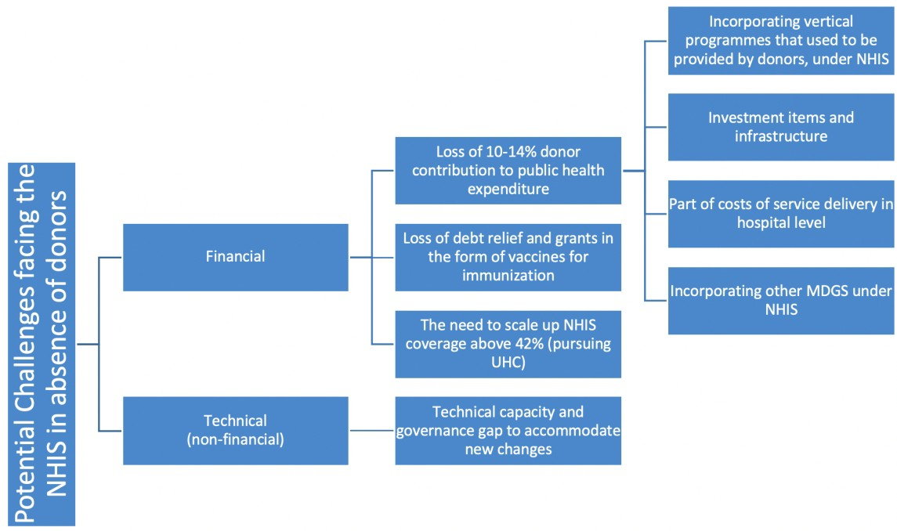

Figure 1 Potential NHIS challenges during transition process UHC-Universal Health Coverage; NHIS-National Health Insurance Scheme

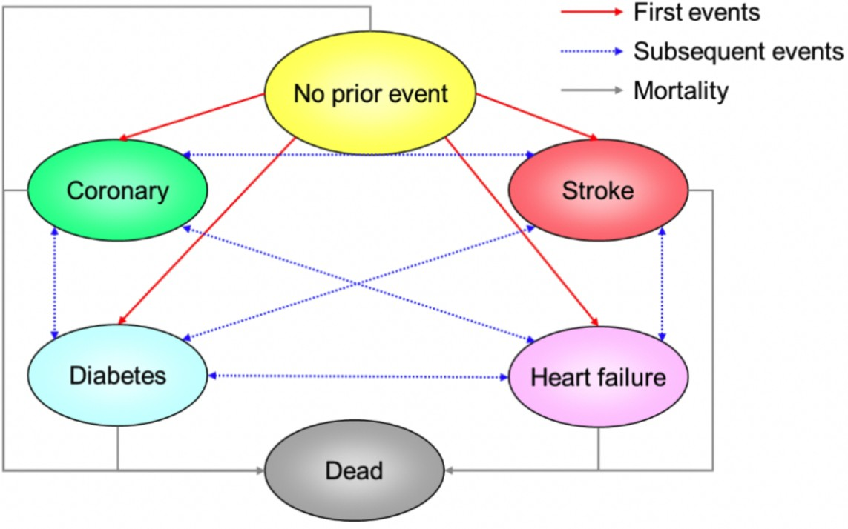

Figure 2 Illustration of treatment model structure

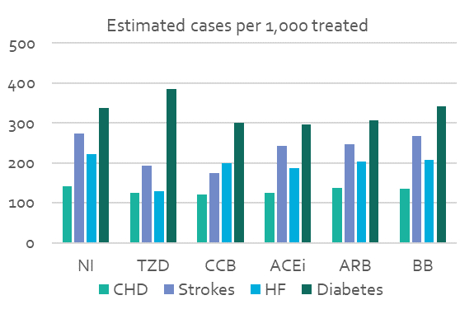

Figure 3 Estimated number of adverse events in treated population (lifetime incidence)
ACEi-Angiotension Converting Enzyme inhibitor; ARB-Angiotension Receptor Blockers; BB-Beta Blockers; CCB-Calcium Channel Blockers; NI-No intervention; TZD-Thiazide like Diuretics

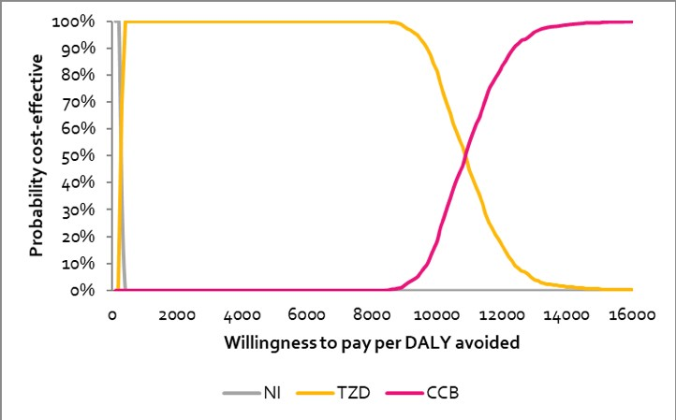

Figure 4 Cost-effectiveness acceptability curve (CEAC) CCB-Calcium Channel Blockers; NI-No intervention; TZD-Thiazide like Diuretics

Table 1 Sources of model inputs
CHD-Coronary Heart Disease; GDHS-Ghana Demographic and Health Survey; GH₵-Ghana Cedis; NHIS-National Health Insurance Scheme; STGs-Standard Treatment Guidelines; WHO-World Health Organisation

Table 2 Estimated number of people receiving NHIS treatment for hypertension
Age group | Controlled | Mild | Moderate | Severe | Total
MEN
25 | 19,315 | 2,534 | 320 | 160 | 22,329
35 | 14,517 | 3,388 | 1,176 | 248 | 19,329
45 | 6,679 | 3,082 | 1,113 | 618 | 11,492
55 | 12,657 | 2,210 | 1,347 | 688 | 16,902
65 | 8,422 | 1,470 | 896 | 458 | 11,246
75 | 10,446 | 1,824 | 1,111 | 568 | 13,949
WOMEN
25 | 15,656 | 5,753 | 1,415 | 943 | 23,766
35 | 24,830 | 10,687 | 2,702 | 2,122 | 40,342
45 | 31,427 | 13,071 | 5,136 | 3,260 | 52,893
55 | 26,693 | 11,102 | 4,363 | 2,769 | 44,926
65 | 19,707 | 8,196 | 3,221 | 2,044 | 33,169
75 | 31,576 | 13,133 | 5,161 | 3,275 | 53,145
Total | 221,925 | 76,451 | 27,960 | 17,151 | 343,488
NHIS-National Health Insurance Scheme

Table 3 Incremental cost-effectiveness analysis: per 1,000 treated population
 | Total |  | Incremental (compared to no Intervention) |  | ICER (compared with next best alternative)
 | Cost (GH₵) | DALYs | Cost (GH₵) | DALYs avoided | (GH₵ per DALY avoided)
NI | 536,562 | 13,447 | – | – | –
TZD | 827,495 | 12,394 | 290,933 | 1,052 | 276 | versus NI
CCB | 6,034,688 | 1,523 | 5,498,126 | 1,523 | 11,061 | versus TZD
ACEi | 5,383,737 | 690 | 4,847,75 | 690 | Dominated by TZD
ARB | 3,934,709 | 416 | 3,398,147 | 416 | Dominated by TZD
BB | 1,871,136 | 202 | 1,334,573 | 202 | Dominated by TZD
ACEi-Angiotension Converting Enzyme inhibitor; ARB-Angiotension Receptor Blockers; BB-Beta Blockers; CCB-Calcium Channel Blockers; DALYs-Disability Adjusted Life Years; GH₵-Ghana Cedis; ICER-Incremental Cost Effectiveness Ratio; NI-No intervention; TZD-Thiazide like Diuretics

Table 4 NHIS Budget Impact for whole treated population (343,488 patients)
Total costs (GH₵ UNdiscounted)
 | Year 1 | Year 2 | Year 3 | Year 4 | Year 5
NI | 5,507,598 | 6,453,082 | 7,102,141 | 7,549,956 | 7,861,999
TZD | 8,426,749 | 13,312,890 | 13,688,062 | 13,925,951 | 14,067,494
CCB | 71,468,372 | 135,651,998 | 132,349,908 | 129,102,548 | 125,960,627
ACEi | 66,093,318 | 124,245,912 | 120,836,360 | 117,496,649 | 114,292,309
ARB | 48,538,500 | 89,934,993 | 87,600,771 | 85,267,258 | 83,003,255
BB | 22,496,680 | 39,411,909 | 38,867,829 | 38,203,087 | 37,485,339
 |  |  |  |  |  | Total
TZD vs NI | 2,919,150 | 6,859,808 | 6,585,921 | 6,375,995 | 6,205,495 | 28,946,370
CCB vs TZD | 63,041,623 | 122,339,108 | 118,661,846 | 115,176,597 | 111,893,132 | 531,112,307

ACEi-Angiotension Converting Enzyme inhibitor; ARB-Angiotension Receptor Blockers; BB-Beta Blockers; CCB-Calcium Channel Blockers; GH₵-Ghana Cedis; NI-No intervention; TZD-Thiazide like Diuretics; VS-Versus

Table 5 Overview of modelled scenarios

NHIS-National Health Insurance Scheme;ACEi- Angiotension Converting Enzyme inhibitor; ARB-Angiotension Receptor Blockers; BB-Beta Blockers; CCB-Calcium Channel Blockers; TZD-Thiazide like Diuretics

Table 6 Results of cost saving scenarios

Scenario | Patients changing drugs | DALYs avoided (discounted) | Lifetime cost saving to NHIS, GH₵ millions (discounted) | Cost savings (vs. current practice),  GH₵ millions (undiscounted)
 |  |  |  | Year 1 | Year 2 | Year 3 | Year 4 | Year 5 | Total 1-5
1) 10% cut in mean drug prices | 0 | 0 | 93.7 | 3.3 | 6.5 | 6.3 | 6.1 | 5.9 | 28.0
2) 10% shift from ACEi/ ARB/ BB to TZD | 6,050 | 3,471 | 19.1 | 0.7 | 1.4 | 1.3 | 1.3 | 1.2 | 5.9
3) 10% shift from CCB to TZD | 13,033 | -6,135 | 67.9 | 2.4 | 4.6 | 4.5 | 4.4 | 4.2 | 20.2

DALYs-Disability Adjusted Life Years; GH₵-Ghana Cedis; TZD-Thiazide like Diuretics; NHIA-National Health Insurance Authority; NHIS-National Health Insurance Scheme

Table 7 Results of health improving scenarios
Scenario | Patients changing drugs | DALYs avoided (discounted) | Lifetime cost to NHIS, GH₵ millions (discounted) | Budget impact (vs. current practice),  GH₵ millions (undiscounted)
 |  |  |  | Year 1 | Year 2 | Year 3 | Year 4 | Year 5 | Total 1-5
4) Prescribe TZD to 10% of NHIA patients diagnosed with hypertension who are not currently treated | 9,170 | 10,776 | 2.16 | 0.06 | 0.16 | 0.15 | 0.14 | 0.14 | 0.51
5) Offer screening to 5% of NHIS patients aged over 40 without a diagnosis of hypertension | 104,476 invited for screening, 71,044 screened, 8,997 offered TZD | 5,512 | 5.07 | 4.20 | 0.07 | 0.07 | 0.06 | 0.06 | 4.47

DALYs-Disability Adjusted Life Years; GH₵-Ghana Cedis; TZD-Thiazide like Diuretics; NHIA-National Health Insurance Authority; NHIS-National Health Insurance Scheme

