Article type: Original article

Running title: TEMPERATURE-BODY SIZE RESPONSES

Temperature-body size responses in insects: a case study of British Odonata

Rungtip Wonglersak^{* a,b}, Phillip B. Fenberg ^{a,b}, Peter G. Langdon ^{c},
Stephen J. Brooks ^{b} and Benjamin W. Price ^{b}

ª Department of Ocean and Earth Sciences, University of Southampton, Southampton, SO14 3ZH, United Kingdom
^{b} Department of Life Sciences, Natural History Museum, London, SW7 5BD, United Kingdom
^{c} Department of Geography and Environment, University of Southampton, Southampton, SO17 1BJ, United Kingdom
*Corresponding author’s e-mail and address: r.wonglersak@soton.ac.uk
7th Floor DC2, Department of Life Sciences, The Natural History Museum, Cromwell Road, London, SW7 5BD, United Kingdom
Abstract
1. Body size is highly correlated with physiological traits, fitness, and trophic interactions. These traits are subject to change if there are widespread reductions of body size with warming temperatures, which is suggested as one of the “universal” ecological responses to climate change. However, general patterns of body size response to temperature in insects have not yet emerged.
2. To address this knowledge gap, we paired the wing length (as a proxy for body size) of 5,331 museum specimens of 14 species of British Odonata with historical temperature data. Three sets of analyses were performed 1) a regression analysis to test for a relationship between wing length and mean seasonal temperature within species and subsequent comparisons across species and suborders, 2) an investigation of whether the body size of species has an effect on sensitivity to warming temperature and, 3) a linear-mixed effects model to investigate factors that potentially affect temperature-size response.
3. The regression analysis indicated that wing length is negatively correlated with mean seasonal temperatures for Zygoptera, while, Anisoptera showed no significant correlation with temperature.
4. There is a significant decline in wing length of all Zygoptera (but not Anisoptera) with collection date, suggesting that individuals emerging later in the season are smaller.
5. Life-cycle type was not important for predicting wing length-temperature responses, whereas sex, species and suborder were indicated as important factors affecting the magnitude of temperature-size responses in Odonata.
6. Overall, wing lengths of Zygoptera are more sensitive to temperature and collection date than Anisoptera.
Key-words: Anisoptera, body size response, climate change, temperature-size rule (TSR), museum collections, Zygoptera
Introduction
Along with species distribution shifts and phenological changes, a decrease in body size is suggested to be a universal ecological response of organisms to warming temperature (Gardner et al., 2011, Ohlberger, 2013). In ectotherms, body temperature depends on environmental temperature, which in turn, can affect body size through both developmental and metabolic rate (Atkinson, 1994, Sheridan & Bickford, 2011). Previous studies have found that the developmental rate of ectotherms is faster at lower latitudes and warmer temperatures (Atkinson, 1994, Angilletta et al., 2004) and is more sensitive to temperature than growth rate (Zuo et al, 2012). Consequently, adult size should be smaller in warm environments compared to individuals growing in cooler temperatures and higher latitudes; this relationship is sometimes referred to as the temperature-size rule (TSR) (Atkinson, 1994).
As well as the direct effects of warming temperature on the developmental rate of ectotherms that can ultimately reduce adult body size, changing food quality and availability with changing temperature can have an indirect effect (Ozgul et al., 2009, Ozgul et al., 2010, Gardner et al., 2011). Previous studies show that many ectothermic taxa do not follow the TSR, especially insects (Sota et al., 2002, Blanckenhorn, 2004, de Queiroz & Ashton, 2004, Wilson et al., 2019). This is thought to be due to season length effects (i.e. longer warm seasons correspond to a longer developmental period), voltinism type (the number of generations per year), sexual size-dimorphism (SSD), trophic level, habitat type, and food quality (Cressa et al., 2008, Kingsolver & Huey, 2008, Schutze & Clarke, 2008, Gibert & DeLong, 2014, Horne et al, 2015, Fenberg et al., 2016).
General patterns of insect body size response to temperature have therefore not yet emerged. This may be partly because it can be challenging to isolate the overall effect of temperature on adult body size given the complex life cycles and ecology of many insects. For instance, adult body size may be directly or indirectly affected by the temperature experienced during each larval stage or whether a species overwinters as an egg or larva (Puzzle, 2004). In addition, voltinism type, which can range from semivoltine (needing more than one year to complete the life cycle), univoltine (one generation per year), bivoltine (two generations per year) or multivoltine (more than two generations per year), is thought to affect temperature-body size response (Horne et al., 2016).
To make matters more complicated, the body size of each sex may respond differently to temperature, or have no response at all (Fenberg et al., 2016). Furthermore, it is unknown whether different phylogenetic groups within an insect order (e.g. between sub-orders) exhibit similar temperature size responses.
A potentially powerful way to determine if there are general body size responses of insects to temperature is to study both sexes of multiple species with varying life history strategies over long historical time scales, from the same geographic region. Natural history collections are valuable resources of such data. In this study, we use museum collections of adult British Odonata as a model group for examining general patterns of insect body size responses to warming temperature because 1) there is a large amount of historical data available for several Odonata species in museum collections; 2) Odonata have seasonal regulation of key life history traits triggered by temperature (e.g. timing of egg hatch and adult emergence (Hassall & Thompson, 2008, Stoks & Córdoba-Aguilar, 2012)); 3) Odonata exhibit a variety of life history strategies, including differences in voltinism type (Corbet et al., 2006), overwintering stage (Verberk et al., 2008), and adult emergence period (Corbet et al., 2006); 4) monthly regional temperature records are available from the whole of the British Isles from 1910 (UK Meteorological Office); and 5) by measuring adult body size only, the same life stage across all years and seasons is consistent, and thus avoids issues of size variation in juvenile life stages and age structure.
In addition to the effects of temperature on adult body size through development rate, temperature could affect adult body size of Odonata by affecting their emergence time (Cothran & Thorp, 2006, Penn, 2015). For example, studies on the damselflies, Coenagrion puella and C. mercuriale, and on the dragonfly, Sympetrum danae, found a negative correlation between adult body size and emergence date (Banks & Thompson, 1985, Michiels & Dhondt, 1989, Purse & Thompson, 2003).
Studies of temperature-size responses in insects should initially be examined at the intraspecific level because species specific traits such as seasonal life cycle will determine which temperature variable (e.g. seasonal or monthly) best predicts adult size. Then, comparisons across species can be made to assess whether there are any general temperature size responses. For example, previous studies have shown that the average size of a species can explain the strength of body size response to temperature change (Forster, et al., 2012, Tseng et al., 2018). In aquatic organisms, large species exhibit greater reduction in body size in response to warming temperature than small species (Forster et al., 2012). This could be explained by oxygen limitation, as the reduced surface area to body mass ratio in large species leads to decreased respiratory surface area, resulting in greater reduction of adult body size in large species compared to small species (Forster et al., 2012).
To investigate if there are body size responses of Odonata to temperature, we analysed species specific responses by pairing mean seasonal temperature during the larval growth period for each species with wing length measurements for 14 British Odonata species, collected between 1910 and 1980. We then compared results across species and by suborder to determine if there are any general patterns of temperature size response across Odonata. In addition, we 1) tested whether the sexes responded differently to temperature; 2) investigated if body size correlates with collection date; and 3) investigated potential drivers that could correlate with the magnitude of temperature-size responses of Odonata, including average adult size of species, life history type and suborder. To our knowledge, this is the first study that assesses body size response to temperature among different Odonata species across historic to modern temporal scales in the same region.
We hypothesized that 1) given the classically assumed TSR, adult wing length (as a proxy for body size) will decrease during years with warmer temperatures. 2) According to previous studies (Forster, et al., 2012, Tseng et al., 2018), we also expected an increase in the magnitude of wing length reduction with increasing temperature in larger species. Thus, Anisoptera could be expected to have a greater reduction in wing length than Zygoptera. Furthermore, negative correlations are expected between temperature and body size for univoltine species as their development is time constrained. Previous studies, however, indicate a converse to the TSR in univoltine insects species (Horne et al., 2015, Fenberg et al., 2016, Wilson et al., 2019). Positive or no correlation between temperature and wing length are predicted in semivoltine species due to their extended growing season in warmer years. Thus, 3) we hypothesized that suborder and/or life cycle type could be predictors of the direction and magnitude of species responses to warming temperature. 4) According to previous studies (Banks & Thompson, 1985, Michiels & Dhondt, 1989, Purse & Thompson, 2003), we also expected smaller wing lengths for specimens collected later in the year due to time-constraints on larval development.
Materials and methods
This study was based on analyses of 5,331 specimens of 14 species of British Odonata, including eight Anisoptera species and six Zygoptera species (Table 1). These species were selected based on their range of life cycle types and the availability of specimens from UK museums (Table S1 in appendix).

Data acquisition
Among the morphological traits of insects, wing size and wing shape have been used to study size responses to environmental or climate change (Hassall, 2015, Bai et al., 2016, Stewart & Vodopich, 2018). Here, wing length was used as a proxy for body size as justified by previous studies (Haas & Tolley, 1998, Corbet, 1999). Additionally, studies on body size in insects (Clapham & Karr, 2012) and Odonata (Worthen & Jones, 2006) suggest a strong correlation between body dimensions and wing length. Many studies on other insects suggested a reflection of body size in wing length (i.e. Dudley, 2000, Loh et al., 2008, Beasley et al., 2012, Bai et al., 2016). Furthermore, wing length remains constant in museum specimens, while other insect body parts, including the thorax and abdomen, shrink over time (Krogmann & Holstein, 2010, Gilbert, 2011).
All specimens were imaged in a standardized template alongside specimen label(s), scale bar, and a colour checker (Figure S1 in appendix). Wing length was obtained by measuring the distance between the base of the leading edge of the wing and the distal end of the first radial anterior vein (R1) of the right-hind wings of each specimen (Figure S1 in appendix). Collection location and date were manually extracted from specimen labels.
The regional air monthly temperature time-series data are derived from the UK Meteorological Office (www.metoffice.gov.uk/climate/uk/ summaries/datasets) and were used to calculate climate variables for analyses. Although Odonata larvae are aquatic and not directly exposed to air temperatures during development, previous studies indicate a linear relationship between air and stream water temperature (Erickson & Stefan, 2000) and air temperature and lake water temperature in the upper metre of the water column (Livingstone & Lotter, 1998). Most of the Odonata species in our study breed in small ponds and lakes. We used mean regional temperature, which compensates for any small variations in water temperature during larval development.
Three sets of analysis were performed in R (R Core Team, 2014): 1) a stepwise regression analysis of each species to investigate body size responses to mean seasonal temperature during their larval growing periods; 2) an investigation of whether body size of species has an effect on sensitivity to warming temperature (interspecific variation); and 3) a linear-mixed effects model to investigate the influence of random factors, including suborder, life-history type, and sex on temperature size responses across species.
Individual species analyses
Previous work found that species with different life histories (e.g. spring and summer species) or voltinism type can affect phenological responses to warming temperature (Hassall et al., 2007). Thus, mean seasonal temperature of the larval period was calculated for each species based on their voltinism type and life cycle characteristics as defined by Corbet et al. (2006) and used as independent variables (Table 1). Prior to analysis of each species, the Variance Inflation Factor (VIF) was estimated to test the multicollinearity among environmental variables. Variables having VIF_{Weight} higher than 3 were removed from the models. A multiple linear regression analysis was performed followed by stepwise linear regression in both directions (forward and backward selection) using the MASS package in R (Venables & Ripley, 2002) to select the best final model with important variables from all possible subset models.
Odonata body size may vary through the season (Cothran & Thorp, 2006, Penn, 2015), thus it is important to consider emergence date as a factor that could affect adult body size. Collection date, which can be considered as a proxy for emergence date (discussed below), was therefore also included as an independent variable in the individual species analyses (Bried, 2009).
Interspecific analyses
For each species, the percentage change in wing length per ºC was calculated using the mean seasonal temperature variables identified in the multiple linear regression analyses described above. Percentage wing length change was then calculated using the formula (exp(slope)−1) × 100; slopes were calculated using the natural log of wing lengths to account for any scaling effects that may have resulted from the differences in size between species and sexes (Forster et al., 2012). Then to investigate if species’ size is related to sensitivity to temperature, a linear regression analysis was performed between the percent change of wing length (per ºC) and mean wing length of each species.
For the linear mixed effects model, four independent temperature variables including mean winter, mean spring, mean summer and mean autumn temperature of the larval period was calculated for each species. For example, for Calopteryx splendens and C. virgo, which are semivoltine species, mean winter temperature was calculated from two years of winter temperature data during their larval growing period (year before their emergence and year of emergence). The linear mixed-effects model was used to examine if there were relationships between the dependent variable (log wing length), the four fixed independent variables (including mean winter, spring summer and autumn temperature) and the random effect variables (species, sex, suborder and life-history type) using the lme4 package (Bates et al., 2017).
Results
The stepwise regression analysis showed significant temperature-size relationships in all Zygoptera species and three Anisoptera species, Aeshna cyanea, Anax imperator and B. pratense (bold text Table 2). Mean autumn temperature of the year before emerging (y-1) and mean spring temperature of the emerging year (y0) were selected and retained as candidates of the fitted model to explain wing length variation of most Zygoptera species (Figures 1e-1h, 2e-2h). Calopteryx splendens, C. virgo, Coenagrion puella and Ischnura elegans showed a significantly smaller wing size with increasing mean autumn temperature of y-1 in both sexes (Figure 1e-1h). Most Zygoptera species, including Calopteryx splendens, C. virgo, Coenagrion puella and Lestes sponsa, also showed significantly reduced wing length with warming spring temperature of y0 (Figure 2e-2h). In contrast, most Anisoptera showed non-significant wing length change with mean spring temperature of y0 (Figure 2a-2d).
The percent change of wing length per degree ºC was calculated for each species to examine if there are interspecific differences in response and whether mean body size is related to the strength and direction of temperature size responses. We found a significant positive correlation between percent change of wing length change per ºC with mean wing length across species (R=0.60, p<0.05; Figure 3a).
Although males are significantly smaller than females in all Zygoptera species, the magnitude and direction of wing length response to temperature is similar in both sexes (Figure 1e-1h and 2e-2h). Three Anisoptera species (Aeshna grandis, Anax imperator and B. pratense) also exhibit a significant effect of sex on wing length responses to temperature (Table 2), which indicates that wing length responses are different in magnitude or direction between the sexes. It seems females have more sensitivity to temperature, but wing length responses in both sexes are non-significant (Figure 1a-1d and Figure 2a-2d).
The stepwise regression analysis shows significantly smaller wing length with later collection date in all six Zygoptera (p<0.01; Figure 4a). Whereas Anisoptera species exhibit non-significant wing length difference across the emergence season (p>0.05; Figure 4b).
A significantly different wing length response is noted between Anisoptera and Zygoptera (Figure 3b). Thus, when comparing across all species, using the linear-mixed effects model, we incorporated suborder as a random effect variable in lieu of correcting for phylogeny.
The linear-mixed effects model indicated that the inclusion of species, sex and particularly suborder, was the best predictive model for wing length variation of Odonata (Table S3 in appendix; Table 3). Given the importance of suborder in the linear-mixed effects model, an independent samples t-test was run between percent wing length change per degree temperature change between Anisoptera and Zygoptera, which indicated a significant difference of magnitude of wing length change (p<0.01; Figure 3b). On average, the wing length in Zygoptera decreases by 1.10mm (SE=0.81) per ºC, whereas the wing lengths of Anisoptera as a whole, do not change with temperature (0.39mm, SE=0.49).
Discussion
There are many different factors that need to be considered when investigating body size response to temperature in insects, including voltinism type, overwintering stage, phylogenetic relationships, and sex. These factors also affect which temperature variables should be used for examining temperature-size responses. Although we find no universal response to temperature and its proxies, we find that Zygoptera tend to have stronger and more consistent responses to seasonal temperature and collecting date than Anisoptera. Also, suborder is indicated as the most important factor affecting the direction and magnitude of wing length responses to temperature. Below we will discuss the likely causes of these results and their implications for future trajectories of temperature-size responses in Odonata.
There were significant negative correlations between wing length of Zygoptera species and mean seasonal temperature, in particular mean temperature of autumn y-1 and mean temperature of spring y0 (Figures 1 and 2). This response corresponds with the temperature-size rule (Atkinson, 1994), as smaller body sizes are found in warmer temperatures. Higher temperatures disproportionately increase developmental rate, resulting in smaller adults (Atkinson, 1994, Angilletta, 2004). In terms of life-history characters, some species are recorded as facultative univoltine species which can switch to a semivoltine lifecycle in parts of their distribution range. Coenagrion puella and Ischnura elegans (Zygoptera) have been recorded as facultative univoltine species in the UK (Corbet et al., 2006). Thus, years with relatively cool mean seasonal temperature might result in larvae switching to a semivoltine life cycle, thereby extending their development for an additional year, and resulting in a larger body size on emergence.
In terms of sexual size dimorphism, if the sexes respond in the same direction and rate to temperature, then the magnitude of SSD would not be predicted to change with increasing temperature. Conversely, if the size of one sex responds to temperature and the other does not, or they respond in opposite directions, then the magnitude of SSD may be predicted to change with warming temperatures (Fenberg et al., 2016). Because most Zygoptera in this study exhibit SSD (Figure S2 in appendix), but the males and females have equally negative size responses to temperature (Figures 1 and 2), we can be fairly confident that the magnitude of SSD will generally be stable with warming temperatures for this taxon. Anisoptera, on the other hand (excluding A. cyanea) do not exhibit SSD (Figure S2 in appendix).
In females, bigger body sizes potentially have greater fecundity, so large females may be selected for. For Anisoptera, correlations between mean seasonal temperature and female wing length were non- or weakly-significant (Figure 1a-1d, 2a-2d). However, similar to males, wing length decreased in female Zygoptera, thus the relative size difference between males and females does not change with respect to temperature.
The linear-mixed effects model indicates that suborder is the most important driver affecting the magnitude of species wing length responses to warming temperature. In contrast, life-history type is excluded from the best fit model, which indicates less selective pressure for life-history type on the wing length responses to temperature. Previous studies have suggested that larger species are likely to have a greater reduction in size than smaller species as temperature increases (Forster, et al., 2012, Horne et al., 2015, Tseng et al., 2018). However, our results show the opposite, whereby small species have a greater reduction in size than large species as temperature increases. Interestingly, Anisoptera species are likely not to show any significant wing length changes with temperature. This result may be because those anisopteran species are strongly territorial and large male body size is linked to mating success (Sokolovska et al., 2000, Córdoba-Aguilar, 2008).
Within the Zygoptera, both Calopteryx splendens and C. virgo also exhibit territoriality and therefore, based on the results above, could be expected to show no body size change or get bigger with warmer temperatures, especially as they are semivoltine, and so have less time-constraints on development than univoltine species. However, our results indicate that in both species the adult males (and females) are smaller when they grow at higher temperatures. A possible explanation is that territoriality in Calopteryx is weaker than in many Anisoptera. Previous studies on Calopteryx indicate that male wing pigmentation is a more important mating cue than territory holding (Córdoba-Aguilar, 2002, Córdoba-Aguilar & Cordero-Rivera, 2005). Moreover, Koskimaki et al. (2009) showed that C. virgo had three mating tactics; 1) territorial 2) non-territorial (sneaking), and 3) non-territorial (wandering). They found that the body size of wandering C. virgo males was smaller than territorial individuals. This may partly account for our results, but it could be that other factors that differ between Anisoptera and Zygoptera have also affected their size responses to temperature. However, further study is required to fully untangle the mechanisms behind the differential wing size responses between Anisoptera and Zygoptera.
Seasonal cline in wing length
A significant negative response between wing length and collection date in all the studied Zygoptera species implies that individuals flying late in the season tend to be smaller than those of the same species flying early in the season. This finding corresponds well with previous field studies on UK populations of the zygopteran, Coenagrion mercuriale (Purse & Thompson, 2003, Lowe et al., 2009), which found larval exuviae emerging late in the season were smaller than those emerging early in the season, and studies in other Zygoptera species (Mahdjoub et al., 2015). This is likely due to the fact that larval development is time-constrained later in the season and therefore larvae accelerate their developmental rate, which comes at the cost of a smaller adult body size (Johansson & Rowe, 1999).
In contrast to Zygoptera, the wing lengths of the Anisoptera we studied do not significantly change with collection date. A previous study on an anisopteran species Sympetrum danae, revealed a decline in body size with emergence date (Michiels & Dhondt, 1989), while a study on Sympetrum rubicundulum, found no significant body size change across the emergence period (Van Buskirk, 1987). Interestingly, most Zygoptera and some Anisoptera, such as S. danae, are non-territorial. Most Anisoptera, including S. rubicundulum, are territorial where body size is relatively important for mating success in males (Sokolovska et al., 2000, Córdoba-Aguilar et al., 2008). Thus, small larvae of territorial species could delay emergence, enabling more time to grow and emerge as larger adults later in the year, thereby increasing their territorial competitiveness (Rowe & Ludwig, 1991, Fuselier et al., 2007).
Adult Anisoptera generally have a slightly greater longevity than adult Zygoptera which may mean that collection date is not as good a proxy for emergence date in Anisoptera compared to Zygoptera. Thus, this may account for the non-significant correlation of wing length with collection date in Anisoptera. In order to assess the influence of earlier emergence dates relative to collecting dates we have randomly assigned earlier emergence dates between 0 and 30 days before collection across the dataset. These simulated datasets have resulted in the same conclusions (see Table S4 in appendix) highlighting that the potential disparity between emergence and collecting date does not influence the overall conclusions. Furthermore, an analysis of collecting date in response to temperature (Figure 3S in appendix) highlights that warmer years result in earlier collecting dates, indicating the collecting date is likely a good proxy for the date of emergence.
Conclusions
In conclusion, we find that 1) Zygoptera do show a decrease in wing length as temperature increases and as the season advances, which corresponds well with previous studies on other insects (Ghosh et al, 2013, Horne et al., 2015, Tseng et al., 2018). In contrast, Anisoptera showed either a non-significant response or become larger (one species) or smaller (two species) with increasing temperature, possibly due to selection for larger individuals in strongly territorial species. 2) Contrary to our hypothesis, Zygoptera, which have a smaller body size than Anisoptera, showed greater sensitivity to temperature than Anisoptera. 3) Suborder is the main factor that affects Odonata temperature-size responses. We also hypothesized that univoltine species would show decreasing size with increasing temperature but that semivoltine species would show less sensitivity. This, however, proved not to be the case and suborder was a better predictor of size response irrespective of life cycle type. Other studies, however, show that life cycle type is important for predicting temperature-size responses. For example, the adult body sizes of some insects get larger with increasing temperatures, most notably univoltine and the first generation of bivoltine butterflies (Fenberg et al., 2016, Wilson et al., 2019). 4) Individuals of Zygoptera flying late in the season tend to be smaller than those of the same species flying early in the season. Taken together our results and these recent studies support the idea that there is no universal temperature-size response for insects and that results will depend upon multiple factors.
Although we find no universal body size response to warming seasonal temperature in Odonata, adult Zygoptera tend to be smaller in years that have warm seasonal temperatures during larval development. We presume that this is because warmer temperature accelerates the developmental rate of damselfly larvae at the cost of smaller adult body size. Future studies should further examine whether temperature size responses in insects vary between various taxonomic categories (i.e. at the order and sub-order levels) and whether other morphological features, such as wing shape are also affected by temperature. Additionally, further study to investigate whether territoriality affects wing length response in both Anisoptera and Zygoptera is needed.
Authors’ Contributions
RW collected and analysed the data and led the writing of the paper. PBF, PGL, SJB and BWP helped conceive the ideas for the research and analyses and provided direction for the writing.
Conflict of Interest Statement
The authors declare that there is no conflict of interest.
Data Accessibility
The R scripts used for data analyses and the raw specimen data, including unique identifier, location (latitude, longitude), collecting date, wing length and corresponding temperature data are available at: https://doi.org/10.5519/0095579.
Acknowledgements
The authors thank to Amoret Spooner (Oxford University Museum of Natural History), Ashleigh Whiffin (National Museums Scotland) and Michael R. Wilson (National Museum of Wales) for providing access to the collections in their care. This project is funded by the Royal Thai Government.
Figure legends
Fig 1: Linear regression of log wing length of Anisoptera (a)-(d) and Zygoptera (e)-(h) vs. mean autumn (y-1) temperature. Red dots and line represent females and blue dots and lines represent males.
Fig 2: Linear regression of log wing length of Anisoptera (a)-(d) and Zygoptera (e)-(h) vs. mean spring (y0) temperature. Red dots and line represent females and blue dots and lines represent males.
Fig 3: (a) Percentage change in mean wing length per °C of each species plotted against natural log wing length for mean seasonal temperature of the season that is indicated as the best variable for explaining wing length variation of each species (a stepwise regression analysis; Table2). A correlation analysis indicated significant positive correlation between percent change in wing length per degree temperature change and average wing length (as a proxy of body size) (r=0.60, p<0.05). (b) Percentage change in mean wing length per °C change of Anisoptera and Zygoptera. A t-test indicated significant difference of percent change in wing length between Anisoptera (x ̅ = 0.39) and Zygoptera (x ̅ = -1.10) (p<0.01).
Fig 4: Linear regressions of hindwing lengths and collecting date (as a proxy of emergence date) of (a) Anisoptera and (b) Zygoptera. Significant results indicated by *** (p<0.001) and * (p<0.05).

Fig 1.
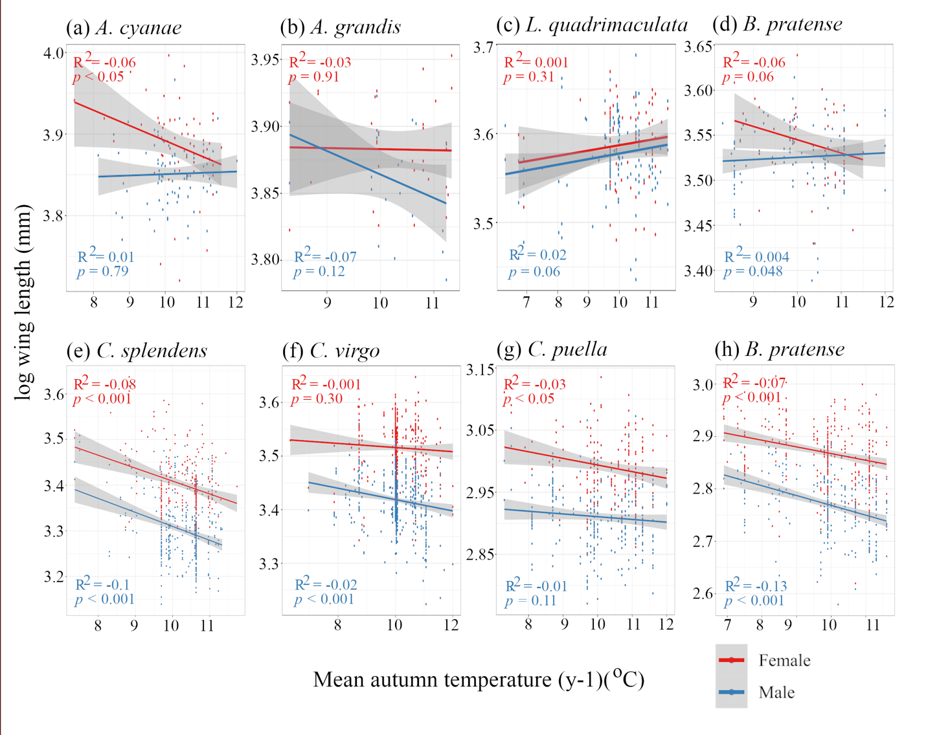

Fig 2.
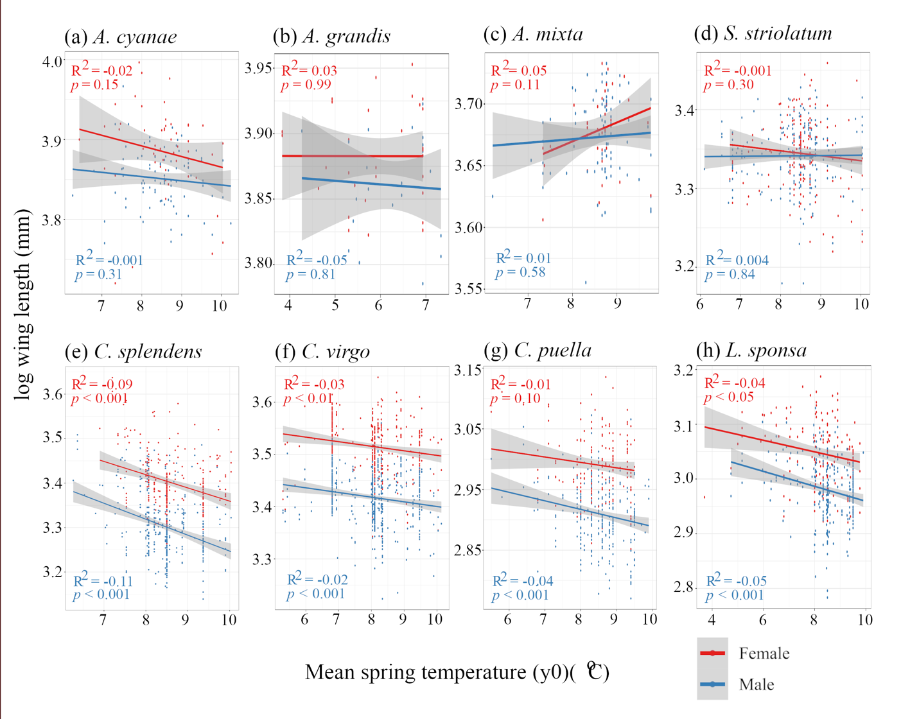

Fig 3.
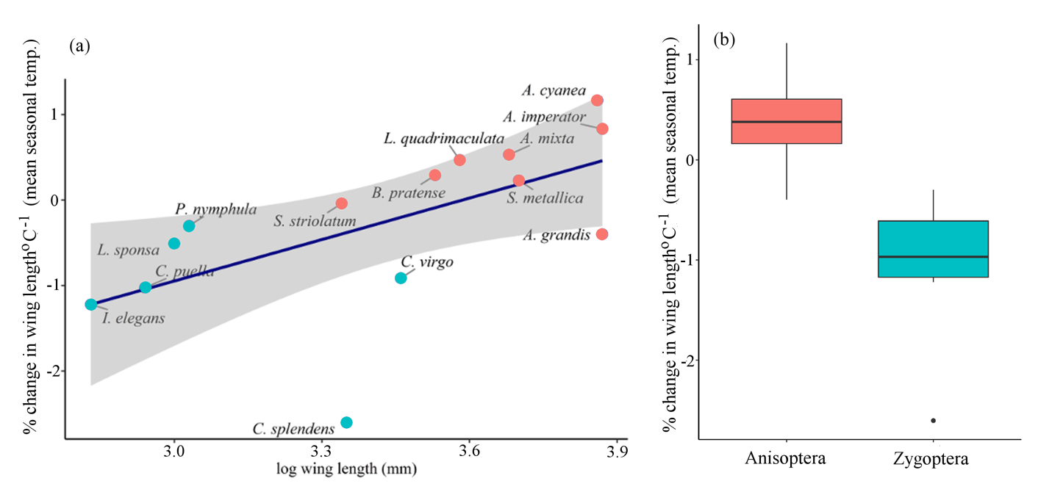

Fig 4.
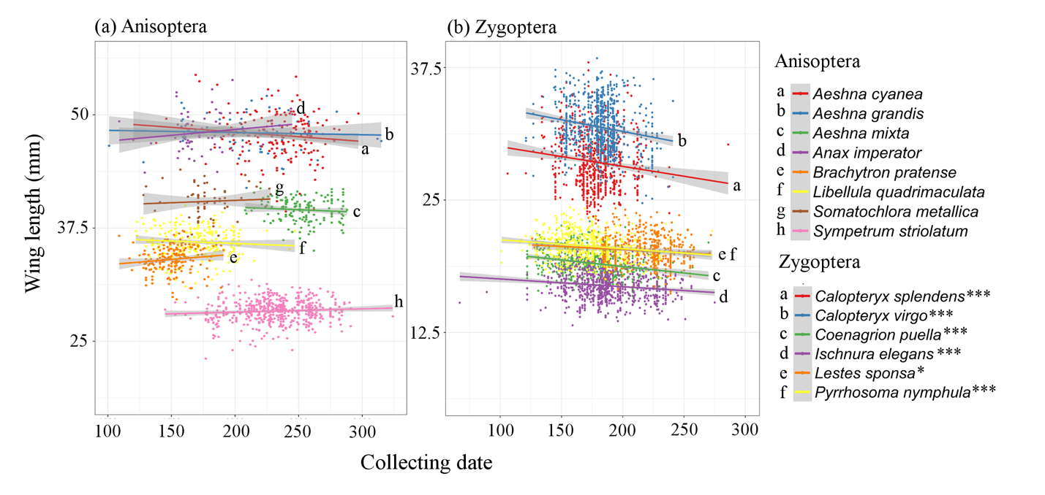

 | Species | N | Corbet’s type | Voltinism type | Environmental variables
Anisoptera | Aeshna cyanea | 179 | spring species | semivoltine | spring (y-1) to spring (y0)
 | Aeshna grandis | 53 | spring species | semivoltine | spring (y-1) to spring (y0)
 | Aeshna mixta | 151 | summer species | Univoltine | spring (y0)
 | Anax imperator | 68 | spring species | semivoltine | spring (y-2) to winter (y0)
 | Brachytron pratense | 194 | spring species | semivoltine | spring (y-2) to winter (y0)
 | Libellula quadrimaculata | 235 | spring species | semivoltine | spring (y-2) to winter (y0)
 | Somatochlora metallica | 64 | summer species | semivoltine | summer (y-2) to spring (y0)
 | Sympetrum striolatum | 482 | summer species | Univoltine | spring (y0)
Zygoptera | Calopteryx splendens | 684 | summer species | semivoltine | summer (y-2) to spring (y0)
 | Calopteryx virgo | 838 | summer species | semivoltine | summer (y-2) to spring (y0)
 | Coenagrion puella | 530 | obligatorily univoltine | Univoltine | summer (y-1) to spring (y0)
 | Ischnura elegans | 730 | obligatorily univoltine | Univoltine | summer (y-1) to spring (y0)
 | Lestes sponsa | 581 | summer species | Univoltine | spring (y0)
 | Pyrrhosoma nymphula | 542 | spring species | semivoltine | spring (y-2) to winter (y0)
Table 1: The 14 Odonata species used in this study and their voltinism type (Corbet & Brooks, 2008). Environmental variables for each characteristic type are calculated from the regional UK mean monthly temperature series. For each variable y-2 is two years before the collecting year, y-1 is a year before the collecting year, and y0 is the collecting year.

Table 2: Coefficients of the stepwise regression model for examining the effects of mean seasonal temperature, sex and day (collection date) on dragonfly wing length across studied species to investigate the effects of each variable on each species wing length.
 |  | Anisoptera |  |  |  |  |  |  |  | Zygoptera
 |  | Aeshna  cyanea | Aeshna  grandis | Aeshna  mixta | Anax  imperator | Brachytron  pratense | Libellula  quadrimaculata | Somatochlora  metallica | Sympetrum  striolatum | Calopteryx  splendens | Calopteryx  virgo | Coenagrion  puella | Ischnura  elegans | Lestes  sponsa | Pyrrhosoma  nymphula
 | Intercept | 52.48*** | 57.68*** | NS | 27.08*** | 33.94*** | 33.98*** | 46.64*** | 27.39*** | 46.43*** | 41.87*** | 24.81*** | 20.52*** | 25.07*** | 23.76***
 | Day | NS | NS | NS | NS | NS | NS | NS | NS | -0.01** | -0.02*** | -0.01*** | -0.01*** | -0.01** | -0.01***
Y-2 | Spring |  |  |  | 0.56** | NS | NS |  |  |  |  |  |  |  | NS
 | Summer |  |  |  | NS | NS | NS | NS |  | NS | NS |  |  |  | NS
 | Autumn |  |  |  | NS | NS | NS | -0.13*** |  | NS | 0.39*** |  |  |  | -0.15**
Y-1 | Winter |  |  |  | NS | 0.23* | NS | 0.47* |  | NS | -0.39*** |  |  |  | NS
 | Spring | 0.53* | NS |  | NS | -0.36* | NS | NS |  | 0.40*** | NS |  |  |  | NS
 | Summer | NS | NS |  | 0.83* | NS | NS | NS |  | NS | -0.29*** | NS | 0.19*** |  | NS
 | Autumn | NS | NS |  | NS | NS | 0.22* | NS |  | -0.86*** | -0.19* | -0.14** | -0.31*** |  | -0.21***
Y0 | Winter | NS | NS |  | NS | 0.21* | NS | NS |  | -0.18** | NS | NS | NS |  | NS
 | Spring | NS | NS | NS |  |  |  | NS | NS | -0.68*** | -0.17** | -0.29*** | NS | -0.29***
 | Sex | NS | -1.14* | NS | 1.44* | -0.69** | NS | NS | NS | -2.96*** | -3.11*** | -1.51*** | -1.63*** | -1.30*** | -1.30***
 | Adjusted R² | 0.18*** | NS | NS | NS | 0.08* | NS | NS | NS | 0.47*** | 0.60*** | 0.45*** | 0.53*** | 0.30*** | 0.33***
A negative symbol shows a negative relationship between wing length and the variables. Significant levels are indicated as *, **, *** for p<0.05, 0.01 and 0.001, respectively.
Blank cells are variables that were not included in a species analysis. NS is non-significant variable.
Table 3: Coefficients of the linear mixed effects model for examining the significant effects of mean seasonal temperature on dragonfly wing length across studied species. A negative symbol shows a negative relationship between wing length and the variables. Significant levels are indicated as *, **, *** for p<0.05, 0.01 and 0.001, respectively. ^{Ɨ} is variance $±$ standard deviation of random variables.
Variables | Random effects |  |  | Intercept | Mean seasonal temperature
 | Suborder | Species | Sex |  | Summer | Autumn | Winter | Spring
Coefficients | 0.099$±$0.31 ^{Ɨ} | 0.048$±$0.220 ^{Ɨ} | 0.003$±$0.054^{Ɨ} | 3.487 | 0.004*** | -0.009*** | -0.004*** | 0.002

A List of Supporting Information Legends
Fig S1: (a) Image of a pinned specimen with labels indicating collector, location and collecting date, specimen barcode, a color checker and a scale bar. (b) Wing length measurement of Odonata wing between the base of the leading edge of the wing and the distal end of the first radial anterior vein (R1).
Fig S2: Box plots of females and males hindwing length for (a) eight species in suborder Anisoptera and (b) six species in suborder Zygoptera. Significant results indicated by *** (p<0.05).
Fig S3: Regression analysis between the average temperature of larval period and collecting date which is a proxy of emergence date.
Table S1: Number of specimens of 14 British Odonatan species from museum collections in the UK and number of specimens.
Table S2: Number of specimens of 14 British Odonatan species from each decade.
Table S3: AIC approach to compare linear-mixed effects models contained different sets of random effects variables.
Table S4: Correlation coefficients and significant values (p-value) between collection date (original collection date and simulation data) and wing length of each Anisoptera species.

References:
Angilletta, M. J. (2004). Temperature, Growth Rate, and Body Size in Ectotherms: Fitting Pieces of a Life-History Puzzle. Integrative and Comparative Biology, 44(6), 498–509. https://doi.org/10.1093/icb/44.6.498
Angilletta, Michael J, Steury, T. D., & Sears, M. W. (2004). Temperature, growth rate, and body size in ectotherms: fitting pieces of a life-history puzzle. Integrative and Comparative Biology, 44(6), 498–509. https://doi.org/10.1093/icb/44.6.498
Atkinson, D. (1994a). Temperature and Organism Size-A biological Law for Ectotherms? In Advances in ecological research (Issue June, pp. 1–58). https://doi.org/10.1016/S0065-2504(08)60212-3
Atkinson, D. (1994b). Temperature and Organism Size—A Biological Law for Ectotherms? Advances in Ecological Research, 25(C), 1–58. https://doi.org/10.1016/S0065-2504(08)60212-3
Bai, Y., Dong, J. J., Guan, D. L., Xie, J. Y., & Xu, S. Q. (2016). Geographic variation in wing size and shape of the grasshopper Trilophidia annulata (Orthoptera: Oedipodidae): Morphological trait variations follow an ecogeographical rule. Scientific Reports. https://doi.org/10.1038/srep32680
Banks, M. J., & Thompson, D. J. (1985). Lifetime mating success in the damselfly Coenagrion puella. Animal Behaviour. https://doi.org/10.1016/S0003-3472(85)80178-0
Bates, D., Maechler, M., Bolker, B., Walker, S., Christensen, R. H. B., Singmann, H., Dai, B., & Eigen, C. (2017). lme4: Fitting linear mixed-effects models using lme4. Journal of Statistical Software. https://doi.org/10.18637/jss.v067.i01
Beasley, D. E., Bonisoli-Alquati, A., Welch, S. M., Møller, A. P., & Mousseau, T. A. (2012). Effects of parental radiation exposure on developmental instability in grasshoppers. Journal of Evolutionary Biology. https://doi.org/10.1111/j.1420-9101.2012.02502.x
Blanckenhorn, W. U. (2004). Bergmann and Converse Bergmann Latitudinal Clines in Arthropods: Two Ends of a Continuum? Integrative and Comparative Biology, 44(6), 413–424. https://doi.org/10.1093/icb/44.6.413
Bried, J. T. (2009). Location and seasonal differences in adult dragonfly size and mass in northern Mississippi, USA (Odonata: Libellulidae). International Journal of Odonatology. https://doi.org/10.1080/13887890.2009.9748332
Clapham, M. E., & Karr, J. A. (2012). Environmental and biotic controls on the evolutionary history of insect body size. Proceedings of the National Academy of Sciences of the United States of America. https://doi.org/10.1073/pnas.1204026109
Corbet, P. S. (1999). Dragonflies: Behavior and ecology of Odonata. Dragonflies: Behavior and Ecology of Odonata, 31(January), xxxiv+829p. https://doi.org/10.1111/j.1365-2427.2001.00664.x
Corbet, P. S., Suhling, F., & Soendgerath, D. (2006). Voltinism of odonata: A review. International Journal of Odonatology, 9(1), 1–44. https://doi.org/10.1080/13887890.2006.9748261
Córdoba-Aguilar, A. (2002). Wing pigmentation in territorial male damselflies, Calopteryx haemorrhoidalis: A possible relation to sexual selection. Animal Behaviour. https://doi.org/10.1006/anbe.2001.1974
Córdoba-Aguilar, Alejandro, & Cordero-Rivera, A. (2005). Evolution and ecology of Calopterygidae (Zygoptera: Odonata): status of knowledge and research perspectives. Neotropical Entomology. https://doi.org/10.1590/s1519-566x2005000600001
Córdoba-Aguilar, Alex. (2008). Dragonflies and Damselflies: Model Organisms for Ecological and Evolutionary Research. In Dragonflies and Damselflies: Model Organisms for Ecological and Evolutionary Research. https://doi.org/10.1093/acprof:oso/9780199230693.001.0001
Cothran, M. L., & Thorp, J. H. (2006). Emergence Patterns and Size Variation of Odonata in a Thermal Reservoir. Freshwater Invertebrate Biology. https://doi.org/10.2307/1467139
Cressa, C., Maldonado, V., Segnini, S., & Chacón, M. M. (2008). Size variation with elevation in adults and larvae of some Venezuelan stoneflies (Insecta: Plecoptera: Perlidae). Aquatic Insects, 30(2), 127–134. https://doi.org/10.1080/01650420701858764
de Queiroz, A., & Ashton, K. G. (2004). The phylogeny of a species-level tendency: species heritability and possible deep origins of Bergmann’s rule in Tetrapods. Evolution, 58(8), 1674. https://doi.org/10.1554/03-596
Dudley, R. (2000). The Biomechanics of Insect Flight: Form, Function, Evolution. Annals of the Entomological Society of America. https://doi.org/10.1093/aesa/93.5.1195f
Erickson, T. R., & Stefan, H. G. (2000). Linear air/water temperature correlations for streams during open water periods. Journal of Hydrologic Engineering. https://doi.org/10.1061/(ASCE)1084-0699(2000)5:3(317)
Fenberg, P. B., Self, A., Stewart, J. R., Wilson, R. J., & Brooks, S. J. (2016). Exploring the universal ecological responses to climate change in a univoltine butterfly. Journal of Animal Ecology, 85(3), 739–748. https://doi.org/10.1111/1365-2656.12492
Forster, J., Hirst, A. G., & Atkinson, D. (2012). Warming-induced reductions in body size are greater in aquatic than terrestrial species. Proceedings of the National Academy of Sciences. https://doi.org/10.1073/pnas.1210460109
Fuselier, L., Decker, P., Lunski, J., Mastel, T., & Skolness, S. (2007). Sex differences and size at emergence are not linked to biased sex ratios in the common green darner, Anax junius (odonata: Aeshnidae). Journal of Freshwater Ecology, 22(1), 107–117. https://doi.org/10.1080/02705060.2007.9664151
Gardner, J. L., Peters, A., Kearney, M. R., Joseph, L., & Heinsohn, R. (2011). Declining body size: A third universal response to warming? In Trends in Ecology and Evolution (Vol. 26, Issue 6, pp. 285–291). https://doi.org/10.1016/j.tree.2011.03.005
Ghosh, S. M., Testa, N. D., & Shingleton, A. W. (2013). Temperature-size rule is mediated by thermal plasticity of critical size in Drosophila melanogaster. In Proceedings of the Royal Society B: Biological Sciences. https://doi.org/10.1098/rspb.2013.0174
Gibert, J. P., & DeLong, J. P. (2014). Temperature alters food web body-size structure. Biology Letters, 10(8), 20140473–20140473. https://doi.org/10.1098/rsbl.2014.0473
Gilbert, J. D. J. (2011). Insect Dry Weight: Shortcut to a Difficult Quantity using Museum Specimens. Florida Entomologist. https://doi.org/10.1653/024.094.0433
Haas, H. L., & Tolley, K. A. (1998). Geographic variation of wing morphology in three Eurasian populations of the fruit fly, Drosophila lummei. Journal of Zoology, 245(April 2001), 197–203. https://doi.org/10.1017/S0952836998006074
Hassall, Chirstopher, Thompson, D. J., French, G. C., & Harvey, I. F. (2007). Historical changes in the phenology of British Odonata are related to climate. In Global Change Biology (Vol. 13, Issue 5, pp. 933–941). https://doi.org/10.1111/j.1365-2486.2007.01318.x
Hassall, Christopher. (2015). Strong geographical variation in wing aspect ratio of a damselfly, Calopteryx maculata (Odonata: Zygoptera). PeerJ. https://doi.org/10.7717/peerj.1219
Hassall, Christopher, & Thompson, D. J. (2008). The effects of environmental warming on odonata: A review. International Journal of Odonatology, 11(2), 131–153. https://doi.org/10.1080/13887890.2008.9748319
Horne, C. R., Hirst, A. G., & Atkinson, D. (2015). Temperature-size responses match latitudinal-size clines in arthropods, revealing critical differences between aquatic and terrestrial species. Ecology Letters, 18(4), 327–335. https://doi.org/10.1111/ele.12413
Horne, C. R., Hirst, A. G., Atkinson, D., Neves, A., & Kiørboe, T. (2016). A global synthesis of seasonal temperature–size responses in copepods. Global Ecology and Biogeography, 25(8), 988–999. https://doi.org/10.1111/geb.12460
Johansson, F., & Rowe, L. (1999). Life history and behavioral responses to time constraints in a damselfly. Ecology, 80(4), 1242–1252. https://doi.org/10.1890/0012-9658(1999)080[1242:LHABRT]2.0.CO;2
Kingsolver, J. G., & Huey, R. B. (2008). Size, temperature, and fitness: Three rules. Evolutionary Ecology Research, 10(2), 251–268.
Koskim??ki, J., Rantala, M. J., & Suhonen, I. (2009). Wandering males are smaller than territorial males in the damselfly Calopteryx virgo (L.) (zygoptera: calopterygidae). Odonatologica.
Krogmann, L., & Holstein, J. (2010). Preserving and Specimen Handling : Insects and other Invertebrates. Manual on Field Recording Techniques and Protocols for All Taxa Biodiversity Inventories. https://doi.org/volumes/volume-8-manual-atbi/volumes/volume-8-manual-atbi/chpater-18/Chapter_18.pdf
Livingstone, D. M., & Lotter, A. F. (1998). The relationship between air and water temperatures in lakes of the Swiss Plateau: A case study with palaeolimnological implications. Journal of Paleolimnology. https://doi.org/10.1023/A:1007904817619
Loh, R., David, J. R., Debat, V., & Bitner-Mathé, B. C. (2008). Adaptation to different climates results in divergent phenotypic plasticity of wing size and shape in an invasive drosophilid. Journal of Genetics. https://doi.org/10.1007/s12041-008-0034-2
Lowe, C. D., Harvey, I. F., Watts, P. C., & Thompson, D. J. (2009). Reproductive timing and patterns of development for the damselfly Coenagrion puella in the field. Ecology, 90(8), 2202–2212. https://doi.org/10.1890/08-1780.1
Mahdjoub, H., Khelifa, R., Zebsa, R., Bouslama, Z., & Houhamdi, M. (2015). Bivoltinism in Coenagrion mercuriale (Zygoptera: Odonata) in the southern margin of its distribution range: emergence pattern and larval growth. African Entomology, 23(1), 59–67. https://doi.org/10.4001/003.023.0120
Michiels, N. K., & Dhondt, A. A. (1989). Effects of emergence characteristics on longevity and maturation in the dragonfly Sympetrum danae (Anisoptera : Libellulidae). Hydrobiologia, 171(2), 149–158. https://doi.org/10.1007/BF00008175
Ohlberger, J. (2013). Climate warming and ectotherm body size - from individual physiology to community ecology. In Functional Ecology (Vol. 27, Issue 4, pp. 991–1001). https://doi.org/10.1111/1365-2435.12098
Ozgul, A., Childs, D. Z., Oli, M. K., Armitage, K. B., Blumstein, D. T., Olson, L. E., Tuljapurkar, S., & Coulson, T. (2010). Coupled dynamics of body mass and population growth in response to environmental change. Nature. https://doi.org/10.1038/nature09210
Ozgul, A., Tuljapurkar, S., Benton, T. G., Pemberton, J. M., Clutton-Brock, T. H., & Coulson, T. (2009). The dynamics of phenotypic change and the shrinking sheep of St. kilda. Science. https://doi.org/10.1126/science.1173668
Penn, G. H. (2015). Seasonal Variation in the Adult Size of Pachydiplax longipennis (Burmeister) (Odonata, Libellulidae)1. Annals of the Entomological Society of America. https://doi.org/10.1093/aesa/44.2.193
Philip Corbet, S. B. (2008). Dragonflies (Collins New Naturalist Library, Book 106).
Purse, B. V., & Thompson, D. J. (2003). Emergence of the damselflies, Coenagrion mercuriale and Ceriagrion tenellum (Odonata: Coenagrionidae), at their northern range margins, in Britain. European Journal of Entomology, 100(1), 93–99.
Puzzle, L. (2004). Temperature , Growth Rate , and Body Size in Ectotherms : Fitting Pieces of a. Current, 509(6), 498–509. https://doi.org/10.1039/C8CC00158H
Rowe, L., & Ludwig, D. (1991). Size and timing of metamorphosis in complex life cycles: time constraints and variation. Ecology, 72(2), 413–427. https://doi.org/10.2307/2937184
Schutze, M. K., & Clarke, A. R. (2008). Converse bergmann cline in a Eucalyptus herbivore, Paropsis atomaria Olivier (Coleoptera: Chrysomelidae): Phenotypic plasticity or local adaptation? Global Ecology and Biogeography, 17(3), 424–431. https://doi.org/10.1111/j.1466-8238.2007.00374.x
Serrano-Meneses, M. A., Córdoba-Aguilar, A., Azpilicueta-Amorín, M., González-Soriano, E., & Székely, T. (2008). Sexual selection, sexual size dimorphism and Rensch’s rule in Odonata. Journal of Evolutionary Biology, 21(5), 1259–1273. https://doi.org/10.1111/j.1420-9101.2008.01567.x
Sheridan, J. a., & Bickford, D. (2011). Shrinking body size as an ecological response to climate change. Nature Climate Change, 1(8), 401–406. https://doi.org/10.1038/nclimate1259
Sokolovska, N., Rowe, L., & Johansson, F. (2000). Fitness and body size in mature odonates. Ecological Entomology, 25(2), 239–248. https://doi.org/10.1046/j.1365-2311.2000.00251.x
Sota, T., Takami, Y., Kubota, K., & Ishikawa, R. (2002). Geographic variation in body size of carabid beetles: patterns resulting from climatic adaptation and interspecific interaction. In Japanese Journal of Entomology New Series (Vol. 5, Issue 3, pp. 88–97).
Stewart, S. S., & Vodopich, D. S. (2018). Environmental effects on wing shape and wing size of Argia sedula (Odonata: Coenagrionidae). International Journal of Odonatology. https://doi.org/10.1080/13887890.2018.1523752
Stoks, R., & Córdoba-Aguilar, A. (2012). Evolutionary Ecology of Odonata: A Complex Life Cycle Perspective. Annual Review of Entomology, 57(1), 249–265. https://doi.org/10.1146/annurev-ento-120710-100557
Tseng, M., Kaur, K. M., Soleimani Pari, S., Sarai, K., Chan, D., Yao, C. H., Porto, P., Toor, A., Toor, H. S., & Fograscher, K. (2018). Decreases in beetle body size linked to climate change and warming temperatures. Journal of Animal Ecology. https://doi.org/10.1111/1365-2656.12789
Van Buskirk, J. (1987). Influence of size and date of emergence on male survival and mating success in a dragonfly, Sympetrum rubicundulum. American Midland Naturalist, 118(1), 169–176.
Venables, W. N., & Ripley, B. D. (2002). Modern Applied Statistics with S Fourth edition by. In World (Vol. 53, Issue March). https://doi.org/10.2307/2685660
Verberk, W. C. E. P., Siepel, H., & Esselink, H. (2008). Life-history strategies in freshwater macroinvertebrates. In Freshwater Biology (Vol. 53, Issue 9, pp. 1722–1738). https://doi.org/10.1111/j.1365-2427.2008.02035.x
Wilson, R. J., Brooks, S. J., & Fenberg, P. B. (2019). The influence of ecological and life history factors on ectothermic temperature–size responses: Analysis of three Lycaenidae butterflies (Lepidoptera). Ecology and Evolution, 9(18), 10305–10316. https://doi.org/10.1002/ece3.5550
Worthen, W. B., & Jones, C. M. (2006). Relationships between body size, wing morphology, and perch height selection in a guild of Libellulidae species (Odonata). International Journal of Odonatology. https://doi.org/10.1080/13887890.2006.9748281
Zuo, W., Moses, M. E., West, G. B., Hou, C., & Brown, J. H. (2012). A general model for effects of temperature on ectotherm ontogenetic growth and development. Proceedings of the Royal Society B: Biological Sciences. https://doi.org/10.1098/rspb.2011.2000

