**Primary prevention of asthma in high-risk children using HDM SLIT; assessment at age 6 years**

**Online supplementary file**

*Cherry Alviani, MSc,a,b,c *Graham Roberts, DM,a,b,d Frances Mitchell, RN,c Jane Martin,RN,a Zaraquiza Zolkipli, MSc,e Louise J Michaelis, PhD,f Pandurangan Vijayanand, PhD,g Ramesh Kurukulaaratchy, DM,ab,c,  Hasan Arshad, DM,a,b,c,

*Equal contribution

aNIHR Southampton Biomedical Research Centre, University Hospital Southampton NHS Foundation Trust, Southampton, UK

bClinical and Experimental Sciences, University of Southampton Faculty of Medicine. Southampton, UK

cThe David Hide Asthma and Allergy Research Centre, St Mary’s Hospital, Isle of Wight, UK.

dHuman Development in Health, University of Southampton Faculty of Medicine. Southampton, UK

eDepartment of Allergy, Addenbrookes NHS Foundation Trust, Cambridge, UK.

fDepartment of Immunology, Infectious Diseases and Allergy, Great North Childrens’ Hospital, Newcastle upon Tyne, UK

gLa Jolla Institute for Immunology, La Jolla, California, USA

**Corresponding author:**

S. Hasan Arshad, DM, Mailpoint 810, Level F, South Block, Southampton General Hospital, Tremona Road, Southampton SO16 6YD, United Kingdom. E-mail: sha@soton.ac.uk.

**Methods**

## Study design

This was a prospective, randomized, double-blind, placebo-controlled phase IIa study. The study methods have been previously described in detail (1, 2). The study was undertaken across two sites: The David Hide Asthma and Allergy Research Centre, St Mary’s Hospital, Isle of Wight and the National Institute of Health Research Southampton Biomedical Research Centre based at University Hospital Southampton. The initial study was conducted between January 2011 and October 2014, follow-up between September 2017 and December 2018. Approval for follow-up age six was granted by NRES Committee (Yorkshire and the Humber- Sheffield Research Ethics Committee, IRAS project ID: 204152, REC reference: 16/YH/0217). Participants’ parents provided written informed consent. The trial has been registered on ClinicalTrials.gov, ID NCT03763630.

## Participants

Infants aged between five and nine months were recruited into the MAPS cohort at primary care child health clinics. Inclusion criteria were a strong family history of atopy (two or more first-degree relatives with allergic disease [food allergy, asthma, eczema, allergic rhinoconjunctivitis]) and negative skin-prick test (SPT) to HDM, cat, grass pollen, peanut, egg and milk (ALK-AbellÓ, HØrsholm, Denmark). In parallel to MAPS, antenatal recruitment occurred into the observational Immune Tolerance in Early Childhood (ITEC) cohort. Each participant could only belong to one cohort. Some participants, recruited at birth into ITEC, opted to join the MAPS study age 6 months. They were therefore considered MAPS participants and no longer part of the ITEC cohort (and analysed as MAPS). MAPS participants were reviewed at 9, 12, 15, 18, 36 and 72 months of age while the ITEC participants were seen at 5, 18, 36 and 72 months of age with similar assessment (see Figure S1).

**Sample Size**

The sample size required to detect correct ordering of the primary outcomes (sensitization) between the two groups for the previous proof of efficacy study was calculated as 60 subjects per group, with 85% probability of demonstrating correct ordering of the groups. This was based on a sensitization rate of 0·27 in the placebo group, as observed at age two years in previous studies. (2, 3) The study was not powered to detect differences in clinical end-points.

### Randomization and masking

Participants were enrolled by the study team and randomized 1:1 in computer-generated blocks by ALK-AbellÓ with participants, care providers and all members of study team remaining blinded to group allocation. Investigational medicinal product (IMP) arrived pre-randomized, received by the pharmacy department and was sequentially allocated to participants.

## Intervention

In the MAPS intervention group, participants received 2000 standard treatment units of glycerinated HDM allergen extract (ALK-AbellÓ) per day equal to 11 µg of HDM allergen (equal parts of *Dermatophagoides pteronyssinus* and *Dermatophagoides farinae).* There was a two-third to one-third mix of group 1 and 2 HDM allergens in a 50% glycerine solution. The placebo was a 50% glycerine solution plus normal saline.. Both products were formulated as oral drops.

### Procedures

*Study Questionnaires:* Participants underwent assessment using the validated International Study of Asthma and Allergies in Childhood questionnaires, study-specific questionnaires and SCORAD forms to assess presence of wheeze, food allergy and eczema severity.

*Skin-Prick Tests (SPT):* SPTs to common aeroallergens and food allergens were performed using standardized reagents from ALK-AbellÓ, HØrsholm, Denmark. Mean wheal diameter was calculated. A positive response was defined as a mean wheal diameter ≥3mm than that elicited by the negative control. At all study visits SPTs were carried out to HDM, grass pollen, cat, peanut, milk and egg. From age three years, additional SPT were performed to tree pollen, alternaria and dog.

*Fractional exhaled Nitric Oxide (FeNO):* FeNO levels were measured at age six only, using the single expiratory breathmethod with a chemiluminescence analyser (Niox Vero desktop system, Aerocrine, Solna, Sweden). FeNO measurement was performed as recommended by the ATS/ERS guidelines (4). A biofeedback video incentive was used to maintainthe expiratory flow rate at 50 ml/s and subjects exhale against resistance to prevent upper airway contamination. Measurements were made in a standardised manner with the subject standingwithout a nose clip and repeated until twoconsecutive results within 10% or 5ppb were obtained; with a maximum of eight attempts. All measurements were undertakenbefore spirometry testing.

*Incentive Spirometry and Reversibility:* Incentive spirometry was performed at age six, using the Koko system (nSpire Health, Longmont, USA). Forced expiratory volume in one second (FEV1), forced vital capacity (FVC), mid expiratory flow (MEF), peak expiratory flow (PEF) were recorded. Percent predicted values for age, height, sex and ethnic origin were calculated for the above data, along with forced expiratory ratio (FEV1/FVC). Spirometry was then repeated, where possible, 15 minutes after administration of 600mcg of salbutamol via large volume spacer. Reversibility was defined as ≥12% increase in FEV1. Spirometry was performed according to the American Thoracic Society / European Respiratory Society guidelines. (5) To perform the test participants had to be free from respiratory infection for the past 14 days, and have abstained from short acting beta-2-agonists for 6 hours, long acting beta-2-agonists for 12 hours. To ensure validity and reproducibility three technically acceptable blows with a maximum of 8 attempts were obtained. The highest of two FEV1 measurements within 10% of each were used.

*Methacholine bronchial hyper-responsiveness testing (BHR):* Methacholine challenge was used to assess bronchial hyperresponsiveness at age six. Testing was performed using a variation of the standardized international protocol recommended by the European Respiratory Society (6). Trained, experienced research nurses undertook the procedure with direct medical supervision. A pre-test spirometry reading was obtained to ensure an FEV1 of above 75% predicted for age and height. Initial inhalation of 0·9% saline was followed 30 and 90 seconds later by spirometry recording to obtain a baseline value. Subsequently, incremental doses from 1·4 µg to 716·8 µg of methacholine were serially administered at five minute intervals, according to the Peter Sterk PD20 protocol (6), using a computerized dosimeter system (Koko Digidoser, PDS Instrumentation, Louisville, USA). To perform this test, participants were required to be free from respiratory infection for 14 days, not taking a course of oral steroids, not taken short acting beta-2-agonist for 6 hours, and long acting beta-2-agonist for 12 hours, and having abstained from caffeine intake for at least 4 hours. The dose of methacholine used was recorded whether it produced a 20% fall in FEV1 or not. At the completion of the protocol or following a 20% fall in FEV1, 600mcg of salbutamol was administered by large volume spacer. After 15 minutes FEV1 was measured one final time, and the procedure terminated once FEV1 returned to 90% or above of baseline.

The methacholine concentration causing a 20% fall in FEV1 from the post-saline value was interpolated and expressed as PD20 FEV1 (provocative dose causing a 20% fall in FEV1). Bronchial responsiveness was defined in relation to the methacholine PD20 FEV1 following guidelines: normal, > 400 µg; borderline, 100-400 µg; mild, 25-100 µg; moderate, 6-25 µg; severe, <6 µg.

**Primary and Secondary Outcomes:**

*Asthma:* For the primary outcome of asthma, all cases were reviewed (blindly to the group allocation for MAPS children) by an adjudication committee of three independent paediatric clinicians with expertise in asthma. The information used included symptom history, response to medication, spirometry, reversibility, FeNO and BHR and a consensus clinical decision was made as to whether or not individual participants had asthma. Participants were allocated to one of five categories: definite asthma, probable asthma, possible asthma, probable not asthma and no asthma.

* “Definite asthma” – where the diagnosis was unquestioned, for example a child with multiple wheezing episodes in the past year, on multiple inhalers with response to these and, where available, abnormal lung function.
* “Probable asthma”- where asthma was the most probable diagnosis but couldn’t be confirmed with absolute certainty (for example children with a history of wheezing, on asthma inhalers with good response to these but normal lung function).
* “Possible asthma” – where there was insufficient information to either confirm or reject the diagnosis.
* “Probable not asthma”- where asthma was highly unlikely based on information provided, but couldn’t be completely rejected as a diagnosis (for example children with no history of symptoms and treatment but with unexpected bronchial hyperactivity in the moderate category).
* “Definite not asthma”- where there was no indication of asthma.

For the purpose of analysis, the “definite not asthma” and “probable not asthma” were grouped together. Comparisons were made between “Definite asthma” cases and “likely asthma (definite + probable asthma) cases.

Secondary outcomes included cumulative sensitization to any tested allergen, cumulative sensitization to HDM, BHR, FeNO, allergic rhinitis, wheeze, eczema and food allergy.

*Wheeze and recurrent toddler wheeze:* Wheeze was reported by parents.Recurrent wheeze was defined as the presence of three or more separate wheezing episodes before the age of four.

*Eczema:* Diagnosis of eczema was based at each assessment on the presence of three of the major diagnostic criteria as defined by Hanifin and Rajka- an itchy rash; in a typical distribution (elbow creases, behind knees, face in an infant) that had persisted for more than 7 days and was coming and going for 6 months or more to indicate it’s chronic and relapsing nature. (7) Diagnosis was based on questionnaire response as most children had quiescent disease at assessment and therefore SCORAD scores were generally very low. (8)

*Rhinitis:* Parental report of a sneezy, runny or blocked nose not associated with a cough/ cold as based on questionnaire response at six years of age.

*Food allergy:* Food allergy was defined as parental report of two or more typical type I hypersensitivity symptoms (urticaria, angioedema, wheeze, diarrhoea and vomiting, oral symptoms, systemic upset) within two hours of ingestion of the index food (a known allergic food). Where possible results were correlated to SPT results (for egg, milk and peanut) to confirm the diagnosis. All possible cases of food reaction were individually reviewed.

**Statistical analysis:**

The study was designed as proof-of-concept to detect hypothesized correct ordering of sensitization age 18 months, and was not powered to detect differences in clinical end-points. An intention-to-treat analysis was performed for all participants that attended at least one post-randomization assessment. No data was censored or imputed. The analysis assumed that any missing data is missing at random. Differences in proportions of participants between the two groups were calculated with regards to primary and secondary end-points, with 95% CI, using appropriate statistics. Time-to-event analysis was undertaken to compare the proportions of participants sensitized in the two groups over time, and Kaplan-Meier curves were generated. The ITEC cohort represents participants who were at high risk for developing allergy (as per MAPS intervention trial) who did not enrol in the MAPS study. A comparison of the baseline characteristics of the ITEC group and the MAPS control group was made. This was to ensure that the results were not biased by factors affecting families’ willingness to participated in the MAPS study. As this was not the case, the above analysis was repeated with comparison between the MAPS intervention group and a combination of the MAPS placebo and ITEC group providing improved power to assess impact of the MAPS intervention. A sensitivity analysis was performed without ITEC participants found to be sensitized at five months of age. Data was initially collected onto paper questionnaire and clinical record forms (CRF) and then doubly entered into the study database, either a community version of Open Clinical database hosted by University Hospital Southampton NHS Foundation Trust for the three year data, or a Microsoft Access database hosted by the Isle of Wight NHS Trust for the six year data. Data management was under the supervision of the Clinical Trials Manager in the David Hide Asthma and Allergy Research Centre, Isle of Wight. Prior to any statistical analysis, all variables were checked for number of missing values, impossible and improbable values. Impossible and improbable values were defined by clinical opinion. Improbable values also included values that were outside three standard deviations of the mean value, any questions regarding the data were queried with the Data Manger. Descriptive statistics were calculated for all variables and distributional assumptions checked.

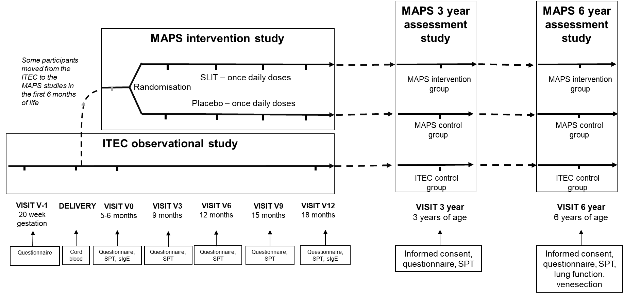

Figure S1 Overview of the MAPS and ITEC cohorts’ study design and follow-up. Follow-up time points were the same for both groups, although the MAPS participants had additional study visits at 9, 12 and 15 months of age whilst receiving the intervention.

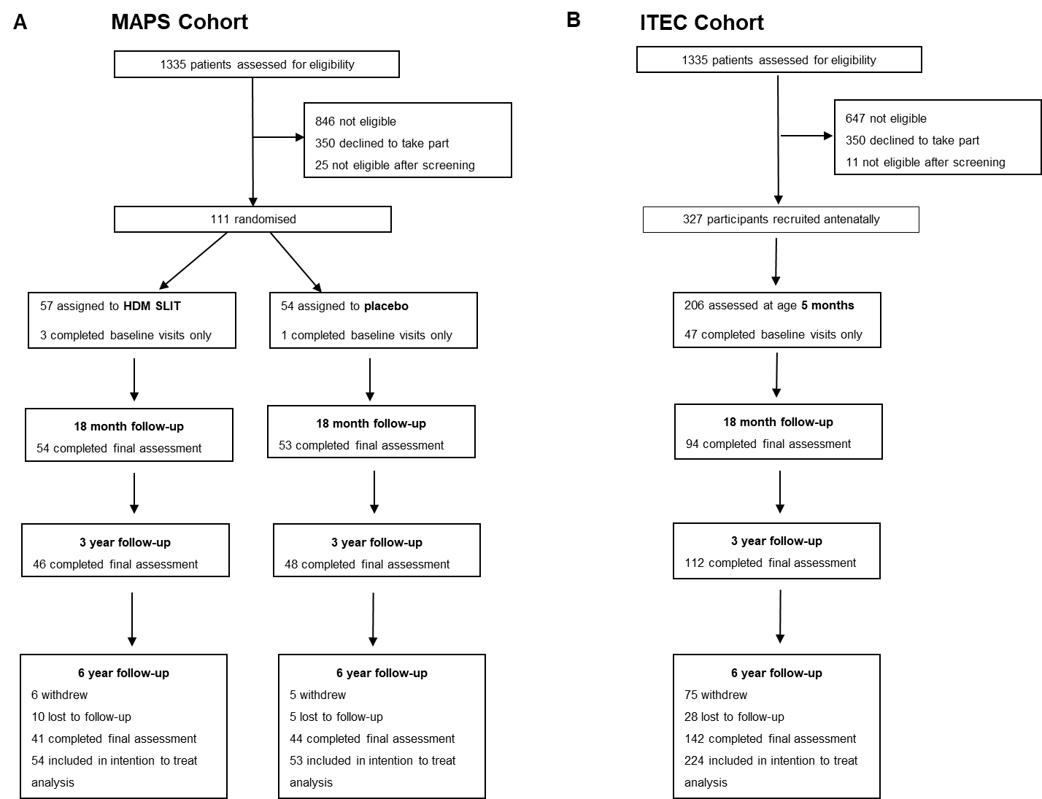

Figure S2 Consort figures for the MAPS (A) and ITEC (B) study population. The intention-to-treat analysis included all participants with at least one follow-up visit.

Table S1 Baseline characteristics for participants assessed at the different time-points. Atopy defined as sensitization based on positive SPT to any allergen, parental atopic disease defined as parental report of asthma, eczema, hayfever or food allergy. Numbers represent frequencies (percentage) or mean (S.D.). MAPS= Mite Allergy Prevention Study participants (intervention cohort). ITEC= Immune Tolerance in Early Childhood participants (observational high risk cohort).

|  |  |  |  |  |  |  |
| --- | --- | --- | --- | --- | --- | --- |
|  | MAPS HDM SLIT – baseline  (N= 57 ) | MAPS placebo – baseline  (N= 54) | ITEC cohort  (N= 224) | MAPS HDM SLIT- 6 years  (N=41) | MAPS - placebo- 6 years  (N= 44) | ITEC- 6 years  (N= 142) |
| Male | 30 (52·6%) | 27 (50·0%) | 115 (51·3%) | 22 (53·7%) | 18 (40·9%) | 72 (50·7%) |
| Age (baseline-months; 6 years- years) | 6.7 (1·3) | 6.9 (1·2) | 6. 0 (1·0) | 6.9 (0·5) | 6.9 (0·45) | 7.7 (0·52) |
| Height (cm) | 68.0 (4·2) | 68.2 (3·2) | 67.2 (3·0) | 123.6 (6·0) | 121.6 (4·7) | 126.3 (6·5) |
| Weight (kg) | 8.2 (1·1) | 8.2 (1·0) | 7.9 (1·1) | 24.3 (3·7) | 23.7 (3·0) | 26.6 (5·4) |
| Ethnicity (Caucasian) | 48 (94·1%) | 46 (97·9%) | 198 (97·1%) | 34 (91·9%) | 38 (97·4%) | 139 (97·9%) |
| Eczema | 3 (5·3%) | 3 (5·6%) | 18 (8·8%) | 15 (36·6%) | 15 (34·1%) | 44 (31·9%) |
| Reported wheeze | 18 (31·6%) | 14 (25·9%) | 71 (34·6%) | 27 (65·9%) | 26 (59·1%) | 97 (68·3%) |
| Atopy | 0 (0·0%) | 0 (0·0%) | 14 (6·2%) | 12 (29·3%) | 12 (27·3%) | 60 (42·2%) |
| Breastfeeding  Never breastfed  Breastfed <2 months  Breastfed 2-4 months  Breastfed > 4 months | 6 (10·5%)  21 (36·8%)  9 (15·8%)  21 (36·8%) | 5 (9·3%)  14 (25·9%)  6 (11·1%)  29 (53·7%) | 35 (17·3)%  69 (34·2%)  19 (9·4%)  79 (39·1%) | 4 (9·8%)  14 (34·2%)  6 (14·6%)  17 (41·5%) | 4 (9·1%)  12 (27·3%)  4 (9·1%)  24 (54·6%) | 19 (15·5%)  41 (33·3%)  8 (6·5%)  55 (44·7%) |
| Pet ownership  Any  Dog  Cat | 33 (57·9%)  18 (31·6%)  18 (31·6%) | 24 (44·4%)  10 (18·5%)  11 (20·4%) | 117 (57·1%)  69 (34·2%)  63 (28·1%) | 29 (70·7%)  16 (39·0%)  16 (39·0%) | 29 (65·9%)  14 (31·8%)  20 (45·4%) | 96 (67·6%)  57 (40·1%)  35 (24·6%) |
| Smoking exposure  No exposure  In utero only  Postnatally only  In utero and post-natal exposure | 18 (35·3%)  7 (13·7%)  10 (19·6%)  16 (31·4%) | 15 (30·6%)  10 (20·4%)  6 (12·2%)  18 (36·7%) | 64 (31·1%)  7 (3·4%)  75 (36·4%)  60 (29·3%) | 18 (48·7%)  7 (19·0%)  3 (8·1%)  9 (24·2%) | 15 (37·5%)  10 (25%)  2 (5·0%)  13 (32·5%) | 64 (52·0%)  7 (5·7%)  23 (18·7%)  29 (23·6%) |
| Daycare attendance before age 2 | 30 (52·6%) | 26 (50·0%) | 77 (38·9%) | 25 (51·0%) | 22 (50·0%) | 53 (44·5%) |
| Maternal Education level  Educated to age 16 years  Educated to age 18 years  Higher education after 18 years | 9 (19·6%)  17 (37·0%)  20 (43·5%) | 12 (26·7%)  18 (40·0%)  15 (33·3%) | 60 (24·5%)  113 (46·1%)  72 (29·4%) | 7 (20·6%)  12 (35·3%)  15 (44·1%) | 8 (21·6%)  17 (46·0%)  12 (32·4%) | 32 (26·2%)  57 (46·7%)  33 (25·1%) |
| Maternal atopic disease | 49 (86·0%) | 46 (85·2%) | 186 (90·3%) | 36 (87·8%) | 39 (88·6%) | 109 (88·6%) |
| Paternal atopic disease | 46 (90·2%) | 42 (87·5%) | 167 (81·5%) | 34 (91·8%) | 33 (84·6%) | 97 (78·9%) |

Table S2 ITEC Cohort comparison. Comparison of baseline characteristics between the MAPS placebo control group and the ITEC cohort. Numbers represent frequencies (percentages). *numbers represent means (S.D.) **Chi-squared test for trend. p<0.05 deemed statistically significant.

|  |  |  |  |
| --- | --- | --- | --- |
|  | MAPS Control (N=54) | ITEC control (N=224) | Difference (95% CI) (p value) |
| Sex (female) | 27 (50.0 %) | 109 (48.7%) | 0.01 (-0.16, 0.14) (0.860) |
| Birth-weight (grams)* | 3397 (477) | 3519 (499) | 122 (-195, 440) (0.45) |
| Parental atopy- (both parents atopic) | 39 (81.3%) | 148 (72.6%) | 0.09 (-0.04, 0.21) (0.21) |
| Ethnicity - caucasian | 46 (97.87%) | 198 (97.06%) | 0.01 (-0.06, 0.04) (0.760) |
| Maternal education   * Educated to age 16 * Educated to age 18 * Higher education | 12 (26.67%)  18 (40.0%)  15 (33.3%) | 54 (26.6%)  92 (45.32%)  57 (28.08%) | p = 0.668** |
| Age at 6 month assessment (months)* | 6.81 (1.10) | 6.03 (0.96) | 0.79 (1.09- 0.49) **(<0.001)** |
| Height 6 months (cm)* | 68.09 (3.10) | 67.22 (3.00) | 0.86 (-1.79, 0.07) (0.071) |
| Weight 6 months (kg)* | 8.18 (1.01) | 7.91 (1.11) | 0.27 (-0.06, 0.6) (0.113) |
| Breastfeeding   * Never breastfed * <2 months * 2-4 months * >4 months | 5 (9.3%)  14 (25.9%)  6 (11.1%)  29 (53.7%) | 35 (17.3%)  69 (34.2%)  19 (9.4%)  79 (39.1%) | **P= 0.028\*\*** |
| Pet at home early life (yes) | 24 (46.2%) | 117 (57.1%) | 0.11 (-0.04, 0.26) (0.158) |
| Dog at home early life (yes) | 15 (27.78%) | 69 (30.8%) | 0.03 (-0.10, 0.16) (0.664) |
| Cat at home early life (yes) | 16 (29.63%) | 63 (28.13%) | -.02 (-0.15, 0.12) (0.826) |
| Smoke exposure (6 months)   * No exposure * In utero or childhood exposure only * In utero and childhood exposure | 16 (32.7%)  15 (30.6%)  18 (36.7%) | 63 (30.7%)  82 (40.0%)  60 (29.3%) | P =0.706** |
| Eczema age 6 months | 5 (5..56%) | 18 (8.78%) | 0.03 (-0.04, 0.10) (0.44) |
| Atopy age 6 months | 0 (0.0) | 12 (5.36) | 0.05 (0.02, 0.08) (0.082) |

**RESULTS**

**Lung function age 6 years**

67 participants (78·8%) underwent baseline spirometry, 33 (80·5%) in the intervention group and 34 (77·3%) in the placebo group. There was no statistical significant difference between the two groups, with the intervention group having a trend for lower baseline FEV1 (99·9% predicted versus 106·4% predicted in the placebo group [6·5% difference, 95% CI -15·1%, 2·1%, p= 0·13]) but also less reversibility following salbutamol administration (2·8% absolute improvement compared to 4·4% in the control group [1·6% difference, 95% CI -5·1, 1·9, p= 0·36]).

Exhaled nitric oxide (FeNO) was measured in 47 (55·3%) of participants, 25 in the intervention group and 22 in the placebo group. Median value for the active group was 7·5 ppb (IQR 6·5- 10·5); median value for placebo group 8·75 ppb (6·5-10·5). (p= 0·65) (Fig S3). One participant in each group had an average FeNO result of >20 ppb.

Bronchial hyper-responsiveness (BHR) was assessed by methacholine challenge in 41 participants (48·2%), 22 in the intervention group and 19 in the placebo group. PD20 values (dose of methacholine resulting in a 20% decrease in FEV1) were calculated as suggested by Coates et al (6) based on the FEV1 of the last and previous to last doses. Based on these results participants were categorized into levels of bronchial hyper-responsiveness: severe (PD20 <6), moderate (PD20 7-25), mild (PD20 26-100), borderline (PD20 101-400) and normal (PD20 >400). There was no overall significant difference in the PD20 results between the group (p= 0·79, Chi-squared test for trend); however 1 (4·6%) of the intervention group had moderate/severe BHR on testing compared to 3 (15·8%) of the placebo group (Table S3).

Diagnosis of asthma is challenging especially in young children with overlapping diagnoses. Multiple guidelines agree that a diagnosis based on symptoms alone is inadequate, and where possible objective lung function testing should be performed.(9, 10). However, an abnormal lung function or reversibility could not be an essential criteria in the presence of asthma treatment. To overcome these conflicting requirements, a panel of independent paediatric respiratory physicians (blind to the group allocation) reviewed all data available for participants including symptoms, asthma treatment and objective parameters (spirometry, reversibility, FeNO and BHR), to reach a consensus decision regarding asthma status. This approach to asthma diagnosis is supported by evidence that in research studies a definition of childhood asthma should be based on a composite score of reported medical diagnosis, symptoms and lung function (11). Participants were classified into five groups based on the probability of asthma. A comparison of differences between the five groups for baseline FEV1, reversibility post bronchodilator, FeNO and bronchial hyper-activity demonstrated a trend for greater reversibility, higher median FeNO measurements and more bronchial hyper-responsiveness in the asthma/ probable asthma groups (Figure S4). Participants with “possible asthma” were excluded from analysis, to prevent incorrect group assignment.



Figure S3 Participant average FeNO results sorted by group. Median value for SLIT group = 7·5 ppb (IQR 6·5- 10·5); median value for placebo group 8·75 ppb (6·5-10·5). (p= 0·65, Mann Whitney-U test.)

Table S3 BHR (bronchial hyper-responsiveness) range distribution within each group. (p= 0·79, Chi-squared test for trend). BHR category defined based on PD20 values - severe (PD20 <6), moderate (PD20 7-25), mild (PD20 26-100), borderline (PD20 101-400) and normal (PD20>400).

|  |  |  |  |
| --- | --- | --- | --- |
| BHR category | HDM SLIT (N=22) | Placebo (N=19) | P Value |
| Severe | 0 (0·0%) | 2 (10·5%) | 0·79 |
| Moderate | 1 (4·6%) | 1 (5·3%) |
| Mild | 10 (45·5%) | 7 (36·8%) |
| Borderline | 10 (45·5%) | 15 (26·3%) |
| Normal | 1 (4·6%) | 4 (21·1%) |

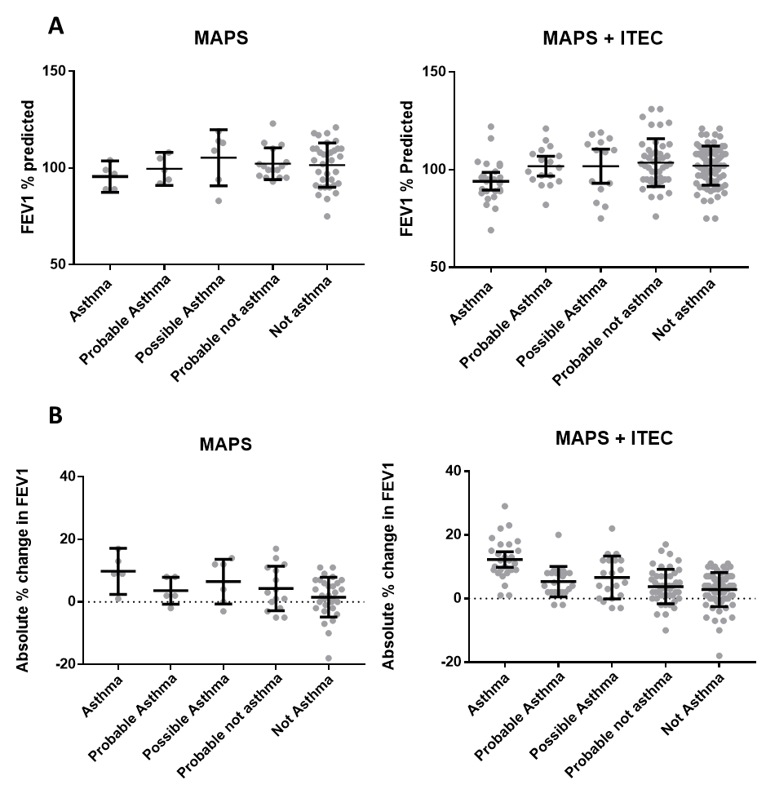

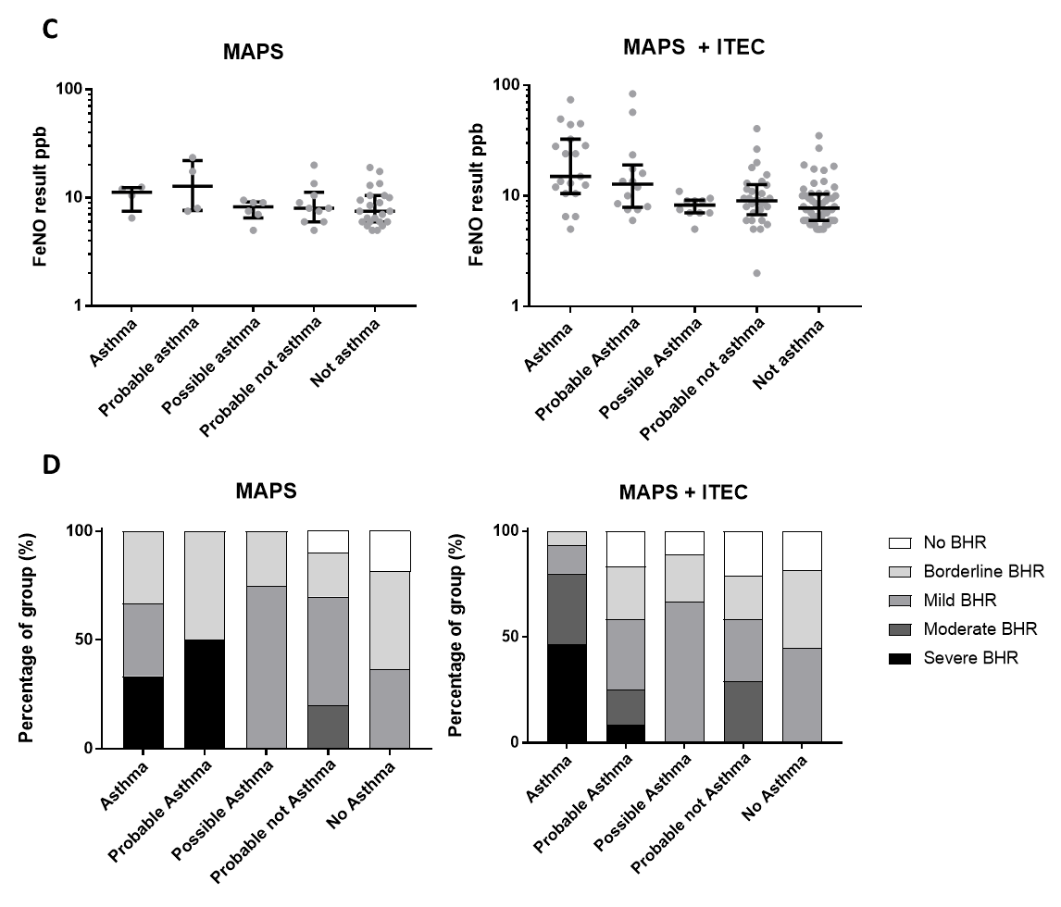

Figure S4 Comparison between five asthma categories of: A - FEV1 % predicted values (mean and 95% C.I.); B- absolute % change in FEV1 post bronchodilator (mean and 95% C.I.); C – exhaled nitric oxide values (median and IQR); D – bronchial hyper-responsiveness category proportion. Results shown for the MAPS cohort alone and MAPS and ITEC cohort combined.

Table S4 Differences in the proportions of participants with clinical atopic disease by treatment group, age six. Figures represent frequencies (percentages). Differences (95% CIs) represent the difference in proportion between the two groups.

|  |  |  |  |  |
| --- | --- | --- | --- | --- |
| Outcome | HDM SLIT (n = 41) | Placebo (n= 44) | Difference in proportion (95% CI) | P value |
| Eczema | 15 (36·6%) | 15 (34·1%) | 0·03 (-0·18, 0·23) | 0·81 |
| “Ever had” wheeze | 27 (65·8%) | 26 (59·1%) | 0·07 (-0·14, 0·27) | 0·52 |
| Recurrent wheeze as toddler | 13 (31·7%) | 13 (29·6%) | 0·02 (-0·17, 0·21) | 0·83 |
| Rhinitis | 21 (51·3%) | 17 (38·6%) | 0·13 (-0·08, 0·34) | 0·25 |
| Likely food allergy | 6 (14·6%) | 8 (18·2%) | -0·04 (-0·19, 0·12) | 0·66 |

Table S5 Sensitization rates to individual allergens over the entire study period to six years of age for the MAPS SLIT and placebo groups. Numbers represent frequencies (percentages). Skin prick testing data.

|  |  |  |
| --- | --- | --- |
|  | MAPS SLIT (N= 57) | MAPS placebo (N= 54) |
| HDM | 8 (14·0%) | 10 (18·5%) |
| Grass pollen | 8 (14·0%) | 7 (13·0%) |
| Tree pollen | 2 (3·5%) | 1 (1·9%) |
| Alternaria | 3 (5·3%) | 1 (1·9%) |
| Cat | 1 (1·8%) | 5 (9·3%) |
| Dog | 4 (7·0%) | 3 (5·6%) |
| Milk | 1 (1·8%) | 0 (0·0%) |
| Hen’s egg | 2 (3·5%) | 2 (3·7%) |
| Peanut | 1 (1·8%) | 4 (7·4%) |

**Sensitivity analysis**

A sensitivity analysis was carried out excluding the ITEC participants who were sensitized on SPT at the initial assessment age six months. Exclusion of these 12 participants did not alter results, and rates of clinical asthma remained significantly higher within the control group compared to intervention group (Table S6).

Table S6 Differences in the proportions of participants with asthma and likely asthma (definite asthma + probable asthma) between the MAPS SLIT group and the MAPS placebo + ITEC cohort. 14 ITEC participants who were found to be sensitized at baseline were excluded from this analysis. Figures represent frequencies (percentages). Differences (95% CIs) represent the difference in proportion between the two groups.

|  |  |  |  |  |
| --- | --- | --- | --- | --- |
| Outcome | HDM SLIT (n = 34) | Placebo (n= 156) | Difference in proportion (95% CI) | P value |
| Asthma  Likely asthma | 1 (2·9)  4 (10·8) | 23 (15·8)  38 (23·6) | -0·13 (-0·21, 0·05)  -0·13 (-0·25, -0·01) | **0·048**  0·086 |

**REFERENCES**

1. Alviani C, Roberts G, Moyses H, Pearson S, Larsson M, Zolkipli Z, et al. Follow-up, 18 months off house dust mite immunotherapy, of a randomized controlled study on the primary prevention of atopy. Allergy. 2019.

2. Zolkipli Z, Roberts G, Cornelius V, Clayton B, Pearson S, Michaelis L, et al. Randomized controlled trial of primary prevention of atopy using house dust mite allergen oral immunotherapy in early childhood. The Journal of allergy and clinical immunology. 2015;136(6):1541-7.e11.

3. Hide DW, Matthews S, Matthews L, Stevens M, Ridout S, Twiselton R, et al. Effect of allergen avoidance in infancy on allergic manifestations at age two years. The Journal of allergy and clinical immunology. 1994;93(5):842-6.

4. ATS/ERS recommendations for standardized procedures for the online and offline measurement of exhaled lower respiratory nitric oxide and nasal nitric oxide, 2005. American journal of respiratory and critical care medicine. 2005;171(8):912-30.

5. Miller MR, Hankinson J, Brusasco V, Burgos F, Casaburi R, Coates A, et al. Standardisation of spirometry. The European respiratory journal. 2005;26(2):319-38.

6. Coates AL, Wanger J, Cockcroft DW, Culver BH, Diamant Z, Gauvreau G, et al. ERS technical standard on bronchial challenge testing: general considerations and performance of methacholine challenge tests. The European respiratory journal. 2017;49(5).

7. Hanifin JM. Diagnostic features of atopic dermatitis. Acta Derm Venereol. 1980;92:44-7.

8. Severity scoring of atopic dermatitis: the SCORAD index. Consensus Report of the European Task Force on Atopic Dermatitis. Dermatology (Basel, Switzerland). 1993;186(1):23-31.

9. BTS/SIGN. British Guideline on the Management of Asthma. 2019.

10. GINA. Pocket Guide For Asthma Management and Prevention. 2019.

11. Silva D, Severo M, Paciencia I, Rufo J, Martins C, Moreira P, et al. Setting definitions of childhood asthma in epidemiologic studies. Pediatric allergy and immunology : official publication of the European Society of Pediatric Allergy and Immunology. 2019;30(7):708-15.