Ecological distinctiveness of birds and mammals at the global scale
Robert S. C. Cooke^{a,b,c,d,e*}, Felix Eigenbrod^{a,b} & Amanda E. Bates^{f,g}
ª Biological Sciences, University of Southampton, Southampton SO17 1BJ, UK
^{b} Geography and Environment, University of Southampton, Southampton SO17 1BJ, UK
^{c} Marwell Wildlife, Thompson’s Lane, Colden Common, Winchester SO21 1JH, UK
^{d} Department of Biological and Environmental Sciences, University of Gothenburg, Box 463, SE-405 30, Göteborg, Sweden
^{e} Gothenburg Global Biodiversity Centre, Box 461, SE-405 30, Göteborg, Sweden
^{f} Department of Ocean Sciences, Memorial University of Newfoundland, St. John's NL A1C 5S7, Canada
^{g} Ocean and Earth Science, National Oceanography Centre, Southampton, University of Southampton, Southampton SO14 3ZH, UK
* Corresponding author: Robert S. C. Cooke +44 (0)2380 597382 rob_cooke@hotmail.co.uk

Abstract
Ecologically distinct species - species with distinct trait combinations - are not directly prioritized in current conservation frameworks. The consequence of this blind spot means species with the most distinct ecological strategies might be lost. Here, we quantify ecological distinctiveness, based on six traits, for 10,960 bird and 5,278 mammal species, summarizing species-level ecological irreplaceability. We find that threatened birds and mammals are, on average, more ecologically distinct. Specific examples of ecologically distinct and highly threatened species are Great Indian Bustard, Amsterdam Albatross, Asian Elephant and Sumatran Rhinoceros. These species have potentially irreplaceable ecological roles and their loss could undermine the integrity of ecological processes and functions. Yet, we also identify ecologically distinct widespread generalists, such as Lesser Black-backed Gull and Wild Boar. These generalist species have distinct ecological strategies that allow them to thrive across multiple environments. Thus, we suggest that high ecological distinctiveness is associated with either high extinction risk or successful hyper-generalism. We also find that ecologically distinct species are generally charismatic (using a previous measure of public perceptions of charisma). We thus highlight a conservation opportunity: capitalizing on public preferences for charismatic species could provide support for the conservation of the most ecologically distinct birds and mammals. Overall, our prioritization framework supports the conservation of species with irreplaceable ecological strategies, complementing existing frameworks that target extinction risk and evolutionary distinctiveness.
Keywords: conservation; prioritization; trait; evolutionary distinctiveness; extinction risk; threatened

1. Introduction
A fundamental goal of conservation biology is to safeguard the diversity of life. Yet, global conservation funding falls short of what is required to prevent the loss of the world's biodiversity (McCarthy et al., 2012). Conservation expenditure must therefore be prioritized to effectively and efficiently minimise extinction and maintain nature’s variability. Indices of priority species are an important tool for the allocation of scarce conservation resources (Isaac et al., 2012). Traditionally, species prioritization frameworks have focussed on vulnerability (i.e., extinction risk), endemism, and ‘flagship’ status (Brooks et al., 2006; IUCN, 2018; Jenkins et al., 2013; Veríssimo et al., 2011). Although these aspects are important in identifying priority species, they focus on a single biodiversity dimension - taxonomic diversity. Yet biodiversity in all its dimensions (i.e., taxonomic, phylogenetic and ecological diversity) is likely required for the persistence of ecosystems (Gamfeldt et al., 2008; Hooper et al., 2005).
The application of phylogenetic diversity to set conservation priorities is gaining momentum (Brum et al., 2017; Gumbs et al., 2018; Isaac et al., 2007; Pollock et al., 2017; Thuiller et al., 2015). Phylogenetic diversity captures the isolation of lineages through deep time and has been applied to species prioritization through the Evolutionarily Distinct and Globally Endangered (EDGE) index, to highlight the role of species-level evolutionary irreplaceability (Gumbs et al., 2018; Isaac et al., 2012, 2007). However, phylogenetic diversity does not directly account for species’ ecological strategies (trait combinations) and thus species’ ecological irreplaceability. Although, researchers have advocated that maximizing phylogenetic diversity will potentially capture ecological diversity, as species traits often reflect shared evolutionary history (Mazel et al., 2018; Monnet et al., 2014; Vane-Wright et al., 1991; Winter et al., 2013). Yet, traits are not necessarily concordant with phylogeny, as phylogenetically divergent species can converge on analogous ecological strategies, due to similar adaptive responses to similar selection pressures (see, e.g. Pianka et al., 2017; Thuiller et al., 2015; Winemiller et al., 2015). For example, pangolins and armadillos, which belong to separate Orders, both have armoured bodies and consume termites and ants. Thus, while maximizing phylogenetic diversity can sometimes help to support trait diversity, phylogenetic diversity captures trait diversity unreliably (Mazel et al., 2018; Redding and Mooers, 2015).
Here we quantify species-level ecological distinctiveness and thus recognise ecological (trait) diversity as a complementary dimension of biodiversity, as has been previously acknowledged spatially (Brum et al., 2017; Pollock et al., 2017; Thuiller et al., 2015) and in a conservation context (Bowen and Roman, 2005; Redding and Mooers, 2015). Traits reflect species’ adaptations to their environment, where species live and how they interact (Violle et al., 2007). Traits also jointly determine a species ecological role and function (Wilman et al., 2014); thus trait combinations are increasingly being used to summarise species’ ecological strategies (Brum et al., 2017; Cooke et al., 2019b). Moreover, a diversity of ecological strategies is required to support and maintain ecosystem processes and functions (Hector and Bagchi, 2007). However, species, and their ecological strategies, are disappearing, with strong implications for the environment (Cooke et al., 2019b). For instance, within an assemblage, the loss of species with distinct ecological strategies may have very different consequences from the loss of species with common ecological strategies (Larsen et al., 2005; Monnet et al., 2014; Mouillot et al., 2013b). Yet, the relationship between the distinctiveness of species’ ecological strategies and extinction risk remains little explored (although see Redding and Mooers, 2015).
To summarize species’ ecological distinctiveness, based on their traits, we employ the ‘functional distinctiveness’ metric (Grenié et al., 2017; Violle et al., 2017). Here we use the term ecological distinctiveness in preference to functional distinctiveness, as the focal traits may or may not directly reflect the ecosystem functions performed by species (Huang et al., 2012), but do directly relate to their ecological strategies (Cooke et al., 2019b). Our analyses therefore build upon the functional rarity literature (Grenié et al., 2018, 2017; Violle et al., 2017), but upscale ecological distinctiveness to a global assessment and thus do not directly incorporate information on taxonomic rarity, such as local abundance or regional restrictedness (Grenié et al., 2017). Instead, we ask how rare the traits of a given species are compared to all other species globally. Our goal is to identify the most distinct ecological strategies for birds and mammals; thus, recognizing species with potentially irreplaceable ecological roles, which could underpin the integrity of ecological processes and functions (Duffy, 2002; Larsen et al., 2005). Our framework therefore builds upon and complements existing taxonomic, e.g. the IUCN Red List (IUCN, 2018), and evolutionary, e.g., the EDGE index (Gumbs et al., 2018; Isaac et al., 2007; Jetz et al., 2014), conservation frameworks.
With these measures we investigate: (1) whether ecologically distinct species are at greater risk of extinction, (2) the relationship between ecological distinctiveness and evolutionary distinctiveness, and (3) which trait extremes dominate the most ecologically distinct species. We make three predictions. First, we predict that threatened species will be more ecologically distinct. This prediction is based on multiple lines of evidence. For instance, extinction risk is evolutionary and ecologically non-random (Cooke et al., 2019b; Purvis et al., 2000), specific traits, e.g., large body size, can therefore lead to higher extinction risk (Ripple et al., 2017); filtering out similar taxa so that survivors of extinction processes are more distinct. In addition, we previously found a disproportionate reduction in total ecological diversity associated with the loss of threatened species (Cooke et al., 2019b), suggesting that threatened species have relatively high ecological distinctiveness. Moreover, specialist species are often at higher risk of extinction (Clavel et al., 2011; Otto, 2018; Sekercioglu, 2011), and we therefore expect these taxa to have specialized trait adaptations for specific environmental conditions, which might make them ecologically distinct (Chapman et al., 2018; Gaston, 1994). Second, we predict that evolutionarily distinct species will also be more ecologically distinct, based on the theory that non-redundant ancestry leads to unique evolutionary features (Faith, 1992), which is then reflected in unique trait combinations for species (Monnet et al., 2014). Third, we predict that body mass will have the greatest influence on ecological distinctiveness, as body mass has a broad range across both mammals and birds. Plus, body mass is arguably the most important trait of birds and mammals, underlying many of their physiological, ecological and evolutionary processes (Rapacciuolo et al., 2017; Smith and Lyons, 2013; Smith et al., 2011).

2. Materials and methods
We performed our analyses separately for 10,960 extant bird and 5,278 extant terrestrial mammal species, to ensure comparability to previous prioritization frameworks, such as the EDGE framework (Gumbs et al., 2018; Isaac et al., 2007). We excluded marine mammals due to the energetic, thermal and metabolic differences that shape ecological strategies in the marine realm (Gearty et al., 2018; Tucker and Rogers, 2014).
All analyses were carried out using R version 3.5.1 (R Core Team, 2018).

2.1 Taxonomy
Taxonomies often vary, due to name revisions at the generic or specific levels, lumping or splitting lower taxa (genera, species) among higher taxa (families), and nomenclature changes (Chamberlain et al., 2012). We used a taxonomy of 10,960 bird and 5,278 mammal species (IUCN, 2018) derived from the IUCN (International Union for Conservation of Nature and Natural Resources) taxonomic framework. All other datasets were then matched to this reference taxonomy.

2.2 Trait data
We selected six traits - body mass, litter/clutch size, habitat breadth, diet type, diet diversity and generation length - that together summarize a species’ form, function and ecological strategy (Cooke et al., 2019b). Body mass reflects the type and amount of resources that species consume and release (Chillo and Ojeda, 2012; Cooke et al., 2019a) and influences species’ contributions to functions such as pollination, predation, and seed-dispersal (Jordano et al., 2007; Ripple et al., 2015, 2014; Sekercioğlu, 2006; Sekercioğlu et al., 2004). Additionally, body mass relates to the scale at which species respond to their environment, to species’ dispersal ability and their susceptibility to disturbance (Fritz et al., 2009; Luck et al., 2012; Newbold et al., 2013). Litter/clutch size indicates species’ reproductive strategies and output (fecundity), and therefore their contribution to trophic processes, for instance by routing basal energy into food-webs via many offspring (Newbold et al., 2013). Habitat breadth indicates a species’ habitat specialism and extent of resource use, and thus the functional influence of a species across habitat types (Chillo and Ojeda, 2012; Cooke et al., 2019a). Plus, a species’ habitat breadth relates to its ability to utilise and compete in a diversity of environments (Luck et al., 2013). Diet type and diet diversity are fundamental traits, because all organisms must acquire and assimilate resources for maintenance, growth and reproduction (Simberloff and Dayan, 1991; Winemiller et al., 2015). Diet type defines the ecological roles and major trophic interactions of species (Burin et al., 2016; Chillo and Ojeda, 2012; Duffy, 2002), and thus relates to functions such as scavenging, pollination, seed dispersal and nutrient cycling (Ripple et al., 2017; Sekercioğlu, 2006; Wenny et al., 2011); whereas diet diversity dictates species’ diet breadth, how species respond to changes in resource availability and summarizes the diversity of food web interactions for a species (Burin et al., 2016; Duffy, 2002; Newbold et al., 2013). Generation length signifies the turnover rate of breeding individuals in a population and therefore relates to the different rates at which taxa survive and reproduce (Cooke et al., 2018; IUCN Standards and Petitions Subcommittee, 2014). Thus, generation length reflects species’ ability to recover after perturbations, where species with short generation length can repopulate or recolonize more quickly after disturbance (Newbold et al., 2013).
We extracted raw trait data (i.e., excluding estimated values) for body mass, litter/clutch size, habitat breadth and diet type from a database for 10,252 birds and 5,232 mammals - compiled by Cooke et al. (2019a) from four main sources (Jones et al., 2009; Myhrvold et al., 2015; Pacifici et al., 2013; Wilman et al., 2014). Habitat breadth was coded using the IUCN Habitats Classification Scheme and was quantified as the number of suitable habitats listed for each species (Cooke et al., 2019a). Diet type categorizes species into five groups according to their primary diet: plant/seed, fruit/nectar, invertebrates, vertebrates (including carrion), and omnivore (score of ≤ 50 in the four other diet categories) (Cooke et al., 2019a; Wilman et al., 2014). For diet diversity, we calculated a Shannon Index on the proportions of 10 diet categories (Santini et al., 2019) extracted from the EltonTraits database (Wilman et al., 2014). BirdLife supplied generation length for birds but restrictions apply to these data, which we used under license for the current study. However, these data can be manually downloaded from the BirdLife website (http://datazone.birdlife.org/species/search). For mammals we obtained generation length values from Pacifici et al. (2013), although we corrected three mammal generation length observations that have since been found to be anomalous (Cooke et al., 2018): Cephalophus adersi, Cephalophus leucogaster and Cephalophus spadix.
We supplemented the trait data with additional data from multiple sources (Dunning, 2008; Jones et al., 2009; Myhrvold et al., 2015; Pacifici et al., 2013; Wilman et al., 2014), so that every species had at least one trait value. We therefore updated the trait data to reflect the changes to the IUCN taxonomy since the trait data was first compiled. The updated trait data (excluding generation length for birds, due to data restrictions) are provided as Appendix A.
Trait data were transformed where it improved normality: log₁₀ for body mass, generation length and litter/clutch size; square root for habitat breadth; and all numeric traits were standardized to zero mean and unit variance (z-transformation) (Figs. B.1 and B.2). Transformation and standardization is recommended, so that each trait has the same weight in the analyses and the units used to measure the traits have no influence (Villéger et al., 2008).

2.3 Trait imputation
Complete trait data were not available for all species. To avoid excluding species, which can lead to reduced statistical power and introduce bias (Kim et al., 2018; Penone et al., 2014; Taugourdeau et al., 2014), we estimated missing data using Multivariate Imputation with Chained Equations (MICE). MICE has been shown to have greater accuracy, improved sample size and smaller error and bias than single imputation methods and the data deletion approach (Penone et al., 2014; Taugourdeau et al., 2014). We implemented MICE based on the functional (the transformed traits) and phylogenetic (the first 10 phylogenetic eigenvectors extracted from trees for birds (Prum et al., 2015) and mammals (Fritz et al., 2009)) relationships between species (Cooke et al., 2019a). We estimated missing data for birds and mammals for body mass (0.4% imputed for birds; 0% imputed for mammals), litter/clutch size (44% for birds; 37% for mammals), habitat breadth (18% for birds; 6% for mammals), diet type (26% for birds; 4% for mammals), diet diversity (26% for birds; 4% for mammals) and generation length (0.2% for birds; 0.4% for mammals). To estimate values, we used the mice() function (mice package (Van Buuren and Groothuis-Oudshoorn, 2011)). We imputed 25 trait datasets to capture the uncertainty in the imputation process. We then performed subsequent analyses across the 25 trait datasets and calculated the associated total variance according to Rubin’s rules - accounting for within imputation variance, between imputation variance and the number of imputations (Vink and van Buuren, 2014).

2.4 Ecological distinctiveness
Species priority lists can differ depending on the isolation metric chosen (Redding et al., 2014). There are many metrics available both for evolutionary (Redding et al., 2014) and ecological isolation (Grenié et al., 2018; Villéger et al., 2008). For instance, trees have previously been used to evaluate the link between evolutionary distinctiveness and trait diversity (Redding and Mooers, 2015), and although trees can potentially be easier to compare (Redding and Mooers, 2015), they can be problematic (Petchey and Gaston, 2006). For example, ecological trees tend to bias the initial distribution of ecological distances towards overestimating the dissimilarity between species pairs (Maire et al., 2015) and are sensitive to the species included in the analysis (Huang et al., 2012). Alternatively, there are two main isolation metric types available: pairwise metrics (average distance to all other species) and neighbour metrics (distance to the nearest relative) (Grenié et al., 2017; Redding et al., 2014).
Here, our primary analyses focus on ecological distinctiveness, also known as functional distinctiveness (Grenié et al., 2017) - a pairwise metric, as we aimed to quantify how uncommon the traits of a given species are compared to all other species globally (Grenié et al., 2018; Violle et al., 2017). We therefore focus on those species located in less species-dense areas of trait space, such as the edges, e.g., ecological outliers (Cooke et al., 2019b; Violle et al., 2017). Prioritizing ecologically distinct species should therefore conserve species with rare trait combinations, maintaining ecological diversity (Cooke et al., 2019b; Grenié et al., 2018).
We calculated the ecological distinctiveness of a species as the average distance in trait space from it to all other species in its Class, using distinctiveness_com() in the funrar package (Grenié et al., 2017). Ecological distances were calculated as Gower pairwise distances between species, which allows mixed trait types (e.g., continuous, categorical, ordinal data) while giving them equal weight (Villéger et al., 2008), using compute_dist_matrix() in the funrar package (Grenié et al., 2017).
However, the traits are not independent, thus equal weighting can lead to overemphasis of specific ecological aspects, due to correlations between the traits. For instance, the strongest correlations (Spearman’s rank correlation coefficients) across the traits are between body mass and generation length for birds (Spearman’s ρ₁₀₉₅₈ = 0.53; Fig. B.3) and between litter size and generation length for mammals (Spearman’s ρ₅₂₇₆ = -0.64; Fig. B.4). To evaluate the effect of non-independence between the traits, we extracted distances between species from a Principal Coordinates Analysis (PCoA), weighted by the eigenvalues. We performed the PCoA on the Gower distances - due to mixed trait types, using the dudi.pco() function in the ade4 package (Dray and Dufour, 2007). PCoA rotates the matrix of Gower distances to summarise inter-species (dis)similarity in a low dimensional, Euclidean space (Legendre and Legendre, 1998). We then extracted the distances from the PCoA and weighted them by the eigenvalues, we used these weighted distances to recalculate ecological distinctiveness. However, our primary analyses focused on the equally weighted measure of ecological distinctiveness, as the correlations between the traits are generally low (Figs. B.3 and B.4), and the selected traits represent different ecological features (Cooke et al., 2019b). Thus, we used the PCoA as a comparative approach.
Furthermore, because ecological distinctiveness is computed using multiple traits, it can be difficult to disentangle the influence of individual traits on the metric. We therefore recalculated ecological distinctiveness excluding each trait one by one and then compared the values to ecological distinctiveness when measured across all six traits. We did not reduce the number of traits lower than five because we might have missed important dimensions of the possible trait space (Mouillot et al., 2014). This analysis of ecological distinctiveness by dimension also helps to reveal the influence and dependence between the traits, contrasting the PCoA approach.
In addition, to evaluate the impact of our metric choice, we also calculated ecological uniqueness, using uniqueness_stack() in the funrar package (Grenié et al., 2017). Ecological uniqueness is the distance of a focal species to its nearest neighbour, thus species with high ecological uniqueness are more distant to their closest neighbour in trait space (Grenié et al., 2017) and could therefore have unique ecological strategies. Importantly, ecological uniqueness is more akin to the fair proportion measure of evolutionary distinctiveness used here than is our pairwise ecological distinctiveness measure (see discussion in Redding et al. (2014)).
We also projected ecological distinctiveness and ecological uniqueness onto the first three principal components (selected based on screeplots - first three principal components explained 52% of the variation in traits for birds and 62% for mammals) extracted from the PCoA. The projection of ecological distinctiveness and ecological uniqueness helped us assess how these metrics capture the shape and structure of trait space for birds and mammals.

2.5 Extinction risk
We used the rl_history() function in the rredlist package (Chamberlain, 2016) to download up-to-date (as of 8th Jan 2019) IUCN categories for birds and mammals (IUCN, 2018). We then performed a multiple comparison Kruskal-Wallis rank-sum test to compare ecological distinctiveness across IUCN categories, using the kruskal() function in the agricolae package (de Mendiburu, 2017). We also performed post-hoc tests using Fisher's least signiﬁcant diﬀerence to diﬀerentiate between groups (de Mendiburu, 2017).

2.6 Evolutionary distinctiveness
Evolutionary distinctiveness measures the relative contribution of a species to the total evolutionary history of their taxonomic group (Gumbs et al., 2018). The evolutionary distinctiveness of a species is high when the species shares its path to the root with few other species or has a long unshared branch length with all the other species (Isaac et al., 2007; Redding et al., 2014, 2008). We obtained evolutionary distinctiveness scores for 10,960 bird species and 5,454 mammal species from the EDGE website (https://www.edgeofexistence.org/edge-lists/, accessed October 2018), but excluded marine mammals and species that were not classified by the IUCN (e.g., taxonomic mismatches or domesticated species, such as Equus caballus).

2.7 Geographic range
We also calculated geographic range size for birds and mammals, using spatial polygons from the IUCN (IUCN, 2018) and BirdLife (BirdLife International and Handbook of the Birds of the World, 2018). Although we expect range size to be associated with habitat breadth, they are derived independently (range size is calculated from distributional data and habitat breadth is derived from IUCN habitats listed as suitable by species’ experts). We filtered the polygons to include only those coded as presence: ‘Extant’ (i.e., we removed polygons coded as presence: ‘Probably Extant’, ‘Possibly Extant’, ‘Possibly Extinct’, ‘Extinct’ or ‘Presence Uncertain’). We re-projected the polygons to cylindrical equal area and then calculated their area in square kilometres, using the area() function in the raster package (Hijmans, 2019), and summed the area across all extant polygons per species. We could not calculate range size for 1,928 birds and 294 mammals, due to lack of spatial data, changes to taxonomy and/or no ‘Extant’ polygons, resulting in data for 9,032 birds and 4,984 mammals.

3. Results

3.1 Ecological distinctiveness
Bird ecological distinctiveness (mean across 25 imputed trait datasets) ranges from 0.28 (Chestnut-winged Cinclodes Cinclodes albidiventris) to 0.69 (Greater Rhea Rhea americana) (Fig. 1). Mammal ecological distinctiveness (mean across 25 imputed trait datasets) ranges from 0.33 (Stephen’s Woodrat Neotoma stephensi) to 0.62 (Leopard Panthera pardus) (Fig. 1). Mean bird ecological distinctiveness is 0.37 (median = 0.36) and mean mammal ecological distinctiveness is 0.41 (median = 0.41). Of the twenty most distinctive birds, five are threatened (Critically Endangered, Endangered or Vulnerable), while seven of the twenty most distinctive mammals are threatened; thus, threatened species are proportionally overrepresented among the most distinctive birds and mammals. Priority species based on ecological uniqueness differ to those based on ecological distinctiveness (Fig. B.5). In particular, the correlation between ecological uniqueness and ecological distinctiveness is lower for mammals: Spearman’s ρ₅₂₇₆ = 0.05 than for birds: Spearman’s ρ₁₀₉₅₈ = 0.52. Yet, six bird species (Fig. 2a and Fig. B.5a) and seven mammal species (Fig. 2b and Fig. B.5b) are present in the top twenty species for both ecological uniqueness and ecological distinctiveness.
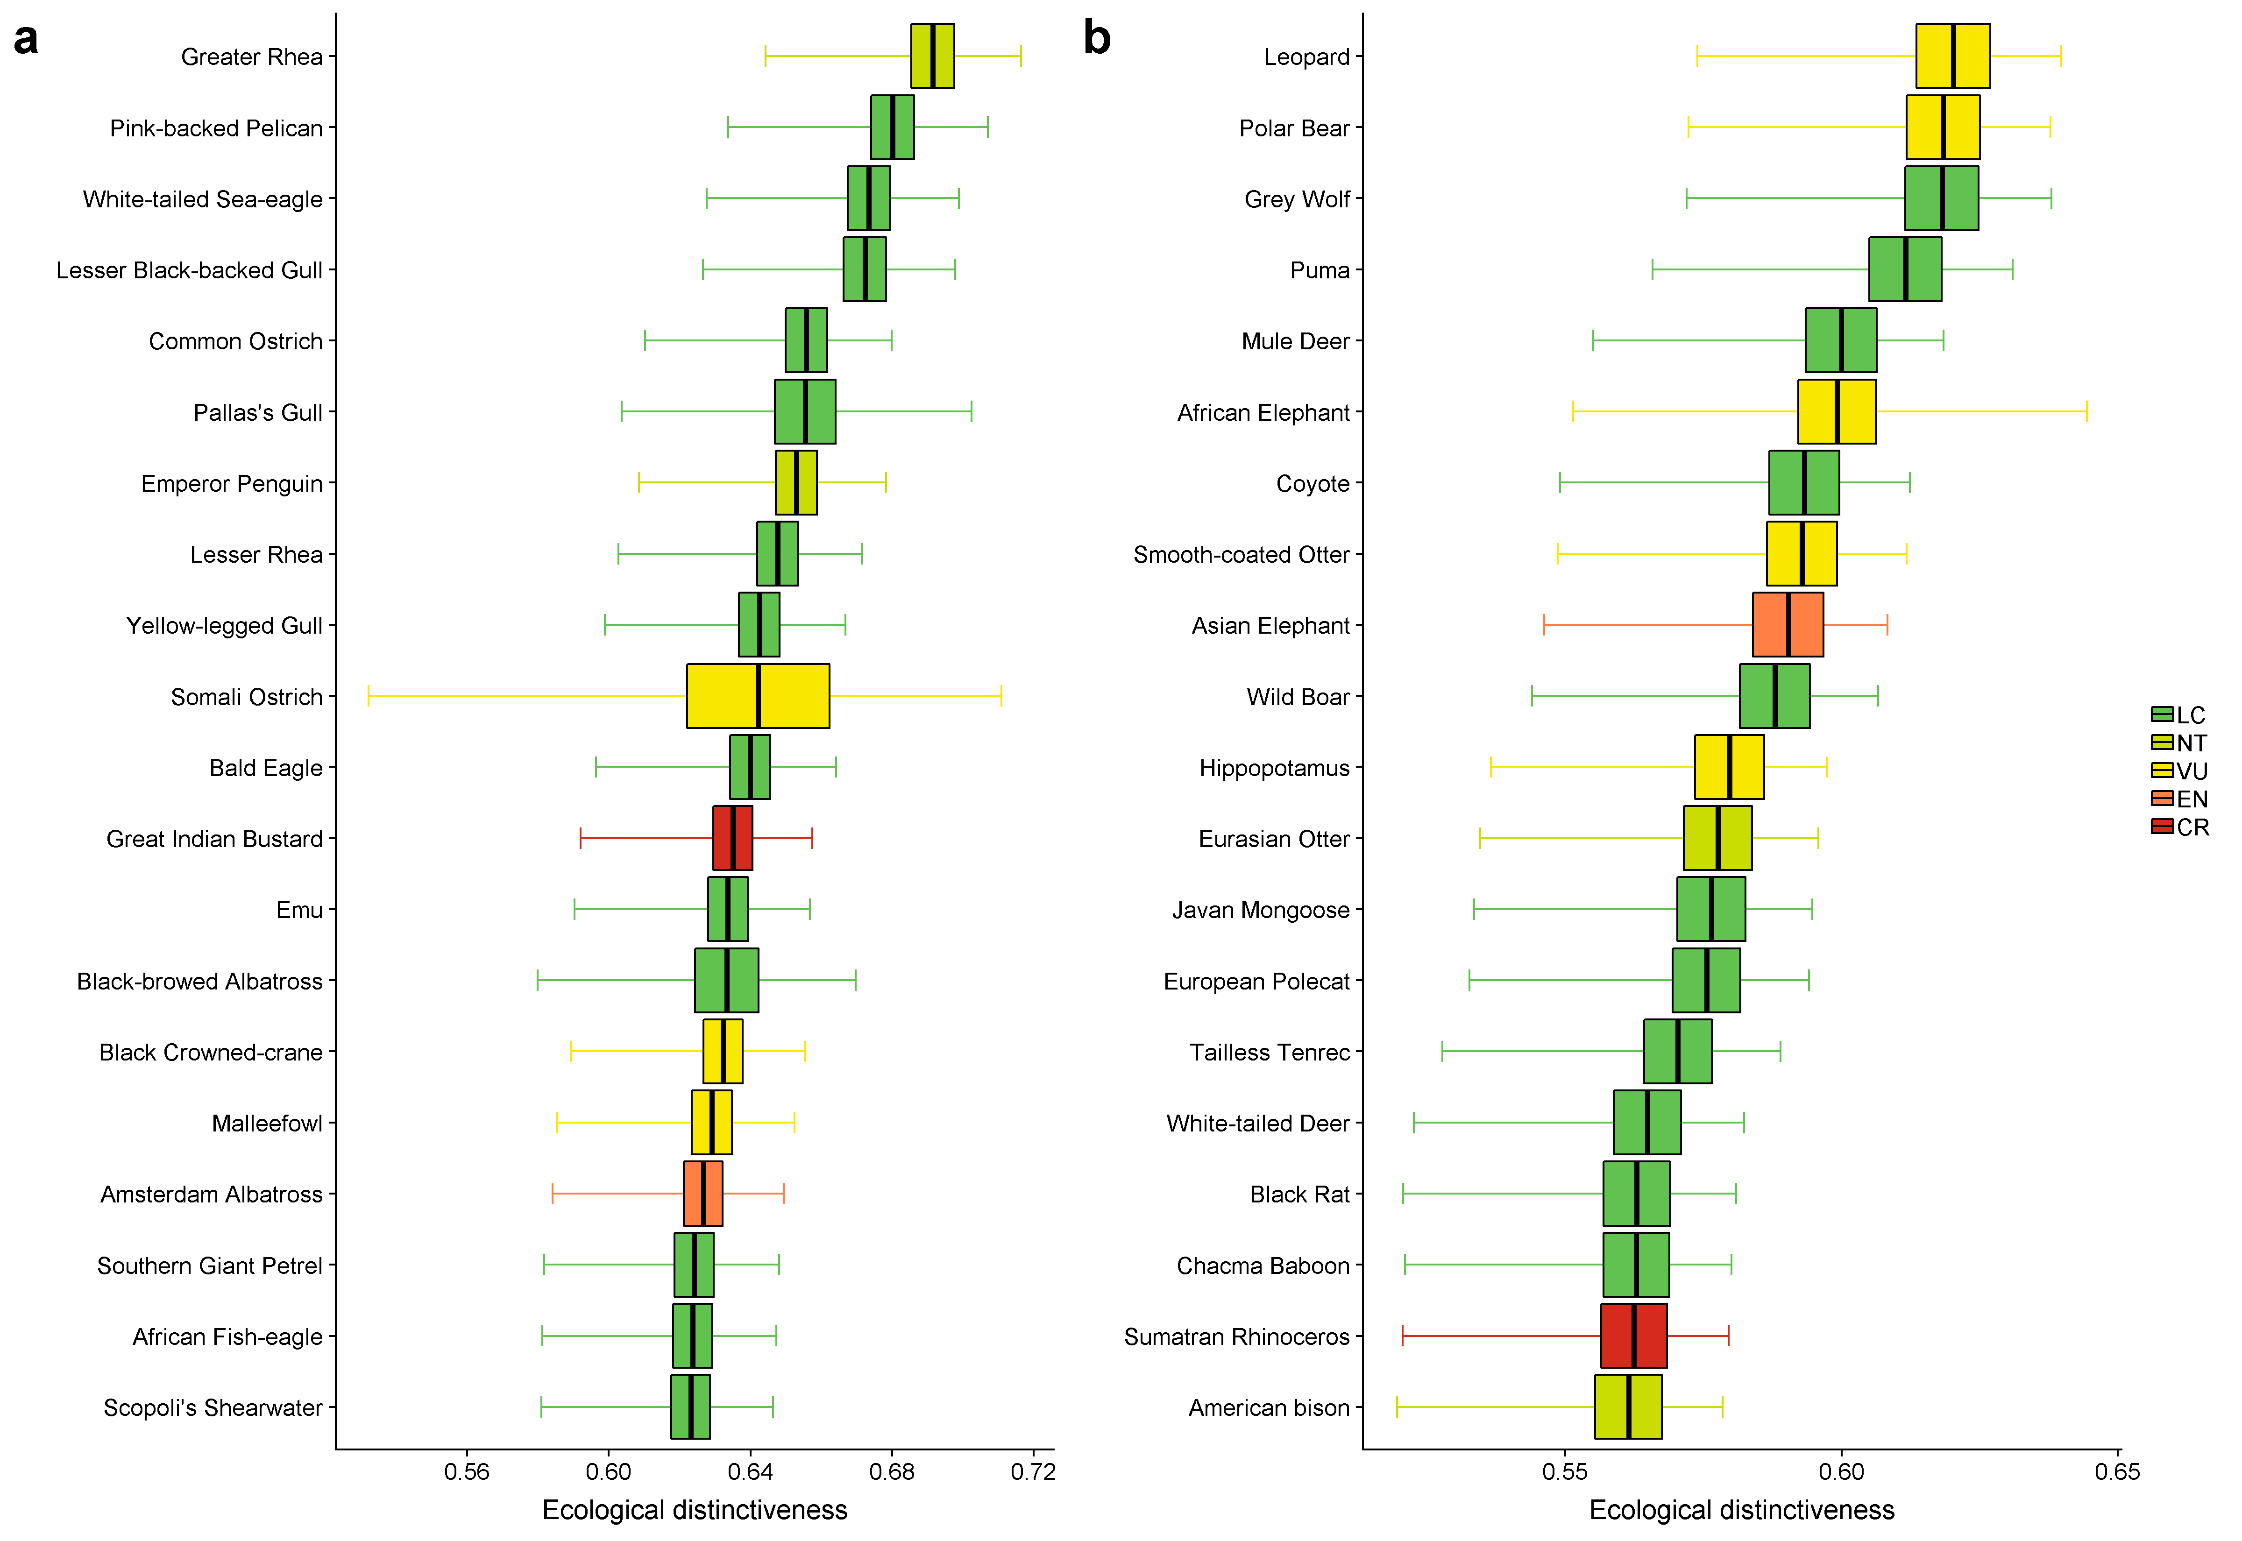
Fig. 1. The twenty most ecologically distinct species globally for (a) birds and (b) mammals. Mean (thick line), 95% confidence intervals around the mean (box) and minimum and maximum (whiskers) for ecological distinctiveness across 25 imputed trait datasets according to Rubin’s rules, based on 10,960 bird species and 5,278 mammal species. Colours depict IUCN Red List status. For ecological distinctiveness scores for all bird and mammal species see Appendix C.

3.2 Ecological distinctiveness and threat status
Ecological distinctiveness differs between IUCN categories for both birds (Fig. 2a; Kruskal-Wallis χ2 = 137, df = 5, P < 0.001) and mammals (Fig. 2b; χ2 = 110, df = 5, P < 0.001). For birds ecological distinctiveness is highest for Critically Endangered (CR; mean ecological distinctiveness = 0.40, statistical sub-group = a), Endangered (EN; 0.39, a) and Vulnerable species (VU; 0.39, a), followed by Near Threatened species (NT; 0.38, b), then Data Deficient species (DD; 0.37, bc), and then Least Concern species (LC; 0.37, c) (Fig. 2a). Ecological distinctiveness for mammals is highest for CR species (0.42, a), followed by EN (0.42, ab) and VU species (0.42, ab), then NT (0.42, b), then LC (0.41, c), and then DD species (0.40, d) (Fig. 2b). Thus, in general, threatened (CR, EN, VU) bird and mammal species are more ecologically distinct than non-threatened (NT, LC) species. Moreover, threatened bird species are more ecologically unique than non-threatened bird species, although there is no difference for mammals (Fig. B.6).
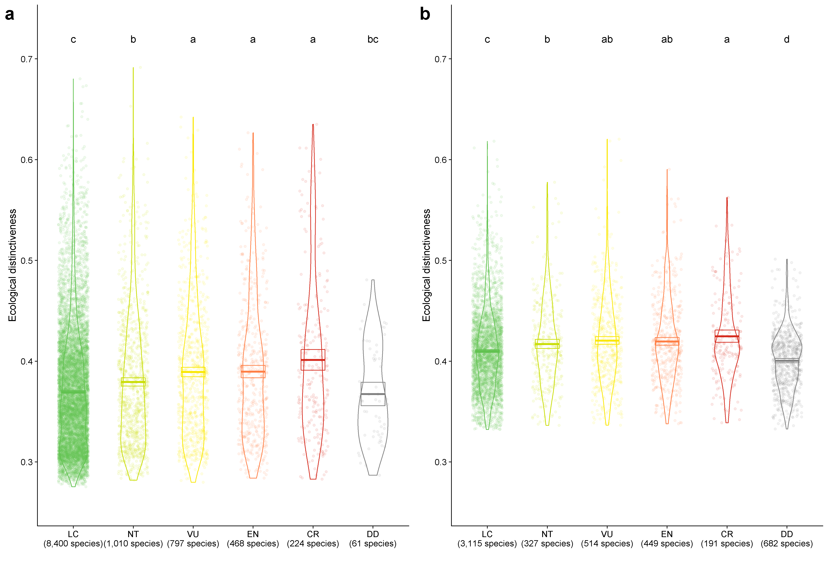
Fig. 2. Ecological distinctiveness within each IUCN category for (a) 10,960 bird species and (b) 5,278 mammal species. The jittered points represent mean ecological distinctiveness across 25 imputed trait datasets for each species. Also included are violins of data density and boxplots where the central thick line is the IUCN category mean distinctiveness and the edges of the rectangle are the 95% confidence intervals around the mean. Letters show statistical sub-groups from a Kruskal-Wallis rank-sum test (group ‘a’ has the highest distinctiveness).

3.3 Ecological distinctiveness and evolutionary distinctiveness
Ecological distinctiveness is very weakly positively correlated with log evolutionary distinctiveness for birds (Spearman’s ρ₁₀₉₅₈ = 0.024), and there is a very weak negative correlation for mammals (Spearman’s ρ₅₂₇₆ = -0.018) (Fig. 3). By contrast, the correlations between ecological uniqueness and evolutionary distinctiveness are stronger than the correlations between ecological distinctiveness and evolutionary distinctiveness. Specifically, ecological uniqueness is weakly positively correlated with log evolutionary distinctiveness for birds (Spearman’s ρ₁₀₉₅₈ = 0.17), and there is also a weak positive correlation for mammals (Spearman’s ρ₅₂₇₆ = 0.26) (Fig. B.7).

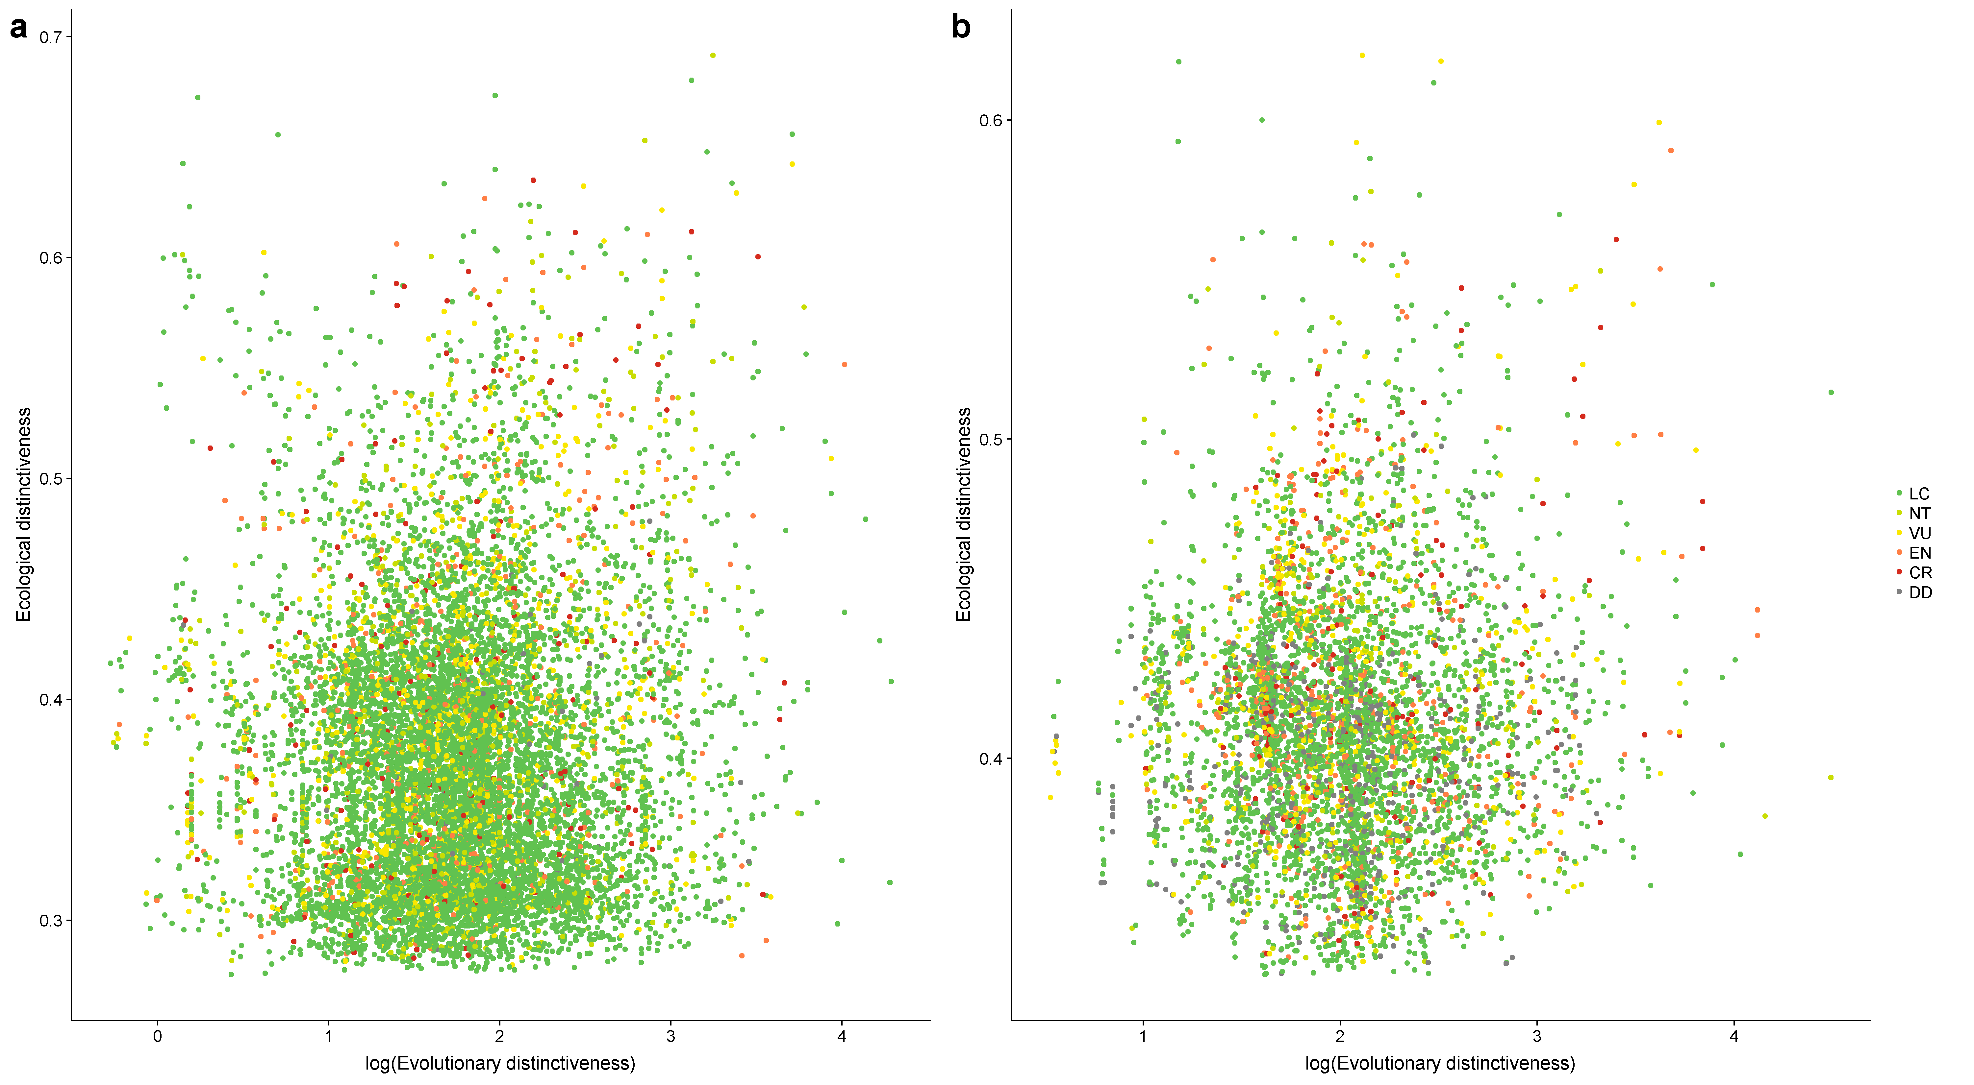
Fig. 3. Very weak correlation between ecological distinctiveness and log evolutionary distinctiveness for (a) 10,960 bird species (Spearman’s ρ₁₀₉₅₈ = 0.024) and (b) 5,278 mammal species (Spearman’s ρ₅₂₇₆ = -0.018). Points represent mean ecological distinctiveness across 25 imputed trait datasets for each species. Colours depict IUCN Red List status.

3.4 Ecological distinctiveness and range size
Although threatened species are, on average, more ecologically distinct than non-threatened species (Fig. 2), we find a weak positive correlation between range size and ecological distinctiveness for both birds (Spearman’s ρ₉₀₃₀ = 0.11; Fig. 4a) and mammals (Spearman’s ρ₄₉₈₂ = 0.19; Fig. 4b).
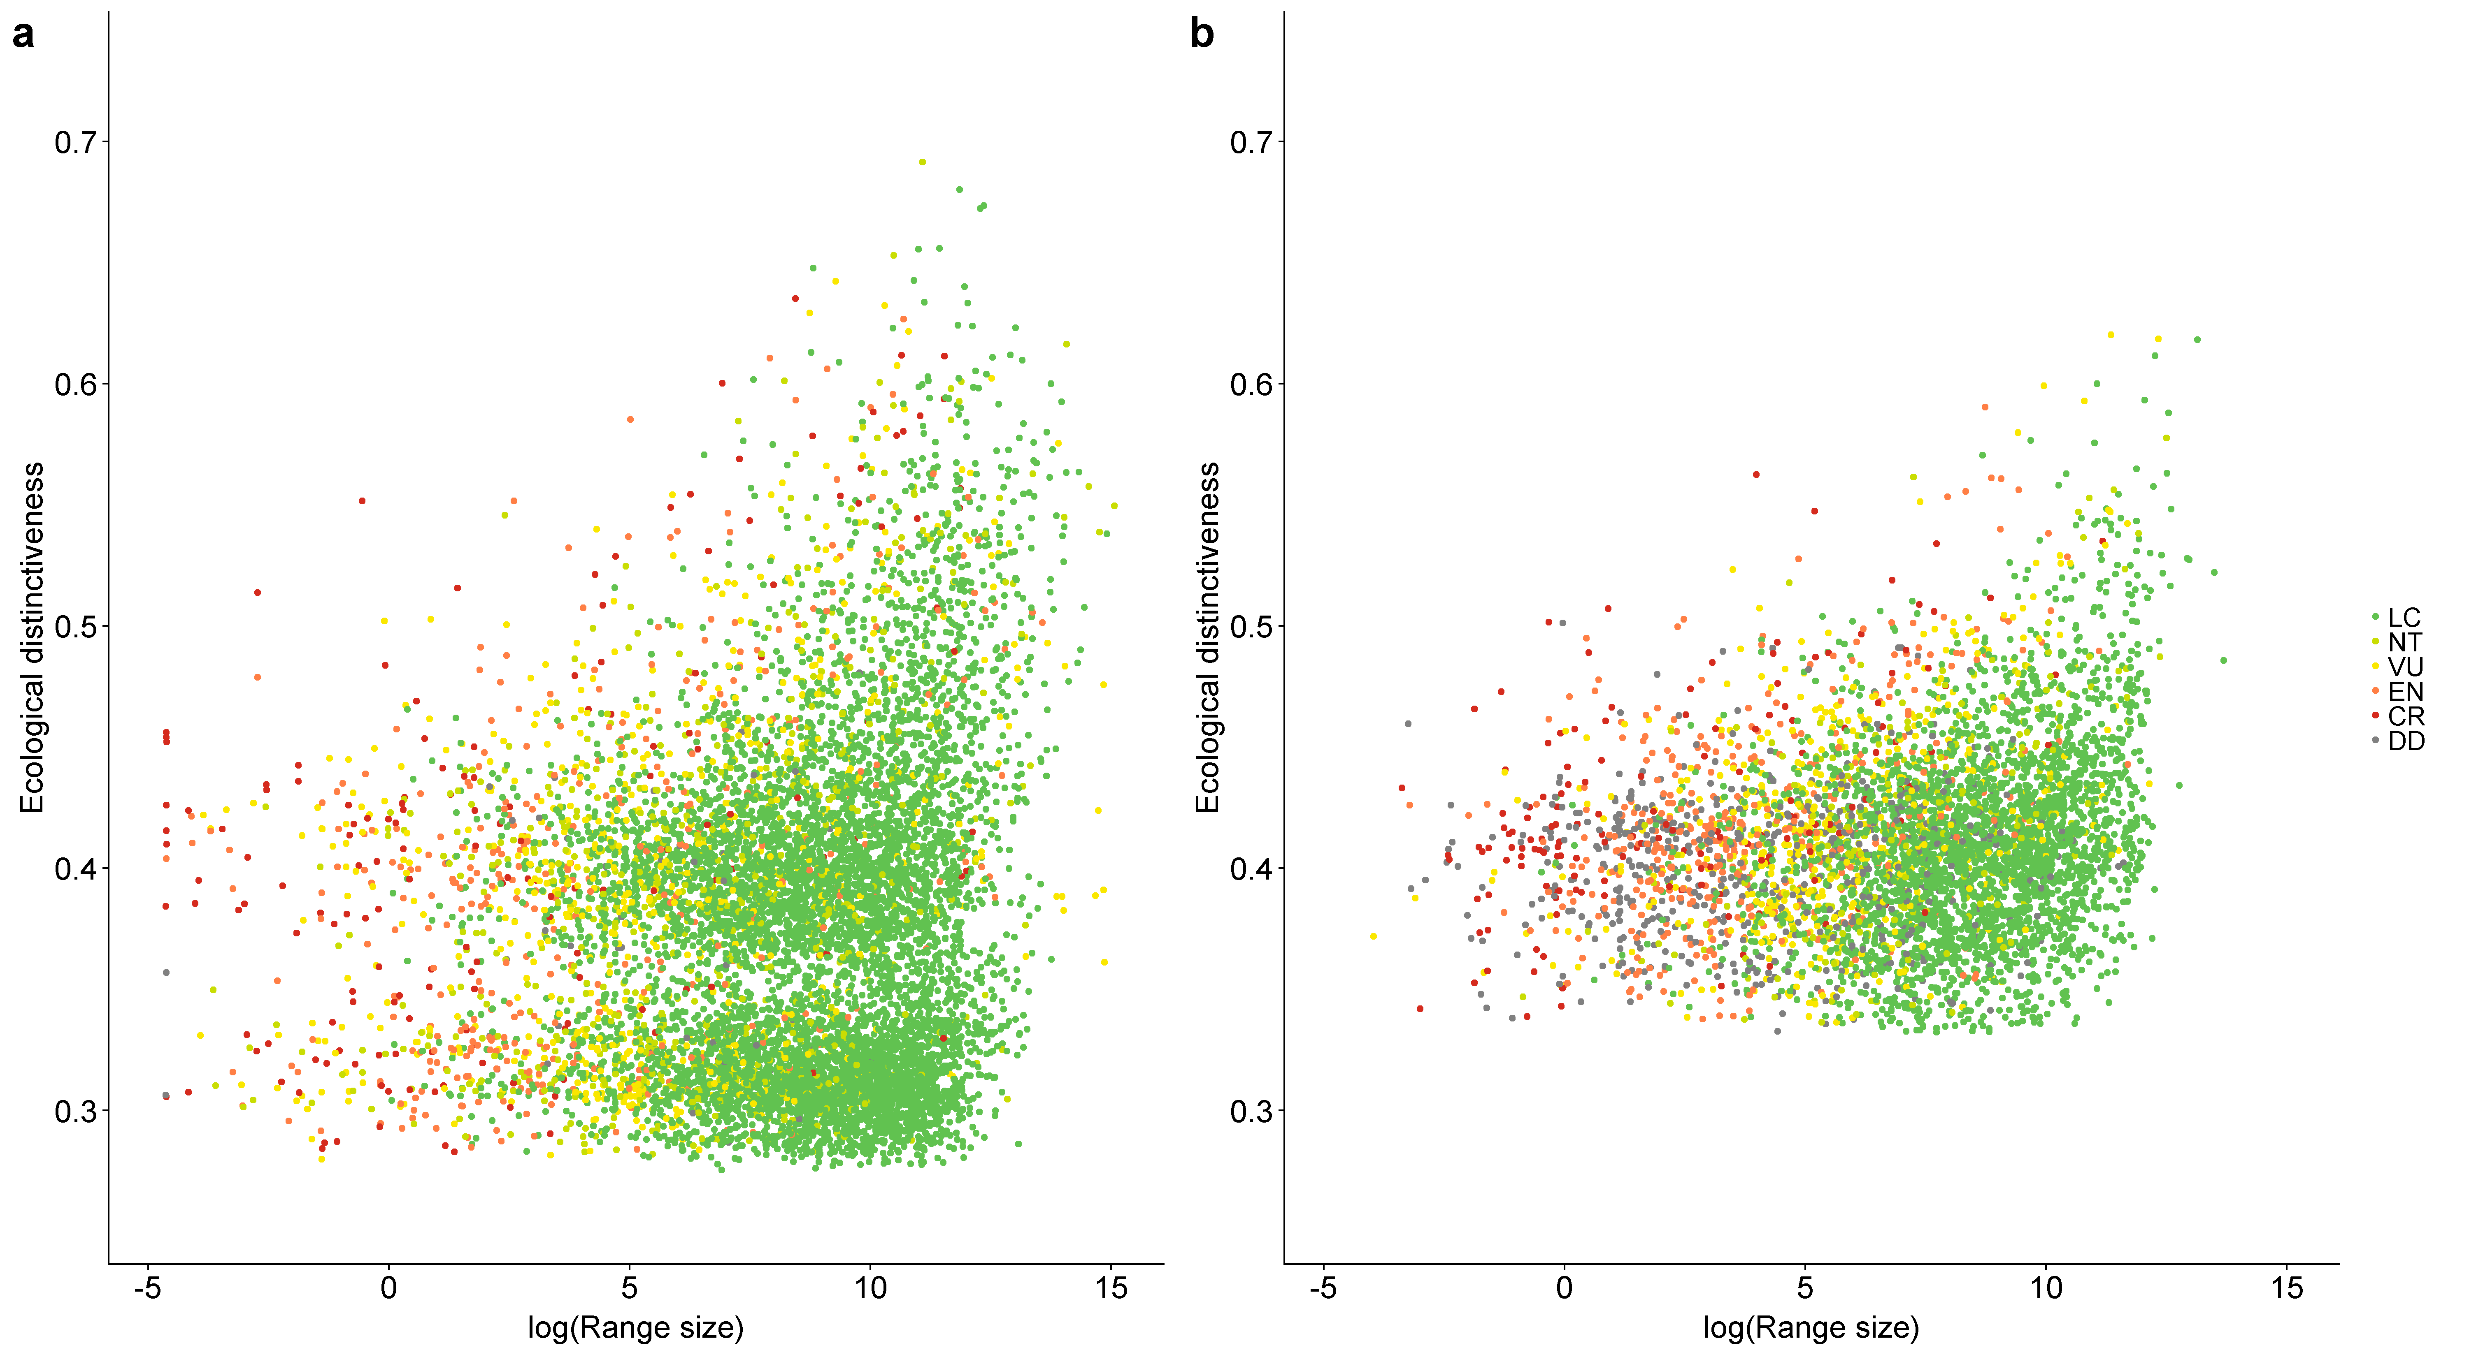
Fig. 4. Weak positive correlation between ecological distinctiveness and log range size for (a) 9,032 bird species (Spearman’s ρ₉₀₃₀ = 0.11) and (b) 4,984 mammal species (Spearman’s ρ₄₉₈₂ = 0.19). Points represent mean ecological distinctiveness across 25 imputed trait datasets for each species. Colours depict IUCN Red List status.

3.5 Ecological distinctiveness by dimension
Ecological distinctiveness for the top twenty bird species is predominantly driven by large body mass, long generation length and high habitat breadth (Fig. 5a). For mammals, the primary drivers of distinctiveness for the top twenty species are large body mass, high habitat breadth and a carnivorous diet (Fig. 5b).
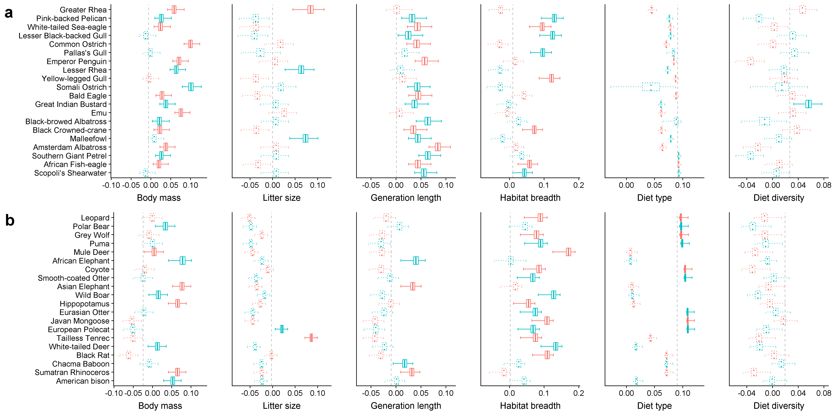
Fig. 5. The difference between ecological distinctiveness for all six traits together and for each trait removed individually for the top twenty ecologically distinct (a) bird and (b) mammal species. Boxplots show the mean (centre line), 95% confidence intervals around the mean (box), minimum and maximum (whiskers) for ecological distinctiveness per species across 25 imputed trait datasets, according to Rubin’s rules. Positive values indicate a decrease in a species’ ecological distinctiveness when we removed the trait, while negative values indicate an increase in distinctiveness when we removed the trait. Alternate rows are coloured red and blue to ease comparison across the plots. The long dashed grey lines represent the global mean difference for each trait. Boxes with 95% confidence intervals not overlapping the global mean have solid outlines (i.e., a greater than average decrease in the species’ ecological distinctiveness when we removed the trait) and those with overlapping confidence intervals have dotted outlines.

3.6 Sensitivity analysis
Ecological distinctiveness is highest at the edges of the PCoA trait space, furthest from the most speciose regions, for both birds (Fig. B.8a) and mammals (Fig. B.8c). By contrast, ecological uniqueness highlights individual isolated species within the PCoA trait space for birds (Fig. B.8b) and mammals (Fig. B.8d), this is particularly apparent for mammals, reflecting the clustered distribution of mammals in trait space (Fig. B.8d).
Ecological distinctiveness and PCoA ecological distinctiveness (ecological distinctiveness based on distances, weighted by eigenvalues, extracted from a PCoA) are highly correlated for both birds (Spearman’s ρ₁₀₉₅₈ = 0.99) and mammals (Spearman’s ρ₅₂₇₆ = 0.95), and thus priority species are similar for the equally weighted and PCoA approaches (Fig. B.9). Accordingly, threatened bird and mammal species have higher PCoA ecological distinctiveness (Fig. B.10) and PCoA ecological distinctiveness is very weakly positively correlated with log evolutionary distinctiveness for birds (Spearman’s ρ₁₀₉₅₈ = 0.048) and for mammals (Spearman’s ρ₅₂₇₆ = 0.033) (Fig. B.11).
Overall, our results and conclusions are qualitatively similar for ecological uniqueness (Figs. B.5, B6 and B.7) and for PCoA ecological distinctiveness (Figs. B.9, B.10 and B.11). Thus, our findings appear robust to the choice of metric and the correlations between the traits, although ecological uniqueness could offer alternative insights on the irreplaceability of species’ ecological strategies.

4. Discussion
We find, as predicted, that on average, threatened birds and mammals are more ecologically distinct than non-threatened species. Continuing to conserve threatened species should therefore simultaneously reduce extinction and support global ecological diversity, thus maintaining nature’s variability.
However, our findings also support the need for a balanced consideration of both non-threatened (i.e., common) and threatened (i.e., rare) species (Chapman et al., 2018; Gaston, 2011). Most of the top twenty ecologically distinct birds and mammals are non-threatened, including ubiquitous species, such as Lesser Black-backed Gull (Larus fuscus), Wild Boar (Sus scrofa), Coyote (Canis latrans) and Black Rat (Rattus rattus). We therefore demonstrate that, although threatened birds and mammals are more ecologically distinct on average, non-threatened species can have extremely distinct ecological strategies, contrary to our predictions. Thus, we find that both common and rare species make unique contributions to ecological diversity (as also reported for hydrothermal vents; Chapman et al., 2018).
We find that these ecologically distinct non-threatened species (e.g., Lesser Black-backed Gull, Wild Boar) are generally large-bodied, habitat generalists, which are often widespread and successful in multiple environments - in other words, hyper-generalists. For example, we observe a positive correlation between range size and ecological distinctiveness. Yet a common ecological tenet is that generalist species are at a disadvantage when competing with specialists - a ‘jack of all trades is a master of none’ mechanism (Büchi and Vuilleumier, 2014; Burin et al., 2016; Marvier et al., 2004). For instance, when a specialist and a generalist species compete for the specialist’s preferred resource, the specialist species should ecologically outperform the other (Burin et al., 2016). Instead, here we suggest that the evolution of distinct ecological strategies could allow some generalist species to separate themselves from direct competitors and reduce interspecific competition, via negative frequency-dependence selection, allowing them to successfully colonise and occupy a diversity of environments (Chapman et al., 2018; Levine and HilleRisLambers, 2009; Violle et al., 2017).
We suggest that it is ecologically difficult to be a hyper-generalist, hence it is rare to be common (Gaston, 2011). Hyper-generalists are therefore distinctive - while this is counter-intuitive, we suggest that generalists potentially require specialist traits to survive in a diverse set of environmental conditions and habitats, although this requires further investigation. In addition, these species could be promoted by human assisted dispersal and/or human impacts (human commensals; e.g., Black Rat, Lesser Black-backed Gull), as generalists can often take advantage of disturbed or heterogeneous landscapes, such as human-dominated systems (Büchi and Vuilleumier, 2014; Marvier et al., 2004; Monnet et al., 2014). Moreover, hyper-generalist species are potentially ecologically important, as they are often involved in engineering environments and interact with many other species (Gaston, 2011). If unchecked, a decline of these distinctive hyper-generalists could lead to cascading ecological effects. The evolutionary and ecological adaptations of these species therefore requires further research to understand why these species are so successful in different environments and how they contribute to ecosystem processes and function across scales. Overall, we suggest that high ecological distinctiveness is associated with either high extinction risk or successful hyper-generalism.
The most ecologically distinct species, as quantified here, often have unique roles in their environment. For example, predators, such as White-tailed Sea-eagle (Haliaeetus albicilla), Leopard (Panthera pardus), Bald Eagle (Haliaeetus leucocephalus), Grey Wolf (Canis lupus) and Puma (Puma concolor) can effect grazing and mesopredation pressure, productivity, disease dynamics and carbon sequestration (Estes et al., 2011; O’Bryan et al., 2018; Ripple et al., 2014; Ritchie et al., 2012; Ritchie and Johnson, 2009); while African (Loxodonta africana) and Asian Elephants (Elephas maximus), and Hippopotamus (Hippopotamus amphibius) can alter vegetation structure and composition, fundamentally restructuring ecosystems (Bakker et al., 2016; Terborgh et al., 2018, 2016). Thus, the ecologically distinct species highlighted here have critical roles in ecosystems across the globe. The loss of these ecologically distinct species could therefore potentially disrupt species interactions and undermine the integrity of ecological processes and functions (Duffy, 2002; Larsen et al., 2005). Moreover, population declines for these ecologically distinct species could also lead to strong impacts, as species’ abundances effect their contributions to ecological processes (Gaston, 2011; Winfree et al., 2015). For instance, species’ ecological effects are often assumed to be proportional to their abundance or biomass (Grime, 1998), although there is evidence that rare species can also have important ecological roles (Leitão et al., 2016; Mouillot et al., 2013a), especially across time and under disturbance (Violle et al., 2017). Thus, it is important to maintain the abundance, as well as the existence, of ecologically distinct species. Furthermore, there is potential to incorporate abundance data into future assessments of ecological distinctiveness, when comparable data becomes available (e.g., accounting for differences in detectability), and this could reveal species that are both ecologically rare and ecologically distinct, as well as species with crucial ecological roles at the local scale (Grenié et al., 2018, 2017).
We find that ecologically distinct species are generally charismatic. For example, six (Elephant, Panther, Polar Bear, Wolf, Hippo and Rhino) of the top twenty most charismatic animals, based on public perceptions of charisma (Albert et al., 2018), correspond to species in the top twenty most ecologically distinct mammals. Public preferences for charismatic bird and mammal species (Morse-Jones et al., 2012; Smith et al., 2012) are reflected in greater willingness-to-pay for conservation focusing on these species (Albert et al., 2018; Colléony et al., 2017; Martín-López et al., 2007). We therefore highlight a conservation opportunity, where the protection of ecologically distinct species can be facilitated through the public support of charismatic species. The use of charismatic species to elicit funding is controversial, as it can divert focus to species that are not the most threatened or ecologically important (Albert et al., 2018; Brodie, 2009; Colléony et al., 2017; Restani and Marzluff, 2002). However, here we show that charismatic species may be deserving of their elevated attention, due to their often-distinct ecological strategies and therefore potentially unique ecological roles. In addition, funding for charismatic species can result in additional benefits (e.g., flagship species), through conservation actions shared with other species (Bennett et al., 2015), because these species tend to be broad ranging and lead to conservation of the habitats encompassing many other species. Flagship marketing remains a key fund raising tool for international agencies (e.g., IUCN and United Nations), non-governmental organisations, local governments, and the scientific community (Bennett et al., 2015). Thus, capitalizing on the appeal of charismatic and/or flagship species will help to conserve the most ecologically distinct species and maintain a diversity of ecological strategies across the globe, supporting and maintaining ecosystem processes and functions (Hector and Bagchi, 2007).
Our species priority lists differ for ecological uniqueness and ecological distinctiveness. The difference between ecological uniqueness and ecological distinctiveness is greater for mammals than for birds, potentially due to the more clustered distribution of mammals in trait space, although this requires further investigation. Ecological uniqueness identifies species that are more distant to their closest neighbour in trait space (Grenié et al., 2017), and uniqueness appears to capture different attributes to ecological distinctiveness, highlighting ecological oddities, such as the Kakapo (Strigops habroptila) and Naked Mole Rat (Heterocephalus glaber). In addition, ecological uniqueness shows stronger (albeit still weak) correlation with evolutionary distinctiveness, compared to the correlation between ecological distinctiveness and evolutionary distinctiveness. We therefore highlight surrogacy between ecological uniqueness (and thus nearest-neighbour metrics of ecological isolation) and evolutionary history, supporting previous predictions that evolutionary distinct species are likely to have more unique features or trait combinations (Faith, 1992; Redding and Mooers, 2015). Thus, there is also potential for the use of ecological uniqueness for conservation prioritization, and indeed ecological uniqueness could be complementary to ecological distinctiveness or might be preferred under different conservation objectives. For example, ecological uniqueness could help to identify individual species isolated in trait space, which could be informative at regional scales where ecological redundancy between species is low (Cooke et al., 2019a). Nonetheless, the species present in the top twenty for both ecological uniqueness and ecological distinctiveness were generally charismatic, reaffirming the importance of the ecological strategies of charismatic species. By contrast, ecological distinctiveness summarizes how uncommon the traits of a given species are compared to all other species globally (Grenié et al., 2018), which can depress differences between species, due to the averaging effect (Redding et al., 2014). The ranking of ecologically distinct species can therefore be sensitive to small differences between species. However, ecological distinctiveness also shows more consistent structuring across trait space than ecological uniqueness and highlights species at the edges of trait space - ecological outliers (Violle et al., 2017). The conservation of species with high ecological distinctiveness should help to maintain a broad range of ecological strategies and minimize predicted directional trait shifts, by conserving those species at the edges of trait space, potentially supporting high ecological strategy diversity and continued ecosystem functioning (Cooke et al., 2019b; Hector and Bagchi, 2007).

5. Conclusions
We demonstrate that evolutionary distinctiveness is a poor surrogate for ecological distinctiveness. We therefore suggest that joint consideration of a species’ evolutionary and ecological distinctiveness could better summarise the irreplaceability of a species and inform conservation prioritization. However management actions must be timely, as well as targeted (Gumbs et al., 2018). Hence, species at imminent risk of extinction are widely considered to be the first priority for immediate conservation action (Gumbs et al., 2018). We therefore propose that highly threatened species that are also ecologically and evolutionarily distinct require urgent attention, as the loss of these species could result in disproportionate ecological consequences (Cooke et al., 2019b) and an over-proportional loss of evolutionary history (Davis et al., 2018; Steel et al., 2018). Ecological distinctiveness, as quantified here, highlights the potential ecological costs of species loss, and therefore provides a complementary perspective to existing conservation prioritization frameworks, e.g., the EDGE approach (Isaac et al., 2007; Redding and Mooers, 2010). We therefore add to the growing consensus that, beyond focusing on the number of species or on those with major extinction risks, other facets of biodiversity need to be considered (Bowen and Roman, 2005; Brum et al., 2017; Isaac et al., 2007; Thuiller et al., 2015). Specifically, we suggest that prioritisation that accounts for extinction risk, ecological distinctiveness and evolutionary distinctiveness can contribute to the overall goal of conservation - maintaining living variation. Thus, we suggest that our quantification of ecological distinctiveness could better inform species prioritization and the direction of conservation actions, highlighting species with irreplaceable ecological strategies.

Acknowledgements
This work was supported by a scholarship (awarded to R.S.C.C) co-funded by the SPITFIRE Doctoral Training Partnership (supported by the Natural Environmental Research Council, grant number: NE/l002531/1) and the University of Southampton.

Appendix A
The 25 imputed trait datasets (excluding generation length for birds, due to data restrictions) for all bird and mammal species (Appendix_A.xlsx). The traits have been transformed log₁₀ for body mass, generation length and litter/clutch size; square root for habitat breadth. Body mass (body_mass_median), litter/clutch size (litter_clutch_size), generation length (GL), habitat breadth (hab_breadth), diet type (diet_5cat) and diet diversity (shdd).

Appendix B
Supporting figures and analyses, including trait distributions, correlations between traits and analysis of ecological uniqueness and PCoA ecological distinctiveness (Appendix_B.docx).

Appendix C
Ecological distinctiveness scores for all bird and mammal species (Appendix_C.xlsx). Mean (Di_mean), max (Di_max), min (Di_min) and standard error (according to Rubin’s rules; Di_se) for ecological distinctiveness across the 25 trait datasets. Also included are the results for PCoA ecological distinctiveness and ecological uniqueness.

Declaration of interest
Declarations of interest: none

Data statement
The raw trait data (i.e., excluding imputed values) for body mass, litter/clutch size, habitat breadth and diet type - compiled by Cooke et al. (2019a) from four main sources (Jones et al., 2009; Myhrvold et al., 2015; Pacifici et al., 2013; Wilman et al., 2014) are available on figshare: https://figshare.com/articles/Global_trade-offs_of_functional_redundancy_and_functional_dispersion_for_birds_and_mammals/5616424
BirdLife supplied generation length for birds but restrictions apply to these data, which we used under license for the current study. However, these data can be manually downloaded from the BirdLife website (http://datazone.birdlife.org/species/search).
The 25 imputed trait datasets (excluding generation length for birds, due to data restrictions) are provided as Appendix A. The traits have been transformed log₁₀ for body mass, generation length and litter/clutch size; square root for habitat breadth. Body mass (body_mass_median), litter/clutch size (litter_clutch_size), generation length (GL), habitat breadth (hab_breadth), diet type (diet_5cat) and diet diversity (shdd).
Evolutionary distinctiveness scores for mammals and birds were freely downloaded here: https://www.edgeofexistence.org/edge-lists/
The calculated ecological distinctiveness scores for all bird and mammal species are provided as Appendix C, as well as the scores for PCoA ecological distinctiveness and ecological uniqueness.

References
Albert, C., Luque, G.M., Courchamp, F., 2018. The twenty most charismatic species. PLoS One 13, e0199149. https://doi.org/10.1371/journal.pone.0199149
Bakker, E.S., Pagès, J.F., Arthur, R., Alcoverro, T., 2016. Assessing the role of large herbivores in the structuring and functioning of freshwater and marine angiosperm ecosystems. Ecography (Cop.). 39, 162–179. https://doi.org/10.1111/ecog.01651
Bennett, J.R., Maloney, R., Possingham, H.P., 2015. Biodiversity gains from efficient use of private sponsorship for flagship species conservation. Proc. R. Soc. B Biol. Sci. 282, 20142693. https://doi.org/10.1098/rspb.2014.2693
BirdLife International and Handbook of the Birds of the World, 2018. Bird species distribution maps of the world. Version 2018.1. [WWW Document]. URL http://datazone.birdlife.org/species/requestdis (accessed 2.13.19).
Bowen, B.W., Roman, J., 2005. Gaia’s handmaidens: the Orlog model for conservation biology. Conserv. Biol. 19, 1037–1043. https://doi.org/10.1111/j.1523-1739.2005.00100.x
Brodie, J.F., 2009. Is research effort allocated efficiently for conservation? Felidae as a global case study. Biodivers. Conserv. 18, 2927–2939. https://doi.org/10.1007/s10531-009-9617-3
Brooks, T.M., Mittermeier, R.A., da Fonseca, G.A.B., Gerlach, J., Hoffmann, M., Lamoreux, J.F., Mittermeier, C.G., Pilgrim, J.D., Rodrigues, A.S.L., 2006. Global biodiversity conservation priorities. Science (80-. ). 313, 58–61. https://doi.org/10.1126/science.1127609
Brum, F.T., Graham, C.H., Costa, G.C., Hedges, S.B., Penone, C., Radeloff, V.C., Rondinini, C., Loyola, R., Davidson, A.D., 2017. Global priorities for conservation across multiple dimensions of mammalian diversity. Proc. Natl. Acad. Sci. U. S. A. 114, 7641–7646. https://doi.org/10.1073/pnas.1706461114
Büchi, L., Vuilleumier, S., 2014. Coexistence of specialist and generalist species is shaped by dispersal and environmental factors. Am. Nat. 183, 612–624. https://doi.org/10.1086/675756
Burin, G., Kissling, W.D., Guimarães, P.R., Şekercioglu, C.H., Quental, T.B., 2016. Omnivory in birds is a macroevolutionary sink. Nat. Commun. 7, 11250. https://doi.org/10.1038/ncomms11250
Chamberlain, S., 2016. rredlist: “IUCN” Red List Client, R package version 0.1.0.
Chamberlain, S., Szoecs, E., Boettiger, C., 2012. taxize: taxonomic search and phylogeny retrieval. F1000Research 2:191. https://doi.org/10.12688/f1000research.2-191.v1
Chapman, A.S.A., Tunnicliffe, V., Bates, A.E., 2018. Both rare and common species make unique contributions to functional diversity in an ecosystem unaffected by human activities. Divers. Distrib. 24, 568–578. https://doi.org/10.1111/ddi.12712
Chillo, V., Ojeda, R.A., 2012. Mammal functional diversity loss under human-induced disturbances in arid lands. J. Arid Environ. https://doi.org/10.1016/j.jaridenv.2012.06.016
Clavel, J., Julliard, R., Devictor, V., 2011. Worldwide decline of specialist species: toward a global functional homogenization? Front. Ecol. Environ. 9, 222–228. https://doi.org/10.1890/080216
Colléony, A., Clayton, S., Couvet, D., Saint Jalme, M., Prévot, A.C., 2017. Human preferences for species conservation: animal charisma trumps endangered status. Biol. Conserv. 206, 263–269. https://doi.org/10.1016/j.biocon.2016.11.035
Cooke, R.S.C., Bates, A.E., Eigenbrod, F., 2019a. Global trade-offs of functional redundancy and functional dispersion for birds and mammals. Glob. Ecol. Biogeogr. 28, 484–495. https://doi.org/10.1111/geb.12869
Cooke, R.S.C., Eigenbrod, F., Bates, A.E., 2019b. Projected losses of global mammal and bird ecological strategies. Nat. Commun. 10, 2279. https://doi.org/10.1038/s41467-019-10284-z
Cooke, R.S.C., Gilbert, T.C., Riordan, P., Mallon, D., 2018. Improving generation length estimates for the IUCN Red List. PLoS One 13, e0191770. https://doi.org/10.1371/journal.pone.0191770
Davis, M., Faurby, S., Svenning, J.-C., 2018. Mammal diversity will take millions of years to recover from the current biodiversity crisis. Proc. Natl. Acad. Sci. U. S. A. 201804906. https://doi.org/10.1073/pnas.1804906115
de Mendiburu, F., 2017. Agricolae: statistical procedures for agricultural research. R Packag. version 1.2.8. https://doi.org/10.1525/california/9780520268326.003.0002
Dray, S., Dufour, A.-B., 2007. The ade4 package: implementing the duality diagram for ecologists. J. Stat. Softw. 22, 1–20. https://doi.org/10.18637/jss.v022.i04
Duffy, J.E., 2002. Biodiversity and ecosystem function: the consumer connection. Oikos 99, 201–219. https://doi.org/10.1034/j.1600-0706.2002.990201.x
Dunning, J., 2008. CRC handbook of avian body masses, 2nd ed, CRC Press. CRC Press. https://doi.org/10.1017/S0963180113000479
Estes, J.A., Terborgh, J., Brashares, J.S., Power, M.E., Berger, J., Bond, W.J., Carpenter, S.R., Essington, T.E., Holt, R.D., Jackson, J.B.C., Marquis, R.J., Oksanen, L., Oksanen, T., Paine, R.T., Pikitch, E.K., Ripple, W.J., Sandin, S.A., Scheffer, M., Schoener, T.W., Shurin, J.B., Sinclair, A.R.E., Soulé, M.E., Virtanen, R., Wardle, D.A., 2011. Trophic downgrading of planet earth. Science (80-. ). 333, 301–306. https://doi.org/10.1126/science.1205106
Faith, D.P., 1992. Conservation evaluation and phylogenetic diversity. Biol. Conserv. 61, 1–10. https://doi.org/10.1016/0006-3207(92)91201-3
Fritz, S.A., Bininda-Emonds, O.R.P., Purvis, A., 2009. Geographical variation in predictors of mammalian extinction risk: big is bad, but only in the tropics. Ecol. Lett. 12, 538–549. https://doi.org/10.1111/j.1461-0248.2009.01307.x
Gamfeldt, L., Hillebrand, H., Jonsson, P.R., 2008. Multiple functions increase the importance of biodiversity for overall ecosystem functioning. Ecology 89, 1223–1231. https://doi.org/10.1890/06-2091.1
Gaston, K.J., 2011. Common ecology. Bioscience 61, 354–362. https://doi.org/10.1525/bio.2011.61.5.4
Gaston, K.J., 1994. Rarity, 1st ed, Population and community biology series. Springer, Netherlands. https://doi.org/10.1007/978-94-011-0701-3
Gearty, W., McClain, C.R., Payne, J.L., 2018. Energetic tradeoffs control the size distribution of aquatic mammals. Proc. Natl. Acad. Sci. U. S. A. 115, 4194–4199. https://doi.org/10.1073/pnas.1712629115
Grenié, M., Denelle, P., Tucker, C.M., Munoz, F., Violle, C., 2017. funrar: an R package to characterize functional rarity. Divers. Distrib. 23, 1365–1371. https://doi.org/10.1111/ddi.12629
Grenié, M., Mouillot, D., Villéger, S., Denelle, P., Tucker, C.M., Munoz, F., Violle, C., 2018. Functional rarity of coral reef fishes at the global scale: hotspots and challenges for conservation. Biol. Conserv. 226, 288–299. https://doi.org/10.1016/J.BIOCON.2018.08.011
Grime, J.P., 1998. Benefits of plant diversity to ecosystems: immediate, filter and founder effects. J. Ecol. 86, 902–910. https://doi.org/10.1046/j.1365-2745.1998.00306.x
Gumbs, R., Gray, C.L., Wearn, O.R., Owen, N.R., 2018. Tetrapods on the EDGE: overcoming data limitations to identify phylogenetic conservation priorities. PLoS One 13, e0194680. https://doi.org/10.1371/journal.pone.0194680
Hector, A., Bagchi, R., 2007. Biodiversity and ecosystem multifunctionality. Nature 448, 188–190. https://doi.org/10.1038/nature05947
Hijmans, R.J., 2019. raster: geographic analysis and modeling with raster data, R package version 2.8-19.
Hooper, D.U., Chapin, F.S., Ewel, J.J., Hector, A., Inchausti, P., Lavorel, S., Lawton, J.H., Lodge, D.M., Loreau, M., Naeem, S., Schmid, B., Setala, H., Symstad, A.J., Vandermeer, J., Wardle, D.A., 2005. Effects of biodiversity on ecosystem functioning: A consensus of current knowledge. Ecol. Monogr. 75, 3–35. https://doi.org/Doi 10.1890/04-0922
Huang, S., Stephens, P.R., Gittleman, J.L., 2012. Traits, trees and taxa: global dimensions of biodiversity in mammals. Proc. R. Soc. B Biol. Sci. 279, 4997–5003. https://doi.org/10.1098/rspb.2012.1981
Isaac, N.J.B., Redding, D.W., Meredith, H.M., Safi, K., 2012. Phylogenetically-informed priorities for amphibian conservation. PLoS One 7, e43912. https://doi.org/10.1371/journal.pone.0043912
Isaac, N.J.B., Turvey, S.T., Collen, B., Waterman, C., Baillie, J.E.M., 2007. Mammals on the EDGE: conservation priorities based on threat and phylogeny. PLoS One 2, e296. https://doi.org/10.1371/journal.pone.0000296
IUCN, 2018. The IUCN Red List of Threatened Species. Version 2018-1 [WWW Document]. URL http://www.iucnredlist.org (accessed 2.13.19).
IUCN Standards and Petitions Subcommittee, 2014. Guidelines for using the IUCN Red List Categories and Criteria. Version 11.
Jenkins, C.N., Pimm, S.L., Joppa, L.N., 2013. Global patterns of terrestrial vertebrate diversity and conservation. Proc. Natl. Acad. Sci. U. S. A. 110, E2602–E2610. https://doi.org/10.1073/pnas.1302251110
Jetz, W., Thomas, G.H., Joy, J.B., Redding, D.W., Hartmann, K., Mooers, A.O., 2014. Global distribution and conservation of evolutionary distinctness in birds. Curr. Biol. 24, 919–930. https://doi.org/10.1016/j.cub.2014.03.011
Jones, K.E., Bielby, J., Cardillo, M., Fritz, S. a., O’Dell, J., Orme, C.D.L., Safi, K., Sechrest, W., Boakes, E.H., Carbone, C., Connolly, C., Cutts, M.J., Foster, J.K., Grenyer, R., Habib, M., Plaster, C. a., Price, S. a., Rigby, E. a., Rist, J., Teacher, A., Bininda-Emonds, O.R.P., Gittleman, J.L., Mace, G.M., Purvis, A., 2009. PanTHERIA: a species-level database of life history, ecology, and geography of extant and recently extinct mammals. Ecology 90, 2648–2648. https://doi.org/10.1890/08-1494.1
Jordano, P., Garcia, C., Godoy, J. a, Garcia-Castano, J.L., 2007. Differential contribution of frugivores to complex seed dispersal patterns. Proc. Natl. Acad. Sci. U. S. A. 104, 3278–3282. https://doi.org/10.1073/pnas.0606793104
Kim, S.W., Blomberg, S.P., Pandolfi, J.M., 2018. Transcending data gaps: a framework to reduce inferential errors in ecological analyses. Ecol. Lett. 21, 1200–1210. https://doi.org/10.1111/ele.13089
Larsen, T.H., Williams, N.M., Kremen, C., 2005. Extinction order and altered community structure rapidly disrupt ecosystem functioning. Ecol. Lett. 8, 538–547. https://doi.org/10.1111/j.1461-0248.2005.00749.x
Legendre, P., Legendre, L., 1998. Numerical ecology, 2nd ed. Elsevier Scientific, Amsterdam. https://doi.org/10.1017/CBO9781107415324.004
Leitão, R.P., Zuanon, J., Villéger, S., Williams, S.E., Baraloto, C., Fortunel, C., Mendonça, F.P., Mouillot, D., 2016. Rare species contribute disproportionately to the functional structure of species assemblages. Proc. R. Soc. B Biol. Sci. 283, 494–499. https://doi.org/10.1098/rspb.2016.0084
Levine, J.M., HilleRisLambers, J., 2009. The importance of niches for the maintenance of species diversity. Nature 461, 254–257. https://doi.org/10.1038/nature08251
Luck, G.W., Carter, A., Smallbone, L., 2013. Changes in bird functional diversity across multiple land uses: interpretations of functional redundancy depend on functional group identity. PLoS One 8, e63671. https://doi.org/10.1371/journal.pone.0063671
Luck, G.W., Lavorel, S., Mcintyre, S., Lumb, K., 2012. Improving the application of vertebrate trait-based frameworks to the study of ecosystem services. J. Anim. Ecol. 81, 1065–1076. https://doi.org/10.1111/j.1365-2656.2012.01974.x
Maire, E., Grenouillet, G., Brosse, S., Villéger, S., 2015. How many dimensions are needed to accurately assess functional diversity? A pragmatic approach for assessing the quality of functional spaces. Glob. Ecol. Biogeogr. 24, 728–740. https://doi.org/10.1111/geb.12299
Martín-López, B., Montes, C., Benayas, J., 2007. The non-economic motives behind the willingness to pay for biodiversity conservation. Biol. Conserv. 139, 67–82. https://doi.org/10.1016/j.biocon.2007.06.005
Marvier, M., Kareiva, P., Neubert, M.G., 2004. Habitat destruction, fragmentation, and disturbance promote invasion by habitat generalists in a multispecies metapopulation. Risk Anal. 24, 869–878. https://doi.org/10.1111/j.0272-4332.2004.00485.x
Mazel, F., Pennell, M.W., Cadotte, M.W., Diaz, S., Dalla Riva, G.V., Grenyer, R., Leprieur, F., Mooers, A.O., Mouillot, D., Tucker, C.M., Pearse, W.D., 2018. Prioritizing phylogenetic diversity captures functional diversity unreliably. Nat. Commun. 9, 2888. https://doi.org/10.1038/s41467-018-05126-3
McCarthy, D.P., Donald, P.F., Scharlemann, J.P.W., Buchanan, G.M., Balmford, A., Green, J.M.H., Bennun, L.A., Burgess, N.D., Fishpool, L.D.C., Garnett, S.T., Leonard, D.L., Maloney, R.F., Morling, P., Schaefer, H.M., Symes, A., Wiedenfeld, D.A., Butchart, S.H.M., 2012. Financial costs of meeting global biodiversity conservation targets: current spending and unmet needs. Science (80-. ). 338, 1229803. https://doi.org/10.1126/science.1229803
Monnet, A.C., Jiguet, F., Meynard, C.N., Mouillot, D., Mouquet, N., Thuiller, W., Devictor, V., 2014. Asynchrony of taxonomic, functional and phylogenetic diversity in birds. Glob. Ecol. Biogeogr. 23, 780–788. https://doi.org/10.1111/geb.12179
Morse-Jones, S., Bateman, I.J., Kontoleon, A., Ferrini, S., Burgess, N.D., Turner, R.K., 2012. Stated preferences for tropical wildlife conservation amongst distant beneficiaries: charisma, endemism, scope and substitution effects. Ecol. Econ. 78, 9–18. https://doi.org/10.1016/j.ecolecon.2011.11.002
Mouillot, D., Bellwood, D.R., Baraloto, C., Chave, J., Galzin, R., Harmelin-Vivien, M., Kulbicki, M., Lavergne, S., Lavorel, S., Mouquet, N., Paine, C.E.T., Renaud, J., Thuiller, W., 2013a. Rare species support vulnerable functions in high-diversity ecosystems. PLoS Biol. 11, e1001569. https://doi.org/10.1371/journal.pbio.1001569
Mouillot, D., Graham, N.A.J., Villeger, S., Mason, N.W.H., Bellwood, D.R., 2013b. A functional approach reveals community responses to disturbances. Trends Ecol. Evol. 28, 167–177. https://doi.org/10.1016/j.tree.2012.10.004
Mouillot, D., Villeger, S., Parravicini, V., Kulbicki, M., Arias-Gonzalez, J.E., Bender, M., Chabanet, P., Floeter, S.R., Friedlander, A., Vigliola, L., Bellwood, D.R., 2014. Functional over-redundancy and high functional vulnerability in global fish faunas on tropical reefs. Proc. Natl. Acad. Sci. U. S. A. 111, 13757–13762. https://doi.org/10.1073/pnas.1317625111
Myhrvold, N.P., Baldridge, E., Chan, B., Freeman, D.L., Ernest, S.K.M., 2015. An amniote life-history database to perform comparative analyses with birds, mammals, and reptiles. Ecology 96, 3109. https://doi.org/10.5061/dryad.t6m96
Newbold, T., Scharlemann, J.P.W., Butchart, S.H.M., Sekercioglu, C.H., Alkemade, R., Booth, H., Purves, D.W., 2013. Ecological traits affect the response of tropical forest bird species to land-use intensity. Proc. R. Soc. B Biol. Sci. 280, 20122131. https://doi.org/10.1098/rspb.2012.2131
O’Bryan, C.J., Braczkowski, A.R., Beyer, H.L., Carter, N.H., Watson, J.E.M., McDonald-Madden, E., 2018. The contribution of predators and scavengers to human well-being. Nat. Ecol. Evol. 2, 229–236. https://doi.org/10.1038/s41559-017-0421-2
Otto, S.P., 2018. Adaptation, speciation and extinction in the Anthropocene. Proc. R. Soc. B Biol. Sci. 285, 20182047. https://doi.org/10.1098/rspb.2018.2047
Pacifici, M., Santini, L., Marco, M. Di, Baisero, D., Francucci, L., Marasini, G.G., Visconti, P., Rondinini, C., 2013. Generation length for mammals. Nat. Conserv. 5, 87–94. https://doi.org/10.3897/natureconservation.5.5734
Penone, C., Davidson, A.D., Shoemaker, K.T., Di Marco, M., Rondinini, C., Brooks, T.M., Young, B.E., Graham, C.H., Costa, G.C., 2014. Imputation of missing data in life-history trait datasets: which approach performs the best? Methods Ecol. Evol. 5, 961–970. https://doi.org/10.1111/2041-210X.12232
Petchey, O.L., Gaston, K.J., 2006. Functional diversity: back to basics and looking forward. Ecol. Lett. 9, 741–758. https://doi.org/10.1111/j.1461-0248.2006.00924.x
Pianka, E.R., Vitt, L.J., Pelegrin, N., Fitzgerald, D.B., Winemiller, K.O., 2017. Toward a periodic table of niches, or exploring the lizard niche hypervolume. Am. Nat. 190, 601–606. https://doi.org/10.1086/693781
Pollock, L.J., Thuiller, W., Jetz, W., 2017. Large conservation gains possible for global biodiversity facets. Nature 546, 141–144. https://doi.org/10.1038/nature22368
Prum, R.O., Berv, J.S., Dornburg, A., Field, D.J., Townsend, J.P., Lemmon, E.M., Lemmon, A.R., 2015. A comprehensive phylogeny of birds (Aves) using targeted next-generation DNA sequencing. Nature 526, 569–573. https://doi.org/10.1038/nature15697
Purvis, A., Agapow, P.M., Gittleman, J.L., Mace, G.M., 2000. Nonrandom extinction and the loss of evolutionary history. Science (80-. ). 288, 328–330. https://doi.org/10.1126/science.288.5464.328
R Core Team, 2018. R: A language and environment for statistical computing [WWW Document]. URL https://www.r-project.org/
Rapacciuolo, G., Marin, J., Costa, G.C., Helmus, M.R., Behm, J.E., Brooks, T.M., Hedges, S.B., Radeloff, V.C., Young, B.E., Graham, C.H., 2017. The signature of human pressure history on the biogeography of body mass in tetrapods. Glob. Ecol. Biogeogr. 26, 1022–1034. https://doi.org/10.1111/geb.12612
Redding, D.W., Hartmann, K., Mimoto, A., Bokal, D., DeVos, M., Mooers, A., 2008. Evolutionarily distinctive species often capture more phylogenetic diversity than expected. J. Theor. Biol. 251, 606–615. https://doi.org/10.1016/j.jtbi.2007.12.006
Redding, D.W., Mazel, F., Mooers, A., 2014. Measuring evolutionary isolation for conservation. PLoS One 9, e113490. https://doi.org/10.1371/journal.pone.0113490
Redding, D.W., Mooers, A.O., 2015. Ranking mammal species for conservation and the loss of both phylogenetic and trait diversity. PLoS One 10, e0141435. https://doi.org/10.1371/journal.pone.0141435
Redding, D.W., Mooers, A.Ø., 2010. Can Systematists help decide the relative worth of bits of biodiversity? Systematist 32, 4–8.
Restani, M., Marzluff, J.M., 2002. Funding extinction? Biological needs and political realities in the allocation of resources to endangered species recovery. Bioscience 52, 169–177. https://doi.org/10.1641/0006-3568(2002)052[0169:febnap]2.0.co;2
Ripple, W.J., Estes, J.A., Beschta, R.L., Wilmers, C.C., Ritchie, E.G., Hebblewhite, M., Berger, J., Elmhagen, B., Letnic, M., Nelson, M.P., Schmitz, O.J., Smith, D.W., Wallach, A.D., Wirsing, A.J., 2014. Status and ecological effects of the world’s largest carnivores. Science (80-. ). 343, 1241484. https://doi.org/10.1126/science.1241484
Ripple, W.J., Newsome, T.M., Wolf, C., Dirzo, R., Everatt, K.T., Galetti, M., Hayward, M.W., Kerley, G.I.H., Levi, T., Lindsey, P.A., Macdonald, D.W., Malhi, Y., Painter, L.E., Sandom, C.J., Terborgh, J., Van Valkenburgh, B., 2015. Collapse of the world’s largest herbivores. Sci. Adv. 1, e1400103. https://doi.org/10.1126/sciadv.1400103
Ripple, W.J., Wolf, C., Newsome, T.M., Hoffmann, M., Wirsing, A.J., McCauley, D.J., 2017. Extinction risk is most acute for the world’s largest and smallest vertebrates. Proc. Natl. Acad. Sci. U. S. A. 114, 10678–10683. https://doi.org/10.1073/pnas.1702078114
Ritchie, E.G., Elmhagen, B., Glen, A.S., Letnic, M., Ludwig, G., McDonald, R.A., 2012. Ecosystem restoration with teeth: what role for predators? Trends Ecol. Evol. 27, 265–271. https://doi.org/10.1016/J.TREE.2012.01.001
Ritchie, E.G., Johnson, C.N., 2009. Predator interactions, mesopredator release and biodiversity conservation. Ecol. Lett. 12, 982–998. https://doi.org/10.1111/j.1461-0248.2009.01347.x
Santini, L., González-Suárez, M., Russo, D., Gonzalez-Voyer, A., von Hardenberg, A., Ancillotto, L., 2019. One strategy does not fit all: determinants of urban adaptation in mammals. Ecol. Lett. 22, 365–376. https://doi.org/10.1111/ele.13199
Sekercioglu, C.H., 2011. Functional extinctions of bird pollinators cause plant declines. Science (80-. ). 331, 1019–1020. https://doi.org/10.1126/science.1202389
Sekercioğlu, C.H., 2006. Increasing awareness of avian ecological function. Trends Ecol. Evol. https://doi.org/10.1016/j.tree.2006.05.007
Sekercioğlu, C.H., Daily, G.C., Ehrlich, P.R., 2004. Ecosystem consequences of bird declines. Proc. Natl. Acad. Sci. U. S. A. 101, 18042–18047. https://doi.org/10.1073/pnas.0408049101
Simberloff, D., Dayan, T., 1991. The guild concept and the structure of ecological communities. Annu. Rev. Ecol. Syst. 22, 115–143. https://doi.org/10.1146/annurev.es.22.110191.000555
Smith, F.A., Lyons, S.K. (Eds.), 2013. Animal body size: linking pattern and process across space, time, and taxonomic group. University of Chicago Press, Chicago (Illinois), USA.
Smith, Felisa A, Lyons, S Kathleen, Sondaar, P.Y., Vartanyan, S.L., Garutt, V.E., Sher, A. V., Agenbroad, L.D., Morris, D., Roth, L., Guthrie, R.D., Palombo, M.R., Foster, J.B., Smith, F. A., Brown, J.H., Gaston, K.J., Blackburn, T.M., Brown, J.H., Gillooly, J.F., Allen, A.P., Savage, V.M., West, G.B., Gillooly, J., Brown, J., West, G., Savage, V., Charnov, E., Allen, A.P., Gillooly, J.F., Brown, J.H., Clarke, A., López-Urrutia, Á., Martin, E.S., Harris, R.P., Irigoien, X., Hou, C., Zuo, W., Moses, M.E., Woodruff, W.H., Brown, J.H., West, G.B., Ernest, S.K.M., White, E.P., Brown, J.H., Jablonski, D., Davidson, A.D., Hamilton, M.J., Boyer, A.G., Brown, J.H., Ceballos, G., Diniz-Filho, J.A.F., Carvalho, P., Bini, L.M., Torres, N.M., Poulin, R., Krasnov, B.R., Mouillot, D., Thieltges, D.W., Smith, F. A., Candolle, A. de, Darwin, C., Watson, H.C., Wallace, A.R., Liocourt, F. de, Arrhenius, O., Willis, J.C., Kleiber, M., Hutchinson, G.E., MacArthur, R.H., Fischer, A.G., Smith, F. A., Lyons, S. K., Ernest, S.K.M., Brown, J.H., Brown, J.H., Maurer, B.A., Brown, J.H., Maurer, B.A., Brown, J.H., Maurer, B.A., Hunt, G., Roy, K., Smith, F. A., Betancourt, J.L., Kerr, J.T., Kharouba, H.M., Currie, D.J., Willis, K.J., Kleczkowski, A., New, M., Whittaker, R.J., Kuhn, I., Bohning-Gaese, K., Cramer, W., Klotz, S., Lyons, S. K., Wagner, P.J., Dziklewicz, K.M., Gotelli, N.J., Graves, G.R., Blackburn, T.M., Gaston, K.J., Blackburn, T.M., Jablonski, D., Roy, K., Valentine, J.W., Raia, P., Meloro, C., Loy, A., Barbera, C., Foote, M., Crampton, J.S., Beu, A.G., Marshall, B.A., Cooper, R.A., Maxwell, P.A., Matcham, I., Foote, M., Crampton, J.S., Beu, A.G., Cooper, R.A., McElwain, J.C., Popa, M.E., Hesselbo, S.P., Haworth, M., Surlyk, F., Payne, J.L., Roy, K., Hunt, G., Jablonski, D., Krug, A.Z., Valentine, J.W., Lyons, S. K., Wagner, P.J., Lyons, S. K., Smith, F. A., Smith, F. A., Economos, A.C., Hokkanen, J.E.I., Peters, R.H., Downhower, J.F., Blumer, L.S., Alexander, R.M., Alexander, R.M., Burness, G.P., Diamond, J., Flannery, T., Clauss, M., Frey, R., Kiefer, B., Lechner-Doll, M., Loehlein, W., Polster, C., Rössner, G.E., Streich, W.J., Smith, F. A., Lyons, S. K., Calder, W.A., Alexander, R.M., Dobson, G.P., Marquet, P.A., Taper, M.L., Falkowski, P.G., Katz, M.E., Milligan, A.J., Fennel, K., Cramer, B.S., Aubry, M.P., Berner, R.A., Novacek, M.J., Zapol, W.M., West, G.B., Brown, J.H., Enquist, B.J., West, G.B., Brown, J.H., Enquist, B.J., Brown, J.H., Nicoletto, P.F., Galilei, G., Haldane, J.B.S., Thompson, D.W., Smith, F. A., Lyons, S. K., Ernest, S.K.M., Jones, K.E., Kaufman, D.M., Dayan, T., Marquet, P.A., Brown, J.H., Haskell, J.P., Wilson, D.E., Reeder, D.M., Brown, J.H., Marquet, P.A., Taper, M.L., Alroy, J., Lyons, S. K., Smith, F. A., Brown, J.H., Lyons, S. K., Smith, F. A., Demment, M.W., Soest, P.J. Van, Lomolino, M. V., Riddle, B.R., Whittaker, R.J., Brown, J.H., Lillegraven, J.A., Kielan-Jaworowska, Z., Clemens, W.A., Crompton, A.W., Alroy, J., Gould, S.J., McShea, D.W., Trammer, J., Bergmann, C., Rensch, B., Tappan, H., Payne, J.L., Smith, A.G., Smith, D.G., Funnell, B.M., Zachos, J.C., Dickens, G.R., Zeebe, R.E., Mayr, E., Mayr, E., Ashton, K.G., Tracy, M.C., Queiroz, A. de, Harding, L.E., Smith, F. A., Brown, J.H., Lyons, S. K., Youberg, K.M., Lister, A.M., Roth, V.L., Smith, F. A., Betancourt, J.L., Brown, J.H., Smith, F. A., Browning, H., Shepherd, U.L., Thompson, J.N., Simberloff, D., Dayan, T., Jones, C., Ogura, G., Carbone, C., Mace, G.M., Roberts, S.C., Macdonald, M.W., Andersson, K., Werdelin, L., Owen-Smith, R.N., Maurer, B.A., McGill, B.J., Rangel, T., Diniz, J.A.F., Hu, X.S., He, F.L., Hubbell, S.P., Isaac, N.J.B., Jones, K.E., Gittleman, J.L., Purvis, A., 2011. How big should a mammal be? A macroecological look at mammalian body size over space and time. Philos. Trans. R. Soc. London B Biol. Sci. 366, 2364–78. https://doi.org/10.1098/rstb.2011.0067
Smith, R.J., Veríssimo, D., Isaac, N.J.B., Jones, K.E., 2012. Identifying Cinderella species: uncovering mammals with conservation flagship appeal. Conserv. Lett. 3, 205–212. https://doi.org/10.1111/j.1755-263X.2012.00229.x
Steel, M., Pourfaraj, V., Chaudhary, A., Mooers, A., 2018. Evolutionary isolation and phylogenetic diversity loss under random extinction events. J. Theor. Biol. 438, 151–155. https://doi.org/10.1016/j.jtbi.2017.11.005
Taugourdeau, S., Villerd, J., Plantureux, S., Huguenin-Elie, O., Amiaud, B., 2014. Filling the gap in functional trait databases: use of ecological hypotheses to replace missing data. Ecol. Evol. 4, 944–958. https://doi.org/10.1002/ece3.989
Terborgh, J., Davenport, L.C., Niangadouma, R., Dimoto, E., Mouandza, J.C., Scholtz, O., Jaen, M.R., 2016. Megafaunal influences on tree recruitment in African equatorial forests. Ecography (Cop.). 39, 180–186. https://doi.org/10.1111/ecog.01641
Terborgh, J., Davenport, L.C., Ong, L., Campos-Arceiz, A., 2018. Foraging impacts of Asian megafauna on tropical rain forest structure and biodiversity. Biotropica 50, 84–89. https://doi.org/10.1111/btp.12488
Thuiller, W., Maiorano, L., Mazel, F., Guilhaumon, F., Ficetola, G.F., Lavergne, S., Renaud, J., Roquet, C., Mouillot, D., 2015. Conserving the functional and phylogenetic trees of life of European tetrapods. Philos. Trans. R. Soc. B Biol. Sci. 370, 20140005. https://doi.org/10.1098/rstb.2014.0005
Tucker, M.A., Rogers, T.L., 2014. Examining predator-prey body size, trophic level and body mass across marine and terrestrial mammals. Proc. R. Soc. B Biol. Sci. 281, 20142103. https://doi.org/10.1098/rspb.2014.2103
Van Buuren, S., Groothuis-Oudshoorn, K., 2011. Multivariate imputation by chained equations. J. Stat. Softw. 45, 1–67. https://doi.org/10.1177/0962280206074463
Vane-Wright, R.I., Humphries, C.J., Williams, P.H., 1991. What to protect? Systematics and the agony of choice. Biol. Conserv. 55, 235–254. https://doi.org/10.1016/0006-3207(91)90030-D
Veríssimo, D., MacMillan, D.C., Smith, R.J., 2011. Toward a systematic approach for identifying conservation flagships. Conserv. Lett. 4, 1–8. https://doi.org/10.1111/j.1755-263X.2010.00151.x
Villéger, S., Mason, N.W.H., Mouillot, D., 2008. New multidimensional functional diversity indices for a multifaceted framework in functional ecology. Ecology 89, 2290–2301. https://doi.org/10.1890/07-1206.1
Vink, G., van Buuren, S., 2014. Pooling multiple imputations when the sample happens to be the population. arXiv 1409.8542.
Violle, C., Navas, M.-L., Vile, D., Kazakou, E., Fortunel, C., Hummel, I., Garnier, E., Oikos, S., May, N., Violle, C., Navas, M.-L., Vile, D., Kazakou, E., Fortunel, C., 2007. Let the concept of trait be functional! Oikos 116, 882–892. https://doi.org/10.1111/j.0030-1299.2007.15559.x
Violle, C., Thuiller, W., Mouquet, N., Munoz, F., Kraft, N.J.B., Cadotte, M.W., Livingstone, S.W., Mouillot, D., 2017. Functional rarity: the ecology of outliers. Trends Ecol. Evol. 32, 356–367. https://doi.org/10.1016/j.tree.2017.02.002
Wenny, D.G., DeVault, T.L., Johnson, M.D., Kelly, D., Sekercioglu, C.H., Tomback, D.F., Whelan, C.J., 2011. The need to quantify ecosystem services provided by birds. Auk 128, 1–14. https://doi.org/10.1525/auk.2011.10248
Wilman, H., Belmaker, J., Simpson, J., de la Rosa, C., Rivadeneira, M.M., Jetz, W., 2014. EltonTraits 1.0: species-level foraging attributes of the world’s birds and mammals. Ecology 95, 2027. https://doi.org/10.1890/13-1917.1
Winemiller, K.O., Fitzgerald, D.B., Bower, L.M., Pianka, E.R., 2015. Functional traits, convergent evolution, and periodic tables of niches. Ecol. Lett. 18, 737–751. https://doi.org/10.1111/ele.12462
Winfree, R., Fox, J.W., Williams, N.M., Reilly, J.R., Cariveau, D.P., 2015. Abundance of common species, not species richness, drives delivery of a real-world ecosystem service. Ecol. Lett. 18, 626–635. https://doi.org/10.1111/ele.12424
Winter, M., Devictor, V., Schweiger, O., 2013. Phylogenetic diversity and nature conservation: where are we? Trends Ecol. Evol. 28, 199–204. https://doi.org/10.1016/j.tree.2012.10.015

