Multiscale three-dimensional imaging of the placenta

Rohan M Lewis*, Jennifer E Pearson-Farr

University of Southampton, Faculty of Medicine

* Corresponding Author: Rohan M Lewis: rohan.lewis@soton.ac.uk

Abstract
Placental function involves multiple different processes which operate at different scales from centimetres to nanometres. Everything that the placenta does from mediating blood flow to gene expression, occur within the three-dimensional framework of its structure. This review outlines how multiscale three-dimensional imaging approaches can provide insight into placental structure and function. Three-dimensional imaging approaches include microCT, confocal, super resolution, light-sheet, and serial block-face scanning electron microscopy. Used together, these approaches allow three-dimensional imaging of the placenta across the scales at which different processes occur. Three-dimensional imaging illustrates the spatial relationships between structures and visualises structures that are not clearly apparent in two-dimensions. Understanding the three-dimensional structure of the placenta enables exploration of the relationship between structure and function, including through the development of computational models based on realistic geometries. Three-dimensional imaging approaches will enhance our understanding of placental function in health and disease.

Key words: microCt, light-sheet microscopy, serial block face scanning electron microscopy, placenta, imaging, confocal

Introduction
The three-dimensional structure of the placenta is the framework which enables it to support fetal development. The specific functions performed by the placenta occur at very different scales, from blood flow at centimetre-micrometre scale to membrane transport at the nanometre scale. Molecular and physiological processes are constrained and determined by placental structure. For this reason, an integrated understanding of placental function requires a multiscale understanding of its anatomy.
Placental function underpins fetal development, and poor placental function may compromise fetal development in ways which predispose to pre and postnatal disease [1]. The diversity in placental structures across species suggest that placental anatomy is subject to strong selective pressures and is of particular significance for successful reproduction. This diversity indicates that adapting placenta structure is an effective way to optimise pregnancy success and subsequent reproductive fitness.
Anatomical studies of the placenta have relied on two-dimensional images supported by three-dimensional data from scanning electron microscopy and vascular casting [2, 3]. Summative data reflecting the underlying three-dimensional structure of the placenta has also been derived from two-dimensional images using stereology [4]. However, these approaches are limited in the information they provide about placental structure, for instance, in describing the spatial relationship between cells or the extent to which there is regional heterogeneity in structure or protein localisation.
Quantification of three-dimensional images has the potential to provide more extensive quantitative information about the placenta, including factors like villous and vascular branching. Another advantage of three-dimensional imaging is that relationships between structures can be more clearly identified. It is also possible to identify structures that are not readily apparent in two-dimensions (e.g. long thin structures embedded within other tissues). Three-dimensional approaches allow a much more effective characterisation of spatial heterogeneity of structures or proteins than two dimensional approaches.
Choosing the right imaging approach, or combination of approaches, is necessary to provide the best understanding of placental anatomy and its relationship to function for any given questions (Table 1). Blood flow within a cotyledon occurs within a volume several centimetres across which might best be imaged by microCT. In contrast, the structures relevant to endocytosis are submicron in scale and best imaged by electron microscopy. Multiscale imaging allows the structures underlying placental function to be determined across multiple scales. By combining these approaches, an integrated view of the placenta can be constructed.
This review will focus on three-dimensional imaging approaches to study placental structure ex vivo using microCT, light microscopy and electron microscopy. It will not address in vivo placental imaging approaches, including MRI and ultrasound, which are well covered elsewhere [5-7].
Micro-computed tomography (microCT)
MicroCT uses X-rays to image samples which are rotated to allow data acquisition at multiple angles (typically hundreds to thousands) to reconstruct a three-dimensional volume [8]. MicroCT can image a whole human placenta ( ≈ 20 cm across) or cubic millimetres of tissue. There is a trade-off between size and resolution, and the highest resolutions can only be achieved with small samples.
In a medical X-ray, the bones are readily observed as their mineral content gives them radiopacity, providing a clear contrast between bone and soft tissue. The placenta, however, is a soft tissue and so the microCT approach will only be useful where there is sufficient contrast between the features of interest to allow them to be distinguished. X-ray contrast in a tissue can be enhanced in placental samples by vascular casting or processing tissues with contrast agents [9, 10]. Following microCT analysis of a vascular cast, correlative imaging is also possible with scanning electron microscopy to study the microscale cellular details imprinted on the resin. Alternatively, imaging approaches have been developed that are optimised for low contrast samples without contrast agents [8]. These low contrast approaches can image wax embedded tissues which may prove invaluable for studying placental tissue. As this approach is also non-destructive, it allows subsequent histological analysis of the sample and correlative imaging combining microCT and histology (Figure 1) [11].
MicroCT has been used successfully in mouse and human placenta, with studies to date primarily focusing on the vasculature [3, 12, 13]. However, the use of contrast-enhanced and low-contrast optimised approaches is expanding the potential of microCT [8, 10]. MicroCT may be particularly informative in studies on the rodent placentas which are small enough to image whole while maintaining high resolution. Multiscale microCT imaging can be used to image whole human placenta and then imaging specific regions at higher resolution to build a more detailed representation of specific regions [14].
Wholemount imaging
Wholemount approaches image an intact region of tissue, whether that be a single villus or cubic centimetre of villi. By using intact regions of tissue, wholemount imaging allows the analysis of the three-dimensional spatial relationships within that tissue without taking thin slices or deforming it under a coverslip. Wholemount imaging can be performed on fixed tissue or live-cell preparations, typically using fluorescent imaging approaches, but can also be performed using transmitted light to visualise tissues directly [15, 16].
For wholemount imaging, a region of tissue will be dissected, fixed and stained directly without embedding in wax or sectioning. Prior to staining, tissue will typically be permeabilised (e.g. with Triton X-100) and antigen recovery approaches are also possible [16, 17]. Tissues can be stained with fluorescently labelled antibodies, lectins as well as organelle and membrane specific dyes in a similar manner to two-dimensional preparations. However, in our experience, staining wholemount and two-dimensional sections under the same conditions does not always produce the same result, and individual optimisation is required.
Once the tissue is stained, it should be optically cleared to optimise imaging. Clearing reduces the absorption and scattering of light within the sample increasing the depth to which imaging can be achieved, and technical considerations of tissue clearing are discussed in Susaki 2016 [18]. Optical clearing of tissues can be achieved with organic solvents, detergents and using electrophoretic methods. In placental tissue, blood can make clearing more difficult and tissue perfusion to remove blood before fixation is helpful, especially for light-sheet where deeper tissue penetration is required. Effective clearing may require optimisation, but good results can be achieved in placenta [19].
Confocal microscopes scan a laser across the surface of the sample in the X-Y dimension and image a specific depth in the Z dimension using a pinhole in front of the camera to exclude emitted light from other depths. Three-dimensional images are generated by sequentially imaging a series of Z planes (Figure 2). Confocal microscopes provide higher resolution than light-sheet microscopes but are more limited in terms of the breadth and in particular the depth of the image that can be generated. To image larger regions tile scanning approaches can be adopted. However, while tile scanning allows a wider field of view, the depth of the image is still limited.
Super-resolution microscopes have not yet been used widely to study placenta, but as they become much more widely available they are likely to replace confocal microscopes in many cases. These microscopes provide advantages over confocal microscopes, including generating higher resolution images, reduced bleaching and faster image acquisition [20]. These super-resolution microscopes will prove useful in exploring subcellular structures. Correlative imaging using super-resolution microscopy to localise specific fluorescent markers and electron microscopy to provide overall structure may also have great potential.
Light-sheet microscopes allow imaging of larger tissue volumes than confocal or super-resolution microscopes. Light-sheet microscopes produce a thin wide beam of light (e.g. 5 mm by 1 cm), where the sample is moved through the beam so only a thin region is illuminated at any one time. The emitted light is recorded from the illuminated section, and then sequentially at different depths through the sample to create a three-dimensional image stack. While light-sheet microscopy provides a broad and deep field of view, the resolution is lower than other approaches.
Wholemount imaging can be performed on live-cell preparations, such as organoids or villous explants [21]. Wholemount imaging of live cells allows time-course studies. Unless using cells transfected with labelled proteins (e.g. GFP or a modern equivalent), fluorescent labels for live-cell wholemount imaging must be cell-permeable (e.g. mitotracker) unless however they are antibodies to cell surface antigens. Live-cell preparations cannot be optically cleared, which may limit the depth at which a sample can be imaged; however, post-fixation, clearing and reimaging would be possible. For time-course studies, confocal microscopy may lead to photo-bleaching, and light-sheet and some of the super-resolution approaches are better in this regard [20].
Stereo microscopy
An alternative three-dimensional wholemount approach does not use fluorescence but directly visualises wholemount villous samples with transmitted light [15]. An interesting feature of stereo microscopy is that it incorporates the analysis of branch points within the imaging rather than trying to determine this later as is typically the case. A computer-assisted approach systematically moves through the villous tree marking branching points and diameters, allowing three-dimensional reconstruction of the villous tree. This approach is well suited for assessing the structure of the villous tree.

Electron microscopy
Traditionally three-dimensional electron microscopy has been limited to scanning electron microscopy (SEM) which focuses on the external surfaces of structures or an internal surface exposed by fracturing. However, SEM is limited in what it can tell us about the internal structure of the placenta. There are two approaches to address these questions, one is TEM- tomography, and others involve imaging serial sections and reconstructing these into a three-dimensional image.
Transmission electron microscopy (TEM) provides high-resolution images which can resolve very small structures (e.g. the two leaflets of a lipid bilayer), but only in two-dimensions. TEM-tomography allows three-dimensional images to be reconstructed by imaging the sample through a tilt series and processing these images to create a high-resolution three-dimensional image. The sections used for TEM-tomography can be 250 nm thick, so this approach produces high-resolution images, but with limited depth.
Serial TEM sections can be imaged and reconstructed to produce a three-dimensional image. Initially, this was done manually, particularly in the neurosciences, although this was very laborious. More recently, automated approaches have been developed to facilitate imaging of serial sections and provide detailed three-dimensional information. These include serial block-face scanning electron microscopy (SBF SEM), focused ion beam SEM (FIB-SEM) and the Array Tomography. SBF SEM includes an inbuilt ultramicrotome within the scanning electron microscope, and the microscope is used to take an image between each section with a Z resolution of around 50 nm [22] (Figure 3). FIB-SEM uses the ion beam to abate tissue from the block face (approximately 10 nm). Array tomography uses ultrathin sections (50-200 nm) that are cut sequentially onto glass slides or, more recently tape-based systems, that allow them to be visualised in sequence by TEM or fluorescent microscopy [23]. The different approaches have different strengths and weaknesses. For instance, FIB SEM can produce higher resolution (especially in the Z-axis) while SBF SEM can image a broader region of tissue (Table 1).
In the human placenta, SBF SEM has been used to identify novel structures, including the three-dimensional structure of different cell types, stromal macrovesicles and fetal red cells poking through gaps in the syncytiotrophoblast [22, 24]. In animals, FIB SEM has been used for a comparative study of microvilli structure [25]. These approaches have significant potential to identify new nanoscale structures, study the interactions between cells and the subcellular organisation within placental cells. The quantification of these images is also an important next step as this will allow for comparison between different population or experimental groups; be these different gestational ages, healthy vs pathological or control vs treated.

Image analysis
While three-dimensional image datasets contain large amounts of information, extracting the meaningful information and performing quantitative analysis can be challenging. Data may need pre-processing (e.g. to reduce noise, correct alignment), then the features of interest must be identified and distinguished from other structures so that they can be visualised and quantified. In addition, the data sets generated are large (for SBF SEM tens or hundreds of gigabytes is typical) and there are practical concerns in terms of data storage and computer processing power needed to work effectively with these datasets. The issues surrounding analysis of three-dimensional image data are extensive, and detailed coverage is beyond the scope of this review, but is reviewed here [26].
Analysis of three-dimensional image data requires specialised software and many packages are available from non-commercial and commercial sources. A core piece of imaging software is FIJI which has a wide range of capabilities with plugins available to support specific tasks [27]. A wide range of other free imaging programs are available online, and some are reviewed in Dufour et al. [28]. Commercial packages, including Avizo and Comsol, provide good segmenting and visualisation tools, at a cost.
To extract specific three-dimensional features (e.g. cell types, organelles) from a data set, the regions of interest must first be identified and labelled. In images made up of a stack of two-dimensional slices, the regions of interest must be labelled on each slice, and these labels can be used to reconstruct the three-dimensional structure. Regions of interest can be labelled, or segmented, manually by drawing around a feature which can be time-consuming. Thresholding can be used to define regions above or below an intensity threshold where there is good contrast between the region of interest and surrounding tissue. Semi-automated approaches are available, including that provided by ITK-SNAP software which use manual seeding and active contour methods to increase the speed and accuracy of segmentation [29]. Machine learning-based approaches have been used successfully in the analysis of placental ultrasound images [30]. For the imaging approaches described here, machine learning-based approaches are being developed in other tissues and will be able to be applied to the placenta [31].

Three-dimensional imaging as the basis for computational modelling
Computational models are being used to study many aspects of placental function, including blood flow, diffusion, membrane transport and metabolism [33]. The ability to produce three-dimensional images of the placenta provides the opportunity to include realistic spatial geometries into these models, improving their predictive power.
To date, studies modelling blood flow and oxygen transfer have taken the most advantage of these three-dimensional imaging approaches [34]. Maternal blood flow has been assessed using confocal imaging, but using microCT may allow modelling of flow across the whole cotyledon [17]. Modelling of the fetal capillary blood flow has also been performed using confocal images [34]. To date, these models have focused on establishing simplified systems with the flow in one circulation, therefore providing a firm foundation for more complex models.
Modelling of nutrient and cortisol transfer across the placenta, have used a compartmental approach which does not realistically reflect the spatial geometry [33, 35, 36]. These models can be experimentally validated against experimental data. However, these models work most effectively under equilibrium conditions. This is because they assume rapid mixing of blood within the intervillous space, and in reality, mixing is much slower because of the complex structures within the placenta [37]. By including spatial geometry into these models, their ability to predict placental function in non-equilibrium conditions will be enhanced.
Ultimately to produce computer models that can represent placental function, different types of model addressing flow, diffusion transport and metabolism need to be incorporated, and this requires an anatomically representative framework. For instance, modelling how placental structure, blood flow and metabolism affect oxygen distribution throughout the cotyledon, which may affect ATP dependent processes. As such, three-dimensional imaging will be central to producing physiologically relevant models of placental function.

Future directions
These imaging approaches have great potential to advance our understanding of placental biology, and to achieve this we need to enhance our ability to extract specific features from the data sets and apply quantitative analysis. In relation to the placenta, three-dimensional imaging techniques will allow better pathological interpretation of samples, a more integrated view of the biology and new insight into comparative placentology. Correlative imaging, where different approaches are used on the same sample, also has significant potential to advance the understanding of placental function.
Comparative placentology could also benefit from the use of three-dimensional imaging approaches [38]. Understanding the evolutionary pressures that shape the placenta provides insight into the factors that are important for successful pregnancy in different species. Modelling of placental structure-function relationships could shed new light onto studies of comparative placentology and help to understand how reproductive biology differs across species [38, 39]. One comparative study has been published using FIB SEM [25].
Correlative imaging applies multiple multiscale imaging approaches to the same sample, allowing additional data to be collected overcoming the limitations of a single technique [40]. There have been correlative imaging studies on human placenta but not using three-dimensional imaging approaches [41]. Paraffin-embedded blocks could be imaged by microCT, then sectioned to allow immunostaining and the resulting images mapped back onto the micro CT derived structure [11]. Correlative imaging in the placenta may prove particularly informative when it is used to combine in vivo techniques such as MRI. Correlative imaging combining in vivo and ex vivo approaches could allow functional measures such as flow to be related to detailed structural analysis or protein localisation.
Online repositories are now available for 3D image data including the European Microscopy Public Image Archive (EMPAIR, www.ebi.ac.uk/pdbe/emdb/empiar). Three-dimensional imaging data sets can be difficult and expensive to generate, public archiving is important as it will allow reanalysis of datasets using improved methods and to allow different questions to be answered.
When something goes wrong in a pregnancy placental pathology is one way to seek explanations for parents and clinicians [42]. Three-dimensional imaging approaches may allow greater insight into what has gone wrong in these pregnancies and provide more meaningful explanations. While these approaches may not be suited to routine investigations at the current time, the development of faster imaging approaches and the application of machine learning-based approaches to data extraction could make these techniques viable for use in routine pathological examination.

Conclusion
Multiscale imaging provides new tools which support a systems approach to understanding placental function. These approaches provide new insights into placental structure and will hopefully provide insight into its function. Three-dimensional imaging may prove particularly informative when used alongside genetic, epigenetic and transcriptomic approaches. As the throughput of these techniques improves, three-dimensional approaches may also be effective in studying pathological conditions and ultimately as a diagnostic tool.

Acknowledgements: RL is funded by the Leverhulme trust (RPG-2019-208). Images were produced with support of the Biomedical Imaging Unit and muVIS X-ray imaging centre. The authors would like to thank Victoria Isakzai for producing images in figure 3.

References
[1] G.J. Burton, A.L. Fowden, K.L. Thornburg, Placental Origins of Chronic Disease, Physiol Rev 96(4) (2016) 1509-65.
[2] G.J. Burton, Scanning electron microscopy of intervillous connections in the mature human placenta, J Anat 147 (1986) 245-54.
[3] T.O. Junaid, R.S. Bradley, R.M. Lewis, J.D. Aplin, E.D. Johnstone, Whole organ vascular casting and microCT examination of the human placental vascular tree reveals novel alterations associated with pregnancy disease, Sci Rep 7(1) (2017) 4144.
[4] T.M. Mayhew, Morphomics: An integral part of systems biology of the human placenta, Placenta 36(4) (2015) 329-40.
[5] P. Slator, R. Aughwane, G. Cade, D. Taylor, A.L. David, R. Lewis, E. Jauniaux, A. Desjardins, L.J. Salomon, A.E. Millischer, V. Tsatsaris, M. Rutherford, E.D. Johnstone, A. Melbourne, w. participants of the, Placenta Imaging Workshop 2018 report: Multiscale and multimodal approaches, Placenta 79 (2019) 78-82.
[6] S. Mathewlynn, S.L. Collins, Volume and vascularity: Using ultrasound to unlock the secrets of the first trimester placenta, Placenta 84 (2019) 32-36.
[7] E. Abaci Turk, J.N. Stout, C. Ha, J. Luo, B. Gagoski, F. Yetisir, P. Golland, L.L. Wald, E. Adalsteinsson, J.N. Robinson, D.J. Roberts, W.H. Barth, Jr., P.E. Grant, Placental MRI: Developing Accurate Quantitative Measures of Oxygenation, Top Magn Reson Imaging 28(5) (2019) 285-297.
[8] O.L. Katsamenis, M. Olding, J.A. Warner, D.S. Chatelet, M.G. Jones, G. Sgalla, B. Smit, O.J. Larkin, I. Haig, L. Richeldi, I. Sinclair, P.M. Lackie, P. Schneider, X-ray Micro-Computed Tomography for Nondestructive Three-Dimensional (3D) X-ray Histology, Am J Pathol 189(8) (2019) 1608-1620.
[9] M.C. Strotton, A.J. Bodey, K. Wanelik, M.C. Darrow, E. Medina, C. Hobbs, C. Rau, E.J. Bradbury, Optimising complementary soft tissue synchrotron X-ray microtomography for reversibly-stained central nervous system samples, Sci Rep 8(1) (2018) 12017.
[10] K. De Clercq, E. Persoons, T. Napso, C. Luyten, T.N. Parac-Vogt, A.N. Sferruzzi-Perri, G. Kerckhofs, J. Vriens, High-resolution contrast-enhanced microCT reveals the true three-dimensional morphology of the murine placenta, Proc Natl Acad Sci U S A 116(28) (2019) 13927-13936.
[11] A.E. Scott, D.M. Vasilescu, K.A. Seal, S.D. Keyes, M.N. Mavrogordato, J.C. Hogg, I. Sinclair, J.A. Warner, T.L. Hackett, P.M. Lackie, Three dimensional imaging of paraffin embedded human lung tissue samples by micro-computed tomography, PloS one 10(6) (2015) e0126230.
[12] Y. Tongpob, S. Xia, C. Wyrwoll, A. Mehnert, Quantitative characterization of rodent feto-placental vasculature morphology in micro-computed tomography images, Comput Methods Programs Biomed 179 (2019) 104984.
[13] L.S. Cahill, M.Y. Rennie, J. Hoggarth, L.X. Yu, A. Rahman, J.C. Kingdom, M. Seed, C.K. Macgowan, J.G. Sled, Feto- and utero-placental vascular adaptations to chronic maternal hypoxia in the mouse, J Physiol 596(15) (2018) 3285-3297.
[14] R. Aughwane, C. Schaaf, J.C. Hutchinson, A. Virasami, M.A. Zuluaga, N. Sebire, O.J. Arthurs, T. Vercauteren, S. Ourselin, A. Melbourne, A.L. David, Micro-CT and histological investigation of the spatial pattern of feto-placental vascular density, Placenta 88 (2019) 36-43.
[15] E. Haeussner, A. Buehlmeyer, C. Schmitz, F.E. von Koch, H.G. Frank, Novel 3D microscopic analysis of human placental villous trees reveals unexpected significance of branching angles, Sci Rep 4 (2014) 6192.
[16] J.A. Sargent, V. Roberts, J.E. Gaffney, A.E. Frias, Clarification and confocal imaging of the nonhuman primate placental micro-anatomy, Biotechniques 66(2) (2019) 79-84.
[17] S. Perazzolo, R.M. Lewis, B.G. Sengers, Modelling the effect of intervillous flow on solute transfer based on 3D imaging of the human placental microstructure, Placenta 60 (2017) 21-27.
[18] E.A. Susaki, H.R. Ueda, Whole-body and Whole-Organ Clearing and Imaging Techniques with Single-Cell Resolution: Toward Organism-Level Systems Biology in Mammals, Cell Chem Biol 23(1) (2016) 137-157.
[19] K. Kagami, Y. Shinmyo, M. Ono, H. Kawasaki, H. Fujiwara, Three-dimensional visualization of intrauterine conceptus through the uterine wall by tissue clearing method, Sci Rep 7(1) (2017) 5964.
[20] S.J. Sahl, S.W. Hell, S. Jakobs, Fluorescence nanoscopy in cell biology, Nat Rev Mol Cell Biol 18(11) (2017) 685-701.
[21] G. Lazzari, D. Vinciguerra, A. Balasso, V. Nicolas, N. Goudin, M. Garfa-Traore, A. Feher, A. Dinnyes, J. Nicolas, P. Couvreur, S. Mura, Light sheet fluorescence microscopy versus confocal microscopy: in quest of a suitable tool to assess drug and nanomedicine penetration into multicellular tumor spheroids, Eur J Pharm Biopharm 142 (2019) 195-203.
[22] E. Palaiologou, O. Etter, P. Goggin, D.S. Chatelet, D.A. Johnston, E.M. Lofthouse, R. Doherty, J. Pearson-Farr, B.G. Sengers, C. Torrens, J.K. Cleal, A.M. Page, R.M. Lewis, Human placental villi contain stromal macrovesicles associated with networks of stellate cells, J Anat 236(1) (2020) 132-141.
[23] K.D. Micheva, S.J. Smith, Array tomography: a new tool for imaging the molecular architecture and ultrastructure of neural circuits, Neuron 55(1) (2007) 25-36.
[24] E. Palaiologou, P. Goggin, D.S. Chatelet, E.M. Lofthouse, C. Torrens, B.G. Sengers, J.K. Cleal, A. Page, R.M. Lewis, Serial block-face scanning electron microscopy of erythrocytes protruding through the human placental syncytiotrophoblast, J Anat 231(4) (2017) 634-637.
[25] A. Kazemian, R. Hooshmandabbasi, E.M. Schraner, A. Boos, K. Klisch, Evolutionary implications of fetal and maternal microvillous surfaces in epitheliochorial placentae, J Morphol 280(4) (2019) 615-622.
[26] E. Meijering, A.E. Carpenter, H. Peng, F.A. Hamprecht, J.C. Olivo-Marin, Imagining the future of bioimage analysis, Nature biotechnology 34(12) (2016) 1250-1255.
[27] J. Schindelin, I. Arganda-Carreras, E. Frise, V. Kaynig, M. Longair, T. Pietzsch, S. Preibisch, C. Rueden, S. Saalfeld, B. Schmid, J.Y. Tinevez, D.J. White, V. Hartenstein, K. Eliceiri, P. Tomancak, A. Cardona, Fiji: an open-source platform for biological-image analysis, Nat Methods 9(7) (2012) 676-82.
[28] A.C. Dufour, A.H. Jonker, J.C. Olivo-Marin, Deciphering tissue morphodynamics using bioimage informatics, Philos Trans R Soc Lond B Biol Sci 372(1720) (2017).
[29] P.A. Yushkevich, J. Piven, H.C. Hazlett, R.G. Smith, S. Ho, J.C. Gee, G. Gerig, User-guided 3D active contour segmentation of anatomical structures: significantly improved efficiency and reliability, NeuroImage 31(3) (2006) 1116-28.
[30] H. Qi, S. Collins, J.A. Noble, Automatic Lacunae Localization in Placental Ultrasound Images via Layer Aggregation, Med Image Comput Comput Assist Interv 11071 (2018) 921-929.
[31] M.H. Hesamian, W. Jia, X. He, P. Kennedy, Deep Learning Techniques for Medical Image Segmentation: Achievements and Challenges, J Digit Imaging 32(4) (2019) 582-596.
[32] M. Glont, T.V.N. Nguyen, M. Graesslin, R. Halke, R. Ali, J. Schramm, S.M. Wimalaratne, V.B. Kothamachu, N. Rodriguez, M.J. Swat, J. Eils, R. Eils, C. Laibe, R.S. Malik-Sheriff, V. Chelliah, N. Le Novere, H. Hermjakob, BioModels: expanding horizons to include more modelling approaches and formats, Nucleic Acids Res 46(D1) (2018) D1248-D1253.
[33] L.I. Stirrat, B.G. Sengers, J.E. Norman, N.Z.M. Homer, R. Andrew, R.M. Lewis, R.M. Reynolds, Transfer and Metabolism of Cortisol by the Isolated Perfused Human Placenta, J Clin Endocrinol Metab 103(2) (2018) 640-648.
[34] A. Erlich, P. Pearce, R.P. Mayo, O.E. Jensen, I.L. Chernyavsky, Physical and geometric determinants of transport in fetoplacental microvascular networks, Sci Adv 5(4) (2019) eaav6326.
[35] E.M. Lofthouse, S. Perazzolo, S. Brooks, I.P. Crocker, J.D. Glazier, E.D. Johnstone, N. Panitchob, C.P. Sibley, K.L. Widdows, B.G. Sengers, R.M. Lewis, Phenylalanine transfer across the isolated perfused human placenta: an experimental and modeling investigation, Am J Physiol Regul Integr Comp Physiol 310(9) (2016) R828-36.
[36] S. Perazzolo, B. Hirschmugl, C. Wadsack, G. Desoye, R.M. Lewis, B.G. Sengers, The influence of placental metabolism on fatty acid transfer to the fetus, J Lipid Res 58(2) (2017) 443-454.
[37] B.G. Sengers, C.P. Please, R.M. Lewis, Computational modelling of amino acid transfer interactions in the placenta, Exp Physiol 95(7) (2010) 829-40.
[38] P. Chavatte-Palmer, A. Tarrade, Placentation in different mammalian species, Ann Endocrinol (Paris) 77(2) (2016) 67-74.
[39] P. Pearce, P. Brownbill, J. Janacek, M. Jirkovska, L. Kubinova, I.L. Chernyavsky, O.E. Jensen, Image-Based Modeling of Blood Flow and Oxygen Transfer in Feto-Placental Capillaries, PloS one 11(10) (2016) e0165369.
[40] T. Takizawa, J.M. Robinson, Correlative fluorescence and transmission electron microscopy in tissues, Methods Cell Biol 111 (2012) 37-57.
[41] C.A. Viall, H. Holloway, Q. Chen, P.R. Stone, L.W. Chamley, Development of a simple, cost-effective, semi-correlative light and electron microscopy method to allow the immunoelectron localisation of non-uniformly distributed placental proteins, Placenta 35(3) (2014) 223-7.
[42] I. Ptacek, N.J. Sebire, J.A. Man, P. Brownbill, A.E. Heazell, Systematic review of placental pathology reported in association with stillbirth, Placenta 35(8) (2014) 552-62.

Table 1, Comparison of different 3D imaging approaches
Imaging approach | Scale | Method | Limitations
Synchrotron | Cm - μm | X-rays pass through sample as it is rotated stepwise | Accessibility and cost
MicroCt | cm - μm | X-rays pass through sample as it is rotated stepwise | Low resolution
Light sheet | cm - μm | Sample moves through laser light sheet | Sample clearing, resolution
Confocal | mm - μm | Laser moves across sample | Depth, sample clearing
Stereo | mm - μm | Light microscope
Super-resolution | μm - nm | Various approaches | Availability
SEM | μm - nm | Electrons bounce off surface | Only sees the surface
SBF SEM | μm - nm | Ultra-microtome inside SEM | Z resolution < X and Y  Sample destroyed
FIB SEM | nm | Ion beam ablates surface of sample | Sample destroyed
TEM tomography | µm - nm | Sectioning onto a tape or slide in sequence then imaged | Loss of sections, requires alignment

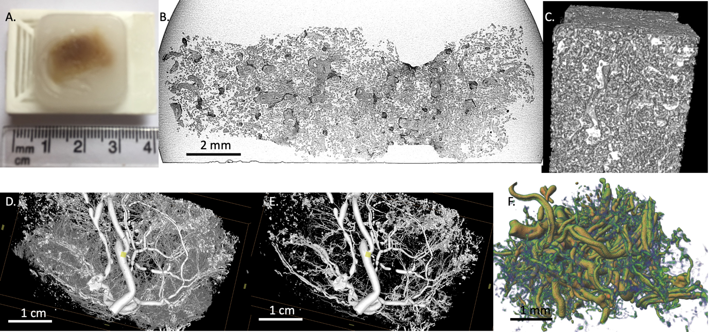
Figure 1, microCT on placental tissue in the cm to mm range including wax embedded tissue and vascular casting. A, MicroCT can be used to non-destructively generate a three-dimensional image of placental tissue within a paraffin wax block. Low contrast imaging approaches mean that it is not necessary to add contrast agents, allowing use of archival samples. B, A 2D slice taken from a 3D microCT data set showing wax embedded placental tissue. C, a 3D reconstruction of a region wax embedded villous tissue imaged by microCT (≈ 3 mm³). D and E, show microCT images of the same region of a whole placenta cotyledon (4 cm) where the fetal circulation had been perfused with microfill, in E the settings were adjusted to show only the larger vessels. The imaged region is 4.8 x 1.98 x 3.9 cm. The discontinuous regions seen in some vessels here suggest that insufficient microfill was perfused to clear the fluid from the longest sections of vessel resulting in fluid filled bubbles. F, microCT imaging of a smaller region of tissue (3 mm) allows resolution of smaller vessels and capillaries. The imaged region is 5.2 x 2.9 x 2.7 mm.

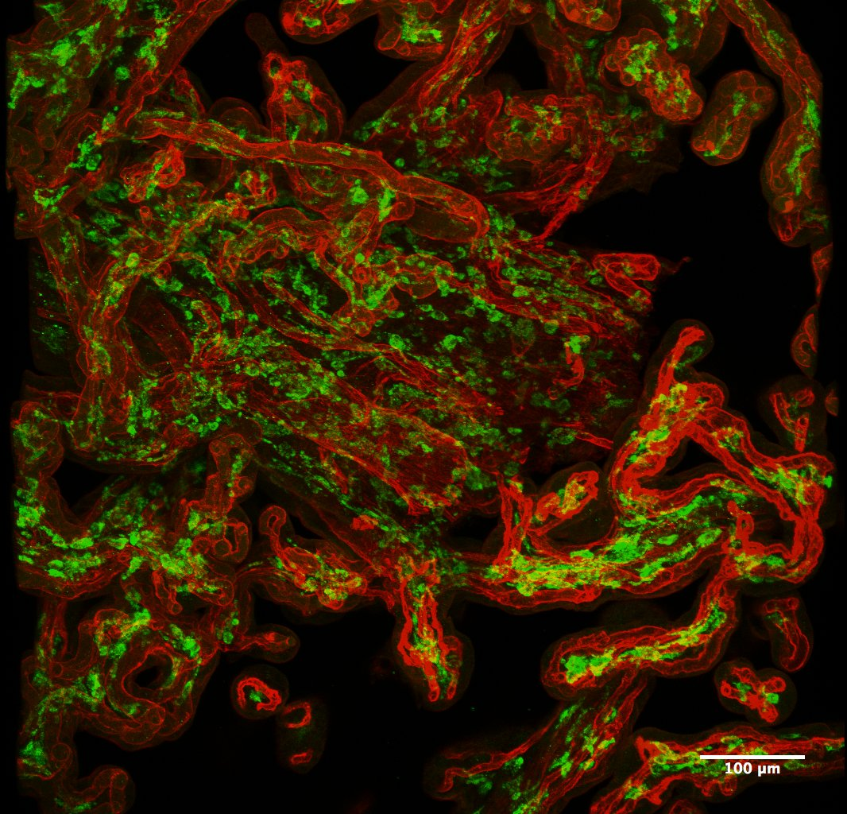
Figure 2, Three-dimensional projection of a confocal image stack showing term human placental villi with the blood vessels stained red (FITC-Aleuria Aurantia Lectin) and the macrophages stained green (anti-CD163 antibody). This image is 40 μm deep.

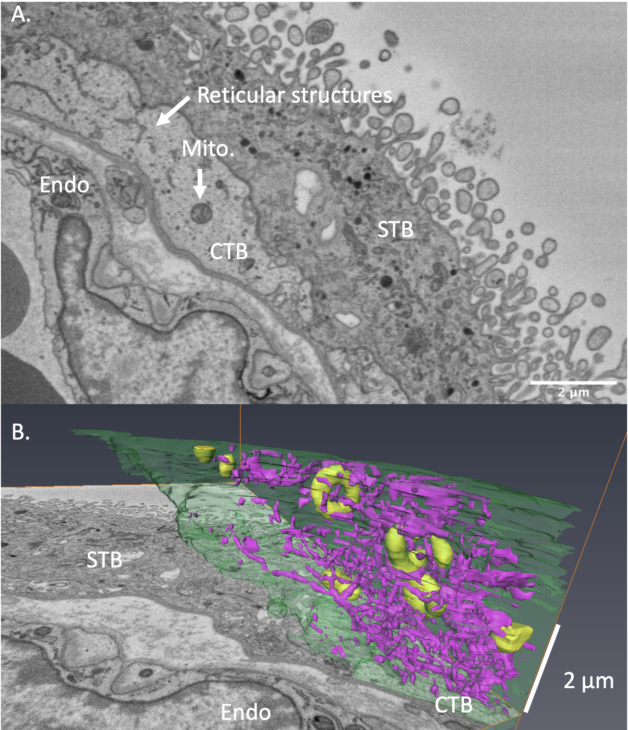
Figure 3, SBF SEM image stacks can be used to reconstruct subcellular structures. Here the plasma membrane, mitochondria and reticular structures of the cytotrophoblast are reconstructed. A, A two-dimensional image from the top of a SBF SEM stack showing a section of villus including cytotrophoblast (CTB) with mitochondria and reticular structures illustrated by arrows. B, a three-dimensional rendering of the cytotrophoblast within this stack with the cell in green, mitochondria in yellow and reticular structures (including endoplasmic reticulum and Golgi) in purple. STB = syncytiotrophoblast, Endo = endothelium.

