Drug delivery for traditional and emerging airway models
Karra. N. ª | Swindle. E.J. ^{b,c} | Morgan. H. ^{a,c}

ª Electronics and Computer Science, Faculty of Physical Sciences and Engineering, ^{b} Clinical and Experimental Sciences, Faculty of Medicine, ^{c} Institute for Life Sciences,
University of Southampton, UK.
Corresponding Author: Hywel Morgan (hm@ecs.soton.ac.uk)

Abstract

Respiratory diseases such as asthma and COPD have no cures and few new treatments. These diseases have an immutable mortality rate and impact millions of individuals worldwide. Respiratory drug development is time-consuming and costly, owing to the inability of existing models to replicate the complexity of human disease (static cell cultures and animal models). The problem is intensified through the way in which drugs are delivered to these models, which is not always representative of the human microenvironment, where different drug delivery methods (impaction, sedimentation and diffusion) target different regions of the lungs. This review describes current models of the human airways together with the range of different aerosol drug delivery methods (commercially available and in development) alongside emerging Organ on Chip technologies.

Keywords: Respiratory Disease; Organ on Chip; In Vitro Models, Drug Discovery; Drug Delivery Platform

Abbreviations

Funding: This work was supported by the Engineering and Physical Sciences Research Council (EPSRC)

Credit Author Statements
Nikita: Investigation, Writing – Original Draft, Visualisation
Hywel: Writing – Review and Editing, Supervision, Funding Acquisition
Emily: Writing – Review and Editing, Supervision

Table of Contents
1. Introduction 2
1.1 The burden of respiratory diseases 2
1.2 The anatomy and cellular physiology of the human lungs 2
1.3 The challenges of respiratory drug development 4
1.3.1 Respiratory diseases 4
1.3.2 Drug delivery to the human airways 4
2. Recapitulating human respiratory diseases and drug delivery 6
2.1 Animal models and drug delivery 6
2.2 In vitro models and drug delivery 7
2.2.1 Static in vitro models 7
2.2.2 Dynamic ‘Organ on Chip’ in vitro models 8
2.2.3 Drug delivery to in vitro models 9
3. Conclusion 16
4. Bibliography 17

Introduction

1.1 The burden of respiratory diseases

Worldwide, chronic respiratory diseases account for 4 million premature deaths per annum [1], with 500 million individuals affected by asthma and chronic obstructive pulmonary disease (COPD) alone [2]. There are no cures and few new treatments have been developed; furthermore, the mortality rate is thought to likely increase over the next decade due to diseases such as COPD [3], predicted to be the 3rd leading cause of death worldwide by 2030 [4].

The impediment to improving mortality rates is complex but may be affiliated with the lack of progress in respiratory drug development, despite the advancement in technology and healthcare over the last decade. Many drugs do not surpass the final stages of clinical trials with only 3% of these drugs reaching the market due to drug safety and efficacy concerns, resulting in prolonged development times of 15-20 years and an expenditure of over $1.5 billion per approved drug [5]. The contributing factors leading to this are complex and multifactorial. One aspect is the difficulty in modelling human physiology and disease with traditional methods using non-complex static in vitro models and/or in vivo animal models. These inadequate models coupled with unphysiologically relevant methods of respiratory drug deposition lead to a deficit in accurate recapitulation, indicating the requirement for a more physiologically relevant model of the human lungs and delivery methods.

1.2 The anatomy and cellular physiology of the human lungs

The human airway consists of the proximal conducting airways (trachea to the terminal bronchioles) and the distal respiratory airways (respiratory bronchioles to the alveoli) (Figure 1). The lungs provide a large surface area (140 m²) enabling efficient gas exchange, achieved through numerous bifurcations of the airways over 20 generations into multiple, shorter and narrower branches when moving deeper into the lungs, ending with clusters of alveoli termed alveolar sacs (the site of gas exchange) [6] (Figure 1).

In addition to gas exchange, the airways also form a physical, chemical and immunological barrier to maintain homeostasis, due to the interaction between the lungs and the external environment through the air breathed in, leading to susceptibility to damage from particulates, toxins, microorganisms and allergens. The oral and nasal cavities contain hairs and mucus that trap airborne particulates. Further down the airways, alternative mechanisms to remove particulates are employed [6], coinciding with the differences in smooth muscle abundance, type of epithelium and cells [7]. The gradually changing epithelium of the airways is shown in Figure 2, where tight junctional proteins between cells separate the apical surface (airway lumen) from the basolateral surface (basement membrane), allowing selective passage of macromolecules and ions.

The barrier function further is strengthened by the entrapment and expulsion of inhaled organisms and compounds via the mucociliary escalator (synchronous beating of cilia to move mucus out of the airways) in the bronchial region (Figure 2) and the constriction of the bronchi and bronchioles in response to irritants, restricting the passage of particulates to the alveoli. If organisms or particulates are able to evade these first-line physical and chemical defences and enter the alveoli, they are neutralised and removed by the immunological barrier. However, the impairment of airway bronchial barrier function and continual exposure to compounds and chronic inflammation can lead to the development or exacerbations of respiratory conditions such as asthma [8] and COPD.

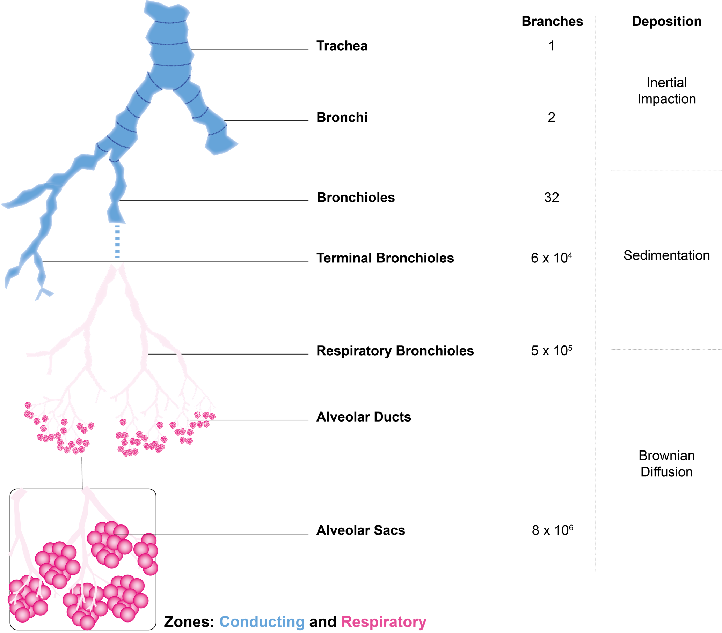
Figure 1: The constituents and branching of the lungs in the conducting (blue) and respiratory (pink) zones and the dominant mechanisms of deposition in these areas. Adapted from [6], [9].
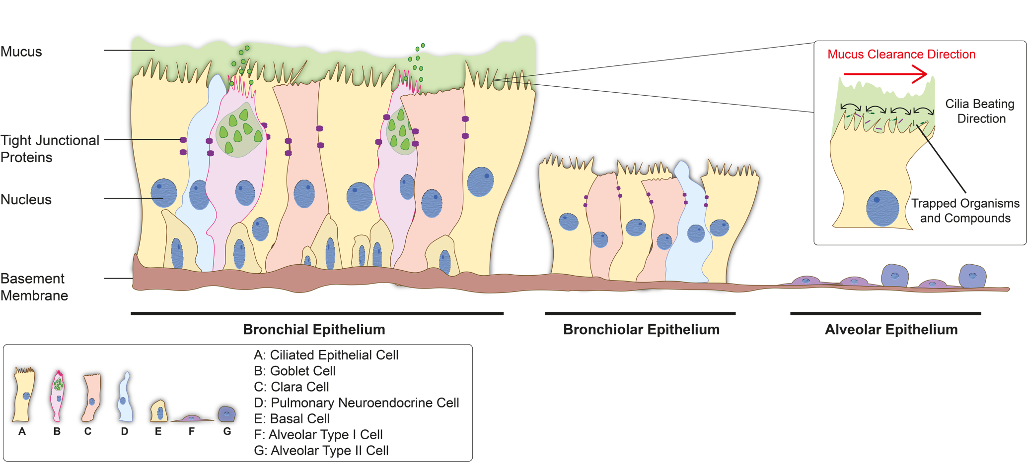
Figure 2: The epithelium cellular changes throughout the lungs from the bronchi to bronchioles to alveoli (adapted from [9],[10]) highlighting the mucocilliary clearance in the bronchial epithelium through the synchronous beating of cilia leading to the movement of mucus out of the lungs.

1.3 Challenges in respiratory drug development

1.3.1 Respiratory diseases
The complexity of respiratory diseases is a major contributing factor in the failure of drug development, as patients have a unique microenvironment and current pharmaceuticals often only alleviate symptoms and are not fully effective in severe disease. Asthma is characterised by airway remodelling, inflammation and spasms in the bronchi resulting in breathing difficulty as the smooth muscle in the airways contracts in response to triggers [6]. But there are many endotypes (e.g. habitual, allergic, non-allergic and occupational) and severities of asthma defined by treatment status (mild, moderate and severe) which cannot be treated in the same way [11].

COPD (specifically emphysema and chronic bronchitis) is characterised by an obstruction to airflow and reduction of oxygenation caused primarily by cigarette smoking affecting the alveolar and bronchial regions respectively. Emphysema refers to the destruction and collapse of alveoli resulting in a reduction of gas exchange surfaces, whereas chronic bronchitis and airway obstruction are caused by mucus accumulation in the bronchioles, airway inflammation and thickening [6]. The myriad of COPD phenotypes have yet to be fully characterised, impeding the progress to drug discovery as patient responses are particular to each individual [12]. The unique nature of these respiratory diseases coupled with the complex physiology of the human lung, provide a plethora of complications in terms of recapitulation. Thus, personalised medication promises improvements in the quest to cure these diseases, but often genetic and environmental interactions contribute to disease pathogenesis.

1.3.2 Drug delivery to the human airways

The challenge of recapitulating disease is complicated by the lack of models that successfully mimic the human lung in terms of barrier function and airway bifurcation (branching) (Figure 1), together with the scarcity of devices or methods that can deliver particulate compounds in a physiologically relevant manner. Branching impacts the delivery of compounds, acting as a particulate sieve; the size of depositing particles decreases when moving deeper into the lungs, with over 50% of particles >10 μm depositing in the mouth and throat regions and the majority of particles between 1 – 5 μm depositing in the lower airways [9]. Size separation is a result of the dominating forces for deposition in different regions of the lungs. Inertial impaction in the conducting airways refers to the inability of larger particles (> 5 μm) to follow abrupt changes in the air streamlines when encountering the bifurcations as the airways become narrower, thus particles deposit in the tracheal and bronchial regions (Figure 3A). Smaller particles 1 – 5 μm have less inertia and change trajectory to reach the lower bronchioles, where particles deposit via sedimentation due to gravitational forces and are influenced by the particle residence time in the airways (Figure 3B). Particles smaller than 1 μm are able to reach the alveolar region where deposition is dependent upon the random motions of particles and their collisions with gaseous molecules (Brownian motion and diffusion) [9], [13] (Figure 3C).
Secondary deposition mechanisms include turbulent flow, interception and electrostatic impaction. Turbulent flow occurs in the upper airways, where the trajectory of particles in terms of their magnitude and direction fluctuates sporadically resulting in mixing and deposition (Figure 3D). Another subordinate mechanism is referred to as interception, where the shape and/or size of a particle influences its impaction likelihood; important for elongated fibre-like particles (Figure 3E). Electrostatic precipitation is driven by electrostatic attraction between the airway walls and charged particles, which occurs when charged particles flowing close to the airway walls induce image charges on the surface, attracting particles of an opposite sign [13] (Figure 3F). The method of drug delivery within models of the human lung must also be physiologically relevant for the region of the lung being recapitulated, which is challenging given the complexity of the human lung and the associated difficulties with recreating viable models.

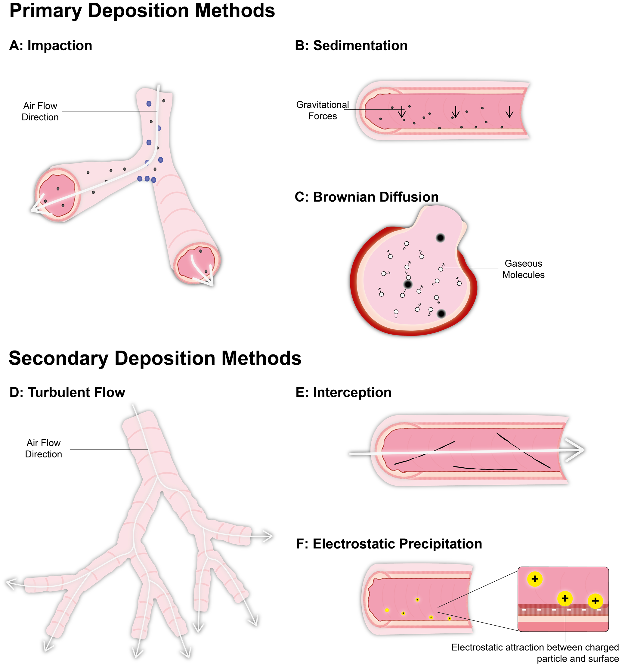
Figure 3: Types of Particle Deposition in the Lungs. Primary Deposition Methods (A-C) and Secondary Deposition Methods (D-F). A: Inertial impaction. B: Sedimentation. C: Brownian diffusion D: Turbulent flow. E: Interception and F: Electrostatic impaction.

Recapitulating human respiratory diseases and drug delivery

2.1 Animal models and drug delivery
Animal models are widely used to emulate human disease and to develop new pharmaceutical drugs. Animal models such as mice [14] can be genetically modified and humanised, providing a complex dynamic environment [15] as organs do not act in isolation given the circulation of nutrients, hormones and mediators around the body [15], [16]. They enable drug-organ interactions to be analysed in real-time particularly absorption, distribution, metabolism and excretion (ADME) [15]. Furthermore, animal models presume an estimation of safe and acceptable starting doses and exposure ranges that can be implemented in the proceeding human clinical trials [17].

However, animals can be exposed to much higher doses compared to those used in standard human trials, leading to extrapolation difficulties [18]. It is also challenging to find appropriate in vivo models that accurately recapitulate the human condition, for instance mimicking the structural changes in the lungs that occur for human-specific diseases such as Asthma [19], where the closest conditions are found in cats with allergic syndrome, or heaves in horses [15], [19]–[21]. Non-Human Primate (NHP) models are also used, which successfully demonstrate respiratory symptoms and relevant cellular/molecular changes [22]. However, these models are costly due to the intensive clinical monitoring and medical care required [18], [22] and time-consuming, requiring frequent exposures over 18 months.

Murine models dominate the field, owing to ease of handling, breeding, maintenance and ease of genetic modification for the study of a particular disease; also molecular probes and reagents are readily available [23]. Murine models have enabled a better understanding of allergic airway inflammation linked to asthma pathophysiology [23] in addition to early and late-stage bronchodilation following allergen exposure [23]. However, naturally occurring respiratory conditions (Asthma and COPD) are absent in mice [14], [23], consequently, mice require peritoneal, subcutaneous or dermal sensitisation methods which are not always physiologically relevant [21] (e.g. injection with egg white protein Ovalbumin). Therefore, mice often do not develop the characteristic irreversible structural changes that occur within human disease following prolonged inflammation [23] except when using more relevant allergens such as House Dust Mite (HDM) extract [21]. Species differences are also present, including size of lungs, branching patterns, mediator release and cellular abundance [21], [24], for instance, goblet cells, mast cells and IgE antibody sparsity in murine lungs [21], [25], [26]. Furthermore, genetic differences between strains require multi-strain testing in order to obtain the complete impact of a pharmaceutical drug, which is both time-consuming and costly [15].

Furthermore, animals used for testing are kept in an artificial environment, whereby exposure to stimulants is controlled, allowing detailed investigation with limited interference from other compounds. Thus animals are unlikely to accurately recapitulate the fundamental environmental factors that contribute to 50% of Asthma susceptibility [20]. Additionally, toxicity is species-specific, demonstrated through severe penicillin toxicity in hamsters and guinea pigs which is absent in mice [27]; this can influence animal selectivity and drug safety during trials. The combination of these various limitations contributes to the impediment in drug research and development, as highlighted by the European Innovative Medicines Initiative [19].

2.2 In vitro models and drug delivery
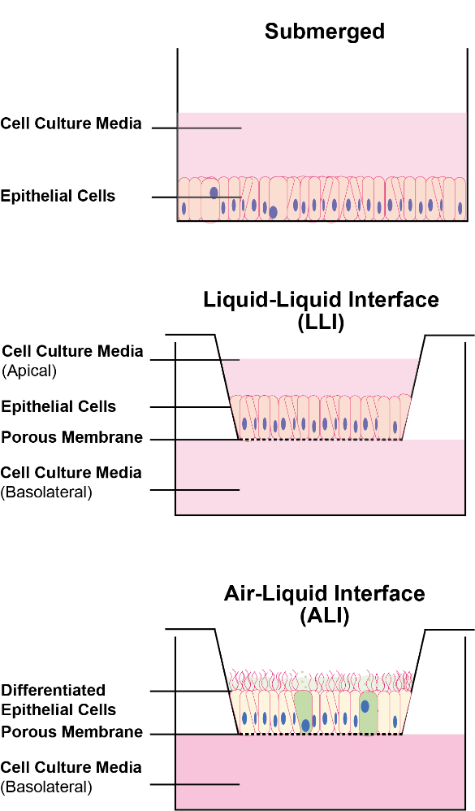
Figure 4: In vitro cell culture conditions refering to the location and/or presence of liquid around the cells.

2.2.1 Static in vitro models

Conventional in vitro models consist of an epithelial barrier (either patient-derived primary cells or immortalised cell lines) grown in either submerged, Liquid-Liquid Interface (LLI) or un-submerged Air-Liquid Interface (ALI) conditions using commercial Transwells or Snapwells. These devices contain a nanoporous support membrane onto which cells are cultured (Figure 4). ALI cultures enable cells to grow, polarise and differentiate developing mucus-producing goblet cells, functional ciliated cells [28] and basal cells.

In vitro models of the lungs enable specific cellular processes to be studied in greater detail enabling a deeper understanding of disease pathogenesis [28], an advantage compared with animal models. This greater insight of specific processes allows potential therapeutic targets to be identified which would be difficult to pinpoint in a whole organism where a plethora of signalling processes occur simultaneously. However, replicating a partial picture of the lungs is also disadvantageous, lacking the complexity that exists in the human internal environment [28]. This shortage of detail is exemplified through static ALI monocultures which lack physiological cell-cell communication, that can be addressed through the co-culturing of multiple cell types such as epithelial cells alongside fibroblasts, endothelial cells, smooth muscle cells or immune cells [28], [29]. These co-culture models allow more physiologically relevant environments to be created and subsequently, complex experiments to be conducted for instance monitoring macrophage and dendritic cell (DC) behaviour with a bronchial epithelium cell line (16HBE14o-) where particulate transfer was observed from DC to macrophages without disruption of barrier integrity [24], [30].

Primary respiratory epithelial and endothelial cells (directly obtained from patients) also increase complexity as they vary from donor to donor [14] thus are more reflective of the human condition with unique patient microenvironments, and can help pave the way towards personalised medication. However, these cells are often isolated from patients that are in the terminal stages of respiratory failure or deceased, so may not provide information regarding disease predisposition and pathogenesis [26], [31]. These cells also require rigorous ethical approval before use and results can be challenging to interpret and standardise given the variability in genetic and lifestyle factors [14].

Complex in vitro modelling can also be achieved using stem cells (cells with the ability to develop into multiple differentiated cell types). Induced pluripotent stem cells (iPSCs) have been shown to generate a mature polarised airway epithelium (ciliated, clara and goblet cells) when using a combination of different cell culture mediums supplemented with sequentially timed inhibitors and activators for developmental signalling pathways. This allows detailed cell-cell communication analysis and precise investigation of lung diseases such as cystic fibrosis, asthma and COPD with respect to pathogenesis and predisposition, providing a potential method for drug screening in the future [26], [31]. However, stem cell research is still in its infancy and complex diseases are challenging to model [32]. Stem cells are also expensive to produce and characterise, difficult to reprogram as evident through the low-efficiency rate [32].

Analytical methods to probe barrier integrity in static in vitro models include the use of fluorescent dyes or molecules to examine macromolecular flux [33], [34], where the leaching of fluorescent molecules such as dextran is measured. Ionic barrier integrity is determined from trans-epithelial electrical resistance (TER) which measures the flow of electrical current between electrodes (in the apical and basolateral chambers) to calculate the Ohmic resistance of the tight junctional proteins between cells. Periodic TER data is obtained through intermittent removal of samples from the incubator and measurement of the resistance using external “chopstick electrodes” [35], but the procedure can unduly perturb the cells.

Static in vitro models provide a means of rapidly investigating compounds in an isolated manner so are beneficial for high throughput applications. But these models lack complexity, for example, no interstitial flow and mechanical movement, and offer only a partial picture of the human microenvironment, missing out crucial organ-organ interactions. Owing to this, static cell cultures are limited in their ability to recapitulate the human condition, much like animal models (subjected to species differences).

2.2.2 Dynamic ‘Organ on Chip’ in vitro models

The Organ on Chip platform aims to address the challenge of recapitulating human disease using in vitro cell culture, providing previously unobtainable information [36]–[38]. Organ on Chip models have evolved in complexity through the incorporation of sensing technologies, faster analysis and response times, reduced running costs and integration of many organ types [39].

Lung on Chip devices (Figure 5) consist of immortalised airway cell lines or primary cells grown in vitro (with or without media perfusion). Two microfluidic channels separated by a nanoporous membrane enable the culture of epithelial and endothelial cells on either side [33], [35]–[38] Continuous media perfusion mimics in vivo interstitial flow, essential for nutrient supply and metabolic waste removal [16]. Lung on Chip devices can also integrate mechanical stretch to recapitulate in vivo forces, viscosities and/or local pressure cycles at rates synonymous with the human microenvironment [24], [37]. Cyclic strain is imparted via elastic deformation of the nanoporous membrane, mimicking the alveolar epithelium and endothelium stretching during inhalation [37], [35] (Figure 5A and Figure 5B ). Other integrated features include biocompatible membranes (Poly (lactic-co-glycolic acid): PGLA) with nanofiber scaffolds (Figure 5C) where the thickness can be altered to replicate different areas of the lungs [33] or pathological conditions [40]. Cells grown in Lung on Chip devices possess functional cilia with the correct organisation and length and demonstrate mucociliary clearance comparable to the human lungs [36]. Lung on chip devices can also be combined with other organs on chips to create a ‘Body on Chip’ [41]–[44] allowing more detailed diagnosis and prognosis in the future for a patient-centric approach since organs in the dynamic human microenvironment do not act in isolation.

Lung on Chip platforms enable monitoring of the inflammatory response after exposure to various stimuli. Polycytidylic acid (Poly I:C) an analogue of viral dsRNA [45] has been used to analyse cellular responses of Asthmatics during viral respiratory infections and platforms allow investigation of crosstalk between the alveolar epithelium and vascular endothelium as evident through endothelium activation and neutrophil recruitment [36], [37]. Another example includes neutrophil and macrophage recruitment following exposure to the bacterial cell-wall component lipopolysaccharide endotoxin (LPS) as found in COPD airways in vivo [36]. It was also found that breathing motions are a major contributor to IL-2 induced pulmonary oedema [46]. Thus, Lung on Chip platforms can model specific and detailed disease interactions.

Organ on Chip technologies can alleviate many of the issues associated with traditional in vitro and in vivo models and could ultimately provide predictive tools for new drug development and discovery [37]. Despite the ability of Lung on Chip devices to better recapitulate the human airway microenvironment, many areas for improvement include changes to barrier thicknesses, cellular composition and incorporation of air pressure and flow changes [37]. The majority of Lung on Chip devices are unable to provide real-time monitoring of cellular responses and are made of materials such as Poly-dimethyl-siloxane (PDMS), which can absorb and leech small hydrophobic molecules such as dyes and drugs [37], rendering them unsuitable for testing of many pharmaceutical drugs [47], [48].

This problem has been addressed in some Organ on Chip devices through the incorporation of integrated electrodes [35], [43], [49] to measure TER in-situ. Some devices [35], [43] using submerged cell cultures (LLI) can provide TER data in real-time, whereas for cells grown at ALI the TER is measured every few days through periodic cell submersion [49]. Thus, exemplifying the integrations that can be made to eradicate setbacks with traditional approaches, to enable closer recapitulation of the human microenvironment, whilst also revealing the obstacles that are yet to be addressed.
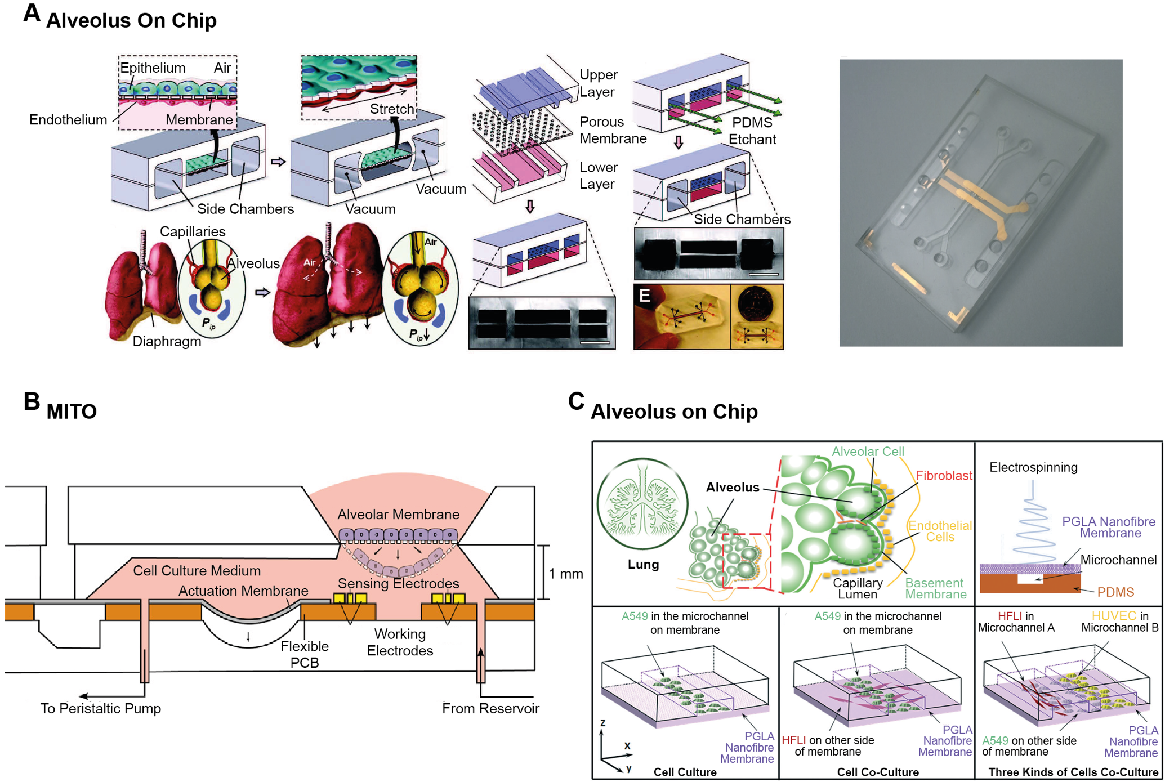

Figure 5: Examples of Lung on Chip devices. A: Wyss Institute’s Alveolous on Chip [37], [49]. B: ARTOG Centre for Biomedical Engineering Research’s MITO system [35]. C: Material Genome Institute’s Alveolus on Chip [33]. Figures reused with permission from Royal Society of Chemistry (A, C) and Elsevier (B), detailed information in references.

2.2.3 Drug delivery to in vitro models

Investigation of pharmaceutical drug efficacy and toxicity is conducted through the exposure of differentiated epithelial cells at an ALI. For static in vitro systems, drugs are directly introduced via direct pipetting of a liquid suspension. Drugs can also be delivered through the air using drug delivery systems that mimic methods of deposition in different regions of the lungs (impaction, sedimentation and diffusion). These drug delivery platforms can integrate with commercially available transwells and traditional types of inhalers to emulate human in vivo inhalation and drug deposition [9].

Inertial Impaction Devices

Inertial impaction is the fundamental basis on which many currently available devices operate and is a physiologically relevant deposition method for the tracheal and bronchial regions of the airways [9] for particles > 5μm [13]. It works on the principle of inertia; devices use a series of perpendicular nozzles, stages and collection plates to separate particles based upon the magnitude of their inertia (illustrated in Figure 6). Larger particles cannot follow the abrupt changes in direction and impact onto a surface, whereas, smaller particles can follow the changes in direction and will continue through to the next collection stage [50]. This method is used in devices such as impingers (twin stage impinger and multi-stage liquid impinger) and impactors (Marple-Miller, Anderson cascade and next generation) depicted in Figure 7A-E respectively.

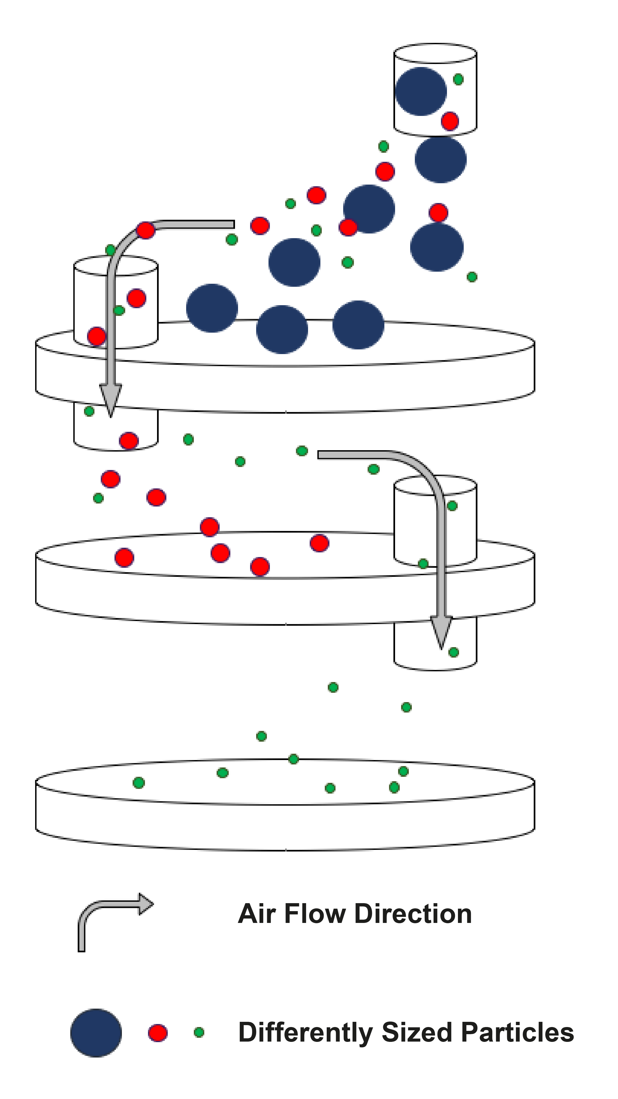
The number of stages and subsequent separation resolution varies between devices, as does the orientation of stages with two [51], [52] or multiple stages [53]–[57] placed either vertically [51]–[56] or horizontally [57]. Physiological relevance can be increased through appropriate air flow rates [52], [58] and liquid incorporation in the stages (<0.2-8 µm depth) mimicking mucus and preventing particle bounce back [53],[54]. Devices can suffer from turbulent flow when integrating transwells (upwardly) [53] but alternate orientations (downwardly) can solve this problem [54]. Usability is also increased with the ability to interface with dry powder inhalers (DPI), pre-metered dose inhalers (PMDI) and nebulisers [57]. However, some devices require multiple dose delivery for quantifiable deposition [51]–[55], unfavourable when working with new developmental pharmaceuticals [55], [59]. Additionally, all devices require regular disassembly/reassembly and cleaning every time new transwells are used or a different sample is processed which is time-consuming.
Figure 6: Inertial Impaction. Arrows indicating airflow direction and particle separation based on inertial force, smaller particles are able to follow abrupt changes in the airflow so can continue to the next stage, whereas larger particles cannot so impact onto the surface.
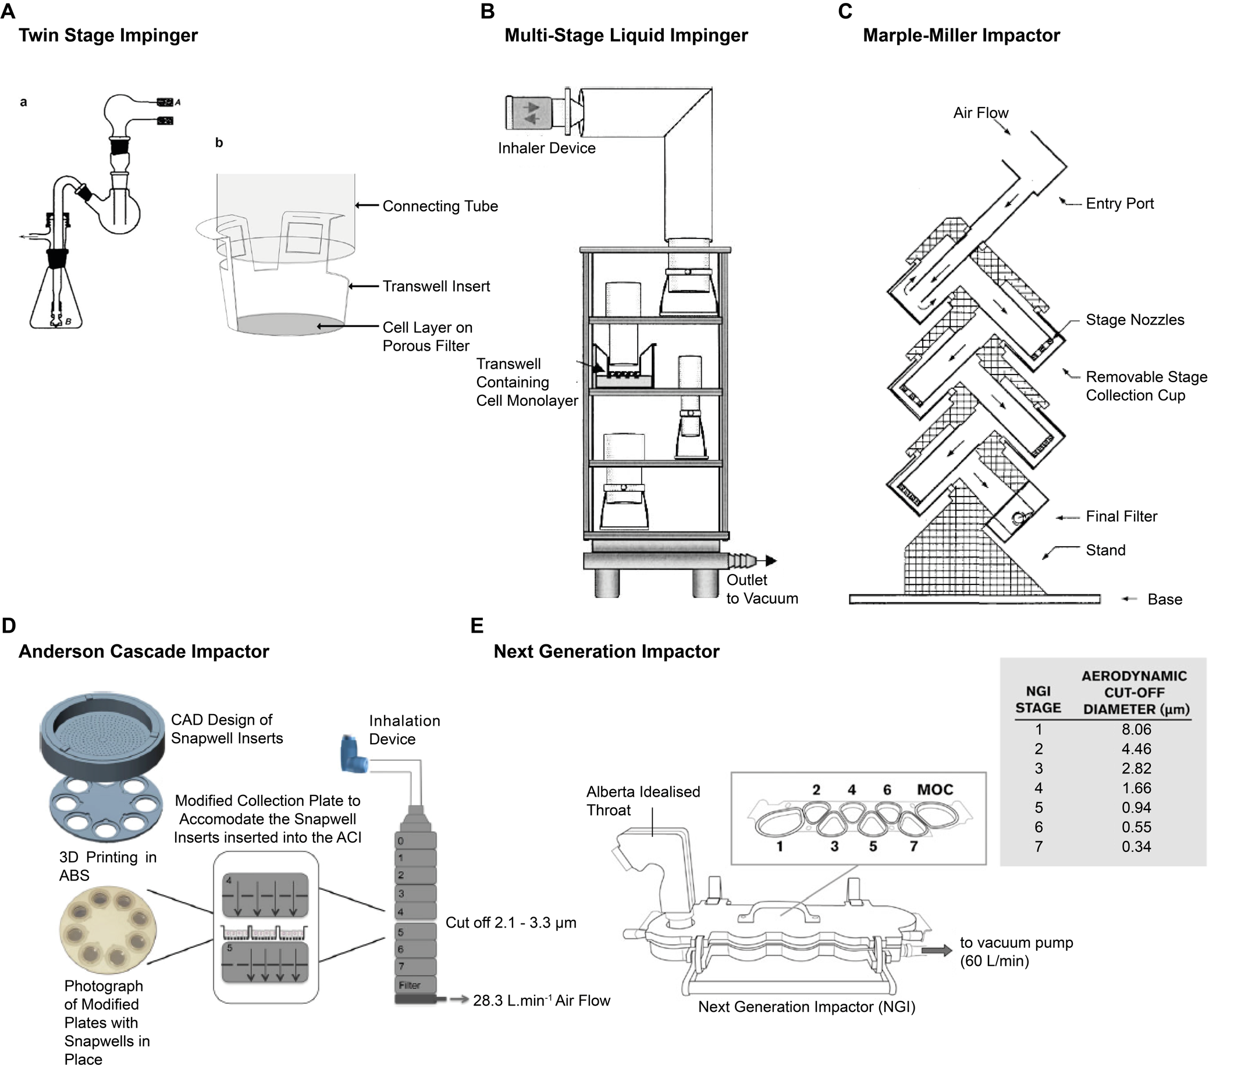

Figure 7: The Fundamental Features and Schematics of Inertial Impaction Devices. A: Twin Stage Impinger [52]. B: Multi-Stage Liquid Impinger [53]. C: Marple-Miller Impactor [55]. D: Anderson Cascade Impactor [59]. E: Next Generation Impactor [60]. Figures reused with permission from Elsevier (A), Springer Nature (B, D, E) and Taylor and Francis Ltd. (C), detailed information in references.

Electrostatic Impaction Devices

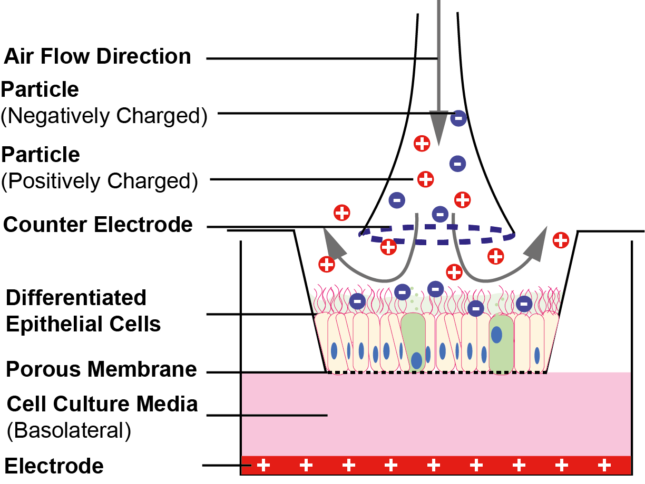
In electrostatic impaction devices, aerosolised particles are charged [61]–[64] and flow through a humidifier before depositing onto cells grown at ALI. A large planar electrode sits underneath a nanoporous membrane along with an electrode in the deposition nozzle above the membrane. Charged particles are attracted to the electrode below the membrane and impact onto the cell surface (Figure 8).
Figure 8: Electrostatic Impaction, charged particles are flowed onto cells. Particles of opposing charge are attracted to the electrode below the cells and impact onto the surface.

Although, electrostatic precipitation is not commonly used compared to inertial impaction [13], there are numerous commercial devices. Examples include the Nano Aerosol Chamber for In Vitro Toxicity (NACIVT) [61], [62] (Figure 9A), the Electrostatic Particulate Dosage and Exposure System (EPDExS) [63] (Figure 9B) and the Novel ALI Exposure system (NAVETTA) [64] (Figure 9C). These devices differ in their transwell orientation (upwards or downwards). Electrostatic deposition allows faster and controlled drug deposition with efficiencies of up to ~100% [62], [63] compared to ~2% efficiency with other devices (CULTEX) [65], and cells were found not to be adversely impacted by the electrical field [62], [63]. Furthermore, this method allows the investigation of low concentration samples [62]. However, particle charge dependence [63] can limit deposition efficiency for poly-disperse aerosols (different sizes and shapes) [66] via changes to mobility [65]. Devices can work without an electric field using a low horizontal flow, but this can lead to variability in the concentration of the deposited drug between transwells due to gradient formation [64].
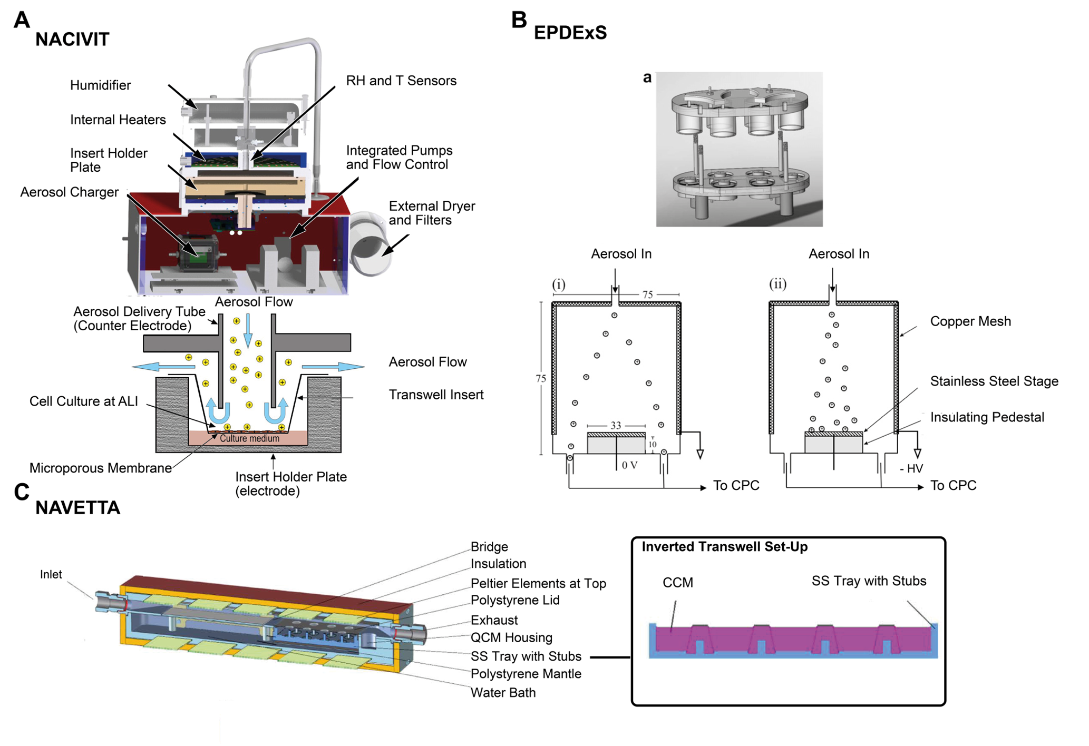
Figure 9: The Fundamental Features and Schematics of Electrostatic Impaction Devices. A: NACIVIT [61]. B: EPDExS [63]. C: NAVETTA [64]. Figures reused with permission from Elsevier (B) and ACS publications (C), detailed information in references.

Sedimentation and Diffusion Devices

Sedimentation and diffusion dominate particle deposition in the terminal and respiratory bronchioles to the alveolar regions [9]. Sedimentation and diffusion devices differ in terms of their working mechanisms compared with impaction devices. A common method utilises pressure differences to gently deposit compounds onto cells, as depicted in Figure 10.

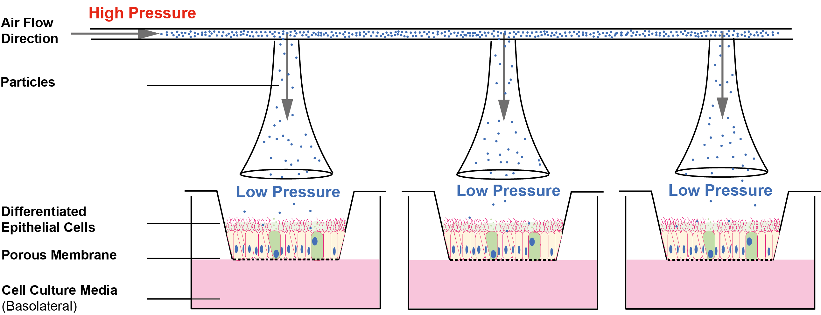
Figure 10: Pressure Derived Sedimentation and Diffusion. Particles are flowed through a tube at high pressure, with low pressure outlets above wells housing cells. Air will naturally flow from an area of high to low pressure allowing sedimentation and diffusion.
Devices using pressure difference to deposit particles with airflow include CULTEX [67] CG and RFS, VITROCELL [65], [66], [68], [69], the Pharmaceutical Aerosol Deposition Device on Cell Cultures (PADDOCC) [70] and the PreciseInhale Xpose ALI [71] (Figure 11A-C, E), Devices operating without airflow consist of the MicroSprayer (Figure 11D) and the Air-Liquid Interface Cell Exposure system (ALICE Cloud) [72] (Figure 11F) [73]. Although, all devices allow direct deposition onto transwells, they differ in numerous ways. For instance, the number of outlets and arrangement (from one outlet [65] for each transwell [67] to one outlet for many transwells [67]) and the ability to separate particles by size (similar to impactors) [70], dosage control [70], size (fitting inside a standard cell culture hood) [72], [74] or intended use (in vivo studies) [74]. Other differences include available functionalities such as: control of insert temperature [67], basolateral filling/emptying, electrostatic impaction capabilities [67] and data acquisition and automatic leak testing [65]. Some devices can also process small sample sizes, addressing issues with systems such as the TSI [59]. These devices however, can be more time-consuming to run (minutes-hours) [68], [70] compared to impaction based devices (seconds)[75] and some devices are problematic when used with viscous samples, reducing compound deposition [76].
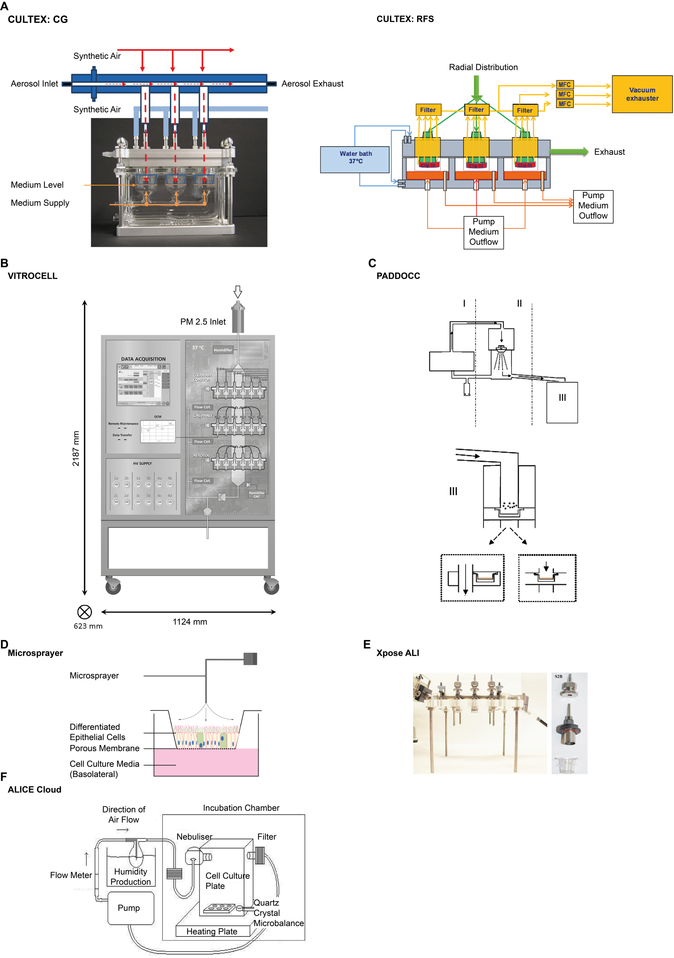

Figure 11: The Fundamental Features and Schematics of Sedimentary and Diffusion Based Devices. A: CULTEX CG and RFS [67]. B: VITROCELL [65]. C: PADDOCC [70]. D: Microsprayer, adapted from [73]. E: Xpose ALI [71]. F: ALICE Cloud [72], [77]. Figures reused with permission from Elsevier (A-C) and the Creative Commons Attribution 2.0 License (F), detailed information in references.
Drug delivery to static cell culture models of the human lungs is complex, with drug formulations undergoing changes prior to deposition onto cells. These changes include size separation (in impactors), flowing through humidified environments (electrostatic impaction) and changes in pressure (in sedimentation and diffusion devices).

The majority of these devices do not integrate with the Organ on Chip technologies. Organ on Chip devices provide a promising solution to the current impediments in respiratory drug development and testing, through complex dynamic culture conditions emulating the human condition. But owing to their unique and mostly enclosed designs, which include tubing and external pumps, they are unable to fit into the drug delivery machinery, revealing a requirement for a new miniature drug delivery device compatible with Organ on Chips. Recent attempts to address this include the use of a smoking instrument in conjunction with a small airway on chip to mimic human smoking behaviour with both cigarettes and e-cigarettes [78]. A commercially available mesh nebuliser has also been used to deliver aerosols to cells either directly [79] or indirectly (through fused silicon tubing [80]). However, vibrating mesh nebulisers can cause blockages for viscous samples and are difficult to clean [81]. Additionally, the nebuliser device is also limited for samples containing proteins as thermal unfolding can occur [76] or shearing of nucleic acids (>5 kbp) into open circular and fragmented configurations [82]. There is therefore a clear need to develop new Organ on Chip compatible drug delivery devices.

Conclusion

The development of new respiratory drug compounds is difficult due to the complexity of the human airways and disease. The developmental process is further hindered through the difficulty in emulation of the human microenvironment with conventional models (static in vitro transwells or animal in vivo models) to test new pharmaceutical compounds. Owing to this, the development of a singular compound is both time-consuming (15-20 years) and costly (>$1.5 Billion) [5].

Traditional methods often fail for numerous reasons. Murine models are predominately used to recapitulate human disease with drug delivery and testing in the form of injection or inhalation of compounds, followed by monitoring of an entire organism response. However, mice are ultimately a different species with a different cellular abundance (fewer goblet and mast cells), branching pattern and lung size compared to humans, meaning it is difficult to translate results across. This is particularly problematic in terms of toxicity (a key aspect during drug testing), as toxicity is species-specific.

Static cell cultures either primary cells (from patients), immortalised cell lines or stem cells grown at LLI or ALI on a nanoporous membrane, allow specific interactions to be investigated in more detail (cell-cell communication with multiple cell co-culture). Drug delivery to these static cell models is possible via the insertion of Transwell /Snapwell inserts into impaction, sedimentation and diffusion devices. These devices differ in their basic working principles, method of size separation, speed of delivery and physiological relevance. However, static cell culture models lack complexity such as the absence of organ-organ interactions, localised forces and pressures which are present in the human lungs. Thus, static cell cultures provide only a partial picture.

To address these challenges the ‘Lung on Chip’ is being developed. This combines in vivo complexity with in vitro specificity, an example is through membrane stretching to mimic breathing, continuous flow of nutrient-rich media to mimic interstitial flow, use of more physiologically relevant support membranes (upon which cells are grown) and through the combination of multiple organs to investigate organ-organ interactions. Lung on Chips can also allow real-time assessment of barrier integrity, and the addition of more biosensors in the future will further increase the data richness.

However, there are still improvements to be made in terms of achieving greater physiological relevance through increasing cellular composition using epithelial, endothelial and immune cells perhaps via the use of stem cells. Also, devices with mechanical movement have only incorporated stretching, but have not included constriction (a key symptom for asthmatic individuals). Future developments can include changes in air-flow and pressure as found in the human airways [37]. The way in which these devices are fabricated can also be updated as current materials (PDMS) can leach and absorb small molecules (drugs and dyes) so are unsuitable for long term investigation and new pharmacological compounds [37], [47], [48], meaning alternative materials must be explored. Furthermore, ‘Lung on Chip’ devices are unique meaning one device does not yet encompass all the advantages examined, so collaborative work to create a well-rounded lung on chip would be beneficial and valuable for drug development and discovery.

Other limitations include the limited number of physiologically relevant drug delivery systems that can interface with these Lung on Chip models. Thus, appropriate platforms need to be developed that are able to generate and correctly deposit a monodisperse aerosol onto cells being grown in these devices. The combination of Lung on Chip devices and integrated drug delivery will enable the identification of unsuccessful pharmaceutical compounds earlier in the pipeline saving both time and money, allowing more compounds to be screened. Use of these devices together will allow a better understanding of human disease to be generated, facilitating the establishment of new therapeutic targets and paving the way for personalised medication through unlocking previously unavailable information impeded by traditional methods.

Bibliography
[1] Forum of International Respiratory Societies, Forum of International Respiratory Societies The Global Impact of Respiratory Disease, Second. Sheffield, 2017.
[2] World Health Organisation, “Global surveillance, prevention and control of CHRONIC RESPIRATORY DISEASES,” WHO Libr., pp. 1–37, 2007, doi: ISBN 978 92 4 156346 8.
[3] C. D. Mathers and D. Loncar, “Projections of global mortality and burden of disease from 2002 to 2030,” PLoS Med., vol. 3, no. 11, pp. 2011–2030, 2006, doi: 10.1371/journal.pmed.0030442.
[4] World Health Organisation, “Global Health Estimates Summary Tables: Projection of Deaths by Cause, Age and Sex, by World Bank Income Group,” Geneva, 2018.
[5] P. J. Barnes et al., “Barriers to new drug development in respiratory disease,” 2015, doi: 10.1183/09031936.00007915.
[6] E. P. Widmaier et al., Vander’s Human Physiology: The Mechanisms of Body Function, 12th ed. New York: McGraw Hill, 2011.
[7] E. E. Marieb and K. N. Hoehn, Human Anatomy and Physiology, Ninth. Essex: Pearson Education Limited, 2014.
[8] C. Xiao et al., “Defective epithelial barrier function in asthma,” J. Allergy Clin. Immunol., vol. 128, no. 3, 2011, doi: 10.1016/j.jaci.2011.05.038.
[9] J. S. Patton and P. R. Byron, “Inhaling medicines: Delivering drugs to the body through the lungs,” Nat. Rev. Drug Discov., vol. 6, no. 1, pp. 67–74, 2007, doi: 10.1038/nrd2153.
[10] C. E. Barkauskas et al., “Lung organoids: current uses and future promise.,” Development, vol. 144, no. 6, pp. 986–997, 2017, doi: 10.1242/dev.140103.
[11] J. Lötvall et al., “Asthma endotypes: A new approach to classification of disease entities within the asthma syndrome,” J. Allergy Clin. Immunol., vol. 127, no. 2, pp. 355–360, 2011, doi: 10.1016/j.jaci.2010.11.037.
[12] M. Miravitlles et al., “Treatment of COPD by clinical phenotypes: Putting old evidence into clinical practice,” Eur. Respir. J., vol. 41, no. 6, pp. 1252–1256, 2013, doi: 10.1183/09031936.00118912.
[13] C. Darquenne and D. Ph, “Chementator: Petroleum refiners fined,” Chem. Eng., vol. 108, no. 5, pp. 140–147, 2001, doi: 10.1089/jamp.2011.0916.
[14] S. Huang et al., “The Use of In Vitro 3D Cell Models in Drug Development for Respiratory Diseases,” Drug Discov. Dev. Present Futur., 2011, doi: 10.5772/50570.
[15] S. Garattini and G. Grignaschi, “Animal testing is still the best way to find new treatments for patients,” Eur. J. Intern. Med., vol. 39, pp. 32–35, 2017, doi: 10.1016/j.ejim.2016.11.013.
[16] C. Blume et al., “Temporal monitoring of differentiated human airway epithelial cells using microfluidics,” PLoS ONE, vol. 10, no. 10. 2015, doi: 10.1371/journal.pone.0139872.
[17] R. Mangipudy et al., “Use of animals for toxicology testing is necessary to ensure patient safety in pharmaceutical development,” Regul. Toxicol. Pharmacol., vol. 70, no. 2, pp. 439–441, 2014, doi: 10.1016/j.yrtph.2014.07.014.
[18] M. L. Graham and M. J. Prescott, “The multifactorial role of the 3Rs in shifting the harm-benefit analysis in animal models of disease,” Eur. J. Pharmacol., vol. 759, pp. 19–29, 2015, doi: 10.1016/j.ejphar.2015.03.040.
[19] A. M. Holmes et al., “Animal models of asthma: Value, limitations and opportunities for alternative approaches,” Drug Discov. Today, vol. 16, no. 15–16, pp. 659–670, 2011, doi: 10.1016/j.drudis.2011.05.014.
[20] K. Mullane and M. Williams, “Animal models of asthma: Reprise or reboot?,” Biochem. Pharmacol., vol. 87, no. 1, pp. 131–139, 2014, doi: 10.1016/j.bcp.2013.06.026.
[21] S. Sagar et al., “Translational value of animal models of asthma: Challenges and promises,” Eur. J. Pharmacol., vol. 759, pp. 272–277, 2015, doi: 10.1016/j.ejphar.2015.03.037.
[22] E. S. Schelegle et al., “Allergic asthma induced in rhesus monkeys by house dust mite (Dermatophagoides farinae),” Am. J. Pathol., vol. 158, no. 1, pp. 333–341, 2001, doi: 10.1016/S0002-9440(10)63973-9.
[23] M. Aun et al., “Animal models of asthma: utility and limitations,” J. Asthma Allergy, vol. Volume10, pp. 293–301, 2017, doi: 10.2147/JAA.S121092.
[24] C. Blume and D. E. Davies, “In vitro and ex vivo models of human asthma,” Eur. J. Pharm. Biopharm., vol. 84, no. 2, pp. 394–400, 2013, doi: 10.1016/j.ejpb.2012.12.014.
[25] A. Pardo-Saganta et al., “Ciliated cells of pseudostratified airway epithelium do not become mucous cells after ovalbumin challenge,” Am. J. Respir. Cell Mol. Biol., vol. 48, no. 3, pp. 364–373, 2013, doi: 10.1165/rcmb.2012-0146OC.
[26] H. W. Snoeck, “Modeling human lung development and disease using pluripotent stem cells,” Dev., vol. 142, no. 1, pp. 13–16, 2015, doi: 10.1242/dev.115469.
[27] P. J. K. Van Meer et al., “The safety, efficacy and regulatory triangle in drug development: Impact for animal models and the use of animals,” Eur. J. Pharmacol., vol. 759, pp. 3–13, 2015, doi: 10.1016/j.ejphar.2015.02.055.
[28] A. J. Miller and J. R. Spence, “In Vitro Models to Study Human Lung Development, Disease and Homeostasis,” Physiology, vol. 32, pp. 246–260, 2017, doi: 10.1152/physiol.00041.2016.
[29] C. Blume et al., “Cellular crosstalk between airway epithelial and endothelial cells regulates barrier functions during exposure to double-stranded RNA,” Immunity, Inflamm. Dis., vol. 5, no. 1, pp. 45–56, 2017, doi: 10.1002/iid3.139.
[30] F. Blank et al., “Macrophages and dendritic cells express tight junction proteins and exchange particles in an in vitro model of the human airway wall,” Immunobiology, vol. 216, no. 1–2, pp. 86–95, Jan. 2011, doi: 10.1016/j.imbio.2010.02.006.
[31] A. L. Firth et al., “Generation of multiciliated cells in functional airway epithelia from human induced pluripotent stem cells,” Proc. Natl. Acad. Sci. U. S. A., vol. 111, no. 17, 2014, doi: 10.1073/pnas.1403470111.
[32] A. E. Omole and A. O. J. Fakoya, “Ten years of progress and promise of induced pluripotent stem cells: Historical origins, characteristics, mechanisms, limitations, and potential applications,” PeerJ, vol. 2018, no. MAY, pp. 1–47, 2018, doi: 10.7717/peerj.4370.
[33] X. Yang et al., “Nanofiber membrane supported lung-on-a-chip microdevice for anti-cancer drug testing,” Lab Chip, vol. 18, no. 3, pp. 486–495, 2018, doi: 10.1039/c7lc01224a.
[34] S. J. Trietsch et al., “Membrane-free culture and real-time barrier integrity assessment of perfused intestinal epithelium tubes,” Nat. Commun., vol. 8, no. 1, pp. 1–7, 2017, doi: 10.1038/s41467-017-00259-3.
[35] Y. Mermoud et al., “Microimpedance tomography system to monitor cell activity and membrane movements in a breathing lung-on-chip,” Sensors Actuators, B Chem., vol. 255, pp. 3647–3653, 2018, doi: 10.1016/j.snb.2017.09.192.
[36] K. H. Benam et al., “Small airway-on-a-chip enables analysis of human lung inflammation and drug responses in vitro,” Nat. Methods, vol. 13, no. 2, pp. 151–157, Feb. 2016, doi: 10.1038/nmeth.3697.
[37] A. M. M. M.-Z. Dongeun Huh, Benjamin D. Matthews and D. E. I. Hong Yuan Hsin, “Reconstituting Organ-Level Lung,” Science (80-. )., vol. 328, no. June, pp. 1662–1669, 2010, doi: 10.1111/j.1460-6984.2012.00147.x.
[38] B. A. Hassell et al., “Human Organ Chip Models Recapitulate Orthotopic Lung Cancer Growth, Therapeutic Responses, and Tumor Dormancy In Vitro,” Cell Rep., vol. 21, no. 2, pp. 508–516, 2017, doi: 10.1016/j.celrep.2017.09.043.
[39] N. Khalid et al., “Recent lab-on-chip developments for novel drug discovery,” Wiley Interdiscip. Rev. Syst. Biol. Med., vol. 9, no. 4, pp. 1–17, 2017, doi: 10.1002/wsbm.1381.
[40] K. Watanabe et al., “Thickness of the basement membrane of bronchial epithelial cells in lung diseases as determined by transbronchial biopsy,” Respir. Med., vol. 91, no. 7, pp. 406–410, 1997, doi: 10.1016/S0954-6111(97)90254-7.
[41] C. D. Edington et al., “Interconnected Microphysiological Systems for Quantitative Biology and Pharmacology Studies,” Sci. Rep., vol. 8, no. 1, pp. 1–18, 2018, doi: 10.1038/s41598-018-22749-0.
[42] T. Satoh et al., “A multi-throughput multi-organ-on-a-chip system on a plate formatted pneumatic pressure-driven medium circulation platform,” Lab Chip, vol. 18, no. 1, pp. 115–125, 2017, doi: 10.1039/c7lc00952f.
[43] J. Yeste et al., “A compartmentalized microfluidic chip with crisscross microgrooves and electrophysiological electrodes for modeling the blood-retinal barrier,” Lab Chip, vol. 18, no. 1, pp. 95–105, 2017, doi: 10.1039/c7lc00795g.
[44] I. Wagner et al., “A dynamic multi-organ-chip for long-term cultivation and substance testing proven by 3D human liver and skin tissue co-culture,” Lab Chip, vol. 13, no. 18, pp. 3538–3547, 2013, doi: 10.1039/c3lc50234a.
[45] A. R. Lever et al., “Comprehensive evaluation of poly(I:C) induced inflammatory response in an airway epithelial model,” Physiol. Rep., vol. 3, no. 4, pp. 1–11, 2015, doi: 10.14814/phy2.12334.
[46] D. Huh et al., “A Human Disease Model of Drug Toxicity–Induced Pulmonary Edema in a Lung-on-a-Chip Microdevice,” Sci. Transl. Med., vol. 4, no. 159, pp. 159ra147-159ra147, Nov. 2012, doi: 10.1126/scitranslmed.3004249.
[47] L. a. Low and D. a. Tagle, “Microphysiological Systems (‘Organs-on-Chips’) for Drug Efficacy and Toxicity Testing,” Clin. Transl. Sci., vol. 10, no. 4, pp. 237–239, 2017, doi: 10.1111/cts.12444.
[48] B. Zhang and M. Radisic, “Organ-on-a-chip devices advance to market,” Lab Chip, vol. 17, no. 14, pp. 2395–2420, 2017, doi: 10.1039/C6LC01554A.
[49] O. Y. F. Henry et al., “Organs-on-chips with integrated electrodes for trans-epithelial electrical resistance (TEER) measurements of human epithelial barrier function,” Lab Chip, vol. 17, no. 13, pp. 2264–2271, 2017, doi: 10.1039/c7lc00155j.
[50] A. Nokhodchi and G. Martin, Pulmonary Drug Delivery: Advances and Challenges. John Wiley & Sons, 2015.
[51] G. W. Hallworth and D. G. Westmoreland, “The twin impinger: a simple device for assessing the delivery of drugs from metered dose pressurized aerosol inhalers,” J. Pharm. Pharmacol., vol. 39, no. 12, pp. 966–972, Dec. 1987, doi: 10.1111/j.2042-7158.1987.tb03142.x.
[52] C. I. Grainger et al., “The permeability of large molecular weight solutes following particle delivery to air-interfaced cells that model the respiratory mucosa,” Eur. J. Pharm. Biopharm., vol. 71, no. 2, pp. 318–324, 2009, doi: 10.1016/j.ejpb.2008.09.006.
[53] J. Fiegel et al., “Large Porous Particle Impingement on Lung Epithelial Cell Monolayers—Toward Improved Particle Characterization in the Lung,” Pharm. Res., vol. 20, no. 5, 2003, doi: 0724-8741/03/0500-0788/0.
[54] M. Bur et al., “A novel cell compatible impingement system to study in vitro drug absorption from dry powder aerosol formulations,” Eur. J. Pharm. Biopharm., vol. 72, no. 2, pp. 350–357, 2009, doi: 10.1016/j.ejpb.2008.07.019.
[55] V. a. Marple et al., “A low-loss cascade impactor with stage collection cups: Calibration and pharmaceutical inhaler applications,” Aerosol Sci. Technol., vol. 22, no. 1, pp. 124–134, 1995, doi: 10.1080/02786829408959732.
[56] D. Cooney et al., “Development of a Size-dependent Aerosol Deposition Model Utilising Human Airway Epithelial Cells for Evaluating Aerosol Drug Delivery,” ATLA, vol. 32, pp. 581–590, 2004.
[57] J. P. Mitchell, “The Next Generation Impactor(NGI): Results from the Evaluation of Prototype Instruments with Pressurised Metered Dose Inhaler (pMDI)-Based Formulations,” 2000, pp. 223–226.
[58] E. R. Weibel, Morphometry of the Human Lung, First. London: Springer- Verlag, 1963.
[59] M. Haghi et al., “In Vitro Cell Integrated Impactor Deposition Methodology for the Study of Aerodynamically Relevant Size Fractions from Commercial Pressurised Metered Dose Inhalers,” Pharm. Res., vol. 31, no. 7, pp. 1779–1787, Jul. 2014, doi: 10.1007/s11095-013-1282-2.
[60] S. Hoe et al., “Use of a Fundamental Approach to Spray-Drying Formulation Design to Facilitate the Development of Multi-Component Dry Powder Aerosols for Respiratory Drug Delivery,” Pharm. Res., vol. 31, no. 2, pp. 449–465, Feb. 2014, doi: 10.1007/s11095-013-1174-5.
[61] M. Geiser et al., “Evaluating Adverse Effects of Inhaled Nanoparticles by Realistic In Vitro Technology,” Nanomaterials, vol. 7, no. 3, p. 49, 2017, doi: 10.3390/nano7020049.
[62] M. Savi et al., “A novel exposure system for the efficient and controlled deposition of aerosol particles onto cell cultures,” Environ. Sci. Technol., vol. 42, no. 15, pp. 5667–5674, 2008, doi: 10.1021/es703075q.
[63] J. P. Stevens et al., “A new method for quantifiable and controlled dosage of particulate matter for in vitro studies: The electrostatic particulate dosage and exposure system (EPDExS),” Toxicol. Vitr., vol. 22, no. 7, pp. 1768–1774, 2008, doi: 10.1016/j.tiv.2008.05.013.
[64] E. Frijns et al., “A Novel Exposure System Termed NAVETTA for in Vitro Laminar Flow Electrodeposition of Nanoaerosol and Evaluation of Immune Effects in Human Lung Reporter Cells,” Environ. Sci. Technol., vol. 51, no. 9, pp. 5259–5269, 2017, doi: 10.1021/acs.est.7b00493.Figure 9C reuse permission granted by ACS publications, for further permissions contact ACS directly.
[65] S. Mülhopt et al., “Toxicity testing of combustion aerosols at the air-liquid interface with a self-contained and easy-to-use exposure system,” Journal of Aerosol Science, vol. 96. pp. 38–55, 2016, doi: 10.1016/j.jaerosci.2016.02.005.
[66] H. R. Paur et al., “In vitro exposure systems and bioassays for the assessment of toxicity of nanoparticles to the human lung,” J. fur Verbraucherschutz und Leb., vol. 3, no. 3, pp. 319–329, 2008, doi: 10.1007/s00003-008-0356-2.
[67] M. Aufderheide et al., “Improvement of the CULTEX®exposure technology by radial distribution of the test aerosol,” Exp. Toxicol. Pathol., vol. 69, no. 6, pp. 359–365, 2017, doi: 10.1016/j.etp.2017.02.004.
[68] A. Comouth et al., “Modelling and measurement of particle deposition for cell exposure at the air-liquid interface,” J. Aerosol Sci., vol. 63, pp. 103–114, 2013, doi: 10.1016/j.jaerosci.2013.04.009.
[69] J. Adamson et al., “Assessment of an in vitro whole cigarette smoke exposure system: The Borgwaldt RM20S 8-syringe smoking machine,” Chem. Cent. J., vol. 5, no. 1, p. 50, 2011, doi: 10.1186/1752-153X-5-50.
[70] S. Hein et al., “A new Pharmaceutical Aerosol Deposition Device on Cell Cultures (PADDOCC) to evaluate pulmonary drug absorption for metered dose dry powder formulations,” Eur. J. Pharm. Biopharm., vol. 77, no. 1, pp. 132–138, 2011, doi: 10.1016/j.ejpb.2010.10.003.
[71] J. Ji et al., “Development of combining of human bronchial mucosa models with XposeALI® for exposure of air pollution nanoparticles,” PLoS One, vol. 12, no. 1, pp. 1–17, 2017, doi: 10.1371/journal.pone.0170428.
[72] A.-G. Lenz et al., “Efficient Bioactive Delivery of Aerosolized Drugs to Human Pulmonary Epithelial Cells Cultured in Air–Liquid Interface Conditions,” Am. J. Respir. Cell Mol. Biol., vol. 51, no. 4, pp. 526–535, Oct. 2014, doi: 10.1165/rcmb.2013-0479OC.
[73] F. Blank et al., “Dendritic cells and macrophages form a transepithelial network against foreign particulate antigens,” Am. J. Respir. Cell Mol. Biol., vol. 36, no. 6, pp. 669–677, 2007, doi: 10.1165/rcmb.2006-0234OC.
[74] Penn-Century, “Instructions for use of a Penn-Century MicroSprayer ® Aerosolizer - Model IA-1C and FMJ-250 High Pressure Syringe,” 2014. [Online]. Available: http://penncentury.com/wp-content/uploads/InstructionsForUse-PennCentury-MicroSprayerSyringeAssembly-MSA-250.pdf. [Accessed: 06-Jan-2019].
[75] D. J. Cooney and A. J. Hickey, “Cellular response to the deposition of diesel exhaust particle aerosols onto human lung cells grown at the air-liquid interface by inertial impaction,” Toxicol. Vitr., vol. 25, no. 8, pp. 1953–1965, 2011, doi: 10.1016/j.tiv.2011.06.019.
[76] M. Röhm et al., “A comprehensive screening platform for aerosolizable protein formulations for intranasal and pulmonary drug delivery,” Int. J. Pharm., vol. 532, no. 1, pp. 537–546, Oct. 2017, doi: 10.1016/j.ijpharm.2017.09.027.
[77] A. Lenz et al., “A dose-controlled system for air-liquid interface cell exposure and application to zinc oxide nanoparticles,” Particle and Fibre Toxicology, vol. 6, no. 1. p. 32, 2009, doi: 10.1186/1743-8977-6-32. Figure 10F reused with permission from the Creative Commons Attribution 2.0 License, modification of the labels (rewritten) only. License available at hRp://creaPvecommons.org/licenses/by/2.0/ .
[78] K. H. Benam et al., “Matched-Comparative Modeling of Normal and Diseased Human Airway Responses Using a Microengineered Breathing Lung Chip,” Cell Syst., vol. 3, no. 5, pp. 456-466.e4, Nov. 2016, doi: 10.1016/j.cels.2016.10.003.
[79] K. Domansky et al., “on-Chip Aerosol Generation for Organs-on-Chips,” 16th Int. Conf. Miniaturized Syst. Chem. Life Sci., pp. 302–304, 2012.
[80] D. C. Leslie et al., “AEROSOL DRUG DELIVERY FOR LUNG ON A CHIP,” pp. 97–99, 2011.
[81] A. Ari, “Jet, Ultrasonic, and Mesh Nebulizers: An Evaluation of Nebulizers for Better Clinical Outcomes,” Eurasian Journal of Pulmonology Eurasian J Pulmonol, vol. 16, no. 16. pp. 1–7, 2014, doi: 10.5152/ejp.2014.00087.
[82] E. R. Arulmuthu et al., “Studies on aerosol delivery of plasmid DNA using a mesh nebulizer,” Biotechnol. Bioeng., vol. 98, no. 5, pp. 939–955, Dec. 2007, doi: 10.1002/bit.21493.

Abbreviations 16HBE14o-: Human Bronchial Epithelial Cell Line ADME-TOX: Absorption, Distribution, Metabolism, Excretion and Toxicity ALI: Air Liquid Interface COPD: Chronic Obstructive Pulmonary Disease DC: Dendritic Cell DPI: Dry Powder Inhaler LLI: Liquid Liquid Interface LPS: Lipopolysaccharide Endotoxin NHP: Non-Human Primate PDMI: Pre-Metered Dose Inhaler PDMS: Polydimethylsiloxane PGLA: Poly(lactic-co-glycolic acid) Poly (I:C): Polycytidylic acid TER: Trans Epithelial Electrical Resistance

