**Tertiary phosphine and arsine complexes of phosphorus pentafluoride, synthesis, properties and electronic structures**

John M. Dykea, James W. Emsleya, Victoria K. Greenacrea, William Levasona, Francesco M. Monzittua, Gillian Reida* and Giuseppina De Lucab

1. School of Chemistry, University of Southampton, Southampton SO17 1BJ, UK. * Email: [G.Reid@soton.ac.uk](mailto:G.Reid@soton.ac.uk)
2. Dipartimento di Chimicae Tecnologie Chimiche, Università della Calabria, via P. Bucci, 87036 Arcavacata di Rende, CS, Italy

**Abstract**

The reaction of PMe3 or PPh3 with PF5 in anhydrous CH2Cl2 or hexane forms the white, moisture sensitive complexes, [PF5(PR3)] (R = Me or Ph). Similar reactions involving the diphosphines, *o*-C6H4(PR2)2,affords the complexes [PF4{*o*-C6H4(PR2)2}][PF6]. The X-ray structures of [PF5(PR3)] and [PF4{*o*-C6H4(PMe2)2}][PF6] show *pseudo-*octahedral fluorophosphorus centers. Multinuclear NMR spectra (1H, 19F{1H}, 31P{1H}) show that in solution in CH2Cl2/CD2Cl2 the structures determined crystallographically are the only species present for [PF5(PMe3)] and [PF4{*o*-C6H4(PMe2)2}][PF6], but that [PF5(PPh3)] and [PF4{*o*-C6H4(PPh2)2}][PF6] exhibit reversible dissociation of the phosphine at ambient temperatures, although exchange slows at low temperatures. The complex 19F{1H} and 31P{1H} NMR spectra have been analysed, including those of the cation [PF4{*o*-C6H4(PMe2)2}]+, which is a second order AA′XX′B2M spin system. The unstable [PF5(AsMe3)], which decomposes in a few hours at ambient temperatures, has also been isolated and spectroscopically characterized; neither AsPh3 nor SbEt3 form similar complexes. The electronic structures of the PF5 complexes have been explored by DFT calculations. The DFT optimized geometries for [PF5(PMe3)], [PF5(PPh3)], and [PF4{*o*-C6H4(PMe2)2}]+ are in good agreement with their respective crystal structure geometries. DFT calculations on the PF5−L complexes reveal the P−L bond strength falls with L: PMe3 > PPh3 > AsMe3 consistent with the experimentally observed stabilities and in the PF5−L complexes, electron transfer from L to PF5 on forming these complexes also follows the order PMe3 > PPh3 ≈ AsMe3.

**Introduction**

Phosphorus pentafluoride is a corrosive, moisture sensitive, gas with a trigonal bipyramidal geometry both in the gas phase and in the solid.1  Like many p-block fluorides it is a Lewis acid and forms complexes with F– and a variety of neutral ligands.2,3,4 However, in contrast to other pentafluorides, including SbF5, AsF5, TaF5 and NbF5, it does not generate a superacid in MF5/AHF media.5  Early studies established that PF5 formed 1:1 adducts with O-donor ligands and solvents, which exhibited fast neutral ligand exchange in solution.2  Neutral monodentate nitrogen-donor ligands gave similar but more stable complexes, whilst with 2,2’-bipyridyl or 1,10-phenanthroline, the products were the ionic, [PF4(diimine)][PF6].2,6,7,8,9 The only crystal structure obtained10 was of [PF5(py)] which showed the expected *pseudo-*octahedral geometry. More recently a considerable range of carbene complexes have been obtained with both acyclic and N-heterocyclic carbenes;3,4,11, 12, 13 this work is summarized in recent reviews.3,13.  In marked contrast to many of the other PF5 adducts, which are moisture sensitive and dissociate/exchange the neutral ligand in solution, the carbene complexes are often highly stable, and some can be recrystallized from water without significant loss. In addition to their inherent interest, the carbene complexes have been proposed as electrolyte additives for lithium-ion batteries,13,14 as liquid crystal substituents13 and as ionic liquids,15 whilst [PF5(IMe)] (IMe = 1,3-dimethylimidazol-2-ylidene) has been identified as a possible carrier for radioisotopic 18F for PET imaging applications.16

Complexes with the heavier and softer donors of Groups 15 have received little study, apart from the [PF5(PMe3-xHx)] (x = 0,1,2) for which NMR spectroscopic data have been reported.17,18  In fact, pnictine complexes of any p-block fluorides are rare.19 Phosphine complexes of types [BF3(PR3)] (R = alkyl), [F3B{µ-R2P(CH2)2PR2}BF3] and [BF2{*o*-C6H4(PMe2)2}]+ have recently been reported, along with a limited number of less stable arsine analogs.20  The stibine complexes, [BF3(SbR3)], are very unstable and the solids lose BF3 at room temperature.21  The strongly polymerized Group 13 fluorides MF3  (M = Al, Ga and In) do not complex with soft donor ligands.22 In Group 14, SiF4 does not appear to form phosphine complexes,23 and whilst phosphine adducts of GeF4 and SnF4 have been well characterized, the arsine analogs proved too unstable to isolate or characterize. 24

Early tensimetric studies of the systems PF5/L (L = SMe2, SEt2 or SeMe2) identified the formation 1:1 complexes at low temperatures, which had a significant vapour pressure at ambient temperatures, the vapours being dissociated into their constituents.25 Slow thermal decomposition (over several days) of [PF5(SMe2)] gave a mixture of [SMe3][PF6 ], [Me2SSMe][PF6] and PF5.26

Here we report the synthesis, structures and spectroscopic data on an unusual series of phosphine and arsine complexes of PF5, including experimental and simulated NMR spectra for [PF4{*o*-C6H4(PMe2)2}][PF6]. DFT calculations have been performed on the new complexes in order to probe their electronic structures, the nature of the PF5-L interaction and their frontier orbitals.

**Results and Discussion**

*Synthesis and Structures:* Bubbling a slow stream of PF5 gas into a solution of PMe3 in anhydrous n-hexane resulted in precipitation of a fine white solid, identified by microanalysis as [PF5(PMe3)]. The reaction using PPh3 in anhydrous CH2Cl2 solution, followed by cautious concentration of the solution under reduced pressure, produced white [PF5(PPh3)]. Similar reactions using the diphosphines, *o*-C6H4(PMe2)2 and *o*-C6H4(PPh2)2,produced 2:1 complexes, which were identified (below) as the ionic species [PF4(diphosphine)][PF6] (Scheme 1).



Scheme 1. Synthesis of the PF5 complexes

The solids hydrolyse slowly in air, but appear to be stable under dry dinitrogen. In solution in chlorocarbons, they hydrolyse easily, and are similar in this respect to the N- and O-donor ligand complexes,2,9,27 but contrast with the hydrolytically robust carbene complexes.11,13,16  Hydrolysis produces varying amounts of [PF6]–, [PO2F2]–  and occasionally POF3, readily identified by their characteristic NMR spectra.28  The NMR spectra (below) show that the complexes containing phenylphosphines are undergoing fast phosphine exchange at room temperature, although this is markedly slowed at low temperature. Bubbling PF5 gas into a solution of AsMe3 in n-hexane, produced a white solid, identified by low temperature NMR spectroscopy in CH2Cl2 as [PF5(AsMe3)]; the AsMe3 is easily displaced by MeCN. The solid arsine complex turns yellow and becomes sticky in a few hours at room temperature, and reproducible microanalytical data could not be obtained. This instability is akin to that found in [BF3(AsMe3)], which has a significant vapour pressure at room temperature and fails to show any 11B-19F coupling in the NMR spectra in solution,20 although in contrast to the boron complex, [PF5(AsMe3)] shows P-F and F-F couplings at 183 K in CH2Cl2 solution (see Table 1 and SI). Saturation of a CH2Cl2 solution of AsPh3 with PF5 followed by careful removal of the solvent under reduced pressure, resulted only in recovery of the free arsine, and the multinuclear NMR spectra of the reaction mixture, even at 183 K, showed no evidence for complex formation. Combining the diarsine, *o*-C6H4(AsMe2)2,and PF5 in either CH2Cl2 or n-hexane produced unidentified white solids and the multinuclear NMR spectra are consistent with a system undergoing rapid exchange even at 183 K. The much lower affinity of PF5 for arsine ligands compared with the phosphines, mirrors that observed with BF3, GeF4 and SnF4.20,24 Reaction of SbEt3 with PF5 in n-hexane gave a grey solid which blackened rapidly. It was insoluble in CH2Cl2 and was not further studied.

Crystals of [PF5(PPh3)] contained two molecules in the asymmetric unit, one of which showed disorder of the fluorines. The second molecule, disorder-free and shown in Fig. 1(b), reveals a monomer with only small deviations from a regular octahedron. The d(P-Feq) distances 1.5926(19) – 1.6112(18) Å are similar to those found in [PF5(carbene)] complexes,12 whilst the d(P-FtransP) is slightly shorter at 1.5886(18) Å. The d(P-F) in the many reported structures of the [PF6]–  ion is typically ~ 1.55 Å.29 and SI In solid PF5 itself (tbp) the d(P-F) are 1.580(2) (P-Fax) and 1.522(1) (P-Feq).1 The d(P-P) in [PF5(PPh3)] is 2.3093(11) Å. Structural data on halophosphorus compounds with P-P bonds are very scarce, but include [PBr3(PMe3)] (2.264(2) Å), which is a dimer with two five-coordinate (PMe3)dibromophosphorus(III) units linked by two bridging bromines.30 Remarkably few compounds that contain P(III)-P(V) bonds have been structurally characterized and most of these contain geometrically constrained ligands as shown in Fig. 2.31 The overwhelming majority of P-P bonded species are based on P(III).

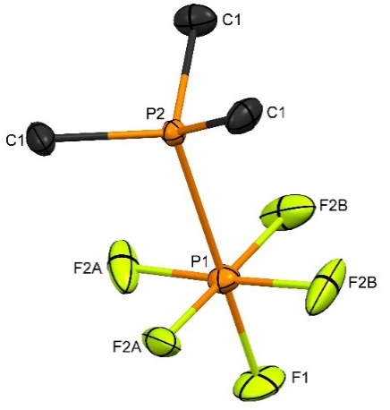 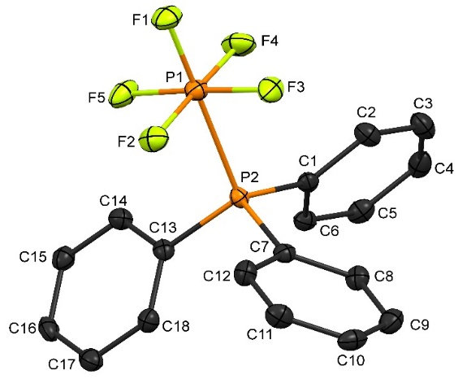

(a) (b)

Fig. 1 The structures of (a) [PF5(PMe3)] and (b) [PF5(PPh3)] showing the atom numbering scheme and with ellipsoids drawn at the 50% probability level. Hydrogen atoms are omitted for clarity. Selected bond lengths (Å) and angles (°): [PF5(PMe3)] (note there is disorder in the equatorial plane, see SI) P1–F1 = 1.597(10), P1–F2B =1.616(11), P1–F2A = 1.596(13), P1–P2 = 2.246(4), F1–P1–F2B = 88.5(5), F2A–P1–F1 = 93.3(6); [PF5(PPh3)] P2–P1 = 2.3093(11), P1–F2 = 1.6051(19), P1–F3 = 1.6112(18), P1–F1 = 1.5886(18), P1–F5 = 1.6044(18), P1–F4 = 1.5926(19), F1–P2–Fn (n = 2-5) = 90.95(10) –91.59(10), P2–P1–Fn = 86.94(7) – 90.54(8).



Fig. 2 The X-ray structures of similar compounds featuring P(III)-P(V) bonds. Reported P-P bond lengths are (a) 2.2023(1) Å, (b) 2.1752(5) Å, (c) 2.234(5) Å, (d) 2.338(2) Å, (e) 2.2962(6) Å.31

The structure solutions from several crystals of [PF5(PMe3)] all showed disorder of the fluorines in the equatorial plane about the fourfold axis, which was satisfactorily modelled (see SI). The bond lengths and angles involving the fluorine are not significantly different to those in [PF5(PPh3)], but the d(P-P) is shorter (2.246(4) Å), which correlates with the greater solution stability of the trimethylphosphine complex.

The structure of the cation in [PF4{*o*-C6H4(PMe2)2}][PF6] is shown in Fig. 3. The cation is a distorted octahedron and particularly notable is the chelate angle <P3–P1–P2 = 90.27(7)°. In the many transition metal structures containing this diphosphine, the chelate angles are typically < 75°,32 the wider angle in the present structure resulting from the small size of the P(V) center. The same effect is present in [BX2{*o*-C6H4(PMe2)2}]+ (X = Cl, Br or I) where the < P–B–P are ~100° on the very small boron center20 In [AlCl2{*o*-C6H4(PMe2)2}2]+  the < P–Al–P is 81.415(13)°.33 The d(P-P) in [PF4{*o*-C6H4(PMe2)2}][PF6] are very similar to that in [PF5(PMe3)] above, and there are only very small differences in the d(P-FtransF) and d(P-FtransP) bonds within the cation. There is no interaction between the cation and the [PF6]– anion.

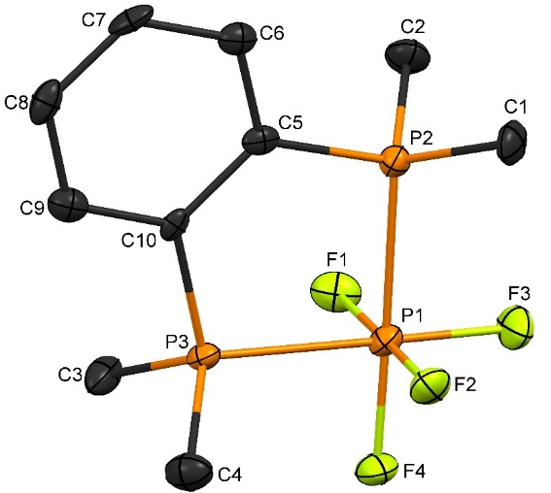

Fig. 3 The structure of the [PF4{*o*-C6H4(PMe2)2}]+ cation showing the atom numbering scheme and with ellipsoids drawn at the 50% probability level. Hydrogen atoms are omitted for clarity. Selected bond lengths (Å) and angles (°): P2 –P1 = 2.2512(19), P3 –P1 = 2.2483(18), P1–F4 = 1.607(3), P1–F2 = 1.619(3), P1–F1 = 1.611(3), P1–F3 = 1.590(3), P3–P1–P2 = 90.27(7), F–P–P(cis) = 88.35(12)–89.55(12), F–P–F(cis) = 90.51(16) – 92.41(17). [PF6]– P–F = 1.578(3) – 1.601(3).

*Spectroscopy:* The IR spectra of the [PF5(PR3)] show the absence of any FnP=O species or of phosphine oxide impurities and contain three strong sharp ν(PF) stretches in the range 880-780 cm-1 (theory C4v = 2A1 + E). The [PF4(diphosphine)][PF6] show the strong stretching and bending modes of the anion at ~ 847vs and ~ 560s, respectively;34 the bands of the [PF4(diphosphine)]+ (theory C2v = 2A1 + B1 +B2) are less readily identified, but possible assignments are given in the Experimental section.

The 1H, 19F{1H} and 31P{1H} NMR spectra were recorded from CH2Cl2/CD2Cl2 solutions at 295 K. The spectra of [PF5(PMe3)]and [PF4{*o*-C6H4(PMe2)2}][PF6] are consistent with the solid state structures determined crystallographically, confirming that the complexes do not dissociate phosphine ligands in solution on the NMR timescale. For the phosphine complex [PF5(PPh3)] and also for [PF5(AsMe3)], the spectra show rapid neutral ligand exchange at room temperature, which slows on cooling the samples, but even at 183 K, the low temperature limiting spectra are not obtained in all cases. The 31P{1H} NMR spectra of the arylphosphine complex at 183 K also shows the presence of variable amounts of ‘free’ phosphine due to dissociation, but this does not occur for the alkylphosphine complexes. Selected NMR data are shown in Table 1 and Fig. 4, and full data are in the Experimental section and the SI.

The 1H NMR spectrum of [PF5(PMe3)] is a doublet of doublets of quintets (Fig. S3) due to coupling of the Me-protons with the two phosphorus centers and the four equatorial fluorines; coupling to the axial fluorine was not observed. The 19F{1H} NMR spectrum (Figs. 4, S4 and S5) consists of a doublet of doublets of doublets (Fig. 4a) due to the four equatorial fluorines coupled to both phosphorus nuclei and the axial fluorine, whilst the axial fluorine resonance is a doublet of quintets (Fig. 4b), due to coupling to the bonded phosphorus and the four equatorial fluorines. The 31P{1H} NMR spectrum exhibits a high frequency doublet of quintets due to the PMe3 and at low frequency, a doublet of doublets of quintets, due to the phosphorus of the PF5 unit(Figs. 4c and d and S6, S7). The spectrum is in good agreement with the data reported18 in CH3CN solution at 310 K.

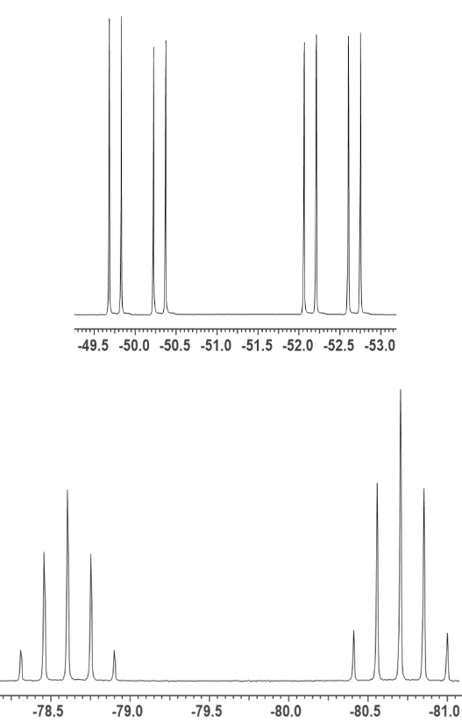

//

1. (b)

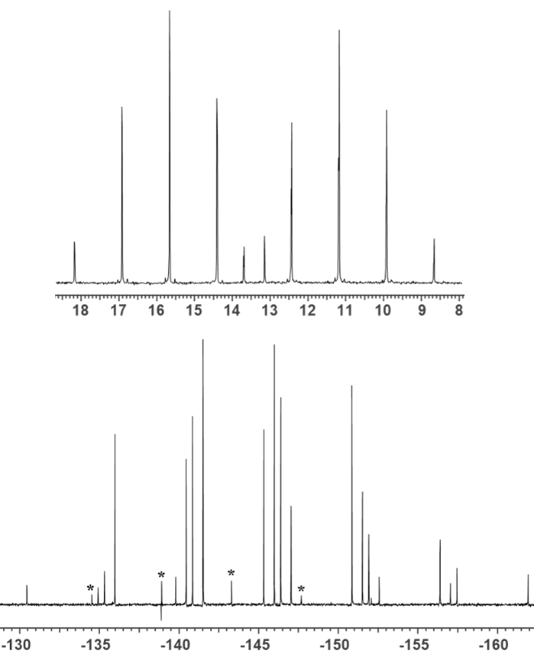



//

(c) (d)

Fig. 4. (Top) 19F{1H} NMR spectrum of [PF5(PMe3)] in CH2Cl2 at 295 K showing (a) the d,d,d arising from the four equatorial fluorines and (b) the d.quin due to the unique F and (bottom) the corresponding 31P{1H} NMR spectrum showing (c) the d,quin arising from the bound PMe3 ligand and (d) the d,d,quin due to the P atom in the PF5 group. * = impurity.

The 19F{1H} NMR spectrum of [PF5(PPh3)] at 293 K shows broad resonances with ill-defined couplings (Fig. S15), but at 183 K the spectrum resembles that of [PF5(PMe3)] (Table 1, Fig. S16). Even at 183 K the corresponding 31P{1H} spectrum (Fig. S17) still appears to be that of a dynamic system, and varying amounts of POF3, [PF6]– and PPh3 appear present in some spectra, indicative of decomposition. Similarly, the NMR spectra obtained from [PF5(AsMe3)] show an exchanging system at 293 K, but that at 183 K are consistent with the slow exchange limit being reached (Figs. S10, S11). Thus, the 1H NMR spectrum at room temperature is a broad singlet, but at 183 K it contains a doublet at δ = 1.60 (d, 3JPH = 7.5 Hz) due to the coordinated arsine, along with a weaker feature at δ = 0.92 due to ‘free’ AsMe3 formed by dissociation/decomposition.

Table 1 Selected multinuclear NMR data.

|  |  |  |  |  |  |
| --- | --- | --- | --- | --- | --- |
| compound | δ(19F) | δ(31P) | JPF (Hz) | JFF (Hz) | JPP (Hz) |
| [PF5(PMe3)]a | –51.3 (d,d,d)  –79.7(d,quin) | + 13.4 (d,quin)  –144.2 (d,d,quin) | 1JPFeq = 895,  1JPFax = 791  2JPFeq = 203 | 2JFF = 56 | 1JPP = 727 |
| [PF5(PPh3)]a,c | –37.6 (br,d)  –88.5 (d) | + 7.7 (br, s)  –141.2 (sext) | 1JPFeq ~ 960,  1JPFax = 995, | 2JFF = 57 | – |
| [PF5(PPh3)]b | –38.95 (d,d)  –78.9 (d, quint) | +22.2 (d, quint)  –141.8 (quin) | 1JPFeq = 937  1JPFax  = 770  2JPFeq = 200 | 2JFF = 57 | 1JPP = 680 |
| [PF5(AsMe3)]a,c | –41.1 (br,d)  ~ –81.0 (br,s) | –140.6 (sext) | 1JPF = ~ 1004 | – | – |
| [PF5(AsMe3)]b | –41.7 (d,d)  –80.2 (d, quin) | –141.8 (d,quin) | 1JPFeq = 960  1JPFax = 797 | 2JFF = 65 | – |

a. CD2Cl2, 295 K, b. CD2Cl2 183 K, c. exchanging system -observed couplings at this temperature.

The 19F{1H} and 31P{1H} spectra of [PF4{*o*-C6H4(PMe2)2}][PF6] (Figures 5 and 6) are those of an AA’XX’B2M spin system (Fig. 7) which is second order and was analysed using the program ARCANA.35



Fig. 5 19F{1H} NMR spectrum of [PF4(*o*-C6H4(PMe2)2}][PF6] (CD2Cl2, 293 K).





1. (b)

Fig. 6. 31P{1H} NMR spectrum of [PF4{*o*-C6H4(PMe2)2}][PF6] (CD2Cl2, 293 K) showing (a) the resonances associated with the coordinated *o*-C6H4(PMe2)2 ligand and (b) those due to the P atoms in the cationic [PF4{*o*-C6H4(PMe2)2}]+ unit and the [PF6]− anion (overlapping).

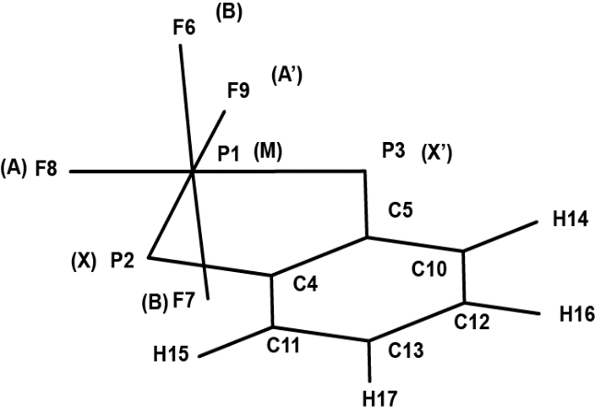

Fig. 7. The interacting 19F and 31P nuclear spins in [PF4{*o*-C6H4(PMe2)2}][PF6]. The results of the analysis are given in Table 2.

Table 2. The chemical shifts (ppm) and coupling constants (Hz) obtained by analysis of the AA’XX’B2M spin system for [PF4{*o*-C6H4(PMe2)2}][PF6].

|  |
| --- |
| δ(P1) = +6.45; δ(P2) = −148.10; δ(F6 ) = −45.72; δ(F8) = −60.55.  J6,8 (FF) = J6,9 (FF) = ± 58.8 ± 1.1a  J7,8 (FF) = J7,9 (FF) = ± 50.1 ± 1.1a  J8,9 = |32.6| ± 0.8  J1,8 = J1,9 = |899.8| ± 0.25.  J2,8 = J3,9 = ± 157.1 ± 0.4b  J3,8 = J2,9 = ± 39.7 ± 0.4b  J2,6 = J3,6 = J2,7 = J3,7 = 105.0 ± 1.4  J1,2 = J1,3 = |357.0| ± 0.2  J23 = |104.6| ± 1.1  J1,6 = J1,7 = |903.0| ± 0.25  1JPF = |710.9 | ± 1.0 for [PF6]− |

a J6,8 = J6,9 and J7,8 = J7,9 have the same sign; b J2,8 = J3,9 and J3,8 = J2,9 have the same sign.

The 19F{1H} spectrum of [PF4{*o*-C6H4(PPh2)2}][PF6] at 183 K is very similar to that of [PF4{*o*-C6H4(PMe2)2}][PF6], confirming the same constitution, although the 31P{1H} spectrum show that even at low temperature, the limiting spectrum has not been reached, and also that some free *o*-C6H4(PPh2)2,formed by decomposition in solution, is present.

**Electronic structures of the PF5-L complexes from the DFT calculations:** Computational studies of tertiary phosphine and arsine complexes of phosphorus pentafluoride complexes were undertaken to complement the experimental data and to probe the nature of the PF5-L interactions and the frontier orbitals in these unusual complexes. The ground state geometries of [PF5(PMe3)], [PF5(PPh3)], [PF4{*o*-C6H4(PMe2)2}]+ and [PF5(AsMe3)] were optimized using DFT with the B3LYP functional, corrected for dispersion, and the basis sets described in the section on DFT calculations (below). Where possible, the starting geometry was the solid-state structure. The bond lengths and angles of the calculated ground state geometries are in close agreement with the crystallographic data, (SI Table S2) and show similar trends in the key bond distances. Most notably, the d(P-P) is longer in [PF5(PPh3)] compared to [PF5(PMe3)], while the d(P-P) distances for the [PF4{*o*-C6H4(PMe2)2}]+ cationare very similar to the corresponding distance in [PF5(PMe3)].

Computed PF5-L B3LYP/6-311G(d) bond dissociation energies for [PF5(PMe3)], [PF5(AsMe3)] and [PF5(PPh3)] are shown in Table 3.These valuesshow that for[PF5(PMe3)], the PF5-L bond energy is reduced when P is replaced by As in the L group, consistent with the experimental observation that [PF5(AsMe3)] has lower stability than [PF5(PMe3)].

Table 3 Bond dissociation energies determined by DFT calculations

|  |  |
| --- | --- |
| **Interaction energies** | **kJ/mol** |
| [PF5(PMe3)] → PF5 + PMe3 | 133 |
| [PF5(AsMe3)] → PF5 + AsMe3 | 90 |
| [PF5(PPh3)] → PF5 + PPh3 | 120 |

For [PF5(PMe3)], atomic charges from an NBO (natural bond orbital) analysis indicate that there is net electron transfer from the PMe3 group to PF5. The net charge on PF5 is -0.60 and +0.60 on PMe3 in this complex. The main change in PF5 on forming the complex is that the positive charge on P (in PF5) decreases and the negative charges on the equatorial F atoms in PF5 increase, while the negative charge on the *trans* F atom remains virtually the same (see SI Table S4). For [PF5(AsMe3)], a similar trend is observed but with less electron density being transferred to PF5 from AsMe3. In this case, the net charge on PF5 in [PF5(AsMe3)] is -0.56, consistent with the weaker donor power of the arsine ligand. For [PF5(PPh3)], again charge transfer takes place from PPh3 to PF5. The net charges on the PF5 and L units in the complex are -0.55 and +0.55 respectively with again the net positive charge on P in PF5 decreasing and the negative charges on the equatorial F atoms in PF5 showing the largest increase.

The frontier molecular orbitals of [PF5(PMe3)] and [PF5(AsMe3)] (Fig. 8) are similar to those of [PF5(PPh3)] (Fig. S29). The HOMO in each case is dominated by the bonding σ-interaction between the P-P or P-As bond. The LUMO in each case contains appreciable anti-bonding character between the P-P or P-As unit, with contributions from the ligands, while the four equatorial fluorines only contribute towards the LUMO in the cases of [PF5(PMe3)] and [PF5(AsMe3)]. In all three complexes the LUMO+1 is focussed on the ligand, with π-bonding between the C(2p) orbitals. The HOMO-1 orbitals of both [PF5(PMe3)] and [PF5(AsMe3)] lie on the PF­5 unit, with anti-bonding interactions between the four equatorial fluorine atoms. In contrast, the HOMO-1 orbital for [PF5(PPh3)] lies on the aryl groups, with the corresponding interactions between the four equatorial fluorine atoms being much lower in energy (HOMO−9; −9.80 eV) compared to the [PF5(PMe3)] and [PF5(AsMe3)] complexes (HOMO−1 PMe3; −9.88 eV, AsMe3; −9.93 eV).

The HOMO and HOMO-1 of [PF4{*o*-C6H4(PMe2)2}]+ (Fig. 9) lie on the aromatic backbone of the ligand, with bonding interactions on the carbon backbone for the occupied orbitals and antibonding interactions from the LUMO, with no contribution from either the coordinating phosphorus atoms or the PF4 unit. The LUMO+1 features antibonding interactions within the phenyl ring with P(3p)-C(2p) π-bonding between the ligand’s phosphorus atoms.

The HOMO/LUMO energies for [PF5(PMe3)] and [PF5(AsMe3)] are very similar, and the HOMO-LUMO energy gap for each is *ca.* 2 eV higher than that for the PPh3 analog. The calculations also show that the corresponding orbitals for [PF4{*o*-C6H4(PMe2)2}]+ lie significantly lower in energy compared for the EMe3 (E = P, As) adducts. This may be attributed to the cationic charge in the diphosphine complex.

|  |  |  |  |
| --- | --- | --- | --- |
| **[PF5(PMe3)]** | | **[PF5(AsMe3)]** | |
| HOMO (-8.63 eV) | LUMO (-0.03 eV) | HOMO (-8.30 eV) | LUMO (-0.43 eV) |
|  |  |  |  |
| HOMO-1 (-9.88 eV) | LUMO+1 (0.14 eV) | HOMO-1 (-9.93 eV) | LUMO+1 (0.11 eV) |
|  |  |  |  |

Fig. 8 Representation of the HOMO-1, HOMO, LUMO and LUMO-1 of [PF5(PMe3)] and [PF5(AsMe3)] determined by DFT analysis.

|  |  |
| --- | --- |
| **[PF4{*o*-C6H4(PMe2)2}]+** | |
| HOMO ( -11.54 eV) | LUMO (-5.45 eV) |
|  |  |
| HOMO-1 (-11.61 eV) | LUMO+1 (-5.13 eV) |
|  |  |

Fig. 9 Representation of the HOMO-1, HOMO, LUMO and LUMO-1 of [PF4{*o*-C6H4(PMe2)2}]+ determined by DFT analysis.

**Conclusions**

A very unusual series of phosphorus pentafluoride complexes with neutral tertiary phosphines of types [PF5(PR3)] and [PF4(diphosphine)][PF6] have been characterized by X-ray crystallography, IR and multinuclear NMR spectroscopy. Those with predominantly alkyl substituents are stable in solution in anhydrous weakly coordinating solvents, but the arylphosphine complexes exhibit fast reversible phosphine exchange at ambient temperatures. PF5 has significantly less affinity for arsine ligands and although interaction occurs, even the [PF5(AsMe3)] was unstable and decomposes quickly at room temperature. Arylarsines and tertiary stibines do not form analogous complexes. This discrimination between phosphines and arsines is characteristic of other p-block fluorides including those of germanium and tin,24 and different from the Group V analogs (NbF5 and TaF5) which form complexes with both phosphines and arsines, although the latter are less stable.36 In passing, we note that the reaction of PCl5 with PMe3 or AsMe3 results in chlorination of the pnictine to PMe3Cl2 or AsMe3Cl2 and formation of PCl3.37

DFT calculations (B3LYP functional) on [PF5(PMe3)], [PF5(PPh3)] and [PF4{*o*-C6H4(PMe2)2}]+ provide some insights into the electronic structures of the compounds for which crystal structures were obtained and were extended to [PF5(AsMe3)] in order to probe the nature of the PF5−L interactions. For [PF5(PMe3)], [PF5(PPh3)] and [PF4{*o*-C6H4(PMe2)2}]+, the DFT optimized geometrical parameters were in good agreement with those determined crystallographically.

For the PF5−L complexes, the P−L bond dissociation energies are in the order: PMe3 > PPh3 > AsMe3, consistent with the experimentally-observed stabilities. Electron transfer from L to PF5 also occurs in the order: PMe3 > PPh3 ≈ AsMe3. These trends in bond energy and electron transfer occur because the P−P interaction in [PF5(PMe3)], which mainly occurs via the P 3p orbitals on each center, is more effective than the P−As interaction in [PF5(AsMe3)], which mainly involve P 3p and As 4p orbitals.

**Experimental**

Phosphorus pentafluoride was obtained from Fluorochem and used as received. PPh3, PMe3, AsMe3, AsPh3 and *o*-C6H4(PPh2)2 were obtained from Strem or Sigma Aldrich and also used as received. *o*-C6H4(PMe2)2 and *o*-C6H4(AsMe2)2 were made by literature methods.38 SbEt3 was made as described.39 CH2Cl2 and MeCN were dried by distillation from CaH2; n-hexane was distilled from Na.

Infrared spectra were recorded as Nujol mulls between CsI plates using a Perkin Elmer Spectrum 100 spectrometer over the range 4000–200 cm−1. 1H, 19F{1H} and 31P{1H} NMR spectra were recorded from CH2Cl2/CD2Cl2 solutions using a Bruker AV400 spectrometer and referenced to TMS via the residual solvent resonance, CFCl3 and 85% H3PO4 respectively. Microanalyses were undertaken by London Metropolitan University. All preparations were undertaken under a dry dinitrogen atmosphere using standard Schlenk, vacuum line and glove box techniques.

***CARE:*** *PF5 is a toxic, corrosive gas and forms HF on hydrolysis. Appropriate safety precautions should be taken in handling PF5 and its complexes.*

**[PF5(PMe3)]:** PMe3 (0.15 g, 2 mmol) was dispersed in dry n-hexane (10 mL) and a slow stream of PF5 bubbled into the solution. Immediate precipitation of a white solid occurred, and after ~ 3 min. the gas flow was stopped, and the white precipitate allowed to settle. After 15 min. the solid was filtered off and dried *in vacuo*. Yield. 0.26 g, 65%. Required for C3H9F5P2 (202.0): C, 17.8; H, 4.5. Found: C, 17.8; 4.6 H %. Crystals of [PF5(PMe3)] were obtained by allowing a CH2Cl2 solution to evaporate in the glove box. 1H NMR (CD2Cl2, 295 K): 1.64 (d,d,quin, 2JPH = 13.7, 3JPH = 9.5, 4JPFeq 1.2 Hz). 19F{1H} NMR (CD2Cl2, 295 K): –51.3 (d,d,d, 1JPFeq = 895, 2JPF = 203, 2JFF = 56 Hz), –79.7 (d,quin, 1JPFax = 791, 2JFF = 56 Hz). 31P{1H} NMR (CD2Cl2, 295 K): +13.4 (d,quin, 2JPFeq = 203, 1JPP = 727 Hz), –144.2 (d,d,quin, 1JPFeq = 895, 1JPFax = 791, 1JPP = 727 Hz). IR (Nujol/cm-1): 823vs, 789vs νPF, 534 δPF.

**[PF5(AsMe3)]:** Was made similarly from AsMe3 (0.12 g, 1 mmol) as a white solid. Yield. 0.125 g, 51%. The white powder slowly turns yellow and becomes sticky on storage at room temperature. This decomposition at ambient temperatures, losing volatile material, prevented reproducible microanalytical data being obtained. 1H NMR (CD2Cl2, 295 K): 1.52 (s); (CD2Cl2, 183 K): 0.92 (s, ’free’ AsMe3), 1.60 (d, 3JPH = 7.5 Hz). 19F{1H} NMR (CD2Cl2, 295 K): –41.1 (d, br 1JPF = ~ 1004 Hz),~ -81.0 (s, br); (CD2Cl2, 183 K): –41.7 (d,d 1JPF = 960 Hz, 2JFF = 65 Hz ), –80.2 (d,quin, 1JPF = 797 Hz, 2JFF = 65 Hz). 31P{1H} NMR (CD2Cl2, 295 K): –140.6 (sextet, 1JPF = 923 Hz); (CD2Cl2, 183 K): –141.8 (d,quin, 1JPFeq = 959, 1JPFax = 795 Hz). IR (Nujol/cm-1): 832vs, 802sh νPF, 558 δPF.

**[PF5(PPh3)]:** PPh3 (0.26 g, 1mmol) was dissolved in dry CH2Cl2 (15 mL) and a slow stream of PF5 bubbled into until no more was absorbed. The clear, colorless solution was concentrated *in vacuo* to ~ 5 mL and the white precipitate filtered off and dried *in vacuo*. Yield. 0.22 g, 60.4 %. Required for C18H15F5P2 (364.2), C, 55.7; H, 3.9. Found: C, 55.8; H, 3.9%. Crystals of [PF5(PPh3)] were obtained by vapour diffusion of n-hexane into a concentrated CH2Cl2 solution of the complex. 1H NMR (CD2Cl2, 295 K): 7.48 (br); (CD2Cl2, 183 K): 7.54 -7.87 (br, m). 19F{1H} NMR (CD2Cl2, 295 K): –37.6 (br,d, 1JPFeq ~ 960 Hz), –88.5 (d, 1JPFax = 995 Hz); (CD2Cl2, 183 K): -38.95 (d,d, 1JPFeq = 937 Hz, 2JFF = 57 Hz), –78.9 (d,quin, 1JPFax = 770 Hz, 2JFF = 56 Hz). 31P{1H} NMR (CD2Cl2, 295 K): + 7.7 (br, s), –141.2 (sext, 1JPF  ~720 Hz); (CD2Cl2, 183 K): +22.2 (d,quin. 1JPP = 680 Hz, 2JPF = 200 Hz ), –141.8 (quin. 1JPFeq = 714 Hz). IR (Nujol/cm-1): 837 vs, 804s νPF, 500 δPF.

[**PF4{*o*-C6H4(PMe2)2}][PF6]****:** A slow stream of PF5 was bubbled into a CH2Cl2 solution (10 mL) of *o*-C6H4(PMe2)2 (0.240 g, 1.2 mmol). After a few minutes a white powder started to deposit, and the PF5 flow was stopped and the mixture allowed to stand for 30 min., after which the white solid was separated by filtration and dried *in vacuo*. Yield 0.38 g, 70%. Required for C10H16F10P4 (450.1): C, 26.7; H, 3.8. Found: C, 26.7; H, 3.2%. Crystals of [PF4{*o*-C6H4(PMe2)2}][PF6] were obtained by allowing a CH2Cl2 solution to evaporate in the glove box. 1H NMR (CD2Cl2, 295K): 2.25 (m), 8.2-8.4 (m). 19F{1H} NMR (CD2Cl2, 295 K): -45.7 (m), -60.6 (m) (see Table 2 for J values), -72.7 (d), 1JPF = 711 Hz). 31P{1H} NMR (CD2Cl2, 295K): + 6.45 (m), -140.1 (m) (see Table 2 for J values). IR (Nujol/cm-1): 847vs, 560s (PF6), 816m, 779, 758m (PF4).

[**PF4{*o*-C6H4(PPh2)2}][PF6]:** Dried *o*-C6H4(PPh2)2 (0.23 g, 0.5 mmol) was dissolved in CH2Cl2 (10 mL) and a slow steam of PF5 passed in until the solution was saturated, resulting in a clear solution, which was allowed to stand for 30 min. and then evaporated to dryness *in vacuo.* The resulting white powder was redissolved in CH2Cl2 (5 mL) and n-hexane (5 ml) added slowly resulting in a white precipitate. After 1 h the white solid was separated by filtration and dried *in vacuo*. Yield 0.19 g, 55%. Required for C30H24F10P4 (698.4): C, 51.6; H, 3.5. Found: C, 51.5; H, 3.5%. 1H NMR (CD2Cl2, 295 K): 7.3-7.8 (m). 19F{1H} NMR (CD2Cl2, 183 K): -34.5 (m), -54.3(m), -73.15 (d). IR (Nujol/cm-1): 836vs, 557s (PF6), 801m, 747m (PF4).

**X-Ray Experimental:** Crystals of the complexes were grown from CH2Cl2 solutions of the complexes allowed to evaporate slowly in the glovebox or by cooling filtrates from the synthesis in a freezer (-18°C). Data collections used a Rigaku AFC12 goniometer equipped with an enhanced sensitivity (HG) Saturn724+ detector mounted at the window of an FR-E+ SuperBright molybdenum (λ = 0.71073 Å) rotating anode generator with VHF Varimax optics (70 μm focus) with the crystal held at 100 K or an Agilent Xcalibur Gemini S diﬀractometer with a CCD plate detector using Mo Kα (λ = 0.71073 Å) radiation with the crystal held at 100 K. Structure solution and reﬁnement were performed using SHELX(S/L)97, SHELX-2013, or SHELX-2014/7.40 The [PF5(PMe3)] structure showed disorder of the equatorial fluorines about the three fold rotation axis, which was satisfactorily modelled. Details are in the SI. The X-ray crystallographic data collections are summarized in Table S1 (SI). Crystallographic data in cif format have been deposited with the Cambridge Crystallographic Data Centre (CCDC) and given numbers [PF5(PMe3)]: 1937639, [PF5(PPh3)]: 1937640, [PF4{o-C6H4(PMe2)2}][PF6]: 1937641, [PPh3H][PF6]: 1937642. Copies of the data can be obtained free of charge from The Director, CCDC, 12 Union Road, Cambridge, CB2 1EZ, UK, fax: +44 1223 366033, e-mail: [deposit@ccdc.cam.ac.uk](mailto:deposit@ccdc.cam.ac.uk) or on the web at [http://www.ccdc.cam.ac.uk](http://www.ccdc.cam.ac.uk/).

**DFT Calculations**

Geometry optimization and frequency calculations with the Grimme correction for dispersion (D3(BJ) version),41a,b using Gaussian1641c were performed on the isolated molecules or cations using the B3LYP42-44 hybrid density functional, using a 6-311G(d) basis set on all atoms. Charges on each center were obtained from a NBO/NPA analysis of the converged wavefunctions (NPA = natural population analysis). Energy minima were confirmed by the absence of any imaginary frequencies. Infrared spectra were also calculated at this level for all optimized structures and the computed harmonic frequencies were scaled by 0.966.44 PF5-L bond dissociation energies were also calculated for the neutral complexes [PF5(PMe3)], [PF5(PPh3)], [PF5(AsMe3)], and [PF5(AsPh3)].

The DFT optimized geometries for isolated [PF5(PMe3)], [PF5(PPh3)], and [PF4{*o*-C6H4(PMe2)2}]+ are in good agreement with their respective crystal structure geometries (SI Table S2). The optimized geometry of the arsine analog, [PF5(AsMe3)], was also calculated for comparative purposes.

**Acknowledgements**

We thank EPSRC for support (EP/P025137/1 and EP/R513325/1) and Dr M. E. Light for assistance with modelling the disorder in the [PF5(PMe3)] crystal structure.

**ASSOCIATED CONTENT**

**Supporting Information**

The SI contains details of the X-ray data collections, further discussion of the disorder in [PF5(PMe3)], IR and multinuclear NMR spectra for the complexes and tables containing the results of the DFT analysis. A file containing the x,y,z coordinates from the computational work is also available.

**Conflicts of Interest**

The authors have no conflicts to declare.

**References**

1. Mootz, D.; Wiebcke, M. *Z. Anorg. Allgem. Chem.,* Fluorides and fluoro acids. XIII. The crystal structure of phosphorus pentafluoride. **1967,** 545, 39-42; Hansen, K. W.; Bartell, L. S. Electron diffraction study of the structure of PF5. *Inorg. Chem.*, **1965**, 4, 1775-1776.
2. Schmutzler, R. Fluorides of phosphorus. in *Adv. Fluorine Chem.,* Stacey, M.; Tatlow, J. C.; Sharpe, A. G. (eds) **1965**, 5, 31-285.
3. Benjamin, S. L.; Levason, W.; Reid, G. Medium and high oxidation state metal/non-metal fluoride and oxide-fluoride complexes with neutral donor ligands. *Chem. Soc. Rev*., **2013,** *42*, 1460-1499.
4. Levason, W.; Monzittu, F. M.; Reid, G. Coordination Chemistry and applications of medium/high oxidation state metal and non-metal fluorides and oxide-fluoride complexes with neutral donor ligands. *Coord. Chem. Rev*. **2019**, 391, 90-130.
5. O’Donnell, T. A. Superacidic reaction media. in *Advanced Inorganic Fluorides*, Nakajima, T.; Zemva, B.; Tressaud, A. (Eds), Elsevier, Amsterdam, **2000**, 329-366.
6. John, C. P.; Schmutzler, R. 19F-Kern magnetische resonanzuntersuchungen an phosphorpentafluorid-basen-komplexen *Z. Naturforsch. Teil B,* **1974**,29, 730-733.
7. Harman, J. S.; Sharp, D. W. A. Reactions between phosphorus pentafluoride and methylamine, ethylamine, and t-butylamine. *J. Chem. Soc. (A),* 1**970**, 1138-1141.
8. Brown, D. H.; Fraser, G. W.; Sharp, D. W. A. The preparation of dialkylaminofluorophosphoranes by the thermal decomposition of dialkylamine–phosphorus pentafluoride adducts. *J. Chem. Soc. (A),***1966**, 171-174.
9. Nguyen, T. Q.; Huang, X.; Janzen, A. F. Preparation and NMR spectra of PF4(N-N)+ and SiF4(N-N), where N-N = 2,2′-bipyridine, 4-fluoro-2,2′-bipyridine, and 1,10-phenanthroline. *Can. J. Chem.,* **1992**, 70, 2089-2093.
10. Sheldrick, W. S. Crystal and molecular structure of the adduct phosphorus pentafluoride–pyridine. *.J. Chem. Soc., Dalton Trans.*, **1974**, 1402-1405.
11. Arduengo III, A. F.; Davidson, F.; Krafczyk, R.; Marshall, W. J.; Schmutzler, R. [Carbene complexes of pnictogen pentafluorides and boron trifluoride](https://rd.springer.com/article/10.1007/s007060070101). *Monatsch. Chem.*, 2000, **131**, 251-265; Arduengo III, A. J.; Krafczyk, R.; Marshall, W. J.; Schmutzler, R. [A carbene−phosphorus(V) adduct](https://pubs.acs.org/doi/10.1021/ja964094h). *J. Amer. Chem. Soc.,* **1997**, 119, 3381-3382.
12. Böttcher, T.; Shyshkov, O.; Bremer, M.; Bassil, B. B.; Röschenthaler, G.-V. [Carbene complexes of phosphorus(V) fluorides by oxidative addition of 2,2-difluorobis(dialkylamines) to phosphorus(III) halides](https://pubs.acs.org/doi/10.1021/om2009827). *Organometallics,* **2012**, *31*, 1278-1280; Tian, C.; Nie, W.; Chen, Q.; Sun, G.; Hu, J.; Borzov, M. V. *C*- and *N*-adducts of *N*-alkenyl substituted Arduengo carbene and *N*-alkyl substituted imidazole with PF5: synthesis and structural investigation. *Russ. Chem. Bull.,* **2014**, *63*, 2668-2674; Tian, C.; Nie, W.; Borzov, M. V.; Su, P. [High-Yield thermolytic conversion of imidazolium salts into Arduengo carbene adducts with BF3 and PF5](https://pubs.acs.org/doi/10.1021/om201086d). *Organometallics,* **2012**, *31*, 1751-1760.
13. Böttcher, T.; Röschenthaler, G.-V. Highly reactive carbenes as ligands for main group element fluorides. Synthesis and applications. *J. Fluorine Chem*., **2015,** *171*, 4-11.
14. Dippel, C.; Schmitz, R.; Müller, R.; Böttcher, T.; Kunz, M.; Lex-Balducci, A.; Röschenthaler, G.-V. Carbene adduct as overcharge protecting agent in lithium ion batteries. *J. Electrochem. Soc*., **2012**, *159*, A1587-1590.
15. Böttcher, T.; Steinhauer, S.; Allefeld, N.; Hoge, B.; Neumann, B.; Stammler, H. G.; Bassil, B. B.; Winter, M.; Mitzel, N. W.; Röschenthaler, G.-V. Carbene complexes of phosphorus(v) fluorides substituted with perfluoroalkyl-groups synthesized by oxidative addition. Cleavage of the complexes reveals a new synthetic protocol for ionic liquids. *Dalton Trans*., **2014**, *43*, 2979-2987.
16. Valbre, B.; Chansaenpak, K.; Wang, M.; Wang, H.; Li, Z.; Gabbaï, F. P. Radiofluorination of a NHC-PF5 adduct: toward new probes for 18F PET imaging. *Chem. Commun.*, **2017**, *53*, 8657-8659.
17. Brown, D. N.; Crosbie, K. D.; Fraser, G. W.; Sharp, D. W. A. Reactions between phosphorus fluorides and trialkylphosphines and aminophosphines. *J. Chem. Soc. (A),* **1969**, 551-554; b) Il'in, E. G.; Nazarov, A. P.; Shcherbakova, M. N.; Buslaev, Yu. A. Six-​coordinate mixed-​ligand fluoro complexes of phosphorus(V). *Dokl. Akad. Nauk. SSSR*, **1980**, *250*, 367-371.
18. a) Schulz, C. W.; Rudolph, R. W. [Phosphorus-phosphorus bond. I. complexes containing highly connected phosphorus atoms, HnMe3-nPPF5. Directly bonded phosphorus-phosphorus coupling constant](https://pubs.acs.org/doi/10.1021/ja00737a011). *J. Amer. Chem. Soc*., 1**971**, *93*, 1898-1903.
19. Burt, J.; Levason, W.; Reid, G. Coordination chemistry of the main group elements with phosphine, arsine and stibine ligands. *Coord Chem. Rev.,***2014,** *260*, 65-115.
20. Burt, J.; Emsley, J. W.; Levason, W.; Reid, G.; Tinkler, I. S. Systematics of BX3 and BX2+ Complexes (X = F, Cl, Br, I) with Neutral diphosphine and diarsine ligands. *Inorg. Chem.,* **2016,** *55,* 8852-8864.
21. Greenacre, V. K.; Levason, W.; Reid, G. [Trialkylstibine complexes of boron, aluminum, gallium, and indium trihalides: synthesis, properties, and bonding](https://pubs.acs.org/doi/10.1021/acs.organomet.8b00265). *Organometallics,* **2018***, 37*, 2123-2135.
22. Bhalla, R.; Burt, J.; Hector, A. L.; Levason, W.; Luthra, S. K.; McRobbie, G.; Monzittu, F. M.; Reid, G. Complexes of aluminium, gallium and indium trifluorides with neutral oxygen donor ligands: Synthesis, properties and reactions. *Polyhedron*, **2016,** *106*, 65-74.
23. George, K.; Hector, A. L.; Levason, W.; Reid, G.; Sanderson, G.; Webster, M.; Zhang, W. Hypervalent neutral O-donor ligand complexes of silicon tetrafluoride, comparisons with other group 14 tetrafluorides and a search for soft donor ligand complexes. *Dalton Trans.***, 2011, *40*, 1584-1593.**
24. Davis, M. F.; Levason, W.; Reid, G.; Webster, M. Complexes of germanium(iv) fluoride with phosphane ligands: structural and spectroscopic authentication of germanium(iv) phosphane complexes. *Dalton Trans.,* **2008**, 2261-2269; Davis, M. F.; Clarke, M.; Levason, W.; Reid, G.; Webster, M. Tin(IV) Fluoride Complexes with tertiary Phosphine Ligands - a comparison of Hard and Soft   Donor   Ligands. *Eur. J. Inorg. Chem.,* **2006,** 2773-2782.
25. Gregor, I. K. Addition compounds of phosphorus pentafluoride. *Chem. Ind.,* **1965**, 385; Gregor, I. K. Addition compounds of phosphorus pentafluoride *III. Aust. J. Chem.,* **1966,** *19*, 1977-1982.
26. Goodrich, R. A.; Treichel, P. M. [The thermal rearrangement of phosphorus pentafluoride adducts of dimethyl ether and dimethyl sulfide](https://pubs.acs.org/doi/10.1021/ja00967a008). *J. Amer. Chem. Soc*., **1966,** *88*, 3509-3511.
27. Tebbe, F. N.; Muetterties, E. L. [Autoionization in complexes of metal pentafluorides](https://pubs.acs.org/doi/10.1021/ic50047a029). *Inorg. Chem.,* **1967**, *6*, 129-132.
28. Christe, K. O.; Dixon, D. A.; Schrobilgen, G. J.; Wilson, W. W. [Tetrafluorophosphate anion](https://pubs.acs.org/doi/10.1021/ja963421i). *J. Amer. Chem. Soc.,* **1997**, *139*, 3918-3928.
29. Banbery, H. J.; Hamor, T. A. [Structure of tetraphenylphosphonium hexafluorophosphate.](https://onlinelibrary.wiley.com/doi/10.1107/S0108270188005761) *Acta Cryst. Sect. C,* **1988**, *C44*, 1683-1684.
30. Müller, G.; Matheus, H.-J.; Winkler, M. Donor-Acceptor complexes between simple phosphines. First structural data for an almost forgotten class of compounds**.** *Z. Naturforsch. Teil B*, **2001**, *56*, 1155-1162.
31. a) Luo, H.; McDonald, R.; Cavell, R. G. A Cationic, Macrocyclic, Six‐Coordinate Phosphorus(V) Compound Containing a Mixed Valence PIII‐PV‐PIII Linear Chain. Angew. Chem., Int. Ed., **1998**, *37*, 1098-1099; b) Jones, P. G.; Freytag, M. CSD Communication (TEVKIP) (Private Communication), **2006**; c) Sheldrick, W. S.; Gibson, J. A.; Röschenthaler, G.-V. The crystal molecular structure of the adduct of 2,2,2-Trifluoro-4,4,5,5-tetrakis(trifluoromethyl)-l,3,2A 5 -dioxaphospholane with trimethylphosphine. A strong P → P Coordinate Bond. *Z. Naturforsch. Teil B*, **1978**, *33*, 1102-1105; d) Kilian, P.; Philp, D.; Slawin, A. M. Z.; Woollins, J. D. Use of Molecular Scaffolding for the Stabilization of an Intramolecular Dative PIII‐PV System. *Eur. J. Inorg. Chem*. **2003**, 249-254; e) Sanchez, M.; Reau, R.; Dahan, F.; Regitz, M.; Bertrand, G. From 1σ4, 2σ2 to 1σ4, 2σn‐Diphosphetes (n = 3–6): The Surprising Persistence of the P-P bond. *Angew.Chem.,Int.Ed.*, **1996**, *35*, 2228- 2230.
32. see for example: Benjamin,S. L.; Chang, Y.-P.; Hector, A. L.; Jura, M.; Levason, W.; Reid, G.; Stenning, G. Niobium tetrahalide complexes with neutral diphosphine ligands. ***Dalton Trans.***, **2016,** ***45***, 8192-8200; Levason, W.; Monzittu, F. M.; Reid. G.; Zhang, W. *Chem. Commun.,* **2018,** ***54***, 11681-11684 and refs therein.
33. Burt, J.; Levason, W.; Light, M. E.; Reid, G. Phosphine complexes of aluminium(iii) halides – preparation and structural and spectroscopic systematics. *Dalton Trans*., **2014**, *43*, 14600-14611.
34. Heyns, A. M. The i.r. and Raman spectra of sodium hexafluorophosphate monohydrate, NaPF6·H2O. *Spectrochim. Acta*, **1977,** *33A*, 315-322.
35. Celebre, G.; De Luca, G.; Longeri, M.; Sicilia, E. Graphical interactive strategy for the analysis of NMR spectra in liquid crystalline phases. *J. Chem. Inf. Comput. Sci*. **1994,** *34*, 539-545.
36. Levason, W.; Light, M. E.; Reid, G.; Zhang, W. Soft diphosphine and diarsine complexes of niobium(v) and tantalum(v) fluorides: synthesis, properties, structures and comparisons with the corresponding chlorides. *Dalton Trans*., **2014, *43*, 9557-9566;** Levason, W.; Reid, G.; Zhang, W. [Six-coordinate NbF5 and TaF5 complexes with tertiary mono-phosphine and -arsine ligands](https://www.sciencedirect.com/science/article/pii/S0022113915000238) *J. Fluorine. Chem*., **2015**, *172*, 62-67.
37. Holmes, R. R.; Bertaut, E. F. The Reaction of Chloramine with Some Trisubstituted Phosphines.  *J. Amer. Chem. Soc*., **1958**, *80*, 2982-2985; Dillon, K. B.; Reeve, R. N.; Waddington, T. V. [Phosphorus pentachloride as a chlorinating agent](https://www.sciencedirect.com/science/article/pii/002219027690004X) *J. Inorg. Nucl. Chem.,* **1976,** *38*, 1439-1441.
38. Kyba, E. P.; Liu, S. T.; Harris, R. L. A facile synthesis of 1,2-bis(phosphino)benzene and related alkylated species. *Organometallics,* **1983**, *2*, 1877-1879; Feltham, R. D.; Kasenally, A.; Nyholm, R. S. [A new synthesis of di- and tri-tertiary arsines](https://www.sciencedirect.com/science/article/pii/S0022328X00910799). *J. Organometal Chem*., **1967**, *7*, 285-288.
39. Taylor, W.; Soto, U. H.; Lynch, V. M.; Rose, M. J. [Antimony-Supported Cu4I4 Cuboid with Short Cu–Cu Bonds: Structural Premise for Near-Infrared Thermoluminescence](https://pubs.acs.org/doi/10.1021/acs.inorgchem.5b02933). *Inorg. Chem*. **2016**, *55*, 3206-3208.
40. Sheldrick, G. M. *Acta Crystallogr., Sect. A: Found. Crystallogr.* **2008**, *64*, 112-122; Sheldrick, G. M. Crystal structure refinement with SHELX. *Acta Crystallogr., Sect. C* **2015**,*71*, 3-8.
41. a) Grimme, S.  Semiempirical GGA-type density functional constructed with a long-range dispersion correction. *J. Comp. Chem*. **2006**, *27*, 1787-1799; b) Grimme, S.; Ehrlich, S.; Goerigk, L. Effect of the damping function in dispersion corrected density functional theory. *J. Comp. Chem.* **2011**, *32* 1456-65; c) Frisch, M. J.; Trucks, G. W.; Schlegel, H. B.; Scuseria, G. E.; Robb, M. A.; Cheeseman, J. R.; Scalmani, G.; Barone, V.; Petersson, G. A.; Nakatsuji, H.; Li, X.; Caricato, M.; Marenich, A. V.; Bloino, J.; Janesko, B. G.; Gomperts, R.; Mennucci, B.; Hratchian, H. P.; Ortiz, J. V.; Izmaylov, A. F.; Sonnenberg, J. L.; Williams-Young, D.; Ding, F.; Lipparini, F.; Egidi, F.; Goings, J.; Peng, B.; Petrone, A.; Henderson, T.; Ranasinghe, D.; Zakrzewski, V. G.; Gao, J.; Rega, N.; Zheng, G.; Liang, W.; Hada, M.; Ehara, M.; Toyota, K.; Fukuda, R.; Hasegawa, J.; Ishida, M.; Nakajima, T.; Honda, Y.; Kitao, O.; Nakai, H.; Vreven, T.; Throssell, K.; Montgomery, Jr., J. A.; Peralta, J. E.; Ogliaro, F.; Bearpark, M. J.; Heyd, J. J.; Brothers, E. N.; Kudin, K. N.; Staroverov, V. N.; Keith, T. A.; Kobayashi, R.; Normand, J.; Raghavachari, K.; Rendell, A. P.; Burant, J. C.; Iyengar, S. S.; Tomasi, J.; Cossi, M.; Millam, J. M.; Klene, M.; Adamo, C.; Cammi, R.; Ochterski, J. W.; Martin, R. L.; Morokuma, K.; Farkas, O.; Foresman, J. B. ; Fox, D. J. Gaussian, Inc., Wallingford CT, **2019**. Becke, A. D. [Density‐functional thermochemistry. III. The role of exact exchange.](https://aip.scitation.org/doi/10.1063/1.464913)  *J. Chem. Phys.*, **1993**, *98*, 5648-4652.
42. Lee, C.; Yang, W.; Parr, R. G. Development of the Colle-Salvetti Correlation-Energy Formula into a Functional of the Electron Density. *Phys. Rev. B: Condens. Matter*, **1988**, *37*, 785-78.
43. Stephens, P. J.; Devlin, F. J.; Chabalowski, C. F.; Frisch, M. J. Ab Initio Calculation of Vibrational Absorption and Circular Dichroism Spectra Using Density Functional Force Fields, *J. Phys. Chem.*, **1994**, *98*, 11623-11627.
44. From [https://cccbdb.nist.gov/vibscalejust.asp](https://eur03.safelinks.protection.outlook.com/?url=https%3A%2F%2Fcccbdb.nist.gov%2Fvibscalejust.asp&data=01%7C01%7CG.Reid%40soton.ac.uk%7C0828f9f01bea42ff557308d774f6eebd%7C4a5378f929f44d3ebe89669d03ada9d8%7C0&sdata=qtOil53IBMxLZ%2Fjb4g0HVNCr0nf0gAxsRZXiib3rPS4%3D&reserved=0), Computational Chemistry Comparison and Benchmark Database.