Review for Transactions of the Institute of Materials Finishing 15 Jan 2019
(Approx. 2,700 words text excl. refs, 1 table, 5 figs and 50 refs).

A Virtuous Cycle in Materials Engineering and Surface Finishing: Design-Print-Image
F. C. Walsh,* L. F. Arenas, C. Ponce de León
Electrochemical Engineering Laboratory, Department of Mechanical Engineering,
University of Southampton, Southampton, SO17 1BJ, UK.
* Author for correspondence; f.c.walsh@soton.ac.uk

Abstract
Electrochemical cells continue to be important in synthesis and processing of commodity and speciality chemicals, environmental remediation, energy conversion and electrodeposition. A current challenge is the increasing need to achieve a high performance from cells which can be easily designed, manufactured or modified. Conventional manufacturing has involved machining of cast and extruded materials in a mechanical engineering workshop, which can involve delays, the need for skilled specialists and considerable costs. Increasingly, the benefits of fast prototyping as a route to manufacture are being realised. Modern approaches to detailed imaging of structures (e.g., by computed tomography) can be combined with on-screen, digital design (via computer software suites), followed by modification then data export to a 3D printer. In this fashion, a fast, flexible, cost effective and attractive route to manufacture of prototype electrodes and cell bodies can be realised. This paper demonstrates the success of a design-image-manufacture cycle to realise polymeric electrochemical flow cell compartments and electrodes. Future developments are suggested.
Keywords: cell geometry; design; digital software; fast prototyping; manufacture.

1. Introduction
Electrochemical cells continue to find use in synthesis and processing of selected commodity and fine chemicals both in the research laboratory and in industry [1-6]. One of the challenges facing the technology is the increasing need to achieve a high performance from cells which are easily designed, manufactured or modified. This is particularly true of flow cells [1,2] used in energy conversion and storage, such as redox flow batteries [7,8], electrosynthesis of organics [9-11], environmental remediation (including removal of metals [12,13] and organic contaminants [14,15] from process streams and wastewaters), specialised electrodeposition of metals [16-18] and composite coatings [19] as well as electrochemical machining [20].

The importance of electrochemical cell design has been emphasised [3-6,8]. Critical aspects include electrode form, cell geometry, cell construction, composition of the components and assembly. Engineering design, which is the process of creating a device, system or method to carry out specific tasks [21], can be implemented to electrochemical technology. It is often an iterative decision-making process, in which science and engineering principles are put in application aiming towards the optimal use of available resources [21]. In the case of electrochemical flow cells, the components include electrodes, possibly a cell divider and a containment vessel for the electrolyte, i.e., the cell body. Appropriate care must be taken to control the reaction environment within the flow cell by selecting the appropriate shape of functional components in order to achieve adequate performance and efficiency [1,22]. The following sections demonstrate the success of a virtuous cycle of design-image-manufacture to realise polymeric flow cell channels together with porous metal electrodes (such as mesh and foam) to utilise them for energy conversion, environmental treatment, electrosynthesis or further surface finishing.

2. Modern manufacturing processes
Conventional manufacturing has typically involved machining of cast and extruded materials in a mechanical engineering workshop, which can involve long delays, the need for highly skilled specialists and considerable costs. Routine operations, such as drilling and milling, strategically remove material in a subtractive manner. However, the benefits of additive processing routes to manufacture are being increasingly realised, particularly in the case of additive manufacturing or 3D printing of materials [23,24]. In addition to their convenience in rapid prototyping [25], these techniques can enable the production of solid geometries difficult or impossible to obtain from conventional machining. Multilateral additive manufacturing now permits integration of components of different composition and functionality into a single operation [26].

On-screen, digital design (via computer software suites), followed by data export to a 3D printer and detailed imaging to confirm and characterize structure (e.g., by computed tomography) then modification. The cycle shown in Figure 1 can proceed in either direction and the starting/stopping point can be anywhere between stages, providing integration and flexibility. In this fashion, a fast, flexible, cost effective and attractive route to manufacture of prototype electrodes and cell bodies can be realised. The cycle may be considered as virtuous in the sense that design, imaging and manufacture are streamlined, facilitating good control over quality and costs.

This approach has successfully been applied to produce, polymer flow cell compartments [27-31], 3D metal porous electrodes [32-35], and flow turbulence promoting polymer meshes [29,31].

3. Electrochemical flow cells for synthesis and energy storage
3.1 Proof of concept: A 3D printed flow cell
An early conceptual cell prototype was produced using an Up Plus 2 printer (PP3DP Ltd.) by resin stereolithography [27]. All cell components, including compression plates were 3D printed, with the exception of fastenings and electrodes; see Figure 2a). Although tolerances of ±0.5 mm on overall length dimensions were achieved, the compression plates suffered deformation caused by heat residual stress. Thus, the resulting cell suited only for short term experiments due to its imperfect hydraulic sealing. Nevertheless, design flaws were identified then corrected. Limiting current experiments for the reduction of ferricyanide ions at the 49 cm² nickel foil electrodes with a 1.5 cm interelectrode gap were demonstrated for the unrestricted electrode channel, which is shown in Figure 2b). The effect of a turbulence promoter in the form of a polyester foam was also studied. Limiting current data, presented in Figure 2c), was employed to establish dimensionless group correlations for the electrochemical mass transport achieved by the 3D printed flow cell. This experience highlighted the need to select printing techniques and conditions that avoid heat residual stresses.

3.2 Design features of an early modular prototype
An early prototype of a working flow cell with a projected electrode surface area of 24 cm² was then developed to provide a controlled reaction environment for the study of the Zn-Ce RFB in the laboratory by accommodating porous electrodes [29]. The design brief in Table 1 summarises the cell design, presenting the dimensions and hydraulic characteristics of the two half-cells as well as the planned operating conditions. The opportunity was taken to simplify the design for low maintenance and ease of assembly. The design drivers for the new laboratory cell were minimum assembly time, elimination of electrolyte leak points, uniform electrolyte flow and the ability to rapidly redesign using experimental feedback.

The cell design went through several iterations, permitting to identify flaws and modify the design. For instance, a first, non-functional rapid prototype for the electrolyte flow channels is shown in Figure 3a), while the final, working 3D printed components are presented in Figure 3b). They were manufactured using an Up Plus 2 printer (PP3DP Ltd.) and a Dimension 1200es (Stratasys Inc.), respectively. In the case of the working components, tolerances of ±0.25 mm were achieved, requiring approximately 8 hours for the printing of three cell frames. A high degree of precision is important in the case of flow fields placed in the inlet manifold of both flow frames, which would have been problematic to manufacture by traditional methods. The components had an average surface roughness of 10.3±1.7 μm.

Both positive and negative electrode compartments were 6.0 cm × 4.0 cm, while the flow and current collector frames were 6.0 cm × 19.0 cm × 0.4 cm thick. The positive and negative electrodes consisted of a mesh and a plate, thus their thickness were 0.75 cm and 0.4 cm, respectively. Manifolds were placed on the same side for compact design. The cell components were aligned and held together in a rigid stainless steel case by means of compression applied using two M6 stainless steel screws, thus allowing to omit fastenings between components. The interior of the 304 stainless steel case was insulated with a 0.5 mm thick polytetrafluoroethylene sheet. A central aim of cell manufacture at this stage was the prevention of electrolyte leaks. Pressure drop measurements were carried out with a digital manometer in a range from 1 to 7 cm s⁻¹, reaching up to 94 kPa in the negative electrode compartment. A flat, smooth 3D printed surface was critical to avoid leaks, necessitating high quality, flexible gaskets and an adequate, uniform compression applied to the different layers.

Relevantly, the fluid flow within the two main iterations of the cell design has been simulated by computed flow dynamics (CFD) in order to improve the uniformity of the flow velocity in the flow channel. As shown in Figure 3c), the first design featured flat flow distributors, which resulted in an asymmetrical distribution of the flow. The second flow field geometry was designed to improve flow symmetry. 3D printed prototyping can aid the design process by permitting the in-house manufacture of custom models, to accelerate the experimental validation of mathematical models created from the cell geometry using computer assisted design (CAD).

4. New developments
4.1 3D printed porous electrodes
Evidently, additive manufacturing can produce a greater impact on the design and production of electrochemical devices through its application to the electrodes themselves. Both planar and porous electrodes can benefit from the possibility of producing fast prototypes, tailoring their design and creating novel configurations, aiming to enhance and control their performance. As a result, several 3D printed porous structures were manufactured using a M2 Multilaser (Concept Laser GmbH) equipment via laser sintering of a stainless steel 316L precursor powder. Stainless steel can be used as a stable cathode for various electrochemical operations [36], while a nickel coating provides a moderately active catalyst, which is stable in alkaline media [37]. Several geometries were produced, including three-dimensional grids of intersecting, empty spherical volumes, having diameters of 1.8 mm and 1.0 mm, as shown in Figure 4a) and Figure 4b), respectively. The individual cells were arranged in a square packing configuration to form a 60.0 mm × 40.0 mm × 3.7 mm porous electrodes (projected area 24 cm²) on an integrated current collector. The surface morphology of the uncoated 1.8 mm and 1.0 mm diameter cell electrodes are shown in the SEM images of Figure 4c) and Figure 4d), respectively. Evidence of laser melting is present in the form of fused clusters of metal and dispersed nodules, which extend the surface area of the electrode.

The concept of 3D printed, tailored porous metal electrodes was thus introduced in a short communication [32], featuring the averaged mass transport characteristics of hexagonal packed cells of 1.8 mm in diameter. The 24 cm² stainless steel electrode was coated with nickel, as indicated in section 5. Limiting currents for the reduction of ferricyanide ion were determined over mean linear flow rates between 1.0 and 6.3 cm s⁻¹ using linear polarisation and chronoamperometry in a flow cell derived from the 3D printed model shown in Figure 3b). The work served to establish the feasibility of tailoring the volumetric mass transport coefficient, k_{m}A_{e}, of the porous electrodes by controlling their surface morphology and surface area. For this particular electrode, the k_{m}A_{e} values were similar to an expanded metal mesh, although metal foam and grid analogues can also be produced.

Insoluble, electrocatalytic anodes in acid media are also important. Hence, the 3D printing of a triangular aperture mesh in titanium and its electrodeposition with platinum was recently demonstrated [35]. Titanium is corrosion resistant and, when coated with platinum, it acquires high catalytic activity for various applications [38], including oxygen evolving anodes in electroplating [39]. The mesh consisted of intersecting open cells with the shape of triangular prisms with 0.31 mm by side and a pitch of 0.31 mm. A workpiece with a diameter of 36.0 mm was manufactured by an external supplier (Proto Labs Ltd., UK) through laser sintering of a Ti-6Al-4V alloy precursor powder, achieving a resolution of 20 microns. As an example of the virtuous cycle, the surface area of the 3D printed structure was estimated from CT scans after its manufacture, revealing that it was approximately 15.8% larger than the surface area of the CAD object. This shows that advanced imaging can then permit to redesign the object to achieve accurate, design properties.

4.2 3D printed turbulence promoters
Turbulence promoters are often mesh-like, polymer structures employed to enhance mass transport to planar electrodes in electrochemical flow cells [40, 41]. Since the enhancement factor for a given turbulence promoter depends on its orientation, shape, porosity and surface area [42], it was desirable to generate different, tailored patterns and aperture sizes by 3D printing. In an early exploratory work [29], the cross-section of 6.0 cm × 19.0 cm components had a flat profile due to manufacturing constraints, but it was found that the printing resolution was important in fabricating turbulence promoters for electrochemical flow cells, as it was difficult to obtain material thin enough to maintain a sufficiently robust separation between each internal square. In practice, structures having sharp angles opposing the direction of fluid flow are much more effective as turbulence promoters [42, 43].

More recently, 3D printed turbulence promoters similar to non-woven polymer meshes have been implemented in the inlet and outlet channels of a flow cell applied to the electrodeposition of metals [31]. The 3D printed turbulence promoters had overall dimensions of 4.0 cm × 5.0 cm at the inlet and 4.0 cm × 2.0 cm at the outlet of the cell. They are shown within the flow frame for the cathode half-cell, as manufactured by machining and by 3D printing in Figure 5a) and Figure 5b), respectively. The structures were printed in ABS using a Dimension 1200es (Stratasys Inc.) printer. Their main function was to homogenize the flow velocity reaching the electroplating workpiece in order to minimize the effect of inlet electrolyte jets and to improve the tertiary current distribution [31]. The square cross-section of the filaments and the dimensions of the mesh were tailored specifically for compatibility with the available computational power for a CFD simulation of the fluid flow of the electrolyte in the cell using COMSOL Multyphysics® (COMSOL Inc.). Indeed, very fine turbulence promoters presently require intensive processing resources which can result in the need for long times, fast processors and large computer memory.

Future developments can be expected, as it has been shown that inert porous meshes and other geometrical matrixes can be 3D-printed for the study of fluid flow in flow cells. These include experimental approaches on fluid flow theory [44], flow transitions [45], mass transport coefficients [46] and pressure drop [47]. 3D printing of much finer turbulence promoter meshes and their hydrodynamic and electrochemical simulations are in progress.

5. 3D printing and surface finishing
Over the last decade, 3D printing has helped transform fast prototyping of metal components in manufacture as well as the production of specialized functional components. Its benefits include convenience, control and versatility. If an appropriate printer is chosen and efficiently operated, 3D printing can be cost effective and minimise wastage of materials. However, limitations include a restricted availability of materials in a suitable form for use as a feedstock and lack of familiarity with this fast-growing technique. The surface properties offered by components (e.g., morphology, porosity and presence of oxides) is sometimes poorly characterised, with a view to further surface finishing, e.g. pre-treatment and coating of nickel [32] and platinum [35]. While the integration of surface finishing and 3D printing to efficiently produce coated components has begun, much progress is possible in this fast-developing field.

3D printing of conductive and non-conductive materials can be followed by integration of (wet or dry) surface finishing stages, including electroplating of metals, polymers and composites, anodising of metals, sol-gel, electrophoretic or electrostatic polymer coating [48]. Such finishing can facilitate decoration of the surface of the component with ordered, templated or random nanostructures, including hierarchical and biomimetic materials, as considered elsewhere [49-51]. Both functional and decorative coatings are possible.

In the field of surface finishing, 3D printing is not restricted to coatings on workpieces. It can also be used to manufacture innovative experimental arrangements and supports. Recent work has demonstrated the approach described here to construct a rectangular section flow channel, model fluid flow and current distribution, then use of the flow cell to deposit nickel on mild steel from a Watts nickel bath [31]. In this case, the workpiece was not 3D printed but the flow cell where coatings samples were produced, as shown in Figure 5b). Examples of nickel coated steel cathodes at different current densities are presented in Figure 5c). The uniformity of the coating was studied by determining the thickness of the deposits by SEM imaging of cross-sectional cuts, an example being provided in Figure 5d). The flow cell is intended to be used in the study of codeposition of nickel along polymer and ceramic particles [19]. It can be expected that 3D printing will offer creative solutions through many indirect applications in surface finishing.

6. Summary
1. Digital imaging of structures via, e.g. computed tomography can be combined with on-screen, digital design (via computer software). Following desired modifications, data can be sent to a 3D printer. This approach can provide, a fast, flexible, cost effective and attractive route to manufacture of prototype electrodes and cell bodies.
2. This paper illustrates the success of a ‘virtuous cycle’ of design-image-manufacture to realise porous metal electrodes (such as mesh and foam) together with polymeric cell compartments containing rectangular section flow channels for energy conversion, electrosynthesis or specialised surface finishing.
3. It is important to realise that the above approach can facilitate automation but adequate control of the process by artisans, at all stages, is a key criterion for success in efficient production of components and devices.
4. The versatility of 3D printing can be extended by the preparation of biomimetic and nanostructured materials as well as the surface finishing of porous, 3D metal electrode structures.
5. In the case of electrochemical flow cells, the design-image-print cycle may also be used to:
a) reverse engineer an existing cell in order to appreciate its design features,
b) improve the features of an existing cell,
c) integrate existing or novel components, such as porous 3-D electrodes, or
d) design improved manifolds or flowfields.

Acknowledgements
Thanks are due to several colleagues who have influenced FCW’s approach to engineering design. Prof David R. Gabe provided the freedom and encouragement to incorporate appropriate polymers, metals and coatings, fabricated by conventional machining and surface finishing techniques, into a rotating cylinder rig, during FCW’s PhD studies at Loughborough University. The late Dr Rod J. Marshall (Southampton University of Southampton) shared an enthusiasm for making working prototypes in a well-equipped garden shed, before heading for the machine tool workshop. LFA shared an enthusiasm for designing, making and testing modern prototype electrochemical flow cells, electrodes and polymer meshes, which incorporated fast prototyping techniques, during his PhD and postdoctoral studies at Southampton University, which were co-supervised by CPDL.

References
[1] F.C. Walsh, C. Ponce de León, Progress in electrochemical flow reactors for laboratory and pilot scale processing, Electrochim. Acta. 280 (2018) 121–148.
[2] F.C. Walsh, D. Pletcher, Electrochemical engineering and cell design, in: D. Pletcher, Z.-Q. Tian, D. Williams (Eds.), Developments in Electrochemistry: Science Inspired by Martin Fleischmann, John Wiley & Sons, 2014: pp. 95–111.
[3] F.C. Walsh, G. Reade, Design and performance of electrochemical reactors for efficient synthesis and environmental treatment. Part 1. Electrode geometry and figures of merit, Analyst. 119 (1994) 791–6.
[4] F.C. Walsh, G. Reade, Design and performance of electrochemical reactors for efficient synthesis and environmental treatment. Part 2. Typical reactors and their performance, Analyst. 119 (1994) 797–7.
[5] D. Pletcher, F.C. Walsh, Industrial Electrochemistry, 2nd ed., Chapman and Hall, London, 1990.
[6] R.J. Marshall, F.C. Walsh, A review of some recent electrolytic cell designs, Surface Technology. 24 (1985) 45–77.
[7] B.R. Chalamala, T. Soundappan, G.R. Fisher, M.R. Anstey, V.V. Viswanathan, M.L. Perry, Redox flow batteries: an engineering perspective, Proc. IEEE. 102 (2014) 976–999.
[8] L.F. Arenas, C. Ponce de León, F.C. Walsh, Engineering aspects of the design, construction and performance of modular redox flow batteries for energy storage, J. Energy Storage. 11 (2017) 119–153.
[9] D. Pletcher, Organic electrosynthesis – A road to greater application. A mini review, Electrochem. Commun. 88 (2018) 1–4.
[10] A. Wiebe, T. Gieshoff, S. Möhle, E. Rodrigo, M. Zirbes, S.R. Waldvogel, Electrifying organic synthesis, Angew. Chem. Int. Ed. 57 (2018) 5594–5619.
[11] B.A. Frontana-Uribe, R.D. Little, J.G. Ibanez, A. Palma, R. Vasquez-Medrano, Organic electrosynthesis: a promising green methodology in organic chemistry, Green Chemistry. 12 (2010) 2099–2119.
[12] J.D. Fisk, J.D. Boyle, Electrolytic toxic metal removal from effluents using reticulated vitreous carbon, Trans. Inst. Met. Finish. 78 (2000) 113–119.
[13] F.C. Walsh, Electrochemical technology for environmental treatment and clean energy conversion, Pure Appl. Chem. 73 (2001) 1819–1837.
[14] F.C. Moreira, R.A.R. Boaventura, E. Brillas, V.J.P. Vilar, Electrochemical advanced oxidation processes: A review on their application to synthetic and real wastewaters, App. Catal. B: Environ. 202 (2017) 217–261.
[15] I. Sirés, E. Brillas, M.A. Oturan, M.A. Rodrigo, M. Panizza, Electrochemical advanced oxidation processes: today and tomorrow. A review, Environ Sci Pollut Res. 21 (2014) 8336–8367.
[16] S. Roy, Y. Gupte, T.A. Green, Flow cell design for metal deposition at recessed circular electrodes and wafers, Chem. Eng. Sci. 56 (2001) 5025–5035.
[17] L.F. Arenas, C. Ponce de León, R.P. Boardman, F.C. Walsh, Electrodeposition of platinum on titanium felt in a rectangular channel flow cell, J. Electrochem. Soc. 164 (2017) D57–D66.
[18] L.F. Arenas, C. Ponce de León, R.P. Boardman, F.C. Walsh, Characterisation of platinum electrodeposits on a titanium micromesh stack in a rectangular channel flow cell, Electrochim. Acta. 247 (2017) 994–1005.
[19] C. Filiatre, L. Towarnicki, F. Mange, A. Foissy, A parallel plate flow cell for the investigation of the role of surfactants in the codeposition of polymer particles in nickel electroplating, J. Appl. Electrochem. 29 (1999) 1393–1400.
[20] D. Deconinck, W. Hoogsteen, J. Deconinck, A temperature dependent multi-ion model for time accurate numerical simulation of the electrochemical machining process. Part III: Experimental validation, Electrochim. Acta. 103 (2013) 161–173.
[21] C.L. Dym, P. Little, E.J. Orwin, Engineering Design: A Project-Based Introduction, 4 ed., Wiley, New York, 2014.
[22] F.F. Rivera, C. Ponce de León, F.C. Walsh, J.L. Nava, The reaction environment in a filter-press laboratory reactor: the FM01-LC flow cell, Electrochim. Acta. 161 (2015) 436–452.
[23] H. Lipson, M. Kurman, Fabricated: The New World of 3D Printing, Wiley, Indianapolis, 2013.
[24] D.D. Gu, W. Meiners, K. Wissenbach, R. Poprawe, Laser additive manufacturing of metallic components: materials, processes and mechanisms, Int. Mater. Rev. 57 (2012) 133–164.
[25] R.I. Noorani, Rapid Prototyping: Principles and Applications, Wiley, New York, 2005.
[26] A. Bandyopadhyay, B. Heer, Additive manufacturing of multi-material structures, Materials Science and Engineering: R: Reports. 129 (2018) 1–16.
[27] C. Ponce de León, W. Hussey, F. Frazao, D. Jones, E. Ruggeri, S. Tzortzatos, et al., The 3D printing of a polymeric electrochemical cell body and its characterisation, Chem. Eng. Trans. 41 (2014) 1–6.
[28] G. Chisholm, P.J. Kitson, N.D. Kirkaldy, L.G. Bloor, L. Cronin, 3D printed flow plates for the electrolysis of water: an economic and adaptable approach to device manufacture, Energy Environ. Sci. 7 (2014) 3026–3032.
[29] L.F. Arenas, F.C. Walsh, C. Ponce de León, 3D-printing of redox flow batteries for energy storage: A rapid prototype laboratory cell, ECS J. Solid State Sci. Technol. 4 (2015) P3080–P3085.
[30] G. Schimo, W. Burgstaller, A.W. Hassel, Potentiodynamic hydrogen permeation on Palladium-Kelvin probe compared to 3D printed microelectrochemical cell, Electrochem. Commun. 60 (2015) 208–211.
[31] T. Pérez-Segura, F. Arenas, J.L. Nava, C. Ponce de León, F.C. Walsh, Design of a filter-press flow cell with parallel plate electrodes to guarantee homogeneous current distributions in turbulent flow conditions. The importance of mathematical modeling coupled to 3D printing, ECS Meet. Abstr. MA2018-02 (2018) 934.
[32] L.F. Arenas, C. Ponce de León, F.C. Walsh, 3D-printed porous electrodes for advanced electrochemical flow reactors: A Ni/stainless steel electrode and its mass transport characteristics, Electrochem. Commun. 77 (2017) 133–137.
[33] J. Lölsberg, O. Starck, S. Stiefel, J. Hereijgers, T. Breugelmans, W. M, 3D‐Printed electrodes with improved mass transport properties, ChemElectroChem. 4 (2017) 3309–3313.
[34] J. Hereijgers, J. Schalck, J. Lölsberg, M. Wessling, T. Breugelmans, Indirect 3D printed electrode mixers, ChemElectroChem. 6 (2019) 378–382.
[35] L.F. Arenas, N. Kaishubayeva, C. Ponce de León, F.C. Walsh, Electrodeposition of platinum on 3D-printed titanium mesh to produce tailored, high area anodes, Trans. IMF. 98 (2020) 48–52. doi:10.1080/00202967.2020.1698158.
[36] H. Schäfer, M. Chatenet, Steel: The resurrection of a forgotten water-splitting catalyst, ACS Energy Lett. 3 (2018) 574–591.
[37] X. Li, F.C. Walsh, D. Pletcher, Nickel based electrocatalysts for oxygen evolution in high current density, alkaline water electrolysers, Phys. Chem. Chem. Phys. 13 (2011) 1162–1167.
[38] P. Hayfield, Development of the noble metal/oxide coated titanium electrode. Part I: The beginning of the story, Platinum Metals Rev. 42 (1998) 27–33.
[39] M.A. Warne, P.C.S. Hayfield, Durability of platinized titanium anodes in electroplating, Trans. Inst. Met. Finish. 45 (1967) 83–92.
[40] A. Storck, D. Hutin, Mass transfer and pressure drop performance of turbulence promoters in electrochemical cells, Electrochim. Acta. 26 (1981) 127–137.
[41] L. Castañeda, R. Antaño, F.F. Rivera, J.L. Nava, Computational fluid dynamic simulations of single-phase flow in a spacer-filled channel of a filter-press electrolyzer, Int. J. Electrochem. Sci. 12 (2017) 7351–7364.
[42] T.R. Ralph, M.L. Hitchman, J.P. Millington, F.C. Walsh, Mass transport in an electrochemical laboratory filterpress reactor and its enhancement by turbulence promoters, Electrochim. Acta. 41 (1996) 591–603.
[43] D. Dendukuri, S.K. Karode, A. Kumar, Flow visualization through spacer filled channels by computational fluid dynamics - II: Improved feed spacer designs, J. Membrane Sci. 249 (2005) 41–49.
[44] K. Boomsma, D. Poulikakos, Y. Ventikos, Simulations of flow through open cell metal foams using an idealized periodic cell structure, International Journal of Heat and Fluid Flow. 24 (2003) 825–834.
[45] S. Bu, J. Yang, Q. Dong, Q. Wang, Experimental study of flow transitions in structured packed beds of spheres with electrochemical technique, Experimental Thermal and Fluid Science. 60 (2015) 106–114.
[46] G. Incera Garrido, F.C. Patcas, S. Lang, B. Kraushaar-Czarnetzki, Mass transfer and pressure drop in ceramic foams: A description for different pore sizes and porosities, Chem. Eng. Sci. 63 (2008) 5202–5217.
[47] A. Inayat, J. Schwerdtfeger, H. Freund, C. Körner, R.F. Singer, W. Schwieger, Periodic open-cell foams: Pressure drop measurements and modeling of an ideal tetrakaidecahedra packing, Chem. Eng. Sci. 66 (2011) 2758–2763.
[48] F.C. Walsh, L.F. Arenas, C. Ponce de León, Developments in electrode design: structure, decoration and applications of electrodes for electrochemical technology, J. Chem. Technol. Biotechnol. 93 (2018) 3073–3090.
[49] F.C. Walsh, Modern developments in electrodes for electrochemical technology and the role of surface finishing, Trans. IMF. 97 (2018) 28–42.
[50] F.C. Walsh, C. Ponce de León, D.V. Bavykin, C.T.J. Low, S.C. Wang, C. Larson, The formation of nanostructured surfaces by electrochemical techniques: a range of emerging surface finishes – Part 1: achieving nanostructured surfaces by electrochemical techniques, Trans. IMF. 93 (2015) 209–224.
[51] F.C. Walsh, C. Ponce de León, D.V. Bavykin, C.T.J. Low, S.C. Wang, C. Larson, The formation of nanostructured surfaces by electrochemical techniques: a range of emerging surface finishes. Part 2: examples of nanostructured surfaces by plating and anodising with their applications, Trans. IMF. 93 (2015) 241–247.
Table 1. Design brief for a 3D printed laboratory flow cell prototype.
Parameter | Symbol | Value
Projected geometrical area of each electrode | A | 24.0 cm²
Length of electrodes in the direction of flow | L | 6.0 cm
Breadth of negative electrode half-cell flow channel | B(-) | 4.0 cm
Breadth of positive electrode half-cell flow channel | B(+) | 4.2 cm
Nominal interelectrode gap | x | 0.7 cm
Height of negative electrode flow channel (including gaskets) | S(-) | 0.6 cm
Height of positive electrode flow channel (including gaskets) | S(+) | 0.95 cm
Cross sectional area of negative electrode flow channel | A_{x}, (-) | 2.4 cm²
Cross sectional area of positive electrode flow channel | A_{x},(+) | 3.99 cm²
Aspect ratio of negative electrode flow channel | γ (-) | 0.15
Aspect ratio of positive electrode flow channel | γ (+) | 0.23
Hydraulic diameter of negative electrode flow channel | d_{e,} (-) | 1.043
Hydraulic diameter of negative electrode flow channel | d_{e,}(+) | 1.549
Dimensionless length of negative electrode flow channel | Le (-) | 0.174
Dimensionless length of positive electrode flow channel | Le (+) | 0.258
Mean linear flow velocity of electrolyte | v | 1-10 cm s⁻¹
Volumetric flow rate of electrolyte in negative electrode channel | Q(-) | 2.4-24 cm³ s⁻¹  9-86 dm³ h⁻¹
Volumetric flow rate of electrolyte in negative electrode channel | Q(+) | 4-40 cm³ s⁻¹  14-144 dm³ h⁻¹

Figure captions
Figure 1. The concept of a cyclic process involving digital design, imaging and manufacture of components and devices. μ-CT: microcomputed X-ray tomography.
Figure 2. A design demonstrating the principle of a 3D printed electrolyte flow cell including electrode frames, endplates and electrode feeder connections. a) 3D printed flow cell in ABS polymer having nickel foil as anode and cathode. b) CAD drawing of the 49 cm² flow channel within the flow cell. c) Limiting current for the reduction of 0.001 mol dm⁻³ potassium ferricyanide in 1 mol dm⁻³ K₂CO₃ at the cathode of the cell for different electrolyte mean linear flow rates: A = 2.04 cm s⁻¹, B = 4.08 cm s⁻¹, C = 6.12 cm s⁻¹, D = 8.16 cm s⁻¹, E = 10.20 cm s⁻¹.
Figure 3. An early flow cell prototype going through different design iterations by its 3D printing in ABS. a) Non-functional rapid prototype of electrode frame and flow channels. b) Improved working prototypes of flow channels with incorporated flow frames. c) CFD simulation of electrolyte flow velocity within the flow channels showing the effect of the flow distributor design on flow distribution in the electrode compartment.
Figure 4. 3D printed stainless steel flow-through porous electrodes for electrochemical flow cells consisting of intersecting spherical open cells in square packaging configuration with integrated current collectors. a) An electrode of 1.8 mm thickness. b) An electrode of 1.0 mm thickness. c) SEM image for the 1.8 mm open cell diameter case. d) SEM image of the 1.0 mm open cell diameter case.
Figure 5. 3D printed flow cell for the electrodeposition of nickel on mild steel. a) Machined electrode frame featuring a polished steel cathode and 3D printed turbulence promoters. b) 3D printed electrode frame in an ABS-like material. c) Samples of nickel coatings on mild steel cathodes obtained at different current densities at a mean linear flow rate of 12.7 cm s⁻¹. d) SEM analysis of the thickness of the nickel deposit.

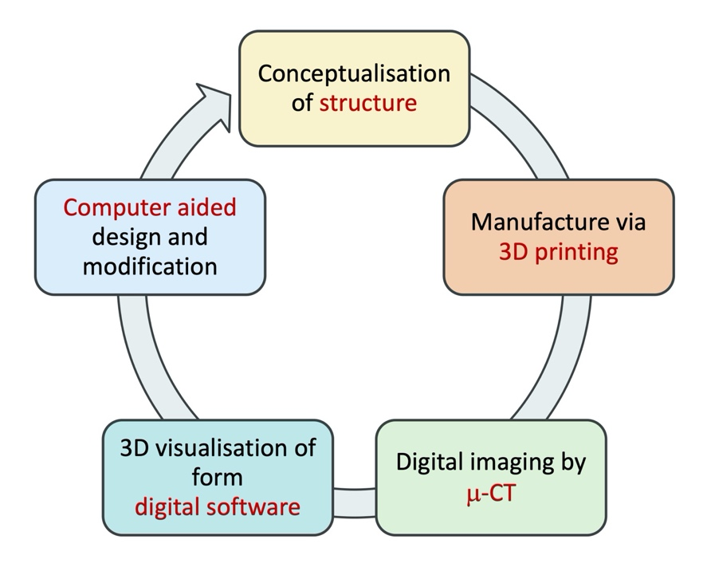
Fig. 1

Fig. 2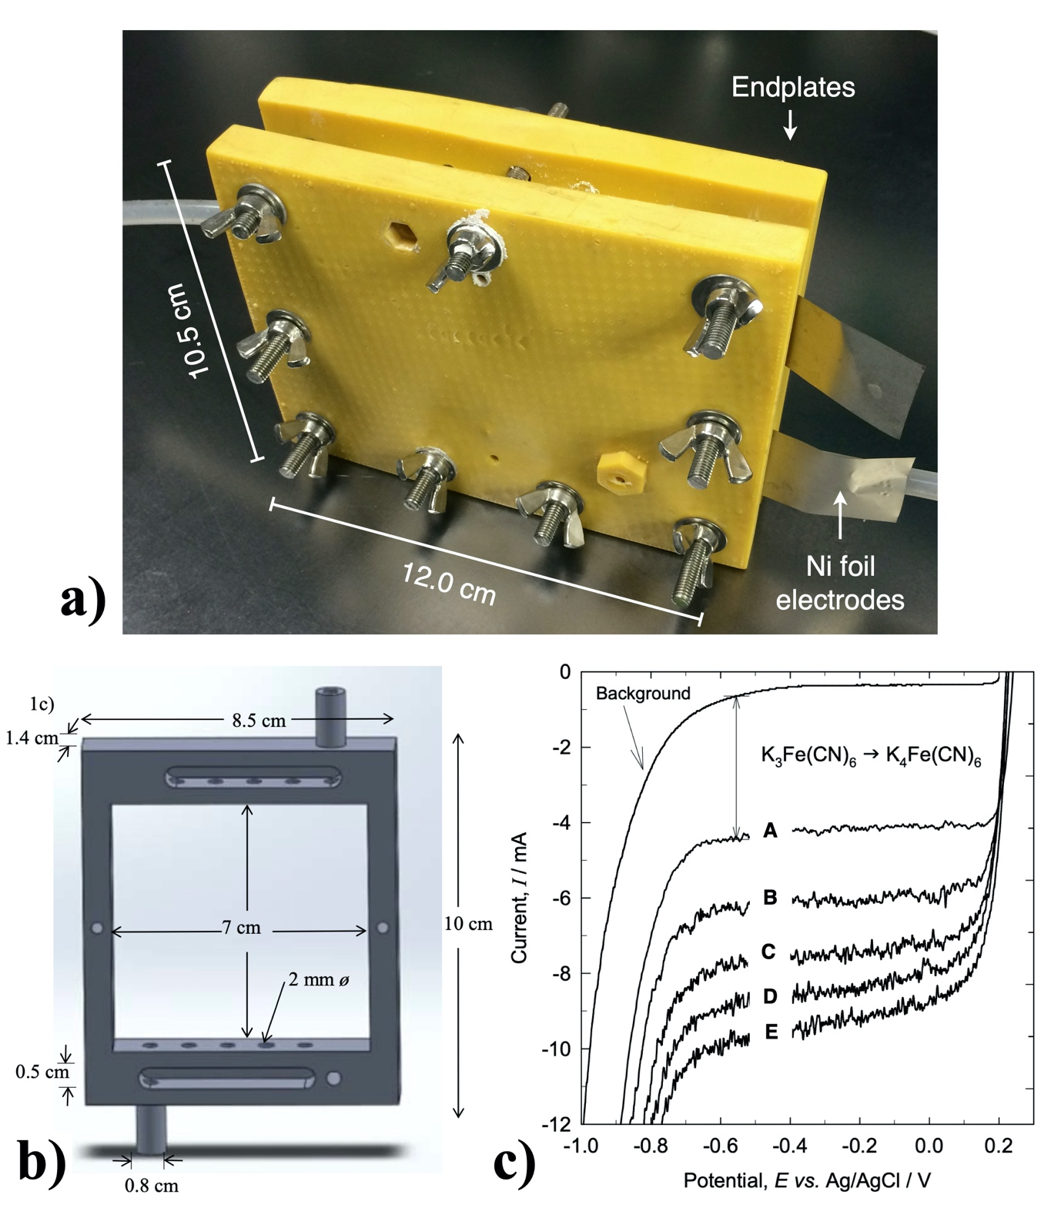

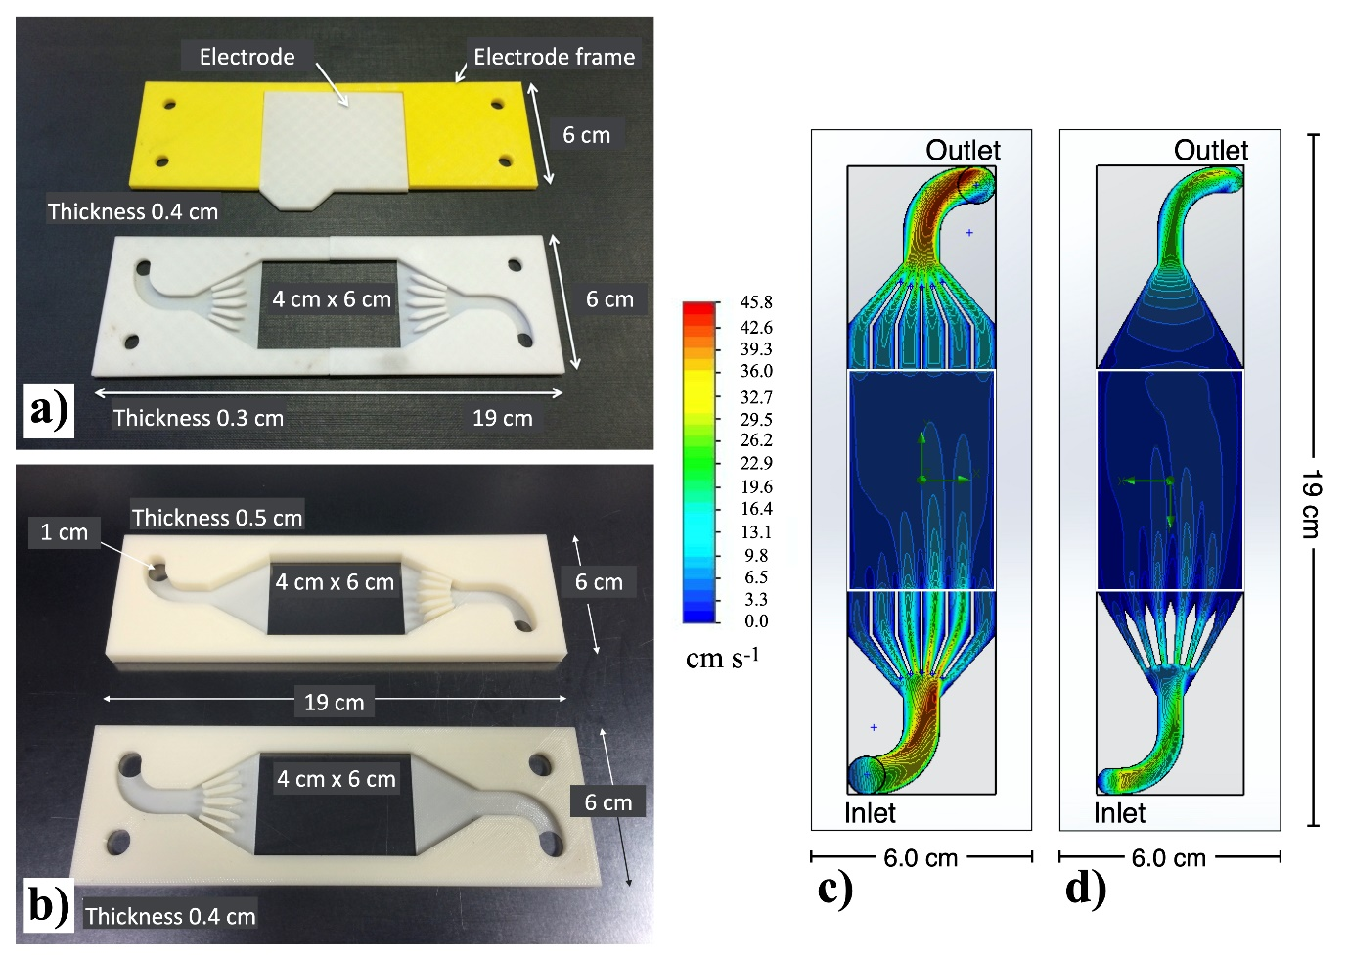

Fig. 3

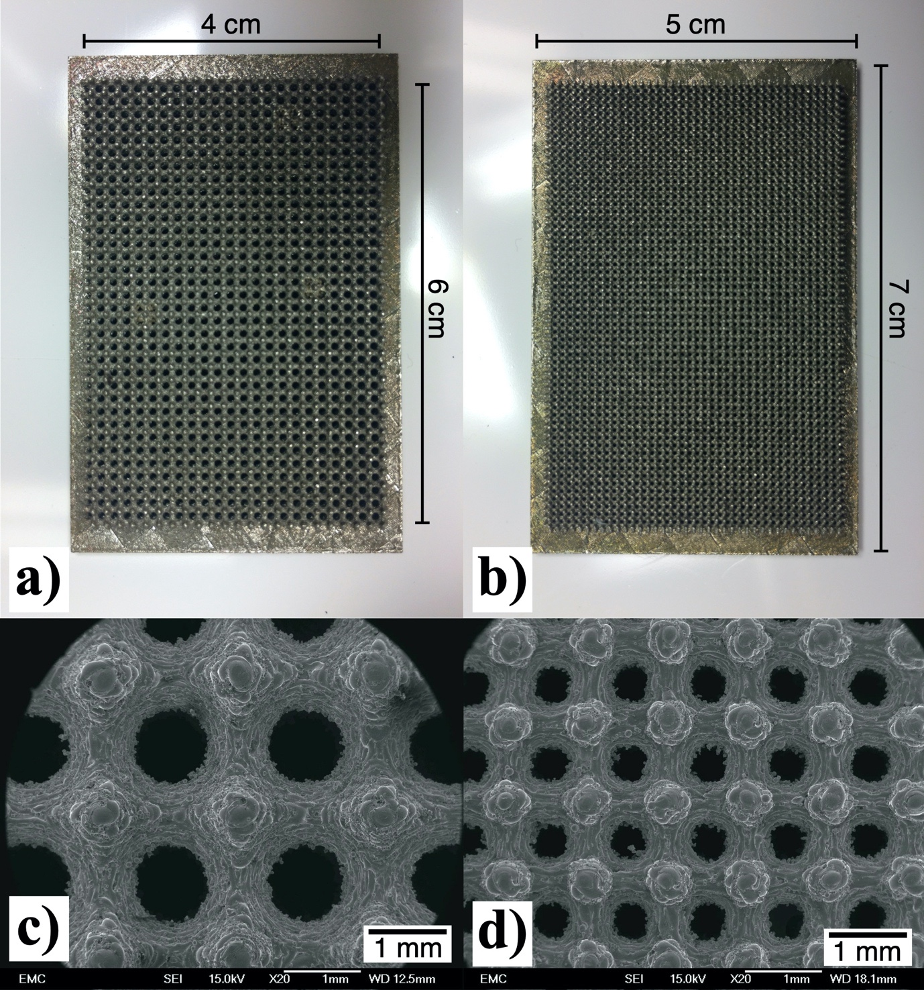

Fig. 4

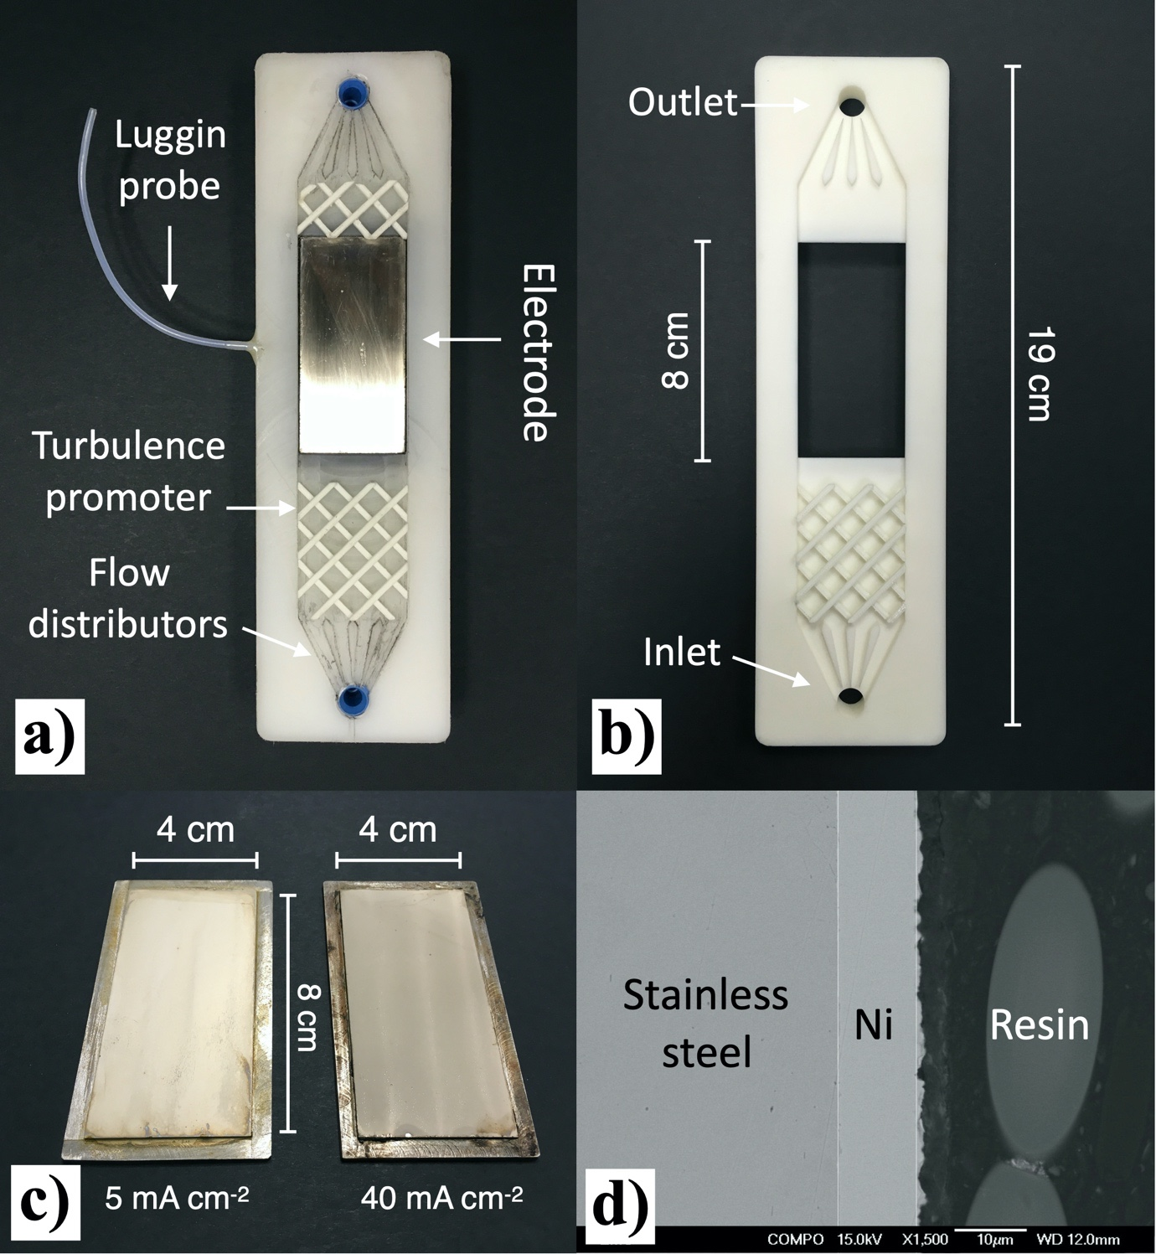

Fig. 5

