Linking root structure to functionality: The impact of root system architecture on citrate enhanced phosphate uptake
Daniel M. McKay Fletcher, Siul Ruiz, Tiago Dias, Chiara Petroselli, Tiina Roose*
Bioengineering Sciences Research Group, Department of Mechanical Engineering, School of Engineering Sciences, Faculty of Engineering and Physical Sciences, University of
Southampton, SO17 1BJ, Southampton, UK
*Corresponding author. Email address: t.roose@soton.ac.uk Telephone: +44 (0) 2380592374
ORCID iD
DMMF: https://orcid.org/0000-0001-6569-2931
SR: https://orcid.org/0000-0002-6273-8516
TD: https://orcid.org/0000-0003-1746-7136
CP: https://orcid.org/0000-0003-2281-6142
TR: https://orcid.org/0000-0001-8710-1063
Twitter: @TiinaRoose

Summary
- Root citrate exudation is thought to be important for phosphate solubilisation. Previous research has concluded that cluster-like roots benefit most from this exudation in terms of increased phosphate uptake, suggesting root structure plays an important role in citrate enhanced uptake (additional phosphate uptake due to citrate exudation).
- Time resolved computed tomography images of wheat root systems were used as the geometry for 3D citrate-phosphate solubilisation models. Citrate enhanced uptake was correlated with morphological measures of the root systems to determine which had the most benefit.
- A large variation of citrate enhanced uptake over 11 root structures was observed. Root surface area dominated absolute phosphate uptake but did not explain citrate enhanced uptake. Number of exuding root tips correlated well with citrate enhanced uptake. Root tips in close proximity could collectively exude high amounts of citrate, resulting in a delayed spike in citrate enhanced uptake.
- Root system architecture plays an important role in citrate enhanced uptake. Singular morphological measurements of the root systems cannot entirely explain variations in citrate enhanced uptake. Root systems with many tips would benefit greatly from citrate exudation. Quantifying citrate enhanced uptake experimentally is difficult as variations in root surface area would overwhelm citrate benefits.
Key words: Root system architecture, citrate, exudation, phosphorus, a-biotic stress, modelling.

Introduction
Phosphorus (P) is considered one of the key macro-nutrients required by plants (Barber, 1995). A characteristic feature of P in soil is that it strongly binds to soil particle surfaces. This processes decreases the quantity of P directly available to plants (Barber, 1995; Oburger et al., 2011). The ratio of solution to soil immobilized P, known as the buffer power, is often used to measure the availability of P in a soil and is often high for P (Barber, 1995). Hence, it is difficult for crops to acquire the necessary amount of P for higher yields without large amounts of fertilisation. Typically, an annual crop producing 10 tons ha⁻¹ of biomass needs 30 kg ha⁻¹ of P during the growing season (Sylvester-Bradley et al., 2017).
Crops are often bred to produce large yields in optimal nutrient and water conditions (Wissuwa et al., 2009; Koevoets et al., 2016); this is usually guided by aboveground performance which can negatively impact belowground traits (Den Herder et al., 2010). For example, studies have suggested that plants bred for high fertility soils have lost the ability to develop symbiotic relationships with mycorrhiza fungi, which are beneficial for acquiring P in poor conditions (Wissuwa et al., 2009). Belowground traits are known to be vital in nutrient/water scarce conditions (Den Herder et al., 2010). With climate change causing more extreme droughts and floods, breeders need to produce high yielding varieties in sub-optimal conditions (Den Herder et al., 2010; Koevoets et al., 2016). Only a small number of genes have been identified that control root traits, one of which enhances early root growth and increases yield in P-deficient soils (Gamuyao et al., 2012; Uga et al., 2013). This gene is notably absent in modern “phosphorus-starvation-intolerant” rice varieties (Gamuyao et al., 2012). Although this is an example of one gene, there is still a vast pool of bio-diversity from which root traits can be found to increase crop yield in poor agricultural settings. Thus, understanding the functionality of root system architecture (RSA) traits will provide important insight as to how we might improve crop breeding to withstand soil changes posed by climate change (Topp et al., 2016). However, unlike above ground traits (e.g. grain mass), it is difficult to assign and measure functionality of root traits due to the complexity of root/soil structure, chemistry, biology, as well as the difficulty of visualising roots in soil.
Under natural conditions, plants have evolved traits to mitigate deficient labile-P supplies. Organic acid anions, such as citrate or oxalate, exuded by roots can lower the soil pH promoting solubilisation of previously inaccessible soil-P supplies (Oburger et al., 2011). Furthermore, organic acids exuded by roots can mobilise P adsorbed to soil particles, thereby enhancing plant P uptake (Gerke et al., 2000a). The benefits of exuding citrate may not only be limited to P deficient soils; locally increased solubilisation makes sorbed P available to plants, allowing farmers to decrease the quantity of fertiliser applied, therefore reducing run-off (Manschadi et al., 2014).
However, the contribution of P mobilisation by organic anions in phosphate absorption is in question. Duputel et al. (2013) found that the addition of citrate can both increase and decrease available P depending on the soil type. Gerke et al. (2000a) found that more than $10$ µmol of citrate g⁻¹ soil was needed for a significant increase in phosphate solubilisation; while typical exudation rates of citrate for P-starved rape roots grown in nutrient solution is $1.2037×{10}^{-6}$ µmol s⁻¹ m⁻¹ of root (Hoffland, 1992). At this rate, it would take $1$ cm of root length almost ten days to exude the 10 µmol required to see significant phosphate solubilisation, not accounting for bio-degradation of the exuded compounds. Furthermore, a combined experimental and modelling study found that a single model root exuding citrate into 1g dry weight of soil did not increase root phosphate uptake (McKay Fletcher et al., 2019b).
Some plant species can form cluster-root architectures that collectively exude large quantities of citrate into a small region of soil in a short burst to intensively solubilise phosphate and other immobile nutrients (Neumann & Martinoia, 2002; Lambers et al., 2006). This is consistent with the modelling findings of Zygalakis and Roose (2012) and Gerke et al. (2000b) who both found that cluster roots achieved the highest phosphate gains from citrate exudation. However, neither of these studies considered the explicit root system geometry in their models. On the other hand, dauciform root forming species (described as roots similar to cluster roots (Lambers et al., 2015)) were found to exude less organic acids and absorbed similar quantities of P to a subgenus that did not form dauciform roots (Güsewell & Schroth, 2017). Furthermore, Ryan et al. (2014) found that citrate enhanced relative biomass in only 2 out of 6 trials by using a low and high exuding wheat (Triticum aestivum).
Densely packed root systems are known to have low P uptake efficiency in terms of root carbon cost, as roots in close proximity to one another compete for the same P supply (De Parseval et al., 2017; McKay Fletcher et al., 2019a). The cumulative organic acid exudation from densely packed roots can mitigate the decreased P uptake efficiency, known as facilitation. However, the mitigating effect of cumulative citrate exudation on decreased P uptake efficiency has been shown to depend on the degree of overlap between the rhizospheres of adjacent roots (De Parseval et al., 2017). Oburger et al. (2011) argued that unlike cluster root forming species, most crop species can only exude small to medium amounts of organic acids, bringing the importance of citrate-phosphate solubilisation in agriculture into question. Lambers et al. (2006) proposed that cluster-root forming species are so successful in highly weathered soil due to their specialized morphology and physiology. Clearly, RSA is linked to organic acid exudation and it may play a role in resulting phosphate gains.
Modelling techniques that consider the RSA (or other structures) can be a useful approach for linking geometry to functionality. Tron et al. (2015) used a root-growth model coupled to a soil-water model to determine which root traits are important for drought tolerance. They found that different RSAs were better in certain drought hydrological scenarios, highlighting the importance of RSA when discussing functionality (although the root systems in this case were simulated). Landl et al. (2019) used a coupled root growth model and water uptake model to determine the role of biopores on RSA and water uptake. Schnepf et al. (2012) modelled the impact of RSA on citrate enhanced phosphate absorption using a root growth model, as their modelling work has a similar scope to the current, we highlight the differences and similarities in the discussion section.
Image-based modelling, a technique which uses images to construct the geometry in the model, is a powerful modelling approach for considering real geometries and their function. Koebernick et al. (2017) used image-based modelling to determine whether effective diffusion of nutrients and hydraulic connectivity of rhizosphere soil was altered by root hairs. They found no differences between rhizosphere soil of wild type barley and a root-hairless mutant. Considering the geometry explicitly is not always necessary; Daly et al. (2018) found that a simple averaged water-uptake model, which represented different RSAs using root length density parameters, predicted water uptake within 2% of an image-based model which used real 3D RSAs extracted from X-ray Computed Tomography (XCT) data. However, the simplified model did not capture the heterogeneous water distribution seen in the image-based model. It is important to note that the root surface area parameter in the simplified model of Daly et al. (2018) was calculated directly from the XCT data to make the averaged model comparable to the image-based model.
Currently, it is difficult to address the impact of the RSA on citrate enhanced phosphate uptake due to the difficulties in quantifying roots, root exudation (Oburger & Jones, 2018) and measuring phosphate uptake simultaneously. This work aims to link RSA morphology to phosphate gains from citrate exudation and disentangle many of the conflicting results regarding P-uptake gains associated with citrate exudation. Specifically, we aim to quantify the impact of the RSA on citrate enhanced phosphate uptake using mathematical modelling. This is achieved by extending the experimentally-parametrised model of McKay Fletcher et al. (2019b) to image based domains. RSAs from 11 time-resolved XCT scans were used as geometries for image-based modelling. The growing RSA both exuded citrate and absorbed P; in the soil, citrate is assumed to enhance P desorption. P uptake for exuding and non-exuding roots was compared under two soil P conditions: High P low buffering (denoted High P) and low P high buffering (denoted Low P) to determine the effect of citrate exudation in highly fertilised soils and low P soils respectively. We hypothesise that RSA plays an important role in citrate enhanced uptake and that the proximity of root tips is an important feature. Geometrical measures of RSAs were correlated with increases in P uptake associated with citrate exudation in order to identify root traits that are important for the P benefits from citrate exudation. Furthermore, for the densest RSA, the model was solved with High P conditions and increasing exudation rates to investigate the effect of high citrate concentrations on the P uptake dynamics.

Materials and Methods

Root system architecture and image-based domain
This study uses imaged wheat (cv. Zebedee) root systems from two soils: Eutric Cambisol (loamy sand, denoted LS) and Argillic Pelosol (clay loam, denoted CL) at 2,4,6,8 and 12 days after germination with 6 replicates per soil type (Daly et al., 2018). The loamy sand had texture 83% sand, 13% clay and 4% silt while the clay loam had texture 36% sand 33% clay and 31% silt. The organic matter contents were 2.3% and 5.5% for the loamy sand and clay loam respectively. The pH was 6.35 and 6.5 for the loamy sand and clay loam respectively. The water extractable P was 530 ppb for the loamy sand (Scotson et al., 2019). No P information was available for the clay-loam, however, both soils were taken from the same field. Both soils were taken from a frequently fertilised field and were hence assumed to contain sufficient levels of other nutrients. Each soil was sieved <2 mm and packed to a bulk density of 1200 kg m⁻³.
The RSAs from the 12 day scans were used as the geometry for a model describing a citrate-exuding root absorbing phosphate. The 12 day state of each RSA can be seen in Figure 1. Root growth in the model was simulated by ‘activating’ the roots at the appropriate root growth rate as calculated from the previous XCT scans, details of which are given in the following sections. The root systems were segmented in the top 60 mm of the pots to avoid capturing effects of the pot on the RSA (Daly et al., 2018). Often, the seminal roots reached this depth before 12 days. The scan resolution (30 µm voxel edge length) was not sufficient to observe and segment fine lateral roots less than approximately 100 µm in diameter, hence these root are not included in the segmented RSA. The impact of not considering fine lateral roots in the model is examined in the discussion.

Citrate phosphate mathematical model
We developed a model describing root citrate exudation, P uptake, diffusion in soil and P reactions to the soil with enhanced desorption due to citrate. The domain considered was a cylindrical pot of soil with a diameter 50 mm and 80 mm high containing growing roots. The 12 day RSAs as extracted from the XCT scans were used as the root surfaces in the model. The root surfaces associated with the RSAs from the XCT scans were activated along the depth in accordance to the individual plant growth rates. We first describe the citrate and phosphate governing equations. We then describe the implementation of the growing RSA.
The soil domain is denoted $Ω⊂R^{3}$ (Figure 2). The whole root surface, as extracted from the 12 day XCT scan is denoted $Γ$ (Figure 2). The active absorbing surface at time $t$ is denoted, $Γ_{r}(t)$, while the portion of the root exuding citrate at time $t$ is denoted $Γ_{on}(t)$ (Figure 2). Notice $Γ_{on}\left(t\right)$ is contained within $Γ_{r}\left(t\right)$, which is itself contained within $Γ$ as a citrate exuding region of the root can also absorb phosphate and the root grows into the 12 day RSA as illustrated in Figure 2. The remainder of the boundary i.e. the inside of the pot and the non-functioning part of the root is denoted $Γ_{e}(t)$. Figure 2 shows a schematic of the domain and its boundaries. The soil is assumed to be homogenous with approximate volumetric water content $ϕ_{l}$ [m³ of soil solution m⁻³ of domain] and volumetric soil solid volume fraction $ϕ_{s}$ [m³ of soil solid m⁻³ of domain].
We assume P and citrate to exist either bound to soil surfaces or unbound in solution in soil. In particular, $P_{l}\left(t,x\right)$ [µmol m⁻³ of soil solution] is the P concentration in solution, $C_{l}\left(t,x\right)$ [µmol m⁻³ of soil solution] represents citrate concentration in solution, $P_{s}(t,x)$ [µmol m⁻³ of soil solid] is the concentration of P bound to soil particles, and $C_{s}\left(t,x\right)$ [µmol m⁻³ of soil solid] is the amount of citrate bound to soil particles.
P and citrate can adsorb to and desorb from soil mineral surfaces, this is modelled using a reversible first order chemical reaction (Barber, 1995). The process of citrate enhanced phosphate desorption is assumed to be dominated by ligand-exchange. That is, citrate competes with phosphate for binding spots on soil mineral surfaces, increasing the amount of available P (Oburger et al., 2011). This is modelled by adding a cross term to the P desorption-adsorption reaction (see equations (1-2)). Citrate is known to be consumed by microbes in the rhizosphere. However, sorption of citrate to soil particles causes a significant reduction in biodegradation rate (up to 99%) (Van Hees et al., 2003). Therefore, citrate in the model is allowed to biodegrade only in the soil solution. Hence, assuming conservation of mass and the diffusion-sorption-reactions for P and citrate, the model can be written as
 | $$\frac{ϕ_{l}∂P_{l}}{∂t}=∇⋅ϕ_{l}D_{P}∇P_{l}-ϕ_{l}β_{1}P_{l}+ϕ_{s}β_{2}P_{s}+ϕ_{s}β_{3}C_{s}P_{s}, x∈Ω,$$ | (1)
 | $$\frac{ϕ_{s}∂P_{s}}{∂t}=ϕ_{l}β_{1}P_{l}-ϕ_{s}β_{2}P_{s}-{ϕ_{s}β}_{3}C_{s}P_{s}, x∈Ω,$$ | (2)
 | $$\frac{ϕ_{l}∂C_{l}}{∂t}=∇⋅ϕ_{l}D_{C}∇C_{l}-ϕ_{l}λ C_{l}-ϕ_{l}γ_{1}C_{l}+ϕ_{s}γ_{2}C_{s}, x∈Ω,$$ | (3)
 | $$\frac{ϕ_{s}∂C_{s}}{∂t}=ϕ_{l}γ_{1}C_{l}-{ϕ_{s}γ}_{2}C_{s}, x∈Ω,$$ | (4)
where $β_{1}$ [s⁻¹] is the rate at which P adsorbs to soil particles, $β_{2}$ [s⁻¹] is the rate at which P desorbs from soil particles, $β_{3}$ [m³ of soil solid s⁻¹ µmol⁻¹] is the rate associated with ligand exchange between citrate and P on soil sorption sites, $γ_{1}$ [s⁻¹] is the rate at which citrate adsorbs to soil particles, $γ_{2}$[s⁻¹] is the rate at which citrate desorbs from soil particles, $D_{P}$ [m² of soil solution s⁻¹] is the diffusion rate of P in soil solution,$D_{C}$ [m² of soil solution s⁻¹] is the diffusion rate of citrate in soil solution (diffusion coefficients include geometric impedance) and $λ$ [s⁻¹] is the rate of citrate bio-degradation.
Boundary conditions are imposed on the root surface and the edge of the pot. In particular, the root is assumed to take up P using Michaelis–Menten kinetics (Barber, 1995) and exude citrate at a steady rate (Geelhoed et al., 1999; Zygalakis & Roose, 2012). The root boundaries are denoted by $Γ_{r}\left(t\right)$ and$Γ_{on}\left(t\right)$, which represent the absorbing and exuding parts of the RSA respectively. These are defined using the growth rates calculated from the XCT data in the following section so that only the root tips exude and roots that have grown can absorb at the given time, $t$ (Figure 2). The citrate root boundary condition is
 | $$ϕ_{l}D_{C}∇C_{l}⋅n_{on}=F_{C}, x∈Γ_{on}(t),$$ | (5)
where $F_{C}$ [µmol m⁻² s⁻¹] is the root citrate exudation rate and $n_{on}$ is the unit normal to the exuding part of the root. The P root boundary condition is
 | $$ϕ_{l}D_{P}∇P_{l}⋅n_{r}=\frac{{-F}_{P}P_{l}}{K_{P}+P_{l}} , x∈Γ_{r}\left(t\right),$$ | (6)
where $F_{P}$[µmol m⁻² s⁻¹] is the maximum P uptake rate achieved by the root, $K_{P}$ [µmol m⁻³] is the P concentration where the uptake rate is half of maximum possible and $n_{r}$ is the unit normal to the absorbing part of the root. Typical exudation rates of citrate for P-starved rape roots grown in nutrient solution at 27°C is $1.2×{10}^{-5}$ µmol s⁻¹ m⁻¹ of root (Hoffland, 1992). These roots typically have a root radius of approximately $4×{10}^{-4}$ m (Kjellström & Kirchmann, 1994), meaning an approximate citrate exudation rate per root surface area (assuming the root is a cylinder) of $F_{C}=4.7894×{10}^{-3}$ µmol m⁻² s⁻¹. Typically $F_{P}=3.26×{10}^{-2}$ µmol m⁻² s⁻¹ and $K_{P}=5.8×{10}^{3}$ µmol m⁻³ (Barber, 1995). On the pot boundary and non-active part of the root a no flux condition is imposed for both phosphate and citrate,
 | $$D_{P}∇P_{l}⋅n_{e}=0, x∈Γ_{e}(t),$$ | (7)
 | $$D_{C}∇C_{l}⋅n_{e}=0, x∈Γ_{e}\left(t\right),$$ | (8)
where $n_{e}$ is the unit normal to the inactive part of the root and the edge of the pot. Initially, there is no citrate in the soil,
 | $$C_{l}\left(0,x\right)=C_{s}\left(0,x\right)=0, x∈Ω,$$ | (9)
Furthermore, there is a known initial concentration of total phosphate in the soil, $P_{tot}$ [µmol m⁻³ of total soil] which exists in equilibrium between adsorbed and solution phosphate,
 | $$P_{l}\left(0,x\right)=\frac{P_{tot}}{ϕ_{l}(1+b_{P})}, x∈Ω,$$ |  | (10)
 |  | $$P_{s}\left(0,x\right)=\frac{ϕ_{l}}{ϕ_{s}}b_{P}P_{l}\left(0,x\right), x∈Ω,$$ | (11)
where $b_{P}= β_{1}/β_{2}$ is the buffer power of phosphate in the soil. Two soil P conditions are used in the numerical experiments, high P low buffering (denoted High P) and low P high buffering (denoted Low P). All parameters used in the model are summarised in Table 1.

Root growth model
In the citrate phosphate model the root boundary is time dependent, therefore, a suitable model describing the evolution of the root surfaces absorbing P, $Γ_{r}(t)$, and surfaces exuding citrate, $Γ_{on}(t)$, in time was required. Numerically, this was implemented by “activating the roots” in the RSA extracted from the 12 day scans using the growth rates calculated from the previous scans. More precisely, growth rates are calculated for each time point by finding the deepest root in each scan, subtracting the depth of the deepest root in the previous scan and dividing by the time difference. As a reference, wheat seminal root elongation rate is typically between 0.0926 and 0.277 µm s⁻¹ depending on soil compaction (Watt et al., 2003; Ruiz et al., 2017). Citrate exudation is typically limited to the apical zone of the root (Hoffland et al., 1989), this was implemented in the model by allowing only the portion of the root within 3 mm of the tip to exude. Mathematically, for each pot the following piecewise function is defined to implement the growing RSA,
 | $$G\left(t\right)=\left\{\begin{aligned}g_{0}, &0 day≤t≤ 2 day \\ g_{2}, &2 day<t≤ 4 day \\ g_{4}, &4 day<t≤ 6 day \\ g_{6}, &6 day<t≤ 8 day \\ g_{8}, &8 day<t≤ 12 day\end{aligned}\right.,$$ | (12)
where $g_{i }[m s^{-1}]∈ R_{≥0}, i=0,2,4,6,8$are the growth rates as calculated from the XCT scans. A root depth indicator function is defined for each $t$,
 | $$dep_{t}\left(z\right)= \left\{\begin{aligned}1, &0≤z≤ \int_{0}^{t}{G\left(τ\right)dτ } \\ 0, &else\end{aligned},\right.$$ | (13)
where $z$ is the space variable representing the vertical direction. Similarly, a root tip indicator function is defined
 | $${tip}_{t}\left(z\right)= \left\{\begin{aligned}1, &\int_{0}^{t}{G\left(τ\right)dτ }-0.003≤z≤ \int_{0}^{t}{G\left(τ\right)dτ } \\ 0, &else\end{aligned},\right.$$ | (14)
to determine the location of the exuding section of the root. The growing root and root tip are then defined as $Γ_{r}\left(t\right)=\left\{\left(x,y,z\right)∈Γ such that dep_{t}\left(z\right)=1\right\}$ and$Γ_{on}\left(t\right)=\left\{\left(x,y,z\right)∈Γ such that tip_{t}\left(z\right)=1\right\}$. A schematic of the relationship between $dep_{t}\left(z\right)$ and $Γ_{r}(t)$; and $tip_{z}(t)$ and $Γ_{on}$ can be seen in Figure 2. For the purposes of numerical simulations, $tip_{t}(z)$ and $dep_{t}(z)$ are smoothed.

Numerical experiments
In order to assess the impact of RSA on citrate enhanced phosphate uptake, the model was solved on each of the RSAs with and without citrate exudation. Two P soil conditions were simulated: High P, representative of a UK arable field with $P_{tot}=2.26×{10}^{4}$ µmol m⁻³ (corresponding to 24 kg per hectare (DEFRA soil nutrient balances UK provisional)) with P adsorption rate $β_{1}=7.899×{10}^{-6}$ s⁻¹ and desorption rate $β_{2}=1.993×{10}^{-7}$ s⁻¹ equating to a buffer power of $40$ (Barber, 1995). Low P, representative of a poor P soil with $P_{tot}=941.7$ µmol m⁻³ (corresponding to 1 kg per hectare (DEFRA soil nutrient balances UK provisional) with P adsorption rate $β_{1}=7.899×{10}^{-6}$ s⁻¹ and desorption rate $β_{2}=7.3684×{10}^{-9}$ s⁻¹ equating to a buffer power of $1072$ (Barber, 1995).
To determine what morphological root system measures were important for increased P uptake from citrate exudation, percentage P uptake increase due to citrate was correlated with root surface area, number of exuding tips, average inter tip distance, solidity (defined as the ratio of root volume to RSA convex hull volume), and total number of exuding tips. Some of these measurements require an image analysis protocol that will be described in the following section. Additionally, using the densest RSA geometry, the model was solved with an increasing range of citrate exudation rates in the High P soil, and P influx was plotted to investigate the gain in P absorption for higher citrate exudations.
A finite element method was used to solve the image-based models using Comsol Multiphysics 5.3. Typically, the meshes had approximately $1.5×{10}^{6}$ volume elements and $2.4×{10}^{5}$ surface elements. Lagrange polynomials of order two were used to approximate the solution in each element. Backwards differentiation formulas between orders 1 and 5 were used in the time discretization. To reduce memory requirements, a segregated approach was taken. As citrate dynamics was independent of P, at each time step $C_{l}$ and $C_{s}$ were solved for first and then $P_{l}$ and $P_{s}$. Any nonlinearities were linearized using one Newton-Raphson iteration. All resulting systems of linear equations were solved using the MUMPS algorithm. Numerical solutions were saved every 3 hours of solution time.
Pearson Correlation Coefficient (PCC) was used to measure linear correlation between P uptake and root measures (such as number of exuding tips or root surface area etc) over all time points and RSAs. For example, let $P_{l}^{i}$ be the solution to equations (1-11) solved on the $i^{th}$ RSA with citrate exudation and let $S_{i}(t)$ be the root surface area at time $t$ of the $i^{th}$ RSA. The whole root uptake rate for the $i^{th}$ RSA at time $t$ is then the active root integrated flux of P:
 | $$F_{i}\left(t\right)=\int_{Γ_{r}\left(t\right)}^{ }{ ϕ_{l}D_{P}∇P_{l}^{i}\left(t\right)⋅n_{r}}dΓ_{r}\left(t\right).$$ | (15)
The PCC of P uptake rates, $F_{i}(t)$, with root surface area over all 11 RSAs and saved model times, $T=[k×3 hours, for k=1,2,…,96]$, was calculated as
 | $$ρ\left(F_{i}\left(t\right),S_{i}\left(t\right)\right)=\frac{\sum_{\begin{aligned}i∈1…11, \\ t∈T\end{aligned}}{F_{i}(t)⋅S_{i}(t)}-n\overline{F}\overline{S} }{{\left(\sum_{\begin{aligned}i∈1…11, \\ t∈T\end{aligned}}{{(F}_{i}{\left(t\right)}^{2}}-n{\overline{F}}^{2})\right)}^{\frac{1}{2}} {\left(\sum_{\begin{aligned}i∈1…11, \\ t∈T\end{aligned}}{(S_{i}{\left(t\right)}^{2}}-n{\overline{S}}^{2}) \right)}^{\frac{1}{2}}},$$ | (16)
where $n=11×96$ and bar denotes average over all RSAs and model times.
The term “citrate enhanced uptake” is used to describe both percentage additional root P flux due to citrate at a given time point, and percentage additional P absorbed by the roots.
Sensitivity analysis on the effect of the biodegradation rate ($λ$) and citrate enhanced desorption rate ($β_{3}$) on citrate enhanced uptake was carried out (see Supplementary Material Figures S1 and S2). Only one RSA in Low P conditions was used due to the computational time of generating numerical solutions. Additionally, citrate enhanced uptake of the 2 day RSA and 12 day RSA was compared over 2 days to investigate the effect of approximating the growing RSA with the 12 day RSA and maximum growth rates (see Supplementary Material Figure S3).

Image analysis
Average inter-tip distance
To determine the role of number of exuding tips and average inter-tip distance in citrate enhanced uptake, an image analysis protocol was developed. The 12-day segmented RSA was skeletonized using BoneJ (Doube et al., 2010). The slice in the skeletonized stack representing the deepest root at the given time point was selected using the growth rates as described by Equation (12). The number of connected components on this slice determined the number of exuding tips at the given time. The mean coordinate of each component was calculated, and the average distance between these means was used to determine average inter tip distance at a given time point. This approach means the measurements are in line with the model RSA as opposed to the XCT data, in particular, all roots are assumed to grow at the rate of the fastest growing root, see Figure 2. These calculations were carried out in Python3.
Solidity
Solidity of an RSA is defined as the ratio of the root volume and RSA convex hull volume (Zurek et al., 2015). Solidity was hypothesised to positively correlate with citrate enhanced uptake, as root systems with high solidity would be contained in a small region of soil and hence collectively create regions of high citrate concentration. Solidity was calculated using the convex hull function in Scipy (Jones et al., 2001) for the 12 day RSAs.

Results
Figure 3 shows the growth rates for each of the replicates as calculated from the time-resolved XCT data. Each root system has grown past the area of segmentation by day 8.

Numerical experiments
First, P uptake rates in the exuding and non-exuding case in the High P soil are compared; citrate enhanced uptake rate is compared with RSA measures in the Low P soil; citrate concentrations are displayed on planes within the soil; cumulative citrate enhanced uptake is compared amongst the RSAs and correlated with total number of root tips and solidity; finally the evolution of citrate enhanced uptake is examined for increasing exudation rates.
Figure 4 shows a comparison of P uptake rate in time for the exuding and non-exuding model roots for each of the root systems in the High P case. Increased root surface area strongly correlates with P absorption rate (Figure 4), with a PCC of 0.955 over all RSAs and times in High P conditions.
Although P uptake rate still strongly correlates with root surface area in Low P conditions (data not shown, PCC of 0.9583 over all RSAs and times) citrate’s contribution to P uptake rate was more noticeable. Figure 5 shows a comparison of percentage increased uptake between the two soil conditions for three RSAs (the other replicates can be seen in Supplementary Material Figures S4 and S5). In the High P scenario, the difference in total absorbed P between the exuding and non-exuding case never exceeded 0.2% across the 11 RSAs (such variations are within the numerical error of the method). Figure 4 shows there was little difference between the exuding (line) and non-exuding (stars) case. In contrast, results suggest that there can be >5% increase in uptake for early time points and RSAs in the Low P conditions (Figure 5).
There was a large variation in percentage increase due to citrate across the RSAs as well as the growth states in the Low P case, Figure 5 and 6. For example, in Figure 6 citrate enhanced uptake reached a maximum of 10% in CL3 while LS1, CL1 and LS3 never achieved more than 5%. Furthermore, citrate enhanced uptake had two local maxima in LS5, CL5 and LS6 while the others had only one local maxima. This all suggests RSA is an important factor in P gains due to citrate exudation.
Root surface area does not explain citrate enhanced uptake in the Low P conditions; the correlation between citrate enhanced P-uptake rates and root surface area had a PCC of -0.07 (Figure 5 and Supplementary Material Figure S4). Number of exuding root tips (Figure 6) and average inter tip distance (Figure 7) were plotted with percentage increase in P uptake rate due to citrate to see if they can explain the variation amongst RSAs. Number of exuding tips had a PCC of 0.39 with percentage increase in P uptake rate due to citrate, while average inter tip distance had a PCC of 0.09. The PCC does not capture the relationship between citrate enhanced uptake and average inter tip distance. A period of high citrate enhanced uptake was often preceded by low average inter tip distance (Figure 7). This can be explained by a positive interference of citrate concentrations when root tips were in close proximity. Figure 8 shows the concentration of citrate in solution on 2D planes located at the depth of the roots at 12, 24 and 48 hours after germination for the CL4 RSA. The state of the root system at the given times is also displayed. At 12 hours, Figure 8a, the root tips were in close proximity, between them there was a region of high citrate concentration (greater than 6 µmol l⁻¹of soil solution). The plant benefit of the solubilised P in this region was not seen until later (Figure 7 CL4 plot at 1.5 days) as the movement of P in the soil is slow. At 24 hours, Figure 8b, the root tips had grown farther apart and less positive interference can be seen. By 48 hours, Figure 8c, only regions of soil immediately adjacent to the root have high citrate concentrations, explaining the reduced citrate enhanced uptake after 2 days, seen in Figure 7 CL4 plot.
Cumulative additional P absorbed due to citrate (normalised by citrate exudation) for each of the root system architectures in the Low P soil is plotted in Figure 9. A wide variation amongst the RSAs can be observed, which is attributed to the variations in RSA morphology. Furthermore, plants maintain high additional P absorbed per citrate exuded from 2 days through to 6 days, similarly low values are maintained in time, Figure 9.
To determine if analysis of the whole root system could predict citrate enhanced uptake, two measurements of the 12 day root systems were plotted against percentage additional P absorbed by plants cumulatively due to citrate after 8 days in the Low P conditions; namely solidity, Figure 10a, and number of root tips at 12 days, Figure 10b. Additional P absorbed by plants cumulatively due to citrate had a PCC with solidity of -0.5 (Figure 10a). Number of root tips at 12 days, however, had a PCC with additional P absorbed by plants cumulatively due to citrate of 0.84, Figure 10b.
In the no citrate exudation case seen in red line Figure 11, initially, the plant rapidly grows into the soil increasing the P absorption rate. Once the RSA stops growing, P supplies in the soil are used up with no means for replenishment except for diffusion from regions of higher P concentration, hence, P absorption rate slowly decreases. In the cases with higher citrate exudation there is a contrasting evolution of P uptake rates, Figure 11. P uptake increases to a distinct maximal value, then as root growth slows, P uptake rapidly decreases due to reduced citrate exudation and citrate biodegradation. In the highest citrate exudation case (yellow line, Figure 11) the root system has absorbed enough P during the initial growth period that the uptake rate drops below the no citrate exudation case at 150 hours due to low P supplies in the soil. As citrate exudation rate increases from 0 to 21.2 µmol m⁻² s⁻¹ the PCC of P uptake rate with root surface area decreases from 0.98 to -0.15 while the PCC of P uptake rate with citrate exudation rate increases from -0.1 to 0.44; exudation rather than root growth becomes the dominant mechanism for P uptake.
The sensitivity analysis found that decreasing the biodegradation rate, $λ$, slightly increased the magnitude and increased the longevity of the citrate enhanced uptake peak, Figure S1a. Increasing the citrate enhanced desorption rate, $β_{3}$, increased the magnitude of the citrate enhanced uptake peak, Figure S1b. Increasing $λ$ decreased the cumulative citrate enhanced uptake over 12 hours non-linearly while increasing $β_{3}$ increased it linearly, Figure S2. See the Supplementary Materials for more details.

Discussion
The role of root system architecture on citrate enhanced uptake
Although extensive research has been carried out on the role of citrate in phosphate solubilisation from soil and plant uptake, little research has been focused directly on the role of RSA. In the current study, time resolved XCT-extracted RSAs were used as the geometries for models. We simulated scenarios with and without citrate exudation to determine the benefit of P uptake from exuding citrate in different soil P conditions. Our results demonstrated large variations in the amount of extra P that plants absorb due to citrate exudation throughout the 11 RSAs. When citrate enhanced uptake was normalised by citrate exudation, the largest gain in P due to citrate was almost 1.5 times the smallest (Figure 9); suggesting that RSA plays a key role in the phosphate benefit from citrate exudation.
Root system morphological measurements were used to determine if a plant’s citrate enhanced uptake can be estimated by solely measuring its RSA, alleviating some of the need for time consuming mathematical modelling. While root surface area correlated well with absolute root P uptake (Figure 4), it correlated poorly with citrate enhanced uptake (Figure 5). The number of exuding tips was a good indicator for citrate enhanced uptake (Figure 6). As a rule of thumb for the Low P conditions, one extra exuding root tip increases P uptake rate by one percent (Figure 6). Periods of low average inter-tip distance were followed by high citrate enhanced uptake (Figure 7). Root tips in close proximity can cumulatively create regions of high citrate concentrations that can explain this increased citrate enhanced uptake, Figure 8. This effect is noticeable in early root system development, where primary roots are inherently close together due to a single origination point. This proximity provides a boost of P uptake due to citrate exudation at approximately one and a half days after germination (Figure 7). This feature of citrate exudation may be important as P nutrition at the very early stages of development is critical for crop yield (Grant et al., 2001; Nadeem et al., 2011). Furthermore, citrate exudation may justify the reduced P uptake efficiency (in terms of RSA carbon cost) of densely packed roots (McKay Fletcher et al., 2019a).
A more holistic measurement of the root system is solidity, which was hypothesised to correlate positively with citrate enhanced uptake. Instead, we found solidity negatively correlated with citrate enhanced uptake (Figure 10a), while total number of root tips correlated positively with it (Figure 10b). A possible explanation is that a roots system with many root tips have many lateral roots which grow horizontally, increasing the convex hull volume of the root system and thus lowering solidity.
The role of soil buffering and P content on citrate enhanced uptake
With High P soil conditions little benefit could be observed from citrate exudation (<0.1% extra P absorbed over the 12 day simulation, this is within the numerical error of the method). However, in the Low P soil a more noticeable effect of citrate was observed (Figure 5), which is consistent with previous research stating that citrate solubilises strongly sorbed phosphates and is effective in low P conditions (Oburger et al., 2011; Ryan et al., 2014).
Comparison to experimental results
The experimental analogue of this modelling study would measure plant P mass in both a high-exuding mutant and low-exuding mutant (similar to Güsewell and Schroth (2017) or Ryan et al. (2014)). It would be difficult to detect P gains due to citrate in the experimental setup as even slight variations in root surface area would overwhelm the P gains from citrate. For example, although Ryan et al. (2014) found citrate exudation could not explain increased biomass between high exuding and low exuding near-isogenic wheat lines, this may have been due to their experimental design. The normalisation of the results presented in the work of Ryan et al. (2014) did not take into account variations in RSA, thus, any gains due to citrate exudation would not be detected due to variations in root surface areas.
Experimental literature suggests that organic acid concentrations greater than 1 mM in the soil solution are required to solubilise significant amounts of P (Mench & Martin, 1991; Jones & Darrah, 1994; Gerke et al., 2000a; Khademi et al., 2010). Typically, concentrations of organic acids in soil are between 1 µM and 50 µM (Khademi et al., 2010). Across all the simulations and time points, the citrate concentrations in soil solution never exceeded 48 µM. Although citrate concentrations did not reach the experimentally-required concentration to significantly solubilise P, increased uptake in the Low P conditions were observed in the simulations (Figure 5). Three possible reasons are proposed to explain this discrepancy. Firstly, singular time point bulk scale solubilisation experiments, such as those cited above, may not be able to simultaneously capture diffusion, uptake, adsorption, and desorption, which occur at different timescales (McKay Fletcher et al., 2019b). Secondly, bulk scale measurements (even when analysing rhizosphere soil) do not measure local pore scale concentrations. It is likely there are local regions of higher concentrations near the root surface despite bulk scale measurements being low (Jones, 1998; Khademi et al., 2010). Finally, differences in soil labile P between the exudation and no-exudation cases are small. There was at most a 0.25% difference when average P concentration in soil solution over the whole domain is compared between the no exudation and exudation cases in the Low P soil. Such a small difference in bulk solubilized P would be difficult to detect experimentally. We conclude lack of bulk scale measured P solubilisation does not imply lack of citrate enhanced uptake.
Comparison to other root-system modelling approaches
The model and aims of this paper are comparable to the work of Schnepf et al. (2012), as such it is worth discussing the similarities and differences. The modelling approach of Schnepf et al. (2012) used a local 1D-cylindrical-diffusion model of competitive adsorption between phosphate and citrate for a single root in order to calculate root volumetric fluxes of phosphate and citrate in a global finite difference model. Within the domain of a global finite difference model, a root growth model is solved (Leitner et al., 2010). This is used to determine the surface area of roots in each discretised volume. For each time step and each discretised volume, the local uptake model, based on local root surface area at that time point, is solved to determine root exudation and uptake to be applied as a volume flux in the global model. Although the aims of the model of Schnepf et al. (2012) are similar to this work, the modelling approach is fundamentally different. Mathematically, our model explicitly considers the roots as surfaces within soil, while Schnepf et al. (2012) considers them as parameters such as root-surface-area density. The approach of Schnepf et al. (2012) has an advantage over the current approach in terms of computational complexity. When using our approach, if the root system became larger and more detailed, the number of elements in the mesh would increase to capture the root surface complexity and computation time would scale at least big-O of the number of elements (Farmaga et al., 2011). While in Schnepf et al. (2012) the same grid could be used for arbitrary RSAs. This advantage may come at the expense of accuracy. Average root length measurements do not capture the geometry within each discretized volume – each root can access all the P within its discretized volume in the approach of (Schnepf et al., 2012). This error will be larger for slow moving nutrients like P.
Auxiliary factors influencing citrate enhanced uptake
Rates of plant organic anion exudation is thought to be controlled by a number of properties including soil nutrient status and the plant diurnal rhythm (Shane & Lambers, 2005; Dessureault-Rompré et al., 2007). In the model a constant rate of citrate exudation was used, parameterised by a hydroponic experiment over 30 minutes (Hoffland, 1992). This is a common assumption made in models of citrate exudation (Gerke et al., 2000a; Schnepf et al., 2012; Zygalakis & Roose, 2012; De Parseval et al., 2017). Even when models considered the effect of a diurnal rhythm on deoxymugineic acid (DMA) enhanced zinc uptake with roots distributed 0.9 mm apart (Ptashnyk et al. (2011)), DMA exudation had little effect on enhanced zinc uptake provided the total quantity exuded on DMA was the same. As such, the temporal variability of citrate exudation was not included in the model. However, we note that other factors may be important when considering a growing root system. For example, if the exudation rates were reduced during periods of low inter-tip distance, the peaks in citrate enhanced uptake would be less pronounced. Currently there is not enough experimental data on the temporal variations of exudation to include an accurate time-dependent exudation function in the model without introducing further approximations. Including such a function would detract from the aim of this study by introducing uncertainty to whether the findings were a result of RSA or the chosen diurnal rhythm. Future studies could consider the impacts of time varying root exudation rates and decouple these dynamics from the aforementioned factors.
Fine lateral roots were not included in the model geometry as they were not detected in the XCT scans. This was due to the trade-off between field-of-view and resolution when using XCT; to capture the full RSA using XCT, the resulting voxel size was not sufficient to resolve the finer lateral roots. The omission of fine lateral roots will potentially affect P and citrate enhanced uptake. However, we believe the qualitative findings regarding the role of root-system architecture in citrate enhanced uptake will persist with the inclusion of fine lateral roots. The inclusion of fine lateral roots will likely amplify citrate enhanced uptake due to the increased number of exuding tips in close proximity. The model roots in the root system grew vertically at the rate of the deepest root, this led to high surface area growth rates, Figure 4. To test how this could affect the results citrate enhanced uptake was compared between the 12 and 2 day RSAs (Figure S3, see the Supplementary Material for more details). The citrate enhanced uptake when using the 12 day RSA behaved similarly to the 2 days RSA until 34 hours after germination. After which, the 12 day RSA under predicts citrate enhanced P uptake. This divergence can be attributed to the 2 day RSA exuding more citrate; the 2 day RSA contained the bottom of the root tip, while in the 12 day case, the root tip was blocked by the non-active part of the root system. The 12 day case is in fact more accurate, as roots are known to exude organic acids from the sides of their tip as opposed to their cap (Jones et al., 2009). Additionally, it was assumed the full root surface area absorbed P independent of age, this is a common approximation for modelling. However, effects of root age on P uptake rates are minimal within 28 days after germination (Jungk & Barber, 1975). As the simulation time is over 12 days we assume this to have minor influences on the results. The current modelling approach is not suitable for including more detailed or larger RSA due to computational limitations. The largest simulation required up to 250GB of memory and 8 days of computation time, including fine lateral roots would increase both these to impractical levels. The modelling approach of Schnepf et al. (2012) would be more suitable for larger RSA after comparison with the current approach for smaller RSA.
Conclusions
Measurements of the functionality of root traits could be important for plant breeders to develop crops that can perform well under sub-optimal conditions. However, measuring root functionality experimentally can prove difficult. Our approach allowed careful control of citrate exudation in order to assess the impact of RSA on citrate enhanced uptake. Our study found that root structure plays an important role in P uptake gains from citrate exudation. The number of exuding tips correlated with citrate enhanced uptake and periods where root tips were in close proximity were followed by periods of increased citrate enhanced uptake. Inductively, cluster-like roots would benefit greatly from citrate exudation. We found that lack of bulk-scale measured P solubilisation by citrate does not imply lack of citrate enhanced P uptake. This is an important consideration for future experimental design.

Acknowledgments
D.M.M.F., and C.P. are funded by ERC Consolidator grant 646809 (Data Intensive Modelling of the Rhizosphere Processes). S.R. and T.R are funded by BBSRC SARISA BB/L025620/1, BBSRC SARIC BB/P004180/1 and NERC NE/L00237/1, T.R. is also funded by EPSRC EP/M020355/1.
We would like to thank Dr. Chris Topp (Danforth Center,USA) for discussions on plant phenotyping and function which contributed to this manuscript.

Author contributions
DMMF, SR and TR designed the study and wrote the paper. CP contributed the soil chemistry expertise. TD contributed to discussions of soil science and modelling techniques.

References
Barber SA. 1995. Soil nutrient bioavailability: a mechanistic approach. New York, USA: John Wiley & Sons.
Daly KR, Tracy SR, Crout NM, Mairhofer S, Pridmore TP, Mooney SJ, Roose T. 2018. Quantification of root water uptake in soil using X‐ray computed tomography and image‐based modelling. Plant, Cell & Environment 41(1): 121-133.
De Parseval H, Barot S, Gignoux J, Lata J-C, Raynaud X. 2017. Modelling facilitation or competition within a root system: importance of the overlap of root depletion and accumulation zones. Plant and Soil 419(1-2): 97-111.
Den Herder G, Van Isterdael G, Beeckman T, De Smet I. 2010. The roots of a new green revolution. Trends in Plant Science 15(11): 600-607.
Dessureault-Rompré J, Nowack B, Schulin R, Luster J. 2007. Spatial and temporal variation in organic acid anion exudation and nutrient anion uptake in the rhizosphere of Lupinus albus L. Plant and Soil 301(1-2): 123-134.
Doube M, Kłosowski MM, Arganda-Carreras I, Cordelières FP, Dougherty RP, Jackson JS, Schmid B, Hutchinson JR, Shefelbine SJ. 2010. BoneJ: Free and extensible bone image analysis in ImageJ. Bone 47(6): 1076-1079.
Duputel M, Devau N, Brossard M, Jaillard B, Jones DL, Hinsinger P, Gérard F. 2013. Citrate adsorption can decrease soluble phosphate concentration in soils: Results of theoretical modeling. Applied geochemistry 35: 120-131.
Farmaga I, Shmigelskyi P, Spiewak P, Ciupinski L 2011. Evaluation of computational complexity of finite element analysis. 2011 11th International Conference The Experience of Designing and Application of CAD Systems in Microelectronics (CADSM). Polyana-Svalyava, Ukraine: IEEE. 213-214.
Gamuyao R, Chin JH, Pariasca-Tanaka J, Pesaresi P, Catausan S, Dalid C, Slamet-Loedin I, Tecson-Mendoza EM, Wissuwa M, Heuer S. 2012. The protein kinase Pstol1 from traditional rice confers tolerance of phosphorus deficiency. Nature 488(7412): 535-539.
Geelhoed J, Van Riemsdijk W, Findenegg G. 1999. Simulation of the effect of citrate exudation from roots on the plant availability of phosphate adsorbed on goethite. European Journal of Soil Science 50(3): 379-390.
Gerke J, Beißner L, Römer W. 2000a. The quantitative effect of chemical phosphate mobilization by carboxylate anions on P uptake by a single root. I. The basic concept and determination of soil parameters. Journal of Plant Nutrition and Soil Science 163(2): 207-212.
Gerke J, Römer W, Beißner L. 2000b. The quantitative effect of chemical phosphate mobilization by carboxylate anions on P uptake by a single root. II. The importance of soil and plant parameters for uptake of mobilized P. Journal of Plant Nutrition and Soil Science 163(2): 213-219.
Grant C, Flaten D, Tomasiewicz D, Sheppard S. 2001. The importance of early season phosphorus nutrition. Canadian Journal of Plant Science 81(2): 211-224.
Güsewell S, Schroth MH. 2017. How functional is a trait? Phosphorus mobilization through root exudates differs little between Carex species with and without specialized dauciform roots. New Phytologist 215(4): 1438-1450.
Hoffland E. 1992. Quantitative evaluation of the role of organic acid exudation in the mobilization of rock phosphate by rape. Plant and Soil 140(2): 279-289.
Hoffland E, Findenegg GR, Nelemans JA. 1989. Solubilization of rock phosphate by rape. Plant and Soil 113(2): 155-160.
Jones DL. 1998. Organic acids in the rhizosphere–a critical review. Plant and Soil 205(1): 25-44.
Jones DL, Darrah PR. 1994. Role of root derived organic acids in the mobilization of nutrients from the rhizosphere. Plant and Soil 166(2): 247-257.
Jones DL, Nguyen C, Finlay RD. 2009. Carbon flow in the rhizosphere: carbon trading at the soil–root interface. Plant and Soil 321(1-2): 5-33.
Jones E, Oliphant T, Peterson P. 2001. SciPy: Open source scientific tools for Python. http://www.scipy.org/.
Jungk A, Barber S. 1975. Plant age and the phosphorus uptake characteristics of trimmed and untrimmed corn root systems. Plant and Soil 42(1): 227-239.
Khademi Z, Jones D, Malakouti M, Asadi F. 2010. Organic acids differ in enhancing phosphorus uptake by Triticum aestivum L.—effects of rhizosphere concentration and counterion. Plant and Soil 334(1-2): 151-159.
Kjellström C, Kirchmann H. 1994. Dry matter production of oilseed rape (Brassica napus) with special reference to the root system. The Journal of Agricultural Science 123(3): 327-332.
Koebernick N, Daly KR, Keyes SD, George TS, Brown LK, Raffan A, Cooper LJ, Naveed M, Bengough AG, Sinclair I. 2017. High‐resolution synchrotron imaging shows that root hairs influence rhizosphere soil structure formation. New Phytologist 216(1): 124-135.
Koevoets IT, Venema JH, Elzenga JT, Testerink C. 2016. Roots withstanding their environment: exploiting root system architecture responses to abiotic stress to improve crop tolerance. Frontiers in Plant Science 7: 1335.
Lambers H, Martinoia E, Renton M. 2015. Plant adaptations to severely phosphorus-impoverished soils. Current opinion in plant biology 25: 23-31.
Lambers H, Shane MW, Cramer MD, Pearse SJ, Veneklaas EJ. 2006. Root structure and functioning for efficient acquisition of phosphorus: matching morphological and physiological traits. Annals of botany 98(4): 693-713.
Landl M, Schnepf A, Uteau D, Peth S, Athmann M, Kautz T, Perkons U, Vereecken H, Vanderborght J. 2019. Modeling the Impact of Biopores on Root Growth and Root Water Uptake. Vadose Zone Journal 18(1).
Leitner D, Klepsch S, Bodner G, Schnepf A. 2010. A dynamic root system growth model based on L-Systems. Plant and Soil 332(1-2): 177-192.
Manschadi AM, Kaul H-P, Vollmann J, Eitzinger J, Wenzel W. 2014. Developing phosphorus-efficient crop varieties—an interdisciplinary research framework. Field Crops Research 162: 87-98.
McKay Fletcher D, Keyes SD, Daly KR, Van Veelen A, Roose T. 2019a. A multi image-based approach for modelling plant-fertiliser interaction. Rhizosphere 10: 100152.
McKay Fletcher D, Shaw R, Sánchez-Rodríguez A, Daly K, Van Veelen A, Jones D, Roose T. 2019b. Quantifying citrate-enhanced phosphate root uptake using microdialysis. Plant and Soil: 1-21.
Mench M, Martin E. 1991. Mobilization of cadmium and other metals from two soils by root exudates of Zea mays L., Nicotiana tabacum L. and Nicotiana rustica L. Plant and Soil 132(2): 187-196.
Nadeem M, Mollier A, Morel C, Vives A, Prud’homme L, Pellerin S. 2011. Relative contribution of seed phosphorus reserves and exogenous phosphorus uptake to maize (Zea mays L.) nutrition during early growth stages. Plant and Soil 346(1-2): 231-244.
Neumann G, Martinoia E. 2002. Cluster roots–an underground adaptation for survival in extreme environments. Trends in Plant Science 7(4): 162-167.
Oburger E, Jones DL. 2018. Sampling root exudates–mission impossible? Rhizosphere 6: 116-133.
Oburger E, Jones DL, Wenzel WW. 2011. Phosphorus saturation and pH differentially regulate the efficiency of organic acid anion-mediated P solubilization mechanisms in soil. Plant and Soil 341(1-2): 363-382.
Oburger E, Kirk GJ, Wenzel WW, Puschenreiter M, Jones DL. 2009. Interactive effects of organic acids in the rhizosphere. Soil Biology and Biochemistry 41(3): 449-457.
Ptashnyk M, Roose T, Jones DL, Kirk GJ. 2011. Enhanced zinc uptake by rice through phytosiderophore secretion: a modelling study. Plant, Cell & Environment 34(12): 2038-2046.
Ruiz S, Schymanski SJ, Or D. 2017. Mechanics and energetics of soil penetration by earthworms and plant roots: higher rates cost more. Vadose Zone Journal 16(8).
Ryan PR, James RA, Weligama C, Delhaize E, Rattey A, Lewis DC, Bovill WD, McDonald G, Rathjen TM, Wang E. 2014. Can citrate efflux from roots improve phosphorus uptake by plants? Testing the hypothesis with near‐isogenic lines of wheat. Physiologia Plantarum 151(3): 230-242.
Schnepf A, Leitner D, Klepsch S. 2012. Modeling phosphorus uptake by a growing and exuding root system. Vadose Zone Journal 11(3).
Scotson CP, Munoz-Hernando M, Duncan SJ, Ruiz SA, Keyes SD, Van Veelen A, Dunlop IE, Roose T. 2019. Stabilizing gold nanoparticles for use in X-ray computed tomography imaging of soil systems. Royal Society Open Science 6(10): 190769.
Shane MW, Lambers H 2005. Cluster roots: a curiosity in context. Root physiology: from gene to function: Springer, 101-125.
Sylvester-Bradley R, Withers PJ, Rollett A, Talboys P, Walker R, Edwards T, Payvandi S, Heppel JP, Roose T, Jones D. 2017. Improving the sustainability of phosphorus use in arable farming–‘Targeted P’. Report of Sustainable Arable LINK Project LK09136. UK: Agriculture and Horticulture Development Board.
Topp CN, Bray AL, Ellis NA, Liu Z. 2016. How can we harness quantitative genetic variation in crop root systems for agricultural improvement? Journal of integrative plant biology 58(3): 213-225.
Tron S, Bodner G, Laio F, Ridolfi L, Leitner D. 2015. Can diversity in root architecture explain plant water use efficiency? A modeling study. Ecological modelling 312: 200-210.
Uga Y, Sugimoto K, Ogawa S, Rane J, Ishitani M, Hara N, Kitomi Y, Inukai Y, Ono K, Kanno N. 2013. Control of root system architecture by DEEPER ROOTING 1 increases rice yield under drought conditions. Nature genetics 45(9): 1097.
Van Hees P, Vinogradoff S, Edwards A, Godbold D, Jones D. 2003. Low molecular weight organic acid adsorption in forest soils: effects on soil solution concentrations and biodegradation rates. Soil Biology and Biochemistry 35(8): 1015-1026.
Watt M, McCully ME, Kirkegaard JA. 2003. Soil strength and rate of root elongation alter the accumulation of Pseudomonas spp. and other bacteria in the rhizosphere of wheat. Functional Plant Biology 30(5): 483-491.
Wissuwa M, Mazzola M, Picard C. 2009. Novel approaches in plant breeding for rhizosphere-related traits. Plant and Soil 321(1-2): 409.
Zurek PR, Topp CN, Benfey PN. 2015. Quantitative trait locus mapping reveals regions of the maize genome controlling root system architecture. Plant Physiology 167(4): 1487-1496.
Zygalakis K, Roose T. 2012. A mathematical model for investigating the effect of cluster roots on plant nutrient uptake. The European Physical Journal Special Topics 204(1): 103-118.

Table 1 Parameters used in the model.
Parameter | Description | Unit | Value
$$ϕ_{l}$$ | m³ of soil solution per m³ of total soil | m³ of soil solution m⁻³ of total soil | 0.3
$$ϕ_{s}$$ | m³ of solid soil per m³ of total soil | m³ of soil solid m⁻³ of total soil | 0.6
$$b_{P}=\frac{β_{1}}{β_{2}}$$ | Buffer power of P in soil | 1 | 39.6 for High P or 1072 for Low P
$$b_{C}=\frac{γ_{1}}{γ_{2}}$$ | Buffer power of citrate in soil | 1 | 4.78 (Oburger et al., 2011)
$$β_{1}$$ | P adsorption rate to solid soil | s⁻¹ | $$7.899×{10}^{-6}$$
$$β_{2}$$ | P desorption rate from solid soil | s⁻¹ | $1.993×{10}^{-7}$ for High P $7.3684×{10}^{-9}$ for Low P
$$β_{3}$$ | P enhanced desorption from soil solid due to adsorbed citrate | m³ of soil solid s⁻¹ µmol⁻¹ | $3.41×{10}^{-13}$ (McKay Fletcher et al., 2019b)
$$γ_{1}$$ | Citrate adsorption rate to solid soil | s⁻¹ | $$b_{C}×γ_{2}$$
$$γ_{2}$$ | Citrate desorption rate to solid soil | s⁻¹ | $$1.2×{10}^{-2}$$
$$λ$$ | Rate of citrate biodegradation | s⁻¹ | $6.87×{10}^{-5}$ (Oburger et al., 2009)
$$D_{P/C}$$ | Diffusion rate of P or citrate in soil water including geometric impedance | m⁵ of soil solution m⁻³ of total soil s⁻¹ | $$2.1×{10}^{-10}$$
$$P_{tot}$$ | Total amount of P in the system | µmol m⁻³ of total soil | $2.26×{10}^{4}$ for High P  $941.7$ for Low P (DEFRA soil nutrient balances UK provisional estimates for 2016)
$$F_{C}$$ | Root citrate exudation rate | µmol m⁻² s⁻¹ | $$4.7894×{10}^{-3}$$
$$F_{P}$$ | Maximum P uptake rate achieved by the root | µmol m⁻² s⁻¹ | $$3.26×{10}^{-2}$$
$$K_{P}$$ | The P concentration where the uptake rate is half $F_{P}$. | µmol m⁻³ | $$5.8×{10}^{3}$$

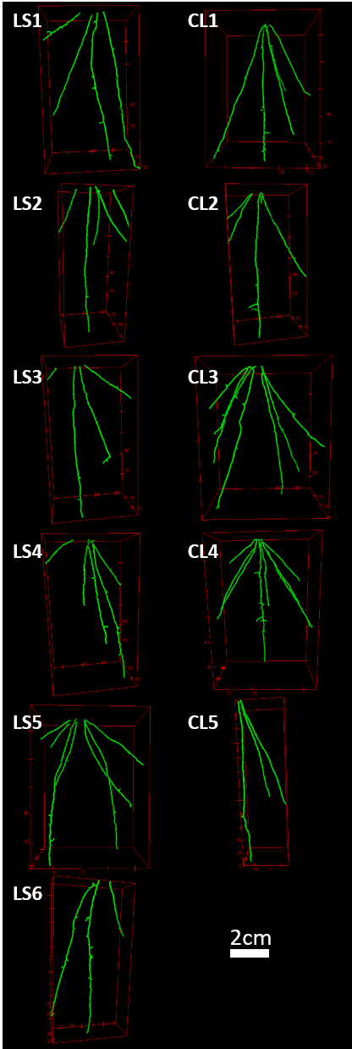
Figure 1: X-ray Computed Tomography extracted root system architectures 12 days after germination. The left column shows the replicates grown in loamy sand (LS) and the right column shows those grown in clay loam (CL).

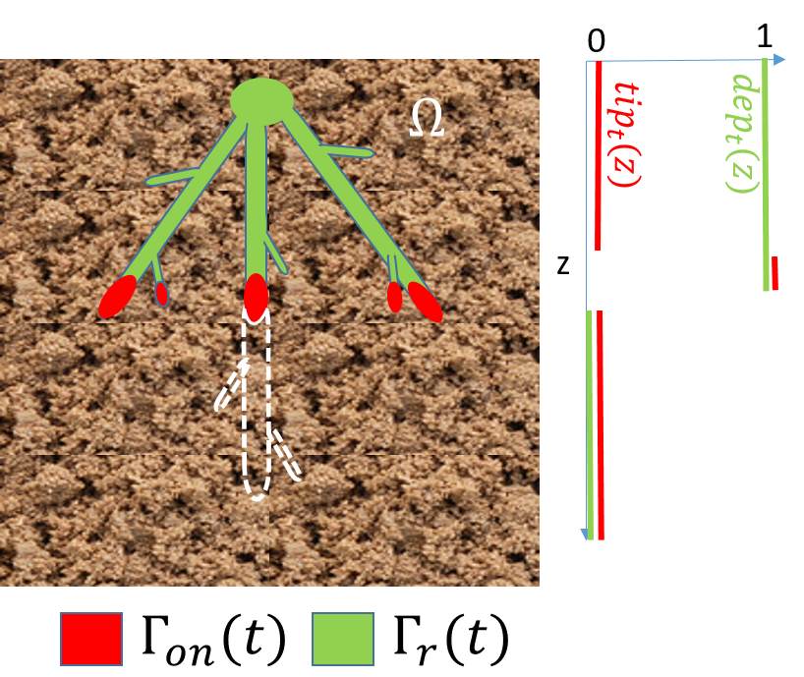
Figure 2: A schematic of the domain for simulations. The absorbing parts of the root system architecture, $Γ_{r}\left(t\right)$, and the exuding part, $Γ_{on}(t)$, are shown for a given time point within $Ω$. As time progresses the roots will grow in to the 12 day state, highlighted in the white-dashed lines. The indicator functions $dep_{t}\left(z\right),$described by equation (13), and $tip_{t}(z)$, described by equation (14) are also plotted in green and red respectively. These functions are used to activate the absorbing and exuding parts of the root system at the appropriate times.

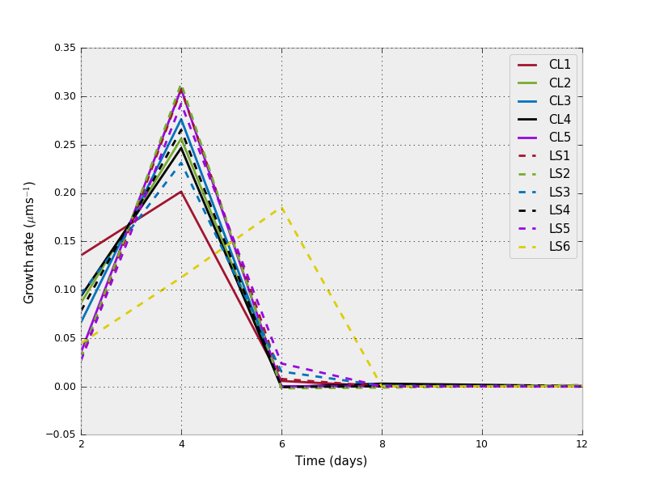
Figure 3: Growth rates of each root system architecture and time point. Growth rates are calculated by finding the deepest root in each scan, subtracting the deepest root in the previous scan and dividing by the time difference.

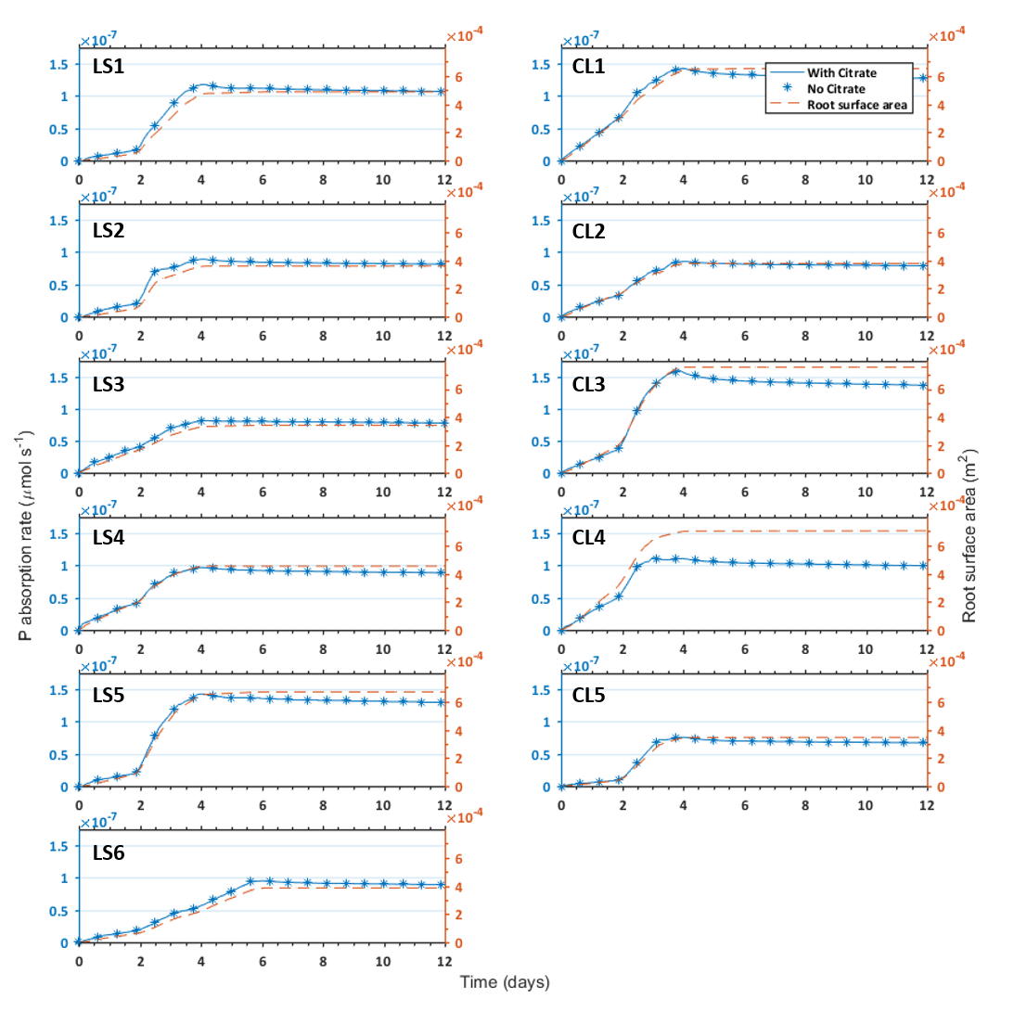
Figure 4: Effect of citrate exudation on phosphorus absorption rates in High P soil. Phosphorus absorption rates of the root system architecture throughout the 12 day simulation period in the exudation (blue line) and no exudation (blue stars) cases. Root surface area throughout the simulation is also plotted in orange dashed lines. The left and right columns show plants grown in the loamy sand and clay loam respectively.

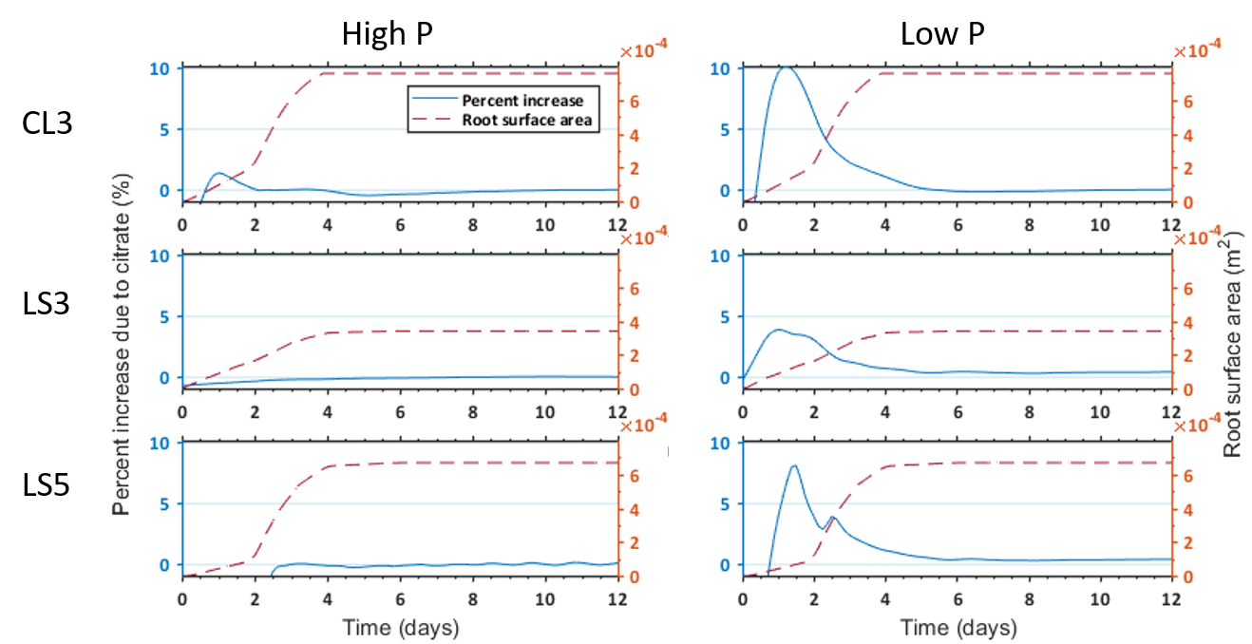
Figure 5: Comparison of citrate enhanced uptake in the High P (left column) and Low P high buffering soil (right column) conditions. Percentage increase of phosphorus absorption rate due to citrate exudation is shown in the blue line for the CL3, LS3 and LS5 treatments. Root surface area is also plotted in orange dashed lines.

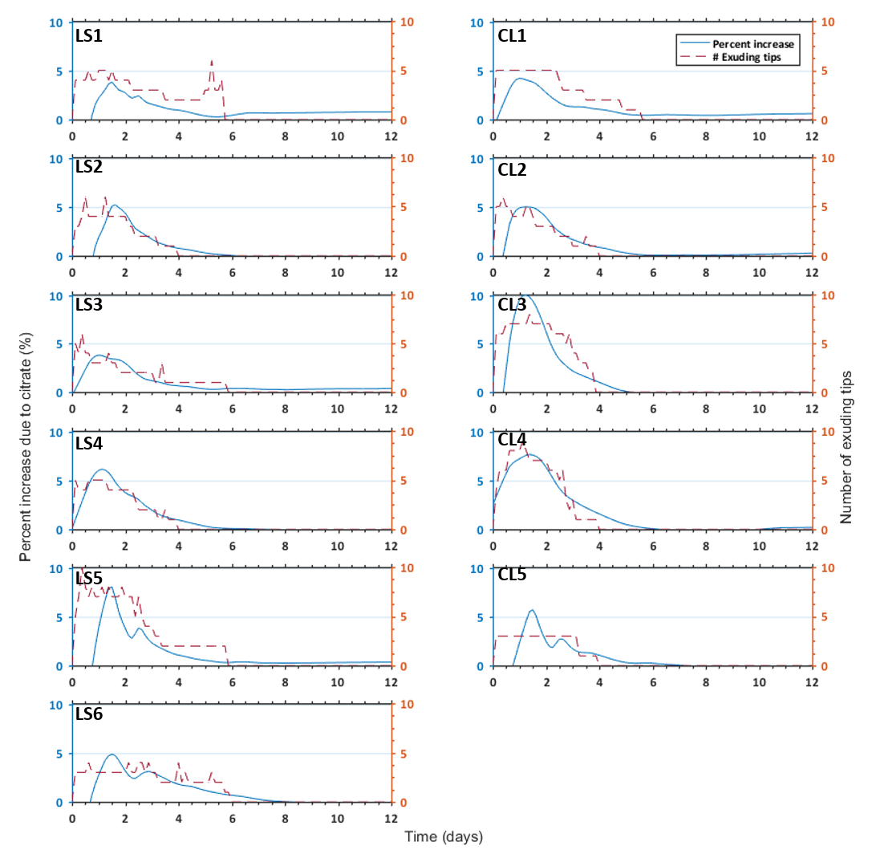
Figure 6: Benefit of citrate exudation on phosphorus absorption in Low P soil with number of exuding root tips. Percentage increase of phosphorus absorption rate due to citrate exudation is shown in the blue line. Number of exuding tips throughout the simulation is also plotted in orange dashed lines. The left and right columns show plants grown in the loamy sand and clay loam respectively.

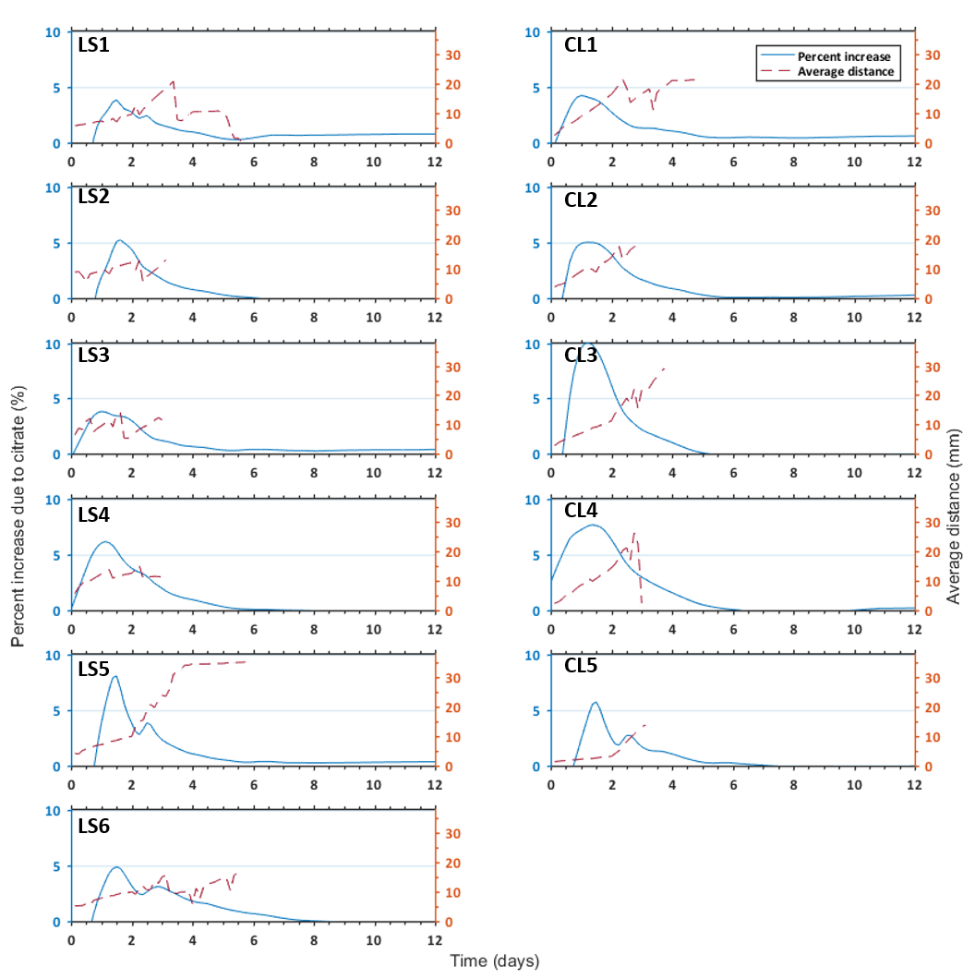
Figure 7: Benefit of citrate exudation on phosphorus absorption in Low P soil with average inter-tip distance. Percentage increase of phosphorus absorption rate due to citrate exudation is shown in the blue line. Average inter-tip distance throughout the simulation is also plotted in orange dashed lines. The left and right columns show plants grown in the loamy sand and clay loam respectively.

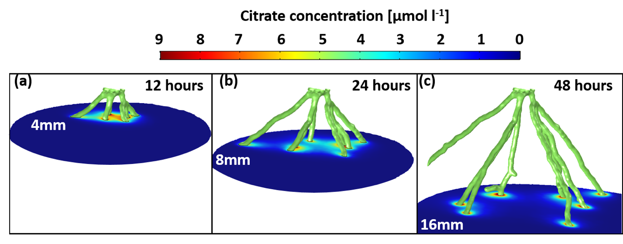
Figure 8: Citrate concentrations on 2D planes for the CL4 root system. Citrate solution concentration at a) 12 hours shown on the x-y plane at 4 mm depth, b) 24 hours shown on the x-y plane at 8 mm depth, and c) 48 hours shown on the x-y plane at 16 mm depth. The depths of planes were chosen to be the location of the root tips at the given time.

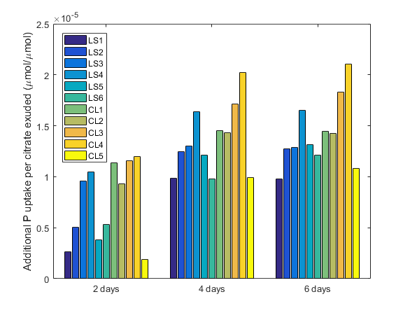
Figure 9: Cumulative additional phosphorus absorbed by plants due to citrate at 2, 4 and 6 days in the Low P soil normalised by cumulative citrate exudation at the given times.
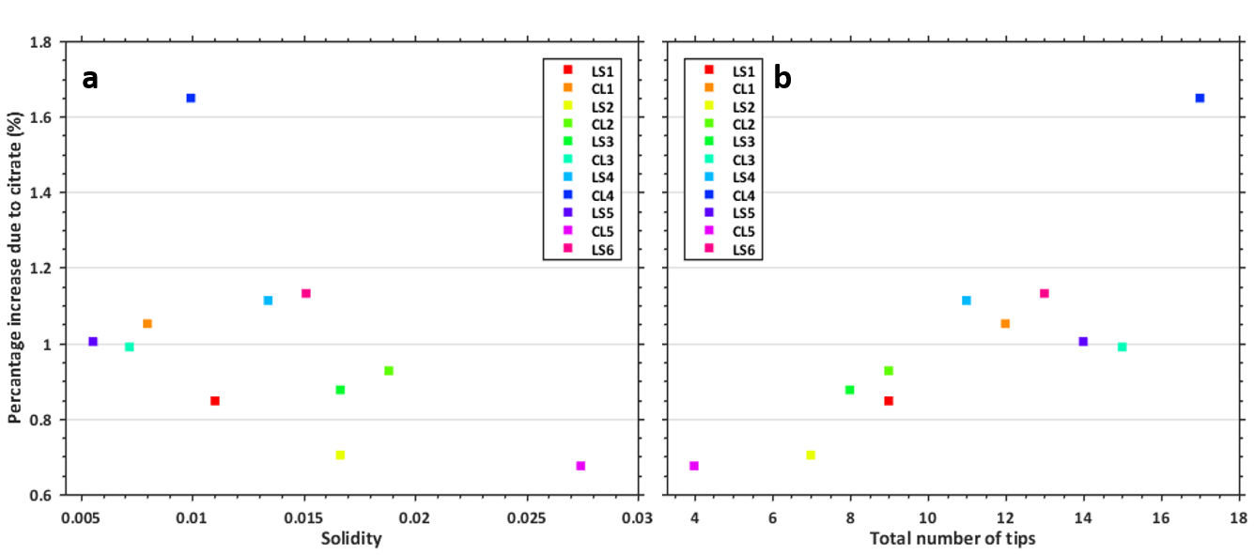
Figure 10: The effect of solidity and total number of tips on citrated enhanced uptake. Percentage additional phosphorus absorbed by plants cumulatively due to citrate after 8 days in the Low P soil against a) solidity of the root system (solidity is defined as the total volume of the roots over the volume of the convex hull of the RSA) and b) total number of root tips.

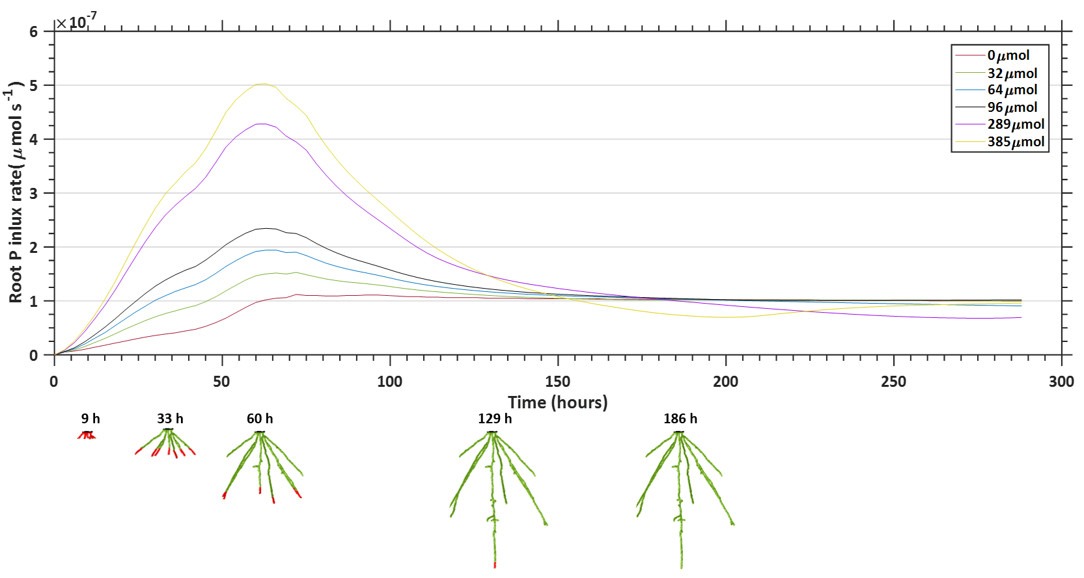
Figure 11: Effect of increased citrate exudation on root P influx rate. Exudation rates are increased from 0 to 21.2 µmol m⁻² s⁻¹ and the P influx rates are plotted in time for the CL4 RSA with High P soil conditions. Plots are labelled by the total amount of citrate exuded by the RSA over the simulation period. A selection of RSA states throughout the simulation are shown along the bottom. Red parts of the roots are exuding citrate ($Γ_{on}(t)$) and green and red parts of the root are absorbing P ($Γ_{r}\left(t\right)$).

