Supplementary Material: Linking root structure to functionality: The impact of root system architecture on citrate enhanced phosphate uptake
Daniel M. McKay Fletcher, Siul Ruiz, Tiago Dias, Chiara Petroselli, Tiina Roose*
Bioengineering Sciences Research Group, Department of Mechanical Engineering, School of Engineering Sciences, Faculty of Engineering and Physical Sciences, University of
Southampton, Southampton, UK
*Corresponding author. Email address: t.roose@soton.ac.uk
Article acceptance date: 3 March 2020

Methods S1 - Sensitivity Analysis

Biodegradation rate ($λ$)
The original biodegradation rate, $λ$, was varied by 10%, 50%, 150% and 1000% in the CL4 geometry with Low P conditions. Figure S2a shows the citrate enhanced uptake dynamics for each biodegradation rate. As the biodegradation rate decreases the intensity and length of citrate enhanced uptake increases. For the 50% case, the amount of additional P absorbed during the peak of citrate enhanced uptake results in the ‘citrate enhanced uptake’ becoming negative after the majority of the citrate degrades. We predict the same phenomenon occurs in the 10% case after 12 hours. In the 1000% case citrate enhanced uptake reduces to almost zero due to the citrate being degraded before it can significantly solubilise P. Figure S3 shows the effect of varying biodegradation on the cumulative citrate enhanced uptake compared to the original parameter value. Increasing $λ$ decreases cumulative citrate enhanced uptake non-linearly.

Citrate enhanced desorption rate ($β_{3}$)
The original citrate enhanced desorption rate, $β_{3}$, was varied by 10%, 50%, 150% and 1000% in the CL4 geometry with Low P conditions. Figure S2b shows the citrate enhanced uptake dynamics for each biodegradation rate. Increasing $β_{3}$ increases the peak of citrate enhanced uptake, but does not affect the longevity of the period of citrate enhanced uptake Figure S3 shows the effect of varying citrate enhanced desorption on the cumulative citrate enhanced uptake compared to the original parameter value. Increasing $β_{3}$ increases cumulative citrate enhanced uptake linearly.

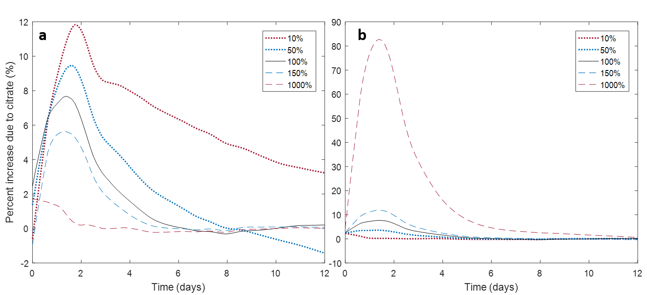
Figure S1: The effect of varying a) biodegradation rate, $λ$ and b) citrate enhanced desorption rate $β_{3}$ on citrate enhanced uptake. The parameters are varied from their original rate (100%, $λ=6.87×{10}^{-5}$ s⁻¹, $β_{3}=3.41×{10}^{-13}$ m³ s⁻¹ µmol⁻¹) to 10%, 50%, 150% and 1000% of the original rate.

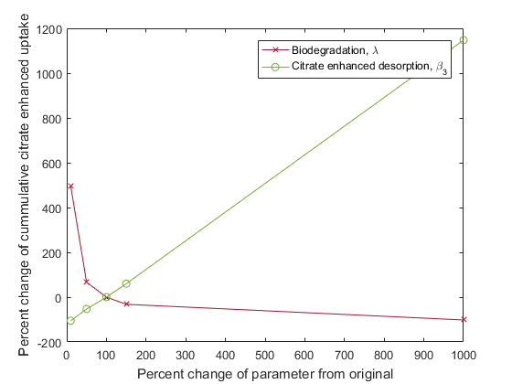
Figure S2: The effect of varying biodegradation rate, $λ$ and citrate enhanced desorption rate $β_{3}$ on cumulative citrate enhanced uptake over 12 days. The y-axis shows percentage change from the original (100%) parameter values. The parameters are varied from their original rate (100%, $λ=6.87×{10}^{-5}$ s⁻¹, $β_{3}=3.41×{10}^{-13}$ m³ s⁻¹ µmol⁻¹) to 10%, 50%, 150% and 1000% of the original rate.

Root system architecture
To investigate the effect of approximating the growing root system architecture (RSA) with the 12 day RSA and maximum growth rates, citrate enhanced uptake of the 2 day RSA and 12 day RSA was compared over the first 2 days. The two day CL5 RSA as extracted from the XCT scan was used as the geometry in the model described by the Citrate phosphate mathematical model section, equations (1-11). The 0 to 2 day growth rate was used to ‘activate’ the root system as described in the Root growth model section, equations (12-14). Extra P uptake due to citrate over the initial two days was then compared between the 12 day RSA and the 2 day RSA, Figure S1. The 12 day RSA is in agreement with the 2 day RSA until 34 hours, after which the 12 day RSA under predicts citrate enhanced uptake. This is because the bottom tip of the root (root cap) is exuding in the 2 day RSA, while the root cap is ‘blocked’ by the remaining non-active part of the RSA, thus not in contact with the soil and exuding in the 12 day RSA. This is demonstrated in Figure 2, where the central root can still grow into the 12 day state and has a white cap, indicating the root cannot exude here. While the other roots have reached their final state and can hence exude from their tips. The 12 day case, where the roots only exude from their sides, is more accurate as roots are known to exude soluble rhizodeposits like organic acids from their side, while insoluble mucilage is exuded from the cap (Jones et al. 2009).
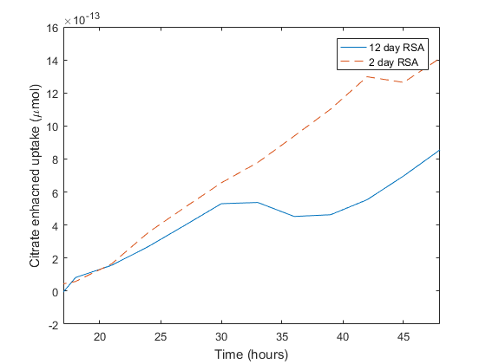
Figure S3: Comparison of extra P uptake due to citrate between the 2 day and 12 day RSA over 48 hours for the CL5 geometry.

Results S2 - Additional Figures

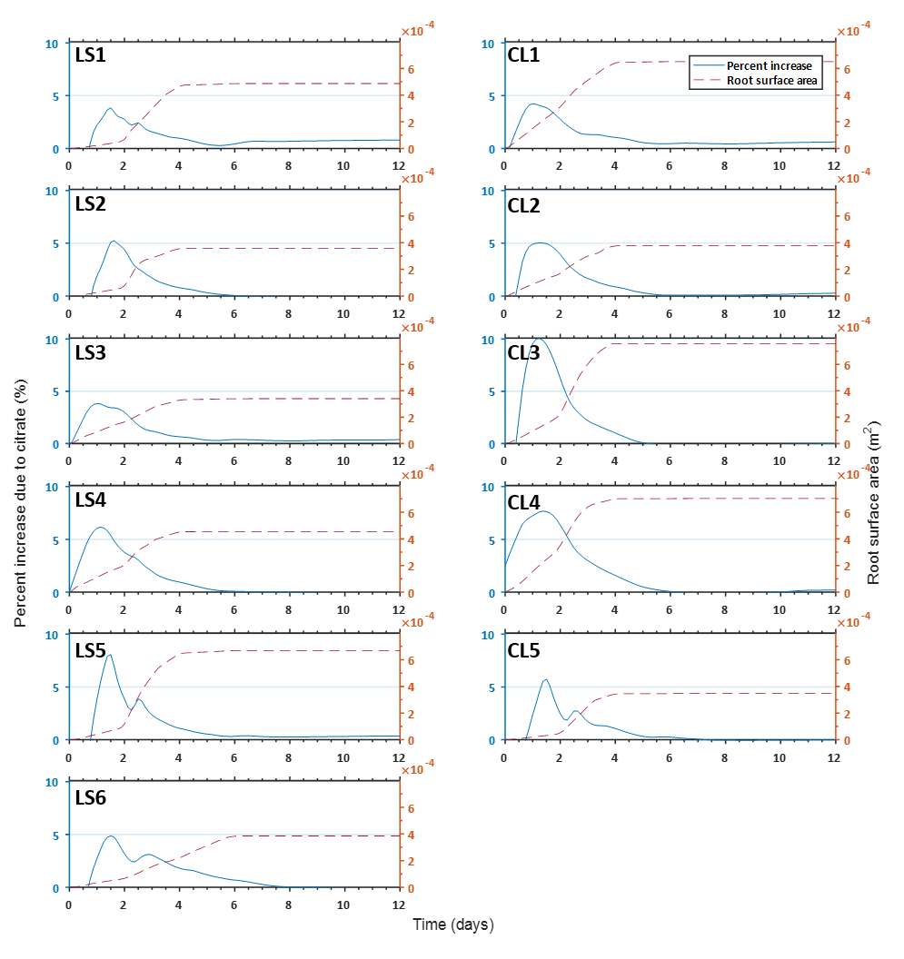
Figure S4: Benefit of citrate exudation on P absorption in Low P soil root surface area. Percentage increase of P absorption rate due to citrate exudation is shown in the blue line. The root surface area throughout the simulation is also plotted in orange dashed lines. The left and right columns show plants grown in the loamy sand and clay loam respectively.

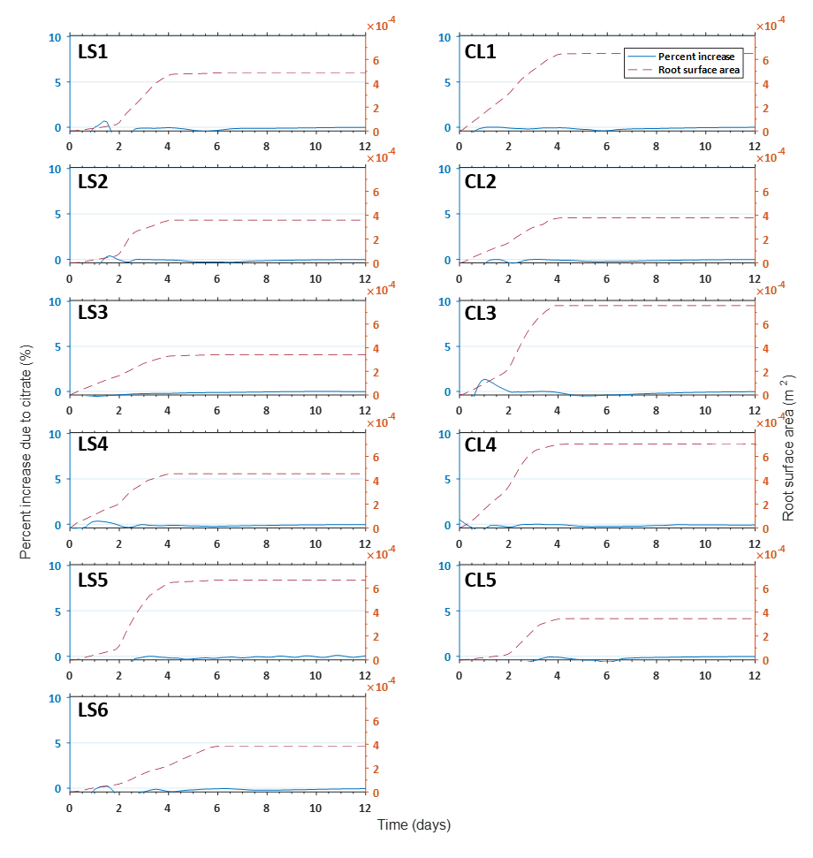
Figure S5: Benefit of citrate exudation on P absorption in High P soil root surface area. Percentage increase of P absorption rate due to citrate exudation is shown in the blue line. The root surface area throughout the simulation is also plotted in orange dashed lines. The left and right columns show plants grown in the loamy sand and clay loam respectively.

References
Jones, D. L., C. Nguyen and R. D. Finlay (2009). "Carbon flow in the rhizosphere: carbon trading at the soil–root interface." Plant and soil 321(1-2): 5-33.

