Cavitation erosion performance of CVD W/WC coatings
Dina Ma¹, Terry J. Harvey¹, Yuri N. Zhuk², Richard G. Wellman³, Robert J. Wood^{1*}
¹nCATS, Faculty of Engineering and Physical Sciences, University of Southampton, UK;
²Hardide plc, Bicester, Oxfordshire, OX26 4UL, UK
³ Surface Engineering, Rolls-Royce plc, Derby, UK

*Corresponding author

Abstract
In the aviation industry, water droplet erosion (WDE) takes place when an aircraft takes off on as wet runway or flies through rain or clouds. The leading edge of turbofan blades suffers from high-speed (300-400 m/s) impingements of water droplets, resulting in material removal that subsequently changes the leading edge profile and surface roughness. This affects the aerodynamic performance of turbofan blades, which eventually leads to efficiency drop of the aircraft engine and the need to replace and/or recondition the blades. A coating solution is targeted, such that, not only that it resists the high impact pressure but also inhibits stress wave reinforcements at the coating-substrate or interlayers interfaces. Past studies indicate similar damage mechanisms to WDE are generated by cavitation erosion (CE) during the early stages (incubation). Hence, CE is introduced in this study to predict the WDE performance. The coatings studied were nanostructured CVD tungsten/tungsten carbide coatings, either hierarchical or monotonic in design, on Ti6Al4V alloy grade 5 substrates. In-depth understanding on the coating damage mechanisms are established by correlating the coating performance with microstructure, crystallographic texture, interface design, coating deposition conditions and mechanical properties for the first time. A particular crystalline texture was found that gives optimum performance. The effect of the initial coating topography on the CE performance is effectively characterised by the surface parameters S_{sk} and S_{ku}. The damage was found to initiate at the grain boundaries of the exposed surfaces. The hierarchical coating microstructure demonstrated enhancement in CE performance compared to a monotonic columnar grain structure. Additionally, it is found that the coating performance under dynamic compressive loadings could not be predicted by a simple H/E approaches. However, combining the H/E ratios with the factors of microstructure and crystal orientations might further facilitate the understanding of coating performances along with better understanding of the role of compressive residual stresses and stress waves propagation or reinforcement through coating depth and at the top surface of the coating.
Keywords: cavitation, water droplet erosion (WDE), erosion resistance, CVD coating, nanostructured tungsten/tungsten carbide, hierarchical and monotonic coatings

Introduction
Water Droplet Erosion (WDE) is the “progressive loss of original material from a solid surface due to continued exposure to impacts by liquid drops or jets” [1]; where, in this case, the liquid is restricted to water and the form restricted to drops. A large range of undesirable material responses have been observed following repeated droplet impingement; from fracture-based mechanisms of erosion for more brittle materials, to unusual ‘fatigue-like’ behaviour and pitting for ductile metals. The response is also often strongly influenced by the ‘severity’ of the repeated impingements; although not perfect, the impingement velocity offers a good indicator. The absence of a complete theory of WDE [2] means we are still frequently in the dark as to how best to combat the damaging effects of repeated high-speed liquid impingement. Advances in surface engineering and coatings could well transform the resistance of surfaces to WDE. However, without clearer understanding, this may well not occur.
Liquid erosion effects many industrial sectors such as aviation, power generation (gas and steam turbines), defence and oil and gas. The former by degradation of machinery and the later by wall loss in pipe system associated with multiphase flows from production wells, processing and transport to storage etc. Leading edge erosion (LEE) is a recognised issue for turbomachinery, wind turbines and rotorcraft. Loss of initial surface roughness and subsequent loss of profile directly effects aerodynamic efficiency and thus power generation / lift. This will increase emissions (by increased fuel consumption) as well as reducing system life and thereby increase through life costs. A related knock-on effect is increased noise and vibration caused by LEE in turbomachinery and rotorcraft. For turbofans the issue is two fold: buzz saw noise on take-off and broad band fan noise both are likely to be amplified by LEE as well increasing the risk of unstable vibrations (‘flutter’). Liquid erosion issues in the oil and gas sector relate to subsea choke valve, wellhead assembly and production pipeline damage adding risk to loss of containment and unplanned change outs that stop production. For nuclear plant the presence of droplets in steam pipe flows generates wall loss and carries a high cost of regular inspection. In short, liquid erosion causes us to release more CO₂ than we need to and threatens the safety of key equipment. Despite over five decades of significant research activity, we remain unable to: theoretically describe WDE [2], relate empirical testing to in-service conditions with confidence [3], or even identify the key material parameters that determine erosion resistance [4].
WDE continues to be a great concern for the power generation industry as the leading edge of steam and wind turbine blades suffer from roughening, material loss and change in leading edge profile. In the case of the aviation industry, WDE takes place when an aircraft flies through a rainstorm or clouds as well as when water is ingested into the engine from landing on and take-off from wet runway. The leading edge of turbofan blades suffers from high-speed, (300-400 ms-1) impingements, this affects the aerodynamic performance of turbofan blades, which eventually leads to efficiency drop of the aircraft engine, increased fuel burn and emissions figures and shortens the service life of the blade or accelerates the need for redressing at maintenance and overhaul.
The evolution of the WDE process can be described by three stages [5]. The first is the incubation period, in which there is no measurable erosion mass loss but surface material is worked/strained; this is followed by a maximum or steady state erosion rate stage. In this stage the erosion rate increases to its maximum and remains constant; this is followed by the deceleration stage. In this stage, the erosion rate starts to decline. This study has an emphasis on the incubation period, in which the primary damage mechanism is induced by water-hammer pressure generated by droplet impingement (the magnitude of which ranges in hundreds of MPa) [5]. These pressures induce stress waves along the surface and through depth into the subsurface and can interact or be reflected by interfaces and create stress reinforcement. These can cause material damage that contributes to the increase of erosion rate in the later stages [2, 5-7]. Previous research [8, 9] indicates there is a correlation in damage mechanism of WDE and cavitation erosion (CE) in the early stages of erosion. During the CE process, microjets are formed by asymmetric implosion of cavitation bubbles on to a solid surface, generating high impact pressure (albeit on a smaller scale (tens of μm) compared to droplet impacts (hundreds of μm)) and stress waves [10]. Material performance shows similarity under the WDE and CE tests and is proposed as a screening process for WDE in ASTM G73 [5].
A combination of material properties should be considered when combatting WDE with coatings [5, 11-15]. Water droplet impingement induces a dynamic loading process with a high strain rate, hence, dynamic mechanical properties apply [16]. The coating must exhibit good adhesion to their substrate but also inhibit stress wave reinforcements along the surface and through depth [17]. Advances in surface engineering and coatings have the potential to offer substantial increases in erosion resistance. However, development is supressed by the lack of certainty regarding the ‘ideal’ coating/surface layer. This results from the questions surrounding the dynamic loading caused by a high-speed water droplet impingement. Surface design needs to accommodate the stresses and strains induced by the complex physics of droplet impacts so their location, duration, and magnitude are important to understand. This knowledge combined with microstructural, defect distribution and appropriate mechanical property details are all critical to robust surface engineering to ensure blade profiles are maintained. Hence, employment of various hard coatings for WDE resistance has been attempted, however, brittle fracture and delamination of the coating due to poor adhesion or cohesion have been reported [18].
This study aims to generate an in-depth understanding of the interplays between hard coating erosion performance-microstructure-crystallographic texture-mechanical properties for nanostructured WC-C coatings.

Experimental methodologies
The titanium alloy used as the substrate was aerospace grade 5 Ti6Al4V alloy on all coated samples.

Coating deposition
The coating systems studied were a series of nano-structured coatings composed of Tungsten Carbide (WC) nano-particles embedded in metal Tungsten (W) matrix. The W/WC coating specimens were produced with CVD by Hardide Coatings Limited in Oxfordshire UK using the conditions listed in Table 1. The coated specimens are polished after the deposition process.

Table 1 Coating details
Coatings | Hierarchical 1  T1200 | Hierarchical 2  T1600 | Monotonic  LT
Manufacturing temperature (º C) | 500 | 500 | 350
Thickness (µm) | ~55 | ~55 | ~60

Microstructural characterisation
Alicona G4 InfiniteFocus system was applied for surface roughness measurements with × 100 lens using 10 nm vertical resolution. A JEOL 6500F Field Emission Gun (FEG)-SEM was used for microstructural analysis. In order to further understand the orientations of the facets on the as-deposited surface, electron back-scattered diffraction (EBSD) analysis was performed using SEM equipped with a NordlysMax3 detector, a CCD camera, the AZtekHKL data acquisition software and the Channel 5.0 post-processing analysis package. The samples were tilted at 60°, the accelerated voltage was set to 20 kV, the minimum step size was 0.2 μm and the indexing was over 80% for all the mappings. X-ray diffraction (XRD) analysis was carried out using a Rigaku SmartLab diffraction system (Rigaku Corporation, Japan) with Cu-Kα X-rays to identify the phase composition of the W/WC coatings. The diffractometer was operated at a grazing incidence angle of 1° for phase identification of the top-surface coatings.

Mechanical properties
Nanoindentation tests were performed using a Micro Materials NanoTest Vantage system equipped with a Berkovich diamond indenter, calibrated by using a standard fused silica sample. All tests were carried out at a stabilized chamber temperature of 25 °C on the polished surface and cross-sections. A load control mode of 30 mN was used for measurements of W/WC coatings. Thermal drift was measured by adding a dwell period of 60 s during unloading and calculated over 60% of the collected depth vs time data. The nanohardness (H) and reduced Young’s Modulus (E_{r}) were calculated using Oliver-Pharr methodology.

Cavitation erosion test
An ultrasonic induced cavitation device (UIP 1000 hdT, Hielscher Ultrasound Technology) was used to carry out the CE tests in a distilled water bath maintained at laboratory temperature (~ 25 °C) with procedures following ASTM G32-92. The specimens were25 mm × 25 mm × 5mm and in a location opposite to the vibrating tip of titanium sonotrode. Cavitation was induced by longitudinal oscillation at 20 kHz at a peak-to-peak amplitude of 50 μm. The titanium tip (grade 5) of the vibrating horn was 18 mm in diameter. A stand-off distance between the tip of the sonotrode and surface of the specimen was set to 1 mm using a filler gauge. After each test interval, the specimens were rinsed, dried and weighed by an analytical balance with a sensitivity of 0.1 mg to determine mass loss. An average value and standard deviation was obtained from 5 readings taken after each test interval.

Results

Topography characterisation
The 3D surface profiles of the coatings are presented in Fig. 1. and are the result of the post-coating polishing techniques used. The corresponding values of R_{a}, S_{a}, S_{sk} and S_{ku} are listed in Table 2, which shows that the R_{a} and S_{a} values of LT coating are the smallest. The sign of skewness (S_{sk}) indicates the level of asymmetry and the predominance of peaks (S_{sk} > 0) or valleys (S_{sk} < 0) within the surface[19]. The S_{sk} values of all coatings are negative, however, that of the LT coating is significantly larger than the other two coatings suggesting it has more and/or deeper valleys. The Kurtosis (S_{ku}) is useful for indicating the peakedness (variation from Gaussian distribution of surface features) of the with the LT coating having a larger peak distribution that the others.
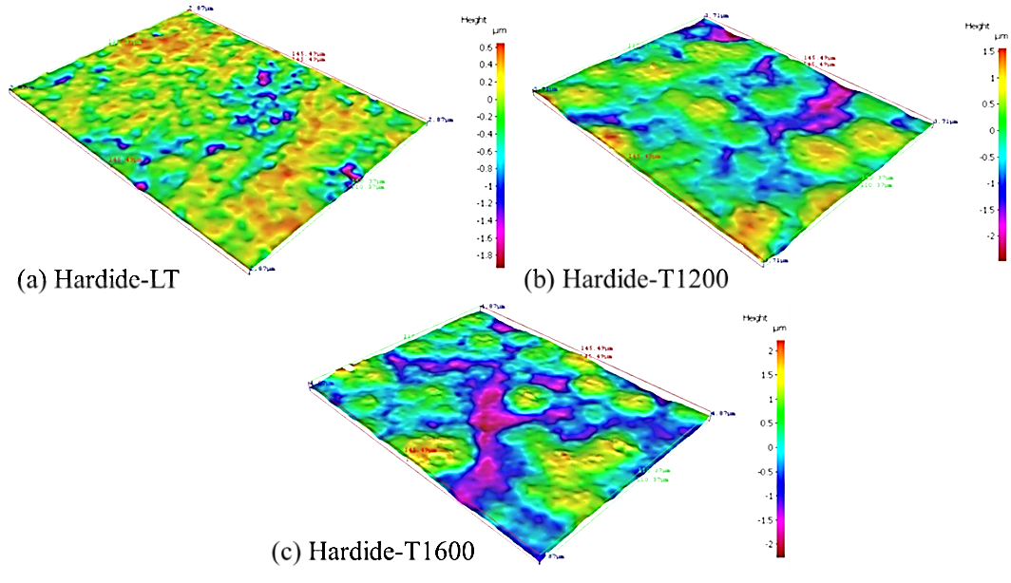
Fig. 1 Surface profiles of the coatings: (a) T1200 coating; (b) T1600 coating; and (c) LT coating
Table 2 Roughness values of the coatings
Coatings | R_{a} / µm | S_{a} / µm | S_{sk}/µm | S_{ku}/µm
LT | 0.24 ± 0.02 | 0.25 ± 0.02 | - 0.80 ± 0.24 | 4.05 ± 0.41
T1200 | 0.28 ± 0.03 | 0.31 ± 0.03 | - 0.18 ± 0.19 | 2.47 ± 0.25
T1600 | 0.35 ± 0.01 | 0.41 ± 0.01 | - 0.04 ± 0.09 | 2.62 ± 0.17

Microstructural characterisation

Surface characterisation
XRD analysis of the coatings, shown in Fig. 2, indicate that there is no variation of the coating composition. As per Table 4, the coating samples had a hardness between 11.5 and 19.5 GPa, which is significantly higher than the hardness of pure metal Tungsten produced by the same CVD method (typically 0.4 GPa), this indicates Tungsten Carbides are present in sufficient amount to influence the material properties. Meanwhile all the XRD spectra on Fig 2 show only Tungsten lines and no characteristic Tungsten Carbide lines, this infers the presence of nanocrystallinity of Tungsten carbides as the likely explanation for the absence of Carbides XRD lines. The intensity of the W (200) peak is significantly higher than the rest in the XRD spectrum of LT coating, thus, a different scale was used to show the lower intensity peaks in Fig. 2 (c).
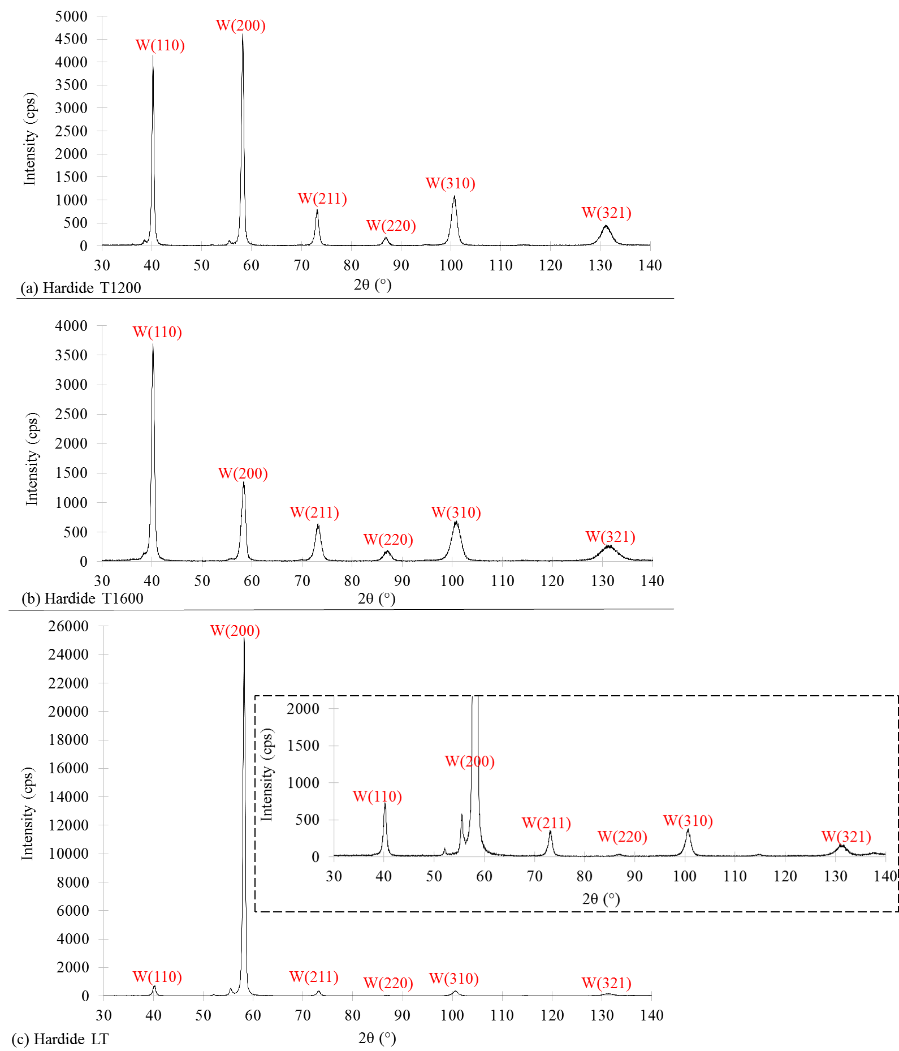
Fig. 2 XRD analysis of (a) T1200; (b) T1600 and (c) LT coatings
SEM observations were conducted to identify the microstructural features of the coatings, as shown in Fig. 3. It can be seen from the lower magnification images, Fig. 3 (a), (c) and (e), that all coating surfaces are composed of dark and shiny areas. The dark zone of all coatings is shown as flat surfaces with presence of macro scratches induced by the post-polishing process. While for the shiny zones, as magnified in Fig.3 (b), (d) and (f), all three coatings present are as deposited regions.
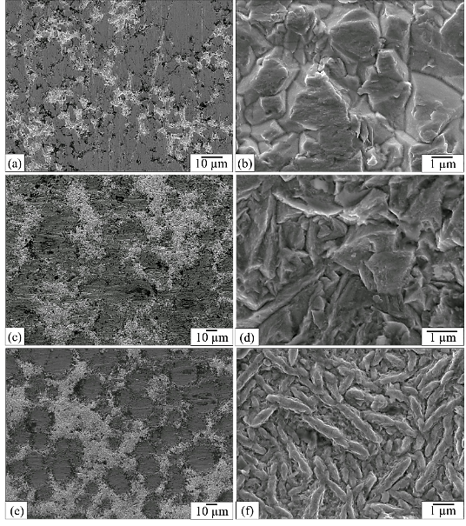
Fig. 3 Microstructure of coating surfaces: (a) and (b) LT; (c) and (d) T1200; (e) and (f) T1600

Cross-sectional characterisation
The cross-sectional characterisation of the coating microstructure was conducted with the SEM and EBSD. The results are shown in Fig. 4. They reveal different structures for all three coatings. The LT coating exhibits columnar grain structures with a preferential growth to the <001> orientation. Three growth stages can be identified in the EBSD grain orientation map in Fig. 4 (a): (1) nucleation and growth of nearly equiaxed grains with random orientations; (2) formation of premature small columnar grains, which is a transitional stage; and (3) stable growth of mature large columnar grains with a preferred orientation normal to the substrate. In this stage, there are a few columnar grains that have grown to full thickness of the coating, but most columnar grain growth is stopped by fine grains nucleated nearby the grain boundaries.
The LT coating has a textured columnar grain structure manufactured by the CVD process. Similar CVD coating structures have been investigated in the past with textured columnar grain growth [20-24]. The formation is due to the growth kinetics favouring only the grains with a <001> axis oriented to the substrate [20-27]. The process resembles the manufacturing process of nanocrystalline diamond (NCD) has a thin film diamond grown with a very high initial nucleation density [26, 27]. There is little or no re-nucleation, as shown in Fig. 4 (a). The grain size and the roughness increase with film thickness as expected for columnar structured coatings.
For T1200 and T1600 coatings, the cross-sectional views present a unique hierarchical coating configuration that are tailored by the CVD process, as shown in Fig. 4 (b) and (c). Three distinct stages of grain growth were observed. Firstly, nucleation of fine equiaxed grains at the interface with the substrate Ti6Al4V material was detected in both coatings, which is the same in the LT coating. The second stage is a 20 to 25 µm layer of coarse columnar grains developed over the first layer in both coatings. The EBSD results show that the columnar grains in both coatings demonstrate a preferred <001> orientation. However, those in T1200 show a stronger texture. The third stage in both coatings is composed of fine grains with a thickness of 25 to 30 µm. The top fine layer in T1200 coating extends from the columnar grains in the second growth stage, showing a branch-like feature. Such transitional change of microstructure facilitates the grain growth in the same <001> orientation for the top layer. While in the case of T1600 coating, the top fine layer is formed independently from the coarse columnar grains. Hence, a distinct interface between these two stages of grain growth is identified. The fine grains in the top layer are in the shape of fine stems with random orientations. Additionally, pre-existing subsurface vertical cracks of up to 15 µm in length were detected within the cross-section of the T1600 coating, as shown in Fig. 4 (c). One end of these cracks were located around 10 to 20 µm beneath the coating surface; while the other end stops at the interface of the fine and coarse layer of the T1600 coating.
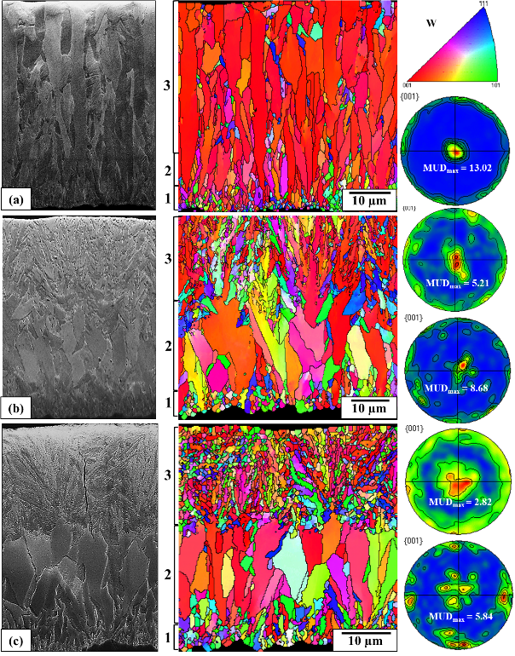
Fig. 4 Cross-sectional views of CVD W coatings: (a) LT; (b) T1200; and (c) T1600; where “MUD_{max}” stands for the maximum value of multiples of uniform density
Further analysis characterised the grain size. However, the resolution of the EBSD analysis (a step size of 0.2 µm was used) cannot precisely identify the grain size of the top fine layers of T1200 and T1600 coatings. Hence, such characterisation was only applied in the growth stage composed of columnar grains in all coatings and the results are presented in Table 3. The width of columnar grains in LT coating is 4.89 µm with the largest height reaches up to the whole thickness of the coating (50 µm). The width of the columnar grains in the second growth stage of T1600 is similar to that of LT coating, which is 4.53 µm; while the average height of such stage is about 12.31 µm. The width of the columnar grains is the largest in T1200 coating, which is 6.43 µm, and the average height is around 15.22 µm.
Table 3 Grain size measurements of each stage of grain growth in all coatings.
Coatings | Growth stage | Stage 2 (µm)
LT | Height | 10 – 50
 | Width | 4.89
T1200 | Height | 15.22
 | Width | 6.43
T1600 | Height | 12.31
 | Width | 4.53

Mechanical properties
Nanoindentation measurements were conducted on the surface of all coatings. The average values of nanohardness and the reduced Young’s modulus are listed in Table 4. The T1600 coating shows the highest nanohardness and Young’s modulus. While those of LT and T1200 coatings are similar. The fluctuation of the data can be potentially correlated to the surface morphology of the coatings observed in the previous section.
Table 4 Nanohardness and reduced Young’s modulus of coatings.
Coatings | LT | T1200 | T1600
Nanohardness | 11.5 ± 3.6 | 12.6 ± 4.5 | 19.5 ± 7.3
Reduced Young’s modulus (GPa) | 309.1 ± 62.4 | 333.8 ± 78.0 | 393.1 ± 123.8
The cross-sectional nanoindentation measurements were conducted through coating thickness from the bottom (Fig. 5) and the relative results (ratio to the value at 10 micrometres from the bottom) are shown in Fig. 6 and Fig. 7. The nanohardness and the reduced Young’s modulus show a trend of gradient increase from the bottom to the surface of all three coatings.
The relative nanohardness profiles of T1200 and T1600 coatings show similar values over the thickness of 30 µm (top fine layers of both coatings). These indentations were located in the layers of coarse columnar grains in both coatings showing the grain size and orientation matter.
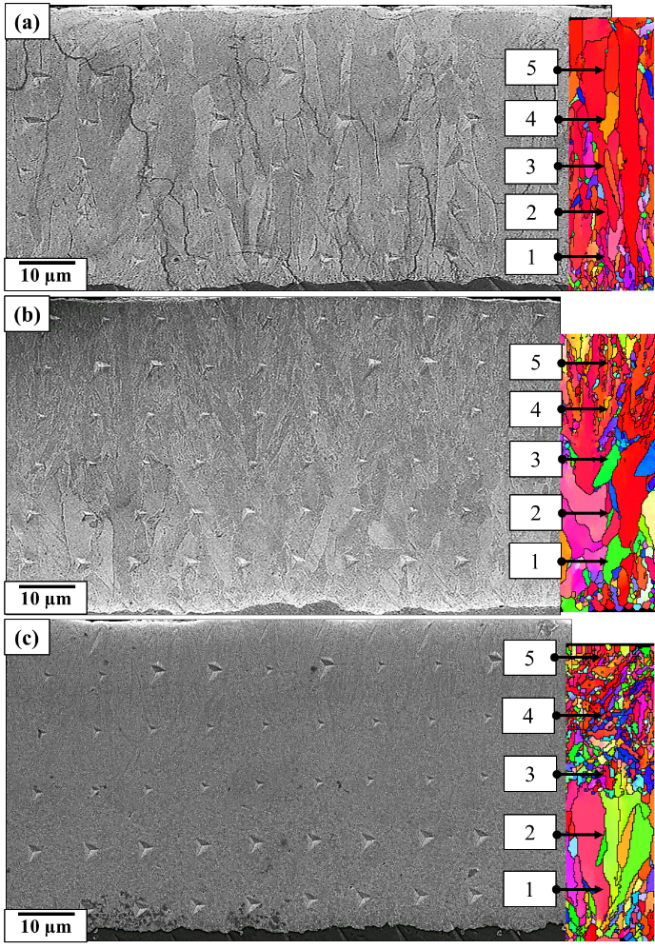
Fig. 5 Cross-sectional nanoindentation measurements on three CVD-W coatings: (a) LT; (b) T1200; (c) T1600.
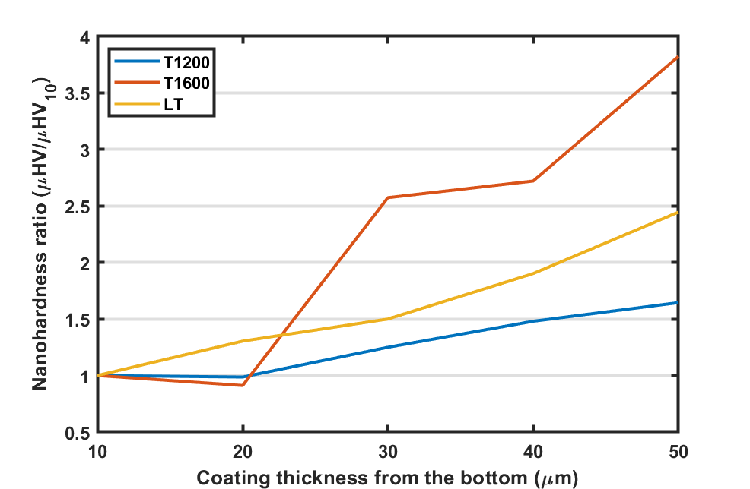
Fig. 6 Cross-sectional relative nanohardness measurements.
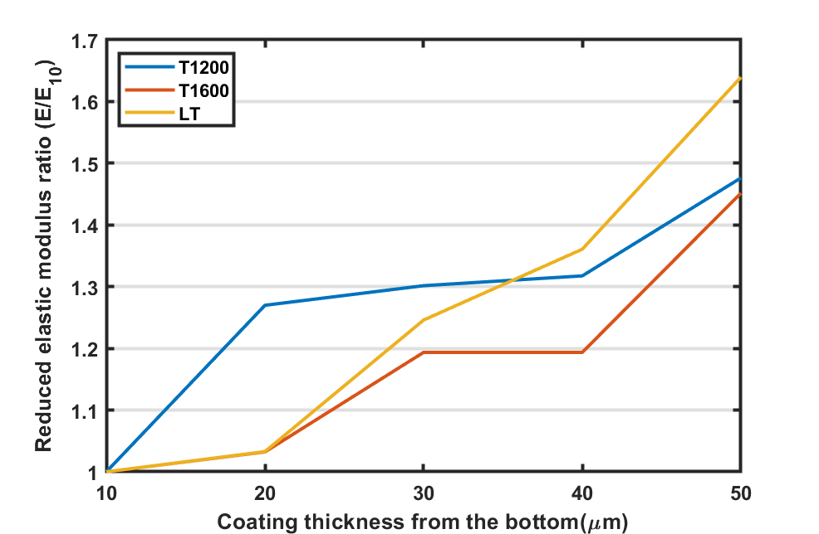
Fig. 7 Cross-sectional effective Young’s modulus

Cavitation erosion performance of the coatings

CE curves
The CE curves of all three coatings with reference to the uncoated Ti6Al4V specimen are plotted in Fig. 8. The cumulative volume loss was converted from the gravimetric measurements and the density used for Ti6Al4V base material and the coatings were 4.5 and 19.4 g/cm³, respectively. All the coatings outperform the substrate Ti6Al4V with significantly lower erosion rate throughout the test period of 330 mins, as shown in Table 5. It can be seen that the Ti6Al4V substrate material reached a maximum erosion rate (greatest slope on CML vs time plots) of 15.6 mg/min after 120 mins of incubation period, while those of the coatings cannot be identified in Fig. 8. Hence, the CE curves of the coatings are presented separately in Fig. 9 to better observe the variation among the coating performances. The T1200 coating shows the best performance among the three coatings with the lowest cumulative volume loss. For the LT coating, a rapid increase of the erosion rate (34.9 mg/min) was detected during the initial 10 mins of exposure to CE. The coating then maintained at an erosion rate of approximately 0.29 mg/min at the end of the test. In the case of the T1600 coating, the CE curve indicates the worst performance among the three coatings. The erosion rate experienced the first significant increase after 30 mins of CE exposure, it then demonstrated a gradual increase until 210 minutes of test. The T1600 coating with a distinct interface between the coarse and fine layer, failed by the premature spallation of the coating surface. This is thought to be due to residual stress variation as a function of the depth of coating. The erosion rate increased drastically to 0.58 mg/min after 210 mins until the end of the CE test. The mean depth of erosion (MDE) of all tested specimens was calculated using Equation (1), and the results are listed in Table 5. The MDE of the uncoated Ti6Al4V substrate is significantly larger (15 to 20 times) than that of the coatings.

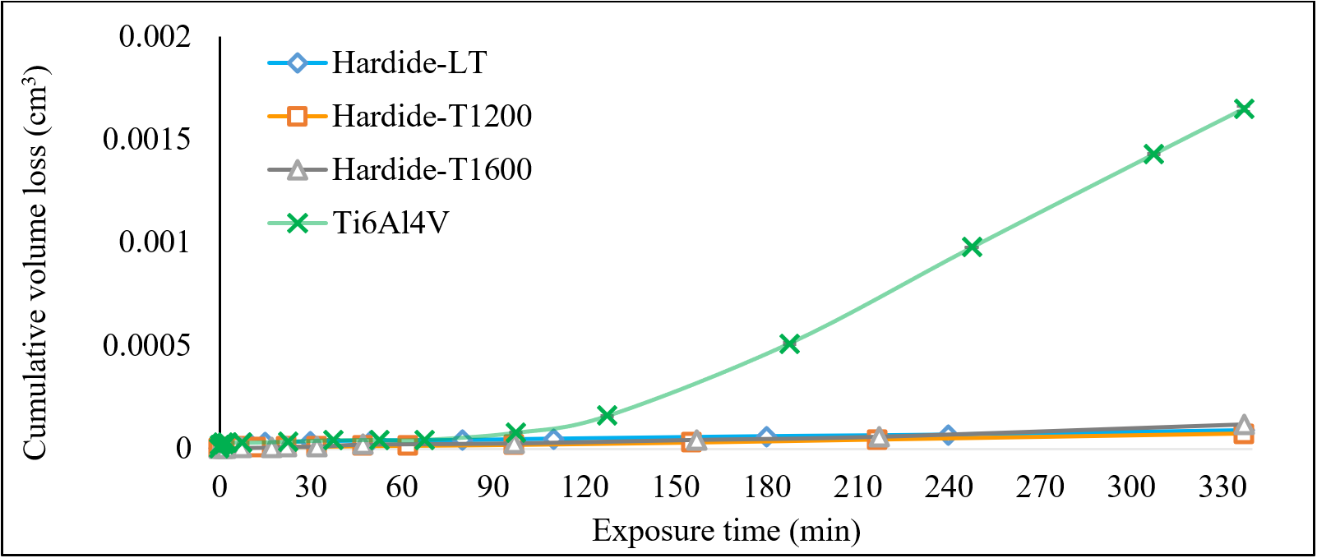
Fig. 8 CE results of the coatings with reference to uncoated Ti6Al4V specimen.

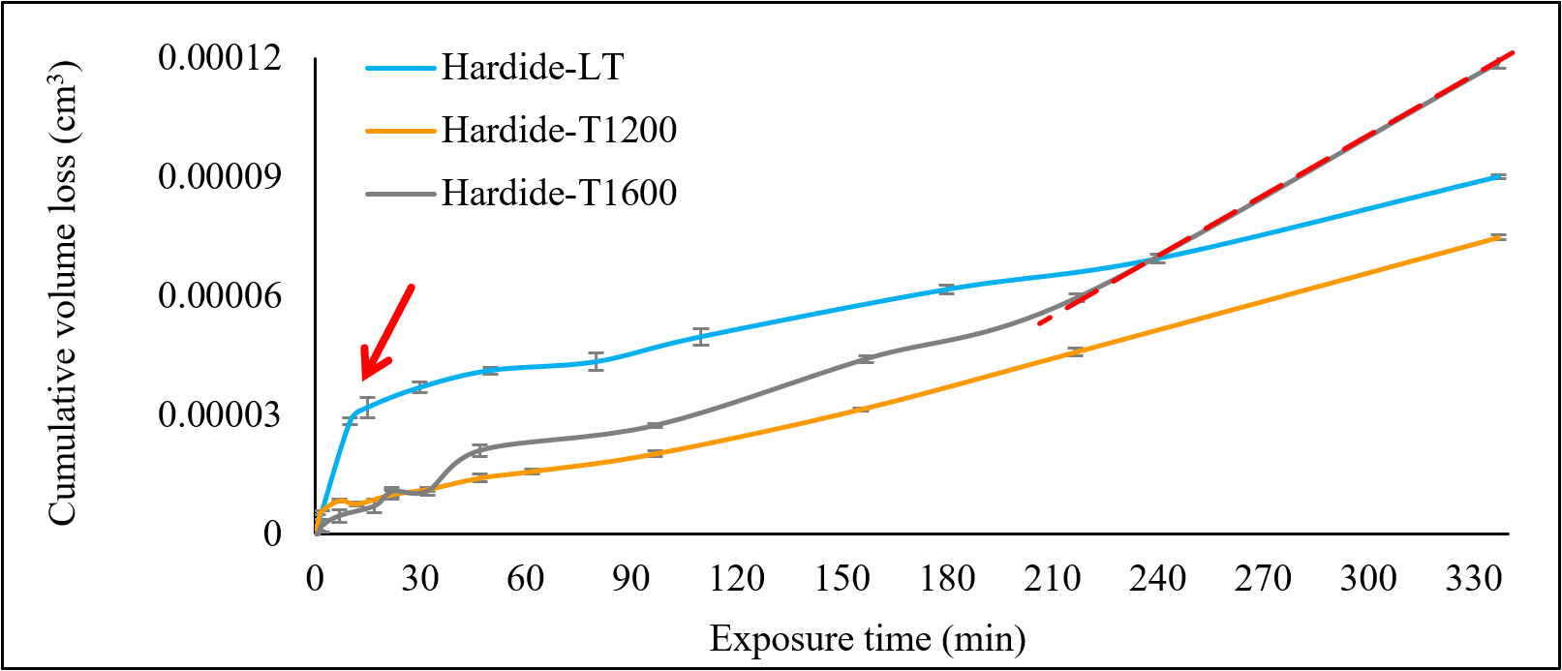
Fig. 9 CE results of the coatings expanded from Fig. 8

$$MDE= \frac{Accumulated mass loss}{Density ×affected area}$$ | (1)
Table 5 ER_{max} (maximum erosion rate) and MDE of Ti6Al4V and three coatings
Coatings | Ti6Al4V | LT | T1200 | T1600
ER_{max} (mg/min) | 15.6 | 34.9 | 0.29 | 0.58
MDE 6.5 hrs (µm) | 9.38 | 0.45 | 0.37 | 0.59

Erosion morphology
Inspection of erosion morphology was conducted through SEM on various sites of the exposed surfaces to understand the material removal behaviour. The exposed surface of the LT coating after CE is shown in Fig. 10. Compared to the pre-tested coating surface shown in Fig. 3 (a) and (b), the exposed surface undergoes intergranular fracture, as shown in Fig. 10 (a) and (b). On closer inspection, cracks were found propagating inside the columnar grains, Fig. 10 (c). As the material removed from the coating surface, erosion craters were formed. Striation marks were observed on the wall of the craters, as shown in Fig. 10 (d). Moreover, formation of cleavage facets and steps was detected, as marked in Fig. 10 (e) and (f). Signs of plastic deformation was found adjacent to the features observed above. It can be seen that the exposure surface of the LT coating indicates a combined brittle and ductile fracture behaviour.
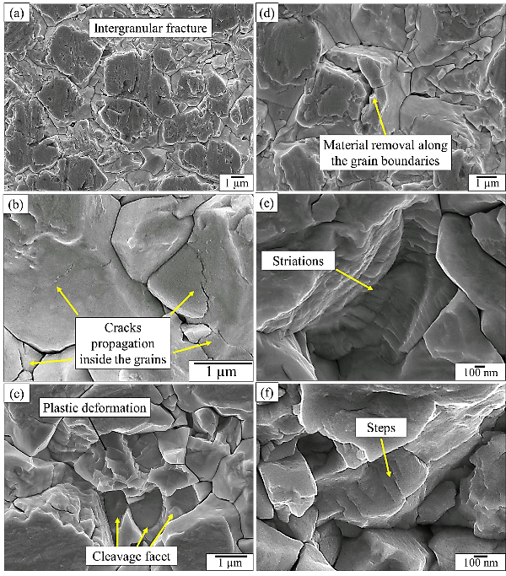
Fig. 10 Post-test exposure surface of LT coating. (a), (b), (c) and (d) (e) (f) features at different magnitudes

The exposed surface of the T1200 coating is shown in Fig. 11. With comparison to the pre-test coating surface in Fig. 3 (c) and (d), the dark zone of the coating surface undergoes brittle fracture after CE exposure. Fig. 11 (a) captures the fragments that are detached from the fractured dark zone. Additionally, cracks were formed at the boundaries of the angular particulates in the shiny zone. These angular edges were polished into a smoother curvature in Fig. 11 (d). Formation of erosion craters followed by material removal is shown in Fig. 11 (e) and (f). Network of small cracks (few microns) were observed inside the erosion craters.
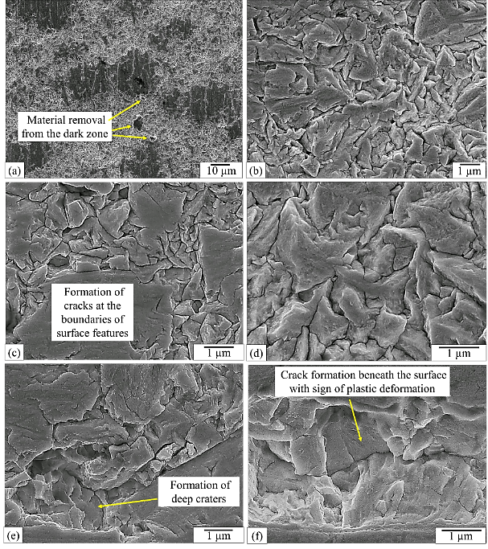
Fig. 11 Post-test exposure surface of T1200. a), (b), (c) and (d) (e) (f) features at different magnitudes

The post-test observation of the T1600 coating surface is shown in Fig. 12. Comparing to the original surface presented in Fig. 3 (e) and (f), the exposed surface reveals brittle failure evidenced by the dark zone being fragmented in Fig. 12 (b). Formation of chevron marks was observed in Fig. 12 (c). Fracture along the boundaries of the stem-like surface features in the shiny zone is shown Fig. 12 (e). Deep erosion craters were formed, Fig. 12 (d). Submicron cavities were found spreading over the exposed surface, as labelled in Fig. 12 (e). Additionally, subsurface deep cracks adjacent to arrays of slip lines are observed in Fig. 12 (f).
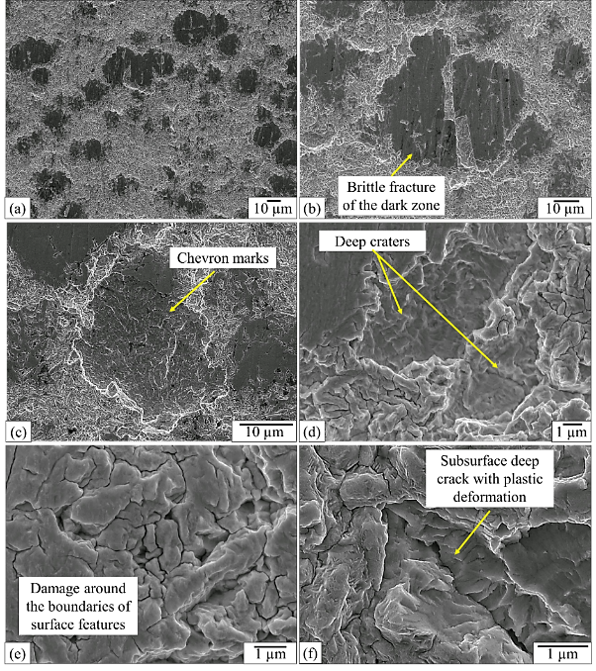
Fig. 12 Post-test exposure surface of T1600 (a), (b), (c) and (d) (e) (f) features at different magnitudes

Cross-sectional analysis
In order to further facilitate the understanding of the CE damage mechanisms, cross-sectional characterisation was conducted through SEM analysis, as shown in Fig. 13 to Fig. 15, respectively.
The LT and the T1200 coatings indicate less damage compared to the T1600 coating. Networks of microcracks were formed at the coating surface on both coating cross-sections. For the LT coating, the cracks were found propagating along the boundaries of columnar grains (as shown in Fig. 13, see ten cracks as indicated by the numbered arrows). As the cracks reach a depth up to approximately 10 µm, laterals cracks were then initiated, propagated and coalesced, which leads to the removal of coating material, as shown in Fig. 13 (e). While for the T1200 coating, the cracks were observed at random locations (shown in Fig. 14) and did not penetrate deeply (less than 5 µm) into the coating. Formation of micropits was detected in Fig. 14 (e). However, such damage was limited within few microns away from the coating surface.
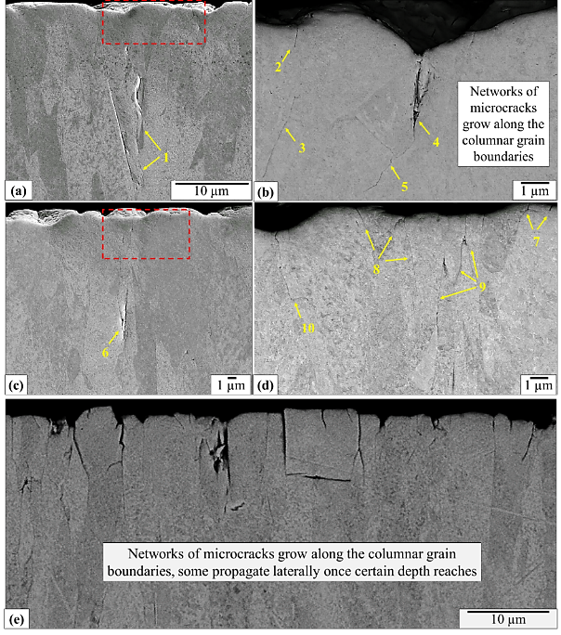
Fig. 13 Cross-sectional analysis of post-tested LT coating. (a), (b), (c) and (d) (e) features at different magnitudes

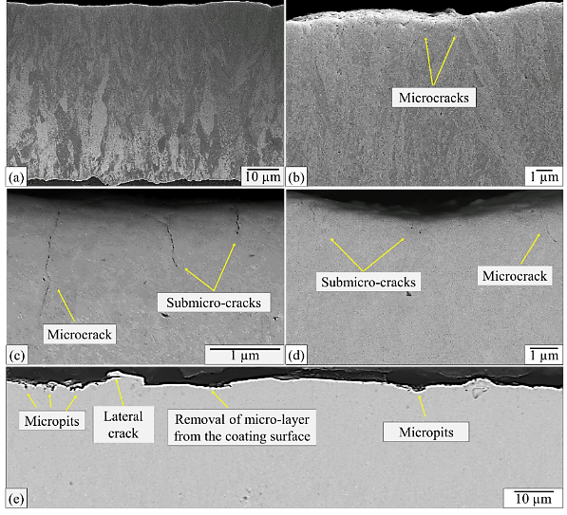
Fig. 14 Cross-sectional analysis of post-tested T1200 coating. (a), (b), (c) and (d) at different magnifications
In the case of the T1600 coating (as shown in Fig. 15), the cross-section indicates a complex damage pattern was generated during the exposure to CE. Small cracks (< 5 µm) were observed at the coating surface, as labelled in Fig. 15 (a), (b) and (c). Subsurface lateral cracks range from 10 to 15 µm in length were found 10 µm away from the coating surface, shown in Fig. 15 (a) and (b). The large vertical cracks shown on Fig15b are similar to vertical cracks on Fig.4c before CE testing, these cracks are located around 10 to 20 μm beneath the coating surface and seems to be the results of residual stresses in the T1600 sample coating combined with the sample sectioning and preparation. But Fig.4c shows the absence of any small cracks (< 5 μm) observed at the coating surface, as labelled in Fig. 15 (a), (b) and (c) and also has no subsurface lateral cracks. These small surface and lateral subsurface cracks are characteristic of the cavitation damage. Formation of a large erosion crater with 30 µm in width and 15 µm in depth was identified due to the detachment of the coating material from the top layer, shown in Fig. 15 (c). Additional cracks were detected developing on the side and bottom walls of the erosion crater. Extended erosion craters with more than 100 µm in width are observed in Fig. 15 (d). Additionally, subsurface large vertical cracks (> 20 µm) were found in Fig. 15 (a), (b) and (d). It can be seen that one end of these cracks locates around 10 to 20 µm beneath the coating surface; while the other end stops at the interface of the fine and coarse layer of the T1600 coating.
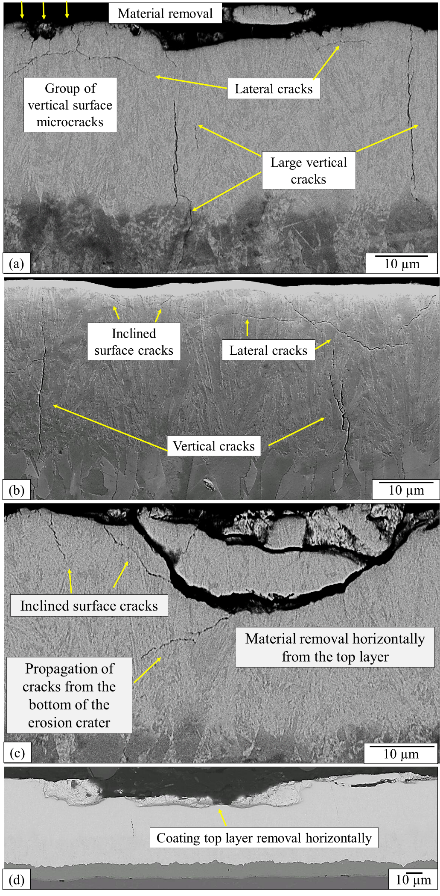
Fig. 15 Cross-sectional analysis of post-tested T1600 coating. (a), (b), (c) and (d) at different magnifications

Discussion
A dynamic stress field is generated during the CE process: compressive stresses are induced over very short durations (fractions of a micro second) by implosion of cavitation bubbles. For example, by the impingement of a microjet on the impact surface [28]. Furthermore, brittle failure can start at the surface due to the surface tensile stress that is present outside the impacted region [29]. The CVD W/WC coatings show superior CE resistance with respect to the substrate Ti6Al4V alloy. The enhanced performance is shown to be significant when comparing to the other coating systems from past studies, as listed in Table 6. Such improvement can be attributed to the tailored microstructure and mechanical properties of the coatings and also residual compressive stresses. The CVD W/WC coatings similar to T1200 and T1600 coatings had residual stresses measured using XRD: the compressive stresses ranging from 580 MPa and 874 MPa were measured. LT type CVD W/WC coating is produced at a lower temperature and is expected to have lower residual compressive stresses. The following discussion is established on the effects of the three factors: coating topography, microstructure and mechanical properties on the CE behaviour.
Table 6 Comparison with the literatures.
Coatings | Er_{max} (mg/min) |  | Manufacturing process | Thickness (µm) | Test period (hour)
LT | 0.004 |  | CVD | ~ 60 | 6.5
T1200 | 0.004 |  |  | ~ 55 | 6.5
T1600 | 0.010 |  |  | ~ 55 | 6.5
M6-HV [30] | 0.027 |  | HVOF | 134 ± 6 | 8
WC-CoCr [30] | 0.041 |  |  | 107 ± 12 | 8
Cr₃C₂-NiCr [31] | 0.05 |  |  | 30 - 40 | 8
CoMoCrSi [32] | 0.125 |  | Plasma spray | / | 2
FeNiCrBSiNbW [33] |  | ~ 0.15 | Arc spray | 230 | 2

Effect of initial coating topography on CE performance
The fracture surfaces of the coatings show the formation of the striation marks adjacent to a plastic deformation zone with cracks, as shown in Fig. 10 (e), Fig. 11 (e) and Fig. 12 (f). The properties of such eroded surfaces are similar to the characteristics of fatigue fracture. This indicates a potential correlation of CE to a fatigue-like process, which has been extensively studied in the past fracture [34-41]. During any fatigue failure, microcracks first formed at stress risers (voids, notches, defects, etc.) or at heterogeneous areas of the material, such as at the interface of difference phases, microstructures and grain boundaries [34-41]. Therefore, a target surface with potential stress risers, such as topographical features observed on the surface of the coatings, is prone to cavitation wear. It is reported that poor initial surface finish due to the pre-existed defects on thermal sprayed coating surface leads to poor CE and WDE performance [33, 38].
The topographical characterisation (S_{a} and S_{q}) of the coating surfaces (Fig. 1) indicate the LT coating exhibits the smoothest surface finish (as listed in Table 2). However, the LT coating shows an abrupt increase in the erosion rate after 10 minutes of CE exposure, while the T1200 and T1600 coatings with a courser surface finish outperform the LT coating at the initial stage of CE.
As S_{a} and S_{q} cannot specify the features of the surface profile [42] the surface parameters S_{sk} (skewness) and S_{ku} (kurtosis) are used to better characterise the features of the surface topography, which might affect the CE rate [43]. The S_{sk} and S_{ku} values are shown in Table 2 that shows modest negative skewness (features below the mean height and peakedness in these features). As seen of the cross-section of LT coating in Fig. 13, cracks initiate at the valley bottoms that coincide with the grain boundaries of the columnar structure. Hence initially a good finishing technique is required to control the initial surface roughness of these coatings.
Although the effect of coating surface topography on the CE performance is identified, the phenomenon is only observed at the initial stage of CE process. The LT coating shows similar erosion rate as the T1200 coating after initial 10 mins of cavitation exposure. The initial high erosion rate may relate to the roughness variation of the LT coating. It has the highest S_{sk} and S_{ku} values, see Table 2. However, further tests need to be conducted to confirm this phenomenon. Hence, the topographical effect is not the sole parameter contributing to the coating CE performance. The effect of which is limited during early stage of CE and is in agreement with past studies [44].

Effect of coating mechanical properties on CE performance
Correlation between the mechanical properties and CE behaviour has been extensively studied in the past [39, 45-47]. Hardness [45], fatigue strength [39-46] and toughness [47] are proposed to have close correlation to the CE resistance, but there is no consensus on one individual property. In a vibratory cavitation system, the stress which is responsible for erosion is primarily due to the concerted collapse of the aggregated bubbles generated by the pressure changes in the liquid, and these generate stress waves in the target material [34, 37, 38, 48, 49]. The deformation and erosion of metals by cavitation are related to the high-velocity impingements of microjets on the surface of the metal and the magnitude of the shock wave emitted by the bubble cloud as bubbles collapse [50]. Hence, the CE resistance of a material in general is connected with its ability to absorb energy [33].
Solid material absorbs the impact energy by conducting elastic deformation, plastic deformation or mixture. Hence, the elasticity and toughness of the coatings are considered as important factors for combating the erosive wear induced by cavitation. Toughness measurement with a nanoindenter [51] cannot be applied in the current study as the coating surfaces does not crack but deform in a ductile fashion during indentation. The hardness (H) of these hard, tough and well resilient coatings ranges between 15 to 25 GPa [52]. The cross-sectional hardness of the best performed T1200 coating falls in the same range. For the other two coatings (LT and T1600), the hardness ranges between 15 to 25 GPa at the top 30 µm of the coating surfaces. This suggests the top layers of the two coatings demonstrate higher hardness than the bottom layers.
Table 7 Summary of coating properties
Coating | H/E surface | H³/E² surface | Grain size  Surface/sub | Residual stress | Roughness  S_{ku} | ER_{max}
T1600 | H | H | Small/large | H | L | M(L×2)
T1200 | M | M | Medium | M | M | L
LT | L | L | Large | L | H | H (L×100)
* H: high, M: medium, L: low
The elasticity and toughness can be correlated to the measured hardness (H) and effective elastic modulus (E) [53]. The H over E ratio (H/E), a description of ‘elastic strain to failure’ has shown some merit in the past studies [53-55]. The H³/E² ratio is proportional to the load that defines the transition between elastic to plastic contact in a ball-on-plane system, which can be a strong indicator of a material's toughness [53]. The H/E and the H³/E² ratios across the coating thickness are plotted in Fig. 16 and Fig. 17 based on the measured H and E values by nanoindentation tests. Coating performance appears to not be well related to either H/E or H³/E² ratios near the surface, see Table 7. This is contrary to previous literature that suggests a stronger relationship than the present study found [31, 56-59]. For example, the incubation period and the erosion rate were found to correlate well with the H/E ratio in the study on CE of HVOF ceramic coatings [31]. In the current study, there is no clear relationship as elastic strain to failure (H/E) is clearly not relevant to the mechanisms of erosion seen. H³/E² relates to the ability of the surface to dissipate energy at plastic deformation during loading. As H and E are quasi-static values and are not dynamic ones but the high strain rates present in cavitation mean this parameter is not correlated to erosion or the mechanisms seen in this study. However, the H³/E² ratio was found to correlate well to the toughness that promotes the CE behaviour of the plasms-sprayed YSZ coatings [57]. The present results indicate that different factors are defining the CE resistance, such as residual stresses.
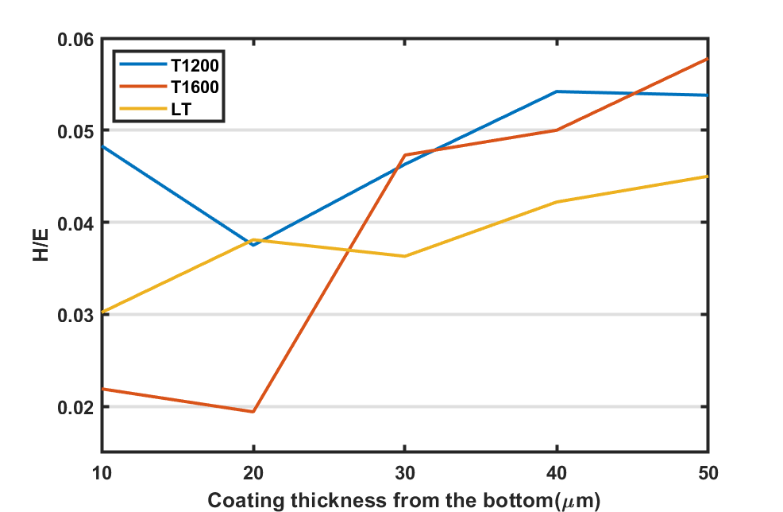
Fig. 16 H /E ratios through all coating thickness
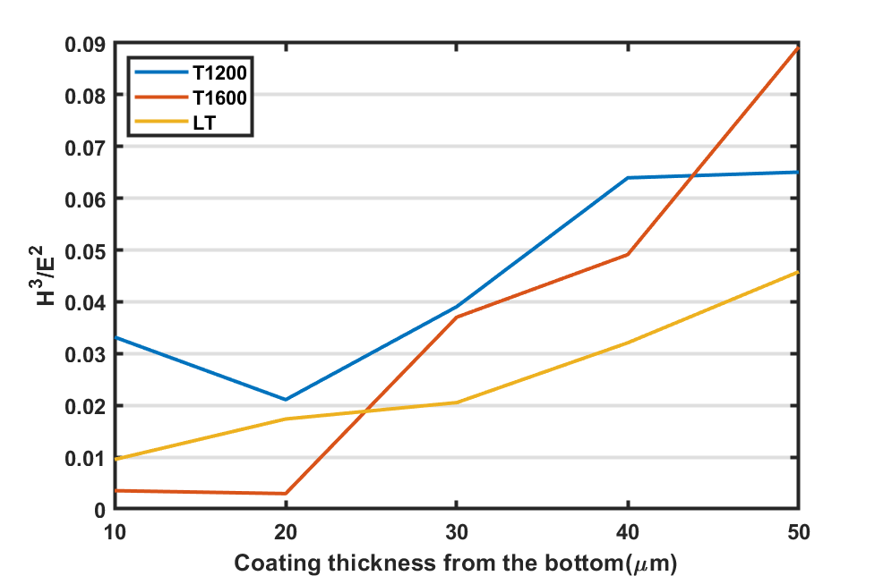
Fig. 17 H³/E² ratios through all coating thickness
It is the coating properties near the eroded surface (at 40 to 50 micron thickness from the bottom) that are likely to control erosion but it is proposed that the poor CE performance of the T1600 coating is attributed to the bottom columnar grain zone (10 and 20 µm), where the H/E and H³/E² ratios show significantly smaller values.
The unique configuration of the hierarchical (T1200 and T1600) coating structures are designed with the potential benefits of: the fine top layers are aimed to improve the resistance to the high impact pressure induced by bubble implosion; while the coarse columnar grains at the bottom layers are to support the top layer with better ductility to dissipate the absorbed impact energy as well as the transmitted stress waves. However, in the case of the T1600 coating, the bottom layer of columnar grains indicates significantly reduced elasticity and toughness. The likelihood is that these hierarchical structures not only have complex mechanical property profiles but also complex residual stress profiles with depth and further work is needed to quantify these using EBSD techniques [60]. The issue of stress wave reinforcement requires reflection of the stress waves by acoustic impedance mismatches. Acoustic impedance being equal to the square root of bulk modulus multiplied by density. Thus the maximum change in impendence is between the coating and Ti-6Al-4V substrate (forgetting the interlayer) as the coating is approximately 3x stiffer and 4x more dense than the substrate – which equates to an impedance 3.5 times bigger. The reflected stress waves meet the newly generated ones under the repeated motions of bubble implosion, leading to stress wave reinforcements. This results in the formation of the tensile stress close to the coating surface and therefore tensile failure modes.

Microstructural effect on CE mechanisms
The main advantage of applying hard and tough coatings is their enhanced resistance to crack growth. During the CE process, small local plastic strains initiate the formation of cracks similar to fatigue cracks. The repeated action of bubble collapse then causes crack propagation, which leads to the removal of material particles. The path of the crack propagation can be affected by different microstructures of the exposed surface.
The post-test SEM analysis shown in Fig. 10 to Fig. 12 indicates an intergranular brittle facture behaviour on all coating surfaces. However, the cross-sectional investigation reveals different damage mechanisms for each coating system due to the variation in the microstructure. The effect of which will be discussed in two main aspects: microstructural configurations and crystallographic orientations of the coatings.

Microstructural configuration of the coatings
There are two main microstructural configurations of coatings: the monotonic LT coating demonstrates a monotonic columnar grain structure; while the hierarchical coatings (T1200 and T1600) show hierarchical microstructures with a layer of coarse columnar grains at the bottom, and a layer of submicron grains at the top. The difference between the T1200 and T1600 coatings configuration is mainly at the transition stage from the coarse to fine layer. In the T1200 coating, the fine grains nucleate at the bottom coarse columnar grains, forming a gradient change of microstructure through the coating thickness. While in the case of T1600 coating, the top fine grains are grown independently from the coarse columnar grain structure at the bottom, hence, a distinct interface between the two layers is formed. Furthermore, the results of the EBSD analysis shown in Fig. 4 reveals the grain size of the three coating surfaces. Compared to the LT coating, both T1200 and T1600 coatings are constructed with a submicron top layer.
The post-test SEM observation of all coating surfaces (Fig. 10 to Fig. 12) indicate a mixture of brittle and ductile fracture behaviour. Intergranular brittle fracture was found on all the coating surfaces irrespective of the variation in the grain size of the exposed surface. This is in agreement with the literature showing that CE at the initial stages involves delineation of the grain boundaries regardless of the grain sizes [61]. One of the many factors that determines amount of the brittle or ductile fracture that occurs in a material is the dislocation density. Increase in dislocation density can be introduced by CE process [48]. When the dislocations reach the grain boundaries, they pile into each other, the intergranular fracture takes place. Literature [62, 63] suggests that grain refinement contributes to better CE resistance as the smaller grains restrain dislocation movements with increased surface grain boundary density. This is in potential agreement with the results obtained in this study. The enhancement in CE performance is only observed in the T1200 coating. The fine grains of the top coating layer provides more grain boundaries to better resist to plastic deformation due to highly localised strain induced by cavitation bubbles. On the other hand, the T1600 coating surface also composed of fine grains shows inferior CE performance. The coating surface was removed due to the formation and nucleation of lateral cracks after CE exposure. This can be due to the significant change in mechanical properties at two layers of the coating microstructure discussed in section 4.2.
One other factor that should be considered is the effect of the microstructural characteristics on the crack propagation mechanisms. It is reported that the cracks formed under CE usually develop perpendicular to the surface and in parallel direction when a certain depth is obtained [37]. This agrees with the cross-sectional views of the LT coating shown in Fig. 13. The cracks were found initiating and propagating along the columnar grain boundaries. Lateral cracks were then developed at a depth around 7 to 8 µm. While for hierarchical coatings (T1200 and T1600), the bush-like and the stem-like fine grains at the top layers play a role in the crack propagation during CE process. The cracks tend to grow horizontally at the coating surface, as the grain boundaries of the fine grains act as obstacles. The cracks deflect and nucleate laterally, instead of growing vertically in depth. Such mechanism can potentially reduce the mass loss rate, leading to less severe damage of the coating.

Crystalline texture of the coatings
The EBSD analysis, shown in Fig. 4 (a) and (b), reveals that the T1200 and LT coatings demonstrate a distinct crystal texture at <001> orientation. The LT coating presents a higher texture intensity with monotonic columnar grain structure. The results of the CE test indicate that these two coatings perform better than the T1600 coating, in which no crystalline texture was observed. Studies on the CE of titanium alloy [37] and stainless steel show that grains with certain orientations resist to cavitation condition better than others. It is argued that although the magnitude of most of the pressure pulses induced by CE is insufficient to indent the hard surface, the magnitude is sufficient to induce shearing in favourably oriented grains. Hence, it is proposed that the CVD W/WC coatings with <001> crystalline texture are likely to better resist to CE. The conjecture can be supported by the study on the wear performance of the textured CVD α-Al₂O₃ coatings. It reveals that the coating with <001> texture demonstrates improved wear resistance [64].
Furthermore, although all the coating fracture surfaces demonstrate brittle intergranular failure, once the material is removed, signs of plastic deformation was detected. It is known that the CVD W coatings with <001> texture show a strong strain rate sensitivity [65, 66]. These coatings show large ductility at all strain rates and significant strain softening during high strain rate deformation, as shown in Fig. 18. On the other hand, the coatings deposited with random orientation exhibit brittle failure. Hence, it can be suggested that the superior CE performance of <001> textured specimens (LT and T1200) can be attributed to the enhanced ductility compared to the random oriented grains (T1600). As the stress wave induce plastic deformation during the CE process [34, 37, 38, 48, 49], specimens with better ductility can delay the formation of microcracks. The fact that the T1200 coating demonstrates better performance than the LT coating is due to a combined effect of the functionally graded microstructure and mechanical properties that have been discussed in the previous sections.
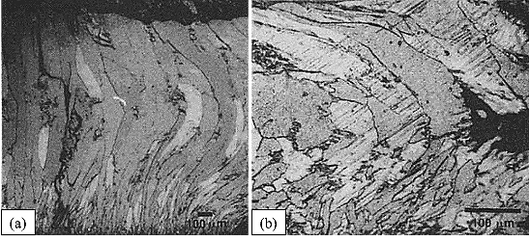
Fig. 18 The cross section of <001> specimens deformed: (a) to a strain of 0.8 under quasistatic loading at a strain rate of 0.0003 s⁻¹ ; (b) a strain of 0.87 at a strain rate of 9500 s⁻¹ [46]

Conclusions
Investigation on the CE performance of three different nanostructured CVD W/WC coatings deposited on Ti6Al4V substrate have been conducted. The following conclusions are drawn:
- All three CVD-W coatings show improvement in the CE resistance with respect to Ti6Al4V substrate, which can be attributed to a combined factors of mechanical properties and microstructures.

- Among the three CVD-W coatings, T1200 and LT coatings demonstrate better resistance to cavitation. T1600 undergoes premature spallation of the coating surface during the CE test.

- The effect of the initial coating topography on the CE performance is more effectively characterised by the surface parameters S_{sk} and S_{ku}. So these should be minimised to yield high erosion resistance.

- The H/E and H³/E² ratios at the top surface do not correlate with erosion rate indicating that the elastic strain to failure or toughness of the coating appear not to control cavitation erosion. Therefore, residual stresses may well be important and need to be measured through thickness as well as stress wave interactions considered and mitigated through coating design.

- Correlation between the superior CE performance of the T1200 and LT coatings and the crystal orientation is identified. Both coatings are textured with <001> orientation, which show better resistance to CE.

- T1200 coating demonstrates enhancement in CE performance compared to the LT coating, which might be due to its hierarchical microstructure.

- The T1600 coating with a distinct interface between the coarse and fine layer failed under the premature spallation of the coating surface. This is thought to be due to residual stress variation as a function of the depth of coating.

Acknowledgments
The authors would like to acknowledge funding from Rolls-Royce and the University of Southampton to support this research and also to Hardide Coatings Ltd for the supply of coatings for testing. Also to thank Dr Ping Lu and Zaihao Tian for their help with the preparation of this manuscript.
Data published in this paper are available from the University of Southampton repository at xxxdoi.

References
[1] A. Standard, "G73, 2010, Standard test method for liquid impingement erosion using rotating apparatus," ed: ASTM International, West Conshohocken, PA, 2010.
[2] W. F. Adler, "Rain impact retrospective and vision for the future," Wear, vol. 233, pp. 25-38, 1999.
[3] M. Elhadi Ibrahim and M. Medraj, "Water Droplet Erosion of Wind Turbine Blades: Mechanics, Testing, Modeling and Future Perspectives," Materials, vol. 13, no. 1, p. 157, 2020.
[4] F. Heymann, "Liquid impingement erosion," ASM handbook, vol. 18, p. 221, 1992.
[5] J. Field, "ELSI conference: invited lecture: liquid impact: theory, experiment, applications," Wear, vol. 233, pp. 1-12, 1999.
[6] F. Heymann, "High‐speed impact between a liquid drop and a solid surface," Journal of Applied Physics, vol. 40, no. 13, pp. 5113-5122, 1969.
[7] F. Heymann, "On the time dependence of the rate of erosion due to impingement or cavitation," in Erosion by Cavitation or Impingement: ASTM International, 1967.
[8] T. Keil, P. Pelz, J. Kadavelil, J. Necker, W. Moser, and D. Christ, "Droplet impact vs. cavitation erosion," in Proceedings of WIMRC 3rd International Cavitation Forum, 4th-6th July, 2011, p. 2011.
[9] C. M. Preece and J. H. Brunton, "A comparison of liquid impact erosion and cavitation erosion," Wear, vol. 60, no. 2, pp. 269-284, 1980.
[10] F. G. Hammitt, "Damage to solids caused by cavitation," Philosophical Transactions for the Royal Society of London. Series A, Mathematical and Physical Sciences, pp. 245-255, 1966.
[11] G. F. Schmitt Jr, "Liquid and solid particle impact erosion," AIR FORCE MATERIALS LAB WRIGHT-PATTERSON AFB OH, 1979.
[12] Y. Oka and H. Miyata, "Erosion behaviour of ceramic bulk and coating materials caused by water droplet impingement," Wear, vol. 267, no. 11, pp. 1804-1810, 2009.
[13] M. Jackson and J. Field, "Liquid impact erosion of single-crystal magnesium oxide," Wear, vol. 233, pp. 39-50, 1999.
[14] C. F. Kennedy, R. H. Telling, and J. E. Field, "Liquid impact and fracture of free-standing CVD diamond," in Window and Dome Technologies and Materials VI, 1999, vol. 3705: International Society for Optics and Photonics, pp. 290-296.
[15] W. F. Adler, "Investigation of liquid drop impacts on ceramics," EFFECTS TECHNOLOGY INC SANTA BARBARA CA, 1982.
[16] G. S. Springer, C.-I. Yang, and P. S. Larsen, "Analysis of rain erosion of coated materials," Journal of Composite Materials, vol. 8, no. 3, pp. 229-252, 1974.
[17] D. Wheeler and R. Wood, "Fracture of diamond coatings by high velocity sand erosion," Philosophical Magazine, vol. 89, no. 3, pp. 285-310, 2009.
[18] D. Ma et al., "Cavitation erosion performance of CrAlYN/CrN nanoscale multilayer coatings deposited on Ti6Al4V by HIPIMS," Journal of Alloys and Compounds, vol. 788, pp. 719-728, 2019.
[19] G. Krolczyk, J. Krolczyk, R. Maruda, S. Legutko, and M. Tomaszewski, "Metrological changes in surface morphology of high-strength steels in manufacturing processes," Measurement, vol. 88, pp. 176-185, 2016.
[20] Y. Lian et al., "Influence of surface morphology and microstructure on performance of CVD tungsten coating under fusion transient thermal loads," Applied Surface Science, vol. 390, pp. 167-174, 2016.
[21] J. Shi et al., "Microstructures of chemical vapor deposited high-purity tungsten achieved by two different precursors," Materials Characterization, vol. 134, pp. 1-8, 2017.
[22] Y. Lv, J. Song, Y. Lian, Y. Yu, X. Liu, and Z. Zhuang, "The thermal properties of high purity and fully dense tungsten produced by chemical vapor deposition," Journal of Nuclear Materials, vol. 457, pp. 317-323, 2015.
[23] K. K. Lai and H. H. Lamb, "Tungsten chemical vapor deposition using tungsten hexacarbonyl: microstructure of as-deposited and annealed films," Thin Solid Films, vol. 370, no. 1-2, pp. 114-121, 2000.
[24] D. Li, A. Goullet, M. Carette, A. Granier, Y. Zhang, and J.-P. Landesman, "Structural and optical properties of RF-biased PECVD TiO2 thin films deposited in an O2/TTIP helicon reactor," Vacuum, vol. 131, pp. 231-239, 2016.
[25] S. Chen, J. Du, G. Gao, and Z. Li, "Microstructure study of CVD W coating on Mo single crystal rods with< 1 1 1> axial orientation by EBSD," Materials Science and Engineering: A, vol. 434, no. 1-2, pp. 95-98, 2006.
[26] E. Fuentes-Fernandez et al., "Synthesis and characterization of microcrystalline diamond to ultrananocrystalline diamond films via Hot Filament Chemical Vapor Deposition for scaling to large area applications," Thin Solid Films, vol. 603, pp. 62-68, 2016.
[27] O. Auciello and A. V. Sumant, "Status review of the science and technology of ultrananocrystalline diamond (UNCD™) films and application to multifunctional devices," Diamond and related materials, vol. 19, no. 7-9, pp. 699-718, 2010.
[28] C. M. Preece, "Treatise on Materials Science and Technology, Vol. 16. Erosion," Academic Press, p. 450, 1979.
[29] M. Mathias, A. Göcke, and M. Pohl, "The residual stress, texture and surface changes in steel induced by cavitation," Wear, vol. 150, no. 1-2, pp. 11-20, 1991.
[30] S. Lavigne, F. Pougoum, S. Savoie, L. Martinu, J. E. Klemberg-Sapieha, and R. Schulz, "Cavitation erosion behavior of HVOF CaviTec coatings," Wear, vol. 386, pp. 90-98, 2017.
[31] G. Taillon et al., "Cavitation erosion mechanisms in stainless steels and in composite metal–ceramic HVOF coatings," Wear, vol. 364, pp. 201-210, 2016.
[32] Y. Wang et al., "Cavitation erosion of plasma-sprayed CoMoCrSi coatings," Tribology International, vol. 102, pp. 429-435, 2016.
[33] J. Lin, Z. Wang, J. Cheng, M. Kang, X. Fu, and S. Hong, "Effect of initial surface roughness on cavitation erosion resistance of arc-sprayed Fe-based amorphous/nanocrystalline coatings," Coatings, vol. 7, no. 11, p. 200, 2017.
[34] S. Ahmed, K. Hokkirigawa, and R. Oba, "Fatigue failure of SUS 304 caused by vibratory cavitation erosion," Wear, vol. 177, no. 2, pp. 129-137, 1994.
[35] A. Abouel-Kasem, K. Emara, and S. Ahmed, "Characterizing cavitation erosion particles by analysis of SEM images," Tribology International, vol. 42, no. 1, pp. 130-136, 2009.
[36] S. Kocanda, "Fatigue failure of metals," 1978.
[37] T. OKADA and Y. IWAI, "Cavitation erosion," JSME international journal. Ser. 1, Solid mechanics, strength of materials, vol. 33, no. 2, pp. 128-135, 1990.
[38] S. M. AHMED, K. HOKKIRIGAWA, R. OBA, and K. KIKUCHI, "SEM observation of the vibratory cavitation-fracture mode during the incubation period and the small roughness effect," JSME international journal. Ser. 2, Fluids engineering, heat transfer, power, combustion, thermophysical properties, vol. 34, no. 3, pp. 298-303, 1991.
[39] W. Będkowski, G. Gasiak, C. Lachowicz, A. Lichtarowicz, T. Łagoda, and E. Macha, "Relations between cavitation erosion resistance of materials and their fatigue strength under random loading," Wear, vol. 230, no. 2, pp. 201-209, 1999.
[40] R. F. Patella, T. Choffat, J.-L. Reboud, and A. Archer, "Mass loss simulation in cavitation erosion: Fatigue criterion approach," Wear, vol. 300, no. 1-2, pp. 205-215, 2013.
[41] R. Richman and W. McNaughton, "A metallurgical approach to improved cavitation-erosion resistance," Journal of Materials Engineering and Performance, vol. 6, no. 5, pp. 633-641, 1997.
[42] M. N. Goodhand, K. Walton, L. Blunt, H. W. Lung, R. J. Miller, and R. Marsden, "The limitations of using “Ra” to describe surface roughness," Journal of Turbomachinery, vol. 138, no. 10, p. 101003, 2016.
[43] S. M. AHMED, K. HOKKIRIGAWA, R. OBA, and Y. MATSUDAIRA, "Developing stages of ultrasonically produced cavitation erosion and corresponding surface roughness," JSME international journal. Ser. 2, Fluids engineering, heat transfer, power, combustion, thermophysical properties, vol. 33, no. 1, pp. 11-16, 1990.
[44] Y. Zhu, J. Zou, W. Zhao, X. Chen, and H. Yang, "A study on surface topography in cavitation erosion tests of AlSi10Mg," Tribology International, vol. 102, pp. 419-428, 2016.
[45] F. Cheng, P. Shi, and H. Man, "Correlation of cavitation erosion resistance with indentation-derived properties for a NiTi alloy," Scripta Materialia, vol. 45, no. 9, pp. 1083-1089, 2001.
[46] R. Richman and W. Mcnaughton, "Correlation of cavitation properties of metals erosion behavior with mechanical," Wear, vol. 140, pp. 63-82, 1990.
[47] J.-W. Lim, J.-J. Lee, H. Ahn, and K.-T. Rie, "Mechanical properties of TiN/TiB2 multilayers deposited by plasma enhanced chemical vapor deposition," Surface and Coatings Technology, vol. 174, pp. 720-724, 2003.
[48] B. Vyas and C. Preece, "Stress produced in a solid by cavitation," Journal of Applied Physics, vol. 47, no. 12, pp. 5133-5138, 1976.
[49] J. Laguna-Camacho, R. Lewis, M. Vite-Torres, and J. V. Mendez-Mendez, "A study of cavitation erosion on engineering materials," Wear, vol. 301, no. 1-2, pp. 467-476, 2013.
[50] L. van Wijngaarden, "Mechanics of collapsing cavitation bubbles," Ultrasonics sonochemistry, vol. 29, pp. 524-527, 2016.
[51] M. Sebastiani, K. Johanns, E. G. Herbert, and G. M. Pharr, "Measurement of fracture toughness by nanoindentation methods: Recent advances and future challenges," Current Opinion in Solid State and Materials Science, vol. 19, no. 6, pp. 324-333, 2015.
[52] J. Musil, "Hard nanocomposite coatings: Thermal stability, oxidation resistance and toughness," Surface and Coatings Technology, vol. 207, pp. 50-65, 2012.
[53] A. Leyland and A. Matthews, "Design criteria for wear-resistant nanostructured and glassy-metal coatings," Surface and Coatings Technology, vol. 177, pp. 317-324, 2004.
[54] A. Leyland and A. Matthews, "On the significance of the H/E ratio in wear control: a nanocomposite coating approach to optimised tribological behaviour," Wear, vol. 246, no. 1-2, pp. 1-11, 2000.
[55] C. Wang, K. Shi, C. Gross, J. M. Pureza, M. de Mesquita Lacerda, and Y.-W. Chung, "Toughness enhancement of nanostructured hard coatings: Design strategies and toughness measurement techniques," Surface and Coatings Technology, vol. 257, pp. 206-212, 2014.
[56] L. Espitia, H. Dong, X.-Y. Li, C. E. Pinedo, and A. P. Tschiptschin, "Cavitation erosion resistance and wear mechanisms of active screen low temperature plasma nitrided AISI 410 martensitic stainless steel," Wear, vol. 332, pp. 1070-1079, 2015.
[57] W. Deng, Y. An, G. Hou, S. Li, H. Zhou, and J. Chen, "Effect of substrate preheating treatment on the microstructure and ultrasonic cavitation erosion behavior of plasma-sprayed YSZ coatings," Ultrasonics sonochemistry, vol. 46, pp. 1-9, 2018.
[58] A. Krella and A. Czyżniewski, "Cavitation erosion resistance of Cr–N coating deposited on stainless steel," Wear, vol. 260, no. 11-12, pp. 1324-1332, 2006.
[59] A. Krella, "The influence of TiN coatings properties on cavitation erosion resistance," Surface and Coatings Technology, vol. 204, no. 3, pp. 263-270, 2009.
[60] M. Kartal, R. Kiwanuka, and F. Dunne, "Determination of sub-surface stresses at inclusions in single crystal superalloy using HR-EBSD, crystal plasticity and inverse eigenstrain analysis," International Journal of Solids and Structures, vol. 67, pp. 27-39, 2015.
[61] C. Lin and J. He, "Cavitation erosion behavior of electroless nickel-plating on AISI 1045 steel," Wear, vol. 259, no. 1-6, pp. 154-159, 2005.
[62] G. Bregliozzi, A. Di Schino, S.-U. Ahmed, J. Kenny, and H. Haefke, "Cavitation wear behaviour of austenitic stainless steels with different grain sizes," Wear, vol. 258, no. 1-4, pp. 503-510, 2005.
[63] M. Hajian et al., "Improvement in cavitation erosion resistance of AISI 316L stainless steel by friction stir processing," Applied Surface Science, vol. 308, pp. 184-192, 2014.
[64] R. M’Saoubi et al., "Microstructure and wear mechanisms of texture-controlled CVD α-Al2O3 coatings," Wear, vol. 376, pp. 1766-1778, 2017.
[65] G. Subhash, Y. Lee, and G. Ravichandran, "Plastic deformation of CVD textured tungsten—II. Characterization," Acta metallurgica et materialia, vol. 42, no. 1, pp. 331-340, 1994.
[66] G. Subhash, Y. Lee, and G. Ravichandran, "Plastic deformation of CVD textured tungsten—I. Constitutive response," Acta metallurgica et materialia, vol. 42, no. 1, pp. 319-330, 1994.

