Image-based quantification of soil microbial dead zones induced by nitrogen fertilization

S. Ruiz^{1$}, D. McKay Fletcher^{1$}, A. Boghi^{1,5}, K. Williams¹, S. Duncan¹, C. Scotson¹, C. Petroselli¹, T. Dias¹, D.R. Chadwick^{2,3}, D.L. Jones^{2,4}, T. Roose^{1*}
¹Bioengineering Sciences Research Group, Department of Mechanical Engineering, School of Engineering, Faculty of Engineering and Physical Sciences, University of Southampton, Southampton SO17 1BJ, UK
²School of Natural Sciences, Bangor University, Bangor LL57 2UW, UK
³Interdisciplinary Research Centre for Agriculture Green Development in Yangtze River Basin, Southwest University, Chongqing, China.
⁴SoilsWest, UWA School of Agriculture and Environment, The University of Western Australia, Perth, WA 6009, Australia
⁵Computational Science Ltd, 30a Bedford Place, Southampton SO15 2DG, UK
* Corresponding author: T. Roose, email: t.roose@soton.ac.uk, Bioengineering Sciences Research Group, Department of Mechanical Engineering, School of Engineering, Faculty of Engineering and Physical Sciences, University of Southampton, University Road, SO17 1BJ Southampton, United Kingdom
$ Authors contributed equally to this manuscript

Abstract
Microbial communities in agricultural soils underpin many ecosystem services including the maintenance of soil structure, food production, water purification and carbon storage. However, the impact of fertilization on the health of microbial communities is not well understood. This study investigates the spatial and temporal dynamics of nitrogen (N) transport away from a fertilizer granule with pore scale resolution. Specifically, we examined how soil structure and moisture content influence fertilizer derived N movement through the soil pore network and the subsequent impact of on soil microbial communities. We develop a mathematical model to describe N transport and reactions in soil at the pore-scale. Using X-ray Computed Tomography scans, we reconstructed a microscale description of a soil-pore geometry as a computational mesh. Solving two-phase water/air model produced pore-scale water distributions at 15, 30 and 70% water-filled pore volume. The N-speciation model considered ammonium (NH₄⁺), nitrate (NO₃⁻) and dissolved organic N (DON), and included N immobilization, ammonification and nitrification processes, as well as diffusion in soil solution. We simulated the dissolution of a fertilizer pellet and a pore scale N cycle at three different water saturations. To aid interpretation of the model results, microbial activity at a range of N concentrations was measured. The model showed that the diffusion and concentration of N in water films is critically dependent upon soil moisture and N species. We predict that the maximum NH₄⁺ and NO₃⁻ concentrations in soil solution around the pellet under dry conditions are in the order of 1×10³ and 1×10⁴ mol m⁻³ respectively, and under wet conditions 2×10² and 1×10³ mol m⁻³, respectively. Supporting experimental evidence suggests that these concentrations would be sufficient to reduce microbial activity in the short-term in the zone immediately around the fertilizer pellet (ranging from 0.9 to 3.8 mm), causing a major loss of soil biological functioning. This model demonstrates the importance of pore-scale processes in regulating N movement and their interactions with the soil microbiome.
Keywords: Nitrogen cycling, Fertilizer dynamics, Pore-scale modeling, Soil health, Diffusion, Microbial activity.

Nomenclature

Latin
$\hat{n}$ Normal direction
${\tilde{c}}_{i}^{L}$Solute concentration in soil-solution (mol · m⁻³_{soil solution})
${\tilde{c}}_{i}^{S}$Solute concentration on soil-solid (mol · m⁻²_{soil mineral surface area})
$\tilde{D_{i}}$Diﬀusivity coeﬃcient (m² · s⁻¹)
f Bulk energy for air-water
$\tilde{F_{i}}$ Nitrogen Species “i” mass flux (mol · m⁻² · s⁻¹)
$\tilde{g}$ Gravity acceleration (m · s⁻²)
$\tilde{J_{{NH}_{4}^{+}}}$ NH₄⁺ Flux from fertilizer (mol · m⁻² · s⁻¹)
$\tilde{J_{{NO}_{3}^{-}}}$ NO₃⁻ Flux from fertilizer (mol · m⁻² · s⁻¹)
$K_{I,2}^{B}$ Michaelis-Menten NO₃⁻ immobilization constant
$K_{M}^{B}$ Michaelis-Menten mineralization constant
$K_{N}^{B}$ Michaelis-Menten nitrification constant
$K_{I,1}^{B}$ Michaelis-Menten NH₄⁺ immobilization constant
$\tilde{M}$ Mobility coefficient (m³ ·s · kg⁻¹)
$\tilde{p}$ Pressure (kg · m⁻¹ · s⁻²)
$S$ Relative Saturation level (-)
$\tilde{t}$ Time (s)
$\tilde{u}$ Combined air-water velocity (m · s⁻¹)
${\tilde{u}}_{a}$ Air velocity (m · s⁻¹)
${\tilde{u}}_{w}$ Water velocity (m · s⁻¹)
$\tilde{U_{{NH}_{4}^{+}}^{S}}$ NH₄⁺ Exchange constant (m · s⁻¹)
$\tilde{U_{{NO}_{3}^{-}}^{S}}$ NO₃⁻ Exchange constant (m · s⁻¹)
$\tilde{U_{org}^{S}}$ Organic-N exchange constant (m · s⁻¹)
Greek
$α$ Free energy scaling coefficient: α=6√2
$\tilde{γ}$ Surface tension (kg ·m⁻¹· s⁻² )
$\tilde{η}(ϕ)$ Combined air-water dynamic viscosity (kg · m⁻¹ · s⁻¹)
${\tilde{η}}_{a}$ Air dynamic viscosity (kg · m⁻¹ · s⁻¹)
${\tilde{η}}_{w}$ Water dynamic viscosity (kg · m⁻¹ · s⁻¹)
θ Solid-liquid contact angle
$κ_{I,1}^{B}$ NH₄⁺ Immobilization rate (s⁻¹)
$κ_{I,2}^{B}$ NO₃⁻ Immobilization rate (s⁻¹)
$κ_{M}^{B}$ Mineralization rate (s⁻¹)
$κ_{N}^{B}$ Nitrification rate (s⁻¹)
$κ_{{NH}_{4}^{+}}^{S}$ NH₄⁺ Release rate (s⁻¹)
$κ_{{NO}_{3}^{ }}^{S}$ NO₃⁻ Release rate (s⁻¹)
$κ_{org N}^{S}$ DON Release rate (s⁻¹)
$\tilde{λ}$ Air-water interface thickness (m)
$\tilde{μ}$ Capillary pressure for air-water (kg · m⁻¹ · s⁻²)
${\tilde{μ}}_{0}$ Reference capillary pressure (kg · m⁻¹ · s⁻²)
$\tilde{ρ}(ϕ)$ Combined air-water density (kg · m⁻³)
${\tilde{ρ}}_{a}$ Air density (kg · m⁻³)
${\tilde{ρ}}_{w}$ Water density (kg · m⁻³)
$\tilde{τ}$ Fertilizer dissolution time constant (s)
$ϕ$ Phase-field variable
Math Operators
$\tilde{∇}$Gradient (m⁻¹)
$∂$ Boundary

Introduction
While nitrogen (N) plays an essential role in stimulating soil life that is particularly beneficial for agricultural systems (Robertson and Vitousek, 2009), potential adverse impact of intensive N fertilization on the soil microbiota is an issue often neglected. Although a meta-analysis showed that N fertilization increases microbial biomass in long-term field trials in general, fertilization with ammonium sulfate reduced microbial biomass due to changes in soil pH (Geisseler and Scow, 2014; Witter et al., 1993). The resulting decreased microbial activity can decrease carbon stabilization and soil health (Jastrow et al., 2007; Trivedi et al., 2016). Consequently, there is a critical need to develop a better understanding of management practices for N fertilizers and other sources of N (e.g. livestock manures, crop residues, biosolids) within agricultural systems (Chen et al., 2016).
N is often the limiting nutrient in many terrestrial ecosystems (Robertson and Vitousek, 2009). Hence, bioavailability of N in agricultural soils is largely controlled by the addition of industrially produced N fertilizers; this practice has steadily increased over the last 50 years (Galloway et al., 2008; van Egmond et al., 2002). As only ~50% of the N applied to an agricultural field is estimated to be taken up by the crop (Lassaletta et al., 2014) and ~2% of commercial fossil fuel consumption is spent on synthesis of N fertilizers (Pfromm, 2017), N use efficiency (NUE) is crucial for maintaining sustainable agricultural practices.
Inefficiencies regarding soil N use can be attributed to a variety of pathways mediated by the N cycle. These include ammonia volatilization, nitrate leaching, denitrification (including N₂O emissions), and surface run-off (Bhat et al., 2011). Compared with liquid fertilizers, deployment of N fertilizer pellets shows promise for improving N use efficiency as they mitigate some of the losses associated with leaching and enhance N uptake (Alemi et al., 2010). This increased efficiency can potentially be enhanced by changing the characteristics of the pellet (e.g. formulation, size, coatings), or placement of fertilizer within the soil profile, or by synchronizing the application times with soil moisture levels (Jones, 2018).
Soil moisture plays a key role in the N cycle and N transport; for example, increased soil moisture can increase NH₄⁺ and NO₃⁻ release from organic materials (Agehara and Warncke, 2005). Under drier soil conditions, we predict that localized NH₄⁺ and NO₃⁻ concentrations within thin water films localized around an individual fertilizer pellet will be extremely high due as the lack of connected water filled pores, which limit dispersion. N availability in soil is also driven by a range of biotic reactions mediated by soil microbes, which constantly transform N between different chemical forms within the soil. As microbial growth and mobility are regulated by soil moisture, these biological reactions are also controlled to a large extent by water availability (Kim and Or, 2017). Additionally, the limited dispersion of N predicted in cases in low water content may result in extreme ionic strengths in soil solution and cytotoxic conditions (Enrique et al., 2008). This may in turn reduce the efficiency of bacterially-mediated processes in the N cycle. Therefore, to improve NUE from fertilizer pellets we need to better understand how water content affects pellet dissolution and diffusion into the surrounding soil and how the resulting concentrations of NH₄⁺ and NO₃⁻ affect the microbial community and subsequent microbial function. However, the processes that underlie differences in dissolution and diffusion from N pellets are not yet well characterized at these fine spatial scales.
This characterization, however, requires pore-scale measurements of soluble N. Although methods exist to study the capture of N by individual microbial cells (Jones et al., 2013), no techniques currently exist to study N concentrations in individual soil pores at sufficient resolution. However, mathematical models enable us to predict N movement within the ‘fertisphere’, i.e., the region of soil influenced by the presence of the fertilizer pellet, at scales that are currently impossible to measure experimentally.
Many field-scale models simulate carbon (C) and N dynamics in soil, such as NCSOIL (Molina et al., 1983), ANIMO (Berghuijs-van Dijk et al., 1985), SOILN (Bergstrom et al., 1991; Johnsson et al., 1987) and others (Bjarnason, 1988; Zagal et al., 1993). However, these models fail to adequately capture the spatial heterogeneity of the soil matrix and therefore are not suitable to understand N dynamics at the pore-scale. In contrast, root-zone models consider the evolution of nutrient chemical species as function of time and the root axis. Most of these models also take into account soil water dynamics (Darcy, 1856; Richards, 1931); examples of this are DAISY (Hansen et al., 1990), SWATNIT (Vereecken et al., 1990; Vereecken et al., 1991) and SUNDIAL (Smith and Bradbury, 1994; Smith et al., 1996). These models normally use a Fickian diffusion approach (Fick, 1855) for N species such as NO₃⁻, NH₄⁺, and organic N. The N reactions, such as hydrolysis (Cabrera and Kissel, 1984), volatilization (Bear and Bachmat, 2012), nitrification, denitrification and mineralization (Wang, 2008) are usually modelled using first order kinetics. These root-zone models have proven useful for investigating optimal rooting strategies to promote resource capture and for understanding source-sink relationships in plant-soil nutrient cycling.
At the finest spatial resolution, pore-scale models have been developed to study the movement of water in the absence (Tracy et al., 2015) and presence of plant roots (Daly et al., 2015), the air-water interface as function of matric potential (Cooper et al., 2017), phosphorus (P) diffusion in soil (Koebernick et al., 2017), P uptake by root hairs (Daly et al., 2016), and the effect of sorption site distribution on solute diffusion (Masum et al., 2016). Pore-scale models are also used to assess the accuracy of larger scale root-zone models (Cooper et al., 2017; Daly and Roose, 2018) and to determine macro-scale soil properties (Daly et al., 2018). These have been used to simulate urea release from coated pellets and its diffusion in a fully saturated porous domain (Trinh et al., 2015), but the approach has yet to be employed to describe an N pellet dispersion in a partially saturated matrix.
We hypothesize that N concentrations in soil pore water under drier conditions may be high enough to hinder microbial communities, and we can quantify these regions considering pore scale image based modeling. Thus, the aim of this study was to develop a model which describes the release of N from a fertilizer pellet, and the subsequent N reactions in soil-solution at a pore-scale level by accounting for key microbial processes at this scale. Specifically, our objectives were to:
- Use a model to determine the spatial arrangement of water in an image-based geometry containing soil solids, air and a fertilizer pellet at different water saturations
- Develop an image-based model that characterizes relevant pore scale N processes
- Quantify N concentrations accounting for air-water phase field model at different saturations
- Link the adverse effects that N concentrations have on relative microbial activity
- Map zones of microbial inhibition based on pore scale N-concentrations
We begin by developing and parameterizing the model for the microbial processes of nitrification, organic N mineralization, ammonium, and nitrate immobilization. We then link these reactions to the physical process of NH₄⁺ and NO₃⁻ diffusion, and NH₄⁺ sorption to soil mineral particle surfaces. Ultimately, we aimed to quantify potential cytotoxic zones around fertilizer granules where microbial activity and thus soil functioning are negatively affected.

Materials and Methods

Imaging
This study used a sandy clay loam textured Eutric Cambisol soil from Bangor University’s Henfaes Experimental Station, Abergwyngregyn, UK. Fertilizer-soil-pore geometry was visualized using X-Ray Computed Tomography (XRCT). Soil particles, air and pellet were segmented in a 54 mm³ cube containing the fertilizer pellet in a corner. See (Fletcher et al., 2019) for details on imaging and image processing.

Meshing
A computational mesh suitable for finite element modelling was generated using ScanIP 2016 (Synopsys Inc., CA, USA). The air/clay-silt mixture phase was volume meshed (Figure 1 (b)), and the primary minerals and fertilizer pellet were surface meshed. Typically, the resulting volume element volume ratio was 2·10⁻⁶ with an average element quality of 0.711. The surface element area ratio was 5·10⁻⁴ with an average element quality of 0.7195. A flow chart of the full methodology can be found in Figure 1 (d).

Effect of fertilizer concentration on microbial activity
Preliminary experiments were conducted to determine fertilizer concentrations that were cytotoxic (measured as reduction in microbial activity). Fresh soil was sieved to pass 2 mm and stored field-moist at 4°C before experimentation (within 72 h). Soil (0.6 g) was laid out in a 1 mm thick layer in a 1 cm diameter polypropylene container. Subsequently, 100 µl of different concentrations of NH₄Cl, NH₄NO₃ or KNO₃ were added to the soil. 12 different N-salt concentrations were used to try and span the full range of potential concentrations that could be induced within the fertisphere, from the maximum solubility of the N-salts (7 M NH₄Cl, 24 M NH₄NO₃, 3 M KNO₃) to very low concentrations, with distilled water as a control. After incubating the soils at 20°C for 24 h to allow the fertilizer treatments to equilibrate with the soil, 10 µl of uniformly ¹⁴C-labelled glucose (10 mM; 690 kBq ml⁻¹) was added dropwise to the soil surface. The soil was placed in a sterile polypropylene container (50 cm³) along with a 1 M NaOH trap (1 ml) to absorb any ¹⁴CO₂ evolved from the soil. The containers were sealed and incubated at 20°C. The NaOH traps were recovered after 1 h and their ¹⁴C content determined using HiSafe-3 scintillation fluid (PerkinElmer Corp., Waltham, MA) and a Wallac 1404 liquid scintillation counter (PerkinElmer Corp.) with automated quench correction. All treatments were undertaken in triplicate.

The fertilizer concentrations were corrected for the intrinsic soil moisture content (174 ± 1 g kg⁻¹) and then plotted against microbial activity (¹⁴CO₂ production). The logistic-based Hill equation was then fitted to the experimental data where
 | $$^{14}{CO}_{2}=\frac{R_{max}}{1+{\left(\frac{IC_{50}}{C_{f}}\right)}^{H}} ,$$ | (1)

where $R_{max}$ is the maximum rate of glucose mineralization, $IC_{50}$ is the point of inflection or fertilizer concentration at which respiration is inhibited by 50%, $C_{f}$ is fertiliser concentration, and $H$ is the Hill coefficient reflecting the slope of the curve. Concentrations corresponding to relative respiration activity below 50% were considered as potential ‘inhibition zones’. Concentrations corresponding to respiration inhibited by 90% were considered as potentially inhospitable zones of microbial activity. We refer to these regions as ‘dead zones’.

Mathematical Model

Nitrogen Model
As the N cycle in soils involves a large number of chemical species and reactions, our aim is to describe the main transformations occurring in the pore-space by accounting for key microbial processes. For this purpose, we consider three chemical species: NH₄⁺, NO₃⁻ and dissolved organic N (DON), which together represent the main forms of N taken up from soil solution by plants and microorganisms(Moreau et al., 2019). We consider the following microbial mediated reactions: nitrification, immobilization and mineralization.
The main reactions in the pore-scale N cycle are shown in Figure 2. No sorption speed is provided for NO₃⁻ as we assume it is not sorbed significantly to the mineral surfaces in this soil (Abaas et al., 2012). Nevertheless, we assume NO₃⁻ can be present on the mineral boundaries as it is consumed by microorganisms which are co-located on mineral surfaces. Large organic compounds generally have slow effective diffusion rates (macroscale diffusion) due to their a greater affinity for sorption sites, while most smaller organic compounds tend to be more mobile due to weaker sorption affinities (Kaiser et al., 2002).
The transport equations in soil-solution for the different N species are formally the same. Therefore, we use the symbol ${\tilde{c}}_{i}^{L}$ to indicate the concentration in soil-solution of the species i, where i=1 is ${\left[NH_{4}^{+}\right]}^{L}$, i=2 is ${\left[NO_{3}^{-}\right]}^{L}$, and i=3 is ${\left[DON\right]}^{L}$. Each N species is only allowed to diffuse in the water phase as calculated from the two-fluid solution. Let $V_{w}$ be the water phase, i.e. where $ϕ=1$ (see SI.A2, SI.A3, and SI.B1 for details), the convection-diffusion equation reads:
 | $$\frac{∂{\tilde{c}}_{i}^{L}}{∂\tilde{t} }+\tilde{∇}⋅\left(\tilde{F_{i}}\right)=0, \tilde{x}∈V_{w},$$ | (2)

where the mass flux is defined as:
 | $$\tilde{F_{i}}=-\tilde{D_{i}}\left[\tilde{∇}{\tilde{c}}_{i}^{L}\right],$$ | (3)
where ${\tilde{D}}_{i}$ is the diffusion coefficient of the N species i. The rate of diffusion is based on published values (Cooper et al., 2017). In analogy with (Cooper et al., 2017) and Eq. (3-2), we used a zero-gradient boundary condition for the N species on the external boundaries, assuming that the solution is periodic at the fluid boundaries:
 | $$\hat{n}⋅\tilde{F_{i}}=0, \tilde{x}∈{∂V}_{e} .$$ | (4)
In this study, the fertilizer considered is ammonium nitrate (NH₄NO₃). The peak flux from the fertilizer $\tilde{F_{i}}$is determined based on the pellet mass and available surfaces that the pellet is allowed to dissolve from:
 | $$\tilde{J_{i}}=\frac{ρ_{AN}V_{f}}{∂V_{f}} \left(\frac{1}{{\tilde{τ} n}_{AN}}\right),$$ | (5)
where $ρ_{AN}$=1725 kg m⁻³ is the density of ammonium nitrate, $V_{f}≈$ 1.25$×$10⁻⁸ m³ is the pellet volume, $∂V_{f}≈$ 2.6$×$10⁻⁵ m² is the pellet surface (calculated from XRCT images), $n_{AN}$= 80.043 g mol⁻¹ is the molar mass of ammonium nitrate, and $\tilde{τ}$[s] is the exponential decay rate constant (assumed to be 3 hours). The fluxes can only be released into soil-solution and hence the boundary condition at the fertilizer pellet boundary is given by.
 | $$\hat{n}⋅\tilde{F_{i}}=\tilde{J_{i}}⋅\exp\left(-\frac{\tilde{t}}{\tilde{τ}}\right), \tilde{x}∈{∂V}_{f}.$$ | (6)
We consider that some of the NH₄⁺ volatilizes into ammonia (NH₃) in the immediate neighborhood of the fertilizer. Therefore, the ammonium flux coefficient $\tilde{J_{{NH}_{4}^{+}}}$ appearing in Eq. (6) is treated as the “net” NH₄⁺ flux, i.e. the flux released from the fertilizer, minus the flux dispersed as NH₃. The nitrate flux coefficient $\tilde{J_{{NO}_{3}^{-}}}$ is considered constant, while there is no DON flux from the fertilizer.
The different N species bind to the mineral surfaces by a combination of surface absorptivity and microbial uptake processes. Their surface concentrations are indicated as ${\tilde{c}}_{i}^{S}$, where i is used in analogy with the concentration in soil-solution. The N species are bound on the minerals from the soil-solution when the mass flux is directed inwards the mineral surface and released when the flux is directed away from the surface. The bound/release rates of the N species on the mineral surfaces are equal to the diffusive flux in the fluid according to the following equations:
 | $$\hat{n}⋅{\tilde{F}}_{NH_{4}}={-U}_{{NH}_{4}^{ }}^{S}{\left[NH_{4}^{+}\right]}^{L}+κ_{{NH}_{4}^{+}}^{S}{\left[NH_{4}^{+}\right]}^{S,B}, \tilde{x}∈{∂V}_{m}$$ | (7a)
 | $$\hat{n}⋅{\tilde{F}}_{{NO}_{3}}=κ_{{NO}_{3}^{ }}^{S}{\left[NO_{3}^{-}\right]}^{B}, \tilde{x}∈{∂V}_{m}$$ | (7b)
 | $$\hat{n}⋅{\tilde{F}}_{org N}={-U}_{org N}^{S}{\left[DON\right]}^{L}+κ_{org N}^{S}{\left[DON\right]}^{S,B}, \tilde{x}∈{∂V}_{m}$$ | (7c)

where $κ_{i}^{S}$ [s⁻¹] and $U_{i}^{S}$[s⁻¹] are the linear surface release and binding rates respectively (See Table 1 for details). A similar approach for modelling surface reactions was used in Keyes et al. (2013. We note that Eq. (7) uses the superscripts “S,B” for NH₄⁺ and DON to indicate that they can be found both in the soil-minerals and in bacteria/microbes, while for NO₃⁻ we used only the superscript “B” because it can be found only in bacteria/microbes.
The chemical transformations by microbes are assumed to be carried out on the soil surfaces. Although some microbes exist in soil-solution, the majority are bound on soil mineral surfaces (Kuypers et al., 2018) so we purposely ignore any microbial mediated reactions in soil bulk solution. We assume a fixed microbial community size for the timescales considered in this study. The reaction rates are either taken from literature (see Table 1) or assumed based on unpublished preliminary experiments.
Measured reaction rates in soil provided linear coefficients for modelling first order kinetic reactions (Jones et al., 2018) (Jones et al., 2012). While these reaction rates are sufficient for describing reactions associated with abiotic reactions under short durations (Wang, 2008), biologically mediated N reactions require more detailed models. Therefore, we invoked Michaelis-Menten kinetics to better characterize the microbial driven surface reactions. Using the maximum reaction rate $V_{max}$ (Jones and Kielland, 2002), converted to units of mol$⋅$m⁻²$⋅$s⁻¹ using specific surface area (Jury and Horton, 2004), the Michaelis-Menten constants are estimated as:

 | $$K_{R}^{B}=\frac{V_{max}}{κ_{R}^{B} },$$ | (8)
where $κ_{R}^{B}$ [s⁻¹] are the linearized biologically driven reaction rates on the soil surfaces. We note the immobilization reaction for NO₃⁻ is considered to have $V_{max}$ half the magnitude of the other reactions (Abaas et al., 2012). A comprehensive list of the reaction constants, with relative dimensions and values, is reported in Table 1.

The different N species on the mineral boundaries are described as:

 | $$\frac{∂{\left[NH_{4}^{+}\right]}^{S,B}}{∂\tilde{t} }=-ϕ\left(\left(\frac{V_{max}}{K_{N}^{B}+{\left[NH_{4}^{+}\right]}^{S,B}}\right)+\left(\frac{V_{max}}{K_{I,1}^{B}+{\left[NH_{4}^{+}\right]}^{S,B}}\right)+κ_{{NH}_{4}^{ }}^{S}\right){\left[NH_{4}^{+}\right]}^{S,B}+ϕ\frac{V_{max}}{K_{M}^{B}+{\left[DON\right]}^{S,B}}{\left[DON\right]}^{S,B}+ϕU_{{NH}_{4}^{ }}^{S}{\left[NH_{4}^{+}\right]}^{L}, \tilde{x}∈{∂V}_{m},$$ | (9a)
 | $$\frac{∂{\left[NO_{3}^{-}\right]}^{B}}{∂\tilde{t} }=ϕ\left(\frac{V_{max}}{K_{N}^{B}+{\left[NH_{4}^{+}\right]}^{S,B}}\right){\left[NH_{4}^{+}\right]}^{S,B}-ϕ\left(\left(\frac{\frac{1}{2}V_{max}}{K_{I,2}^{B}+{\left[NO_{3}^{-}\right]}^{B}}\right)+κ_{{NO}_{3}^{ }}^{S}\right){\left[NO_{3}^{-}\right]}^{B}, \tilde{x}∈{∂V}_{m},$$ | (9b)
 | $$\frac{∂{\left[DON\right]}^{S,B}}{∂\tilde{t} }=ϕ\left(\frac{V_{max}}{K_{I,1}^{B}+{\left[NH_{4}^{+}\right]}^{S,B}}\right){\left[NH_{4}^{+}\right]}^{S,B}+ϕ\left(\frac{\frac{1}{2}V_{max}}{K_{I,2}^{B}+{\tilde{c}}_{{NO}_{3}^{ }}^{B}}\right){\left[NO_{3}^{-}\right]}^{B}-ϕ\left(\left(\frac{V_{max}}{K_{M}^{B}+{\left[DON\right]}^{S,B}}\right)+κ_{org N}^{S}\right){\left[DON\right]}^{S,B}+ϕU_{org N}^{S}{\left[DON\right]}^{L}, \tilde{x}∈{∂V}_{m}.$$ | (9c)

Spatial averages of the different species concentrations obtained from the image based model were compared to simplified models that are not explicitly resolved spatially. The standard deviation from the spatial mean concentrations were determined to assess the accuracy of domain averaged values. Details can be found in SI.A4.

Results

Nitrogen Model
Figure 3 (a)-(c) illustrates the concentration of N species in soil-solution in a 2D section at 0 and 7 hrs time points at different saturation values. In Figure 3 (a), the NH₄⁺ concentration in soil-solution is highlighted. The outward NH₄⁺ flux from the fertilizer pellet is set to decay over time, with the total flux decreasing to 10% after 7hrs. The NH₄⁺ diffuses through the water domains over time, with high concentrations local to the fertilizer pellet, and reducing concentrations with increased distance from the pellet. Under the low saturation scenario, maximum concentrations remain comparatively greater and more localized than in the higher water saturation cases. For the 30% water saturation case, results show similar trends to the 15% saturation case. However, the same mass of NH₄⁺ diffuses through a greater volume of water, resulting in lower maximum concentration values. The maximum NH₄⁺ concentrations and the overall concentration gradients in the 70% saturation case were very distinct from the 30% and 15% cases. The overall magnitudes of the concentrations are lower, similar to the 30% saturation case. At the final time point, the overall concentration of the domain is more uniform, with few isolated patches of low concentration.
Simulated NO₃⁻ profiles (Figure 3 (b)) initially appear similar to NH₄⁺, but change considerably towards the end of the simulation. The geometric heterogeneities do not appear to influence NO₃⁻ concentrations. As a result, the concentration gradients are all relatively low across the domain after 7 hrs for each of the different saturation scenarios. The trend regarding the final concentration values remains consistent, i.e. the concentrations are higher in the lower saturation conditions.
The trend for DON (Figure 3 (c)) also appears to be different to the results for the other compounds. The concentrations in all of the domains and all of the simulations remain in the order of 10⁻² mol m⁻³. Under the low water saturation simulation (15% and 30%), slight gradients can be seen across the domain away from the fertilizer pellet. However, for the 70% saturation case there is no clear discernible gradient near the final time points. Lastly, the maximum DON concentration magnitudes do not appear to change with the different saturation degrees.

Inferences of soil microbial ‘dead zones’
Figure 4 illustrates a correlation between relative microbial respiration rates and soil N concentration. Relative microbial respiration falls to ~10% at 4000 mol m⁻³ of NH₄NO₃. The summed concentrations of NH₄⁺ and NO₃⁻ were used to estimate NH₄NO₃ concentrations in solution. Using the relationship from Figure 4, we infer the microbial inhibition zones in the soil pore space at different soil moistures (Figure 5). Results show that for the driest scenario (Figure 5 (a-d)), the microbial ‘dead zone’ (regions in red outlined with a white contour) propagates through water-connected pore space and gradually spans the distance of the entire domain by the end of the 420 mins. For the moderately wet regime (Figure 5 (e-h)), the microbial ‘dead zone’ remains fairly localized and never completely spans the distance of the pore space by the end of the 420 mins. Finally, for the wet case (Figure 5 (i-l)), the region is considered a microbial inhibited zone. However, concentrations never falls below the 10% threshold. This suggests that, while the region may still be affected, the severity of inhibition is reduced under wetter conditions.

Discussion
Pore scale modelling revealed a highly localized spatial and temporal pattern of NH₄⁺ and NO₃⁻ concentration in soil solution. Ammonium and nitrate maximum concentrations remain comparatively greater and more localized at lower soil water saturations than the higher water saturation cases (Figure 3 (a)-(b)). The overall larger variations with water saturation status can be attributed to two main factors. The same amount of dissolved ammonium diffuses into a smaller volume of water under the drier scenario, thus higher concentrations are to be expected. The second factor resulting in the higher concentration of ammonium in the 15% saturation scenario is the limited connectivity of the water domain. With fewer liquid bridges, dissolved ammonium becomes quickly isolated near the ammonium pellet, thus even after the pellet dissolves, the concentrations in the fertisphere remain high. For the 30% saturation case the water subdomain is better connected, resulting in noticeable reductions in the concentration values due to the pellet being fully dissolved and the ammonium and nitrate being allowed to move through the domain. Ammonium and nitrate concentrations are lower for the higher saturation cases, as the volume of ammonium is distributed throughout a larger volume of water (a diluting effect). Differences between the nitrate and ammonium diffusion behavior can be attributed to the fact that nitrate does not bind to the mineral surfaces, resulting in relatively lower nitrate concentration gradients throughout the liquid domain.
A simplified average model gave a good representation of the averaged behavior of the pore space (see SI.A4, SI.B2, and Figure SI.B2-1). We note that the simplified model’s accuracy is also due to specific values being available for the parameters $R_{f}$ and $R_{S}$ (the surface to volume ratios of the fertilizer and soil surfaces respectively). This information is not routinely measured. Under the assumption that average models such as NCSOIL, ANIMO, or SOILN (Berghuijs-van Dijk et al., 1985) (Molina et al., 1983) have the associated input information (i.e. R_{f} and R_{s}), their results should provide an accurate representations of the mean behavior of the system.
However, the simplified average model fails to capture the nuances that arise from the geometric heterogeneities (Figure 3 (d)-(f)), which are ubiquitous to soil systems. The standard deviation of concentrations of ammonium can be large and remain large throughout the duration of the simulations for 30% and 15% water saturations. This is of particular significance when considering field scale, as high local fertilizer pellet concentrations will be averaged out spatially. In contrast to ammonium, nitrate in solution appears to be well represented by the averaged model (particularly over longer time spans). This is due to the lack of reactions on mineral surfaces, which facilitate uniform domain concentrations. We conclude that when modelling nitrate fertilizer pellet dissolution, the simplified spatially averaged models are representative of the pore-scale concentrations under higher saturation regimes and longer time scales (Bergstrom et al., 1991; Johnsson et al., 1987).
Another novel point of this study was the link between microbial activity and fertilizer concentrations. Experimental data (Figure 4) clearly demonstrated the potential adverse effects that high concentrations of fertilizer-derived solutes can have on soil microbial activity. Those results coupled with our image-based model (Figure 5) allowed us to infer regions in the soil pore space that would severely affect microbial activity under different saturation conditions. While image-based modelling in soils is not uncommon (Aravena et al., 2014; Fletcher et al., 2019), applications inferring microbial activity in an explicit soil geometry is particularly novel. There are currently no tools that can spatially resolve or monitor microbes in 3 dimensional soil pores. Our method of linking nutrient concentrations to soil microbial inactive zones provides bounds on microbial community estimates that might circumvent measurement difficulties. Further refinements to our methodology through expediting the model throughput or having better estimates of in-situ solute concentrations (i.e. N species, O₂, CO₂, etc.) would help to more accurately estimate local pore scale probability distributions of microbial activity.
The image based model results (Figure 5) revealed that the ‘dead zones’ of biological activity extend furthest through the connected liquid phase under drier conditions. This is a consequence of higher concentrations of both nitrate and ammonium in the connected liquid phase caused by the equivalent mass quantities of N being released from the fertilizer pellet into lower volumes of water. Consequently, the simulations with greater soil moistures, though exhibiting clear inhibition zones (25% relative microbial activity), never reached critical concentrations that would reduce the relative microbial activity to be less than 10%. This would suggest that fertilization applications should be initiated under moist conditions to maintain optimal soil biological functioning However, caution must also be taken to ensure that N is not leached into groundwater or denitrified to N₂O under very wet conditions (Van Grinsven et al., 2013) (Duncan et al., 2018). Furthermore, although our simulations suggest that microbial communities local to the fertilizer pellet would become severely inhibited, and may even be largely eradicated on the basis of cytotoxicity, it is likely that microorganisms will re-colonize vacant regions once solute concentrations fall due to the high availability of labile microbial necromass (Marschner and Rumberger, 2004). Although microbial activity may recover quickly, soils are often rich in microbial diversity (Bickel et al., 2019), thus there is no guarantee that the same/similar microbial community will re-occupy the region post perturbation (Gonze et al., 2017). Cytotoxic effects of high ammonium concentrations have been monitored and quantified in past field trials (Enrique et al., 2008). However, further experimental work is required to understand the longer term effects of the predicted high local fertilizer concentration on soil microbial communities. Ultimately, this approach could help to understand the delicate interplay between fertilization and microbial activity, thus guiding further research to better understand the juxtaposition between nitrogen use efficiency, soil biodiversity, microbial nitrogen use, and even carbon sequestration (Erisman et al., 2008).
This study developed an image based modeling platform for inferring microbial impedance zones around a fertilizer pellet at the pore scale. The scope of the current framework of this study was model development and preliminary inferences. ‘Dead zone’ affected regions may hinder certain auxiliary microbial functions such as cycling soil organic matter, contributing to soil structure (Tecon and Or, 2017), and potentially influencing soil mechanical properties directly (Jalili et al., 2018). However, the feedback between microbial ‘dead zones’ and microbial mediated reactions remain to be fully quantified and must be further explored. Coupling the interactions between microbial mediated reactions, life, and death rates may elucidate links between Michaelis-Menten reactions and commonly used Monod bacterial growth kinetics (Kim and Or, 2017). Furthermore, future investigations could consider more explicit microbial models that couple their individual movement to pore-space N transformations on explicit geometries(Kim and Or, 2017). This would require particular attention to scaling (Ebrahimi and Or, 2016; Matzavinos and Ptashnyk, 2016). Experimental validation tests could be developed using micro fluidic devices that emulate soil pore space, which would allow for microbial visualization along with nutrient application control (Borer et al., 2018).

Conclusion
In conclusion, this study developed a modeling platform capable of quantifying the transport and reactions of N species and quantities at the pore scale that are otherwise difficult to measure at the pore-scale resolution. We outline the interplay between soil moisture and N concentrations, which highlights the central role that soil water content plays in governing biogeochemical processes in imaged pore space and surfaces.
Our developments allow us to make some limited inferences pertaining to soil microbial activity based on linking our model to an empirical coupling between microbial activity and N concentrations. We outline spatial regions that microbial activity appears to be impeded based on spatially concentrated N concentrations. Again, these results suggest that drier conditions will enhance the cytotoxic zones near the fertilizer pellet, which will result in ‘dead zones’ for microbial activity.
The model results provide a more nuanced prospective to soil fertilization and NUE. While fertilizing under drier conditions will likely reduce the risk of N losses in soil, a more delicate balance of soil moisture is required to sustain a healthy microbiome. Furthermore, results provide a method for generating information and relationships that cannot be monitored by contemporary measurement approaches, which are more likely to average out the details at the pore scale.
There are research gaps and uncertainties that require further investigations. The methods invoked are computationally intensive and require better automated throughput for regular application. Furthermore, the assumptions made simplify the N cycle to a subset of reactions determined to be essential for this study. When including plants in soil, it may be necessary to extend the model to include more key reactions. Lastly, the microbial mediated reactions should carefully consider feedbacks from the impeded activity zones.

Declaration of interest
The authors declare no conflict of interest.

Associated content
Supporting information:
The following information is available on-line:
- SI methods
  - Two fluid (air water) model
  - Two fluid (air water) boundary conditions
  - Bulk nitrogen model
- SI Results
  - Two fluid solution
  - Bulk N model comparison

Acknowledgements
D.M.M.F., K.A.W, C.P.S. and C.P. are funded by ERC Consolidator grant 646809 (Data Intensive Modelling of the Rhizosphere Processes). S.R., A.B. and T.R are funded by BBSRC SARISA BB/L025620/1, BBSRC SARIC BB/P004180/1 and NERC NE/L00237/1, T.G.D. and T.R. are funded by EPSRC EP/M020355/1. D.L.J. and D.R.C. are supported by BB/P004539/1 and the UK-China Virtual Joint Centre for Agricultural Nitrogen (CINAg, BB/N013468/1), which is jointly supported by the Newton Fund, via UK BBSRC and NERC, and the Chinese Ministry of Science and Technology. We would also like to thank the anonymous reviewers for their comments, which have helped to streamline the manuscript.

References
Abaas E, Hill PW, Roberts P, Murphy DV, Jones DL. Microbial activity differentially regulates the vertical mobility of nitrogen compounds in soil. Soil Biology & Biochemistry 2012; 53: 120-123.
Agehara S, Warncke DD. Soil moisture and temperature effects on nitrogen release from organic nitrogen sources. Soil Science Society of America Journal 2005; 69: 1844-1855.
Alemi H, Kianmehr M, Borghaee A. Effect of pellet processing of fertilizer on slow-release nitrogen in soil. Asian Journal of Plant Sciences 2010; 9: 74.
Aravena JE, Berli M, Ruiz S, Suarez F, Ghezzehei TA, Tyler SW. Quantifying coupled deformation and water flow in the rhizosphere using X-ray microtomography and numerical simulations. Plant and Soil 2014; 376: 95-110.
Bear J, Bachmat Y. Introduction to modeling of transport phenomena in porous media. Vol 4: Springer Science & Business Media, 2012.
Berghuijs-van Dijk J, Rijtema P, Roest C. ANIMO: agricultural nitrogen model. Note no. 1671. Institute for Land and Water Management Research, Wageningen, 1985.
Bergstrom L, Johnsson H, Torstensson G. Simulation of Soil-Nitrogen Dynamics Using the Soiln Model. Fertilizer Research 1991; 27: 181-188.
Bhat R, Murthy D, Saidutta M. Modeling of Urea Release from Briquettes Using Semi infinite and Shrinking Core Models. Chemical Product and Process Modeling 2011; 6.
Bickel S, Chen X, Papritz A, Or D. A hierarchy of environmental covariates control the global biogeography of soil bacterial richness. Scientific Reports 2019; 9: 12129.
Bjarnason S. Calculation of Gross Nitrogen Immobilization and Mineralization in Soil. Journal of Soil Science 1988; 39: 393-406.
Borer B, Tecon R, Or D. Spatial organization of bacterial populations in response to oxygen and carbon counter-gradients in pore networks. Nature Communications 2018; 9: 769.
Cabrera M, Kissel D. Rate of urea hydrolysis in soil as affected by urea concentration. Agronomy Abstracts. ASA, Madison, WI, 1984, pp. 268.
Chen M, Sun F, Shindo J. China’s agricultural nitrogen flows in 2011: environmental assessment and management scenarios. Resources, Conservation and Recycling 2016; 111: 10-27.
Cooper LJ, Daly KR, Hallett PD, Naveed M, Koebernick N, Bengough AG, et al. Fluid flow in porous media using image-based modelling to parametrize Richards' equation. Proceedings of the Royal Society A - Mathematical Physical and Engineering Sciences 2017; 473: 20170178.
Daly K, Cooper L, Koebernick N, Evaristo J, Keyes S, Van Veelen A, et al. Modelling water dynamics in the rhizosphere. Rhizosphere 2017.
Daly KR, Keyes SD, Masum S, Roose T. Image-based modelling of nutrient movement in and around the rhizosphere. Journal of Experimental Botany 2016; 67: 1059-70.
Daly KR, Keyes SD, Roose T. Determination of macro-scale soil properties from pore scale structures: image-based modelling of poroelastic structures. Proceedings of the Royal Society A - Mathematical Physical and Engineering Sciences 2018; 474: 20170745.
Daly KR, Mooney SJ, Bennett MJ, Crout NMJ, Roose T, Tracy SR. Assessing the influence of the rhizosphere on soil hydraulic properties using X-ray computed tomography and numerical modelling. Journal of Experimental Botany 2015; 66: 2305-2314.
Daly KR, Roose T. Homogenization of two fluid flow in porous media. Proceedings of the Royal Society A: Mathematical, Physical and Engineering Sciences 2015; 471: 20140564.
Daly KR, Roose T. Determination of macro-scale soil properties from pore-scale structures: model derivation. Proceedings of the Royal Society A - Mathematical Physical and Engineering Sciences 2018; 474: 20170141.
Darcy H. Les fontaines publiques de la ville de Dijon: exposition et application: Victor Dalmont, 1856.
Ding H, Spelt PD. Wetting condition in diffuse interface simulations of contact line motion. Physical Review E 2007; 75: 046708.
Duncan S, Daly K, Sweeney P, Roose T. Mathematical modelling of water and solute movement in ridged versus flat planting systems. European Journal of Soil Science 2018.
Ebrahimi A, Or D. Microbial community dynamics in soil aggregates shape biogeochemical gas fluxes from soil profiles--upscaling an aggregate biophysical model. Global Change Biology 2016.
Enrique AG, Bruno C, Christopher A, Virgile C, Steven C. Effects of nitrogen availability on microbial activities, densities and functional diversities involved in the degradation of a Mediterranean evergreen oak litter (Quercus ilex L.). Soil Biology & Biochemistry 2008; 40: 1654-1661.
Erisman JW, Sutton MA, Galloway J, Klimont Z, Winiwarter W. How a century of ammonia synthesis changed the world. Nature Geoscience 2008; 1: 636.
Fick A. Ueber diffusion. Annalen der Physik 1855; 170: 59-86.
Fletcher DMM, Keyes SD, Daly KR, van Veelen A, Roose T. A multi image-based approach for modelling plant-fertiliser interaction. Rhizosphere 2019; 10: 100152.
Galloway JN, Townsend AR, Erisman JW, Bekunda M, Cai Z, Freney JR, et al. Transformation of the nitrogen cycle: recent trends, questions, and potential solutions. Science 2008; 320: 889-92.
Geisseler D, Scow KM. Long-term effects of mineral fertilizers on soil microorganisms–A review. Soil Biology and Biochemistry 2014; 75: 54-63.
Gonze D, Lahti L, Raes J, Faust K. Multi-stability and the origin of microbial community types. ISME J 2017; 11: 2159-2166.
Hansen S, Jensen H, Nielsen N, Svendsen H. Daisy, a soil plant system model. Danish simulation model for transformation and transport of energy and matter in the soil plant atmosphere system. The National Agency for Environmental Protection 1990: 369.
Jastrow JD, Amonette JE, Bailey VL. Mechanisms controlling soil carbon turnover and their potential application for enhancing carbon sequestration. Climatic Change 2007; 80: 5-23.
Johnsson H, Bergstrom L, Jansson PE, Paustian K. Simulated Nitrogen Dynamics and Losses in a Layered Agricultural Soil. Agriculture Ecosystems & Environment 1987; 18: 333-356.
Jones DL. Can In-situ Soil Nitrate Measurements Improve Nitrogen-use Efficiency in Agricultural Systems?: International Fertiliser Society, 2018.
Jones DL, Clode PL, Kilburn MR, Stockdale EA, Murphy DV. Competition between plant and bacterial cells at the microscale regulates the dynamics of nitrogen acquisition in wheat (Triticum aestivum). New Phytologist 2013; 200: 796-807.
Jones DL, Kielland K. Soil amino acid turnover dominates the nitrogen flux in permafrost-dominated taiga forest soils. Soil Biology & Biochemistry 2002; 34: 209-219.
Jones DL, Magthab EA, Gleeson DB, Hill PW, Sanchez-Rodriguez AR, Roberts P, et al. Microbial competition for nitrogen and carbon is as intense in the subsoil as in the topsoil. Soil Biology & Biochemistry 2018; 117: 72-82.
Jones DL, Shannon D, Murphy DV, Farrar J. Role of dissolved organic nitrogen (DON) in soil N cycling in grassland soils. Soil Biology & Biochemistry 2004; 36: 749-756.
Jones DL, Willett VB, Stockdale EA, Macdonald AJ, Murphy DV. Molecular Weight of Dissolved Organic Carbon, Nitrogen, and Phenolics in Grassland Soils. Soil Science Society of America Journal 2012; 76: 142-150.
Jury WA, Horton R. Soil physics: John Wiley & Sons, 2004.
Kaiser K, Guggenberger G, Haumaier L, Zech W. The composition of dissolved organic matter in forest soil solutions: changes induced by seasons and passage through the mineral soil. Organic Geochemistry 2002; 33: 307-318.
Keyes SD, Daly KR, Gostling NJ, Jones DL, Talboys P, Pinzer BR, et al. High resolution synchrotron imaging of wheat root hairs growing in soil and image based modelling of phosphate uptake. New Phytologist 2013; 198: 1023-1029.
Kim M, Or D. Hydration status and diurnal trophic interactions shape microbial community function in desert biocrusts. Biogeosciences 2017; 14: 5403-5424.
Koebernick N, Daly KR, Keyes SD, George TS, Brown LK, Raffan A, et al. High‐resolution synchrotron imaging shows that root hairs influence rhizosphere soil structure formation. New Phytologist 2017; 216: 124-135.
Kuypers MMM, Marchant HK, Kartal B. The microbial nitrogen-cycling network. Nature Reviews Microbiology 2018; 16: 263-276.
Lassaletta L, Billen G, Grizzetti B, Anglade J, Garnier J. 50 year trends in nitrogen use efficiency of world cropping systems: the relationship between yield and nitrogen input to cropland. Environmental Research Letters 2014; 9: 105011.
Marschner P, Rumberger A. Rapid changes in the rhizosphere bacterial community structure during re-colonization of sterilized soil. Biology and Fertility of Soils 2004; 40: 1-6.
Masum S, Kirk GJ, Daly K, Roose T. The effect of non‐uniform microscale distribution of sorption sites on solute diffusion in soil. European Journal of Soil Science 2016; 67: 514-522.
Matzavinos A, Ptashnyk M. Stochastic homogenization of the Keller–Segel chemotaxis system. Nonlinear Analysis 2016; 144: 58-76.
Molina J, Clapp C, Shaffer M, Chichester F, Larson W. NCSOIL, A Model of Nitrogen and Carbon Transformations in Soil: Description, Calibration, and Behavior 1. Soil Science Society of America Journal 1983; 47: 85-91.
Moreau D, Bardgett RD, Finlay RD, Jones DL, Philippot L. A plant perspective on nitrogen cycling in the rhizosphere. Functional Ecology 2019; 33: 540-552.
Nye PH, Tinker PB. Solute movement in the soil-root system. Vol 4: Univ of California Press, 1977.
Pfromm PH. Towards sustainable agriculture: Fossil-free ammonia. Journal of Renewable and Sustainable Energy 2017; 9: 034702.
Picioreanu C, vanLoosdrecht MCM, Heijnen JJ. Modelling the effect of oxygen concentration on nitrite accumulation in a biofilm airlift suspension reactor. Water Science and Technology 1997; 36: 147-156.
Richards LA. Capillary conduction of liquids through porous mediums. physics 1931; 1: 318-333.
Robertson GP, Vitousek PM. Nitrogen in Agriculture: Balancing the Cost of an Essential Resource. Annual Review of Environment and Resources 2009; 34: 97-125.
Smith J, Bradbury N. Demonstration of sundial: simulation of nitrogen dynamics in arable land. Soil Responses to Climate Change. Springer, 1994, pp. 243-244.
Smith JU, Bradbury NJ, Addiscott TM. SUNDIAL: A PC-based system for simulating nitrogen dynamics in arable land. Agronomy Journal 1996; 88: 38-43.
Tracy SR, Daly KR, Sturrock CJ, Crout NM, Mooney SJ, Roose T. Three‐dimensional quantification of soil hydraulic properties using X‐ray Computed Tomography and image‐based modeling. Water Resources Research 2015; 51: 1006-1022.
Trinh TH, KuShaari K, Basit A. Modeling the Release of Nitrogen from Controlled-Release Fertilizer with Imperfect Coating in Soils and Water. Industrial & Engineering Chemistry Research 2015; 54: 6724-6733.
Trivedi P, Delgado-Baquerizo M, Anderson IC, Singh BK. Response of Soil Properties and Microbial Communities to Agriculture: Implications for Primary Productivity and Soil Health Indicators. Frontiers in Plant Science 2016; 7: 990.
van Egmond K, Bresser T, Bouwman L. The European nitrogen case. AMBIO: A Journal of the Human Environment 2002; 31: 72-8.
Van Grinsven HJ, Holland M, Jacobsen BH, Klimont Z, Sutton MA, Jaap Willems W. Costs and benefits of nitrogen for Europe and implications for mitigation. Environmental Science & Technology 2013; 47: 3571-9.
Vereecken H, Vanclooster M, Swerts M. A model for the estimation of nitrogen leaching with regional applicability. Fertilization and the Environment. Universitaire Pers Leuven, Leuven (Belgium), 27-30 Aug 1990, 1990.
Vereecken H, Vanclooster M, Swerts M, Diels J. Simulating water and nitrogen behaviour in soils cropped with winter wheat. Nitrogen Turnover in the Soil-Crop System. Springer, 1991, pp. 233-243.
Vorobev A, Boghi A. Phase-field modelling of a miscible system in spinning droplet tensiometer. Journal of Colloid and Interface Science 2016; 482: 193-204.
Wang FL. Modeling the spatial distribution of nitrogen leaching from dairy farmland. Vadose Zone Journal 2008; 7: 439-452.
Witter E, Martensson AM, Garcia FV. Size of the Soil Microbial Biomass in a Long-Term Field Experiment as Affected by Different N-Fertilizers and Organic Manures. Soil Biology & Biochemistry 1993; 25: 659-669.
Zagal E, Bjarnason S, Olsson U. Carbon and nitrogen in the root-zone of barley (Hordeum vulgare L.) supplied with nitrogen fertilizer at two rates. Plant and Soil 1993; 157: 51-63.

Tables
Table 1: Simulation Parameters.
Symbol | Description | Value | Units | Reference
$${\left[NH_{4}^{+}\right]}^{L,0}$$ | Initial NH₄⁺ concentration in soil-solution | 7.14·10⁻³ | mol · m⁻³ | (Jones et al., 2004)
$${\left[NO_{3}^{-}\right]}^{L,0}$$ | Initial NO₃⁻ concentration in soil-solution | 286·10⁻³ | mol · m⁻³ | (Jones et al., 2004)
$${\left[DON\right]}^{L,0}$$ | Initial DON concentration in soil-solution | 14.28·10⁻³ | mol · m⁻³ | (Jones et al., 2004)
$$\tilde{J_{{NH}_{4}^{ }}}$$ | NH₄⁺ flux from fertilizer, i.e. flux of volatilized ammonia | 9.16·10⁻⁴ | mol · m⁻²· s⁻¹
$$\tilde{J_{{NO}_{3}^{ }}}$$ | NO₃⁻ flux from fertilizer | 9.16·10⁻⁴ | mol · m⁻²· s⁻¹
$$\tilde{J_{Org N}}$$ | DON flux from fertilizer | 0 | mol · m⁻²· s⁻¹
$$\tilde{D_{{NH}_{4}^{ }}}$$ | Diffusivity coefficient of NH₄⁺ in soil solution | 1.86·10⁻⁹ | m²· s⁻¹ | (Picioreanu et al., 1997)
$$\tilde{D_{{NO}_{3}^{ }}}$$ | Diffusivity coefficient of NO₃⁻ in soil solution | 1.7·10⁻⁹ | m²· s⁻¹ | (Picioreanu et al., 1997)
$$\tilde{D_{Org N}}$$ | Diffusivity coefficient of DON in soil solution | 1.38·10⁻⁹ | m²· s⁻¹
$$U_{{NH}_{4}^{ }}^{S}$$ | NH₄⁺ sorption rate | 1.30·10⁻⁵ | m · s⁻¹ | (Jones et al., 2012)
$$U_{org N}^{S}$$ | DON sorption rate | 3.71·10⁻⁶ | m· s⁻¹
$$κ_{I,2}^{B}$$ | NO₃⁻ immobilization rate | 1.77·10⁻⁶ | s⁻¹ | (Jones et al., 2018)
$$κ_{M}^{B}$$ | Mineralization rate | 2.22·10⁻⁴ | s⁻¹ | (Jones et al., 2018)
$$κ_{N}^{B}$$ | Nitrification rate | 3.54·10⁻⁴ | s⁻¹
$$κ_{I,1}^{B}$$ | NH₄⁺ Immobilization rate | 6.48·10⁻⁵ | s⁻¹
$$κ_{{NH}_{4}^{+}}^{S}$$ | NH₄⁺ Release rate | 4.60·10⁻³ | s⁻¹
$$κ_{{NO}_{3}^{ }}^{S}$$ | NO₃⁻ Release rate | 4.60·10⁻³ | s⁻¹
$$κ_{org N}^{S}$$ | DON Release rate | 4.60·10⁻³ | s⁻¹
$$V_{max}$$ | Max reaction rate | 3.33$⋅$10⁻⁹ | mol$⋅$m⁻²$⋅$s⁻¹ | (Jones and Kielland, 2002)
$$K_{I,2}^{B}$$ | Michaelis-Menten NO₃⁻ immobilization constant | 9.50·10⁻⁴ | mol$⋅$m⁻² | (Jones et al., 2018)
$$K_{M}^{B}$$ | Michaelis-Menten Mineralization constant | 1.50·10⁻⁵ | mol$⋅$m⁻² | (Jones et al., 2018)
$$K_{N}^{B}$$ | Michaelis-Menten Nitrification constant | 9.40·10⁻⁶ | mol$⋅$m⁻²
$$K_{I,1}^{B}$$ | Michaelis-Menten NH₄⁺ Immobilization constant | 5.10·10⁻⁵ | mol$⋅$m⁻²

Figures
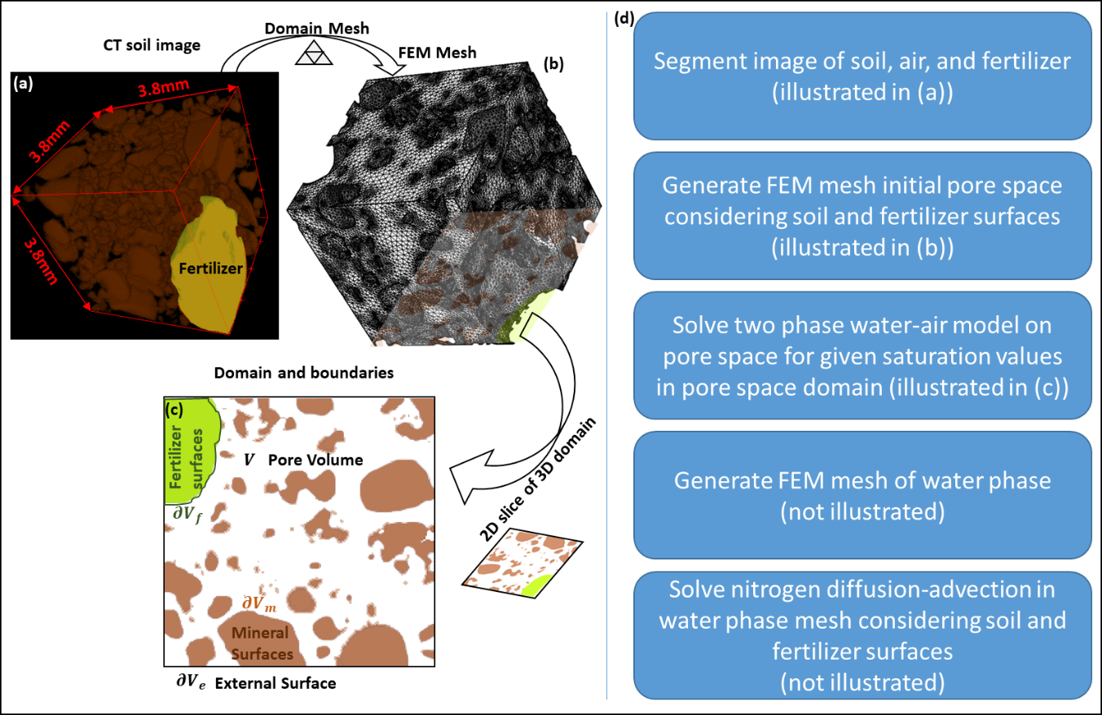
Figure 1: Pre-processing pipeline for image-based modelling. (a) A 54.9 mm³ 3D XRCT image of soil containing a fertilizer pellet is used to generate the finite element mesh (FEM) (b). The finite element mesh domain is the soil pore space. An image slice taken from the bottom of the domain (c) to illustrate the physical representation of the soil domain (d). The physical pore space domain ($V$) consists of mineral surfaces ($∂V_{m}$), external boundaries ($∂V_{e}$) and the fertilizer surface ($∂V_{f}$). (d) A flow chart details the work methodology.

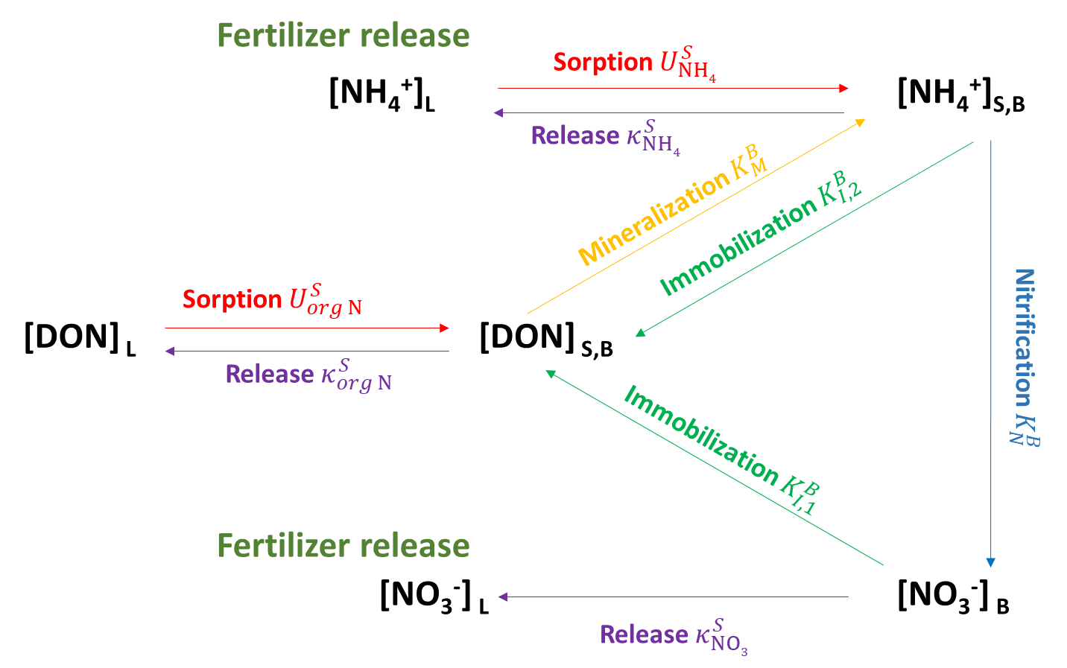
Figure 2: The pore-scale nitrogen cycle considered in the new model. The reactions are reported alongside the reaction constants involved. The $K_{l}^{B}$ constants represent the Michaelis-Menten constants for the different reactions promoted by the microbial community, i.e. nitrification ($K_{N}^{B}$), mineralization ($K_{M}^{B}$) and immobilization of nitrate ($K_{I,2}^{B}$) and ammonium ($K_{I,1}^{B}$). The constants $U_{i}^{S}$represent the sorption speed to the mineral surfaces, occurring in absence of microorganisms, and the constants $κ_{i}^{S}$represent the linear release rates from the mineral surfaces.

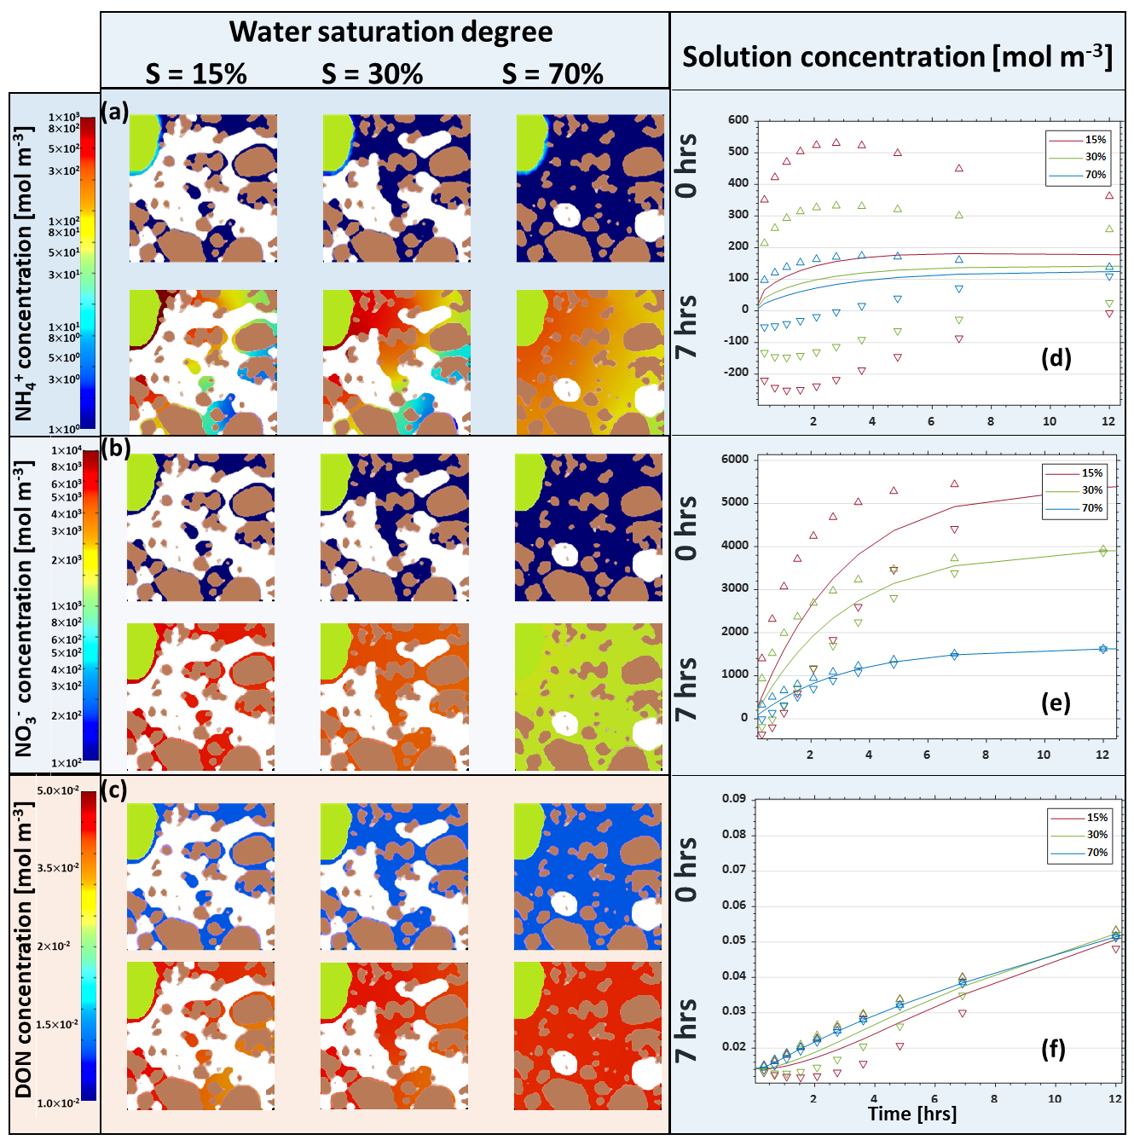
Figure 3: Nitrogen species concentrations in solution. Spatially resolved concentrations for 0 and 7 hours are plotted for water saturations of 15%, 30%, and 70% for species (a) NH₄⁺ (b) NO₃⁻, and (c) DON. Subplot area is on 3.8 mm × 3.8 mm as in Figure 1. Note that the color scale in (a) and (b) span several orders of magnitude. Associated domain averages and spatially associated standard deviations were plotted over 12 hours for (c) NH₄⁺ (d) NO₃⁻, and (e) DON. Domain averages and standard deviations are determined by the concentrations at the element nodes.

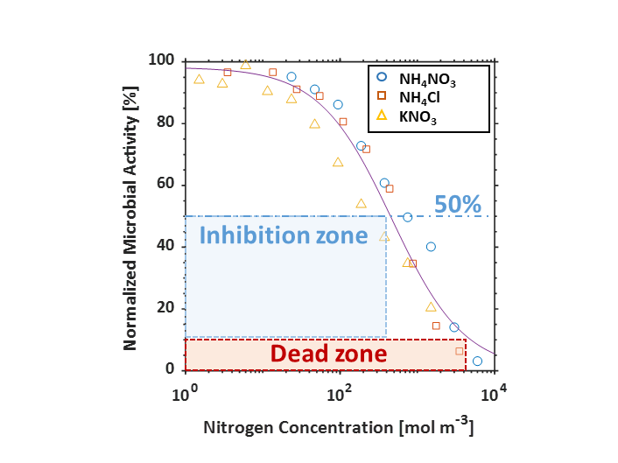
Figure 4: Relationship between fertilizer concentration and relative soil microbial activity (to the control, zero N addition) for three different N fertilizers (NH₄NO₃, NH₄Cl and KNO₃). The symbols represent the experiment values while the line represents the fit of the Hill equation to the experimental data. Regions where N concentrations reduce relative microbial activity to 50% is considered the inhibited zones. Regions where N concentrations reduce microbial activity to 10 % are considered dead zones.

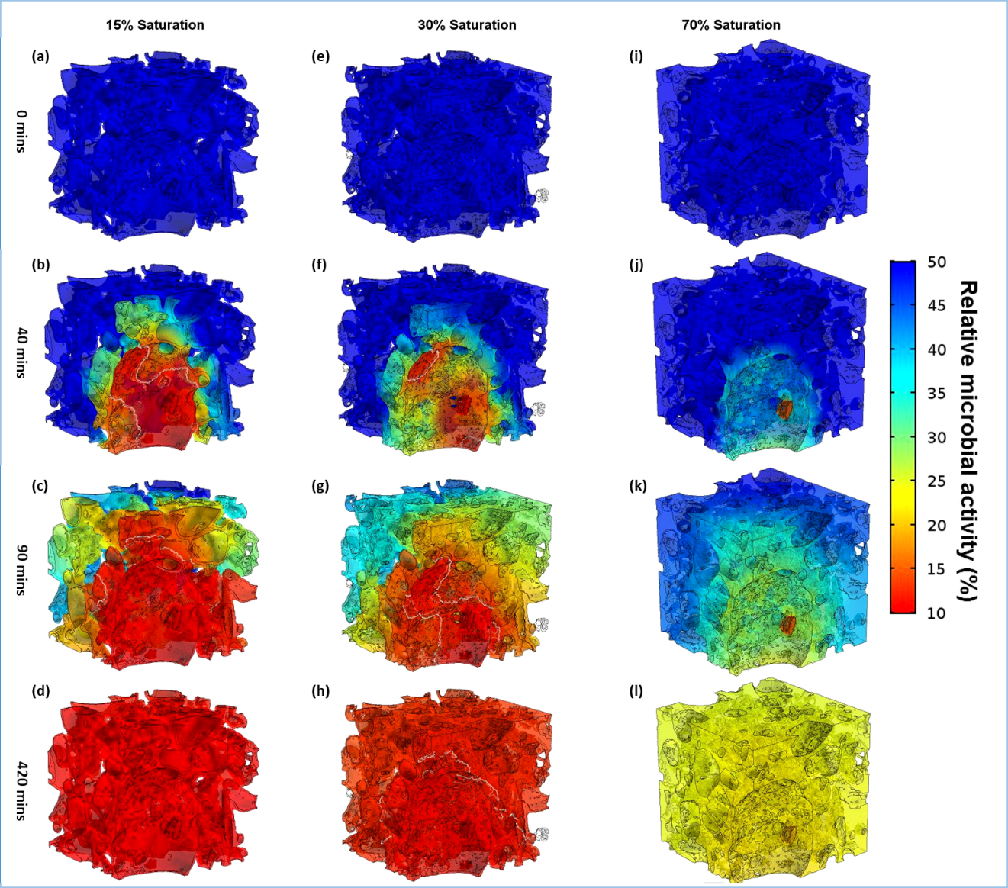
Figure 5: Evolution of microbial inhibited zones in the soil pore space dependent on time and soil water content (S). All regions below 50% activity are considered inhibited zones. White contours illustrate the evolution of the potential dead zone moving through the soil pore space. (a) S = 15%, t = 0 s; (b) S = 15%, t = 40 min; (c) S = 15%, t = 90 min; (d) S = 15%, t = 420 min; (e) S = 30%, t = 0 s; (f) S = 30%, t = 40 min; (g) S = 30%, t = 90 min; (h) S = 30%, t = 420 min; (i) S = 70%, t = 0 s; (j) S = 70%, t = 40 min; (k) S = 70%, t = 90 min; (l) S = 70%, t = 420 min. Concentrations never require contour lines highlighting the death zones for S = 70%. Alternatively, panel (d) is also absent of contours, as the entire domain has activity below 10%.

Supporting information

Two-fluid (air-water) model

Let $V$ represent the air-filled pore as extracted from the XRCT scan. The domain boundaries $∂V$ can be described as external $∂V_{e}$ or solid $∂V_{s}$ boundaries, the latter including the mineral $∂V_{m}$and the fertilizer $∂V_{f}$ boundaries Figure 1(c). The air-water interface in the soil air-filled pore space is determined with a model that has been successfully used in soil-science (Cooper et al., 2017; Daly and Roose, 2015) as well as in industrial applications (Vorobev and Boghi, 2016). Thus, the steady state two phase equation is given by:
 | $${\tilde{λ}}^{ }{\tilde{∇}}^{2}ϕ={\tilde{λ}}^{-1}\frac{∂f\left(ϕ\right)}{∂ϕ}-\frac{{\tilde{μ}}_{0}}{α\tilde{γ}}, \tilde{x}∈V_{ },$$ | (2-1)
where $ϕ$ is the phase-field variable, which is equal to 1 in pure water and equal to 0 in the air, $\tilde{μ}$ is the capillary pressure, $\tilde{γ}$ is the air-water surface tension, $\tilde{λ}$ the interface thickness of the air-water interface region, $α(=6 \sqrt{2})$ is a scaling parameter that accounts for excess free energy contributed by the interfacial thickness (Ding and Spelt, 2007), and $f\left(ϕ\right)= ϕ^{2}{(1-ϕ)}^{2}$ is the bulk energy of air and water. The phase field equation assumes non-trivial solution only at the air-water interface$(0<ϕ<1)$, where the surface tension is dominant. To categorize the bulk saturation values, we define saturation S as:
 | $$S=\frac{1}{V_{ }}\int_{V_{ }}{ϕ d\tilde{x}}.$$ | (2-2)

Two-fluid (air-water) boundary conditions

The fluid cannot penetrate the solid boundaries. Thus, a liquid-vapour interface requires a solid boundary forming a prescribed contact angle $θ$ between the liquid and vapour. In the case of water and minerals, this angle can be approximated with 0. The afore-mentioned boundary conditions can be described by the following equations:
 | $$\hat{n}⋅\tilde{∇}ϕ=\left\|\tilde{∇}ϕ\right\|cosθ, \tilde{x}∈∂V_{s},$$ | (3-1)
where θ is the air-water contact angle on the mineral surfaces. In the case of the external boundaries, we impose the condition that the air and water flow fields are periodic. Therefore,
 | $$\hat{n}⋅\tilde{∇}ϕ=0, \tilde{x}∈∂V_{e}.$$ | (3-2)
Output of this model is the pore-space geometry specific configuration of air and water at different levels of saturation. Subsequent modelling of N solute diffusion is restricted to the water phase, where $ϕ=1$. The geometry of the water phase solution was exported and meshed in order to efficiently solve the modelling described in the next section. The water mesh had $6×{10}^{-5}$ to $11×{10}^{5}$ volume elements with a typical volume element volume ratio of $0.8×{10}^{-5}$ to$5.48×{10}^{-5}$ with an average element quality of $0.5942$ to $0.65$. The number of surface elements is $3×{10}^{5}$ to $3.5×{10}^{5}$ with an element area ratio of $2.1×{10}^{-4}$ to $0.001065$ and an average element quality of $0.709$ to $0.725$.

Bulk nitrogen model

We present a simplified space-independent N model, used to determine if N dynamics can be captured without considering the pore space. Using the same notation as the previous section, N is described space-independently by the following set of equations:
 | $$\frac{d{\left[NH_{4}^{+}\right]}^{S,B}}{d\tilde{t} }=-\left(\left(\frac{V_{max}}{K_{N}^{B}+{\left[NH_{4}^{+}\right]}^{S,B}}\right)+\left(\frac{V_{max}}{K_{I,1}^{B}+{\left[NH_{4}^{+}\right]}^{S,B}}\right)+κ_{{NH}_{4}^{ }}^{S}\right){\left[NH_{4}^{+}\right]}^{S,B}+\left(\frac{V_{max}}{K_{M}^{B}+{\left[DON\right]}^{S,B}}\right){\left[DON\right]}^{S,B}+U_{{NH}_{4}^{ }}^{S}{\left[NH_{4}^{+}\right]}^{L},$$ | (4-1a)
 | $$\frac{d{\left[NO_{3}^{-}\right]}^{B}}{d\tilde{t} }=\left(\frac{V_{max}}{K_{N}^{B}+{\left[NH_{4}^{+}\right]}^{S,B}}\right){\left[NH_{4}^{+}\right]}^{S,B}-\left(\left(\frac{\frac{1}{2}V_{max}}{K_{I,2}^{B}+{\left[NO_{3}^{-}\right]}^{B}}\right)+κ_{{NO}_{3}^{ }}^{S}\right){\left[NO_{3}^{-}\right]}^{B},$$ | (4-1b)
 | $$\frac{d{\left[DON\right]}^{S,B}}{d\tilde{t} }=\left(\frac{V_{max}}{K_{I,1}^{B}+{\left[NH_{4}^{+}\right]}^{S,B}}\right){\left[NH_{4}^{+}\right]}^{S,B}+\left(\frac{\frac{1}{2}V_{max}}{K_{I,2}^{B}+{\left[NO_{3}^{-}\right]}^{B}}\right){\left[NO_{3}^{-}\right]}^{B}-\left(\left(\frac{V_{max}}{K_{M}^{B}+{\left[DON\right]}^{S,B}}\right)+κ_{org N}^{S}\right){\left[DON\right]}^{S,B}+U_{org N}^{S}{\left[DON\right]}^{L},$$ | (4-1c)
 | $$\frac{d{\left[NH_{4}^{+}\right]}^{L}}{d\tilde{t} }=R_{S}\left({-U}_{{NH}_{4}^{ }}^{S}{\left[NH_{4}^{+}\right]}^{L}+κ_{{NH}_{4}^{+}}^{S}{\left[NH_{4}^{+}\right]}^{S,B}\right)+\tilde{J_{{NH}_{4}^{ }}}\exp\left(-\frac{\tilde{t}}{\tilde{τ}}\right)R_{F},$$ | (4-1d)
 | $$\frac{d{\left[NO_{3}^{-}\right]}^{L}}{d\tilde{t} }=R_{S}(κ_{{NO}_{3}^{ }}^{S}{\left[NO_{3}^{-}\right]}^{B})+\tilde{J_{{NO}_{3}^{ }}}\exp\left(-\frac{\tilde{t}}{\tilde{τ}}\right)R_{F},$$ | (4-1e)
 | $$\frac{d{\left[DON\right]}^{L}}{d\tilde{t} }=R_{s}({-U}_{org N}^{S}{\left[DON\right]}^{L}+κ_{org N}^{S}{\left[DON\right]}^{S,B})$$ | (4-1f)
where $R_{F}$ [m⁻¹] is the ratio of the surface area of the fertiliser pellet in contact with water and the volume of the water phase; and $R_{S}$ [m⁻¹] is the ratio of the surface area of soil minerals in contact with water and the water phase volume, both calculated from the solution of the air-water model. The relative solution of the bulk model given by eq (13a-f) is compared to the averages of the image-based model in the $S=15\%$ case, where the image-based model averages are calculated in the soil solution using the following equation,
 | $$mean\left({\tilde{c}}_{i}^{L}\right)=\frac{1}{|\left|V_{w}\right||}\int_{V_{w}}{({{\tilde{c}}_{i}^{L}}})d\tilde{x},$$ | (4-2)
and on the mineral surfaces in contact with the soil mineral surface solution using
 | $$mean\left({\tilde{c}}_{i}^{S,B}\right)=\frac{1}{|\left|{∂V}_{m}∩∂V_{w}\right||}\int_{{∂V}_{m}∩∂V_{w}}{({\tilde{c}}_{i}^{S,B}})d\tilde{x}.$$ | (4-3)

SI Results

Two-Fluid solutions

The location of the planes used to visualise the simulation results to the 3D soil pore space water configuration are shown in Figure SI.B1-1. The saturation has been obtained by varying the reference capillary pressure ${\tilde{μ}}_{0}$ ; the air and water domain results are similar to (Daly et al., 2017; Daly et al., 2018). In Figure SI.B1-2 to Figure SI.B1-3), we show the phase field $ϕ$ at different water saturation percentages.

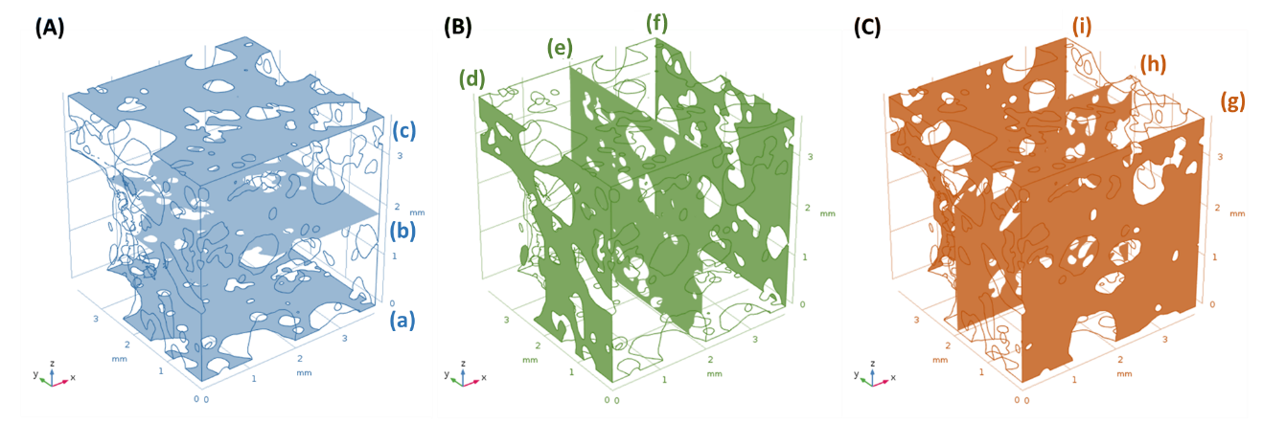
Figure SI.B1-1: The locations of the nine representative planes used to display the solution of the two-fluid model. (A) shows XY planes designated with blue subscripts (a)-(c), (B) shows YZ planes designated with green subscripts (d)-(e), and (C) shows the XZ planes designated with orange subscripts (g)-(i). Sub planes labelled (a)-(i) are consistent with Figure (4) to Figure (6) in main text.

Figure SI.B1-2 illustrates the water phase field at 70% saturation on the representative planes. Few air pockets, with the diameter of 1-2 mm, can be seen in the domain. The air pocket shape is irregular due to the tortuous, 3D geometry of the soil minerals. It is interesting to note that in proximity of the mineral particles, the air pockets are stretched parallel to the mineral surface. In the present study, we assumed θ = 0, meaning that the minerals particle surfaces are fully wetted, which is a reasonable approximation (Nye and Tinker, 1977).
In Figure SI.B1-3, the phase field at S = 30 % is shown. The scenario is radically different compared to S =70 % (Figure SI.B1-2). Air occupies most of the domain, and the water phase exhibits two morphological configurations. The first is constituted by isolated patches of water, wetting groups of mineral particles in the middle of air pockets, while the second is represented by networks, where patches of water, wetting mineral islets, are connected through water bridges. The latter morphological structure requires more water and it is therefore more dominant at higher saturation values.
In Figure SI.B1-4, the phase field at S = 15% is shown. The solution is similar to the S = 30% case (Figure SI.B1-3), but in this case the isolated water patches are more prevalent. The network of water bridges is still present, but it connects fewer mineral particles. Furthermore, the thickness of the water film, surrounding the mineral particles is reduced.

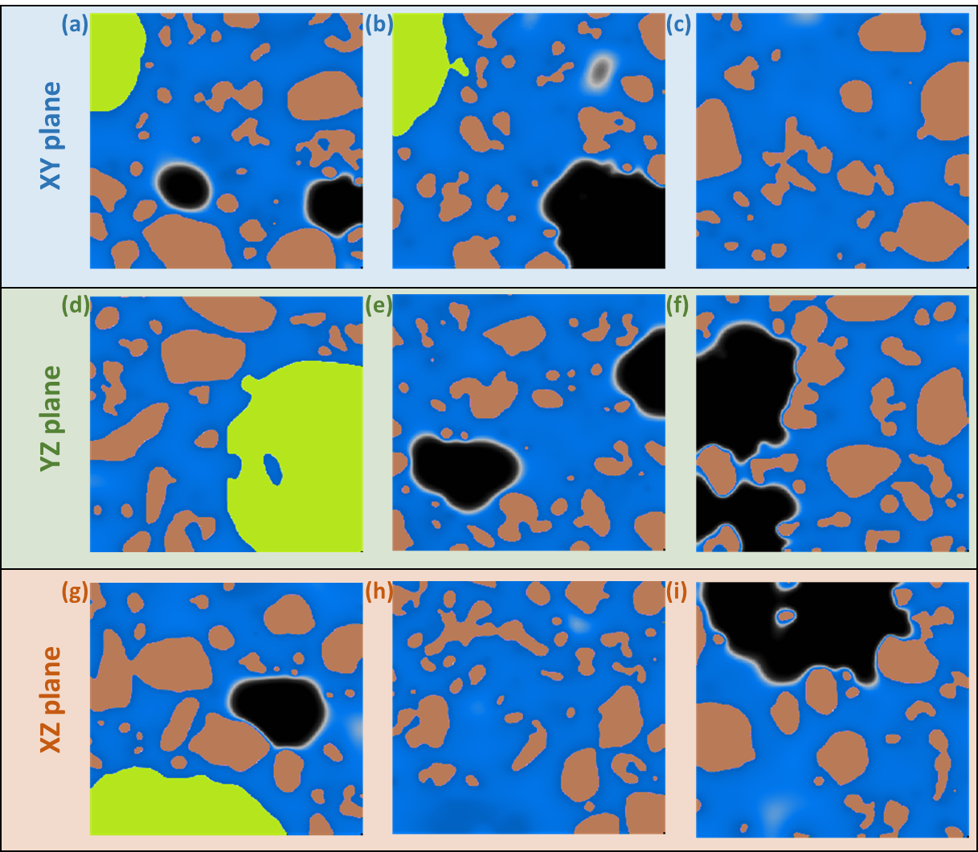
Figure SI.B1-2: Phase field at S = 70%. Blue = water; black = air; brown = minerals; green = fertilizer pellet. Subplot area: 3.8 mm × 3.8 mm. (a) XY plane, ΔZ = 0 mm; (b) XY plane, ΔZ = 1.9 mm; (c) XY plane, ΔZ = 3.8 mm; (d) YZ plane, ΔX = 0 mm; (e) YZ plane, ΔX = 1.9 mm; (f) YZ plane, ΔX = 3.8 mm; (g) XZ plane, ΔY = 0 mm; (h) XZ plane, ΔY = 1.9 mm; (i) XZ plane, ΔY = 3.8 mm.

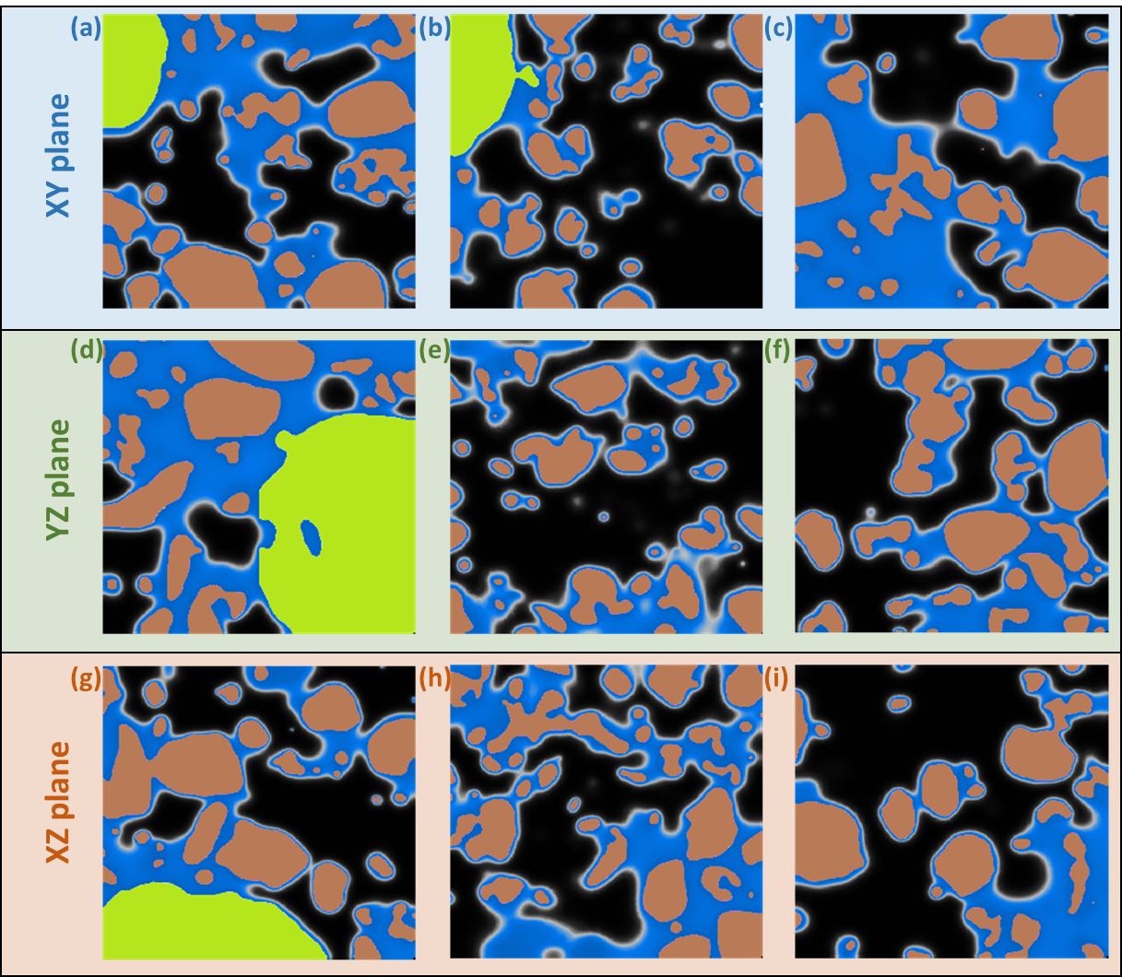
Figure SI.B1-3: Phase field at S = 30%. Blue = water; black = air; brown = minerals; green = fertilizer pellet. Subplot area: 3.8 mm × 3.8 mm. (a) XY plane, ΔZ = 0 mm; (b) XY plane, ΔZ = 1.9 mm; (c) XY plane, ΔZ = 3.8 mm; (d) YZ plane, ΔX = 0 mm; (e) YZ plane, ΔX = 1.9 mm; (f) YZ plane, ΔX = 3.8 mm; (g) XZ plane, ΔY = 0 mm; (h) XZ plane, ΔY = 1.9 mm; (i) XZ plane, ΔY = 3.8 mm.

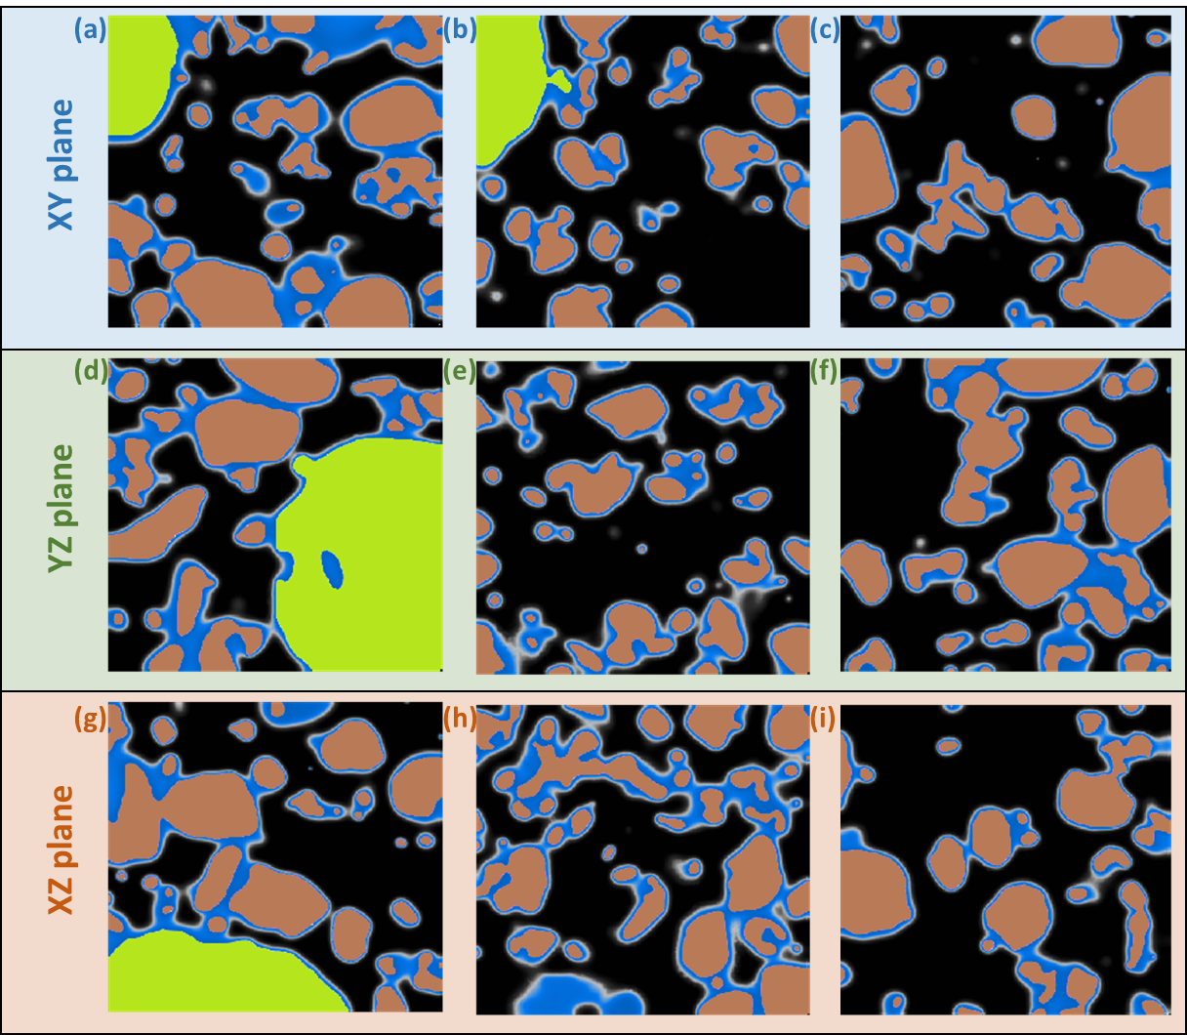
Figure SI.B1-4: Phase field at S = 15%. Blue = water; black = air; brown = minerals; green = fertilizer pellet. Subplot area: 3.8 mm × 3.8 mm. (a) XY plane, ΔZ = 0mm; (b) XY plane, ΔZ = 1.9 mm; (c) XY plane, ΔZ = 3.8 mm; (d) YZ plane, ΔX = 0 mm; (e) YZ plane, ΔX = 1.9 mm; (f) YZ plane, ΔX = 3.8 mm; (g) XZ plane, ΔY = 0 mm; (h) XZ plane, ΔY = 1.9 mm; (i) XZ plane, ΔY = 3.8 mm.

Bulk N model comparison

The simplified model is compared to the averages of the image-based model in the $S=15\%$ case, Figure SI.B2-1. The simplified ordinary differential equation model (given by eqs (13a-13f) approximates the averages of the imaged-based model well (<1% error) for all the N species in soil solution and on mineral surfaces (Figure SI.B2-1). Although the average values are consistent between the averaged model and the image based model, the spatial variability cannot be captured by the averaged model.

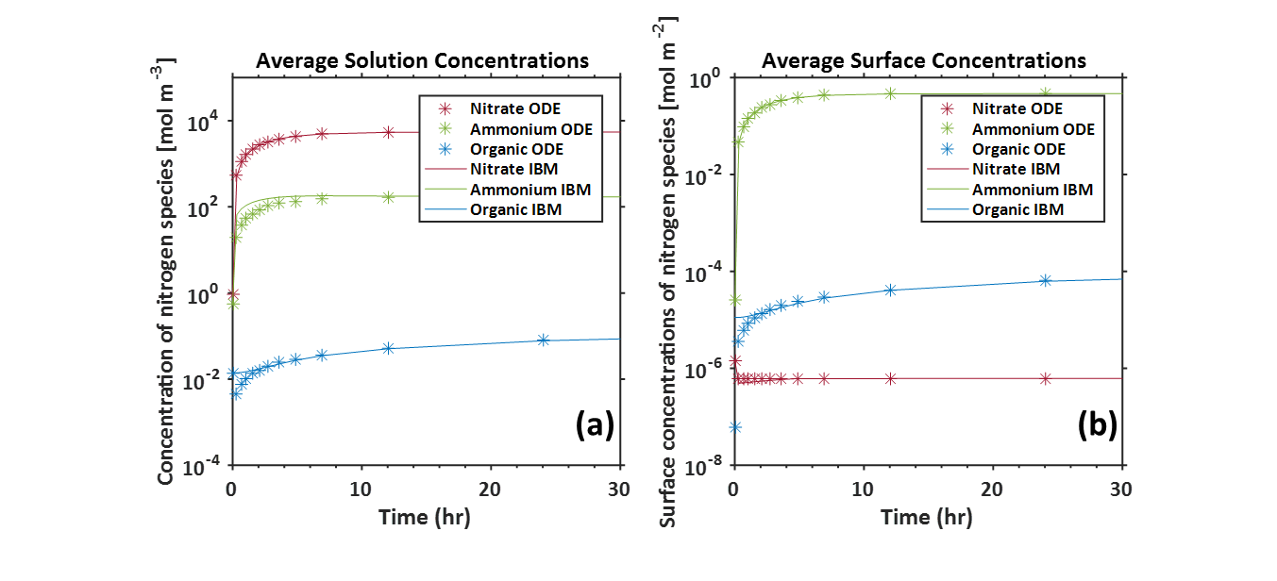
Figure SI.B2-1: Comparison of the average image-based model solution with the simplified N model solution for (a) in the soil solution and (b) on the soil surfaces, for the $S=15\%$ case. The averages for the image-based model in (a) are calculated as $\frac{1}{|\left|V_{w}\right||}\int_{V_{w}}{{\tilde{c}}_{i}^{L}}d\tilde{x}$ and in (b) the average on the minerals in contact with the water, $\frac{1}{|\left|{∂V}_{m}∩∂V_{w}\right||}\int_{{∂V}_{m}∩∂V_{w}}{{\tilde{c}}_{i}^{S,B}}d\tilde{x}$.

Figure SI.B2-2 shows the average of the image-based model of the N species in solution and on the mineral surfaces for each of the saturation scenarios. The top/bottom markers show the standard deviation of the concentrations in the soil solution or mineral surfaces. For NO₃⁻ in solution (Figure SI.B2-2 a), the standard deviation from the mean values are greatest for the first 10 hours of the simulation for the 15% and 30% simulations and almost negligible for the 70% simulation. For the 15% saturation case, results for the first 5 hours could have a standard deviation as large as the mean value. Similar trends could be shown for the surface bound NO₃⁻ (Figure SI.B2-2 b). However, the surface bound nitrogen appears to quickly transform into other forms of nitrogen. Ammonium both in solution (Figure SI.B2-2 c) and on the surfaces (Figure SI.B2-2 d) appear to have the largest standard deviations from the mean than any of the other modelled species. The deviation from the mean appears persistent throughout time, suggesting that averaged models may fail to adequately characterize pore scale NH₄⁺ dynamics. Similar to what was modelled in the profiles, DON in solution or bound to surfaces (Figure SI.B2-2 e-f) appear to have very similar averaged behaviours despite the saturation degree. However, at lower saturations (15% and 30%), we see more pronounced standard deviations within the first 10 hours (similar to the NO₃⁻).
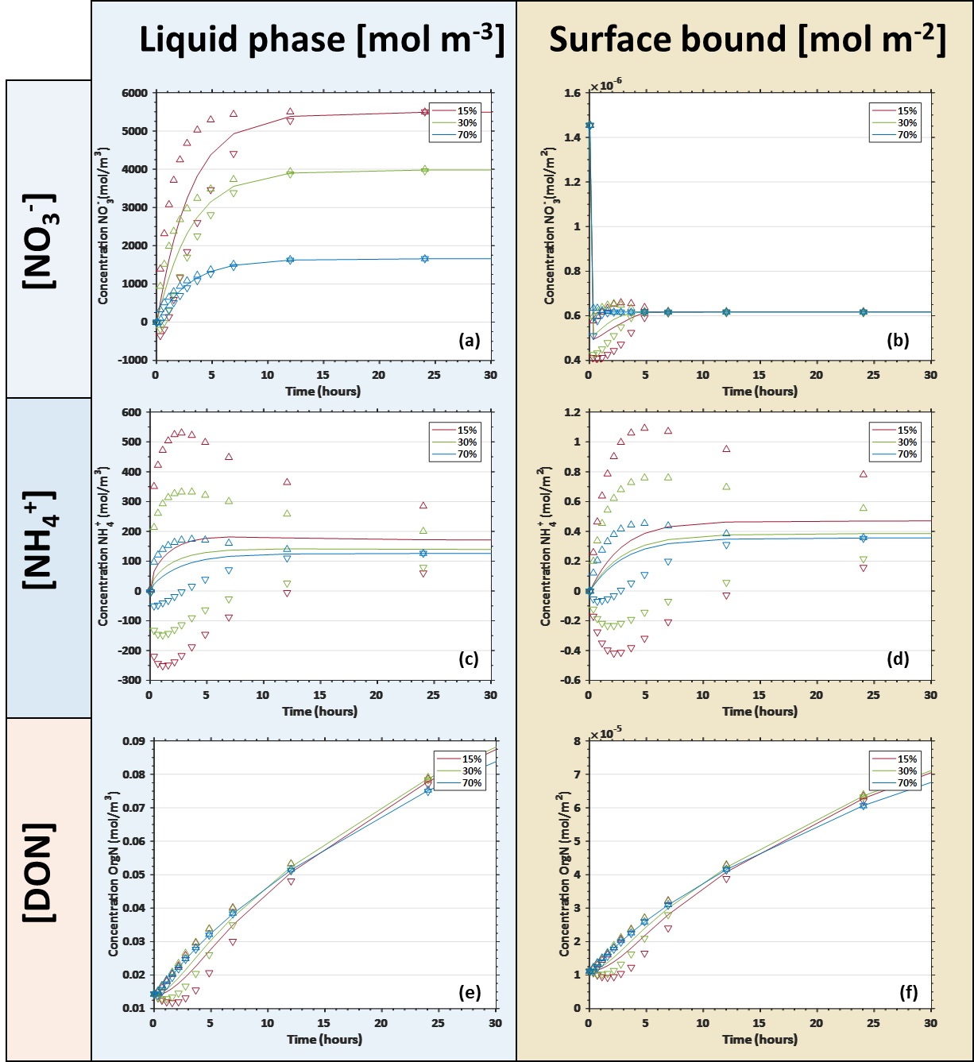
Figure SI.B2-2: Spatial averages and standard deviations of concentrations for each N species in solution and on mineral surfaces from the image-based model: (a) NO₃⁻ in solution; (b) NO₃⁻ on mineral surfaces; (c) NH₄⁺ in solution; (d) NH₄⁺ on mineral surfaces; (e) DON in solution and (f) DON on mineral surfaces. The top/bottom markers shows the range of one standard deviation of the concentrations attained in the soil solution or mineral surfaces. Spatially averaged concentrations consider values at each element node.

