Tracking forest biophysical properties with automated digital repeat photography: a fisheye perspective using digital hemispherical photography from below the canopy
Luke A. Brown¹*, Booker O. Ogutu¹ and Jadunandan Dash¹
¹School of Geography and Environmental Science, University of Southampton, Highfield, Southampton, SO17 1BJ, United Kingdom

Abstract
In recent years, digital repeat photography has received increasing attention as an inexpensive means by which seasonal changes in vegetation canopies can be monitored. Offering automation and an increased measurement frequency, colour indices derived from above-canopy digital repeat photography have proven a popular alternative to traditional observations of forest phenology. Nevertheless, previous work has demonstrated several features in time-series of colour indices that are unrelated to canopy structure, limiting their utility to track specific biophysical properties such as leaf area index (LAI). Whilst techniques such as digital cover photography and the use of radiometric sensors are better suited to this task, they are restricted by the need for careful calibration of above- and below-canopy reference sensors, ancillary information on canopy leaf angle distribution, and smaller measurement footprints. Using data collected at a deciduous broadleaf forest site in Southern England, we investigated a new method to derive continuous measurements of LAI, making use of automated digital hemispherical photography (DHP) from below the canopy. After applying simple data screening procedures, the LAI observations derived from our automated DHP system demonstrated very close agreement with those obtained from manually acquired DHP images, which were collected under optimal illumination conditions over the surrounding forest plot (r² = 0.99, RMSE = 0.20, NRMSE = 13%). By combining our automated DHP system with an above-canopy time-lapse digital camera, we then investigated the relationship between the green chromatic coordinate (GCC) and LAI. Distinct hysteresis effects were observed, as were substantial differences between phenological transition dates derived from the GCC and LAI, particularly in the case of the onset of senescence. Our results indicate that phenological transition dates derived from colour indices cannot easily be linked to any one biophysical property. We recommend further investigation of the automated DHP approach, which provides time-series of LAI whose physical interpretation is straightforward, as an alternative to above-canopy digital repeat photography.

Keywords
Digital hemispherical photography; digital repeat photography; green chromatic coordinate; leaf area index; PhenoCam

*Corresponding author: l.a.brown@soton.ac.uk
1. Introduction
Forests cover approximately 30% of the Earth’s land surface (FAO, 2015). They are a major carbon sink, and account for approximately 50% of terrestrial gross primary productivity (Beer et al., 2010). Monitoring forest biophysical properties such as leaf area index (LAI), which determines light interception and the size of the interface between the biosphere and atmosphere, is crucial in understanding drivers of carbon fixation, responses to climate change, and feedbacks to the climate system (Richardson et al., 2013; Sellers et al., 1997). Unfortunately, the in situ measurement of biophysical variables such as LAI is a time-consuming and laborious process, and whilst advances in non-destructive, indirect techniques have been made (Bréda, 2003; Jonckheere et al., 2004; Weiss et al., 2004), in situ measurements are still restricted by resource constraints. Because in situ measurements typically involve spatial replicate sampling, they are able to capture variability at the plot (and site) scale useful to forest managers and ecologists, but their periodic nature means they cannot adequately characterise temporal dynamics. Improved information on these dynamics is required by models of vegetation productivity, biosphere-atmosphere interactions, and the surface energy balance. Therefore, there is a clear need to develop cost-effective techniques for the continuous monitoring of forest biophysical properties over time.
In recent years, digital repeat photography has received increasing attention as an inexpensive form of near-surface remote sensing by which seasonal changes in vegetation canopies can be monitored. The term digital repeat photography refers to several techniques, including the use of above-canopy digital cameras with an oblique field-of-view (FOV) to characterise canopy colour (hereafter referred to as above-canopy digital repeat photography), and more recently, the use of below-canopy digital cameras facing upwards to estimate canopy cover (hereafter referred to as digital cover photography). These techniques make use of standard or wide-angle lenses, providing a FOV of approximately 30° to 60° (Chianucci and Cutini, 2013; Pekin and Macfarlane, 2009; Richardson et al., 2007).
From time-series of images acquired using above-canopy digital repeat photography, colour indices can be extracted, enabling seasonal changes in greenness to be captured (Richardson et al., 2009, 2007; Sonnentag et al., 2012). The technique has proven a popular alternative to traditional observations of forest phenology, enabling phenological transition dates to be determined from the time-series as opposed to manual observations of events such as bud-burst and leaf opening. The largest initiative, the PhenoCam network, currently incorporates 616 sites (mostly based in North America) equipped with digital time-lapse cameras (Richardson et al., 2018a). Other notable networks include the European Phenology Network (Wingate et al., 2015), and the Phenological Eyes Network (Nagai et al., 2018). Above-canopy digital repeat photography is particularly promising in the context of validating satellite-derived land surface phenology products, as its wide FOV (i.e. 60°) provides an increased measurement footprint when compared to traditional observations of individual trees, helping to overcome spatial scaling issues (Hufkens et al., 2012; Richardson et al., 2009, 2007). Using above-canopy digital repeat photography, several studies have evaluated the quality of satellite-derived phenological transition dates, including those from the Advanced Very High Resolution Radiometer (AVHRR), Moderate Resolution Imaging Spectroradiometer (MODIS), Operational Land Imager (OLI) and Visible and Infrared Radiometer Suite (VIIRS) (Baumann et al., 2017; Hufkens et al., 2012; Klosterman et al., 2014; Liu et al., 2017; Melaas et al., 2016; Richardson et al., 2018b; Zhang et al., 2018).
Nevertheless, in addition to phenological transition dates, there is a need to monitor specific biophysical variables such as LAI and provide improved information on their temporal dynamics. Above-canopy digital repeat photography is not optimised for this task. Previous analysis has indicated that over deciduous broadleaf forest, time-series of colour indices derived from above-canopy digital repeat photography incorporate several features unrelated to canopy structure. These include a spring peak, which is caused by the non-linear relationship between greenness and leaf chlorophyll concentration (Wingate et al., 2015), a summer decline, which appears to be related to increases in brown pigments and seasonal changes in solar illumination geometry (Brown et al., 2017), and saturation of the greenness signal at an LAI of approximately 2 to 2.5 (Keenan et al., 2014; Wingate et al., 2015). In addition, colour indices derived from above-canopy digital repeat photography represent a relative radiometric quantity, confounding physical interpretation were they to be used to derive biophysical properties, and preventing direct comparison between sites (Sonnentag et al., 2012).
In light of the limitations of above-canopy digital repeat photography, it is worth noting that several alternative approaches to the continuous monitoring of forest biophysical properties have been investigated. For monitoring LAI, these have included automated digital cover photography (Ryu et al., 2014, 2012; Toda and Richardson, 2017) and the use of radiometric sensors to estimate transmittance (Brede et al., 2018; Qu et al., 2014; Ryu et al., 2014; Toda and Richardson, 2017). Despite their potential, several challenges are yet to be resolved. In the case of the radiometric methods, careful calibration is required to ensure that pairs of above- and below-canopy sensors can be used to derive accurate measurements of transmittance, whilst variable and/or direct illumination can lead to substantial artefacts (Fang et al., 2018; Qu et al., 2014). In the case of digital cover photography (and several of the radiometric approaches), there is a need to specify the canopy leaf angle distribution, which is challenging to determine directly due to limited angular sampling. For this reason, a spherical leaf angle distribution is typically assumed (Chianucci and Cutini, 2013; Macfarlane et al., 2007b, 2007a; Toda and Richardson, 2017). Nevertheless, Pisek et al. (2013) found this assumption to be valid for only five out of fifty-eight investigated broadleaf species, and so if robust estimates of LAI are to be obtained using digital cover photography, ancillary data on the leaf angle distribution of the canopy in question are required (Ryu et al., 2014, 2012, 2010b). Finally, issues related to the spatial representativeness of LAI estimates derived using digital cover photography result from its narrow FOV (Ryu et al., 2012, 2010b; Toda and Richardson, 2017).
In this study, we investigate a new method to derive continuous measurements of LAI, making use of automated digital hemispherical photography (DHP) from below the canopy. Unlike the previously described methods, DHP relies on the use of a fisheye lens to provide increased angular sampling, and can be used to estimate canopy leaf angle distribution, removing the requirement for ancillary information. It also avoids the need for above-canopy sensors, whilst its wide FOV (up to 180°) provides a substantial measurement footprint. When compared to other techniques such as ceptometry and the LI-COR LAI-2000 instrument, Garrigues et al. (2008) suggested DHP was the most robust and least sensitive to illumination conditions. Importantly, advances in processing DHP images with minimal user involvement have been made in recent years (Jonckheere et al., 2005; Macfarlane et al., 2014; Pueschel et al., 2012). Using thirteen months of data collected at Wytham Woods, a deciduous broadleaf forest site in Southern England, we assess the ability of automated DHP acquisition and data processing methods to track forest LAI. We then compare the technique with above-canopy digital repeat photography using colour indices. In doing so, we attempt to answer the following questions:
- Can robust estimates of LAI be derived from continuous time-series of automated DHP images?
- How are colour indices derived using above-canopy digital repeat photography related to LAI?
- Are there substantial differences between phenological transition dates derived from time-series of LAI and colour indices?

2. Materials and methods
2.1. Study site
The study took place at Wytham Woods (51.7734° N, 1.3384° W), an established 400 ha research forest comprised of ancient semi-natural woodland in Oxfordshire, United Kingdom (UK) (Figure 1). The site is characterised by clay soils, whilst the primary species are sycamore (Acer pseudoplatanus), ash (Fraxinus excelsoir), and hazel (Corylus avellana). Managed by the University of Oxford, the site forms part of the UK Environmental Change Network (ECN), and features an 18 ha long-term monitoring area associated with the Forest Global Earth Observatory (ForestGEO) network of inventory sites. Within the south-west corner of the 18 ha monitoring area, a canopy walkway provides access to the top of the tree crowns. The dominant species surrounding the canopy walkway are sycamore (Acer pseudoplatanus), oak (Quercus robcur), and beech (Fagus sylvatica). Previous studies at the site have carried out detailed characterisation of canopy structure during leaf-on and leaf-off conditions, using terrestrial laser scanning (TLS), DHP, and LI-COR LAI-2200 measurements (Calders et al., 2018a, 2018b; Origo et al., 2017).
2.2. Deploying time-lapse digital cameras
In April 2018, two Harbortronics Cyclapse time-lapse digital camera systems were deployed on the canopy walkway. Both consisted of a waterproof housing containing a Harbortronics DigiSnap Pro intervalometer and full-frame Canon EOS 6D digital single lens reflex (DSLR) camera. Each was powered by a 14.8 V 6.2 Ah lithium-ion battery and 10 W photovoltaic panel. The first system, which was used for DHP, was mounted below the canopy at approximately 2 m above the ground, facing directly upwards (Figure 1). The housing was fitted with an acrylic dome, whilst the camera was equipped with a Sigma 8 mm F3.5 EX DG fisheye lens. The second system, which was used for deriving colour indices, was mounted at the top of the walkway at approximately 15 m above the ground, facing north north-west at an angle just below horizontal (Richardson et al., 2009; Sonnentag et al., 2012) (Figure 1). In this case, the camera was equipped with a Canon 28-135 mm F3.5-5.6 IS USM lens, which was set to its minimum focal length. To prevent the build-up of internal condensation, a bag of silica gel desiccant was placed within each housing.
The location of the cameras was designed to maximise their common FOV. Both were configured to acquire raw images (CR2 format) every 30 minutes between 05:00 and 21:00 local time, providing a total of thirty-four images per day. Following the recommendations of Macfarlane et al. (2014), the below-canopy camera was set to underexpose images by one stop relative to automatic exposure. In the case of the above-canopy camera, a fixed white balance setting of ‘daylight’ was selected, according to the recommendations of Richardson et al. (2009). Because of its upward facing nature, it was assumed that the below-canopy camera was more likely to require periodic cleaning. For this reason, it was equipped with a cellular modem, enabling the transmission of images via file transfer protocol (FTP) to enable its condition to be monitored remotely. In practice, little to no cleaning was required throughout the study period.
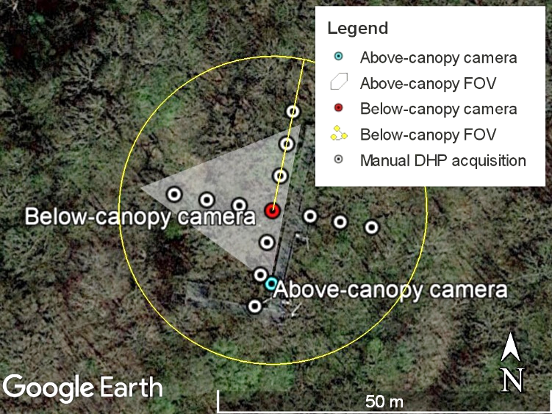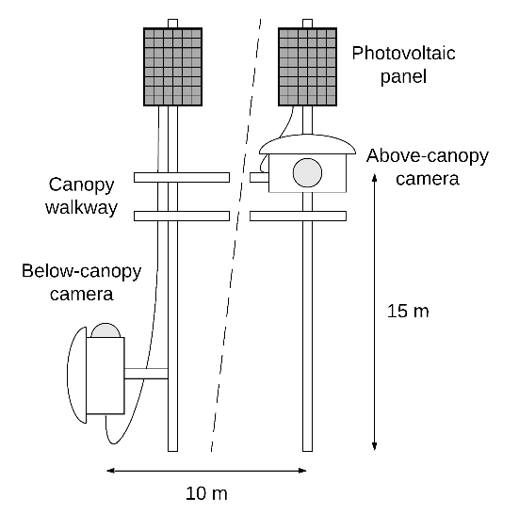
(a) (b)
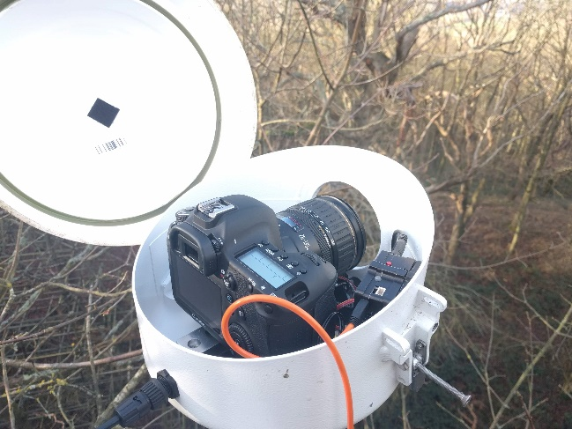 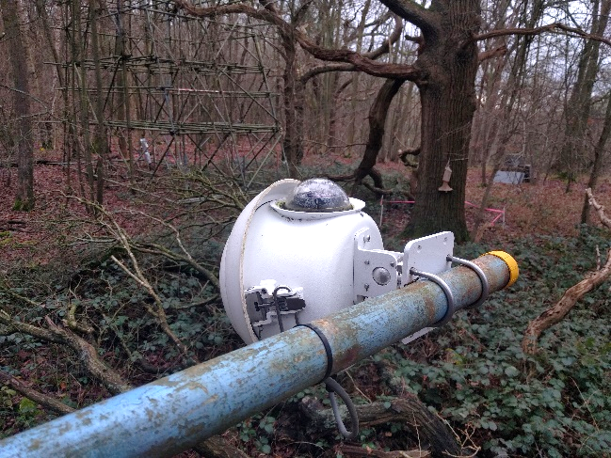
(c) (d)
Figure 1: Plan view of the experimental setup (a), schematic diagram of the installation (not to scale) (b), and images of the above- (c) and below-canopy cameras (d). Note that whilst part of the below-canopy camera’s FOV is obstructed by the lid of the housing, this portion of the image ($θ$ > 60°) is not analysed (Section 2.3).
2.3. Deriving time-series of LAI and colour indices
Before analysis, raw images were pre-processed in order to avoid internal processing by the camera firmware, which has been shown to increase sensitivity to photographic exposure. As recommended by Macfarlane et al. (2014), we performed gamma correction and contrast stretching to saturate 1% of pixels at the high and low ends of the histogram, before storing the result in 8-bit form for further analysis.
To calculate LAI from each below-canopy image, pixels were first classified as belonging to the sky or vegetation canopy, enabling the gap fraction to be calculated. We adopted Ridler and Calvard's (1978) clustering algorithm to objectively classify each image without user involvement. When compared to thirty-four alternative unsupervised classification algorithms over a range of canopy conditions, Jonckheere et al. (2005) concluded that Ridler and Calvard's (1978) method provided the most accurate estimates of gap fraction. To minimise the effects of chromatic aberration and multiple scattering within the canopy, we restricted analysis to the blue band (Leblanc et al., 2005; Macfarlane et al., 2014, 2007a; Zhang et al., 2005).
Once classified, each image was divided into six zenith rings, and each zenith ring was divided into a further thirty-six azimuth cells. Zenith angles greater than 60º were not analysed due to the increased occurrence of mixed pixels at the extremes of the image (Jonckheere et al., 2004; Weiss and Baret, 2017). From the estimates of gap fraction in each ring and cell, plant area index (PAI) was derived as a discretisation of Miller's (1967) integral, accounting for the effects of foliage clumping using the method of Lang and Yueqin (1986), such that
$$PAI=2\sum_{i=1}^{6}{-\overline{\ln{P\left(θ_{i}\right)}}\cos{θ_{i} w_{i}}}$$
where $P\left(θ_{i}\right)$ is the gap fraction in ring $i$, $θ_{i}$ is its central zenith angle, and $w_{i}$ is the weight associated with each ring. Weights were calculated to sum to one accounting for the restricted range of sampled zenith angles, such that
$$w_{i}=\frac{\sin{θ_{i}d{θ_{i}}}}{\sum_{i=1}^{6}{\sin{θ_{i}d{θ_{i}}}}}$$
(LI-COR, 2013). Unlike in the LAI-2000 (Welles and Norman, 1991), the last ring was not weighted as if it extended down to the horizon, as Leblanc and Chen (2001) suggest this leads to underestimation of PAI. PAI values were converted to LAI by subtracting wood area index (WAI), which was estimated as the mean PAI observed during leaf-off conditions (Toda and Richardson, 2017) (defined here as December to March, PAI = 1.35). This also enabled the contribution of the canopy walkway, which could not be distinguished from the forest canopy by the classification, to be accounted for.
To derive colour indices from the above-canopy images, a region-of-interest (ROI) was defined to exclude non-canopy features within the camera’s FOV, such as the sky. Within this ROI, we calculated the green chromatic coordinate (GCC), which is a widely used measure of canopy greenness in above-canopy digital repeat photography (Keenan et al., 2014; Richardson et al., 2009, 2007; Sonnentag et al., 2012; Toomey et al., 2015). The GCC was calculated as
$$GCC= \frac{{DN}_{green}}{{DN}_{red}+{DN}_{green}+{DN}_{blue}}$$
where ${DN}_{red}$, ${DN}_{green}$, and ${DN}_{blue}$ are mean digital number values in the red, green, and blue bands of the image, respectively.
Once LAI and the GCC were calculated, data screening was carried out to remove spurious values and supress noise. In the case of digital cover photography, current approaches to screen poor quality images are not well established, with some studies relying on manual inspection (Toda and Richardson, 2017). Ryu et al. (2012) were able to automatically identify images with water droplets on the camera housing by their smaller file size (presumably due to the use of lossy compression). Because we recorded raw images with no compression, we could not apply this method to our data, as no appreciable difference in file size was observed between images. Instead, we implemented an alternative data screening approach. This was based on the observation that most sources of noise (including water droplets on the camera housing, overexposure, and suboptimal illumination conditions) were negatively biased (i.e. they led to a reduction in derived values). As such, the upper envelope of the data could be considered to represent the best quality observations. To exploit this fact, the maximum LAI and GCC values were selected from the thirty-four available observations in each day, providing a time-series with daily temporal resolution. To assess the ability of the data screening method to supress high frequency noise, a lag = 1 autocorrelation analysis was carried out on both the screened and unscreened time-series.
2.4. Benchmarking automated LAI data against manual DHP acquisitions
Additional field data collection was carried out in the vicinity of the canopy walkway to assess the robustness of the automated data processing and screening methods described in Section 2.3. This involved the manual acquisition of optimal, user-operated DHP images, which were collected on fourteen dates under best-case illumination conditions (i.e. uniform overcast skies or close to sunrise/sunset) (Bréda, 2003; Chianucci and Cutini, 2012; Jonckheere et al., 2004). In this case, images were acquired using a Nikon Coolpix 4500 digital camera equipped with an FC-E8 fisheye lens, which was stabilised using a monopod and bubble level. Thirteen images were acquired within the surrounding 40 m x 40 m area on each date. Based on the recommendations of Majasalmi et al. (2012), a cross-based sampling scheme similar to that proposed in the Validation of European Land Remote Sensing Instruments (VALERI) project (Baret et al., 2005) was adopted (Figure 1). Images were processed to derive LAI as described in Section 2.3. As a means of verifying the processing method, estimates of PAI were also compared with those derived according to Warren-Wilson (1963) (i.e. making use of the gap fraction in the hinge region surrounding 57.5° only) (Appendix A). When model assumptions are met, the two estimates should demonstrate close agreement (Canisius et al., 2010; Leblanc and Chen, 2001).
Agreement between screened and manually acquired observations was assessed using the coefficient of determination (r²) and root mean square error (RMSE). A normalised RMSE (NRMSE) was calculated by dividing the RMSE by the mean of the optimally acquired observations, whilst bias and precision were quantified as the mean and standard deviation of differences, respectively.
2.5. Deriving phenological transition dates and evaluating their consistency
To derive phenological transition dates from the data provided by the digital time-lapse systems, double logistic functions were fit to the associated time-series of LAI and the GCC. The double logistic function is widely used to represent forest phenology (Atkinson et al., 2012; Beck et al., 2006; Richardson et al., 2009; Zhang et al., 2003), and takes the form
$$g\left(x\right)=a+\frac{b}{\left[1+\exp\left(c-dx\right)\right] \left[1+\exp\left(e-fx\right)\right]}$$
where $g\left(x\right)$ is the LAI or GCC value at a given date, $a$ is the base level, $b$ is the seasonal amplitude, $c$ and $d$ control the timing and rate of the start of season, and $e$ and $f$ control the timing and rate of the end of season. Once fit, the onset of greenness was determined as the date at which the ascending limb reached 50% of the seasonal amplitude, whilst the onset of senescence was determined when the descending limb reached 50% of the seasonal amplitude (Bater et al., 2011; Coops et al., 2012; Melaas et al., 2016; Nijland et al., 2016). To account for the fact that annual time-series of colour indices often demonstrate asymmetry, transition dates were also calculated using the modified double logistic function proposed by Elmore et al. (2012), which introduces an additional term to account for summer decline. Transition dates were calculated using the double logistic and modified double logistic functions for both LAI and the GCC, enabling us to evaluate their sensitivity to the choice of function in the case of each variable.

3. Results
3.1. Time-series of LAI and the GCC
At a temporal resolution of 30 minutes (between 05:00 and 21:00 local time), the unscreened data were subject to a considerable degree of noise, which was expressed as high frequency variation in LAI and GCC values unrelated to changes in forest biophysical properties (Figures 2a and 3a). Within a given day, a difference between minimum and maximum LAI values of up to 3.73 could be observed, although the mean difference was 1.26 (Figure 2a). In the case of the GCC, the greatest difference between minimum and maximum values in a given day was 0.08, whilst the mean difference was 0.03 (Figure 3a). The screened data, which represented daily maximum LAI and GCC values, were characterised by greatly reduced variability and more plausible temporal sequences (Figures 2a and 3a). For LAI, the smoother nature of the screened data was reflected by increased lag = 1 autocorrelation (Table 1).
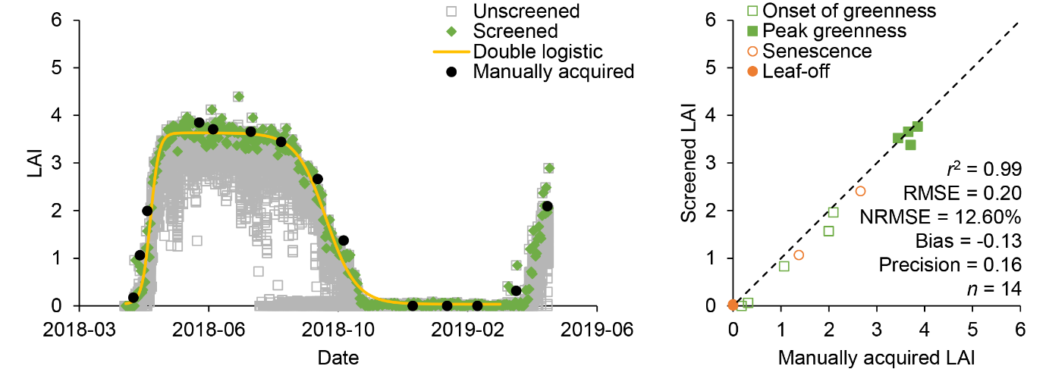
(a) (b)
Figure 2: LAI values throughout the study period (a), in addition to the relationship between screened LAI values and LAI derived from DHP images manually acquired within the surrounding 40 m x 40 m area under optimal illumination conditions (b).
Table 1: Lag = 1 autocorrelation of screened and unscreened LAI and GCC time-series.
Time-series | LAI | GCC
Screened | 0.99 | 0.98
Unscreened | 0.97 | 0.98
The time-series of the GCC was characterised by pronounced asymmetry (Figure 3a). A spring peak was observed in the middle of May (GCC = 0.52), whilst a subsequent decline in GCC values occurred over the summer, between the start of June and the end of October (GCC = 0.47 to 0.40). In contrast, the time-series of LAI was characterised by increased symmetry, demonstrating comparative stability during peak greenness over the course of the summer months (Figure 2a). For LAI, the onset of greenness was approximately 30% more rapid than senescence (Figure 2a).
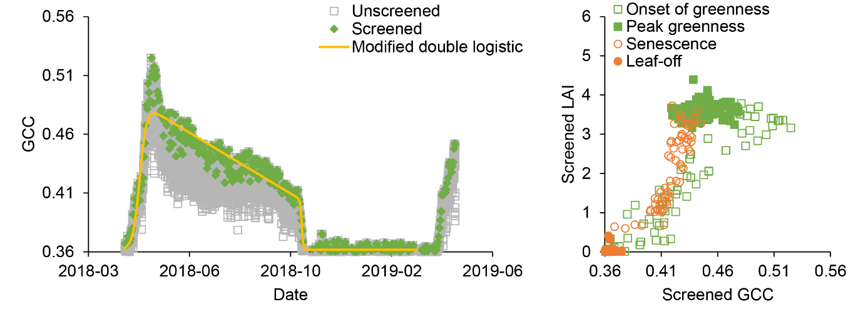(a) (b)
Figure 3: GCC values throughout the study period (a), in addition to the relationship between LAI and the GCC when considering screened observations of both variables (b).
3.2. Evaluation of screened LAI data against manually acquired DHP
In terms of LAI derived from the automated DHP system, the screened data demonstrated very close agreement with manually acquired DHP data (collected under best-case illumination conditions at thirteen points within the surrounding 40 m x 40 m area). This was reflected by a strong linear relationship (r² = 0.99), high accuracy (RMSE = 0.20, NRMSE = 12.60%), low bias (-0.13) and high precision (0.16). Minimal scatter was observed at all LAI values, with points lying close to the 1:1 line regardless of their magnitude (Figure 2b). These results were reflected by good temporal consistency in the time-series of screened and manually acquired DHP data (Figure 2a).
3.3. Relationship between the GCC and LAI
The observed relationship between the GCC and LAI was non-linear, highly dependent on phenological stage, and characterised by hysteresis effects. This was most distinctly demonstrated when comparing interpolated values provided by the phenological functions fit to the GCC and LAI (Figure 4b), but was also clearly apparent in the screened GCC and LAI observations (Figure 3b). During the onset of greenness (Figure 4b, Phase 1), the GCC increased exponentially with increases in LAI, ranging from 0.36 (LAI = 0.65) to 0.47 (LAI = 3.68). Throughout peak greenness, a reduction in the GCC from 0.47 to 0.43 occurred independently of any changes in LAI (Figure 4b, Phase 2). A near-linear decrease in the GCC was then observed during senescence (from 0.43 to 0.40), until an LAI of 0.70 (Figure 4b, Phase 3). At this point, large decreases in the GCC (0.40 to 0.36) were observed despite relatively small decreases in LAI (0.70 to 0.50) (Figure 4b, Phase 4). The GCC then remained constant with further decreases in LAI (0.50 to 0.00) (Figure 4b, Phase 5).
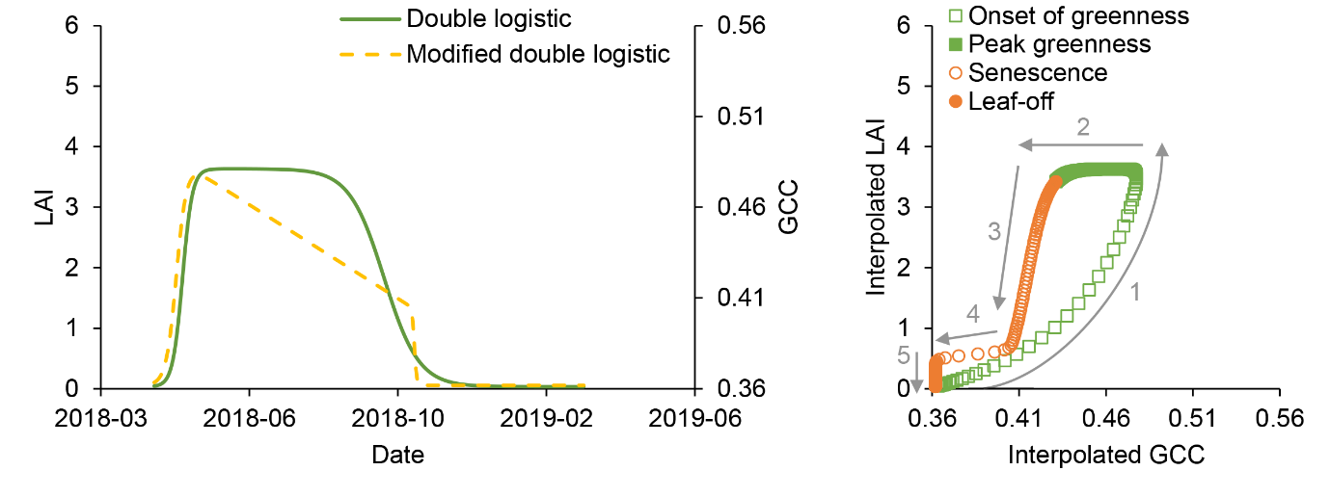(a) (b)
Figure 4: Interpolated LAI and GCC values provided by the phenological functions throughout the study period (a), in addition to the relationship between LAI and the GCC when considering interpolated observations of both variables (b). Hypothesised phases of the relationship are indicated in grey.
3.4. Consistency of phenological transition dates
The transition dates derived from LAI were least sensitive to the choice of phenological function, demonstrating an identical onset of greenness and 4 days difference in the onset of senescence according to the double logistic and modified double logistic functions (Table 2). Transition dates derived from the GCC were considerably more sensitive to the choice of function, demonstrating a later onset of greenness (2 days) and onset of senescence (7 days) according to the modified double logistic function (Table 2). In all cases, substantial differences between transition dates derived from LAI and the GCC were observed. When derived from the GCC, the onset of senescence occurred between 12 and 23 days earlier than when derived from LAI, depending on the adopted function. Reduced differences were observed in terms of the onset of greenness, which occurred between 5 and 7 days earlier when derived from the GCC as opposed to LAI (Table 2).

Table 2: Phenological transition dates (day of year) derived from the double logistic and modified double logistic functions fit to the time-series of LAI and the GCC.
 | Double logistic function |  |  | Modified double logistic function
Variable | Onset of greenness | Onset of senescence |  | Onset of greenness | Onset of senescence
LAI | 126 | 289 |  | 126 | 293
GCC | 119 | 270 |  | 121 | 277

4. Discussion
4.1. Utility of automated DHP for tracking forest LAI
Information on the temporal dynamics of forest biophysical properties is required by models of vegetation productivity, biosphere-atmosphere interactions, and the surface energy balance. Because in situ measurements are restricted by resource constraints, there is a need for cost-effective techniques to continuously monitor forest biophysical properties over time. Previously investigated techniques for the continuous monitoring of biophysical variables such as LAI have been subject to a number of challenges, including the need for calibration of above- and below-canopy sensors, ancillary information on canopy leaf angle distribution, and limited measurement footprints (Fang et al., 2018; Qu et al., 2014; Ryu et al., 2012; Toda and Richardson, 2017). To overcome these challenges, we investigated a new approach based on automated DHP. Using established and automated analysis methods, a time-series of LAI was successfully derived from the acquired imagery. Whilst this time-series was subject to a considerable degree of variability, our simple data screening approach was able to supress much of the observed noise, providing a good description of LAI dynamics at a daily temporal resolution without requiring manual inspection.
Importantly, the screened observations derived from our automated DHP system were in very close agreement with LAI obtained from DHP images that were manually acquired under optimal illumination conditions. This finding lends support to the basis of our data screening approach, which assumes that most sources of noise are negatively biased. By selecting the daily maximum LAI value and ensuring that the automated DHP system was configured to acquire images close to sunrise and sunset, the effects of suboptimal illumination conditions could largely be supressed. Additionally, the same data screening approach proved effective in supressing noise in the GCC. Although they require different illumination conditions, previous studies have demonstrated that the upper envelope can also be considered to represent the best quality observations in the case of colour indices derived from above-canopy digital repeat photography (Sonnentag et al., 2012).
4.2. Relationship between the GCC and LAI and implications for phenological research
In recent years, several studies have provided insight into the relationship between colour indices derived from above-canopy digital repeat photography and forest biophysical properties (Brown et al., 2017; Keenan et al., 2014; Wingate et al., 2015; Yang et al., 2014). By combining our automated DHP system with an above-canopy time-lapse digital camera, we were able to investigate this relationship in greater detail than previously possible. Whilst the non-linear nature of the GCC-LAI relationship is well-known (Keenan et al., 2014), little attention has been paid to the role of seasonal dependencies. To our knowledge, this study is the first to explicitly explore this relationship using continuous measurements of LAI throughout the phenological cycle. Our results indicate that the GCC-LAI relationship is characterised by distinct hysteresis effects, and that its form is governed by phenological stage. Five distinct hypothesised phases can be identified (Figure 4b):
- During the onset of greenness, the GCC is initially sensitive to increases in LAI, until gaps in the canopy (as viewed obliquely) are filled (Keenan et al., 2014). Further increases in the GCC are caused by increases leaf chlorophyll concentration until the spring peak in GCC values (Wingate et al., 2015).
- During peak greenness, changes in the GCC occur independently of changes in LAI (Yang et al., 2014), and are due to the summer decline in GCC values, which is likely caused by increases in the concentration of brown pigments, in addition to seasonal changes in illumination geometry (Brown et al., 2017).
- During senescence, we hypothesise that decreases in the GCC are the result of changes in pigmentation, until gaps in the canopy re-emerge. This provides an explanation for the earlier onset of senescence identified in the case of the GCC, since changes in pigmentation begin before any reduction in LAI. Once gaps re-emerge, further decreases in the GCC are driven by a combination of changes in pigmentation and decreases in LAI.
- Towards the end of senescence, the remaining leaves turn from yellow to brown, leading to large decreases in the GCC despite relatively small decreases in LAI.
- Once the remaining leaves are completely brown, the GCC is insensitive to further decreases in LAI.
It is as a result of this complex relationship that substantial differences between phenological transition dates derived from the GCC and LAI are observed, particularly in the case of the onset of senescence. These findings have important implications for phenological research utilising above-canopy digital repeat photography, and indicate that transition dates derived from colour indices cannot be easily linked to any one biophysical property. In this respect, the GCC may be described as a cryptic or ambiguous measure of phenology (Albert et al., 2019), as its seasonality is driven by multiple processes that may at times be compensatory, making physical interpretation challenging. In particular, caution should be exercised when evaluating the quality of satellite-derived phenological metrics, as the underlying vegetation indices are typically most sensitive to structural properties such as LAI. As such, substantial discrepancies may be observed, not necessarily because of a deficiency in the satellite product itself, but because of the sensitivity of above-canopy digital repeat photography to different characteristics.
As the greatest differences in phenological transition dates derived from the GCC and LAI were observed in case of the onset of senescence, it is worth noting that other colour indices including the red chromatic coordinate (RCC) have been shown to provide more robust estimates of autumn phenology than the GCC (Sonnentag et al., 2012; Yang et al., 2014). Similarly, the adoption of near-infrared enabled digital cameras, which are now installed at over 400 PhenoCam sites, may alleviate the issues associated with the GCC to some extent, enabling the calculation of vegetation indices more sensitive to canopy structure such as the normalised difference vegetation index (NDVI). Indeed, Petach et al. (2014) note such an approach provides different information on canopy status when compared to colour indices such as the GCC. Nevertheless, the radiometric quantities provided by the technique are relative, and Filippa et al. (2018) demonstrate that site-specific scaling factors are required to make data comparable to satellite-derived NDVI, reducing the universal applicability of the approach.
4.3. Potential of automated DHP in forest research
In contrast to above-canopy digital repeat photography, the automated DHP approach presented in this study provides time-series of LAI, whose physical interpretation is straightforward, and whose transition dates are comparatively insensitive to the choice of phenological function. Whilst previous work has highlighted the increased measurement footprint associated with above-canopy digital repeat photography (Hufkens et al., 2012; Richardson et al., 2009, 2007), we suggest that a substantial measurement footprint can also be achieved using automated DHP, particularly when compared to digital cover photography (Table 3). In addition to providing data at a spatial scale useful to forest managers and ecologists, this is particularly relevant for applications in the validation of decametric satellite-derived biophysical variables (such as those from the Sentinel-2 missions) (Brown et al., 2019). In this context, an additional advantage of automated DHP is the ability to derive other relevant biophysical parameters such at the fraction of intercepted photosynthetically active radiation (FIPAR) and the fraction of vegetation cover (FCOVER) (Li et al., 2015; Weiss et al., 2014). Future work could also investigate the feasibility of estimating green LAI, which is more directly related to canopy-scale photosynthesis (Delegido et al., 2015; Haboudane et al., 2004; Weiss et al., 2004), by exploiting the colour information from above-canopy digital repeat photography in synergy with automated DHP.
Table 3: Approximate measurement footprint achieved by automated DHP and digital cover photography for different canopy heights.
Technique | Camera height (m) | Effective FOV (°) | Canopy height (m) | Footprint (m)
Automated DHP | 2ª | 120ª | 10 | 28
 |  |  | 15 | 45
 |  |  | 20 | 62
Digital cover photography | 2ª | 30^{b} | 10 | 4
 |  |  | 15 | 7
 |  |  | 20 | 10
ªThis study
^{b}Chianucci and Cutini (2013); Pekin and Macfarlane (2009)
Notwithstanding its advantages, we acknowledge that the deployment of a below-canopy DHP system poses several practical challenges. At sites without a mains supply, power will typically be provided by a photovoltaic panel, necessitating either a) access to a clearing or tower, or b) a large array of photovoltaic panels to make up for their reduced efficiency under shade. Additionally, any system installed below the canopy (including radiometric sensors and digital cover photography systems) may be susceptible to the accumulation of debris. In areas with cellular coverage, automated file transmission could be adopted, as in this study, enabling the condition of the system to be visually assessed remotely. Such an approach also enables monitoring of battery status, remaining storage capacity, and within-housing humidity/temperature levels, both reducing the required frequency of maintenance visits, and enabling system downtime to be minimised. In addition to the desiccant used to prevent internal condensation in this study, the adoption of a low-wattage heating element to prevent lens fogging could also be envisaged, although the associated power requirements might restrict this solution to established sites with a mains supply.
Since many of the practical considerations pertinent to automated DHP apply to other near-surface remote sensing techniques, it is important to note that the cost of an automated DHP system is comparable to that of a standard digital time-lapse camera (and substantially less expensive than the man-hours and operator training required for manual DHP data collection). Additionally, less expensive hardware could be adopted in future work without necessarily compromising data quality, particularly given the declining cost and continued increase in resolution of commercially available digital cameras. For example, Ryu et al. (2014, 2010a) and Kim et al. (2019) describe near-surface remote sensing systems developed using commodity hardware, and it is foreseeable that a similar approach could be applied to develop an automated DHP system at lower cost. In light of its advantages, we recommend further investigation of automated DHP as an alternative to above-canopy digital repeat photography in forest research. Having tested the approach at a deciduous broadleaf forest site, there is now a need to confirm its applicability to other forest types that present additional measurement challenges.

5. Conclusions
Although techniques such as the use of radiometric sensors and digital cover photography have been used for the continuous monitoring of forest biophysical properties such as LAI, several challenges are yet to be resolved. In this study, we investigated the use of automated DHP to overcome these challenges. Our results indicate that automated DHP can accurately track forest LAI at a daily temporal resolution, and that simple data screening approaches can successfully supress noise without manual inspection. When compared to colour indices derived from above-canopy digital repeat photography, automated DHP is advantageous in that it provides time-series of LAI itself, making physical interpretation straightforward, whilst also offering a substantial measurement footprint. Additionally, unlike radiometric sensors and digital cover photography, above-canopy sensors or ancillary data on canopy leaf angle distribution are not required. Using our automated DHP system, we were able to investigate the relationship between colour indices derived from above-canopy digital repeat photography and LAI in greater detail than previously possible. Our results reveal that this relationship is characterised by hysteresis effects and is highly dependent on phenological stage. The complexity of this relationship makes it challenging to link transition dates derived from colour indices to any one biophysical property. Given its advantages and comparable cost, we recommend the automated DHP approach is further investigated as an alternative to above-canopy digital repeat photography in forest research.

Appendix A
To verify the adopted DHP processing method, we compared estimates of PAI derived from manually acquired DHP images according to Miller (1967) (as described in Section 2.3) with those derived according to Warren-Wilson (1963) (i.e. making use of the gap fraction in the hinge region surrounding 57.5° only). When model assumptions are met, the two estimates, which are based on nearly independent angular sampling, should demonstrate close agreement (Canisius et al., 2010; Leblanc and Chen, 2001). PAI was derived according to Warren-Wilson (1963) as
$${PAI}_{57.5°}=\frac{-\overline{\ln{P(θ_{57.5°})}}}{0.93}$$
where $P(θ_{57.5°})$ is the gap fraction in a zenith ring centred on 57.5° (± 5°), accounting for the effects of foliage clumping using the method of Lang and Yueqin (1986). A strong relationship, (r² = 0.97), high accuracy (RMSE = 0.31, NRMSE = 11%), low bias (0.15) and high precision (0.29) was observed (Figure A1).
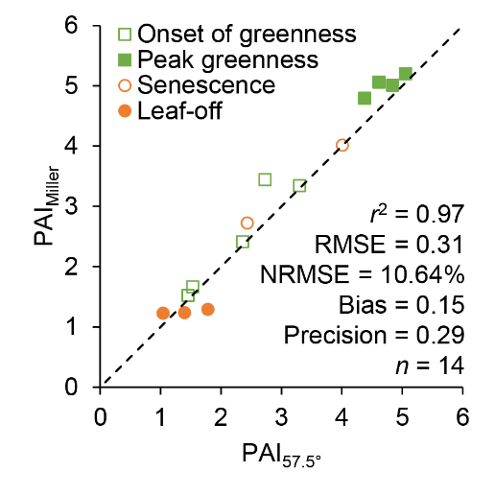
Figure A1: Comparison of PAI values derived from manually acquired DHP images according to Miller (1967) and Warren-Wilson (1963).
Acknowledgements
This work was supported by the European Space Agency and a University of Southampton Vice Chancellor’s Scholarship. The authors are grateful to Yadvinder Mahli, Nigel Fisher, and the University of Oxford for facilitating access to Wytham Woods, and also extend thanks to Charles George, Harry Morris and Julio Pastor-Guzman for assistance with instrument deployment and the collection of field data. Gratitude is extended to Mark Roberts and the Habortronics team for their willingness to perform modifications to the standard Cyclapse housing and for their support in troubleshooting the DigiSnap Pro intervalometer. Finally, the authors thank the two anonymous reviewers for their constructive comments, which helped to substantially improve the manuscript.

References
Albert, L.P., Restrepo‐Coupe, N., Smith, M.N., Wu, J., Chavana‐Bryant, C., Prohaska, N., Taylor, T.C., Martins, G.A., Ciais, P., Mao, J., Arain, M.A., Li, W., Shi, X., Ricciuto, D.M., Huxman, T.E., McMahon, S.M., Saleska, S.R., 2019. Cryptic phenology in plants: Case studies, implications, and recommendations. Glob. Chang. Biol. 25, 3591–3608. https://doi.org/10.1111/gcb.14759
Atkinson, P.M., Jeganathan, C., Dash, J., Atzberger, C., 2012. Inter-comparison of four models for smoothing satellite sensor time-series data to estimate vegetation phenology. Remote Sens. Environ. 123, 400–417. https://doi.org/10.1016/j.rse.2012.04.001
Baret, F., Weiss, M., Allard, D., Garrigues, S., Leroy, M., Jeanjean, H., Fernandes, R., Myneni, R., Privette, J., Morisette, J., Bohbot, H., 2005. VALERI : a network of sites and a methodology for the validation of medium spatial resolution land satellite products. Institut National de la Recherche Agronomique, Avignon, France.
Bater, C.W., Coops, N.C., Wulder, M.A., Hilker, T., Nielsen, S.E., McDermid, G., Stenhouse, G.B., 2011. Using digital time-lapse cameras to monitor species-specific understorey and overstorey phenology in support of wildlife habitat assessment. Environ. Monit. Assess. 180, 1–13. https://doi.org/10.1007/s10661-010-1768-x
Baumann, M., Ozdogan, M., Richardson, A.D., Radeloff, V.C., 2017. Phenology from Landsat when data is scarce: Using MODIS and Dynamic Time-Warping to combine multi-year Landsat imagery to derive annual phenology curves. Int. J. Appl. Earth Obs. Geoinf. 54, 72–83. https://doi.org/10.1016/j.jag.2016.09.005
Beck, P.S.A., Atzberger, C., Høgda, K.A., Johansen, B., Skidmore, A.K., 2006. Improved monitoring of vegetation dynamics at very high latitudes: A new method using MODIS NDVI. Remote Sens. Environ. 100, 321–334. https://doi.org/10.1016/j.rse.2005.10.021
Beer, C., Reichstein, M., Tomelleri, E., Ciais, P., Jung, M., Carvalhais, N., Rodenbeck, C., Arain, M.A., Baldocchi, D., Bonan, G.B., Bondeau, A., Cescatti, A., Lasslop, G., Lindroth, A., Lomas, M., Luyssaert, S., Margolis, H., Oleson, K.W., Roupsard, O., Veenendaal, E., Viovy, N., Williams, C., Woodward, F.I., Papale, D., 2010. Terrestrial Gross Carbon Dioxide Uptake: Global Distribution and Covariation with Climate. Science (80-. ). 329, 834–838. https://doi.org/10.1126/science.1184984
Bréda, N.J.J., 2003. Ground-based measurements of leaf area index: a review of methods, instruments and current controversies. J. Exp. Bot. 54, 2403–2417. https://doi.org/10.1093/jxb/erg263
Brede, B., Gastellu-Etchegorry, J.-P., Lauret, N., Baret, F., Clevers, J., Verbesselt, J., Herold, M., 2018. Monitoring Forest Phenology and Leaf Area Index with the Autonomous, Low-Cost Transmittance Sensor PASTiS-57. Remote Sens. 10, 1032. https://doi.org/10.3390/rs10071032
Brown, L.A., Dash, J., Ogutu, B.O., Richardson, A.D., 2017. On the relationship between continuous measures of canopy greenness derived using near-surface remote sensing and satellite-derived vegetation products. Agric. For. Meteorol. 247, 280–292. https://doi.org/10.1016/j.agrformet.2017.08.012
Brown, L.A., Ogutu, B.O., Dash, J., 2019. Estimating Forest Leaf Area Index and Canopy Chlorophyll Content with Sentinel-2: An Evaluation of Two Hybrid Retrieval Algorithms. Remote Sens. 11, 1752. https://doi.org/10.3390/rs11151752
Calders, K., Origo, N., Burt, A., Disney, M., Nightingale, J., Raumonen, P., Åkerblom, M., Malhi, Y., Lewis, P., 2018a. Realistic Forest Stand Reconstruction from Terrestrial LiDAR for Radiative Transfer Modelling. Remote Sens. 10, 933. https://doi.org/10.3390/rs10060933
Calders, K., Origo, N., Disney, M., Nightingale, J., Woodgate, W., Armston, J., Lewis, P., 2018b. Variability and bias in active and passive ground-based measurements of effective plant, wood and leaf area index. Agric. For. Meteorol. 252, 231–240. https://doi.org/10.1016/j.agrformet.2018.01.029
Canisius, F., Fernandes, R., Chen, J., 2010. Comparison and evaluation of Medium Resolution Imaging Spectrometer leaf area index products across a range of land use. Remote Sens. Environ. 114, 950–960. https://doi.org/10.1016/j.rse.2009.12.010
Chianucci, F., Cutini, A., 2013. Estimation of canopy properties in deciduous forests with digital hemispherical and cover photography. Agric. For. Meteorol. 168, 130–139. https://doi.org/10.1016/j.agrformet.2012.09.002
Chianucci, F., Cutini, A., 2012. Digital hemispherical photography for estimating forest canopy properties: current controversies and opportunities. iForest - Biogeosciences For. 5, 290–295. https://doi.org/10.3832/ifor0775-005
Coops, N.C., Hilker, T., Bater, C.W., Wulder, M.A., Nielsen, S.E., McDermid, G., Stenhouse, G., 2012. Linking ground-based to satellite-derived phenological metrics in support of habitat assessment. Remote Sens. Lett. 3, 191–200. https://doi.org/10.1080/01431161.2010.550330
Delegido, J., Verrelst, J., Rivera, J.P., Ruiz-Verdú, A., Moreno, J., 2015. Brown and green LAI mapping through spectral indices. Int. J. Appl. Earth Obs. Geoinf. 35, 350–358. https://doi.org/10.1016/j.jag.2014.10.001
Elmore, A.J., Guinn, S.M., Minsley, B.J., Richardson, A.D., 2012. Landscape controls on the timing of spring, autumn, and growing season length in mid-Atlantic forests. Glob. Chang. Biol. 18, 656–674. https://doi.org/10.1111/j.1365-2486.2011.02521.x
Fang, H., Ye, Y., Liu, W., Wei, S., Ma, L., 2018. Continuous estimation of canopy leaf area index (LAI) and clumping index over broadleaf crop fields: An investigation of the PASTIS-57 instrument and smartphone applications. Agric. For. Meteorol. 253–254, 48–61. https://doi.org/10.1016/j.agrformet.2018.02.003
FAO, 2015. Global Forest Resources Assessment 2015. Food and Agriculture Organizaion of the United Nations, Rome, Italy.
Filippa, G., Cremonese, E., Migliavacca, M., Galvagno, M., Sonnentag, O., Humphreys, E., Hufkens, K., Ryu, Y., Verfaillie, J., Morra di Cella, U., Richardson, A.D., 2018. NDVI derived from near-infrared-enabled digital cameras: Applicability across different plant functional types. Agric. For. Meteorol. 249, 275–285. https://doi.org/10.1016/j.agrformet.2017.11.003
Garrigues, S., Shabanov, N.V., Swanson, K., Morisette, J.T., Baret, F., Myneni, R.B., 2008. Intercomparison and sensitivity analysis of Leaf Area Index retrievals from LAI-2000, AccuPAR, and digital hemispherical photography over croplands. Agric. For. Meteorol. 148, 1193–1209. https://doi.org/10.1016/j.agrformet.2008.02.014
Haboudane, D., Miller, J.R., Pattey, E., Zarco-Tejada, P.J., Strachan, I.B., 2004. Hyperspectral vegetation indices and novel algorithms for predicting green LAI of crop canopies: Modeling and validation in the context of precision agriculture. Remote Sens. Environ. 90, 337–352. https://doi.org/10.1016/j.rse.2003.12.013
Hufkens, K., Friedl, M., Sonnentag, O., Braswell, B.H., Milliman, T., Richardson, A.D., 2012. Linking near-surface and satellite remote sensing measurements of deciduous broadleaf forest phenology. Remote Sens. Environ. 117, 307–321. https://doi.org/10.1016/j.rse.2011.10.006
Jonckheere, I., Fleck, S., Nackaerts, K., Muys, B., Coppin, P., Weiss, M., Baret, F., 2004. Review of methods for in situ leaf area index determination. Agric. For. Meteorol. 121, 19–35. https://doi.org/10.1016/j.agrformet.2003.08.027
Jonckheere, I., Nackaerts, K., Muys, B., Coppin, P., 2005. Assessment of automatic gap fraction estimation of forests from digital hemispherical photography. Agric. For. Meteorol. 132, 96–114. https://doi.org/10.1016/j.agrformet.2005.06.003
Keenan, T.F., Darby, B., Felts, E., Sonnentag, O., Friedl, M.A., Hufkens, K., O’Keefe, J., Klosterman, S., Munger, J.W., Toomey, M., Richardson, A.D., 2014. Tracking forest phenology and seasonal physiology using digital repeat photography: a critical assessment. Ecol. Appl. 24, 1478–1489. https://doi.org/10.1890/13-0652.1
Kim, J., Ryu, Y., Jiang, C., Hwang, Y., 2019. Continuous observation of vegetation canopy dynamics using an integrated low-cost, near-surface remote sensing system. Agric. For. Meteorol. 264, 164–177. https://doi.org/10.1016/j.agrformet.2018.09.014
Klosterman, S.T., Hufkens, K., Gray, J.M., Melaas, E., Sonnentag, O., Lavine, I., Mitchell, L., Norman, R., Friedl, M.A., Richardson, A.D., 2014. Evaluating remote sensing of deciduous forest phenology at multiple spatial scales using PhenoCam imagery. Biogeosciences 11, 4305–4320. https://doi.org/10.5194/bg-11-4305-2014
Lang, A.R.G., Yueqin, X., 1986. Estimation of leaf area index from transmission of direct sunlight in discontinuous canopies. Agric. For. Meteorol. 37, 229–243. https://doi.org/10.1016/0168-1923(86)90033-X
Leblanc, S.G., Chen, J.M., 2001. A practical scheme for correcting multiple scattering effects on optical LAI measurements. Agric. For. Meteorol. 110, 125–139. https://doi.org/10.1016/S0168-1923(01)00284-2
Leblanc, S.G., Chen, J.M., Fernandes, R., Deering, D.W., Conley, A., 2005. Methodology comparison for canopy structure parameters extraction from digital hemispherical photography in boreal forests. Agric. For. Meteorol. 129, 187–207. https://doi.org/10.1016/j.agrformet.2004.09.006
LI-COR, 2013. LAI-2200C Plant Canopy Analyser Instruction Manual. LI-COR, Lincoln, Nebraska, United States.
Li, W., Weiss, M., Waldner, F., Defourny, P., Demarez, V., Morin, D., Hagolle, O., Baret, F., 2015. A Generic Algorithm to Estimate LAI, FAPAR and FCOVER Variables from SPOT4_HRVIR and Landsat Sensors: Evaluation of the Consistency and Comparison with Ground Measurements. Remote Sens. 7, 15494–15516. https://doi.org/10.3390/rs71115494
Liu, Y., Hill, M.J., Zhang, X., Wang, Z., Richardson, A.D., Hufkens, K., Filippa, G., Baldocchi, D.D., Ma, S., Verfaillie, J., Schaaf, C.B., 2017. Using data from Landsat, MODIS, VIIRS and PhenoCams to monitor the phenology of California oak/grass savanna and open grassland across spatial scales. Agric. For. Meteorol. 237–238, 311–325. https://doi.org/10.1016/j.agrformet.2017.02.026
Macfarlane, C., Grigg, A., Evangelista, C., 2007a. Estimating forest leaf area using cover and fullframe fisheye photography: Thinking inside the circle. Agric. For. Meteorol. 146, 1–12. https://doi.org/10.1016/j.agrformet.2007.05.001
Macfarlane, C., Hoffman, M., Eamus, D., Kerp, N., Higginson, S., McMurtrie, R., Adams, M., 2007b. Estimation of leaf area index in eucalypt forest using digital photography. Agric. For. Meteorol. 143, 176–188. https://doi.org/10.1016/j.agrformet.2006.10.013
Macfarlane, C., Ryu, Y., Ogden, G.N., Sonnentag, O., 2014. Digital canopy photography: Exposed and in the raw. Agric. For. Meteorol. 197, 244–253. https://doi.org/10.1016/j.agrformet.2014.05.014
Majasalmi, T., Rautiainen, M., Stenberg, P., Rita, H., 2012. Optimizing the sampling scheme for LAI-2000 measurements in a boreal forest. Agric. For. Meteorol. 154–155, 38–43. https://doi.org/10.1016/j.agrformet.2011.10.002
Melaas, E.K., Sulla-Menashe, D., Gray, J.M., Black, T.A., Morin, T.H., Richardson, A.D., Friedl, M.A., 2016. Multisite analysis of land surface phenology in North American temperate and boreal deciduous forests from Landsat. Remote Sens. Environ. 186, 452–464. https://doi.org/10.1016/j.rse.2016.09.014
Miller, J., 1967. A formula for average foliage density. Aust. J. Bot. 15, 141–144. https://doi.org/10.1071/BT9670141
Nagai, S., Akitsu, T., Saitoh, T.M., Busey, R.C., Fukuzawa, K., Honda, Y., Ichie, T., Ide, R., Ikawa, H., Iwasaki, A., Iwao, K., Kajiwara, K., Kang, S., Kim, Y., Khoon, K.L., Kononov, A. V., Kosugi, Y., Maeda, T., Mamiya, W., Matsuoka, M., Maximov, T.C., Menzel, A., Miura, T., Mizunuma, T., Morozumi, T., Motohka, T., Muraoka, H., Nagano, H., Nakai, T., Nakaji, T., Oguma, H., Ohta, T., Ono, K., Pungga, R.A.S., Petrov, R.E., Sakai, R., Schunk, C., Sekikawa, S., Shakhmatov, R., Son, Y., Sugimoto, A., Suzuki, R., Takagi, K., Takanashi, S., Tei, S., Tsuchida, S., Yamamoto, H., Yamasaki, E., Yamashita, M., Yoon, T.K., Yoshida, T., Yoshimura, M., Yoshitake, S., Wilkinson, M., Wingate, L., Nasahara, K.N., 2018. 8 million phenological and sky images from 29 ecosystems from the Arctic to the tropics: the Phenological Eyes Network. Ecol. Res. 33, 1091–1092. https://doi.org/10.1007/s11284-018-1633-x
Nijland, W., Bolton, D.K., Coops, N.C., Stenhouse, G., 2016. Imaging phenology; scaling from camera plots to landscapes. Remote Sens. Environ. 177, 13–20. https://doi.org/10.1016/j.rse.2016.02.018
Origo, N., Calders, K., Nightingale, J., Disney, M., 2017. Influence of levelling technique on the retrieval of canopy structural parameters from digital hemispherical photography. Agric. For. Meteorol. 237–238, 143–149. https://doi.org/10.1016/j.agrformet.2017.02.004
Pekin, B., Macfarlane, C., 2009. Measurement of Crown Cover and Leaf Area Index Using Digital Cover Photography and Its Application to Remote Sensing. Remote Sens. 1, 1298–1320. https://doi.org/10.3390/rs1041298
Petach, A.R., Toomey, M., Aubrecht, D.M., Richardson, A.D., 2014. Monitoring vegetation phenology using an infrared-enabled security camera. Agric. For. Meteorol. 195–196, 143–151. https://doi.org/10.1016/j.agrformet.2014.05.008
Pisek, J., Sonnentag, O., Richardson, A.D., Mõttus, M., 2013. Is the spherical leaf inclination angle distribution a valid assumption for temperate and boreal broadleaf tree species? Agric. For. Meteorol. 169, 186–194. https://doi.org/10.1016/j.agrformet.2012.10.011
Pueschel, P., Buddenbaum, H., Hill, J., 2012. An efficient approach to standardizing the processing of hemispherical images for the estimation of forest structural attributes. Agric. For. Meteorol. 160, 1–13. https://doi.org/10.1016/j.agrformet.2012.02.007
Qu, Y., Han, W., Fu, L., Li, C., Song, J., Zhou, H., Bo, Y., Wang, J., 2014. LAINet – A wireless sensor network for coniferous forest leaf area index measurement: Design, algorithm and validation. Comput. Electron. Agric. 108, 200–208. https://doi.org/10.1016/j.compag.2014.08.003
Richardson, A.D., Braswell, B.H., Hollinger, D.Y., Jenkins, J.P., Ollinger, S. V., 2009. Near-surface remote sensing of spatial and temporal variation in canopy phenology. Ecol. Appl. 19, 1417–1428. https://doi.org/10.1890/08-2022.1
Richardson, A.D., Hufkens, K., Milliman, T., Aubrecht, D.M., Chen, M., Gray, J.M., Johnston, M.R., Keenan, T.F., Klosterman, S.T., Kosmala, M., Melaas, E.K., Friedl, M.A., Frolking, S., 2018a. Tracking vegetation phenology across diverse North American biomes using PhenoCam imagery. Sci. Data 5, 180028. https://doi.org/10.1038/sdata.2018.28
Richardson, A.D., Hufkens, K., Milliman, T., Frolking, S., 2018b. Intercomparison of phenological transition dates derived from the PhenoCam Dataset V1.0 and MODIS satellite remote sensing. Sci. Rep. 8, 5679. https://doi.org/10.1038/s41598-018-23804-6
Richardson, A.D., Jenkins, J.P., Braswell, B.H., Hollinger, D.Y., Ollinger, S. V, Smith, M.-L., 2007. Use of digital webcam images to track spring green-up in a deciduous broadleaf forest. Oecologia 152, 323–334. https://doi.org/10.1007/s00442-006-0657-z
Richardson, A.D., Keenan, T.F., Migliavacca, M., Ryu, Y., Sonnentag, O., Toomey, M., 2013. Climate change, phenology, and phenological control of vegetation feedbacks to the climate system. Agric. For. Meteorol. 169, 156–173. https://doi.org/10.1016/j.agrformet.2012.09.012
Ridler, T.W., Calvard, S., 1978. Picture Thresholding Using an Iterative Selection Method. IEEE Trans. Syst. Man. Cybern. 8, 630–632. https://doi.org/10.1109/TSMC.1978.4310039
Ryu, Y., Baldocchi, D.D., Verfaillie, J., Ma, S., Falk, M., Ruiz-Mercado, I., Hehn, T., Sonnentag, O., 2010a. Testing the performance of a novel spectral reflectance sensor, built with light emitting diodes (LEDs), to monitor ecosystem metabolism, structure and function. Agric. For. Meteorol. 150, 1597–1606. https://doi.org/10.1016/j.agrformet.2010.08.009
Ryu, Y., Lee, G., Jeon, S., Song, Y., Kimm, H., 2014. Monitoring multi-layer canopy spring phenology of temperate deciduous and evergreen forests using low-cost spectral sensors. Remote Sens. Environ. 149, 227–238. https://doi.org/10.1016/j.rse.2014.04.015
Ryu, Y., Sonnentag, O., Nilson, T., Vargas, R., Kobayashi, H., Wenk, R., Baldocchi, D.D., 2010b. How to quantify tree leaf area index in an open savanna ecosystem: A multi-instrument and multi-model approach. Agric. For. Meteorol. 150, 63–76. https://doi.org/10.1016/j.agrformet.2009.08.007
Ryu, Y., Verfaillie, J., Macfarlane, C., Kobayashi, H., Sonnentag, O., Vargas, R., Ma, S., Baldocchi, D.D., 2012. Continuous observation of tree leaf area index at ecosystem scale using upward-pointing digital cameras. Remote Sens. Environ. 126, 116–125. https://doi.org/10.1016/j.rse.2012.08.027
Sellers, P.J., Dickinson, R.E., Randall, D.A., Betts, A.K., Hall, F.G., Berry, J.A., Collatz, G.J., Denning, A.S., Mooney, H.A., Nobre, C.A., Sato, N., Field, C.B., Henderson-Sellers, A., 1997. Modeling the Exchanges of Energy, Water, and Carbon Between Continents and the Atmosphere. Science (80-. ). 275, 502–9. https://doi.org/10.1126/science.275.5299.502
Sonnentag, O., Hufkens, K., Teshera-Sterne, C., Young, A.M., Friedl, M., Braswell, B.H., Milliman, T., O’Keefe, J., Richardson, A.D., 2012. Digital repeat photography for phenological research in forest ecosystems. Agric. For. Meteorol. 152, 159–177. https://doi.org/10.1016/j.agrformet.2011.09.009
Toda, M., Richardson, A.D., 2017. Estimation of plant area index and phenological transition dates from digital repeat photography and radiometric approaches in a hardwood forest in the Northeastern United States. Agric. For. Meteorol. 1–10. https://doi.org/10.1016/j.agrformet.2017.09.004
Toomey, M., Friedl, M.A., Frolking, S., Hufkens, K., Klosterman, S., Sonnentag, O., Baldocchi, D.D., Bernacchi, C.J., Biraud, S.C., Bohrer, G., Brzostek, E., Burns, S.P., Coursolle, C., Hollinger, D.Y., Margolis, H.A., McCaughey, H., Monson, R.K., Munger, J.W., Pallardy, S., Phillips, R.P., Torn, M.S., Wharton, S., Zeri, M., Richardson, A.D., 2015. Greenness indices from digital cameras predict the timing and seasonal dynamics of canopy-scale photosynthesis. Ecol. Appl. 25, 99–115. https://doi.org/10.1890/14-0005.1
Warren-Wilson, J., 1963. Estimation of foliage denseness and foliage angle by inclined point quadrats. Aust. J. Bot. 11, 95–105.
Weiss, M., Baret, F., 2017. CAN-EYE V6.4.91 User Manual. Institut National de la Recherche Agronomique, Avignon, France.
Weiss, M., Baret, F., Block, T., Koetz, B., Burini, A., Scholze, B., Lecharpentier, P., Brockmann, C., Fernandes, R., Plummer, S., Myneni, R., Gobron, N., Nightingale, J., Schaepman-Strub, G., Camacho, F., Sanchez-Azofeifa, A., 2014. On Line Validation Exercise (OLIVE): A Web Based Service for the Validation of Medium Resolution Land Products. Application to FAPAR Products. Remote Sens. 6, 4190–4216. https://doi.org/10.3390/rs6054190
Weiss, M., Baret, F., Smith, G.J., Jonckheere, I., Coppin, P., 2004. Review of methods for in situ leaf area index (LAI) determination Part II: Estimation of LAI, errors and sampling. Agric. For. Meteorol. 121, 37–53. https://doi.org/10.1016/j.agrformet.2003.08.001
Welles, J.M., Norman, J.M., 1991. Instrument for Indirect Measurement of Canopy Architecture. Agron. J. 83, 818–825. https://doi.org/10.2134/agronj1991.00021962008300050009x
Wingate, L., Ogée, J., Cremonese, E., Filippa, G., Mizunuma, T., Migliavacca, M., Moisy, C., Wilkinson, M., Moureaux, C., Wohlfahrt, G., Hammerle, A., Hörtnagl, L., Gimeno, C., Porcar-Castell, A., Galvagno, M., Nakaji, T., Morison, J., Kolle, O., Knohl, A., Kutsch, W., Kolari, P., Nikinmaa, E., Ibrom, A., Gielen, B., Eugster, W., Balzarolo, M., Papale, D., Klumpp, K., Köstner, B., Grünwald, T., Joffre, R., Ourcival, J.-M., Hellstrom, M., Lindroth, A., George, C., Longdoz, B., Genty, B., Levula, J., Heinesch, B., Sprintsin, M., Yakir, D., Manise, T., Guyon, D., Ahrends, H., Plaza-Aguilar, A., Guan, J.H., Grace, J., 2015. Interpreting canopy development and physiology using a European phenology camera network at flux sites. Biogeosciences 12, 5995–6015. https://doi.org/10.5194/bg-12-5995-2015
Yang, X., Tang, J., Mustard, J.F., 2014. Beyond leaf color: Comparing camera-based phenological metrics with leaf biochemical, biophysical, and spectral properties throughout the growing season of a temperate deciduous forest. J. Geophys. Res. Biogeosciences 119, 181–191. https://doi.org/10.1002/2013JG002460
Zhang, X., Friedl, M.A., Schaaf, C.B., Strahler, A.H., Hodges, J.C.F., Gao, F., Reed, B.C., Huete, A., 2003. Monitoring vegetation phenology using MODIS. Remote Sens. Environ. 84, 471–475. https://doi.org/10.1016/S0034-4257(02)00135-9
Zhang, X., Jayavelu, S., Liu, L., Friedl, M.A., Henebry, G.M., Liu, Y., Schaaf, C.B., Richardson, A.D., Gray, J., 2018. Evaluation of land surface phenology from VIIRS data using time series of PhenoCam imagery. Agric. For. Meteorol. 256–257, 137–149. https://doi.org/10.1016/j.agrformet.2018.03.003
Zhang, Y., Chen, J.M., Miller, J.R., 2005. Determining digital hemispherical photograph exposure for leaf area index estimation. Agric. For. Meteorol. 133, 166–181. https://doi.org/10.1016/j.agrformet.2005.09.009

