The effect of shape and size distribution of abrasive particles on the volume loss of enamel using micro-abrasion

M Baig¹, R Cook¹, J Pratten² and R Wood¹

¹national Centre for Advanced Tribology at the University of Southampton (nCATS), Highfield, Southampton, SO17 1BJ,
² GSK Consumer Healthcare, St Georges Avenue, Weybridge, KT13 0DE, UK

mb9g14@soton.ac.uk
Abstract. Wear of enamel during tooth brushing is a complex phenomenon with many variables affecting the level of loss. Toothpastes contain angular abrasive particles at a concentration of 12% - 15% v/v abrasive designed to remove biofilm and extrinsic stains that also have the potential to harm the tooth enamel resulting in wear. Toothpastes contain multi-modal particles in the size range of 4µm - 12µm. The aim of this paper is to develop an understanding of the relationship between the combined effects of particle shape, size, size distribution and load on the volume loss of enamel under abrasive testing. Micro-abrasion testing using a Nylon ball, to simulate the toothbrush, was undertaken on hydrated bovine enamel disks using volume concentrations of 5% – 20% v/v alumina and silica. Post experimental surface analysis was performed to analyse the wear scar morphology and groove analysis. The synergistic effects were calculated of bimodal particles vs. mono sized particles. Mono-sized particles as compared to bimodal, appeared to give the best outcome and least wear of enamel. A positive synergy existed for the alumina and silica bimodal tests, indicating the bimodal particle distribution was causing more wear than the mono-sized particles. The mechanism of material removal was a combination of crushing and fracture of the enamel prisms (rods), followed by micro-chipping and removal of enamel. The magnitude and the distribution of the particle sizes is the most dominant factor in determining the levels of wear, with smaller particles and narrow distributions of the particle size reducing the magnitude of wear. The shape of the particles is also a major factor influencing wear, with the spherical tests generating lower wear rates than the angular tests.
Keywords: Enamel, micro-abrasion, abrasive particle, wear mechanisms, synergy

- Introduction

Having clean teeth is an important aspect of health and attractive appearance. The most common method for maintenance of oral hygiene is tooth brushing using a toothpaste. Many types of toothpastes contain abrasive particles that are harmful to the delicate tissues of the teeth. The most commonly used abrasives in toothpastes are angular alumina and silica. The main role of an abrasive agent is to remove extrinsic stains from tooth surfaces and biofilms. The ability of the bristles to trap abrasive particles, keeping them in contact with the tooth surface, will determine the extent to which tooth material is removed, as well as having an effect on the abrasive nature of the toothpaste. The enamel surface is abraded when hard particles with large asperities or sharp edges contact the surface under load [1].

The mechanical properties of the biological materials and abrasive particles are shown in Table 1.
Surface biofilms on teeth have a low hardness (HV) to that of dentine (0.55 - 0.68 GPa) and can easily be removed with less abrasive agents contained in a toothpaste. To polish a tooth surface a lustre has to be given to the enamel. To achieve this, the abrasive agents in toothpaste have to be harder than the enamel surface. However, many toothpastes contain harder abrasives such as alumina with a hardness of 2500 HV and silica with a hardness of 1200 HV to give a polished appearance to the enamel surface [2, 3]. The most commonly used abrasive particles in toothpastes are alumina and silica particles with a typical size between 4µm – 12µm (i.e multi-modal). The standard volume concentrations of abrasive in toothpaste is 0.15% v/v [1].

Microabrasion testing has been used to assess wear on dental composites, such as amalgam and porcelain [4]. A test carried out by Chan et al, compared dental restorative material wear rates to enamel and found that enamel had undergone brittle delamination under their tests. A later study carried out by Antunes et al, compared abrasion resistance of dental composites and came to the conclusion that micro abrasion tests were suitable for the study of dental materials [5].

Pena et al, compared the wear on enamel and dental composites using the micro-abrasion rig and slurries containing SiC (silicon carbide) particles with either water or artificial saliva. The wear performance and tribological behaviour of enamel compared to the dental composites was different when using the SiC-artificial saliva slurry. A reason for this was due to the compatibility of enamel and saliva. A thin film covered the enamel with the SiC-artificial saliva slurry which helped to decrease the wear rate and protect the enamel. A higher wear rate was reported with enamel compared to the dental composites due to the brittle nature and low organic content of enamel. Enamel is made up of 1% -2% proteins and this accounts for the low organic content and thus the brittle nature. Scratch tests have been performed on enamel in different directions to investigate the anisotropic properties of enamel and the difference in mechanical results in different enamel directions. In the occlusal section of enamel, brittle delamination was observed at higher loads. At lower loads the enamel was shown to deform and show evidence of cracks and fracture of enamel [6].

A study carried out by Adachi and Hutchings, developed a contact severity model for evaluating wear and mapped micro-abrasive wear mode regimes of engineering surfaces. This study is now used as a bench mark for comparing results with other studies and serves as the starting point for reference with future tests [7].

No studies have looked at the wear of enamel when subjected to toothpaste abrasive using wear rigs that simulate the oral environment. The objective of this paper is to develop an understanding of the magnitude and mechanisms of wear caused by two and three body and mixed- mode abrasion using the Plint TE66 micro-abrasion rig (TE66 Phoenix Tribology, UK) which is widely used for wear testing engineering materials because it is a repeatable test allowing for control of the abrasive mechanisms, within a micro-scale contact which test the microscale response of the material. This enabled the investigation of the effect of size/ combination of sizes and morphology of abrasive particles on the wear rate and mechanisms of enamel tissue.

In order to see if a change in abrasive size affected the volume loss of enamel, bimodal slurries were made. The bimodal slurries (bimodal alumina and bimodal silica) were made by mixing 50% of the two monosized particles to produce a slurry with a bimodal particle size range. The bimodal alumina slurry contained 50% of 5µm alumina particles and 50% of 9µm alumina particles and the bimodal silica slurry contained 50% of 5µm silica particles and 50% of 10µm silica particles. Synergy was calculated for the bimodal alumina and bimodal silica tests. It was evaluated to observe the interaction between the different sizes of particles.

 | Enamel | Dentine | Biofilm | Alumina | Silica
Hardness / GPa | 1.47 – 1.60[8] | 0.55 - 0.68[8] | 0.39 [9] | 24.5 [10] | 11.7 [11]
Youngs modulus / GPa | 62 – 98[8] | 24.8[8] | 3.8 x 10⁻⁷ [12] | 413 [10] | 74.8 [11]
Density | 2.8 – 3.0 g/ml [13] | 13700 – 32300 mm² [14] | - | 3.98mg/m³  [10] | 2.65  mg/m³ [11]

Table 1

Mechanical properties of biological materials and abrasive particles.

- Experimental Details

A large and systematic experimental programme was undertaken to investigate the influence of particle shape, size and composition. The samples used were hydrated bovine enamel discs which had been prepared by polishing back from the facial side of a central incisor and hydrated in artificial saliva for 24 hours. The wear tests were performed using a micro-abrasion system (TE66 Phoenix Tribology, UK) [15]. The micro-abrasion testing was performed at a fixed speed of 0.35ms⁻¹ for 1 minute, using a pre-soaked nylon ball to simulate the tooth brush bristle material. The wear tests were performed at 3 loads (0.1N, 0.2N and 0.5N). For each particle size and material, slurries were made with concentrations of 5, 10, 15 and 20% volume fraction of abrasive. All slurries were manufactured using artificial saliva which adhered to BS EN ISO 11609:2010. The wear scars were measured using an Alicona optical microscope in accordance with the guidelines set out by Gant and Gee et al. [15]. The wear mechanism was interpreted by scar analysis using the Scanning Electron Microscope (SEM). The sliding velocity was kept constant at 0.035ms⁻¹ to relate to the brushing speeds, for a test duration of 1 minute to produce a well-defined crater, with eight repeats performed for each test setup. 7 different angular particles with controlled size distributions of two different materials were used (1µm alumina, 5µm alumina, 9µm alumina, GSK 9µm alumina, 5µm silica, 10µm silica and GSK 8µm silica). The specification and size range of the particles are shown in Table 2. The GSK particles were provided by the sponsor company (GSK healthcare) and have a narrow particle size range, compared to the standard abrasive particles used. The GSK particles are representative of particles used in toothpastes.
To investigate the effect of wider particle size ranges and to investigate whether a combination of two distinct particle sizes provide a synergistic effect i.e. the combined effect of two mono-sized particles being greater than the individual mono-sized particles on the level of wear. The single sized particles (5µm + 9µm alumina and 5µm + 10µm silica) were mixed to provide a bimodal alumina and a bimodal silica group. To determine the effect of particle shape, tests were also performed with a 5µm spherical silica and compared with angular 5µm silica and GSK 8µm silica. For each test condition all three (constant) normal loads (0.1, 0.2 and 0.5N) were used and the sliding distant was set to a constant 2m respectively. The test conditions are summarised in Table 2.

To study the mechanistic wear behaviour of enamel, multi-pass scratch tests were performed on hydrated bovine enamel using the nano-indenter. A hydrated bovine disc was nano-scratch tested using a 5µm spherical diamond tip and loads of 20mN, 50mN, 80mN and 100mN at 16.7 µm/s scratch speeds over a 500 µm length, to observe the mechanical response of enamel.

The microstructure of enamel is anisotropic and its mechanical properties are influenced by the orientation (location and arrangement) of the rods. Enamel is composed of rods (also referred to as prisms), which are the primary unit of the enamel structure. The enamel rods lie perpendicular to the tooth surface and have a length of 6-8 microns and a width of 5µm. The enamel rod is made up of a head and a tail which resembles a key-hole shape. Hydroxyapatite crystals make up each rod, Figure 1.
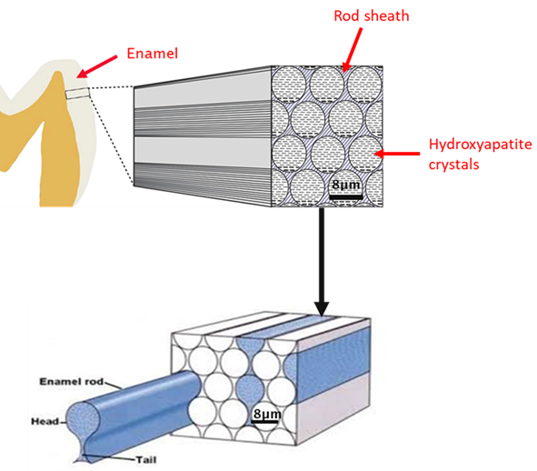

Figure 1: Schematic of enamel rods. Adapted from [16].

Table 2

Test conditions and specification of the abrasives used for the micro abrasion tests (TE66 Phoenix Tribology, UK).

Test conditions
Ball sliding velocity (ms⁻¹) | 0.035
Volume fraction (% v/v) of abrasives | 0.05, 0.10, 0.15, 0.20
Ball material | Nylon
Counterface material | Enamel
Fluid | 0.5% Carboxymethyl cellulose + 10% glycerine  (artificial saliva base)  +  Abrasive (5,10,15,20%)
Time/ minute | 1
 | Mean particle size / µm | Maximum particle size / µm | Supplier
Abrasive particles/  Angular | 1µm alumina | 1.79 | Logitech, UK
Abrasive particles/  Angular | 5µm alumina | 8.1 | Logitech, UK
Abrasive particles/  Angular | 9µm alumina | 10.2 | Logitech, UK
Abrasive particles/  Angular | Bimodal  5µm + 9µm alumina |  | Logitech, UK
Abrasive particles/  Angular | GSK 9µm alumina | 10.4 | Almantis, USA
Abrasive particles/  Angular | 5µm silica | 23 | US Research Nanomaterials, USA
Abrasive particles/  Angular | 10µm silica | 28 | US Research Nanomaterials, USA
Abrasive particles/  Angular | Bimodal  5µm + 10µm silica |  | US Research Nanomaterials, USA
Abrasive particles/  Angular | GSK 8µm silica | 9 | Huber, Germany
Abrasive particles/  spherical | 5µm spherical silica | 6.1 | US Research Nanomaterials, USA
Abrasive particles/  spherical | GSK 6.5µm spherical silica | 8.8 | Huber, Germany
No. of repeats per test (craters formed) | 8

The morphology of the abrasive particles was shown by SEM observation. Figure 2 shows the angular alumina particles. All the abrasive particles were angular in feature with sharp knife-like edges, despite the difference in their size and distribution.
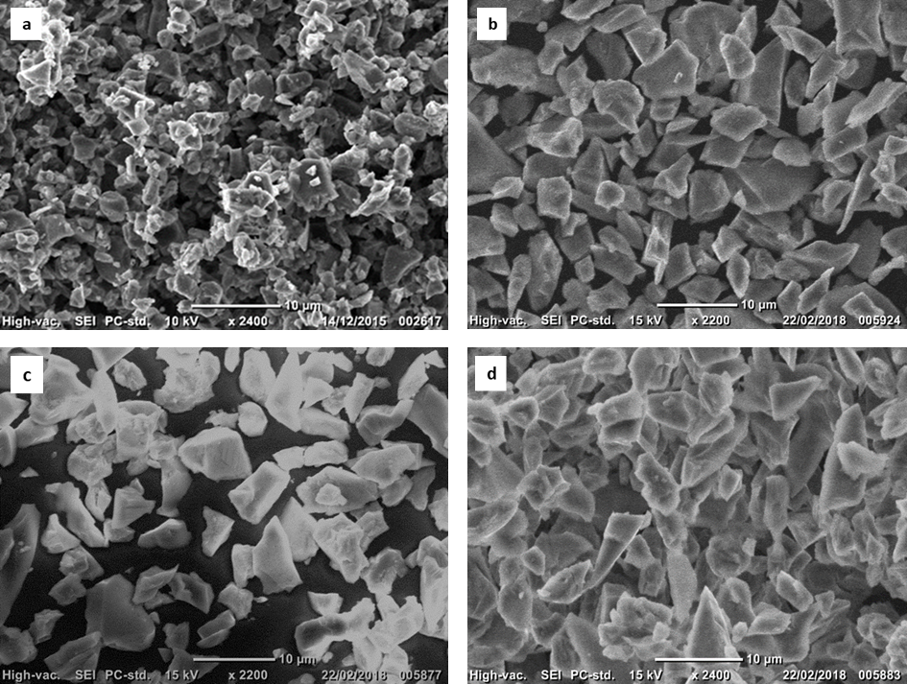

Figure 2: Angular alumina (a) 1µm alumina; (b) 5µm alumina; (c) 9µm alumina; (d) GSK 9µm alumina.

Figure 3 shows the angular silica particles. Despite the difference in the particle size and distribution, the silica particles were all angular in feature. Figure 3a and Figure 3b show the 5µm silica and 10µm silica particles. Many large particles >14µm were present and fragments of smaller particles <5µm were present. There was also evidence of sub-micron particle-debris.
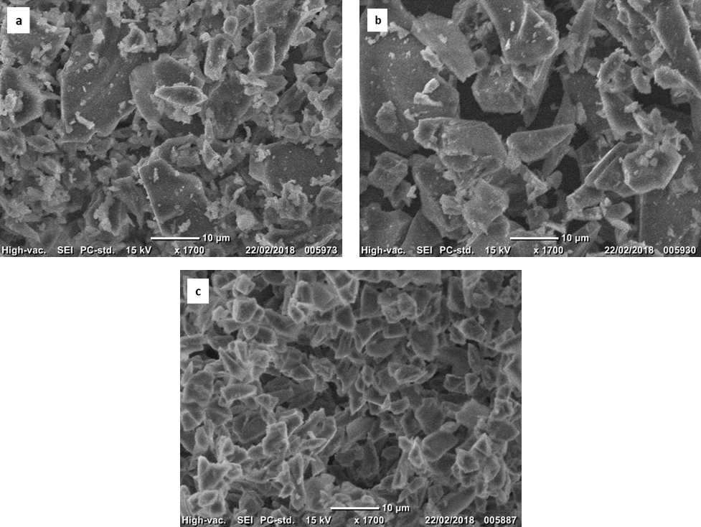

Figure 3: Angular silica (a) 5µm silica; (b) 10µm silica; (c) GSK 8µm silica.

Scratch tests were performed on the bovine enamel disc to observe the mechanistic response of enamel and to better understand the wear mechanisms. The hydrated enamel was shown to be chipped and displaced at the sides of the scratch. No visible pile up was observed. This confirms that the wear of the enamel rods will be via a chipping or fracture process and thus can be linked to the wear mechanisms of enamel when undergoing micro-abrasion. Figure 4 shows the scratch on the bovine disc.

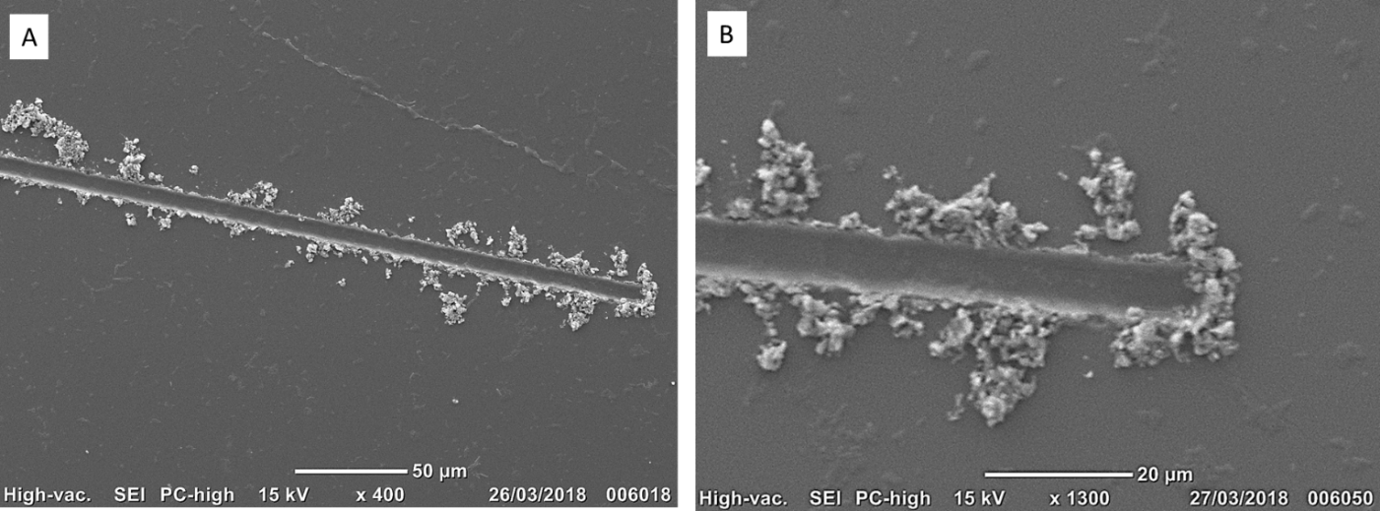

Figure 4: SEM of scratch on bovine disc at a load of 80mN (a) enamel displaced at the sides of the scratch; (b) close up of the tip of scratch. No pile up is visible.

The SEM (JOEL model JCM 6000PLUS benchtop) was used to investigate the topography of enamel and to provide information on the wear mechanisms after the wear tests. The enamel microstructures were examined at an operating voltage of 15kV and working distances of 10mm – 11mm.

- Results

3.1 Particle shape

3.1.1 Volume loss

Figure 5a-c shows the average volume loss for 5µm angular silica, 5µm spherical silica and 8µm GSK silica. 5µm angular silica shows the highest volume loss compared to the 5µm spherical silica and 8µm GSK silica. There was a significant difference in the volume loss of 5µm angular silica compared to the 5µm spherical silica (p<0.05). Between 0.05% v/v and 0.10% v/v, there was a change from grooving to mixed-mode abrasion, which caused an increase in volume loss for the angular 5µm silica, GSK 8µm silica and spherical 5µm silica. Mixed-mode abrasion is a combination of two-body grooving and 3-body rolling abrasion. A change in wear mechanism from grooving to mixed-mode for the angular 5µm tests results in 2.5x more wear and a 0.0025mm³ increase in volume loss from 0.0010mm³ at volume fraction 0.05% – 0.10% v/v, Figure 5a – c. A change in wear mechanism from grooving to mixed-mode for the 5µm spherical silica tests results in 5x more wear and a 0.0023mm³ volume loss increase from 0.0005mm³ of enamel for volume fractions 0.05% – 0.10% v/v, Figure 5a-c. A decrease in volume loss of enamel was observed for the 5µm spherical silica above 0.10% v/v for Figure 5a-c. An increase in volume loss above 0.10% v/v was used by more abrasives entraining into the contact [17]. The statistics demonstrated there was a significant difference between the volume loss of GSK 8µm silica and 5µm spherical silica (p<0.05), with GSK 8µm silica producing higher wear.
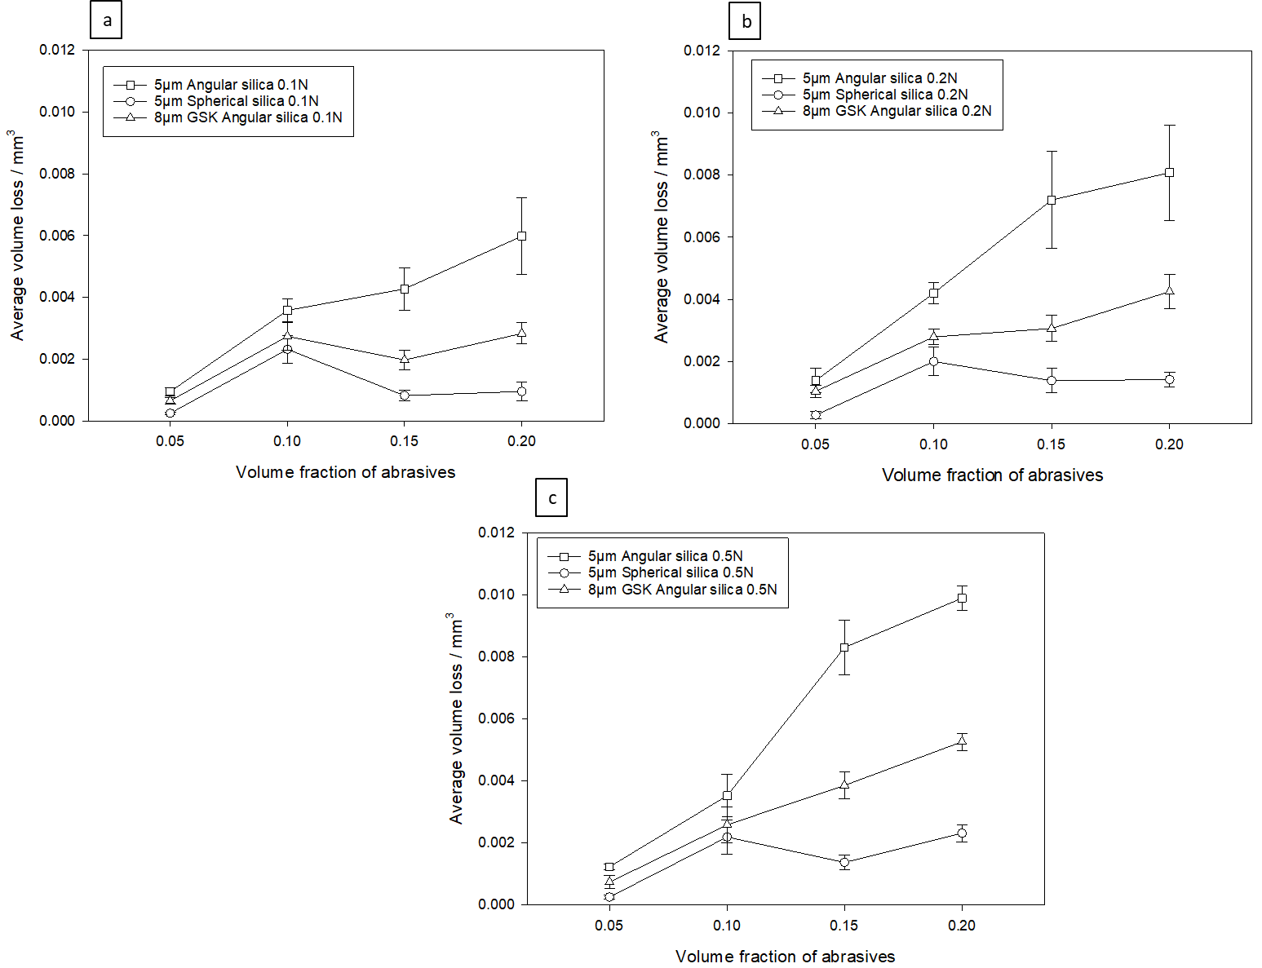

Figure 5: Average volume loss for 5µm angular silica, 8µm GSK silica and 5µm spherical silica (a) 0.1N; (b) 0.2N; (c) 0.5N.

3.1.2 Groove width

This section details groove analysis conducted on the wear scars. The groove widths were measured, by taking multiple measurements of the grooves and the average groove width was calculated for each mechanism (grooving and mixed-mode).
Table 3 shows the groove width data for 5µm angular silica, GSK 8µm angular silica and 5µm spherical silica. The maximum and mean particle sizes taken from SEM micrographs are also shown in Table 3.
There was a change in groove width, with a change in shape of the particles. The 5µm spherical silica particles generated narrower grooves than the 5µm angular silica and the GSK 8µm angular silica for the grooving mechanism. For the mixed-mode mechanism there was no significant difference (p>0.05) in average groove width between the angular 5µm silica and spherical 5µm silica, however there was a significant difference between the groove widths for GSK 8µm angular silica and 5µm spherical silica (p<0.05).

3.2 Particle size

In order to see if a change in abrasive size affected the volume loss of enamel, mono-sized angular particle sizes were investigated along with aspects of bimodal distribution. In this section, comparisons are made with mono-sized angular particles of alumina and silica slurries. The GSK particles were provided by the sponsor company (GSK) and have a narrow particle size range compared to the standard abrasive particles used in this test.

3.2.1 Angular alumina

Figure 6 shows the average volume loss for angular alumina, 1µm, 5µm, 9µm, bimodal alumina and GSK 9µm alumina.
There was a significant difference between the 1µm alumina and bimodal alumina tests, (p<0.05).
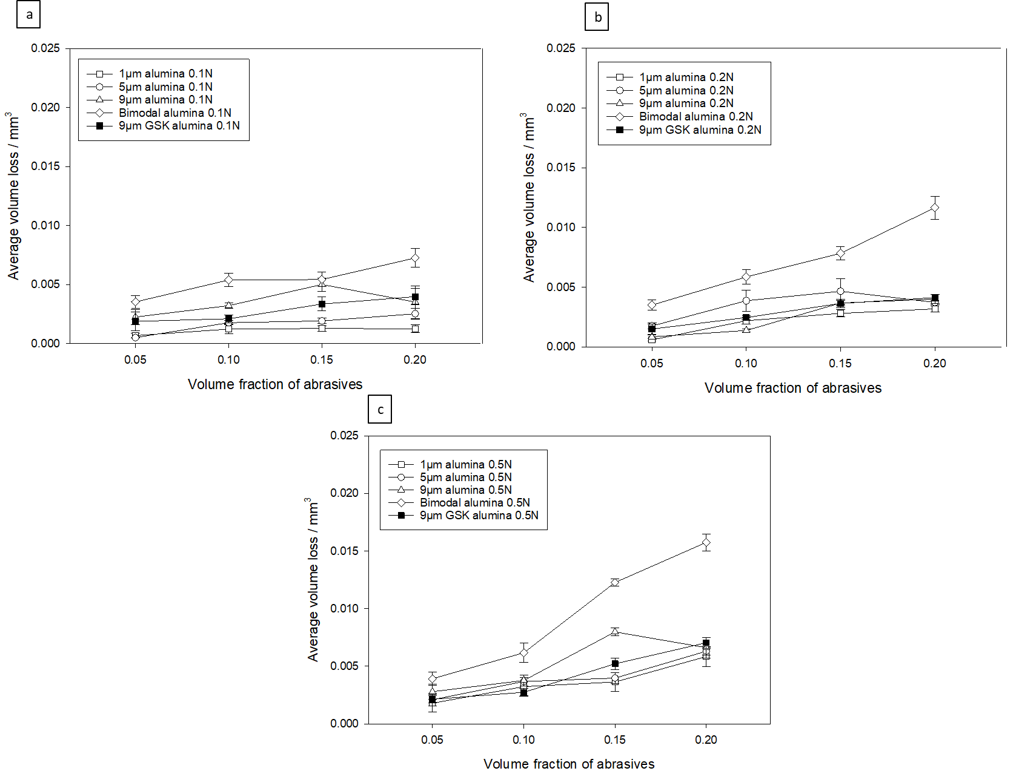

Figure 6: Average volume loss for 1µm alumina, 5µm alumina, 9µm alumina, bimodal alumina and 9µm GSK alumina (a) 0.1N; (b) 0.2N; (c) 0.5N.

3.2.2 Angular silica

Figure 7 shows the average volume loss for the silica tests. At 0.05% v/v the 5µm silica and GSK 8µm silica produced grooving abrasion on the enamel surface. There was a change in wear mechanism for the 5µm angular silica above 0.05% v/v where it changed from grooving to mixed-mode abrasion. The 10µm silica and bimodal silica (5µm + 10µm) tests all generated mixed-mode abrasion, Figure 7. The bimodal silica tests always dominate the mono-sized silica tests.

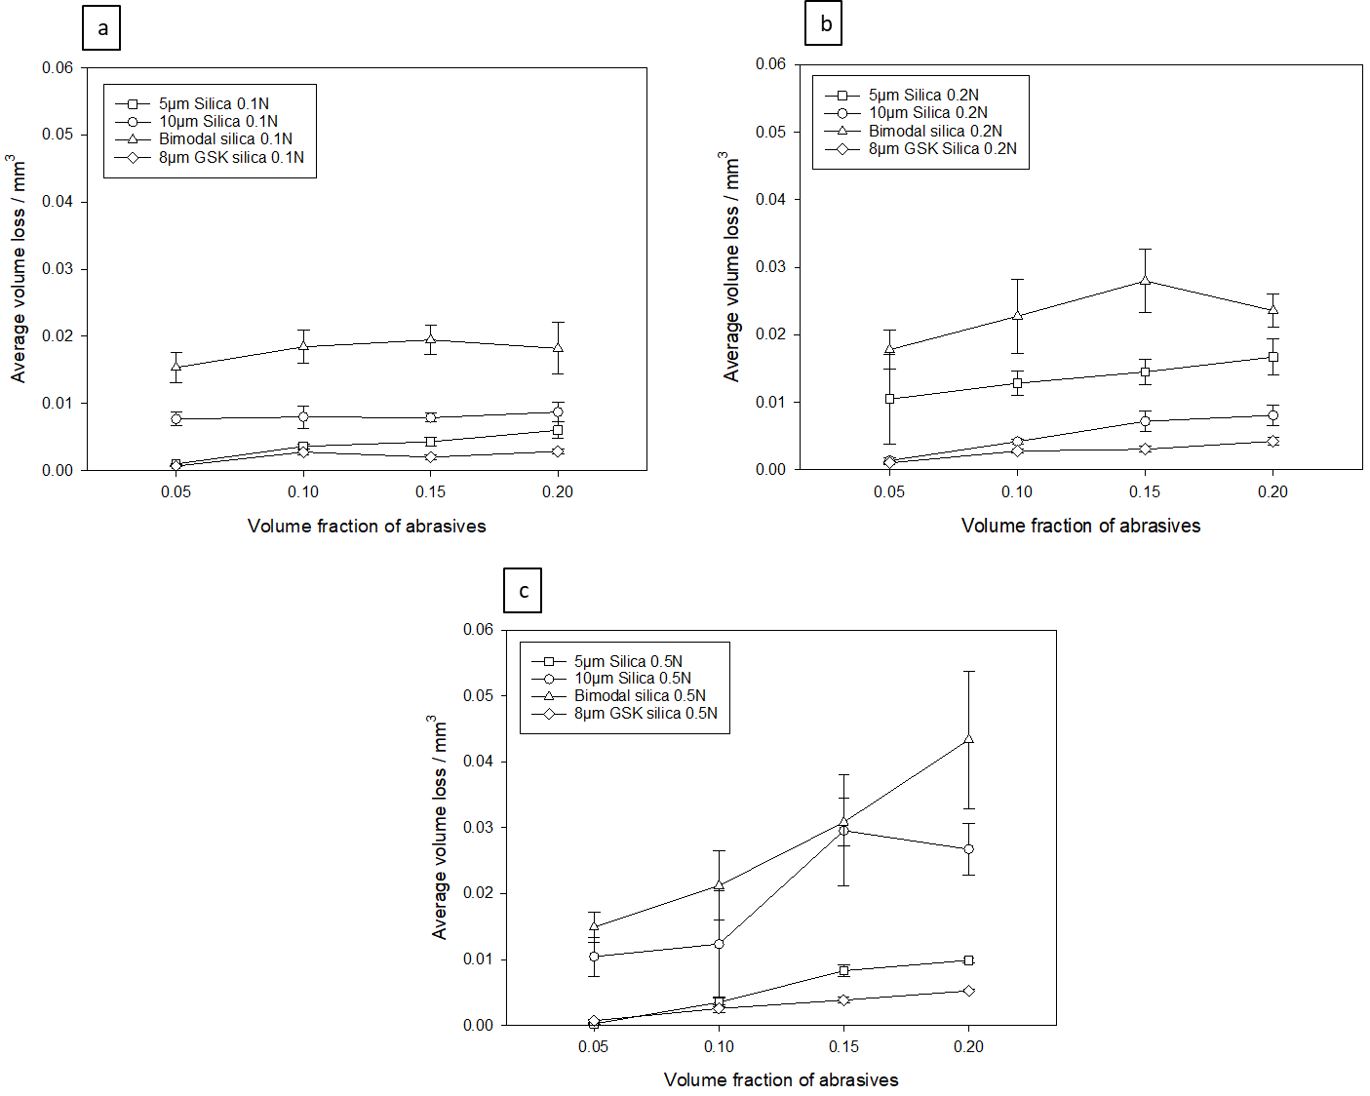

Figure 7: Average volume loss for 5µm silica, 10µm silica, bimodal silica and 8µm GSK silica (a) 0.1N; (b) 0.2N; (c) 0.5N.

3.2.3 Spherical silica

Figure 8 shows the average volume loss for the spherical silica tests. At 0.05% v/v, grooving abrasion dominated both the 5µm spherical silica and GSK 6.5µm spherical silica. The GSK 6.5µm spherical silica generated a higher volume loss than the 5µm spherical silica for all the tests, Figure 5a-c. There was a significant difference in the average volume loss between both the particles, (p<0.05). There was a drop in volume loss of enamel observed for the 5µm spherical silica above 0.10% v/v. This is due to an increased rolling action and less grooving taking place above 0.10% v/v, resulting in a decrease in volume loss of enamel, Figure 8a-c.

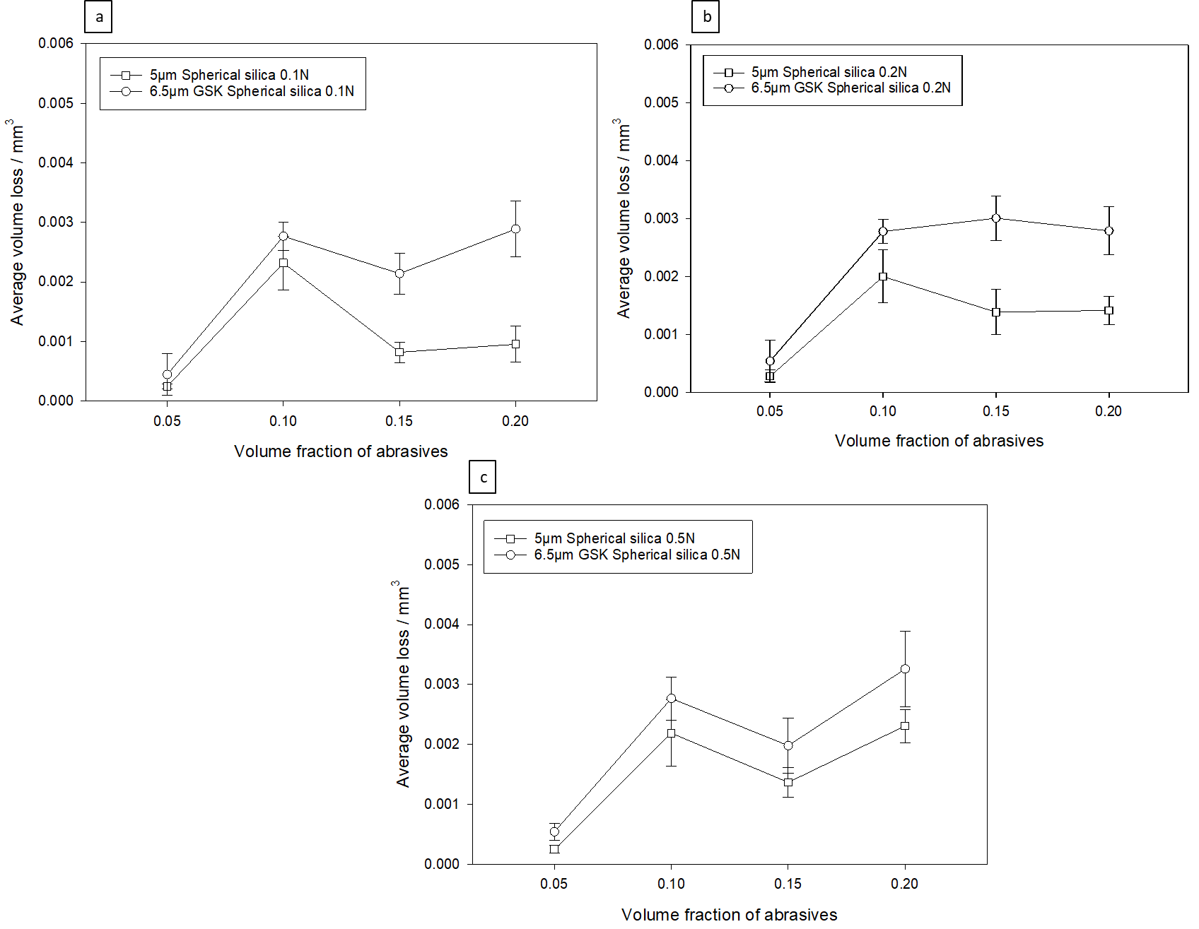

Figure 8: Average volume loss for 5µm spherical silica and 6.5µm spherical silica (a) 0.1N; (b) 0.2N; (c) 0.5N.

3.3 Synergy

Synergy was evaluated to observe the interaction between the different sizes of particles. Synergy and antagonism can be represented by Equation 1 and Equation 2 below. Where V is volume loss.

$\frac{1}{2}V_{5μm alumina/silica}+ \frac{1}{2}V_{9μm alumina or 10μm silica}< V_{Bimodal}$ Equation 1

If Equation 1 is true, there is synergy.

$\frac{1}{2} V_{5μm alumina/silica}+\frac{1}{2} V_{9μm alumina or 10μm silica} > V_{Bimodal}$ Equation 2

If Equation 2 is true, antagonism is present.

Synergy was calculated using Equations 3 and 4.

$Synergy V alumina= Bimodal 7μm V-(\frac{9µm alumina V}{2} + \frac{5µm alumina V}{2})$ Equation 3

$Synergy V silica=Bimodal 7.5 μm V-(\frac{10µm silica V}{2}+ \frac{5µm alumina V }{2})$ Equation 4

The percentage synergy was calculated using Equations 5 and 6.

$\% syngery V alumina=\frac{Synergy V alumina}{Bimodal 7µm V} x 100$ Equation 5

$\% synergy V silica=\frac{Synergy V silica}{Bimodal 7.5µm V} x 100$ Equation 6

Figure 9 shows the percentage synergy for bimodal alumina using Equation 5. There is a 35% – 65% positive synergy, which indicates the bimodal particles are affecting the volume loss of enamel and causing more wear, compared to the mono-sized particles.
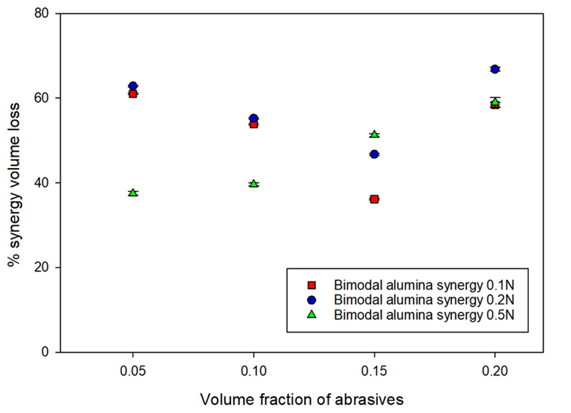

Figure 9: Percentage synergy for bimodal alumina.

Figure 10 shows the percentage synergy for bimodal silica using Equation 6. There is a 25% - 58% positive synergy, which indicates the combination of the bimodal particles effect the volume loss of enamel and this results in a higher volume loss of enamel, hence the positive synergy.

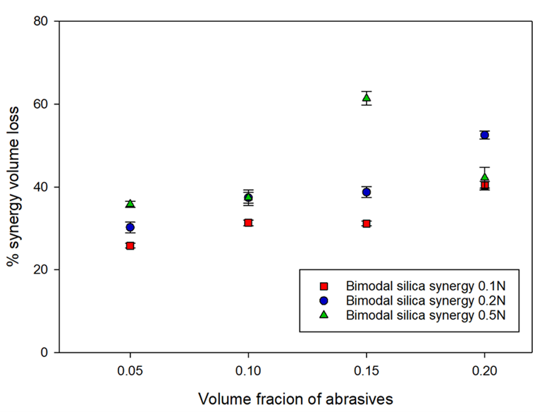
Figure 10: Percentage synergy for bimodal silica.

3.4 Wear mechanisms

Figure 11 shows the wear scars produced with angular 1µm, 5µm, 9µm, and GSK 8µm alumina. These wear scars are also a typical representation for the wear scars produced with angular, 5µm silica, 10µm silica and GSK 8µm silica. Figure 11 a, c, e and g all show the grooving mechanism with the wear scar consisting of multiple grooves. Figure 11 b, d, f and h show the mixed-mode mechanism. The mixed-mode wear scar consisted of grooves, fracture, chipping and an indented surface with shallow pits representing damage of enamel. The typical representation of the grooving mechanism observed for all the tests is grooves, indicating 2-body grooving. For the mixed- mode wear scar it consists of multiple grooving, fracture of enamel, indents and chipping. Brittle mechanisms such as chipping is observed, as is structural damage of enamel which results in an uneven, textured surface, (Figure 11). With an increase in particle size, the grooves increased in size. There were subtle differences with the mixed-mode wear mechanism, Figure 11.

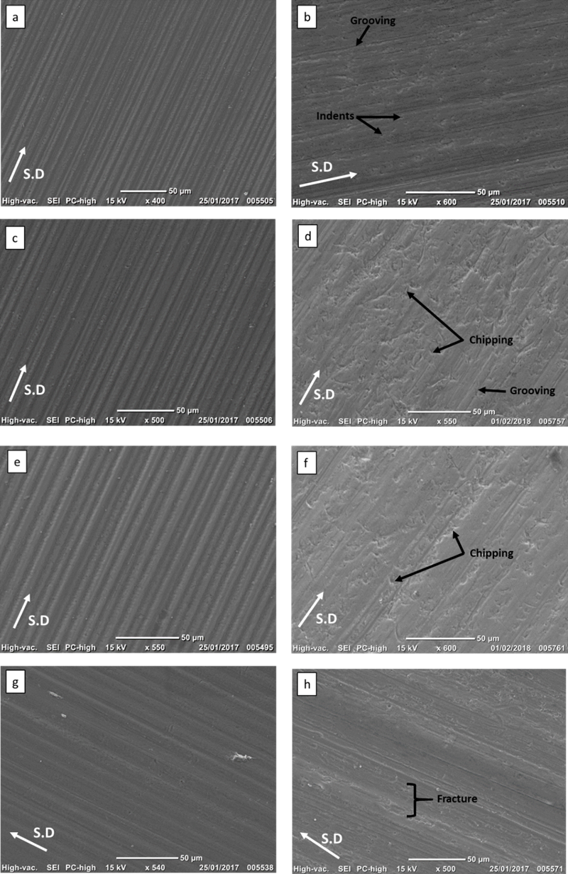

Figure 11: SEM images of angular alumina wear scars, at 0.2N (a) 1µm, grooving; (b) 1µm, mixed-mode; (c) 5µm, grooving; (d) 5µm, mixed-mode; (e) 9µm, grooving; (f) 9µm, mixed-mode; (g) GSK 9µm alumina, grooving; (h) GSK 9µm alumina, mixed-mode. Figures a,c,e and g are all 0.05% v/v and Figures d,b,f and h are all 0.10 % v/v.

Figure 12 shows the wear scar produced for 9µm angular alumina at a load of 0.1N and a volume fraction of 0.20% v/v. The wear scar appears to have an indented surface throughout, indicating rolling abrasion. The mechanism for rolling abrasion is a combination of chipping and indenting, with multiple indents removing/ damaging material from the enamel surface.
Figure 13 shows typical wear scars produced with bimodal silica (5µm + 10µm). The mixed-mode mechanism shows signs of chipping, fracture of enamel rods and grooving. The wear scar for mixed-mode is a typical representation of all the wear scars produced with bimodal silica (5µm + 10µm) and bimodal alumina (5µm + 9µm).
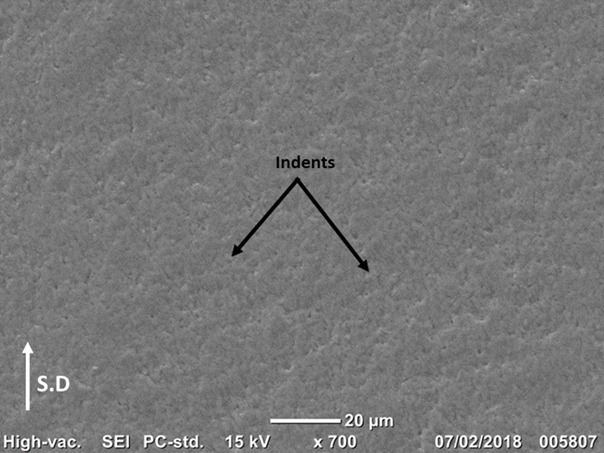

Figure 12: SEM images of wear scar produced with 9µm angular alumina, 0.1N at 0.20% v/v showing 3-body rolling.

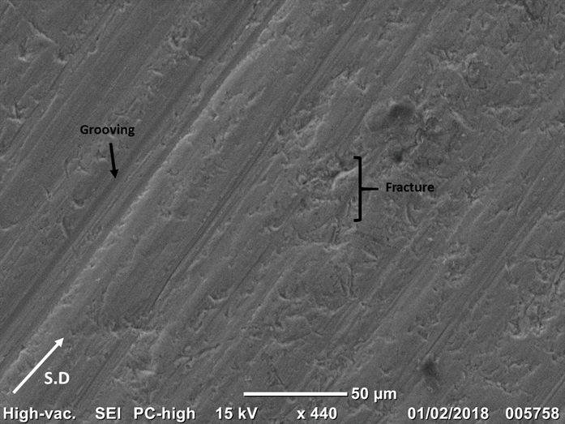
Figure 13: SEM images of wear scar with bimodal silica (5µm + 10µm), load 0.2N, 0.10% v/v.
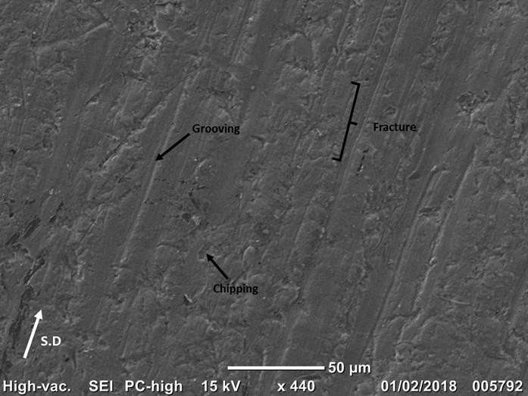

Figure 14: SEM images of wear scar for 10µm silica, load 0.2N, 0.10% v/v.

Figure 14 shows the typical wear scar for 10µm silica. The wear scars produced with the bimodal silica show areas of multiple grooves and signs of chipping and fracture of the enamel rods. On comparison of the wear scars produced with the 10µm silica show less grooving, however a damaged enamel surface is observed with many fractured enamel rods and signs of chipping.

Figure 15 shows the typical wear scars produced with 5µm spherical silica (Figure 15a and Figure 15b) and GSK 6.5µm spherical silica (Figure 15c and Figure 15d). These wear scars are a typical representation of the wear scars produced with the 5µm spherical silica and GSK 6.5µm spherical silica tests. Figure 15a and 15c show grooves while Figure 15b and 15d show mixed mode and rolling abrasion. An increase in the groove width for the grooving mode is evident, from 5µm spherical silica to GSK 6.5µm spherical silica, Figure 15a and Figure 15c. There were subtle differences in the wear scars produced with 5µm spherical silica and GSK 6.5µm spherical silica.

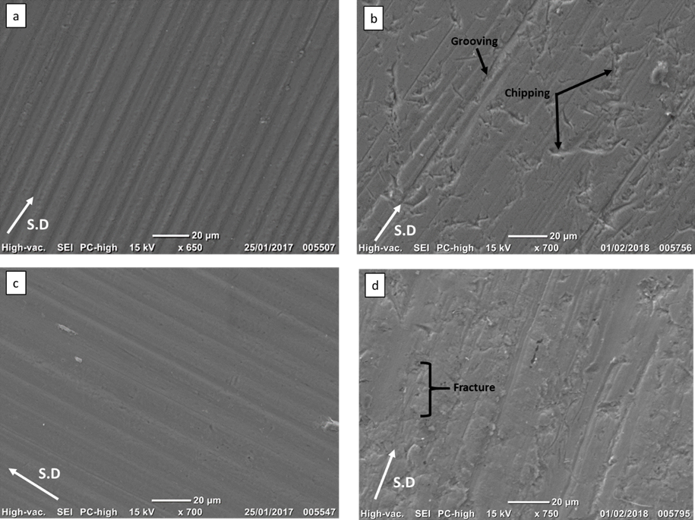
Figure 15: SEM images of wear scar of spherical silica at a load of 0.2N (a) 5µm spherical silica grooving; (b) 5µm spherical silica mixed-mode; (c) GSK 6.5µm spherical silica grooving; (d) GSK 6.5µm spherical silica mixed-mode. Figures a and c are 0.05% v/v and Figures b and d are 0.10% v/v.

3.5 Wear groove analysis

Table 3 shows the groove widths for the abrasive particles.

The groove width for the bimodal alumina (5µm + 9µm) was reported as 11.01µm. The maximum size of particles in the alumina 5µm and alumina 9µm slurry are doing the most damage to create this large groove width. The largest groove widths were observed with the bimodal silica. This is due to the large 10µm particles in the bimodal silica test, resulting in a higher load per particle, whereas in the 10µm silica tests there are more 10µm silica particles, which results in a lower load per particle, hence the smaller groove. The large groove width for the bimodal silica (5µm + 10µm) mixed mode is a result of the maximum particle size of the silica 5µm and silica 10µm tests.

There is an increase in groove width from 5µm spherical silica to GSK 6.5µm spherical silica for the grooving and mixed-mode mechanism.

Table 3: Average groove width data for the abrasive particles.

 | Grooving |  | Mixed- mode
 | Average groove width / µm | Standard deviation | Average groove width / µm | Standard deviation
Alumina 1µm  Maximum– 1.79µm  Mean – 1µm | 3.31 | 0.73 | 3.73 | 0.65
Alumina 5µm  Maximum – 8.1µm  Mean – 5µm | 6.94 | 1.72 | 7.67 | 1.36
Alumina 9µm  Maximum– 10.2µm  Mean – 9µm | 9.01 | 1.64 | 11.63 | 1.72
Bimodal alumina  5µm + 9µm  Mean - 7µm | 11.01 | 1.16 | 14.91 | 1.54
GSK 9µm alumina  Maximum – 10.4µm  Mean – 9µm | 9.22 | 0.77 | 11.97 | 0.93
Silica 5µm  Maximum – 23µm  Mean – 5µm | 6.48 | 0.58 | 7.36 | 1.71
Silica 10µm  Maximum – 28µm  Mean – 10µm | 10.28 | 1.09 | 11.83 | 2.72
Bimodal silica  5µm + 10µm  Mean – 7.5µm | - | - | 16.17 | 1.96
GSK 8µm silica  Maximum size– 9µm  Mean size – 8µm | 8.39 | 0.37 | 10.08 | 1.07
5 µm Spherical silica  Maximum size – 6.1µm  Mean size – 5µm | 5.28 | 0.63 | 6.96 | 1.23
GSK 6.5µm spherical silica  Maximum size – 8.8µm  Mean size – 6.5µm | 5.87 | 0.87 | 8.08 | 0.95

- Discussion

In the previous sections, we have examined the influence of particle shape and size on the volume loss of enamel. This section will discuss the main findings of which factors control the severity of contact and therefore control wear. The main factors that control wear are thought to be:

- Load per particle
- Shape of particle (contact stresses)
- Entrainment of particles – i.e concentration / number in contact
- Particle- particle interaction
- Friction between the particle and the ball/ sample

4.1 Limitations

The 5µm and 10µm angular silica particles have a wide distribution with maximum particle sizes of 23µm and 28µm respectively. From section 3.1, the volume loss of enamel is influenced by the maximum particle size of the 5µm silica particle, which is 23µm. The comparison of particle shape on the volume loss of enamel would not represent the morphology changes; the maximum particle size of the angular 5µm silica particle would be dominating the comparison. This matter has been addressed by the addition of angular GSK 8µm silica for comparison purposes as these particles had a more controlled mono-sized particle distribution compared to the 5µm silica (Section 3.1).

4.2 Nature of abrasives

The hardness of the abrasives could affect the amount of enamel loss, with the hardness of enamel being in the region of 1.47 GPa - 1.60GPa [18]. The silica tests resulted in a higher volume loss of enamel (Figure 6), compared to the alumina tests, Figure 5. This is unexpected, as alumina is a harder abrasive than silica. Alumina has a hardness of 24.5GPa, whereas silica has a hardness of 11.7GPa [10, 11]. An explanation for this could be the wide particle distribution for the 5µm and 10µm silica. The maximum particle size for the 5µm and 9µm alumina was 8.1µm and 10.2µm, whereas for the 5µm and 23µm silica, the maximum particle size was 10µm and 28µm respectively. The groove analysis showed larger grooves for the angular silica tests.

4.3 Influence of particle shape

The particle shape can influence the behaviour of the particles and thus the volume loss of enamel. Angular particles have sharp edges including highly concentrated contact stresses, which can chip the enamel or fracture the enamel which results in crack formation which can network deep into the rods, whereas spherical particles have round edges and induce much lower stress which affect the area/ depth of enamel removal. In engineering it has been established that spherical particles are less damaging than angular particles. A study carried out by Speerschneider et al, on the wear damage of stainless steel by alumina filled PTFE material, found a reduction in abrasive damage by the spherical particles compared to the angular alumina particles. The particle size of both particles was 7µm. It has been noted that using a geometrically shaped particle such as a spherical particle, reduces the abrasive damage and thus differences in wear and friction are observed with specific geometrically shaped particles. This was observed in the present tests, where 5µm spherical silica generated a lower volume loss of enamel compared to the 5µm angular silica and angular GSK 8µm silica, Figure 2. The grooving wear scar was similar in appearance for the angular 5µm silica, spherical 5µm silica and angular GSK 8µm silica (Figure 3a, c, e). However, there were more indents observed with the 5µm spherical silica with a decrease in volume loss of enamel above 0.10% v/v (Figure 16). This is evidence that more rolling and less grooving abrasion occurred. The indenting observed on the enamel surface is likely to result in densification of the enamel tissue, which causes enamel structure damage. Densification is caused by the compression of enamel during high loading, which after a number of cycles causes enamel structural damage. After a number of compressive loading cycles, this results in removal of enamel and breakup of the enamel prism surface by crushing of the prisms [19].
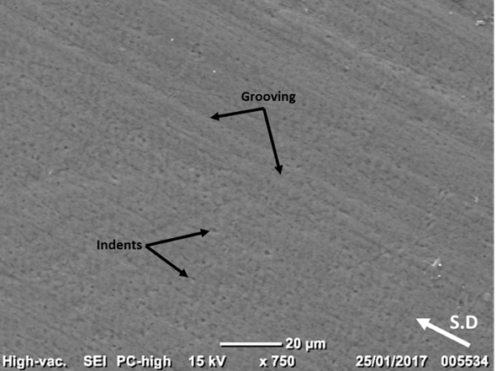
Figure 16: SEM image of mixed-mode wear scar for 5µm spherical silica at 0.5N and volume fraction 0.20% v/v.

The mixed-mode regime shows signs of an irregular surface, where the indents and fracture of enamel occurs in random directions. This is consistent with results in previous studies, [6, 20].
A study conducted by Silva, et al used a hard martensitic steel ball on a steel substrate and used alumina and silica abrasive particles in a slurry solution consisting of water at a concentration of 75gcm³. The silica particles were spherical in shape whereas the alumina particles were angular. Silva et al, confirmed that angular sharp particles such as alumina give higher specific wear rate (SWR) and cause more wear than spherical particles This is confirmed by the current study with angular particles generating higher wear rates than the spherical particles [21].
Bai et al, carried out tests on a diamond-like carbon film using sand particles. The study found the shape of the particle influenced the movement modes of particles which in turn effects the volume loss of material [22]. For the present study, a higher volume loss of enamel was observed in the mixed-mode region. The increase of volume loss of enamel in mixed- mode can be due to a number of reasons, such as the angular shape of the particles, the contact stresses exerted by the angular particles on the enamel surface and the entrainment of particles in the contact. The spherical silica particles produced indents indicating rolling abrasion in the mixed-mode wear regime. The 5µm spherical silica particles roll when they are in the contact between the nylon ball and the enamel disc 4.[22].

4.4 Influence of particle size

Two-body and three-body abrasion

It has been noted that the size distribution of particles should also be considered when conducting micro-abrasion tests, due to the variations on the abrasive particles which are active during the micro-abrasion test [23]. As a result, if the abrasive particle distributions in the slurry are not identified, it can affect the wear volumes [23]. Gomez et al, found that an increase in average particle size did not increase the wear volume. The number of particles in the contact were responsible for the amount of wear. They found that the lower fractions of larger particles in the slurry resulted in deeper penetrations of the wear scar and thus a higher wear volume. They also found that the larger particles made the initial contact and then the lower fractions of large particles in the slurry distribution resulted in the rest of the wear volume loss [23].
Figure 16 shows the typical wear scar for rolling abrasion. The rolling abrasion causes a rough surface topography with clear indent features at the scale of the abrasive particles. The removal of material is due to fracture and crushing of enamel rods and subsequent surface damage or removal of enamel rods by other particles. Pena et al, reported plastic deformation and brittle delamination on the enamel surface when wear tests were conducted. No signs of plastic deformation were observed in the present study. Bai et al, mentions that three body abrasion is a complicated process and many factors can influence the 3-body wear process such as the size, shape, number and density of abrasive particles. Three body rolling wear was observed with the 9µm alumina at 0.20% v/v volume fraction and a load of 0.1N. Rolling abrasion is often observed with a high volume fraction and low loads. The present study confirms this finding. This could be due to the entrainment of particles in the contact, resulting in rolling abrasion. It was found that a higher volume loss of material was observed by the grooving mechanism than three-body rolling. This occurrence is not observed in the current study, as grooving abrasion resulted in a lower volume loss of enamel than the rolling mechanism, Figure 4.
Gomez et al, reported that an increased tendency for rolling abrasion instead of grooving could be due to a decrease in contact pressure during the test which results in particle rolling. It was concluded by Gomez et al, that rolling abrasion was not associated with bimodal particle distributions or wide particle distributions. Another possible explanation for rolling abrasion in the wear scar could be due to the decreased test severity during the micro-abrasion test. This could be due to the entrainment of particles in the contact, resulting in rolling abrasion [23]. It was found that a higher volume loss of material was observed by the grooving mechanism than three-body rolling. This occurrence is not observed in the current study, as grooving abrasion resulted in a lower volume loss of enamel than the rolling mechanism, Figure 3.
Esteves et al, investigated the effect of ball rotation speed and the size of the abrasive particles. An increase in the ball speed resulted in an increase in the number of abrasive particles embedded in the wear scar at the input region where the abrasive particles enter between the ball and the specimen. The size of the abrasive particles was found to be higher at the input region than the middle of the wear scar [24].

Mixed- mode + bimodal abrasion

Mixed mode (2-body grooving with 3-body rolling) abrasion provided higher wear rates than solely 2-body grooving in all the tests. The bimodal tests produced higher wear rates than the single component sized particle tests. This can be explained by the bigger particles receiving a higher load per particle as they go through the contact, causing more damage on the enamel surface. Bimodal silica tests caused more wear than the bimodal alumina tests due to the larger particles within the bimodal silica when compared to the bimodal alumina (10μm vs. 9 μm). Mixed- mode abrasion gives discrete 2-body and 3-body regions in the scar.
Figure 5 shows the average volume loss of enamel for the silica tests. The GSK 8µm silica particles produced the lowest volume loss. These particles had a tighter particle distribution to the angular 5µm silica particles.
The highest wear rates were produced by the bimodal particle size distributions due to a shift to mixed-mode abrasion. Mixed mode gave higher wear rates compared to 2-body grooving in all the tests. This was caused by the increase in size of the silica particles.
A study conducted by Katra et al, highlighted the difficulty in quantifying a bimodal distribution for a test. They suggested, the combination of two sizes of particles changes the distribution of particles and for this reason, a mean particle size cannot be correctly assumed for bimodal tests. Gava et al, suggests using the maximum particle size to quantify the bimodal tests, due to the largest particles in the bimodal slurry being dominant, or alternatively by taking an average of the two particle sizes [2]. The latter method of taking the average particle size has been used for these tests [25].
The abrasive size also has an effect on the severity of wear. An increase in force transmitted per abrasive particle is seen with an increase in mean size of abrasive. For constant volume loading of particles, increasing the mean abrasive size reduces the number of particles at the interface of the ball and sample, which then results in an increase in force per particle. The bigger the size of the abrasive particle, the greater the wear rate. da Silva et al, highlights the fact the size of the abrasive is the one of the most important factors in controlling the wear rate and mechanism, alongside load per abrasive particle. This is also confirmed in the current study, with the bimodal tests generating the highest wear rates [21].
As expected, an increase in the particle size within the slurry, contributed to an increase in the volume of material loss. The origin of this effect lies in the load per particle as it travels through the contact. The slurries were manufactured using volume fraction and therefore the smaller sized particle slurries contained a higher number of particles. The load was therefore distributed between more particles in the small- size particle slurries, producing less damage than the larger-size and more highly loaded particles. In the bimodal slurries, the larger particles are fewer in number however, when they are drawn through the contact they are subject to the highest load per particle causing the increased level of damage seen.
The increased levels of volume loss of the silica tests compared to the alumina tests is due to the difference in the size distribution. The alumina mono-sized particles had a tightly controlled size range within 3µm, whereas the silica had particles as large as 28µm. The larger particles within the silica tests have elevated the volume losses for the reasons outlined above.

  - Synergy evaluation

There have been no previous attempts in understanding synergy due to bimodal size distribution in oral tribology. Synergy can be described as the effect of two factors combined together will be greater than the sum of the separate individual factors [26]. In this case we are looking at two distinct sizes.
From section 3.3, there was a 35-65% positive synergy with the alumina tests compared to a 25% - 60% synergy with the bimodal silica (Figure 6 and Figure 7) tests. This explains there were other factors besides the size of the particles, which have an effect on the synergy. This could be factors such as the entrainment of particles, load per particle and the wear mechanisms such as the micro-chipping of enamel.
The synergy indicates that the bimodal particles give more wear than the mono-sized particles and an increased wear rate (Figure 6 and Figure 7). Synergy is caused by the interaction between rolling and grooving. Crushing and indentation of enamel takes place and grooving of the damaged surface and these interactions occur all over the wear scar surface. The effect of grooving, chipping and fracture takes place on crushed or densified enamel rods creates enhanced volume loss and grove width. This contributes to the positive synergy. Synergy is therefore observed when there is an overlap of the 2-body and 3-body regions in the scar while mixed mode abrasion appears to have separate 2-body and 3-body regions.

- Conclusions

The purpose of this research was to develop an understanding of the magnitude and mechanisms of enamel wear caused by two, three and mixed- mode abrasion. The experimental approach was conducted using the Plint TE66 micro-abrasion rig (TE66 Phoenix Tribology, UK) to investigate the effect of size/ combination of sizes and morphology of abrasive particles on the wear rate and mechanisms of enamel tissue. As a result of the findings, the following conclusions were obtained:

The effects of changing the particle shape, size and size distribution on the volume loss of enamel were investigated using the micro-abrasion tester. The following conclusions can be made:

• Particle size and the magnitude of the distribution of the particle sizes is a key variable in determining the volume loss of enamel, with smaller particles and narrow distributions of the particle size reducing the enamel loss.

• The large particles in the bimodal slurry appear to take a higher load and cause more damage.

• Mono-sized particles distribute the load across lots of particles. A wider particle distribution, as in the silica tests, results in the larger particles taking the higher load and this results in more damage on the enamel surface.

• A change in shape of particles for the silica particles from angular to spherical caused a decrease in volume loss of enamel, due to lower contact stresses of the spherical particles when contacting the enamel surface.

• Wider grooves are caused by the large particles sliding, which generate a higher load per particles and cause larger grooves by processes such as chipping, fracture and crack networking.

• A positive synergy is produced for the bimodal alumina and bimodal silica tests, highlighting the fact the bimodal particles cause more enamel removal than the mono-sized particles, due to 3-body and 2-body abrasion occurring at the same points on the enamel surface while mixed mode abrasion has separate regions.

• The wear volume was affected by the wear mechanism, with 2 body-grooving generating less damage than the mixed mode wear regime.

• The grooving mechanism is a result of the abrasive particles being trapped by the Nylon ball under loading. The abrasive particles micro-chip the enamel surface and enamel removal takes place, which results in 2-body grooving.

• The mixed-mode mechanism is observed as a combination of grooving, fracture and indents on the enamel surface. Brittle mechanisms such as chipping, crushing and fracture of enamel rods are observed on the enamel surface. Indenting is a result of densification of the enamel tissue, which causes enamel structural damage.

• 5µm alumina particles generate more volume loss of enamel compared to the GSK 9µm alumina. The distribution of particles with the 5µm alumina is ±3.1µm. The GSK 9µm alumina have a tighter size distribution (±2.69µm).

Acknowledgements

This research was sponsored by GSK Consumer Healthcare.

Data statement: All data supporting this study are openly available from the University of Southampton repository at

References

1. Joiner, A., Review of the extrinsic stain removal and enamel/dentine abrasion by a calcium carbonate and perlite containing whitening toothpaste. . International Dental Journal, 2006. 56: p. 175- 180.
2. GSK, Sensitivity and Acid Erosion - Spherical silica GSK, Editor. 2016, GlaxoSmithKline: Weybridge, U.K.
3. Lewis, R. and R.S. Dwyer- Joyce, Interactions Between Toothbrush and Toothpaste Particles During Simulated Abrasive Cleaning. Journal of Engineering Tribology, 2006. 220(8): p. 755 - 765.
4. Chan, D.C., The effect of microabrasion on resrotative materials and tooth surface. Operative dentistry, 1996. 21(2): p. 63 - 8.
5. Antunes, P.V. and A. Ramalho, Study of Abrasive Resistance of Composites for Dental Restoration by Ball Cratering. Wear, 2003. 255: p. 990 - 998.
6. Pena, A., et al., Micro-Abrasion Study of Some Dental Restorative Materials and Enamel. Journal of Engineering Tribology, 2013. 227(5): p. 486 - 495.
7. Adachi, K. and I.M. Hutchings, Wear mode mapping for the micro-scale abrasion test. Wear, 2003. 255.
8. Baig, M., Understanding the role of tribology in maintaing oral hygiene in National Centre for Advanced Tribology. 2019, University of Southampton: UK.
9. Flemming, H.C., J. Wingender, and U. Szewzyk, Biofilm Highlights, ed. U. Szewzyk. Vol. 1. 2011, Germany Springer.
10. AzoM. Alumina - Aluminium oxide. Azo Materials 2001 [cited 2018 17th March]; Available from: https://www.azom.com/properties.aspx?ArticleID=52.
11. AzoM. Silica- Silicon Dioxide. Azo Materials 2001 [cited 2018 17th March]; Available from: https://www.azom.com/article.aspx?ArticleID=1114.
12. Rmaile, A., et al., Microbial Tribology and Disruption of Dental Plaque Bacterial Biofilms. Wear, 2013. 306: p. 276 - 284.
13. Weigand, A., et al., Impact of Toothpaste Slurry Abrasivity and Toothbrush Filament Stiffness on Abrasion of Eroded Enamel - An In Vitro Study. Acta Odontologica Scandinavica, 2008. 66(4): p. 231 - 235.
14. Tanaka, J.L.O., et al., Comparative Analysis of Human and Bovine Teeth: Radiographic Density. Brazilian Oral Research, 2008. 22(4): p. 346 - 351.
15. Gant, A.J. and M.J. Gee, A review of micro-scale abrasion testing. Journal of Physics, 2011. 44.
16. Hand, A.R. Enamel structure, compostion and properties. Pocket Dentistry 2015; Available from: http://pocketdentistry.com/contact/.
17. Trezona, R.I., D.N. Allsop, and I.M. Hutchings, Transitions between two-body and three-body abrasive wear: influence of test conditions in the microsclae abrasive wear test. Wear, 1999. 225-29.
18. Craig, R.G. and F.A. Peyton, The Microhardness of Enamel and Dentin. Journal of Dental Research, 1957. 37(4): p. 661 - 668.
19. Xia, J., et al., Enamel crystallite strength and wear: nanoscale responses of teeth to chewing loads. The royal society Publishing, 2017. 14.
20. Luo, D.B., V. Fridrici, and P. Kapsa, Relationships between the fretting wear behaviour and the ball cratering resistance of solid lubricant coatings. Surface and Coatings Technology, 2010. 204: p. 1259 - 1269.
21. da Silva, W.M., R. Binder, and J.D.B. de Mello, Abrasive wear of steam-treated sintered iron. Wear, 2005. 258.
22. Bai, L., et al., Influence of third particle on the tribological behaviours of diamond-like carbon films. Scientific reports, 2016.
23. Gomez, A.O., et al., Effect of abrasive particle size distribution on the wear rate and wear mode in micro-scale abrasive wear tests. Wear, 2015. 328-329: p. 563-568.
24. Esteves, P.J., et al., Effect of ball rotation speed on wear coefficient and particle behavior in
micro-abrasive wear tests. Wear, 2019. 426-427: p. 137-141.
25. Gava, G.H.S., et al., Effect of load partition and particle distribution on micro-abrasive wear mapping of two-phase metal matrix composites. Wear, 2013. 301.
26. Investopedia. Synergy. 2018 [cited 2018 03.07.18]; Available from: https://www.investopedia.com/terms/s/synergy.asp#.

